Find a good mapping from complement of circular sector to complement of unit circle.

Here is what I would like to find:

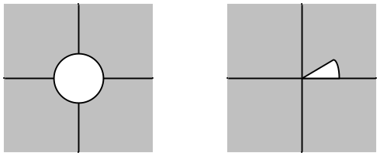

One's first thought is to somehow use the mapping w = z6 which let's say maps the circular sector on the right to the full circle on the left, and then just "take the complement" of this mapping, somehow:

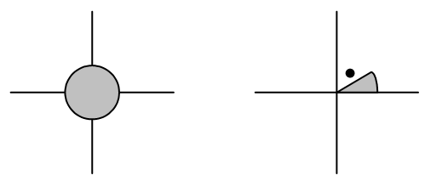

But under this mapping z6, the point marked with the dot does not get mapped somewhere on the exterior of the disk on the left. It in fact gets mapped to the interior of the disk on the next Riemann sheet, which is now what we want. I went off and did Problem 1 below before I realized that it does not solve this basic problem.

Problem 1: Make a mapping that does this:

(1) maps ray at α to ray at 0
(2) maps ray at 2π to ray at π.

This is in hopes of finding a mapping that does this:

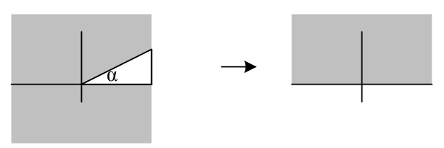

Want the gray area on the left to map into the gray area on the right. Seems pretty simple, doesn't it?

As a candidate solution, let's try this mapping

f(φ) = expi (a+bφ)

Then our two conditions are

expi(a+αb) = 1
expi(a+2πb) = -1

This can be written as

a + αb = 0 => b = -a/α
a + 2πb = π

Second equation then says

a - 2πa/α = π

a[ 1 - (2π/α)] = π

a = π / [ 1 - (2π/α) ]

b = -(π/α) / [ 1 - (2π/α) ]

Then we have

a + bφ = π / [ 1 - (2π/α) ] - (π/α) φ / [ 1 - (2π/α) ]

= {π / [ 1 - (2π/α) ]}(1 - φ/α) = π [1 - (φ/α) ] / [ 1 - (2π/α) ]

Let's check this result. If φ = α, phase is 0. If φ = 2π, phase is π. Looks good. So one solution to our posed Problem 1 is this:

f(φ) = exp { iπ[1 - (φ/α) ] / [ 1 - (2π/α) ] }

= exp { iπ / [ 1 - (2π/α) ] } exp { -iπ(φ/α) / [ 1 - (2π/α) ] }

Now define these two real quantities,

c = π / [ 1 - (2π/α) ] d = - (π/α) / [ 1 - (2π/α) ]

= α π / (α - 2π) = - α π /(2π-α) = + π / (2π-α)

Then we have

f(φ) = eic eidφ

Now consider this analytic mapping

w = F(z) = eic zd
z w

I believe this mapping takes the gray region into the gray region, and in fact does it without radial distortion. So once again

F(z) = e-iαπ/(2π-α) z π/(2π-α)
F(eiφ) = e-iαπ/(2π-α) e iφπ/(2π-α)

One more check.

F(eiα) = e-iαπ/(2π-α) e iαπ/(2π-α) = 1

F(ei2π) = e-iαπ/(2π-α) e i(2π)π/(2π-α) = ei[-απ + 2ππ]/(2π-α) = eiπ[-α +2π] /(2π-α) = eiπ= -1

Here is a concrete example. Suppose α = π/3. Then we have

c = - α π /(2π-α) = -(π/3)π/(2π-π/3) = -π (1/3)/ (2-1/3) = -π (1/3)/ (5/3) = -π/5

d = + π / (2π-α) = π / (2π-π/3) = 1 / (2-1/3) = 1/(5/3) = 3/5

Then

F(z) = e-iπ/5 z3/5
F(eiφ) = e-iπ/5 eiφ3/5

And if φ = π/3 we get e-iπ/5 ei(π/3)3/5 = e-iπ/5 e+iπ/5 = 1

And if φ = 2π, we get e-iπ/5 ei(2π)3/5 = e-iπ/5 eiπ6/5 = eiπ(5/5) = eiπ = -1

You can see that I am nervous about the result being wrong.

Conclusion: we now have a "reasonable" mapping from the complement of an open wedge to the upper half plane:

z w

w = F(z) = eic zd

c = - α π /(2π-α)
d = π / (2π-α)

Comment: Problem 1 was "an interesting problem" yes, but I don't see how I can use it's result to get an answer to the originally posed question. I thought I was going to draw this picture,

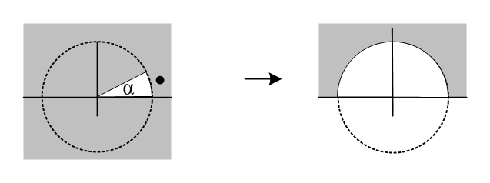
and claim I had a mapping from gray to gray, but that is wrong because, for example, the point marked with the black dot does not get mapped into the gray on the right. It is in the open wedge shown above, and it gets mapped nowhere in the full gray area (upper half plane) so certainly it does not get mapped anywhere in the restricted gray area on the right below.

I think this is a much harder problem than I thought, or I am missing something very basic.

The Riemann mapping theorem I think says that such a mapping must exist.

I cannot find anything on the web, hard to search:

"conformal mapping" "complement of a"

"conformal mapping" tables

"conformal mapping" "circular sector"

"complement of a circular sector"

http://math.fullerton.edu/mathews/c2003/ConformalMapDictionary.4.html

This is a very nice site with lots of stuff. Here is one suggestive idea:

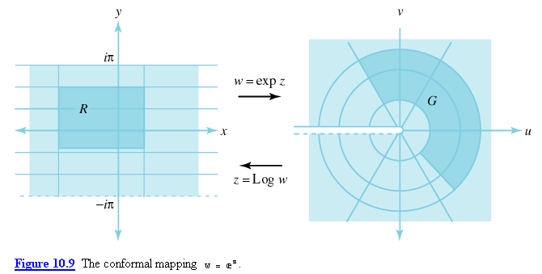

Have I overlooked the mapping w = ez ? (which we studied a lot in Ahlfors)

z = ln(w) = ln(reiθ) = ln(r) + iθ

So I can then map the complement of a circular sector into the complement of a rectangle which runs off to ∞ to the left, so at least this gets the edges straightened out! Here is a "list of conformal map on the web"

http://math.fullerton.edu/mathews/c2003/ConformalMappingBib/Links/ConformalMappingBib_lnk_1.html

Here is a book which says a little about "exterior or a rectangle" (and says it is a problem)

http://books.google.com/books?id=Aw4SOBFKF2kC&pg=PA84&lpg=PA84&dq=conformal+mapping+%22exterior+of+a+rectangle%22&source=bl&ots=3Bx_KaGq50&sig=Wd_bGqhQjHkGclKXdQ3MynOEPo4&hl=en&ei=gSLqSuDlAYS2sgO6mqznCA&sa=X&oi=book_result&ct=result&resnum=1&ved=0CA0Q6AEwAA#v=onepage&q=&f=false

And here is a quote of interest from arxiv.org/pdf/0705.0643

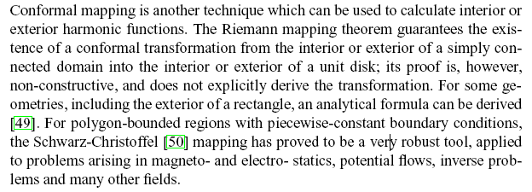

Note mention of "exterior of a rectangle".

and here is another

http://books.google.com/books?id=SR4QI6g1m68C&pg=PA9&dq=%22handbook+of+conformal+mapping%22&lr=#v=onepage&q=&f=false

Here is a quote from this book:

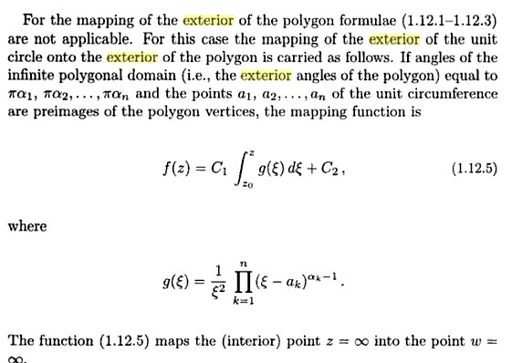

So I think it is all doable, I just don't know enough about conformal mapping. The above book ends with a "catalog" but we are blocked from seeing it. Marriott has it QA360 .I93 1995 and it is checked in on Science Level 1.

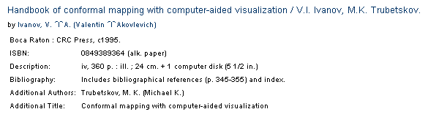


I could go look at it, but it may not help me.

So for now, I regard this as an interesting problem but will let it go.

My motivation was Stagold exercise 6.47 where we want the charge on the outside of a circular sector "bent ring" of metal. I was going to use the mapping to get the potential outside the sector (wedge), then differentiate to get the charge distribution.

