Notes on Contour Integration and Handling Cuts PhL 12.8.08

This is a collection of miscellaneous notes on this general topic.

1. What is the cut structure of f(t) = t1/3 (1-t)1/2.

Here is a useful picture:

m = 0,1,2 n = 0,1
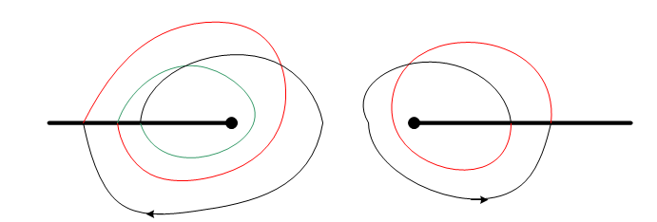

For the branch point on the left which arises from t1/3, there are three sheets encountered as you rotate around the point t=0 many times. If we had f(t) = t1/3, we would have just the left branch cut, and we would say that f(t) had 3 sheets. Similarly, if we just had f(t) = (1-t)1/2, we would only have the branch cut on the right, and the function f(t) would have 2 sheets. For some unknown reason, I have put the "ant path" going CCW on the right, and CW on the left. Should not matter.
We can think of 3 winding numbers possible on the left, and 2 on the right. Call these m and n. Then the phase accrued by moving away from the black-black sheet is this

phase = 2π( m/3 - n/2)

m n ( m/3 - n/2) Sheet name:
0 0 0 black-black
1 0 1/3 red-black
2 0 2/3 green-black
0 1 -1/2 black-red
1 1 1/3 - 1/2 = -1/6 red-red
2 1 2/3 - 1/2 = +1/6 green-red

There are 6 sheets for f(t) = t1/3 (1-t)1/2 because there are six different phases, and they are equally spaced around the circle:

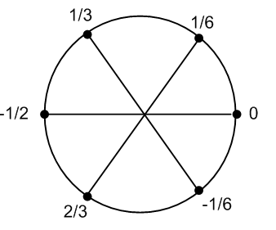

There are other ways to draw the cuts, for example

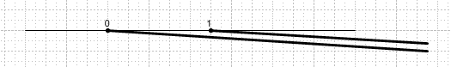

You might think you could somehow join these two branch cuts at infinity and then deform them into this position:

That thought would be incorrect for this example! The two cuts don't "cancel" on the right side. Another way to see this is to suppose the above picture were true. Then you could draw a circle containing this supposed cut, and when you traverse this circle, you pick up a phase +2π/3 from t1/3 and a phase +2π/2 from (1-t)1/2, so total phase is 2π(1/3+1/2) = 2π(5/6) so you don't arrive back where you started, so the function is not single valued, so this cannot be "a sheet".

Example: If we had both fractions the same, say 1/3, then total phase = 2π(1/3+1/3) = 2π(2/3), and still you cannot draw the above picture.

Example: But if both have power 1/2, then the cuts on the right do "cancel" because our phase is then 2π(1/2+1/2) = 2π = 0, so yes, single valued. See page 49-49 of Schaum green complex variables book for exactly this case.

Moral: Just because there are two branch points going to infinity, you cannot in general "join them at infinity" and then deform them into an isolated local branch cut. Only in some cases can you do that.

Theorem: In the above case, if you do a little circle around the left branch point so that t1/3 changes phase by 2π/3, the phase of the vector (1-t) does not change at all !!! It might deflect slightly as the surface is traversed. (1-t) does NOT pick up a winding number.

Example: Consider the Beta function B(x,y) = $^{\int_{0}^{1}{}}$dt tx-1(1-t)y-1 . For general values of x and y, there are two cuts, and you cannot just draw a cut between 0 and 1 for exactly the reasons just discussed.

Example: Consider the integral representation of the confluent hypergeometric function discussed in Messiah's appendix volume 1 page 480:

∫Γ dt ezt tα-1(1-t)β-α-1

The factor ezt has no branch cuts so we can ignore it. The rest is like our examples above. Suppose we try to make the finite cut from 0 to 1 and wind around the entire thing with a large circle. We pick up the following phase:

2π [ (α-1) + (β-α-1)] = 2π β the α cancel

Therefore, if it happens that β = integer b, as top page 481 Messiah assumes, THEN we CAN draw the cut in this manner! So in the picture on page 481 of the contour, you can think of a cut between 0 and 1, and the contour Γ is a closed contour all on one sheet, and the condition of the Laplace Method applies so the "parts" vanish, etc. See separate doc on Laplace's Method for more.

Example: Consider the first term of an ezt expansion in the above integral, so we then have

∫Γ dt tα-1(1-t)β-α-1

As just discussed, if β = b = integer, then we CAN draw an isolated cut from 0 to 1 and have Γ be a contour all on one sheet surrounding the cut. We can view the contour in either of these ways:

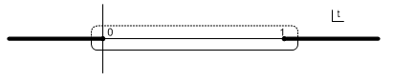
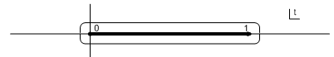

If α and b are (positive enough) such that the "semicircle" integrals around the branch points vanish, then the upper picture provides an interesting way to evaluate the integral. Notice that it does not matter which way we go to get to the dotted contour when b is an integer. If we go CCW at t=1, we pick up the phase 2π(b-α-1) = -2πα. If we go CW at t=0, we pick up phase -2π(α-1) = -2πα . The phase is the same either way, because the dotted portion of the contour is on the same sheet whichever way to get to it.
So, if we think of the contour as the usual CCW, then the lower part gives convergent $^{\int_{0}^{1}{}}$, while the upper part gives - e-2πiα $^{\int_{0}^{1}{}}$, where the overall minus is because this runs right to left. Thus, we know that

∫Γ dt tα-1(1-t)b-α-1 = [ 1 - e-2πiα ] $^{\int_{0}^{1}{}}$ dt tα-1(1-t)b-α-1 = [ 1 - e-2πiα ] B(α,b-α)

where we take the Beta function integral representation from GR page 948. We can rewrite this as

B(α,b-α) = [ 1 - e-2πiα ]-1∫Γ dt tα-1(1-t)b-α-1

If we were to define α = x and b-α = y this would be written as

B(x,y) = [ 1 - e-2πix ]-1∫Γ dt tx-1(1-t)y-1 x + y = b = integer

Thus, we have detected a double typo in Messiah B.5 which is that he should have - x in the phase exponent there, not y.

Messiah deals with this Beta function for the following reason. Consider in B.4 the leading term "1" of the expansion of ezt . Suppose we assume that

K ∫C dt ezt tα-1(1-t)β-α-1 = F(α,β,z)

Then it must be true that, setting z = 1 so we keep only the first term in the series F,

K ∫C dt 1 tα-1(1-t)β-α-1 = 1

But this integral we know (from above) is [ 1 - e-2πiα ] B(α,b-α). Thus, we conclude that

K = [ 1 – e-2πiα]-1 / B(α,β-α)

and then we arrive at the fact that

F(α,β,z) = [ 1 – e-2πiα]-1 / B(α,β-α) * ∫C dt ezt tα-1(1-t)β-α-1

which is Messiah B.6. He is then on his way to defining the W1 and W2 functions which are used in the analysis of Coulomb scattering.

2. How do you draw Riemann sheets:

Here is one attempt.

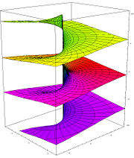

When we draw our contour pictures, we are drawing a top view of this structure. The branch point is a dot in the middle of such a projection. We can imagine the branch but drawn from the center vertical line to a point on the left cube face. Maybe the first sheet is yellow, then the second sheet is red, and the third sheet is purple.

