Cuts for the function f(-z) PhL 2.12.10

I have been confused about "this subject" for at least two days, so that means it is time to power up a monograph exactly on the subject to try to break the logjam. I am on the Quest for the Oblate Bloid, and this is just another roadblock on that voyage. I keep being sent back to kindergarten, again and again.

I think this is now a dead document. See "the meaning of f(-z) for power...".

Example #1L: What is the meaning of this function: f(z) = (z-1)^{α}_{0,0L} 1
Example #1R: What is the meaning of this function: f(z) = (z-1)^{α}_{0,0R} 2
Example #2L: What is the meaning of this function: g(z) = (-z-1)^{α}_{0,0L} 2
Example #2R: What is the meaning of this function: g(z) = (-z-1)^{α}_{0,0R} 4
Summary of our results so far: 5
Example #3: Study of g(z) = f(-z) in terms of form and in terms of evaluation. 6
Example #1L2L: What is the meaning of this function: h(z) = (z-1)^{α}_{0,0L} + (-z-1)^{α}_{0,0L} 6
Example #1L2R: What is the meaning of this function: h(z) = (z-1)^{α}_{0,0L} + (-z-1)^{α}_{0,0R} 7
Example #1LP: What is the meaning of this function: h(z) = (∓i)^{α}(z-1)^{α}_{0,0L} 7
Example #2LP: What is the meaning of this function: r(z) = (±i)^{α}(-z-1)^{α}_{0,0L} 8
Example #2RP: What is the meaning of this function: r(z) = (±i)^{α}(-z-1)^{α}_{0,0R} 9
Example #1LP2RP. What is the meaning of : s(z) = (∓i)^{α}[(z-1)^{α} ]_{0,0L} + (±i)^{α}[(-z-1)^{α}]_{0,0R} 9

Example #1L: What is the meaning of this function: f(z) = (z-1)α0,0L

We start with something we think we understand. We use the usual convention and draw the cut to the left, so here is the picture:

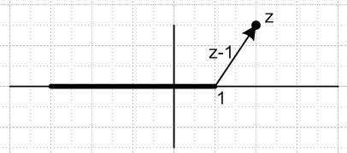

Everything seems "clear" to me for this situation. Angles in range (-π,π). I have α = real always, by the way. So this thing is always real on the uncut real axis to the right. It is a real analytic function. My fancy notation would be f(z) = (z-1)α0,0L or sometimes (z-1)Lα0 . I just don't seem to have any questions here. But let's go ahead and make a little picture for comparison with later examples:

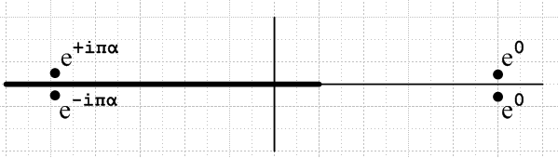

This function is real analytic, and the values above and below the cut are related by complex conjugation, which is a theorem we are sort of reproving right here.

Example #1R: What is the meaning of this function: f(z) = (z-1)α0,0R

OK, here is out new picture:

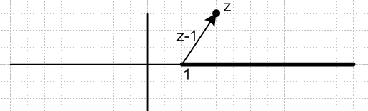

Angle range is now (0,2π). When z = 5+iε, just above the cut, we have f(z) = real, that fact has not changed at all. In fact, everything in the upper half plane is unchanged. It is just as if we took the 1L cut and rotated it CCW by 180 degrees to get the 1R situation. Of course the principal sheet is different now for the lower half plane. But nothing is confusing. I know exactly how to compute f(z) here for any position of the point z. The answer is this: f(z) = |z-1|α eiαθ where θ is the angle of z-1. Absolutely no confusion here. Here is our new picture:

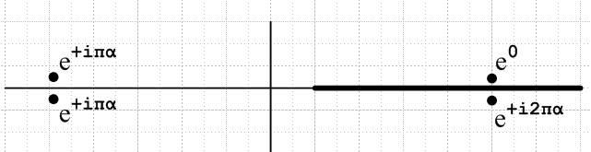

Example #2L: What is the meaning of this function: g(z) = (-z-1)α0,0L-1

I have simply added a minus sign in front of the z. This is the situation that constantly confuses me.
First of all, where is the branch point for the function g(z)? It has to be at z+1=0 or z = -1. So let's draw the cut off to the Left from z = -1. What is the picture now?

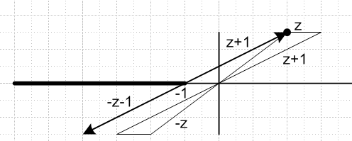

I first draw the vector z+1 = z – (-1) which is the heavy top arrow. Then -z-1 must be this arrow exactly reversed as I have drawn it. You can construct "translated" versions if arrows z+1 and -z-1 as shown by the light triangles, by doing the obvious vector addition.
Our important "starting position" is I think to put z just above the real axis on the right. Then we claim that -z-1 is just below the cut on the left with phase -π-δ, and is on the same Riemann sheet with z. Then as we drop z on the right below the cut, vector -z-1 passes through the cut to the next sheet, but maintains its basic angle of -π. In this way, we are "defining" a certain Principal Sheet of this function.
If we took a different starting position where z was just below the axis on the right, then we would say that -z-1 was at angle +π and was on the same sheet as z. This is a different definition of the Principal Sheet for this function and gives different phases. So this is one thing I think that has been confusing me. For the function (z-1)α, we don't have this ambiguity. We "start" with z on the right side real axis either above or below, and it makes no difference because do don't have to thing about the vector -z-1, we only have to think about the vector z-1 which is always on the same sheet with z.
So once again, for (z-1)α examples, z and z-1 are always on the same sheet so we never get confused. But for (-z-1)α examples, as we shall see below, as z moves around on the principal sheet, z-1 has a tendency to wander OFF the principal sheet.

We shall now consider various locations for the point z, and study what g(z) in each case.

Case 1: Try z = 5+iε. In this case -z-1 is just below the cut with phase -π, and we have

g(z) = (-z-1)α = |-z-1|α e-iπα

Case 2: Try z = 5-iε . In this, if we keep z on the principal sheet, then -z-1 must of necessity go up through the cut, but it will still have the phase -π (call it -π-δ if you like). It will NOT have phase +π. Therefore, g(z) has the same value it had at z = 5+iε, and we find that things are continuous as we pass down through the real axis on the right, as we expect since there is no cut there.

Case 3. Now lets try z = -5+iε so it is just above the cut. Then -z-1 has zero phase and we get

g(z) = (-z-1)α = |-z-1|α e0

so our function is real above the cut.

Case 4. Now lets try z = -5-iε so it is just below the cut. But how do we "arrive" at this case? We have to take the z shown and rotate it CW quite a bit, because z must stay on the principal sheet of g(z). As we rotate, the vector -z-1 passes up through the cut onto the next sheet. When z = 5, the phase of -z-1 is -π, as noted above. If we then rotate z CW another π, then the phase of -z-1 is -2π. We find then that

g(z) = (-z-1)α = |-z-1|α e-i2πα

This then is the value just below the cut.
Here then is a summary of our four cases. Each round black dot represents a location of z for g(z) on the principal sheet. We show only the phase of g(z). In all cases the magnitude is |-z-1|α and in all four cases that is the same number 6α.

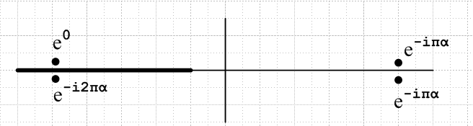

As expected: (1) there is a discontinuity across the cut on the left. (2) there is no discontinuity on the right. (3) the function is not real on the real axis, so it is not real analytic.
So this now seems "not too bad". I have just described what I call (-z-1)α0,0L.

Example #2R: What is the meaning of this function: g(z) = (-z-1)α0,0R-1

Here is our new picture:

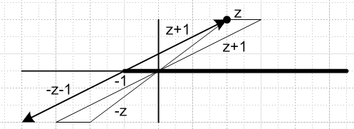

It is the same picture exactly, but with the cut drawn to the right. The difference is mainly that we now give z the angle range (0,2π). So let's now redo our four cases:

Case 1: Try z = 5+iε. In this case -z-1 is just below the uncut region at the left and has angle +π.

g(z) = (-z-1)α = |-z-1|α e+iπα

Case 2: Try z = 5-iε . We have to rotate z CCW by 2π from Case 1 to get to this case, because we must keep z on the new principal sheet of this example. As we do this, -z-1 which started at +π ends up at angle +3π. It is now on the next sheet. So we have

g(z) = (-z-1)α = |-z-1|α e+i3πα

Case 3. Now lets try z = -5+iε . Then -z-1 has phase +2π.

g(z) = (-z-1)α = |-z-1|α e+i2πα

Case 4. Now lets try z = -5-iε . The vector -z-1 moves up through the cut on the right, be basically stays at angle 2π as in case 3. We then get

g(z) = (-z-1)α = |-z-1|α e+i2πα

Here then is a summary of our four cases.
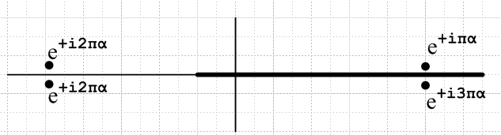

As expected: (1) there is a discontinuity across the cut on the right. (2) there is no discontinuity on the left. (3) the function is not real on the real axis, so it is not real analytic.
So this now also seems "not too bad". I have just described what I call (-z-1)α0,0R.

Summary of our results so far:

f(z) = (z-1)α0,0L

f(z) = (z-1)α0,0R

g(z) = (-z-1)α0,0L

g(z) = (-z-1)α0,0R
General observations:

(1) only the first function is real analytic (unless α happens to be an integer)
(2) In going from f(z)R to f(-z)R, you add πα to all four phases.
(3) In going from f(z)L to f(-z)L, you add - πα to all four phases.

Question: for the (-z-1)α, which form is more "intuitive" , the L or R? If z = -5, you would think this thing would be a positive number 4α . For the L case, that is correct but only above the cut.

Example #3: Study of g(z) = f(-z) in terms of form versus in terms of evaluation.

Suppose we start with the function f(z) = (z-1)α0,0L as defined above.

We are allowed to evaluate this function for any z on the Principal Sheet. One such value might be z1, so f(z1) = (z1-1)α0,0L Another value might be z2 = -z1 so we have then f(-z1) = (-z1-1)α0,0L . How is this related to the quantity g(z1) = (-z1-1)α0,0L ? Consider these pictures:

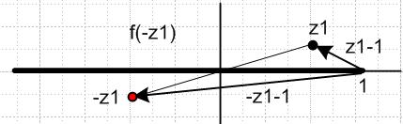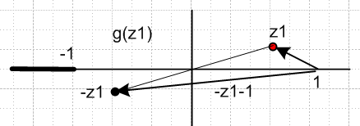

f(-z1) = (-z1-1)α0,0L = |-z1-1|α exp(+iπ ang(-z1-1))

g(z1) = (-z1-1)α0,0L = |-z1-1|α exp(+iπ ang(-z1-1))

The vector shown in both pictures has the same angle, perhaps -170 degrees so the values of these to objects are exactly the same. What is different is what happens as we lower z1 down vertically from its starting position. On the left, it falls through the cut, and -z1 see-saws up through the cut, so these two points end up on different sheets, neither of which is the Principal Sheet. In the right picture, where the branch point is at -1, nothing unusual happens, everything stays on the same sheet. Of course on the left if you started with z1 below the cut on the principal sheet, then -z1 would be above the cut and it too would be on the principal sheet, so no big deal I guess. And on the left you could keep z1 on the principle sheet by swinging around the point z = 1 instead of going down through the cut. But -z1 would still have to pass up through the cut.
Can we say that g(z) = f(-z) not as an evaluation, but as a functional form? You want to say no, because the function f(z) has a branch point at 1. But I guess the function f(-z) has branch point at -1, if you regard it as a functional form. I don't know why, but something is confusing me here. I think if you have some function F(z) with a branch point at z = a, then G(z) ≡ F(-z) has a branch point at z = -a. In our examples we take the cut to the left in either case.
How can I make my notation distinguish between the two cases above?

f(z) = (z-1)α0,0L // lets call this (z-1)α0,0L1

You look at this and you know the cut situation, no confusion. If I write

f(-z) = (-z-1)α0,0L // let's call this (z-1)α0,0L-1

then since I have used the symbol "f ", you can assume I am talking here about the function f(z) evaluated at the location z = -z, as if it were some z = z3. We still have the branch cut going to the left from z=1. But if all you see is (-z-1)α0,0L , then you cannot tell which thing we are talking about! So in the next example, things are in fact unclear as to what the second term really means! There are two choices.
So OK, I have to now back up and re-think all this stuff. I am trying to build up to a model for the Legendre function. I think the g(z) function is the wrong path to go now!
I will start using the notation shown above where I add an indication of the branch point!

Example #1L2L: What is the meaning of this function: h(z) = (z-1)α0,0L + (-z-1)α0,0L-1

If we pull both cuts off to the Left, we get this picture:

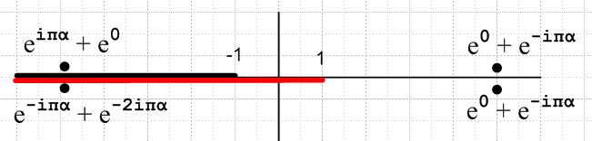

The function is NOT real analytic. The values above and below the cut are NOT related by complex conjugation. We are simply adding the two functions so we inherit both cuts.

Now we are going to example some more examples where we introduce a new element which is that the definition of the function will be different by certain signs if we are in the upper or lower half plane.

Example #1L2R: What is the meaning of this function: h(z) = (z-1)α0,0L + (-z-1)α0,0R-1

I won't draw this, but it will be the sum of these two items:
f(z) = (z-1)α0,0L
g(z) = (-z-1)α0,0R

The sum function will have a cut everywhere along the real axis. In a sense it has a double cut in the range -1,1. Not very nice.

Example #1LP: What is the meaning of this function: h(z) = (∓i)α(z-1)α0,0L

We can of course write this as e∓iπα (z-1)α where the upper sign is for Im(z) > 0, and lower for <0. So let's take our picture above:

f(z) = (z-1)α0,0L

and manually apply our four phase factors to get:

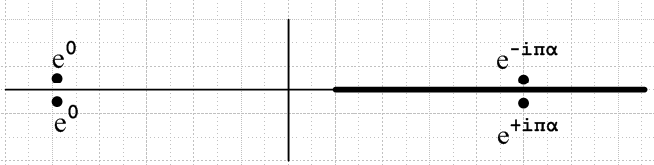 h(z) = (∓i)α(z-1)α

What has happened here here?? The added phase factors have reversed the direction of the cut! I have to draw the cut to the right now because there is clearly no cut on the left, and just as clearly we now have a cut on the right. This function h(z) is real analytic if you consider it to be a single function ! We have basically cancelled the phases on the left and thereby we have removed the cut on the left. Notice that this function h(z) really is a continuous function everywhere on the cut z plane, despite the (∓i)α factor.
So this is very tricky. We are using the (z-1)α0,0L function, but the phase factor out front reverses the cut in effect. We have to continue, however, to use (-π,π) for (z-1)α0,0L , as if the cut were to the left.
The resulting phases don't match any of our earlier pictures. However, the following function

k(z) =e+iπα (∓i)α(z-1)α = (i)2α (∓i)α(z-1)α

results in phases that are exactly the same as those of f(z) = (z-1)α0,0R . Since we get agreement at the four test points, I will conjecture that we would get agreement at all points in the z plane. So what exactly does this mean:

e+iπα (∓i)α[(z-1)α ]0,0L = [(z-1)α] 0,0R

h(z) = (∓i)α[(z-1)α ]0,0L = e-iπα [(z-1)α] 0,0R
LHS RHS

On the LHS, we are to treat [(z-1)α ]0,0L as having its usual Principal Sheet, cut to the left, and (-π,π) angles for the vector z-1. On the RHS we are to treat [(z-1)α]0,0R as having its usual Principal Sheet, cut to the right, and (0,2π) angles for the vector z-1. If you select any point in the z plane, you treat it as being on the principal sheet of either function, even though these sheets are not the same. Then if you follow the rules just specified, a calculation of the value of the LHS will give the same result as a calculation of the value of the RHS. So the two functions are equal in this sense. You could replace one with the other, as long as you understand the rules.
Question: in this example, what happens to phases as we pull the four sample points toward the imaginary axis? The phases show are the phases of the (z-1) vector in this picture. As the two points on the left come in, there is no phase change at all, so they both stay at e0, all the way in. However, as the two points on the right pass the z = 1 branch point, there is a change. The upper dot gains eiπα as z-1 swings around the branch point. And the lower dot gains the negative. So let's improve this picture with more sample points:

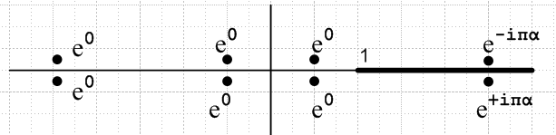 h(z) = (∓i)α(z-1)α

Example #2LP: What is the meaning of this function: r(z) = (±i)α(-z-1)α0,0L-1

The manually added phases are now e±iπα . So start with g(z) = (-z-1)α0,0L above,
g(z) = (-z-1)α0,0L

and now manually add the new phases to get:

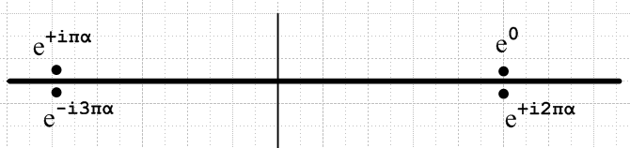

This is "not very nice". Now the "cut" is along the entire real axis. So let's jump at once to the next example.

Example #2RP: What is the meaning of this function: r(z) = (±i)α(-z-1)α0,0R-1

The manually added phases are now e±iπα . So start with g(z) = (-z-1)α0,0R above,

g(z) = (-z-1)α0,0R

and now manually add the new phases to get:

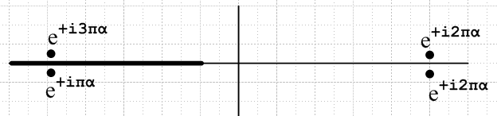 r(z) = (±i)α (-z-1)α0,0R

Now we get that same "cut reversal effect" as in Example #1LP. One difference is that this r(z) is not real analytic. However, the following function,

e-i2πα (±i)α (-z-1)α0,0R

results in phases that are exactly the same as those of f(z) = (z-1)α0,0L . Since we get agreement at the four test points, I will conjecture that we would get agreement at all points in the z plane. So what exactly does this mean:

e-i2πα (±i)α (-z-1)α0,0R = (z-1)α0,0L

r(z) = (±i)α [(-z-1)α]0,0R = e+i2πα [(z-1)α]0,0L
LHS RHS

This is the same idea as our previous example. If you "follow the rules" for the 0,0L and 0,0R functions, these two expressions give the same value for any z in the complex plane.
Now as before, let's pull the points in to make more sample points. It is easy to see what the result is going to be:

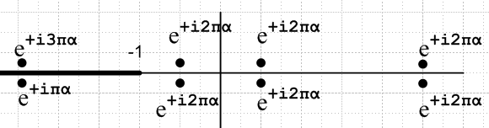 r(z) = (±i)α (-z-1)α0,0R

Example #1LP2RP. What is the meaning of : s(z) = (∓i)α[(z-1)α ]0,0L + (±i)α[(-z-1)α]0,0R-1

Here we are adding two functions shown above, I copy them down here: s(z) = h(z) + r(z)

h(z) = (∓i)α(z-1)α0,0L

r(z) = (±i)α (-z-1)α0,0-1

Now something new happens. The two functions have a common region where there is no cut, so the cut structure of the sum looks like this:

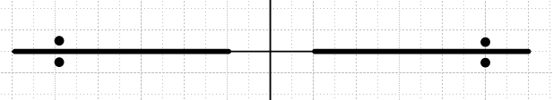 s(z) = h(z) + r(z)

I am sure there is no cut there in the sum function for (-1,1). We can see the first term h(z) will be real on this cut (those e0 phases), but the second term r(z) in general will not be real. It will be real only in the special case that 2α = integer in which case e+i2πα = +1 or -1 depending on even or odd integer. So in general, we should not expect to see s(z) being real on the uncut region (-1,1).
Just above and below z = 0, we expect to get s(z) = |1|α e0 + |1|α e+i2πα = (1 + e+i2πα ) which is some complex number.

Also, we can write this sum function two ways:

s(z) = (∓i)α[(z-1)α ]0,0L + (±i)α[(-z-1)α]0,0-1

s(z) = e-iπα [(z-1)α]0,0R + e+i2πα [(z-1)α]0,0L

Looking directly at these expressions, it is quite difficult I think to see where the cuts are located.

Change of Interpretation 2.13.10

In the section called Example #3 above, I discuss the two possibly meanings of (-z-1)α , and I proposed there a way to distinguish these two meanings:

(-z-1)α0,0L = g(z) = (-z-1)α0,0L-1

(-z-1)α0,0L = f(-z) = (-z-1)α0,0L1

I now think that, in the context of the Legendre stuff I am about to do, it is the second form I really want. When we write AP(z) + BP(-z), we don't mean that the second P is some different function. It is the same function f(z), just evaluated at the point - z, which is the second line above. So this then brings up some new Examples which I will now handle:

Example #2L: What is the meaning of this function: F(z) ≡ f(-z) = (-z-1)α0,0L1

We

Example #2LPA: What is the meaning of this function: rA(z) = (±i)α(-z-1)α0,0L1

The manually added phases are now e±iπα . So start with f(-z) = (-z-1)α0,0L1 above,
g(z) = (-z-1)α0,0L

and now manually add the new phases to get:

This is "not very nice". Now the "cut" is along the entire real axis. So let's jump at once to the next example.

Consider this function:

F(z) = [(z-1)α ]0,0L(-z) = f(-z)

and here is our picture for f(z),

f(z)

The function f(z) has a branch point at z = 1 going to the Left. We want to evaluate this function at the point -z. Suppose z = -2 + iε, just above the cut on the left. Then -z = 2 -iε which is on the uncut portion of the z axis to the right. The phase for this point is thus 0. And the phase for -z-1 is also 0. Here is a picture of this situation:

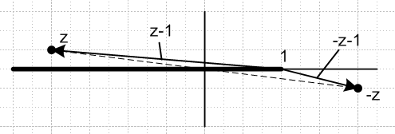

Therefore we would write in this case,

F(z) = f(-z) = (-z-1)α0,0L1 = |z-1|α e0

Yet Another Plan

Start with this function

f(z) = (z-1)α0,0L

which has these phases at our test points:

Now, we define a new function as follows:

F(z) ≡ f(-z)

I would claim that the correct picture for this function is the above picture with everything reflected through the origin. That new picture would be this:

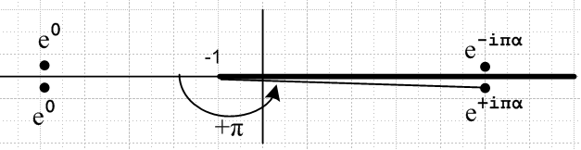

In this new picture, our angle range is still (-π,π) but is measured from the direction opposite the cut, something we normally do not like to do. This new function F(z) has a branch point at -1, and it goes off to the right, because our rule is to " reflect every point".

Example: H(z) = f(z) + f(-z)

The function f(z) has a branch cut and sample points as shown here:

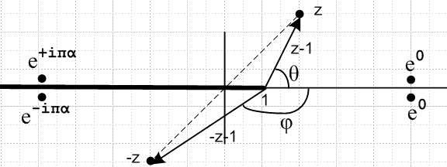

Let's try to compute H(z) for the point z shown:

H(z) = f(z) + f(-z) = (z-1)α + (-z-1)α

= |z-1|α eiαθ + |-z-1|α eiαφ θ > 0 φ < 0

I don't see any confusion about this computation. The number we get is unambiguous. Both z and -z are on the principle sheet of f(z). We don't have to define any functions other than f(z) .

Now if we wanted to make a sample-phase-points picture for H(z), what would it look like. Let's do the four cases: (Top left means z on top left )

Top left: θ = π, φ = 0: |z-1|α eiαπ + |-z-1|α e0 eiαπ + e0
Bottom left: θ = -π, φ = 0 |z-1|α e-iαπ + |-z-1|α e0 e-iαπ + e0
Top right: θ = 0, φ = -π |z-1|α e0 + |-z-1|α e-iαπ e0 + e-iαπ
Bottom right: θ = 0, φ = +π |z-1|α e0 + |-z-1|α e+iαπ e0 + e+iαπ

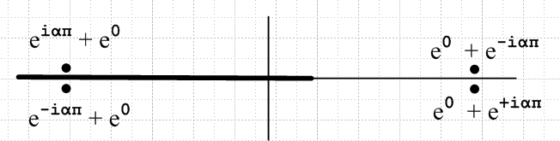

Example: I(z) = (∓i)α f(z) + (±i)α f(-z)

We can take the previous sample points and adjust them as this expression indicates. We get:

Top left: (e-iαπ eiαπ + e+iαπe0 ) = e0 + e+iαπ
Bottom left: (e+iαπ e-iαπ + e-iαπ e0) = e0 + e-iαπ
Top right: (e-iαπ e0 + e+iαπ e-iαπ) = e-iαπ + e0
Bottom right: (e+iαπ e0 + e-iαπ e+iαπ) = e+iαπ + e0

This says there is a cut everywhere for I(z).

Example: I(z) = f(z) + f(z*)

This is a different function now, seen for this first time in this document. It is this

I(z) = f(z) + f(z*) = |z-1|α eiαθ + |z-1|α e-iαθ

Top left: θ = π |z-1|α eiαπ +|z-1|α e-iαπ eiαπ + e-iαπ
Bottom left: θ = -π |z-1|α e-iαπ +|z-1|α e+iαπ e-iαπ + eiαπ
Top right: θ = 0 |z-1|α e0 +|z-1|α e0 e0 + e0
Bottom right: θ = 0 |z-1|α e0 +|z-1|α e0 e0 + e0

I want to say this has no cut, but I(z) is no longer an analytic function of z, it is I(z,z*). Therefore, you cannot really talk about cuts in the z place for such a thing.

Example: I(z) = f(z) + f(z*) restricted to imaginary axis.

In this case, we get the "left" side points above since x = 0 is to the left of the branch point. Then

Top left: θ = π |z-1|α eiαπ +|z-1|α e-iαπ eiαπ + e-iαπ
Bottom left: θ = -π |z-1|α e-iαπ +|z-1|α e+iαπ e-iαπ + eiαπ

Example: I(z) = (∓i)2α f(z) + (±i)2α f(z*) restricted to imaginary axis.

In this case, we get the "left" side points above since x = 0 is to the left of the branch point. Then before applying the signed coefficients, we get this

Top left: θ = π |z-1|α eiαπ +|z-1|α e-iαπ eiαπ + e-iαπ
Bottom left: θ = -π |z-1|α e-iαπ +|z-1|α e+iαπ e-iαπ + eiαπ

and after, we get this

Top left: θ = π e-iαπ |z-1|α eiαπ + eiαπ |z-1|α e-iαπ e0 + e0
Bottom left: θ = -π eiαπ |z-1|α e-iαπ + e-iαπ |z-1|α e+iαπ e0 + e0

Here is the idea I am looking for: we "unwind the phases" of the two terms so both terms are then at zero phase. The two terms are exactly the same, +iζ and -iζ . So consider:

J(ζ) = (∓i)2α f(iζ) + (±i)2α f(-iζ) ζ > 0
J(-ζ) = (±i)2α f(-iζ) + (∓i)2α f(iζ) ζ > 0

This function J(ζ) is real, and it is symmetric J(ζ) = J(-ζ).

Example: pnm(ζ) = [ (∓i)-m Pnm(iζ) + (±i)-mPnm(-iζ)] /2

Think of α = -m/2. Then this matches the previous example. In Bateman p 126 (22) the second terms are cancelled and we have just the first terms. Since z2 is the same for iζ or for -iζ, I think the two terms are in fact exactly equal! if this is true, then we can just say

pnm(ζ) = (∓i)-m Pnm(iζ) // wrong

which is completely new to me right now! But this is incorrect because P has those 2 terms and you have to get the second terms to cancel. Each term on its own is complex, as Maple verifies.

************************************************************

What Would Maple Do ?

(1) Consider the function f(z) = (z-1)1/2. We know that f(5) = (4)1/2 = +2 in our usual definition. This is our definition of the principal sheet of this function.

What then do we get if we evaluate this at z = -3? This point is assumed by Maple to be on top of the cut of f(z). The vector -z-1 = -3-1 has phase +π. Therefore f(-3) = (-3-1)1/2 = |-3-1|1/2 (eiπ)1/2 = + 2i. Maple agrees! So we understand that if we put in real numbers z < 1, we are evaluating really at -3+iε. This is the "above the cut" convention. Here is explicit verification from Maple:

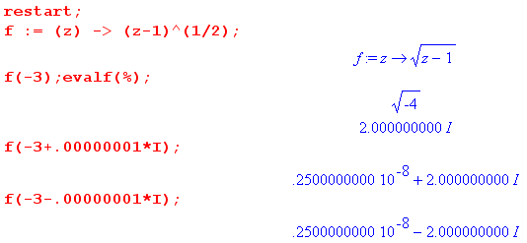

This code shows completely clearly what Maple is doing: The last two evaluations show above and below the cut. If you have no imaginary part, it assumes above the cut. All is clear, and here is the picture:

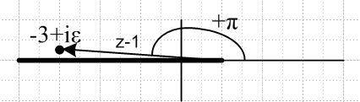

(2) Consider the function g(z) = (-z-1)1/2 . Let's first look at what Maple says:

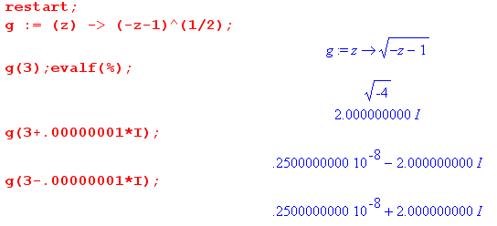

For sure there is an effective cut on the right since above and below give different values. Let's now try to construct a picture which matches what Maple has done: Here is a our first picture:

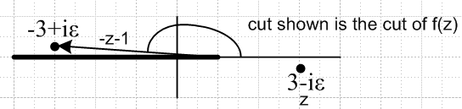 g(3-iε) = f(-3+iε) = +2i

It is the same picture as above, but z is now lower right. g(3-iε) is the same as f(-3+iε). We are just "evaluating" f at the point -z. The cut I show above is the cut for f(z). If we want a picture for g(z), then we have to draw the cut on the right side.

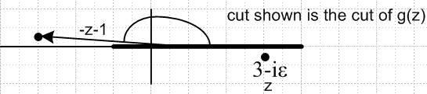 g(3-iε) = f(-3+iε) = +2i

If we look at the upper picture, we have no problem with the angle of -z-1 being +π. The lower picture agrees that this phase is +π if we measure angles the same we did for f(z) !! Normally when I draw a cut to the right, I measure the angle differently. But Maple is measuring it in the same way. Notice in the lower picture that the vector -z-1 does not go to the branch point, it goes to z = +1.
Here are the other pictures where the angle is now -π in both pictures:

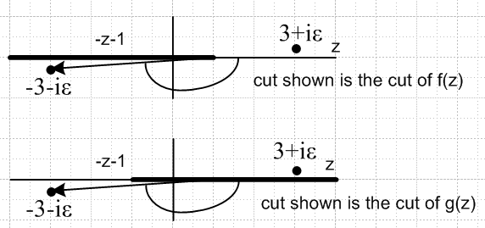 g(3+iε) = f(-3-iε) = -2i

So what can we say about Maple?

(1) for f(z) = (z-1)α cut is (-∞,1), angles measured (-π,π) with zero angle to the right = (z-1)α0,0L.
If z < 1 real, it is assumed that z is above the cut on the left.

(2) for g(z) = (-z-1)α, cut is (-1,∞), angles measured (-π,π) with zero angle to the right = (-z-1)α0,0R
If z > 1 real, it is assumed that z is below the cut on the right. This definition is compatible with thinking in terms of g(z) = f(-z).

So the function (-z-1)α0,0R is different from the way I was defining it earlier.

To define a function completely you need to know:

(1) location of the branch point
(2) direction of the cut
(3) how angle is measured
(4) winding number(s)

