Limes Inferior and Superior PhL 8.14.09

This general subject came up in Ahlfors pp 34 and 35.

Here is some helpful web stuff:

http://books.google.com/books?id=Nilzh5adHPgC&pg=PA20&lpg=PA20&dq=%22limes+superior%22+wiki&source=bl&ots=CTtw725fBo&sig=a73lGx_Ddvg1tptp7fQqaXvXA_k&hl=en&ei=N3-FSr7qNJKEswPNn5itBw&sa=X&oi=book_result&ct=result&resnum=7#v=onepage&q=&f=false

1. First, here is the definition of inf and sup:

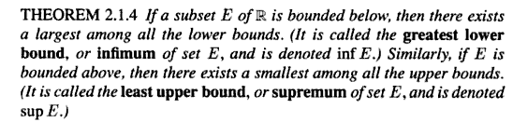

This "theorem" seems to be a statement of obvious fact to me, and the definitions are fine.

2. Then:

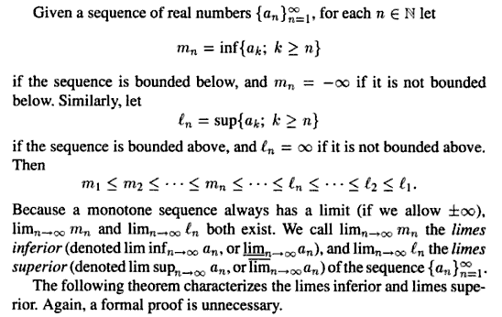

So mn is the greatest lower bound of the TAIL of the sequence starting at n. As you let n increase, you are knocking out the early part of the tail. This could knock out some large negative number, say, and then your greatest lower bound increases. So that is why he shows mn as being a monotonically increasing sequence in the above. Notice that the mn for finite n are finite real numbers.

And ln is the least upper bound of the TAIL of the sequence starting at n. As you let n increase, you are knocking out the early part of the tail. This could knock out some large positive number, say, and then your greatest upper bound decreases. So that is why he shows ln as being a monotonically decreasing sequence in the above. Notice that the ln for finite n are finite real numbers.

In any event, we must always have an upper bound greater than a lower bound, so that accounts for the central part of the long inequality list he shows above. Thus I think I have justified this claim:

We now define the following animals,

limes inferior ≡ limn→∞ ( mn ) = limn→∞ (inf{ak; k ≥ n} ) = lim n→∞ an

limes superior ≡ limn→∞ ( ln ) = limn→∞ (sup{ak; k ≥ n} ) =$\overline{lim}$ n→∞ an

A monotone sequence always has a limit, if we include ±∞ as legal limits. This is a separate theorem that he quotes here, and seems very reasonable to me. We can see that the mn is monotone increasing, and ln is monotone decreasing, and each of these two sequences "has a limit". Thus, the two "limes" things exist but could be infinite.

So what are the possible things that might happen here? If we look separately at the mn, we would say that either its limit is a finite number M, or is + ∞. [ This would happen it the sequence marches off to ∞ ] And if we look separately at the ln, we would say that either its limit is a finite number L, or is -∞. So let's examine the four cases:

mn ln
M L in this case must have M ≤ L
∞ L impossible
M -∞ impossible
∞ -∞ impossible

So only one situation it seems to me is even possible, the first above. I would be tempted to say that if we end up with some M < L so that M ≠ L, then our sequence ak does NOT converge, and if M = L then it does converge and it converges to M = L. There is only a single "accumulation point", not two different accumulation points.
The web source does not comment on what I have just said (yet). Instead we get this claim:

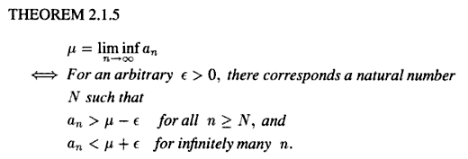

This is very confusing for my non-math-logic brain. Let's draw a picture and think in terms of an "accumulation point" which is really the central idea here:
mN m∞
. . . . . . . . . |. . . ....| |
ak → aN μ μ+ε
μ - ε

Let's pick some mN that is distance ε to the left of accumulation point μ = m∞. We know that all elements of the sequence for n > N are in this ε range, so we would say μ - an < ε for all these elements, and this is what the first claim made above says.
Suppose then we look at a point at μ + ε in the above picture. The entire tail is obviously to the left of this point no matter where you start the tail. Any tail has an infinite number of elements. Thus we would say that an < μ+ε for infinitely many n, the second claim.
So I accept this theorem as reasonable, but I don't yet see the point of such a theorem. Now let's draw the corresponding reverse picture:

| |..... .| . . . . . . . .
λ lN ← ak
λ-ε λ+ε

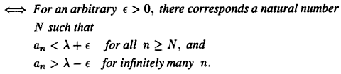

Based on the two parts of this theorem, our web author then claims

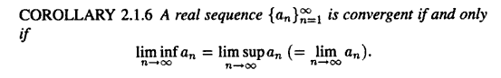

This looks like my claim about that convergence means M = L, and I guess here it means μ = λ, but I sure don't see the need for his theorem to arrive at this conclusion.

Comments: A sequence has a head and a tail, let us say, with dividing point at n. The increasing set of lower bounds mn described above arise as we knock out more and more of the sequence head and we get into the endgame of the sequence. Same for the decreasing sequence of upper bounds ln as we knock out these same head elements. I think maybe I see a the issue here. Suppose the sequence ends up cycling back and forth between two or more finite endgame points, just by its construction. Such a sequence would have more than one "convergence subsequence". For such a sequence, we would end up with M < L. That is to say, the limes inferior (coming up from below) is less than the limes superior (coming down from the right). So yes, we have M < L and the sequence does not converge! So easy to construct a sequence that does this. On the other hand, the situation M = L corresponds to having only one convergent subsequence (one accumulation point).
Notice that if we had two (or more) accumulation points separated by a finite distance and we end up cycling between them, then we don't have a Cauchy sequence because we don't have d(xm,xn) → 0 for large m,n.

In Stak Chapter 2 I quote my notes:

"A metric space is complete only if every Cauchy sequence is also a convergent sequence. Cauchy is the double limit idea that d(xm,xn) → 0 for large m,n but convergent means d(xm,x) → 0. You can make a metric space complete by adding the missing points. For example, the set of rational numbers is not complete, but the set of real numbers is complete. "

Since the reals are complete, we know that a Cauchy sequence is a convergent

So we seem to have several related ideas here:

(1) Only one accumulation point => Cauchy sequence d(xm,xn) → 0. If the space is complete (so x is not missing) , then this implies d(xm,x) → 0 so we have "regular" sequence convergence as well.

(2) If there are multiple accumulation points, then we fail to have Cauchy convergence as well as regular convergence.

(3) Multiple accumulation points is indicated (for the reals) by M < L.

Application

On page 34 Ahlfors wants to prove that , for a sequence of real elements,

sequence is regularly convergent ⇔ sequence is Cauchy convergent

Proving the => direction is pretty trivial. Going the other way is harder and is what Ahlfors spends time on. His method is to show that M = L and therefore there is only one accumulation point and therefore the sequence is regularly convergent.

But in Stakgold language, { sequence is regularly convergent <= sequence is Cauchy convergent } is merely the definition of a vector space (like the reals) being "complete". Since the reals are complete, it must be true, and Ahlfors proves it is true, although his proof is too convoluted for me to follow.

Notice that the notion of limes superior and inferior are limited to sequences of REAL numbers and would not apply as stated above to more general sequences in vector spaces. You would have to replace ak with ||ak|| to get something sensible. Then two distinct accumulation points would be indicated by two different norm limits MAYBE. If both accumulation points were on the same sphere, they would have the same norms, and things would not work!

