Study of (1-z)α and related functions PhL 2.16.10

Part I: (z-1)^{α} 2
1. The Generic function (z-1)^{α}. 2
Question 1: Is the function a different function for different choices of the cut take-out angle? 3
Question 2: Is the function a different function for different choices of the angle meas. ? 4
2. The Standard Function (z-1)^{α}_{0L} . 4
3. The Alternate Function (z-1)^{α}_{0R} . 5
Question 1: Is there a relationship between (z-1)^{α}_{0R} and (z-1)^{α}_{0L} ? 6
Question 2: Is there a relationship between the Principal Sheets of (z-1)^{α}_{0R} and (z-1)^{α}_{0L} ? 6
Question 3: How does this relate to log functions? 7
Question 4: How does this relate to the Q₁(z) function? 7
Part II: (-z-1)^{α} 9
1. The Generic function (-z-1)^{α}. 9
2. The Standard Function (-z-1)^{α}_{0R} . 11
Question 1: How is (-z-1)^{α}_{0R} related to (z+1)^{α}_{0L} ? 12
Question 2: How is (-z+1)^{α}_{0R} related to (z-1)^{α}_{0L} ? 13
Question 3: How is (-z-a)^{α}_{0R} related to (z+a)^{α}_{0L} ? 14
Question 4: How is (z²-1)^{α} related to (z-1)^{α} (z+1)^{α} ? 14
(a) The Main Point. 14
(b) Computational details 15
(c) Bateman formulas for P and Q with (z²-1)^{α} . 16
3. The Alternate Function (-z-1)^{α}_{0L} . 16
Part III: (1+z)^{α} 17
Part IV: (1-z)^{α} 17
Question 1: What is the relationship between f(z) ≡ (z-1)^{α}_{0L} and g(z) ≡ (1-z)^{α}_{0R} ? 18

Summary of standard function results. For functions of the form (z-a)α0L, angles are measured (-π,π) from the cut extension. For functions of the form (-z-a)α0R , angles are measured (-π,π) from the cut. All angles are positive when they run CCW. Below, we have g(z) = f(-z). We have two different versions of f(z) and g(z) in these pictures:
________________________________________________________________
f(z) = (z-1)α0L :
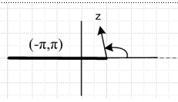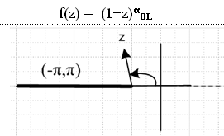
________________________________________________________________

f(-z) = (-z-1)α0L g(z) = (-z-1)α0R :
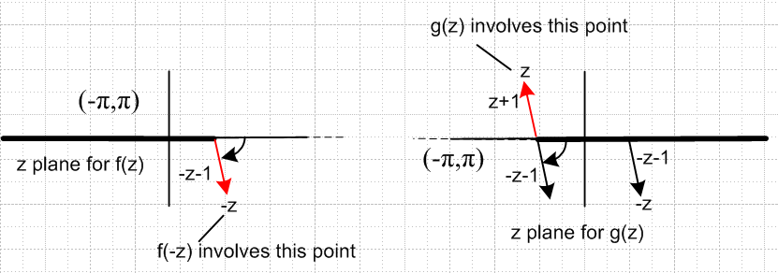
________________________________________________________________

f(-z) = (1-z)α0L eval g(z) = (1-z)α0R
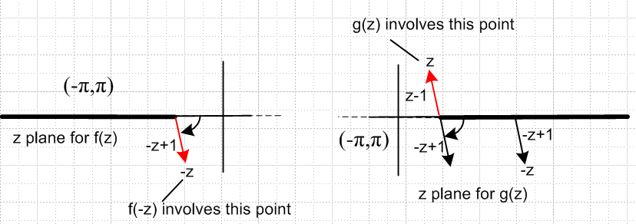
________________________________________________________________

Relation: (z-1)α0L = e±iαπ (1-z)α0R Im(z) 0

Part I: (z-1)α

1. The Generic function (z-1)α.

Consider the function f(z) = (z-1)α. We know there is a branch point at z = 1, and we imagine pulling off the cut in some arbitrary direction as shown here:

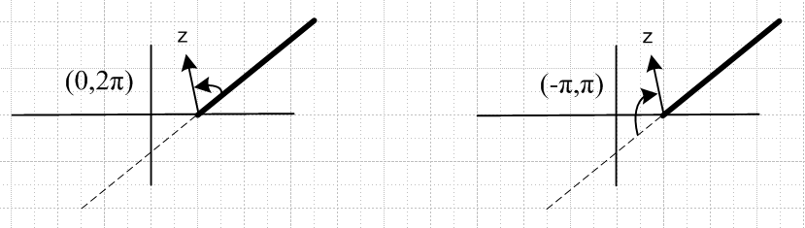

There are two reasonable ways to measure the angle of the vector (z-1), both of which are independent of the actual angle at which the cut is taken off to infinity. On the left we measure from the cut. On the right we measure from the cut projection. Our convention is always to regard a CCW rotation (as on the left) as a positive angle, and CW as a negative angle (as on the right).
The Principal Sheet of our function is all vectors in the range (0,2π) using the left figure angle measurement method, and all vectors in the range (-π,π) using the right figure angle method. In either method, we can talk about other Riemann sheets:

Left Right

Sheet -2 (-4π,-2π) Sheet -2 (-5π,-3π)
Sheet -1 (-2π,0) Sheet -1 (-3π,-π)
Sheet 0 (0,2π) Sheet 0 (-π,π)
Sheet 1 (2π,4π) Sheet 1 (π,3π)
Sheet 2 (4π,6π) Sheet 2 (3π,5π)

In any given column of angle numbers, you move down one row by adding 2π.

One notation I sometimes use is to put the Sheet number as a subscript to the function. For example

(z-1)α-2

means we are talking about z being on Sheet -2 of (z-1)α. The principal sheet is (z-1)α0 and in this case I might just dispense with the 0 and the default for (z-1)α would then mean z is on the principal sheet, and then the analytic continuation of this to all sheets is the meaning of our generic function (z-1)α.

Question 1: Is the function a different function for different choices of the cut take-out angle?

To answer this, we have to consider how we would evaluate the function. We have

(z-1)α = |z-1|α exp[iα arg(z-1)]

This makes the answer to the question quite clear. If you change the cut angle, as for example

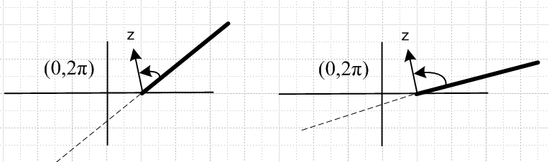,

then yes, you change the value of the function because for the same point z in the z-plane, you have changed its angle. You change the phase of the function. The phase change will be eiαγ where γ is the angle between the two cuts.

Question 2: Is the function a different function for different choices of the angle meas. ?

Again, we consider the evaluation:

(z-1)α = |1-z|α exp[iα arg(z-1)]

Again, the two angles are different. If our angles are θ>0 on the left, and φ<0 on the right, then we know for points z above the cut line, we have θ-φ = π. Therefore, if we evaluate our function in the two different angle methods, we find that (z-1)α(0,2π) = θ = φ+π = eiαπ (z-1)α(-π,π) . [ I am using a shortcut notation the reader can surely figure out. ] For a point z below the cut line both angles change sign, so we find that φ-θ = π and so we get the reverse phase. that is to say:

(z-1)α(0,2π) = e±iαπ (z-1)α(-π,π) upper sign for z above cut line

So the answer is that the measurement method changes the numbers, so yes, we have different functions.

2. The Standard Function (z-1)α0L .

Of all the possible choices of cut angle, taking it to the Left is "the standard choice". We then have these pictures:

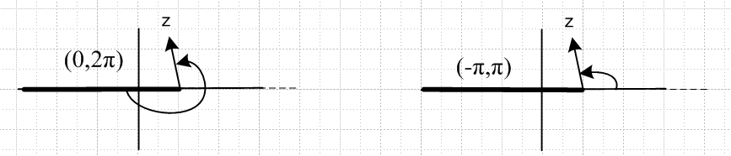

Nobody ever uses the angle method shown on the left in this case, they use the one on the right. So this cut choice, and the range (-π,π) is what we might call "the standard function (z-1)α ". This is, for example, the meaning of the function (z-1)α in the Maple program. I sometimes call this (z-1)αL. If I want to make the point that z is on the Principal Sheet of this function, I say (z-1)α0L.

Let's do a little Maple check. First, we take a point just above the cut:

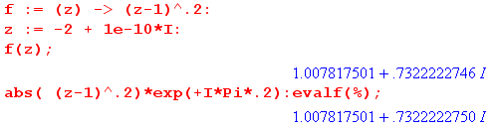

and a point just below the cut

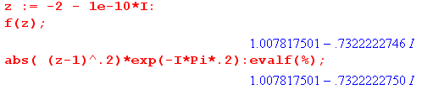

and of course to the right the phase will be zero and we just get the same positive number either way.

3. The Alternate Function (z-1)α0R .

Nevertheless, I sometimes find myself interested in another choice of cut take-off angle, which is taking the cut off to the right:

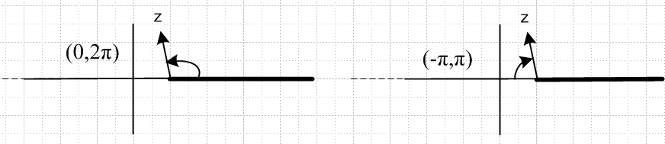

In this case, I usually use the (0,2π) angle method, so it is the left picture. I call this (z-1)α0R. So let's now review our two functions of interest so far:

(z-1)α0R (z-1)α0L

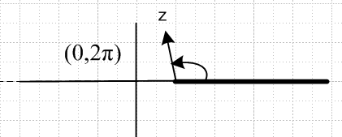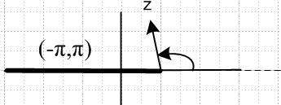
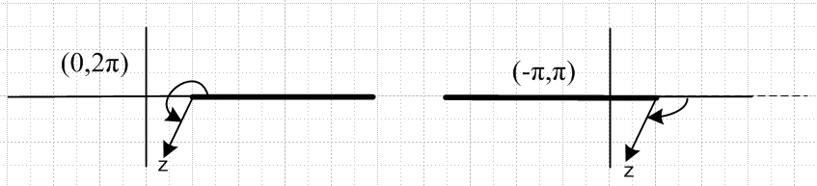

where I show the angles for z being above or below the cut line.

Question 1: Is there a relationship between (z-1)α0R and (z-1)α0L ?

Again, what we mean is: "are the evaluations of these two functions related?", where for each function we assume z is on the principal sheet of that function. It seems pretty clear from the upper two pictures above that the two functions are exactly the same if Im(z) > 0, but not the same otherwise. For the lower two pictures, assume the angle on the right is -θ with θ > 0. Then the left angle is 2π-(-θ) = 2π+θ. The we find that (z-1)α0R = (2π+θ) = eiα2π θ = e+iα2π (z-1)α0L. So here is the "relationship" we wanted:

(z-1)α0R = (z-1)α0L Im(z) ≥ 0

(z-1)α0R = e+iα2π (z-1)α0L Im(z) ≤ 0

Maple does not know about the function (z-1)α0R, but we could define it as on the two lines above and then use it in Maple if we so wanted.

Question 2: Is there a relationship between the Principal Sheets of (z-1)α0R and (z-1)α0L ?

(1-z)α0L (1-z)α0R
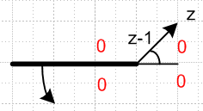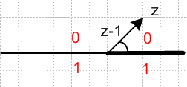

If we imagine that we started with the upper left picture, then we rotated the cut CCW by 180 degrees to get the upper right picture, then we could say the following: The principal sheets in the upper half plane for the two functions are the same (here labeled 0). All we did is rotate the cut, so the upper half plane "stayed as it was". But the lower half plane of the right picture (which is part of the principal Sheet 0 of
(z-1)α0R ) is in fact the lower half plane of Sheet 1 of the function (z-1)α0L . If you think of the rotation action of the cut in the left picture, as we rotate the cut CCW, we "expose" the +1 sheet that is lying there.
Let's consider the same two pictures above, but for z drawn in the lower half plane:

(1-z)α0L (1-z)α0R
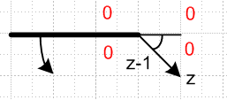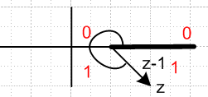

In the right image we see z of course on Sheet 0 of (z-1)α0R , but that same z is on Sheet 1 of (z-1)α0L.

So here is a way to describe this relationship:

(z-1)α0R = (z-1)α0L Im(z) ≥ 0
(z-1)α0R = (z-1)α1L Im(z) ≤ 0

The second line says: "The function (z-1)α0R for z on its principal sheet has the same value as the function (z-1)α1L has for that same z on its Sheet 1" . Look at the lower pair of pictures as you read this next sentence: But we know that (z-1)α1L = [(z-1)e+i2π]α0L = e+i2πα (z-1)α0L because this is exactly what we mean by our winding number notation. Thus the above two lines can be written as

(z-1)α0R = (z-1)α0L Im(z) ≥ 0
(z-1)α0R = (z-1)α0L e+i2πα Im(z) ≤ 0

and we have now replicated our results of Question 1, but now we have added the notion of "rotating the cut" to relate our two functions.

If we set α = 1 above, we can rewrite our two line rule above this way:

(z-1)0R = (z-1)0L Im(z) ≥ 0
(z-1)0R = (z-1)0L e+i2π Im(z) ≤ 0

It is true that e+i2π = 1, but the above is a "symbolic" form that is meant to be inserted into a "power" expression, and once we do that, we get e+i2πα ≠ 1. So it would be wrong to set e+i2π = 1 in the symbolic form. If we think of (z-1)α0L and therefore (z-1)0L as the "standard function", we write it as just (z-1). Then our symbolic rule becomes,

(z-1)0R = (z-1) Im(z) ≥ 0
(z-1)0R = (z-1) e+i2π Im(z) ≤ 0

Question 3: How does this relate to log functions?

Although this document is about "powers", the ideas also apply to log functions. We can apply the above rules to get

ln(z-1)0R = ln(z-1) = ln(z-1) Im(z) ≥ 0
ln(z-1)0R = ln[ (z-1) e+i2π] = ln(z-1) + i2π Im(z) ≤ 0

In a power, we get a phase in the lower line, but in a log we get an imaginary additive term!

Question 4: How does this relate to the Q1(z) function?

(a) Preparation. Which Bateman formula can we use? Our favorite p 130 (32) has Γ(±μ) so is no good. The first viable form is (36), but let's use (37) which says

Q1(z) = (1/3) (z-1)-2 F(2, 2; 4; 2/(1-z))

The F function is cut for arg ≥ 1. Here is a plot of arg = 2/(1-z) :

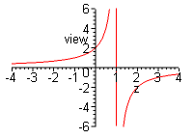which says arg ≥ 1 when z runs from z ≥ -1 and z ≤1, ie, on (-1,1)

So the function F(2, 2; 4; 2/(1-z)) is cut on (-1,1). Maple tells us that:

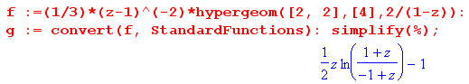
and then we see the log as the "source" of our cut on (-1,1). As usual, we can think of this as two cuts going to the left, which happen to cancel for z ≤ -1. The factor ln(z-1) is associated with the cut from z=+1 going to the left, and we are going to now rotate this cut to the right, leaving the other one put.

(b) Application to Q1(z). We now apply our symbolic rule above:

Q1(z)0R = (z/2)ln[(z+1)/(z-1)OR] - 1 = (z/2)ln[(z+1)/(z-1)] - 1 Im(z) ≥ 0

Q1(z)0R = (z/2)ln[(z+1)/(z-1)OR] - 1 = (z/2)ln[(z+1)/{(z-1)e+i2π] - 1 Im(z) ≤ 0

= (z/2)ln[(z+1)/{(z-1)] -1 + + (z/2)ln[e-i2π] = (z/2)ln[(z+1)/{(z-1)] - 1- iπz Im(z) ≤ 0

If we regard (z-1)OL as the "standard" and just write it as (z-1) we have:

Q1(z)0R = Q1(z)0L = Q1(z) = (z/2)ln[(z+1)/(z-1)] - 1 Im(z) ≥ 0
Q1(z)0R = Q1(z)0L = Q1(z) - iπz = (z/2)ln[(z+1)/(z-1)] - 1 - iπz Im(z) ≤ 0

(c) Implications: What have we learned here!
First, the log "additive factor" got multiplied by z/2 in this example, and that means that the asymptotic behavior of Q1(z)0R on a ray to ∞ in the lower half plane is z1 due to the added factor , whereas we know that Q1(z)0L behaves as z-2 along such a ray. But Q1(z)0R and Q1(z)0L decay as z-2 for a ray to ∞ in the upper half plane, as you can show from the log expression, or as you can see from the hypergeometric form where F → 1 and (z-1)-2 becomes z-2.
Second, the function Q1(z)0R maybe be regarded as the analytic continuation of Q1(z)0L going "down through the cut". As was discussed in Question 2 above, by rotating the z = +1 cut down and around to the right, we have "exposed" the region (sheet +1) below the cut of Q1(z)0L , and it is on this region that we are evaluating the function Q1(z)0R. It is very important to understand this.
The implication is that, like Q1(z)0L, the function Q1(z)0R is a solution of the Legendre ODE, but the function Q1(z)0R has an asymmetric asymptotic behavior as z → ∞ in the upper versus lower half plane, whereas Q1(z)0L has a symmetric decay in either upper or lower half plane. This fact means that the function Q1(z)0R might be useful as part of the solution of certain potential theory problems, such as the hole in the plate with an uniform E field distant on the upper side. Smythe solves this problem using the function Q1(z=iζ)0R = ζ cot-1(ζ) – 1 which indeed has asymmetric asymptotic behavior up and down on the imaginary axis. Here is a plot of Q1(iζ)0R versus ζ and you can see the left/right asymmetry:

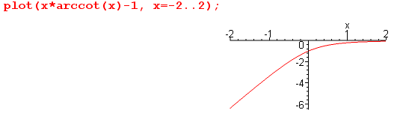

It took me a long time to understand how this all works. Although it is not immediately obvious from the log form, it is true that Q1(z)0L = Q1(-z)0L which says Q1(iζ)0L = Q1(-iζ)0L so Q1(iζ)0 is completely symmetric going up or down on the imaginary axis, and we can in fact write Q1(iζ)0L = |ζ| cot-1(|ζ|) – 1 which we can then plot to show the symmetry

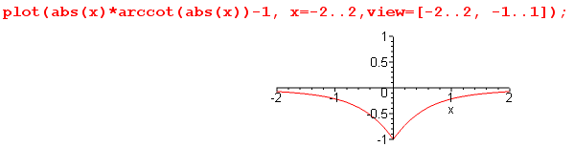

In general, since Qνμ(-z)0L = – Qνμ(z)0L e±iπν , the function Qνμ(z)0L is symmetric apart from the phase factor shown, whereas Qνμ(z)0L may have asymmetric behavior. This is revealed in Bateman 133 (37) if you first think of the F cut from (-1,1) as being the two cuts mentioned above, and you rotate the z = +1 cut over to the right. For general μ, we also have an outside factor (z-1)-μ/2-ν-1 and this cut is also rotated to the right along with the F cut. Then we have a "clear path" from the upper to the lower half plane through the uncut region (-1,1) which we can use for Qνμ(iξ)OR.
Notice that when we "CCW-rotate the cut" attached to z = 1 from left to right, we still end up with
(z-1)α in our function. This cut rotation does NOT convert (z-1)α to (1-z)α . This should be pretty obvious, but it is always possible to get this confused.

Part II: (-z-1)α

1. The Generic function (-z-1)α.

(a) Preliminary. In general, if we have some f(z) with a cut structure and some angles, then we can think of the function g(z) = f(-z) as having a cut structure which is the complete reflection of the z plane through the origin. Such reflection does not change the CCW or CW sense of angles.

(b) Application to Generic (-z-1)α . I want to think of the function g(z) ≡ (-z-1)α in the following way:

g(z) ≡ (-z-1)α = f(-z) where f(z) = (z-1)α

Here we attempt to draw the z plane for f(z) on the left, and for g(z) on the right:

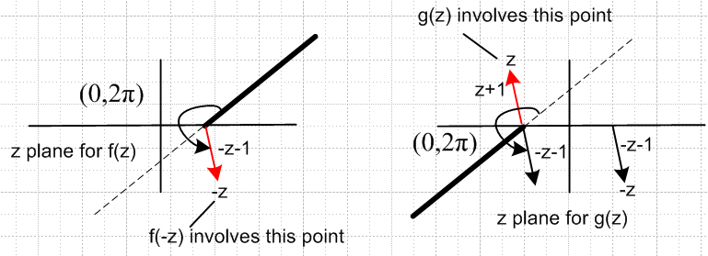

Our calculation of g(z) for some z is then this (using the left picture only)

g(z) = f(-z) = (-z-1)α = |-z-1|α exp[i α arg(-z-1)]

where arg(-z-1) is the large positive angle in the left picture, if we use the (0,2π) angle scheme. If we want to get the exact same number by computing using the right drawing, we have to use a (0,2π) angle scheme there for vector -z-1, but the 0 point of this angle scheme is the cut extension, not the cut! This is the ONLY way to measure angles on the right so you get the same answer as you get on the left.

Now let's repeat the above drawings but this time we will use our other (-π,π) angle scheme on the left and see what is then required on the right.

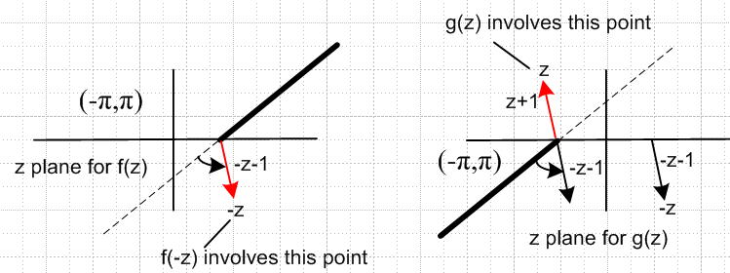

We can just repeat the text above at "Our calculation...". Now arg(-z-1) for the left picture is the short arrow shown which is a small positive angle. To make this work, we have to use the same (-π,π) angle scheme in the right picture, but again we have the reverse sense of the angle scheme on the left. We must base our (-π,π) scheme on the right with the 0 line being the cut, not the cut extension as on the left. This is the ONLY way to measure angles on the right so you get the same answer as you get on the left.

2. The Standard Function (-z-1)α0R .

This means in the left picture f(z) we take the cut off to the left, so it is pretty easy to just redraw the above picture pair accordingly, I will use the (-π,π) scheme:

f(z) = (z-1)αOL g(z) = (-z-1)α0R

We need not repeat our words about the angle schemes. As for sheets, we want -z to be on the principle sheet of f(z) on the left, and z to be on the principal sheet of g(z) on the right. As we swing z around the point z = -1 on the right, keeping z on the principal sheet of g(z) , the point -z swings around z=+1 on the left and stays on the principal sheet of f(z)

Notice that if the z in g(z) is at the point z = -5, arg(-z-1) = |-z-1|α e±0 and we find that g(z) is real positive, something very desirable. Similarly for z = +5, we have f(z) = real positive. It is these "real positive" values on the uncut regions that can in fact be used to define the principal sheets of f(z) and g(z).

So this thing above on the right is "the standard g(z) = (-z-1)α " This "standardness" includes the direction of the cut, and the way angle is measured -- off the cut extension using (-π,π).

Let's do a little Maple check. First, we do a point just above the cut for g( z) so expect arg(-z-1) = -π

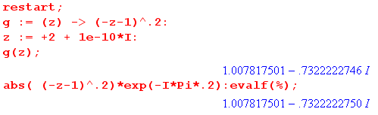

Similarly, we can take a point just below the cut and expect angle +π.

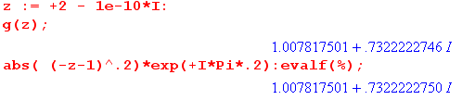

If we set z = - 2±iε, Maple says you get 1 both ways. So I think we are "good with Maple".

Here is how we compute our function, one more time:

f(-z) = (-z-1)α = |-z-1|α exp[i α arg(-z-1)] // angle as shown on the left
// measured from the cut extension with (-π,π)

g(z) = (-z-1)α = |-z-1|α exp[i α arg(-z-1)] // angle as shown on the right
// measured from the cut with (-π,π)

We get the same number doing this either way.

Question 1: How is (-z-1)α0R related to (z+1)α0L ?

These are both "standard functions", so we evaluate each according to rules above. The z+1 function has branch point at -1 instead of 1, but otherwise same idea as above in Section 1, so in the pictures, just ignore the vertical line:

(z+1)α0L = |z+1|α exp[iα arg(z+1)] arg(z+1) in range (-π,π) with 0 to the right = θ

The -z-1 function of course has its branch point also at z = -1, and we evaluate as follows:

(-z-1)α0R = |-z-1|α exp[i α arg(-z-1)] arg(-z-1) in range (-π,π) with 0 to the right = φ

f(-z) = (-z-1)α0L g(z) = (-z-1)α0R :

So how do we relate the two angles involved here? With z in the upper half plane, θ > 0 and φ < 0 and we would say then that θ + (-φ) = π. For z in the lower half plane, signs of both angles change so φ + (-θ) = π, and as usual, we summarize both cases by saying θ-φ= ±π . This then tells us:

(z+1)α0L = |z+1|α exp[iαθ] = |z+1|α e±iπα exp[iαφ] = e±iπα |-z-1|α exp[iαφ] = e±iπα (-z-1)α0R

So the answer to our question is this:

(z+1)α0L = e±iπα (-z-1)α0R or (-z-1)α0R = e∓iπα (z+1)α0L

Let's see if Maple agrees with this equation on the right. Start with z = -2+iε :

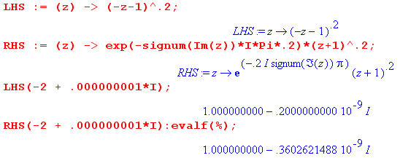

The point z = -2-iε gives the same agreement. Now try z = +2+iε:

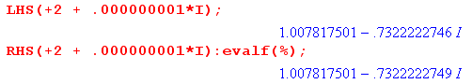

And then z = +2-iε gives the same agreement with the imaginary parts both + .73.
Let's write the relationship a few more times:

(-z-1)α0R = e∓iπα (z+1)α0L
(-z-1)α = e∓iπα (z+1)α
(-z-1) = e∓iπ (z+1) symbolic form agrees with Bateman mid page 123 !!

Question 2: How is (-z+1)α0R related to (z-1)α0L ?

Compared to question 1 above, we have done nothing but slide the branch point horizontally. The result will be this:

(z-1)α0L = e±iπα (-z+1)α0R or (-z+1)α0R = e∓iπα (z-1)α0L

Being always cautious, let's give this a Maple test:

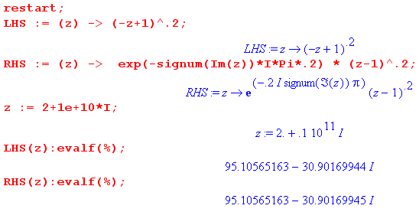

I did the other three quadrants changing signs and we get agreement in all quadrants.
Again, we write this result again several ways:

(-z+1)α0R = e∓iπα (z-1)α0L
(-z+1)α = e∓iπα (z-1)α
(-z+1) = e∓iπ (z-1) // symbolic, agrees with Bateman p 123 mid page

Question 3: How is (-z-a)α0R related to (z+a)α0L ?

This seems a better way to give the overall result:

(z+a)α0L = e±iπα (-z-a)α0R or (-z-a)α0R = e∓iπα (z+a)α0L

Question 4: How is (z2-1)α related to (z-1)α (z+1)α ?

(a) The Main Point.

This is a tricky question, pay attention. Suppose we define two functions of a complex variable z.

f1(z) ≡ (z2-1)α with α = .2 say

f2(z) ≡ (z-1)α (z+1)α

If in Maple we evaluate these two functions at z = 2, we get the same positive real number.

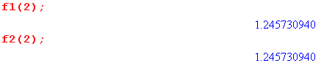

But if we evaluate at some complex point in Quadrant II, we get very different answers:

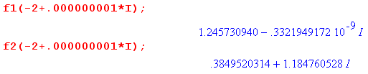

The main point is that f1and f2 are really two different functions which happen to agree on the positive real axis!

(b) Computational details

In f1(z) ≡ (z2-1)α when we set z = -2, we first square it to get +4, then we have 3α = 1.245730940.

In f2(z) ≡ (z-1)α (z+1)α we really have (-3+iε)α (-1+iε)α and we get:

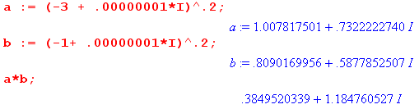

Let's see if we can get this same .384 result a third way. We can use our rule from above that (-z-a)α0R = e∓iπα (z+a)α0L to write
(-z-1)α = e∓iπα (z+1)α
(-z+1)α = e∓iπα (z-1)α
=> (-z-1)α(-z+1)α = e∓i2πα (z+1)α(z-1)α

In our case we have z = -2 +iε so we use the upper sign and claim that

(-[-2+iε] -1)α(-[-2+iε]+1)α = e-i2πα ([-2+iε]+1)α([-2+iε]-1)α

1α 3α = e-i2πα (-1+iε)α(-3+iε)α

=> (-1+iε)α(-3+iε)α = e+i2πα 1α 3α .

We computed the LHS above as a*b. We compute the RHS here:

I am doing "lots of checks" because I often make "lots of errors". So far, so good, our three methods all agree.

You might wonder how Maple computes something like (-3)^.2 Here is the answer:

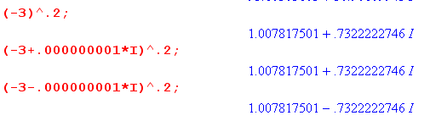

If assumes a positive imaginary part. So think of it is ( [-3+iε] - 0)α of the form (z-a)α. Once more little exercise. Our rule says:

(-z-a)α = e∓iπα (z+a)α => (-z)α = e∓iπα (z)α

(-[-3+iε])α = e-iπα ([-3+iε])α with z = -3+iε

3α = e-iπα (-3+iε)α => (-3+iε)α = e+iπα 3α

(c) Bateman formulas for P and Q with (z2-1)α .

So when you see a factor like (z2-1)μ/2 sitting in a Bateman formula, what function is really implied? Until today, I failed to understand this question. I never made any distinction between these two functions:

(z2-1)μ/2 and (z-1)μ/2(z+1)μ/2

Those factors "get into" the Bateman formulas from the various hypergeometric Kummer like formulas. If you look through the tables, you see that that only time something like (z2-1)α appears in a factor, the F argument involves z2 and then (z2-1)α is what will arise from Kummer. My conclusion is that the function as written is correct, it really is (z2-1)μ/2 and NOT (z-1)μ/2(z+1)μ/2 . Therefore, we may conclude that:

f1(z) ≡ (z2-1)α

f1(-z) ≡ ([-z]2-1)α = (z-1)α = f1(z)

BUT !!! On page 122 Bateman directly says that this is not right! Right after discussing formula (41) for Q in the form p 122 (5), Bateman says

"we assume (z2-1)μ/2 = (z-1)μ/2 (z+1)μ/2 "

and the range of the angles is then shown, as I always do it. OUCH! So I am on hold right now on this question.

3. The Alternate Function (-z-1)α0L .

I could develop this out, but I don't think we will ever use it, so let's leave it undone for now.

Part III: (1+z)α

We treat this function in all respects as (z+1)α which is exactly the same as (z-1)α treated in Part I above, except the branch point is at z = +1 instead of z = -1. We could copy down and edit all of Part I as follows:

(a) in all pictures, move the vertical line marking x = 0 exactly two units to the right.
(b) replace every occurrence of (z-1) by (z+1).

No new "thinking" is needed (thank goodness). Here it is:

The Standard Function (1+z)α0L :

f(z) = (1+z)α0L
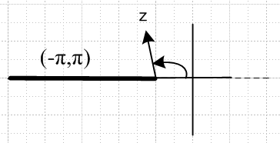

Part IV: (1-z)α

We treat this function in all respects as (-z+1)α which is exactly the same as (-z-1)α treated in Part II above, except the branch point is at z = +1 instead of z = -1. We could copy down and edit all of Part II as follows:

(a) in all pictures, move the vertical line marking x = 0 two units as appropriate (right or left)
(b) replace every occurrence of (-z-1) by (-z+1).

No new "thinking" is needed (thank goodness). Here it is:

The Standard Function (1-z)α0R :

f(-z) = (1-z)α0L eval g(z) = (1-z)α0R

Question 1: What is the relationship between f(z) ≡ (z-1)α0L and g(z) ≡ (1-z)α0R ?

We first call up our basic pictures for each of these functions

f(z) ≡ (z-1)α0L g(z) ≡ (1-z)α0R
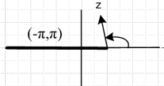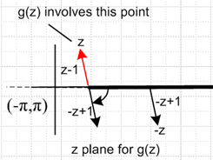

f(z) = |z-1|α exp[iα arg(z-1)] angle = θ > 0 as shown above left

g(z) = |1-z|α exp[iα arg(1-z)] angle = φ < 0 as shown above right

We can see that θ + [-φ] = π when Im(z) > 0 as in our pictures. For Im(z) < 0, both angles change sign, so our rule is then [-θ] + φ = π. We can combine the rules as

θ - φ = ±π Im(z) 0

Then we have:

f(z) = |z-1|α exp[iα arg(z-1)] = |z-1|α exp[iα θ] = |z-1|α exp[iα (±π + φ)]

= |z-1|α exp[iα (±π )] exp[iα (φ)] = e±iαπ |1-z|α exp[iα (φ)] = e±iαπ g(z)

So we conclude that

f(z) = e±iαπ g(z) Im(z) 0
or
(z-1)α0L = e±iαπ (1-z)α0R Im(z) 0

which agrees with what I obtained at some earlier point. Maple is in full agreement with this last equation, which in Maple terms we would just write as

(z-1)α = e±iαπ (1-z)α Im(z) 0

Comment: As z wanders over the Principal Sheet of (z-1)α0L , z wanders over the Principal Sheet of
(1-z)α0R. But these principal sheets are cut differently! The cuts are not rotations of each other, they are parity reflections of each other through the origin with a subsequent hor. displacement of 2 units. You can think of this as a rotation of the cut followed by a redefinition of the principal sheet.

