The meaning of f(- z) for powers PhL 2.13.10

1. Normal interpretation of f(z) = (z-1)^{α}. 1
1A. Normal interpretation of f(z) = (1-z)^{α}. 3
2. Question: What would be a "normal" interpretation of g(z) = (-z-1)^{α} 3
2A. Normal interpretation of f(z) = (-1-z)^{α}. 5
3. Application Example: h(z) = f(z) + g(z) 6
4. Application Example: f₁(z) = (∓i)^{2α} f(z) 6
5. Application Example g₁(z) = (±i)^{2α} g(z) 7
6. Application Example: k(z) = f₁(z) + g₁(z) = (∓i)^{2α} (z-1)^{α}_{0LA} + (±i)^{2α} (-z-1)^{α}_{0RA} 9
7. Application Example: p_{n}^{m} (z) = (∓i)^{-m} P_{n}^{m}(z) + (±i)^{-m} P_{n}^{m}(-z) 11

1. Normal interpretation of f(z) = (z-1)α.

Suppose we define

f(z) = (z-1)α

We think we know what the "normal" interpretation of this function is:
• branch point at z = +1
• cut pulled off to the Left
• angle of vector z-1 lies in the range (-π,π) where vector at angle 0 points to the right. ("A")
• for z real and z < 1, we assume z = z+iε and so is above the cut on the left.
• f(z) is real on the real axis z>1 for the Principle Branch with winding number 0 (real analytic)

Here is a picture showing a particular value of z above the cut:

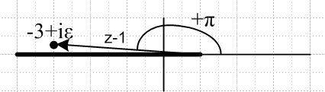

This is a function I might call (z-1)α0LA . This notation means winding number 0, cut to the Left, and angle measurement convention "A" as defined in the dot above. We can always locate the branch point by setting the power argument to 0.
This "normal interpretation" is exactly the way Maple thinks. Here is some supporting code.

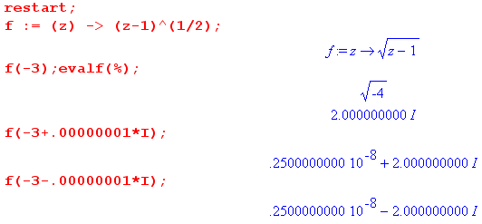

For example, in the last case we have z = -3-iε which is below the cut, so angle is =-π, and therefore

(z-1)1/2 = |z-1|1/2 e-iπ(1/2) = |-3-1|1/2 (-i) = -2i

Comments: We could come up with other methods of measuring the angle. For example, we could define zero angle as a vector z-1 pointing to the left with tip just under the cut, then we could have the range be (0,2π) with angle increasing in the CCW direction. Certainly most sources have angle increasing CCW.
We could also choose to pull the cut off at some other angle. One common choice would be to pull it off to the Right. In that case, one might measure angle with 0 degrees being an arrow to the right with tip just above the cut, and range (0,2π) increasing CCW (method "B"). Here is how we might do this:

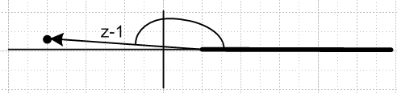

Points in the upper half plane have the same angle of z-1 as before, but in the lower half plane things are now different. This would then be (z-1)α0RB , meaning winding number 0, cut to the Right, angle method "B". Notice that this method causes f(z) to be real on the top of the real axis on the right. It is as if we just swung the branch cut 180 degrees CCW pivoting it on the branch point.
We could alternatively measure angle here with z-1 pointing to the left as 0 degrees, then CCW to +π or CW to -π. This would be method "C" is measuring angle. Using this method, we could have the function (z-1)α0RC being real and positive on the negative real axis on the left! This is definitely "counter intuitive" and would I think be a bad way to do it. Sometimes people use this kind of angle convention when you want to pull the cut off at some weird angle: the 0 degree mark is an arrow opposite the cut.
Here is an example! Bateman p 114 (1) gives an integral for F(a,b,c,z) with |arg(1-z)| < π which keeps you off the cut which runs (1,∞). This is exactly our method C !

Conclusion: For 90% of all applications, I would use angle method "A" and have the cut going to the Left. This is (1-z)α0LA. If I needed the cut to go to the right, I would use angle method "B" and hence
(z-1)α0RB . In very rare cases, I might use (z-1)α0RA . This would be a little strange because then -4 would be at both +π and -π, but there could be some special reason to do this (see below).
Maple always thinks in terms of (1-z)α0LA . It cannot do anything else.

1A. Normal interpretation of f(z) = (1-z)α.

The normal interpretation involves taking the vector 1-z and giving it our usual Method A angles, so that the vector 1-z has angle in range (-π,π).

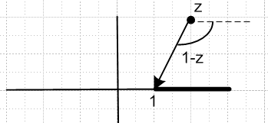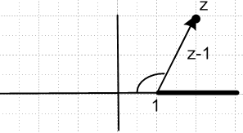

f(z) = |1-z|α exp[ iα( arg(1-z) ]

If z = 2±iε, we have angle ∓ iπ so phase is e∓iαπ and we have a cut on the right
If z = -2±iε we have angle 0 so no cut on the left.

Therefore, this function has a cut going to the right. This is I think the "natural" interpretation.

If we insist on working with the vector z-1, we can draw the picture on the right above. With the convention that a drawn angle is negative if drawn CW from some starting point (as in this figure), then if we treat the vector z-1 as having an angle in the range (-π,π) relative to the line to the left, then we get exactly the same phases as noted above for our two test cases. The angle shown in our figure to the right might be - 120 degrees, for example, the same as the angle for the left figure.

2. Question: What would be a "normal" interpretation of g(z) = (-z-1)α

This is a seemingly innocent and simple question, but I have managed to blow off about 3 days being confused by it. There are lots of ways to define this function, and the "normal way" is not as obvious as it is for the function f(z) = (1-z)α .
First of all, we can see that g(z) has a branch point at z = -1 since this makes -z-1 = 0. So then the question is this: is it more normal to pull off the cut to the right? Or to the left? And then what would be the normal way to measure the angle? And of what vector are we then measuring the angle? Well, the vector whose angle we need to know how to measure must be -z-1, since this is what appears in the power expression, so at least we know that much.

Well, here is what I think the "normal" method should be:
(1) the way Maple does it.
(2) the way that makes g(z) = f(-z) in all respects, where f(z) = (z-1)α0LA (the "normal" f(z) ).

What we mean by g(z) = f(-z) is this: we have a fully defined function f(z) = (z-1)α0LA. We can evaluate this for any point z on the Principal Sheet. So we can regard "-z" as just some point where we evaluate the function. Then f(-z) is whatever you get, and then that is the value of g(z). If we follow through on this idea, here is what we find:

• branch point of g(z) is at z = -1
• cut pulled off to the Right
• angle of vector -z-1 lies in the range (-π,π) where vector at angle 0 points to the right. ("A")
• for z real and z >-1 , we assume z = z-iε which is below the cut on the right.
• g(z) is positive real on the real axis z < - 1; this defines the Principle Branch, winding # 0.

I guess I would have to call this (-z-1)α0RA. Here is the development that leads to the above bullets. Consider first:

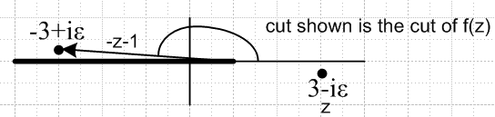 g(3-iε) = f(-3+iε) = +2i

Using this picture, we conclude that g(3∓iε) = ±2i . Remember, g(z) = f(-z) = (-z-1)α. So the argument of the power is not z-1, but -z-1. BUT, the fact that g(z) is different at 3∓iε means that g(z) has a cut on the right, not a cut on the left! Thus, we draw this picture:

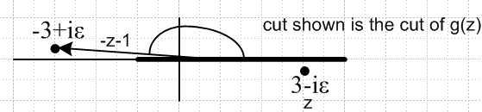

It is the same picture, we have just moved the cut and branch point. So we now see g(z) having the branch point at z = -1 as claimed. BUT, we are still measuring angles the "A" way for vector -z-1. Notice that the vector -z-1 connects the point -z not to the g(z) branch point at -1, but to the f(z) branch point at z = +1.
Now if we want to know g(3), we are going to assume this is g(3-iε), so (-z-1)α = |-z-1|α (e+iπ)α . If ζ = 1/2, this will then say (-z-1)1/2 = |-z-1|1/2 (e+iπ)1/2 = +i |-3-1|1/2 = +2i (see code below).
Once again, I will call this interpretation by the name (-z-1)α0RA . It is the way Maple works, as this code shows:

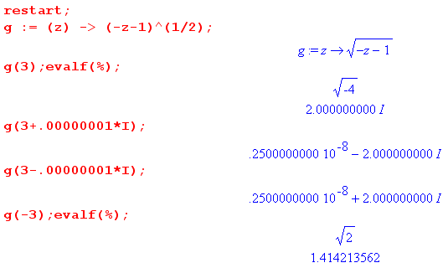

Comments: Really, once we have chosen f(z) = (z-1)α0LA , we are really forced to g(z) = (-z-1)α0RA . This is the only interpretation which is consistent with " g(z1) equals f(z) evaluated at the point z = -z1". If you try to do anything else, you get inconsistency. Of course this method also gives f(z) = g(-z) in a fully consistent manner.

2A. Normal interpretation of f(z) = (-1-z)α.

This is a much simpler version of section 2 above. Just think of this as the same as Section 1A, but we have moved the branch point from 1 to -1. We get all the same conclusions that we got above.

Here is the edited text from 1A:

The normal interpretation involves taking the vector -1-z and giving it our usual Method A angles, so that the vector -1-z has angle in range (-π,π).

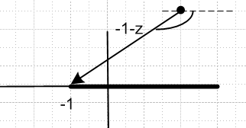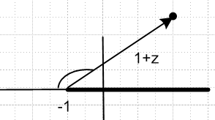

f(z) = |-1-z|α exp[ iα( arg(-1-z) ]

If z = 2±iε, we have angle ∓ iπ so phase is e∓iαπ and we have a cut on the right
If z = -2±iε we have angle 0 so no cut on the left.

Therefore, this function has a cut going to the right. This is I think the "natural" interpretation.

If we insist on working with the vector z+1, we can draw the picture on the right above. With the convention that a drawn angle is negative if drawn CW from some starting point (as in this figure), then if we treat the vector z+1 as having an angle in the range (-π,π) relative to the line to the left, then we get exactly the same phases as noted above for our two test cases. The angle shown in our figure to the right might be - 120 degrees, for example, the same as the angle for the left figure.

3. Application Example: h(z) = f(z) + g(z)

Consider the following function:

h(z) = f(z) + g(z) = (z-1)α0LA + (-z-1)α0RA

This sum function is cut along the entire real axis because we have to superpose the cuts of the two terms. These cuts are (-∞,1) and (-1,+∞). We know exactly how to evaluate this function by evaluating each term and then adding them. Maple knows how to do this too.

4. Application Example: f1(z) = (∓i)2α f(z)

Consider the following function:

f1(z) = e∓iπα f(z) = e∓iπα (z-1)α0LA
or
f1(z) = (∓i)2α f(z) =(∓i)2α (z-1)α0LA

where we use the upper sign if Im(z) > 0, and the lower sign if Im(z) < 0. Recall this picture we had for f(z) = (z-1)α0LA

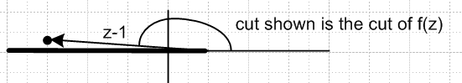

You can see that the coefficient we have chosen exactly "unwinds" the phase of the vector z-1. For the point shown, we have

f1(-3+iε) = e-iπα |z-1|α e+iπα = |z-1|α = real and positive

Similarly

f1(-3-iε) = e+iπα |z-1|α e-iπα = |z-1|α = real and positive

So this function f1(z) in fact has no cut on the left! But it does have a cut on the right:

f1(3+iε) = e+iπα |z-1|α e0 = e+iπα |z-1|α
f1(3- iε) = e-iπα |z-1|α e0 = e-iπα |z-1|α

Therefore, a correct picture for f1(z) would be this:

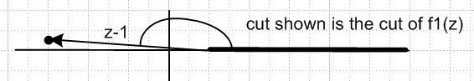

At the real axis, our function f1(z) is fully continuous through the real axis, despite our (∓i)2α coefficient, so f1(z)is I am pretty sure an "analytic function" away from the cut shown.
Let's compute the following specific value for later use:

f1(0.5 ± iε) = e∓iπα |1/2-1|α e±iπα = |1/2|α = real and positive

Here is some supporting Maple work for this function: ( consider 10-9 = 0)

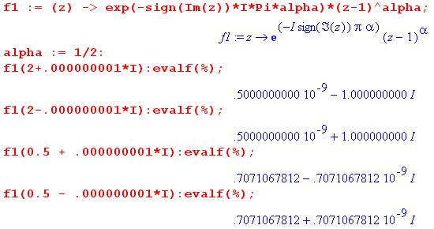

5. Application Example g1(z) = (±i)2α g(z)

Consider the following function:

g1(z) = e±iπα g(z) = e±iπα (-z-1)α0RA
or
g1(z) = (±i)2α g(z) =(±i)2α (- z-1)α0LA

where we use the upper sign if Im(z) > 0, and the lower sign if Im(z) < 0. Recall this picture we had for g(z) = (- z-1)α0RA

You can see that the coefficient we have chosen exactly "unwinds" the phase of the vector -z-1. For the point shown, we have ( for z = 3-iε we use the lower sign)

g1(3-iε) = e-iπα |-z-1|α e+iπα = |z-1|α = real and positive

Similarly

g1(3+iε) = e+iπα |-z-1|α e-iπα = |z-1|α = real and positive

So this function f1(z) in fact has no cut on the right! But it does have a cut on the left:

g1(-3+iε) = e+iπα |-z-1|α e0 = e+iπα |-z-1|α
g1(3 -iε) = e-iπα |-z-1|α e0 = e-iπα |-z-1|α

Therefore, a correct picture for g1(z) would be this:

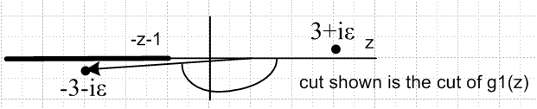

At the real axis, our function g1(z) is fully continuous through the real axis, despite our (±i)2α coefficient, so g1(z)is I am pretty sure an "analytic function" away from the cut shown.
Let's compute the following specific value for later use:

g1(0.5 ± iε) = e±iπα |-1/2-1|α e∓iπα = |3/2|α = real and positive

Here is supporting Maple work for g1(z) : ( note that $\sqrt{3/2}$ = 1.2247 )

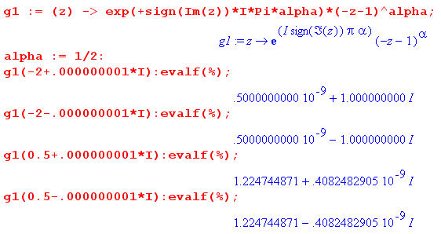

6. Application Example: k(z) = f1(z) + g1(z) = (∓i)2α (z-1)α0LA + (±i)2α (-z-1)α0RA

Consider the following function:

k(z) = f1(z) + g1(z) = e∓iπα f(z) + e± iπα g(z) = e∓iπα (z-1)α0LA + e± iπα (-z-1)α0RA
or
k(z) = f1(z) + g1(z) = (∓i)2α f(z) + (±i)2α g(z) = (∓i)2α (z-1)α0LA + (±i)2α (-z-1)α0RA

where we use the upper sign if Im(z) > 0, and the lower sign if Im(z) < 0. We recall the cut structure of the two functions f1 and g1 :

When we add these two functions, we superpose the two cuts, but we still have an uncut portion on the real axis which is in the range (-1,1) for z.

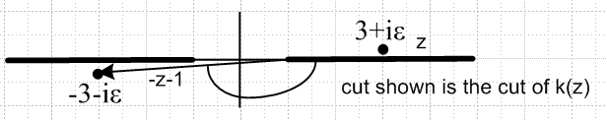

Let's evaluate our functions at z = 1/2±iε copying from above:

f1(0.5 ± iε) = e∓iπα |1/2-1|α e±iπα = |1/2|α = real and positive
g1(0.5 ± iε) = e±iπα |-1/2-1|α e∓iπα = |3/2|α = real and positive

so we find that

k(0.5 ± iε) = |1/2|α + |3/2|α = real and positive // .7 + 1.2 = 1.9

Notice that, when we are in the region (-1,1), our coefficients "unwind the phases" of both terms, leaving us with a sum of two positive numbers. If we take z → -z (within this interval), we get the same two positive numbers in the reverse order. Therefore, k(z) = k(-z) in this interval!

Here is our Maple support, just to stay on track:

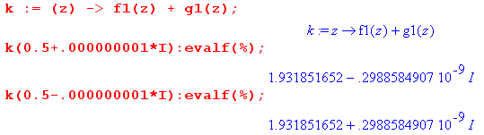

confirming the absence of a cut at z = 0.5. And here is confirmation of the symmetry k(z) = k(-z):

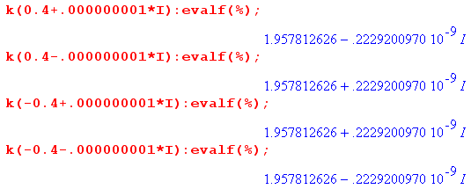

Special Case A: Suppose we consider z = iζ where ζ is real, so z is pure imaginary. Then we have:

k(z) = f1(z) + g1(z) = (∓i)2α f(z) + (±i)2α g(z) = (∓i)2α (z-1)α0LA + (±i)2α (-z-1)α0RA

but now -z = z* so we can say

k(z) = f1(z) + g1(z) = (∓i)2α f(z) + (±i)2α g(z) = (∓i)2α (z-1)α0LA + (±i)2α (z*-1)α0RA

= (∓i)2α (z-1)α0LA + C.C.

= real !

I guess it must turn out that (z*-1)α0RA = [(z-1)α0RA]* = [(z-1)α0LA]* which we could do battle with, but I know it is true. Now if k(z) = real, then k(z) = k(z*). Then if we define:

K(ζ) = k(iζ)

we find that K(ζ) is both real and symmetric. Here is some Maple confirmation:

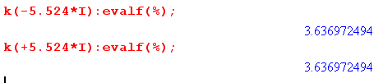

Also, here is the overall symmetry property that k(z) = k(-z) for complex:

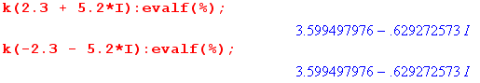

Conclusion: In fact k(z) has these three properties:

Fact 1: k (-z) = k (z) for arbitrary z
Fact 2: k(-z) = k(z) = real for z in (-1,1)
Fact 3: k(-z) = k(z) = real for z = imaginary

We shall see that the next example, though more complicated, has these same three properties!

7. Application Example: pnm (z) = (∓i)-m Pnm(z) + (±i)-m Pnm(-z)

[ NOTE: for some strange reason I called this function q instead of p in my Maple test1.mws doc. Thus you see certain q's appearing below in Maple pastes, they should all be p. ]

This has been our target all along. The P functions are Legendre functions as described in Bateman. If we look at Bateman p 126 (22) we see an expression for Pnm(z) where there are two terms and both F functions are functions of z2. Here is the "z structure" of these terms

Pnm(z) = A (z+1)-m/2 (z-1)-m/2 F(.... ; z2) + B z (z+1)-m/2 (z-1)-m/2 F'(.... ; z2)

When we construct the sum above, we end up with

pnm (z) = A (z+1)-m/2 [(∓i)-m(z-1)-m/2] F(.... ; z2) + B z (z+1)-m/2 [(∓i)-m (z-1)-m/2 ] F'(.... ; z2)

+ A (-z+1)-m/2 [(±i)-m (-z-1)-m/2] F(.... ; z2) + B (-z) (-z+1)-m/2 [(±i)-m (-z+1)-m/2 ] F'(.... ; z2)

= [(∓i)-m(z-1)-m/2] (z+1)-m/2 { A F(.... ; z2) + B z F'(.... ; z2) }

+ [(±i)-m (-z-1)-m/2] (-z+1)-m/2 { A F(.... ; z2) – B z F'(.... ; z2) }

If we think of α = -m/2 we can write this as:

pnm (z) = [(∓i)2α(z-1)α] (z+1)-m/2 { A F(.... ; z2) + B z F'(.... ; z2) } (*)
+ [(±i)2α (-z-1)α] (-z+1)-m/2 { A F(.... ; z2) – B z F'(.... ; z2) }

= f1(z) (z+1)-m/2 { A F(.... ; z2) + B z F'(.... ; z2) } (**)
+ g1(z) (-z+1)-m/2 { A F(.... ; z2) – B z F'(.... ; z2) }

where f1 and g1 are the functions we studied above. So our case here has similarities to the previous example where we just had k(z) = f1(z) + g1(z). But we have additional z-dependent factors, so we cannot draw any immediate conclusions without doing a little more work.
First, let's rewrite p this way, looking at (*) above

pnm (z) = [(∓i)-m(z2-1)-m/2] { A F(.... ; z2) + B z F'(.... ; z2) } (***)
+ [(±i)-m (z2-1)-m/2] { A F(.... ; z2) – B z F'(.... ; z2) }

Now this has the following form:

pnm (z) = (∓i)-m [ Geven(z) + Godd(z)] + (±i)-m [Geven(z) – Godd(z)]

Now take z → -z (which changes the phase signs):

pnm (-z) = (±i)-m [ Geven(z) - Godd(z)] + (∓i)-m [Geven(z) + Godd(z)]

So we have just shown that p is symmetric in z for arbitrary z.

Fact 1: pnm (-z) = pnm (z) for arbitrary z

Now, if z is in the interval (-1,1), we showed above that f1(z) and g1(z) are each real (this is because in each case we have unwound the phase of the power). Therefore, since everything else in our expression (**) is real, we obtain the next fact:

Fact 2: pnm (-z) = pnm (z) = real for z in (-1,1)

Now suppose z is pure imaginary. Then looking at (***) we have that

pnm (z) = [(∓i)-m(z2-1)-m/2] { A F(.... ; z2) + B z F'(.... ; z2) } + C.C.

The z2 factors are invariant under C.C, and we have z → -z in the second term. Therefore we find our next fact:

Fact 3: pnm (-z) = pnm (z) = real for z = imaginary

Now we want to call in Maple support at once on these radical claims. We have m = 1.3 and n = 2.2 as our representative "oddball" values.

Fact 1: Symmetry at a complex point:

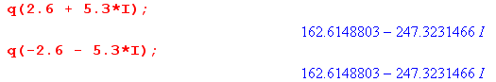

Fact 2: Symmetry and reality in (-1,1) ( real part is same whether you use + iε or -iε)

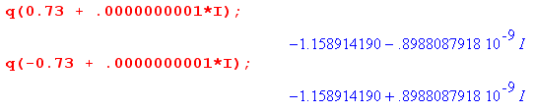

Fact 3: Symmetry and reality in (-i∞,i∞)

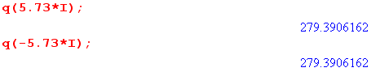

Note: The Maple file here is called test1.mws and is stored in the Legendre folder. I had to take a huge digression to fix a bug I was having with these plots. I was using the sign() function instead of the signum() function, and that caused a nightmare. See Maple notes doc on this topic. So here you only see things after the bug was fixed.

Here is a plot of Im(p) over the square (-2,-2) to (2,2); it is quite interesting. The view option cuts off the delta type peaks.

plot3d(Im(p(x+y*I)), x= -2..2, y= -2..2, view=-10..10);

Here in the left view you see a horizontal line segment that shows things being real on x = (-1,1). The ends of this line segment are roughly marked by my red arrows, but of course at -1 and +1 we have the huge tower peaks. If you slide off this line segment to either side, you get imaginary part. This is easy to see while you are rotating the graphic, but I have tried to pick a few pix on the right where this is at least visible.

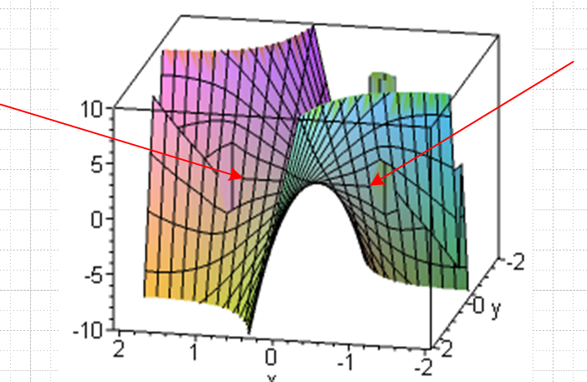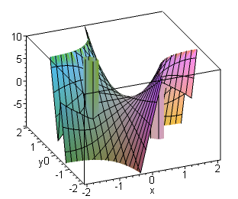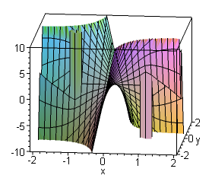

But we claim that our function should also be real on the imaginary axis. That is seen in this picture:

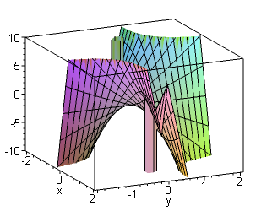

It is the near-horizontal line that shows it.

Note added: Looking at our Fact 2 Maple stuff above, it seems pretty clear that p is uncut in the range (-1,1) on the real axis, since we get the same real result for z ± iε. If we go off to the right, we find the cut present :

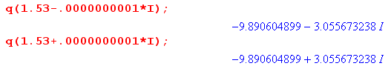

and similarly if we go off to the left, which we know at once from the symmetry rule Fact 1. Therefore we can add:

Fact 0: The function pnm (z) has cuts (-∞,-1) and (+1,+∞) and is uncut on (-1,1) where it is real. The function pnm (z) is "real analytic" because it is real on a piece of the real axis. On the cuts, the value above and below are related by complex conjugation.

What do these cuts look like in our Maple plot? Consider this image
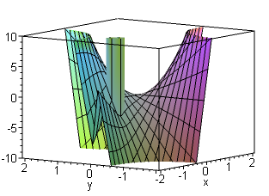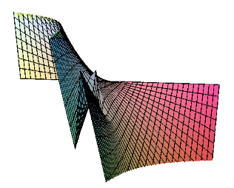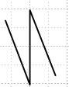
You see about half of the abovementioned (-1,1) line segment ending at the green pillar. Then in the left foreground in front of the pillar, you see "the cut". It appears as a jagged tilted Z shape due to the limited mesh resolution. At higher resolution it would really show a discontinuity I think. I tried grid = [40,40] on the right. In the limit, the center part of the sideways will be perfectly vertical, and this shows the discontinuity in the imaginary part as you pass across the cut.

We can also plot Re(p).

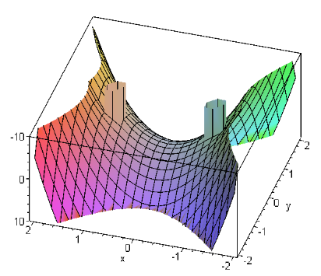
This is a much more relaxed function. It has a ∪ shape on our (-1,1) pure real domain, and ∩ shape for the (-i∞,i∞) domain. You can see that it is perfectly symmetric on both these domains! I wanted to see how that worked out in a plot, and that led to my huge Maple bug with sign digression, but now we are back and above you see it! If you think of this as Re p(z) = Re p(x,y), you see that this function is the same if you change the sign of x, or y, or of both. Thus, Re p(z) = Re p(-z), so we see our known symmetry at least for the real part. This must also be true for the imaginary part but that is a little hard to see from the pictures above.

