Buck Chapters 3

Chapter 3: Integration 1
3.1 The Definite Riemann Integral 1
3.2 Evaluation of Definite Integrals: a grab bag of methods 3
3.3 Taylor's Theorem 6
3.4 Improper Integrals 10
3.5 Set Functions 23

Chapter 3: Integration [ pp 97-157 ]

3.1 The Definite Riemann Integral

The Bucks approach the topic of Riemann integration in E2 as area. They don't mention here that there are other integral concepts such as the Stiljes integral. They do give a few examples where the domain D is not E2 but is perhaps 2D integers or 2D rationals, but their main interest is En.

Their tools are as follows:

D = bounded domain D on which the function f is defined
Γ = boundary of D
R = a rectangle that encloses D.
N = any grid of rectangles which "cover" R and this D within R (grid need not be evenly spaced)
N' = a refinement of N = a grid with more "lines" than grid N
Rij = grid rectangles partitioned into 3 groups as Fig 3-1 shows. Group 2 are the straddlers.
d(N) = max of diameters of all the Rij in the grid N
(N,D) = the area of 1+2 (outside) has GLB = S
S(N,D) = the area of 1 (inside) has LUB = s
imagine considering ALL possible covering sets {Rij}, with arbitrarily small rectangles
(D) = GLB of area over all possible sets {Rij} = S
A(D) = LUB of area over all possible sets {Rij} = s
A(Γ) = (D) - A(D) = area of boundary, which we know will be 0
pij = arbitrary point within Rij
{pij} = set where we pick some pij in each Rij
f = a bounded function over D
Mij = max value of f over all Rij
mij = min value of f over all Rij

With these technology tools, we then write the Riemann integral of f(x,y) as the limit of the Riemann sum:
S(N, f, {pij}) ≡ Σij f(pij) A(Rij) → ∫∫R f = the "integral" as d(N) → 0

I do not follow all the details, but see how a good set of unambiguous tools will lead to solid results.

Theorem 1: If f is continuous, then the above integral limit exists.

Their proof is 2 1/2 pages and includes three Lemmas. Continuity of f is only used with Lemma 3 as we get near the end of the proof.

Lemma 1. If you refine grid N to get grid N', this is what happens (seems rather obvious)

innersum(N) ≤ innersum(N') ≤ outersum(N') ≤ outersum(N)

Lemma 2. Note s and S above. This lemma just says ordering is as in p 101 figure.

Obviously as we crank down, (N) moves to the right, S(N) moves to the left, and s and S are caught in the middle, and eventually you will get a limit where s = S = the Riemann area.

Lemma 3. We temporarily assume that f is continuous on D. This lemma then shows | (N) - S(N)| → 0
which is the cranking down just mentioned.

We now back out a bit. Let E be a set of points in D which (1) has 0 area and (2) where f is not continuous. You might think of this situation graphically like so:

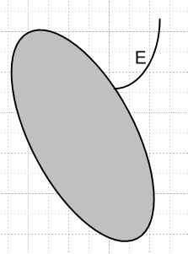

where E is a little curve which hangs out as shown.

Theorem 2. If D contains such a set E, the integral still exists.

This requires a detailed study of the various Rij near the intersection region, and continuity and bounded means uniform continuity, and somehow they show that the existence proof of the integral survives the set D having a strand E. This proof ends lower middle page 103.

Theorem 3. This seems a rather technical theorem which is unclear at the start. What does it mean to say that the set D "has an area"? In the proof they say this means that the boundary has 0 area. The idea is that you can cookie-cut any bounded (and interiorly continuous) D out of some rectangle R where you set f = 0 outside D but within R. Then the theorem says integral is independent of choice of R, which again seems pretty obvious.

Having done all this work for D in E2, they restate things for E1. The strandy set E becomes just an isolated point on the real line where function f is discontinuous. We know that in 1D, having such a discontinuity in a function does not stop area from existing, and this is what Theorem 2' says.

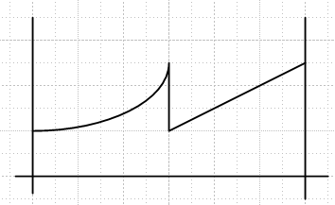

Theorem 4. A collection of obvious statements: integration commutes with addition f + g, or with multiplication by a constant. And positive f means integral is positive, and we have the integral form of
| a + b | ≤ |a| + |b|, which is called "the triangle inequality" since that is what it is in ≥ 2D. The corollary on page 106 is a statement that this triangle thing becomes an equality in 1D and we can divide a 1D integral at any interior point we like.

The Bucks do try to clarify the meaning of integral notations as on bottom of page 105 and elsewhere.

I guess all this machinery is really necessary if you want to do rigorous proofs of the claims. Since I am just doing a review of Buck to "see what is in there", I don't feel the need to follow details of proofs.

3.2 Evaluation of Definite Integrals: a grab bag of methods

First page comments on the unavoidable need for dummy integration variables. It notes that you should not take seriously the "d" of dx as a differential, and they suggest an alternate notation where the integration variable just appears inside a box. Soon they will give an example of why significant.
On page 108 we evaluate an integral of xy2 over the unit square by actually constructing a simple 2D grid and doing the sums and then taking the limit k→∞. That is to say, we are carrying out the theoretical presentation method. But then when we try to compute 1D integral of $\sqrt{x}$ over interval [1,2], the sum is too hard to do. But if you replace the even grid with an uneven grid, you get a sum that can be done and you get a number for the integral. If course we know the answer here is (2/3)x3/2|21 = (2/3)[ 23/2 - 1].
Now comes the Fundamental Theorem of Integration: you can just use the "antiderivative" evaluated at the endpoints, as I just did above. This is Theorem 5, but f must be continuous!

Theorem 5: If f is continuous on your 1D closed interval, the antiderivative F exists.

A simple proof is given.

Theorem 6. You can always add a constant to get a new antiderivative.

Theorem 7. This constant cancels out if you do a definite 1D integral. That is, $^{\int_{a}^{b}{}}$f = F(b) - F(a).

The notion of 1D change of variable is presented, and again we get a warning about interpretation of the dx or du in these integrals. If the variable change function is x = φ(u), then φ'(u) must exist and must be continuous for things to work (then new integrand will be continuous).

Page 11 gives two examples which give wrong results, and the reader must figure out why.
In the first example, we try to integrate 1/x2 right through x = 0 where the function is unbounded and discontinuous. Since discontinuous, the antiderivative method is disallowed for the interval [-2,2], which is why you get a junk answer which is finite negative. In fact the integral is divergent and positive.
In the second example, we change variables using u = 1/x so dx = -du/u2. The integration endpoints don't change and remain -1 to 1 under this change, but obviously the differential changes sign, so you think the resulting integral is negative! But if you think of "box area", you realize that you should really be using dx = +du/u2 to make things work, which is that Jacobian abs value they have not mentioned. The areas of the rectangles you are adding are always positive! This then is a case where the warning against the strict dx = -du/u2 interpretation is significant.

Theorem 8. If f is continuous on a closed rectangle R in 2D, then you can say

∫D f = [$^{\int_{a}^{b}{}}$$^{\int_{c}^{d}{}}$dx dy ] f(x,y) = $^{\int_{a}^{b}{}}$dx [ $^{\int_{c}^{d}{}}$dy f(x,y) ] = could do in other order

They give a long 1 1/2 page proof which uses the mean value theorem for integrals. A simpler proof would be that of Exercise 13 which shows that F(x) ≡ $^{\int_{c}^{d}{}}$dy f(x,y) is continuous in x, and then by Theorem 1 we know that $^{\int_{a}^{b}{}}$dx F(x) exists, and so on. They claim their proof is more general when you later try to weaken the assumption to almost-everywhere continuous f.

So much for 1D integrals, the Bucks move first to 2D integrals, The idea that you can do one of them first and then do the other is subject of Theorem 8, at least for integral over a simple aligned rectangle. Just proving this obvious theorem using their various "power tools" takes a full 2 pages. The "mean value theorem for integrals" is used, and I have added comments on this above below the other mean value theorems.

Page 113 has a technical issue that the inner integral might not exist for certain values of the outer variable, but this might still be OK in terms of doing the double integral. This is subject of Lebesgue integration which avoids such problems, and we are given Munroe's 1953 book as a reference.

Theorem 9. The one-variable-at-a-time integration method is OK even if D contains a discontinuous point set E, as long as this "strand E" does not have a finite vertical or horizontal piece! If both vertical and hor integrations encounter a strand "at an angle", then strand makes no contribution and can be ignored and you can do your double integral in either order. This seems pretty technical to me!

Corollary. Suppose D is defined by some continuous boundary functions φ(x) ≤ y ≤ ψ(x). Then you can do the inner dy integral between these functions, and then finally do the outer dx integral, as shown top of page 115. This application seems to avoid the strand E problem altogether. A simple example is given which I called Ex 1 (page 115), and then a more complicated example is at least stated, where there are multiple boundaries as shown on page 116. It is just shown how you could do the integration, given some continuous function f. Remember: in 1D a strand E would be an isolated point of discontinuity which is OK for the integral, and in 2D a strand is a strand of hair either inside or outside the region D on which function f is discontinuous, but which has no area so is OK. [ we are now mid page 116 ]

[116] The chapter at this point does some veering around. We are first reminded of what the Riemann sum looks like in 1D with some x-axis points xi. For some set of boxes, we can approximate the integral using the trapezoidal rule:

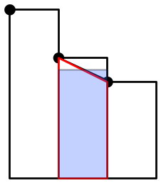

Here the center box is replaced by the red trapezoid, and then its area is the same as the blue rectangle which has a height which is the average of the two adjacent values. The boxes don't have to be the same width for this idea.
In Simpson's rule, you fit three adjacent values to a quadratic P(x) like so:

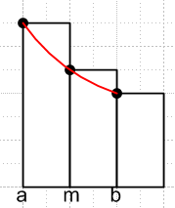

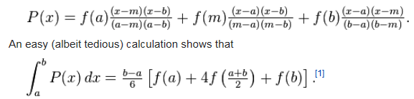

If f(x) is a cubic, the leading term ax3 is odd over the interval (think of m as m = 0) and makes no contribution to the integral, so Simpson is exact for cubics and lower power polys. Bucks do not clarify this little detail, but some web person did.
I guess for a full integral you would add up the rectangles a pair at a time like the pair shown above.
The Bucks' point is only that you can approximate integrals using the Riemann boxes in various clever ways.

Their next random topic involves the integral shown top of page 118. Their point seems to be that if you want the total area as the meaning of the integral, then you have to negate the D1 contribution because it's contribution is a negative number. For some reason they refer to an integral like that on page 117 as "an iterated integral" though I don't see exactly what is being iterated.

Next is the fact that you can do either integration first (order reversal) and we get some examples of that. Relation 3-1 shows two ways to handle the triangular domain integral shown. It certainly helps me to have the two detailed pictures in there which they have omitted which show the two orderings. I guess that is what they mean by "iterated". You do little strips in one direction and then add those up in the other direction. Not a great Buck section. They then compute a very special n-dimensional integral and have a typo in the result.

[120] The next example is what I would call "evaluation of an integral by differentiation with respect to a parameter". For them y is the integration variable and x is the parameter, and ∂xf = fx is called f1. Well, what this is really about is taking the operator ∂x through the integral, and of course you would use that perhaps in doing an integral by the method just stated in bold.

Theorem 10. If f and ∂xf are both defined and continuous on x in [a,b] and y in [c,d], then

{∂x [ $^{\int_{c}^{d}{}}$dy f(x,y) ]} (x) = ∂xF(x) = F'(x) = {$^{\int_{c}^{d}{}}$dy [∂xf(x,y)] } (x) for all x in [a,b]

Here (x) just shows that something is a function of x. This says you can "differentiate under the integral sign".

Page 121 Example 1. The parameter is x so desired integral is F(x). Compute F'(x). You can differentiate "through the integral" as long as Theorem 10 is OK on continuity conditions.

Page 121 Example 2 is better. We start with a messy log integral of the kind I often deal with. Diff through the integral to get rid of the log and you have a simpler integral F'(x) = ... You do this integral, and they get some arctan thing for the indefinite. They then evaluate at endpoints and end up with a simple result that F'(x) = π/(x+1). Then integrate to get F(x) = π ln[(x+1)/2] where you have to figure out the constant term -πln(2) by looking at the original integral.

The final deal here is how to generalize this method if the endpoints ALSO depend on the parameter, and the result is shown in (3-4) on p 122 which I agree with.

At this point the Bucks throw 2 1/4 pages of Exercises at the reader, pp 122-124. A battery of 21 exercises.

3.3 Taylor's Theorem [124]

Definition: f(x) is class C0 on [a,b] means f(x) is continuous on [a,b].

Definition: f(x) is class C1 on [a,b] means f(1)(x) = df/dx exists and is continuous on [a,b]. Thus, one says that a C1 function f(x) is continuous and differentiable on [a,b].

Definition: f(x) is class C2 on [a,b] means f(2)(x) = d2f/dx2 exists and is continuous on [a,b].

Definition: f(x) is class Cm on [a,b] means f(m)(x) = dmf/dxm exists and is continuous on [a,b].

C' = C1 and C" = C2 and some functions are C∞

I think the above means if f is Cn then it is Cm for all m ≤ n, but that is not stated at this point (maybe a theorem to come). I will now verify this claim.

What more do we know about a C2 function from the above definition?

Theorem PL1: First, here is a little theorem from a PDF I found somewhere

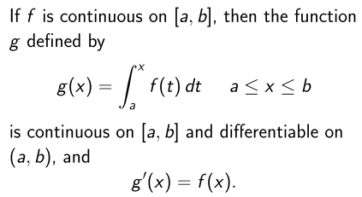

How would I prove this? Look at the limit from both directions.

g(x+dx) = $^{\int_{a}^{x+dx}{}}$f(t)dt = g(x) + $^{\int_{x}^{x+dx}{}}$f(t)dt = g(x) + dx f(x) since f(t) is continuous

If f(t) blows up at t = x, it is not continuous there! I know this from Chapter 2

Theorem 10: f continuous on closed and bounded (compact) S in En ⇒ f is bounded on S .

Thus, if S is closed and bounded like [a,b], and if f is unbounded on S, it cannot be continuous on S.
Thus, we may assume f(x) is finite so we have

g(x+dx) = g(x) + dx f(x)

This says as we approach x from x ± dx, we get g(x), so g(x) must be continuous at x. And g(x) is obviously differentiable since f(x) is the derivative of g(x), so I guess that is a proof. Note that g(x) is continuous from the inside at the endpoints, but might not be differentiable at the endpoints since you have no idea what the function does outside the endpoints other than it

Lemma PL1. Suppose f(x) is C2. Then ∂2f(x) = f"(x) exists and is continuous by C2 definition. By Theorem PL1 we then know that f'(x) is continuous and differentiable and thus f(x) is also C1.

Theorem PL2. If f(x) is Cm , it is also Cm-1.

Theorem PL3. If f(x) is Cm , it is also Cm-1, Cm-2....C1, C0. QED

If we try to approximate a function f(x) near x0 by a poly of degree n, one way is to insist that ∂nP(x) = ∂nf(x) at this one point, and this results in the Taylor series polynomial which one could write P(x; n,x0) to stress dependence on x0 and n.

A major subject is estimating the error in the fit of f(x) with P(x; n,x0). At x = x0 all the higher terms vanish and we have an exact fit, that is to say, P(x0; n,x0) = f(x0), so we expect the error to somehow be proportional to |x-x0| perhaps to some power. Note that Rn(x) ≡ f(x) - P(x; n,x0) .

Theorem 11 [126] gives an exact formula for the error as an integral:

Rn(x; x0) = (1/n!) $^{\int_{x0}^{x}{}}$dt f(n+1)(t) (x-x0)n

and you can see that this vanishes in some manner as x→ x0 both from integrand and endpoints!

Their proof is as follows. Let t stand in for the expansion point x0 and define g(t; x) as follows:

g(t; x) ≡ P(x; n,t) = f(t) + f'(t)(x-t) + (1/2!) f"(t)(x-t)2 + ... = Σm=0n (1/m!) f(m)(t) (x-t)m

Note for use below that

∂tg(t; x) = Σm=0n (1/m!)∂t[ f(m)(t) (x-t)m]

= Σm=0n (1/m!)[ f(m)(t) m (x-t)m-1(-1) + f(m+1)(t) (x-t)m ]

= Σm=0n (1/m!)[ f(m)(t) m (x-t)m-1(-1)] + Σm=0n (1/m!) [ f(m+1)(t) (x-t)m ]

= Σm=1n (1/m!)[ f(m)(t) m (x-t)m-1(-1)] + Σm=0n (1/m!) [ f(m+1)(t) (x-t)m ] ≡ S1+ S2

because the m = 0 term in the first sum vanishes. Now in the second sum let m' = m+1 so that

S2 = Σm=0n (1/m!) [ f(m+1)(t) (x-t)m ] = Σm'=1n+1 (1/[m'-1]!) [ f(m')(t) (x-t)m'-1 ]

= Σm=1n+1 (1/[m-1]!) [ f(m)(t) (x-t)m-1 ] //changed m' to m, now sep out last term

= Σm=1n (1/[m-1]!) [ f(m)(t) (x-t)m-1 ] + (1/[n]!) [ f(n+1)(t) (x-t)n ]

≡ S3 + (1/n!) [ f(n+1)(t) (x-t)n ] .

Meanwhile we can write

S1 = Σm=1n (1/m!)[ f(m)(t) m (x-t)m-1(-1)] = Σm=1n (1/[m-1]!)[ f(m)(t) (x-t)m-1(-1)] = - S3

So we end up with

∂tg(t; x) = S1+ S2 = (-S3) + { S3 + (1/n!) [ f(n+1)(t) (x-t)n ] } = (1/n!) [ f(n+1)(t) (x-t)n ]

and so two series cancel out and we get a single term as the result.

Meanwhile, consider:

g(x; x) - g(x0; x) = P(x; n,x) - P(x; n,x0) = f(x) - P(x; n,x0) = Rn(x; x0)

Then you can write

Rn(x; x0) = g(x; x) - g(x0; x) .

Now think of x0 as the variable and x is a fixed number. Then we can write

g(x; x) - g(x0; x) = $^{\int_{x0}^{x}{}}$dt ∂tg(t; x)

So that

Rn(x; x0) = $^{\int_{x0}^{x}{}}$dt ∂tg(t; x)

and we now have Rn expressed as an integral. But we computed ∂tg(t; x) above, so result is

Rn(x; x0) = $^{\int_{x0}^{x}{}}$dt { (1/n!) [ f(n+1)(t) (x-t)n ]} = (1/n!) $^{\int_{x0}^{x}{}}$dt f(n+1)(t) (x-t)n QED

Corollary 1. [126] Start with the above result,

Rn(x; x0) = (1/n!) $^{\int_{x0}^{x}{}}$dt f(n+1)(t) (x-t)n = $^{\int_{x0}^{x}{}}$dt h(t; x)

Now the "mean value theorem for integrals" which I quote and proved earlier says

$^{\int_{a}^{b}{}}$f(x) dx = f() $^{\int_{a}^{b}{}}$dx = f()[b-a] for some in [a,b]

So I translate this to read

$^{\int_{x0}^{x}{}}$dt h(t; x) = h(τ; x) $^{\int_{x0}^{x}{}}$dt = h(τ; x)(x-x0) for some τ in [x,x0]

Therefore,

Rn(x; x0) = h(τ; x)(x-x0) = { (1/n!) [ f(n+1)(τ) (x-τ)n ]} (x-x0)

I think this is probably true for some τ, but it is not the desired result! So let's try our "weight added" version of the mean value theorem:

$^{\int_{a}^{b}{}}$f(x)g(x)dx = f() $^{\int_{a}^{b}{}}$g(x)dx

which we rewrite with renamed variables

$^{\int_{a}^{b}{}}$F(t)g(t)dt = F(τ) $^{\int_{a}^{b}{}}$g(t)dt τ somewhere in [a,b]

and we want to apply this to

Rn(x; x0) = (1/n!) $^{\int_{x0}^{x}{}}$dt f(n+1)(t) (x-t)n

So write

$^{\int_{x0}^{x}{}}$F(t)g(t)dt = F(τ) $^{\int_{x0}^{x}{}}$g(t)dt τ somewhere in [x0,x]
or
$^{\int_{x0}^{x}{}}$[ f(n+1)(t) / n!] (x-t)ndt = [ f(n+1)(τ) / n!] $^{\int_{x0}^{x}{}}$ (x-t)n dt τ somewhere in [x,x0]

Now we are claiming that g(t) = (x-t)n where t < x in the integration, so x-t > 0 and then g(t) > 0 as required. Then we can do the little integral

$^{\int_{x0}^{x}{}}$ (x-t)n dt = (-1)n $^{\int_{x0}^{x}{}}$ (t-x)n dt = (-1)n 1/(n+1)* (t-x)n+1 | xx0

= (-1)n 1/(n+1)* [ 0 - (x0-x)n+1] = (-1)n+1 1/(n+1)* (x0-x)n+1 = 1/(n+1)* (x-x0)n+1

And then we get this final result

Rn(x; x0) = (1/n!) $^{\int_{x0}^{x}{}}$dt f(n+1)(t) (x-t)n = $^{\int_{x0}^{x}{}}$[ f(n+1)(t) / n!] (x-t)ndt

= [ f(n+1)(τ) / n!] $^{\int_{x0}^{x}{}}$ (x-t)n dt = [ f(n+1)(τ) / n!] 1/(n+1)* (x-x0)n+1

= [ f(n+1)(τ) / (n+1)!] (x-x0)n+1

which is the result at the bottom of page 126 as Corollary 1.

Corollary 2. [ 127] This just write things out as

f(x) = P(x; n,x0) + Rn(x; x0)

= Σm=0n (1/m!) f(m)(x0) (x-x0)m + f(n+1)(τ) (x-x0)n+1 / (n+1)!
truncated Taylor remainder part

where we don't know τ but we know it lies in the range [x0,x] .

The fact that the remainder can be written in the above manner is "Taylor's Theorem".

Comment: This stuff seems to require that x ≥ x0 but surely the results apply for x ≤ x0 as well, perhaps with some sign change. I will hold off on this, maybe Bucks will comment.

For n = 0 Corollary 2 says

f(x) = f(x0) + f'(τ) (x-x0)

which compare to our notes above y(b) = y(a) + y'(c)(b-a) = MVT of diff calculus.

Example 1: f(x) = ex They show that | Rn | < e/(n+1)! x0 = 0 Maclaurin

For example, with n = 5 you get 1/6! = .0014 so keep just 5 terms with error .0014 out of 2.73.

Definition: f(x) is analytic at x0 if it is C∞ in some open interval around x0 AND Rn → 0 on interval.

In other words, you can use an infinite Taylor series for an analytic function.

Counterexample 1: f(x) = exp(-1/x2) which I think is an essential singularity at x = 0. It turns out that as x→0, the function and all derivatives →0, so we seem to have C∞. It turns out that f(x) is analytic in any interval not including x = 0. It turns out that f(n)(x) = x-3n Poly2n-1(x) exp(-1/x2) and the last factor is what causes f(n)(0) = 0. Then the Taylor series is a sum all zeros and remainder is always exp(-1/x2) for n terms, so we do not have Rn → 0. For that reason, f(x) is NOT analytic at x = 0, even though it is C∞ there.

[ p 129] Example 2. They comment that the Taylor series may not be the most accurate polyn for a given f(x), and example of ex is given.

Example 3: Consider f(x) = 1/(1+x2) = 1 - x2 + x4 - x6 ...

I think in Ahlfors language, this has a convergence disk of |x| < 1, so it diverges outside that. The implication here for Bucks is that as you add more terms, accuracy gets worse after some point of you consider x outside the unit disk.

Example 4: One way to integrate a function is to approximate the integrand as a Taylor series. Here the function exp($\sqrt{x}$) is expanded in a Taylor series and the integral done by approximation in this way.

Question: Why was the Taylor expansion presented in this chapter on "integration"? It seems perhaps a little out of place. In 3rd Ed, the integration chapter is preceded by a differentiation chapter and the Taylor series is put there. Amazon has the TOC for 3rd Ed.

3.4 Improper Integrals

In terms of a 1D integral, improper could mean either that the domain is infinite at one of both ends, or that the function is infinite somewhere, or both. For general D, the domain D could be infinite, and the function could take one or more infinite values on the domain.

The first problem is handled first.

Example 1 [131] is Fig 3-6 which shows an infinite domain D. I cover it with a sequence of rectangles (squares) which have upper right coordinate (n,n). The main idea is that as the set expands, you capture more and more of the area of D. The amount captured, which is A(Dn) where Dn = D ∪ Rn, is a monotonically increasing set of real numbers, so either this sequence has a limit or it does not. If we could show there was an upper bound, we would know (an earlier theorem) that it converges to some finite value. For this example, we explicitly compute A(Dn) = 2 tan-1(n). This has the obvious limit 2, and then that is our answer. Notice how the concept of "area" is mapped into the concept of a "sequence" which we know something about from earlier sections. We get to use tools developed earlier.

Example 2 [131] is different. One eight of the area of interest is shown in Fig 3-7 in gray. We just do that area and multiply by 8 to get the full answer. A piece of the right edge of the square Rn is shown. We explicitly compute the area shown in gray which is A(Dn) and it has two pieces I call integrals α and β. Although we perhaps could do the β integral, the Bucks instead show that the integrand is ≥ 1/2x and then also by an earlier theorem, we know that β ≥ 4 ln (n) and so then α+β ≥ 4 + 4 ln(n). Clearly there is no bound since this keeps increasing with n, and so the integral diverges in this example.

Example 3 [132] is the same idea with a similar picture but has 4th powers instead of 2nd powers on f(x,y). In this case α integral is the same, but the β integral is shown to be ≤ 8(1/2-2/2n2) → 4. In this case, then, we find that α+β ≤ 8, and there IS a bound, and so the integral converges. But we have not computed the value, we just have shown it is some finite value ≤ 8. Maple cannot do this integral!

Theorem 12 (p 133). The claim is that the integral found by the "expanding rectangles" method is the same no matter what set of rectangles you select, as long as the set forms an expanding cover of the plane.

In the proof, they make a distinction between rectangle Rn and its interior which is called Un which is an open set. Consider one of the other rectangles R'j . Since this is bounded and closed, Heine-Borel says it must be covered by a finite subset of the Un! Since our set is expanding, that means there is some finite integer k such that R'j fits inside Uk. That is to say, for any R'j, there exists some k where R'j ⊂ Rk. When this is intersected with D, you find that D'j ⊂ Dk. You then have

A(D'j) ≤ A(Dk) ≤ limn→∞A(Dn) = B // Heine Borel says finite k exists so A(D'j) ≤ A(Dk)

where we assume this limit exists. So we have

A(D'j) ≤ limn→∞A(Dn) = B

Take the limit as j→∞ and it must be less than the bound B so we have

limn→∞A(D'n) ≤ limn→∞A(Dn)

Now redo the entire logic with prime and no prime reversed and you get

limn→∞A(Dn) ≤ limn→∞A(D'n)

and thus you have shown that

limn→∞A(Dn) = limn→∞A(D'n)

and so if one set of rectangles gives you a finite result, any other set of rectangles must give the same result. What we all like is that this is an application of the Heine Borel theorem. The above proof does not work if there were no finite subcover. Very cool, good work Buckaroos!

So far we have only done "areas" but now we throw in a function and we are talking an integral

∫∫D f

Reminder: Up to now we have required that D be bounded and f be bounded (and continuous). If either D or f is unbounded, Bucks call this an improper integral.

Although the discussion could proceed with D over En, the Bucks consider only D over E1 so we are only dealing with 1D improper integrals here.

The first issue then is what to do with $^{\int_{c}^{∞}{}}$dx f(x) ? What we do is consider limr→∞+ $^{\int_{c}^{r}{}}$dx f(x). If the limit exists, then the integral has that meaning or definition. Examples:

$^{\int_{0}^{∞}{}}$dx e-x = 1 = limit exists

$^{\int_{0}^{∞}{}}$dx sin(x) = [ -cos(x) ]∞0 = -cos(∞) + 1 = does not exist since cos oscillates and lim is undefined.

What you say is that the sin(x) integral "diverges" even though it is bounded between 0 and 2.

You do this same thing for -∞ on the lower endpoint.

Both endpoints infinite. Consider this example:

$^{\int_{-∞}^{∞}{}}$ dx (1+x)/(1+x2) = $^{\int_{-∞}^{∞}{}}$ dx (1)/(1+x2) + $^{\int_{-∞}^{∞}{}}$ dx (x)/(1+x2) = even + odd integrals

If you break each integral down to $^{\int_{-∞}^{0}{}}$ +$^{\int_{0}^{∞}{}}$, then the two odd integrals diverge as ln(∞) while the even integral is finite. The fact that the two odd integrals cancel if you take a simul limit does not matter, the integral is said to diverge. This idea of taking 2 terms like this is the "ordinary integral". The Cauchy principal value limit is different:

CPV = limr→∞ $^{\int_{-r}^{r}{}}$ dx (1+x)/(1+x2)

and when you do it this way, the odd term contribution is always 0 because the two sides cancel

$^{\int_{-r}^{r}{}}$ dx (x)/(1+x2) = 0 since integrand is odd

and so only the finite part survives.
This CPV seems a little different from the similar idea in complex variable theory where we integrate right through a pole and we then have the δ function stuff. No doubt Bucks will get to that later.

We are now bottom of page 135. We have considered infinite domain D (in 1D), and now instead we want to consider an infinite function f situation. The first example is integrating 1/$\sqrt{x}$down to x = 0 where it is infinite. The area is put into the usual sequence form and we find that A(D) = 2 and that is the integral. It is finite, though the integrand is infinite at x = 0. To be consistent with earlier pictures, the top of the picture 3-8 should be white. Maybe they have fixed this in 3rd ed, but I cannot tell from google books.

Comment: In the page 136 figure, the line 1/n2 has played no role yet and adds confusion. Yes, it is correct, but why do they show it?

For some general function (not just 1/$\sqrt{x}$) you can restate what was done above in this way

A(D) = limn→∞ { $^{\int_{a}^{b}{}}$ dx min(f(x), n) } = limn→∞ { $^{\int_{a}^{b}{}}$ dx fn(x) } = limn→∞ {A(Dn)}

The integral is the grey area in Fig 3-8 if drawn properly with type piece white. So this is just a more general way to do our little actions above. This fn(x) is f(x) truncated at the top at y=n.

Theorem 13. Suppose f is continuous on (a,b] and f≥ 0. Then the A(D) [ shown above as a limit on n of the fn integral] is in fact the same as lim r→a $^{\int_{r}^{b}{}}$ dx f(x). I guess the idea is that f(x) is not continuous at a, but things still work. Somehow this seems obvious to me. We have f ≥ 0 so there will be no negative area contributions to confuse things. I will skip the proof and move on.

Theorem 13 There are two ways to take the limit for an integral of the type shown in Fig 3-8 where the integrand is unbounded at one end, which we will assume is the "a" end.

1. A(D) = limn→∞ $^{\int_{a}^{b}{}}$dx fn(x) fn(x) = f(x) sliced off at y = n

2. A(D) = limr→a $^{\int_{r}^{b}{}}$dx f(x)

In the first method, we first integrate the "sliced off function fn(x)" over the full interval [a,b] at each fixed n and get some An, then we take A = limn→∞An. In the second method we integrate the full function only on [r,b] to get some Ar and then take A' = limr→aAr. Here "a" is the singular end. The claim is that you always get A = A' as long as f is continuous on the entire interval except at the problem point a, and as long as f(x) is non-negative. This seems very reasonable to me, and I skip the proof. One implication of A = A' is that if either is finite, then the other is finite and has the same value. If either is infinite, so is the other, and you have a divergent integral.

Example 1 page 138. This shows the r-limit method outlined above, but at the upper endpoint b = 1, and the integral in the example is finite.

Example 2 page 138. This integral has a discontinuity at both ends, so the first step is to break it into the sum of two intervals where the boundary is put at some safe continuous point, here x = 1/2. Then you study each integral separately using the r-method. They shows that the 0 to 1/2 integral, though it has problem at x = 0, nevertheless converges by the r-method. The 1/2 to 1 integral with problem at x = 1 is shown to diverge at that end. Thus, the original integral is divergent.

Example 3 page 139. The integral shown here has both issues at once: (1) it has an unbounded domain D since the upper endpoint is ∞; (2) it has an unbounded integrand at x = 0. The Bucks break it into two integrals each of which has only one of the problems. In this example, each of the two integrals converges, but they don't bother to do them.

Change of Variables. If you do x = φ(u) where (as usual) φ(u) must be C' on the mapped interval [α,β], then even if you have to take a limit to show that φ(β) = b, the variable change is allowed. If the converted integral is convergent, then so was the original integral!

Example 4 page 139. The original dx integral has 0 as problem endpoint, but the converted du integral has no problem endpoints and is finite, from which we conclude that the original integral is convergent.

Example 5 page 139 . Upper endpoint is ∞, but change to θ and both endpoints are finite and integrand is also finite so you end up with a finite integral.

Example 6 page 139 . This one again has ∞ as an endpoint. The variable change to u converts this integral to $^{\int_{0}^{1}{}}$sin(1/u)du . Although the sin oscillates very fast at u =0, the integrand is bounded, the domain is bounded, and the integral is finite:

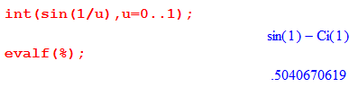

You are always allowed to split any integration interval into a union of subintervals. If any of the sub-integrals diverges, then the original integral diverges (in the ordinary sense, ignoring CPV). BUT, this rule does not apply to other integral sums.

1. $^{\int_{a}^{c}{}}$dx f(x) = $^{\int_{a}^{b}{}}$dx f(x) + $^{\int_{b}^{c}{}}$dx f(x) // this is always OK

2. $^{\int_{a}^{c}{}}$dx [ f(x) + g(x) ] = $^{\int_{a}^{c}{}}$dx f(x) + $^{\int_{a}^{c}{}}$dx g(x) // can have a problem

The problem that can be had is that you might find the two integrals on the right diverge, but the integral on the left converges, as shown in the Example 7 page 139. The divergent contributions associated with endpoint a = 0 in this example happen to cancel if you do it as the single integral on the left.

Theorem 14 (Comparison Test) page 140. Here we assume that endpoint b might have a problem, and we assume that 0 ≤ f(x) ≤ g(x) on [a,b). Note that both functions are non-negative as well as f is smaller than g. The obvious result is that $^{\int_{a}^{b}{}}$dx f(x) ≤ $^{\int_{a}^{b}{}}$dx g(x) . So if the g(x) integral is finite, so is the f(x) integral, though you don't know what it is.

Corollary. At first this seems strange, but it is OK. Now both functions f and g are non-negative, but neither is larger than the other by requirement. Consider the ratio r(x) = f(x)/g(x). We are still working on the interval [a,b). Suppose r(x) → L at the right endpoint b, where L is positive and finite. This rules out the possibility that f(b) = 0 or g(b) = 0 [ but allows 0/0 if limit L is finite]. The corollary then claims that ∫f and ∫g either both diverge or both converge, so this puts another convergence test in your toolbox.

The proof starts out in a confusing way that took a while to understand. If r(x) = L at the right endpoint, and if f and g are both continuous in a tiny region to the left of x = b, then in that small region which they refer to as (x0,b) the function r(x) will still be close to L, so we will have L/2 ≤ r(x) < 2L in this tiny region (the 2's could be 3's). This then lets you say f < 2Lg and g < (2/L)f. By Theorem 14, f < 2Lg tells you that ∫f converges if ∫g converges, and g < (2/L)f tells you the reverse. So ∫f converge ⇔ ∫g converge. If either converges, so does the other. Contrapositively, if either diverges, so does the other. I did not mention this detail: we are only talking about the integrals over the little interval leading up to endpoint b, but this is all that matters if you are talking convergence. We are assuming in other words that the right endpoint might have an issue and that the other end and middle is OK. I do think Bucks have omitted to state that f and g should be continuous away from endpoint b.

So this Theorem and the Corollary provide two useful convergence tests. We first arm ourselves with the obvious facts at the bottom of page 140, just to have this data at hand. Then we state a new theorem and consider some examples.

Theorem 15. ∫|f| converges ⇒ ∫f converges . A trivial tiny proof is given which I buy.

Note Added later: Combine the two theorems 15 and 14, where we have one problem endpoint which is part of the theorem 14 premise. Then

∫f ≤ ∫|f| and |f| ≤ |g| => ∫f ≤ ∫ |g|
so that ∫ |g| converges ⇒ ∫f converges

In Example 1 below, f = sinx/x2, |f| = |sinx/x2| , g = |1/x2|.

Example 1 page 141. First, we know that $^{\int_{1}^{∞}{}}$dx sinx/x2 ≤ $^{\int_{1}^{∞}{}}$dx |sinx/x2| from Theorem 15. Second, we know that $^{\int_{1}^{∞}{}}$dx |sinx/x2| ≤ $^{\int_{1}^{∞}{}}$dx |1/x2| from Theorem 14 since f = |sinx/x2| ≤ g = |1/x2| . Combining these two facts we conclude that $^{\int_{1}^{∞}{}}$dx sinx/x2 ≤ $^{\int_{1}^{∞}{}}$dx |1/x2| = finite.

Example 2 page 141. First, we know that $^{\int_{0}^{1}{}}$dx cos(1/x)/$\sqrt{x}$ ≤ $^{\int_{0}^{1}{}}$dx |cos(1/x)/$\sqrt{x}$| from Theorem 15. Second, we know that $^{\int_{0}^{1}{}}$dx |cos(1/x)/$\sqrt{x}$| ≤ $^{\int_{0}^{1}{}}$dx |1/$\sqrt{x}$| from Theorem 14 since
f = |cos(1/x)/$\sqrt{x}$| ≤ g = |1/$\sqrt{x}$| . Combining these two facts we conclude that
$^{\int_{0}^{1}{}}$dx cos(1/x)/$\sqrt{x}$ ≤ $^{\int_{0}^{1}{}}$dx |1/$\sqrt{x}$| = finite, so the integral is finite. This example is just like the preceding example but the problem endpoint is left 0 instead of right ∞.

Example 3 page 141. Now we have an issue at each endpoint 0 and ∞. We know we are OK at the lower endpoint since sinx/x → 1 so we are integrating 1/$\sqrt{x}$ near x = 0 which we know is OK. So break the integral into two pieces, 0 to 1 and 1 to ∞, and the first integral is OK and we then have only to ponder the 1 to ∞ integral. But on the 1 to ∞ interval we can apply the same logic as the previous two examples which shows that the 1 to ∞ integral is finite. Thus, the full 0 to ∞ integral is finite.

∫f = absolutely convergent if ∫|f| is convergent. [ so then we know ∫f also converges ]

∫f = conditionally convergent if ∫f also converges but ∫|f| diverges.

All examples above were the first case.

Example 4 page 141. This example $^{\int_{1}^{∞}{}}$dx sin(x)/x with issue at ∞ endpoint does not succumb to our method of the first two examples above since ∫1/x is log divergent at ∞, so we don't know by that method whether this integral converges or not. I suspect it does since the sine chops up the log.

Integration by parts I guess is valid even if you have problem endpoints. You just do it at finite r and then take limit. We now continue Example 4 doing parts, first backing off the endpoint from ∞ to r :

$^{\int_{1}^{r}{}}$dx sin(x)/x = as shown page 142

There is then no problem with the r→∞ limit after doing parts, and then line A shows that the resulting integral $^{\int_{1}^{∞}{}}$dx sin(x)/x is finite, but they don't evaluate the result, though I will :

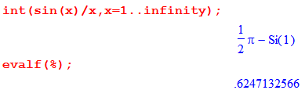

and

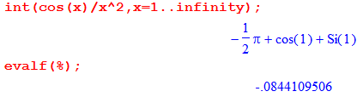

Example 5: What do we know about $^{\int_{1}^{∞}{}}$dx |sin(x)/x| ? Maple refuses to do it. On page 142 with much ado, the Bucks show that $^{\int_{1}^{∞}{}}$dx |sin(x)/x| ≥ finite + (π/2) log [ (m+1)/2 ] where we are supposed to take m→∞ to get our result. We conclude that $^{\int_{1}^{∞}{}}$dx |sin(x)/x| ≥ ∞ and so diverges. In this situation, the sine no longer "dices up" the 1/x with both signs and you lose the converging effect.

Therefore: $^{\int_{1}^{∞}{}}$dx sin(x)/x = convergent
$^{\int_{1}^{∞}{}}$dx |sin(x)/x| = divergent
=> $^{\int_{1}^{∞}{}}$dx sin(x)/x = conditionally convergent

Example 6 page 143. The integral has an issue at x = ∞ but to me it "looks" convergent there. We do the parts integration (this time skipping the notation r→∞). The new questionable integral certainly looks much more convergent now with an extra 1/x in the integrand. You can apply the Theorem 14 to show that the resulting integral is less than the one without the sin(x) factor. But it is not really obvious to the reader why this resulting integral converges, reader would have to prove that. But it turns out this is a doable integral,

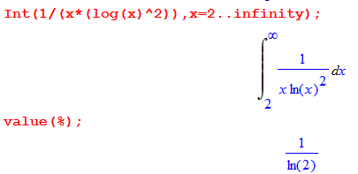
and there you are.

Theorem 16 (Dirichlet Test). This is a fairly complicated theorem to state, and it relates to the product of two functions f(x)g(x) for an integral with upper endpoint ∞. You assume the three items:
1. f, g and g' are continuous on [c,∞) and define F(r) ≡ $^{\int_{c}^{r}{}}$f(x)dx
2. ∫g' is absolutely convergent (which just means ∫|g'| is convergent)
3. Define F(r) ≡ $^{\int_{c}^{r}{}}$f(x)dx and assume F(r) is bounded on [c,∞)
THEN ∫fg converges.

Question: Could you replace item 3 with premise: ∫f converges ?
No! For example, $^{\int_{c}^{r}{}}$sin(x)dx is bounded but does not converge.

In any event, Bucks give a trivial proof which I read and accept.

Corollary 1. (Theorem 16a) This is an alternate statement of Theorem 16 where we replace premise 2 by this:
New item 2: g(x) is monotone decreasing down to 0

Now g(x) is always positive, and now g(x) looks a little more like an above, decreasing to 0. Note that g'(x) is then always negative. Bucks trivially show that such a g(x) meets property 2.

Notice the vague similarity between Theorem 16a and the Dirichlet test for sequences. The monotone decreasing g(x) → 0 appears as monotone decreasing sequence an → 0

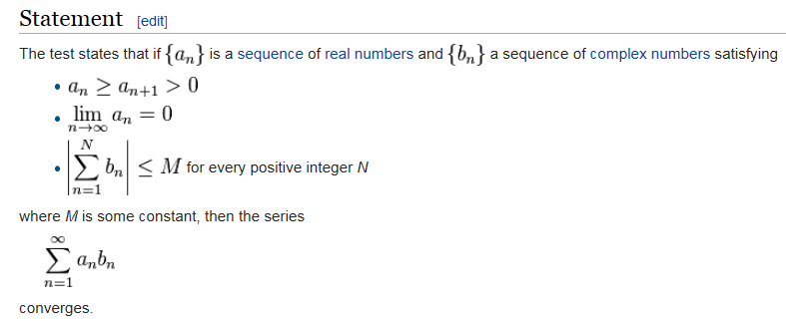

You could doubtless take the sequence theorem to the continuum in a limit. Then sequence an becomes the continuous function g(x) and Σ1N b(n) becomes $^{\int_{c}^{r}{}}$f(x)dx and so on.
Corollary 2. This is nothing more than Theorem 16a for f(x)= sin(x) or cos(x). Each of these functions is of course continuous and has a bounded integral.

Example 1: Consider $^{\int_{0}^{∞}{}}$cos(x)/$\sqrt{x}$. We know this is OK at the x = 1 endpoint since ∫1/$\sqrt{x}$ converges there, so the upper endpoint is the only issue. But think of g(x) = 1/$\sqrt{x}$ which is our monotone decreasing function. By Corollary 2, the integral converges, and here is Maple chiming in,

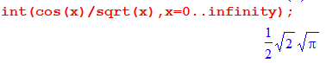
Phil Exercise 1 -- a Long Digression on a Specific Integral Type

A more dramatic example would be this

$^{\int_{0}^{∞}{}}$cos(x) / x.01

which I cannot make Maple do analytically or numerically. At the low end, we are highly convergent, while at the high end just barely convergent. Now g(x) = 1/x.01 which is monotone decreasing, albeit very slowly. Even x.4 is a problem. I have no idea how to compute this integral and neither does Wolfram Alpha. The problem might be this: as you get way out near x = 106, say, you might like to take a small Δx = 100 as reasonable for a trap rule. But cos(x) winds like mad in this interval!

Idea: Suppose you chop up the range into pieces each being 2π wide. Then

I = Σn=0∞ $^{\int_{2πn}^{2πn+2π}{}}$cos(x) / x.01

Now let y = x - 2πn so

$^{\int_{2πn}^{2πn+2π}{}}$dx cos(x) / x.01 = $^{\int_{0}^{2π}{}}$dy cos[y+2πn] / [y+2πn].01 = $^{\int_{0}^{2π}{}}$dy cos(y) / [y+2πn].01

Maple can numerically do this integral for any integer n. So I am claiming that

$^{\int_{0}^{∞}{}}$cos(x) / x.4 = Σn=0∞ Jn Jn ≡ $^{\int_{0}^{2π}{}}$dy cos(y) / (y+2πn).4

or more generally for α in the range (0,1] (at least) ,

$^{\int_{0}^{∞}{}}$cos(x) / xα = Σn=0∞ Jn Jn ≡ $^{\int_{0}^{2π}{}}$dy cos(y) / (y+2πn)α

So here is some Maple code to compute this integral by numerically integrating each Jn term. I start using exponent 0.5 since I know what the right answer is for that case,

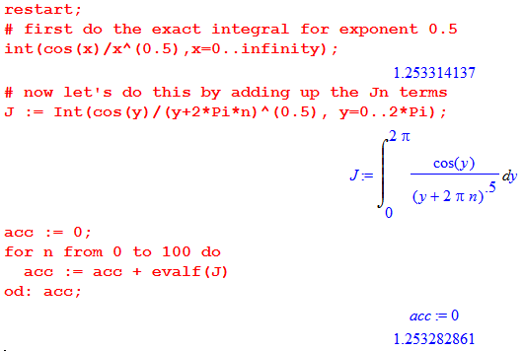

Here you see that adding up the first 200 terms gives the right answer to 5 decimal places. Now try the exponent 0.4. I let Maple add up 2000 terms with Digits = 20 just to be safe. Here is what the end of the sequence of sums looks like:

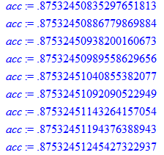

It is still upticking in the 9th place, so one is not really sure this thing is stable, but it is certainly tempting to say that the integral is .87532 to 5 decimal places.
Here is an interesting GR7 integral (p 439 )

Suppose I set u = 0 and a = 1, this says

$^{\int_{0}^{∞}{}}$dx cos(x) / x1-μ = Γ(μ) cos(πμ/2) 0 < μ < 1

Replace 1-μ = α so μ = 1-α, to get

$^{\int_{0}^{∞}{}}$dx cos(x) / xα = Γ(1-α) cos(π[α-1]/2) 0 < α < 1

Now
cos(π[α-1]/2) = cos(πα/2 - π/2) = cos(π/2-πα/2) = sin(πα/2)

so my result is

$^{\int_{0}^{∞}{}}$dx cos(x) / xα = Γ(1-α) sin(πα/2) 0 < α < 1

Let's test this for α = 0.5. RHS is then Γ(0.5) sin(π/4) = 1.2533141373155002512 in agreement with the result quoted above. Therefore I predict

$^{\int_{0}^{∞}{}}$dx cos(x) / x0.4 = Γ(0.6) sin(π(0.4)/2)

Thus my gut feel for 5 decimal places was OK, but the next place was not stable! Next,

$^{\int_{0}^{∞}{}}$dx cos(x) / x0.01 = Γ(.99) sin(π(0.01)/2)

What is the limit as α→ 1? Then we have $^{\int_{0}^{∞}{}}$dx cos(x) / x which blows up at x = 0.
What is the limit as α→ 0? Then we have $^{\int_{0}^{∞}{}}$dx cos(x) . This result (see p 134 for sine) does not exist, but the limit $^{\int_{0}^{∞}{}}$dx cos(x) / xα converges to 0 for any tiny α > 0.

These two facts hopefully explain this plot of Γ(1-α) sin(πα/2)

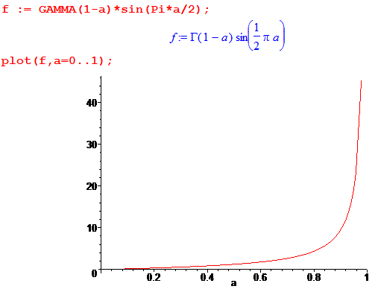

Just for fun, what happens with the sine case? Go back to the GR7 well

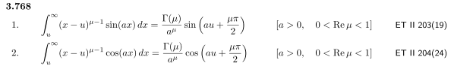

so then with u = 0 and a = 1 we get

$^{\int_{0}^{∞}{}}$dx sin(x) / x1-μ = Γ(μ) sin(πμ/2) 0 < μ < 1

Replace 1-μ = α so μ = 1-α, to get

$^{\int_{0}^{∞}{}}$dx sin(x) / xα = - Γ(1-α) sin(π[α-1]/2) 0 < α < 1

Now
sin(π[α-1]/2) = sin(πα/2 - π/2) = - sin(π/2-πα/2) = - [cos(πα/2) ]

so the result is

$^{\int_{0}^{∞}{}}$dx sin(x) / xα = Γ(1-α) cos(πα/2)

which is the same as the cos(x) case but with sin→cos on the RHS. That is:

$^{\int_{0}^{∞}{}}$dx cos(x) / xα = Γ(1-α) sin(πα/2) 0 < α < 1
$^{\int_{0}^{∞}{}}$dx sin(x) / xα = Γ(1-α) cos(πα/2) 0 < α < 1

The pole at zero cancel at α = 1, so this might be OK for 0 < α < 2, and Maple shows this:

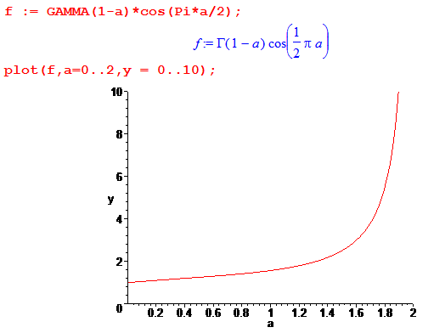

In particular for α → 0 we get integral = 1. Here are plots of the two functions for α = 0.1 and you see perhaps why the green sine integral grabs more positive area at the start than the cosine integral, even though the cosine curve in red is in fact unbounded at x = 0. One ahead on area, green sine stays ahead.

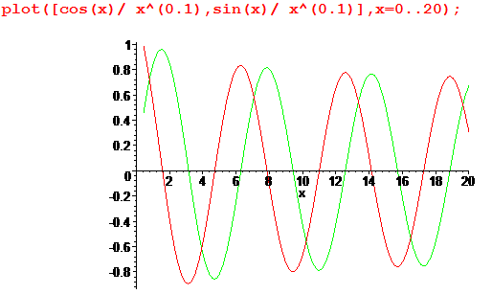

In fact, here are numeric integrals out to π for the two functions, showing green sine wins :

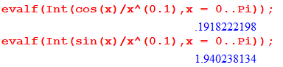

***************************** End of Long Digression ********************************

So we can rehash the two examples on page 144:

Example 1. $^{\int_{0}^{∞}{}}$cos(x2) dx transforms to (1/2)$^{\int_{0}^{∞}{}}$cos(u) du/$\sqrt{u}$. We can see that at low end have 1$\sqrt{u}$ which converges there. At high end it is my example above with α = 1/2 so converges there as well.

Example 2. $^{\int_{0}^{∞}{}}$sin(1/x) dx/x transforms to $^{\int_{1}^{∞}{}}$sin(u) du/u, again OK at high end since we studied this situation in Example 4 on page 141.

Am now mid page 144, ready to cut new ground and it is 1 PM 12/31/14.

[145] Example 1. The context here is that f is bounded and continuous and positive on D. This is stated hidden in text in the lower half of p 144. But we are going to allow D to be infinite, but f is bounded. For D being 2D, one can think of ∫Df as being the volume under f, as in Maple plot3d. One can define the limit here just as was done earlier, with an expanding set of rectangles Rn and we know that the result will be the same for any such set. So now comes the example top page 145. We have f = xye-r^2 and D is the first quadrant, so yes, f is positive and bounded on D, and continuous. Using the obvious set of squares, we compute A(Dn) and get a certain function of n, then the limit gives A(D) = 1/4.

[145] Example 2. We now do the reverse case where D is finite but f is unbounded. This case is trickier as this example shows. We take D = unit square and f = y/$\sqrt{x}$. We still have f being positive and continuous, but it is unbounded on the square edge at x = 0. I plotted it in Maple, pretty simple surface. The Bucks compute this integral as a limit in the two ways discussed earlier: (a) the truncate the top method, and (b) the r limit method. In the page 146 picture, their black dot in misplaced, it should be where I have drawn the circle. The domain then has pieces 1,2 and 3 (three corresponding volumes!). Piece 1 is the truncated piece, and the three integrals are shown bottom page 145, I verified them all in Maple. This gives you as usual A(Dn) and you take the n→∞ limit and find that ∫D f = 1
Turning the page to 145, the integral is recomputed using the r method. In this case, we use a single (double) integral as shown top p 146 which is the region to the right of the vertical dotted line in Fig 3-9. Things are easier here, and we then take r→0 to get the same answer 1.

Page 146 states a "Definition" of the meaning of the convergence of ∫D f. It allows D to be infinite, and but need f continuous and positive on D (but f could be unbounded). Now instead of Dn = D ∪ Rn with rectangles Rn, you can use any more general "expanding sequence of closed sets" Dn which converges to D. It then says the double integral converges if the sequence ∫Dn f → a finite value c. I wonder if this is guaranteed to be the same value c for any choice of the sets Dn?

[146] Example 1. We take f = (x2+y2)-λ and D = unit disk. We take the Dn to be an annulus of inner radius r, for r>0 we avoid the problem at r = 0. It is easy to compute A(Dn) = A(r), and we find that the answer is integral = π(1-λ) as long as λ < 1. Otherwise the integral diverges.

Up to now, f has been non-negative on the domain D, but now we allow general f, and we get right into some trouble.

[147] Example 2. We take f = sin(r2) and D = first quadrant. So f happens to be bounded, but the domain is infinite. Obviously f takes both positive and negative values.
In their first gambit, they take the Rn squares with obvious corner at (n,n). The double integral of f is easy to do and the result is π/4 for this integral.
In the second approach, the Dn are a set of quarter disks of radius n. Using polars, what we get this time is that A(Dn) = (π/4)[1 - cos(n2)] which does not converge! So this different choice of the Dn gives a completely different result !!! We are then led to

Theorem 17. If f is continuous on D and if ∫D |f| converges, then ∫D f converges and has the same value for all choices of the Dn.

This seems about the same as Theorem (p 141) for 1D integrals combined with Theorem 12 (p 133) which says you get the same result for all sets of rectangles, while here for all "sets" of Dn. The proof is pretty simple. Now we have two conclusions:

∫D f exists ⇔ get same convergent result for any Dn // bottom p 148

∫D f exists ⇔ ∫D |f| exists // top p 149.

In the 1D world you had in contrast

∫D f exists ⇐ ∫D |f| exists

which allowed ∫D f to exist and ∫D |f| NOT to exist, a situation called conditional convergence. This condition it seems is not possible in the 2D world.

[149] Example 1. The example is a 1D integral e-x^2 on (0,∞). Maple says the indefinite integral involves the error function, fine. There are two things said for this example:

(a) You can show that the tail above R is less than e-R so if you want the integral accurate to .001, you could first pick R to make the tail less than .0005. You are left with the finite (0,R) integral which you could then do for example by Simpson's Rule to accuracy of .0005. Then add and the result is accurate to the desired .001. So Bucks are talking about an approximation method here, an interest of theirs.

(b) In this particular example, there is a trick for doing the integral. You write it squared, then combine into a 2D integral where D = first quadrant. Integrand is positive, so any method works. Bucks go to polar coords and use an R method to get the R→∞ result. The trick here is that dA brings in a factor of r, so then the dr integral is doable as a simple indefinite integral.

Note: Bucks did not mention any 3D integrals, but give one in the last exercise.

3.5 Set Functions [p 151-157]

This is a sort of abstract adder section which is of interest to the Bucks, I will do it. At the end we see that this is a small piece of measure theory, Lebesgue measure and all that stuff.

Define a point mapping as f: D→ R where f(p) maps a single point p in a domain D of Rn to the reals.

Meanwhile, consider some distribution of mass ρ(r) in 3D space. Maybe the distribution contains continuum and delta function point pieces. Suppose we think of the domain as that portion of Rn which contains some mass. That domain is some set of points S within Rn. You can think of this set of points separately from the density function ρ. Perhaps the S is the "support" for ρ, a sort of "matte". You could imagine that there are lots of sets S that are possible. For example, a single point plus an sphere. We shall denote the set of all possible sets S by A. Bucks like to call this set of sets a "collection" of sets, or a "class" of sets, where these terms are not really defined. In any event, for any S you pick, you have S ⊂ A. Now forget ρ for the moment, and think just about volume. Any set S has some "volume" (or area in 2D). So you can certainly talk about a function A : A → R where A(S) = the area of set S in 2D. This thing "A" is thus a mapping from the set of sets of points in Rn to R. Bucks refer to this mapping A as a "set function". The function A has a set S as its argument, whereas the function above f(p) has a single point as its argument.

Bucks want us the think in the abstract about a general set function F : A → R with F(S). On page 152 they define the meaning of saying that the set function F is "finitely additive". The property stated looks a little like the linearity property of a linear point function: f(p1) + f(p2) = f(p1+ p2) where p1 and p2 are disjoint points in space. The property says instead F(S1) + F(S2) = F(S1∪S2) where S1 and S2 are disjoint sets. To me, this says that somehow F(S) is representing an "extensive" property of the set S, something like area or mass or charge, not something like color or temperature.

Bucks want to claim that every possible set function F(S) can be written in the form F(S) = ∫S φ where they really mean you are integrating over space, and φ is a some point function. Our example with mass then says M(S) = ∫S dV ρ(r) and this set function tells you the mass of a set with support S. So they will build up a little set of definitions and theorems.

The Definition of p 152 I would say defines what it means for a set function F(S) to be "continuous at a point p0". The idea is that as you shrink a ball around p0 whose contents of points is in the set S, and the ball has radius δ in Rn, then F(S) → L with closeness ε. It would seem that L = f(p0) for some point function f which is related to set function F. For the area function, A(S) → L = 0, since p a point has no area.

Example: if F(S) is mass density ρ(S), then at some point p0 it has a value which you can arrive at by narrowing your sets S until S contains just the point p0. This seems reasonable for a smooth distribution but less reasonable for a delta function ρ.

The next Definition extends the above to all points p in some region D, not just for p0. Then the idea is that F(S) → L(p) where now L depends on the point. They call it g(p), and it is going to end up being φ of the above claim. This definition describes F being "uniformly continuous" on D.

[153] We come now to a very strange definition of a "derivative of a set function at point p". Remember this is all abstract so far. They define

F'(S at p) = limS→p F(S)/A(S).

It seems clear that the limit would just be ρ(p), our mass density for that example. We are now ready for

Theorem 18. Let: D = open set in En whose boundary has "no area".
φ = a point function continuous and bounded on D
F = the set function defined as F(S) = ∫S φ

Then the set function derivative F'(S at p) exists for all p within any rectangle in D, and in fact we have
F'(S at p) = φ(p). Since p can be anywhere in D, we say that the set function F(S) is uniformly differentiable on D and that derivative is φ(p) for any p in D. I skip the proof. It does not make use of any external theorems, just a set of ε δ type steps.

Theorem 19. Let: F(S) = defined for at least all rectangles in Rn
[p 154] F(S) = uniformly differentiable on some closed rectangle E in Rn
where the derivative is f(p) for p in E
F(S) = finitely additive as defined above

Then f(p) is continuous on E, and one can write F(R) = ∫R f for any rectangle inside E.

This is close to saying that for any D in Rn if F(S) is uniformly differentiable and additive over D, then you can "represent" F(S) as the integral of f(p) which is the derivative of F(S).

Here is wiki on fundamental theorem of calculus:

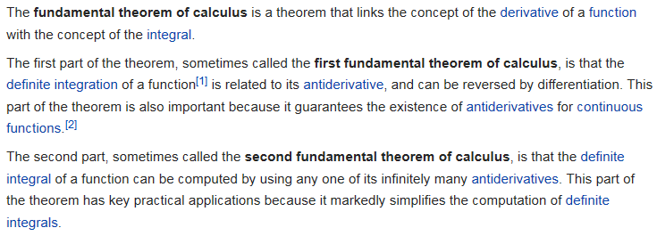

So Theorem 19 is showing that if f is the set derivative of F, then F is the set integral of f, and one can refer then to F as the "set antiderivative" of f. We have proven that for any f(p), the antiderivative F(S) exists. So we are mimicking the FTOC of 1D simple calculus with our fancy set functions.

The proof of Theorem 19 is a whole page of ε δ work and I have not studied it.

Corollary [ p 155] : If you add the "monotone property" that S1 ⊂ S2 ⇒ F(S1) ⊂ F(S2) to the previous theorem (smaller set of points must have a smaller total mass, for example, or a smaller area, or a smaller amount of any extensive property), then the previous theorem can be extended to apply not just to any rectangle R inside rectangle E, but to any set S in inside E. This then completes the FTOC idea outlined above. Again, I skip the proof.

Bucks claim they will use some of this set function theory for handling change of variables in integration in Chapter 6. The general subject is called "measure theory" and involves something called the Radon-Nikodym Theorem (1930). A "set function" is really within the "theory of Jordan content and finitely additive measures". You can see that an integration volume dV is a "measure" and changing variables is going to deal with this object. Think of the invariant Haar measure dg on a group, etc. Bucks give a reference to Halmos's 1950 Measure Theory book. The RN theorem and set functions are addressed on page 137 of my own Riesz Sz.-Nagy book on Functional Analysis. Though this book does not seem to mention "Jordan content", it is very strong on Lebesgue measure; here from wiki:

