Buck and Wolfram Mobius Strips PhL 2.26.15

Bucks deal with this on page 340, Wolfram here

http://mathworld.wolfram.com/MoebiusStrip.html

The problem was converting the equations r = Σ(u,v) to a cubic equation so I could maybe figure out a way to plot the surface. Here are my notes on that cubic equation derivation, it was quite messy. In the end I didn't really need that cubic equation, but here it is anyway. So the fancy Mobius Strip can be generated from a simple cubic function f(x,y,z) = 0. That is to say, it lies on this global surface, see below.

Mobius Algebra:

Start with (6-33) and replace

sin(u/2) = s cos(u/2) = c = $\sqrt{1-s2}$ sin(u) = 2sc = 2s$\sqrt{1-s2}$ cos(u) = 1-2s2

The three equations are then (I have replaced constant 2 with R)

x = (R-vs)(1-2s2)
y = (R-vs)2s$\sqrt{1-s2}$
±z = v$\sqrt{1-s2}$ // since cos(u/2) could have either sign, thinking of $\sqrt{1-s2}$ ≥ 0.

r2 = x2+ y2 = (R-vs)2 //obvious fact from (6-33)
r = R-vs // probably this is the right root for r

The ±z means that you can swap z ↔ - z at any point and get a new solution. I will assume +.

I want to eliminate v and s from these equations. I will first eliminate v like so:

v = z/$\sqrt{1-s2}$ = $\sqrt{1-s2}$.

I now have two equations as follows

x = (R-$\sqrt{1-s2}$s)(1-2s2)
y = (R-$\sqrt{1-s2}$s)2s$\sqrt{1-s2}$

and I also know that

r = (R-vs) = (R-$\sqrt{1-s2}$s)

Let's solve this last equation for s

(R-r) = $\sqrt{1-s2}$s

$\sqrt{1-s2}$(R-r) = zs

(1-s2)(R-r)2 = z2s2

s2 [z2 + (R-r)2] = (R-r)2 => s2 = $\frac{(R-r)2}{[ z2 + (R-r)2]}$

s = (R-r) / $\sqrt{z2+(R-r)2}$ = $\sqrt{z2+(R-r)2}$

I can then solve for c:

c2 = 1-s2 = 1 - $\frac{(R-r)2}{[ z2 + (R-r)2]}$ = $\frac{z2 + (R-r)2 - (R-r)2}{z2 + (R-r)2}$ = $\frac{z2}{z2 + (R-r)2}$

c = $\sqrt{z2+(R-r)2}$

So I end up again with

s = $\sqrt{z2+(R-r)2}$
c = $\sqrt{z2+(R-r)2}$
v = $\sqrt{1-s2}$
But
1-s2 = $\frac{z2}{z2 + (R-r)2}$

so that
$\sqrt{1-s2}$ = $\sqrt{z2+(R-r)2}$

and then

v = $\sqrt{1-s2}$ = z * $\sqrt{z2+(R-r)2}$ = $\sqrt{z2+(R-r)2}$

So I will again summarize my solutions for s,c and v:

s = $\sqrt{z2+(R-r)2}$
c = $\sqrt{z2+(R-r)2}$

v = $\sqrt{z2+(R-r)2}$ (**)

Comment: I think if you slice the Mobius strip with the z = 0 plane, you get a circle with r = R, known as the "mid point circle". This corresponds to v = 0 in the above.

Now s and c have no dimensions, while v has dimension of z which is all correct. I have derived these equations twice from scratch so I think they are right.

Now go back to the original equations, number then 1,2,3,4:

x = (R-vs)(1-2s2) 1
y = (R-vs)2sc 2
z = vc 3
r = (R-vs) 4

Does any of these equations give the Wolfram cubic?? [ see later ] Try them one at a time:

(4) r = (R-vs) = (R - $\sqrt{z2+(R-r)2}$$\sqrt{z2+(R-r)2}$) = (R - (R-r)) = (R-R+r) = r

No, this one just gives an identity, so it is not the one.

(3) z = vc = $\sqrt{z2+(R-r)2}$ $\sqrt{z2+(R-r)2}$ = z

No, this one also just gives an identity. Continue onwards:

(2) y = (R-vs)2sc = (R-$\sqrt{z2+(R-r)2}$$\sqrt{z2+(R-r)2}$)2$\sqrt{z2+(R-r)2}$$\sqrt{z2+(R-r)2}$

= (R - (R-r)) 2 (R-r)z / [z2 + (R-r)2] = r 2 (R-r)z / [z2 + (R-r)2]

= 2rz(R-r) / [z2 + (R-r)2]

Rewrite this as

y [z2 + (R-r)2] = 2rz(R-r)

yz2 + y(R-r)2 - 2rz(R-r) = 0 (2)

But this has a radical in it, whereas Wolfram's result has no radical

But OK, lets now do equation #1 and see what it says

(1) x = (R-vs)(1-2s2)

Now from above I have

s = $\sqrt{z2+(R-r)2}$ => s2 = $\frac{(R-r)2}{z2 + (R-r)2}$

=> (1-2s2) = 1 - $\frac{2(R-r)2}{z2 + (R-r)2}$ = $\frac{z2 + (R-r)2 - 2(R-r)2}{z2 + (R-r)2}$ = $\frac{z2 - (R-r)2}{z2 + (R-r)2}$

I then get

x = (R-vs)(1-2s2) = (R-$\sqrt{z2+(R-r)2}$$\sqrt{z2+(R-r)2}$) $\frac{z2 - (R-r)2}{z2 + (R-r)2}$

= (R-(R-r)) $\frac{z2 - (R-r)2}{z2 + (R-r)2}$ = r $\frac{z2 - (R-r)2}{z2 + (R-r)2}$

Rewrite this as

x [z2 + (R-r)2] = r [ z2 - (R-r)2 ]

xz2 + x(R-r)2 = rz2 - r(R-r)2

xz2 + x(R-r)2- rz2+ r(R-r)2 = 0 (1)

So next, write the (1) and (2) equations next to each other, each term in each equation is L3

xz2 + x(R-r)2- rz2+ r(R-r)2 = 0 (1)
yz2 + y(R-r)2 - 2rz(R-r) = 0 (2)

As they stand, each of these equations contains a linear r term (shown below) and for that reason, neither equation can be a cubic polynomial as Wolfram suggests. ( r = $\sqrt{x2+ y2}$ = the problem radical).

Is there some way to combine these to eliminate the radical r? Try solving each for r and then set the RHS's equal:

[1] xz2 + x(R-r)2 - rz2+ r(R-r)2 = 0

xz2 + x(R2-2rR+r2) - rz2+ r(R2-2rR+r2) = 0

xz2 +xR2-2xrR +xr2 - rz2+ rR2 - 2Rr2 +r2r = 0

r(-2xR - z2+R2+r2) = -xz2 -xR2 -xr2+2Rr2 // note presence of a "linear r term".

r = $\frac{-xz2 -xR2 -xr2+2Rr2}{-2xR - z2+R2+r2}$

[2] yz2 + y(R-r)2 - 2rz(R-r) = 0

yz2 + y(R2-2rR+r2) - 2rz(R-r) = 0

yz2 + yR2 -2yrR + yr2 - 2rzR + 2zr2 = 0

yz2 + yR2 + yr2 + 2zr2 = + 2rzR + 2yrR

yz2 + yR2 + yr2 + 2zr2 = + r(2Rz + 2yR)

r = $\frac{yz2 + yR2 + yr2 + 2zr2}{2Rz + 2yR}$

Now set [1] = [2] and see what happens:

$\frac{-xz2 -xR2 -xr2+2Rr2}{-2xR - z2+R2+r2}$ = $\frac{yz2 + yR2 + yr2 + 2zr2}{2Rz + 2yR}$

Cross multiply to get

( -xz2 -xR2 -xr2+2Rr2)(2Rz + 2yR) = (yz2 + yR2 + yr2 + 2zr2)(-2xR - z2+R2+r2)

I will now switch to Maple:

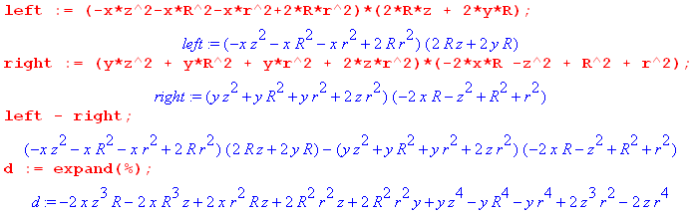

I then replace r2 = x2+ y2 and get this result:

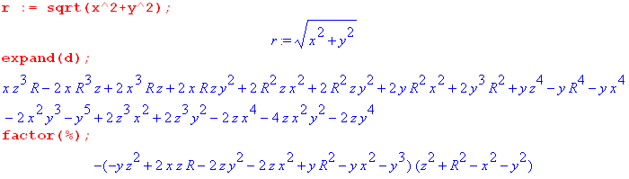

Amazingly the final thing factors into a cubic times a quadratic. Our equation is left - right = 0, so my result has two separate solutions which are:

x2+y2+z2 = R2 // which is a sphere of radius R

-yz2 + 2xzR - 2zy2 - 2zx2 + yR2 - yx2 - y3 = 0 // which is a cubic surface

I think the sphere is a spurious solution. You would get a sphere if you could have v = 0, based on:

x2 + y2 + z2 = r2 + z2 = (R-vs)2 + (vc)2 = R2 + v2 -2Rvs // = R2 if v = 0

but we know that v = $\sqrt{z2+(R-r)2}$and we only get v = 0 on the mid-point circle of the strip. If you have variable v set to 0, THEN and only then do you get a sphere as a possible surface and again I think it is spurious. Continuing:

Negate all terms in the above cubic line,

yz2 - 2xzR + 2zy2 + 2zx2 - yR2+ yx2 + y3 = 0

Reorder as follows

- yR2 + yx2 + y3 - 2xzR + 2zx2 + 2zy2 + yz2 = 0
or
- R2y + x2y + y3 - 2Rxz + 2x2z + 2y2z + yz2 = 0

Now compare this to Wolfram

We agree except where I have z they have -z. Let's compare our starting equations:

x = [R - v sin(u/2)]cos(u)
y = [R - v sin(u/2)]sin(u)
z = v cos(u/2) // Me

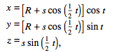 // Wolfram

Let's try to see how s,t are related to u,v :

I need to have

cos(t) = cos(u) which means I need to have t = u ±2π t/2 = u/2 ± π
sin(t) = sin(u)

Now look at half angle guys

cos(t/2) = cos(u/2 ± π) = cos(π ± u/2) = -cos(u/2)
sin(t/2) = sin(u/2 ± π) = ± sin(π ± u/2) = - sin(u/2)

The Wolfram equations then become

x = [R - s cos(u/2)] cos(u)
y = [R - s sin(u/2)] sin(u)
z = -s sin(u/2)

Now set s = v and the Wolframs become

x = [R -v cos(u/2)] cos(u)
y = [R -v sin(u/2)] sin(u)
-z = v sin(u/2) // Wolfram with t = u ± 2π and s = v

Compare to my Buck equations:

x = [R - v sin(u/2)]cos(u)
y = [R - v sin(u/2)]sin(u)
z = v cos(u/2) // Buck with 2 = R

Therefore, in order to get from Wolfram to Buck, we need to make these changes:

t → u ± 2π
s → v
z → -z

This then explains why I found that the Buck and Wolfram cubics are related by z ↔ -z. This is of course just a vertical reflection of the Mobius strip. But maybe my solution is also valid with z ↔ -z anyway so this last detail is not so important.

Once again from Wolfram

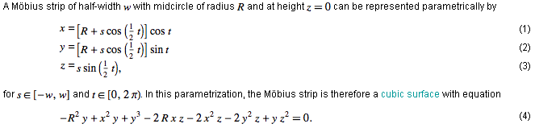

So Wolfram's range is

-W/2 < s < W/2 where W is the strip full width
0 < t < 2π
R = "mid-circle radius"

If I convert these ranges and choose t = u - 2π and s = v these become

-W/2 < v < W/2 where W is the strip full width
0 < u < 2π this must take you around the strip somehow.
R = "mid-circle radius"

So Bucks have W = 2 as the full width of their strip since they say |v| < 1.

Comment: You might somehow generate this strip by taking a line segment and translating it around the big circle while at the same time rotating it so that when you get all the way around the big circle, the line segment has rotated π about the center line, and that then makes it have one surface.

Question: How can I plot this function:

- R2y + x2y + y3 - 2Rxz + 2x2z + 2y2z + yz2 = 0

All I really know is that the Mobius strip lies on this more global surface. Here is Maple

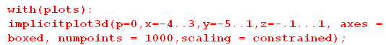

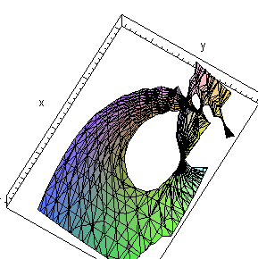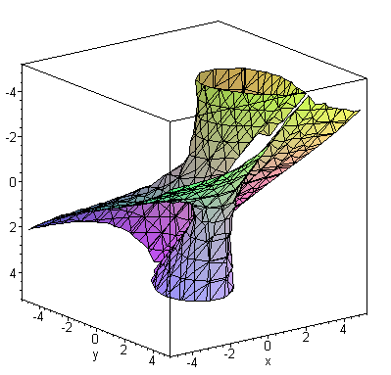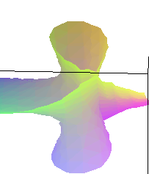

Very hard to see, but it is there. See the Buck picture on p 347. The "flat part" is at 7 o'clock, while the vertical tip over point is about 1 o'clock (left pic) The implicitplot has trouble figuring things at the tip-over point. On the right as you rotate the surface, you see that its global features are two cones that meet in an unusual manner, where for each cone the surfaces passes through the cone surface, allowing you to move from the inside of the conic surface to the outside. An ant can get from anywhere to anywhere on this surface without punching through the surface. The global thing has a single continuous surface. The Mobius strip is just a particular piece of this surface that is more comprehensible with a static picture. Detail: As ant wraps around the cone' inside surface on a path, it appears to pass through a wall as it stays on that surface. But for the ant, that wall is not really there. He stays on his surface passing through the math location of the wall, but points on the wall are not close to him. If his vision fades with distance, he cannot see the wall because points on it are far away. A humbling exercise. There are probably simpler examples.

To see this right, you really need a routine which can plot the original functions.

OK, I found it!

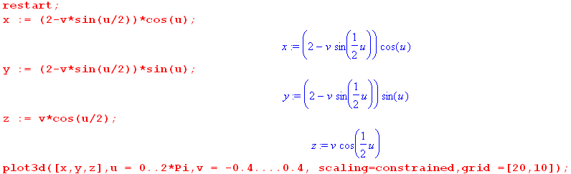

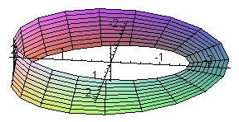
Here I oriented things to look like the Buck picture on p 347.

