Example of a non-uniformly convergent series PhL 12.15.15

1. Example 1 1
1.1 What Bucks say : lack of order interchange 1
1.2 Bucks on Uniform Continuity of Series with Parameter 1
1.3 Example 1 Cauchy 3
2. Example 2 (similar to the Legendre case for the horn toroid, but simpler) 8
2.1 Setting things up: lack of order interchange 8
2.2 Show this example does not have Uniform Continuity 10
2.3 Show lack of Cauchy Property 13

1. Example 1

1.1 What Bucks say : lack of order interchange

This example appears as Ex 1 in Buck p 180. It is mentioned, but not studied much, and here I want to complete that "study". We have this series,

ak(x) = x(1-x)k Sn(x) = Σk=0n ak(x) = partial sum S(x) = Σk=0∞ ak(x) .

Bucks show that S(x) = 1 (they call this F(x) ). Interval of interest is [0,1].

1. The Buck discussion is simply the following. Can you interchange order of n→∞ with x→0 ? If you could then you would have

limn→∞ limx→0 [Σk=0n x(1-x)k ] = 0

limx→0limn→∞ [Σk=0n x(1-x)k ] = 1

so you get a different result when you "interchange order of limits".

Without explicitly saying so, the implication is that this series is not uniformly convergent on [0,1]. But I ask the question: Is this series UC on [0,1] ? I want a yes or no clean answer.

1.2 Bucks on Uniform Continuity of Series with Parameter

2. Now the Buck definition of UC is p 182 A which applies to a sequence. If I apply this to the sequence of partial sums, it says this:

To have UC, you must have (note: this is NOT the Cauchy condition, that comes below later)

limn→∞ || Sn(x) - S(x)||E = 0 .

Now for our example, we know that S(x) = 1 for 0 < x ≤ 1. Bucks argue that limx→0+ (S(x)) = 1 as well, so then we have S(x) = 1 for 0 ≤ x ≤ 1 .

We also know that

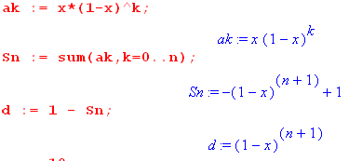

Notice that the partial sum Sn has an extremely simple closed form.

Then the series will be UC provided:

limn→∞ || 1 - Sn(x)||E = 0
or
limn→∞ || (1-x)n+1||E = 0

Is this true or is it not true? We have to compute the E operation before we can answer that. I claim that the max value of (1-x)n+1 occurs at x = 0. For example, here is a plot for n = 10:

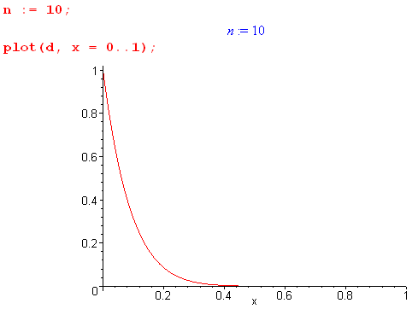

So therefore

|| (1-x)n+1||E = 1

Our UC test is then :

limn→∞ || (1-x)n+1||E = 0 ?

limn→∞ { 1 } = 0 ?

1 = 0 ?

Obviously 1 ≠ 0 and therefore our series is NOT UC on this interval. That is the clean answer I have been looking for. The problem is at the x = 0 end of the interval.

1.3 Example 1 Cauchy

3. How about the "Cauchy property" ? Consider:

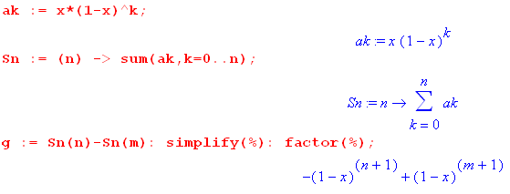

The Cauchy condition requires that

limn,m→∞ || Sn - Sm||E = 0 n,m > N

So for my example we would have to show that

limn,m→∞ || -(1-x)n+1 + (1-x)m+1 ||E = 0 n,m > N

Now let Maple do some work. We locate the value x = xmax where -(1-x)n+1 + (1-x)m+1 has zero derivative, and therefore we hope where it has a maximum :

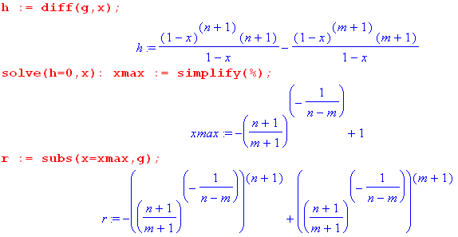

So the last item here is || -(1-x)n+1 + (1-x)m+1 ||E if I assume xmax falls in the range [0,1]. Some Maple plots suggest that this is always the case.

So now we have a tough question: Does the above expression → 0 for all large m and n? I am not sure how to answer that question since not sure what limits to take. But I can plot the object like so:

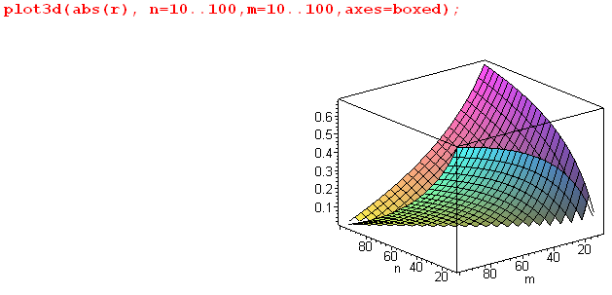

Here I have assumed N = 10, and I explore a small range of n,m > N in the plot. The worst case seems to occur where n = N and m = max value, and vice versa. This is born out by (compare to picture)

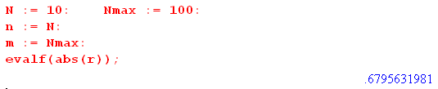

One could then study a range of Nmax values by just making a 1D plot, first fixing n at some N.

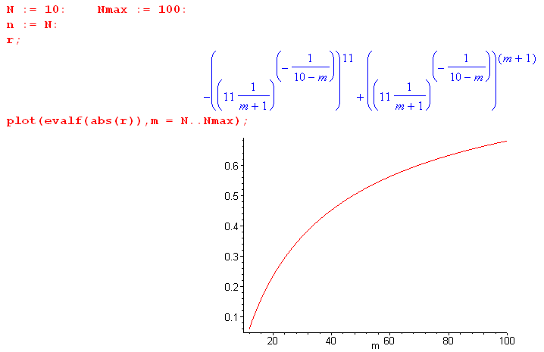

Here we pick n = N = 10 and we let m range from N to Nmax . If I set Nmax = 10000, our r thing seems to be going to 1:

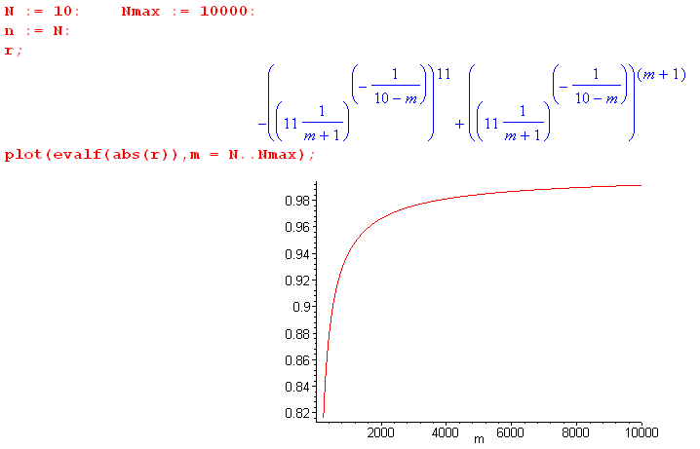

This is a problem for Cauchy property because we want this to be true

limn,m→∞ || -(1-x)n+1 + (1-x)m+1 ||E = 0 .

But for N = 10, if I set n = 10 and m → ∞. we seem to get a limit of 1 instead of 0.

Can this be improved by raising to N = 100?

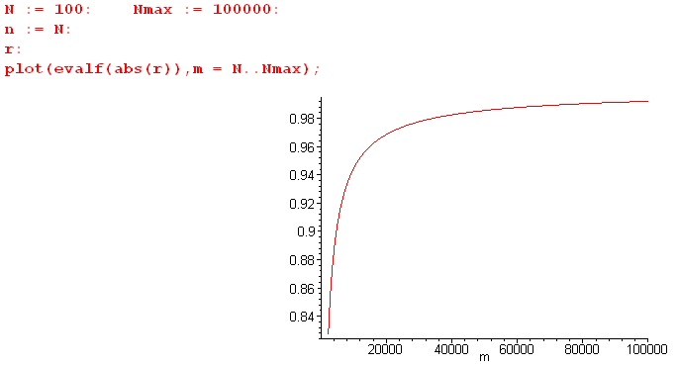

So the answer is no, the situation is not improved by raising N. So we are looking "non-Cauchy".

Question: go back to

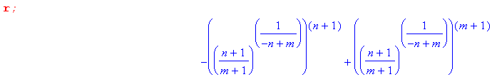

Can I directly take the limit m→ ∞ in this expression? Maple says this

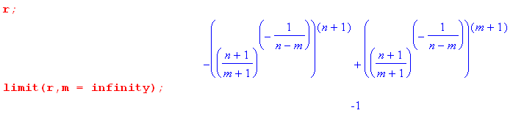

How does it reach that conclusion? Consider the two terms

t1 = -ab a = $\frac{n+1}{m+1}$ b = - $\frac{n+1}{n-m}$

t2 = ac c = - $\frac{m+1}{n-m}$

Now if m→ ∞, we have

a→ 0 b→ 0 c → 1 .

Then

t1 = -00 = -1

t2 = 01 = 0

and there is your answer. But how do I know that 00 = 1? Maple knows this fact

and here is the fact graphically

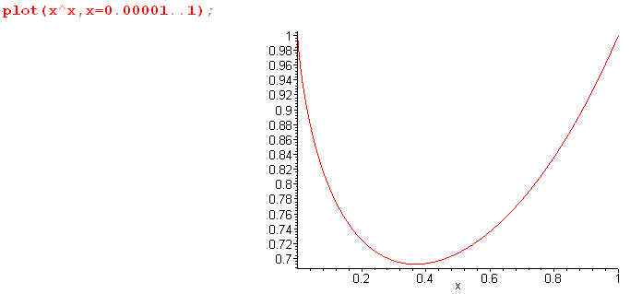

Cauchy Summary: For the series on [0,1] with ak = ak(x) = x(1-x)k I have studied whether or not this is true:

limn,m→∞ || Sn - Sm ||E = 0 n,m > N .

It turns out for this simple example that you can compute

|| Sn - Sm ||E = | r(n,m)| as shown above.

The Cauchy property requires that this thing go to 0 for large m and n both > N. I then study just a small subset of this huge m,n space. I study the area where m → ∞. I find for that area that

| r(n,∞)| = 1, independent of n.

Thus, I have shown that there is a region of the n,m space for which || Sn - Sm ||E = 1. Thus, we cannot possibly have the Cauchy property for this example since if we did we would need || Sn - Sm ||E → 0 for all double-distant regions of the n,m space. But I have found a piece of the double-distant region where this is not true.

2. Example 2 (similar to the Legendre case for the horn toroid, but simpler)

2.1 Setting things up: lack of order interchange

I now want to repeat the above work for a different example, namely

ak = x e-2kx

Sn = Σk=0n x e-2kx

This is a simple geometric sum and Maple tells us that the partial sum Sn(x) is given by,

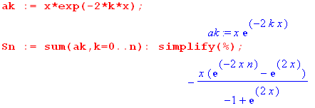

If I multiply top and bottom by e-x I get

Sn(x) = - x $\frac{e-2xn-x - ex}{-e-x+ ex}$ = - x $\frac{e-(2n+1)x - ex}{2sh(x)}$

In the limit x→ 0 we then get

numer ≈ 1 -(2n+1)x - (1+x) = 1 -2nx -x -1 + x = -2nx

so
Sn(0) = - x $\frac{-2nx}{2x}$ = nx = 0.

Thus, if you take any finite partial sum, it vanishes at x = 0. This is born out by plotting:

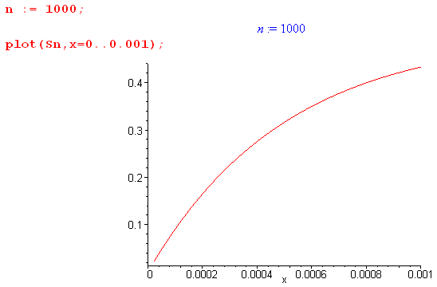

Now, I have just shown that

limn→∞ { limx→0 Sn(x)} = limn→∞ {0} = 0 (a)

In the previous example we knew the exact sum going to n = ∞. Do we know that here? Go back to

Sn(x) = - x $\frac{e-2xn-x - ex}{-e-x+ ex}$ = - x $\frac{e-(2n+1)x - ex}{2sh(x)}$

If I take n→∞ I get

S(x) = limn→∞ Sn(x) = - x $\frac{0 - ex}{2sh(x)}$ = x $\frac{ex}{2sh(x)}$

so I guess I do know the exact sum in this case as well. Now take the x→0 limit to get

S(0) = x*1/(2x) = 1/2

I have just shown that

limx→0 limn→∞ { Sn(x)} = 1/2 (b)

So order interchange is not allowed and that suggests that the sum is not UC on [0,1].

Here Maple verifies all the above:

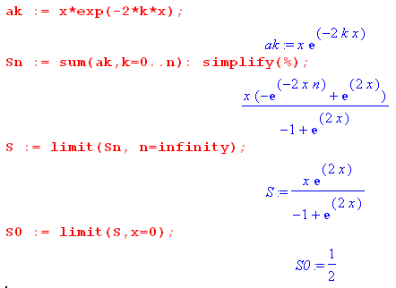

2.2 Show this example does not have Uniform Continuity

Now let's look at the definition of UC

limn→∞ || Sn(x) - S(x)||E = 0 .

In our case we know that

Sn(x) = - x $\frac{e-(2n+1)x - ex}{2sh(x)}$

S(x) = x $\frac{ex}{2sh(x)}$

Therefore,

S(x) - Sn(x) = x $\frac{e-(2n+1)x}{2sh(x)}$

Maple does this as follows:
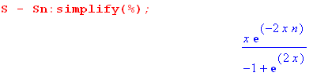

Where is the max of this function? Plot it

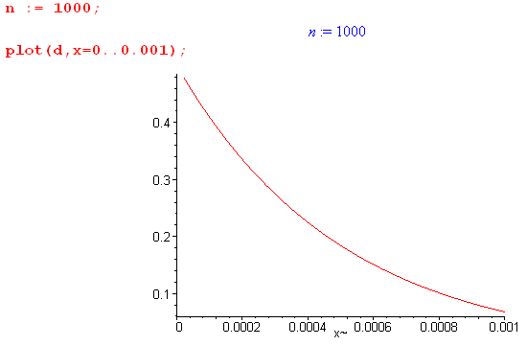

So the max occurs at x = 0 and from my form I can see that

|| Sn(x) - S(x)||E = |Sn(0) - S(0)| = |0 -1/2)| = 1/2

But we then have

limn→∞ {|| Sn(x) - S(x)||E} = 0 = limn→∞ { 1/2} = 1/2

Thus, by the definition of UC, this series is NOT uniformly continuous. Had we set the lower end of our range to .001 instead of 0, the result would be different. Then we would have:

S(x) - Sn(x) = x $\frac{e-(2n+1)x}{2sh(x)}$

Probably the max is then at x = .001 and we would have

|| Sn(x) - S(x)||E = Sn(.001) - S(.001)

= (.001) $\frac{e-(2n+1)(.001)}{2sh(.001)}$ ≈ (1/2)e-(2n+1)(.001)

and then

limn→∞ {|| Sn(x) - S(x)||E} = limn→∞ { (1/2)e-(2n+1)(.001)} = 0

and then for this interval we DO have UC of the series.

The problem is clearly at the x = 0 endpoint.

2.3 Show lack of Cauchy Property

Finally, what happens with the Cauchy property business? We want to have

limn,m→∞ || Sn - Sm||E = 0 n,m > N

to have Cauchy. In our case of Example 2 we have

Sn(x) = - x $\frac{e-(2n+1)x - ex}{2sh(x)}$

Therefore

Sn(x) - Sm(x) = - x $\frac{e-(2n+1)x - ex}{2sh(x)}$ + x $\frac{e-(2m+1)x - ex}{2sh(x)}$

= - x $\frac{e-(2n+1)x}{2sh(x)}$ + x $\frac{e-(2m+1)x}{2sh(x)}$ = $\frac{x}{2sh(x)}$ [ e-(2m+1)x - e-(2n+1)x ]

Now: where does this have its maximum? If we try the same thing we did above, we run into trouble. We want to set the derivative to 0 and solve for x that gives the max, but this time we don't get a closed form result. To wit:

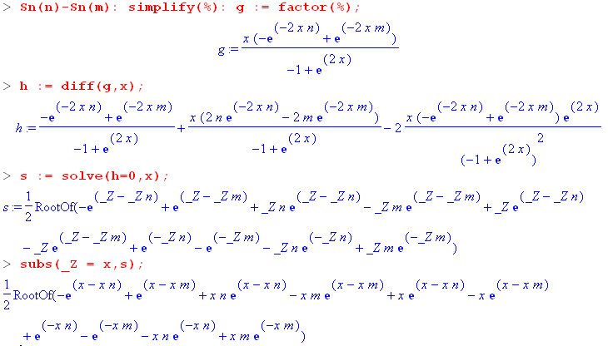

To get the solution, we have to find the root of a transcendental equation. So we are not going to do that, so we are not going to get a closed-form result for || Sn - Sm||E . The best we can do is pick some value of n and plot against m and x. Here is an example of such a plot

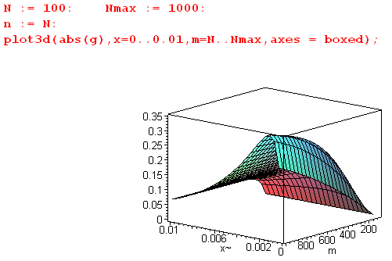

If I assume that the worst case situation is when m = Nmax (which was the case in the previous example, and looks to be the case here from the above graph), then we can make a 1D plot

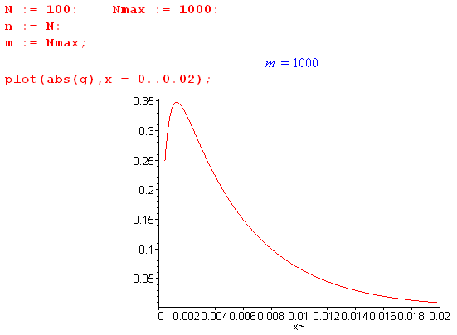

So here we see that at some small x there really is a max of g = Sn(x) - S(x). Things seem similar to the previous example, so suppose we just set m = ∞. Well we have

g = Sn(x) - Sm(x) = $\frac{x}{2sh(x)}$ [ e-(2m+1)x - e-(2n+1)x ] ≈ $\frac{x}{2sh(x)}$ [- e-(2n+1)x ]

Then I can do lots of plots such as

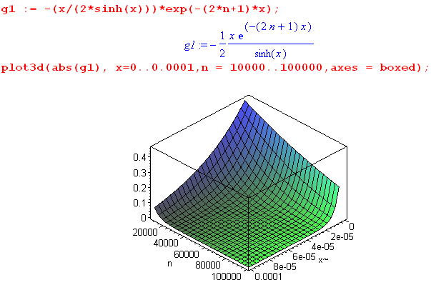

Playing with these plots suggests that there is no lower endpoint on the range of n that will make the object abs(g1) hammer down to some ε I have n = 10,000 above and we are still hitting 0.4. So we are not going to find a value of N such that

limn,m→∞ || Sn - Sm||E = 0 n,m > N

In other words, this example does NOT have the Cauchy property, but it is difficult to directly show this fact since it involves a transcendental equation. One could not doubt come up with some bounds that would prove that we are non-Cauchy, but I am already a believer.

