A Math Problem PhL 12.10.13

Overview: I had a simple trig function f(x) = acos2(x) + bsin2(x-c) which I could see had four places in the range (-π.π) where the slope is zero. But my usual calculus method for finding these zero-slope points was only showing up the maxima and not the minima. The paradox was reconciled when I realized that the w = (1/2) tan-1(z) solution really needed Nπ/2 added to it due to the multiple branches, and then this filled in the missing zero slope values. I then learned how Maple displays these extra solutions using its inscrutable _Z notation, and I updated my user's guide with this new info.

1. Setting the Stage

Consider this function. where a and b are positive real, c is real as well,

f(x) = acos2(x) + bsin2(x-c) .

Here is what this function looks like

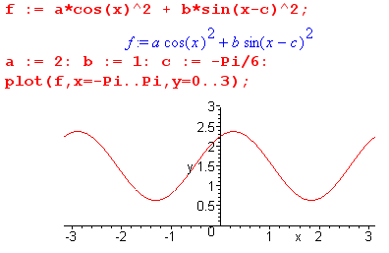

With the range -π to π there are two maxima and two minima. We wish to find these locations, so we take the derivative of f(x)

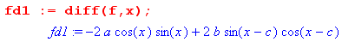

which we write as

f'(x) = -asin(2x)+bsin(2x-2c)

To find the locations of zero slope we write4

-asin(2x)+bsin(2x-2c) = 0
or
asin(2x) = bsin(2x-2c)
or
asin(2x) = bsin(2x)cos(2c)-bcos(2x)sin(2c)
or
[a-bcos(2c)] sin(2x)= -bsin(2c)cos(2x) huh??????
or
tan(2x) = [-bsin(2c)]/[a-bcos(2c)]

We are now going to make some name changes. First, replace x by θ since we are talking about angles

tan(2θ) = [-bsin(2c)]/[a-bcos(2c)]

Second, let x = num and y = den, so we then have

tan(2θ) = y/x

In our example above we have y and x both positive, since

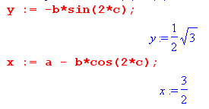

2. Solving a certain equation

We seek the solution θ to this last equation. Note that y and x could each have either sign. Now finally let φ = 2θ so this equation then reads

tan(φ) = y/x

which is our "canonical form" which we studied in the Earth Sun appendix, from which I quote :

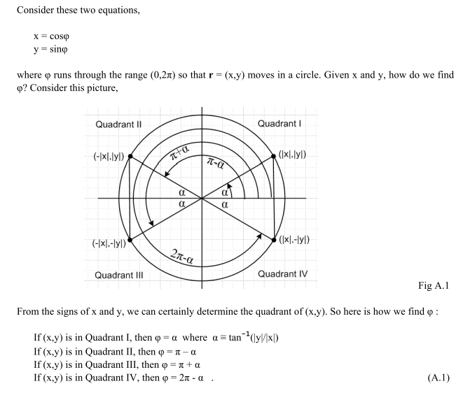
This shows that there are four different solutions of tan(φ) = y/x depending on the quadrant defined by

x>0 y>0 Quadrant I φ = α ≡ tan-1 (|y|/|x|) solution #1
x<0 y>0 Quadrant II φ = π-α solution #2
x>0 y<0 Quadrant III φ = π+α solution #3
x<0 y<0 Quadrant IV φ = 2π-α solution #4

Let us suppose that x > 0 and y > 0 (as in our example). Then we are Quadrant I and there is only one solution which is the above solution #1. That solution is then φ = α. Translating back to our problem we find

2θs = tan-1(y/x)

This then is the ONLY solution and it is in quadrant I for 2θ. Perhaps the answer is θs = 20o.

[ This is the only solution on the principle branch of the function w = tan-1(z). But as Spiegel p 18 shows, there are other branches, and in fact if w = tan-1(z) is a solution on the principle branch, then other solutions are w + Nπ where N is any integer. Thus, if 2θs is a solution, so is 2θs + Nπ . This can be restated: if θs is a solution, then so is θs + N(π/2). This then gives us not one but four solutions where θs takes the range (-π,π). ]

Now go back to our starting function

f(θ) = acos2(θ) + bsin2(θ-c) .

This function is periodic with period π so we have

f(θ) = f(θ±π)

Therefore, if θ= θs is a place where f(θ) has zero slope, f(θ) also has zero slope at θs±π which is in agreement with our plot above. Thus, this function has zero slope at 20o ± π .

[ This fact is true, but we already have the conclusion we want without using this last fact . ]

3. My confusion and why I am treating this Math Problem

My solution method has "discovered" the two points where f(x) is a maximum, but it seems to be overlooking the two places where f(x) is minimum! What have I done wrong? Let's now plot the derivative and see if it really hits 0 four times in (-π,π). I have plotted both fd1 and fd1m (manual) wherein I did the sin2x = 2sinxcosx thing in each term. Both these plots are the same and here it is:
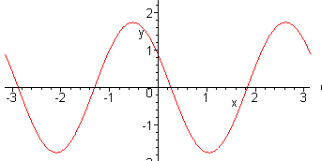

You clearly see the four zero crossings. So why does my method seem to miss two of these crossings? For my example numbers we have

tan(2θ) = y/x = [$\sqrt{3}$/2]/[3/2] = 1/$\sqrt{3}$

Now, the function tax(ξ) is periodic with period π, as shown Spiegel page 14. Thus

tan(ξ) = tan(ξ±π)

That means in the above we have

tan(2θ) = tan(2θ±π)

Thus, if 2θs is a solution of tan(2θ) = y/x, then so is 2θs ± π.
Thus, if θs is a solution of tan(2θ) = y/x, then so is θs ± π/2.

So this explains the mystery, finally. I now go back and add some comments in red.

4. How Maple deals with this fact:

Several interesting facts here, and I want to get this down for future reference.

(a) Maple is unable to solve the slope=0 equation before I go in and rewrite it manually:

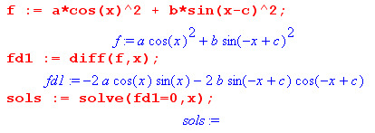
but it does not set the env variable that Help talks about

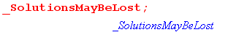

Maple is saying that "there are no solutions" in its behavior, but that is wrong. It just cannot find the solution because it does not make use of sin(2x) = 2sin(x)cos(x). However, we can make it use this identity in the following manner, and then it CAN find a solution

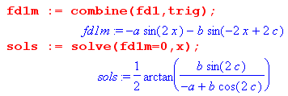

(b) Maple knows about the π/2 fact, but does not say so unless you ask:

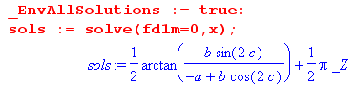

This last mysterious notation means (π/2) times any integer in the field Z of real numbers. I finally found something on this notation in the official Maple manual

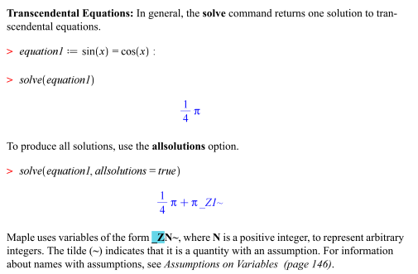

So probably if I had the current version of Maple, I would see $\frac{1}{2}$π_Z1 instead of $\frac{1}{2}$π_Z, and this then allows for multiple possible integers. This is a different use than in the RootOf stuff. I just added all this _Z stuff to my user guide. Hurray!

