The Inverse Gradient PhL 3.12.14

Summary of Result: You are given this problem to solve for φ(x,y)

∇2D φ(x,y) = A(x,y) .

Here are two possible ways to write the solution

φ(x,y) - φ(x1,y1) = $^{\int_{x1}^{x}{}}$Ax(x,y1)dx + $^{\int_{y1}^{y}{}}$Ay(x,y)dy
= f(x) + g(x,y)

φ(x,y) - φ(x1,y1) = $^{\int_{y1}^{y}{}}$Ay(x1,y)dy + $^{\int_{x1}^{x}{}}$Ax(x,y)dx
= F(y) + G(x,y)

In graphics terms, you imagine you have a plot3D of a function φ(x,y) as a height over a plane x,y and you know 2D gradient at every point x,y, and that gradient is called A(x,y) . Then just from this gradient, you can figure out the function of the surface φ(x,y), but you have to pick an arbitrary point x1,x2 in order to express the result. And φ(x1,y1) is then selected as an arbitrary constant of integration. Knowing the gradient of course does not tell you the absolute DC level of a function. There is of course a 3D version of this result implied by the discussion below.

*********************************************************************************

This arose today in the context of "low freq limit of my theory.doc" concerning transmission lines doc and some repair work I was doing there. I had these equations

∂yEz(x,y) = -jωBx(x,y)
∂xEz(x,y) = jωBy(x,y)

and was wondering how to "solve for Ez". I realized after a while this said ∇2Dφ = A and so the more general problem is this inverse gradient problem. Here are my notes moved here from the just mentioned doc, since this result is just a general calculus issue having nothing really to do with lines doc.

********************************************************************************

Here I first thought of this as a system of two PDE's !

Now of course we hit exactly on a huge PL Knowledge Hole which is PDE's. Let's give it a dumb try ( I did this somewhere, maybe Sneddon; no, in my own PDE notes!)

Ez(x,y) = -jω$^{\int_{}^{y}{}}$dy Bx(x,y) + f(x) = F(x,y) + f(x)
Ez(x,y) = -jω$^{\int_{}^{x}{}}$dx By(x,y) + g(y) = G(x,y) + g(y)

Then it must be that

F(x,y) + f(x) = G(x,y) + g(y)
so
F(x,y) - G(x,y) = g(y) - f(x)

which seems rather amazing -- that the difference between these two messy functions is the difference of two functions each of one variable. It seems unlikely. My little 2-equation system is too simple for Polyanin, he doesn't do first order anything. Well, he has a separate first order handbook, but it doesn't have any "systems".

After that distraction, I got on with the problem in question:

Well how about a simpler approach. Suppose

∇φ = A A = specified

Then write

φ(r) - φ(r1) = ∫ ∇φ • dr = ∫ A • dr = line integral in 3D space from r1 to point r

= $^{\int_{x1}^{x}{}}$Ax(x,y,z)dx + $^{\int_{y1}^{y}{}}$Ay(x,y,z)dy + $^{\int_{z1}^{z}{}}$Az(x,y,z)dz [ wrong, fixed below ]

This obvious solution suggested by a PDF where a certain web author writes (pdf is nearby)

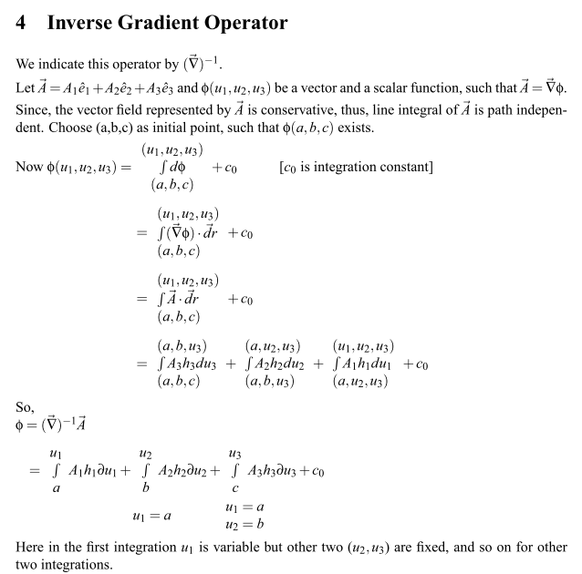

Now I will attempt to do this "my way" and see if I get the same result. The above author has used an appropriate curvilinear coordinates scale factor hi for each "leg" of his taxi-cab path, but I am just interested now in Cartesians so I ignore the hi factors.

∇2Dφ = A A = specified solve for φ

So write

φ(x,y) - φ(x1,y1) = ∫ ∇φ • dr = ∫ A • dr = line integral in 2D space from r1 to point r

= $^{\int_{x1}^{x}{}}$Ax(x,y)dx + $^{\int_{y1}^{y}{}}$Ay(x,y)dy [ wrong still, need to see path ]

But then I get

∂xφ = ∂x [$^{\int_{x1}^{x}{}}$Ax(x,y)dx ] + ∂x [$^{\int_{y1}^{y}{}}$Ay(x,y)dy] [ wrong ]

As usual, I am confused. Why doesn't this second term contribute. [ Every question spawns 5 more questions. ]

I think I should clear this up right here to have it in one place, so digressing on a spawned question now.

The claim is that when you write for ∇2Dφ = A

φ(x,y) - φ(x1,y1) = ∫ ∇2Dφ • dr = ∫ A • dr = line integral in 2D space from r1 to point r

the integral is the same for all possible paths of integration. Therefore, suppose you take the following carefully selected path written here as p1 + p2 (as opposed to some arbitrary path p)

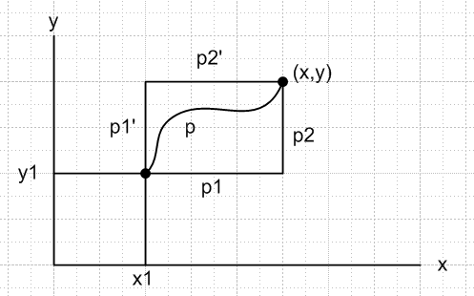

Then:

φ(x,y) - φ(x1,y1) = ∫ A • dr = ∫p1 A • dr + ∫p2 A • dr

= $^{\int_{x1}^{x}{}}$Ax(x,y1)dx + $^{\int_{y1}^{y}{}}$Ay(x,y)dy
= f(x) + g(x,y)

We could instead take the pair of primed paths. Then we get

φ(x,y) - φ(x1,y1) = ∫ A • dr = ∫p1' A • dr + ∫p2' A • dr

= $^{\int_{y1}^{y}{}}$Ay(x1,y)dy + $^{\int_{x1}^{x}{}}$Ax(x,y)dx
= F(y) + G(x,y)

Staring at things, we find that

g(x1,y) = F(y)
G(x,y1) = f(x)

but I don't see how this adds anything.

Consider:

Ax(x,y) = ∂xφ(x,y) = ∂xf(x) + ∂xg(x,y) = Ax(x,y1) + $^{\int_{y1}^{y}{}}$∂xAy(x,y)dy
Ay(x,y) = ∂yφ(x,y) = ∂yg(x,y) = Ay(x,y)

Ax(x,y) = ∂xφ(x,y) = ∂xG(x,y) = Ax(x,y)
Ay(x,y) = ∂yφ(x,y) = ∂yF(y) + ∂yG(x,y) = Ay(x1,y) + $^{\int_{x1}^{x}{}}$∂yAx(x,y)dx

Again, probably OK, but not exactly relevant to what the web author is saying.

I don't see how this gives the author's result which I will first quote in 3D and change to 2D.
Here is the quote:

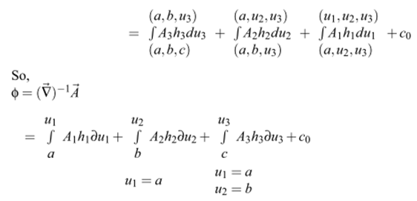

and here is my 2D version of the quote with the scale factors set to 1,

φ(u1,u2) = $^{\int_{(a,b)}^{(a,u2)}{}}$A2du2 + $^{\int_{(a,u2)}^{(u1,u2)}{}}$A1du1 + c0

= $^{\int_{(a,u2)}^{(u1,u2)}{}}$A1du1 + $^{\int_{(a,b)}^{(a,u2)}{}}$A2du2 + c0

= $^{\int_{a}^{u1}{}}$A1(u1,u2) du1 + $^{\int_{b}^{u2}{}}$A2(a,u2)du2 + c0
or
φ(x,y) =$^{\int_{x1}^{x}{}}$A1(x,y) dx + $^{\int_{b}^{y}{}}$A2(x1,y)dy + c0 a = x1 x = u1 y = u2

which compare to my 2nd result

φ(x,y) = $^{\int_{x1}^{x}{}}$Ax(x,y)dx + $^{\int_{y1}^{y}{}}$Ay(x1,y)dy + φ(x1,y1)
= G(x,y) + F(y)

So OK, we are saying the same thing.

Conclusion: You are given this problem to solve for φ(x,y)

∇2D φ(x,y) = A(x,y)

Here are two possible ways to write the solution

φ(x,y) - φ(x1,y1) = $^{\int_{x1}^{x}{}}$Ax(x,y1)dx + $^{\int_{y1}^{y}{}}$Ay(x,y)dy
= f(x) + g(x,y)

φ(x,y) - φ(x1,y1) = $^{\int_{y1}^{y}{}}$Ay(x1,y)dy + $^{\int_{x1}^{x}{}}$Ax(x,y)dx
= F(y) + G(x,y)

In graphics terms, you imagine you have a plot3D of a function φ(x,y) as a height over a plane x,y and you know 2D gradient at every point x,y, and that gradient is called A(x,y) . Then just from this gradient, you can figure out the function of the surface φ(x,y), but you have to pick an arbitrary point x1,x2 in order to express the result.

