Continuous functions which are not differentiable PhL 4.20.09

This subject has always seemed a little vague to me, and it is causing trouble with "Theorem 11" in my Stakgold Chapter 2 meta notes, so now is a good time to "delve" a little.

Are there some simple examples of L2 functions which are not differentiable? L2 means function is square integrable on the interval of interest. Certainly if a function f(x) is finite on an interval, it will be L2, provided you have some reasonable method of "integration".

It is easy to draw a discontinuous function which is square integrable and thus L2 , so we could make this breakdown at the start:

L2 functions = (continuous functions ) ∪ (discontinuous functions )

When we say a function is continuous here, we mean it is continuous at every point in the interval. In this dichotomy, a "piecewise continuous" function belongs in the discontinuous bin. At a point of discontinuity, the slope is infinite, so the derivative would be infinite, so at those points of discontinuity, the derivative does not exist; at those points, f(x) is "not differentiable".

So our real question is this: are there continuous functions which are not differentiable?

Let's start with the Weierstrass Function, and I quote wiki:

________________________________________________________________________

The Weierstrass function is a pathological example of a real-valued function on the real line. The function has the property that it is continuous everywhere but differentiable nowhere. It is named after its discoverer Karl Weierstrass.

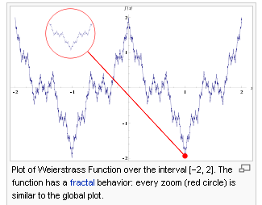

Historically, the Weierstrass function is important because it was the first published^{[1]} (1872) to challenge the notion that every continuous function was differentiable except on a set of isolated points.

In Weierstrass' original paper, the function was defined by
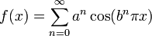,
where 0 < a < 1, b is a positive odd integer, and
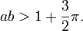
This construction, along with the proof that it is nowhere differentiable, was first given by Weierstrass in a paper presented to the 'Königliche Akademie der Wissenschaften' on 18 July 1872.
Naively it might be expected that a continuous function must have a derivative, or that the set of points where it is not differentiable should be 'small' in some sense. According to Weierstrass in his paper, earlier mathematicians including Gauss had often assumed that this was true. This might be because it is difficult to draw or visualize a continuous function whose set of nondifferentiable points is something other than a finite set of points. [ Analogous results for better behaved classes of continuous functions do exist, for example the Lipschitz functions, whose set of non-differentiability points must be a Lebesgue null set. When we try to draw a general continuous function, we usually draw the graph of a function which is Lipschitz and has other nice properties.]
The Weierstrass function could perhaps be described as one of the very first 'fractals', although this term was not used until much later. The function has detail at every level, so zooming in on a piece of the curve does not show it getting progressively closer and closer to a straight line. Rather between any two points no matter how close, the function will not be monotone.
It turns out that the Weierstrass function is far from being an isolated example: although it is "pathological", it is also "typical" of continuous functions:
- In a topological sense: it can be shown that the set of nowhere-differentiable real-valued functions on [0, 1] is dense in the vector space C([0, 1]; R) of all continuous real-valued functions on [0, 1] with the topology of uniform convergence.
______________________________________________________________________________

In summary: in order for a function ƒ to have a derivative it is necessary for the function ƒ to be continuous, but continuity alone is not sufficient.
Most functions which occur in practice have derivatives at all points or at almost every point. However, a result of Stefan Banach states that the set of functions which have a derivative at some point is a meager set in the space of all continuous functions.^{[5]} Informally, this means that differentiable functions are very atypical among continuous functions. The first known example of a function that is continuous everywhere but differentiable nowhere is the Weierstrass function.
_____________________________________________________________________________

Here is an interesting applet

http://www.univie.ac.at/future.media/moe/galerie/diff2/diff2.html

which shows some series that are simpler that the Weierstrauss one above. The sine one appears to be this
f(x) = Σn=0∞ an sin(nx) where an is some kind of slowly decreasing amplitude

If you sum the first 9 terms in this series, you get

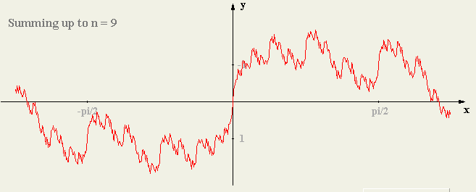

The point is that the series includes terms of arbitrarily high frequency (with "sufficient amplitude"), that is why there will always be non-monotone behavior in any zoom, and this is more or less why you cannot have a derivative. What is the derivative of an infinite frequency signal? Yet "continuity" seems true, there are no "jumps" in the curve.
The function sin(1/x) is non-differentiable at the one point x = 0, so not as bad as the fractal functions above.
It is true that a Fourier Series of a differentiable function seems to have the above property. The key feature which I have not really examined is that as the terms increase in frequency, they have to decrease in amplitude somewhat slowly so that you maintain the "non-monotonic" property at any zoom level.

I have now found a nice Master's Thesis that looks at the history of this subject (ie, the subject being functions which are everywhere continuous but (almost) nowhere differentiable). The author shows there was history before the 1872 Weierstrass presentation. He does lots of the supporting math as well, including a full proof for each historical case. [ This thesis is from Lulea University of Technology, 2003, author Johan Thim. Lulea is in Sweden, ]

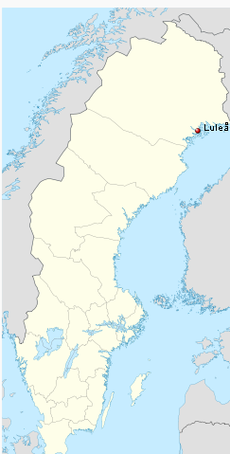

In 1830, Bolzano gave a graphical description of a fractal like sawtooth function that had this property.
Then in 1980 Cellerier gave this one:

f(x) = Σk=1∞ sin(akx)/ak a > 1000

but it was found in his posthumous notes in 1890, after Weierstrass.
In 1861 Riemann came up with this one:

f(x) = Σk=1∞ sin(k2x)/k2

though this one is in fact differentiable at (a small number of ) certain points:

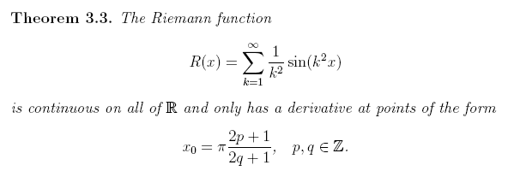
Then there is the Darboux function of 1973/5 :

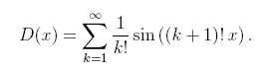

_________________________________________________________________________________

My general comments: Most these functions are the limits of partial sums of ordinary continuous and differential functions. That is, each partial sum Sk is fully differentiable everywhere (as well as being continuous). I think the limit is in fact a "regular function" and not just a generalized function associated with a distribution like δ(x). You would not say that δ(x) was continuous or differentiable at x = 0.

