Practice on the bipolar coordinates Capacitor Problem PhL 2.18.14

The first question here is: how do you arrive at the claim that φ = cξ for the cylinders. I give a good answer to that now in bipolar doc. Most of the rest is "practice" for the pathway from φ to E to n to q. I spent a lot of hours then making the connection to φt and K of lines doc. This last is now clarified and written up in bipolar doc.

_________________________________________________________________________________

I arrive first at this picture:

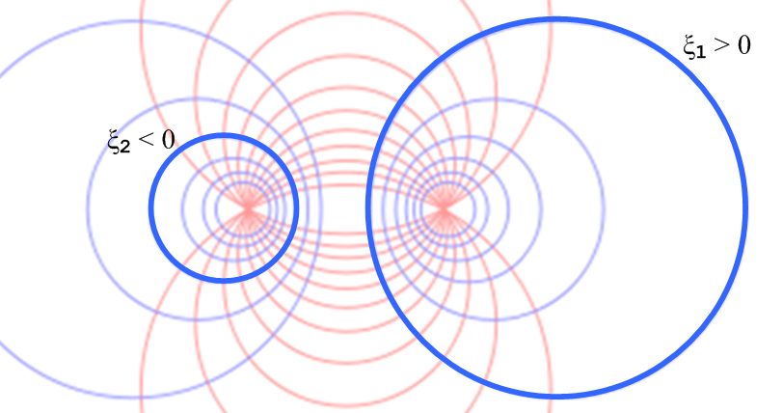

which depicts the two cylinders.

Plan A. If this picture is viewed from "far away" , the cylinders become line charges? But I don't really have a justification for that claim. They are always offset from the focal point no matter how far away you go.

Plan B. Different argument: Suppose φ(ξ) is the solution potential for the above capacitor in the region between the conductors. If we were to replace the right conductor cross section with the next smaller blue circle, ξ1' say, we claim that the potential solution for this new capacitor problem is the same function φ(ξ). We know that the function φ(ξ) will be a constant on this smaller right blue circle since that entire circle has the value ξ = ξ1'. We know that the Laplace equation is unique, so the same φ(ξ) must solve both problems in the space between the conductors of each problem.
But I don't believe this argument. As you change one conductor, everything could shift around!

Plan C. Suppose I try my general method: that means I have to find the full Green's function. Do I know the Green's function for the above set of conductors? Heck no! I put a point charge in some weird location, it is probably a horrible function. So my general method would be very difficult to carry out.

Plan D. Suppose I make an ansatz that the solution potential has this form

φ(ξ,u) = φ(ξ) = c ξ

where c is some unknown constant that probably depends on ξ1 and ξ2 and a. At least I can then say that this potential is constant on the two blue cylinder surfaces, so it is at least a viable candidate solution.

V1 = φ(ξ1) = cξ1
V2 = φ(ξ2) = cξ2

ΔV = V1-V2 = c(ξ1-ξ2)
_____________________________________________________________________________

Side question: what are the dimensions of φ? Recall that in 3D we have -∇2φ(x) = ρ(x)/ε. If φ does not depend on z, this becomes -∇22D φ(x,y) = ρ(x)/ε. Suppose ρ(x) describes a line charge in cylindrical coordinates at r = 0. Then ρ(x) = λ δ(r)/2πr. The RHS has dim = C/m * 1/m * 1/m = C/m3 correct. Now consider -∇22D f(x,y) = δ(r)2D . We know that f(x,y) = ln(1/r)/2π .Then from (I.1.8) I get

-∇2 φ(x) = ρ(x)/ε. => φ(x) = ∫d2x' [ln(1/R)/2π] ρ(x')/ε + homogeneous solutions
The Poisson Equation (I.1.8)

so then

φ(x) = ∫d2x' [ln(1/R)/2π] λ δ(r')/2πr' (1/ε) R = | x - r' |
= (λ/2πε) ∫d2x' [ln(1/R)/2π] δ(r')/r'
= (λ/2πε) ∫d2x' [ln(1/R)/2π] δ(r')/r'
= (λ/2πε) 2π ∫r'dr' [ln(1/R)/2π] δ(r')/r'
= (λ/2πε) ∫dr' [ln(1/R)] δ(r')

= (λ/2πε) [ln(1/R)|r'=0]

= (λ/2πε) ln(1/|x|)

So one might write

φ(r) =(λ/2πε) ln(1/r) // like 3D that says φ(r) = (q/4πε)(1/r).

This 2D result is in agreement with my Appendix L result that says

φ1(r) = (1/2πε1) q ln(1/r) + (q/2π) ln(1/R) (1/ε0-1/ε1) (L.2.6)'

where we can ignore the constant second term and we have q = λ.

Now that I finally have a real-world potential, what are its units?

φ(r) =(λ/2πε) ln(1/r) = C/m * m/F = C/F = volt

So in 2D, the potential still has dimensions of volts.

Therefore:

dim(c) = volts
_____________________________________________________________________________

What is the electric field implied by this potential?

E = - grad φ

But I showed earlier that in bipolar coordinates

[grad f](x) = (1/h) [ (∂ξf ) + (∂uf ) ]

so then

[grad φ](x) = (1/h) [ (∂ξφ ) ] = (c/h)

E = - (c/h)

This is certainly a simple result. I don't know the sign of α yet, so all I can say is that this electric field when evaluated at ξ = ξ1 is normal to the cylinder surface, which is what it must be in electrostatics.

Now since points "inward" at my ξ1 sphere on the right, if I let En be the normal electric field pointing out, then the above says

En(ξ1,u) = c/h(ξ1,u) dim OK, both sides are volts/m

Now, how does one obtain from this the surface charge density on the surface? This sounds like a possibly treacherous area. I am tempted to use my Section 1 lines doc formula which says

n = ε En (1.1.47) dim OK

// dim n = C/m2 dim(εEn) = farad/m * volts/m = C/m2

This n is a 2D charge density. There is some possible sign ambiguity which I will ignore. This seems then to say

n(ξ1,u) = (cε) 1/h(ξ1,u) h(ξ1,u) = a/(chξ1-cosu)

n(ξ1,u) = (cε/a) (chξ1 - cosu) // dim = Coul/m2 both sides OK

This n has dimensions C/m2 and it is the physical surface charge density on the surface of the right cylinder which has parameter ξ1. It is a function of u. [ I tried but am unable to describe this in terms of a 1D charge density. ]

Now, how do we describe a patch of area on the conductor where this surface charge n exists? I think the distance can be dz in the z direction along the cylinder, and distance will be ds around the perimeter. My idea then is to use result

(ds)2 = Σk hk2 (dxk)2 = [a2/(chξ–cosu)2] [ (dξ)2 + (du)2] (3.4)

which tells me that if I don't vary ξ, I basically have

(ds)2 = h2 (du)2 ds = h du

which I guess is what a scale factor is all about! So the charge on my patch is

dq = n(ξ1,u)dz ds = n(ξ1,u)dz h du = [(cε) 1/h(ξ1,u)] dz h du = cε dz du

Notice that dq is a constant times du so equal du's have equal dq's. But equal du's do not correspond to equal dθ's.

Then the total charge in a ring around our conductor is

Q = cε dz∫du = 2πε c dz

The charge per unit length on conductor C1 is then

q = 2πε c /Coul/m

At least I seem to be going somewhere, albeit at a snail's pace. Exploration in the canoe.

For the other conductor, I think the result is exactly but same but we pick up a minus sign because for a blue circle on the left, points out instead of points in, so En has a change of sign. So here then is what I think I have found

q1 = 2πε c = q // charge per unit length on conductor C1 on the right
q2 = - 2πε c = - q

Am I yet in a position to talk about capacitance?

q = -CΔV

C = -q/ΔV = - 2πε c / [c(ξ1-ξ2) = 2πε/[ξ1-ξ2]

Issues now to study:
(1) why is this result independent of ansatz constant c ?
(2) are the dimensions of C what I expect them to be? DONE
(3) does this result agree with lines doc where I refer to ξi as Bi ? Yes, DONE

Sisyphus: each question answered spawns 5 new questions.

Issue (2): Looking at C = 2πε/[ξ1-ξ2], dim(C) = farad/m since capacitance per meter.
But dim(ε) = farad/m as well, so dimensions are OK.

Issue (3): In (6.3.2) I claim that K = 2(B2-B1) so then K = 2(ξ2-ξ1). But why is this negative?

ouch! I have C1 on the left in lines doc since that is how I always drew things with two conductors. So C2 is on the right, and it is B2 that is ξ1 !! That is unfortunate.

But apart from that problem, we get agreement, so (3) is OK.

But I still don't know the constant c !! Well, I do know that

ΔV = V1-V2 = c(ξ1-ξ2)

So if the potential between the two conductors is V > 0, then I can say

c = V/(ξ1-ξ2)

Then my ansatz potential is

φ = [V/(ξ1-ξ2)] ξ

Suppose I write this in the language of lines doc

φ = $\frac{1}{4πξ}$ q φt

Then I would argue that

φt = 4πε φ/q = (4πε/q) [V/(ξ1-ξ2)] ξ

= 4πε [ξ/( ξ1-ξ2)] (V/q)

= 4πε [ξ/( ξ1-ξ2)] (1/C)

= 4πε [ξ/( ξ1-ξ2)] (1/2πε/[ξ1-ξ2])

= 4πε [ξ/( ξ1-ξ2)] [(ξ1-ξ2)/2πε)

= 4πε [ξ] [1/2πε)

= 2 ξ
= 2 ln ($\frac{s1}{s2}$)

and finally this agrees with lines doc.

φt(x) ≈ ln(s22/s12) // limiting form as point x = (x,y) moves far from the conductors

So it has taken me about 8 hours to obtain this factor of 2, and I am not really sure how I did it!

