Bipolar Coordinates and the Two-Cylinder Capacitor
Phil Lucht
Rimrock Digital Technology, Salt Lake City, Utah 84103
last update: Aug 2, 2014

Maple code is available upon request. Comments and errata are welcome.
The material in this document is copyrighted by the author.

The graphics look ratty in Windows Adobe PDF viewers when not scaled up, but look just fine in this excellent freeware viewer: http://www.tracker-software.com/pdf-xchange-products-comparison-chart .

The table of contents has live links. Most PDF viewers provide these links as bookmarks on the left.

Overview and Summary 3
1. Reminder of regular polar coordinates 5
2. Bipolar Coordinates 6
3. The metric tensor, scale factors, distance, and the Jacobian 12
4. The inverse transformation 14
5. Connection to Toroidal and Bispherical Coordinates 16
6. Interpretation of the coordinates ξ and u 17
7. The circle angle θ 19
8. Some Differential Operators in Bipolar Coordinates 23
9. Separability of the Laplace equation in Bipolar Coordinates 29
10. The Two-Cylinder Capacitor Problem Part I 31
(a) Statement of the Problem 31
(b) Finding the Potential 32
(c) Finding the Charge q and therefore the Capacitance C = q/V 33
(d) Surface charge density versus angle θ and the Center of Charge 36
11. The Two-Cylinder Capacitor Problem Part II 41
(a) Aligning the Cylinders 41
(b) Capacitance in terms of R₁, R₂ and b 43
(c) The Cylinder Over Plane Case 44
(d) The Offset Coaxial Cylinders Case 45
12. The Metric Tensor with Application to Bipolar Coordinates 48
Example 1: Polar coordinates 50
Example 2: Bipolar Coordinates 51
13. Bipolar Coordinates as a Conformal Map 53
(a) Basic Conformal Mapping Facts 53
(b) Example: Polar Coordinates in (u,θ) format 54
(c) Example: Bipolar Coordinates as a Conformal Map 55
(d) A Final Visit to the Two-Cylinder Capacitor Problem 57
14. Inverse Transformation, Bipolar Circles and the Interior Angle u 59
(a) Finding the Inverse Bipolar Transformation 59
(b) Equations for the circles 60
(c) Interior angle u 61
15. Bipolar and Toroidal Coordinates treated in other Sources 62
(a) Morse and Feshbach 62
(b) Some Other Sources 63
Appendix A: Fourier Analysis of the angular charge distribution n₁(ξ₁,θ) 64
References 68

Overview and Summary

This document is intended as a generic guide for the use of bipolar coordinates. These 2D coordinates serve as a simple example of general curvilinear coordinates in n dimensions and allow one to see how the underlying tensor machinery operates. In addition, bipolar coordinates can be represented as an analytic mapping from Cartesian coordinates, an aspect which can only occur with 2D coordinates. The electrostatics problem of two infinite, parallel, conducting cylinders provides a real-world application of the use of bipolar coordinates, but the reader uninterested in that subject may ignore Sections 10 and 11. With the addition of an azimuthal third variable, bipolar coordinates become either toroidal or bispherical coordinates, but the essence of these two 3D coordinate systems lies in the bipolar coordinates from which they are constructed by azimuthal rotation. If bipolar coordinates are simply extruded in the z direction, the resulting 3D system is called bi-cylindrical coordinates.

Section 1 reviews polar coordinates, then Section 2 discusses the bipolar coordinates we call ξ and u with respect to their level curves -- certain red and blue circles. The forward transformation is stated.

Section 3 displays the metric tensors and scale factors for both polar and bipolar coordinates.

Section 4 states the bipolar inverse transformation.

Section 5 shows how 2D bipolar coordinates are related to 3D toroidal, bi-spherical and bi-cylindrical coordinates.

Section 6 gives geometric interpretations of the bipolar coordinates ξ and u.

Section 7 discusses a certain "circle angle" θ for the blue circles relative to their centers.

Section 8 calculates some differential operators in bipolar coordinates using Ref [3] templates.

Section 9 shows how the Laplace equation is separable in bipolar coordinates but the Helmholtz equation is not.

Section 10 states and then solves the electrostatics problem of two infinite, parallel, conducting cylinders using bipolar coordinates. The potential φ is first obtained, and from it the electric field E. From that the surface charge n is computed and then integrated to get the total charge q (per length of cylinder). This yields an expression for the capacitance (per unit length) for the two-cylinder problem. The surface charge density is expressed first in terms of bipolar coordinate u and then in terms of the circle angle θ, and finally plots of n(θ) are shown for various values of bipolar coordinate ξ.

Section 11 fills in some extra details of the two-cylinder problem. It is first shown how to relate the bipolar coordinate parameters a, ξ and u to the radii Ri and center-separation b of the cylinders. This allows the capacitance to be expressed in terms of R1, R2 and b. The last sections discuss the cylinder-over-plane and concentric cylinders versions of the problem.

Section 12 shows how to compute the metric tensor and scale factors for an arbitrary transformation connecting Cartesian to curvilinear coordinates in n dimensions. The metric tensor and scale factors are then computed for polar and bipolar coordinates with some assistance from Maple.

Section 13 discusses conformal mapping and then analyzes both polar and bipolar coordinates in terms of their conformal maps w = f(z) where f(z) is analytic. For bipolar coordinates the mapping is drawn in some detail showing how the w-plane maps to the z-plane. The last section revisits the two-cylinders problem and shows how it can be instantly solved using conformal mapping (and that fact that analytic mappings of harmonic functions are harmonic functions).

Section 14 derives certain facts quoted earlier. The bipolar inverse transformation is obtained from the forward transformation. The equations for the circles of the bipolar level curves are derived. Finally, the geometric interpretation of bipolar angle u is verified.

Section 15 compares notes between our bipolar coordinates ξ and u and those of other sources, with special emphasis on Morse and Feshbach.

Appendix A does a Fourier analysis of the surface charge density on a two-cylinder capacitor.

A few References are then provided.

When equations are restated, their equation numbers are put into italics.

SI units are used throughout.

1. Reminder of regular polar coordinates

Polar coordinates r and θ can be taken to have these ranges

0 ≤ θ ≤ 2π 0 ≤ r ≤ ∞ . (1.1)

The relationship between polar coordinates and the usual Cartesian coordinates x and y is,

x = rcosθ
y = rsinθ (1.2)

which we refer to as "the forward transformation".
For curvilinear coordinates {x'i} in n dimensions, the "level surface for coordinate x'i" is a surface on which the coordinate x'i is constant and all the other coordinates vary. A level surface has dimension n-1. For example, in spherical coordinates the level surfaces for coordinate r are a set of spheres. In two dimensions the level surfaces are just curves, and we shall refer to them as "level curves".
In polar coordinates as shown below, the level curves for r are the blue circles centered at the origin, while the level curves for θ are the red rays emanating from the origin.

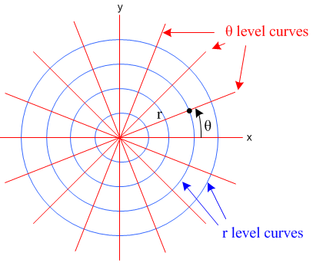 (1.3)

No special work is required to find an "interpretation" of the meaning of r and θ: r is the radius of one of the blue circles, θ is the angle of one of the rays. Whereas θ is dimensionless, dim(r) = meters.

Having defined above the notion of a level surface (a level curve in 2D), we must now mention the distinct notion of a "coordinate line". For curvilinear coordinates {x'i} in n dimensions, the "coordinate line for coordinate x'i" is a curve on which the coordinate x'i varies while all other coordinates stay fixed. For example, in spherical coordinates, a radial ray is a coordinate line, since on such a ray r varies while both θ and φ are constant. Thus, in the drawing above, each θ level curve (red ray) is an r coordinate line (r varies on a ray), and vice versa. It is just terminology, but we shall need it below.

2. Bipolar Coordinates

There are several different ways to define bipolar coordinates. In this document, the two coordinates will be called ξ and u with the following ranges

-∞ ≤ ξ ≤ ∞ 0 ≤ u ≤ 2π // both ξ and u are dimensionless .(2.1)

The Greek letter ξ ("xi") is pronounced "zeye" in English.

The relation between bipolar coordinates u and ξ and the Cartesian coordinates x and y is given by this forward transformation,

x = a shξ/(chξ - cosu) (2.2)
y = a sinu/(chξ - cosu)

where a is an arbitrary positive real number. Notice that there is no such extra number like "a" in polar coordinates as shown in (1.2). That is because polar coordinates has only one "pole" whereas bipolar coordinates has two poles, and 2a tells how far apart these poles lie.

The level curves for ξ and u are considerably more complicated than they are for polar coordinates. Here they are (taken from wiki)
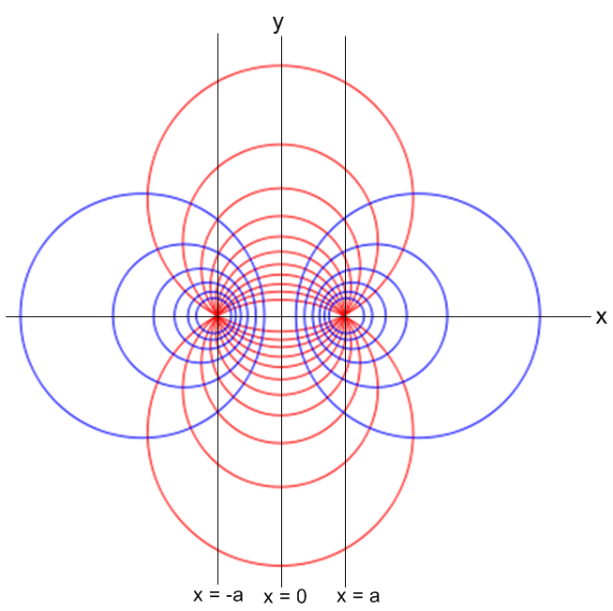 (2.3)

http://en.wikipedia.org/wiki/Toroidal_coordinates

Very close to each pole, the level curves look like those of polar coordinates in Fig (1.3).

There are perhaps 20 things to be said about this picture, and we just have to start somewhere and eventually get everything stated.

The blue circles [ the ξ level curves ]

The blue level curves are all perfect circles, but they are not concentric circles! These circles have the historical name Circles of Apollonius (of Perga) who discovered their interesting properties around 230 BC. One can see that the blue circles on the right form a set of circles which are zeroing in on the right "focal point" which is located at (x,y) = (a,0). Each of these blue circles is labeled by a value of coordinate ξ. Circles which are very tight around the focal point on the right have large positive values of ξ with +∞ as the limit. As the circles move away from the focal point and get larger, they have smaller values of ξ. Eventually the blue circles get very large and have a limiting circle which is in effect the y axis. This limiting circle has value ξ = 0+ε and has an infinite radius and one imagines it curving off to the right after a few miles of hugging the y axis. The full set of blue circles on the right then has ξ in (0,∞).
The blue circles on the left are mirror images of the blue circles on the right. If a circle on the right has a label ξ = +3, then the mirror image circle on the left has label ξ = -3. The limiting circle on the left which has shrunk around the left-side focal point has ξ = -∞. The huge circle with infinite radius with ξ = 0-ε one imagines runs up the y axis and eventually curves off to the left to form that huge circle. The full set of blue circles on the left has ξ in (-∞,0).
We show in Section 14 that the blue level curves really are circles with the following equation,

(x - xc)2 + y2 = R2 xc = a/thξ R = a/|shξ| (2.4)

and this equation applies to both the left and right set of blue circles. On the right ξ > 0 so the circle center lies at xc > 0. On the left, ξ < 0 and the circle center lies at xc < 0. In either case R > 0 of course. The abbreviations are sh for sinh and th for tanh, the hyperbolic functions. No blue circle ever crosses the y axis. To see this on the right, one need only show that xc > R, and this follows from (2.4) since chξ > 1.
So hopefully at this point the reader has a good understanding of how the blue circles are labeled with the coordinate ξ. A blue circle is a locus of constant ξ. It is a ξ level curve.

Here we have Maple generate some blue circles for selected values of ξ using a = 5:

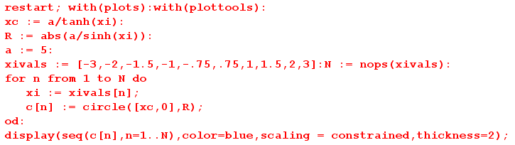

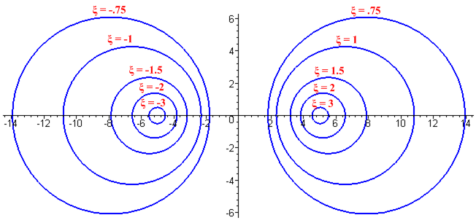 (2.5)

If one were to double a to a = 10, the blue circles would look exactly the same except the x and y axis numbers would all be doubled. So parameter ξ really determines the "shape" of a blue circle with respect to the focal point.

The red circles [ the u level curves ]

We show in Section 14 that the red level curves in Fig 2.3 lie on circles with this equation,

x2 + (y- yc)2 = R2 yc = a /tanu R = a/|sinu| . (2.6)

To verify that these circles all pass through the two focal points (x,y) = (±a,0), we evaluate:

x2 + (y- yc)2 = R2
a2 + (yc)2 = R2 ?
a2 + a2 /tan2u = a2/sin2u ?
1 +cos2u / sin2(u) = 1/sin2u ?
sin2u + cos2u =1 ? yes!

The red circles are more complicated than the blue circles for several reasons. A key reason is that the u level curves are not really the red circles, they are truncated red circles. The truncation is along the line between the two focal points. Each red circle in effect forms two truncated circles, and each of these truncated circles has a different value of u !! By truncated circle we mean a circle which has one piece removed -- a partial circle ( a "segment" seems to be the 2D interior of a partial circle).

In these examples, the truncated circles are shown in red:

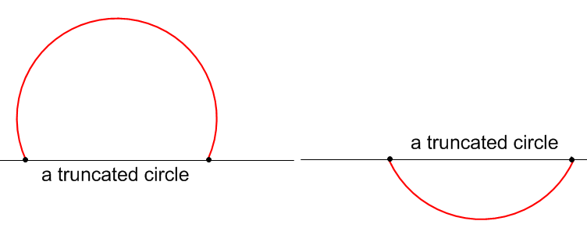 (2.7)

Because every circle is truncated at the two focal points, it is a simple fact that all these circles touch the two focal points, as Fig (2.3) shows.
A second complication is the manner in which the truncated-circle level curves are labeled. One is free to set the range to be (-π,π) or (0,2π) or something else (as long as the range is 2π wide), and one is also free to set the angle at which the coordinate is zero. In the following, we choose the range (0,2π) and we set u = 0 for points on the x axis which have |x| > a. Other choices are discussed in Section 15.
First, here is a selection of upper truncated-circle u level curves, each with a u label :
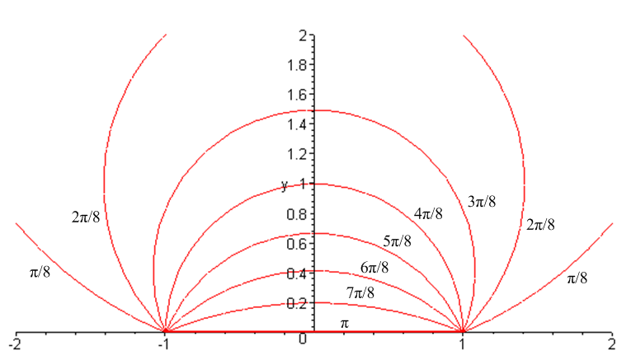 (2.8)

The coordinate u is an angle, but we have yet to show any interpretation of this angle -- that is coming soon. Right now we want to show how different values of u label the different truncated circles. We can start with a truncated circle which would be a straight red line joining the two focal points (which in this picture are drawn at ± 1 instead of ± a). This red line has u = π. Then as we move "up" a little bit, we get to the relatively "shallow" truncated circle which is marked by u = (7/8)π. As these truncated circles become "fuller", the u value drops off. At u = π/8 the truncated circle has a very large radius. The limiting case is an infinite circle with u = 0 which, if drawn above, would occupy the two regions of the x axis
(-∞,-1) and (1,∞).
To summarize, the red truncated circles for y≥ 0 have u values in range (0,π) and the general way this works is shown in Fig (2.8).
We now look at some of the lower truncated circles:

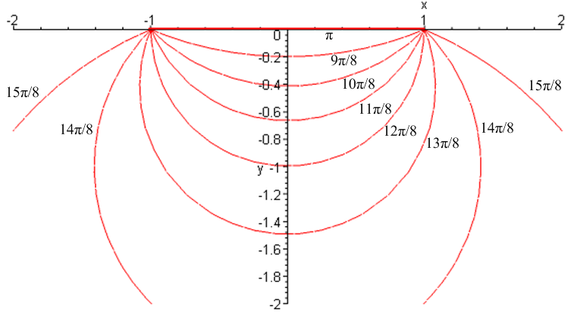 (2.9)

We start again with the focal point connector line u = π. Then as the truncated circles become fuller going downward, the u value increases. By the time we have reached u = (15/8)π, the truncated circle is very large. The limiting case here is what we might call u = 2π-ε and this is the same "truncated circle" as the case u = 0 described above. That is to say, it occupies the two regions (-∞,-1) and (1,∞).

The following drawing attempts to show the range of u on the two sides of the coordinate diagram,

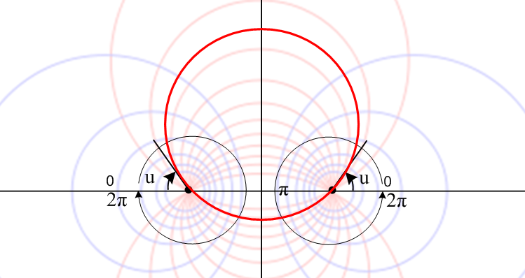 (2.10)

A particular red circle is highlighted, and it's upper part has the value u indicated in the drawing.
The astute reader might notice that the angle u appears to be the angle which is tangent to the heavy red circle as it passes through the left or right focal points. This observation is in fact correct and will be discussed below. If one were to zoom close in around the right focal point, for example, one would find that the emanating red lines are exactly the rays of a polar coordinate system (like Fig 1.3) centered at the focal point, and u is in fact just the standard polar angle θ of that zoomed-in system.
When we select (0,2π) to be the range for coordinate u, we find that there is a discontinuity where we have to jump from u = 0 to u = 2π on the ray from the right focal point to x = +∞ ( and similarly on the ray from the left focal point to x = -∞). If one were interested mainly in the region of space generally between the focal points, this discontinuity would be of no concern. However, suppose one were interested in computing the 2D electrostatic potential everywhere for the upper truncated portion of the heavy red circle shown in Fig (2.10), and suppose the heavy red circle had coordinate u = u0. In this case, if one uses range (0,2π) for u, one finds a discontinuity in u right in the middle of the space of interest. It is much better in this case to use (u0, u0+2π) as the range for u, since that puts the discontinuity right on the red circle (u = u0) so it does not interfere with the surrounding region where we want to compute the potential. That choice is indicated here:
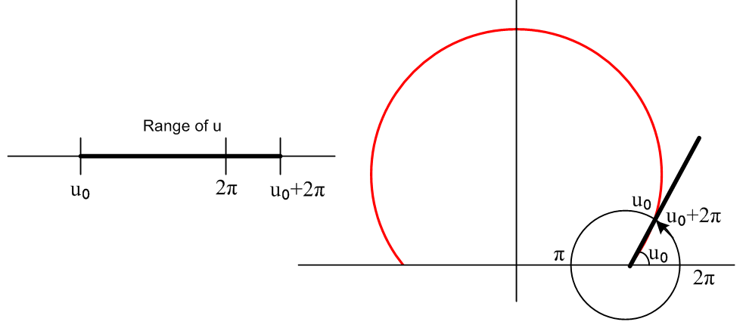 (2.11)

Hopefully at this point the reader has a good understanding of how the red truncated circles are labeled with the coordinate u A red truncated circle is a locus of constant u. It is a u level curve.
Although we have hinted at an "interpretation" of the coordinate u, nothing has been said yet about interpreting the coordinate ξ. We shall return to the subject of interpretation in Section 6 below, but first some supporting facts will be developed.

3. The metric tensor, scale factors, distance, and the Jacobian

Once again, it is helpful to think first of polar coordinates, then come back to bipolar coordinates.

Polar Coordinates

The polar coordinate system is an orthogonal system. This means that at any given point in the x-y plane, the two level curves passing through that point are at right angles. This is quite obvious looking at the little graph of concentric circles and rays shown in Fig 1.3 above. Orthogonality of a curvilinear coordinate system is directly connected to the fact that the "metric tensor" is diagonal, and its diagonal elements are the squared "scale factors". For example, as shown in Section 12, the metric tensor for polar coordinates r and θ has this form

metric tensor 'ij = $\left(\begin{matrix}grr & 0 \\ 0 & gθθ\end{matrix}\right)$= $\left(\begin{matrix}hr2 & 0 \\ 0 & hθ2\end{matrix}\right)$ = $\left(\begin{matrix}1 & 0 \\ 0 & r2\end{matrix}\right)$ hr = 1 hθ = r

Jacobian = hrhθ = r so dA = dxdy = rdrdθ (3.1)

In the polar coordinates case, the scale factors are hr = 1 , hθ = r. The Jacobian is the thing that appears in the "volume element" dxdy = Jdrdθ and we are used to this volume (actually area) element as rdrdθ.
We shall have more to say about metric tensors in Section 12. The significance of the metric tensor is that it describes differential Cartesian distance ds in terms of coordinate differentials. For example,

(ds)2 = (dx)2 + (dy)2 // Cartesian coordinates, x1 = x, x2 = y

(ds)2 = ΣkΣm 'km dx'k dx'm // the x'k are some non-Cartesian coordinates (perhaps x'1= r)

(ds)2 = Σk 'kk (dx'k)2 = Σk h'k2 (dx'k)2 // for a diagonal metric tensor, h'k =

(ds)2 = hr2 (dr)2 + hθ2(dθ)2 = (dr)2 + r2(dθ)2 // for polar coordinates: x'1 = r, x'2 = θ (3.2)

This last result is familiar if one draws a little right triangle with edges dr and (rdθ).
Imagine a general curvilinear coordinate system with n coordinates, the sth coordinate of which is called α. One could define a differential vector dx' = (0,0,....dα, 0,0....). The length of vector dx' in Cartesian space would then be ds = hαdα. This is the meaning of the "scale factors" like hα. In more detail,

(ds)2 = |dx'|2 = dx' • dx' = ΣkΣm 'km dx'k dx'm = 'ss (dα)2 = hα2 (dα)2 => ds = hα dα

Notation: In our notation, the xi are Cartesian coordinates like (x,y) while x'i are some curvilinear coordinates like (r,θ), and the prime is needed to distinguish them. The primes are maintained while indices are numeric, but are dropped when the specific coordinate is used, as for example in h'1 = hr = 1 for polar coordinate r. Then ij = δi,j is the Cartesian metric tensor while 'ij is the curvilinear metric tensor. The overbar indicates that ij is a covariant tensor, while the lack of overbars indicate that the x'k are contravariant vector components. See Section 12 in brief and Ref [3] for much detail.

Bipolar Coordinates

These coordinates are also orthogonal. A careful inspection of Fig (2.3) shows that each intersection of a red line with a blue line is a right angle intersection. The metric tensor for bipolar coordinates is of course diagonal, and it happens that the two scale factors hξ and hu are exactly the same (see Section 12),

metric tensor 'ij = $\left(\begin{matrix}gξξ & 0 \\ 0 & guu\end{matrix}\right)$= $\left(\begin{matrix}hξ2 & 0 \\ 0 & hu2\end{matrix}\right)$ hξ = hu = a/(chξ–cosu) ≡ h

Jacobian = hξhu = h2 = a2/(chξ–cosu)2 so dA = dxdy = [a2/(chξ–cosu)2]dξdu . (3.3)

The reason hu and hξ are the same is explained in Section 13: 2D scale factors are always the same when 2D curvilinear coordinates arise from an analytic transformation of the Cartesian coordinates (that is to say, a conformal map).
The differential distance is determined by the above metric tensor to be

(ds)2 = Σk h'k2 (dx'k)2 = [a2/(chξ–cosu)2] [ (dξ)2 + (du)2] . (3.4)

4. The inverse transformation

The forward transformation from (ξ,u) to (x,y) was given above as

x = a shξ/(chξ - cosu) (2.2)
y = a sinu/(chξ - cosu) .

We show in Section 14 that the inverse transformation is given by

ξ = tanh-1[2ax/(x2+ y2 +a2)]
u = tan-1[ 2ay/(x2+y2- a2)] . (4.1)

However, it turns out that the second equation has a certain ambiguity which is resolved by this sequence of steps to compute (ξ,u) from (x,y):

1. Compute ξ = tanh-1[2ax/(x2+ y2 +a2)] // first line of (4.1)
2. Compute cosu = chξ - (a/x)shξ // solve first line of (2.2) for cosu
3. Compute sinu = (y/x)shξ. // ratio of lines in (2.2)
4. Compute u = arctan2Pi(sinu,cosu) // get tan-1 in range (0,2π)

Here arctan2Pi(y,x) is meant to return an angle in the range (0,2π). Notice that the sign of ξ is determined by the sign of x in step 1. Maple code for arctan2Pi(y,x) appears in (7.12) below.

The inverse expression for ξ can be written in a different manner using the following identity,

tanh-1 z = (1/2) ln ($\frac{1+z}{1-z}$) |z| < 1 Spiegel Handbook 8.57 . (4.2)

Our intention is to set z = 2ax/(a2+ x2+ y2) in this identity, but we first make sure that |z| < 1 :

|2ax/(a2+ x2+ y2)| < 1 ?
2a|x| < a2+ x2+ y2 ?
-y2 < (a - |x|))2 ? yes!

Then
tanh-1 [2ax/(a2+ x2+ y2)] = (1/2) ln [$\frac{1 + 2ax/(a2+ x2+ y2)}{1 - 2ax/(a2+ x2+ y2)}$
= (1/2) ln [$\frac{a2+ x2+ y2 + 2ax}{a2+ x2+ y2 - 2ax}$] = (1/2) ln [$\frac{(x+a)2 + y2}{(x-a)2 + y2}$]

so we then have this alternate form for the ξ inversion formula:

ξ = (1/2) ln [$\frac{(x+a)2 + y2}{(x-a)2 + y2}$] . (4.3)

Taking a preliminary look at Fig 6.1 below we see these distances defined

s12 = | x + a |2 = (x+a)2 + y2 since a = (a,0)

s22 = | x - a |2 = (x-a)2 + y2 . (4.4)

Thus, our inversion formula (4.3) can be written

ξ = (1/2) ln($\frac{s12}{s22}$) = ln ($\frac{s1}{s2}$) (4.5)
or
$\frac{s1}{s2}$ = eξ . (4.6)

This is the key property that Apollonius noticed with regard to the blue circles: on any blue circle, this distance ratio is a constant and here we see that the constant happens to be eξ.

5. Connection to Toroidal and Bispherical Coordinates

Suppose we relabel the y axis of Fig 2.3 to be the z axis, and then rotate the right half of Fig 2.3 (ξ ≥ 0) 360o about this new z axis to form a 3D figure. This rotation creates a third azimuthal coordinate φ in (0,2π) which is the amount of rotation about this newly named z axis. The blue circles become toroids, which is why this system is called toroidal coordinates. The two focal points become a ring, and this ring is not at the center line of the toroids, just as the focal point in 2D is not at the center of the blue circles. Meanwhile, the red truncated circles become spherical "bowls" some of which are shallow and some of which are very large and deep with a relatively small round opening. The opening of each spherical bowl is the disk of radius a which is formed by the rotation of the segment joining the two foci. The bowl for u = π is degenerate and is just this disk -- an extremely shallow bowl. The shallow bowls are sometimes used to model a liquid droplet lying on a flat surface (a "sessile droplet"). Recall the two extremal truncated circles at u = π and u = 0. In the 3D toroidal system the one at u = π becomes a disk of radius a as just noted, while the one at u = 0 (or 2π) becomes an infinite plane with a radius-a hole in the center -- an "iris". For toroidal coordinates in this parameterization one has

x = a cosφ shξ/(chξ - cosu) ρ = a shξ/(chξ - cosu) = $\sqrt{x2+y2}$
y = a sinφ shξ/(chξ - cosu) hξ = hu = a/(chξ - cosu)
z = a sinu/(chξ - cosu) hφ = a shξ/(chξ - cosu) (5.1)

where the scale factors may be found using the method of Section 12. The hξ and hu scale factors are just those of the bipolar coordinates as shown in (3.3). The reader can find a general discussion of toroidal coordinates (ξ,u,φ) in Ref [4] along with a discussion of toroidal harmonics and the associated Mehler-Fock transform.

On the other hand, we can instead relabel the x axis of Fig 2.3 to be the z axis, and then proceed to rotate the top half of Fig 2.3 (0 ≤ u ≤ π) 360o about this new z axis to form a 3D figure, once again adding a third azimuthal coordinate. The blue circles in this case become spheres (non-concentric!), and this dual set of blue spheres provides the name of this system: bi-spherical coordinates. Meanwhile, the truncated red circles become strange objects of revolution. The shallower red truncated circles become American "footballs" while the fuller red truncated circles become fat donuts with no hole which have a center line of length 2a. The degenerate u = π truncated circle -- which is just the line segment joining the two foci -- remains that line segment in 3D. The u = 0 (or 2π) extremal donut is in fact all space except for the line segment joining the foci. One might use these limiting cases to model a "needle" or a 3D space with a needle-shaped cavity.

Finally, if we simply extrude the bipolar coordinates into the plane of paper, direction z, we obtain a 3D coordinate system known as bi-cylindrical coordinates. These are the implicit coordinates used below in the treatment of the two cylinders (Section 10).

6. Interpretation of the coordinates ξ and u

Consider the following marked up version of Fig (2.3),

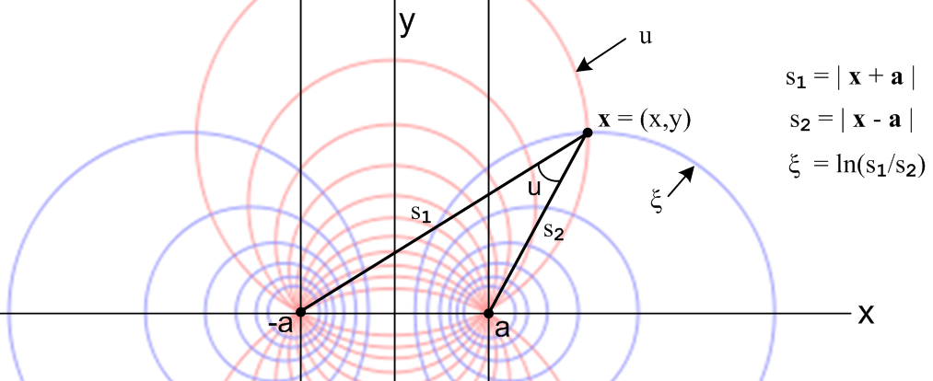
(6.1)
Interpretation of ξ

Let x = (x,y) be some point as shown. Let the distances from this point to the two focal points be s1 and s2 as shown, where s1 is the distance to the left focal point. The magic property of the blue Circles of Apollonius is that on any blue circle, one has s1/s2 = constant. We have in fact just proven this fact in (4.6) where we found that s1/s2 = eξ . Since ξ is a label for the blue circle, ξ is certainly constant on the blue circle, so s1/s2 = eξ is then constant over the blue circle ξ. So ξ = ln(s1/s2) is then one "interpretation" of the bipolar coordinate ξ. Notice that for points on the right, s1 > s2 so the ratio s1/s2 is > 1 which means ln(s1/s2) is positive, confirming our earlier comment that ξ > 0 for blue circles on the right side. If the point x were on the y axis, we would have s1 = s2 and ξ = ln(1) = 0, also in agreement with earlier comments. And if we zoom in on a tiny blue disk surrounding the right focal point, it will have s2 → 0 and then ξ = ln(s1/s2) → +∞. A tiny blue circle on the left then has ξ → -∞.

Interpretations of u

In Fig (6.1), as the point x moves along the red truncated circle labeled u, an ancient theorem about circles (the "inscribed angle theorem" see wiki) says that the angle we have marked as u -- whatever it is -- remains constant. As shown in Section 14, this angle is exactly the bipolar coordinate u.
A second interpretation for u is obtained by moving the point x of Fig (6.1) down its red circle so it approaches the focal point (through which that red circle must pass). In this limit, the s1 line becomes nearly horizontal and then there are two equal "alternate interior angles" which are then both u.

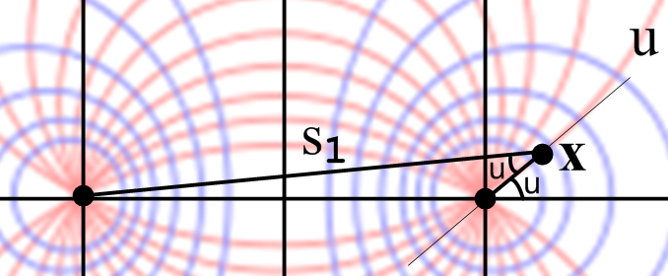 (6.2)

Thus one can interpret u as the angle at which the red circle labeled by u intersects the x axis. This allows one to get a rough idea of the value u a given red circle has. In the Fig (6.2) perhaps u = 45o = π/4, in which case the entire red circle of interest has u = π/4. As noted earlier, u is the normal polar angle in range (0,2π) of the red circles which become "rays" when one zooms in close to the focal point.
As another example, we move point x to the shallowest upper truncated red circle:

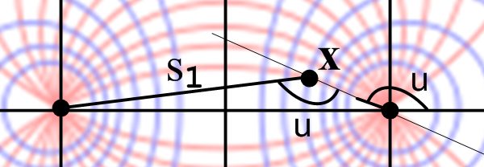 (6.3)

Again in the limit that point x approaches the focal point, we have equal alternate interior angles both equaling u, and in this case perhaps u = (5/6)π. One more example shows what happens for truncated red circles below the x axis:

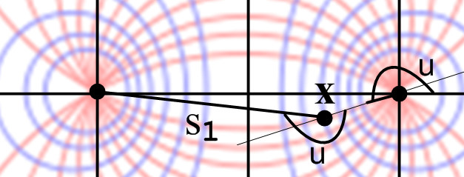 (6.4)

Here perhaps u = (7/6)π.

7. The circle angle θ

For a blue circle on the right (label ξ > 0) we define the ordinary polar angle θ as shown here :

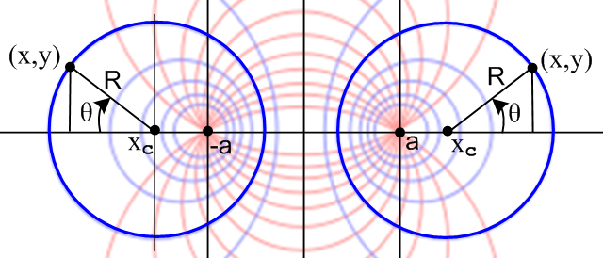 (7.1)

In the capacitor problem broached in Section 9, we shall be interested in the surface charge on the surfaces of blue circles (cross sections of cylinders) in terms of angle θ. We would therefore like to know how θ is related to ξ and u. From (2.2) and (2.4) we write,

cosθ = sign(ξ) $\frac{x-xc}{R}$ = sign(ξ) $\frac{a shξ/(chξ - cosu)- a/thξ}{a/|shξ|}$ = $\frac{a shξ/(chξ - cosu)- a/thξ}{a/shξ}$

= $\frac{sh2ξ/(chξ - cosu)- chξ}{1}$ = $\frac{sh2ξ- chξ(chξ-cosu)}{chξ-cosu}$ = $\frac{chξ cosu -1}{chξ-cosu}$ (7.2)

sinθ = $\frac{y}{R}$ = $\frac{a sinu/(chξ - cosu)}{a/|shξ|}$ = $\frac{|shξ| sinu}{chξ - cosu}$ (7.3)

tanθ = $\frac{sinθ}{cosθ}$ = $\frac{|shξ| sinu}{chξ cosu - 1}$ . (7.4)

The inverse equations are then provided by Maple,

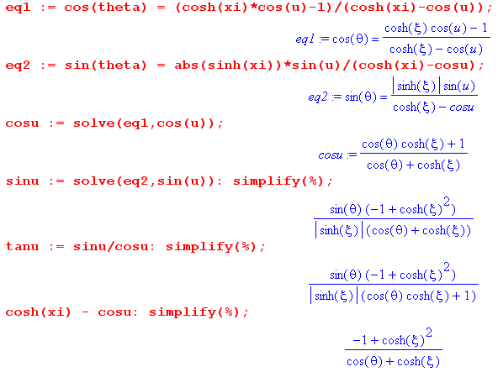
which we rewrite as

cosu = $\frac{chξcosθ+1}{chξ + cosθ}$ (7.5)

sinu = $\frac{|shξ|sinθ}{chξ + cosθ}$ (7.6)

tanu = $\frac{|shξ|sinθ}{chξcosθ+1}$ (7.7)

where the last Maple result says

chξ - cosu = $\frac{sh2ξ}{chξ + cosθ}$ . (7.8)
Holding ξ fixed and differentiating with respect to u gives

sinu du = sh2ξ d(chξ+cosθ)-1 = - sh2ξ(chξ+cosθ)-2 [ -sinθ dθ ] = sh2ξ sinθ (chξ+cosθ)-2dθ

or, using sinu from above,

$\frac{|shξ|sinθ}{chξ + cosθ}$du = sh2ξ $\frac{1}{(chξ + cosθ)2}$sinθdθ
or
du = $\frac{|shξ|}{chξ + cosθ}$dθ => $\frac{du}{dθ}$ = $\frac{|shξ|}{chξ + cosθ}$ (7.9)

All results can then be summarized in a box:

Relations between θ and (ξ,u) $\frac{du}{dθ}$ = $\frac{shξ}{chξ + cosθ}$ (7.10)
sinθ = $\frac{|shξ| sinu}{chξ - cosu}$ sinu = $\frac{|shξ| sinθ}{chξ + cosθ}$ chξ - cosu = $\frac{sh2ξ}{chξ + cosθ}$

cosθ = $\frac{chξ cosu -1}{chξ-cosu}$ cosu = $\frac{chξ cosθ+1}{chξ + cosθ}$ $\frac{1}{chξ - cosu}$ = $\frac{chξ + cosθ}{sh2ξ}$

tanθ = $\frac{|shξ| sinu}{chξ cosu - 1}$ tanu = $\frac{|shξ| sinθ}{chξcosθ+1}$ h = $\frac{a}{chξ - cosu}$ = a $\frac{chξ + cosθ}{sh2ξ}$

Algebra can always use some checking. From the above we find

ds = hudu = [h][du] = [a $\frac{chξ + cosθ}{sh2ξ}$][ $\frac{|shξ|}{chξ + cosθ}$dθ] = $\frac{a}{|shξ|}$dθ = Rdθ = hrdθ = ds .

We can do two other quick checks. When u = 0, we expect to get θ = 0 :

cosθ = $\frac{chξ -1}{chξ-1}$ = 1 sinθ = 0 tanθ = 0 .

A final check: as ξ → ∞, we expect θ = u since θ is then the same as the tangent angle to the red truncated circles, as shown for example in Fig (6.2):

cosθ = $\frac{chξ cosu}{chξ}$ = cosu sinθ = $\frac{|shξ| sinu}{chξ}$= sinu tanθ = $\frac{|shξ| sinu}{chξ cosu - 1}$ = tanu .

Here for selected values of ξ are plots of θ = θ(u) based on (7.4),

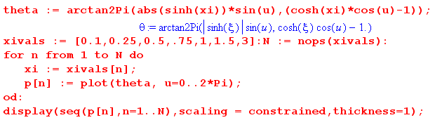

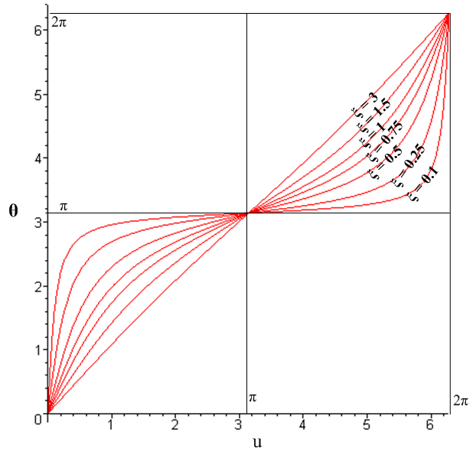 (7.11)

For ξ ≥ 3 say (tiny blue circles), the plot is basically θ = u, but for smaller values of ξ (larger blue circles) the plot is non-linear. In the case ξ = 0.1, for example, almost the entire range of u maps into a small region near θ = π. This is caused by the large blue circles flattening against the y axis where many u lines are encountered for a small range of θ near π.
Arctan2Pi is a custom Maple procedure designed to return an angle in the range (0,2π) :

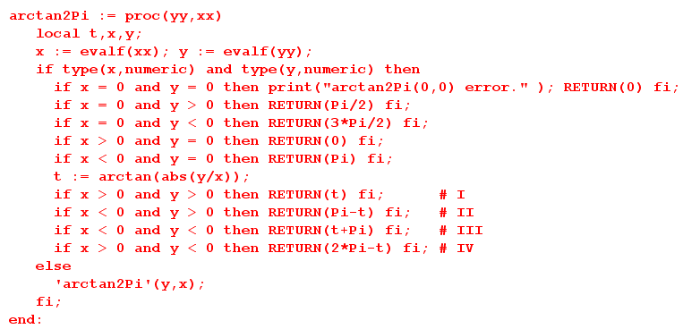 (7.12)

8. Some Differential Operators in Bipolar Coordinates

We shall use some general formulas from Ref [3], but first some strange notation needs explaining. In the subject of curvilinear coordinates treated from a correct tensor viewpoint, there exist three different kinds of "basis vectors" we call en, en and n associated with a particular curvilinear system. All these vectors are vectors in Cartesian space. A vector B in Cartesian space can be expanded in three ways using these basis vectors, and we include a fourth expansion onto Cartesian components :

B = Σn Bn en Bn = the contravariant components of vector B
B = Σn Bn en Bn = the covariant components of vector B
B = Σn Bn n Bn = the unit-vector components of vector B
B = Σn Bn Bn = the Cartesian components of vector B . (8.1)

Notice the need for four different notations for the components! In the last Cartesian line the unit vector notation is = , = etc. The first and third expansions are related in a simple manner,

en = hnn Bn = (1/hn) Bn => Bn en = Bn n (8.2)

where hn is the scale factor for coordinate n. It turns out that hn is the length of basis vector en and that is why n is a unit vector. Since unit vectors are convenient to use, we will use the B = Σn Bnn expansion.

The unit vector n (or en) at some point x is always tangent to the coordinate line for coordinate x'n which passes through point x (the en are called "tangent base vectors" in Ref. [3] ), and n (or en) always points in the direction in which the coordinate x'n increases.

The notation above applies in any number of dimensions, but our interest is two dimensions.

First, on familiar turf, for polar coordinates with 1 = r and 2 = θ one might write.

1 = r = 2 = θ = (8.3)

and then these unit vectors appear as shown at a particular point indicated by a black dot:

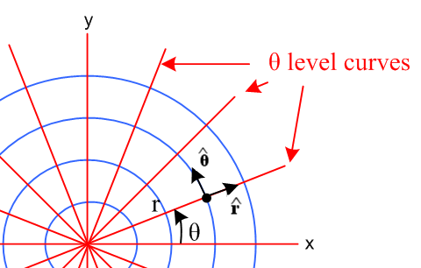 (8.4)

The curvilinear unit vectors are different at different points in space! The unit vector points in the direction of increasing r, while points in the direction of increasing θ. A vector B is expanded this way,

B = B1 1 + B2 2 = Br + Bθ = Br + Bθ . (8.5)

Here we finally "relax" our notation and write Br = Br and Bθ = Bθ since at this point everything is unambiguous and we can thus avoid the use of fancy fonts. However, if we talk about B1 and B2, things are again ambiguous since these could refer to Br and Bθ or to the Cartesian Bx and By. Thus, we will generally avoid the notations B1 and B2.

For bipolar coordinates, we choose 1 = ξ and 2 = θ, so then

1 = ξ = 2 = u = . (8.6)

Here is how these unit vectors appear in our bipolar coordinates drawing at some arbitrary points of interest,

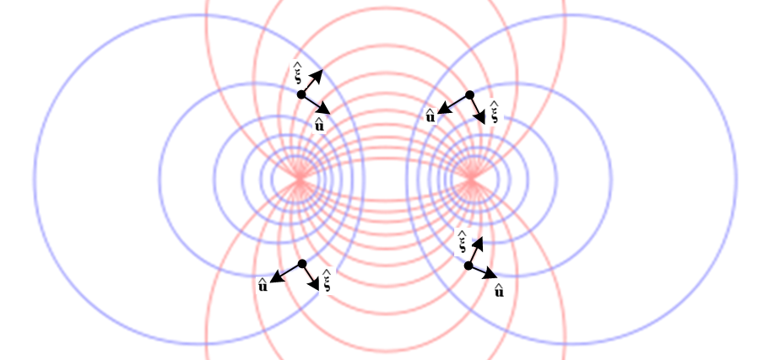 (8.7)

For blue circles on the right, points into the circle interior (recall ξ = +∞ at the focal point), while points counterclockwise around the blue circle (since u increases in that direction). On the left things are reversed: on the left, points away from the circle interior, while points clockwise. Notice that the unit vectors are tangent to the coordinate lines passing through the point of interest. Since bipolar coordinates are an orthogonal coordinate system (like polar coordinates), the unit vectors are at right angles to each other at any point.

Our bipolar expansion of a vector B is then

B = B1 1 + B2 2 = Bξ + Bu = Bξ + Bu . (8.8)

where we again relax the formal notation and use components Bξ and Bu.
Another notation we shall use below is this:

∂1 = ∂ξ ≡ ∂/∂ξ ∂2 = ∂u ≡ ∂/∂u . (8.9)

These are "covariant" derivatives as described in Ref [3].

Having done all this preparation, we can now express div B in bipolar coordinates. We first quote the general curvilinear template form from Section 14 of Ref [3], then simplify the notation as noted above,

divergence orthogonal:

[div B](x) = [1/(Πihi)] ∂n [(Πihi) Bn / hn] B = Bn n

= [1/(hξhu)] { ∂ξ [hξhu Bξ /hξ] + ∂u [hξhu Bu /hu] } . (8.10)

In bipolar coordinates we had from (3.3)

hξ = hu = a/(chξ–cosu) ≡ h . (3.3)

Since the scale factors are the same, we will just refer to either one as "h". Then we continue above

[div B](x) = h-2 { ∂ξ [h Bξ] + ∂u [hBu] } . (8.11)

Before doing more, one should note that components like Bξ are really Bξ(ξ,u), that is, they are functions of the curvilinear coordinates, just as on the left side Bx = Bx(x,y). B is a "vector field".
In (8.11) the object on the left is div B in Cartesian coordinates. What is on the right is this same div B "expressed in bipolar curvilinear coordinates". There is only one div B object, but one can express it in any coordinate system one wants.
We could leave the result as stated above, but we shall continue on :

[div B](x) = h-2 { (∂ξh) Bξ + (∂uh) Bu + h ∂ξBξ + h ∂uBu } (8.12)

Compute

(∂ξh) = ∂ξ [ a(chξ–cosu)-1] = -a (chξ–cosu)-2 shξ = -(h2/a) shξ

(∂uh) = ∂u [ a(chξ–cosu)-1] = -a (chξ–cosu)-2 sinu = -(h2/a) sinu (8.13)

so then

[div B](x) = h-2 { -(h2/a) shξ Bξ - (h2/a) sinu Bu + h ∂ξBξ + h ∂uBu }

= -(1/a) [ shξ Bξ + sinu Bu ] + (1/h) [∂ξBξ + h ∂uBu]

= -(1/a) [ shξ Bξ + sinu Bu ] + (1/a) (chξ–cosu) [∂ξBξ + ∂uBu]

= (1/a) { (chξ–cosu) (∂ξBξ + ∂uBu) - shξ Bξ - sinu Bu } . (8.14)

This is the final result. Notice how very different it is from the Cartesian coordinates expression,

[div B](x) = ∂xBx + ∂yBy . (8.15)

If we assume the vector field B is dimensionless, then from (8.15) we know div B has dimensions 1/m. This dimension is provided in (8.14) by the leading 1/a factor. Everything else is dimensionless! In particular, the coordinates ξ and u are dimensionless and then (chξ–cosu) ≥ 0 is dimensionless.

Here Maple checks our algebra in moving from (8.11) to (8.14) :

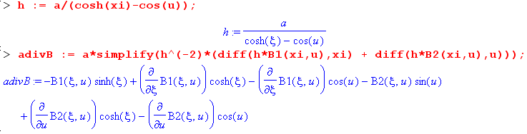

and one sees with some effort that this is the same as (8.14).

Next on our list of differential operators is the gradient. We quote again from Section 14 of Ref. [3],

gradient orthogonal:
[grad f](x) = (1/hi) (∂if ) i (8.16)

The notional detail here is that

f(x,y) = f (ξ,u) . (8.17)

We use an italic f on the right because, as a function of two variables, f and f are different functions! One could write for example,

f (ξ,u) = f(x,y) = f(a shξ/(chξ - cosu), a sinu/(chξ - cosu)) (8.18)

and it is pretty obvious that f and f are different functions of their respective variables.
Having now said this, we again "relax" our notation and get rid of the italic f. Then the function name f is "overloaded" and its meaning is determined by the implied argument list. So :

[grad f](x) = (1/hi) (∂if ) i

= (1/h1)(∂1f ) 1 + (1/h2)(∂2f ) 2

= (1/h) [ (∂1f ) 1 + (∂2f ) 2 ]

= (1/h) [ (∂ξf ) + (∂uf ) ]

= (1/a) (chξ - cosu) [ (∂ξf ) + (∂uf ) ]

= (1/a) (chξ - cosu) [$\frac{∂f(ξ,u)}{∂ξ}$ + $\frac{∂f(ξ,u)}{∂u}$ ] . (8.19)

There is only one grad f and on the right here we have expressed it in bipolar coordinates. It is of course a vector quantity and so is a linear combination of the bipolar unit vectors. The Cartesian form is simpler,

[grad f](x) = ∂xf(x,y) + ∂yf(x,y) . (8.20)

If f is dimensionless, then grad f has dimensions 1/m and again this is provided by the leading factor (1/a) in (8.19).

There is no "curl" in 2D, and we shall ignore the "vector Laplacian" so our only remaining differential operator is the scalar Laplacian. Again we relax things and write f as f. From Section 14 of Ref [3],

(scalar) Laplacian orthogonal:
[lap f](x) = [1/(Πihi)] ∂m[ (Πihi) (1/hm2) (∂mf ) ] // orthogonal (8.21)

where [lap f](x) is the same as [∇2f](x) . So:

[∇2f](x) = [1/(Πihi)] ∂m[ (Πihi) (1/hm2) (∂mf ) ]

= h-2 { ∂1[ h2 (1/h2) ∂1f + ∂2[ h2 (1/h2) ∂2f }

= h-2 { ∂1[∂1f + ∂2[∂2f }

= h-2 { ∂ξ2f + ∂u2f }
= (1/a2) (chξ–cosu)2 ($\frac{∂2f(ξ,u)}{∂ξ2}$ + $\frac{∂2f(ξ,u)}{∂u2}$) . (8.22)

This result is not too much more complicated that the Cartesian form

[∇2f](x) = ∂x2f(x,y) + ∂y2f(x,y) . (8.23)

The result (8.22) appears on the current wiki bipolar coordinates page as follows,

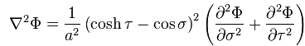

where their τ and σ are our ξ and u.

We can now summarize our three results in bipolar coordinates:

Some differential operators expressed in bipolar coordinates (8.24)

div B = (1/a) { (chξ–cosu) (∂ξBξ + ∂uBu) - shξ Bξ - sinu Bu } (8.14)

grad f = (1/a) (chξ - cosu) [ (∂ξf ) + (∂uf ) ] = (1/h) [ (∂ξf ) + (∂uf ) ] (8.19)

∇2f = (1/a2) (chξ–cosu)2 [ ∂ξ2f + ∂u2f ] = (1/h2) [ ∂ξ2f + ∂u2f ] (8.22)

9. Separability of the Laplace equation in Bipolar Coordinates

The Laplace equation is trivially separable in bipolar coordinates just as it is in Cartesian coordinates:

∇2f = 0 => [ ∂ξ2f + ∂u2f ] = 0 . // from (8.22) (9.1)

Try
f(ξ,u) = f1(ξ)f2(u) // a "separated" form (9.2)

then
∇2f = ∂ξ2[f1(ξ)f2(u)] + ∂u2[f1(ξ)f2(u)] = 0
or
f2(u) ∂ξ2f1(ξ) + f1(ξ) ∂u2 f2(u) = 0
or
$\frac{∂ξ2f1(ξ)}{f1(ξ)}$ + $\frac{∂u2f2(u)}{f2(u)}$ = 0 // has form F(ξ) + G(u) = constant (9.3)

so then

$\frac{∂ξ2f1(ξ)}{f1(ξ)}$ = k2
$\frac{∂u2f2(u)}{f2(u)}$ = -k2 (9.4)

where k2 (k can be complex) is the separation constant. For k2 > 0 the atomic forms are

f1(ξ) = [sh(kξ), ch(kξ)]
f2(u) = [sin(ku), cos(ku)] . (9.5)

If a problem of interest has a full range for coordinate u, then k gets quantized to an integer so that the function f2(u) is single valued in u. In any event, the harmonics are then

[sh(kξ), ch(kξ)] [sin(ku), cos(ku)] k2 > 0 . (9.6)

If k2 < 0 then the trig and hyperbolic function roles are switched in (9.5). If k2 = 0, the solutions are

f1(ξ) = [1, ξ] // meaning f1(ξ) = α1 + βξ = α + βξ
f2(u) = [1, u] . (9.7)

A general solution has the form ( we allow arbitrary non-zero k in the sum)

f(ξ,u) = Σk≠0 [ Ak sh(kξ) + Bk ch(kξ) ][ [Cksin(ku) + Dkcos(ku)]

+ (A0 + B0ξ)(C0+ D0u) (9.8)

where in principle the sum could be discrete and/or continuous depending on the problem.
Suppose we know for some reason that f(ξ,u) = f(ξ), independent of u. Then we have to rule out all contributions of the form shown on the first line of (9.8) since they all have u dependence. In fact, the only possible solution in this case is f(ξ) = A + Bξ . If we further know that f(0) = 0, then f(ξ) = Bξ is the only possible solution. This situation will arise in the next section.
For the Helmholtz equation (∇2 + λ)f = 0 this separation fails because the (chξ–cosu) factor cannot be thrown out as for the Laplace equation. That is to say, one has

(1/a2) (chξ–cosu)2 [ ∂ξ2f + ∂u2f ] + λ f = 0 (9.9)

and trying f(ξ,u) = f1(ξ)f2(u) gives

[ $\frac{∂ξ2f1(ξ)}{f1(ξ)}$ + $\frac{∂u2f2(u)}{f2(u)}$] = -λa2 $\frac{1}{(chξ–cosu)2}$ (9.10)

which cannot be written as F(ξ) + G(u) = constant.
Not surprisingly, for toroidal or bispherical coordinates the result is the same: Laplace is separable, Helmholtz is not.

10. The Two-Cylinder Capacitor Problem Part I

(a) Statement of the Problem

The canonical "capacitor problem" involving bipolar coordinates concerns two parallel and infinitely long cylindrical conductors. The problem is to find the capacitance per unit length C. Due to the nature of the geometry, the problem can be treated solely in cross section as a 2D potential theory problem:

∇2φ(x,y) = 0 => ∇22D φ(x,y) = 0 ∇2 = ∇2D2 + ∂z2 . (10.1)

The opening step is to imagine that the conductor cross sections are arranged so as to align with two of the blue circles in the bipolar coordinates drawing. This can certainly be done by a suitable rotation of the conductors so their center lines both lie on the x axis followed by a selection of parameter "a" so that the conductors then line up with some ξ2 > 0 blue circle on the right, and some other blue circle ξ1 < 0 on the left. We assume that this part of the problem is carried out (see Section 11 (a) below), and we now have this situation:

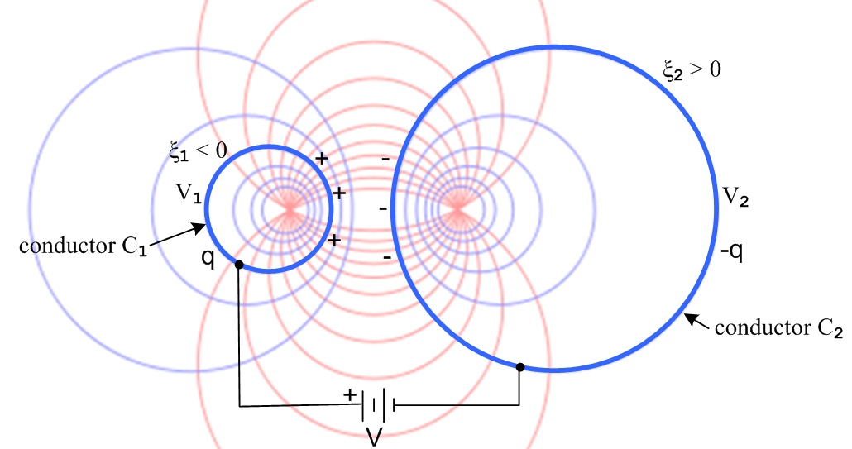 (10.2)

Both cylinders are first neutral, then we attach a battery of voltage V such that C1 has positive charge and therefore positive potential V1. Some charge Q flows onto the left conductor, and this same charge is extracted from the right conductor, so the conductors then have equal and opposite charges: Q on the left, -Q on the right. The conductors settle at some potential values V1 and V2 which are at this point "unknowns" of the problem. What is known is V, a, ξ1 and ξ2. The symbol q refers to charge per unit length of the left cylinder.

Comment: For infinite cylinders, a very large battery would be needed! We can assume that the two conductors are restricted so they are only 100 miles long, and then the total required Q is finite.

(b) Finding the Potential

This capacitor problem is a boundary value problem as follows:

∇2D2φ = 0 φ(C1) = V1
φ(C2) = V2
φ(∞) = 0 φ(C1) - φ(C2) = V = V1-V2 . (10.3)

There are four boundary conditions specified. The first three boundary conditions specify that the solution potential must be a constant on three "surfaces" (2D curves). These three conditions specify the potential on all surfaces enclosing the dielectric region of this capacitor problem, and such a specification makes this a "Dirichlet problem". The fourth boundary condition says that the potential difference between the two cylinders must be V. In potential theory, a Dirichlet problem always has a solution, and that solution is always unique. Note that we have a Dirichlet problem even though we don't yet know what V1 and V2 are.

In order to meet the first two boundary conditions φ(C1) = V1 and φ(C2) = V2, we know that the potential solution must have the form φ(ξ,u) = φ(ξ). This is so because each conductor has a ξ label, and we know all points on a blue circle have the same value of ξ, since in fact these circles are surfaces of constant ξ (level curves) of the bipolar coordinate system. According to the third last paragraph of the previous section, that Laplace solution must have the form φ(ξ) = A + Bξ. Recall now that ξ ≈ 0 describes huge blue circles which run up the y axis and basically bend off to infinity either to the right or left (ξ = ± 10-8 say). On portions of these circles far from the conductors, we know that ξ ≈ 0. But on these distant portions of the circles we are supposed to have φ(∞) = 0. Thus we have φ(ξ) = Bξ since φ(0) = 0.

Aside: It is not exactly clear what happens on the portions of these huge ξ = ± 10-8 circles that are close to the conductors on the y axis in the region between the conductors. We know that if φ = 0 on a distant section of a huge blue circle, it must also be 0 on that portion of the huge circle which passes down the y axis between the conductors, because all points on a blue circle have the same φ. One interpretation of this fact requires a bit of work: one can show that the surface charge on each of our capacitor blue circles acts as if it were concentrated at the focal point, and since these charges are q and - q, that explains why φ = 0 on the y axis (the center of charge is computed in (d) below).

The solution to our capacitor problem then can be taken as,

φ(ξ,u) = φ(ξ) = - c ξ , (10.4)

where c is a constant. This certainly is a simple form, and it certainly is a solution of the Laplace equation

∂ξ2φ + ∂u2φ = 0. (9.1)

It also meets the first three of our four boundary conditions, as noted above. The fourth boundary condition will determine the constant c as well as the values of V1 and V2. We know that

φ(ξ2) = - c ξ2 = V2 = the potential on conductor C2
φ(ξ1) = - c ξ1 = V1 = the potential on conductor C1 (10.5)

Therefore, since V = V1 - V2, we have

V = - c ξ1 + c ξ2 = c(ξ2-ξ1) (10.6)

so c is then given by

c = V / (ξ2- ξ1) = V / (ξ2+ |ξ1|) > 0 . (10.7)

The solution potential is then

φ(ξ) = - $\frac{ξ}{ξ2-ξ1}$V (10.8)

from which we find that

V2 = - $\frac{ξ2}{ξ2-ξ1}$V = - $\frac{ξ2}{ξ2+|ξ1|}$V < 0
V1 = - $\frac{ξ1}{ξ2-ξ1}$V = + $\frac{|ξ1|}{ξ2+|ξ1|}$V > 0 . (10.9)

This is all fine and well, but we still have not computed the capacitance of our capacitor!

(c) Finding the Charge q and therefore the Capacitance C = q/V

The plan here is to first find the electric field from the potential, then find the conductor surface charge density from the electric field, and then integrate that to get q, and then capacitance is C = q/V.

In bipolar coordinates using summary box (8.24) the electric field at an arbitrary point outside the conductors shown in Fig (10.2) is given by

E = -gradφ = - (1/h) [ (∂ξφ) + (∂uφ) ] (1/h) = (chξ–cosu)/a > 0

= - (1/h) [ (∂ξ[- $\frac{ξ}{ξ2-ξ1}$V] ) = (V/h) $\frac{1}{ξ2-ξ1}$ = (V/h) $\frac{1}{ξ2+|ξ1|}$
= (V/a) (chξ–cosu) $\frac{1}{ξ2+|ξ1|}$ . (10.10)

The first observation is that this E field always points in the direction. Looking at Fig (8.7) this means that the electric field always points along the red level curves, so these lines are in fact the "electric field lines" for the capacitor. Since the blue circles are orthogonal to these field lines, the blue circles must be equipotentials for the capacitor problem, something we already know from (10.8). Thus, we are spared the task of drawing the electric field and equipotential lines for our problem since the bipolar coordinate system provides these lines. The fact that E = (positive quantity) is consistent with the left conductor having positive charge as shown in Fig (10.2). As expected, at each conductor surface the electric field is normal to the surface. This is always the case in electrostatics.
The surface charge density n on a conductor surface is related to the normal electric field evaluated just above the surface according to n = εEn, where ε is the dielectric constant of the medium between the conductors (which we assume is non-conducting). Since dim(ε) = farad/m and dim(En) = volt/m, the units of n are dim(n) = farad-volt/m2 = coulomb/m2 as expected. On the left in Fig 8.7 we may identify the outfacing normal unit vector = so En = (V/h) $\frac{1}{ξ2-ξ1}$. Thus

n1(ξ1,u) = ε $\frac{V}{h(ξ1,u)}$$\frac{1}{ξ2-ξ1}$ // surface charge density on the left conductor C1
(10.11)
n2(ξ2,u) = - ε $\frac{V}{h(ξ2,u)}$$\frac{1}{ξ2-ξ1}$ // surface charge density on the right conductor C2

For the right conductor C2, h is evaluated with ξ = ξ2 and the minus sign arises because on the right we have the different situation = - , as in Fig (8.7).
We now wish to integrate the surface charge density to obtain the total charge q. Consider then a tiny patch of area on the left conductor which has dimension ds along the perimeter and dz into the plane of paper, so dA = dsdz. Going along the perimeter, ξ = constant so dξ = 0. From (3.4) then ds = hdu. This is of course the meaning of a scale factor in the first place, ds = hudu gives distance ds as u is varied du with ξ fixed . Compare to polar coordinates ds = hθdθ = rdθ as θ varies with r fixed. Thus,

dAi = dsidz = hu(ξi,u)dudz = h(ξi,u)dudz . (10.12)

We then rewrite (10.11) as [ dim(dQi) = charge on area patch of dAi ] ,

dQ1(ξ1,u) = n1(ξ1,u)dA1 = [ε $\frac{V}{h(ξ1,u)}$$\frac{1}{ξ2-ξ1}$]dA1 = ε $\frac{V}{ξ2-ξ1}$du dz

dQ2(ξ2,u) = n1(ξ2,u)dA2 = - [ε $\frac{V}{h(ξ2,u)}$$\frac{1}{ξ2-ξ1}$]dA2 = - ε $\frac{V}{ξ2-ξ1}$du dz . (10.13)

Notice that the scale factor h has canceled out and that the dQ values are still equal and opposite.

The total charge Q1 on a ring of depth dz of conductor C1 on the left is then given by

Q1 = ∫ dQ1(ξ1,u) = $^{\int_{0}^{2π}{}}$ [ε $\frac{V}{ξ2-ξ1}$du dz] = ε $\frac{V}{ξ2-ξ1}$dz$^{\int_{0}^{2π}{}}$du = 2πε $\frac{V}{ξ2-ξ1}$dz . (10.14)

In the u integral around the left blue circle in Fig (10.2) the bipolar coordinate varies from u = 0 on the left edge going up, reaches u = π on the focal line, then reaches u = 2π when the circle is completed. Thus, the charge per unit length in z is given by

q = q1 = 2πε $\frac{V}{ξ2-ξ1}$ (10.15)

and of course we will find that q2 = - q due to the minus sign in the second line of (10.13).
The capacitance per unit length of the two-cylinder capacitor is then given by

C = q/V = 2πε $\frac{1}{ξ2-ξ1}$ dim(ε) = farad/m (10.16)

We will verify this result in Section 11 with external sources.
If we use (10.15) to replace V by q in the potential (10.8) we find

φ(ξ) = - $\frac{ξ}{ξ2-ξ1}$V = - $\frac{ξ}{ξ2-ξ1}$$\frac{q}{C}$ = - $\frac{ξ}{ξ2-ξ1}$q $\frac{ξ2-ξ1}{2πε}$ = - $\frac{q}{2πε}$ξ . (10.17)

This is the solution of a differently-stated capacitor problem. Imagine that we load up the two conductors with charges q and -q using the mechanism of (10.2) and then we disconnect the battery. We then vary the size of the two conductors by changing ξ1 and/or ξ2. The charge on conductor C1 of course remains q as this happens. We see that the potential between the conductors is always φ(ξ) = -(q/2πε) ξ ! When stated in this manner with q fixed, the potential is independent of ξ1 and ξ2.
Using (4.3) we can write our two potential forms in Cartesian coordinates:

φ(ξ) = - $\frac{ξ}{ξ2-ξ1}$V = - $\frac{V}{2(ξ2-ξ1)}$ ln [$\frac{(x+a)2 + y2}{(x-a)2 + y2}$] = - $\frac{V}{2(ξ2-ξ1)}$ ln [$\frac{s12}{s22}$] (10.8) (10.18)

φ(ξ) = - $\frac{q}{2πε}$ξ = - $\frac{q}{4πε}$ ln [$\frac{(x+a)2 + y2}{(x-a)2 + y2}$] = - $\frac{q}{4πε}$ ln [$\frac{s12}{s22}$] (10.17) (10.19)

which can be restated without minus signs in this way,

φ(ξ) = $\frac{V}{2(ξ2-ξ1)}$ ln [$\frac{s22}{s12}$] = $\frac{V}{2(ξ2-ξ1)}$ ln[ $\frac{(x-a)2 + y2}{(x+a)2 + y2}$] (10.18a)

φ(ξ) = $\frac{q}{4πε}$ ln [$\frac{s22}{s12}$] = $\frac{q}{4πε}$ ln[ $\frac{(x-a)2 + y2}{(x+a)2 + y2}$] . (10.19a)

In Chapter 5 of Ref [5] we define a dimensionless transverse potential φt by,

φ(x,y,z) = $\frac{1}{4πε}$ q(z) φt(x,y) Ref [5] (5.1.1)

and comparison with (10.19a) shows that (using also (4.5) above),

φt(x,y) = ln [$\frac{s22}{s12}$] = ln[ $\frac{(x-a)2 + y2}{(x+a)2 + y2}$] = -2ξ (10.20)

where the first form is in agreement with (6.1.2) of Ref [5]. The new fact is that φt = -2ξ in bipolar coordinates which is a very simple result for the transverse potential. Also from Ref [5], the system for φt was

∇t2 φt(x,y) = 0 φt(C1) = K1 φt(C2) = K2 K1-K2 = K . Ref [5] (5.4.3)

so we find that

K1 = -2ξ1 K2 = -2ξ2 K = K1-K2 = 2(ξ2-ξ1) (10.21)

where K is a certain parameter which determines transmission line parameters. This expression for K appears in the form K = 2(B2-B1) in Ref [5] (6.3.2) where the bipolar coordinate ξ is B (and where ξ is used for the complex dielectric constant, totally unrelated to ξ here).

(d) Surface charge density versus angle θ and the Center of Charge

In terms of the circle angle θ, distance along the circle C1 is given by

ds1 = hθdθ = R1dθ (10.22)

and the area element (for thinking about charge density) is

dA1 = ds1 dz = R1dθ dz . (10.23)

From (10.13) we then have

dQ1(ξ1,θ) = n1(ξ1,u) dA1 = [ε $\frac{V}{h(ξ1,u)}$$\frac{1}{ξ2-ξ1}$] [dA1] = [ε $\frac{V}{h(ξ1,θ)}$$\frac{1}{ξ2-ξ1}$] [R1dθ dz]

= ε V $\frac{sh2ξ1}{a(chξ1+cosθ)}$$\frac{1}{ξ2-ξ1}$( a/|shξ1| ) dθ dz = ε V $\frac{1}{ξ2-ξ1}$ $\frac{|shξ1|}{chξ1+cosθ}$ dθ dz // (2.4) for R1

= $\frac{1}{2π}$ [2πε $\frac{V}{ξ2-ξ1}$] $\frac{|shξ1|}{chξ1+cosθ}$ dθ dz = $\frac{q}{2π}$ $\frac{|shξ1|}{chξ1+cosθ}$ dθ dz // q from (10.15) . (10.24)

As a check on this result, we integrate over dθ,

∫ dQ1(ξ1,θ) = $\frac{q}{2π}$|shξ1| dz $^{\int_{0}^{2π}{}}$$\frac{dθ}{chξ1+cosθ}$ = $\frac{q}{2π}$|shξ1| dz $\frac{2π}{|shξ1|}$ = q dz (10.25)

where the integral is provided by Maple,

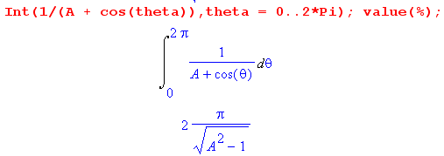 (10.26)

The conclusion is that the total charge in a ring of depth dz over the C1 perimeter is q dz, which is correct.
We have obtained then these expressions for the two conductors' charge densities,

dQ1(ξ1,θ) = n1(ξ1,θ)dA1 = $\frac{q}{2π}$ $\frac{|shξ1|}{chξ1+cosθ}$ dθ dz
dQ2(ξ2,θ) = n2(ξ2,θ)dA1 = - $\frac{q}{2π}$ $\frac{|shξ2|}{chξ2+cosθ}$ dθ dz . (10.27)

It is convenient now to define,

n1(ξ1,θ) = dQ1(ξ1,θ)/[dθdz] = $\frac{q}{2π}$ $\frac{|shξ1|}{chξ1+cosθ}$
n2(ξ2,θ) = dQ2(ξ2,θ)/[dθdz] = - $\frac{q}{2π}$ $\frac{|shξ2|}{chξ2+cosθ}$ (10.28)

where these italic n's are angular charge densities, per unit length of conductor. Then from (10.25),

$^{\int_{0}^{2π}{}}$n1(ξ1,θ) dθ = q
$^{\int_{0}^{2π}{}}$n2(ξ2,θ) dθ = - q (10.29)

Fact: When the total charges (per unit length) are specified as q and -q on the two conductors, the angular surface charge density n1(ξ1,θ) on conductor C1 is independent of both the focal parameter a and the ξ2 value of conductor C2. If one were to vary ξ2 from C2 being very small to very large, n1(ξ1,θ) would not change. (10.30)

We see this explicitly in (10.28) and it follows from (10.17) which says the potential for fixed q is independent of a, ξ1 and ξ2. We could take conductor C2 to be a thin wire at the focal point (ξ2 = ∞), or the plane at x=0 (ξ2= 0), n1(ξ1,θ) is always given by the first line of (10.28).

We can now compute the "center of charge" for the right blue circle having parameter ξ2. Just for the purposes of this calculation, we center the blue circle at x = 0,

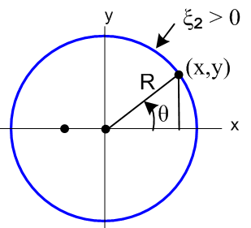 (10.31)

The center of charge is given by

<x> = $^{\int_{0}^{2π}{}}$$^{\int_{0}^{2π}{}}$ . (10.32)
From (10.29) the denominator integral -q . The numerator is

$^{\int_{0}^{2π}{}}$ n2(ξ2,θ) (R2 cosθ) dθ = $^{\int_{0}^{2π}{}}$[ - $\frac{q}{2π}$ $\frac{|shξ2|}{chξ2+cosθ}$] (R2 cosθ) dθ

= - $\frac{q}{2π}$ shξ2 R2 $^{\int_{0}^{2π}{}}$dθ $\frac{cosθ}{chξ2+cosθ}$ // ξ2 > 0 (10.33)

so then

<x> = $\frac{1}{2π}$ shξ2 R2 $^{\int_{0}^{2π}{}}$dθ $\frac{cosθ}{chξ2+cosθ}$ = $\frac{a}{2π}$ $^{\int_{0}^{2π}{}}$dθ $\frac{cosθ}{chξ2+cosθ}$ (10.34)

since R2 = a/shξ2 from (2.4). Maple does the integral,

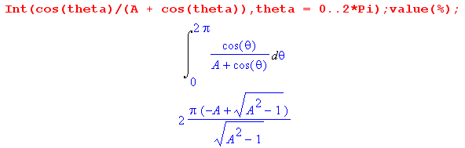 (10.34)
so then

<x> = $\frac{a}{2π}$ 2π ( -chξ2 + shξ2)/shξ2 = a ( -1/th(ξ2) + 1) = -a/th(ξ2) + a = - xc+ a

= - (xc -a) < 0 (10.36)

But looking at Fig (7.1), the quantity xc - a > 0 is the distance from the focus to the circle center. It seems fairly obvious that <y> = 0 since n is symmetric about the x axis. Therefore we have just proven:

Fact: For a capacitor made of two cylinders, the center of charge for each cylinder cross section lies exactly at the bipolar coordinate system focal point. (10.37)

We only showed this on the right side, but the reader will no doubt accept it as true on the left as well since it is just the mirror image situation.

Implication: The 2D potential outside two conducting disks holding charge q on the left and -q on the right is the same as the 2D potential of a point charge q at the left focus and a point charge -q at the right focus. (10.38a)
Implication: The 3D potential outside two infinite conducting cylinders holding charge/m q on the left and -q on the right is the same as the 3D potential of a line charge/m q on the left focal line and a line charge/m -q on the right focal line. (10.38b)

In 2D potential theory, the potential of a unit positive point charge is (1/2πε) ln(1/s) where s is the distance from the charge to the observation point. Therefore, if we superpose the potential of our two focal point charges we get, looking at Fig (6.1),

φ = (q/2πε) ln(1/s1) - (q/2πε) ln(1/s2) = (q/2πε)ln(s2/s1) = (q/4πε)ln(s22/s12)

= - $\frac{q}{4πε}$ ln [$\frac{s12}{s22}$] . (10.39)

This agrees with our earlier calculation of the potential shown in (10.19). The result is of course no big surprise, since we already found in (10.17) that

φ(ξ) = - $\frac{q}{2πε}$ξ , (10.16)

so that the potential (for the problem of fixed charges q and -q) doesn't even know about ξ1 and ξ2 and must therefore be valid for ξ1 = -∞ and ξ2 = +∞ which "circles" are the focal points.

In closing this section, we generate some plots of angular surface charge versus θ for various values of ξ. These will be made using (10.28),

n1(ξ1,θ) = $\frac{q}{2π}$ $\frac{|shξ1|}{chξ1+cosθ}$ . (10.28)

In the following Maple code the factor q/2π is set to 1 :

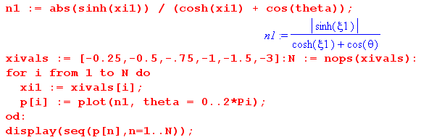

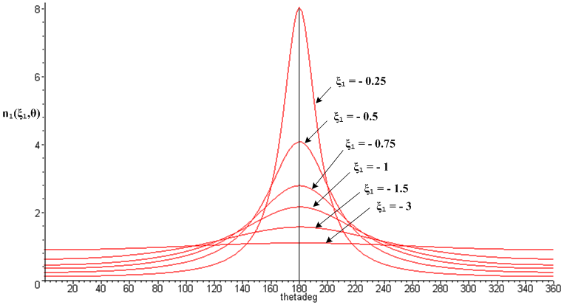
(10.40)
Since each n1(ξ1,θ) has the same area q , each curve above has the same area 2π.

In the figure below, the large conductor pair has ξ = ±0.25 and would exhibit the most strongly peaked charge distribution shown above. Most of this distribution lies in the range ±40o from 180o, as marked by the red curve:

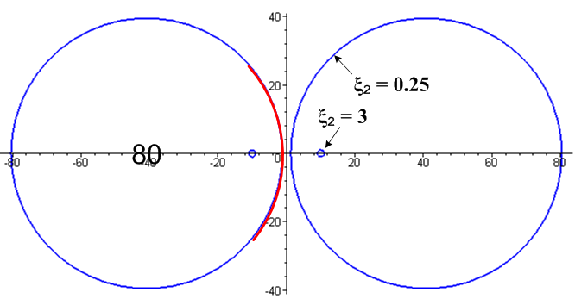 (10.41)

The tiny conductor pair has ξ = ±3 and for that pair the charge distribution is very close to uniform at all angles, as shown by the ξ1 = -3 curve in Fig (10.38).

Appendix A calculates the Fourier "moments" of the angular charge distribution n1(ξ1,θ) .

11. The Two-Cylinder Capacitor Problem Part II

Here we fill in some of the pieces omitted in Part I.

(a) Aligning the Cylinders

Consider again Fig (10.2) which shows the two cylinders. We know the radii and center locations of the two cylinders from (2.4),

(x - xc)2 + y2 = R2 xc = a/thξ R = a/|shξ| (2.4)

so that

R2 = a/|shξ2| xc2 = a/thξ2
R1 = a/|shξ1| xc1 = a/thξ1 . (11.1)

The distance between the cylinder centers we shall call b,

b = xc2 - xc1 = a/thξ2 - a/thξ1 . (11.2)

We wish to compute the parameters a, ξ1 and ξ2 in terms of R1,R2 and b. There are three equations in three unknowns,

R2 = a/|shξ2|
R1 = a/|shξ1|
b = a( cothξ2 - cothξ1) . (11.3)

In Fig (10.2) ξ2 > 0 and ξ1 < 0. To make our algebra investment below a little more general, we assume that sign(ξ2) = +1 but sign(ξ1) = σ1, allowing ξ1 to have either sign. From (11.1),

1/thξ2 = cothξ2 = $\sqrt{1 + 1/sh2ξ2}$ = $\sqrt{1 + (R2/a)2}$
1/thξ1 = cothξ1 = σ1$\sqrt{1 + 1/sh2ξ1}$ = σ1$\sqrt{1 + (R1/a)2}$. (11.4)

Then

b = xc2 - xc1 = a ($\sqrt{1 + (R2/a)2}$ - σ1$\sqrt{1 + (R1/a)2}$ ) = ( $\sqrt{a2+R22}$ - σ1 $\sqrt{a2+R12}$) . (11.5)

Square to get

b2 = (a2+R22) + (a2+R12) - 2σ1$\sqrt{a2+R22}$$\sqrt{a2+R12}$
or
(b2-2a2-R22-R12) = - 2σ1$\sqrt{a2+R22}$$\sqrt{a2+R12}$. (11.6)

Square again to get

(b2-2a2-R22-R12)2 = 4(a2+R22) (a2+R12) . (11.7)

Maple solves this equation for a = a(b,R1,R2) as follows,

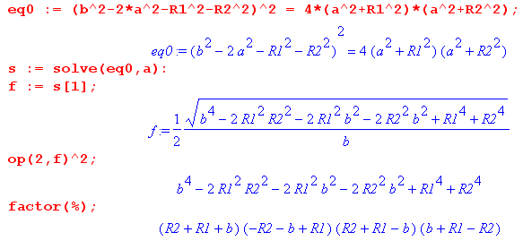

The last line may be written [ b2- (R1+R2)2] [ b2- (R1-R2)2] so we conclude that

a = (1/2b) $\sqrt{b2 - (R2+R1)2}$$\sqrt{b2 - (R2-R1)2}$ . (11.8)

Given this expression for a, the other two unknowns in (11.3) are,

shξ2 = (a/R2) => ξ2 = sh-1 (a/R2) = ln[ (a/R2) + $\sqrt{1+(a/R2)2}$]
shξ1 = σ1(a/R1) => ξ1 = σ1sh-1 (a/R1) = σ1 ln[ (a/R1) + $\sqrt{1+(a/R1)2}$] , (11.9)

so our solution for a, ξ2 and ξ1 in terms of R1, R2 and b is then,

a = (1/2b) $\sqrt{b2 - (R2+R1)2}$$\sqrt{b2 - (R2-R1)2}$

ξ2 = sh-1 (a/R2)

ξ1 = σ1sh-1 (a/R1) . (11.10)

As an example, we measure from Fig (10.2) that b = 6 cm, R2 = 3.5 cm, R1 = 1.3 cm, and σ1 = -1 so

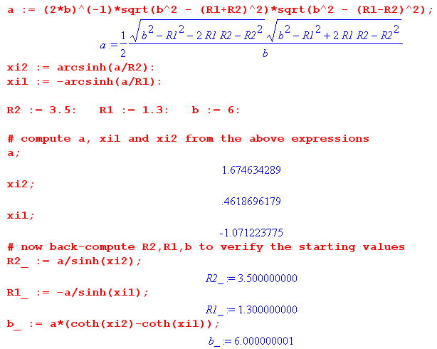

(b) Capacitance in terms of R1, R2 and b

Consider now:

ch(ξ2 - ξ1) = ch(|ξ2| - σ1|ξ1|) = ch|ξ2| ch|ξ1| - σ1 sh|ξ2| sh|ξ1| // Spiegel 8.21

= $\sqrt{1+sh2ξ2}$$\sqrt{1+sh2ξ1}$ - σ1 sh|ξ2| sh|ξ1|

= $\sqrt{1+(a/R2)2}$$\sqrt{1+(a/R1)2}$ - σ1 (a/R2) (a/R1) // from (11.9)

= (1/R1R2) $\sqrt{a2+R22}$$\sqrt{a2+R12}$ - σ1 (a/R2) (a/R1)

= (R1R2)-1 [$\sqrt{a2+R22}$$\sqrt{a2+R12}$ - σ1a2 ] . (11.11)

But from (11.6) we know that

$\sqrt{a2+R22}$$\sqrt{a2+R12}$ = (b2-2a2-R22-R12)/(-2σ1) = -σ1(b2-2a2-R22-R12)/2 (11.12)

Inserting this into (11.11) gives

ch(ξ2 -ξ1) = (R1R2)-1[-σ1(b2-2a2-R22-R12)/2 -σ1a2]

= (2R1R2)-1 σ1[-(b2-2a2-R22-R12) -2a2]

= (2R1R2)-1 σ1[-b2+2a2+R22+R12 -2a2]

= (2R1R2)-1 σ1[-b2+R22+R12] ,

where a has vanished. We then have

ξ2-ξ1 = ch-1 [ σ1 $\frac{-b2+R22+R12}{2R1R2}$] = ch-1 [$\frac{σ1}{2}$( - $\frac{b2}{R1R2}$ + $\frac{R2}{R1}$ + $\frac{R1}{R2}$ ) ] . (11.13)

From (10.15), we may therefore express the capacitance per unit length as

C = 2πε $\frac{1}{ξ2-ξ1}$ = $\frac{σ1}{2}$$\frac{b2}{R1R2}$$\frac{R2}{R1}$$\frac{R1}{R2}$ . (11.14)

In particular, for Fig (10.2) we have σ1 = - 1 so this says

C = 2πε $\frac{1}{ξ2-ξ1}$ = $\frac{1}{2}$$\frac{b2}{R1R2}$$\frac{R2}{R1}$$\frac{R1}{R2}$ . (11.15)

This result agrees with Ref [5] (4.11.30) which states C = 4πε/K along with (6.3.10) for K,

K = 2 ch-1 { (1/2) [ (b2/a1a2) - (a1/a2) - (a2/a1)] } . Ref [5] (6.3.10)

(c) The Cylinder Over Plane Case

If in Fig 10.2 one takes the limit ξ1 → 0, the blue circle on the left becomes the vertical y axis, and the situation is then that of a cylinder lying over a ground plane, as indicated here (dielectric is gray),

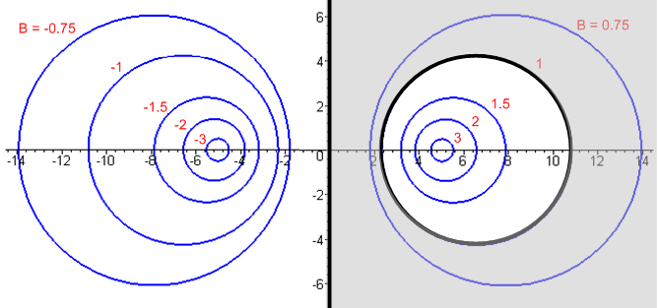 (11.16)

In this limit,

φ(ξ) = - $\frac{ξ}{ξ2}$V (10.8)

V2 = - V
V1 = 0 (10.9)

E = (V/a) (chξ–cosu) $\frac{1}{ξ2}$ (10.10)

n(ξ1,u) = ε $\frac{V}{h(0,u)}$$\frac{1}{ξ2}$ // surface charge density on the left conductor C1 (y axis)
(10.11)
n(ξ2,u) = - ε $\frac{V}{h(ξ2,u)}$$\frac{1}{ξ2}$ // surface charge density on the right conductor C2

q = q1 = 2πε $\frac{V}{ξ2}$ (10.14)

C = q/V = 2πε $\frac{1}{ξ2}$ (10.15)

φ(ξ) = - $\frac{q}{2πε}$ξ . // no change (10.16)

The capacitance can be expressed alternatively as follows. Consider from (2.4),

x2c = a coth ξ2 = a chξ2/shξ2
R2 = a/sh(ξ2) (2.4)

Therefore

x2c/R2 = chξ2 => ξ2 = ch-1(x2c/R2) .

But xc2 being the center of the ξ2 blue circle is the height h of that center above the plane, so

ξ2 = ch-1(h/R2) = ln [ (h/R2) + $\sqrt{(h/R2)2 + 1}$ ] ≈ ln (2h/R2) if h >> R2 . (11.17)

The capacitance for the radius R2 cylinder with center line h above the plane is then

C = 2πε $\frac{1}{ξ2}$ = $\frac{2πε}{ch-1(h/R2)}$ = $\sqrt{(h/R2)2 + 1}$ (11.18)

which agrees with (6.3.19) of Ref [5] along with C = 4πε/K.

(d) The Offset Coaxial Cylinders Case

If in Fig (10.2) the small blue circle with ξ1 < 0 is replaced by its mirror image blue circle with ξ1> 0, one obtains an offset coaxial capacitor, where again the dielectric is gray,

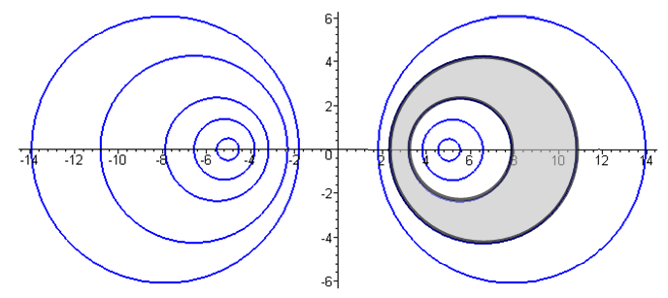 (11.19)

The "math" for this case is the same as done in Section (b) above, except now σ1 = +1 instead of -1. The parameter b is still the distance between the two cylinder centers b = xc2-xc1. The quantity (ξ2-ξ1) is now negative since ξ1 > ξ2. We just read off the results from above,

φ(ξ) = - $\frac{ξ}{ξ2-ξ1}$V (10.8)

V2 = - $\frac{ξ2}{ξ2-ξ1}$V > 0
V1 = - $\frac{ξ1}{ξ2-ξ1}$V > 0 (10.9)

E(ξ,u) = (V/h(ξ,u)) $\frac{1}{ξ2-ξ1}$ (10.10)

n(ξ1,u) = - ε $\frac{V}{h(ξ1,u)}$$\frac{1}{ξ2-ξ1}$ > 0 // surface charge density on the inner conductor C1
(10.11)'
n(ξ2,u) = ε $\frac{V}{h(ξ2,u)}$$\frac{1}{ξ2-ξ1}$ < 0 // surface charge density on the outer conductor C2

Both normals have flipped around causing new minus signs in (10.11). Finally,

C = q/V = 2πε $\frac{1}{ξ2-ξ1}$ dim(ε) = farad/m (10.15)
φ(ξ) = - $\frac{q}{2πε}$ξ // no change (10.16)

The capacitance C can be expressed in terms of b, R1 and R2 using (11.14) with σ1 = +1, so

C = 2πε $\frac{1}{ξ2-ξ1}$ = $\frac{1}{2}$$\frac{b2}{R1R2}$$\frac{R2}{R1}$$\frac{R1}{R2}$ . (11.20)

which agrees with (6.3.13) of Ref [5] along with C = 4πε/K.

For the perfectly centered coaxial cable we set b = 0 (no offset of centers). In this case

ch-1 [$\frac{1}{2}$($\frac{R2}{R1}$ + $\frac{R1}{R2}$ )] = ln [$\frac{R2}{R1}$] // an identity for R2 > R1 (11.21)

so then

C = $\frac{2πε}{ln(R2/R1)}$ (11.22)

The identity (11.21) can be proven using ch-1x = ln(x + $\sqrt{x2+1}$) for x ≥ 1.

One might well wonder how this centered case can be reached since Fig (11.19) above seems to indicate that the two cylinders can never have a common center. We do know that the centers become "more common" for larger values of ξ1 and ξ2, something visible in Fig (2.5) for example. There the ξ = 2 and ξ = 3 circles are pretty close to concentric, but not quite.
To resolve this mystery, we consider equations (11.10) from above,

a = (1/2b) $\sqrt{b2 - (R2+R1)2}$$\sqrt{b2 - (R2-R1)2}$

ξ2 = sh-1 (a/R2)

ξ1 = σ1sh-1 (a/R1) (11.10)

If b becomes very small, the first line above says

a = (1/2b)(R2+R1)(R2-R1)

so as b→0 one has a → ∞. With σ1 = +1, the next two equations say

ξ2 = sh-1 (a/R2) ≈ ln(2a/R2) → ∞
ξ1 = sh-1 (a/R1) ≈ ln(2a/R1) → ∞

so as b→0, both ξ1 and ξ2 become very large and then the circles are concentric in the limit.

12. The Metric Tensor with Application to Bipolar Coordinates

The notation used in this section is the "non-standard" notation used in the first 6 chapters of Ref [3].

The defining (non-linear) transformation for bipolar coordinates was given in (2.2),

x = a shξ/(chξ - cosu) (2.2) (12.1)
y = a sinu/(chξ - cosu) .

It is useful to think of

x = (x1, x2) = (x,y) Cartesian coordinates

x' = (x'1, x'2) = (ξ,u) bipolar coordinates . (12.2)

The non-linear transformation (12.1) is then a special case of

x = F-1(x') (12.3)

where in general x and x' each have n components, while our example has n = 2. For curvilinear coordinates, the transformation is always invertible, so one can also write,

x' = F(x) . (12.4)

We think of this transformation as being a mapping from x-space to x'-space, where x-space is Cartesian space and x'-space is "the space of some curvilinear coordinates" called x'n :

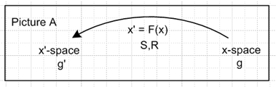 (12.5)

In general the transformations F and F-1 are non-linear, but if we look in the neighborhood of a specific point x in x-space (corresponding to point x' in x'-space) we can define the following two linear transformations ( that is, matrix transformations) ,

dx'i = Σk(∂x'i/∂xk) dxk = Σk Rik dxk Rik ≡ (∂x'i/∂xk)
dxi = Σk( ∂xi/∂x'k) dx'k = Σk Sik dx'k Sik ≡ (∂xi/∂x'k) (12.6)

which we can then write as

dx' = R(x) dx Rik(x) ≡ (∂x'i/∂xk) R = S-1 // dx'i = ΣjRij dxj
dx = S(x') dx' Sik(x') ≡ (∂xi/∂x'k) S = R-1 // dxi = ΣjSij dx'j . (12.7)

Thus, at a specific point in space, the transformation F has a linearized form which is described by either matrix R or matrix S. These are just matrices of derivatives as shown, and RS = 1 by the chain rule.
Any vector which transforms in this manner, in going from x-space to x'-space,

V' = RV (12.8)

is called a contravariant vector. It is a vector that transforms the way dx transforms.
On the other hand, any vector which transforms this way

' = ST (12.9)

is called a covariant vector. Matrix ST is the transpose of matrix S. We annotate covariant vectors and other tensors with an overbar, whereas contravariant objects get no overbar. It is easy to show that the velocity of a particle transforms as a contravariant vector, whereas the gradient of a scalar function transforms as a covariant vector, just to give two examples.
The covariant metric tensor 'ij is a square matrix which determines the length ds in Cartesian space of a differential vector dx' in x'-space. Cartesian space (which is x-space) has ij = δi,j . We put a prime on 'ij to make clear it is the metric tensor for x'-space, while ij is the metric tensor for x-space. We then write for Cartesian coordinates,

(ds)2 = Σij ij dxidxj = Σij δi,j dxidxj = Σi (dxi)2 = (dx1)2 + (dx2)2 + ..... (12.10)

For "some other" (that is, some curvilinear) coordinates x' we have instead

(ds)2 = Σij 'ij dx'idx'j . (12.11)

The distance (ds)2 in either case is the square of distance in real physical Cartesian space. In (12.11) this distance is expressed in terms of the curvilinear coordinates.

Recall now from (12.7) that

dxi = ΣkSik dx'k .

We can insert this twice into the (12.10) to get

(ds)2 = Σij ij dxidxj = Σij ij [ΣkSik dx'k] [ΣsSjs dx's]

= Σks [Σij ij SikSjs ] dx'k dx's . (12.12)

We now rename the indices in this sequence

i → m
j→ n
k → i
s → j

to get

(ds)2 = Σij [Σmn mn SmiSnj ] dx'i dx'j (12.13)

But comparison with (12.11) shows that

'ij = Σmn mn SmiSnj = Σmn δm,n SmiSnj = Σm SmiSmj = Σm STimSmj = [STS]ij . (12.14)

Thus we have shown that

' = STS (12.15)

and this then tells us how to compute the metric tensor for any transformation x' = F(x) !

Note: As shown in Ref. [3], in the "standard notation" one writes (12.12) in this way

(ds)2 = Σij gij dxidxj = Σij gij [ΣkSik dx'k] [ΣsSjs dx's]

= Σks [Σij gij SikSjs ] dx'k dx's (12.12)

where upper indices are contravariant and lower indices are covariant. For our purposes here, this notation seems overkill and we prefer the simpler "college calculus" notation described above where all indices are "down", overbars mark pure covariant tensors, while no-overbar means a pure contravariant tensor.

Example 1: Polar coordinates

Here we happen to choose θ = 1 and r = 2, it does not matter how this is done. So:

x = (x1, x2 ) = (x,y)
x' = (x'1, x'2) = (θ,r)

x = F-1(x') ↔ x = rcos(θ) x1 = x'2 cos(x'1)
y = rsin(θ) x2 = x'2 sin(x'1)

S11 = (∂x/∂θ) = -rsinθ
S12 = (∂x/∂r) = cosθ Sik ≡ ( ∂xi/∂x'k)
S21 = (∂y/∂θ) = rcosθ
S22 = (∂y/∂r) = sinθ
so
S = $\left(\begin{matrix}-rsinθ & cosθ \\ rcosθ & sinθ\end{matrix}\right)$ (12.16)

' = STS

To avoid making errors, we call upon Maple to compute '

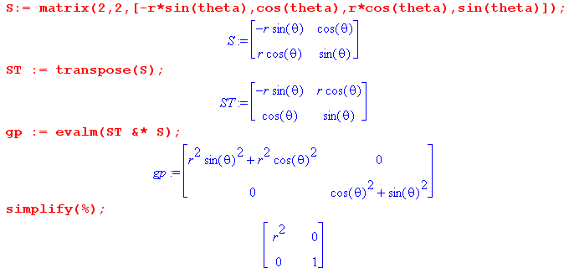

Thus we find that

' = $\left(\begin{matrix}gθθ & gθr \\ grθ & grr\end{matrix}\right)$ = $\left(\begin{matrix}r2 & 0 \\ 0 & 1\end{matrix}\right)$ => hθ = $\sqrt{gθθ}$= r // scale factors (12.17)
=> hr = $\sqrt{grr}$= 1

Had we been lazier, we could have had Maple do the whole thing, soup to nuts (xp means x' ):

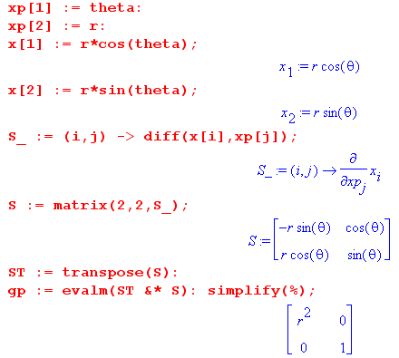

Example 2: Bipolar Coordinates

Here we let Maple do it all, following the model shown above:

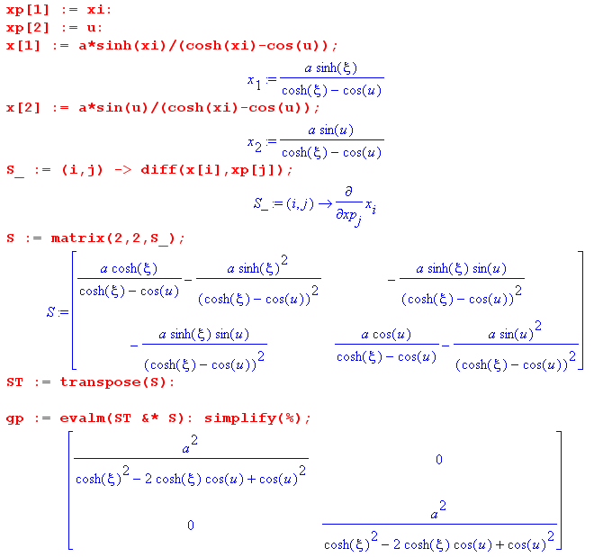

We thus arrive at the result

' = $\left(\begin{matrix}gξξ & 0 \\ 0 & guu\end{matrix}\right)$ gξξ = guu = $\frac{a2}{(chξ-cosu)2}$ => hξ = hu = $\frac{a}{(chξ-cosu)}$ . (12.18)

Thus is derived the metric tensor quoted in (3.3) above. As a fringe benefit, the reader has a quick way to compute the metric tensor for any curvilinear coordinate system in n dimensions.
As shown in Ref [3] Section 5 (j), the metric tensor ' is related to the tangent base vectors en in this manner,

'mn = em • en = hmhn m • n (12.19)

where, for example, in the polar coordinates above one has 1 = and 2 = . Therefore, if the base vectors are orthogonal, then ' is a diagonal matrix (and vice versa). In Cartesian coordinates,

mn = • = δm,n where = , = etc (12.20)

13. Bipolar Coordinates as a Conformal Map

(a) Basic Conformal Mapping Facts

Some fundamental theorems about conformal maps are easy to show (see e.g. Ahlfors p 73).
Suppose w = f(z) where f(z) is any function analytic near z = z0. Let z(t) be path in the complex z-plane that maps into some path w(t) in the complex w-plane, where t is some real parameter which labels points on the paths. Then,

dw/dt = df/dz * dz/dt => w'(t) = f '(z) z'(t) . (13.1)

Here w'(t) is tangent to the path in w-space, while z'(t) is tangent to the path in z-space. Then

arg w'(t) = arg f '(z) + arg z'(t) . (13.2)

If z0 = z(t0) this says

arg w'(t0) = arg f '(z0) + arg z'(t0) . (13.3)

Now let z1(t) and z2(t) be two paths which pass through z0, and let w1(t) and w2(t) be the corresponding paths in w-space which pass through w0 = f(z0). Then

arg w1'(t0) = arg f '(z0) + arg z1'(t0)

arg w2'(t0) = arg f '(z0) + arg z2'(t0) .

Subtract to get

arg w1'(t0) - arg w2'(t0) = arg z1'(t0) - arg z2'(t0) . (13.4)

This says that whatever the angle is between the two paths in z space, the angle is the same between the two corresponding paths in w space. So: "angles are preserved". The fact that f(z) is analytic near z0 means that f(z) and f '(z) are both perfectly well defined at z0 and f '(z0) is the same regardless of the direction from which one approaches z0 in the complex z plane. All normal functions are analytic where they don't have poles, branch points, or obscure "essential singularities".
Now go back to w = f(z) and write

dw = f '(z) dz => |dw| = |f '(z)| |dz|
or
|dw(t0)| = |f '(z0)| |dz(t0)| (13.5)

|dz(t0)| is the length of a differential piece of the path z(t) in z-space touching z0
|dw(t0)| is the length of a differential piece of the path w(t) in w-space touching w0.

In general one won't have |f '(z0)| = 1 so the differential segments won't have the same length. In fact, the length |dz(t0)| is scaled up or down going to |dw(t0)| by some real number k = |f '(z0)|. The thing to notice is that |dw(t0)| = k |dz(t0)| applies for any path z(t) passing through z0, regardless of its angle at z0. If we swing this little vector dz(t0) to lots of different angular positions in z-space, the length of the resulting paths dw(t0) is always the same -- it is just the length of the z-space dz times k. Thus, under an analytic mapping, differential distance at some point z0 may be scaled, but it is scaled the same in all directions, so "scaling is the uniform over direction".
Recall that for 2D orthogonal coordinates, where the metric tensor is diagonal, we have

(ds)2 = Σij 'ij dx'idx'j = Σi 'ii (dx'i)2 = h12 (dx'1)2 + h22 (dx'2)2

= hu2 (du)2 + hv2 (dv)2 where we give names (u,v) = (x'1,x'2) . (13.6)

If the transformation arises from a conformal map w = f(z) such that

u + iv = f (x + iy) that is w = f(z) , (13.7)

then we know two facts:
(1) At a point z0 in z-space, if two level curves are at right angles, then they will also be at right angles in w-space, since angles are preserved. Thus, (u,v) is an orthogonal coordinate system.
(2) the scale factors hu and hv must be the same, since distance is scaled equally in all directions. In fact, looking at (13.5) and (13.6) we identify ds = |dz| and so |f '(z0)| = |dw|/|dz| = |du|/|ds| = 1/hu, so

h = hu = hv = 1/ |f '(z0)| (13.8)

which allows the scale factors to be computed directly from f(z).
A final conformal mapping fact is Riemann's mapping theorem (see e.g., Spiegel, Complex Variables, p201) which says that there always exists an analytic function which provides a 1-to-1 conformal mapping between a 2D region bounded by any simple (that is, non-self-intersecting) curve and the unit disk, where the curve itself maps into disk perimeter. The implication is that any two arbitrary simple regions of 2D space are connected by some unique analytic f(z).

(b) Example: Polar Coordinates in (u,θ) format

Consider this analytic mapping (if a mapping is analytic, so is its inverse, away from singularities),

w = ln(z) = f(z) => z = ew // f'(z) = 1/z (13.9)

Then write z = ew as

x + iy = e(u+iv) = eu eiv = eu (cosv + isinv)
so
x = eu cosv
y = eu sinv . (13.10)

Rename v→θ and leave u as is

x = eu cosθ
y = eu sinθ . (13.11)

We compute the metric tensor as earlier,

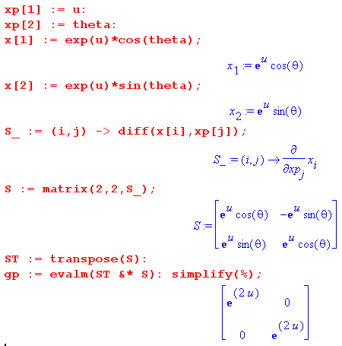

Sure enough, we find that hθ = hu = eu . The scale factors are equal because we treated the transformation properly as a conformal map. We used variables (u,θ). If we set eu = r, that is fine, but (r,θ) are then not related to (x,y) by a conformal map, so that is why hr ≠ hθ .

Alternatively, using (13.8), we find that h = |f '(z)|-1 = |1/z|-1 = |z| = |ew| = |eu+iv| = eu .

(c) Example: Bipolar Coordinates as a Conformal Map

Consider this analytic mapping of the form w = f(z)

w = -i ln [$\frac{z+a}{z-a}$] = f(z) => eiw = $\frac{z-a}{z+a}$ . // f'(z) = 2ia/(z2-a2) (13.12)

The inverse mapping is then,

eiwz + eiwa = z - a => z(eiw-1) = -a(eiw+1)
so
z = -a $\frac{eiw+1}{eiw-1}$ = -a $\frac{eiw/2+e-iw/2}{eiw/2- e-iw/2}$ = -a $\frac{2 cos(w/2)}{2i sin(w/2)}$ = ia $\frac{cos(w/2)}{sin(w/2)}$ = ia cot(w/2) (13.13)

where

z = x+iy w = u + iv = u + iξ
w* = u - iv = u - iξ w*- w = -2iξ w* + w = 2u . (13.14)

Now write (13.13) as

x + iy = ia $\frac{cos(w/2)}{sin(w/2)}$ = ia $\frac{sin(w*/2)}{sin(w*/2)}$ $\frac{cos(w/2)}{sin(w/2)}$ (13.15)

Evaluating the top and bottom using standard trig identities,

sin(w*/2)cos(w/2) = (1/2){sin[$\frac{w*-w}{2}$] + sin[$\frac{w*+w}{2}$]} = (1/2){sin[-iξ] + sin[u] } = (1/2){-ishξ + sinu}
sin(w*/2)sin(w/2) = (1/2){cos[$\frac{w*-w}{2}$] - cos[$\frac{w*+w}{2}$]} = (1/2){cos[-iξ] -cos[u] } = (1/2){chξ - cosu}
(13.16)
gives

x + iy = ia $\frac{-ishξ + sinu}{chξ - cosu}$ = a $\frac{shξ + isinu}{chξ - cosu}$. (13.17)

Therefore,

x = a shξ/(chξ-cosu)
y = a sinu/(chξ-cosu) (13.18)

and these are the equations (2.2) used to define bipolar coordinates. Since this transformation arises from a conformal map, we expect the two scale factors to be the same. We can compute h from (13.8) :

h = $\frac{1}{|f'(z)|}$ = $\frac{|z2-a2|}{2a}$ = $\frac{| -a2cot2(w/2) - a2|}{2a}$ = (a/2) |csc2(w/2)| = $\frac{a}{2 sin(w/2)sin(w*/2)}$

= a/( chξ - cosu) // using (13.16) (13.19)

which agrees with (3.3)
Here then is what the conformal mapping looks like going from the w-plane to the z-plane,

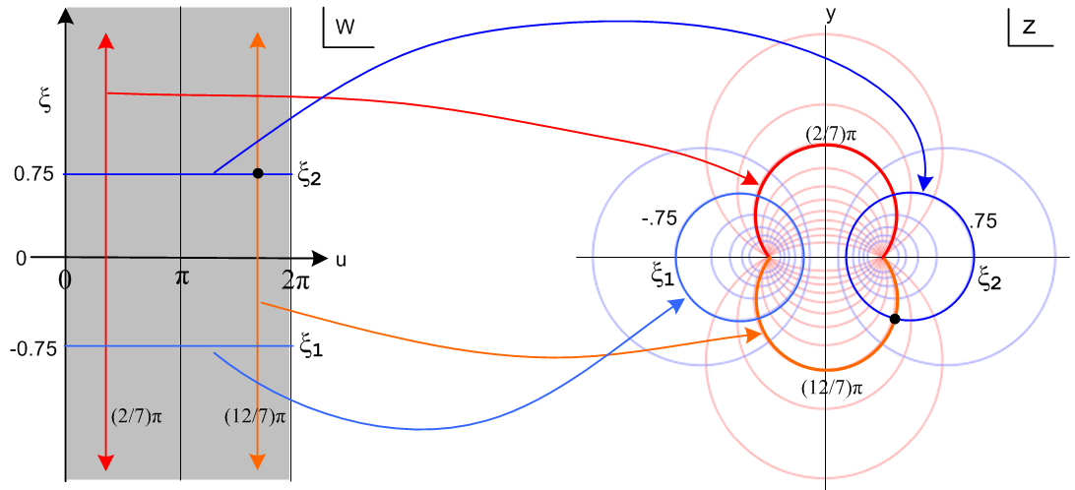
(13.20)
The focal points on the right map back to ξ = ±i∞ on the left.

(d) A Final Visit to the Two-Cylinder Capacitor Problem

The region inside the infinite vertical gray strip on the left in Fig (13.20) maps into the entire z plane on the right. If one imagines the w-plane as made up of an infinite number of such vertical strips, each of those strips maps into an identical copy of the entire z plane (so-called Riemann sheets). So imagine that we go ahead and draw all the strips on the left. One could then think of the resulting two infinite blue horizontal lines on the left as being the cross section of a "parallel plate capacitor" (in w-space) having plate separation ξ2 - ξ1. The potential between the plates of such a parallel plate capacitor is easily shown to be

φ(ξ) = - V (ξ/Δξ) volts // = -V (sξ/sΔξ) where s = 1 meter

= - [V/(ξ2-ξ1)] ξ (13.21)

if the plates have potential difference V, or

φ(ξ) = - [q/2πε)] ξ (13.22)

if the plates have charge q and -q. From this last equation the capacitance C is then,

C = q/V = q/[φ(ξ1) - φ(ξ2)] = 2πε/(ξ2 - ξ1) . (13.23)

A famous theorem of conformal mapping (see e.g. Spiegel p 233 Theorem 2) says that if φ(ξ,u) is a solution of the Laplace equation in w-space where φ takes constant values on an enclosing set of boundary surfaces σw, then

Φ(x,y) ≡ φ(ξ(x,y),u(x,y)) (13.24)

is a solution of the Laplace equation in z-space where Φ takes those same constant values but on the boundary set σz which is the mapping of σw. Recall that such Laplace solutions are unique.
Here then is one way we could have solved the two-cylinder capacitor problem:

(1) Trivially write down the solutions just quoted above in w-space for the parallel plate capacitor. The boundaries σw here are the two parallel plates and φ = V1,V2 on the two plates with V = V1-V2.

(2) Compute Φ(x,y) as just described from φ. In this case, we would have Φ(x,y) = φ(ξ(x,y) ). As shown above in Fig (13.20) the mapped boundaries in z-space are the two cylinders ξ2 and ξ1. Therefore the solution to the two-cylinders problem in z space is this

Φ(x,y) = φ(ξ(x,y) ) = - [q/2πε)] ξ(x,y) = - [q/4πε)] ln [$\frac{(x+a)2 + y2}{(x-a)2 + y2}$] (13.25)

where we used the inverse relationship (4.3) for ξ(x,y).
Equations (13.21), (13.22), (13.23) and (13.25) agree with (10.8), (10.17), (10.16) and (10.19) obtained without the use of conformal mapping.

14. Inverse Transformation, Bipolar Circles and the Interior Angle u

(a) Finding the Inverse Bipolar Transformation

The "forward" bipolar transformation is the defining set of equations (2.2),

x = a shξ/(chξ - cosu) (14.1)
y = a sinu/(chξ - cosu) .

To obtain the inverse transformation, we start by dividing the above two equations,

x/y = shξ/sinu => sin2u = sh2ξ (y/x)2 . (14.2)

Solving the first equation of (14.1) for cosu gives

cosu = chξ - (a/x)shξ => cos2u = (chξ - (a/x)shξ)2 . (14.3)

Then just do the algebra line by line,

sin2u + cos2u = 1

sh2ξ (y/x)2 + (chξ - (a/x)shξ)2 = 1

sh2ξ (y/x)2 + ch2ξ - 2 (a/x)chξshξ + (a/x)2sh2ξ - 1 = 0

sh2ξ (y/x)2 + sh2ξ - 2 (a/x)chξshξ + (a/x)2sh2ξ = 0

shξ (y/x)2 + shξ - 2 (a/x)chξ + (a/x)2shξ = 0

shξ y2 + x2shξ - 2axchξ + a2shξ = 0

shξ( y2 + x2+a2) = 2axchξ

thξ = 2ax/(x2+y2+ a2)

ξ = tanh-1 [2ax/(x2+y2+ a2)] (14.4)

which is the claim of the first line of (4.1).
Now we repeat the same set of steps, more or less. Write (14.2) as

shξ = sinu (x/y) => sh2ξ = sin2u (x/y)2 . (14.5)

Then solve the second of equations (14.1) for chξ

chξ = cosu +(a/y) sinu => ch2ξ = (cosu +(a/y) sinu)2 . (14.6)

Then comes similar algebra:

ch2ξ - sh2ξ = 1

(cosu +(a/y) sinu)2 - sin2u (x/y)2 = 1

cos2u + 2(a/y) sinu cosu +(a/y)2 sin2u - sin2u (x/y)2 - 1 = 0

- sin2u + 2(a/y) sinu cosu +(a/y)2 sin2u - sin2u (x/y)2 = 0

- sinu + 2(a/y) cosu +(a/y)2 sinu - sinu (x/y)2 = 0

- sinu y2 + 2ay cosu +a2 sinu - sinu x2 = 0

sinu(x2 + y2 - a2) = 2ay cosu

tanu = 2ay/ (x2 + y2 - a2)

u = tan-1[2ay/ (x2 + y2 - a2)] (14.7)

which is the claim of the second line of (4.1).

(b) Equations for the circles

Blue Circles of constant ξ (Apollonius):

Start with (14.4) which says

x2+ y2+ a2 = 2ax cothξ

x2 - 2axcothξ + y2 = -a2

x2 - 2axcothξ + a2coth2ξ+ y2 = -a2 + a2coth2ξ

(x - acothξ)2 + y2 = a2(coth2ξ-1) = a2/sh2ξ

(x - xc)2 + y2 = a2(coth2ξ-1) = R2 xc = a/thξ R = a/|shξ| (14.8)

which is the claim of (2.4).

Red Circles of constant u:

Start with (14.7) which says

y2 + x2 - a2 = 2ay cotu

y2 - 2ay cotu + x2 = a2

y2 - 2ay cotu + (a cotu)2 + x2 = a2 + a2 cot2u

(y - a cot u)2 + x2 = a2(1 +cot2u) = a2/sin2u

(y - yc)2 + x2 = R2 yc = a/tanu R = a/|sinu| (14.9)

which is the claim of (2.6).

(c) Interior angle u

In the following picture we label the interior angle of interest u' and shall show that u' = u, the bipolar coordinate.

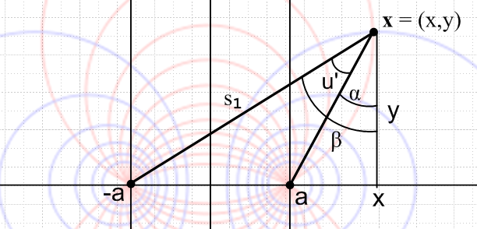
(6.1)

We make use of the two right triangles shown above where u' = (β - α) and

tanα = (x-a)/y
tanβ = (x+a)/y .

Then
tanu' = tan(β-α) = $\frac{tanβ - tanα}{1+tanα tanβ}$ = $\frac{y2tanβ - y2tanα}{y2+ytanα ytanβ}$ = $\frac{y(x+a) - y(x-a)}{y2+(x-a)(x+a)}$ = $\frac{2ay}{y2+x2-a2}$
so
u' = tan-1[$\frac{2ay}{y2+x2-a2}$] . (14.10)

But the inversion formula (14.7) says the right side of (14.10) is u, and therefore u' = u.

15. Bipolar and Toroidal Coordinates treated in other Sources

(a) Morse and Feshbach

Morse and Feshbach treat bipolar coordinates in Vol II page 1210 using our same ξ coordinate. However, instead of our angle u with range (0,2π) for the second coordinate, they use a different angle θ with range (0,2π) (their angle θ is totally unrelated to our circle angle θ of Section 7). The relation is this:

u = (θ+π) mod(2π) 0 ≤ u < 2π

θ = (u-π) mod(2π). 0 ≤ θ < 2π (15.1)

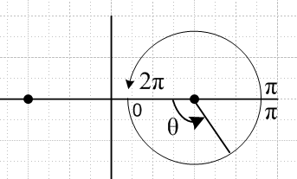 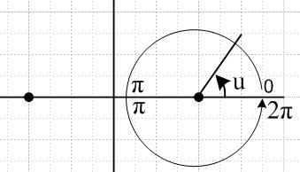 (15.2)

Morse & Feshbach bipolar coordinate θ Our bipolar coordinate u
θ = 0 between foci, increases CCW u = 0 for |x| >a, increases CCW

The effect on various expressions of changing from u to θ is easily summarized:

sinu = sin(π+θ) = -sinθ sinu ↔ -sinθ
cosu = cos(π+θ) = -cosu cosu ↔ -cosθ
tanu = tanθ tanu ↔ tanθ . (15.3)

Our toroidal coordinates as described above in Section 5 are (ξ,u,φ) where (ξ,u) are our bipolar coordinates and φ is the azimuth. When Morse and Feshbach treat toroidal coordinates on page 666, they introduce five brand new symbols μ and θ along with ξ1,ξ2,ξ3. Their μ is our ξ, and their θ is our u :

(ξ,u,φ) → (μ,θ,φ) (15.4)

where they write θ in a scripted font showing it is different from their earlier bipolar coordinate θ. To further complicate matters, on page 666 they express most of the "facts" of toroidal coordinates in terms of these three generic coordinates

ξ1 = ch(ξ) ξ2 = cos(u) ξ3 = cos(φ) (15.5)

Finally, on page 1301 Morse and Feshbach display yet another notation for toroidal coordinates:

(ξ,u,φ) → (μ,η,φ) (15.6)

which is the same as ours with ξ → μ and u → η.

(b) Some Other Sources

In each case, we show how our bipolar and toroidal coordinates map into their coordinates.

Current wiki bipolar and toroidal coordinates pages use:

bipolar (ξ,u) → (τ,σ) -π < σ ≤ π http://en.wikipedia.org/wiki/Bipolar_coordinates
toroidal (ξ,u,φ) → (τ,σ,φ) http://en.wikipedia.org/wiki/Toroidal_coordinates (15.7)

Margenau and Murphy discuss bipolar and toroidal coordinates on pages 187-190. Their coordinates are

bipolar (ξ,u) → (η,ξ) 0 ≤ ξ ≤ 2π
toroidal (ξ,u,φ) → (η,ξ,ψ) (15.8)

Moon and Spencer use :

bipolar (ξ,u) → (u,v) // page 53, Table 2.02 item E.4
toroidal (ξ,u,φ) → (η,θ,ψ) -π < θ ≤ π // page 112-115 (15.9)

We can rewrite (13.13) in this manner, using w = u+iξ from (13.14),

z = ia cot($\frac{w}{2}$) = ia tan( $\frac{π}{2}$-$\frac{w}{2}$ ) = ia tan($\frac{[π-u]-iξ}{2}$ ) . (15.10)

If we define an angle β to replace u as

β = (π-u) mod 2π -π ≤ β ≤ π (15.11)

then we find

z = ia tan($\frac{β-iξ}{2}$ ) = a tanh( i $\frac{β-iξ}{2}$) = a tanh ( $\frac{ξ+iβ}{2}$) . (15.12)

Lebedev et al. use this angle β along with ξ which they call α so that

x + iy = a tanh ( $\frac{α+iβ}{2}$) // Lebedev p 212 (4) with a = c (15.13)

and then Lebedev has bipolar coordinates α and β which are related to ours according to

α = ξ -∞ < α < ∞
β = (π-u) mod 2π -π < β ≤ π

The angle β is the same as θ of Morse and Feshbach shown in (15.1), but M&F use 0 ≤ θ < 2π.

Appendix A: Fourier Analysis of the angular charge distribution n1(ξ1,θ)

As discussed in Section 10, for the two-cylinder capacitor the angular charge distribution on conductor C1 shown in Fig (10.2) is called n1(ξ1,θ). We are interested in finding the Fourier components of this function of θ. The moments Nm are defined by this complex Fourier Series transform,

n1(ξ1,θ) = $\sum_{m = -∞}^{∞}{}$ Nm ejmθ // expansion (A.1)
Nm = (1/2π) $^{\int_{-π}^{π}{}}$dθ n1(ξ1,θ) e-jmθ . // projection (A.2)

Thus, using (10.28),

n1(ξ1,θ) = $\frac{q}{2π}$ $\frac{|shξ1|}{chξ1+cosθ}$ , (10.28)

we find the following projections of the charge density,

Nm = (1/2π) $\frac{q}{2π}$ |shξ1 | $^{\int_{-π}^{π}{}}$dθ $\frac{e-jmθ}{chξ1+cosθ}$ ≡ (1/2π) $\frac{q}{2π}$ |shξ1| I . (A.3)

The integral I can be evaluated as follows

I = $^{\int_{-π}^{π}{}}$dθ $\frac{e-jmθ}{chξ1+cosθ}$ = $^{\int_{-π}^{π}{}}$dθ $\frac{cos(mθ)-jsin(mθ)}{chξ1+cosθ}$ = $^{\int_{-π}^{π}{}}$dθ $\frac{cos(mθ)}{chξ1+cosθ}$

= 2 $^{\int_{0}^{π}{}}$dθ $\frac{cos(mθ)}{chξ1+cosθ}$ = $\frac{2}{chξ1}$$^{\int_{0}^{π}{}}$dθ $\frac{cos(mθ)}{1+sechξ1cosθ}$ ≡ $\frac{2}{chξ1}$ J (A.4)

GR7 p 391 3.613 provide the following integral we can use for integral J,

which we translate to say (A.5)
J = $^{\int_{0}^{π}{}}$dθ $\frac{cos(mθ)}{1+sechξ1cosθ}$ = $\frac{π}{|th(ξ1)|}$ [ $\frac{|th(ξ1)| - 1}{sech(ξ1)}$] m m ≥ 0 (A.6)

But

$\frac{|thξ1|-1}{sechξ1}$ = $\frac{|shξ1|/chξ1-1}{1/chξ1}$ = |shξ1|- chξ1 = - e-|ξ$_{1}$| (A.7)

so the integral is

J = $\frac{π}{|th(ξ1)|}$ [-e-|ξ$_{1}$|]m = $\frac{π}{|th(ξ1)|}$ (-1)m e-m|ξ$_{1}$| . m ≥ 0 (A.8)

Since the integral J is manifestly even in m, the result is in fact

J = $\frac{π}{|th(ξ1)|}$ (-1)m e-|mξ$_{1}$| . all m (A.9)

Integral I is then

I = $\frac{2}{chξ1}$J = $\frac{2π}{|sh(ξ1)|}$(-1)m e-|mξ$_{1}$| (A.10)

and the moments are

Nm = (1/2π) $\frac{q}{2π}$ |shξ1| I = (1/2π) $\frac{q}{2π}$ |shξ1| $\frac{2π}{|sh(ξ1)|}$ (-1)m e-|mξ$_{1}$|

= (q/2π) (-1)m e-|mξ$_{1}$| => N0 = (q/2π) . (A.11)

The "relative moments" ηm are defined by

ηm ≡ Nm/N0 = (-1)m e-|mξ$_{1}$| . (A.12)

Since Nm = N-m we can write the expansion above as

n1(ξ1,θ) = $\sum_{m = -∞}^{∞}{}$ Nm ejmθ = N0 + 2 $\sum_{m = 1}^{∞}{}$ Nm cos(mθ) = N0 [ 1 + 2 $\sum_{m = 1}^{∞}{}$ ηm cos(mθ) ]
= (q/2π)[ 1 + 2 $\sum_{m = 1}^{∞}{}$ (-1)m e-m|ξ$_{1}$| cos(mθ) ] (A.13)

where q is the total charge on the conductor. If |ξ1| is very large, indicating that the conductor is approaching a thin wire centered on one of the focal points, only the m = 0 term survives and the charge distribution is just the constant value n1(ξ1,θ) = (q/2π). This shows that "widely spaced" round conductors have isotropic charge distributions in θ, consistent with Fig (10.40) with ξ1 = -3. On the other hand, if |ξ1| is relatively small, such as ξ1 = -0.25 appearing in Fig (10.40), one sees in the sum (A.13) that terms will have alternating signs near θ = 0 causing cancellation, whereas near θ = π where cos(mθ) = (-1)m the terms will be additive, resulting in a peak centered at θ = π . Again, see Fig (10.14).

We shall now evaluate the sum in (A.13) to make sure it reproduces the starting function (10.28). We wish to show that :

1 + 2 $\sum_{m = 1}^{∞}{}$ (-1)m e-m|ξ$_{1}$| cos(mθ) = $\frac{|shξ1|}{chξ1+cosθ}$ ? (A.14)
or
1 + 2 $\sum_{m = 1}^{∞}{}$ (-1)m e-my cos(mθ) = $\frac{shy}{chy+cosθ}$ . ? y = |ξ1| (A.15)

Rewrite the LHS of (A.15) as

LHS = 1 + 2 $\sum_{m = 1}^{∞}{}$ (-1)m e-my (1/2) [ ejmθ + e-jmθ]
= (1/2) [1 + 2 $\sum_{m = 1}^{∞}{}$ (-1)m e-my ejmθ ] + (1/2) [1 + 2 $\sum_{m = 1}^{∞}{}$ (-1)m e-my e-jmθ ]
= (1/2) [1 + 2 $\sum_{m = 1}^{∞}{}$ (-1)m e-m[y-jθ] ] + c.c.
= (1/2) [1 + 2 $\sum_{m = 1}^{∞}{}$ (-1)m e-2mx ] + c.c. where x ≡ (y-jθ)/2 (A.16)

The bracketed sum appears in GR7 p27 as 1.232.1,

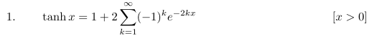 (A.17)
so then

LHS = $\frac{1}{2}$tanh( $\frac{y-jθ}{2}$) + c.c. = Re [$\frac{1}{2}$tanh( $\frac{y-jθ}{2}$) ] . (A.18)

At this point, we hand the problem over to ancient Maple V which is not too smart about half angle formulas, so we provide assistance along the way. The first step is to obtain a real expression for LHS :

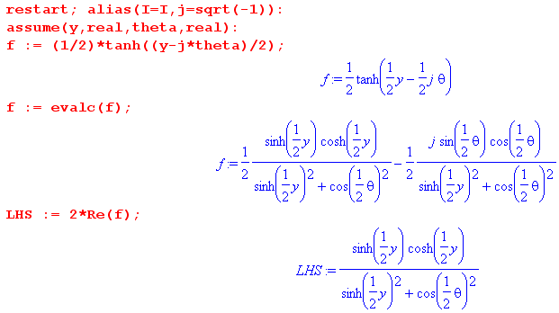
The next step is to manually replace all these half angle functions. Maple needs to see the upper and lower functions separately, so we do what it needs:

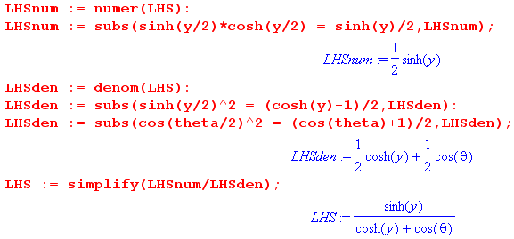

Since this is the RHS of (A.15), we have verified (A.15) and thus (A.14).

References

[1] L. A. Ahlfors, Complex Analysis, 2nd Ed. ( McGraw-Hill, New York, 1966).

[2] N.N. Lebedev, I.P. Skalskaya and Y.S. Uflyand, Worked Problems in Applied Mathematics, (Dover, New York, 1965). There are not many books like this one. In the first 2/3 of the book, 566 problems requiring various mathematical techniques from various fields of physics and engineering are presented with hints as to their solution, and in last 1/3 a subset of these problems is solved.

[3] P. Lucht, Tensor Analysis and Curvilinear Coordinates (2014), http://user.xmission.com/~rimrock. If not there, search on .

[4] P. Lucht, The Charged Bowl in Toroidal Coordinates (2013), see above.

[5] P. Lucht, Transmission Lines and Maxwell's Equations (2014), see above.

[6] H. Margenau and G.M. Murphy, The Mathematics of Physics and Chemistry, 2nd Ed. (D. van Nostrand, London. 1956).

[7] P. Moon and D.E. Spencer, Field Theory Handbook, Including Coordinate Systems, Differential Equations and their Solutions (Springer-Verlag, Berlin, 1961). This book is not about quantum field theory or anything like that, it is about curvilinear coordinate systems, how the Laplace and Helmholtz equations appear in each system, and what the solutions of these equations look like. This husband and wife team wrote several excellent books. Long ago they were strangely involved in an accident involving a test of general relativity.

[8] P.M. Morse and H. Feshbach, Methods of Theoretical Physics ( McGraw-Hill, New York, 1953). The bible on this general subject.

[9] M.R. Spiegel, Theory and Problems of Complex Variables (Schaum's Outlines, McGraw-Hill, 1964 & 1974). A second edition is in print (2009) with coauthors S. Lipschutz, J. Schiller and D. Spellman.

[10] M.R. Spiegel, S. Lipschutz, M. and J. Liu, Schaum's Outlines: Mathematical Handbook of Formulas and Tables (4th Ed.), (McGraw-Hill, 2012). The excellent original 1968 edition by Murray Spiegel (deceased) has been a dog-eared reliable friend for many years. John Liu was added for the 1999 2nd Ed, and Seymour Lipschutz joined for the 2008 3rd Ed. Not to be confused with a watered-down "Easy Outline" version. This low-cost paperback is an excellent fast reference for well-known mathematical facts.

[GR7] I.S. Gradshteyn and I.M. Ryzhik, Table of Integrals, Series, and Products, 7th Ed. ( Academic Press, New York, 2007). Editor Dan Zwillinger has been collecting errata. A PDF version exists.

