Retired bipolar sections (c) and (d) PhL 2.23.14

Older version, this has been replaced.

(c) Example: Bipolar Coordinates as a Conformal Map

Consider this analytic mapping of the form w = f(z)

w = ln ($\frac{z+a}{z-a}$) => ew = $\frac{z+a}{z-a}$. (13.12)

The inverse mapping happens to be (easy to show)

z = a $\frac{ew+1}{ew-1}$ = a coth(w) = ia cot(iw) z = x+iy w = u+iv . (13.13)

Write this as

x + iy = a $\frac{(eu+iv+1)}{(eu+iv-1)}$ = a $\frac{(eu+iv+1)}{(eu+iv-1)}$$\frac{(eu-iv-1)}{(eu-iv-1)}$ = a $\frac{(e2u - eu[eiv - e-iv] - 1)}{(e2u - eu[eiv+ e-iv] + 1)}$

= a $\frac{(eu - [eiv - e-iv] - e-u)}{(eu - [eiv+ e-iv] + e-u)}$ = a $\frac{2sh(u) - 2isin(v)}{2ch(u) - 2cos(v)}$ = a $\frac{sh(u) - isin(v)}{ch(u) - cos(v)}$ . (13.14)

Therefore

x = a shu/(chu-cosv)
y = -asinv/(chu-cosv) . (13.15)

Now make the following name changes (in this order)

u → ξ
v → -u (13.16)

Then

x = a shξ/(chξ-cosu)
y = a sinu/(chξ-cosu) (13.17)

and these are the equations used to define bipolar coordinates. Since this transformation arises from a conformal map, we expect the two scale factors to be the same.
Notice that taking u → -u does not change the scale factor hu,

(ds)2 = hu2 (du)2 + hv2 (dv)2 → h-u2 (-du)2 + hv2 (dv)2 = h-u2 (du)2 + hv2 (dv)2

=> hu2 = h-u2 . (13.18)

Since h must always be positive, hu2 = h-u2 = > hu = h-u.
In the polar coordinates case, taking eu → r does make a difference, since eudu = dr = rdu :

(ds)2 = hu2 (du)2 + hθ2 (dθ)2 = hr2 (dr)2 + hθ2 (dθ)2 => hu = r hr .

That is why (hr,hθ) = (1,r) whereas (hu,hθ) = (r,r) .
Notice that z = x+iy but w = ξ - iu because we negated u. One could write w* = ξ + iu and just think of the mapping this way,

w* = ln ($\frac{z+a}{z-a}$) z = x+iy w* = ξ - iu (13.19)

We will just call it w-space since using the label +u or -u has no significance.

Here then is what the conformal mapping looks like going from the w-plane to the z-plane,

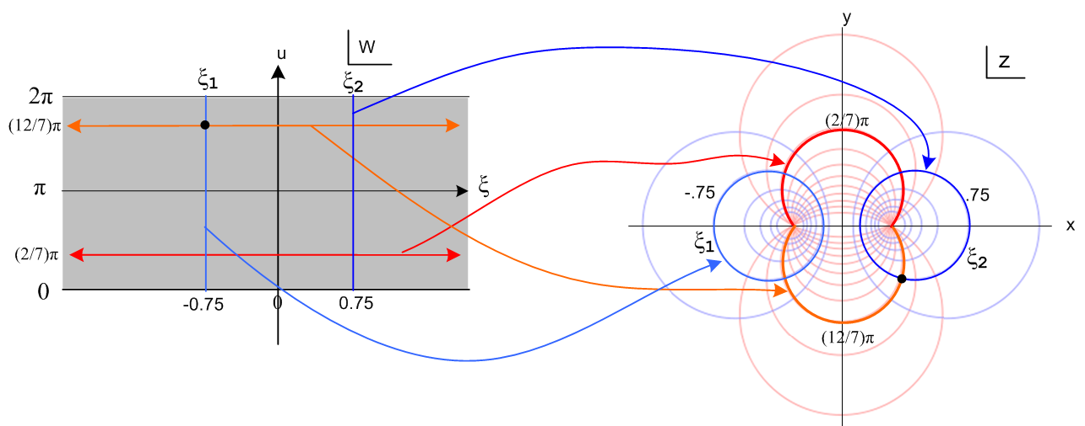
(13.20)
The focal points on the right map back to ξ = ±∞ on the left.

(d) A Final Visit to the Two-Cylinder Capacitor Problem

The region inside the infinite horizontal gray strip on the left in Fig (13.20) maps into the entire z plane on the right. If one imagines the w-plane as made up of an infinite number of such horizontal strips, each of those strips maps into an identical copy of entire z plane (so-called Riemann sheets). So imagine that we go ahead and draw all the strips on the left. One could then think of the resulting two infinite blue vertical lines on the left as defining a "parallel plate capacitor" (in w-space) having plate separation ξ2 - ξ1. The potential between the plates of such a parallel plate capacitor is easily shown to be

φ(ξ) = - V (ξ/Δξ) // => Eξ = V/Δξ = volts/separation

= - [V/(ξ2-ξ1)] ξ (13.21)

if the plates have potential difference V, or

φ(ξ) = - [q/2πε)] ξ (13.22)

if the plates have charge q and -q. From this last equation the capacitance C is then,

C = q/V = q/[φ(ξ1) - φ(ξ2)] = 2πε/(ξ2- ξ1) . (13.23)

A famous theorem of conformal mapping says that if φ(ξ,u) is a solution of the Laplace equation in w-space where φ takes constant values on an enclosing set of boundary surfaces σw, then

Φ(x,y) ≡ φ(ξ(x,y),u(x,y)) (13.24)

is a solution of the Laplace equation in z-space where Φ takes those same constant values but on the boundary set σz which is the mapping of σw. Recall that such Laplace solutions are unique.
Here then is one way we could have solved the two-cylinder capacitor problem:

(1) Trivially write down the solutions just quoted above in w-space for the parallel plate capacitor. The boundaries σw here are the two parallel plates and φ = V1,V2 on the two plates with V = V1-V2.

(2) Compute Φ(x,y) as just described from φ. In this case, we would have Φ(x,y) = φ(ξ(x,y) ). As shown above in Fig (13.20) the mapped boundaries in z-space are the two cylinders ξ2 and ξ1. Therefore the solution to the two-cylinders problem in z space is this

Φ(x,y) = φ(ξ(x,y) ) = - [q/2πε)] ξ(x,y) = - [q/4πε)] ln [$\frac{(x+a)2 + y2}{(x-a)2 + y2}$] (13.25)

where we used the inverse relationship (4.3) for ξ(x,y).
Equations (13.21), (13.22), (13.23) and (13.25) agree with (10.8), (10.17), (10.16) and (10.19) obtained without the use of conformal mapping.

