Doing some dimensional repairs PhL 3.3.14

I had a few problems in bipolar doc with the dimensions of charge objects. I got it all straightened out, and this is why we have different symbols n and n for surface charge in different senses. I also had to modify certain dQ quantities. The issue is whether something is per area, per length in z, per angle θ, per distance ds, and so on. I think everything is OK in bipolar doc as of 7.30.14 when I am reviewing this doc.

10. The Two-Cylinder Capacitor Problem Part I

(a) Statement of the Problem

The canonical "capacitor problem" involving bipolar coordinates concerns two parallel and infinitely long cylindrical conductors. The problem is to find the capacitance per unit length C. Due to the nature of the geometry, the problem can be treated solely in cross section as a 2D potential theory problem:

∇2φ(x,y) = 0 => ∇22D φ(x,y) = 0 ∇2 = ∇2D2 + ∂z2 . (10.1)

The opening step is to imagine that the conductor cross sections are arranged so as to align with two of the blue circles in the bipolar coordinates drawing. This can certainly be done by a suitable rotation of the conductors so their center lines both lie on the x axis followed by a selection of parameter "a" so that the conductors then line up with some ξ2 > 0 blue circle on the right, and some other blue circle ξ1 < 0 on the left. We assume that this part of the problem is carried out (see Section 11 (a) below), and we now have this situation:

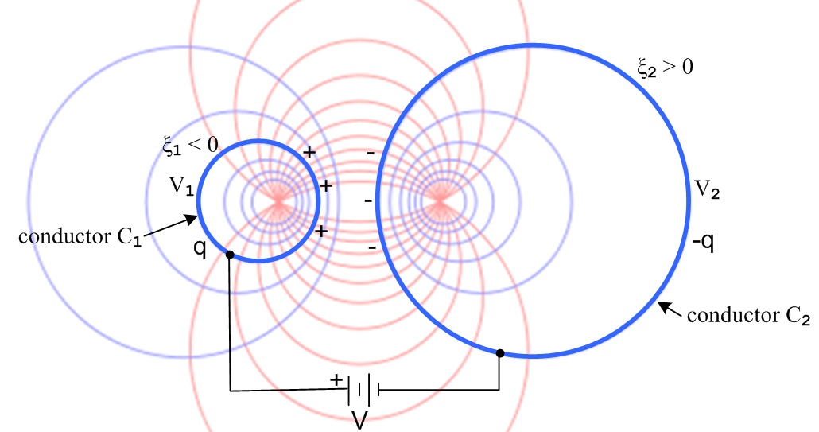 (10.2)

Both cylinders are first neutral, then we attach a battery of voltage V such that C1 has positive charge and therefore positive potential V1. Some charge Q flows onto the left conductor, and this same charge is extracted from the right conductor, so the conductors then have equal and opposite charges: Q on the left, -Q on the right. The conductors settle at some potential values V1 and V2 which are at this point "unknowns" of the problem. What is known is V, a, ξ1 and ξ2. The symbol q refers to charge per unit length of the left cylinder.

Comment: For infinite cylinders, a very large battery would be needed! We can assume that the two conductors are restricted so they are only 100 miles long, and then the total required Q is finite.

(b) Finding the Potential

This capacitor problem is a boundary value problem as follows:

∇2D2φ = 0 φ(C1) = V1
φ(C2) = V2
φ(∞) = 0 φ(C1) - φ(C2) = V = V1-V2 . (10.3)

There are four boundary conditions specified. The first three boundary conditions specify that the solution potential must be a constant on three "surfaces" (2D curves). These three conditions specify the potential on all surfaces enclosing the dielectric region of this capacitor problem, and such a specification makes this a "Dirichlet problem". The fourth boundary condition says that the potential difference between the two cylinders must be V. In potential theory, a Dirichlet problem always has a solution, and that solution is always unique. Note that we have a Dirichlet problem even though we don't yet know what V1 and V2 are.

In order to meet the first two boundary conditions φ(C1) = V1 and φ(C2) = V2, we know that the potential solution must have the form φ(ξ,u) = φ(ξ). This is so because each conductor has a ξ label, and we know all points on a blue circle have the same value of ξ, since in fact these circles are surfaces of constant ξ (level curves) of the bipolar coordinate system. According to the third last paragraph of the previous section, that Laplace solution must have the form φ(ξ) = A + Bξ. Recall now that ξ ≈ 0 describes huge blue circles which run up the y axis and basically bend off to infinity either to the right or left (ξ = ± 10-8 say). On portions of these circles far from the conductors, we know that ξ ≈ 0. But on these distant portions of the circles we are supposed to have φ(∞) = 0. Thus we have φ(ξ) = Bξ since φ(0) = 0.

Aside: It is not exactly clear what happens on the portions of these huge ξ = ± 10-8 circles that are close to the conductors on the y axis in the region between the conductors. We know that if φ = 0 on a distant section of a huge blue circle, it must also be 0 on that portion of the huge circle which passes down the y axis between the conductors, because all points on a blue circle have the same φ. One interpretation of this fact requires a bit of work: one can show that the surface charge on each of our capacitor blue circles acts as if it were concentrated at the focal point, and since these charges are q and - q, that explains why φ = 0 on the y axis (the center of charge is computed in (d) below).

The solution to our capacitor problem then can be taken as,

φ(ξ,u) = φ(ξ) = - c ξ , (10.4)

where c is a constant. This certainly is a simple form, and it certainly is a solution of the Laplace equation

∂ξ2φ + ∂u2φ = 0. (9.1)

It also meets the first three of our four boundary conditions, as noted above. The fourth boundary condition will determine the constant c as well as the values of V1 and V2. We know that

φ(ξ2) = - c ξ2 = V2 = the potential on conductor C2
φ(ξ1) = - c ξ1 = V1 = the potential on conductor C1 (10.5)

Therefore, since V = V1 - V2, we have

V = - c ξ1 + c ξ2 = c(ξ2-ξ1) (10.6)

so c is then given by

c = V / (ξ2- ξ1) = V / (ξ2+ |ξ1|) > 0 . (10.7)

The solution potential is then

φ(ξ) = - $\frac{ξ}{ξ2-ξ1}$V (10.8)

from which we find that

V2 = - $\frac{ξ2}{ξ2-ξ1}$V = - $\frac{ξ2}{ξ2+|ξ1|}$V < 0
V1 = - $\frac{ξ1}{ξ2-ξ1}$V = + $\frac{|ξ1|}{ξ2+|ξ1|}$V > 0 . (10.9)

This is all fine and well, but we still have not computed the capacitance of our capacitor!

(c) Finding the Charge q and therefore the Capacitance C = q/V

The plan here is to first find the electric field from the potential, then find the conductor surface charge density from the electric field, and then integrate that to get q, and then capacitance is C = q/V.

In bipolar coordinates using summary box (8.24) the electric field at an arbitrary point outside the conductors shown in Fig (10.2) is given by

E = -gradφ = - (1/h) [ (∂ξφ) + (∂uφ) ] (1/h) = (chξ–cosu)/a > 0

= - (1/h) [ (∂ξ[- $\frac{ξ}{ξ2-ξ1}$V] ) = (V/h) $\frac{1}{ξ2-ξ1}$ = (V/h) $\frac{1}{ξ2+|ξ1|}$
= (V/a) (chξ–cosu) $\frac{1}{ξ2+|ξ1|}$ . (10.10)
ok to here
The first observation is that this E field always points in the direction. Looking at Fig (8.7) this means that the electric field always points along the red level curves, so these lines are in fact the "electric field lines" for the capacitor. Since the blue circles are orthogonal to these field lines, the blue circles must be equipotentials for the capacitor problem, something we already know from (10.8). Thus, we are spared the task of drawing the electric field and equipotential lines for our problem since the bipolar coordinate system provides these lines. The fact that E = (positive quantity) is consistent with the left conductor having positive charge as shown in Fig (10.2). As expected, at each conductor surface the electric field is normal to the surface. This is always the case in electrostatics.
The surface charge density n on a conductor surface is related to the normal electric field evaluated just above the surface according to n = εEn, where ε is the dielectric constant of the medium between the conductors (which we assume is non-conducting). Since dim(ε) = farad/m and dim(En) = volt/m, the units of n are dim(n) = farad-volt/m2 = coulomb/m2 as expected. On the left in Fig 8.7 we may identify the outfacing normal unit vector = so En = (V/h) $\frac{1}{ξ2-ξ1}$. Thus

n(ξ1,u) = ε $\frac{V}{h(ξ1,u)}$$\frac{1}{ξ2-ξ1}$ // surface charge density on the left conductor C1
(10.11)
n(ξ2,u) = - ε $\frac{V}{h(ξ2,u)}$$\frac{1}{ξ2-ξ1}$ // surface charge density on the right conductor C2

STOP. Dimension checks here give dim(n) = farad/m *volt*1/m = coul/m2 so OK, dim(n) = Coul/m2

For the right conductor C2, h is evaluated with ξ = ξ2 and the minus sign arises because on the right we have the different situation = - , as in Fig (8.7).
We now wish to integrate the surface charge density to obtain the total charge q. Consider then a tiny patch of area on the left conductor which has dimension ds along the perimeter and dz into the plane of paper, so dA = dsdz. Going along the perimeter, ξ = constant so dξ = 0. From (3.4) then ds = hdu. This is of course the meaning of a scale factor in the first place, ds = hudu gives distance ds as u is varied du with ξ fixed. Compare to polar coordinates ds = hθdθ = rdθ as θ varies with r fixed. Thus,

dA = dsdz = hududz = h du dz . (10.12)

We then rewrite (10.11) as,

dQ(ξ1,u) = n(ξ1,u)dA = [ε $\frac{V}{h(ξ1,u)}$$\frac{1}{ξ2-ξ1}$]dA = ε $\frac{V}{ξ2-ξ1}$du dz

dQ(ξ2,u) = n(ξ2,u)dA = - [ε $\frac{V}{h(ξ2,u)}$$\frac{1}{ξ2-ξ1}$]dA = - ε $\frac{V}{ξ2-ξ1}$du dz . (10.13)

STOP. Since n = cou/m2 it must be that dn = cou. On RHS dim = farad/m*volt*m = far-volt = cou, OK/

Notice that the scale factor h has canceled out and that the dn values are still equal and opposite.

The total charge Q1 on a ring of depth dz of conductor C1 on the left is then given by

Q1 = ∫ dQ(ξ1,u) = $^{\int_{0}^{2π}{}}$ [ε $\frac{V}{ξ2-ξ1}$du dz] = ε $\frac{V}{ξ2-ξ1}$dz$^{\int_{0}^{2π}{}}$du = 2πε $\frac{V}{ξ2-ξ1}$dz . (10.14)

In the u integral around the left blue circle in Fig (10.2) the bipolar coordinate varies from u = 0 on the left edge going up, reaches u = π on the focal line, then reaches u = 2π when the circle is completed. Thus, the charge per unit length in z is given by

q = q1 = 2πε $\frac{V}{ξ2-ξ1}$ (10.15)

and of course we will find that q2 = - q due to the minus sign in the second line of (10.13).
The capacitance per unit length of the two-cylinder capacitor is then given by

C = q/V = 2πε $\frac{1}{ξ2-ξ1}$ dim(ε) = farad/m (10.16)

We will verify this result in Section 11 with external sources.
If we use (10.15) to replace V by q in the potential (10.8) we find

φ(ξ) = - $\frac{ξ}{ξ2-ξ1}$V = - $\frac{ξ}{ξ2-ξ1}$$\frac{q}{C}$ = - $\frac{ξ}{ξ2-ξ1}$q $\frac{ξ2-ξ1}{2πε}$ = - $\frac{q}{2πε}$ξ . (10.17)

This is the solution of a differently-stated capacitor problem. Imagine that we load up the two conductors with charges q and -q using the mechanism of (10.2) and then we disconnect the battery. We then vary the size of the two conductors by changing ξ1 and/or ξ2. The charge on conductor C1 of course remains q as this happens. We see that the potential between the conductors is always φ(ξ) = -(q/2πε) ξ ! When stated in this manner with q fixed, the potential is independent of ξ1 and ξ2.
Using (4.3) we can write our two potential forms in Cartesian coordinates:

φ(ξ) = - $\frac{ξ}{ξ2-ξ1}$V = - $\frac{V}{2(ξ2-ξ1)}$ ln [$\frac{(x+a)2 + y2}{(x-a)2 + y2}$] = - $\frac{V}{2(ξ2-ξ1)}$ ln [$\frac{s12}{s22}$] (10.8) (10.18)

φ(ξ) = - $\frac{q}{2πε}$ξ = - $\frac{q}{4πε}$ ln [$\frac{(x+a)2 + y2}{(x-a)2 + y2}$] = - $\frac{q}{4πε}$ ln [$\frac{s12}{s22}$] (10.17) (10.19)

which can be restated without minus signs in this way,

φ(ξ) = $\frac{V}{2(ξ2-ξ1)}$ ln [$\frac{s22}{s12}$] = $\frac{V}{2(ξ2-ξ1)}$ ln[ $\frac{(x-a)2 + y2}{(x+a)2 + y2}$] (10.18a)

φ(ξ) = $\frac{q}{4πε}$ ln [$\frac{s22}{s12}$] = $\frac{q}{4πε}$ ln[ $\frac{(x-a)2 + y2}{(x+a)2 + y2}$] . (10.19a)

In Chapter 5 of Ref [5] we define a dimensionless transverse potential φt by,

φ(x,y,z) = $\frac{1}{4πε}$ q(z) φt(x,y) Ref [5] (5.1.1)

and comparison with (10.19a) shows that (using also (4.5) above),

φt(x,y) = ln [$\frac{s22}{s12}$] = ln[ $\frac{(x-a)2 + y2}{(x+a)2 + y2}$] = -2ξ (10.20)

where the first form is in agreement with (6.1.2) of Ref [5]. The new fact is that φt = -2ξ in bipolar coordinates which is a very simple result for the transverse potential. Also from Ref [5], the system for φt was

∇t2 φt(x,y) = 0 φt(C1) = K1 φt(C2) = K2 K1-K2 = K . Ref [5] (5.4.3)

so we find that

K1 = -2ξ1 K2 = -2ξ2 K = K1-K2 = 2(ξ2-ξ1) (10.21)

where K is a certain parameter which determines transmission line parameters. This expression for K appears in the form K = 2(B2-B1) in Ref [5] (6.3.2) where the bipolar coordinate ξ is B (and where ξ is used for the complex dielectric constant, totally unrelated to ξ here).

(d) Surface charge density versus angle θ and the Center of Charge

In terms of the circle angle θ, distance along the circle C1 is given by

ds = hθdθ = R1dθ (10.22)

and the area element (for thinking about charge density) is

dA = ds dz = R1dθ dz . (10.23)

From (10.13) we then have ok to here

dQ(ξ1,θ) = n(ξ1,u) dA = [ε $\frac{V}{h(ξ1,u)}$$\frac{1}{ξ2-ξ1}$] [dA] = [ε $\frac{V}{h(ξ1,θ)}$$\frac{1}{ξ2-ξ1}$] [R1dθ dz]

= ε V $\frac{sh2ξ1}{a(chξ1+cosθ)}$$\frac{1}{ξ2-ξ1}$( a/|shξ1| ) dθ dz = ε V $\frac{1}{ξ2-ξ1}$ $\frac{|shξ1|}{chξ1+cosθ}$ dθ dz // (2.4) for R1

= $\frac{1}{2π}$ [2πε $\frac{V}{ξ2-ξ1}$] $\frac{|shξ1|}{chξ1+cosθ}$ dθ dz = $\frac{q}{2π}$ $\frac{|shξ1|}{chξ1+cosθ}$ dθ dz // q from (10.15) (10.24)

STOP. Above, dim(RHS) = (cou/m) * m = cou, so dn = cou, still OK

As a check on this result, we integrate over dθ,

∫ dQ(ξ1,θ) = $\frac{q}{2π}$|shξ1| dz $^{\int_{0}^{2π}{}}$$\frac{dθ}{chξ1+cosθ}$ = $\frac{q}{2π}$|shξ1| dz $\frac{2π}{|shξ1|}$ = q dz (10.25)

where the integral is provided by Maple,

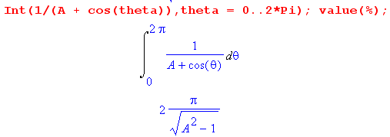 (10.26)

The conclusion is that the total charge in a ring of depth dz over the C1 perimeter is q dz, which is correct.
We have obtained then these expressions for the two conductors' charge densities,
ok to here

dQ1(ξ1,θ) = n1(ξ1,θ)dA = $\frac{q}{2π}$ $\frac{|shξ1|}{chξ1+cosθ}$ dθ dz

dQ2(ξ2,θ) = n2(ξ2,θ)dA = - $\frac{q}{2π}$ $\frac{|shξ2|}{chξ2+cosθ}$ dθ dz . (10.27)

STOP. Had to change dθ to dA = R1dθ dz. Now all three expressions are Coulombs

Fact: When the total charges (per unit length) are specified as q and -q on the two conductors, the surface charge density n1(ξ1,θ) on conductor C1 is independent of both the focal parameter a and the ξ2 value of conductor C2. If one were to vary ξ2 from C2 being very small to very large, n1(ξ1,θ) would not change.
(10.28)

We see this explicitly in (10.27) and it follows from (10.17) which says the potential for fixed q is independent of a, ξ1 and ξ2. We could take conductor C2 to be a thin wire at the focal point (ξ2 = ∞), or the plane at x=0 (ξ2= 0), n1(ξ1,θ) is always given by the first line of (10.27).

We can now compute the "center of charge" for the right blue circle having parameter ξ2. For the purposes of this calculation, we center the blue circle at x = 0,

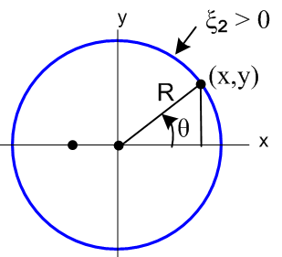 (10.29)

The center of charge is given by

<x> = $^{\int_{0}^{2π}{}}$$^{\int_{0}^{2π}{}}$ . (10.30)
The denominator integral is the total charge on a ring of C2 which is -q dz . The numerator is

$^{\int_{0}^{2π}{}}$[dQ2] (x) = $^{\int_{0}^{2π}{}}$[ - $\frac{q}{2π}$ $\frac{|shξ2|}{chξ2+cosθ}$ dθ dz] (R2 cosθ)

= - $\frac{q}{2π}$ shξ2 dz R2 $^{\int_{0}^{2π}{}}$dθ $\frac{cosθ}{chξ2+cosθ}$ // ξ2 > 0 (10.31)

so then

<x> = $\frac{1}{2π}$ shξ2 R2 $^{\int_{0}^{2π}{}}$dθ $\frac{cosθ}{chξ2+cosθ}$ = $\frac{a}{2π}$ $^{\int_{0}^{2π}{}}$dθ $\frac{cosθ}{chξ2+cosθ}$ (10.32)

since R2 = a/shξ2 from (2.4). Maple does the integral,

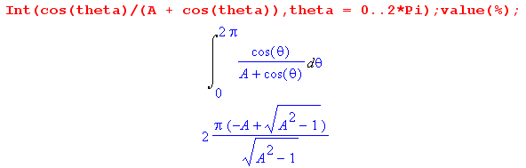 (10.33)
so then

<x> = $\frac{a}{2π}$ 2π ( -chξ2 + shξ2)/shξ2 = a ( -1/th(ξ2) + 1) = -a/th(ξ2) + a = - xc+ a

= - (xc -a) < 0 (10.34)

But looking at Fig (7.1), the quantity xc -a > 0 is the distance from the focus to the circle center. It seems fairly obvious that <y> = 0 since n is symmetric about the x axis. Therefore we have just proven:

Fact: For a capacitor made of two cylinders, the center of charge for each cylinder cross section lies exactly at the bipolar coordinate system focal point. (10.35)

We only showed this on the right side, but the reader will no doubt accept it as true on the left as well since it is just the mirror image situation.

Implication: The potential of two cylinders holding charge q on the left and -q on the right is the same as the 2D potential of a point charge q at the left focus and a point charge -q at the right focus. (10.36)

In 2D potential theory, the potential of a unit positive point charge is (1/2πε) ln(1/s) where s is the distance from the charge to the observation point. Therefore, if we superpose the potential of our two focal point charges we get, looking at Fig (6.1),

φ = (q/2πε) ln(1/s1) - (q/2πε) ln(1/s2) = (q/2πε)ln(s2/s1) = (q/4πε)ln(s22/s12)

= - $\frac{q}{4πε}$ ln [$\frac{s12}{s22}$] . (10.37)

This agrees with our earlier calculation of the potential shown in (10.19). The result is of course no big surprise, since we already found in (10.17) that

φ(ξ) = - $\frac{q}{2πε}$ξ , (10.16)

so that the potential (for the problem of fixed charges q and -q) doesn't even know about ξ1 and ξ2 and must therefore be valid for ξ1 = -∞ and ξ2 = +∞ which "circles" are the focal points.

In closing this section, we generate some plots of surface charge versus θ for various values of ξ. These will be made using (10.27) ok to here

dQ1(ξ1,θ) = $\frac{q}{2π}$ $\frac{|shξ1|}{chξ1+cosθ}$ dθ dz = [$\frac{q}{2π}$dz] $\frac{|shξ1|}{chξ1+cosθ}$dθ (10.27)
Q1(ξ1,θ) = [$\frac{q}{2π}$dz] $\frac{|shξ1|}{chξ1+cosθ}$ .

STOP. I do have a problem here. The object dn is charge, so you would expect n to also be charge!
I have made some repairs. I could now define

λ1(ξ1,θ) = Q1(ξ1,θ)/dz = $\frac{q}{2π}$ $\frac{|shξ1|}{chξ1+cosθ}$ = linear charge density C/m

ok to here, no changes have been made to this point
Ignoring the constant factor q dz/2π we have Maple make plots of the charge density n1(ξ1,θ) :

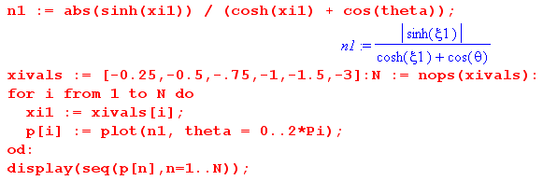

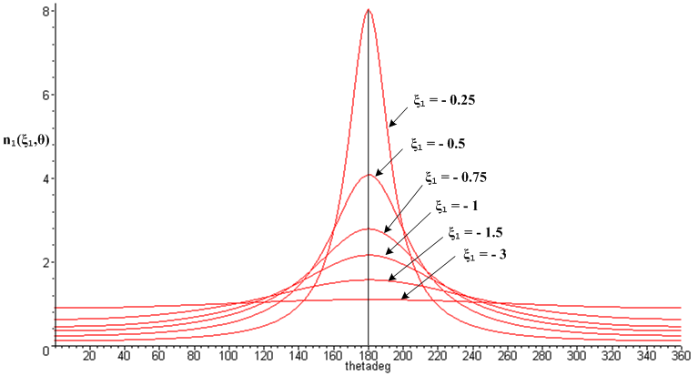
(10.38)
Since each Q1(ξ1,θ) has the same area q dz, each curve above has the same area 2π.

In the figure below, the large conductor pair has ξ = ±0.25 and would exhibit the most strongly peaked charge distribution shown above. Most of this distribution lies in the range ±40o from 180o, as marked by the red curve:

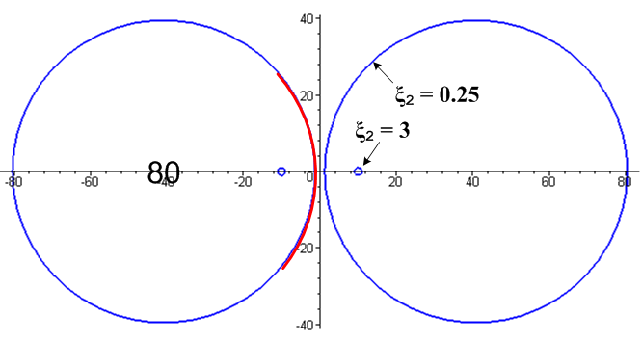 (10.39)

The tiny conductor pair has ξ = ±3 and for that pair the charge distribution is very close to uniform at all angles, as shown by the ξ1 = -3 curve in Fig (10.38).

11. The Two-Cylinder Capacitor Problem Part II

Here we fill in some of the pieces omitted in Part I.

(a) Aligning the Cylinders

Consider again Fig (10.2) which shows the two cylinders. We know the radii and center locations of the two cylinders from (2.4),

(x - xc)2 + y2 = R2 xc = a/thξ R = a/|shξ| (2.4)

so that

R2 = a/|shξ2| xc2 = a/thξ2
R1 = a/|shξ1| xc1 = a/thξ1 . (11.1)

The distance between the cylinder centers we shall call b,

b = xc2 - xc1 = a/thξ2 - a/thξ1 . (11.2)

We wish to compute the parameters a, ξ1 and ξ2 in terms of R1,R2 and b. There are three equations in three unknowns,

R2 = a/|shξ2|
R1 = a/|shξ1|
b = a( cothξ2 - cothξ1) . (11.3)

In Fig (10.2) ξ2 > 0 and ξ1 < 0. To make our algebra investment below a little more general, we assume that sign(ξ2) = +1 but sign(ξ1) = σ1, allowing ξ1 to have either sign. From (11.1),

1/thξ2 = cothξ2 = $\sqrt{1 + 1/sh2ξ2}$ = $\sqrt{1 + (R2/a)2}$
1/thξ1 = cothξ1 = σ1$\sqrt{1 + 1/sh2ξ1}$ = σ1$\sqrt{1 + (R1/a)2}$. (11.4)

Then

b = xc2 - xc1 = a ($\sqrt{1 + (R2/a)2}$ - σ1$\sqrt{1 + (R1/a)2}$ ) = ( $\sqrt{a2+R22}$ - σ1 $\sqrt{a2+R12}$) . (11.5)

Square to get

b2 = (a2+R22) + (a2+R12) - 2σ1$\sqrt{a2+R22}$$\sqrt{a2+R12}$
or
(b2-2a2-R22-R12) = - 2σ1$\sqrt{a2+R22}$$\sqrt{a2+R12}$. (11.6)

Square again to get

(b2-2a2-R22-R12)2 = 4(a2+R22) (a2+R12) . (11.7)

Maple solves this equation for a = a(b,R1,R2) as follows,

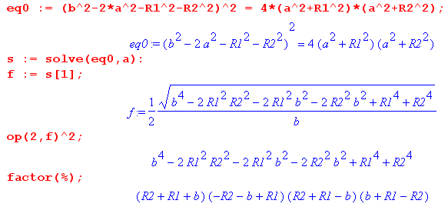

The last line may be written [ b2- (R1+R2)2] [ b2- (R1-R2)2] so we conclude that

a = (1/2b) $\sqrt{b2 - (R2+R1)2}$$\sqrt{b2 - (R2-R1)2}$ . (11.8)

Given this expression for a, the other two unknowns in (11.3) are,

shξ2 = (a/R2) => ξ2 = sh-1 (a/R2) = ln[ (a/R2) + $\sqrt{1+(a/R2)2}$]
shξ1 = σ1(a/R1) => ξ1 = σ1sh-1 (a/R1) = σ1 ln[ (a/R1) + $\sqrt{1+(a/R1)2}$] , (11.9)

so our solution for a, ξ2 and ξ1 in terms of R1, R2 and b is then,

a = (1/2b) $\sqrt{b2 - (R2+R1)2}$$\sqrt{b2 - (R2-R1)2}$

ξ2 = sh-1 (a/R2)

ξ1 = σ1sh-1 (a/R1) . (11.10)

As an example, we measure from Fig (10.2) that b = 6 cm, R2 = 3.5 cm, R1 = 1.3 cm, and σ1 = -1 so

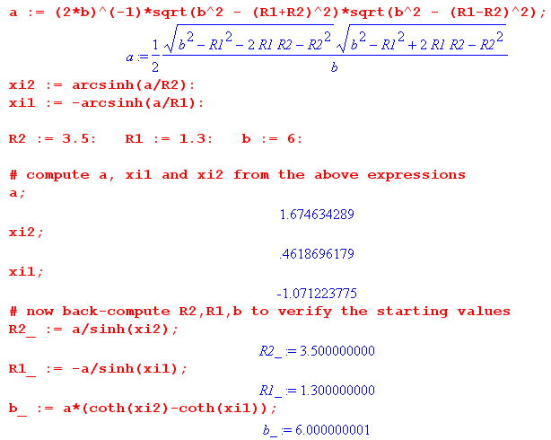

(b) Capacitance in terms of R1, R2 and b

Consider now:

ch(ξ2 - ξ1) = ch(|ξ2| - σ1|ξ1|) = ch|ξ2| ch|ξ1| - σ1 sh|ξ2| sh|ξ1| // Spiegel 8.21

= $\sqrt{1+sh2ξ2}$$\sqrt{1+sh2ξ1}$ - σ1 sh|ξ2| sh|ξ1|

= $\sqrt{1+(a/R2)2}$$\sqrt{1+(a/R1)2}$ - σ1 (a/R2) (a/R1) // from (11.9)

= (1/R1R2) $\sqrt{a2+R22}$$\sqrt{a2+R12}$ - σ1 (a/R2) (a/R1)

= (R1R2)-1 [$\sqrt{a2+R22}$$\sqrt{a2+R12}$ - σ1a2 ] . (11.11)

But from (11.6) we know that

$\sqrt{a2+R22}$$\sqrt{a2+R12}$ = (b2-2a2-R22-R12)/(-2σ1) = -σ1(b2-2a2-R22-R12)/2 (11.12)

Inserting this into (11.11) gives

ch(ξ2 -ξ1) = (R1R2)-1[-σ1(b2-2a2-R22-R12)/2 -σ1a2]

= (2R1R2)-1 σ1[-(b2-2a2-R22-R12) -2a2]

= (2R1R2)-1 σ1[-b2+2a2+R22+R12 -2a2]

= (2R1R2)-1 σ1[-b2+R22+R12] ,

where a has vanished. We then have

ξ2-ξ1 = ch-1 [ σ1 $\frac{-b2+R22+R12}{2R1R2}$] = ch-1 [$\frac{σ1}{2}$( - $\frac{b2}{R1R2}$ + $\frac{R2}{R1}$ + $\frac{R1}{R2}$ ) ] . (11.13)

From (10.15), we may therefore express the capacitance per unit length as

C = 2πε $\frac{1}{ξ2-ξ1}$ = $\frac{σ1}{2}$$\frac{b2}{R1R2}$$\frac{R2}{R1}$$\frac{R1}{R2}$ . (11.14)

In particular, for Fig (10.2) we have σ1 = - 1 so this says

C = 2πε $\frac{1}{ξ2-ξ1}$ = $\frac{1}{2}$$\frac{b2}{R1R2}$$\frac{R2}{R1}$$\frac{R1}{R2}$ . (11.15)

This result agrees with Ref [5] (4.11.30) which states C = 4πε/K along with (6.3.10) for K,

K = 2 ch-1 { (1/2) [ (b2/a1a2) - (a1/a2) - (a2/a1)] } . Ref [5] (6.3.10)

(c) The Cylinder Over Plane Case

If in Fig 10.2 one takes the limit ξ1 → 0, the blue circle on the left becomes the vertical y axis, and the situation is then that of a cylinder lying over a ground plane, as indicated here (dielectric is gray),

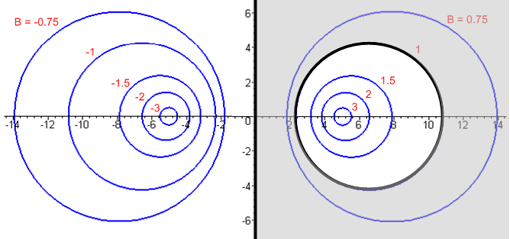 (11.16)

In this limit,

φ(ξ) = - $\frac{ξ}{ξ2}$V (10.8)

V2 = - V
V1 = 0 (10.9)

E = (V/a) (chξ–cosu) $\frac{1}{ξ2}$ (10.10)

n(ξ1,u) = ε $\frac{V}{h(0,u)}$$\frac{1}{ξ2}$ // surface charge density on the left conductor C1 (y axis)
(10.11)
n(ξ2,u) = - ε $\frac{V}{h(ξ2,u)}$$\frac{1}{ξ2}$ // surface charge density on the right conductor C2

Check dim: εV/a = farad/m*volt*1/m = cou/m2 so OK. So this n is charge/m2 and no dz appears.

q = q1 = 2πε $\frac{V}{ξ2}$ (10.14)

C = q/V = 2πε $\frac{1}{ξ2}$ (10.15)

φ(ξ) = - $\frac{q}{2πε}$ξ . // no change (10.16)

The capacitance can be expressed alternatively as follows. Consider from (2.4),

x2c = a coth ξ2 = a chξ2/shξ2
R2 = a/sh(ξ2) (2.4)

Therefore

x2c/R2 = chξ2 => ξ2 = ch-1(x2c/R2) .

But xc2 being the center of the ξ2 blue circle is the height h of that center above the plane, so

ξ2 = ch-1(h/R2) = ln [ (h/R2) + $\sqrt{(h/R2)2 + 1}$ ] ≈ ln (2h/R2) if h >> R2 . (11.17)

The capacitance for the radius R2 cylinder with center line h above the plane is then

C = 2πε $\frac{1}{ξ2}$ = $\frac{2πε}{ch-1(h/R2)}$ = $\sqrt{(h/R2)2 + 1}$ (11.18)

which agrees with (6.3.19) of Ref [5] along with C = 4πε/K.

(d) The Offset Coaxial Cylinders Case

If in Fig (10.2) the small blue circle with ξ1 < 0 is replaced by its mirror image blue circle with ξ1> 0, one obtains an offset coaxial capacitor, where again the dielectric is gray,

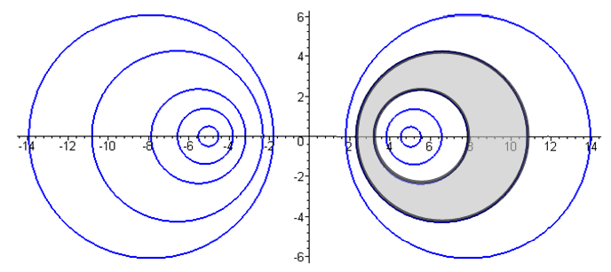 (11.19)

The "math" for this case is the same as done in Section (b) above, except now σ1 = +1 instead of -1. The parameter b is still the distance between the two cylinder centers b = xc2-xc1. The quantity (ξ2-ξ1) is now negative since ξ1 > ξ2. We just read off the results from above,

φ(ξ) = - $\frac{ξ}{ξ2-ξ1}$V (10.8)

V2 = - $\frac{ξ2}{ξ2-ξ1}$V > 0
V1 = - $\frac{ξ1}{ξ2-ξ1}$V > 0 (10.9)

E(ξ,u) = (V/h(ξ,u)) $\frac{1}{ξ2-ξ1}$ (10.10)

n(ξ1,u) = - ε $\frac{V}{h(ξ1,u)}$$\frac{1}{ξ2-ξ1}$ > 0 // surface charge density on the inner conductor C1
(10.11)'
n(ξ2,u) = ε $\frac{V}{h(ξ2,u)}$$\frac{1}{ξ2-ξ1}$ < 0 // surface charge density on the outer conductor C2

Both normals have flipped around causing new minus signs in (10.11). Finally,

C = q/V = 2πε $\frac{1}{ξ2-ξ1}$ dim(ε) = farad/m (10.15)
φ(ξ) = - $\frac{q}{2πε}$ξ // no change (10.16)

The capacitance C can be expressed in terms of b, R1 and R2 using (11.14) with σ1 = +1, so

C = 2πε $\frac{1}{ξ2-ξ1}$ = $\frac{1}{2}$$\frac{b2}{R1R2}$$\frac{R2}{R1}$$\frac{R1}{R2}$ . (11.20)

which agrees with (6.3.13) of Ref [5] along with C = 4πε/K.

For the perfectly centered coaxial cable we set b = 0 (no offset of centers). In this case

ch-1 [$\frac{1}{2}$($\frac{R2}{R1}$ + $\frac{R1}{R2}$ )] = ln [$\frac{R2}{R1}$] // an identity for R2 > R1 (11.21)

so then

C = $\frac{2πε}{ln(R2/R1)}$ (11.22)

The identity (11.21) can be proven using ch-1x = ln(x + $\sqrt{x2+1}$) for x ≥ 1.

One might well wonder how this centered case can be reached since Fig (11.19) above seems to indicate that the two cylinders can never have a common center. We do know that the centers become "more common" for larger values of ξ1 and ξ2, something visible in Fig (2.5) for example. There the ξ = 2 and ξ = 3 circles are pretty close to concentric, but not quite.
To resolve this mystery, we consider equations (11.10) from above,

a = (1/2b) $\sqrt{b2 - (R2+R1)2}$$\sqrt{b2 - (R2-R1)2}$

ξ2 = sh-1 (a/R2)

ξ1 = σ1sh-1 (a/R1) (11.10)

If b becomes very small, the first line above says

a = (1/2b)(R2+R1)(R2-R1)

so as b→0 one has a → ∞. With σ1 = +1, the next two equations say

ξ2 = sh-1 (a/R2) ≈ ln(2a/R2) → ∞
ξ1 = sh-1 (a/R1) ≈ ln(2a/R1) → ∞

so as b→0, both ξ1 and ξ2 become very large and then the circles are concentric in the limit.

