Inversion of Conical Coordinates PhL 10.18.10

Overview (2 pages) 1
1. Starting the inversion. 3
2. Understanding the mapping (μ,ν) → (X²,Y²,Z²). 3
(a) First, let's just plot the surface in Maple. 3
(b) Now write the equation for this surface. 4
(c) The domain restriction for X,Y. 6
(d) An implication of our 3D space plane 7
(e) Direct computation of r 7
3. Inversion Plan A : fails. 8
4. Inversion Plan B. 8
5. What about the two signs? 12
6. Summary of Inversion of Conicals 13

______________________________________________________________________________

Overview (2 pages)

We want to invert this system in which h and k are fixed parameters: eg x = x(r,μ,ν; k,h)

x = r μν/(hk)
y = r $\sqrt{μ2 - h2}$$\sqrt{h2 - ν2}$/(hs) s = $\sqrt{k2-h2}$ 0 < ν < h < μ < k
z = r $\sqrt{k2 - μ2}$$\sqrt{k2 - ν2}$/(ks)

The inversion comes out being this eg ν = ν(x,y,z; k.h)

r = $\sqrt{x2+y2+ z2}$ s2 = k2- h2
ν = $\sqrt{W2 - 4h2k2(x/r)2}$ / $\sqrt{2}$ W = k2(x/r)2 + s2(y/r)2 + h2
μ = h k(x/r) (1/ν)

In Section 1 I consider the intermediate transformation from (μ,ν) to a certain (X2,Y2,Z2) and I show that as the point (μ,ν) covers its prescribed "legal" rectangle, the point (X2,Y2,Z2) remains inside a certain rectangular 3D region. I realize that the (μ,ν) rectangle must map into some kind of 2D surface in (X2,Y2,Z2) space.

In Section 2 (a) I had Maple plot this surface for a specific h,k pair, and found it to be a flat surface. It is a plane inscribed into the above rectangular 3D region, thus making a tilted triangle. In (b) I then went on to find the equation of this plane in (X2,Y2,Z2) space. I did this by having Maple invert a 3x3 matrix:

aX2 + bY2 + cZ2 + d = 0 where the normal to the plane is n = (a,b,c)

n = (s2, k2, h2) d = -h2k2s2 where nd is distance from the plane to the origin

In the mapping (μ,ν) → (X2,Y2,Z2) only two of the 3D variables can be independent. If we choose these to be X2 and Y2, then Z2 is forced to take the value given by the above equation of the plane:

Z2 = k2s2 – (s/h)2X2- (k/h)2Y2

In (c) I show that not any pair (X2,Y2) is "legal". You must select them such that

s2X2 + k2Y2 ≤ h2k2s2 // "domain restriction"

which is the region of the (X2,Y2) plane underneath our (X2,Y2,Z2) triangle noted above, and of course this triangular planar region (and the triangle) fits inside the 3D rectangular region mentioned above.

In (d) I show that if we start with our plane equation above and insert our original definitions of X2,Y2,Z2 we obtain the result x2+ y2+ z2 = r2. So we can interpret our plane equation as the mapping of this plane in (x2,y2,z2) space to the plane in (X2,Y2,Z2) space. In (x,y,z) space of course the surface is a sphere, and in (X,Y,Z) space we get a certain ellipsoid.

In (e) I directly derive x2+ y2+ z2 = r2 from the original forward transformation equations.

In Section 3 I try to "invert" the forward transform by a certain Cramer's Rule method, but I find that the we get MA = B with detM=0, so I cannot solve for the vector A given M and B.

In Section 4 I try a different inversion method and get a quadratic equation in variable ν2 which of course can be solved, and the solution is

ν±2 = [ (X2 + Y2 + h4) ± $\sqrt{(X2+ Y2 + h4)2 - 4h4X2}$] / 2h2

I later show that only the – sign gives ν < h, so the intermediate inversion becomes

ν2 = [ U – $\sqrt{U2 - 4h4X2}$] / 2h2 where U ≡ (X2 + Y2 + h4)
μ2 = X2/ν2

If you select a legal pair (X2,Y2), that implies a certain (X2,Y2,Z2) on the tilted triangle, and that corresponds to the above pair (μ,ν) which lies in the legal range 0 < ν < h < μ < k.

In Section 5 I show that the – sign above gives ν < h, while the + sign gives ν > h and must be ruled out.

In Section 6 I "finish" the full inversion by replacing X2,Y2,Z2 by their original expressions and I obtain thereby the result quoted at the start of this overview.

In Section 7 I relate the Moon and Spencer conical variables to those of Hobson.
_______________________________________________________________________________

1. Starting the inversion.

Here are the Hobson forward equations (p 456) , which agree with those of M&F,

x = r μν/(hk)
y = r $\sqrt{μ2 - h2}$$\sqrt{h2 - ν2}$/(hs) s = $\sqrt{k2-h2}$ 0 < ν < h < μ < k
z = r $\sqrt{k2 - μ2}$$\sqrt{k2 - ν2}$/(ks)

We can process these equations in the following steps

x2 = r2μ2ν2/(h2k2)
y2= r2(μ2-h2)(h2-ν2)/(h2s2)
z2= r2(k2-μ2)(k2-ν2)/(k2s2)

(hkx/r)2 = μ2ν2 ≡ X2
(hsy/r)2 = (μ2-h2)(h2-ν2) = - μ2ν2 + h2μ2 + h2ν2 - h4 ≡ Y2
(ksz/r)2 = (k2-μ2)(k2-ν2) = μ2ν2 – k2μ2 – k2ν2 + k4 ≡ Z2

X2 = μ2ν2
Y2 = (μ2-h2)(h2-ν2) = - μ2ν2 + h2μ2 + h2ν2 - h4
Z2 = (k2-μ2)(k2-ν2) = μ2ν2 – k2μ2 – k2ν2 + k4 0 < ν < h < μ < k

As always assume k > h are both fixed and >0. Notice that X,Y,Z come out being restricted as follows:

0 < X2 < h2k2
0 < Y2 < (k2-h2)(h2) = s2h2
0 < Z2 < k4

So for X,Y,Z in first quadrant, this says

0 < X < hk
0 < Y < sh
0 < Z < k2

There are two additional restrictions on X,Y,Z which will appear below.

2. Understanding the mapping (μ,ν) → (X2,Y2,Z2).

We know that a 2D point (μ,ν) maps into a 3D point (X2,Y2,Z2). The rectangular region in the μ-ν plane determined by 0 < ν < h < μ < k (for given k > h > 0) maps into a 2D surface in the 3D space. What is the equation of this 2D surface?

(a) First, let's just plot the surface in Maple. Here is the code

restart; with(plots):
> X2 := mu^2*nu^2;
> Y2 := (mu^2-h^2)*(h^2-nu^2);
> Z2 := (k^2-mu^2)*(k^2-nu^2);
> k := 3;
> h := 2;
> p1 := plot3d([X2,Y2,Z2], mu = h..k, nu = 0..h):
> display(p1,labels = ["X2","Y2","Z2"]);

and here is the plot we get

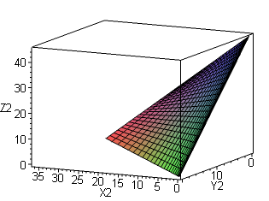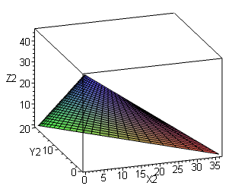

The surface we get is planar, and is in fact a triangle. This was a little unexpected for me. You see this by rotating the above figure in Maple. You also see in this figure that there is a restriction on the domain to which we shall return below.

(b) Now write the equation for this surface.

We know that the equation of a plane is

aX2 + bY2 + cZ2 + d = 0 where the normal to the plane is n = (a,b,c)

Let's install our above section (a) expressions for X2,Y2,Z2 into the above equation of a plane:

a(μ2ν2) + b(- μ2ν2 + h2μ2 + h2ν2 - h4) + c(μ2ν2 – k2μ2 – k2ν2 + k4) + d = 0

(a - b + c) μ2ν2 + (bh2- ck2)μ2 + (b h2- ck2)ν2 + (d - bh4 + ck4) = 0

(a - b + c) μ2ν2 + (bh2- ck2)(μ2 +ν2) + (d - bh4 + ck4) = 0

We can satisfy this equation if we can find a,b,c,d such that

a - b + c = 0
h2b - k2c = 0
- h4b + k4c + d = 0

The normal (a,b,c) is of course not normalized, so we can select a = 1 for example and then solve for b,c,d. We then have

- b + c = -1
h2b - k2c = 0
- h4b + k4c + d = 0

$\left(\begin{matrix}-1 & 1 & 0 \\ h2 & -k2 & 0 \\ -h4 & k4 & 1\end{matrix}\right)$$\left(\begin{matrix}b \\ c \\ d\end{matrix}\right)$ = $\left(\begin{matrix}-1 \\ 0 \\ 0\end{matrix}\right)$ M C = E => C = M-1E

Maple can give us the result here

with(linalg);M :=matrix(3,3,[-1,1,0,h^2,-k^2,0,-h^4,k^4,1]);
> MINV := inverse(M);
> E := matrix(3,1,[-1,0,0]);
> C := evalm(MINV&*E);

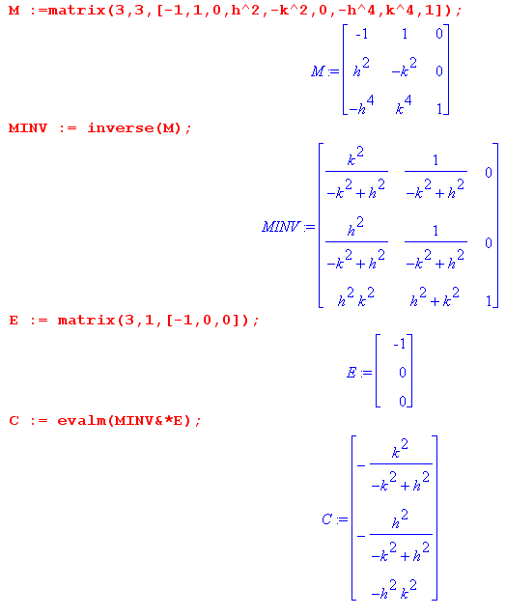
So using s = $\sqrt{k2-h2}$ as earlier, we find our solution to be

a = 1 b = k2/s2 c = h2/s2 d = -h2k2

Our equation of the plane stays the same if we scale it by s2 so we can say

n = (s2, k2, h2) d = -h2k2s2

Let's now verify our result

aX2 + bY2 + cZ2 + d =?= 0

s2X2 + k2Y2 + h2Z2 - h2k2s2 =?= 0

s2 μ2ν2 + k2(- μ2ν2 + h2μ2 + h2ν2 - h4) + h2(μ2ν2 – k2μ2 – k2ν2 + k4) - h2k2s2 =?= 0

(k2-h2) μ2ν2 + k2(- μ2ν2 + h2μ2 + h2ν2 - h4) + h2(μ2ν2 – k2μ2 – k2ν2 + k4) - h2k2(k2-h2) =?= 0

+ k2(+ h2μ2 + h2ν2 - h4) + h2(– k2μ2 – k2ν2 + k4) - h2k2(k2-h2) =?= 0

+ k2( - h4) + h2( + k4) - h2k2(k2-h2) =?= 0

and it is verified! So to summarize, the surface in our 3D space is the following

aX2 + bY2 + cZ2 + d = 0

(a,b,c) = (s2, k2, h2) and d = -h2k2s2

s2 X2 + k2Y2 + h2 Z2 = h2k2s2 s2 = (k2-h2)

This result agrees a previous calculation, but I failed to realize that we have a plane! So if you specify say X2,Y2, then you are forced to the following particular value of Z2:

Z2 = k2s2 – (s/h)2X2- (k/h)2Y2

(c) The domain restriction for X,Y. Another thing we learn from our equation above is this:

aX2 + bY2 = -d - cZ2

s2X2 + k2Y2 = h2k2s2 - h2Z2

When Z2 takes its smallest value 0, the RHS takes it's max value. This then gives us the domain restriction mentioned above regarding the triangle plot, and we have

s2X2 + k2Y2 ≤ h2k2s2

which defines a triangle in the X2-Y2 plane extending out from the origin. Only for X2,Y2 values in this triangle do we get a positive Z2 value and then all three values are consistent with 0 < ν < h < μ < k .

(d) An implication of our 3D space plane

Just above we found that

s2 X2 + k2Y2 + h2 Z2 = h2k2s2 s2 = (k2-h2)

What happens if we install our original definitions of X,Y,Z ?

X = (hkx/r)
Y = (hsy/r)
Z = (ksz/r)

Then we get

s2 (hkx/r)2 + k2 (hsy/r)2 + h2 (ksz/r)2 = h2k2s2

But every factor contains h2 and k2 and s2, so remove these to get

(x/r)2 + (y/r)2 + (z/r)2 = 1

x2+ y2+ z2 = r2

So, when at the very start when we transformed from (x,y,z) to (r,μ,ν), we could have immediately shown this fact.

(e) Direct computation of r2 .We had

x = r μν/(hk)
y = r $\sqrt{μ2 - h2}$$\sqrt{h2 - ν2}$/(hs) s = $\sqrt{k2-h2}$ 0 < ν < h < μ < k
z = r $\sqrt{k2 - μ2}$$\sqrt{k2 - ν2}$/(ks)

x2+ y2+ z2 = r2{ [μν/(hk)]2 + [$\sqrt{μ2 - h2}$$\sqrt{h2 - ν2}$/(hs)]2 + [$\sqrt{k2 - μ2}$$\sqrt{k2 - ν2}$/(ks)]2 }

= r2{ μ2ν2/(hk)2 + (μ2-h2)(h2-ν2)/ (hs)2 + (k2-μ2)(k2-ν2)/ (ks)2 }

= r2 { [s2μ2ν2 + (μ2-h2)(h2-ν2)k2 + (k2-μ2)(k2-ν2)h2 } / (h2k2s2)

= r2 { [(k2-h2)μ2ν2 + (μ2-h2)(h2-ν2)k2 + (k2-μ2)(k2-ν2)h2 } / (h2k2s2)
11 12 21 22 11 12 21 22
= r2 { k2μ2ν2 - h2 μ2ν2 +μ2h2k2- μ2ν2k2 - k2h4+h2k2ν2 + k4h2- k2h2ν2 - k2h2μ2 + h2μ2ν2 } / (h2k2s2)

= r2 { - k2h4 + k4h2 } / (h2k2s2) = r2 { (h2k2)(k2-h2)} / (h2k2s2) = r2 { 1 }

3. Inversion Plan A : fails. How do we answer that kind of question in general? Well, we want to eliminate μ and ν completely and see what relation obtains. To start this process, let's "use up" the first equation by subbing into the second two:

Y2 = - X2 + h2μ2 + h2ν2 - h4
Z2 = X2 – k2μ2 – k2ν2 + k4

This gives a Cramer's rule problem to solve for μ, ν. If we could solve it, we could take our solution μ,ν and insert into say the first equation above to get our surface. So here is the Cramer's rule problem

μ2 + ν2 = (X2 + Y2 + h4)/h2
μ2 + ν2 = (X2 – Z2 + k4)/k2

$\left(\begin{matrix}1 & 1 \\ 1 & 1\end{matrix}\right)$$\left(\begin{matrix}μ2 \\ ν2\end{matrix}\right)$ = $\left(\begin{matrix}(X2 + Y2 + h4)/h2 \\ (X2 – Z2 + k4)/k2\end{matrix}\right)$

But our 2x2 matrix has det = 0 and there is no inverse. So how then do we solve for μ and ν?

4. Inversion Plan B. Start again with

X2 = μ2ν2
Y2 = - μ2ν2 + h2μ2 + h2ν2 - h4
Z2 = μ2ν2 – k2μ2 – k2ν2 + k4

The second equation can be written

Y2 = - X2 + h2X2/ν2 + h2ν2 - h4

ν2Y2 = - ν2X2 + h2X2 + h2ν4 - ν2h4

h2ν4 - (X2+ Y2 + h4) ν2 + h2X2

This is a quadratic equation we can solve to get ν2

ν2 = [ (X2 + Y2 + h4) ± $\sqrt{(X2+ Y2 + h4)2 - 4h4X2}$] / 2h2
μ2 = [ (X2 – Z2 + k4) ± $\sqrt{(X2 – Z2 + k4)2 - 4k4X2}$] / 2k2

We obtained the second solution doing Y2 → -Z2 and h→k in our second equation. This gives the impression that you can select any X2,Y2and Z2 and obtain μ2 and ν2. Well, from the first equation, it is true that you can select an arbitrary set of values for X2 and Y2, and obtain two positive ν2 values which are then at least viable in terms of ν. Imagine we have picked such an (X,Y) pair. What happens in the second equation as we then try out various values for Z? If Z is such that (X2 – Z2 + k4) is positive, then we obtain two viable values for μ. So we could start with Z = 0 and increase it until the quantity stops being positive. But this is operationally incorrect, because Z2 we have shown in (b) above must take this value:

Z2 = k2s2 – (s/h)2X2- (k/h)2Y2

We then have

(X2 – Z2 + k4) = X2 – k2s2 + (s/h)2X2 + (k/h)2Y2 + k4

= X2[ 1 - (k2-h2)/h2] + (k/h)2Y2 + k2 (k2 - s2) s = $\sqrt{k2-h2}$

= ( 2 - k2/h2) X2 + (k/h)2Y2 – k2h2

This is a big mess. I think we should forget the second equation in the pair above, and just take this as the solution for μ

μ2 = X2/ν2

So here then is our inversion of the M&S forward transformation

ν2 = [ (X2 + Y2 + h4) ± $\sqrt{(X2+ Y2 + h4)2 - 4h4X2}$] / 2h2

μ2 = X2/ν2

This then is a mapping from X,Y → μ,ν. We have ν2 > 0 for both signs, so there are two solutions going on here. Let's write them as

ν±2 = [ (X2 + Y2 + h4) ± $\sqrt{(X2+ Y2 + h4)2 - 4h4X2}$] / 2h2

μ±2 = X2/ν±2

Now, let's verify that our forward direction comes out OK. But there is nothing really to verify! The first one is obvious, the second one goes with our ν quadratic solution so it must be right. The third equation is for Z2 which is determined by X,Y. We might now define

U ≡ (X2 + Y2 + h4)

Then our solutions are

ν±2 = [ U ± $\sqrt{U2 - 4h4X2}$] / 2h2 U ≡ (X2 + Y2 + h4)
μ±2 = X2/ν±2

We can now plug these into the forward equations to check them:

X2 = μ2ν2
Y2 = (μ2-h2)(h2-ν2)
Z2 = (k2-μ2)(k2-ν2)

Here is Maple code which does this, and I will present it in some detail. First, we assume some unknown values for μ and ν, and from them we compute X,Y,Z and also U

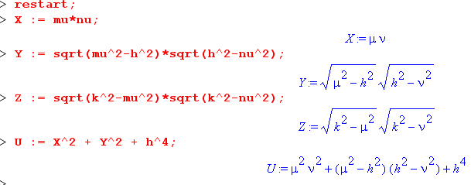

Next, we compute ν±2 and μ±2 using our formulas above (I will take the + sign first)

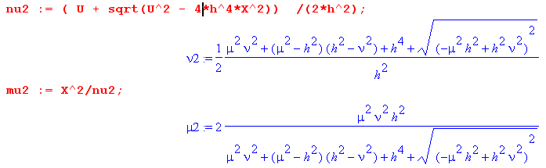

where nu2(mu2) means the inversion computed value of ν2(μ2). We now take these computed values and insert them into new versions of our X,Y,Z equations which I denote using an underbar. The first one is this

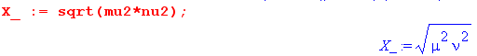

We then give Maple some extra information



Then we find

so we correctly end up with X_ = X.
We next do this for the Y equation and we get

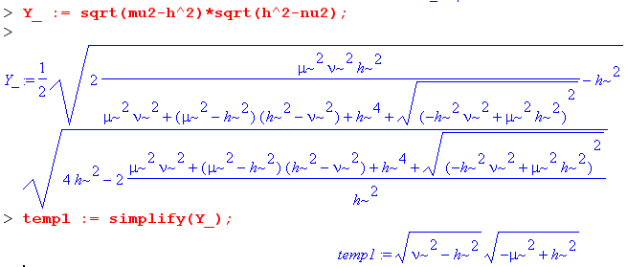

This is the correct answer, but we expect it to appear as Y2 = (h2-ν2) (μ2-h2) since we gave it all that advice, but OK, it is correct. Without the "advice", it refuses to simplify the big mess above.
Finally, we do

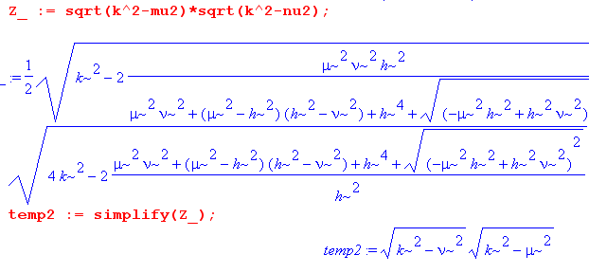
This one we expect to appear as Z2 = (k2-μ2)(k2-ν2) so it is exactly right. If I take the minus sign, we get these same three answers, the only difference is that temp1 appears in more reasonable way

But the point is that either sign works!

5. What about the two signs?

By doing some plots, I have convinced myself that if you use the minus sign, you end up with a solution for ν which is in fact ν < h, as it is supposed to be. If you use the other sign, you get an illegal ν > h. So going back to

ν±2 = [ (X2 + Y2 + h4) ± $\sqrt{(X2+ Y2 + h4)2 - 4h4X2}$] / 2h2

I think we can show that ν- < h, which is to say

ν–2 = [ (X2 + Y2 + h4) – $\sqrt{(X2+ Y2 + h4)2 - 4h4X2}$] / 2h2 < h2
or
[ (X2 + Y2 + h4) – $\sqrt{(X2+ Y2 + h4)2 - 4h4X2}$] < 2h4
or
$\sqrt{(X2+ Y2 + h4)2 - 4h4X2}$ > (X2 + Y2 + h4)- 2h4
or
(X2+ Y2 + h4)2 - 4h4X2 > [(X2 + Y2 + h4)- 2h4]2
or
(X2+ Y2 + h4)2 - 4h4X2 > (X2 + Y2 + h4)2- 4h4(X2 + Y2 + h4) + 4h8
or
- 4h4X2 > - 4h4(X2 + Y2 + h4) + 4h8
or
- 4h4X2 > - 4h4(X2 + Y2)
or
X2 < (X2 + Y2) which, finally, is manifestly true.

If we took the other sign, then we can show I bet that ν > h, so copy and paste to see

ν–2 = [ (X2 + Y2 + h4) + $\sqrt{(X2+ Y2 + h4)2 - 4h4X2}$] / 2h2 > h2 ?
or
[ (X2 + Y2 + h4) + $\sqrt{(X2+ Y2 + h4)2 - 4h4X2}$] > 2h4
or
$\sqrt{(X2+ Y2 + h4)2 - 4h4X2}$ > - [(X2 + Y2 + h4)- 2h4 ]
or
(X2+ Y2 + h4)2 - 4h4X2 > [(X2 + Y2 + h4)- 2h4]2 // same here on out
or
(X2+ Y2 + h4)2 - 4h4X2 > (X2 + Y2 + h4)2- 4h4(X2 + Y2 + h4) + 4h8
or
- 4h4X2 > - 4h4(X2 + Y2 + h4) + 4h8
or
- 4h4X2 > - 4h4(X2 + Y2)
or
X2 < (X2 + Y2) which, finally, is manifestly true.

So the conclusion is that only the minus sign solution is valid. Since both solutions are positive, it is not surprising to find that the smaller value of ν is correct, ie, in range 0 < ν < h. So solutions are really

ν2 = [ U – $\sqrt{U2 - 4h4X2}$] / 2h2 U ≡ (X2 + Y2 + h4)
μ2 = X2/ν2

I am sure you could go on to show that when (X2,Y2) lies in our legal triangle, we get μ in the correct range. It is tricky to make the plot because you have to restrict the domain as noted above,

s2X2 + k2Y2 ≤ h2k2s2

Y2 ≤ h2s2- (s2/k2)X2

so I won't bother to do it.

6. Summary of Inversion of Conicals

We start with these forward direction equations:

x2 = r2μ2ν2/(h2k2)
y2= r2(μ2-h2)(h2-ν2)/(h2s2)
z2= r2(k2-μ2)(k2-ν2)/(k2s2)

which we rewrite as

(hkx/r)2 = μ2ν2 ≡ X2
(hsy/r)2 = (μ2-h2)(h2-ν2) = - μ2ν2 + h2μ2 + h2ν2 - h4 ≡ Y2
(ksz/r)2 = (k2-μ2)(k2-ν2) = μ2ν2 – k2μ2 – k2ν2 + k4 ≡ Z2

As the first part of our inversion, we solve for μ,ν as follows:

ν2 = [ U – $\sqrt{U2 - 4h4X2}$] / 2h2 U ≡ (X2 + Y2 + h4)
μ2 = X2/ν2

but then we need to make the X,Y replacements to get

r = $\sqrt{x2+y2+ z2}$
ν2 = [ U – $\sqrt{U2 - 4h4(hkx/r)2}$] / 2h2 U ≡ ((hkx/r)2 + (hsy/r)2 + h4)
μ2 = X2/ν2 = h2[ k2(x/r)2 + s2(y/r)2 + h2]
= h2 W
Maybe we can write this more simply:

ν2 = [ h2W – $\sqrt{h4W2 - 4h6k2(x/r)2}$] / 2h2
= [ h2W –h2 $\sqrt{W2 - 4h2k2(x/r)2}$] / 2h2
= (1/2)[ W – $\sqrt{W2 - 4h2k2(x/r)2}$] W = k2(x/r)2 + s2(y/r)2 + h2

So once again, here is the inversion:

r = $\sqrt{x2+y2+ z2}$
ν = $\sqrt{W2 - 4h2k2(x/r)2}$ W = k2(x/r)2 + s2(y/r)2 + h2
μ = (hkx/r)/ν = hk(x/r)/ν

One more time

r = $\sqrt{x2+y2+ z2}$ s2 = k2- h2
ν = $\sqrt{W2 - 4h2k2(x/r)2}$ / $\sqrt{2}$ W = k2(x/r)2 + s2(y/r)2 + h2
μ = h k(x/r) (1/ν)

So you are given an arbitrary first quadrant x,y,z and you compute r. You already know h,k,s. So you know W and you know r,ν,μ.

