About Conical Coordinates PhL 11.5.10

Motivation to study these coordinates came from the Hobson chapter on ellipsoidal coordinates. His reason for introducing them is that conicals provide a simpler world in which to study the Lamé E functions. Below I sometimes refer to more detailed notes in my raw Hobson notes.

Overview (1 page , added 11.8.10) 1
1. Understanding Conical Coordinates. 2
(a) Elliptic cone as family of similar ellipses 2
(b) Shape of blue cones as μ approaches the limits h and k. 3
(c) Shape of yellows cones as ν approaches the limits 0 and h. 4
(d) Picture showing all three level surfaces 5
(e) Thinking about the complex ν and μ planes and signs of the radicals 6
(f) Summary on ranges of μ and ν 7
2. Moon and Spencer as Second Source for Conical Coordinates Information 9
3. Quadric Surfaces 9
4. Inversion of the conical coordinates 10
5. The Hobson η and ζ auxiliary variables: metric tensor and Laplace equation 10
6. Sample Problem Solution in Conical Coordinates: conical separation and atoms: Lamé E's 11

__________________________________________________________________________________

Overview (1 page , added 11.8.10)

In Section 1 I give a physical description of the conical coordinates with lots of detail, pictures of the level surfaces and so on.

In Section 2 I merely quote Moon and Spencer as a "second source" for conical coordinates data. This is not a very commonly used coordinate system and not many books include it. For example, M&F have only a tiny amount and it seems wrong.

In Section 3 I show pictures and give equations of all "quadric surfaces", something I never done before for some reason. The elliptic cone is one such surface, the sphere a special case of the ellipsoid.

In Section 4 I quote my results from " Inversion of Conical Coordinates.doc" where I invert the conical coordinates. The result is a bit messy, but much simpler than the inversion of the ellipsoidals.

In Section 5 I describe the "natural coordinates" η and ζ that one can use to replace μ and ν. I show how in these coordinates, the metric tensor and Laplacian become very simple. It is convenient to have "hybrid equations" where η,ζ appear in derivatives, but μ and ν appear elsewhere. The η and ζ variables are certain elliptic integrals of the μ and ν coordinates. In the notes below, I am summarizing more detailed notes which live in my Hobson notes doc in the ellipsoidals folder. You can think of η,ζ as "speed adjusted" versions of μ,ν which make the metric tensor simple. Cone labels could be η,ζ if you wanted.

In Section 6 I use conical coordinates to find the potential between two metal elliptic cones held at different constant potentials V1 and V2. The result is amazingly simple when expressed in the natural η coordinate:

V(η) ={ (V1-V2) η + (V2η1 - V1η2) } / (η1-η2)

η(μ) = [K - dn-1(μ/k; k1)]/k k1' ≡ h/k k1 = $\sqrt{1-(h/k)2}$ K = K(k12)

μ(x,y,z) = hk(x/r) (1/ν) = hk(x/r) $\sqrt{2}$/ $\sqrt{W2 - 4h2k2(x/r)2}$ W = k2(x/r)2 + s2(y/r)2 + h2

I then go on to state the claim (see Hobson notes for details) that you can find separated solutions of the Laplace equation in conical coordinates of this form

V = rn En,p(μ) En,p(ν)

where the E functions are Lamé functions which are first kind solutions of the Lamé ODE:

(∂ζ2 E(ν/ζ)) – [ n(n+1) ν2– p(h2+k2)] E(ν/ζ) = 0
or
(ν2-h2)(ν2-k2) ∂ν2 E(ν/ζ) + ν(2ν2-k2-h2) ∂ν E(ν/ζ) + [p(h2+k2) - n(n+1) ν2 ] E(ν/ζ) = 0

So now we know what the "atoms" look like in conical coordinates. It turns out (Hobson notes) that you have to visualize the two E functions together as a single 2-variable Sturm-Liouville problem which is oscillatory in μ and ν, but which cannot be decomposed into a product of 1D SL-problems! The two separation constants n and p get quantized at the same time in the 2D problem. You can think of μ,ν as describing a point on the sphere and being alternatives to θ,φ.
__________________________________________________________________________________

1. Understanding Conical Coordinates.

(a) Elliptic cone as family of similar ellipses

The conical system has spheres and elliptical cones as level surfaces, and two parameters h and k with k > h. Hobson gives the equations of the cones: (cone labels are μ and ν)

x2/μ2 + y2/(μ2-h2) = z2/(k2-μ2) blue cones with μ label

x2/ν2 = y2/(h2-ν2) +z2/(k2-ν2) yellow cones with ν label

The cones point out in the direction of the isolated term in the equation. In order for all denominators to be positive (which is the basis of the following discussion) we need the following to be true: 0 < ν2 < h2 < μ2 < k2 which implies that k > h if these are taken positive.
Notice that x = y = z = 0 solves both equations, so any of these cones has its tip at the origin. For the μ cones, we see that for a fixed z, we get an ellipse parallel to the x-y plane (blue). For the ν cone, for a given x we get an ellipse parallel to the y-z plane (yellow). In the blue case, for a fixed μ, as we increase z, the ellipses get gradually larger, and these ellipses form the surface off an elliptical cone. Similarly in the other case. So here is our picture:
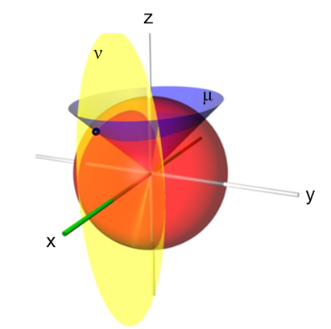

Comment added 10.28.10. If we take a slice of the blue μ cone in the plane z = k2-μ2, we get an ellipse which has the equation x2/μ2 + y2/(μ2-h2) = 1, and so h is the focal distance of this particular ellipse. If we define z2/(k2-μ2)= α2 for some general constant z, we then have x2/μ'2 + y2/(μ'2-h'2) = 1 where μ' = αμ and h' = αh. Basically the other cross section ellipses are just scaled up or down versions of our special ellipse having α = 1. That is, both semi major axes A and B as well as the focal distance C are all scaled together. Thus the cross section ellipses are a family of similar ellipses (not confocal ellipses), so as you go far out in the cone, the cross section is always an ellipse and does not become a circle. The ratio of the semi-minor to semi-major axes is always B/A = (μ-h)/μ = 1 - (h/μ). So for a given blue cone μ, we can regard the parameter h as determining the B/A ratio of the ellipses which form the cone μ. I scratch compute ε = C/A = A(h/μ)$\sqrt{2(μ/h)-1}$, so the B/A ratio is I think the simplest measure of eccentricity. This paragraph I think clarifies what is meant by an "elliptic cone".

(b) Shape of blue cones as μ approaches the limits h and k.

For the blue μ cone, we see from the first equation that our range of μ is h < μ < k.

x2/μ2 + y2/(μ2-h2) = z2/(k2-μ2)

As μ → k, the z2 coefficient becomes very large, so the equation takes a form like Ax2+By2 = 1000z2. This means that even for small z, 1000z2 is quite large, so the cross section ellipses are large, which means the blue cone is flattening down toward the z=0 plane. As we move to this limit, the ellipse ratio approaches the constant value B/A = 1 - (h/μ) = 1 - (h/k) [y/x] . In this limit, the cone is approaching the z = 0 plane but remains elliptic:
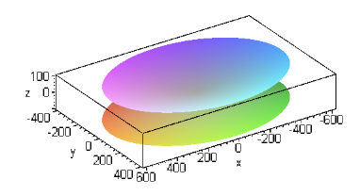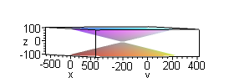

implicitplot3d(x^2 + 2*y^2 = 30*z^2,x=-600..600,y=-400..400, z=-100..100,style=patchnogrid, grid = [60,60,60],scaling = CONSTRAINED,axes=boxed);

As μ → h, the coefficient of y2 becomes very large, so we get something like Ax2 + 1000y2 = Cz2, so the ellipse cross sections are becoming very eccentric, with the y semi-major axis very small. So the blue cone is thus crushing toward the y=0 plane in this limit and now B/A → 0 in the limit.
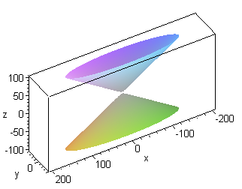

implicitplot3d(x^2 + 30*y^2 = 2*z^2,x=-200..200,y=-40..40, z=-100..100,
style=patchnogrid, grid = [60,60,60],scaling = CONSTRAINED,axes=boxed);

(c) Shape of yellows cones as ν approaches the limits 0 and h.

For the yellow ν cone, we see from the first equation that our range of ν is 0 < ν < h.

y2/(h2-ν2) +z2/(k2-ν2) = x2/ν2

As ν → 0, we get our 1000x2 on the right, so cones are flattening our flat toward the x=0 plane which is similar to the case μ→k above. Here the ratio B2/A2 = (h2-ν2)/ (k2-ν2) so B/A → (h/k). [ z/y ]

As ν → h, we have 1000y2 + Bz2 = Cx2 so the yellow cross section ellipses are getting very eccentric with the y semi-major axis again very small, so the yellow cone is crushing toward the y=0 plane.

Here are some sample pictures for these two cases:
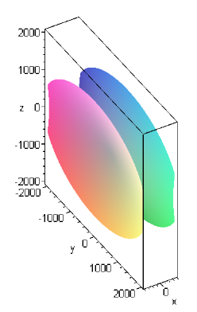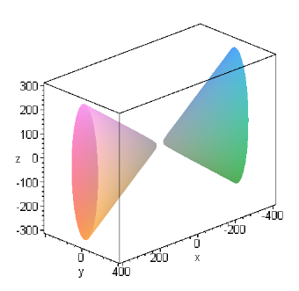

implicitplot3d(y^2 + 2*z^2 = 30*x^2,x=-400..400,y=-2000..2000, z=-2000..2000,style=patchnogrid, grid = [60,60,60],scaling = CONSTRAINED,axes=boxed); LEFT

implicitplot3d(30*y^2 + 2*z^2 = x^2,x=-400..400,y=-200..200, z=-300..300,style=patchnogrid, grid = [60,60,60],scaling = CONSTRAINED,axes=boxed); RIGHT

To summarize:

blue μ cone: μ → k => flat in z=0 plane μ→h => crushed toward y=0 plane

yellow ν cone: ν → 0 => flat in x=0 plane ν → h => crushed toward y=0 plane

Remember that if you look at any point on the intersection of any blue cone and any yellow cone, tiny local surface patches on these cones near this point will be at right angles, and of course both of these patches will also be at right angles to a patch on a sphere. Conicals are an orthogonal system!

(d) Picture showing all three level surfaces

So here is our improved picture where the arrow tips show the direction in which either cone gets crushed toward the x=0 plane, while the arrow tails show the limit where the cone flattens into a plane.

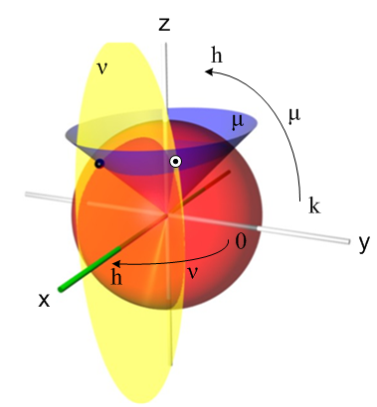

The black dot shows a point (x,y,z) which lies on the two cones and the red sphere, but this point has y < 0, so it is "the wrong point". The correct point is the dot in the white circle which has x,y,z all positive and is thus in the "first octant". The coordinates are all positive according to our standard equations

x = r μν/(hk)
y = r $\sqrt{μ2 - h2}$$\sqrt{h2 - ν2}$/(hs) s = $\sqrt{k2-h2}$ 0 < ν < h < μ < k
z = r $\sqrt{k2 - μ2}$$\sqrt{k2 - ν2}$/(ks)

So these equations with positive square roots give you any point in the first octant.

Things now become a little complicated. If we think of something like y = y(μ,ν), we have to think of the complex μ plane and the complex ν plane for the function y = y(μ,ν) and z(μ,ν).

(e) Thinking about the complex ν and μ planes and signs of the radicals

For the ν plane we have this picture:
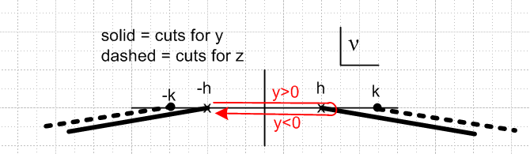

So for y you start off with your positive square root for $\sqrt{h2 - ν2}$ = $\sqrt{h + ν}$$\sqrt{h - ν}$ . First run (red) along the top from ν = -h passed ν = 0 and to ν = +h. Doing this gives us access to both x < 0 and x > 0 halfspaces and we have let's say y and z both > 0, so we have two octants covered. Then you rotate around the branch point at h and run backwards from ν = +h to ν = -h. The rotation causes the square root $\sqrt{h - ν}$to become – $\sqrt{h - ν}$ because the vector h-ν has rotated 2π radians clockwise. This means of course that $\sqrt{h2 - ν2}$ becomes – $\sqrt{h2 - ν2}$, so on the second part of our traversal, we end up with y < 0, and that is how we "access" the y < 0 halfspace, and now we have 4 octants covered. Notice that as we did this, we stayed on the same sheet of the function $\sqrt{k2 - ν2}$ (dotted cuts) which appears in the z expression, so z did not change sign.

We can now consider the μ plane situation

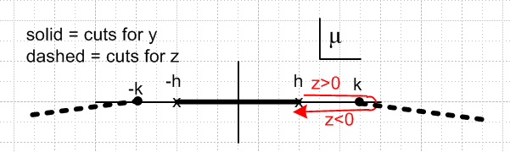

As we run along the red curve here, we assume $\sqrt{k2 - ν2}$ > 0 on the first part of the traversal, so that z > 0, and then this becomes – $\sqrt{k2 - ν2}$ on the second part of the traversal, and we get z < 0, and this then gives us all eight octants. As we do this red path, notice that we stay on the same sheet of $\sqrt{h2 - ν2}$ so y did not change sign.

(f) Summary on ranges of μ and ν

In order to access all 8 octants of x,y,z space, we have to think of μ and ν capable of traversing the red paths shown in the above pictures! Our ranges are -h < ν < h and h < μ < k, but just giving the ranges does not tell the whole story, as the pictures indicate. Don't forget that we have another range which is r > 0. Hobson alludes to this discussion of μ and ν on page 455, but there he is talking about them with regards to ellipsoidal, not conical, coordinates.
Let's look one more time at our cone picture:

If we think of the arrows here as being the upper portion of our two red curves, then we can access any point in the first octant only. If we then extend the range of ν by adding (-h,0), that flips our yellow cone backwards and we pick up the x < 0 half space. The equation x2/ν2 = y2/(h2-ν2) +z2/(k2-ν2) actually describes a yellow "bi-cone" having both pieces, but we decide to start with just the x > 0 cone for ν > 0. (We did not mention the bi-cone fact above. ) So imagine, then, that we have enlarged the ν arrow so the tail is at -h and the tip at +h, so we cover x<0 and x > 0 with y>0. The reverse traversal of this elongated arrow then gives us the y<0 half space, where for example the black point lies. Similarly, the reverse traversal of the μ arrow gives us z < 0 which means the blue cone is flipped downward in this case. This is all pretty difficult to illustrate in a picture, but let's try a combination of picture and words:

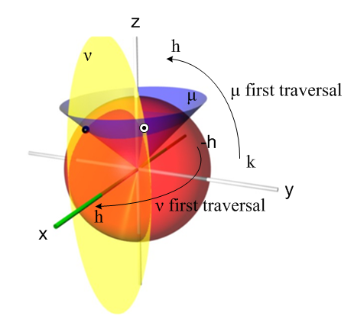
Here "first traversal" means traversing the upper red portions of our trajectories. So with both μ and ν doing their first traversals, we have the two cones as shown, though the yellow cone would be flipped for the ν<0 part of the first ν traversal. We access only the upper right quarter of the yellow cone in either of its flipped positions, and we access also just the right half of the blue cone. If we then take ν on its second traversal, we have y < 0 so we get the other (left) half of the blue cone, and the top left part of the yellow cone (again, in either of its flipped positions). If we then do the second μ traversal, the blue cone is flipped down and we get it and the lower half of the yellow cone.

2. Moon and Spencer as Second Source for Conical Coordinates Information

Luckily we have Moon and Spencer on duty as a "second source" (p 37). The translation table is this:

Hobson MS
k, h c, b
r, μ, ν r, θ, λ

I can now translate the MS x,y,z equations:

x2= r2μ2ν2/(k2h2) // agrees

y2 = r2(μ2-h2)(h2-ν2)/[ h2(k2-h2)] // agrees

z2 = r2(k2-μ2)(k2-ν2)/[k2(k2-h2)] // agrees!

3. Quadric Surfaces

In passing, I note that I never thought of elliptic cones as being in the conicoid family (quadric surfaces), but they are. Really a limit of the hyperboloids. Here is a nice picture:

http://www.math.umn.edu/~rogness/quadrics/index.shtml

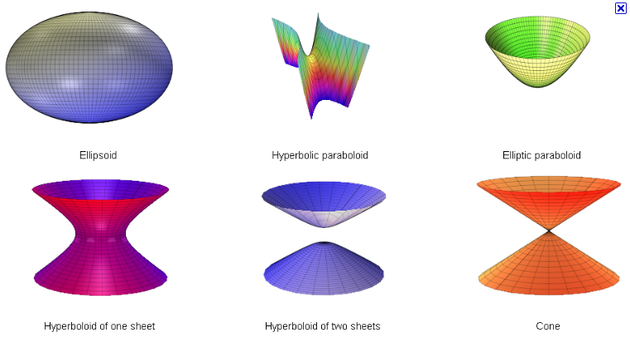

ellipsoid + x2/A2 + y2/B2 + z2/C2 = 1
one sheet hyperboloid + x2/A2 + y2/B2 – z2/C2 = 1
two sheet hyperboloid – x2/A2 – y2/B2 + z2/C2 = 1
cone (elliptic) + x2/A2 + y2/B2 – z2/C2 = 0
elliptic paraboloid + x2/A2 + y2/B2 – z/C = 0
hyperbolic paraboloid (saddle) + x2/A2 – y2/B2 – z/C = 0

I have yet to see the "hyperbolic paraboloid" surface appear in a coordinate system, but have seen all the others!

4. Inversion of the conical coordinates

Just out of curiosity, I went off and "inverted" the conical coordinates (separate doc) and found

Forward conical:
x = r μν/(hk)
y = r $\sqrt{μ2 - h2}$$\sqrt{h2 - ν2}$/(hs) s = $\sqrt{k2-h2}$ 0 < ν < h < μ < k
z = r $\sqrt{k2 - μ2}$$\sqrt{k2 - ν2}$/(ks)

Inverse conical:
r = $\sqrt{x2+y2+ z2}$ s2 = k2- h2
ν = $\sqrt{W2 - 4h2k2(x/r)2}$/ $\sqrt{2}$ W = k2(x/r)2 + s2(y/r)2 + h2
μ = h k(x/r) (1/ν)

5. The Hobson η and ζ auxiliary variables: metric tensor and Laplace equation

Hobson then starts talking about ∇2V = 0 in conicals r,μ,ν. He at first mysteriously comes up with certain "alternative coordinates" η for μ, and ζ for ν.

η(μ) = $^{\int_{h}^{μ}{}}$dμ /$\sqrt{μ2-h2}$$\sqrt{k2-μ2}$ ζ(ν) = $^{\int_{0}^{ν}{}}$dν /$\sqrt{h2-ν2}$$\sqrt{k2-ν2}$

The inverses of the above two equations are these, where sn and dn are Jacobi functions,

μ(η) = k dn(K - kη,k1) K = K(k12)

ν(ζ) = k sn(kζ, k1') k1' ≡ h/k k1 = $\sqrt{1-(h/k)2}$

We can formally invert these inversions to get

dn-1(μ/k, k1 ) = K - kη => η(μ) = [K - dn-1(μ/k, k1)]/k

sn-1(ν/k, k1') = kζ => ζ(ν) = (1/k) sn-1(ν/k, k1')

I show in my Hobson notes the motivation for these strange coordinates: If we write the metric tensor expression (ds)2 in r,u,v we get something not very nice looking with lots of denominator factors (Hobson page 456 E). But using the η and ζ alternates, we find things simplify to

(ds)2 = (dr)2 + (μ(η)2-ν(ζ)2) r2 { (dη)2 + (dζ)2 }

which is quite simple, although it is "hybrid" in the sense that it has all four coordinates μ,ν,η,μ. The implication of the above is the following set of very simple "scale factors" for this orthogonal system

hrr2 = 1 Q1 = 1 r, η, ζ = 1,2,3
hηη2= hζζ2= [μ(η)2-ν(ζ)2] r2 Q2 = Q3 = r $\sqrt{μ2- ν2}$

Using these in my general orthogonal curvilinear formula for ∇2, I show in detail that

∇2f = (1/ hηη2) { ∂r [hηη2 (∂rf)] + (∂η2f) + (∂ζ2f) }

which again is quite simple, and our Laplace equation is even simpler

∇2V = 0 ⇔ ∂r [hηη2 (∂rV)] + (∂η2V) + (∂ζ2V) = 0 hηη2 = [μ(η)2-ν(ζ)2] r2

We are still "hybrid" here, but ONLY the η and ζ coordinates appear in the derivatives, that is the key point. The functions relating η ↔ μ and ζ ↔ ν are well defined, if a little complicated. In one direction you have certain elliptic integrals, and in the other you have certain inverse Jacobi functions. In either direction, both parameters h and k are involved. That is to say, for example, we have η = η(μ; h,k)

Now, without twitching a single muscle, we find these possible solutions to "potential problems" in conical coordinates:

V = Aη + B or V = Cζ + D

6. Sample Problem Solution in Conical Coordinates: conical separation and atoms: Lamé E's

I have to pause here to solve a specific problem to illustrate the power of what Hobson has just done. Suppose we want to know the potential between two metal elliptical cones μ1(η1) at V1 and μ2(η2) at V2, where our elliptical cones are described by x2/μ2 + y2/(μ2-h2) = z2/(k2-μ2) where k>h are constants. This certainly sounds like a foreboding problem even to the Jackson-trained electrostatics student!! But let's just try a solution of the form V(η,ζ) = Aη + B where A and B are just numbers (ie, constants). Here are our two boundary conditions:

V1 = Aη1 + B
V2 = Aη2 + B => V1-V2 = A(η1-η2) => A = (V1-V2)/ (η1-η2)

Then we have

B = V1-Aη1 = V1-η1(V1-V2)/ (η1-η2) = [V1(η1-η2) -η1(V1-V2)]/ (η1-η2)

= (V2η1 - V1η2)/ (η1-η2)

So we have a candidate problem solution [ it is a function of only one of the three conical coordinates]

V(r, η, ζ) = V(η) = Aη + B = [ (V1-V2) η + (V2η1 - V1η2) ] / (η1-η2)

This proposed solution first of all satisfies the Laplace equation, and second of all it satisfies our two boundary conditions which enclose a region of space. From potential theory we know this solution is unique, we have found A solution, so that is THE solution! We have given a very simple one line solution to this very complicated sounding problem! Of course we can rewrite the solution in terms of μ1 μ2 and μ using our Jacobi functions. As we learn later, we have

K - kη = dn-1(μ/k; k1) => kη = K - d dn-1(μ/k; k1) => η(μ) = [K - dn-1(μ/k; k1)]/k

where K and k1 are certain known functions of h and k,

k1' ≡ h/k k1 ≡ $\sqrt{1-(h/k)2}$ K ≡ K(k12)

So our solution is then

V(μ) ={ (V1-V2) η + (V2η1 - V1η2) } / (η1-η2)

= { (V1-V2) [K - dn-1(μ/k; k1)]/k + (V2 [K - dn-1(μ1/ k; k1)]/k - V1[K - dn-1(μ2/ k; k1)]/k)} / ([K - dn-1(μ1/ k; k1)]/k -[K - dn-1(μ2/ k; k1)]/k)

= { (V1-V2) [K - dn-1(μ/ k; k1)]/k

+ (V2 [K - dn-1(μ1/ k; k1)] - V1[K - dn-1(μ2/ k; k1)] } / ([K - dn-1(μ1/k1)] -[K - dn-1(μ2/ k; k1)])

= { (V1-V2) [K - dn-1(μ/ k; k1)]/k

+ (V2 [K - dn-1(μ1/ k; k1)] - V1[K - dn-1(μ2/ k; k1)] } / (- dn-1(μ1/k1)] +dn-1(μ2/ k; k1) )

= { (V1-V2) [K - dn-1(μ/ k; k1)]/k

+ (V2 [K - dn-1(μ1/ k; k1)] - V1[K - dn-1(μ2/ k; k1)] } / (- dn-1(μ1/ k; k1)] +dn-1(μ2/ k; k1) )

So our result is then as follows, and it almost still fits on one line:

V(μ) = { (V1-V2) [K - dn-1(μ/ k; k1)]/k + (V2 [K - dn-1(μ1/ k; k1)] - V1[K - dn-1(μ2/ k; k1)] }
/ [dn-1(μ2/ k; k1) - dn-1(μ1/ k; k1) ]

If you wanted this result in Cartesian coordinates, you would replace μ by μ(x,y,z) as per our inversion formula above:

μ(x,y,z) = h k(x/r) (1/ν) = h k(x/r) $\sqrt{2}$/ $\sqrt{W2 - 4h2k2(x/r)2}$

where W = k2(x/r)2 + s2(y/r)2 + h2

Admittedly, in Cartesians V(x,y,z) is a pretty complicated function, but what do you expect for the potential between two complicated elliptic cones!! What's amazing is that you can even solve the problem at all!

Hobson next goes on to show this important fact. He shows that, due to the simple form for ∇2 we found above, you can find a separated form for the Laplace solution which has this form

V = rn En,p(μ/η) En,p(ν/ζ)

where n and p are separation constants, and where En,p(ν/ζ) solves this ODE

(∂ζ2 E(ν/ζ)) – [ n(n+1) ν2– p(h2+k2)] E(ν/ζ) = 0

(ν2-h2)(ν2-k2) ∂ν2 E(ν/ζ) + ν(2ν2-k2-h2) ∂ν E(ν/ζ) + [p(h2+k2) - n(n+1) ν2 ] E(ν/ζ) = 0

where the first form uses variable ζ and the second uses ν. We are not too surprised to find the exciting fact that in the separated atomic form, the μ and ν functions are the SAME function. We are not too surprised because the two sets of cones look quite "symmetric" in the conicals picture above. Notice that the ODE above is symmetric under h↔k.
I think this is the Lamé equation and the En,p(ν/ζ) are the Lamé functions, but Hobson holds off on making this identification at this point. Nor do we know if or how the constants n and p get quantized.

