The potential of a charged ellipsoid PhL 11.10.09

I found the solution, but it required learning of lot of new stuff, all from the M&F volumes, it was well worth the time spent. Almost all coordinate systems are limits of the ellipsoidal system. See Overview section below which compresses this 73 page doc into 5 pages; there is also a META doc at 14 p)

Overview ( 5 pages, added 10.8.10 : see also separate older META doc, 14 pages) 2
0. Starting the search 6
A. The Surfaces of Ellipsoidal Coordinates and The Equations for Such Surfaces. 8
B. How to Obtain Cartesian Coordinates from Ellipsoidal Coordinates 18
C. Statement of the Helmholtz (Laplace if k₁=0) Equation in Ellipsoidal Coordinates 18
D. Statement of the Separated Equations in Ellipsoidal Coordinates 19
E. The connection between M&F Ellipsoidal Coordinates and Wolfram Ellipsoidal 19
E1. The Byerly Coordinates compared to M&F ones. 23
F. Comments on the Remainder of M&F Chap 5 on ODE's 25
G. Summary Page on Ellipsoidal Coordinates 27
H. Statement of the ODE for Separated Functions in Ellipsoidals: Lamé Equation 31
I. Series Solutions to the Lamé Equation at z=0 36
J. Simple First-Kind Solutions to the Lamé Equation for m = 0,1,2 : functions E^{p}_{m}(z) 37
K. Second-Kind Solutions to the Lamé Equation for m = 0,1,2 : functions F^{p}_{m}(z) 39
L. The Potential of a Charged Metal Ellipsoid 40
M. The alternate ellipsoidal coordinates (λ,μ,ν) and Jacobi function connection to (ξ₁,ξ₂,ξ₃) 42
N. Comparison of the M&F Solution of the Charged Ellipsoid to the solution of Kelvin 43
O. The charge density on a charged metal ellipsoid. 45
P. The inverse coordinate formulas for ellipsoidal coordinates 46
Q. Comments on Ellipsoidal Coordinates 51
R. Express the charged ellipsoid potential in Cartesian coordinates. 53
S. How would you PLOT the charge density on the ellipsoid using Maple? 54
T. Generate those nice fixed-ξ_{i} surfaces using Maple 59
U. Verifying The Cubic Coordinate Inversion Equations 60
V. Compare Kelvin and M&F on dV/dn: interpretation of p 62
W. More on σ for ellipsoid, ellipse and disc; capacitances of various objects (10.8.10) 66
(a) Expression for p, and then limit of p when ellipsoid is crushed A→0. 66
(b) Differentiate the potential. 68
(c) Show cancellation of A factors when we go flat. 69
(d) Capacitances of various objects 71
(e) Summary of main facts of this last effort: 73
X. Explanation of a sign error in M&F statement of the ellipsoidal PDE (8.12.11) 74
Y. Show that the M&F separated equations agree with M&S (8.12.11) 77
Z. How exactly does the separation of ellipsoidals work (8.12.11) 78

__________________________________________________________________________________

Overview ( 5 pages, added 10.8.10 : see also separate older META doc, 14 pages)

In Section 0 I state the obvious comment that ellipsoidal coordinates are probably right for Kelvin's charged ellipsoid problem just due to the nature of the orthogonality of equipotential lines and electric field lines. I show the football picture from Wolfram and quote the conic equations for the three surface types. Wolfram use not ξ1, ξ2, ξ3 but rather ξ, η, ζ which are not just a reordering of the ξi.

In Section A I take notes on the M&F discussion of ellipsoidal coordinates which are ξ1, ξ2, and ξ3 which correspond to an ellipsoid, the single-sheeted vertical warped bloid (b < ξ2 < a), and the two-sheeted horizontal warped bloid. I made some pretty good pictures of each of these surfaces, and also made two different drawings showing slices. These are valuable pictures for me. The x direction is "up" which is the central axis of the single sheeted warped bloid, while the z direction is the axis of the football which is the central axis of the two-sheeted horizontal warped bloid.

In Section B I quote the M&F x,y,z expressions as functions of the ξi, as well as the scale factors hi.

In Section C I quote the M&F Helmholtz equation in terms of the ξi and define the fn(ξn) and Gi factors.

In Section D I do the Helmholtz separation and find that the separated equation is the same for each ξi. The separation constants are k2 and k3 while k1 is the Helmholtz constant (k1= 0 for Laplace equation). In this ξi equation we always have ξi2 as the first term in each radical. When the proper range for each ξi is accounted for, we get factors of i, and then the three equations are slightly different as shown in Section H below. The range situation is this: 0 ≤ ξ3 ≤ b ≤ ξ2 ≤ a ≤ ξ1

In Section E I resolve the relation between the M&F and the Wolfram ellipsoidal coordinates.

In Section E1 I comment on Byerly's ellipsoidal stuff (I have his book) where ξ1, ξ2, ξ3 = λ,μ,ν.

In Section F I note that all other coordinates are reductions of the ellipsoidal system. This was all in M&F 5.1 and I note that Chap 5 is a huge Chapter on ODE's. At a later time, I read and annotated it all but not in this doc.

In Section G I quote the M&F Chap 5 summary page on ellipsoidals, and that for general curvilinear operators. M&F then have more ellipsoidal stuff in Chap 10 where they solve 3D problems, see below.

In Section H we rewrite the three identical separated equations from Section D this way (k1= 0 now)

fn ∂n [ fn (∂n Xn(ξn)) ] + [ {k22 + (k32 /(a2- b2)} ξn2 - {(k22 b2 + k32 a2/(a2- b2) } ] Xn(ξn) = 0
fn ∂n [ fn (∂n Xn(ξn)) ] + [ {– m(m+1)} ξn2 – {-κ} ] Xn(ξn) = 0

where the two separation constants are changed from k2 and k3 to m and κ this way:

– m(m+1) = k22 + (k32 /(a2- b2) -κ = k22 b2 + k32 a2/(a2- b2)

The equation above is the Lamé equation and its solutions are the Lamé functions. Here are two more standard forms for the above ODE :

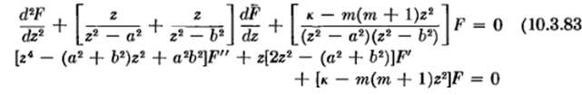

At the time I wrote this doc, I had no real sources on Lamé functions. Not in Schaum or AS or "my WW", CH had a little. Wiki had some stuff which I quote, and I had found the Byerly 1959 Dover as well (from 1893). I now have the Bateman Lamé chapter, the WW one, and Moon and Spencer hard copy, as well as the Hobson 1931 Lamé chapter 11. So today my Lamé shelf is well stocked.

When we then account for "ranges" of the ξn we find that fn = iFn for the ξ2 equation so it picks up an overall minus sign since fn appears twice, and this leads to the famous separated equations

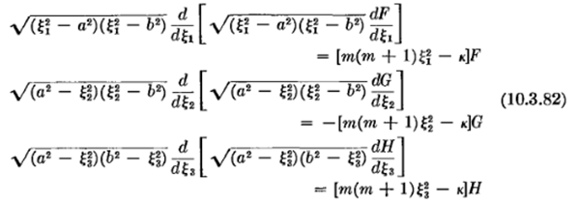

The first and second kind Lamé functions are E and F, and here is the general atomic form for a separated solution of the Laplace equation in ellipsoidal coordinates:

[ Amp Emp(ξ1) + Bmp Fmp(ξ1)] [ A'mp Emp(ξ2) + B'mp Fmp(ξ2)] [ A''mp Emp(ξ3) + B''mp Fmp(ξ3)]

where the meta doc says κ = (a2+b2)p. I understand the four "species" stuff. It turns out solutions only exist for certain discrete values of m and κ (or p).

In Section I I note that the Lamé functions have five singular points with these indices

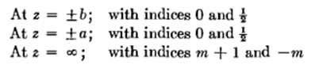
so we expect to see power series solutions with possible leading factors $\sqrt{z±a}$ and $\sqrt{z±b}$. As commented in "Frobenius Method Applied to the Associated Legendre Equation.doc", this is consistent with leading factors of the form $\sqrt{z2-a2}$ and $\sqrt{z2-b2}$ which we see in the next section.

In Section J I start looking at the actual Lamé functions. At this time, things seemed pretty mysterious. I quote some of the lower E functions from M&F. Here are a few sample functions:

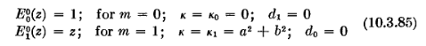
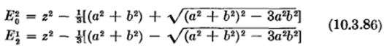
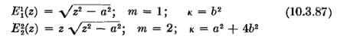
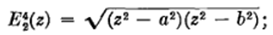

The meta notes quote more functions from Byerly, showing the K,L,M,N species notation.

In Section K I note the "trick" for obtaining the second kind Lamé functions F from the first kind E. For example, we have this famous one which goes with E00(z) = 1,
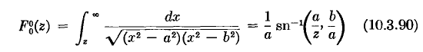
which is basically the solution of the charged ellipsoid when z = ξ1, see next section.

In Section L I "do" the charged ellipsoid problem. There is not much to do. Based on the requirement that you build your solution of atoms, and you need V(ξ1=C) = constant, and you need good asymptotic behavior, you conclude that

V(ξ1)/const = F00(ξ1) E00(ξ2) E00(ξ3) = (1/a) sn-1(a/ξ1,b/a) * 1 * 1 = (1/a) sn-1(a/ξ1,b/a)

= (1/a) F[sin-1(a/ξ1),b/a]

and when you set the constant you get

V(ξ1) = V0 F[sin-1(a/ξ1),b/a] / F[sin-1(a/c),b/a]

where ξ1= C = c is the label of the charged ellipsoid, and ξ1 is the variable taking you outside that.

In Section M I discuss certain alternate coordinates λ,μ,ν mentioned by M&F (not same as Byerly's).

In Section N I show that you can swap a↔b in the M&F charged ellipsoid solution and it is the exact same function, and this then explains why the Kelvin and M&F results are the same,

V(ξ1) = V0 F[sin-1(a/ξ1),b/a] / F[sin-1(a/c),b/a] // M&F, as shown above
V(ξ1) = V0 F[sin-1(b/ξ1),a/b] / F[sin-1(b/c),a/b] // as given by Kelvin

In Section O I write an expression for the surface charge density σ on a charged ellipsoid

4πσ = E⊥ = - dV/dn = - [dV(ξ1)/dξ1] (dξ1/dn) = - [ dV(ξ1)/dξ1] (1/hξ1)

= – [ dV(ξ1)/dξ1] $\sqrt{(ξ12- a2) (ξ12- b2)}$ / $\sqrt{(ξ12- ξ22) (ξ12- ξ32)}$

where all the action is in the last radical. More on this in Section W below.

In Section P I show how one can compute, algorithmically at least, ξi as functions of x,y,z which I refer to as the transformation "inversion". You write out the conic and it is a cubic in ξ, and the three solutions fall into the three ranges, and then you know the ξi. The results are so complex that they are not worth pasting here. There are also three sum rule things like ξ12 + ξ22 + ξ32 = r2 + a2 + b2. In addition, we know a certain rule involving Kelvin's p function as shown in Section W.

In Section Q I ask "how do we know the three ellipsoidal surfaces are orthogonal?" We know of course since the metric tensor (which we can compute) is diagonal. I have not other answer at this point. I did not compute the metric tensor myself, by the way. I examine this issue in 2D in "about 2D Ellipsoidal Coordinates.doc"

In Section R I wonder if there is some "reasonable" way to express the potential of the charged ellipsoid in Cartesian coordinates? I conclude that there is not, but later (W) I get a sort of hybrid result for σ.

In Section S I cause Maple to plot σ (on charged ellipsoid) in several different formats.

In Section T I cause Maple to generate the surfaces of the "football".

In Section U I take some test (x,y,z) points and compute the ξi using my inversion algorithm. Then I use those in the forward formulas to get the same (x,y,z), so this verifies my inversion work. Found multiple very bad Schaum 1968 cubic page errors when doing this.

In Section V I show that $\sqrt{(ξ12- ξ22) (ξ12- ξ32)}$ = ABC $\sqrt{x2/A4 + y2/B4 + z2/C4}$ and I write an expression for the "k" used in Kelvin's paper (which fact seems not very important now). This ABC relation is one of the few "contact points" you can make between these coordinate systems, and of course this involves Kelvin's famous p function, more below.

In Section W, added 8.8.10, I do several things, here are the topics:

(a) Expression for p, and then limit of p when ellipsoid is crushed A→0.
(b) Differentiate the potential and install into the σ formula
(c) Show cancellation of A factors when we go flat.
(d) Capacitances of various objects
(e) Summary of main facts of this last effort:

The summary (e) is a good one -- it gives the key results for each of the above lettered subsections. Go read it right now ! I will quote just one result here which is the general ellipsoidal σ:

4πσ(ξ1=c=C; x,y,z) = ( aV0/F[sin-1(a/c),b/a] ) (1/ABC) p(x,y,z)

which shows that σ ~ p in the general case, just as Kelvin claimed. Remember that a confocal ellipsoid family is determined by the two focal distances a and b.
_________________________________________________________________________________

0. Starting the search

Introduction. I have read Kelvin's attempt to solve this problem and am familiar with his solution. It appears that the spheroid limit of his solution does not a agree with the M&F spheroid solution [ but I later resolved this problem so it does agree.] We know that M&F talk about ellipsoidal coordinates, and maybe the solution to this problem is sitting there in M&F somehow, ready to be extracted perhaps with a little pulling. [ it is there, in fact , see L below]

Coordinates and The Plan. If one is looking for equipotentials that are ellipsoids, it is at least a good start to look for a coordinate system in which the ellipsoids have labels -- that is, are surfaces of constant label ξ or whatever. And it is also good if the coordinate system is orthogonal, because then if we have a constant potential on an ellipsoid, there will be some curvilinear coordinate lines which come off perp to the surface, call these lines of constant η, and these might then be electric field lines. At least locally to the ellipsoid in question, they will be exactly that. If you find such a coordinate system, you might ask: if you put one ellipsoid at a constant potential, will the other ellipsoids be equipotential surfaces? Differentially, it seems true. If you compare two adjacent (separated by small dξ) ellipsoids, the η lines are perp to the surface everywhere on the ellipsoid. We know that if the surface charge is in equilibrium, the electric field -dV/dn must be perp to the ellipsoid everywhere on the ellipsoid, so the η lines must be electric field lines. And we know that other equipotential surfaces must be perp to these lines. So it just seems inescapable that yes, the family of other ellipsoids will be equipotentials for charge on any given one. You can just walk along dξ in each step to larger and larger ellipsoids. At the very least, the family of confocal ellipsoids is at least an excellent candidate for the equipotential surfaces!
If this conjecture is true, then it would seem that we would know the EP surfaces right at the start. Our problem would then be to examine the Laplace equation in the newfound coordinates, write a separable product solution f(ξ)g(η)h(τ), and look for a solution where the latter two functions are just constants, then you would have V = f(ξ) which (1) is constant on each ellipsoid, and thus is doing what we want in that regard; (2) solves Laplace. Then it would seem that you are done. Probably you will find there are some "quantum numbers" which must take special values.

Implementing the Plan. So let's give this approach a try and see where it leads. M&F on their p 1304 of volume II seem to be getting into this discussion. Let's listen in on that discussion and comment on it. Here is the opening gambit

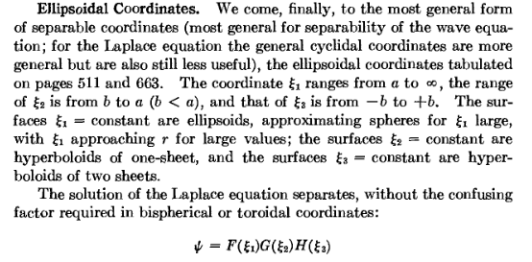

So let's get this range stuff right. The two semi-major axes are a and b, and we have

0 ξ3 b ξ2 a ξ1 ∞
hyper2 hyper1 ellipsoids

So only the ξ3 coordinate can have both signs. If you hold ξ1 constant, you get ellipsoids, etc. Now here is the only picture I have been able to find that is at least dimly comprehensible, and I will flash in the adjacent information as well, where this is from Wolfram:
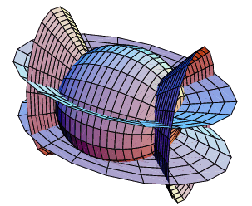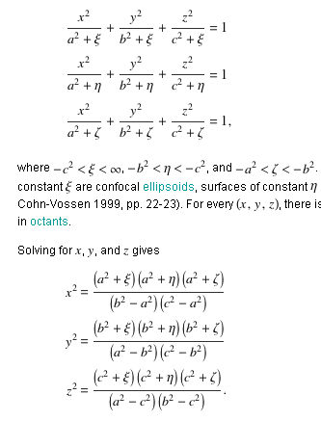

Note: as we shall see below, the blue surfaces shown here are really both part of the same one-sheet hyperboloid, whereas the red surfaces are the two halves of a two-sheet hyperboloid. The first fact is not obvious just looking at this picture.

Now there is only one problem: the coordinates ξ,η,ξ shown here are NOT the coordinates that M&F use, and I want to do things the M&F way. [ below I will show the connection ] The subject is spread out in the M&F book, so our first order of business is to extract and assemble the required information from M&F on "ellipsoidal coordinates". In other words, with the M&F quote shown above, we have started at the end of the story and we need to back up to the beginning.

M&F on Ellipsoidal Coordinates: Chapter 5 only

A. The Surfaces of Ellipsoidal Coordinates and The Equations for Such Surfaces.

The starting point seems to be volume I page 511 in a chapter all about "separable coordinates"

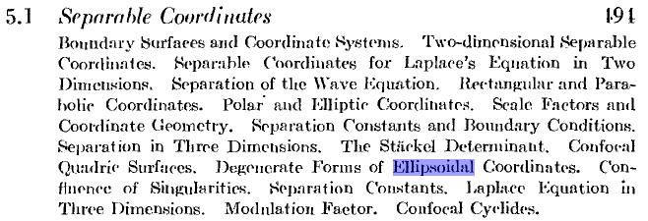

We are in the 3D part of this chapter. We start with this

ξ1 ≥ B ≥ A are the semi-major axes

The ξ1 Coordinate:

The ellipsoid equation is this: x2/(ξ12- a2) + y2/(ξ12- b2) + z2/(ξ12) = 1

Before getting into the M&F text, we are going to have an ellipsoid of this form (below), where ξ1=C≥B≥A are the semi-major axes (we have set a certain c = 0, see later). The variable ξ1 labels an ellipsoid and is also its largest semi axis, and that axis is along the z axis. Here is a picture of this ellipsoid, just to get the ball rolling. We shall always use this choice of x,y,z directions in our drawings: [ the drawing does not well show that ξ1= C > B, but that is the intended situation. ]

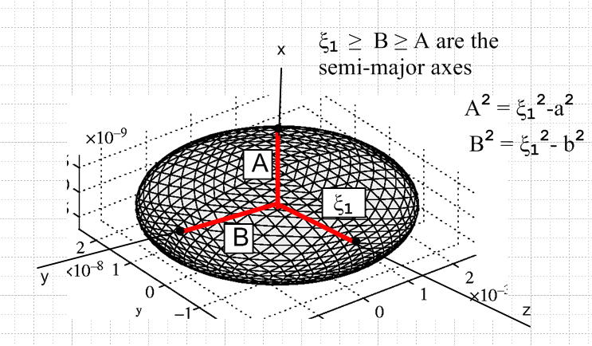

Now, before taking another breath, we need to examine the three ellipses in the x=0, y=0 and z=0 planes:

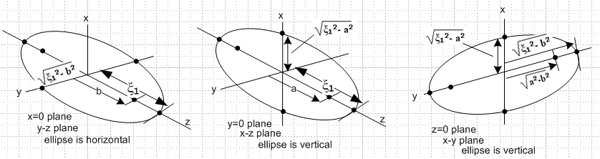

For each case we show the two semi axes and the focal distance. Note that the first two don't have the same focal distance! Here then is the meaning of a and b:

a = focal distance of the y=0 plane vertical ellipse, along the z axis
b = focal distance of the x=0 plane horizontal ellipse , also along the z axis

When you crush the ellipsoid flat by pushing down on the top, the left picture applies, you get A = 0 so ξ1 = a so your ellipsoid is now an ellipse with semi major a, semi minor $\sqrt{a2-b2}$, focus b.. This is the direction we must crush in because we know that A is the shortest semi of the ellipsoid. If you needed to take a stretching limit, you would do that in the z direction.
The above pictures are important because they tell us exactly what a,b and ξ1 mean for an ellipsoid. Usually in a problem we are dealing with an ellipsoid of interest, not one of the other surfaces.

So, now we start in to M&F, knowing ahead of time that ξ1 is the generic ξ below in range ξ ≥ a. Much of the above discussion appears now in M&F's words:

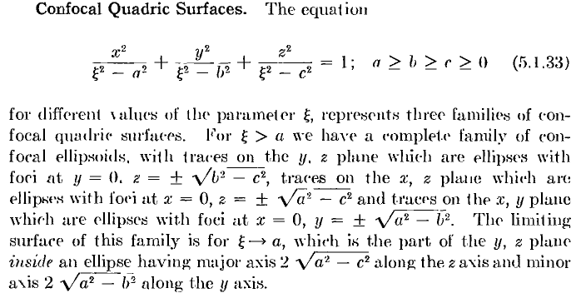

That is a lot to chew! Here ξ is a sort of "generic coordinate" and it appears squared in the equation, different from the wiki picture above. Also, things like a2 here have the opposite sign from wiki. So forget wiki. [ more later ] We want to be thinking a ≥ b ≥c so all the square roots shown are positive. We pick some ξ > a. Notice then that all three denominators are then positive, so we are talking ellipsoid. The x denominator is the smallest, not the usual situation. Now suppose z = 0 so we look in the x-y plane. We obviously have an ellipse and the y direction is largest so A2 = ξ2- b2 and B2= ξ2 - a2 so F2 = a2- b2 which agrees with his "traces on the x,y plane" comment above. As you vary ξ, C is fixed, so the ellipsoids are all "confocal". This is true in all three ri = 0 planes! So this clarifies a little bit the meaning of ellipsoids being "confocal": if the ellipsoids of varying ξ are aligned with the three axes and centered at the origin (always the case), then the projected ellipses in each of the three axis planes form a confocal set of ellipses. A special fancy meaning for "confocal" but pretty clear.
Now consider the last sentence in the quote above. Redefining A,B,C now, write the M&F equation as

x2/A2 + y2/B2 + z2/C2 + = 1

Then as ξ→a, A approaches zero and the ellipsoid is crushed flat into an ellipse in the y-z plane having semi major axis AA2 = C2(ξ=a) = ξ2- c2 = a2-c2 and semi minor axis BB2 = ξ2- b2 = a2-b2, in agreement with the M&F claim stated above. So probably these coordinates will be good for finding the potential of an ellipse, just as oblate spheroidals were good for finding the potential of a disk. So we have that now under our belt (in theory).

Comment: Note please that a,b,c are NOT the semi axes of the ellipsoid, they are just three real parameters. The three semi axes are these (where I now use variable ξ1 since that is what it will be later for the ellipsoid case).

A = $\sqrt{ξ12-a2}$ B = $\sqrt{ξ12-b2}$ C = $\sqrt{ξ12-c2}$

We have four parameters here to describe an ellipsoid that needs only A,B,C to define itself. Below M&F simply set c=0 and then we have

A = $\sqrt{ξ12-a2}$ B = $\sqrt{ξ12-b2}$ C = ξ1

So now ξ1 IS in fact the largest semi axis, and above shows it is in the z direction. You might as well make your label be something useful. Since b is the smaller of a,b, we know that B is the next largest semi axis, and A is the smallest semi axis. So yes, for a given ξ1, those parameters a and b are related to the size of the semi axes, but only as shown.

The ellipsoid equation is this: x2/(ξ12- a2) + y2/(ξ12- b2) + z2/(ξ12) = 1

Comment 11.3.10: If we go to the x=0 plane, we have y2/(ξ12- b2) + z2/(ξ12) = 0 and we see at once that we can interpret ξ1 as the larger semi-major axis of this ellipse. This is also the largest semi-major axis of the ellipsoid.

The ξ2 Coordinate:

The 1-sheet bloid equation is this: - x2/(a2- ξ22) + y2/(ξ22- b2) + z2/(ξ22) = 1

We are now ready for the next large spoonful of M&F soup:

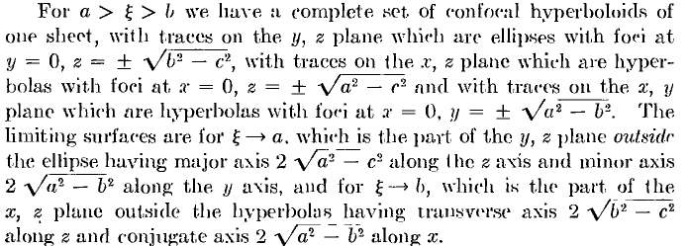

In this range of ξ, what we called A2 above has gone negative, while the other two are still positive. So rewrite as (redefine A again)

- x2/A2 + y2/B2 + z2/C2 = 1 - x2/(a2- ξ2) + y2/( ξ 2- b2)+ z2/(ξ2- c2) = 1

The special axis here is clearly the x axis. I need a picture right now! (paste screen clip into Visio etc)
Notice that if you solve the above for x, you get two x values for each (y,z) value.

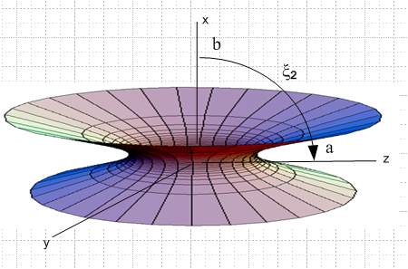 ξ2

The x = constant curves are ellipses longer in the z direction since denominator C > B. In the equatorial plane, we have x = 0 we have just ellipse y2/B2 + z2/C2 = 1 with C > B and C2 - B2 = F2 = b2- c2, just as M&F claim. Obviously the two focal points of this ellipse are on the z axis. If you take a different slice of this thing, say in the y = 0 plane, you have - x2/A2 + z2/C2 = 1 which is a hyperbola.

What about coordinate range? To see, set z=0 and look at hyperbolas. We have b ≤ ξ2≤ a.
If ξ2→ a, the thing goes flat (iris with elliptical hole semis a,b)

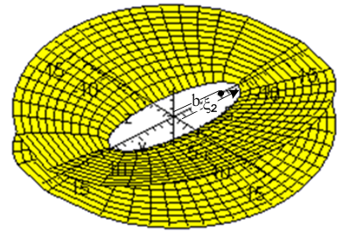

The ξ2→ b+ is less obvious, but may be understood this way. Imagine with our surface - x2/A2 + y2/B2 + z2/C2 = 1 that we take B → 0+. The coefficient of y2 becomes large, so to make the equation still be true, we have to shrink y. The surface basically gets squashed in the y direction. Here is a plot where we are close to this limit

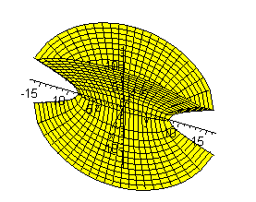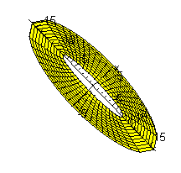
Looking down from the top you still see ellipses, as shown in the right, but they are squashed. I used to think this limit was a elliptical cylindrical tube, that that was wrong.
One final comment: Consider again - x2/A2 + y2/B2 + z2/C2 = 1. What happens if you make the RHS smaller and eventually let it → 0? If you drop it to 1/100, say, that is the same as scaling down A,B and C by a factor of 10. Eventually they are all 0, and - x2/A2 + y2/B2 + z2/C2 = 0 describes an elliptic cone as you find in conical coordinates.

The 1-sheet bloid equation is this: - x2/(a2- ξ22) + y2/(ξ22- b2) + z2/(ξ22) = 1

Comment 11.3.10: If we go to the x=0 plane, we are on the elliptical football field shown in the third picture back, which is the "neck" of the 1-sheet bloid with perimeter y2/(ξ22- b2) + z2/(ξ22) = 0. We see that we can interpret ξ2 as the largest semi-major axis of this neck. It is a distance and I have just added it to the football field picture above.

So I am happy now with the above spoonful. Open wide:

The ξ3 Coordinate:

The 2-sheet bloid equation is this: - x2/(a2- ξ32) - y2/(b2- ξ32) + z2/(ξ32) = 1

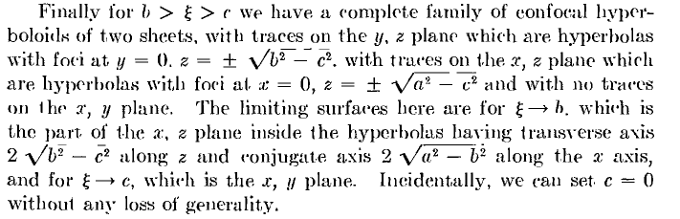

Now we redefine B as well since we have c < ξ < b < a and we have

- x2/A2 - y2/B2 + z2/C2 = 1 - x2/(a2- ξ2) - y2/(b2- ξ2)+ z2/(ξ2- c2) = 1

In this case the z axis seems to be the "symmetry axis" [ but beware, the two sheets are not surfaces of revolution!] and I need another picture. I put the axes here exactly in the same position as in the last picture. Notice that for each (x,y) value, you get two z values. If we set z = 0 we find there are no solutions (x,y), as they say "no traces in the x,y plane". My drawing does not show the fact that these surfaces are not symmetrical in x and y, but they are. We know A > B for ξ in the range for this surface set, so at z = z1, the slice ellipse will be wider in the x direction than the y direction, which is maybe sort of how the picture looks.

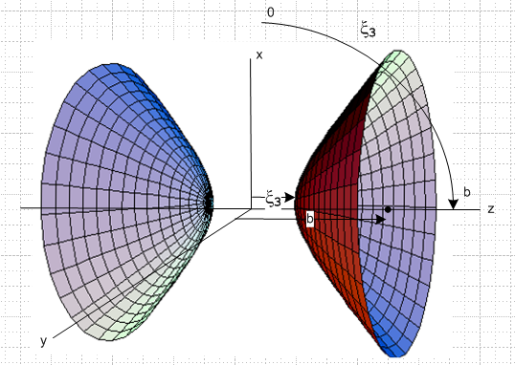 ξ3

Now elsewhere we have to show that for the three ranges of ξ above, the three surface sets are "orthogonal". Assume that for the moment. Set ξ = ξ1 for the first case (ellipsoids) and ξ = ξ2 for the second case (one sheet hyperboloids) and ξ = ξ3 for the two sheet case shown just above. We then know that

x2/( ξ12-a2) + y2/( ξ12- b2)+ z2/(ξ12- c2) = 1 c < b < a < ξ1

- x2/(a2- ξ22) + y2/( ξ22- b2)+ z2/(ξ22- c2) = 1 c < b < ξ2 < a

- x2/(a2- ξ32) - y2/(b2- ξ32)+ z2/(ξ32- c2) = 1 c < ξ3 < b < a

where in each equation, all three denominators are positive.

What about coordinate range? To see, set x=0 and look at hyperbolas. We have 0 ≤ ξ3 ≤ b. Here is the equation with x = 0,

y2/(b2- ξ32)+ z2/(ξ32) = 1

If ξ3→ b, we get two narrow pencil cones tubing out left and right. If ξ3→ 0, the bowls flatten out and go vertical.
As noted for the previous surface, considering - x2/A2 - y2/B2 + z2/C2 = 1, if we were to take the RHS to 0, that is like scaling A,B,C to 0 and our surface becomes a pair of opposed elliptic cones, as one find in conical coordinates.

The 2-sheet bloid equation is this: - x2/(a2- ξ32) - y2/(b2- ξ32) + z2/(ξ32) =1

Comment 11.3.10: If we start at the origin and march in the positive z-axis direction, after a certain distance we will hit the tip of the right sheet of the 2-sheeted bloid. On the z axis we have x=y=0, so we see that we can interpret ξ3 as just this distance! I have just added this distance label to the picture above.

Assembly of the three surfaces.

If we combine the above three surfaces, we get a picture I stole from Wolfram and then edited:

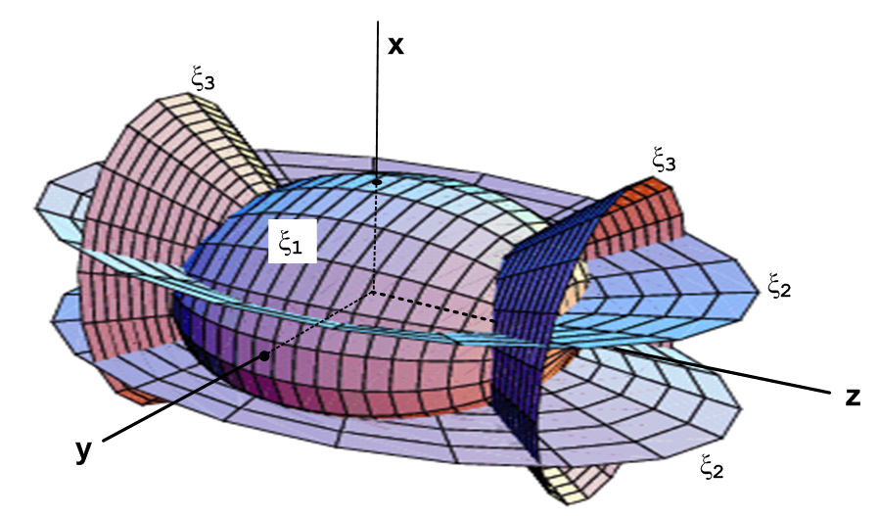
This picture should make perfect sense to the reader who has paid attention to this point.

How do ξi ranges relate to the picture? Gathering from above:

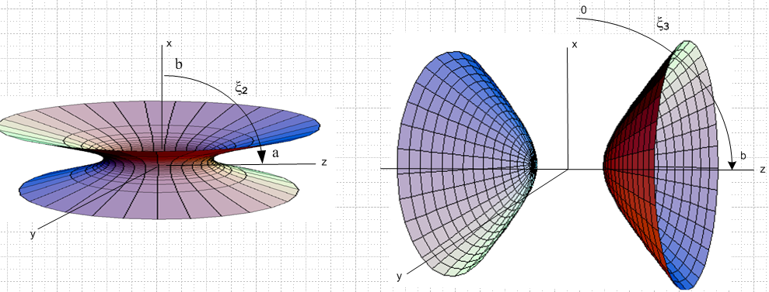

The y=0 plane slice.

Let's look at a slice of this 3D drawing which is the y=0 plane, where C = ξ2 and A2 = a2 - ξ22 and tan(φ) = A/C = $\sqrt{a2- ξ22}$ / ξ2 . However, my slice will have the ξ3 surfaces coned down more than shown above. You can see the angles φ shown in the picture. The inscribed box idea is from Schaum p 39 where asymptotes run through the corners and hyperbola touches the edges. Vary ξ2 and you vary C and A so blue curve moves, but stay confocal with focal distance a.
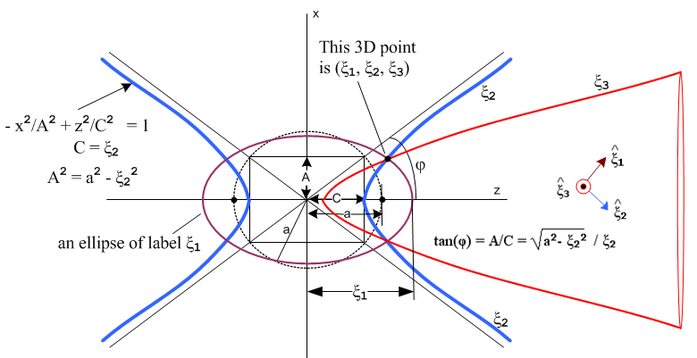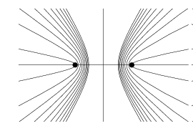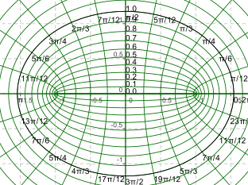

The main point of the above complicated drawing is to show the ξ2 one-sheet projected hyperbolas which are blue. As we vary ξ2, we vary the angle φ. Since b ≤ ξ2 ≤ a, the angle φ can get as small as 0 (blue sheet becomes the yz plane with elliptical hole in center). But the largest the angle can be is tanφ = $\sqrt{a2- b2}$ / b. The lower right drawing shows various values of φ, and the left one just shows a nice family of confocal hyperbolas.

NOW there is more to say. I show in purple one of the ellipsoids which will have normal 1 as drawn on the right. As we change ξ2, we move in the 2 direction as shown. In red I show one of the ξ3 hyperbolas in the y=0 plane. A block dot shows a place where all three of these surfaces (purple ξ1, blue ξ2, red ξ3) intersect at a certain dotted 3D point. The mystery issue is how we can have 3 be perp to these other two vectors (since we know they must all be orthogonal, just like our friends ). We have to imagine our dotted point to be some small ε toward the viewer, out of the plane of paper. Then the red surface is a highly crushed chili pepper that is nearly flat. So as you change ξ3 moving this surface, the point moves toward the viewer. It took me a long time to get that understood. Basically on the y=0 plane the red hyperboloid is singular and is crushed completely flat.

The reader should now ponder how the above drawing is the y=0 slice of the following general drawing, where I tried to use the same colors for things. Of course the ξ3 surface shown below is not the right one, we have to crush it into the y=0 plane and also cone it down so it goes inside the blue hyperboloid.

B. How to Obtain Cartesian Coordinates from Ellipsoidal Coordinates

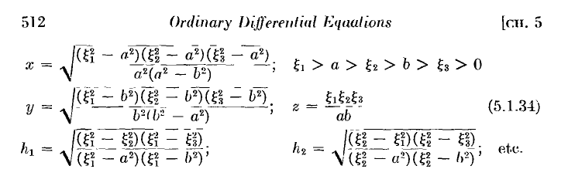

where z has a very simple form. These equations give (x,y,z) in the first octant only which is fine. Oddly he shows only two of the three metric tensor Qi factors [ MM: dsk = Qk dqk = $\sqrt{Gkk}$ dqk ]

Note that c is gone because we set it to 0 as commented on above.

Rewrite the above Cartesian coordinate expressions in a form where each (..) is positive:

x = (1/a) $\sqrt{(ξ12 - a2) (a2 - ξ22) (a2 - ξ32) / (a2- b2)}$
y = (1/b) $\sqrt{(ξ12 - b2) (ξ22-b2) (b2 - ξ32) / (a2- b2)}$
z = ξ1ξ2ξ3 / ab

Note: if you take the limit ξ1→ ∞, I have verified that the above gives x2 + y2+ z2 = ξ12 , that is, ξ1 → r.

At this point M&F fit this into the Stackel determinant business which I have not yet studied (and will try to avoid studying if possible). But here are two important conclusions they reach on page 512

[ Where do the above equations come from? See "where do..." doc. It is just Cramer's rule applied to the three conicoid surface equations. ]

C. Statement of the Helmholtz (Laplace if k1=0) Equation in Ellipsoidal Coordinates

(1) The Helmholtz equation (∇2 + k12)ψ = 0 has this form: [ there should be a minus sign before the large Σ symbol on the left, a MF typo, see Sections X and Ybelow for details on this and also how the separation works. ]

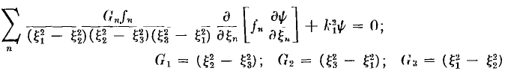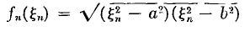
and of course we set k1= 0 for the Laplace equation we are eventually heading for here. Rewrite

Σn [Gn/ (G1G2G3)] fn ∂n (fn∂nψ) + k12ψ = 0 G1 = ξ22- ξ32 etc and fn2= (ξn2-a2) (ξn2-b2)

D. Statement of the Separated Equations in Ellipsoidal Coordinates

(2) If you try ψ = X1(ξ1) X2(ξ2) X3(ξ3), then you get a separated equation for each function,

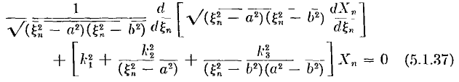

The numbers k2 and k3 are separation constants (not components of some vector k ). Notice that only variable ξn is appearing in this equation for Xn(ξn) . Right now I have no idea whatsoever on how one would find these separation constants in a given problem, or what might quantize them etc. But at least M&F have "done the math" for me (which I can check later, see Section Y below! ). I am, after all, exactly interested in doing the separation for my charged ellipsoid problem. I could try it right now, but let's hold just a bit.

E. The connection between M&F Ellipsoidal Coordinates and Wolfram Ellipsoidal
___________________________________________________________________________

Question: Why do the Wolfram inversion equations look so different from the M&F ones?
In the M&F world the quadric equations were this: ( we allow c ≠ 0 for now)
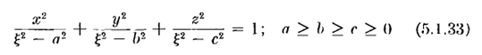
where we set the generic variable ξ = ξ1, ξ2, ξ3 for the three regions ξ1 ≥ a ≥ ξ2≥ b ≥ ξ3≥ c ≥ 0 . Note that if we go below c, all three denoms are neg and we are back to the ellipsoid. The meaning of the three constants a,b,c is that a2- c2 = fxz2 and b2- c2 = fyz2 , a2- b2 = fxy2, where the f are the focal distances of the three aligned slices of the ellipsoid, as illustrated above by me. The semi-majors are A2 = ξ12- c2 for the largest, and C2= ξ12- a2 for the smallest and B2= ξ22- b2 for the middle.
In the Wolfram world (let's prime everything here) we have ( I deduce the ordering of the sizes of the parameters from the inequality statement which the W site goes give)

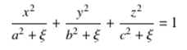 with c' ≥ b' ≥ a' which is the reverse of M&F!

where the generic variable ξ = ξ', η', ζ' with ranges -a'2 ≤ ζ' ≤ -b'2 ≤ η' ≤ -c'2 ≤ ξ' ≤ +∞. Notice the strange arrangement that variables η' and ζ' are always negative, while ξ' can have both signs, something I certainly don't like much. We can see the connection is this:

ξ12 - a2 = a'2 + ξ' ξ12 = ξ' + a'2 + a2 ξ' = ξ12 – a'2 - a2
ξ22 - b2 = b'2 + η' ξ22 = η' + b'2 + b2 η' = ξ22 – b'2 - b2
ξ32 - c2 = c'2 + ζ' ξ32 = ζ' + c'2 + c2 ζ' = ξ32 – c'2 - c2

Suppose someone hands me a Wolfram system ξ', η', ζ', a', b', c'. I could construct an M&F system such that the following equations were true for any positive C2 ≥ c'2 I wanted, [ I would set a,b,c as in the middle column here ]

a'2 + a2 = C2 a2 = C2 - a'2 => ξ12 = ξ' + C2
b'2 + b2 = C2 b2 = C2 - b'2 => ξ22 = η' + C2
c'2 + c2 = C2 c2 = C2 - c'2 => ξ32 = ζ' + C2

At the extreme, I could choose C = c' and then have

a2 = c'2 - a'2 => ξ12 = ξ' + c'2 ξ' = ξ12 – c'2
b2 = c'2 - b'2 => ξ22 = η' + c'2 η' = ξ22 – c'2
c2 = c'2 - c'2 = 0 => => ξ32 = ζ' + c'2 ζ' = ξ32 – c'2

Then my "usual" M&F system (having c = 0) is related to the arbitrary Wolfram system by a constant shift of all three variables! In what follows, unfortunately I have primes on M&F and no primes on Wolf , but apart from that, the conclusion is the same.

Older section of notes: First, here are the Wolfram equations:

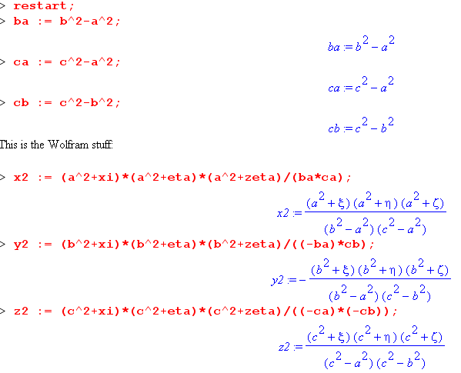
which agrees with what I have quoted above (imagine everything with primes on it)
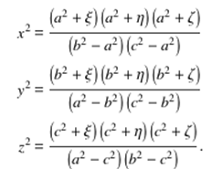

Now the symbols a,b,c are the "Wolfram symbols". Let's then define

c2 + ξ ≡ ξ12
c2 + η ≡ ξ22
c2 + ξ ≡ ξ32

c2- a2 ≡ (a')2
c2- b2 ≡ (b')2

Visually we can see at once that z2 = ξ12 ξ22 ξ32 / [(a')2(b')2] or z = ξ1 ξ2 ξ3 / [(a')(b')] which is the desired M&F form (and why I made these definitions of course). So let Maple compute this all out:

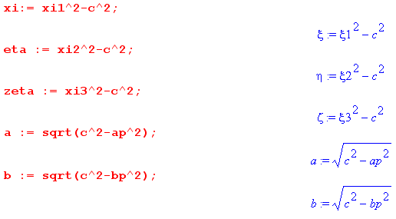
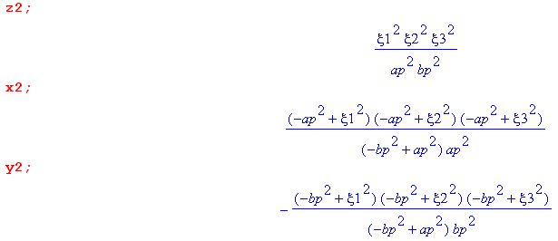

which we compare now to the M&F forms above

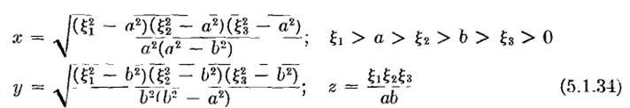

and the agreement is exact where we interpret a' as the "Morse and Feshbach a".

So, given the M&F coordinates ξ1ξ2ξ3 with a'b'c' , here is how you get the Wolfram ones:

ξ ≡ ξ12 - c2
η ≡ ξ22 - c2
ξ ≡ ξ32 - c2

a2 = c2 - (a')2
b2 = c2 - (b')2
c2 = (c')2

Now that this mystery is cleared up, let's forget about the Wolfram coordinates. [ Of course you have to worry about the correct ranges for the Wolfram coordinates, etc etc. ] The Wolfram picture still applies to the M&F case. You can see that the parameters are just "translated" by -c2 and not squared.
___________________________________________________________________________

E1. The Byerly Coordinates compared to M&F ones.

Again, here is the M&F situation
and here is the Byerly situation
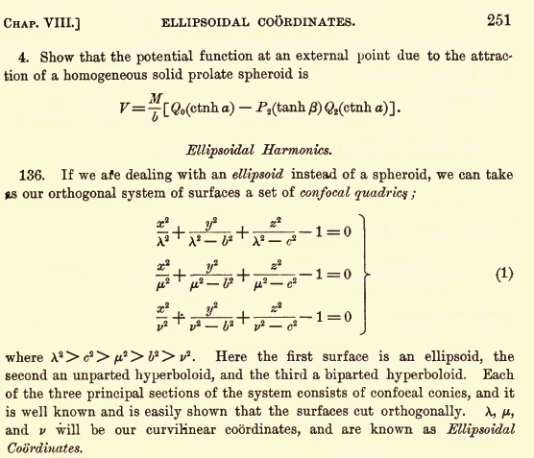

In Byerly the constants have the ordering c' ≥ b' ≥a' and he has set a' = 0. ( Imagine all the Byerly constants above are primed. So for Byerly, it is the x-axis of the ellipsoid which has the longest semi major axis which equals the coordinate λ (whereas in M&F it is the z-axis and its semi is ξ1). To make the equations align as stated, we must have

λ2= ξ2- a2 => λ2= ξ2- a2
λ2 - b'2= ξ2- b2 => λ2= ξ2- b2 + b'2
λ2 - c'2 = ξ2- c2 => λ2= ξ2- c2 + c'2

which tells us that we need

a2 = b2 - b'2 = c2 - c'2

So if we are handed a Byerly system a',b',c' we can try to construct an M&F system like this:

c2 = c'2 + C2 so that c2 - c'2 = C2
so b2 = b'2 + C2
a2 = C2
But then we get c > a which is wrong for M&F. The obvious correct connection is this:

Byerly M&F
x z
λ ξ1
y y
μ ξ2
z x
ν ξ3
c a
a c
b b

So the first point is that Byerly's variables λ,μ,ν are NOT the same as M&F's tricky ones. BUT, Byerly does go on to develop those tricky ones and he calls then α,β,γ :

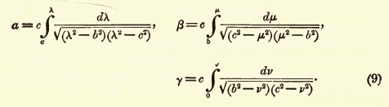
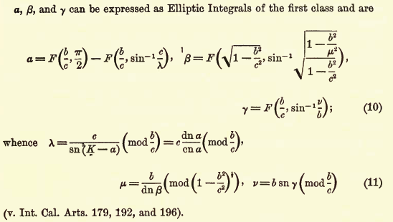

And here you see the dn and cn functions that M&F talk about.

F. Comments on the Remainder of M&F Chap 5 on ODE's

Now we shall let M&F wrap up their discussion with more spoonfuls:

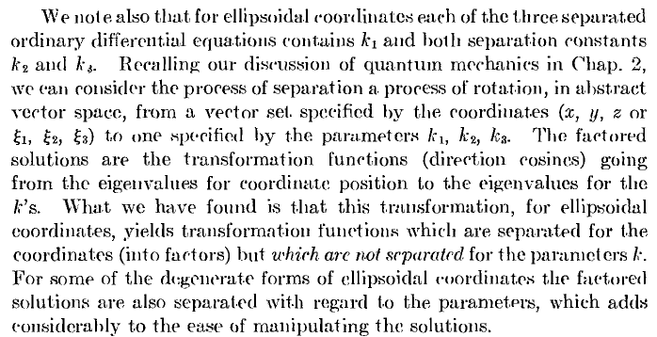

First, I think he is saying that in coordinate space, we have ψ( ξ1, ξ2, ξ3) = X1(ξ1) X2(ξ2) X3(ξ3) and we can think of this as we think of f(r,θ,φ) = R(r) Θ(θ) Φ(φ) and we end up doing a transform of each of these functions onto the appropriate set of eigenfunctions for the problem, like Rl(r) Plm(cosθ) e±imφ and then this serves as a building block for constructing solutions. For Helmholtz in spherical these are different functions, but the same idea. In Laplace, we transform from (r,θ,φ) to (l,m), the space of separation constant values. The "direction cosine" comment refers to <θφ|lm> = Ylm(θ,φ) like • in E3. The last comment just points out that the separation constants k2, k3 appear in all three equations for Xn as you see above, so not as nice as the situation for Φ(φ) where only m appears by itself. But it is true that in the Θ(θ) equation we do get both l and m appearing, so not too dissimilar for what we have with the ξi. M&F sort of include the Helmholtz k1 with the other k's in their paragraph which I guess is fine. I think k1 would be a further separation constant if we included the time coordinate, etc etc.

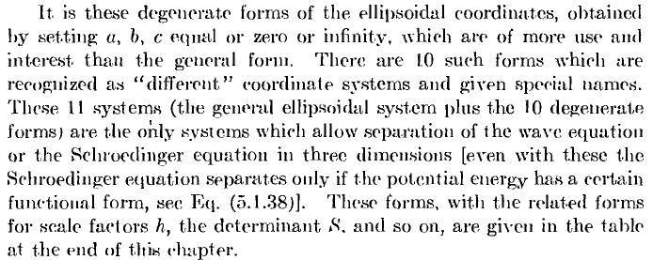

Don't miss the point made here, namely, that ellipsoidal coordinates are the mother of all coordinate systems. Here for example is how you get from ellipsoidal to spheroidal oblate:

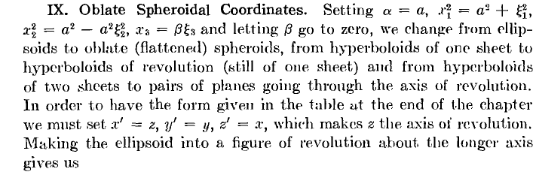

In other words, our new coordinates will be (x1, x2, x3) as shown. When he says β→0, he really means of course that ξ3→∞ which means the two-sheet hyperboloid becomes the φ = constant plane. He also implies that b = a, should have said that. This paragraph is not very clear to me, but I am sure I could nail it down if I wanted (I don't want). [ see later-written notes morphing ellipsoidal coordinates.doc ]

Beyond this point, still in M&F Section 5.1, M&F has a lot of other things to say. They go on in Section 5.2 to talk about how you go on to solve the separated equations, all in fully general terms. We are talking second order ODE's here with the specific functions a(x), b(x) c(x) or maybe p(x) and q(x) as shown above. I don't want to digress on this right now, I hope I can get along without it. The topics that come up are what you would expect: Wronskians of independent solutions, power series, ordinary and singular points (regular and irregular), the indicial equation(s), recursion formulas, connection to hypergeometric, Mathieu functions, all the special functions in fact -- lots of pages, this is a whole COURSE on ODE's, still in Section 5.2. [ Well, I now see that the title of Chapter 5 is in fact "ODEs", 155 pages long. ] It is like the general "theory section" you would like to see in front of Bateman's chapters, so this stuff is very valuable. Many times I was looking for exactly this kind of information, and here it is -- but today is not the day. This chapter ends with a whopping 40 problems, and THEN comes the appendix on coordinate systems. I will paste here the page for ellipsoidals:

G. Summary Page on Ellipsoidal Coordinates

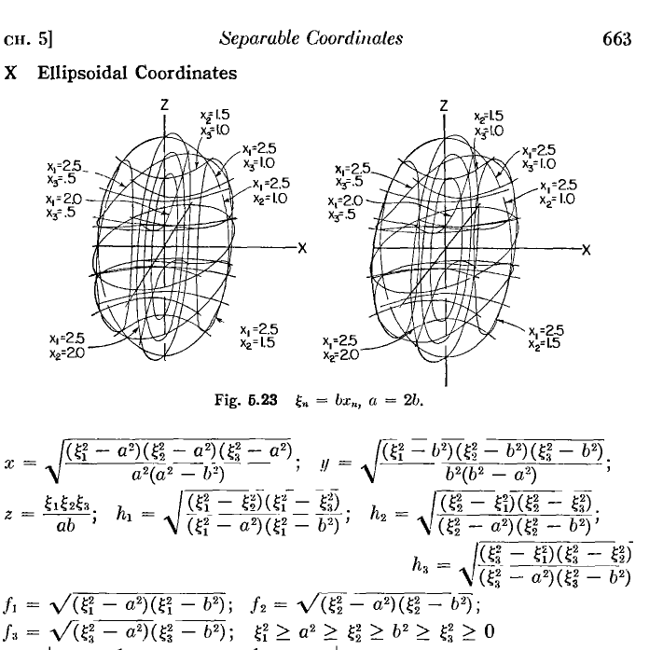

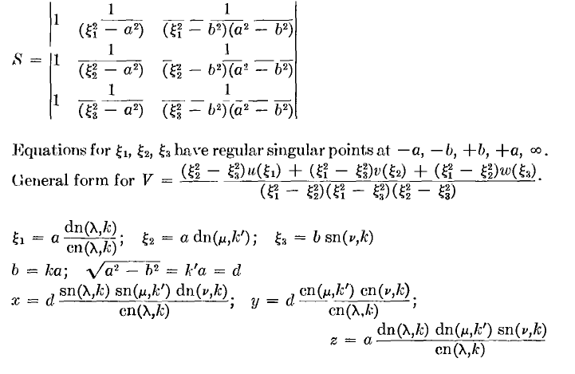
Comments on the above below, but first:
And here I will throw in the general vector operator summary from Vol I p 138 (orthogonals)

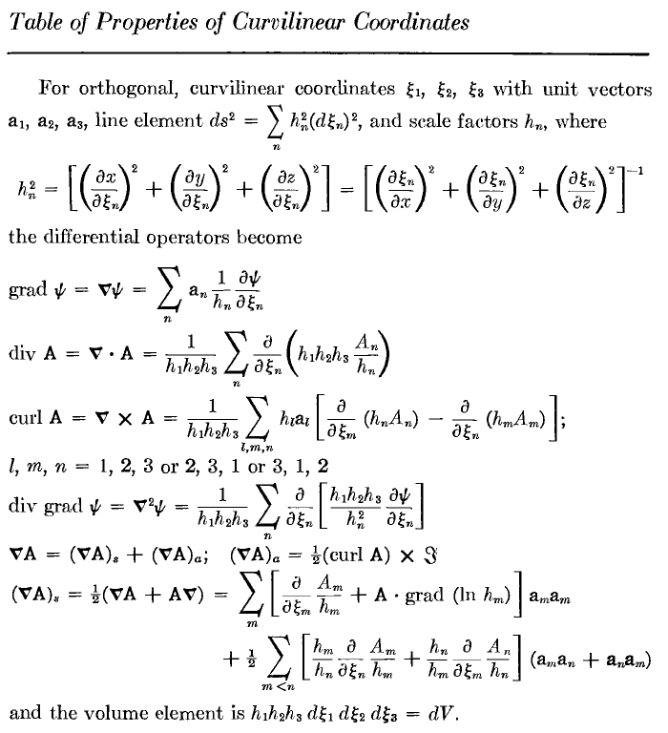
Comments on the above: S is that Stackel determinant he talks about in the general formalism for separable coordinates. The "general form for V" refers to the form the potential V must have in the SE for things to separate! So this has nothing to do with my current problem. Then at the end he is saying you can reparameterize ξ1 ξ2 ξ3 into variables (λ, μ, ν) where k = b/a and k' having the usual relation to k which I remember from my elliptic functions paper. Then you can express x,y,z in terms of the Jacobi elliptic functions as shown. So now the ellipsoids are constant λ surfaces. He never said anything about this alternate form in the text that I read. You do get the feeling that "elliptic functions" are going to be involved in solutions to problems in this coordinate system! [The fi functions are shown a few pages above. ]

I think I have now "extracted" all the ellipsoidal stuff there was in Chapter 5, let's move on.

M&F on Ellipsoidal Coordinates: Chapter 10 only

The next area of ellipsoidal interest is here in Volume II :

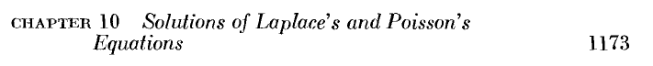
and in particular

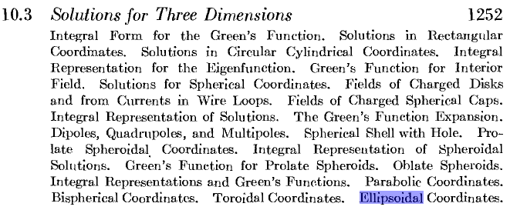

This certainly sounds up my alley today! Now ready for what I started above: ( p 1304)

H. Statement of the ODE for Separated Functions in Ellipsoidals: Lamé Equation

Note: p 511 and 663 are what I looked at above. Notice, by the way, direct page number references, one of my complaints about Stakgold. Also, page numbers continue up through both volumes, also unlike Stakgold. Next: [ maybe the left-side radicals are those fi functions above]

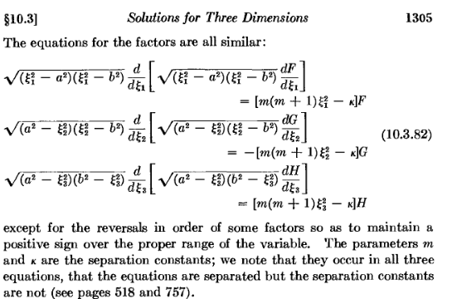

Let's derive these things. Our ODE above [ 5.1.37] was this fn2= (ξn2-a2) (ξn2-b2)

(1/fn) ∂n [ fn (∂n Xn(ξn)) ] + [ k12 + k22/(ξn2-a2) + k32/ [(ξn2-b2)(a2- b2)] Xn(ξn) = 0

Multiply through by fn2 to get

fn ∂n [ fn (∂n Xn(ξn)) ] + fn[ k12 + k22/(ξn2-a2) + k32/ [(ξn2-b2)(a2- b2)] Xn(ξn) = 0

fn ∂n [ fn (∂n Xn(ξn)) ]

+ [(ξn2-a2) (ξn2-b2)k12 + k22 (ξn2-b2) + k32(ξn2-a2) / (a2- b2)] Xn(ξn) = 0

Now assume Laplace equation so k1 = 0, then have

fn ∂n [ fn (∂n Xn(ξn)) ] + [k22 (ξn2-b2) + k32(ξn2-a2) / (a2- b2)] Xn(ξn) = 0

fn ∂n [ fn (∂n Xn(ξn)) ] + [ {k22 + (k32 /(a2- b2)} ξn2 - {k22 b2 + k32 a2/(a2- b2) } ] Xn(ξn) = 0

fn ∂n [ fn (∂n Xn(ξn)) ] + [ {– m(m+1)} ξn2 – {-κ} ] Xn(ξn) = 0

where we have replaced k2 and k3 with constants m(m+1) and κ as shown. All three equations are the SAME! However, in the mid range for ξ2 each fn makes a factor of i, so two factors makes a -1, and that is why the sign is different as shown above for the ξ2 equation.

– m(m+1) = k22 + (k32 /(a2- b2) -κ = k22 b2 + k32 a2/(a2- b2)

Compare these equations to earlier

We have k1 = 0 since Laplace and not Helmholtz. They have then multiplied through by the radical on the left, and have regrouped into new separation constants m and κ, just arbitrary real numbers at this point. And yes, factors arranged so all are positive for their respective variable. So far so good!

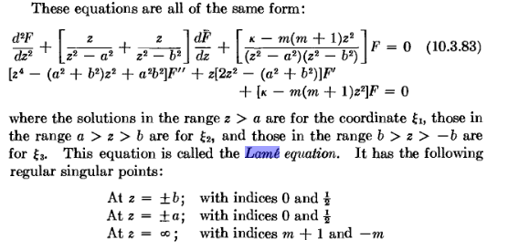
Very good! The ODE for each coordinate is the SAME! It's just that the legal range of the three variables (now called z) is different. The Lamé Equation front and center! Standard 2nd ODE form, you see the functions: a 4th, 3rd and 2nd degree poly in z. [ Notice that the big radicals are gone when you do the product derivatives in the first form above. ]

[Lamé is not in Schaum. In A&S Lamé is mentioned on page 641 only in passing, in a chapter on the Weierstrass elliptical functions, I think it is related to the Weierstrass P function and the world of elliptical functions. [ Bateman Vol 3 has a good Lamé chapter, but I did not have this volume when I was writing this doc.] . Even W&W have little to say, but they do point out that Lamé is a certain limit of a very general ODE that in fact encompasses all ODE's of physics that have 5 regular singular points or some such. Both W&W and M&F have presentations on the theory of ODE's which I have only disjointed pieces of in my ODE notes. Another loose end in the Phil world. ] Wang and Guo have a good section on Lame (google books only with pages missing). I now see that in 4th edition of WW "course in modern analysis) they added one more chapter XXIII which my 2nd edition does not have, and it is exactly on Lame functions!!!! Ouch. BUT, I just found it in djv on the 4shared site, coming in now. The 4th ed is 1927 and last reprinting was in 1990. I think Lame got added in the 3rd edition

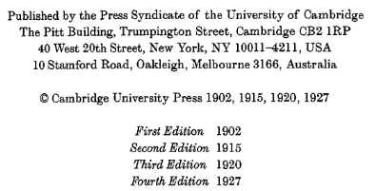

So I now have that extra chapter. They use the word "species". This is a long chapter and surely has everything you ever wanted to know about Lamé functions and the various ODE's and the connection to the Weierstrass P function and so on. So if I need it, I have it.

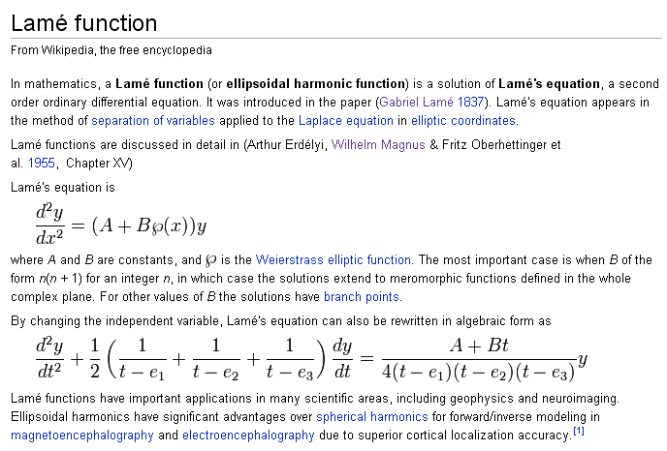

I have searched the web for a while on Lamé functions and there is not much out there. At least Wolfram has something that agrees with M&F. Hobson has the real book, 1931 and later edition. Courant Hilbert vol 1 has a little on Lame. Wolfram quotes a Byerly 1959 Dover book which I may have found. The actual book is 1893 and I now have it! It explains everything. Here are the Byerly separated equations compared to M&F. Translation: a,b→b,c and ξ1, ξ1

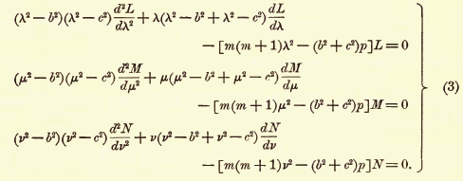

where I presume that M&F's a,b → b,c and ξ1, ξ2, ξ3 → λ,μ,ν and then κ → (b2 + c2) p and this p is the label on the functions! In M&F language, that means κ = (a2+ b2)p.
Here is a big point: if you think about the spherical situation, we have Rl(r)Plm(cosθ)e±imφ and only one of the three product functions carries both separation constants. In ellipsoidal, each of the three product functions carries both constants as labels! And each function as we shall see can come in a first or second kind with the same two labels, these being the two independent solutions of an ODE, sort of like Plm and Qlm . So a general solution term is something like this:

[ Amp Emp(ξ1) + Bmp Fmp(ξ1)] [ A'mp Emp(ξ2) + B'mp Fmp(ξ2)] [ A''mp Emp(ξ3) + B''mp Fmp(ξ3)]

and here is a form which is a special case of the above

Gmp(ξ1) Gmp(ξ2) Gmp(ξ3) where G is either E or F.
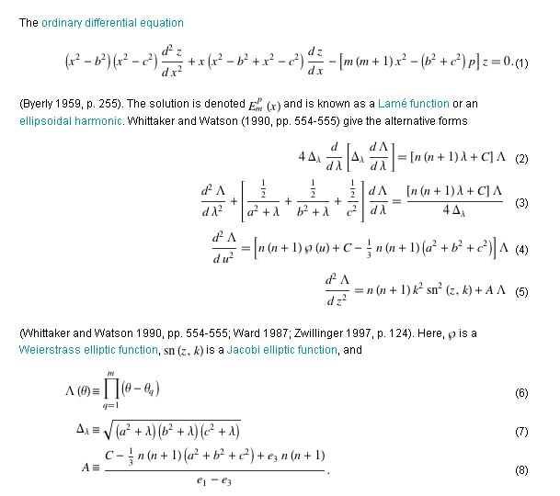

They also talk about the first and second kind functions as done below.

I. Series Solutions to the Lamé Equation at z=0

There are 5 regular singular points, as shown. From my "ode1" notes, I am reminded that these are points where the coefficient functions are not analytic, and you see clearly in the first form above that this occurs when z = ±a, ±b. The z=∞ point always requires a little more work. I am guessing that the "indices" shown above are those of the indicial equation when you expand around the singular point in question. Recall this theorem,

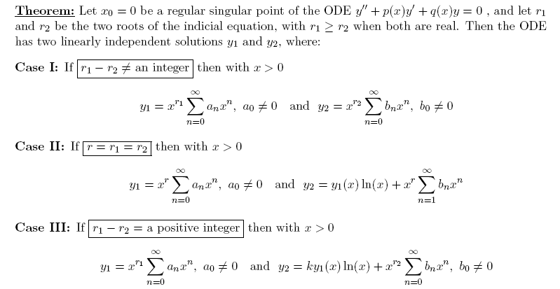

So at the first four singular points, I think you get two Case I solutions where one will have a square root branch point. You have to replace x → (x - x0) in the above, where x0 is the regular singular point. But for the last singular point, I guess we get case III and we have a normal and a log solution present.
So, M&F consider a series solution of the above equation about the point z = 0. I am not sure they really mean 0, or mean you are supposed to make the replacement I just show. This seems the natural place to start if you are just shopping around looking for Lamé equation solutions. Try Σndnzn, the recursor breaks into the even and odd power coefficients as I am used to seeing.
Suppose you could find a solution f(z) = Σndnzn that converges for all z in (0,∞). Then you would have found a Laplace solution of the form u(ξ) = f(ξ1) f(ξ2) f(ξ3), because the range of each variable lies in the range (0,∞). Now M&F go on to show (I am not pasting all the text now) that for general values of the separation constants, κ and m, you cannot find a viable f(x) with this property, so you cannot write such a simple triple product for your solution. The reason is that in one of the ranges (probably the high range) the series diverges.

J. Simple First-Kind Solutions to the Lamé Equation for m = 0,1,2 : functions Epm(z)

But for m = integers, there appear to be functions f(x) that work! Here are two such f(x) solutions:
[ notice that the second link where κ = a2 + b2 means p = 1, the label. ]

The function notation here seems to be Esm where I think the upper index is something else I don't yet know about. So our solutions here are

E00(ξ1) E00(ξ2) E00(ξ3) = 1 * 1 * 1 = 1 m = 0 κ = 0

E10(ξ1) E10(ξ2) E10(ξ3) = ξ1 ξ2 ξ3 = abz ~ z m=1 κ = a2+b2

so these are certainly two admirably simple Lamé solutions.
He next examines m = 2 and finds the following slightly more complicated solutions

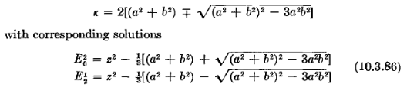

I suspect the upper one should be E20 since m = 2, a typo? I could find no M&F errata on the web, nor does that word appear in either volume.
Now doing a certain trick, M&F come up with some more simple solutions, for m = 1 and 2

So we can try these to get [ I am just looking back at our x,y,z equations above ]

E11(ξ1) E11(ξ2) E11(ξ3) = $\sqrt{ξ12- a2}$ * $\sqrt{ξ22- a2}$ * $\sqrt{ξ32- a2}$ = x a $\sqrt{a2-b2}$ ~ x
E22(ξ1) E22(ξ2) E22(ξ3) = ξ1 $\sqrt{ξ12- a2}$ * ξ2 $\sqrt{ξ22- a2}$ * ξ3 $\sqrt{ξ32- a2}$ = x a $\sqrt{a2-b2}$abz ~ xz

Swapping in b for a, there are two more

which I presume would lead to y in place of x in the triple products and a↔b.

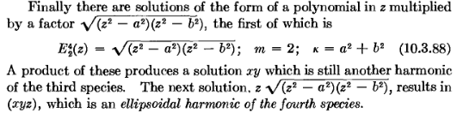

The term "nth species" must have some historic source. These functions are some of the "ellipsoidal harmonics".

K. Second-Kind Solutions to the Lamé Equation for m = 0,1,2 : functions Fpm(z)

All of the above solutions blow up at large z, so we want to see some second kind functions as well. To this end, M&F quote a result developed earlier which I will try to summarize here. First, p and q are defined by (and then I show Lame)
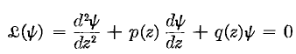

Then here is the little theorem:

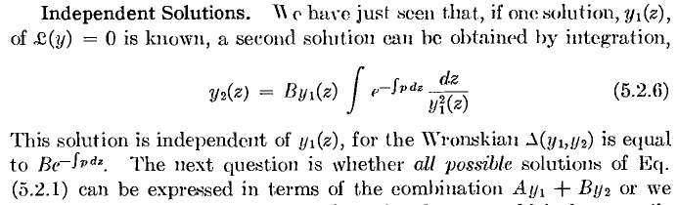

We can see p(z) sitting there in Lame, so let Maple take a spin,

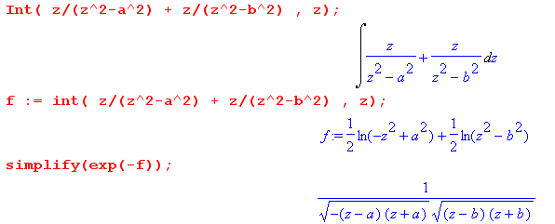

This then confirms his next claim which is

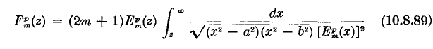
where z is the lower endpoint I guess arbitrarily. [ This endpoint location certainly suggests that F(∞) = 0] Now he is making clear that the lower index is always m, and the upper is just some mysterious "p". The (2m+1) is of course arbitrary. It is not obvious to me that these decay at large z, but I suspect it is true. So we can stick all our solutions found so far into this thing and generate corresponding second kind solutions. In particular,

L. The Potential of a Charged Metal Ellipsoid

Now stand back, because all of sudden he is giving me the solution to my problem:

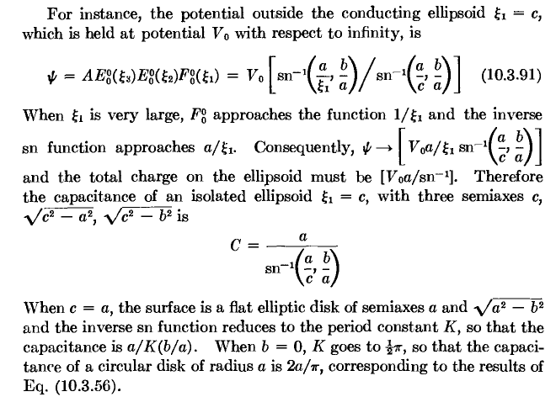

So here it is! Some comments are definitely needed here. First, leave sn-1 as is and just try to follow what they are saying.

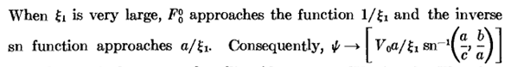

He is just saying the limit of the sn-1 is a/ξ1 so you get this form as ξ1 → ∞, therefore V(∞) = 0 so we can forget about that side of ΔV for our capacitor. Next,

Where is this coming from?? Well, recall that ξ1 is the semi-major large axis of our ellipsoid ξ1 = C. For large ξ1 this is the radius of the sphere! The charge looks like a point charge, so ψ = Q/r and we read off that Q = V0a /sn-1, got it. Then Q = CΔV so C = Q/ΔV = Q/V0 = V0a /sn-1 / V0 = a / sn-1, got it. The flat ellipse disk limit was ξ1 = a from earlier in this doc, and we get sn-1(1,b/a) which he says is K. And then he takes that ellipse to the circle. So here is everything you ever wanted to know about this problem!!!
Now if I look at my own doc on elliptical integrals, I would say

sn-1(x,k) = G(x,k) = $\int_{0}^{x}{}$ dt $\sqrt{(1-t2)(1-k2t2)}$

But now if we want to relate this to other people's stuff, we need my other results which are

• So the A&S trick to distinguish how things are parameterized is to say this:

F(φ,k) = F(φ|m) = F(φ\α) k = sinα m = k2

F(φ,k) ≡ G(sinφ, k) => G(x,k) = F(sin-1x,k)

Therefore

sn-1(x,k) = G(x,k) = F(sin-1x,k) = F(sin-1x | m) = F(sin-1x \ α) k = sinα m = k2

and we have this special case

sn-1(1,k) = G(1,k) = F(π/2,k) = F(π/2 | m) = F(π/2\ α) = K(k) k = sinα m = k2

so I can now write the solution in terms of F functions that make me feel better

ψ(ξ1, ξ2, ξ3) = ψ(ξ1) = V0 F[sin-1(a/ξ1),k=b/a] / F[sin-1(a/c),k=b/a]

where ellipsoid holding the charge has largest semi axis = c. The other two axis semis are

A = $\sqrt{ξ12-a2}$ B = $\sqrt{ξ12-b2}$ C = ξ1 = c
smallest middle largest

A = $\sqrt{c2-a2}$ B = $\sqrt{c2-b2}$ C = c
smallest middle largest

So if someone asks you for the potential of an ellipsoid C,B,A (large to small), you compute c,b,a and stick them into the above formula.
How do we know this is the solution to our problem? It meets our BC, and it solves Laplace, and vanishes at ∞ (the other part of the Dirichlet boundary). Case closed.

So I think this is Kelvin's result, and I need to go recheck why I thought it was wrong!

M. The alternate ellipsoidal coordinates (λ,μ,ν) and Jacobi function connection to (ξ1,ξ2,ξ3)

But while we are here, let's finish out the M&F section. He says we can "change variables"

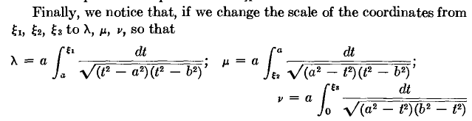

to λ,μ,ν (which appear on that summary page pasted above). Now recall from above

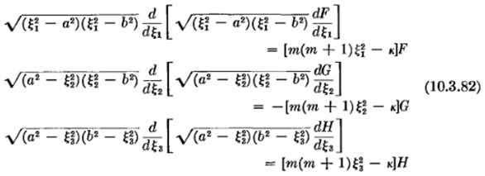

The claim is that the variable change clears out all the radicals, and the equations become

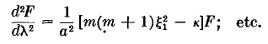

where now each equation has both ξi AND its transformed variable, which is a bit ugly. The three equations are different because the new variables are different (he fails to write the other two equations). He says that by studying this equation, you can somehow find the inverse transform

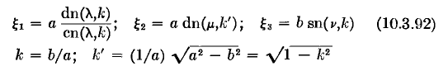

which result I will just have to "take on faith", and it does appear on the summary page. Here then is the last paragraph of Chapter 10:

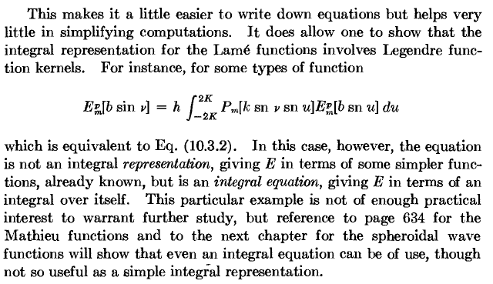

N. Comparison of the M&F Solution of the Charged Ellipsoid to the solution of Kelvin

1. Here is the M&F solution, copied from above: the variable is ξ1

ψ(ξ1, ξ2, ξ3) = ψ(ξ1) = V0 F[sin-1(a/ξ1),k=b/a] / F[sin-1(a/c),k=b/a]

and here are the semi axes of the ellipses which are confocal to the one at ξ1 = c

A = $\sqrt{ξ12-a2}$ B = $\sqrt{ξ12-b2}$ C = ξ1 = c
smallest middle largest

A = $\sqrt{c2-a2}$ B = $\sqrt{c2-b2}$ C = c
smallest middle largest

2. Here is the Kelvin solution, copied from my "Kelvin paper parsing.doc":

v(φ) = v1 F(φ,c')/F(φ1,c') where a = f csc(φ) sinφ = (f/a) φ = sin-1(f/a)

f 2 = a12-b12 = a2-b2 these are the focal distances of the two extremal ellipses
g 2 = a12-c12 = a2-c2
c' = g/f
φ1 = csc-1(a1/f)
φ = csc-1(a/f) cscφ = (a/f) cosφ = $\sqrt{1 - (f/a)2}$
sinφ = (f/a) secφ = 1/$\sqrt{1 - (f/a)2}$ tanφ = (f/a)/ $\sqrt{1 - (f/a)2}$

In the Kelvin solution the quantities like a,b are semis, not focal distances as in the M&F solution. And a is the largest semi axis and it acts as the variable here, φ = csc-1(a/f).

3. Reconciliation. Let's first start with the M&F solution and write it in terms of the semi axes which are A,B,C where C is the largest and A the smallest:

a = $\sqrt{c2-A2}$ b = $\sqrt{c2-A2}$ c = C = ξ1

ψ(C1) = V0 F[sin-1($\sqrt{C2-A2}$/C1),k=$\sqrt{C2-B2}$/$\sqrt{C2-A2}$] / F[sin-1($\sqrt{C2-A2}$/ C),k=$\sqrt{C2-B2}$/$\sqrt{C2-A2}$]

Now let's change floats as follows

A → c the smallest semi
B → b the middle semi
C → a the largest semi

ψ(a1) = V0 F[sin-1($\sqrt{a2-c2}$/a1),k=$\sqrt{a2-b2}$/$\sqrt{a2-c2}$] / F[sin-1($\sqrt{a2-c2}$/ a),k=$\sqrt{a2-b2}$/$\sqrt{a2-c2}$]

Here we have a1 being the variable, but I want a to be the variable, so we just swap the names. The radicals are the same with or without 1 suffix because they are focal distances! So here is M&F now:

ψ(a) = V0 F[sin-1($\sqrt{a2-c2}$/a),k=$\sqrt{a2-b2}$/$\sqrt{a2-c2}$] / F[sin-1($\sqrt{a2-c2}$/ a1),k=$\sqrt{a2-b2}$/$\sqrt{a2-c2}$]

and then THIS is the result that can be directly compared to Kelvin's result.
First, for Kelvin we have

c' = g/f = $\sqrt{a2-c2}$/$\sqrt{a2-b2}$

so Kelvin's result becomes

v(φ) = v1 F(sin-1($\sqrt{a2-b2}$/a), $\sqrt{a2-c2}$/$\sqrt{a2-b2}$)/F(sin-1($\sqrt{a2-b2}$/a1), $\sqrt{a2-c2}$/$\sqrt{a2-b2}$) (*)

If I do the swap b↔c, then the two results agree! Now you would think that the result should in fact be symmetrical under such a swap, since the variable is the semi of the longest axis. Let's define

k ≡ $\sqrt{a2-b2}$/$\sqrt{a2-c2}$

Then here are our two results:

ψ(a) = V0 F[sin-1($\sqrt{a2-c2}$/a),k] / F[sin-1($\sqrt{a2-c2}$/ a1),k] // M&F

v(φ) = v1 F(sin-1($\sqrt{a2-b2}$/a), 1/k)/F(sin-1($\sqrt{a2-b2}$/a1), 1/k) // Kelvin

So we just want to show that, with either result, we get the same thing under b↔c. Consider then this transformation rule GR p 908 from the table

F(φ*,1/k) = k F(φ,k) where cosφ* = Δφ = $\sqrt{1 - k2sin2φ}$

In our case, let's start with M&F line above which has

φ = sin-1($\sqrt{a2-c2}$/a) k = $\sqrt{a2-b2}$/$\sqrt{a2-c2}$

Now on scratch I compute that Δφ = b/a so cosφ* = b/a => sinφ*= $\sqrt{a2-b2}$/a . Thus I have shown

F(sin-1($\sqrt{a2-b2}$/a), 1/k) = k F(sin-1($\sqrt{a2-c2}$/a), k)

This same is true if we replace a →a1 etc for b and c . But then we can remove the 1 subscripts in the radicals since all ellipsoids are confocal, then we get

F(sin-1($\sqrt{a2-b2}$/a1), 1/k) = k F(sin-1($\sqrt{a2-c2}$/a1), k)

When we take the ratio, the k factors cancel, so we have shown that

F(sin-1($\sqrt{a2-b2}$/a), $\sqrt{a2-c2}$/$\sqrt{a2-b2}$) / F(sin-1($\sqrt{a2-b2}$/a1), $\sqrt{a2-c2}$/$\sqrt{a2-b2}$)

= F(sin-1($\sqrt{a2-c2}$/a), $\sqrt{a2-b2}$/$\sqrt{a2-c2}$ ) / F(sin-1($\sqrt{a2-c2}$/a1), $\sqrt{a2-b2}$/ $\sqrt{a2-c2}$)

which is the result we seek: everything stays the same under b↔c, just as we would physically expect. Therefore Kelvin and M&F agree exactly, so these results must be correct.

O. The charge density on a charged metal ellipsoid.

Plan A. The formula I will use is 4πσ = E⊥ = -dV/dn. First = is from divE = 4πρ normalization + pillbox, second from definition of E. We know that 1 = = for our problem. In the formula, dn is supposed to be a distance in Cartesian space, not some abstract entity. But we see that 1 IS a unit vector in Cartesian space ( this is true for any curvilinear coordinate of course). So I think we can just say

4πσ = E⊥ = -dV/dn = -dV(ξ1)/dξ1

with no corrections required. But this must be wrong since it would say σ = constant on ellipsoid ξ1.
Slippery stuff as usual. Here is why this is wrong. Suppose f = (x3 - 2x) . Then it is true that = , but that does not mean df = dx.

Plan B. So we make a mid-course correction. We know that

(dn)2 = hξ12 (dξ1)2 + other two terms.

But we are changing ξ1 in doing our derivative, so we have dn = hξ1 dξ1, so the correct equation is

4πσ = E⊥ = -dV/dn = -[dV(ξ1)/dξ1] (dξ1/dn) = -[ dV(ξ1)/dξ1] (1/hξ1)

which of course is just what the usual curvilinear gradient formula says. Then dV(ξ1)/dξ1 is a function only of the ellipsoid label ξ1, but hξ1 then varies over the ellipsoid. So this will be our answer:

4πσ = –[ dV(ξ1)/dξ1] $\sqrt{(ξ12- a2) (ξ12- b2)}$ / $\sqrt{(ξ12- ξ22) (ξ12- ξ32)}$

and so the denominator is what shows how things vary on the surface. But how do I express this factor in Cartesian coordinates?? Do I want to? What is the best way to describe location on an ellipsoid? Recall our picture from above: 0 ≤ ξ3 ≤ b ≤ ξ2 ≤ a ≤ ξ1

This subject is continued in a later section.

P. The inverse coordinate formulas for ellipsoidal coordinates

We also know that, for a ≥ b ≥ 0 (c=0) we have [ a > b are the focal distances. ]

x2/( ξ12- a2) + y2/( ξ12- b2)+ z2/ξ12 = 1 ξ1 > a ellipsoids
x2/( ξ22- a2) + y2/( ξ22- b2)+ z2/ξ22 = 1 b < ξ2 < a one sheet hyperboloids
x2/( ξ32- a2) + y2/( ξ32- b2)+ z2/ξ32 = 1 0 < ξ3 < b two sheet hyperboloids

The general plan to do the inversion is to write the generic equation above as a cubic, then use the Schaum cubic formula to solve. We make the following shorthand notation and then process,

α = a2 β = b2 u = ξ2

x2/( ξ2- a2) + y2/( ξ2- b2)+ z2/ξ2 = 1

x2/( u- α) + y2/( u- β)+ z2/u = 1

u(u-β)x2 + u(u-α)y2+ (u-α) (u-β)z2 = u (u-α) (u-β)

u2(x2+y2+z2) + u(-βx2-αy2-αz2 - βz2) + (αβz2) = u3 + u2(-α-β) + u(αβ)

u2(x2+y2+z2) + u(-βx2-αy2- (α+β)z2) + (αβz2) - u3 + u2(α+β) - u(αβ) = 0

- u2(x2+y2+z2) + u(βx2+αy2+ (α+β)z2) - (αβz2) + u3 - u2(α+β) + u(αβ) = 0

u3 – (x2+y2+z2 + α + β)u2 + (βx2+αy2+ (α+β)z2 +αβ) u - (αβz2) = 0 // red checked batch

which we summarize this way

u3 – h u2 + f u - k = 0

k = αβz2 // all three are positive
f = βx2+αy2+ (α+β)z2 +αβ
h = x2+y2+z2 +(α+β)

So we set u = ξi2 and here is how it works: Pick a point x,y,z. The cubic hopefully has three solutions, and we will find that we get one solution in each of our ranges noted above, and then these are our three coordinates. That is how it should work out! Here is what the picture should look like, where we are plotting f(u) = u3 – m u2 + n u - k
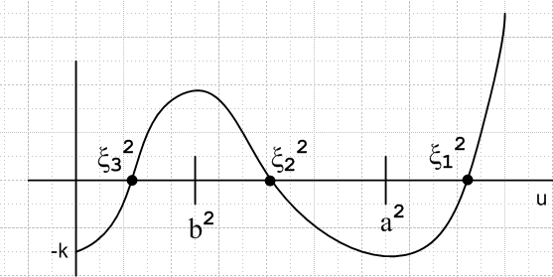

(1) Fiddling a bit with Schaum. Skip This ! and just see Summary below!

Let's see what Schaum p 32 has to say about this. We identify:

a1 = -h = - [(x2+y2+z2 +(α+β)]
a2 = f = βx2+αy2+ (α+β)z2 +αβ
a3 = -k = - αβz2

Q = (3a2 - a12)/9 = (3f - h2)/9
R = ( 9a1a2- 27a3- 2a13 )/54 = (-9hf +27k + 2h3)/54 h = (r2 + γ)
D = Q3 + R2

The claim is that if D < 0, there are three unequal real roots. But the equations Schaum gives for these real roots imply that Q < 0. This seems non-obvious to me. Write

a1 = -h = - (r2 + γ) γ = (α+β)
a2 = f = βx2+αy2+ (α+β)[ r2-x2-y2] +αβ
= -αx2 - βy2 + γr2 + αβ

So looking at 9Q = 3a2 - a12 and knowing that a2> 0, this could only be negative if the second term is larger than the first term. Let's "explore"

9Q = -3αx2 - 3βy2 + 3γr2 + 3αβ - (r2 + γ)2
= -3αx2 - 3βy2 + 3γr2 + 3αβ - r4- 2γr2- γ2
= -3αx2 - 3βy2 + γr2 + 3αβ - r4- γ2
= - r4 + γr2 -3αx2 - 3βy2 + (3αβ - γ2)

Try completing the square

= - ( r4 - γr2 + γ2/4) + γ2/4 -3αx2 - 3βy2 + (3αβ - γ2)
= - ( r2 - γ/2)2 + γ2/4 -3αx2 - 3βy2 - (γ2 - 3αβ)
= - ( r2 - γ/2)2 -3αx2 - 3βy2 - (γ2 - 3αβ - γ2/4)
= - ( r2 - γ/2)2 -3αx2 - 3βy2 - (3γ2/4 - 3αβ)
= - ( r2 - γ/2)2 -3αx2 - 3βy2 - 3 (γ2 - 4αβ) /4
= - ( r2 - γ/2)2 -3αx2 - 3βy2 - 3 (α-β)2 /4

And finally we have shown that Q < 0 ! So we are still alive in the three real roots idea. The next thing we need to show is that D = Q3 + R2< 0. Since we just showed Q < 0, we would have to show that

|Q|3 > R2

Meanwhile, we have

R = ( 9a1a2- 27a3- 2a13 )/54 = (-9hf +27k + 2h3)

h = (r2 + γ) f = (-αx2 - βy2 + γr2 + αβ) k = αβz2

R = (-9hf +27k + 2h3)

= -9 (r2 + γ) (-αx2 - βy2 + γr2 + αβ) + 27 αβz2 + 2(r2 + γ)3

Generally we have to show that

D = Q3 + R2 = [(3f - h2)/9]3 + (-9hf +27k + 2h3)2/ (54)2 < 0

We know that Q3 is negative, so at least we have a chance. Multiply through by 542

542/93 = 4 so we have to show that

4 (3f - h2)3 + (-9hf +27k + 2h3)2 < 0

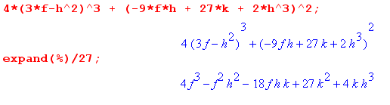
h = (r2 + γ) k = αβz2

So somehow this must be < 0 . Maple expands it into a nightmare.

OK, Uncle!!! The algebra is just a disaster.

(2) Summary of the Inversion Formula Results

There are two formats for presenting the cubic solutions. In both cases, we start with x,y,z and a,b, and we construct combinations as follows:

h = x2+y2+z2 +(a2+b2) L2 // all these are poly2
f = b2x2+ a2y2+ (a2+b2)z2 +a2 b2 L4
k = a2 b2z2 L6

and then from these we construct

R = (-9hf +27k + 2h3)/54 // poly6 (ie, poly of 6th degree in x,y,z)
Q = (3f - h2)/9 // poly4

Then in the "complex solution method" we further define

D = Q3 + R2 // poly12
S = [ R + $\sqrt{D}$]1/3 // [ poly6 +$\sqrt{poly12}$] 1/3
T = [ R - $\sqrt{D}$]1/3 // [ poly6 –$\sqrt{poly12}$] 1/3

and then the solutions are given by (S-T will be pure imaginary)

ξ12 = h/3 + (S+T) // poly2 + [ poly6 +$\sqrt{poly12}$] 1/3 + [ poly6 –$\sqrt{poly12}$] 1/3
ξ22 = h/3 - (S+T)/2 – (i$\sqrt{3}$)(S-T)/2
ξ32 = h/3 - (S+T)/2 + (i$\sqrt{3}$)(S-T)/2

I think the way this works is that Q<0, so Q3 < 0, and D<0 so $\sqrt{D}$ = i$\sqrt{|D|}$. Then we have

S = [ R + i$\sqrt{|D|}$]1/3 T = [ R - i$\sqrt{|D|}$]1/3

This says that T = S* so that S+T = S+S* = 2Re(S) and S-T = S-S* = 2i Im(S). This then makes all the ξi2 shown above come out real, and we presume we will find that ξi2 > 0.

In the "real solution method" we don't use S and T, but instead further define

θ = cos-1(R/$\sqrt{-Q3}$) // cos-1(poly6/ $\sqrt{poly12}$)

and then the solutions are

ξ12 = h/3 + 2$\sqrt{-Q}$ cos(θ/3) // poly2 + $\sqrt{poly4}$* cos{ [1/3] cos-1(poly6/ $\sqrt{poly12}$) }
ξ22 = h/3 + 2$\sqrt{-Q}$ cos(θ/3 + 2π/3)
ξ32 = h/3 + 2$\sqrt{-Q}$ cos(θ/3 + 4π/3)

I have verified explicitly that both these forms are correct, using Maple file "ellips coord check.mws". I am glad I did this check because the 1968 Schaum formulas had a total of 6 errors in them, which are corrected in the 2008 edition (see below) (and which Wolfram has right).
The results are unbelievably messy which is no doubt why M&F don't present them.

(3) There are a few other facts that might be useful, concerning the cubic solutions. Go back to our equation

u3 – h u2 + f u - k = 0

k = αβz2 // all three are positive
f = βx2+αy2+ (α+β)z2 +αβ
h = x2+y2+z2 +(α+β)

u1 = ξ12
u2 = ξ22
u3 = ξ32

These extra facts appear at the bottom page 32 Schaum, and then arise trivially from writing the cubic in factored form. They are:

ξ12 + ξ22 + ξ32 = h = x2+y2+z2 +a2 + b2

ξ12 ξ22 + ξ22 ξ32 + ξ12 ξ32 = f = b2x2+ a2y2+ (a2+b2)z2 + a2 b2

ξ12 ξ22 ξ32 = k = a2 b2z2

So, although the general formulas for ξi2(x,y,z) are awesomely messy, these symmetric combinations all have simple forms in terms of the Cartesian coordinates. The last result we already know, since it is just the z equation of the x,y,z M&F equations, but the others are a little new to me.

Q. Comments on Ellipsoidal Coordinates

(1) In one view, you look at your equation for the ellipsoid written in this manner,

x2/(ξi2-a2) + y2/( ξi2- b2)+ z2/(ξi2) = 1 A2 = ξi2-a2 B2 = ξi2- b2 C2 = ξi2

Everything enters quadratically in both coordinate systems. In x,y,z coords are either sign, but the surface is symmetrical in that f(±x,±y,±z) = f(x,y,z), so first octant is all we need deal with where xi are all plus. Just staring at this equation, you see the confocal nature of the ellipses and hyperboloids. If you try to solve this equation for ξi2, you obviously get a cubic for this variable, and here is what the cubic looks like:
F(u) = u3 – h u2 + f u - k = 0
k = αβz2 // all three are positive
f = βx2+αy2+ (α+β)z2 +αβ
h = x2+y2+z2 +(α+β) // note that g = h + k/f

For each (x,y,z), you get three roots (ξ12, ξ22, ξ32) in the regions shown (though I have not proven this fact), so you might as well think of the ξi as only positive. Thus, we match our triple ξi range with the first Cartesian octant. We can see that the mapping Cartesian octant → ξi space is 1 to 1, but not obvious it is onto, filling the entire ranges. On the other hand, we know the mapping ξi → (x,y,z) explicitly,

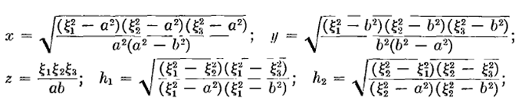

so we know that the mapping ξi → x,y,z is also 1 to 1. So the mapping really is 1 to 1, invertible, and therefore onto in both directions -- that has a name like topological mapping or some such.

(2) How do we know that the ξi coordinates are orthogonal?

Let's first consider this in spherical coordinates where I pull up my standard issue picture:

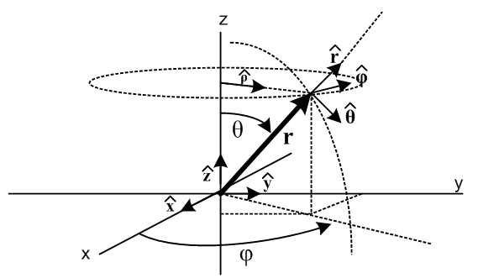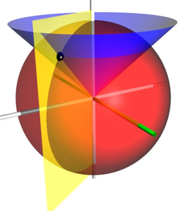

Think about the "planes" that are defined when one variable is held fixed and the others varied:

fixed vary plane
r θ,φ spherical surface patch r2dΩ (red sphere)
φ r,θ vertical plane at φ (yellow)
θ r.φ cone (blue)

If you look at the black dot in the color picture on the right, you see that locally you have three perp planes. Once you know that is true, you know the triad of unit vectors is orthogonal.
This is much harder to "see" in ellipsoidal coordinates: (my black dot is just under the ξ1)
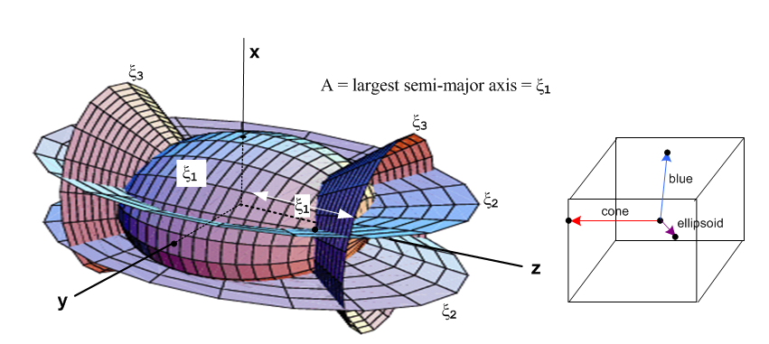

I simply don't know the right way to explain why things are orthogonal. I know it is true in this computation, where qi = ξi and we just compute directly from our "x,y,z equations".

gkp = Tki Tpi = $\begin{matrix}∂xi \\ ∂qk\end{matrix}$$\begin{matrix}∂xi \\ ∂qp\end{matrix}$

R. Express the charged ellipsoid potential in Cartesian coordinates.

The solution we found above was this:

ψ(ξ1, ξ2, ξ3) = ψ(ξ1) = V0 F[sin-1(a/ξ1),b/a] / F[sin-1(a/c),b/a]

What are a,b,c here? The actual charged ellipsoid has ξ1 = c and has the two focal distances a and b, as per our recently made pictures:

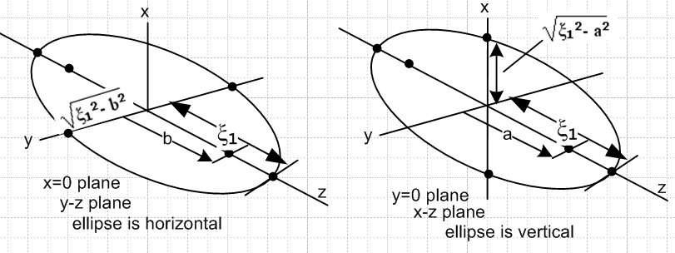

Now the only way I know how to put this into Cartesian coordinates is to use the messy cubic inversion formulas found in the last section. For example, ξ12 = h/3 + 2$\sqrt{-Q}$ cos(θ/3). Now THAT is one ugly muffin! We know the surfaces of constant ψ are ellipsoids confocal to the charged one. But the potential itself ψ(x,y,z) is amazingly complicated, considering that the surfaces themselves have the simple Cartesian form

x2/( ξ12-a2) + y2/( ξ12- b2)+ z2/(ξ12) = 1

The problem is simply this: given such a surface, you need to find the number ξ1 that is its "label", so you can put that label into the simple potential formula. But solving for the label ξ1 means solving the cubic equation and THAT is what is so ugly. Given a point (x,y,z) in Cartesian space, which ξ1 ellipsoid does that point lie on?
Imagine trying to solve the Laplace equation for this problem in Cartesian space. It is a "simple" Dirichlet problem for a capacitor, one electrode at infinity with potential -V, the other being the metal ellipsoid with potential V. This is a "standard (exterior) Dirichlet problem". If you could somehow solve it, you would get the mess shown above, the ugly muffin.
We have a similar problem in dealing with the surface charge density on the charged ellipsoid (and in fact with anything regarding our ellipsoid).

S. How would you PLOT the charge density on the ellipsoid using Maple?

Code is store here: "plot sigma ellip coord.mws"

Here is our expression obtained above for the surface charge α on our charged metal ellipsoid,

4πσ = E⊥ = -dV/dn = -dV(ξ1)/dξ1 (dξ1/dn) = -[ dV(ξ1)/dξ1] (1/hξ1)

- [ dV(ξ1)/dξ1] $\sqrt{(ξ12- a2) (ξ12- b2)}$ / $\sqrt{(ξ12- ξ22) (ξ12- ξ32)}$

so all the interest is in the last factor, since ξ1 = c, a constant for our ellipsoid.
The plan is to make the surface brightness be proportional to σ (but later I try hue as well). To that end, we set f equal to the ratio of radicals shown above, which is normalized to unity at (ξ2, ξ3) = (a,b). This point is the tip of the longest end of the ellipsoid, so we expect that it will be the brightest point. ( I will insert the full text code below).

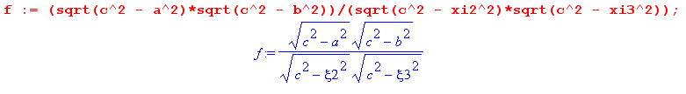
Next, we enter our "x,y,z equations" to map from ξ space to Cartesian space

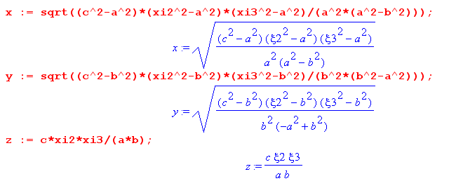

which can be compared with our earlier M&F equations where we have set ξ1 = c:

Next, we want to have the user enter the three semi-major axes to define an ellipsoid that way, and from these we compute the two long axis focal distances a and b,

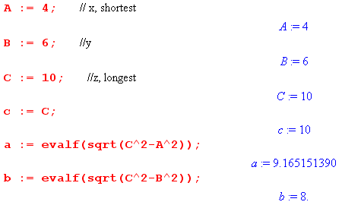

Next, for warmup we just plot the surface charge density versus ξ2 and ξ3 . Notice that the two variables (ξ2 , ξ3) = (xi2,xi3) are scanned over their legal ranges which are 0 ≤ ξ3 ≤ b and b ≤ ξ2 ≤ a,

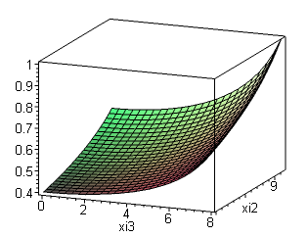
which shows that our scaled σ ranges from about 0.4 up to 1.0 in this example. The upper corner is at the largest values of a and b, which as noted correspond to the longest top of the ellipsoid which we expect to have the most charge.

Next, we create the desired "football plot". The code is this:
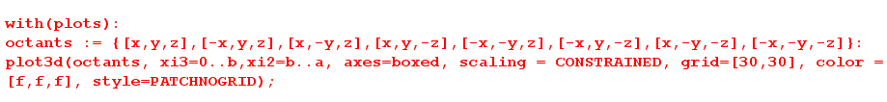

In order to see all 8 octants of our ellipsoid, we create a set {} "octants" containing the obvious 8 points. Then the plot3d command "scans" the space (ξ2,ξ3) = (xi2,xi3) just as in the previous plot. At each scanning point, it computes the 8 mirror points and puts them in a data list along with a grayscale color set by our color function (which is just σ, the surface charge), represented by RGB = f,f,f. You can at least see that the charge is most on the pointiest ends and least on the most oblate ends.

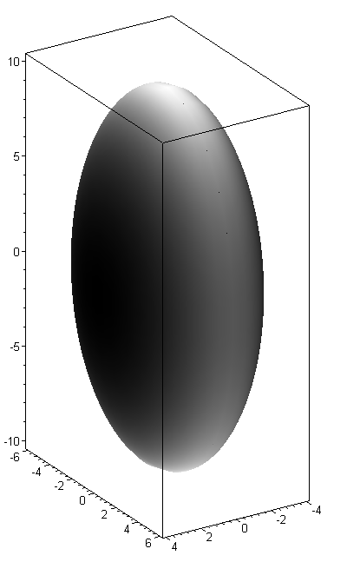

Unfortunately, Maple scales the RGB "color" from so it fills the entire range from 0 to 1, whereas we would like to see the color being roughly 0.4 to 1 as shown by the previous graph. I cannot find a way around this problem. ( I tried lots of tricks, you would have to directly edit the data structure).
The hue method is a little more exciting. Instead of having it span the luminance spectrum as I did above, we can let it span the hue spectrum by saying "color=f". Here is the plot along with a calibration hue spectrum

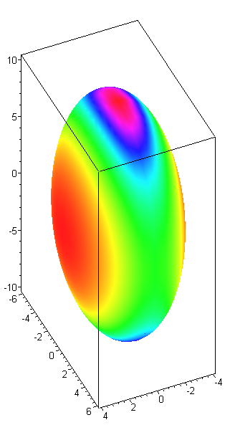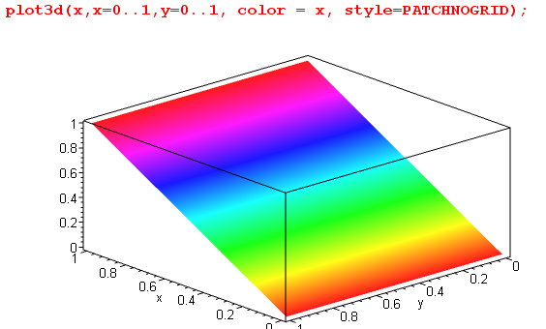

Now the pointy ends of our ellipsoid are red as expected, the most oblate ends are orange, and the intermediate ends are green. In some sense, this is a very good way to plot σ, as long as we understand that the full hue spectrum is only mapping σ in the range (0.4, 1.0). Hue is very sensitive to the eye.

Text code:
> restart:
> f := (sqrt(c^2 - a^2)*sqrt(c^2 - b^2))/(sqrt(c^2 - xi2^2)*sqrt(c^2 - xi3^2)):
> x := sqrt((c^2-a^2)*(xi2^2-a^2)*(xi3^2-a^2)/(a^2*(a^2-b^2))):
> y := sqrt((c^2-b^2)*(xi2^2-b^2)*(xi3^2-b^2)/(b^2*(b^2-a^2))):
> z := c*xi2*xi3/(a*b):
> A := 4: // x, shortest
> B := 6: //y
> C := 10: //z, longest
> c := C:
> a := evalf(sqrt(C^2-A^2)):
> b := evalf(sqrt(C^2-B^2)):
> plot3d(f, xi3=0..b,xi2=b..a, axes=boxed):
> with(plots):
> octants := {[x,y,z],[-x,y,z],[x,-y,z],[x,y,-z],[-x,-y,z],[-x,y,-z],[x,-y,-z],[-x,-y,-z]}:
> plot3d(octants, xi3=0..b,xi2=b..a, axes=boxed, scaling = CONSTRAINED, grid=[30,30], color= f , style=PATCHNOGRID);
> restart;
> plot3d(x,x=0..1,y=0..1, color = x, style=PATCHNOGRID);

T. Generate those nice fixed-ξi surfaces using Maple

For example, we want to hold ξ1 fixed and scan the other two to create the ellipsoidal surface. But this is exactly what we did above on our charge distribution plot.

Experiment: I tried drawing the basic ellipsoid and it works fine, but I could not make the axes stick out from the figure so you could see them better with their labels. Putting view= [-30..30,-30..30,-30..30] into the display command fixed this. Before I discovered that, I tried making an outer transparent surface. Maple does not support transparent, wireframe is as close as they come, so I was above to do this.

p1 := plot3d(octants, xi3=0..b,xi2=b..a, axes=normal, scaling = CONSTRAINED, grid=[20,20],style=patch):
p2 := plot3d(octants1, xi3=0..b,xi2=b..a, axes=normal, scaling = CONSTRAINED, grid=[10,10],style=wireframe, color = [1,0,0]):
display([p1,p2],view= [-30..30,-30..30,-30..30],labels = ["x","y","z"])
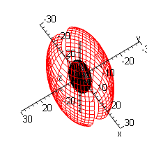

I has a lot of trouble putting the labels in the right places in the "normal" frame mode, whereas in the boxed mode it is OK. . I can extend the axes, but it wants to put the x,y,x labels inside the surface region where you cannot see them.

view= [-15..15,-15..15,-15..15],

OK, I am fine with the ellipsoid. How do I now make the OTHER two surfaces? Different range of ξ coordinates! By the way, in the "patch" style, Maple does remove hidden surfaces.
OK, I have now created a serious Maple program in file "ellipsoidal coords 1.mws", and here are some of the output pictures:

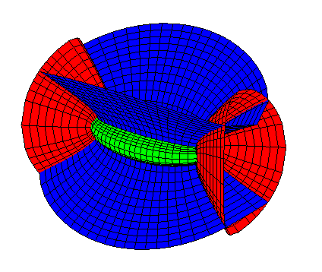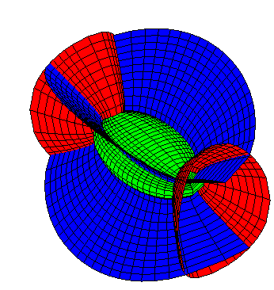

You can see that the blue and red surfaces are asymmetrical since the ellipsoid is. So this is my version of the Wolfram picture I used above. These pictures make it a little more clear that the triad of unit vectors at an intersection pint is orthogonal.

Detail: to get Maple to allow viewing in this manner, which matches other plots in my document, I had to interchange the definition of x and z, because otherwise it wants to put the red cones up and down along the z axis, and that is the way it draws it in space, and you can alter your viewpoint with "orientation", but you cannot make the red cones be right and left no matter where you look from.

U. Verifying The Cubic Coordinate Inversion Equations

Here is where I found the errors in Schaum p 32 on cubics.

I have entered this in, and have checked many times, but it is not working! Something is wrong somewhere. Transcription, starting point, typos? Let's try to get an independent check on Schaum's claims on page 32, just in case. I am seeing some problems! The Wolfram page works like this:

Wolfram Schaum
a2 → a1
a1 → a2
a0 → a3

Wolfram's definitions of R and Q map correctly into Schaum's

Wolfram:
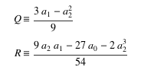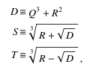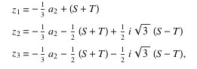

Wolfram's D matches that of Schaum, the discriminant. But Schaum's definitions of S and T are both wrong, they should be a cube root, not a square root as shown above. Then Schaum and Wolfram agree on the complex form of the three solutions also shown on the right. And then Schaum's complex formula set gives me the right results (will show below). But now the section 9.4 results are wrong. Here are the Wolfram results:
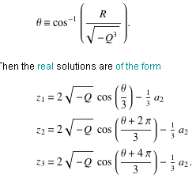 Wolfram

So Schaum now has several more errors: first, should not have a -R in the θ definition, and I think this does make a difference. Second, he forgets to add the pieces shown! Horrors! There is a 2008 edition of this Spiegel thing with snippet view, and all these errors have been fixed! So for once, it wasn't me who screwed up.

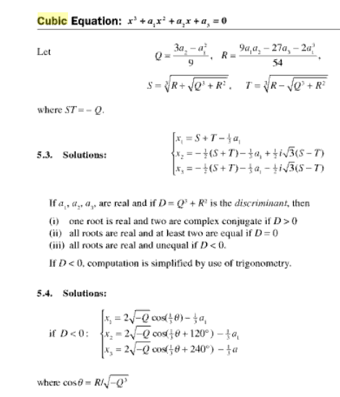

V. Compare Kelvin and M&F on dV/dn: interpretation of p

The M&F result, found above in this doc, is this ( on or off the surface of the charged metal ellipsoid.)

-dV/dn = -[dV(ξ1)/dξ1] (dξ1/dn) = -[ dV(ξ1)/dξ1] (1/hξ1)

= -[ dV(ξ1)/dξ1] $\sqrt{(ξ12- a2) (ξ12- b2)}$ / $\sqrt{(ξ12- ξ22) (ξ12- ξ32)}$

where "the interest" is in the last factor. Can I show that this denominator factor has this form:

$\sqrt{(ξ12- ξ22) (ξ12- ξ32)}$ = F(ξ1,a,b) $\sqrt{x2/A4 + y2/B4 + z2/C4}$

where A,B,C are the semi-major axes

A2 = ξ12 - a2 B2 = ξ12 - b2 C2 = ξ12

This seems to be the claim that Kelvin makes and in fact seems to derive on page 12 / 32 of the PDF.
If it were true, I think I could show it pretty easily. I would want to show this

(ξ12- ξ22) (ξ12- ξ32) = f(ξ1) [ x2/ (ξ12 - a2)2 + y2/(ξ12 - b 2)2 + z2/(ξ12)2 ] (*)

Question: how do I know I have correctly aligned my semi-major axes? This is the way we have done things all along,

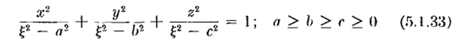
This shows that what I call A above really is the semimajor that goes with x, not with y or z.

So you would think it would be a simple matter to insert our x,y,z formulas into the RHS of to see if it is true or not for some f(ξ1). Let's write (*) in this way

h(ξ1, ξ2, ξ3) = f(ξ1) k (ξ1, ξ2, ξ3)

Here then is some Maple work. We set up the k function like this

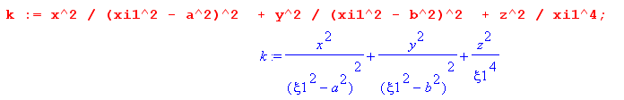

and we set in the x,y,z equations like this:

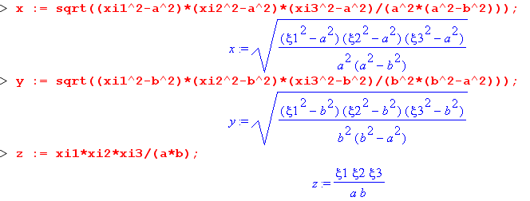
The k function then comes out being

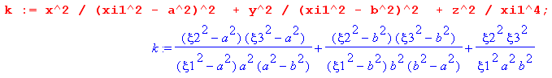

Meanwhile, the h function is this:

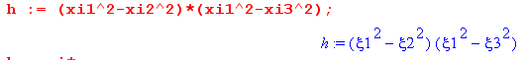

Now expand both h and k in powers of ξ2 and ξ3 like this:

h = Σmn hmn(ξ1) ξ2mξ3n
k = Σmn kmn(ξ1) ξ2mξ3n

There are exactly four terms in each sum. If it is true that h = f(ξ1) k. then it must be true that

hmn(ξ1) = f(ξ1) kmn(ξ1)

and this must be true for all four coefficients on each side. We are matching powers term by term in two independent variables ξ2 and ξ3. Suppose then we define

fmn(ξ1) = hmn(ξ1)/ kmn(ξ1)

Then we should find that all four fmn objects are the SAME! Let's see if that is true: Start with 22:

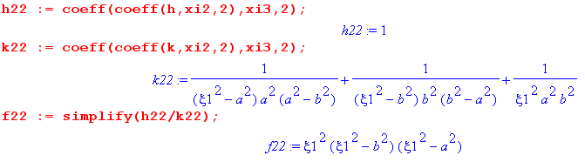

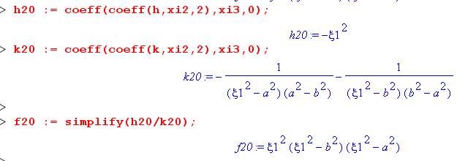

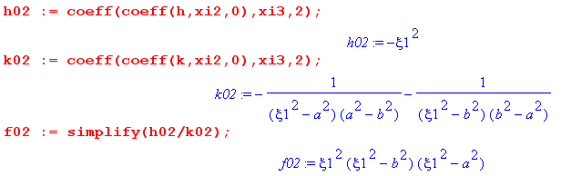

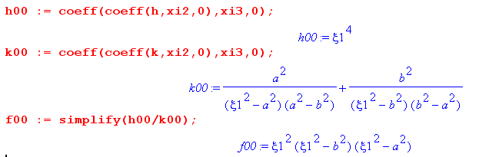

I am starting to believe. I need not have done all this work ( I started out with some errors, and that is what led me to the double series approach above). We find directly that

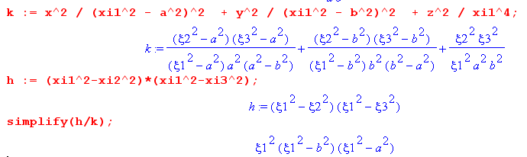

But notice this factor is just A2B2C2 since above we had

A2 = ξ12 - a2 B2 = ξ12 - b2 C2 = ξ12

So here is what I have now shown:

$\sqrt{(ξ12- ξ22) (ξ12- ξ32)}$ = F(ξ1,a,b) $\sqrt{x2/A4 + y2/B4 + z2/C4}$

where F = ABC. In other words:

$\sqrt{(ξ12- ξ22) (ξ12- ξ32)}$ = ABC $\sqrt{x2/A4 + y2/B4 + z2/C4}$

[ L2 L2]1/2 = L3 [ L-2]1/2

L2 = L2

Therefore we can write our potential in this manner:

A2 = ξ12 - a2 B2 = ξ12 - b2 C2 = ξ12

-dV/dn = -[dV(ξ1)/dξ1] (dξ1/dn) = -[ dV(ξ1)/dξ1] (1/hξ1)

= -[ dV(ξ1)/dξ1] $\sqrt{(ξ12- a2) (ξ12- b2)}$ / $\sqrt{(ξ12- ξ22) (ξ12- ξ32)}$

= -[ dV(ξ1)/dξ1] $\sqrt{(ξ12- a2) (ξ12- b2)}$ / [ABC$\sqrt{x2/A4 + y2/B4 + z2/C4}$]

= -[ dV(ξ1)/dξ1] (AB / ABC) p

= -[ dV(ξ1)/dξ1] (1/ξ1) p

where p = 1/$\sqrt{x2/A4 + y2/B4 + z2/C4}$. We can compare this equation then to that of Kelvin,

-dv/dn = 4π k p

from which we may conclude that

4πk = -[ dV(ξ1)/dξ1] (1/ξ1)

So if you want to plot charge density, you could do it using p.

W. More on σ for ellipsoid, ellipse and disc; capacitances of various objects (10.8.10)

Mystery Question Added 8.8.10.

Q: How do we reconcile the above formula for σ on an ellipsoid in terms of Kelvin's p, and the known result for σ on a charged disk? The Kelvin thing does not seem to blow up at the edge, but the known σ result does! I think the answer has to do with dA and what happens to it when you crush an ellipsoid into an ellipse or disk. I leave this as a pending question because I am now in the middle of Sneddon and trying to finish that book.

Answer to Question Added 10.7.10.

(a) Expression for p, and then limit of p when ellipsoid is crushed A→0.

First, we already know these facts:

V(ξ1) = V0 F[sin-1(a/ξ1),b/a] / F[sin-1(a/c),b/a]

4πσ = – [ dV(ξ1)/dξ1] (1/ξ1) p(x,y,z)

(1/ξ1) p(x,y,z) = $\sqrt{(ξ12- a2) (ξ12- b2)}$ / $\sqrt{(ξ12- ξ22) (ξ12- ξ32)}$ = AB/$\sqrt{(ξ12- ξ22) (ξ12- ξ32)}$

semis: C ≥ B ≥ A. A2 = ξ12 - a2 B2 = ξ12 - b2 C2 = ξ12

p(x,y,z) = 1/$\sqrt{x2/A4 + y2/B4 + z2/C4}$ = ABC / $\sqrt{(ξ12- ξ22) (ξ12- ξ32)}$ // Note: V = (4π/3)ABC

So, let's start with p = 1/$\sqrt{x2/A4 + y2/B4 + z2/C4}$ where C ≥ B ≥ A. What happens as we crush our ellipsoid flat into an ellipse? Look back at the picture, or just take a hint from p, to remember that our association with axes is A,B,C ↔ x,y,z so the longest semi is along the z axis having C = ξ1, so we are not going to crush C to zero since it is the largest. Instead, we want to crush so that A → 0 which means focal distance a→ ξ1 = C. We let B ≠ C at first so our flat thing will be an ellipse. What happens if A → 0 in our p formula? The problem is that as we squash down, our flat ellipse will be in the x = 0 plane so we will also have x → 0, so it not obvious how to deal with this p formula with its x2/A4 term. Looking at our "ellipse is vertical" picture above, we certainly must have |x| ≤ A for any (x,y,z) on the ellipse. However, from the equation of the ellipsoid we know that

x2/A2 = ( 1 - y2/B2 - z2/C2)

which is some "reasonably valued" expression even after flattening. If we install this into p we get

p = A / [ ( 1 - y2/B2 - z2/C2) + y2A2/B4 + z2A2/C4 ]1/2

so in the small A limit this becomes

p = A / $\sqrt{1 - y2/B2 - z2/C2}$ // small A limit of p

which is at least starting to "look right". Think of that "tangent plane" for the very flat ellipsoid. As long as you are not at the very end, the plane tips violently toward the x=0 flat plane and so the distance p is very small, and you can see that if A→0, we will have p→0 as well.

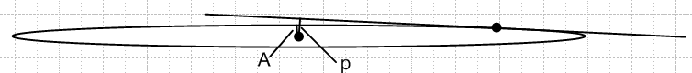

At this point, then, assuming A is very small, we have

4πσ = – [ dV(ξ1)/dξ1]|ξ1=C (1/C) p(x,y,z) = – [ dV(ξ1)/dξ1] |ξ1=C (1/C) A / $\sqrt{1 - y2/B2 - z2/C2}$

where C = the larger semi of the flat ellipse we are approaching. Something must arise from the dV/dξ1 which will cancel our factor of A ! Our known potential is this

V(ξ1) = V0 F[sin-1(a/ξ1),b/a] / F[sin-1(a/c),b/a]
A = $\sqrt{c2-a2}$ B = $\sqrt{c2-b2}$ C = c
smallest semi middle semi largest semi

so we are now faced with differentiating this thing wrt ξ1.

(b) Differentiate the potential.

So consider this to reduce symbol count

f(x) = F[sin-1(a/x),b/a]

Looking at my pendulum elliptic integral doc, I would claim that

∂F(φ,k)/∂φ = 1/$\sqrt{1-k2sin2φ}$

If we set φ = sin-1(a/x) , then sinφ = a/x and we then have

∂F(φ,k)/∂φ = 1/$\sqrt{1-k2a2/x2}$

Notice that

sinφ = a/x => cosφdφ = - (a/x2)dx = - (1/a) (a2/x2)dx = - (1/a) sin2φ dx

=> dφ/dx = - (1/a) sin2φ / cosφ = - (1/a) (a2/x2)/ $\sqrt{1 - a2/x2}$ = – (a/x2)/ $\sqrt{1 - a2/x2}$

Meanwhile, we surely have

∂F(φ,k)/∂x = ∂F(φ,k)/∂φ (dφ/dx) = (1/$\sqrt{1-k2a2/x2}$) (– (a/x2)/ $\sqrt{1 - a2/x2}$ )

which is to say

∂F(sin-1(a/x),k)/∂x = – (a/x2) (1/$\sqrt{1-k2a2/x2}$)(1/$\sqrt{1 - a2/x2}$)

which is to say

∂F(sin-1(a/ξ1),k)/∂ξ1 = – (a/ξ12) (1/$\sqrt{1-k2a2/ξ12}$)(1/$\sqrt{1 - a2/ξ12}$)

But in our situation we have k = b/a so this becomes

∂ξ1F(sin-1(a/ξ1),k) = – (a/ξ12) (1/$\sqrt{1-b2/ξ12}$)(1/$\sqrt{1 - a2/ξ12}$)
or
∂ξ1F(sin-1(a/ξ1),b/a) = – a (1/$\sqrt{ξ12-b2}$)(1/$\sqrt{ξ12 - a2}$)

which then tells us that

∂ξ1V(ξ1) = ( V0/F[sin-1(a/c),b/a] ) ∂ξ1F(sin-1(a/ξ1),b/a)

= – ( aV0/F[sin-1(a/c),b/a] ) (1/$\sqrt{ξ12-b2}$)(1/$\sqrt{ξ12 - a2}$)

= – ( aV0/F[sin-1(a/c),b/a] ) (1/AB) // the derivative result

In passing, I note that we can install this into our σ expression to get this:

4πσ = – [ dV(ξ1)/dξ1] { $\sqrt{(ξ12- a2) (ξ12- b2)}$ / $\sqrt{(ξ12- ξ22) (ξ12- ξ32)}$}

= ( aV0/F[sin-1(a/c),b/a] ) (1/$\sqrt{ξ12-b2}$)(1/$\sqrt{ξ12 - a2}$) { $\sqrt{(ξ12- a2) (ξ12- b2)}$ / $\sqrt{(ξ12- ξ22) (ξ12- ξ32)}$}

= ( aV0/F[sin-1(a/c),b/a] ) / $\sqrt{(ξ12- ξ22) (ξ12- ξ32)}$

which I repeat: [ this is σ on a charged ellipsoid with label ξ1 as a function of ξ2 and ξ3 ]

4πσ(ξ1 label, ξ2, ξ3) = ( aV0/F[sin-1(a/c),b/a] ) / $\sqrt{(ξ12- ξ22) (ξ12- ξ32)}$ ξ1 = C
A = $\sqrt{c2-a2}$ B = $\sqrt{c2-b2}$ C = c
smallest semi middle semi largest semi

At this point we could use our fact above

(1/ξ1) p(x,y,z) = $\sqrt{(ξ12- a2) (ξ12- b2)}$ / $\sqrt{(ξ12- ξ22) (ξ12- ξ32)}$

to state this general σ result where variation is all in terms of x,y,z

4πσ(ξ1 label, x, y,z) = ( aV0/F[sin-1(a/c),b/a] ) (1/ξ1) p(x,y,z) / $\sqrt{(ξ12- a2) (ξ12- b2)}$

But this is off the path I am on, so we just leave it sitting there.

(c) Show cancellation of A factors when we go flat.

From above we have shown that,

[ dV(ξ1)/dξ1] |ξ1=C = – ( aV0/F[sin-1(a/c),b/a] ) (1/AB)

We can insert this into our nearly-flat charge density formula 4πσ = – [ dV(ξ1)/dξ1] (1/ξ1) p(x,y,z) to get

4πσ = – [ dV(ξ1)/dξ1] |ξ1=C (1/C) A / $\sqrt{1 - y2/B2 - z2/C2}$

= (1/C) A ( aV0/F[sin-1(a/c),b/a] ) (1/AB)(1/$\sqrt{1 - y2/B2 - z2/C2}$)

and sure enough we get our desired cancellation of the very small A's and we then have

4πσ = (1/C) ( aV0/F[sin-1(a/c),b/a] ) (1/B) (1/$\sqrt{1 - y2/B2 - z2/C2}$)

where now A = 0 and a = c = C. But then we can write

sin-1(a/c) = sin-1(1) = π/2

and then

F[ π/2,b/a] = K(b/a) = K($\sqrt{C2-B2}$/ C)

so we then have

4πσ = (1/C) ( aV0/ K($\sqrt{C2-B2}$/C) (1/B) (1/$\sqrt{1 - y2/B2 - z2/C2}$)
or
4πσ = (1/BC) ( CV0/ K($\sqrt{C2-B2}$/C) (1/$\sqrt{1 - y2/B2 - z2/C2}$)

and I guess I claim this is the charged density on a charged ellipse with semis C ≥ B which lies in the y-z plane. Let's now pretend it lies in the x-y plane so that

4πσ = (1/B) [ V0/ K($\sqrt{C2-B2}$/C) ] (1/$\sqrt{1 - x2/C2 - y2/B2}$) // σ on an ellipse in x-y plane

and then C is the longer semi axis which runs along the x axis, and the shorter one B along the y axis. If we then take the limit that B = C to get a round disc of radius C, then

4πσ = (1/C) ( V0/ K(0) (1/$\sqrt{1 - ρ2/C2}$

= (1/C) ( 2V0/ π) (1/$\sqrt{1 - ρ2/C2}$ // since K(0) = π/2 from AS p 591 top left

Divide through by 4π to get

σ = (V0/2π2C) (1/$\sqrt{1 - ρ2/C2}$

Now set the disk radius to a to avoid upcoming confusion

σ = (V0/2π2a) /$\sqrt{1 - ρ2/a2}$ = (V0/2π2) /$\sqrt{a2 - ρ2}$

Now use the fact that q = CV0 with C = (2/π)a as capacitance. Then q = (2/π)a V0 and V0= πq/(2a) so

σ = V0 (1/2π2) /$\sqrt{a2 - ρ2}$ = πq/(2a) (1/2π2) /$\sqrt{a2 - ρ2}$ = (q/4πa) /$\sqrt{a2 - ρ2}$

This is the surface charge on say the upper surface of the ellipsoid as we crush it down, so if we want both sides we double this, and that then agrees with green Jackson 3.179 p 93.

(d) Capacitances of various objects

I seem to have missed this in all of the above, so let's do it here. Our general ellipsoid potential is this:

V(ξ1) = V0 F[sin-1(a/ξ1),b/a] / F[sin-1(a/c),b/a]

We know for large ξ1 that , using sin-1(1/x) ≈ 1/x,

sin-1(a/ξ1) ≈ a/ξ1 << 1

so we can use the small argument expansion of F that F(x,k) = x ( pencil AS page 594) so we have

V(ξ1) ≈ V0 (a/ξ1) / F[sin-1(a/c),b/a]

From the equation of our ellipsoid

x2/( ξ12- a2) + y2/( ξ12- b2)+ z2/ξ12 = 1 ξ1 > a ellipsoids

We can see that if ξ1→ ∞, this equation becomes

x2/( ξ12) + y2/( ξ12)+ z2/ξ12 = 1 ξ1 > a ellipsoids

=> r2 = ξ12

so in this limit, ξ1 → r. We then have

V(ξ1) ≈ V0 (a/r) / F[sin-1(a/c),b/a] = Q/r => Q = V0 a / F[sin-1(a/c),b/a]

and from this we read off our Q = CV capacitance

cap(ellipsoid ξ1= C) = Q/V0 = a / F[sin-1(a/c), b/a] C ≥ B ≥ A
A = $\sqrt{c2-a2}$ B = $\sqrt{c2-b2}$ C = c

In the flattened to ellipse limit, A = 0 and a = c and we have F[π/2,b/a] = K(b/a) = K(b/c) so

cap(ellipse) = a / K(b/c)

and when we make B = C so b = 0, this is the following, where a = c = C = radius of disc

cap(disc) = a / K(0) = (2/π)a

If we go back to the ellipsoid, if we set A = B, we get the prolate spheroid, which means a = b. We can then use F[x,1] = ln [ (1+sinx)/cosx ] ( my pendulum doc) to get

F[sin-1(a/c),1] = ln [ (1+sinx)/$\sqrt{1 - sin2x}$] = ln [ (1+(a/c))/$\sqrt{1 -(a/c)2}$]

= ln [ (c+a)/$\sqrt{c2 -a2}$] = ln [ (c+a)/A]

so we conclude that

cap(prolate, ξ1= C) = a / F[sin-1(a/c), 1] = a / ln [ (C+a)/A] A = $\sqrt{c2-a2}$

As verification of this result, I found a PDF which claims V is given by

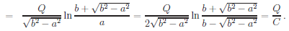

where their a,b are my A,C so that $\sqrt{b2- a2}$ = $\sqrt{C2- A2}$ = my a , so I can convert their first result to say

V = (Q/a) ln [( C + a)/A] = (Q/a) ln [( C + a)/A]

from which we get from Q = CV

cap = Q/V = a / ln [( C + a)/A]

which then verifies my result. I don't think I have seen this before. We could talk about a prolate needle limit of this result where we take C very large so a ≈ b ≈ C we seem to get

cap(needle) = C / ln [( 2C/A]

which approaches 0 as A → 0 (super thin needle of half length C). Again our pdf mentions this

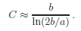

where b >> a which is my C >> A so their result is C / ln (2C/A) and we again agree!

If we go back to the ellipsoid C ≥ B ≥ A, if we set B = C, we get the oblate spheroid, which means b=0. We then use fact that F[x,0] = x (AS p 594) so say

cap(oblate ξ1= C) = Q/V0 = a / F[sin-1(a/c),0] = a / sin-1(a/c) c = C = B ≥ A

IN the same pdf, the potential in this case is

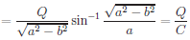

where now their b,a are my A,C so that $\sqrt{a2- b2}$ = $\sqrt{C2- A2}$ = my a, so they are claiming

V = (Q/a) sin-1(a/C) => cap = Q/V = a / sin-1(a/C)

which again verifies my result. If we then flatten this oblate, we recover the disk result cap = a / (π/2).

Here then is a summary of these capacitance results.

A = $\sqrt{c2-a2}$ B = $\sqrt{c2-b2}$ C = c C ≥ B ≥ A

cap(ellipsoid) = Q/V0 = a / F[sin-1(a/c), b/a]

cap(ellipse) = a / K(b/c)

cap(disc) = a / K(0) = (2/π)a

cap(prolate spheroid) = a / F[sin-1(a/c), 1] = a / ln [ (C+a)/A] A = B a = b

cap(needle) = C / ln [( 2C/A]

cap(oblate spheroid) = Q/V0 = a / F[sin-1(a/c),0] = a / sin-1(a/c) B = C b = 0

(e) Summary of main facts of this last effort:

(a) We start with this basic information

V(ξ1) = V0 F[sin-1(a/ξ1),b/a] / F[sin-1(a/c),b/a]

4πσ = – [ dV(ξ1)/dξ1] (1/ξ1) p(x,y,z)

(1/ξ1) p(x,y,z) = $\sqrt{(ξ12- a2) (ξ12- b2)}$ / $\sqrt{(ξ12- ξ22) (ξ12- ξ32)}$ = AB/$\sqrt{(ξ12- ξ22) (ξ12- ξ32)}$

semis: C ≥ B ≥ A. A2 = ξ12 - a2 B2 = ξ12 - b2 C2 = ξ12

p(x,y,z) = 1/$\sqrt{x2/A4 + y2/B4 + z2/C4}$ = ABC / $\sqrt{(ξ12- ξ22) (ξ12- ξ32)}$ // Note: V = (4π/3)ABC

and if we flatten by taking A→0 we find that (and give a graphical explanation)

p = A / $\sqrt{1 - y2/B2 - z2/C2}$ // small A limit of p

(b) We compute the derivative ∂ξ1V(ξ1) using the fact that

∂F(φ,k)/∂φ = 1/$\sqrt{1-k2sin2φ}$ => ∂ξ1F(sin-1(a/ξ1),b/a) = – a (1/$\sqrt{ξ12-b2}$)(1/$\sqrt{ξ12 - a2}$)

with the result

∂ξ1V(ξ1) = – ( aV0/F[sin-1(a/c),b/a] ) (1/AB)

and if we insert this in to our general σ formula we get these equivalent results,

4πσ(ξ1 label, ξ2, ξ3) = ( aV0/F[sin-1(a/c),b/a] ) / $\sqrt{(ξ12- ξ22) (ξ12- ξ32)}$ ξ1 = C = c

4πσ(ξ1 label, x, y,z) = ( aV0/F[sin-1(a/c),b/a] ) (1/ABC) p(x,y,z)

(c) Inserting the small A limit for p into this last gives our flat ellipse charge density in the y-z plane:

4πσ(ξ1 label, x, y,z) = ( aV0/F[sin-1(a/c),b/a] ) (1/BC) (1 / $\sqrt{1 - y2/B2 - z2/C2}$)

But since a = c, we have sin-1(a/c) = sin-1(1) = π/2 so this simplifies to

4πσ = (1/B) [ V0/ K($\sqrt{C2-B2}$/C) ] (1/$\sqrt{1 - x2/C2 - y2/B2}$) // σ on an ellipse in x-y plane

If we then set B = C for a disc and define ρ as usual, then, using K(0) = π/2, we get Jackson:

σ = (1/C) ( V0/ K(0) (1/$\sqrt{1 - ρ2/C2}$) = (V0/2π2C) (1/$\sqrt{1 - ρ2/C2}$) = (q/4πC) /$\sqrt{C2 - ρ2}$

(d) I compute the capacitance of various objects, results are

A = $\sqrt{c2-a2}$ B = $\sqrt{c2-b2}$ C = c C ≥ B ≥ A

cap(ellipsoid) = Q/V0 = a / F[sin-1(a/c), b/a]

cap(ellipse) = a / K(b/c)

cap(disc) = a / K(0) = (2/π)a

cap(prolate spheroid) = a / F[sin-1(a/c), 1] = a / ln [ (C+a)/A] A = B a = b

cap(needle) = C / ln [( 2C/A]

cap(oblate spheroid) = Q/V0 = a / F[sin-1(a/c),0] = a / sin-1(a/c) B = C b = 0

X. Explanation of a sign error in M&F statement of the ellipsoidal PDE (8.12.11)

Let's start here, taken from MF
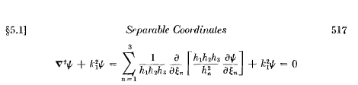

and this agrees with my general formula for ∇2 and there are no minus signs anywhere,

lap(f) = div grad(f) = (1/ [Q1Q2Q3]) ∂i [Q1Q2Q3 (Qi)-2 (∂if) ] // orthog

where Qi = hi = the scale factors.
So what are the scale factors? Here is what MF says they are
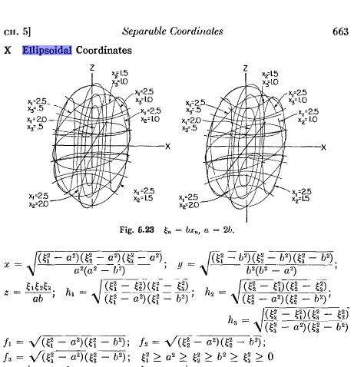

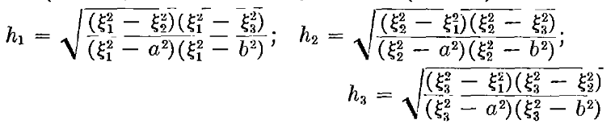

Let's accept these cyclic definitions of the Gi from somewhere in MF

Then we can read off

Q12 = h12 = G3(-G2)/f12 = -G2G3/f12
Q22 = h22 = (-G3)G1/f22 = -G3G1/f22
Q23 = h32 = G2(-G1)/f32 = -G1G2/f32

so as expected, these equations are cyclic. Staring at the above, the three RHS's don't look positive, but they are as I will now show. It is a characteristic of the ellipsoidal coordinates that they are each in certain ranges with respect to the parameters a and b, namely,

0 ≤ ξ3 ≤ b≤ ξ2≤ a≤ ξ1

From this and the definitions above, we see that ( all is cyclic here)

f12 = (ξ12-a2)( ξ12-b2) = + + = + G1 = (ξ22- ξ32) = +
f22 = (ξ22-a2)( ξ22-b2) = - + = - G2 = (ξ32- ξ12) = -
f32 = (ξ32-a2)( ξ32-b2) = - - = + G3 = (ξ12- ξ22) = +

and that then explains why all our Q12 are in fact positive.

Q12 = h12 = G3(-G2)/f12
Q22 = h22 = G3G1/(-f22)
Q23 = h32 = (-G2)G1/f32

h1 = $\sqrt{G3(-G2)/f12}$
h2= $\sqrt{G3G1/(-f22)}$
h3 = $\sqrt{(-G2)G1/f32}$

h1h2h3 = G1(-G2)G3 / [ f1f3$\sqrt{-f22}$]

where all "items" are positive. We can also do some ratios

h2h3/h1 = $\sqrt{G3G1/(-f22)}$$\sqrt{(-G2)G1/f32}$ / $\sqrt{G3(-G2)/f12}$

= G1f1 / [ $\sqrt{-f22}$f3 ]

So here then is the first term in ∇2 as shown above from p 517 MF,

{ [ f1f3$\sqrt{-f22}$]/ [G1(-G2)G3] } ∂1 [{G1f1 / [ $\sqrt{-f22}$f3 ] } ∂1ψ ]

= f1/ [(-G2)G3] * ∂1 [f1∂1ψ ] // f2 and f3 and G1 are not functions of ξ1

So our first term in ∇2ψ is this

first term in ∇2ψ = – [ f1/(G2G3)] ∂1 [f1∂1ψ ] = – [ G1f1/(G1G2G3)] ∂1 [f1∂1ψ ] (*)

But here is how MF claims things are at a different point in the book.
↓ wrong!

which I transcribe as

Σn [Gn/ (G1G2G3)] fn ∂n (fn∂nψ) + k12ψ = 0 wrong

With n=1, comparison with (*) shows that M&F have a sign error in their result above. The best fix would be to put a - sign before the sum!! This way, we can interpret the equation simply as (∇2+k12) ψ = 0.
I verified this against M&S p 42 for ∇2 where we say that ξ1,ξ2,ξ3 = η,θ,λ. I only verified the first M&S term, rest must be cyclic. So this sign error will go into my M&F errata.
So here is the corrected statement of the Helmholtz equation:

– Σn [Gn/ (G1G2G3)] fn ∂n (fn∂nψ) + k12ψ = 0 right

Y. Show that the M&F separated equations agree with M&S (8.12.11)

Here is the M&F separated equation set with my transcription

(1/fn)∂n[fn∂n(Xn)] + { k12 + { k22/(ξn2-a2) + k32/[(ξn2-b2) (a2-b2)] } Xn = 0

Let's compute the first term,

(1/fn)∂n[fn∂n(Xn)] = (1/fn){ fn ∂n2(Xn) + ∂nfn∂n(Xn)] = ∂n2(Xn) + (1/fn) (∂nfn) ∂n(Xn)

But

∂nfn = (1/fn) [ (ξn2-a2) ξn + (ξn2-b2) ξn ] = (ξn/fn) [ (ξn2-a2) + (ξn2-b2) ] = (ξn/fn)[ 2ξn2-a2-b2]

And therefore

(1/fn) (∂nfn) ∂n(Xn) = (ξn/fn2)[ 2ξn2-a2-b2] ∂nXn

Therefore we can write the M&F separated equation this way:

∂n2Xn + (ξn/fn2)[ 2ξn2-a2-b2] ∂nXn + { k12 + { k22/(ξn2-a2) + k32/[(ξn2-b2) (a2-b2)] } Xn = 0

fn2∂n2Xn + ξn[ 2ξn2-a2-b2] ∂nXn + fn2{ k12 + { k22/(ξn2-a2) + k32/[(ξn2-b2) (a2-b2)] } Xn = 0

The 3rd term coefficient can be written as

(ξn2-a2)(ξn2-b2) { k12 + { k22/(ξn2-a2) + k32/[(ξn2-b2) (a2-b2)] }

= k12(ξn2-a2)(ξn2-b2) + k22(ξn2-b2) + k32(ξn2-a2)/ (a2-b2)

= k12ξn4 + [ k12(-a2-b2) + k22 + k32/(a2-b2) ] ξn2 + [ k12(a2+b2) - b2k22 - a2k32/(a2-b2)]

Now if we define

α3 = [ k12(-a2-b2) + k22 + k32/(a2-b2) ]
α2 = [ k12(a2+b2) - b2k22 - a2k32/(a2-b2)]

Then our separated equation becomes

fn2∂n2Xn + ξn[ 2ξn2-a2-b2] ∂nXn + [ k12ξn4 + α3ξn2 + α2]Xn = 0

and this agrees exactly with M&S p 43 bottom, where k12 = κ2 . Therefore I have verified the M&F separated equation against M&S.

Z. How exactly does the separation of ellipsoidals work (8.12.11)

By brute force here I show that, if we assume the separation ODE equations given by MF, then ψ = X1X2X3 does satisfy the Helmholtz equation. It is not pretty. Things are perhaps done better in my Stackel notes (which were not written when I wrote this section Z; here I just wanted to make sure things worked, and in so doing I found the sign error noted above. )

With the sign error corrected, the Helmholtz equation reads (see end of Section X above)

– Σn [Gn/ (G1G2G3)] fn ∂n (fn∂nψ) + k12ψ = 0 right

I want to see how the two separation constants arise. So yes, try ψ = X1(ξ1) X2(ξ2) X3(ξ3) in the above. Let's sneak a peak at the separated result to use as a guide (I show this below from MF)

(1/fn)∂n[fn∂n(Xn)] + { k12 + { k22/(ξn2-a2) + k32/[(ξn2-b2) (a2-b2)] } Xn = 0

Let's now just write out our PDE (use cyclic copies) (I now put the minus sign correction on k12)

(1/G2G3) f1∂1(f1∂1ψ) + (1/G3G1) f2∂2(f2∂2ψ) + (1/G1G2) f3∂3(f3∂3ψ) - k12ψ = 0

Remember, this is the 3D Helmholtz equation and we are going to process it step after step.

Now ∂1ψ = (∂1X1)X2X3 and then ∂1(f1∂1ψ) = ∂1(f1[(∂1X1)X2X3]) = ∂1(f1(∂1X1)) X2X3 so we can install this in 3 cyclic places to get

(1/G2G3) f1∂1(f1[∂1X1]) X2X3
+ (1/G3G1) f2∂2(f2[∂2X2]) X3X1
+ (1/G1G2) f3∂3(f3[∂3X3]) X1X2 - k12X1X2X3 = 0

Now divide by the triple product to get and multiply by a triple G

G1 f1∂1(f1[∂1X1]) /X1
+ G2 f2∂2(f2[∂2X2]) /X2
+ G3 f3∂3(f3[∂3X3]) /X3 - k12G1G2G3 = 0

G1 f12 (1/f1) ∂1(f1[∂1X1]) /X1
+ G2 f22 (1/f2)∂2(f2[∂2X2]) /X2
+ G3 f32 (1/f3)∂3(f3[∂3X3]) /X3 - k12G1G2G3 = 0

Now define the grouping (1/f1) ∂1(f1[∂1X1]) to be Y1. Then we have

G1 f12 Y1 /X1 + G2 f22 Y2 /X2 + G3 f32 Y3/X3 - k12G1G2G3 = 0

Now here is the supposed separated solution

(1/fn)∂n[fn∂n(Xn)] + { k12 + k22/(ξn2-a2) + k32/[(ξn2-b2) (a2-b2)] } Xn = 0
Yn + { k12 + k22/(ξn2-a2) + k32/[(ξn2-b2) (a2-b2)] } Xn = 0

Yn/Xn = - { k12 + { k22/(ξn2-a2) + k32/[(ξn2-b2) (a2-b2)] }

So install this supposed separated form into 3 places in our PDE and then our Helmholtz equation becomes,

- G1 f12 { k12 + k22/(ξ12-a2) + k32/[(ξ12-b2) (a2-b2)] }
- G2 f22 { k12 + k22/(ξ22-a2) + k32/[(ξ22-b2) (a2-b2)] }
- G3 f32 { k12 + k22/(ξ32-a2) + k32/[(ξ32-b2) (a2-b2)] }
- k12G1G2G3 = 0

Is this equation true? Write it as

Ak12 + Bk22 + Ck32 = 0

I need to show that A=B=C = 0. We have, staring at the above:

A = - G1 f12- G2 f22- G3 f32 - G1G2G3
B = - G1 f12/(ξ12-a2) - G2 f22/(ξ22-a2) - G3 f32/(ξ32-a2)
C = - G1 f12/[(ξ12-b2) (a2-b2)] - G2 f22/[(ξ22-b2) (a2-b2)] - G3 f32/[(ξ32-b2) (a2-b2)]
= {- G1 f12/(ξ12-b2) - G2 f22/(ξ22-b2) - G3 f32/(ξ32-b2) }/(a2-b2)

It is certainly not obvious that any of these coefficients vanish, but I will go ask Maple.

Let's try A first

A = - G1 f12- G2 f22- G3 f32 - G1G2G3

Maple shows that this does vanish! Here is my Maple evidence where the reader can check each line.

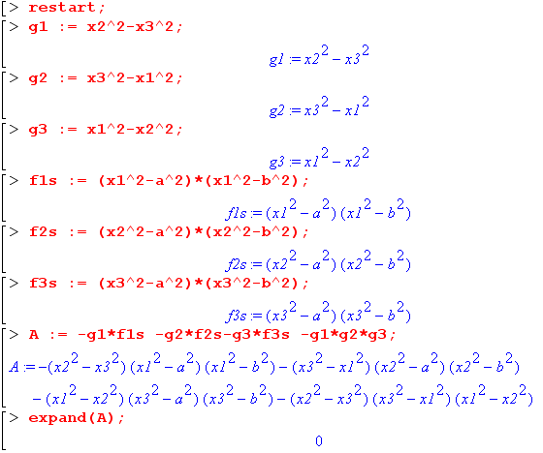

And similarly B and C also vanish:

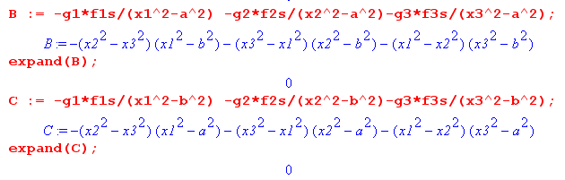

Now that we know it works, let's try to continue in the forward direction where we left off above. The PDE we have converted to this form, (again, this is the processed Helmholtz equation)

G1 f12 Y1 /X1 + G2 f22 Y2 /X2 + G3 f32 Y3/X3 - k12G1G2G3 = 0 (**)

where I defined

Y1 = (1/f1) ∂1(f1[∂1X1])

If you now assume assume that

Yn/Xn = - { k12 + k22/(ξn2-a2) + k32/[(ξn2-b2) (a2-b2)] }

and you write it all out, then (**) is seen to be true and the Helmholtz equation is satisfied by our assumed solution form ψ = X1X2X3.
My conclusion is that the Stackel stuff is pretty powerful and I guess I had better check into it. There is some fancy determinant magic going on here. [ I now have checked into it, see ODE notes. ]

