The potential of a charged ellipsoid META PhL 11.26.09

The raw doc is 53 pages long and hugely convoluted, I will try to do a summary here of the main stuff. This doc ended up being 14 pages.

References: Byerly*, W&W*, Moon & Spencer, Hobson,

0. Starting the search 1
A. The Surfaces of Ellipsoidal Coordinates and The Equations for Such Surfaces. 1
B. How to Obtain Cartesian Coordinates from Ellipsoidal Coordinates 2
C. Statement of the Helmholtz (Laplace if k₁=0) Equation in Ellipsoidal Coordinates 2
D. Statement of the Separated Equations in Ellipsoidal Coordinates 2
E. The connection between MF Ellipsoidal Coordinates and Wolfram Ellipsoidal 2
E1. The Byerly Coordinates compared to MF ones. 3
F. Comments on the Remainder of MF Chap 5 on ODE's 3
G. Summary Page on Ellipsoidal Coordinates 3
H. Statement of the ODE for Separated Functions in Ellipsoidals: Lamé Equation 3
I. Series Solutions to the Lamé Equation at z=0 4
J. Simple First-Kind Solutions to the Lamé Equation for m = 0,1,2 : functions E^{p}_{m}(z) 4
K. Second-Kind Solutions to the Lamé Equation for m = 0,1,2 : functions F^{p}_{m}(z) 6
L. The Potential of a Charged Metal Ellipsoid 6
M. The alternate ellipsoidal coordinates (λ,μ,ν) and Jacobi function connection to (ξ₁,ξ₂,ξ₃) 6
N. Comparison of the MF Solution of the Charged Ellipsoid to the solution of Kelvin 6
O. The charge density on a charged metal ellipsoid. 9
P. The inverse coordinate formulas for ellipsoidal coordinates 10
Q. Comments on Ellipsoidal Coordinates 10
R. Express the charged ellipsoid potential in Cartesian coordinates. 10
S. How would you PLOT the charge density on the ellipsoid using Maple? 10
T. Generate those nice fixed-ξ_{i} surfaces using Maple 11
U. Verifying The Cubic Coordinate Inversion Equations 11
V. Compare Kelvin and MF on dV/dn: interpretation of p 12

0. Starting the search

I think I understand the ellipsoidal coordinates now and see in general how using the right orthogonal coordinates allow solution of electrostatics problems of corresponding geometry. I know the ellipsoidals are a separable system. I show the Wolfram coordinates which seem strange but later in section E I reconcile them.

A. The Surfaces of Ellipsoidal Coordinates and The Equations for Such Surfaces.

This section discusses the three "quadric surfaces" involved, and shows the focal distances a and b in some pretty good slice pictures. I am quite comfortable with this stuff now, and have gotten Maple to draw the surfaces "custom" for me. See "morphing" and "quick tour of coord systems" docs, the latter stored one level up. A major point to keep in mind: the equations for the three "surfaces" are really all the same when written in terms of a generic ξ. But for each range shown below, the surface is geometrically different.

0 ξ3 b ξ2 a ξ1 ∞
hyper2sheet hyper1sheet ellipsoid

Later we should not be surprised to find that the ODEs for the separated functions are basically the same.

B. How to Obtain Cartesian Coordinates from Ellipsoidal Coordinates

Here I just paste in the x,y,z equations from MF. This is the "direction" that is always easy. Going the other way is what I call the inversion problem, see section P below. [ But where do these equations come from? In a separate doc, I show they come from the three quadric surface equations via Cramer's Rule. ]

C. Statement of the Helmholtz (Laplace if k1=0) Equation in Ellipsoidal Coordinates

If you write ∇2 in ellipticals, you can write the Helmholtz equation (∇2 + k12)ψ = 0 in ellipticals. This is another pasted equation and of course ψ is not yet separated. The equation can be written this way

Σn [Gn/ (G1G2G3)] fn ∂n (fn∂nψ) + k12ψ = 0 G1 = ξ22- ξ32 etc fn2= (ξn2-a2) (ξn2-b2)

D. Statement of the Separated Equations in Ellipsoidal Coordinates

Here we try ψ = X1(ξ1)X2(ξ2)X3(ξ3) and we find this separated equation

(1/fn) ∂n [ fn (∂n Xn(ξn)) ] + [ k12 + k22/(ξn2-a2) + k32/ [(ξn2-b2)(a2- b2)] Xn(ξn) = 0

where k2 and k3 are the separation constants. Note that f1 is real since ξ1 > a,b. Then f2 is imaginary, and f3 is real again. Of course the two imaginary i's of the f2 case cancel out so all is real. Notice that each of the three separation equations involves both separation constants, a situation different from spherical coordinates, which we shall comment on below.

E. The connection between MF Ellipsoidal Coordinates and Wolfram Ellipsoidal

This section does what it says and seems a bit out of place here in the development, but OK. I refer to the Wolfram parameters as a', b', c' and his generic coordinate as ξ' (though not primed in this cut/paste)

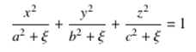 with c' ≥ b' ≥ a' (the reverse of MF) ξ' = ξ', η', ζ'

We compare this to the MF equation where we have a different a,b,c (not primed)

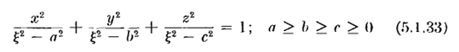 ξ = ξ1, ξ2, ξ3

The two systems are related obviously by (1) MF is squared; (2) shift by constant for each variable. It is possible, given a Wolfram system, to choose a,b,c such that the shifts are all the same. Pick any C ≥ c' and then you find

a'2 + a2 = C2 a2 = C2 - a'2 => ξ12 = ξ' + C2
b'2 + b2 = C2 b2 = C2 - b'2 => ξ22 = η' + C2
c'2 + c2 = C2 c2 = C2 - c'2 => ξ32 = ζ' + C2

and on the right you see the constant shifts.

E1. The Byerly Coordinates compared to MF ones.

The Byerly λ,μ,ν are very much like ξ1, ξ2, ξ3 but we have to do x↔z and a↔c on constants. Byerly defines the "tricky" coordinates he calls α,β,γ which allow for simpler inversion formulas, though in MF these are called λ,μ,ν -- just to add to the confusion.

F. Comments on the Remainder of MF Chap 5 on ODE's

Some obscure remarks about conjugate variables (think Fourier) being a rotation in Hilbert space. Then we have the idea of all systems being degenerate versions of the ellipsoidal system. This chapter then becomes a huge monograph on ODE's which I should someday read (or perhaps read it in W&W). [ I later (circa 12/20/09) read and took notes on the 50-page Section 5.2 on ODE's, see elsewhere. ]

G. Summary Page on Ellipsoidal Coordinates

Here I pasted in the MF "ellipsoidal summary page" followed by the MF generic curvilinear differential operators page. We now leave MF Chapter 5 and move to MF Chapter 10.

H. Statement of the ODE for Separated Functions in Ellipsoidals: Lamé Equation

Here we just rewrite the ODE's for the three separated functions with k1 = 0 for Laplace, and we end up with

fn ∂n [ fn (∂n Xn(ξn)) ] = [ m(m+1)ξn2 - κ ] Xn(ξn) fn2= (ξn2-a2) (ξn2-b2)

All 3 equations are the same, BUT for ξ2 we have fn = imaginary, so we pick up a -1 on the LHS of the ξ2 equation when we rewrite the square root integrands as positive quantities. He renames the three separated functions this way: ψ = X1(ξ1)X2(ξ2)X3(ξ3) = F(ξ1)G(ξ2)H(ξ3). Key idea: the three equations really are the same, all written the same way as above, so they have the same solutions. We shall find that these solutions are polynomials and square root radical combinations called crudely Emκ(ξn) where κ is later replaced by an integer p. These functions, or perhaps the product of three, are the first kind ellipsoidal harmonics
I looked pretty hard for Lame information and there is very little on the web, see main doc. [ But then I found and downloaded the Byerly book of 1898, and found the W&W Chapter 23 in new download, so I am now in good shape I think on Lame and ellipsoidal harmonic "data". ] [ I later 12/24/09 tried to read the WW chapter, but found it completely opaque and useless.] [ Don't forget Moon and Spencer. ]

I. Series Solutions to the Lamé Equation at z=0

Suppose you could find a solution f(z) = Σndnzn that converges for all z in (0,∞). [ Note that any truncated series like f(z) = z "converges", despite the fact that as z→∞ we have f→∞.] Then you would have found a Laplace solution of the form u(ξ) = fm,κ(ξ1) fm,κ (ξ2) fm,κ (ξ3), because the range of each variable lies in the range (0,∞). Now MF go on to show that for general values of the separation constants, κ and m, you cannot find a viable f(x) with this property, so the hoped-for separated triple-product form fails to exist. The reason is that in general the Frobenius series diverges for |z| > R ( it must have Rconv = ∞), or has inverse powers that cause blow up at the origin (z=0 problem). These two conditions force m and κ to become quantized so we have actual solutions which are first-kind functions.

J. Simple First-Kind Solutions to the Lamé Equation for m = 0,1,2 : functions Epm(z)

But if we go with special values of m (low integers m = 0,1,2...), and corresponding special values of κ, then you can find some solutions called Emp(ξ, aka z). These are "first kind" since they are polynomials in z and thus blow up for large ξ. Here are some examples: ( various "species" )

E00(ξ1) E00(ξ2) E00(ξ3) = 1 * 1 * 1 = 1 m = 0 κ = 0
E10(ξ1) E10(ξ2) E10(ξ3) = ξ1 ξ2 ξ3 = abz m=1 κ = a2+b2

E11(ξ1) E11(ξ2) E11(ξ3) = $\sqrt{ξ12- a2}$ * $\sqrt{ξ22- a2}$ * $\sqrt{ξ32- a2}$ = x a $\sqrt{a2-b2}$ ~ x
E22(ξ1) E22(ξ2) E22(ξ3) = ξ1 $\sqrt{ξ12- a2}$ * ξ2 $\sqrt{ξ22- a2}$ * ξ3 $\sqrt{ξ32- a2}$ = x a $\sqrt{a2-b2}$abz ~ xz

From Byerly I learn that κ = (a2+ b2)p where p is the upper label ( so I think MF have maybe goofed up their labels above -- it is more complicated than that, see below). The general solution term is then this

[ Amp Emp(ξ1) + Bmp Fmp(ξ1)] [ A'mp Emp(ξ2) + B'mp Fmp(ξ2)] [ A''mp Emp(ξ3) + B''mp Fmp(ξ3)]

and here is a form which is a special case of the above

Gmp(ξ1) Gmp(ξ2) Gmp(ξ3) where G is either E or F.

Byerly explains on page 256 or so that you have to have m = integer to get truncation of your recursion relation, and then you need special values of "p" to avoid negative powers that would blow up at the origin, and this is how the m and p get "quantized". Byerly shows ("following Heine") that there really are four "species" of solutions for E which he calls K,L,M and N and here is his table for m = 1,2,3

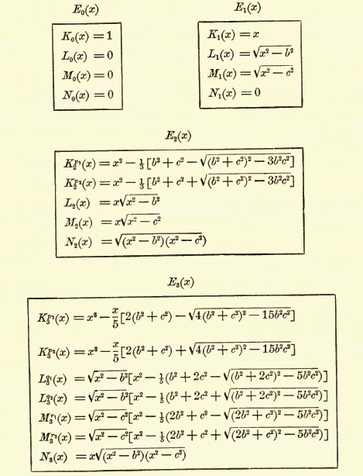

Notice that the L and M solutions have one radical while the N has two and the K have none, which I think is always the case. These are all first-kind solutions. He then goes on to show that every solution has a corresponding solution, and in general you can combine the two

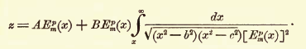

The above is what is quoted on the Wolfram ellipsoidal harmonics site.
I just downloaded Whittaker and Watson 4th edition which has the "new" (1920) chapter on Lame functions, and it has more of the above stuff.

K. Second-Kind Solutions to the Lamé Equation for m = 0,1,2 : functions Fpm(z)

These are found by a nice ODE trick and we find that for each E there is a corresponding F which is goes I think to 0 at large z, so called second-kind functions.

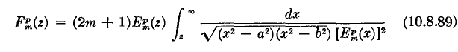

If we stick in our super trivial E00(ξ1) = 1 here we get

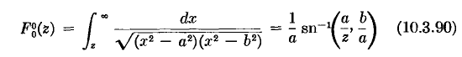

which is our baby!

L. The Potential of a Charged Metal Ellipsoid

Consider this obvious Lamé / Laplace solution of the form 1 * 1 * something:
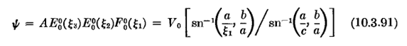
This solves Laplace, and it is a constant V0 on the ellipsoid ξ1 = c, and vanishes at ∞. Had the first two functions not been constants, this would not be true. So we are LOOKING for a function of just this form. The first two functions MUST be E00 otherwise there will be dependence on ξ2 and ξ3. But then the ξ1 function must be a linear combination of E00 and F00 . But the first, being 1, does not vanish for large ξ1 so it must be the second. So, once you know the general form of the Lamé solution shown above, and once you know that you want potential ψ constant on a ξ1 surface, this is the ONLY solution it can be!!! In sphericals outside a sphere of radius a we would say ψ = Y00(θ,φ) (a/r) = 1 * 1 * (a/r) since l = 0 and m = 0. [ In the limit ellipsoid → sphere, we have a→0 and b→0 so limit not totally obvious above, but I have done this elsewhere, see below. ]

M. The alternate ellipsoidal coordinates (λ,μ,ν) and Jacobi function connection to (ξ1,ξ2,ξ3)
Here MF I think talk about that second Byerly choice of coordinates. So I think the heavy math theory has now ended and the rest is just technical details.

N. Comparison of the MF Solution of the Charged Ellipsoid to the solution of Kelvin

The MF solution is this (where a ≥ b are the two focal distances)

ψ(ξ1, ξ2, ξ3) = ψ(ξ1) = V0 F[sin-1(a/ξ1),b/a] / F[sin-1(a/c),b/a]
A = $\sqrt{c2-a2}$ B = $\sqrt{c2-b2}$ C = c
smallest semi middle semi largest semi
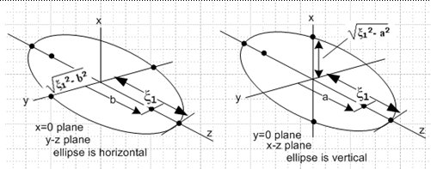

I show (in raw notes) how you can trivially rewrite the MF solution above as the first line below:

ψ(a) = V0 F[sin-1($\sqrt{a2-c2}$/a), $\sqrt{a2-b2}$/$\sqrt{a2-c2}$] / F[sin-1($\sqrt{a2-c2}$/ a1), $\sqrt{a2-b2}$/$\sqrt{a2-c2}$]
ψ(a) = V0 F[sin-1($\sqrt{a2-b2}$/a), $\sqrt{a2-c2}$/$\sqrt{a2-b2}$] / F[sin-1($\sqrt{a2-b2}$/a1), $\sqrt{a2-c2}$/$\sqrt{a2-b2}$]

where (!!) the meaning of a and b has now been redefined. Now, we have

c b a
smallest semi middle semi largest semi

and now the focal distances are f2 ≡ a2 - b2 and g2 ≡ a2 - c2 with g > f. We can regard the largest semi "a" as the variable = ξ1. It of course labels ellipsoids. The second line of the pair above comes from b↔c on the RHS, the proof of which's validity requires use of a certain F function transformation rule. We can rewrite the two lines above as

ψ(a) = V0 F[sin-1(g/a), f/g] / F[sin-1(g/a1), f/g] // restatement of MF above
ψ(a) = V0 F[sin-1(f/a), g/f] / F[sin-1(f/a1), g/f] // this line is "the Kelvin solution"

The first line is identical with the original MF solution, setting ξ1 = a and realizing that we just have new names g > f for those focal distances that were a>b. The second line is the way the solution appears in the Kelvin paper. So we could rewrite these as: ( reference one now has semi = a instead of a1)

ψ(ξ1) = V0 F[sin-1(g/ ξ1), f/g] / F[sin-1(g/a), f/g] // restatement of MF above
ψ(ξ1) = V0 F[sin-1(f/ ξ1), g/f] / F[sin-1(f/a), g/f] // this line is "the Kelvin solution"

semis: ξ1= a ≥ b ≥ c focals: g2 ≡ a2 - c2 and f2 ≡ a2 - b2 g > f

(a) If we take b→a, we inflate our ellipsoid to become oblate, f = 0, and the first line above could be used to state the solution in this case, where we use

F(φ,k) = F(φ|m) = F(φ\α) k = sinα m = k2 F(φ,0) = φ
AS p 589
AS p 594
to get [ a = ξ1]

ψ(a) = V0 F[sin-1(g/a), 0] / F[sin-1(g/a1), 0] = V0 sin-1(g/a) / sin-1(g/a1) g2 ≡ b2 - c2

where g indicates the amount of oblateness (spherical when g =0). From here we could then take the limit c → a to inflate our pillow up to a sphere, so g→0 and we get

ψ(a) = V0 sin-1(g/a) / sin-1(g/a1) = V0 (a1/a)

giving the famous ψ(r) = V0R/r outside an equipotential sphere of radius R.
On the other hand, we could instead take c → 0 and crush the pillow down to a flat ellipse. Then we just have g = b and our solution is

ψ(a) = V0 sin-1(b/a) / sin-1(b/a1)
ψ(ξ1) = V0 sin-1(b/ ξ1) / sin-1(b/a)

This is the potential everywhere of a flat ellipse of semis a and b. And if a = b we get

ψ(ξ1) = V0 sin-1(a/ ξ1) / [ π/2] potential of circular disk of radius a

(b) Alternatively, we could first take c→b taking us to a prolate football. Then g = f and we use the second form above (either form gives the same result) to get

F(φ,k) = F(φ|m) = F(φ\α) k = sinα m = k2 F(φ,k)
F(φ,1 ) = F(φ| 1) = F(φ\90) = ln(secφ + tan φ)

ψ(a) = V0 F[sin-1(f/a),1] / F[sin-1(f/a1), 1] f2 = g2 = a2 - b2

where now f is a measure of the prolateness and I won't bother to write it out as logs. If, however, we now go to the spherical limit where f → 0, we can use this fact for small φ,

F(φ| 1) = ln(secφ + tan φ) = ln( 1/cosφ + sinφ/cosφ) ≈ ln(1+φ) ≈ φ

and we then find that ψ(a) = V0(a1/a), as before.

Summary:

Potential of an ellipsoid of semi's a > b > c with g2 ≡ a2 - c2 and f2 ≡ a2 - b2 so g > f :

ψ(ξ1) = V0 F[sin-1(g/ ξ1), f/g] / F[sin-1(g/a), f/g] // restatement of MF above
ψ(ξ1) = V0 F[sin-1(f/ ξ1), g/f] / F[sin-1(f/a), g/f] // this line is "the Kelvin solution"

Potential of oblate spheroid where a = b > c:

ψ(ξ1) = V0 sin-1(g/ ξ1) / sin-1(g/a) where g2 ≡ a2 - c2

Sublimit where a = b = c for sphere: ψ(ξ1) = V0 (a/ξ1)

Sublimit where c = 0, flat ellipse a > b: ψ(ξ1) = V0 sin-1(b/ ξ1) / sin-1(b/a)
Sublimit c = 0 and a = b, flat disk: ψ(ξ1) = V0 sin-1(a/ ξ1) / [π/2]

Potential of prolate spheroid where a > b = c: F[

ψ(ξ1) = V0 F[sin-1(f/ ξ1),1] / F[sin-1(f/a), 1] f2 = a2 - b2

Sublimit a >>> b = c, cylinder: did not do this one, a ≈ f

[ Question: why in oblate spheroidals do we get tan-1 as the disk solution instead of sin-1 ? ]
ANSWER added 1.10.10: In oblate you get cot-1 or tan-1 forms which you can convert to sin-1 using "the little triangle". See "the Smythe method for Green's Functions, cone exampls.doc" for details.

O. The charge density on a charged metal ellipsoid.

I show that the general result for any of the above cases is this (V = ψ)

4πσ = E⊥ = -dV/dn = -[dV(ξ1)/dξ1] (dξ1/dn) = -[ dV(ξ1)/dξ1] (1/hξ1) =

–[ dV(ξ1)/dξ1] { $\sqrt{(ξ12- a2) (ξ12- b2)}$ / $\sqrt{(ξ12- ξ22) (ξ12- ξ32)}$}

where a ≥ b are the two focal distances. So the "action" is all in the last factor, this tells how charge density varies over the surface of your ellipsoid, ellipse, disk or sphere.
But how could it vary over the sphere?? If we take the sphere limit a = b = 0 of our inversion formula results below we get this

h = r2 f = k = 0 R = h3/27 = (h/3)3 Q = -(h/3)2

D = Q3 + R2 = -(h/3)6 + (h/3)6 = 0

S = T = R1/3= h/3 S+T = 2h/3 S - T = 0

ξ12 = h/3 +2h/3 = h = r2 => ξ1 = r
ξ22 = h/3 - h/3 = 0
ξ32 = h/3 - h/3 = 0 add up to get h which is correct

These are all "in range, we expect to see ξ2 = ξ3 = 0. Then

1/$\sqrt{(ξ12- ξ22) (ξ12- ξ32)}$ = 1/(ξ12) = 1/r2

and of course the numerator radical is also ξ12 so num/den = 1, and σ is then

4πσ = – [ dψ(ξ1)/dξ1] ψ(ξ1) = V0 (a/ξ1) ψ' = - V0a/ξ12

4πσ = V0a/ξ12 = V0/a = Q / a2 and Q = 4πa2σ

So the basic answer is that in the sphere limit, ξ2 = ξ3 = 0 and our "factor" shows no variation.

P. The inverse coordinate formulas for ellipsoidal coordinates

With the help of corrected Schaum, I write down the exact inversion formulas that give the three ξi in terms of x,y,z and a,b. We of course already know the forward formulas for x,y,z in terms of ξi and a,b. I state three relatively simple combination formulas like ξ12 + ξ22 + ξ32 = h = x2+y2+z2 +a2 + b2.

Q. Comments on Ellipsoidal Coordinates

(1) Here I argue that the mapping between the first octant of x-space and ξ-space is 1-to-1 and invertible and the inverse solutions for the ξi2 are the roots of a certain cubic [ α = a2, β = b2 ] and the curve shows the appropriate ranges for the three variables.

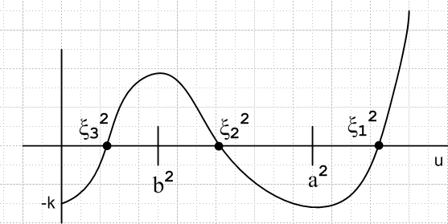

F(u) = u3 – h u2 + f u - k = 0
k = αβz2 // all three are positive
f = βx2+αy2+ (α+β)z2 +αβ
h = x2+y2+z2 +(α+β) // note that g = h + k/f

(2) How do we know that the ξi coordinates are orthogonal? Just one of my pet questions, I comment on this in a separate doc as well. [ "about 2D ellipsoidal..." ]

R. Express the charged ellipsoid potential in Cartesian coordinates.

I argue that it is a mess because the ellipsoid is labeled by ξ1 and ψ(ξ1) is simple, but ξ1(x,y,z) is the big mess.

S. How would you PLOT the charge density on the ellipsoid using Maple?

I first plot the "factor" ( ~ σ) directly in ξ2, ξ3 and get the totally reasonable plot on the left:
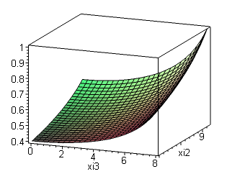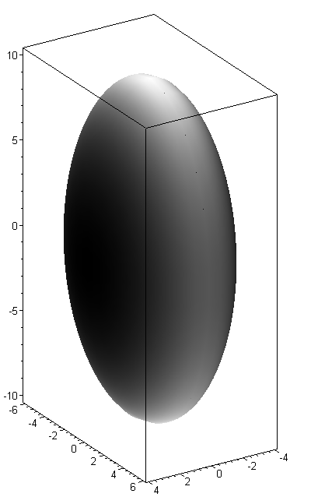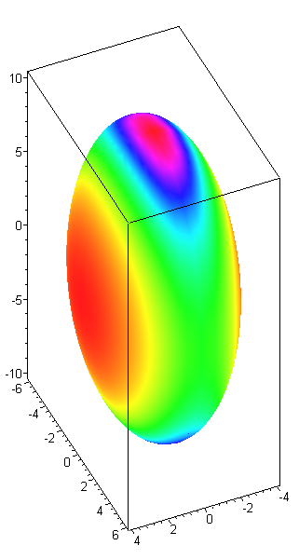

I then figured out how to plot this on the ellipsoid using grayscale and false color, the latter being the best, as shown on the right above. [ Another approach is to use the Kelvin p expression! ]

T. Generate those nice fixed-ξi surfaces using Maple

Here for the first time I was able to get the generate for myself the famous pictures,

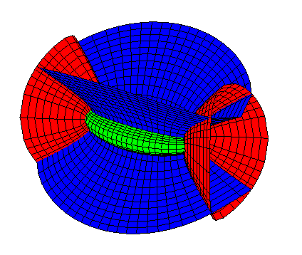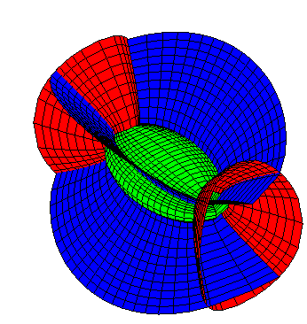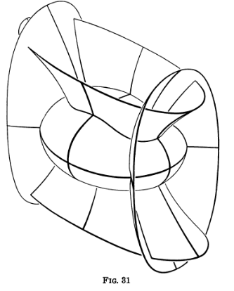

which I think Hilbert and Cohn-Vossen would have enjoyed if they had computers in 1898. I show their picture on the right above, which is pretty good.

U. Verifying The Cubic Coordinate Inversion Equations

Back in section P I summarize the corrected inversion formulas for ξi in terms of x,y,z. Here I verify using Maple that the results are now correct. At first they were wrong because Schaum was wrong in 1968. But Schaum got corrected and I pasted in the corrected page from the 2008 edition of the book.

V. Compare Kelvin and MF on dV/dn: interpretation of p

Here in clumsy roundabout fashion I prove the following very useful fact:

$\sqrt{(ξ12- a2) (ξ12- b2)}$ / $\sqrt{(ξ12- ξ22) (ξ12- ξ32)}$ = (1/ξ1) p(x,y,z)
where
p = 1/$\sqrt{x2/A4 + y2/B4 + z2/C4}$ a,b are focal distances, and

semis: A2 = ξ12 - a2 B2 = ξ12 - b2 C2 = ξ12

4πσ = – [ dV(ξ1)/dξ1] { $\sqrt{(ξ12- a2) (ξ12- b2)}$ / $\sqrt{(ξ12- ξ22) (ξ12- ξ32)}$}

= – [ dV(ξ1)/dξ1] (1/ξ1) p(x,y,z)

So although ξ1 is a very messy function of x,y,z, it turns out that our σ-factor is a very simple function of x,y,z. So in retrospect, I could have used p to make my charge plots above. Moreover, p has a simple geometrical interpretation: p = the perp distance from ellipse center to the plane tangent to an ellipsoid at point x,y,z. Only Kelvin brought out this useful fact. I find the p expression here to be very "morph friendly". I keep feeling there is some "scaling method" of doing ellipsoidal coordinates that is related to a 2D conformal map. That would be an entertaining problem, but I have done enough!

W. More on σ for ellipsoid, ellipse and disc; capacitances of various objects (10.8.10)

I added this section much later than the rest of the doc, and subsection (e) contains a summary, so I just paste that right here, but first here are titles of the little subsections:

(a) Expression for p, and then limit of p when ellipsoid is crushed A→0. 60
(b) Differentiate the potential. 62
(c) Show cancellation of A factors when we go flat. 63
(d) Capacitances of various objects 65
(e) Summary of main facts of this last effort: 67

(a) We start with this basic information

V(ξ1) = V0 F[sin-1(a/ξ1),b/a] / F[sin-1(a/c),b/a] // potential of charged ellipsoid

4πσ = – [ dV(ξ1)/dξ1] (1/ξ1) p(x,y,z) // charge density on same

(1/ξ1) p(x,y,z) = $\sqrt{(ξ12- a2) (ξ12- b2)}$ / $\sqrt{(ξ12- ξ22) (ξ12- ξ32)}$ = AB/$\sqrt{(ξ12- ξ22) (ξ12- ξ32)}$

semis: C ≥ B ≥ A. A2 = ξ12 - a2 B2 = ξ12 - b2 C2 = ξ12 = c2

p(x,y,z) = 1/$\sqrt{x2/A4 + y2/B4 + z2/C4}$ = ABC / $\sqrt{(ξ12- ξ22) (ξ12- ξ32)}$ // Note: V = (4π/3)ABC

and if we flatten by taking A→0 we find that

p = A / $\sqrt{1 - y2/B2 - z2/C2}$ // small A limit of p

(b) We compute the derivative ∂ξ1V(ξ1) using the fact that

∂F(φ,k)/∂φ = 1/$\sqrt{1-k2sin2φ}$ => ∂ξ1F(sin-1(a/ξ1),b/a) = – a (1/$\sqrt{ξ12-b2}$)(1/$\sqrt{ξ12 - a2}$)

with the result

∂ξ1V(ξ1) = – ( aV0/F[sin-1(a/c),b/a] ) (1/AB) // "radial" derivative of potential

and if we insert this in to our general σ formula we get these equivalent results,

4πσ(ξ1 label, ξ2, ξ3) = ( aV0/F[sin-1(a/c),b/a] ) / $\sqrt{(ξ12- ξ22) (ξ12- ξ32)}$ ξ1 = C = c

4πσ(ξ1 label, x, y,z) = ( aV0/F[sin-1(a/c),b/a] ) (1/ABC) p(x,y,z)

(c) Inserting the small A limit for p into this last gives our flat ellipse charge density in y-z plane:

4πσ(ξ1 label, x, y,z) = ( aV0/F[sin-1(a/c),b/a] ) (1/BC) (1 / $\sqrt{1 - y2/B2 - z2/C2}$)

But since a = c, we have sin-1(a/c) = sin-1(1) = π/2 so this simplifies to

4πσ = (1/B) [ V0/ K($\sqrt{C2-B2}$/C) ] (1/$\sqrt{1 - x2/C2 - y2/B2}$) // σ on an ellipse in x-y plane

If we then set B = C for a disc and define ρ as usual, this becomes, using K(0) = π/2, we get Jackson:

σ = (1/C) ( V0/ K(0) (1/$\sqrt{1 - ρ2/C2}$) = (V0/2π2C) (1/$\sqrt{1 - ρ2/C2}$) = (q/4πC) /$\sqrt{C2 - ρ2}$

(d) I compute the capacitance of various objects, results are

A = $\sqrt{c2-a2}$ B = $\sqrt{c2-b2}$ C = c C ≥ B ≥ A

cap(ellipsoid) = Q/V0 = a / F[sin-1(a/c), b/a]

cap(ellipse) = a / K(b/c)

cap(disc) = a / K(0) = (2/π)a

cap(prolate spheroid) = a / F[sin-1(a/c), 1] = a / ln [ (C+a)/A] A = B a = b

cap(prolate needle) = C / ln [( 2C/A]

cap(oblate spheroid) = Q/V0 = a / F[sin-1(a/c),0] = a / sin-1(a/c) B = C b = 0

