Ellipse with ρ,θ coordinates PhL 3.26.05

Motivation: Here we discuss a strange coordinate system ρ,θ for the x,y plane that has no name and which nobody uses. My interest is this: in a way, this is a simplified version of Hobson's discussion of ellipsoidal coordinates ρ,μ,ν versus spherical coordinates r,θ,φ. I am confused by the tangent vector situation, and want to see what that looks like here.

Maple work is done in "rho theta ellipse system.mws".

1. Description of our strange coordinate system 1
2. Question about the level curves 2
3. What is the relationship between x,y and ρ,θ ? 3
(a) Show that ρ± f 3
(b) Express ρ,θ in terms of x, y 4
(c) Express x,y in terms of ρ,θ 4
(d) Verify the above result for x,y as functions of ρ,θ 6
4. Compute the Tup matrix 6
5. Compute the metric tensor. 8
6. Conclusion: 9

1. Description of our strange coordinate system

I want a 2D coordinate system where θ is a normal polar coordinate, but ρ is an "ellipse label" . Consider the following equation for an ellipse: [ θ will be the spherical polar angle in Hobson ]

x2/ρ2 + y2/(ρ2-f2) = 1 A = ρ = semi-major B = $\sqrt{ρ2-f2}$ = semi-minor

A2 - B2 = f2 f = focal distance ρ ≥ f

As we vary ρ, we get a family of confocal ellipses with focal distance f. Thus, ρ is our ellipse label, as desired. Here is our opening picture:

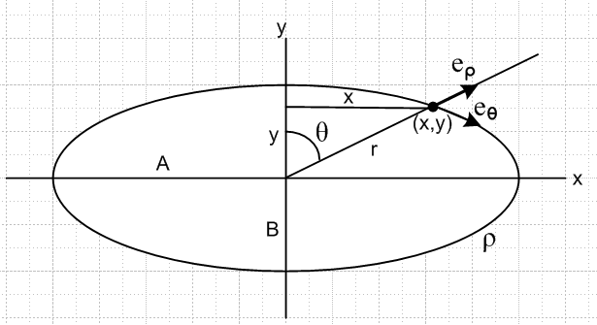

If ρ is very large, our ellipse becomes a large circle of radius ρ. As ρ → f, the ellipse becomes a tight string capturing the two foci.

2. Question about the level curves

In the transformation from x,y to ρ,θ, what are the "level curves"?

The q-space region which corresponds to the entire x-y plane is shown below in gray (it goes up forever).
The set of line segments at various ρ values (ρ = constant ) map into the confocal ellipses in the x,y plane, so those ellipses are level curves for ρ. The vertical half rays θ = constant in q space map into origin based rays in x,y space, so these rays are the level curves for θ. So the drawing above shows one level curve for ρ, and one level curve for θ.

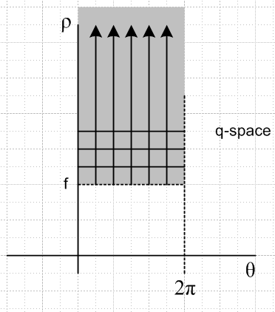

Now, since we are in a 2D world, a "level curve" is the same thing as a "coordinate line" (see tensor doc). Therefore, the tangent base vectors are going to go along the level curves, and this is shown in the first picture above. We expect these two tangent vectors to be non-orthogonal as the picture requires. Since g' ij = ei • ej, we expect the metric tensor to have no 0 elements (see below).

3. What is the relationship between x,y and ρ,θ ?

First off, from our ellipse equation above we obtain this quadratic equation situation for ρ2

ρ4 - (x2+y2+f2)ρ2+ x2f2 = 0

=> ρ2 = [(x2+y2+f2) ± $\sqrt{(x2+y2+f2)2 - 4 x2f2}$]/2

Both roots are clearly ≥ 0. I think I could show that one of these solutions has ρ < f and the other ρ > f, so only the + sign root is meaningful. Well, let's actually show it:

(a) Show that ρ± f

(x2+y2+f2) ± $\sqrt{(x2+y2+f2)2 - 4 x2f2}$ 2f2 ?

± $\sqrt{(x2+y2+f2)2 - 4 x2f2}$ 2f2 - (x2+y2+f2) ?

± $\sqrt{(x2+y2+f2)2 - 4 x2f2}$ f2 - (x2+y2) ?

I am unable to come up with a clean inequality theorem and notation that handles both inequality cases at the same time, so I am forced now to consider the two cases separately.

First the + case:

$\sqrt{(x2+y2+f2)2 - 4 x2f2}$ > f2 - (x2+y2) ?

(x2+y2+f2)2 - 4 x2f2 > [f2 - (x2+y2)]2 ?

(r2+f2)2 - 4 x2f2 > (f2 - r2)2 ?

(r2+f2)2 - (r2-f2)2 > 4 x2f2 ?

4 r2f2 > 4 x2f2 ? yes since y2> 0

Second the - case:

- $\sqrt{(x2+y2+f2)2 - 4 x2f2}$ < f2 - (x2+y2) ?

$\sqrt{(x2+y2+f2)2 - 4 x2f2}$ > (x2+y2) - f2 ?

(x2+y2+f2)2 - 4 x2f2 > [f2 - (x2+y2)]2 ?

From here on this case is the same as the previous case so the answer is again yes. Therefore, we have shown that
ρ±2 ρ±2 f2 => ρ± f

so only ρ+ is meaningful and the other solution is spurious (it might have something to do with hyperbolas, but I don't care about that now).

(b) Express ρ,θ in terms of x, y

So, given a point (x,y) we can determine which ellipse it lies on as follows:

ρ2 = [(x2+y2+f2) + $\sqrt{(x2+y2+f2)2 - 4 x2f2}$]/2

We also know that

tanθ = x/y // for our unusual polar angle definition

So here then we have ρ(x,y) and θ(x,y)

ρ = $\sqrt{(x2+y2+f2)2 - 4 x2f2}$

θ = tan-1(x/y)

(c) Express x,y in terms of ρ,θ

What about the other direction? One's first "thought" is this

x = r sinθ
y = r cosθ

r2 = x2+ y2

but we don't know r as r(ρ,θ). We shall learn it soon! So let's instead invert our two equations above:

2ρ2 = (x2+y2+f2) + $\sqrt{(x2+y2+f2)2 - 4 x2f2}$

x2 = y2 tan2θ => x2 + y2 = y2(1 + tan2θ) = y2sec2θ

y2 = x2 cot2θ => x2 + y2 = x2(1 +cot2θ) = x2csc2θ

The first equation then becomes

2ρ2 = (x2+y2+f2) + $\sqrt{(x2+y2+f2)2 - 4 x2f2}$

= x2csc2θ + f2 + $\sqrt{(x2csc2θ +f2)2 - 4 x2f2}$

We can in theory solve this equation for x2

2ρ2 - x2csc2θ - f2 = $\sqrt{(x2csc2θ +f2)2 - 4 x2f2}$

(2ρ2 - x2csc2θ - f2)2 = (x2csc2θ +f2)2 - 4 x2f2

4ρ4 + x4csc4θ + f4 - 4 ρ2x2csc2θ - 4ρ2f2 + 2x2f2 csc2θ
= x4csc4θ + f4 + 2 x2csc2θ f2 - 4 x2f2

4ρ4 - 4 ρ2x2csc2θ - 4ρ2f2 = - 4 x2f2

ρ4 - ρ2x2csc2θ - ρ2f2 = - x2f2

ρ4 - ρ2x2csc2θ - ρ2f2 + x2f2 = 0

(- ρ2x2csc2θ + x2f2) + ρ4 - ρ2f2 = 0

x2 (- ρ2csc2θ + f2) + ρ2(ρ2-f2) = 0

x2 (ρ2csc2θ - f2) - ρ2(ρ2-f2) = 0

x2 (ρ2csc2θ - f2) =ρ2(ρ2-f2)

x2 = ρ2(ρ2-f2)/ (ρ2csc2θ - f2)

and we can see since csc2θ > 1 and ρ > f that both numerator and denominator are positive. Keep processing a bit

x2 = sin2θ ρ2(ρ2-f2)/ (ρ2 - f2sin2θ)

We can then compute y2 this way

y2 = x2 cot2θ = cos2θ ρ2(ρ2-f2)/ (ρ2 - f2sin2θ)

Now let's define

R2 = ρ2(ρ2-f2)/ (ρ2 - f2sin2θ) R = ρ $\sqrt{(ρ2-f2)/ (ρ2 - f2sin2θ)}$

We have then showed that

x = R sinθ
y = R cosθ
r2 = R2 => r = R

(d) Verify the above result for x,y as functions of ρ,θ

If we insert the above x,y into the ρ2 equation, should just get ρ2= ρ2. I tried to make Maple show this, but it could not figure it out, but I was then above to verify the above with some random numbers:

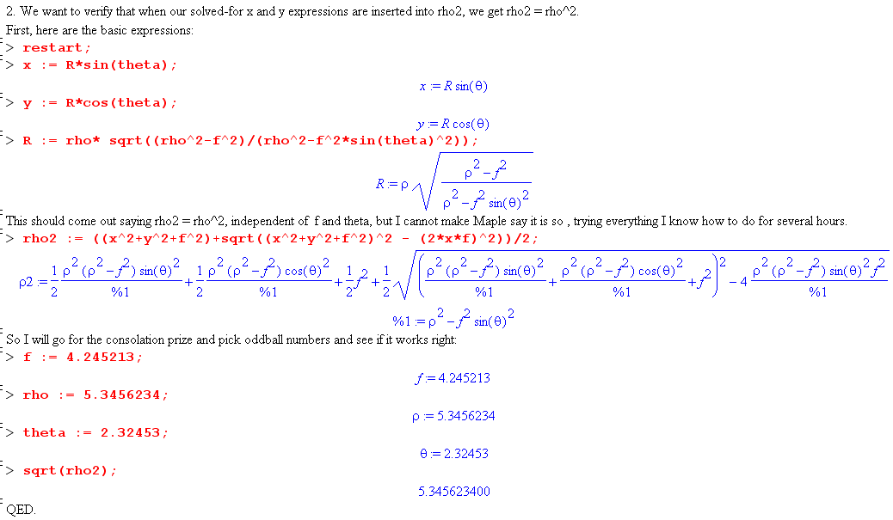

4. Compute the Tup matrix

Here is the Maple code which does this

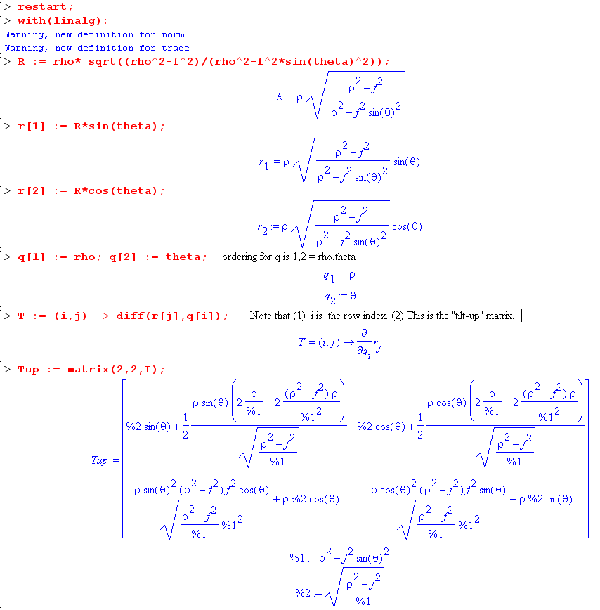

The top row is the vector eρ . We can see that the components of the vector have this form

eρ = (sinθ * stuff, cosθ * stuff) = stuff (sinθ, cosθ) => ex/ey = tanθ

Knowing that ρ > f, we know that %1 > 0 and %2 > 0, so stuff > 0 as well. Thus result then agrees exactly with the picture above.

The second row is the vector eθ. For θ in the first quadrant (as in our drawing), the x component is positive. The y component could have either sign. In our picture, the y component is negative, so hopefully this is all correct.

5. Compute the metric tensor.

I did this in Maple, it is a horrendous mess but I was able to simplify the elements, and below I am able to grind it down to something chewable. Maple says (after much work)

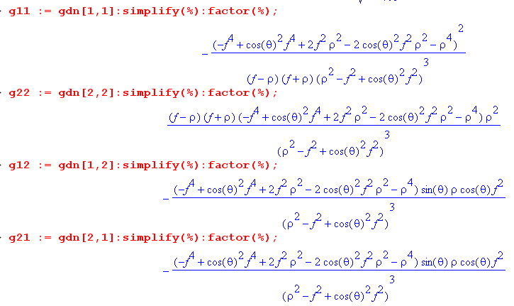

We can see that g21 = g12 as expected. So here are manual results

g11 = ( -f4 + f4cos2θ + 2f2ρ2 - 2ρ2f2cos2θ - ρ4)2 / [(ρ2-f2)( ρ2-f2+ cos2θ f2)3]

= (f4 [-1 + cos2θ] + 2 f2ρ2[1 - cos2θ] - ρ4)2 / [(ρ2-f2)( ρ2-f2[1- cos2θ])3]

= (-f4sin2θ + 2ρ2f2sin2θ - ρ4)2 / [(ρ2-f2)( ρ2-f2sin2θ)3] dim = L0

g22 has the same long factor in the numerator so the result is this

g22 = ρ2(ρ2-f2) (f4sin2θ - 2ρ2f2sin2θ + ρ4) / ( ρ2-f2sin2θ)3 dim = L2

and g12= g21 is similar

g12= g21 = ρf2sinθcosθ(f4sin2θ - 2ρ2f2sin2θ + ρ4) / ( ρ2-f2sin2θ)3 dim = L1

And we summarize

gρρ = (-f4sin2θ + 2ρ2f2sin2θ - ρ4)2 / [(ρ2-f2)( ρ2-f2sin2θ)3] dim = L0

gθθ = ρ2(ρ2-f2) (f4sin2θ - 2ρ2f2sin2θ + ρ4) / ( ρ2-f2sin2θ)3 dim = L2

gρθ = ρf2sinθcosθ(f4sin2θ - 2ρ2f2sin2θ + ρ4) / ( ρ2-f2sin2θ)3 dim = L1

Here is a more compact presentation:

gρρ = A2B / (ρ2-f2) dim = L0 A = (f4sin2θ - 2ρ2f2sin2θ + ρ4)

gθθ = ρ2(ρ2-f2) AB dim = L2 B = 1/( ρ2-f2sin2θ)3

gρθ = ρf2sinθcosθ AB dim = L1

(ds)2 = gρρ (dρ)2 + gθθ(dθ)2 + 2 gρθ(dρ)(dθ)

Obviously this ρ,θ coordinate system is non-orthogonal. If f goes to zero, A = ρ4, B = 1/ρ6 and we get

gρρ = ρ8ρ-6 / (ρ2) = 1

gθθ = ρ2(ρ2) ρ-2 = ρ2

gρθ = 0

(ds)2 = (dρ)2 + ρ2 (dθ)2

and this is the result for a circle with r = ρ.

6. The Hobson connection

3D 2D
ellipsoidal coordinates bipolar coordinates (ellipses and hyperbolas)
spherical coordinates polar coordinates r and θ
conical coordinates polar coordinates r and θ
ellipsoidal ρ,θ,φ system the ρ,θ system of this doc

In the 3D conical system, we have the usual polar cone pointing up which becomes our polar angle θ cone of polar coordinates. The other sideways 3D conical cone does not exist in the 2D system. So it happens that the 2D analog of both spherical and conical coordinates is the polar coordinates.

