Tour of Hobson's Ellipsoidal Harmonics Book PhL 3.26.05

See the end for info on Mr. Hobson himself.

The Theory of Spherical and Ellipsoidal Harmonics
E. W. Hobson 1931 FRS, ScD, LLD

When I was doing ellipsoidal coordinates, this book was mentioned in various places, and I could never find a source for it. There are used copies for $90 on Amazon, the book is of course out of print. I was able finally to check this out from Marriott and today I will take a look at it.
The book is written in the style of numbered sections 1-292 which increment through the 11 chapters. Each page at the top shows page number, Chapter number, and Section number, with references on page bottoms as needed. I like this approach. Some of the many equations have numbers which start with (1) in each chapter. It was possible to do a simple 2 page up 100% copy for the pages I copied.

Chapter 1 : The Transformation of Laplace's Equation [1]

1. Comments on the Laplace equation and BV problems
2. Curvilinear coordinates hi, scale factors called Hi
3. How to write ∇2 on curvilinear coordinates
4. Separation of variables
5. Some simple Smythian forms : note the use of over/below un-bracketed notation on page 8

Chapter 2: Solution of Laplace in polar (spherical) coordinates with m=0: the Pn and Qn [9]

6-30. This is a special case of the hi, the Hi are stated, and we are off and running. We get the SL problem in z which he calls μ, the usual recursion relations for coefficients. He starts with m=0 so we have Pn(μ) and we then get lots of facts about this function, sometimes written Pn(cosθ), some forms involving F. This is like a mini-Bateman section. He then starts into integral representations for the Pn including the Mehler one. He writes "shew" for "show". He has example sections where he states a problem then solves it. We are then onto the recursions for the Pn . Then come integrals involving Pn functions.

31-53. Finally we get to the Qn functions, and we more or less repeat the stuff of the last paragraph. There is some mention of doing numerical "quadratures" work I think. I get the impression that every single equation is derived in line by Hobson.

Chapter 3: The Legendre Associated Functions [89]

54-73. Hobson allows that n and m can be arbitrary, but he will be working with n ≥ m ≥ 0 for a while.
Notice the reverse order in the name. Tessoral and sectorial, and we are off on properties of Pnm(μ). He mentions notational differences and says that Ferrars (1877 book on spherical harmonics) used

Tnm(cosθ) = (-1)m Pnm(cosθ).

Heine's notation mentioned. Some reader has added some crude arrows and check marks in this chapter. He then obtains series involving Pnm functions and from these get gets integral representations. On page 98 he gets around to defining Pn-m , including integral representations for this. Then the generating function on p 105. Many pages have thumb rips on the bottom. ON p 109 he starts into Qnm(cosθ), and then integral representations for this Q.

Chapter 4: Spherical harmonics [119]

74-113. This chapter is a little strange in its starting point. We have a section on "Maxwell's Theory of Poles". A pole seems to be just the intersection of a ray (an axis for Hobson) with the sphere. He has some direct quotes from Maxwell. Eventually on page 137 we get the atomic spherical form for sphericals, cosmφ only. This is all exceedingly strange and probably most would say "old fashioned". Then on page 150 we start seeing Yn(θ,φ) notation. On page 152 we have "the theory of the Newtonian potential". I just noticed that Hobson does not use dot products, but writes out xx'+yy'+zz'. On page 163 we see the angular portion of L2 stated for the first time, but no "operators", no "Hilbert space", no Lie algebra.
We come then to page 166 where he lists a table of "harmonics of degree zero", exceedingly strange. I think these are Laplace solutions, but all are written out in terms of x,y,z,r and φ. I'm not sure what the word "degree" means. We have "line harmonics" and then "circulatory harmonics". Every page of this book has about 10 equations. This entire chapter is very strange indeed.

Chapter 5: Spherical harmonics of General Type [178]

114-190 . I think the idea here is to move away from integer n and m ("general type"). So we then get into the hypergeometric equation and the Riemann P-function solution notation. Hobson then expends many pages to get us to the point where we write Pnm(μ) in the very first Bateman F form. I imagine he has shown along the way that this reproduces the many integer results he has so far accumulated. Lots of interesting contour integration pictures. We then get similar F forms for Qnm(μ) on p 195. Then on page 205 we have the famous relation between Pnm and Pn-m and he uses the old-fashioned Π notation

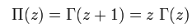

Hobson is now off on deriving I guess all those Bateman table forms. He then on page 227 gets around to talking about what Bateman calls on-the-cut versions of P and Q, and Hobson defines his versions of these things, perhaps they are the same. Those Π things are flying all over every page. Then we are on to the issues of Pnm(-μ) and Qnm(-μ). The strange contours continue unabated! Then we have integral representations for things like Pnm(coshψ) so we are off on the positive real axis, p 262. We are then doing "generalizations of Mehler's expressions" which is just a boatload more of integral representations. On page 272 I happen to notice mention of the conical functions with n = -1/2+ip. He will talk about such things as "expansions of P and Q in powers of (some small expression)" and these are of course just the entries in the Bateman tables. On page 289 he is then off doing recurrence relations for the P's now in our more general world, and some reader has written "wrong! see such and so" . Some poor typesetter had to set this entire book containing perhaps 5,000 equations!

Chapter 6: Approximate Values of the Generalized Legendre's Functions [293]

191-204. This includes various asymptotic limits P and Q functions. I presume by "generalized" in the title of this chapter Hobson is just referring to the P and Q when n and m are not integers. There is no mention in this book of Sturm-Liouville theory, those buys were both in the 1800's.

Chapter 7: Representations of Functions by Series [318]

205-217 . The first dozen pages here seem to have nothing to do with any series. Eventually on page 335 we get the usual generating function series. So he is talking here about "series involving P and Q functions" , not series for P and Q functions. I think all of this chapter is concerned with the question of the convergence of the simple P series. Again, no mention of basis, Hilbert Space. He just didn't have these tools in 1931 I guess.
Well he is talking about two series in the chapter. The "Legendre Series" really means expanding a function f(x) onto the Pn(x). I would write f(z) = ΣnfnPn(z). In my world, we have an expansion and a projection, a complete transform, I know that the Pn(z) form a "complete basis", so I never worry about convergence issues. The "Laplace Series" refers to expanding f(θ,φ) on a sphere and he writes it this way

f(θ,φ) = (1/4π) Σn=0∞ (2n+1) ∫dΩ f(θ,φ) Pn(cosγ)

with the usual meaning of cosγ. So here we are sort of mixing an addition theorem with an expansion theorem. People spent a lot of time worrying about convergence of such series. I think nowadays I would have a simple rotation group explanation of the above expansion. Oh yes, no mention of "rotation group" in this 500 page book on "spherical harmonics", fascinating. Continuous Lie group stuff appeared in the 1880's.

Chapter 8: The Addition Theorems for General Legendre's Functions [360]

218-228. Just as Hobson seemed not to know about group theorem, just so I, when writing my thesis in 1976, did not know about Hobson's 1931 book and this chapter in it! One has to remember the pre-internet era where you had to track down every reference at a library or in some "data base". I never did an interlibrary loan at UCB, I was ignernt and no one was helping me to be less so. I used the Rad Lab library, but hardly ever went into the main campus library. There was a one room physics library on campus, I do remember it, but don't remember checking out books there in all those years! But I must have checked out books because I have lots of Xerox copies of books.
Hobson opens with the usual P addition theorem on the first page, and then he is off again with hundreds of equations, perhaps showing convergence, who knows. On page 379 he has some addition theorem involving both P and Q functions. Perhaps something like this would make the connection between the oblate σ on a disk and the simple known results. Remember the role of group theory for addition theorems, something he does not seen to have in his arsenal.

Chapter 9: The Zeros of Legendre's and Associated Functions [385]

229-241. He gives no motivation for why you would want to know the zeros, but of course I know why. He gets into both real and complex zeros. Lots of cases considered eg page 396. He first does P, then Q, in terms of finding zeros. He also does the conicals. He then moves on to find the zeros in the variable n instead of μ. He ends with comments on numerical calculations. Oh yes, Hobson had no computers, there was no such thing as a "computer" in 1931.

Chapter 10: Harmonics for spaces bounded by surfaces of revolution [410]

242-268. So here we are going to hit on the curvilinear systems that have azimuths. The prolate spheroids are on page 412 and the atomic forms are quoted such as Pnm(cosθ)Pnm(coshη) times sin/cos mφ. I think he may have an addition theorem or two in this context, as I already know about. Thence onto the oblate spheroids on page 421 and we now of course have an imaginary argument. His imaginary i is a little script thing you can hardly see and it has no dot on it. Then on page 433 we have "The Ring-Functions" which are the toroidals. He later uses the notation Kpm(coshη) = P-1/2+ipm(coshη). That leading radical factor appears and again we have atomic forms. Next we have a section on "Harmonic Functions for spaces with Conal Boundaries". We would now say "conical" I think. The idea here is that you now have Pn where n = ns are the zeros of Pn(cosγ) where γ is your metal conical surface. All fine and dandy. Next p 264 is onto "Dipolar Coordinates" but I am not clear what these even are! It is some kind of "inversion" of spherical coordinates where some of the surfaces become spindles. The very last section is called "Harmonics for a Bowl" which of course uses toroidals and so those Kpm functions mentioned above occur. Again, a "bowl" is a surface of revolution and fits into this chapter. All in all, this is an interesting collection of information under an interesting chapter title.

Chapter 11: Ellipsoidal Harmonics [454]

269-292. Finally we get to the only chapter that is of interest to me and was my motivation for getting this book. I did not know of course that there would be only one chapter of 40 pages on this topic, and I will no doubt copy these pages since Lame function information is very hard to find! DONE.

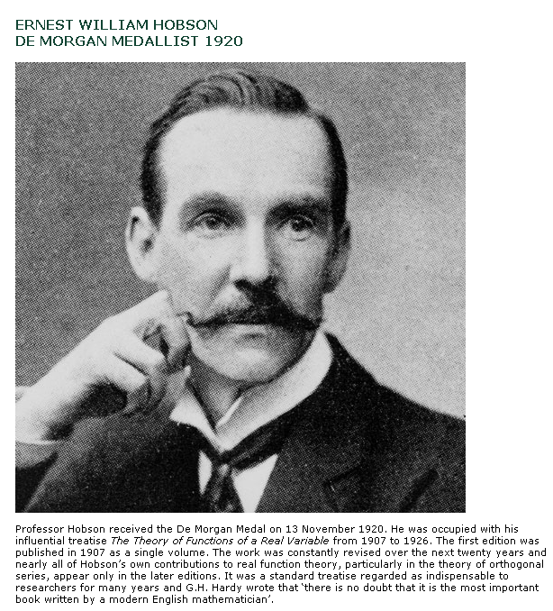

A Review from 1932, one year after publication:

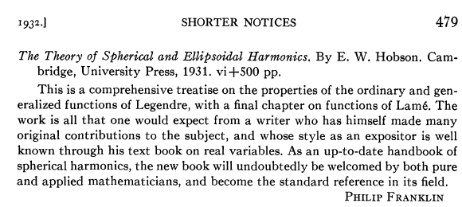

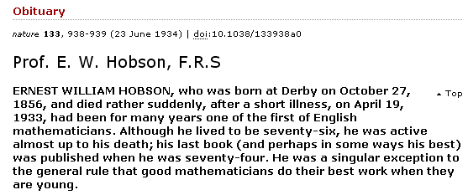

Biography

Ernest William Hobson
Born: 27 Oct 1856 in Derby, England
Died: 19 April 1933 in Cambridge, Cambridgeshire, England

Ernest Hobson's mother was Josephine Atkinson. His father, William Hobson, was the editor of the Derbyshire Advertiser, jointly owning the paper and also playing a large role in local politics. Ernest was [2]:-

Brought up in rigidly Low Church surroundings ... [and] seems to have felt bitterly the fetters of dogmatism and resolved to shake them off.

He was not the infant prodigy that many mathematicians are, rather the reverse in fact for he was considered as a child to be without many gifts. He attended Derby School where he was well taught, but failed to shine until he was 13 years old when he suddenly amazed everyone by gaining distinction in the Cambridge Junior Local Examinations in mathematics, natural sciences, French and music. While at school [2]:-

... he developed strong views of rationalism, becoming ... an avowed radical and agnostic.

He studied at the Royal College of Science and gained a Whitworth scholarship in 1871 which enabled him to study physics with Frederick Guthrie at the Royal School of Mines. These two institutions combined in 1907 to become Imperial College of Science and Technology which was a College of the University of London from 1908. Hobson then won a mathematics scholarship to Christ's College, Cambridge, entering in 1874.

He graduated as Senior Wrangler (ranked first in the list of First Class students) in the Mathematical Tripos of 1878 despite, as noted in [2], being:-

... more notable as a thinker than as a calculator.

He was appointed to a fellowship at Christ's College in 1879 and taught at Cambridge for the rest of his life. For many years, however, he only taught at the College, playing hardly any role in university life outside College [2]:-

His work consisted in private coaching and in lecturing in Christ's on more or less elementary mathematics for the Pass and honours examinations.

Perhaps, rather surprisingly, he coached Philippa Fawcett, the Senior Woman Wrangler of 1890, despite his well known strongly held views against women. He married Selina Rosa Knüsli, who came from Glarus in Switzerland, in 1882 and continued with his College life until 1904 when he was appointed to a university lectureship. Cambridge had set up two new prestigious lectureships in the previous year, the Cayley lectureship and the Stokes lectureship. Hobson was the first appointment to the Stokes lectureship.

Hobson published A Treatise on Trigonometry in 1891 [2]:-

... which possessed a standard of rigour new to Cambridge.

He was introduced to modern analysis by Young and after this he began to make a real contribution to research. His research concentrated on convergence, in particular convergence of series of orthogonal functions.

His book Theory of Functions of a Real Variable published in 1907 was the first English book on the measure and integration developed by Baire, Borel and Lebesgue. Hardy believed that this work had been of major importance in the development of pure mathematics in Britain. Probably mainly due to this particularly influential work, Hobson was elected Sadleirian professor at Cambridge in 1910. The Sadleirian chair only became vacant that year because Forsyth had been forced him to resign the chair after a scandal resulted from his love affair with the wife of C V Boys. The Theory of Functions of a Real Variable was a [2]:-

... solid book of reference, for which the mathematical world owes a debt of gratitude to the author, [but was] soon out of print and out of date. The leisure which Hobson enjoyed after his election to the Sadleirian Professorship enabled him to devote himself to its complete rewriting, and the second edition (1922-25) was double the size of the first. It is characterised not merely by a great breadth of information and by a critical and conscientious consultation of authorities of the most varied nationalities, but more especially by conspicuous objectiveness and fairness.

Another book which Hobson published was Squaring the circle in 1913. This is a delightful little work which I [EFR] greatly enjoyed reading. Entertainingly written, yet packed with useful information, it leaves me wishing that he had written more popular works.

Hobson was elected a fellow of the Royal Society in 1893, serving as a member of its council, and being awarded the Society's Royal Medal in 1907. He was an active member of the London Mathematical Society, being president of the Society 1900-2 and receiving the De Morgan Medal of the Society in 1920. He was also president of Section A of the British association at its meeting in Winnipeg, Canada, in 1909.

To many Hobson is better known for the Gifford lectures he gave on The domain of natural science at the University of Aberdeen in 1921-22 than for his mathematical contribution. This comment is in no way intended to minimise the value of his mathematical contributions, rather it is to emphasise the high regard in which his Gifford lectures were held. These lectures were published in 1923.

Article by: J J O'Connor and E F Robertson

October 2003

___________________________________

