Parsing a Lord Kelvin Paper (ver 1) (1824 -1907, born Belfast, then lived Glasgow) PhL 11.9.09

Preliminary Remarks (see Overview below)

Warning: this is not the "bowl" paper -- that is another paper in this volume!

Lord Kelvin = Sir William Thomson. My volume of collected papers was in fact published by Kelvin himself in 1872 when he was 48 years old, then a second edition with errata fixed appeared in 1884, which is the one I have (Kelvin died much later in 1907).

The paper I review here is the very first of the 42 papers in the volume of ~800 pages. The title:

"On the uniform motion of heat in homogeneous solid bodies and its connexion with the mathematical theory of electricity".

A heat problem might be to start with a hot metal ellipsoid of uniform surface temperature and embed this in a perhaps less heat-conducting, uniform, and perhaps solid medium going out to infinity. The problem is to find the temperature everywhere outside the metal ellipsoid. I guess the heat "moves" out from the constant temperature metal ellipsoid as a "uniform motion of heat". We don't think of heat as "moving" any more, but "flowing". Similarly, we say water flows, it doesn't "move". An object moves. The analogous electrostatics problem is a charged metal ellipsoid of constant potential sitting in a vacuum, and we want to know the potential everywhere inside and outside the ellipsoid. I think part of Kelvin's novelty was showing the connection between heat flow and electrostatics without really talking about the Laplace equation and boundary value problems. The connection was not clear at that time 1842.

The paper consists of 24 short (on average) sections (Sec 1 thru Sec 24) , each having its purpose. These sections are in three groupings of which the central grouping is of most interest to me.

This paper was written in 1842 when Billy Thomson was age 18 (what was I doing at age 18?) and published by his Glasgow math professor father under a pseudonym PQR. This was his third paper, the first two supported Fourier's work which the British naturally opposed for a reason I don't understand This third paper was republished with some footnotes in 1854, and then republished again in the collection volumes. A copy of the 1884 collection sits in the University of Toronto library, and was digitized by Microsoft in 2008 and I was able to download it as a 42 MB searchable PDF file. Very amazing. [ I later converted this to a fast djvu file which is 51 MB which finally makes the document usable! Conversion took all day, circa 10.1.10.]

Kelvin's work is very hard to follow for various reasons. One is that many symbols he uses differ from those of today. Another is the lack of clean logic flow, and a third is language -- words and phrases are different now, though his writing is exemplary. Another is that he seems to be solving several problems at the same time. Another is heavy reliance on geometry. Also, there is not even a single drawing, I presume because drawings were expensive to print. I might add that many of his arguments are just not very good -- they are convoluted, could be simplified. In his defense, I have to say he was more or less inventing all this stuff (at least for himself) in his writing.

Note: I got somewhat balled up in Section 3 of these notes and eventually started over in the "parse 2" doc. But I will retain these notes since Sections 4 and 6 are correct and I did not repeat them in parse 2.

Preliminary Remarks (see Overview below) 1
Overview (10.6.10 3 pages) 2
1. Kelvin's problem and his solution. 5
2. Preliminary Calculations on the Perp Distance p 6
3. Kelvin Parsing 8
The First Part of Kelvin's Paper (Sec 1-Sec 10) 8
The Middle Part of Kelvin's Paper (Sec 11-Sec 18) 10
Section 11. 10
Section 12. 11
Section 13. 13
Sections 14-18 14
Sections 19-20 15
The Final Part of Kelvin's Paper (Sec 21-Sec 24) 16
4. Spheroidal limit of Kelvin's solution 16
5. Comments 17
6. Is there force on a mass inside a similar ellipsoidal shell? 19

________________________________________________________________________________

Overview (10.6.10 3 pages)

In Section 1 I simple quote Kelvin's solution to the charged ellipsoid problem. In this solution, a,b,c are semi-major axes of the ellipsoid, while f and g are the two focal distances computed from a,b,c. The solution is quite simple, involving the first-kind elliptic integral F(x,y) and csc-1 functions. He credits Lamé for first solving this problem in 1837 (but not proving it), while Kelvin is writing in 1842.

In Section 2 I discuss the distance p = 1/$\sqrt{x2/a4 + y2/b4 + z2/c4}$ and state expressions for the three direction cosines at some point (x,y,z) on the surface of an ellipse. I prove this formula in 2D only. This is nothing but geometry. The 3D derivation would not be difficult I think.

In Section 3 I begin my "Kelvin parsing" :

• In Sec's 1-10 Kelvin derives a few concepts which are obvious to a Freshman electrostatics student. These include V = q/R and superposition to get V = ∫dA σ/R. He notes that Et = 0 at a conducting surface, and E⊥ = 4πσ. He notes that ∫dA σ/R = V0 is an integral equation to be solved for σ on a conductor's surface at potential V0. I am greatly confused by the history of who knew what when. I am phrasing all these "facts" in electrostatics language, but Kelvin states them in heat flow language.

• In Sec 11 he talks gravitational forces and ellipsoids. (1) He claims (no proof) that if you create a thin mass shell of uniform density ρ between two similar ellipses, the gravitational force inside will be 0. [ I prove this I think in my Section 6 below.] My notes don't state why this fact, if true, is useful. I think it may be this: If true and we put a pillbox through the surface and consider ∫G•dA = mass enclosed where G = -∇V is the grav field, we find -dA(dV/dn) = 4πdm where n is the normal and dm is the mass in the pillbox from the shell, and dV/dn is just outside the shell. The point is that the inside face of the pillbox makes not contribution since V = constant inside. (2) He goes on to define a smallness parameter k related to the thinness of the shell and he then writes things like δa/a = δb/b = δc/c = k = δp/p where I understand that δp is the shell thickness at a point of interest. Kelvin defines his ρ ≡ dm/dA which you can think of (like σ) as a "shell mass density" which is not the same as the uniform 3D density of the matter making up the shell which I call ρ'. The volume containing the mass dm is dV = δp dA so certainly ρ' = dm/dV = ρdA/δpA = ρ/δp = ρ/(kp). Therefore he knows that ρ = kpρ'. He then assumes matter having ρ' = 1, so then ρ = kp = dm/dA. (3) He combines these last two results to get -dV/dn = 4πkp which is his Equation (a). This was a lot of arm waving to get such a simple result! But from this result, we get our first hint that in an ellipsoidal electrostatic problem, we might expect the charge density σ to be proportional to the geometric distance p. If we extend k from its infinitesimal definition k = δa/a to a finite definition k = (a-a1)/a1, then we can think of k as labeling the outer ellipsoid (no subscript) a,b,c so now k is describing the finite shell between a reference ellipsoid 1 and one outside it. At this point, the outer ellipsoid could be similar, confocal or something else relative to the reference ellipsoid.

• In Sec 12 we compress our outer ellipsoidal surface down onto the inner one and say we have a very thin surface mass density ρ = kp on the inner shell, where k is now just some very small constant related to the smallness of the original similar shell. Parameters of this inner surface have subscript 1, such as a1. So now the outer surface (subscript 2) is completely gone. But, now we create another outer surface which is a different one. We seek a nearby outer surface which differs from the inner shell by a small constant potential C, so if the inner shell has constant V (a piece of electrostatics metal) then the outer ellipsoid will be an equipotential. Using equation (a) from Sec 11, Kelvin shows that the equation of such an outer shell is in fact an ellipsoid which is confocal to the inner one (not similar to it). He is able to label this outer ellipsoid with θ1 where θ1 = C/(4πk) = constant, so now we have the concept of a parameter labeling a confocal ellipsoid. We now have today's standard equation for an ellipsoid which I quote. I presume by iterating this argument, we find that all the surrounding confocal ellipsoids are equipotential surfaces. Since ellipsoids were new to me at this reading, I have a long comment where I do the math for ellipsoidal surfaces and discuss the focal distances involved called f and g.

• In Sec 13 Kelvin is going to equate the grav flux going through the two shells. As I show in my parse 2 notes, for the inner ellipsoid we can say

flux inner = ∫inner shell dv/dn dA = – ∫inner shell 4πk1p1 dA = - 4πk1 ∫inner shell p1 dA

Today's writer would just evaluate the integral ∫p1dA1 over the ellipsoid, but Kelvin does it by a trick. He re-imagines the inner surface to have a tiny thickness bounded by two similars with δp/p = k' with k' some small constant. the integral is then ∫δp/k' * dA = (1/k') ∫δp dA = (1/k') ∫δn dA = (1/k') Vshell.
But earlier in the notes I show that the volume of a shell of similars is Vshell = 4πk'abc. Thus we have shown that ∫inner shell p1 dA = 4πabc and we have done this integral. so flux inner = -(4π)2k1a1b1c1 where k1 is the "label" of the inner ellipsoid. The flux for the outer one is done the same way, and we let it be described by k, a, b, c so flux equality says k1a1b1c1 = kabc and k = k1(a1b1c1)/(abc). So this tells you how to compute k for the outer ellipsoid where k1 is the label for the reference one. Now we have that dv/dn = - 4πkp = -4π [k1(a1b1c1)/(abc)] p which is Equation (c).[ I think this calculation is true for any two ellipsoids with the same center, confocal similar or otherwise? ]

• In Sec 14-18 Kelvin integrates the above dv/dn equation to get the final answer for v. Since we have a well defined expression that p = 1/$\sqrt{x2/a4 + y2/b4 + z2/c4}$ and everything else is constant, this is just a matter of "doing an integral". He grinds away on the crank. He finds the angle which is the elliptic integral angle φ and gets things cast into the first kind elliptic integral and gets the result I quote in my Section 1.

• In Sec 19 Kelvin summarizes what he has done. He keeps using the phrase "uniform motion of heat" which seems to mean "electric flux lines perpendicular to equipotential surfaces".

• In Sec 20, he claims that Lamé first solved this problem in 1837 by means of the Laplace equation. I mention a nice book "convolutions in French math". Kelvin then does Lamé's solution. I note below that Lamé invented curvilinear coordinates later in 1859.

• In Sec's 21-24 (sudden topic change) Kelvin computes the force acting on a test mass in the presence of a uniform solid ellipsoid, including the case that the test mass lies inside the ellipsoid. He expresses the results as integrals and claims his results agree with work done by others. He makes use of the fact, in the inside case, the force is due only to the ellipsoid which is interior to the point, due to his "similar shell no force" claim made earlier.

In Section 4, I take the spheroid limit of Kelvin's general ellipsoid result (stated in Section 1), but I first (a ≥ b ≥ c) do a certain b↔c swap, then I set a = b and the results just fall out. The elliptical integral F goes away, and we get the famous sin-1 result which I quote, and which I obtain using oblate coordinates in my #2 oblate doc.

In Section 5 I just have some comments. The first is that Kelvin later acknowledged that he did not know of the work of Green or Gauss (Gauss's Law!) and credits them accordingly. The second is that Kelvin drifts randomly between the three potential theory applications of heat, gravity and electrostatics. The third concerns the cost of drawings probably being very high, each needed a wood-engraving. I note that people said Fφ to mean F(φ), and nothing to mean zero. I comment that I learned the general notion of confocal ellipsoids written out in terms of ξ1 for example in later ellipsoidal coordinate discussions. I think curvilinear coordinates in general were invented by Lamé this 1859 paper "Leçons sur les coordonnées curvilignes et leurs diverses applications" which has a Google book scan, it is of course in French. Lamé then considered the Laplace equation in various coordinate systems. Comment that Kelvin papers are not a place for a novice to start studying! Comment that metal cube has not been solved analytically says Jim Ball.

In Section 6 I tried to prove by some arm-waving that the potential on the inner surface and inside a uniform thick ellipsoidal shell bounded by two similar ellipsoids is constant! Kelvin makes use of this fact for a very thin such shell, but of course you can stack them to get a thick shell. My proof I now realize is completely false, so I have to just accept this fact for the time being. It would be a good exercise in ellipsoidal coordinates.
________________________________________________________________________________

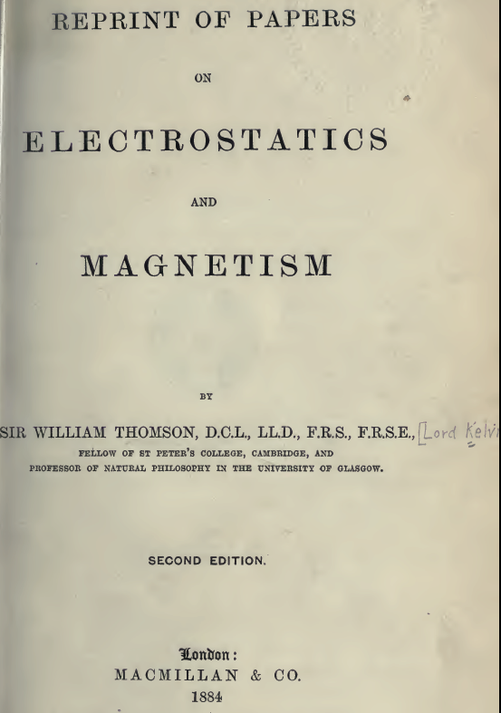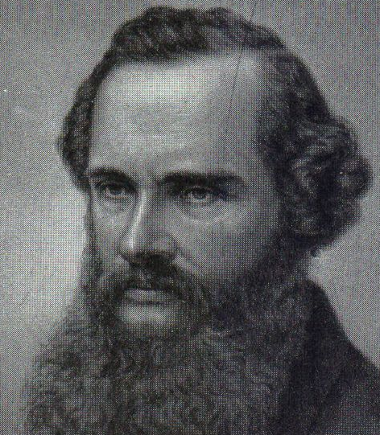

1. Kelvin's problem and his solution.

His problem is to compute the potential of a charged metal ellipsoid of semi-major axes a1,b1,c1. He concludes that the equipotential surfaces are all "confocal" (in a special ellipsoidal sense) with the metal surface, which seems right. His result is this, where F is "my" standard 1st kind elliptic integral.

v(φ) = v1 F(φ,c')/F(φ1,c') where a = f csc(φ)

f 2 = a12-b12 = a2-b2 // f,g are the focal distances of the two extremal ellipses
g 2 = a12-c12 = a2-c2
c' = g/f
φ1 = csc-1(a1/f)
φ = csc-1(a/f)

Kelvin comments that the solution was first found by Lamé in 1837 and he verifies his result against Lamé's, Lamé appears to have used ellipsoidal coordinates in some form (later I learned that the ellipsoidal harmonics are in fact called Lamé functions! )

2. Preliminary Calculations on the Perp Distance p

Kelvin likes a certain ellipse distance parameter he calls p which is the perp distance from ellipsoid center to the tangent plane of a point P = (x,y,z) on the ellipsoid. The vector p is parallel to the normal vector n at the point P. For an ellipsoid of semi major axes a,b,c this quantity is

p = 1/$\sqrt{x2/a4 + y2/b4 + z2/c4}$

Moreover, the direction cosines for the unit vector = are given by

cosα = (x/a2) / $\sqrt{x2/a4 + y2/b4 + z2/c4}$ = •
cosβ = (y/b2) / $\sqrt{x2/a4 + y2/b4 + z2/c4}$ = •
cosγ = (z/c2) / $\sqrt{x2/a4 + y2/b4 + z2/c4}$ = •

So we know now how to express the normal at a point (x,y,z) on an ellipsoid in terms of x,y,z.

While these items might be of only minor interest to the modern day ellipsoid researcher, they play a key role in Kelvin's very geometrical calculation of the potential of a charged ellipsoid.

The following detail notes are taken verbatim from my oblate doc, and I leave them there as well. I would advise the reader to skip this section unless very interested in this small detail.

(2) What is the perp distance p to the tangent plane at point r on an spheroid a,b ?

I only ask this because it seems significant to Kelvin in his paper (see elsewhere).
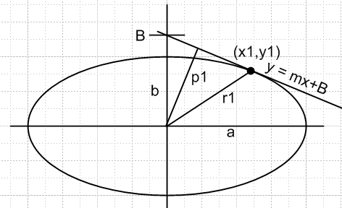

Since x2/a2+ y2/b2 = 1 we know that dy/dx = - (b/a)2(x/y) = m at point (x,y). Line is then

y = mx + B m = [- (b/a)2(x1/y1)] B = y1 - m x1

If we write out B and use the ellipse equation again, we find that B = b2/y1.

The vector from the tangent point to the intercept point on top is this

v = (0,B) - (x1,y1) = (-x1, B-y1) = (-x1, -mx1) = -x1(1,m)

and we know p•v = 0 so we have

px 1 + py m = 0 => py = -px/m

But we also know that py = mpx + B so set equal to get

-px/m = mpx + B => px = -Bm/(m2+1) => py = B/(m2+1)

Now we know distance p which we set out to find:

p2 = px2+ py2 = B2/(m2+1) = (y1 - m x1)2/ (m2+1) m = [- (b/a)2(x1/y1)]

If you plug in m and do the algebra and, on the numerator, use the fact that x12/a2 + y12/b2 = 1, you get this result that is the Kelvin result:

p = 1/$\sqrt{x12/a4 + y12/b4}$

Note that is the same as , the normal at the surface at the tangent point. If we wanted to know the "direction cosine" for to the y axis, cosβ = • = • , we could compute from the picture

cosβ = p/B = (y1/b2) / $\sqrt{x2/a4 + y2/b4}$

So we have a little theorem here:

Theorem 1: Given an ellipse (a,b), and given a point (x,y) on this ellipse, the perpendicular distance from the center of the ellipse to the plane tangent at (x,y) is given by

p = 1/$\sqrt{x2/a4 + y2/b4}$

Kelvin claims that you can generalize this to an arbitrary ellipsoid (a,b,c) and the result is

p = 1/$\sqrt{x2/a4 + y2/b4 + z2/c4}$

which seems pretty reasonable to me. Would have to redo the above proof using planes instead of lines. Then you would find that'

cosβ = p/B = (y1/b2) / $\sqrt{x2/a4 + y2/b4 + z2/c4}$

and similar results for the other two direction cosines of which I just add here

cosα = p/A = (x1/a2) / $\sqrt{x2/a4 + y2/b4 + z2/c4}$
cosβ = p/B = (y1/b2) / $\sqrt{x2/a4 + y2/b4 + z2/c4}$
cosγ = p/C = (z1/c2) / $\sqrt{x2/a4 + y2/b4 + z2/c4}$

I am mentioning all this direction cosine stuff because it shows up later where I "parse" Kelvin Section 12.

3. Kelvin Parsing I am looking at the following paper, first in the collection

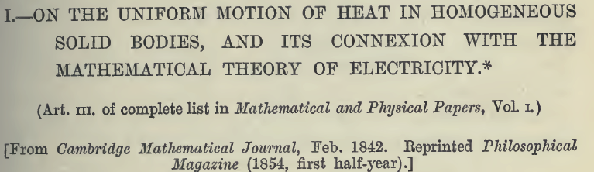

The First Part of Kelvin's Paper (Sec 1-Sec 10)

Summary: The first 10 sections have the general title

"Temperature at any point within or without an isothermal surface"

which could be restated as

"The potential inside and outside a charged metal conductor "

Basically this is a discussion of V = ∫dA σ/R and E⊥ = 4πσ and Et = 0, and we have mention that ∫dA σ/R = V0 is an integral equation you might solve for σ on a metal surface at potential V0. All the facts presented below are Freshman electrostatics applications of Gauss's Law which Kelvin seemed not to know about He was inventing the subject for himself. In footnotes added later, Kelvin credits authors including Gauss and Green for predating his work here. Here are some history timeline claims which make Kelvin seem a bit out of touch: (paper is 1842)

1764 - Joseph Louis Lagrange discovers the divergence theorem in connection with the study of gravitation. It later becomes known as Gauss's law. (See 1813).

ca. 1813 - Laplace shows that at the surface of a conductor the electric force is perpendicular to the surface and that .
1813 - Karl Friedrich Gauss rediscovers the divergence theorem of Lagrange. It will later become known as Gauss's law.

In Sec 1 Kelvin defines an isothermal surface (equipotential surface)

In Sec 2 he argues that if you are at some point outside ("without") some complicated localized surface containing heat sources in steady state, you can regard the sources as equivalent to a source-bounding surface on which you know some surface density of heat sources. In thermal world temperature is the potential, and this just says that the you can determine the potential by integrating over the surface heat source density (think charge density).

In Sec 3 he derives that v = A/r as the contribution of some point on the surface which is r from our observation point. Not too earth shattering. He is saying V = q/r for electrostatics. For a patch of surface we will have dV = σdA/r for electrostatics, and σ = surface heat source density he calls ρ for his problem.

In Sec 4 he suggests that you then integrate so v = ∫(ρ/r)dA. He writes dA = dω2. He regards the surface as having a label 1, so everything has a 1 subscript. He comments that if your surface happens to be an isothermal surface with temperature (potential) v1, then v1 = ∫(ρ1/r1)dA1 is an integral equation you would have to solve to find ρ1. Very Stakgold like.

In Sec 5 he argues using "heat flow language" that V = v1 in the entire interior of a equipotential (isothermal) surface. Fine. He goes on to say that if we think of the heat source as charge density, the force of the surface on a test charge just outside the surface is everywhere normal to the surface. The language he uses is very tortuous, talking about our putting an "attractive medium" on the surface (which I think of as charge density opposite that of a test charge, or just mass for gravitational force).

In Sec 6, even more tortuous, he discusses the idea of a mapping of isothermal surfaces and another mapping showing force lines which are perpendicular to the isotherms. I know all about it. He is constantly intermixing the heat and charge models. No mention of the "Laplace equation" or ODE's.

In Sec 7 he gives a verbal derivation of the fact that E = 4πσ outside a charged metal surface, but he writes this as -dv1/dn1 = 4πρ1. We are getting a little class in electrostatics (perhaps before it existed!)

In Sec 8 (he uses the word "nothing" in place of our modern word "zero") he restates the conclusion of Sec 7, reminding us that the force near the surface is perp to the surface.

In Sec 9 he uses a lot of words the tell us what flux is. Total flux through a surface is E, the "expenditure of heat".

In Sec 10 he rederives his expression for flux = - ∫ dv/dn dω2 which we write as -∫E•dA . He seems amazed that the charge will distribute itself on a conductor such that the field is normal to the surface. I have been using Gauss's law but here is a wiki observation:

"Gauss's Law was formulated by Carl Friedrich Gauss in 1835, but was not published until 1867"

and our Kelvin paper is 1842! [ But the 1835 date is in question based on comments above. ]

And so ends Sec 1-10 of this paper. He then says "the following is an example of the application of these principles: -- " and that takes us into Sec 11 with which we begin below.

The Middle Part of Kelvin's Paper (Sec 11-Sec 18)

Section 11. I am now starting into Kelvin's section 11. In the triple analogy electrostatics, temperature and gravity, he is now talking gravity. He opens with this claim that is certainly not obvious to me, and I will fill in some extra words I think he implies. If you construct a thin ellipsoidal shell as being between two "similar ellipsoids", and you construct this shell with a material of constant density ρ, then the gravitational force on a piece of mass inside the shell will be 0. This seems a mighty large assumption to make at the start of a long explanation of something, with no reference as to why it should be true. I think similar ellipsoids means they have the same center and are just linearly scaled relative to each other. [ I show his assumption is true Section 6 below ] [ and he does comment on this around Section 20 ]
Let's "accept" this claim for the moment, and see where he is headed. We have the discussion I read before that a,b,c are the semi axes, and δa/a = δb/b = δc/c = k = δp/p where p is his magic distance from center to the tangent plane. I agreed earlier that δp is the thickness of the shell at the tangent point, you draw a little picture and this comes out being true. His shell is from two ellipsoids 1 and 2. The mass of a shell chunk at the tangent point would be ρ δp dA where ρ is the mass density, δp is the thickness. Remember that as you go around the ellipsoid, p varies in the general range of a,b,c, it is never 0 or infinite. So we then know that dm = ρ δp A = ρ(kp)dA. Now let's imagine that the mass density ρ = 1, so we then have that dm = (kp)dA . Then dm/dA = kp and this is what Kelvin means by his symbol "ρ". So fine, we now have ρ = kp. Note that k is a dimensionless constant k << 1 but k>0,
The volume of an ellipsoid is V = (4π/3) abc (Schaum p 10). Here is the volume of the shell:

δV = (4π/3) (δa)bc + (4π/3) a (δb) c + ... = (4π/3) k abc + ..

= 4πkabc.

In his equation (a) (below) he is merely saying that the equivalent of E = - dV/dn = 4πσ, but here it is the gravitational potential V = v, and σ = dm/dA = ρ = kp. So I am happy with (a), given the big assumption we made at the start,

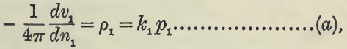

We can think of k as being a label for our outer similar ellipsoid. k = 0 and you get the original.

Comment #1. In the above, we had k as a small number. Suppose we let the outer ellipsoid #2 be similar but much larger than the inner one #1. Then k2 = (a2-a1)/a1 etc. So imagine that the #1 ellipsoid is a reference ellipsoid. Any similar one can be described by k = (a-a1)/a1 where k is some number. But suppose we have an outer ellipsoid #3 which is NOT similar to the original, but has the same center. He wants to claim that this is described by some number k2 but we won't have k2 = (a3-a1)/a1. He is trying to say that all ellipsoids with the same center have some label k, but he is just not clear what this label is.

Comment #2. Thinking of ellipses, it is pretty clear that the family of ellipses confocal to a reference inner ellipse is different from the family of ellipses you get by just scaling up the reference ellipse. None of the outer ellipses in one family will match any ellipse of the other family. The same idea applies to ellipsoids.

Section 12. What exactly is dv1? Our mass started out being real matter of density one, but now we are going to crush this mass down to make it be a mass surface layer on the inner ellipse. Nothing really changes when we do this. Then we make an outer ellipse in space which is formed by moving out distance dn at each point on the inner ellipse, where is the normal at each point, and dv1 is the change in potential going from the mass surface to this outer ellipse. The potential decreases, so dv1 = - C. Our equation (a) is dv1/dn = -4πkp so kp dn = C/4π, I agree. Then say pdn = C/(4πk) ≡ θ1 = a constant. Although k is very small, C must be smaller still, because pdn must be small. This is so because p is on the order of a,b,c but dn a differential along the normal vector at the tangent plane contact point.
By the way, notice that at the a-end of the ellipsoid, we have pdn = ada where da is just dn there.
Now let's imagine some direction cosines which determine the vector d

cosα = • etc

Then we have

dnx = dx = dn cosα // for example

Now how does he come up with this fancy expression for the direction cosine??? OK, I have derived this in my little detail section above, so it is a done deal. ( I did it in 2D, believe it in 3D). So I now agree completely with this line of Kelvin,

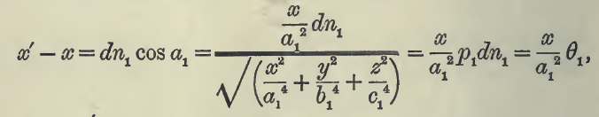

Kelvin now goes on to derive the equation for the outer ellipse, I accept the algebra shown without doing it. We then have this for the outer ellipse

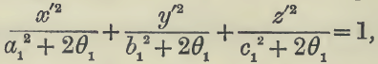

Now he claims that this new ellipsoid has the same foci as the original inner ellipse! Now an ellipsoid can be thought of (by me) as having two sets of foci relative to the long axis. If the semi axes are a,b then we know the focus distance is c'2 = a2-b2. And similarly for semi axes a,c we get c"2 = a2-c2. So the point is that if you add a constant amount to the denominator as shown above, the differences like a2-c2 don't change so the foci stay put.
OK here then is the point. Kelvin started out by constructing his mass shell as being the matter between two closely spaced similar ellipses. Note that a pair of similar ellipses have δc'/c = k just like all other distances, and are therefore NOT confocal. He then crunches this mass shell into a differentially small surface and then constructs an equipotential outer ellipsoid. He finds that this one is NOT similar to the original one, but is confocal with it! So he has shown that the equipotential surfaces for mass on a given ellipsoid (or charge, or temperature etc) are a family of confocal ellipsoids where confocal refers to the two extremal 2D ellipses which characterize the ellipsoid. If z' is the symmetry axis, then one of these extremal ellipses has x' = 0 and the other has y' = 0, and the above because a 2D ellipse equation to which my comments then apply.

Comment: Here is Kelvin's inner ellipsoid where a1, b2 and c2 are semi-major axes:

x2/a12 + y2/b12 + z2/c12 = 1

In elliptical coordinate notation, we now know we can write a general ellipsoid in a family a,b as

x2/( ξ12-a2) + y2/( ξ12- b2)+ z2/(ξ12) = 1 (*)

where a and b here are the focal distances for the two extremal ellipses passing through the long end of the ellipsoid, as I have drawn elsewhere, AND where ξ1 = the longest semi major axis. We can make this general form match the specific ellipsoid of Kelvin by making these identifications,

a12 = ξ12-a2 ξ12- b2 = b12 ξ12 = c12

So to get the match, we select ξ1 = c1 and then a2 = c12- a12 and b2 = c12- b12 .
Now go back to the general form shown in (*). Now we know that we can get to another confocal ellipsoid by changing ξ12 by a constant value Δξ12. So here is another ellipsoid in this same family

x2/( ξ12+Δξ12-a2) + y2/( ξ12+Δξ12- b2)+ z2/(ξ12+Δξ12) = 1
or
x2/( a12+Δξ12) + y2/( b12+Δξ12)+ z2/(c12+Δξ12) = 1

and if we set Δξ12 = 2θ1, we get Kelvin's general form for an ellipse confocal with his starting one:

Now suppose we consider an confocal outer ellipsoid with semi-major axes a,b,c (where these a and b are different from those used above, we are overloaded, beware). Then there must be some θ1 which makes the above pasted picture be the same as this

x2/a2 + y2/b2 + z2/c2 = 1

so we could then know that

a2- a12 = b2-b12 = c2-c12 = 2θ1 = Δξ12

which is why Kelvin claims above (d) that

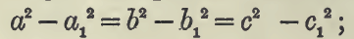

Meanwhile, our outer ellipsoid with semi-majors a,b,c has these two extremal ellipse foci,

f2 = a2-b2 g2 = a2 - c2

which is why Kelvin then says

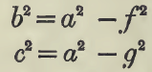

which lets Kelvin write that abc = a $\sqrt{a2-f2}$$\sqrt{a2-g2}$. But he can relate f and g to the inner ellipse "1",by
combining these last two equation sets to get

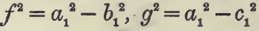

which of course are the same distances, now belonging to the inner confocal ellipse.

Section 13. I agree that pdn = ada at the ellipsoid end. This says dn/da = a/p, agreed. So you could label your larger ellipsoid by a and da, constants. Then you know how the thickness varies of the shell you have made with your two confocal ellipses: dn = (a da) 1/p so his favorite parameter p is the controlling factor here.

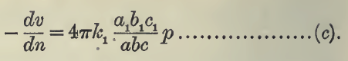

Now consider any ellipsoid of our confocal family. We know from the comments at the end of Section 11 above that we can describe this ellipsoid by some number k, a label. Yes, this k is a constant at all points on the surface of this ellipsoid. Kelvin now switches to the temperature/ heat model and says that if you consider two isothermal surfaces, the heat flowing through either must be the same (Gauss's law for electric flux, yet to come however). These two surfaces can be far apart. By equating the heat flows, he concludes that

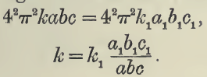

where k1 is the "label" for the original surface (the reference # 1) and k for the new isothermal surface. As noted above, Kelvin is hazy about what the label k really is. But by comparing the heat flow, he shows that if your reference original ellipse has k1, then an outer isothermal one has k as shown above.
Now I think the trick is that as you build out your isothermal surfaces, you maintain that arrangement that the normals are continuous lines, as in our 2D elliptical coordinates.

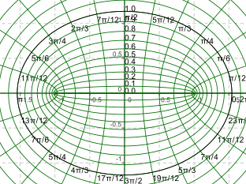 confocal families

So Kelvin at this point has shown that the product abc provides the label of an equipotential surface and he ends this section with,

Sections 14-18 Kelvin now wants to integrate the equation above to get an expression for v. He messages the integral into the elliptic form (which must have been known at the time)

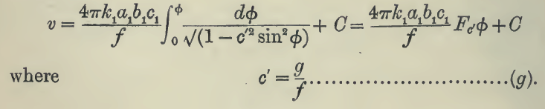

and he even calls it the F function. We would refer to c' as "k" and the integral as F(φ,k=c'). Notice his interesting way of writing the F function without a paren, just as I write sin φ without a paren. The results of his integration are then this

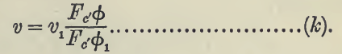
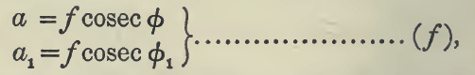

which is new to me.

Sections 19-20 . In Section 19 he gives a too-short summary of what he as so far shown. In Section 20 he then claims that a guy named Lamé first solved this problem

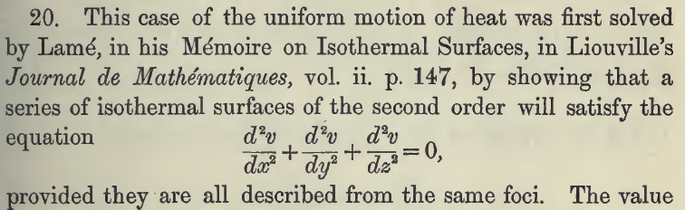

but we don't get a date on this and I see no section of references. But this Google scanned book

Convolutions in French mathematics, 1800-1840: from the calculus ..., Volume 2
By Ivor Grattan-Guinness

says the year was 1837. (This book conceals its reference list!)
Kelvin then reviews Lame's development. He does not use the phrase "Laplace equation" above.

There are a few more sections to this paper, but I skip them. Let's look again at his main conclusion:

v(φ) = v1 F(φ,c')/F(φ1,c') where a = f csc(φ) sinφ = (f/a) φ = sin-1(f/a)

f 2 = a12-b12 = a2-b2 these are the focal distances of the two extremal ellipses
g 2 = a12-c12 = a2-c2
c' = g/f
φ1 = csc-1(a1/f)
φ = csc-1(a/f) cscφ = (a/f) cosφ = $\sqrt{1 - (f/a)2}$
sinφ = (f/a) secφ = 1/$\sqrt{1 - (f/a)2}$ tanφ = (f/a)/ $\sqrt{1 - (f/a)2}$

So the variable here is φ which is a function of a. So ellipses are labeled by a in this method. Here the function F is the standard elliptic integral of the first kind.

Comments: Kelvin's solution is nice because it is directly in terms of the semi axes a,b,c of the ellipsoid in question, and f and g are the focal distances in the two extremal ellipses parallel to the long axis a.

The Final Part of Kelvin's Paper (Sec 21-Sec 24)

"Attraction of a homogeneous ellipsoid on a point within or without it".

This is a sort of non-sequitur discussion that he throws in because he has built up some tools that are relevant. He is asking for the force exerted on a test point mass located inside or outside a uniform solid ellipsoid. For a test mass inside, he thinks of the solid ellipsoid as the sum of a set of similar shells as per the earlier discussion, where he claimed (without proof I still think) that inside such a shell there is no force and the potential is constant. So for the "inside" problem, the force is due only to the solid ellipsoid interior to the test point. He obtains integrals for the components of this force called A,B,C along the three axes of the ellipsoid. For the outside problem, there is a similar result, I think only the integration endpoints are different. So this is a little exercise in integrating something over an ellipsoid, not really that exciting. He claims that his resulting integrals (he never does them) agree with work previously done.

4. Spheroidal limit of Kelvin's solution

What is the "spheroidal limit" of the Kelvin solution? Remember that his general three semi axes are a,b,c where we have a ≥ b ≥ c. If we draw an OBLATE spheroidal picture, the vertical distance must be c, the shortest of the three.
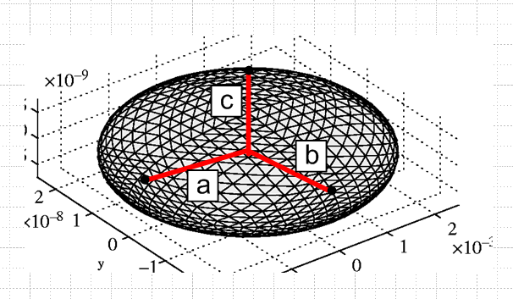

If we were to take the spheroid limit of Kelvin's result then a = b so f = 0, g = $\sqrt{a2-c2}$ so c' = ∞. At the same time, we will have φ = 0 and φ1 = 0, so this is a pretty tricky limit to take of the Kelvin solution, namely F(0,0)/F(0,0), though it could be done. I think the limit is more easily taken if we transform the F function somehow so things are more finite at the limit. In our situation we have k = c' → ∞ which means k' → i∞.
In my MF notes on the potential of a charged ellipsoid, I show that the Kelvin result is symmetric under swap of b and c, which is physically what we expect. I show that there using the basic F function transform which takes k to 1/k. So rewrite the Kelvin result above like this, doing the b↔ c swap:

v(φ) = v1 F(φ,c')/F(φ1,c') where a = f csc(φ) sinφ = (f/a) φ = sin-1(f/a)

f 2 = a12-c12 = a2-c2 these are the focal distances of the two extremal ellipses
g 2 = a12-b12 = a2-b2
c' = g/f
φ1 = csc-1(a1/f)
φ = csc-1(a/f) cscφ = (a/f) cosφ = $\sqrt{1 - (f/a)2}$
sinφ = (f/a) secφ = 1/$\sqrt{1 - (f/a)2}$ tanφ = (f/a)/ $\sqrt{1 - (f/a)2}$

Now in our limit a=b we get g = 0 and f = $\sqrt{a2-c2}$ so c' = 0 and things are much nicer. To connect with AS notion, we have

F(φ,k) = F(φ|m) = F(φ\α) k = sinα m = k2

In our case, we have c' = k = 0 so this says

F(φ,0) = F(φ|0) = F(φ\0) = φ // this last from AS page 594 17.4.19

So Kelvin's result is then

v(φ) = v1 F(φ,0)/F(φ1,0) = v1 φ/φ1 = v1 sin-1(f/a)/ sin-1(f/a1)

My M&F solution to this problem is (from page 22? of my oblate spheroidal.doc notes), when I install correct parameters for the focal distance f and semi-major axis A,

ψ(a) = V1 [sin-1(f/a) / sin-1(f/a1) ]

and, happy day finally, the spheroidal limit of the ellipsoidal Kelvin formula agrees with what I got quite a while ago doing MF on oblates.

5. Comments

• This is fascinating, to read one of Lord Kelvin's papers of 1842. The analogy between heat and electrostatics seems to have been a new one at this time. A footnote points out that Kelvin and others in France including Gauss did not know that George Green in 1828 figured all this stuff out, including Gauss's law which Kelvin applies here. This paper was republished in 1854 with acknowledgement to Green and others.

• Kelvin starts out talking about gravity and a mass shell, but he seems to seamlessly switch over to temperature and thermal conductivity when he has to talk about "flux", and eventually he is talking about electric charge. His model transitions are not very well delineated. I am not so sure it was clear to his readers that a point source of the potential in the three cases is mass, heat source, and charge and that in this sense all three problems are Laplace equation and deal with an inverse square force. He does not mention fluid flow, at least not in this paper.

• There is not one single drawing, so long sentences are used to described the various geometries of interest. Printing in 1842 at least allowed for Greek letters. Probably this stuff was all set up in moveable type, a drawing would require a major extra cost. I imagine each drawing becoming a lead plate that gets mixed with the metal letters in a press (correct, see quote below). Now of course this would all be done optically and drawings are probably relatively free, except some artist has to make them and get paid for that function. Web:

In the early 19th century the proliferation of popular journals, which often serialised novels for mass-circulation, produced a boom in popular illustration. The medium moved away from steel engraving which was the standard in the early century towards wood-engraving which could more easily be incorporated into pages of text. Book and journal publishers would employ workshops of wood-engravers to render artists' drawings onto polished blocks of fine-grained yew or box-wood which could then be locked directly into the printing-chase with the metal type. Notable figures of the early century were John Leech, George Cruikshank, Dickens' illustrator Hablot Knight Browne and, in France, Honoré Daumier. The same illustrators would contribute to satirical and straight-fiction magazines, but in both cases the demand was for character-drawing which encapsulated or caricatured social types and classes.

• Variable of a function is not put in parens, and the word "nothing" is used for "zero".

• The writing is clear, but major assumptions are made.

• Reading this has given my a better understanding of the confocal ellipsoidal coordinates I was looking at yesterday

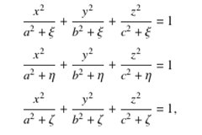

In each equation the variable (like ξ) is the label of a quadric surface. If you compare two surfaces with a different label, such as ξ1 and ξ2, they differ by an adder in all three denominators, and this means that the focal distances like a2-b2 of the two extremal ellipses of the ellipsoid (or similar for hyper) do not change, hence "confocal". So surely these are the right coordinates to use to solve Laplace in a problem like Kelvin's where all three semi-major axes are different. But I wonder what happens if you try to find a solution of Laplace using the usual separation of variables method? There is no simple azimuthal quantum number. I think MF deal with this issue somewhere in their two volumes. One wonder's how you would use these coordinates to arrive at Kelvin's conclusions. [ Lamé functions! ]

• I would not recommend reading papers like this to learn things for the first time. The author is himself just learning the stuff, things are not connected to more general ideas we now know, like Gauss's Law, say. There is a lack of pictures, notation is different, it is a long row to hoe for the modern reader, though it can be done (as I have shown above).

• Just an aside. Jim told me today that he did not teach with M&F with rather with Matthews and Walker. They had a short undergrad course, and a grad course that sometimes went a whole year. He said the potential of a simple metal cube has never been analytically computed, though the square has, probably by a conformal map. Mentioned a Jackson problem of a half dome on a plane which is not soluble either. Jim taught with green and red Jackson. Later talked about Fred's calculation of boat wake.

6. Is there force on a mass inside a similar ellipsoidal shell?

Regarding Kelvin's starting assumption that the gravitational potential inside a thin mass shell like that shown below between two similar ellipses is a constant.

Kelvin constructs a mass shell between two similar ellipsoids as I show here:

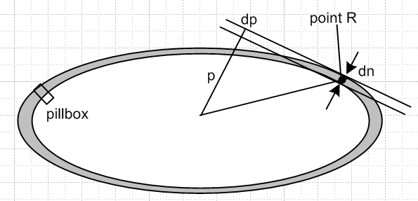

and he claims that dm = ρ dp A = ρ(kp)dA so the mass per area goes as dm/dA = kp where I set the 3D mass density to 1. So let's call this σ = surface mass density. In electrostatics we say -dV/dn = 4πσ where σ is the surface charge density, and Kelvin is applying this idea somehow to mass and gravitational force. In EM we derive this fact from a Gauss Law applied to a pillbox having one end inside a conductor where we know E = 0. I guess the gravitational situation is that our thin mass shell is in equilibrium, our mass filling liquid is stable and so feels no force, just as there is no force inside a conductor since charge (mass) could flow if there was. That is to say, the gravitational potential is constant inside the differentially thin mass shell (and therefore everywhere inside). So THIS [-dV/dn = 4πσ ] is where he is sneaking in the assumption he made at the start, and which is so non-obvious to me.
It would suffice to show that the potential is constant everywhere on the surface of the interior ellipsoid, then Laplace would tell us it was that same constant inside that ellipsoid, so we have this simpler problem then [ here ρ is the σ of the last paragraph, we integrate over a thin similar shell ]

∫shell ρ dV 1/|r- r1| = independent of r1 where r1 is on the inner shell surface

But Kelvin has shown (see earlier) that for a thin similar shell made of uniform material of density ρ' = 1 that we have ρ = kp ( ρ = effective surface density) where k is a small constant k = δp/p etc, where

p = 1/$\sqrt{x2/a4 + y2/b4 + z2/c4}$

So here then is our problem: we need to show this

∫shell dxdydz [1/$\sqrt{x2/a4 + y2/b4 + z2/c4}$] 1/ = indep of r1

which is a 3D volume integral and the shell has some uniform but differential thickness dt, because we have already accounted for the variation in the thickness with the p factor. Another way to write this is:

∫shell dA [1/$\sqrt{x2/a4 + y2/b4 + z2/c4}$] 1/ = indep of r1

where dA is the area element at some point (x,y,z) on the ellipsoid. But I don't know how to write this area in Cartesian coordinates so I don't know what to do at this point.

I really need to convert this whole thing to ellipsoidal coordinates in order to compute the integral, but that is "cheating" because we are at the Kelvin level of things. In particular, I don't know what to install for dA. I thought in the following blue text I had a proof, but now I see it is completely bogus because I omitted a factor AND it just makes no sense. I think the conclusion is true, however, that the inside of a thin or thick similar ellipsoidal mass shell is an equipotential. I presume it is also true in 2D. So I put this problem on one of my very many "back burners" for when I have time and motivation to pursue it.

Here is how I think the problem could be solved in two steps:

(1) In great detail with regard to the integration endpoints, write out the exact integral in Cartesian coordinates,

∫shell dxdydz 1/ // factor missing

where the "shell" is the region between two similar ellipsoids, not necessarily differentially spaced, and where r1 is a point lying on the inner surface of the shell. Then change variables to x' = x/a, y' = y/b, z' = z/c and rewrite the integral. I suspect it will come out looking like this, ignoring an overall constant,

∫shell' dx'dy'dz' 1/ // factor missing

where r1' is some scaled point (on the inner shell') obtained by x1' = x1/a, etc. I think the new integration shell will be a spherical mass shell of uniform (finite) thickness. Then we have reduced our problem to the sphere shell problem which surely is a simpler problem to deal with (and we know the answer ahead of time). Then we just have to show the result for a differential spherical shell, which is part 2 below.

(2) For the sphere shell problem, we can put our generic test surface point r1' at the north pole of the sphere without loss of generality, so that r1' = (0,0,1), and we will then get

$^{\int_{-1}^{1}{}}$ d(cosθ') [1/$\sqrt{x'2/a2 + y'2/b2 +(cosθ')2/c2}$] 1/$\sqrt{(x')2 + (y')2 + (cosθ'-1)2}$

$^{\int_{-1}^{1}{}}$ d(cosθ') 1/$\sqrt{1 - cosθ'2 + (cosθ'-1)2}$

$^{\int_{-1}^{1}{}}$ dx 1/$\sqrt{1 - x2 + (x-1)2}$ = $^{\int_{-1}^{1}{}}$ dx 1/$\sqrt{1-x}$ = 2$\sqrt{2}$

This is from a little orange slice surface at some φ. Then we add up over all φ to get

potential at point at north pole = constant * 2π * 2$\sqrt{2}$

The only point of doing the integral was to show that the answer is finite. Symmetry tells us that we get this same result for any point r1' on the sphere, so we have V = constant on the sphere, and thus inside the sphere from Laplace. The integral we started with is independent of r1. So the main job left is to do part (1) above.

(3) Here is an easy way to do (1), I just realized. Imagine the outer ellipsoid is the inner one scaled up by some factor k which let's say for the moment is k = 1.3, so the ellipsoids are not differentially apart. The outer one has, let's say, semis a2, b2, c2. If we now change to new coordinates x' = x/a2, y' = y/b2 and z'= z/c2, then the outer ellipsoid becomes a sphere as follows:

x2/a22 + y2/b22 + z2/c22 = 1 → x'2 + y'2 + z'2 = 1 = sphere

Here is what happens to the inner ellipsoid

x2/a12 + y2/b12 + z2/c12 = 1 → x'2/ [a12/a22] + y'2/ [b12/b22] +z'2/ [c12/c22] = 1

But we know that the three denominators are the same because ellipses are similar!

[a12/a22] = [b12/b22]= [c12/c22] = k-2

Therefore the inner ellipsoid ALSO becomes a sphere. In the primed integration space, then, we end up with two concentric spheres and we are integrating over the space between them. Once there, we know by symmetry that the integral cannot depend on the choice of r1. So we take our starting integral and convert it, by changing variables, to another form where we are integrating over the volume between two spheres and our point of interest is on the surface of the inner sphere. Then we treat the volume as a stack of spherical shells all lying outside our point. Each shell puts no force on our test point, according to (2) above, so the finite volume gives not force either. The potential is not a constant on the thick spherical shell, but that does not matter. The constant potential inside will match that of the inner sphere.

Conclusion: If you distribute uniform mass in the finite region between any two similar ellipsoids, the potential in the interior of the inner ellipsoid will be a constant, matching that on the inner ellipsoid. The problem just maps trivially into that of two concentric spheres with uniform mass between them. It is clear from the latter situation that the potential in the thick shell is not constant radially, though it is tangentially. Therefore, a piece of mass anywhere inside the thick shell will feel an inward radial force. In other words, there will be gravitational radial stress that is 0 at the inner surface and increases as you go outward. A particle in the thick shell sees all the mass inside it as a central point mass pulling it in. If you consider a radial tube of mass through the thick shell, as a whole it will experience a force which is the sum of all radial inward forces on all its components, so that tube will want to collapse inward and if made of a gas, our arrangement will collapse inward unless restrained by an inner membrane shell.

