WW Chapter 23: Lame Functions PhL 12.24.09

I keep these original notes just for fun, see the Take Two notes instead of these.
I scanned this Chapter 23 12/09 and got nothing out of it. Only after I read Hobson and then came back did things make sense. Still, I don't think this is a very good chapter, it just seems very random just to get items checked off a checklist. Not a single Lamé function is written out anywhere! No Fourier analysis. No comparison with other authors' work. Not didactic in nature.

Comment: Today (12.24.09) I made a due diligence effort to try and read a little of this WW last chapter. I found it completely opaque and terrible in every regard. The reader has no idea what they are doing, where they are going, what the motivation is. Huge steps are omitted. I think this is probably regarded by everyone as a horrible part of ODE theory but at least WW have "gathered up" various results with detailed references, such as the ODE in terms of Jacobi or Weierstrass elliptic functions. This chapter just doesn't speak my language, and I don't care "that much" about the subject anyway. I was hoping to learn at least something. It did make me write up the Cramer's Rule derivation of the x,y,z expressions.

[ Later on 10.10.10 I took a second look at this chapter. It made a little more sense, and I altered the first part of my notes below. But just does not seem relevant to me right now. ]

[ Still later on 11.17.10. See "take 2" notes written after I read Hobson. ]

Recall this is the chapter that they added in an edition after my 2nd edition, but I have it in PDF. The copier person was a little careless, but think things will be OK. [ I was stupid when I bought this old edition of the book, be sure to check on things like that next time. ]

The starting point of the discussion is not an ODE, but is instead the equation that makes the various quadric surfaces:

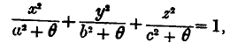

In M&F we call the generic variable ξ, and the specific variables ξ1,2,3 each of which has a certain range to make its certain conicoid. Here the authors use θ and θ1,2,3 as the variables which play this same role, even though the equation is slightly different from that used by M&F. The point is that, for example, with θ in the right range you get a family of confocal ellipsoids.
The authors are going to follow an obscure paper by Niven in their approach to this entire subject, one written in 1892. Accordingly, then make shorthands for two expressions, one having a -1.

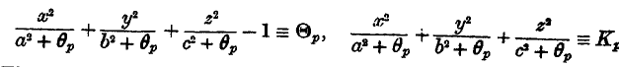

so it seems that Kp - 1 = Θp. If we set Θ1 = 0, then we are talking one of the conicoid surfaces. They want the ellipsoid long axis to be x, and the shortest to be z. Then we stay ellipsoid when ξ > a, and I guess this means a > b > c.
Now comes another definition. They write Π(Θ) ≡ Θ1Θ2... Θm . They don't say what m is, but I have deduced that the options are m =1, m = 2, or m=3, so you have products of one, two or three of the above huge factors. [ :-) ] We are then told to consider this set of 8 different kinds of functions:

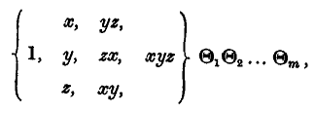

Their Plan: The four columns are the four "species" of solution. The rows are called "types" for a given species, so there are three types for the second and third species. I think they are going to consider these 8 bracketed functions in combination with the three different possible Θ products (Θ1, Θ1Θ2 and Θ1Θ2Θ3 ), and they are going to apply ∇2 to the whole mess and get very messy expressions. Then they are going to say that if you select certain values of the coordinates θi to make the mess be 0, with those special values you will have then constructed functions which satisfy the Laplace equation, and these functions they call "ellipsoidal harmonics". It seems that in this case, all 8x3 = 24 kinds of harmonics will be polynomials in the variables x,y,z and probably these are all "first kind" harmonics. They are then going to show that all these harmonics solve some sort of Lamé ODE.

To start off this program, in their Section 23-21 on page 538 they pick the "1" from the bracket, and Π(Θ) = Θ1 and certainly this is the simplest case you can think of. By setting ∇2 [ 1 * Θ1] = 0 they get a quadratic equation that has two solutions for θ1 so if you "go with" these values, in this way you have found two of the simplest first-kind first-species ellipsoidal harmonics. Regrettably, they fail to write down what these harmonics actually are!
The next case they consider is Π(Θ) ≡ Θ1Θ2... Θm where they treat m as a variable m = 1,2,3 but they want to treat this case in general for m. So they are still selecting the "1" from the bracket above. By requiring that ∇2 Π(Θ) = 0, they come up with a set of conditions that the variables θ1...θm must satisfy. That set of m conditions is this

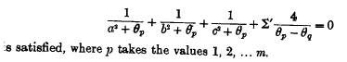

where Σ' I think means Σq≠p, this is a typo. Our next task is to construct this first-species polynomial:

Λ1(θ) = Πq=1m (θ-θq)

They show that ∇2 Π(Θ) = 0 is equivalent to requiring that this expression vanish

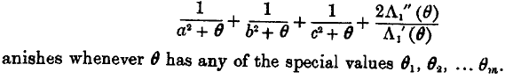
I think they mean to say "any of the special values OF θ1...θm. " They then message the above equation into this one

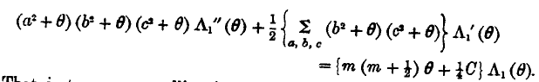

and this is beginning to look like a Lamé equation in the function Λ1(θ). I think they then set n = 2m and they then end up with

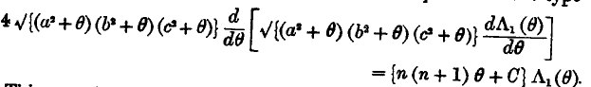

which they claim IS the Lamé equation. Based on my claims above, we would have n = 2,4,6 as the only choices, but I think they now have in mind n being any even integer. For given m, they claim there are m+1 values of C such that we have a harmonic function as the solution. This concludes this little section of the WW book.
In Section 23-22 they move to the next option where we take the "x" from the bracket, so the candidate solution now has the form xΠ(Θ) where as before Π(Θ) ≡ Θ1Θ2... Θm. They turn the crank and this time they define

Λ2(θ) = Πq=1m (θ-θq)

where I think the 2 means this is going to be a second species solution polynomial in θ. Again they come up with the same Lamé equation more or less. They suggest that perhaps we should just study this ODE and forget all this Niven stuff.
In Section 23-23 they do the form yzΠ(Θ) and define Λ3(θ) and again get Lamé.
In Section 23-24 they do the form xyzΠ(Θ) and define Λ3(θ) and again get Lamé.

The rest of the chapter just does not seem very interesting to me since I nowhere see any examples of the functions we are talking about!! But here are some old original notes I wrote, and we get their orthogonality proof that I conjectured about in my 2D doc.

___________________________________________________________________________

They then get around to defining the coordinates, but not using my Cramer's method, some other method, and they get

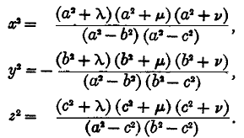

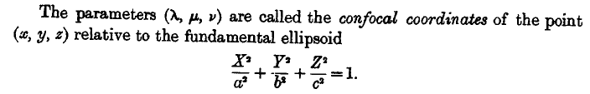

I think you get the above fundy ellipsoid if you set λ = ξ1 = 0. [ ellipsoidal coordinates = confocal ones]

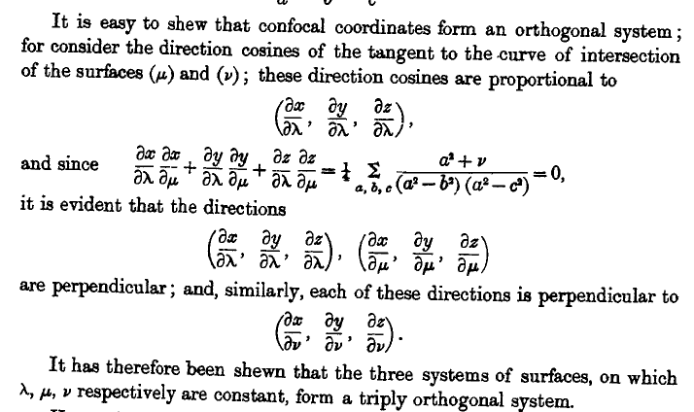

At least they mention this issue which I spent some time wondering about. Here is a method of proof where those derivatives are the eλ etc type curvilinear base tangent vectors I talk about a lot somewhere.
I am now at p 551, they have continued to throw out obscure meaningless junk in large quantities.
At page 553 they come back down to earth and we have as shown below. We still have the mysterious "m" and θp as I guess a parameter, and there are our three ellipsoidal coordinates sitting in there. Where did this come from? Go back a few steps:

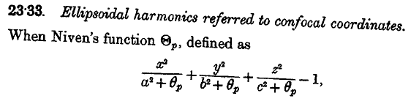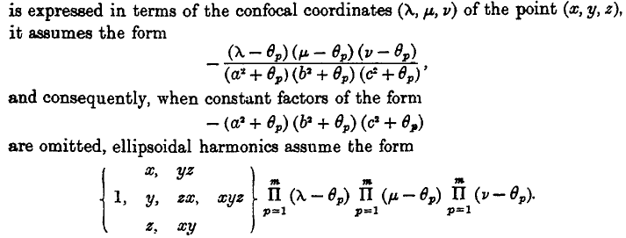
Recall
So you stick in the x,y,z expressions and the Niven form comes out as shown. We still have a mysterious integer m telling us how many things are multiplied together.
Now we finally get around to a separated form ,

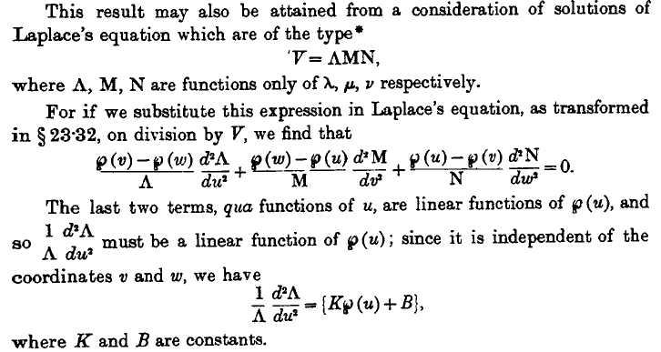

What on earth is this p function? I think I know, but they never even mention it! It is the Weierstrass elliptical integral function which WW talk about on page 429 and which I know nothing about. I only know about Jacobi elliptic functions. Oy! Again, they just throw it in with no comment!
The last equation above appears on page 641 of AS, so I have seen it before, where AS call it the Lame equation in passing. So maybe the ODE comes out being very simple as shown, where the price you pay is that you have that Weierstrass elliptic function sitting in there. Normally we don't have "special functions" appearing as the coefficient functions of an ODE! But I guess if you do that here, the equation becomes quite simple. AS have zero to say about this.
Now somewhere along the line they mention (u,v,w) as coordinates. Maybe that is another "cost" of getting the simplified ODE, you have to transform to these mysterious variables instead of (λ,μ,ν). Pretty soon we get the same equation for each of our (u,v,w) variables

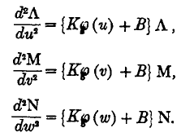

so that all three separated equations are the same. Then for some reason we set

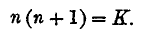

Moving right along on page 554:

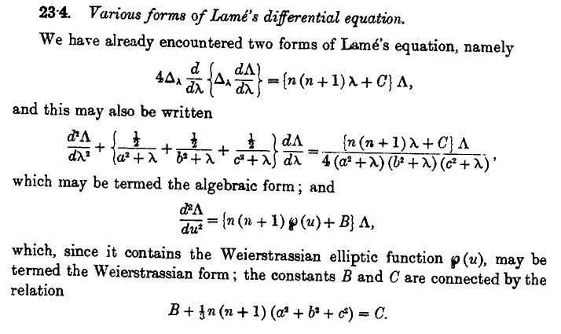

What are a,b,c ? They are the constants of our reference ellipsoid, fine.

Now stand back: they want to make the p(u) thing be ξ, a variable! Then the ODE is this:

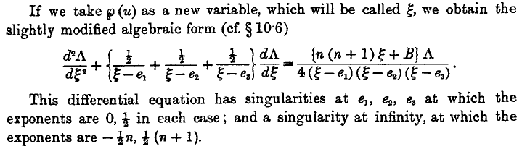

At this point, we have only 4 singular points total, the ei and ∞. I thought we were supposed to have 5?
But don't go away. In case you need more Lame ODE forms, here is another one:

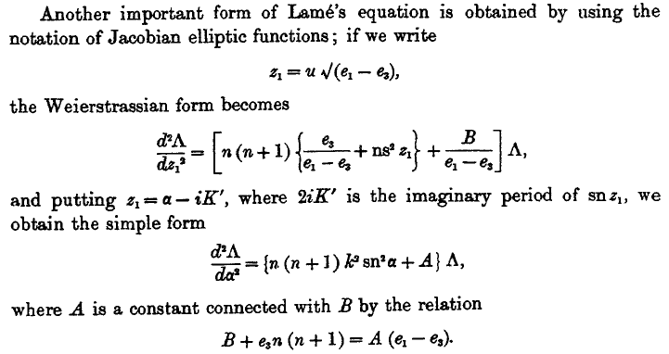

where now we have good old Jacobi elliptic functions thrown in for good measure (like ns and sn ).

Page 556: Now we are going to look for series solutions of our ξ-variable Lame ODE:

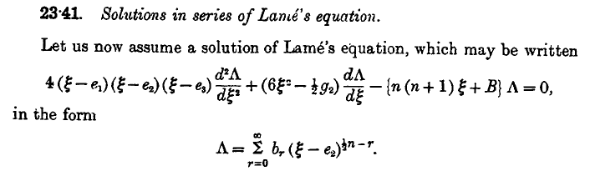

This of course leads to another huge mess, the conclusions are obscure. This is just an expansion around one of the regular singular points e2. The index includes the n thing which I think MF call m and is some kind of eigenvalue integer for this equation, not sure why.
Well here is the claim:

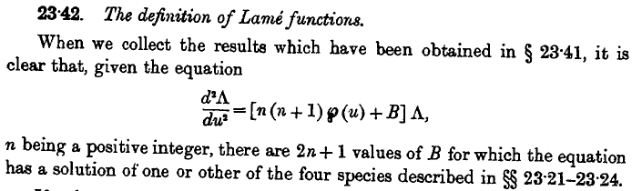

So in some sense constant B gets quantized as a sort of eigenvalue, but we already have n quantized.

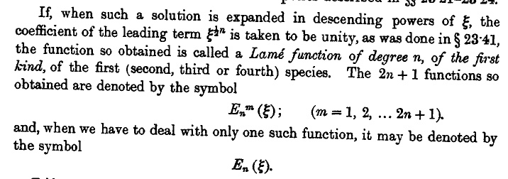

So here you see that horrible E notation for the first kind solutions. Label m just lists them off.
I now skip ahead to p 562 and we then have:

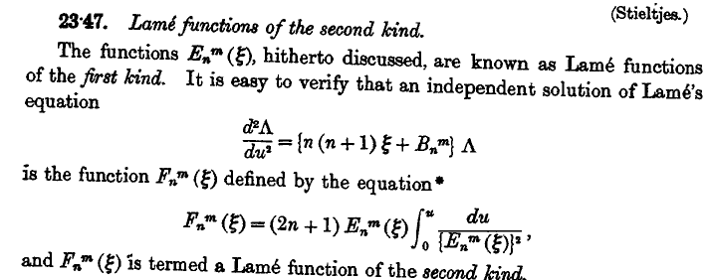

so here you see "the trick" at work, and this is the same idea as I think MF talks about. I think the equation should have ξ and not u in the derivative.

Uncle! Uncle! I have had enough. This is an absolutely terrible chapter. I wonder who wrote it. The 4th Ed is 1927, probably Dover 1996 or some such. Both authors initial the 6 line preface on my birthday in the year 1927.

Comment: Here is what I was hoping to learn and did not: There is a certain Lame equation that is the separated equation for each coordinate when you do ellipsoidal coordinates. This equation contains two separation constants which MF call κ and m. I wanted to learn what was causing at least the m value to become quantized. The WW chapter made zero contribution to this question, as far as I could tell. [ But I know the answer to the question now 10.10.10, see "finding solutions to the Lamé equation.doc" ]

I do have other books on Lame. One is Smythe, but he says things are really too complicated for his book, but he still manages to come up with the ellipsoid solution using some integration method.

The other source I have is a Byerly book in PDF which is Dover 1959. I mention Byerly in my ellipsoidal docs 3 and 4, says "search". [ And now I have Bateman and more.]

