W&W Lamé Chapter, Take Two PhL 11.12.10

I am writing these notes just after finishing Hobson.
These notes make my earlier notes pretty worthless, but I kept them just for fun.

Overview (2 pages) 1
Ellipsoidal Conventions confusion. 3
Notes on WW Chapter 23 4

_______________________________________________________________________________

Overview (2 pages)

First I compare notations and show that, where they treat the same subjects, WW and Hobson agree. This applies to the surface equations and the Niven forms. MF have a different convention which in effect has a z↔x swap compared to WW/Hobson.

The first action is to assume the Niven form, jam that into Laplace to get the characteristic equations in θ, define Λ(θ) = Πi=1m(θ-θi), and show that the characteristic equation can be written as an ODE for Λ. It turns out that the last terms of the char equations are just 2Λ"/Λ'. They integrate this and the result is a form of the Lamé equation. They do this for each of the four "species" which are defined to be the Niven form functions with 0,1,2 or 3 factors of xi in the bracket (species = 1,2,3,4 however). They treat the species one at a time with these results

first species E(θ) = poly(θ) 1
second species E(θ) = {$\sqrt{a2+θ}$, $\sqrt{b2+θ}$, $\sqrt{c2+θ}$} poly(θ) x..
third species E(θ) = {$\sqrt{a2+θ}$$\sqrt{b2+θ}$, $\sqrt{a2+θ}$$\sqrt{c2+θ}$,$\sqrt{b2+θ}$ $\sqrt{c2+θ}$} poly(θ) xy..
fourth species E(θ) = $\sqrt{a2+θ}$$\sqrt{b2+θ}$$\sqrt{c2+θ}$ poly(θ) xyz

But they are "working in" the variable θ of the Niven world, not the ρ2 = θ + a2 of the Hobson world, so the solutions look a little different. But it is trivial to show that the square roots when converted to ρ2 are those we know and love (note that $\sqrt{a2+θ}$ = $\sqrt{ρ2}$ = ρ, so that root is not a root in Hobson variables). While Hobson uses three variables of this ρ type (ρ,μ,ν) [ the MF ξi type], WW instead use three variables of the θ type (λ,μ,ν). These are their "ellipsoidal coordinates" and they are like those I saw long ago in Wolfram. So who's to say it's better to write the E functions in μ rather than θ?

Next, W&W do Hobson's derivation that you can write the Niven Gn as the D operator on the Hn. They do an induction proof which of course I did not pursue.

Then late in the came, WW start talking about ellipsoidal coordinates (confocal quadric, as they like to call them, a good name) and of course they are using their θ type (λ,μ,ν) coordinates. For these coordinates they state the x,y,z equations and give the scale factors. Maybe some time I might do a Maple run on these coordinates.

Then they suggest we might consider some different choices of coordinates. So far they have talked only about the θ style coordinates. They introduce what I will call u-type coordinates (u,v,w) which are defined according to u = ℘-1[ θ + (a2+ b2+ c2)/3] where ℘ is the Weierstrass elliptic function (which I comment on a bit). Inverting this says θ = ℘(u) - (a2+ b2+ c2)/3 . We might compare this to Hobson who says that ξ2 = θ + a2 so then ξ2 = ℘(u) - (a2+ b2+ c2)/3 + a2 = ℘(u) + K, K being this constant. This would mean for example that ℘(λ)- ℘(μ) = λ - μ = ρ2 - μ2 where red are Hobson coordinates. When this coordinate change is done, the new Laplacian has this factor (or this is the entire thing)

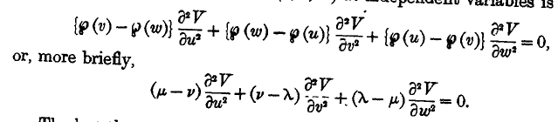

which is very similar to the Hobson ∇2 written in Hobson's ξ,η,ν

∇2 = [(ρ2- ν2) (ρ2- μ2) (μ2-ν2)]-1 { (μ2-ν2) ∂ξ2 + (ρ2- ν2) ∂η2 +(ρ2- μ2) ∂ζ2 }

I suspect that the u,v,w coordinates either ARE Hobson's ξ,η,ν (perhaps offset by constants) or are close to them. Enough said.

WW then do a separation and find that their Lamé equation implies harmonics have the ΛΛΛ form. Maybe I would write this as Λn,p(λ) Λn,p(μ) Λn,p(ν) inserting WW's θ type coordinates. This is of course the analog of Hobson's EEE.

WW then go off to consider some different coordinates and their corresponding Lamé equations. One coordinate type is called α with this equation

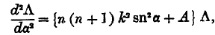

and another is called ξ with some other equation. He claims ( I use ρ for a Hobson variable here)

ξ = ℘(u) = θ + (a2+ b2+ c2)/3 = ρ2 - a2 + (a2+ b2+ c2)/3 = ρ2 - K.

Then he notes that the leading term in a K function is then ξn/2 = ρn and he presents just the symbol for an E function as Enm(ξ) which would then be Enm(ρ2). That is all we get on notations for Lamé functions! They say a few quick words about the zeros of these functions (the θ space zeros called θi of course). They then mention the second kind functions. They show that there are 2n+1 of these things (probably they did that earlier). They show the E functions are linearly independent. Then yet another set of variables (α,β,γ) which might be the α ones I mentioned above. The final sections have a few integral equations containing E's on both sides, then some integral representations for the E functions, comment on generalized Lamé, and references.

___________________________________________________________________________________

Ellipsoidal Conventions confusion.

1. Both Hobson and WW write their θ forms in this manner

x2/(a2+θ) + y2/(b2+θ) + z2(c2+θ) = 1 a>b>c>0

where x has the largest denominator. This is consistent with Hobson's first equation on page 454 which reads

x2/ξ2+ y2/(ξ2-h2) + z2(ξ2-k2) = 1

If we compare these two equations we see that

a2+θ = ξ2 // as appears in Hobson page 477 just above B
b2+θ = ξ2-h2 => a2-b2= h2
c2+θ = ξ2-k2 => a2-c2= k2

If we solve the x,y,z equations using Cramer's rule, defining ξ = (ρ,μ,ν), we obtain Hobson p 455 A where we see that x = ρμν/hk. This explains WHY we get x in this last equation and not z.

2. M&F on the other hand don't do the Niven stuff , and they work with this surface convention

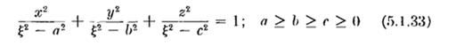
Notice that the a,b,c which appear here are NOT the a,b,c which appear in the Hobson or WW θ surface equation. And: for M&F, it is the z axis (not the x axis) that gets the largest denominator and they set c = 0 and then they have

z2/ξ2 + y2/(ξ2 - b2) + x2/(ξ2-a2) a > b

where a > b are the two ellipsoid focal distances. For this reason, you see that MF have z = ρμν/hk, or as they express it

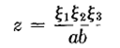

Comparing to Hobson, a = k and b = h. We see now why Hobson called these things k and h instead of a and b, to avoid confusion with his later use of a,b,c in the θ surface equations. I congratulate Hobson on this choice.
The M&F form is useful for going to the prolate limit and having the z axis being the longest axis and the symmetry axis, and that is probably why they set things up that way. On the other hand, if MF go to the oblate limit, they must have x as the shortest axis, so x will end up as the symmetry axis, whereas oblate in Hobson gives the z axis as symmetry.

3. When WW do their exploration of xΠΘ as their second-species example, they end up with polynomials multiplied by $\sqrt{a2+θ}$ . But this is then $\sqrt{ξ2}$ = ξ, so xΠΘ "has no square root" out front, which means it if K class, and this agrees with Hobson and my Hobson notes.

Notes on WW Chapter 23

p536: A good page. They note that regular tesseral harmonics have nodes on the sphere which are along lines of constant θ and φ. They claim a similar set of ellipsoidal harmonics exists with similar properties on an ellipsoid. I note that it is the factored form that causes the nulls to be on constant parameter surfaces, and that will be true for the tesserals or for the E(ρ)E(μ)E(ν) Hobson ellipsoidal harmonics. The Lamé reference is 1839. Niven did the Cartesian stuff much later in 1892, and that is the WW focus.

p537: Here W&W assert without any justification the Niven usual form for the harmonics and the integer m is unspecified. With Hobson, I now have a complete understanding of where this form comes from and why it is in fact the ellipsoidal harmonics expressed in Cartesians. W&W are going to simply assume this form I guess and see where it leads. They define the usual four species which Hobson never mentions, and they do not mention Hobson's class, nor do we have any K,L,M,N stuff at this point.

p 538: If we do a first species case (I=0 for me, K class) and assume a single Θ factor (so m = 1), requiring the form to satisfy Laplace gives the usual Hobson θ equation for this simple case and you get the quadratic for θ and you can find the solutions. For n = 2 and K class I = 1, my J = 1 so this is the m=1 case they are doing, but they don't show this connection. These are the two K2 functions, but they are not called this here, nor are they written out, we just get the two θ solutions. No wonder I was confused!
Index n is called the degree. Hobson uses this same word on page 481, but there he is really referring to the highest power of a polynomial. Hobson really avoids calling n anything other than n. It is not the degree of the polynomial part of Ln,p(ρ) for example, but the large μ limit would be ρn. Wiki says the spherical harmonic Ynm uses words n = degree and m = order carried over from Pnm(z).

p 539: We just wing along as I did in my notes and we end up in mid page with the θ equation system which determines the θi (for K class = 1st species)
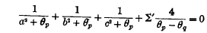 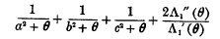= 0

By defining a certain Λ1 function, the last term can be written differently as on the right above. In fact, they define Λ1(θ) = Πi=1m(θ-θi) and knowing what I know, this is in fact Πi=1m (ρ2-ρs2) and this is going to end up being the poly part of the Lamé function (which for first species is all of the function). Probably the subscript 1 means it is first species or K.

p540: (first species = K class) The above Λ equation is trivially integrated and we end up with an ODE for Λ which is more or less the Lamé ODE.
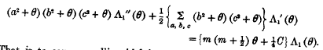

which they rewrite as

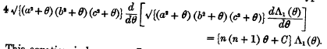

Notice the historical manner in which a square root of a large quantity is denoted! The constant C is the quantity p of Hobson (or close to it). They have changed from m to n for no good reason. From the get-go our m was assumed an integer, so n is an integer above, and the C = p are going to be some eigenvalues. We are working in θ space, not ρ2space, something to keep in mind. C will have n/2+1 values he claims (this is for the K class only) and you recall my [ now I would write J+1 instead of r+1 ]

K r+1 r = n/2 if n even, else (n-1)/2

which agrees. I don't know if he has said n has to be even for K class. Yes, right here they state that.
So what has actually happened here? They start with the Niven form out of the blue. They require it to satisfy Laplace and that gives the θ equations. They define Λ1(θ) = Πi=1m(θ-θi) = Πi=1m (ρ2-ρs2) and the θ equations become an ODE in Λ1(θ). They don't mention the θ = ρ2-a2 connection at this point, I just happen to know that, see opening comment above. So for K class, this ODE in Λ1(θ) is the Lamé equation expressed in variable θ instead of variable ρ. They do call it "the Lamé differential equation".

p541: Now we do second species which has that extra {x y z} out front. But they specifically choose the case "x" which Again he sets ∇2 = 0 as Hobson did. (actually, Hobson is in W&W's future, not past. Hobson is past for me. ) They don't write the characteristic equations, they just write the ODE that results, where this time Λ2(θ) = Πi=1m(θ-θi). I know that the solutions θi will be different for species 2 than for species 1, so think Λ(2)(θ) = Πi=1m(θ-θi(2)) and that is why Λ has a 2 label. The extra {x y z} causes the resulting "Lamé " equation to be different,

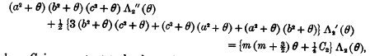

You can see the middle term is a different from the first species, and so is the RHS. The "p" here is called C2. We then define Λ = $\sqrt{a2+θ}$Λ2 and rewrite the ODE in terms of this Λ and get

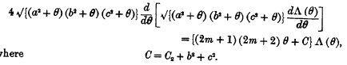

So we seem to have a square root involved for xΠΘ but we know that a2+θ = ξ2 and this square root becomes no square root and this is consistent with xΠΘ being K class. However, the other two functions in this second species ( that is to say, yΠΘ and zΠΘ) will have $\sqrt{b2+θ}$ and $\sqrt{c2+θ}$ which we translate:

yΠΘ $\sqrt{b2+θ}$ = $\sqrt{b2- a2 + a2 +θ}$ = $\sqrt{ξ2-h2}$ = Hobson L class
xΠΘ $\sqrt{c2+θ}$ = $\sqrt{c2- a2 + a2 +θ}$ = $\sqrt{ξ2-k2}$ = Hobson M class

WW refer to the members of a species as types.

p542. Third species continues, and they get

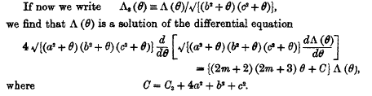

It is again the same equation and we have the "two square roots". In two cases one of the two square roots dissolves when we go to ξ coordinates and we the L and M class functions. In the third base we really do get two square roots and that is the N class. Here is my Hobson form

En,p(ρ) En,p(μ) En,p(ν)
= { 1 x y z xy xz yz xyz } κ' Πs=1J (ρ2- ρs2) (μ2- ρs2) (ν2- ρs2)
K K L M M L N N
e o o o e e e o // values of n for which this form applies (n even or odd)

so you see that this two square root thing is the yz function of N class.

They are then into the fourth species:

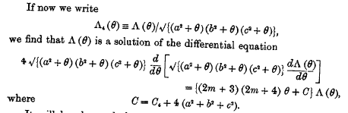

This will give three square roots, of which two remain square roots when we change to ξ coordinates, so this 4th species is N class.
So the upshot here is that WW are doing everything in terms of θ as the variable instead of ξ, and this causes a different square root structure of the functions. They get

first species E(θ) = poly(θ)
second species E(θ) = {$\sqrt{a2+θ}$, $\sqrt{b2+θ}$, $\sqrt{c2+θ}$} poly(θ) x,y,z
third species E(θ) = {$\sqrt{a2+θ}$$\sqrt{b2+θ}$, $\sqrt{a2+θ}$$\sqrt{c2+θ}$,$\sqrt{b2+θ}$ $\sqrt{c2+θ}$} poly(θ)
fourth species E(θ) = $\sqrt{a2+θ}$$\sqrt{b2+θ}$$\sqrt{c2+θ}$ poly(θ)

p543: At mid page, W&W simply quote the notion that the Gn and the Hn. The Hn were spherical harmonics for Hobson, but here they are weakly introduced. It sounds like they are the conical harmonics since he talks about using Kp instead of Θp. And I know the conicals are linear combinations of the sphericals of the same n. So we are on the same track. They quote this Hobson result ( p 486 A )

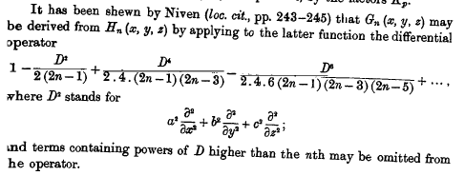

W&W are going to prove this now but only for first species, and they refer to Hobson's 1893 paper for the other cases.

p 544-546: They present an induction proof of the above and get to the result which now appears as

A new section starts after this. The counts for functions in each species are stated with total 2n+1. My counts were by class, so a little different.

p547: We get a reference to a "memoir" of Darwin on geological application of these harmonics. The paper referenced was 11 years before Darwin's death, so I think the word memoir just means what we now call "a paper". It does not mean posthumous.
We now start off in a different direction which is a review of ellipsoidal coordinates (which they call "confocal coordinates"). We get right into the "confocal quadric system", and we get confocal ellipsoid family with θ as parameter, and we see that setting the thing to 0 gives a cubic and the three roots are called λ,μ,ν which are like Hobson ρ,μ,ν.

p548: The x,y,z equations are derived I guess from my Cramer's rule (but all in the θ system; that is to say, the three θ coordinates are called λ,μ,ν and these are very different from Hobson's ρ,μ,ν ).

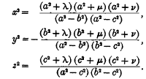

We know of course that θ = ξ2-a2 so we have this connection

λ = ρ2-a2 = ξ12-a2
μ = μ2-a2 = ξ22-a2 where WW variables on the left and Hobson variables in the middle
ν = ν2-a2 = ξ32-a2

Now they show that this system is orthogonal basically by computing off-diagonal elements of the metric tensor and showing they are 0, but the term "metric tensor" is not used. Calculation results are just quoted.
Note: you are going to run into the θ coordinates (λ,μ,ν) in the literature. Moon and Spencer page 41 however use Hobson ρ,μ,ν coordinates, but they call them η,θ,λ just to liven things up.

Note: I could create a metric tensor file for the WW (λ,μ,ν) coordinates, but have not done so.

p 549: The scale factors are now derived. They compute one, and the others come from cyclic just in the coordinates, something I guess I did not realize. They claim a little result:

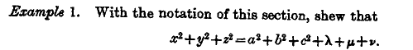

Topic change now and first appearance of those Weierstrass functions. They say

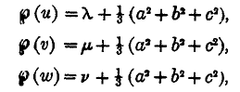

For example, ℘(v) = μ2-a2 + (1/3)(a2+ b2+ c2) in Hobson language. Thus means that coordinate "v" is a speed-rescaling of Hobson coordinate μ, which is an alternative to Hobson's η(μ) rescaling. So all we are doing is replacing λ,μ.ν with rescaled coordinates u,v,w.

Notice from the above that

℘(v)- ℘(w) = μ-ν and this would equal μ2 - ν2 in Hobson's coordinates!

The idea then is that ℘(v) = μ2 - K if we want to relate Hobson μ to WW v.

The reader is assumed to know about "Weierstrassian elliptic functions". This is another gaping hole in my knowledge, but here is a hint

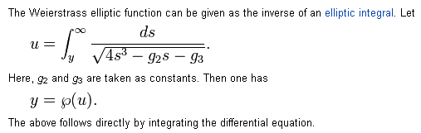

And this from Wolfram:
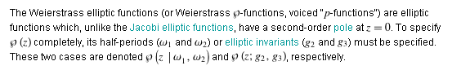

It turns out that g2 and g3 are 2D lattice sums Σ'mn of 1/[2mω + 2nω'] where m=n=0 is of course excluded. Here 2ω and 2ω' are the periods of your p function in real and imaginary directions, somewhat like the Jacobi functions. For any choice of ω and ω', you end up with some numbers g2 and g3 which are called the elliptic invariants. Then u = ℘-1(y) is the elliptic integral shown, and so y = ℘(u).

The third power in the root is the new thing to me, usually it is 4th power for F functions. So these functions are going to be a whole world like the Jacobi functions. They are doubly periodic. Bateman vol II p 328 has a lot to say about these guys. So OK, this is a special function group I have never had to use, and which has a very strange notation of a bolded script lower case p (I guess it's a p). There are θ and σ functions related to it.

p 550: So basically W&W are defining u,v,w as new ellipsoidal coordinates which are the inverse-p function of the quantities shown above. Fine. The new x,y,z equations are these : (first, for x)

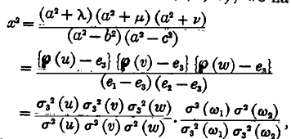
where the ei are these things

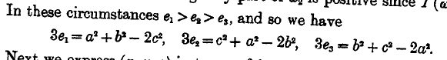

where the ωi are related to the periods of the functions. I think the σ labels refer to the two periods that each has. We end up with these x,y,z equations

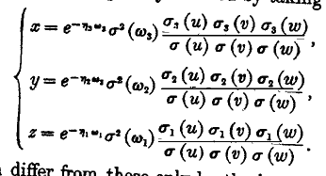

and we have a Halphen reference.

p 551-552: They are now going to claim that the form of Laplacian is simple in these new coordinates u,v,w. On this page they do the first step which is to get ∇2 expressed in terms of λ,μ,ν which I think I am familiar with. But stand by: here is how the Laplace equation ends up:

This is identical to what Hobson got with his little helper coordinates ξ,η,ζ see Hobson p 458 A. I'll bet they are the same guys. In Hobson we got this

∇2 = [(ρ2- ν2) (ρ2- μ2) (μ2-ν2)]-1 { (μ2-ν2) ∂ξ2 + (ρ2- ν2) ∂η2 +(ρ2- μ2) ∂ζ2 }

The factors multiplying the second derivatives exactly match given the connection noted above. So this sure makes it appear that u,v,w = ξ,η,ν of Hobson. I think I could make the connection using GR7 data:

First, here is a repeat of the above inverse p function definition, where ei are defined as well, I guess you can select one of them.
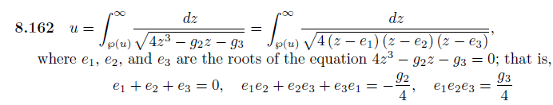
Then later they say

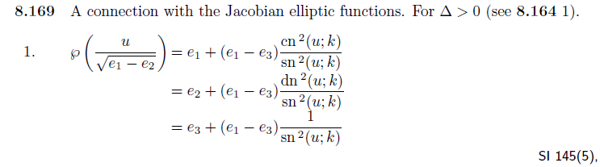
I am sure this is the way it works out!

p 553: Another gear change, and we are back to Niven's stuff with

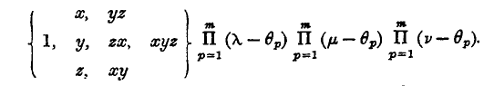
which I am happy with from Hobson (who does not bother with the commas inside {...}. ) They then use this form to make the claim that the ellipsoidal harmonics can be factorized into a product of three functions. I quote some stuff

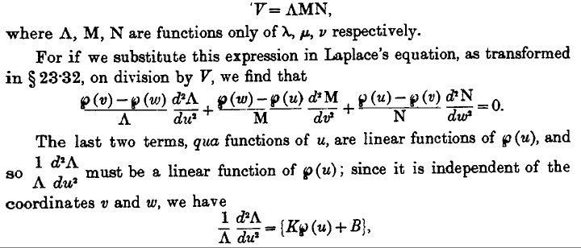

so the separated harmonic is going to have the Hobson EEE form, here called ΛΛΛ. And we get a nice footnote on another phrase Hobson uses,

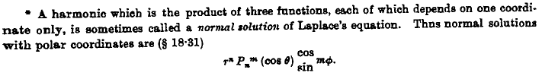

p 554: and to no great surprise, we now get

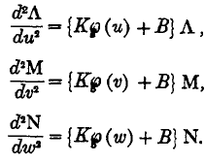

so the three separated functions solve the same ODE. These are similar to Hobson p 457 which Hobson got from the conical coordinates analysis. Hobson's equations are much simpler as on page 457 C.

But now W&W are off on another path.

p 555: The topic is "different forms of the Lamé ODE". We start off with the above which is rewritten this way and is called "the Weierstrassian form of the Lamé equation".

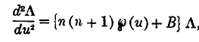

Here is Hobson's Lamé equation in η, which we see is basically the same thing, modulo a constant

(∂η2 E(μ/η)) + [ n(n+1) μ2– p(h2+k2)] E(μ/η) = 0

This one is the "algebraic form"

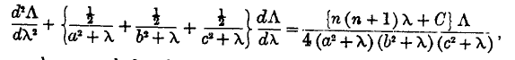

which is I think the Hobson form. He notes that

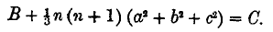

Then we have

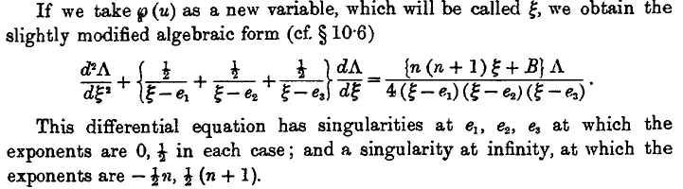

and this is the "modified algebraic form". This might be today's standard Lamé form, and Hobson's one in the μ variable.

And yet another form with Jacobi functions

None of these forms is the Hobson helper coordinate form.

p556-558: They then decide to use the weird ξ form which has one of those g invariant things in it, although I don't see that in the above ξ equation. His new one is this:

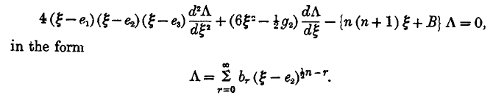

where they are proposing a Frobenius form. The g thing may be a typo? That factor is really this

2[ (ξ-e1) (ξ-e2) + (ξ-e1) (ξ-e3) + (ξ-e2) (ξ-e3)] = 6ξ2 + Bξ + C

so g2 I guess just stands for the Bξ+C part. In any event, you don't see g2 again! We of course get into the recursion relations for the series coefficients. This section does not seem to go anywhere interesting. But we do get this little remark:

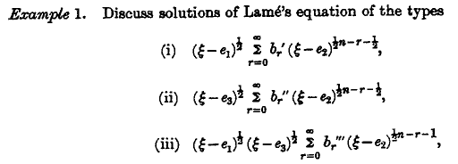

which is not quite what I want to see, because it is in this weird coordinate ξ. These are Frobenius solutions about the singular point e2, whereas my KLMN functions I think are about μ = 0. On page 558 we get the use of the word "first kind" which I think means one of the Hobson classes. At least we finally get the familiar notation

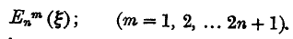

p 559: Shows that the Lamé functions are linearly independent

p 560-561: Shows that the ellipsoidal harmonics are linearly independent. Now finally we get to this

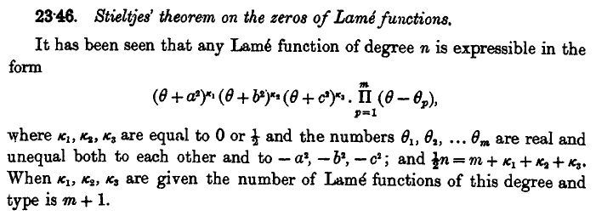

Yes, this is what they derived earlier, I agree. They show from the above that you get the same "characteristic equations" we got earlier for finding the θi.

p 562-3: We are now off on the second-kind Lamé functions using the usual "trick" formula. They show how you can represent Fn.p without integrals in a thing similar to the Q Legendre function.

p 564: Now we get yet another set of variables which might be our Hobson friends:

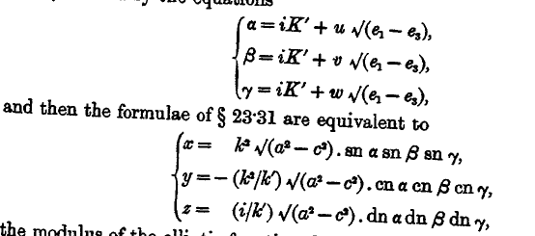

But then it does not look very promising. This stuff goes with the sn ODE quoted above.

p 565-566: Now we get some integral equations that the Lamé's satisfy. For example,

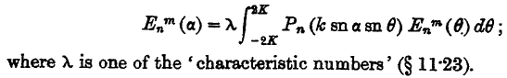

They spend a page deriving this fact. They come up with another one satisfied by some of the species.

p 567-569: Now come some integral representations for Lamé functions. These are pretty obscure, with lots of Jacobi functions showing up.

p 570-574: Generalizations of the Lamé equation. Needless to say, I have no interest in this subject.

p 575: Now comes a good list of references starting with 1839 Lamé and ending in 1901 with Darwin.

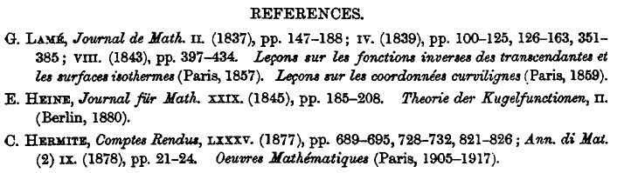
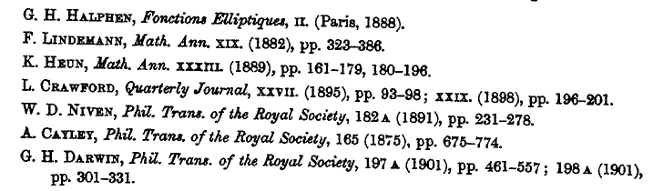

p 576: They now have a set of exercises for the student, which they call "examples". Here is the one I attempted today but could not do easily: (I think details are earlier in the Hobson book. Section 80)

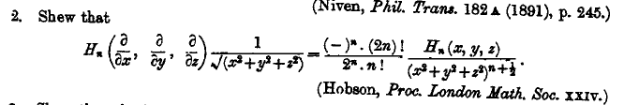

Comments:

(1) no list of the lowest solutions.
(2) no mention of K,L,M,N notation, that must have come later. But this book is 1927, and Hobson's is 1931 and Hobson has them. From the reference list above, this chapter might have been written as early as 1917. Hobson follows the 1859 paper of Heine on special functions (kugelfunctionenen). Byerly's book was 1893 and he certainly knew about KLMN.
(3) no use of the nice Hobson coordinates ξ,η,ζ [ but maybe under the name u,v,w ? ]

