2D Ellipsoidal Coordinates PhL 11.16.09

It occurred to me that, before diving into the 3D ellipsoidals, some work with 2D would be useful in answering some as-yet-unanswered questions. Let's try to do this in analogy with the 3D method.

Overview (10.9.10, 2 pages). 1
1. Setup. 3
2. Find the x,y equations. 3
3. Comparison with known elliptical coordinates: 4
4. Why do the curves intersect at right angles? 6
Geometry Method. 6
Metric tensor method. 7
5. Conformal Map interpretation. 8

________________________________________________________________________________

Overview (10.9.10, 2 pages).

In Section 1 I write out the 3D conic equations, and compare these to the 2D conic equations:

y2/( ξ12-a2) +x2/(ξ12) = 1 0 < a < ξ1 ellipses labeled by ξ1
- y2/(a2- ξ22) +x2/(ξ22) = 1 0 < ξ2 < a hyperbolas labeled by ξ2

This is a family of ellipses and hyperbolas which are all confocal with focal distance a. You can see that A = ξ1 and B = $\sqrt{ξ12- a2}$ so A ≥ B so the long ellipse dimension is along the x axis. I have changed variable names relative to the text to make things come out right.

In Section 2, for the 2D case I solve for x,y in terms of ξ1,ξ2 using Cramer's rule to get

± x = ξ1ξ2/a
± y = $\sqrt{(ξ12-a2) (a2- ξ22)}$ /a 0 < b < ξ2 < a < ξ1

In Section 3 I fit these results in with various authors definitions of 2D elliptical coordinates. In one system the dimensionless coordinates are μ and ν and we get ( note ξ1 ≥ a and ξ2 ≤ a, as required)

ξ1 = a ch μ => (ξ12-a2) = a2 sh2 μ ξ1 or μ labels an ellipse
ξ2 = a cos ν => (a2- ξ22) = a2 sin2 ν ξ2 or ν labels a hyperbola

± x = (1/a) a ch μ a cos = a ch μ cos v
± y = (1/a) a sh μ a sin v = a sh μ sin v

Another system uses σ,τ which are just dimensionless scaled versions of ξ1 and ξ2 :

σ = ξ1/a = ch μ
τ = ξ2/a = cos ν

± x = a σ τ
± y = a $\sqrt{(σ2-1)(τ2-1)}$ 0 < b < ξ2 < a < ξ1

and here is the famous picture
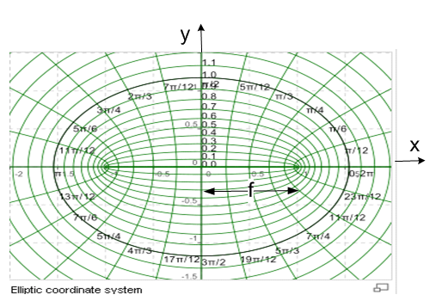

In Section 4 I show that the ellipses and hyperbolas intersect at right angles. I first do this geometrically by constructing differential 2D vectors which are tangent to the ellipse (dre) and the hyperbola (drh) passing through the point (x,y) and I show that dre• drh = 0. This proves that, for a confocal set of curves as described by our two opening equations, the intersections are always right angles. I could probably extend this method to showing orthogonality in the 3D ellipsoidal case, but did not try. As a second method of proof, I then have Maple compute the metric tensor gkp = Tki Tpi = $\begin{matrix}∂xi \\ ∂qk\end{matrix}$$\begin{matrix}∂xi \\ ∂qp\end{matrix}$ which comes out being (qi = ξi)

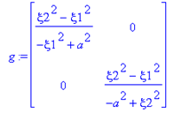
From our curvilinears and tensors doc we know that ei • ej = (ei)k (ej)k = Tik Tjk = g' ij where the ei are (unnormalized) tangent vectors aligning with my dre and drh. This shows that diagonality of g goes with orthogonality and we also have computed hξ12 and hξ22 scale factors as shown.

In Section 5 I make the connection between our 2D elliptical coordinates and conformal mapping. If we consider the analytic transformation,

z = (a/2) [ w + 1/w ] w = (z/a) [ 1 - $\sqrt{1 - (a/z)2}$ ] ,

if we construct concentric circles and rays in w space, they map into our ellipses and hyperbolas. We know that circles and rays are orthogonal, and we know that a conformal map preserves angles, so we conclude that things are orthogonal in z space as well, another proof of orthogonality. I then study the situation when a → 0 which causes the ellipses to morph into circles and the bloids into intersecting lines.
_________________________________________________________________________________

1. Setup.

First, here are the 3D equations:

x2/( ξ12-a2) + y2/( ξ12- b2) + z2/(ξ12- c2) = 1 c < b < a < ξ1

- x2/(a2- ξ22) + y2/( ξ22- b2) + z2/(ξ22- c2) = 1 c < b < ξ2 < a

- x2/(a2- ξ32) - y2/(b2- ξ32) + z2/(ξ32- c2) = 1 c < ξ3 < b < a

and without loss of generality we set c = 0 to get

x2/( ξ12-a2) + y2/( ξ12- b2) + z2/(ξ12) = 1 0< b < a < ξ1

- x2/(a2- ξ22) + y2/( ξ22- b2) + z2/(ξ22) = 1 0 < b < ξ2 < a

- x2/(a2- ξ32) - y2/(b2- ξ32) + z2/(ξ32) = 1 0 < ξ3 < b < a

Let's trim this down to 2D by removing y:

x2/( ξ12-a2) +z2/(ξ12) = 1 0 < a < ξ1

- x2/(a2- ξ22) +z2/(ξ22) = 1 0 < ξ2 < a

We still have "legal ranges" for our two elliptical coordinates (as we shall now call them) ξ1 and ξ2. We recognize the first equation as an ellipse and the second as a hyperbola. a is the focal distance.

2. Find the x,y equations.

We seem to have a simple linear matrix problem here.

$\left(\begin{matrix}1/(ξ12-a2) & 1/(ξ12) \\ -1/(a2- ξ22) & 1/(ξ22)\end{matrix}\right)$$\left(\begin{matrix}x2 \\ z2\end{matrix}\right)$ = $\left(\begin{matrix}1 \\ 1\end{matrix}\right)$

which we can solve for x2 and y2. Let's do that right now in Maple. But might as well use simpler coordinates, so let u = ξ12 and v = ξ22 and α = a2 and β = b2 and s = x2 and t = z2 so

$\left(\begin{matrix}1/(u-α) & 1/(u) \\ -1/(α- v) & 1/(v)\end{matrix}\right)$$\left(\begin{matrix}s \\ t\end{matrix}\right)$ = $\left(\begin{matrix}1 \\ 1\end{matrix}\right)$

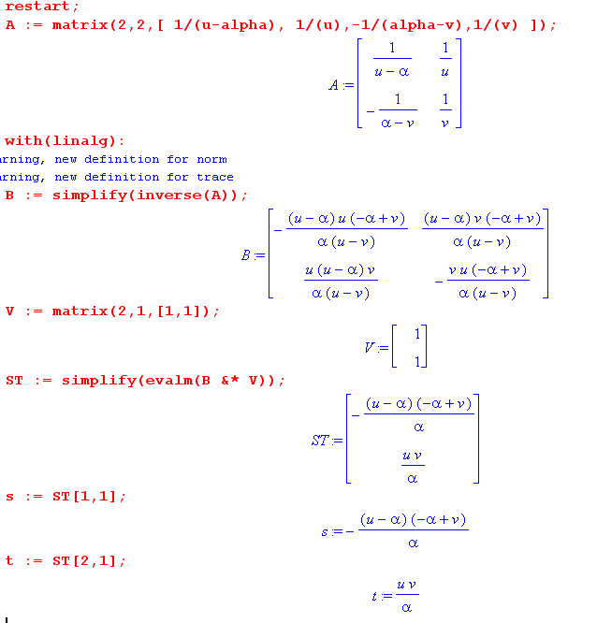

Therefore we read off:

± x = $\sqrt{(ξ12-a2) (a2- ξ22)}$ /a 0 < b < ξ2 < a < ξ1

± z = ξ1ξ2/a

3. Comparison with known elliptical coordinates:

Here is a paste from my tour doc

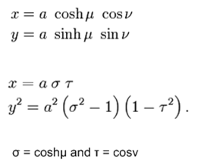

Try this connection:

ξ1 = a ch μ => (ξ12-a2) = a2 sh2 μ
ξ2 = a cos ν => (a2- ξ22) = a2 sin2 ν

Then my x equation becomes

± x = (1/a) a sh μ a sin v = a sh μ sin v
± z = (1/a) a ch μ a cos ν = a ch μ cos v

And then we can further define

σ = ξ1/a = ch μ
τ = ξ2/a = cos ν

and we then get

± x = a $\sqrt{(σ2-1)(τ2-1)}$ 0 < b < ξ2 < a < ξ1
± z = a σ τ

Now suppose we swap names around such that our (x,z) → (y,x). Then our results can be all be restated as follows:

y2/( ξ12-a2) +x2/(ξ12) = 1 0 < a < ξ1 focal distance = a
- y2/(a2- ξ22) +x2/(ξ22) = 1 0 < ξ2 < a

± x = ξ1ξ2/a
± y = $\sqrt{(ξ12-a2) (a2- ξ22)}$ /a 0 < b < ξ2 < a < ξ1

ξ1 = a ch μ => (ξ12-a2) = a2 sh2 μ ξ1 or μ labels an ellipse
ξ2 = a cos ν => (a2- ξ22) = a2 sin2 ν ξ2 or ν labels a hyperbola

± x = (1/a) a ch μ a cos = a ch μ cos v
± y = (1/a) a sh μ a sin v = a sh μ sin v

σ = ξ1/a = ch μ
τ = ξ2/a = cos ν

± x = a σ τ
± y = a $\sqrt{(σ2-1)(τ2-1)}$ 0 < b < ξ2 < a < ξ1

The hyperbola equation has the form " x2 ≈ y2 +1 " which means some (q,0) is on the curve which means the hyperbola opens left and right, and we get our usual picture

4. Why do the curves intersect at right angles?

This question is the main reason for my writing this doc.

Geometry Method. Let's first consider an arbitrary ellipse labeled by ξ1, and an arbitrary (but confocal) hyperbola labeled by ξ2. We have

y2/( ξ12-a2) +x2/ξ12 = 1 0 < a < ξ1
- y2/(a2- ξ22) +x2/ξ22 = 1 0 < ξ2 < a

Where do these curves intersect? We know the answer from above

± x = ξ1ξ2/a
± y = $\sqrt{(ξ12-a2) (a2- ξ22)}$ /a 0 < b < ξ2 < a < ξ1

Notice in passing that at an intersection point we have

x2/y2 = ξ12ξ22 / [ (ξ12-a2) (a2 - ξ22) ]

Now differentiate both quadric equations and you quickly show that

dre = (dx,dy) = dx [ 1 , (-x/y) (ξ12-a2)/ ξ12 ]

drh = (dx,dy) = dx [ 1 , (+x/y) (a2-ξ22)/ ξ22 ]

Then

dre• drh = (dx)2 { 1 - x2/y2 * (ξ12-a2)/ ξ12 * (a2-ξ22)/ ξ22 }

= (dx)2 { 1 - ξ12ξ22 / [ (ξ12-a2) (a2 - ξ22) ] * (ξ12-a2)/ ξ12 * (a2-ξ22)/ ξ22 }

= (dx)2 { 1 - 1} = 0

Thus we have shown that at any intersection point (there are 4) dre•drh = 0 which means the intersection point is at right angles. We have just proved:

Theorem: If you consider an any ellipse and any hyperbola which are confocal, they intersect at right angles.

Notice that this method of showing orthogonality does not extend well to 3D since we have dx, dy, dz to worry about.

Metric tensor method. Write out the x,y equations

x = ξ1ξ2/a
y = $\sqrt{(ξ12-a2) (a2- ξ22)}$ /a 0 < b < ξ2 < a < ξ1

Here is my boiler plate text from the oblate spheroidal doc:

dxa = Tab dx'b Tab ≡ $\begin{matrix}∂x'a \\ ∂xb\end{matrix}$ Tab ≡ $\begin{matrix}∂xb \\ ∂x'a\end{matrix}$ = something we could compute!

The metric tensor is given by

gkp = Tki Tpi = $\begin{matrix}∂xi \\ ∂qk\end{matrix}$$\begin{matrix}∂xi \\ ∂qp\end{matrix}$ or in matrix notation : g = TTT

(ds)2 = gij (dξi) (dξj)

Take it Maple! :

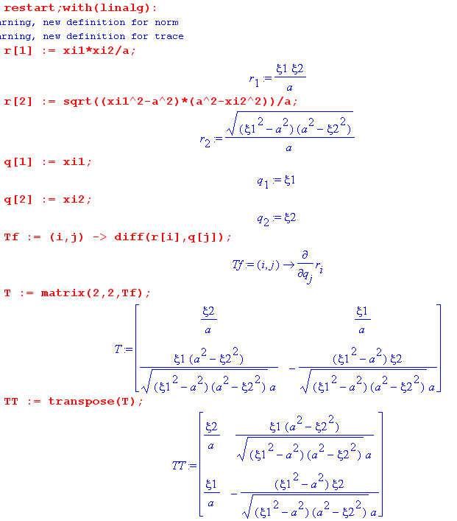
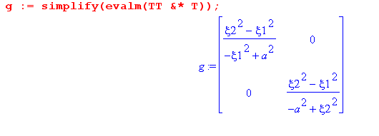
These are dot products of unit vectors and the fact that g is diagonal tells us what we want to know.

5. Conformal Map interpretation.

Look at Ahlfors page 94. He writes a conformal mapping in (15), then shows that for w = ρeiθ you will get, in (x.y) space, ellipses and hyperbolas as in (16) and (17). He has

A = semi-major = (ρ+1/ρ)/2
B = semi-minor = (ρ-1/ρ)/2

Therefore the focal distance of the ellipse is

C2 = A2 - B2 = (1/4) [(ρ+1/ρ)2 - (ρ-1/ρ)2] = (1/4) [ 4 ] = 1

For the hyperbola shown, we get the same conclusion.

How would we adjust these equations to have a focal distance of "a" ? Try just scaling z by a constant, so

z' = a z => x' = ax y' = ay

Then equations p 95 become

x'2 / [ (a/2)(ρ+1/ρ)]2 + y'2 / [ (a/2)(ρ-1/ρ)]2 = 1

x'2 / [a cosθ]2 - y'2 / [a sinθ]2 = 1

So indeed, the focal distance is a. So here is our transformation that does this:

z = (a/2) [ w + 1/w ]

w = (z/a) - $\sqrt{(z/a)2 - 1}$ = (z/a) - (z/a) $\sqrt{1 - (a/z)2}$ = (z/a) [ 1 - $\sqrt{1 - (a/z)2}$ ]

We still have analytic functions hence conformal maps. What happens then if we examine a → 0 ?

$\sqrt{1 - (a/z)2}$ ≈ 1 - (a/z)2/2 => [ 1 - $\sqrt{1 - (a/z)2}$ ] ≈ (a/z)2/2 => w ≈ (a/2z) = small

z ≈ (a/2) (1/w) = (a/2)(2z/a) = z, consistent

So for a "very small" our mapping is just this

w ≈ (a/2) / z

z ≈ (a/2) / w

If we set w = ρeiθ, then we have

z = (a/2)(1/ρ)e-iθ

Therefore, a circle in w space of radius ρ maps into a circle in z space of radius 1/ρ.
A ray at angle θ in w space maps into a ray of angle -θ in z space.

Looking at Ahlfors's page 95 picture, as a → 0 the two focal points converge to the origin, the hyperbolas must all pass through the origin and they have "become rays". Consider this picture

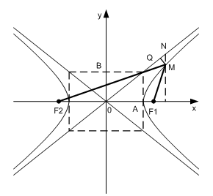
As a → 0, the focal points move in and the hyperbola moves in. The asymptotes are determined by the ratio of the axes which

x'2 / [a cosθ]2 - y'2 / [a sinθ]2 = 1

are independent of a. So in the limit, the four pieces of the hyperbola shown above becomes the four rays (two lines) which are the asymptotes. And at the same time, the ellipses becomes circles. Now here is our motivation for all this meandering:

Fact: There is an analytic mapping from the 2D elliptical coordinate system z to the Polar coordinate system w which mapping contains the parameter a, the focal distance for the ellipses and hyperbolas.

z = (a/2) [ w + 1/w ]
w = (z/a) - $\sqrt{(z/a)2 - 1}$

If we draw concentric circles and rays in w-space, these map into ellipses and hyperbolas in z space. Since the intersection of any circle and ray in w space is orthogonal, the intersection of any ellipse and hyperbola in z space must also be orthogonal, since we know that any analytic mapping preserves angles !!! So THAT is a nice reason this orthogonality is true.

Fact: As we let a → 0, this mapping becomes

z ≈ (a/2) / w
w ≈ (a/2) / z

which maps those same concentric circles and rays in w-space into (different) concentric circles and rays in z-space. Each full hyperbola morphs into a pair of lines. This is how you think of a 2D elliptic coordinate system with parameters labeling the ellipses and hyperbolas morphing into a polar system. The hyperbola label ν which was the angle of the asymptote becomes the azimuthal angle φ (more or less). The ellipse label ξ1 becomes radius r.

