Where do the Cartesian ellipsoidal expressions come from PhL 12.24.09
What is the meaning of c ?

Overview (10.10.10, 1/2 page) 1
Part I: Where do the Cartesian ellipsoidal expressions come from 2
Part I: What is the significance of parameter c (which we end up setting to 0) 10.10.10 4

________________________________________________________________________________

Overview (10.10.10, 1/2 page)

In Part I I show how you start with the conic equations for the three conicoids of the ellipsoidal system, and you solve this system of three equations for x,y,z in terms of ξ1, ξ2, ξ3 using Cramer's rule and this gives the "usual" set of equations for x,y,z that people normally take as the defining equations for the ellipsoidal coordinate system.

In Part II I show that with c > 0, the three zero-plane slice ellipses of a general ellipsoid have these focal distances: (I have added supporting data on the right)

fx = $\sqrt{b2- c2}$ // that is, this is the focal distance for the x=0 plane ellipse slice
fy = $\sqrt{a2- c2}$ c < ξ3 < b < ξ2 < a < ξ1
fz = $\sqrt{a2- b2}$ C ≥ B ≥ A. A2 = ξ12 - a2 B2 = ξ12 - b2 C2 = ξ12- c2
and
fz2 = fy2 – fx2 x2/( ξ12-a2) + y2/( ξ12- b2)+ z2/(ξ12- c2) = 1 c < b < a < ξ1

So, the three focal distances cannot be independently set, and there are really only two independent variables which describe the shapes of a confocal family of ellipses (the family members each have a ξ1 label). So the simplest thing to do is set c = 0 and have a and b be those two independent variables. Then we get

fx = b // that is, this is the focal distance for the x=0 plane ellipse slice
fy = a 0 < ξ3 < b < ξ2 < a < ξ1
fz = $\sqrt{a2- b2}$ C ≥ B ≥ A. A2 = ξ12 - a2 B2 = ξ12 - b2 C2 = ξ12
and
fz2 = fy2 – fx2 x2/( ξ12-a2) + y2/( ξ12- b2)+ z2/ξ12 = 1 0 < b < a < ξ1

and here is my picture from the long doc,

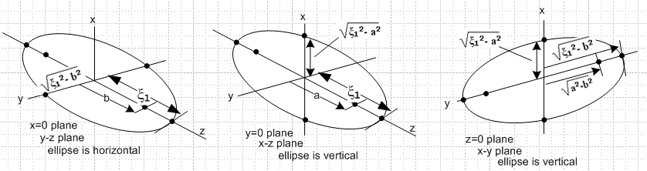
_________________________________________________________________________________

Part I: Where do the Cartesian ellipsoidal expressions come from

In my ellipsoidal notes, I often quoted the MF expressions for x,y,z,

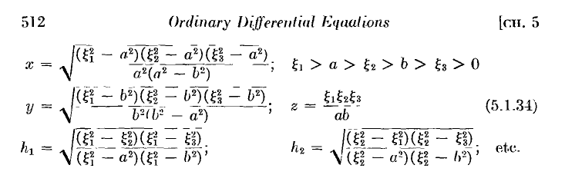

but I never thought about "where these equations come from". I think this is how it works. We start out with our three intersecting quadric surfaces

x2/( ξ12-a2) + y2/( ξ12- b2)+ z2/(ξ12- c2) = 1 c < b < a < ξ1

- x2/(a2- ξ22) + y2/( ξ22- b2)+ z2/(ξ22- c2) = 1 c < b < ξ2 < a

- x2/(a2- ξ32) - y2/(b2- ξ32)+ z2/(ξ32- c2) = 1 c < ξ3 < b < a

Each surface is labeled by a ξi coordinate. I think we can solve the above three equations for x,y,z with a simple Cramer's rule. I seem to recall this from somewhere, but I guess I never wrote it down. I will do it in Maple. Write the above three equations in matrix form:

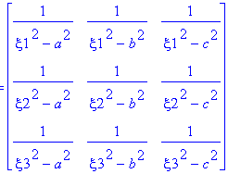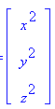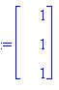

Then tell Maple to compute the inverse of this matrix and apply to the column of 1's to get x2 etc. We get

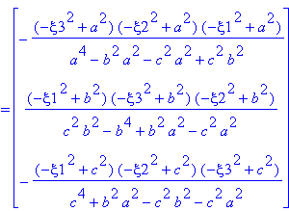

Manually we can write this as

x2 = (ξ12-a2) (ξ22-a2) (ξ32-a2)/ [ (a2-c2)(a2-b2)]
y2 = (ξ12-b2) (ξ22-b2) (ξ32-b2)/ [ (b2-a2)(b2-c2)]
z2 = (ξ12-c2) (ξ22-c2) (ξ32-c2)/ [ (c2-b2)(c2-a2)]

Now we usually set c = 0 without loss of generality, and this becomes

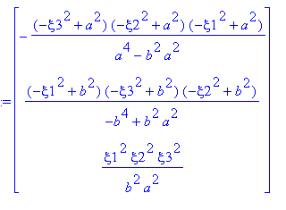

which we can compare now to our MF quote:

and there you have it! So here I will write out the results

x2 = (ξ12-a2) (ξ22-a2) (ξ32-a2)/ [ a2(a2-b2)]
y2 = (ξ12-b2) (ξ22-b2) (ξ32-b2)/ [ b2(b2-a2)]
z2 = ξ12 ξ22 ξ32 / a2b2

Comments: Each ξi labels a quadric surface, ie, a conicoid. I know these intersect in 8 places with obvious symmetry, but let's think of the first octant only. The above expressions tell you (x,y,z) in terms of (ξ1, ξ2, ξ3). This is the one Cartesian point in the first octant the lies on all three surfaces.

WW in their Lame chapter write the general x,y,z equations in this way

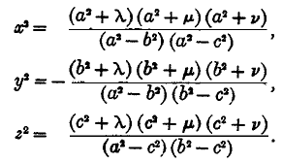

where they refer to their coordinates as (λ,μ,ν) instead of (ξ1,2,3). This shows that when c ≠ 0, the denominators do factor (my solution above did not show things factored).

Part I: What is the significance of parameter c (which we end up setting to 0) 10.10.10

For the ellipse with c showing we have

x2/( ξ12-a2) + y2/( ξ12- b2)+ z2/(ξ12- c2) = 1 c < b < a < ξ1

which says

A2 = ξ12-a2
B2 = ξ12-b2
C2 = ξ12-c2 => C ≥ B ≥ A
ξ12 = A2+a2 = B2+b2 = C2+c2

If we take a slice in any coordinate zero plane, we get an ellipse. For example, for x = 0 we get

y2/( ξ12- b2)+ z2/(ξ12- c2) = 1 c < b < ξ1
B2 = ξ12-b2
C2 = ξ12-c2 => C ≥ B

An ellipse has only one focal distance, and for this ellipse it is

f2 = C2-B2 = b2- c2

Now let's try the y = 0 plane ellipse:

x2/( ξ12-a2) + z2/(ξ12- c2) = 1 c < a < ξ1
A2 = ξ12-a2
C2 = ξ12-c2 => C ≥ A
f2 = C2- A2 = a2- c2

And finally we do the z = 0 plane ellipse

x2/( ξ12-a2) + b2/(ξ12- b2) = 1 c < b < ξ1
A2 = ξ12-a2
B2 = ξ12-b2 => B ≥ A
f2 = B2- A2 = a2- b2

Here is a summary, and notice that things are not "cyclic" in nature, the middle item is reverse cyclic:

plane focal distance squared
x=0 b2- c2
y=0 a2- c2
z=0 a2- b2

x2/( ξ12-a2) + y2/( ξ12- b2)+ z2/(ξ12- c2) = 1 c < b < a < ξ1

There are three focal distances and three parameters to describe them. BUT, consider these three equations for the three focal distances,

fx = $\sqrt{b2- c2}$
fy = $\sqrt{a2- c2}$
fz = $\sqrt{a2- b2}$

We find that

fz2 = fy2 – fx2

This tells us that for a completely general ellipsoid, you cannot arbitrarily set the three focal distances of the zero coordinate slice ellipses. Only two are independent.
For example, if fx = fy you get fz= 0 which means the cross section in the z=0 plane is a circle. We then have a = b > c so A = B < C and we have a prolate spheroid with sym axis in the z direction.
Another example is fz = fy which tells us fx = 0. In this case c = b < a so C = B > A and we then have an oblate spheroid with sym axis in the x direction.

But there is more. You can select two of the three focal distances independently, but there are restrictions. If the two you want to select are fx and fy, you must have fy ≥ fx ! And since fx2 = fy2 – fz2 , if you want to pick fy and fz, then you must make sure fy ≥ fz. But since fy2 = fx2 + fz2, you can select fx and fz any way you want.

So one conclusion we reach is that there is no need for three parameters a,b,c to define a confocal general ellipsoid family ( whose members are described by label ξ1). Two will do. The convention is to set c = 0 and then we have

fx = b // Notice that fx = b, not a, though a appears with x in the conic
fy = a
fz = $\sqrt{a2- b2}$

And we already have stated that a ≥ b as part of our system definition, so we are saying fy ≥ fx which gives a non-negative fz.

So we can regard c in two ways:
First, it is a redundant parameter in defining a confocal family.
Second, if we look at our last conicoid equation above

- x2/(a2- ξ32) - y2/(b2- ξ32)+ z2/(ξ32- c2) = 1 c < ξ3 < b < a

we see that c sets the lower range endpoint for the ξ3 variable which defines the 2-sheeted bloid. Whatever c≥0 you select for this endpoint, the range of ξ3 will be (c,b). Were you to set c close to b, then all the "action" of this ξ3 variable takes place in a narrow range, but the surfaces span the same set of surfaces regardless of how you decide to "scale" the ξ3 variable. There is nothing to be gained by having c ≠ 0 except it gives some "term symmetry" to the conic equations.

