Kelvin Parsing Attempt #2 PhL 11.14.09

Overview (10.7.10): Here I take a harder look at the Kelvin Sec's 11-23 of the ellipsoid paper. In retrospect, I think my " parse #1" doc overview is all the "overview reader" needs. The extra fine gleaning done here does not add much. The harder you push on it, the harder it pushes back at you. I now must accept that this Kelvin paper is really just a historical artifact that is not very useful in deriving the charged ellipsoid solution. The "right way" is to do it in ellipsoidal coordinates where the result falls out quickly. Trying to "parse Kelvin" is like trying to paint a house with a toothbrush. You could do it, but you would have to draw a large set of accompanying drawings, and you would have to translate every single sentence into the modern world. I think one might find there are holes in Kelvin's derivation, such as the issue of the constant potential inside a thin similar shell. As stated elsewhere, the significance of the paper is that Kelvin was the first to "prove" the result, and any "first proof" of something is likely to be convoluted, confusing and incomplete. Remember he was only 18 and his standards for clarity were probably not as high as in his later life.
_________________________________________________________________________________

Things are very slippery here. I don't believe my first "parsing" of Kelvin's work, so let's just try again on another whole pass. // I feel this pass was successful and I now believe all of Kelvin's results.

Section 11 (page 7 / 27) Here is the first chunk of this 1 page Section 11,

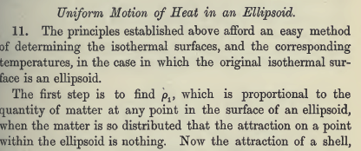

In Section 6 of Parsing #1, I tried to convince myself of this fact: If you construct a mass shell of uniform density which fills the space between two concentric similar ellipsoids (even if finitely different), then there will be no force on a test mass in the empty space inside the inner ellipsoid. Since this is true where the two ellipsoids are finitely different, then it must be true if they are very close together as well. Moreover, if you think of this similars-ellipsoidal shell as very thin, you can regard the potential as constant on both sides of the shell and inside the thin shell as well.
I tried to prove this fact about no force on a test mass inside basically by showing that the gravitational potential is constant on the surface of the inner ellipsoid. I tried to do this by showing that the integral ∫shell dV ρ /|r- r1| , where r1 is any point this inner surface, and where ρ = 1, is in fact independent of the point r1.This fact is not very obvious. So let's accept this to be true, and I just comment that it was probably not very obvious to a reader of his paper. Notice that as you move your test mass around inside the shell, the mass on the shell does not run around like surface charge on a conductor so this is not a Green's function situation where, as Jim pointed out, you would need an "image mass" to get V = constant on even a sphere. This subject of no force on a test mass is broached by Kelvin in his Sections 21-23.
So for me this was a major effort, and we are just in the second paragraph of Kelvin!

So we make ourselves a thin "similar ellipsoids" mass shell, and we note that the thickness of the shell dn at any given point varies as you move around on the shell. It is then dn(x,y,z). Then we come to Kelvin's next slippery construction which involves this picture (ignore pillbox for now)

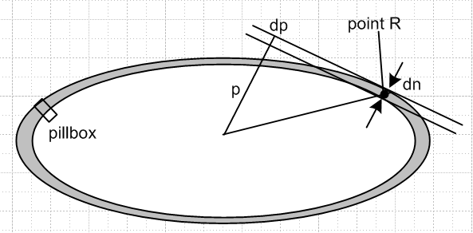

The thickness of the shell over at point R is dn, and this is the same as distance dp which is on the end of a vector p which is from center to the tangent plane, being perp thereto. So claim that dn = dp.

Side Question 1: Would Δn = Δp apply for largely spaced similar ellipses? The ellipse equation says

dy/dx = (b2/a2)(x/y)

So if we scale up x→5x and y→5y then the slope stays the same, so if you draw tangent planes at points where a ray intersects both ellipses, they will be parallel. But it is clear that "dn" has no real meaning in this situation. You cannot draw a dn segment that is perpendicular at both ends. So we conclude that the whole idea of dn = dp only applies in the closely spaced similar ellipses limit.

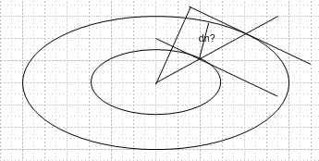

Side Question 2: Would dp = dn be true for a thin shell made from two confocal concentric ellipses? The answer is YES, in the limit that they are closely spaced. Do it with an equation using θ, or simply note that when closely spaced, when you draw your tiny dn, the two tangent planes are parallel as dn→0 certainly, so dp = dn differentially. So this fact that dn = dp applies to closely spaced similar or confocal ellipses. [ Kelvin never makes use a thin shell made this way. ]

Theorem 1: For closely spaced similar ellipses, we claim δa/a = δb/b = δp/p = k << 1. By definition, two ellipses are similar if a'/a = b'/b = C = 1 + 1/k, so we know δa/a = δb/b = k. But what about dp/p? We have

p = R-1/2 R = x2/a4 + y2/b4 + z2/c4
dp = -(1/2)R-3/2 dR dR = ???

Here between the two ellipses all 6 variables x,y,z,a,b,c are changing, so messy. Easier idea is that when you draw two similar ellipses, every distance between two points is scaled up by δs/s = k, QED.

Side Question 3: What similar δ thing would be true for two closely spaced confocal ellipses? We know in this case that a'2 = a2 + 2θ and b'2 = b2 + 2θ so c2 = c'2. Then aδa ≈ θ and bδb ≈ θ so we conclude that aδa ≈ bδb so then δa/b ≈ δa/a which is NOT the same result as Theorem 1. In Section 12 below, Kelvin is going to show that aδa = pδn in equation (b). But we know for either similar or confocal shell that δn = δp, so we can summarize everything for confocals saying ada = bdb = pdp. So that is the new rule for confocals.

I went off and confirmed that you can compute the length of this p vector to be

p = 1/ $\sqrt{x2/a4 + y2/b4 + z2/c4}$

which is certainly a "nice looking" result. For a sphere, p would be the radius. Since our mass density is ρ' = 1, a constant, we know that the "area density" at point R is proportional to dn. Kelvin burns a lot of words stating this. He imagines that the similarity scaling factor is "k" perhaps k =.05 for the picture shown above. Here are those words: ( I am omitting nothing he says in my screen clips)

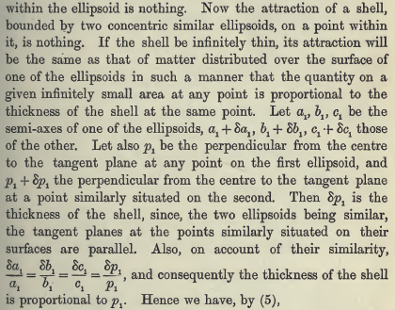

So I am completely happy with all the above text.
Now we come to the next super slippery part of the discussion. We just showed that the shell's "areal" mass density can be written as ρ1 = C dn = C dp where C is some unknown constant [ similars or confocals]. But we also know that dp/p = k [ similars only!] , our similarity scaling factor .05 or whatever, so we have ρ1 = (Ck)p ≡ k1p where now k1 is our new unknown constant. So this is ONE part of equation (a) coming below: ρ1 = k1p1 [ similars only ] where the 1 labels just mean we are talking about our inner or outer shell ellipsoids which are very close together and are similar.
But now Kelvin slips in a very major second idea which ties back, finally, to the idea that there is no force on a test mass inside our (similar) shell. We know that, in general, div E = 4πρ, where E is the gravitational force field and ρ is the mass density at the same point in space, and we know we can write E = - ∇v where v is a potential. Using a pillbox straddling both shell boundaries (shell is diff thin!), as shown in the drawing above, we know that E = 0 on the interior dA area, and E = some value E at the other end of the pillbox, just outside. So 4π (mass enclosed) is equal to EdA which says 4πρ1dA = EdA or E = 4πρ1 of -dv/dn = 4πρ1, where ρ1 us our "areal" mass density which we just showed above is ρ1 = k1p1. This is similar to E = 4πσ where σ is the areal charge density on a charged conductor. The key fact here is that you have to know that E = 0 inside the shell, and that is what I spent parse 1 older notes Section 6 developing. So with all this hoopla, we are able to move 3 lines forward in Kelvin's paper:

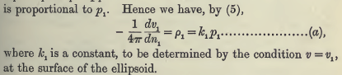 // similars only!!

which brings Section 11 to a close. Of course dv/dn is the normal derivative of v. For a given ellipsoid (call it ellipsoid #1, which is our then double shell thing), we know that dv/dn is proportional to our very explicit p thing shown above. The proportionality constant k1 is specific to ellipsoids #1.
Equation (a) tells us the gravity field just outside our special thin shell construction made from two closely spaced similar concentric ellipsoids. In deriving (a), we used two facts specific to this similars situation. First, was that E = 0 inside the shell, second was that dp/p = k. In Section 14 below, Kelvin applies equation (a) to a math ellipsoid far outside the similars-shell, which math ellipsoid is confocal to the similars-shell. He claims that dv/dn on this larger confocal ellipsoid is proportional to p for that ellipsoid, proportionality constant some unknown k, specific to that outer ellipsoid. I see no argument why this should be true, nor did Kelvin give one. [ but see notes later ]

Section 12 (page 7 / 27)

Now suddenly we are going to forget about closely spaced similar ellipsoids. We are going to consider our constructed ellipsoidal shell as infinitely thin, and therefore the potential is constant on it everywhere, and not just on the inner surface where we showed that was true. We then want to think about a nearby (primed) surface outside this shell which is going to be an equipotential of v = v1 - C with C some small amount (maybe he should have called it dC). Kelvin is going to show that this outer equipotential surface is in fact another ellipsoid, which is in fact confocal with our thin shell ellipsoid (and not similar to it). So let's listen in:

Our equation (a) shown above then says this, since dv1 = -C: (not the same C as I used above! )

C/(4πk1) = p1dn1 ≡ θ1 = an unknown constant since k1 was unknown (**)

[ We are only allowed to use equation (a) because we are applying it just outside and very close to our similars-shell where we showed it was true.]

Now at a point R (see picture above) we have our little vector dn1 = (dx,dy,dz) which connects our super-thin starting shell to the posited outer equipotential surface. He calls dx = x'-x where x' is on that outer surface and x in the inner one.
At this point, we have to go run off and do a whole separate exercise which I did in the original parsing notes. We actually know the direction of the dn1 vector as a function of location on the ellipsoid:

d1• = cosα1 = p/A = (x1/a2) / $\sqrt{x2/a4 + y2/b4 + z2/c4}$
d1• = cosβ1 = p/B = (y1/b2) / $\sqrt{x2/a4 + y2/b4 + z2/c4}$
d1• = cosγ1 = p/C = (z1/c2) / $\sqrt{x2/a4 + y2/b4 + z2/c4}$

This is "just a geometry problem", and another thing the poor reader has to go off and derive. (Kelvin has some appendix typo info on this in one of his later sections. )
So the following would be true

dx = dn1 cosα1
dy = dn1 cosβ1
dz = dn1 cosγ1

These cos things are "direction cosines". If we insert the expression above we get

dx = dn1 cosα1 = dn1 (x1/a2) / $\sqrt{x2/a4 + y2/b4 + z2/c4}$ = dn1 (x1/a2) p1

where everything is supposed to have a "1" subscript, and where on the right we just use our formula found earlier for p and which is really a part of all this direction cosine derivation. But now you see on the right the combination p1dn1 which we set to θ1 above, and which we know is a constant, so we have

dx = x' - x = θ1(x1/a1)2

This then carries us through the following text chunk:

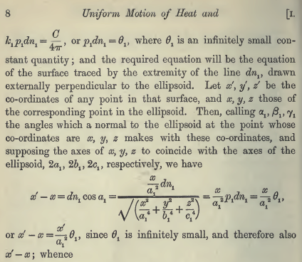

We then know, for example, that

x = x' (1-θ1/a1)2 ≈ x' / (1+θ1/a1)2 since θ1<< 1

and we can do the same discussion for the y and z coordinates so all in all

x ≈ x' / (1+θ1/a1)2
y ≈ y' / (1+θ1/a1)2
z ≈ z' / (1+θ1/a1)2

which shows us how the point (primed) on the new surface relates to that on the original. It we stick these three equations into the equation of our original ellipse and keep using θ1<< 1, we get just what he now says:

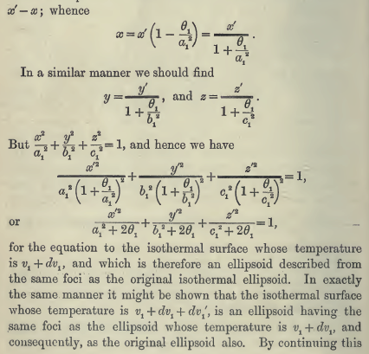

At this point, looking at the last form shown above, if is obvious that the outer "surface" really is, in fact, another ellipsoid. And we can see that differences like a2 - b2 = a12 - b12 and similarly b→c, and this says for sure that this new surface is an ellipsoid which is confocal to the original one! He just imagines "building out" a set of these to get the equipotential surface lay of the land!
And so ends Section 12. It was not too bad, but there is a lot more to come.

Section 13 (page 9 / 29)

So we have shown that , for example, a2 = a12 + 2θ1 so write

(a1 + da1)2 = a12 + 2θ1 => 2a1da1 ≈ 2θ1 => θ1 ≈ a1da1

But we already know that θ1 = p1dn1 from (**) above. So a1da1 = p1dn1 or dn/da = a/p. I like writing this as dn1 = a1da1/p1 . If we go out distance da1 at the ellipsoid "end", then we know dn anywhere on the ellipsoid. We have then dealt with all of Section 13 which is just this text,

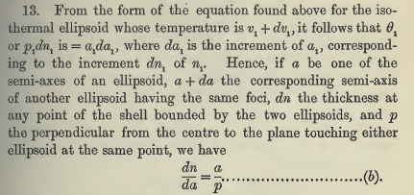

It is not clear to me yet what he plans to do with this equation (b).

Section 14 (page 9 / 29)

Here I run into big trouble. First, I quote my own paragraph above:

"Equation (a) tells us the gravity field just outside our special thin shell construction made from two closely spaced similar concentric ellipsoids. In deriving (a), we used two facts specific to this similars situation. First, was that E = 0 inside the shell, second was that dp/p = k. In Section 14 below, Kelvin applies equation (a) to a math ellipsoid far outside the similars-shell, which math ellipsoid is confocal to the similars-shell. He claims that dv/dn on this larger confocal ellipsoid is proportional to p for that ellipsoid, proportionality constant some unknown k, specific to that outer ellipsoid. I see no argument why this should be true, nor did Kelvin give one. He just tried to fool the reader. "

Here then is the troublesome text:

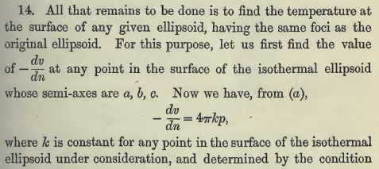

So all I can do at this point is take this to be an "ansatz" and see if it leads to a solution from which we can then verify that everything is self consistent. I cannot "prove" (a) on the math ellipse because I don't know what the potential function is there.

Notes Added to Explain This.

(1) Kelvin is pretty short with explanatory words. He is thinking about a distant outer confocal ellipsoid on which V = constant. He knows at this point that the equipotentials are ellipsoids confocal to the starting one. He then implicitly does what I might call a Dirichlet Image Model. In the real problem we have some surface out there a,b,c which has some constant potential v on it. But we can replace the real problem with an another second problem which meets exactly this same boundary condition: V = constant on an ellipsoid. This second problem is to have a thin similar-ellipses mass shell out there at the site of our first problem's distant mathematical ellipsoid. We can use our pill box on this second-problem mass shell to conclude that -dv/dn = 4πkp just outside this "model" ellipsoidal shell, using exactly the same arguments we made above for the inner shell. The constant k will have to be adjusted to get the desired potential v on this distant mass shell. So, in the real problem there is of course not actual mass shell out there at the mathematical confocal ellipsoidal boundary of constant potential v. But the Laplace equation solution out there must have the form -dv/dn = 4πkp because that is in fact a viable solution for the same boundary conditions. So this is my "support" argument for what I was calling an ansatz above. We then claim that the equation -dv/dn = 4πkp on every single one of those confocal ellipsoids, where k is some sort of label for the ellipsoid.

(2) Now another addition to these notes. Imagine our picture above where we see dn drawn

Imagine that the two ellipsoids shown here are confocal (poorly drawn for that) so that the potential drop across the boundary is δV everywhere. We know that δn varies somehow as we move around the ellipse shown here. At places the shell is wider, larger δn, we know that δV/δn must be less, since δV is constant. Now imagine some kind of variable like constant k, but I will call it ξ1, which labels the confocal ellipsoids, so ξ1 = constant on a given one. The potential then is really V = V(ξ1). The difference between two nearby ellipsoids would then be dV = (dV(ξ1)/dξ1 )dξ1. Now suppose there is some "metric tensor" relation such that the physical Cartesian distance between the two ellipsoids is dn at some point R. Then dξ1 = hξ1-1 dn if we move in a direction where ξ2 and ξ3 don't vary ( some orthogonal other coordinates). Then we have E = field = -dV/dn = -dV/dξ1 * dξ1/ds = - V'(ξ1) hξ1-1. Now, in our MF ellipsoidal coordinates, which is what applies to this situation, we know that

hξ1-1 = $\sqrt{(ξ12- a2) (ξ12- b2)}$ / $\sqrt{(ξ12- ξ22) (ξ12- ξ32)}$ = (1/ξ1)2 p(x,y,z) (*)

and thus we have -dV/dn = - V'(ξ1) hξ1-1 = V'(ξ1) (1/ξ1)2 p(x,y,z) = 4πk p(x,y,z) so the connection is
that 4πk = V'(ξ1) (1/ξ1)2 which, as he always said, is some constant on an ellipsoid.

The upshot then is this: As you move around on a mathematical confocal ellipsoid, the gravitational field E = -dv/dn varies over the ellipsoid entirely due to the metric tensor factor which you can express either in terms of ξ1 ξ2 ξ3, or in terms of p(x,y,z). So p(x,y,z) is exactly how the electric field varies on a ξ1 surface outside a charged metal ellipsoid. When applied to the metal ellipsoid itself, this tells us that p(x,y,z) describes exactly how the charge distributes itself on the metal. It is entirely just a metric tensor factor, that is the main point. I prove (*) above in my section V (a cap letter!) of my doc "potential of charged ellipsoid".

We now return to my original notes where I was very unhappy about the treatment of the outer ellipsoid.

Now for the rest of this section, Kevin cheats the reader severely. He imagines that both the inner and outer confocal ellipses are somehow each "built from" closely spaced similar ellipses, so both of these shells have some tiny differential thickness. We accept this for the inner surface which actually contains some mass, and for which we derived (a). But somehow we are supposed to believe that (a) is also true near the mass-empty outer similars-built shell. We cannot derive it there because we don't have the intermediary mass density ρ to use, but OK, we have accepted it as ansatz.

Now here is his text,

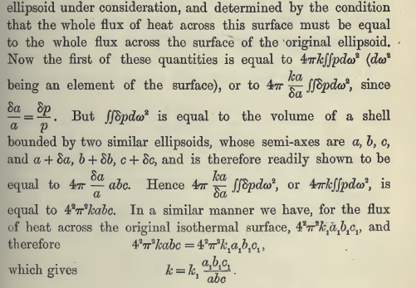

Now I will go through each step in detail. I agree that flux through two concentric confocal similars-built-thin shells must be the same, that part is not a cheat. The flux through either shell is this

∫shell E•dA = ∫shell ∇v •dA = ∫shell dv/dn dA

Now at our inner shell we can apply equation (a) which was derived for that shell and we get

flux inner = ∫inner shell dv/dn dA = – ∫inner shell 4πk1p1 dA = - 4πk1 ∫inner shell p1 dA

and for this inner shell (built from two similars with δn = δp etc) we can say δp/p = k'= δa/a ( I add a prime since this is an unknown constant, don't want to confuse it with k yet to come). Therefore we make use of p = δp/k'

flux inner = - 4πk1 (1/k')∫inner shell δp1 dA1 = - 4πk1(1/k')∫inner shell δn1 dA1

This last integral is the volume of the inner shell made from similars and we know it is 4π abc k' so we conclude that

flux inner = - 4πk1(1/k') 4π abc k' = -(4π)2 k1 a1b1c1

Now we exactly repeat each step for the outer similars-built-thin shell using our ansatz that (a) is true there as well. [ which means using our Dirichlet Image Model idea ] Doing this gives

k1 a1b1c1 = k abc

which is flux conservation. He never really says whether the outer confocal "shell" is close to the inner one, or is far distant from it. Therefore, he implies all along that this is true for far-spaced confocal shells.

His motivation for doing this is to find k given k1, so he can use this newly found k in his ansatz potential -dv/dn = 4πkp, and then we have his final result of Section 14,

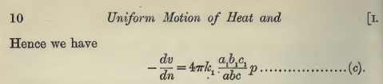

Now let's look at his nice result that k1 a1b1c1 = k abc which basically says

k1vol1 = k vol

so that the label "k" varies inversely with ellipsoid volume, a very simple result. In terms of my "notes added" above where we found that 4πk = V'(ξ1) (1/ξ1)2, this tells us that this combination varies in proportion to ellipse volume, something not very obvious when you stare at the Lame solution V(ξ1).

Section 15 (page 10 / 30)

First, let's example equation (d)

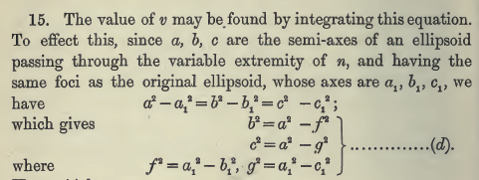

The first equation is true because each of these quantities is 2θ1 (or my ξ12 ellipsoidal coordinate). The four remaining equations just state the two principle axis ellipse foci in terms of either confocal ellipse. So nothing has happened here except we are saying the two ellipses are confocal. The idea now is first to replace b and c in the denominator of (c) as follows:

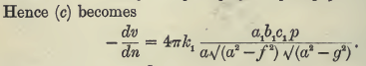

Now finally we make use of our earlier mystery equation (b) which said a δa = p δp = p δn and which we now apply on the right side to say dn/a = da/p which then cancels our p factor we then have

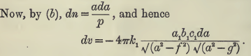

He then integrates this along the path from a1 to a which has differential da, to get v:

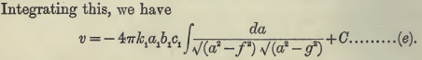

Section 16 (page 10 / 30)

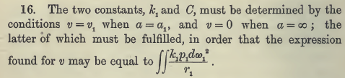

Nothing difficult there. Far away it looks like a point charge so need v→ 0. Put v1 on inner surface with the mass on it.

Section 17 (page 10 / 30)

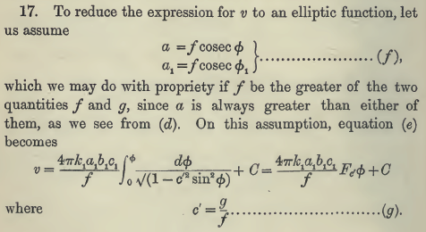

The da integral goes (a1,a) . He changes variables from a to φ according to a = f csc φ so
da = - f cscφ cotφ dφ. Then

$\sqrt{a2-f2}$ = f $\sqrt{(a/f)2-1}$ = f $\sqrt{csc2φ-1}$ = f cscφ $\sqrt{1 - sin2φ}$ = f cscφ cosφ.

$\sqrt{a2-g2}$ = f $\sqrt{(a/f)2-c'2}$ = f $\sqrt{csc2φ-c'2}$ = f cscφ $\sqrt{1 - c'2sin2φ}$

Then

da / [$\sqrt{a2-f2}$$\sqrt{a2-g2}$] = - f cscφ cotφ dφ / [f cscφ cosφ f cscφ $\sqrt{1 - c'2sin2φ}$]

= - f cotφ dφ / [f cosφ f cscφ $\sqrt{1 - c'2sin2φ}$]

= - f cosφ cscθ dφ / [f cosφ f cscφ $\sqrt{1 - c'2sin2φ}$]

= - dφ / [f $\sqrt{1 - c'2sin2φ}$]

where our integration endpoints are now a1 = f cscφ1 and a = f csc φ. But the lower endpoint integral evaluation is just "a constant" and he puts this into the C shown and makes the lower endpoint be φ = 0. And so yes, we end up with (g). Notice that the famous factor "p" does not appear anywhere.

Now as a→∞, we have sinφ→0 so φ→0. Going to this limit then sets C = 0. And evaluate at φ = φ1 gives the rest, and we end up with this,

Section 18 (page 11 / 31)

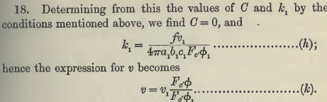

where Fc'φ is my F(φ,c'), elliptic first kind integral.

Section 19 (page 11 / 31)

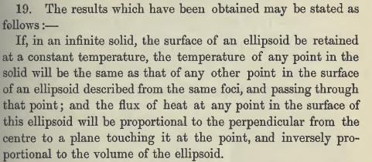

This is his little wrap up. Since I know his final result is correct, I guess the ansatz must be justified, as well as the various strange steps.

Section 20 (page 11 / 31)

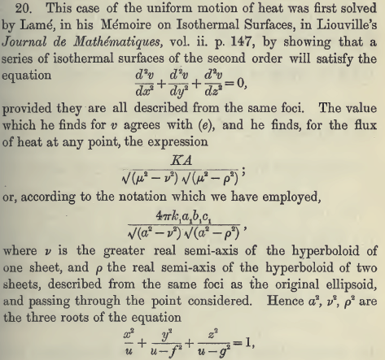

So Lamé did the problem in ellipsoidal coordinates and the cubic equation looks familiar. He then shows that using the Lamé solution, you can work backwards to his result that

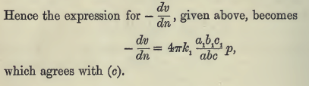

Sections 21-23 (page 12 / 32)

In these sections, which conclude the paper, Kelvin shows what I showed, that a similars-shell of uniform mass density exerts no force on a test mass inside. He then shows other formulas for the force on a test mass outside, which he associates with someone named Ivory. In these formulas, e and e' are the principle major ellipse eccentricities and a,b,c are the usual semi-major axes. I have not studied these sections.

In Section N of my doc mentioned above "potential of charged ellipsoid" I show that Kelvin's solution for the potential of a charged ellipsoid exactly matches that found by MF using the ellipsoidal coordinates.

