Morphing Ellipsoidal Coordinates PhL 11.25.09

Overview (10.10.10, 1/6 page). 1
(0) General Ellipsoidal. 1
(1) Prolate Spheroidal. 2
(2) Spherical. 3
(3) Elliptical Cylindrical. 4
(4) Oblate Spheroidal. 5
OrthgonalityArgument. 5

_________________________________________________________________________________

Overview (10.10.10, 1/6 page).

I show here graphically (using Maple) how you start with the general ellipsoidal coordinates and, by taking suitable limits, you arrive at simpler coordinate systems. I do this for four systems number 1 to 4 in the contents above. The pictures really say it all. We find that both the 1-sheet and 2-sheet bloid surfaces can butterfly into azimuthal planar surfaces in the right circumstances. And in the spherical case, we see half of a 2-sheet bloid becoming a cone. I conclude with a comment that there must be some conformal-like morphing theory that would let you start with spheroidal and morph to general ellipsoidal and conclude that orthogonality is somehow preserved, something like 2D conformal mapping but in 3D.
_______________________________________________________________________________

(0) General Ellipsoidal. A red ellipsoid (squashed football) has semi-major axes A<B<C. Below are some Maple-drawn ellipsoidal coordinate surfaces in their unmorphed form from "ellipsoidal coords surfaces 1.mws". In these pictures we have A,B,C = 3,6,10. This determines the focal distances a, b according to a2 = C2- A2 and b2 = C2-B2. We know that a,b then define a particular "confocal family" of red ellipsoids, one of which we see below (the one with red ξ1 = 10). For the other two constant-parameter surfaces we have used yellow ξ2 = (b+a)/2 and blue ξ3 = (9/10)b, just to make nice pictures. Recall that 0 ≤ ξ3 ≤ b ≤ ξ2 ≤a ≤ ξ1 .

semis: C ≥ B ≥ A. A2 = ξ12 - a2 B2 = ξ12 - b2 C2 = ξ12

The blue surface is the 2-sheeted bloid (clear in the pictures), while the yellow surface is the 1-sheeted bloid (not so clear due to the hidden surface drawing method which puts it inside the red ellipsoid)

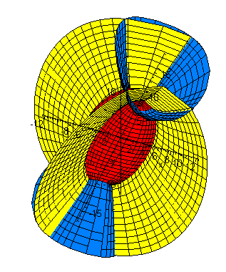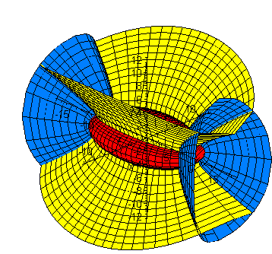

I should comment in passing that Maple has problems with certain A,B,C settings so I adjust around these to get clean pictures. One problem is that pieces of surfaces will be missing. I know why this is, and it is studied in another doc, but here the reader is just being made aware of the problem.

(1) Prolate Spheroidal. If the football is unsquashed, what happens? That would be the prolate spheroidal limit. Imagine looking at the red football from the upper right in the above left picture. The cross section of this squashed ball is an ellipse, but if we unsquash it this ellipse morphs into a circle. A question is then: what happens to the yellow one-sheeted bloid in this limit? The prolate limit means a = b and A = B < C. We started with A,B,C = 3,6,10, but let's go to A = 5.5 to get closer to the prolate case. Our picture is now

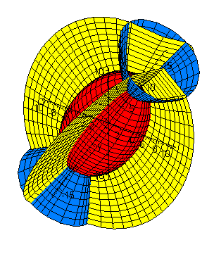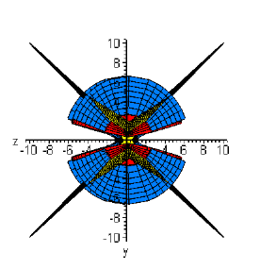
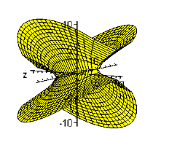 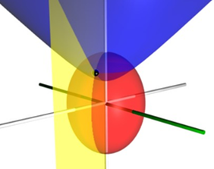prolate

and you can see that the yellow 1-sheet bloid surface is getting very flat and is approaching the intersection of two planes (four half planes). In each quadrant on the upper right, the yellow half-plane is nearly a surface of constant azimuth when viewed from this direction! If we go all the way to the prolate system, we need only keep one of these four half planes. Compare to the usual prolate picture shown lower right above! This then shows how the 1-sheet bloid (the ξ2 coordinate) becomes the azimuth coordinate in prolate spheroidal coordinates. Similarly, only half of the blue 2-sheeted bloid is retained and you see it in the lower right picture as well.

(2) Spherical. Start with the prolate spheroidal case shown above, the lower right picture. If we reduce the value of C so we have A,B,C = 5.5, 6, 6.5 instead of our original 3,6,10, the red ellipsoid approaches a sphere and the blue bloid half approaches a cone! My Maple program needs some tweaking to draw this picture, but it seems pretty obvious so I won't tweak. The spherical coordinate result is this

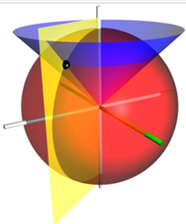

where of course now the blue cone is a surface of constant polar angle θ.

(3) Elliptical Cylindrical. If we select A,B,C = 4, 6, 50 instead of our original 3,6,10, the red ellipsoid gets elongated (its cross section is still an ellipse) and we get this picture , where I now set ξ2 = (2/10)b which moved the blue 2-sheet bloid closer toward the center of the ellipsoid:
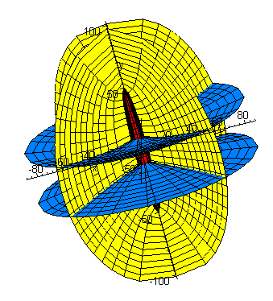
You can see that each blue bloid half is approaching a plane. If we pick one of these two planes, it becomes the blue z = constant plane of elliptical cylindrical coordinates. At the same time, we see that the yellow surface is again getting flat (as it did in the prolate case above) and is becoming two intersecting planes again, and we select one of the four half-planes as our azimuth. Voila:

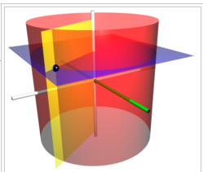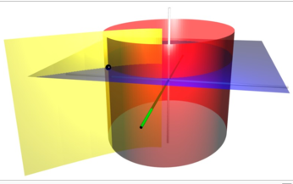

These pictures agree with my non-limiting Maple plot of you go to the central region of the plot. The real limit of course is C → ∞, and we have shown only C = 50.

(4) Oblate Spheroidal. This limit is C = B ≥ A. To get close to this, we use A,B,C = 3, 6, 6.5 and we obtain the plot on the left:
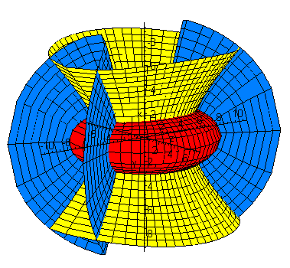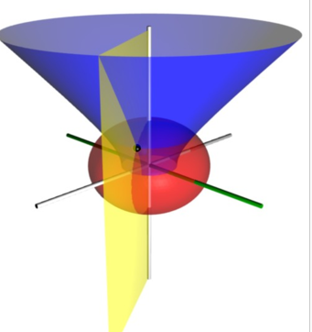

In this case, it is the blue 2-sheet bloid that is morphing into two intersecting blue planes and is thus becoming the azimuthal coordinate of oblate spheroidals. On the right we show the official oblate drawing, so the reader has to imagine the yellow and blue colors swapped in that drawing. As usual, we keep only the upper half of the 1-sheeted bloid and let its parameter vary in such a way that it can reach the lower half space, so an x,y,z location has a unique prolate coordinate representation.

OrthgonalityArgument. In the spherical system we know that we have full base vector orthogonality. All these other systems are obtained in some 3D conformal morphing sense from that system, so appealing to conformality, we expect orthogonality to be preserved. There is no 3D conformal theory that I know of, but the existent 2D conformal theory would apply to any aligned slice at any point in the morphing. I suspect that if you are maintaining 2D orthogonality on all slices in all directions all the time, your 3D base vectors must maintain orthogonality during any morphing action. You would track an intersection point and consider the base vectors in pairs maybe, or their projections somehow. I think a proof could be managed along these lines. Of course we know it is true because we know how to compute the metric tensor g'ab and in fact it is diagonal. Since its elements are the dot products ea•eb of base vectors, we know they are orthogonal.

Status: At this point, we have related 4 of the 11 usual curvilinear coordinate systems by morphing from the stem cell which is the ellipsoidal system. Presumably one could similarly study the other systems in this manner, as morphs from the general ellipsoidal system. M&F discuss this subject at length.

