Legendre Question PhL 12.31.09

This starts as a Lamé question, but I think I can convert it to a simpler Legendre question. Once I know the answer, it will all seem stupid and trivial, but right now I don't know the answer, so I will maintain this document even after the answer is found. I am completely clueless at the moment.

See overviews of Plan E and Plan F below for a summary.

1. Statement of the Lamé Question: 1
2. Statement of the Legendre Question: 3
3. Investigation of the Question 4
Plan A1. 4
Plan B. 4
Plan C: 5
Plan D. 5
Plan E. 6
Plan F: Notes added 10.13.10 10

__________________________________________________________________________________

Overview (2 pages, added 10.13.10)

My goal in this doc was to explain why the Lamé E solutions have "the forms they do" as in the four species. None of these forms seemed to match my naive Frobenius forms like $\sqrt{z-b}$f(z) where f(z) is analytic. Eventually in Plan F I understood why $\sqrt{z2-b2}$f(z) really is "of the form $\sqrt{z-b}$f(z)", and the key is to make clear what you mean by "analytic". The question is: "analytic where?"
In Section 1 I write the Lamé equation and "state my problem"; it is a reasonable statement.
In Section 2 I realize that the Legendre ODE provides a simpler case. Instead of having four finite singular points ±a, ±b, it has only two which are ±1. At each of these points the index is ±m/2. The same kind of question arises. You would list (z-1)m/2f(z) as a possible solution form, but in fact you find that some Legendre solutions have the form Pnm(z) = (z2-1)m/2 ∂mPn(z) where ∂mPν is just a polynomial when n is an integer, and this "form" does not seem to be "on the list of Frobenius forms" for this problem. Moreover, in general we know that Pnm(z) ~ (1+z) m/2(1-z)-m/2 F and this form is also not on the list.
In Section 3 I then being my "investigations" which are lettered A,B,C...
In Plan A I note that the ODE has z→ -z symmetry so f(z;a,b) = sol ⇒ f(-z;a,b) = sol. I then tried to linearly combine these +z and -z solutions to get the Lamé form $\sqrt{z2- a2}$ g(z) but to no avail. I could have done a similar unsuccessful investigation using the a → -a symmetry.
In Plan A1 I assume that f(z) in the solution g(z) = $\sqrt{z-a}$ f(z) is even, then try again to do a linear combination, but no cigar.
In Plan B I imagine starting with $\sqrt{z-a}$ f(z) and "winding around the branch point z = -a". This certainly seems obscure, but I was recalling some place that indicated you might pick up a $\sqrt{z+a}$ factor by doing this? Here is, in fact, what I was recalling [ from "bateman1.doc" in ODEs: ]

Loop Around Branch Point Theorem: If we take any solution f(z) of our ODE that has a singularity at z=0, and if we "analytically continue" that solution on a loop around the singularity, we obtain a phase times the original function f(z) plus a second term which also solves the ODE. If we think of f(z) as our "first" solution to the ODE, then this second term will be a "second" solution.

So I if you start with $\sqrt{z-a}$ f(z) and wind around z = a, you might pick up a phase plus a second term, so you are NOT going to pick up $\sqrt{z+a}$ times the term you start with! Bad memory.
In Plan C I ponder the right word to use for the analytic continuation formulas Bateman uses for the Legendre functions. Connection formulas seems the right phrase. Then I try to use such a formula to concoct, from Frobenius basic forms, a form with factor (z2-1)m/2 for Legendre functions. I get nowhere.
In Plan D I look at the basic P function F-definition when F is a truncating series. Then we have

Pnm(z) = A (1+z) m/2(1-z)-m/2 p(z-1)

where p is a polynomial. This "form" has r+1 = -m/2 and r-1 = m/2 for exponents, and does not appear on my "list" mentioned above for Legendre solutions. It converges in a huge open disk of radius 2 about z = 1. I notice, maybe for the first time, that in such a disk, (1+z) m/2 is completely analytic. This is the clue to resolving the confusion, as will be seen below.
In Plan E I at least move a bit at least for Legendre: (a) I restate the above now obvious fact that in some convergence region R, a function is completely analytic even if it has branch points outside that region. (b) Therefore, the expression shown above for P really does have the "form" Pnm(z) = (1-z)-m/2 f(z) where f(z) is analytic in a region about z = 1. (c) If the factor (1+z)m/2 in the above Pnm(z) were missing, we would wonder why convergence fails on the radius 2 circle since then nothing happens at z = -1 to stop extension to a larger radius. Therefore, Pnm(z) = A (1-z)-m/2 p(z-1) could not be a solution with p a polynomial. (d) I regard this as an argument that you MUST have a form like Pnm(z) = A(1+z) ε1 m/2 (1-z) ε2 m/2 h(z) which, first of all, has one of our "listed forms", and secondly has a factor which limits the convergence radius. Examples of such a form are S1(z) = A (1-z2)±m/2 h(z) and S2(z) = A [ (1+z)/(1-z)]±m/2 h(z) both of which we see in Bateman. (f) Pnm(z) = (z2-1)m/2 ∂mPn(z) is another example.
Note that the general argument being made here for P works in some sense because we have a poly around z=1 so the disk is centered there. In the Lamé case, however, as MF do it, the center is at z= 0. But I think we could make the same argument with Lamé had we done a form around z = a, say, though the b branch point might then interfere. But there is another problem with Lamé: if we take f(z) = $\sqrt{z-a}$ p(z) as a candidate, it is perfectly OK at z = -a since r=0 is an allowed exponent there (whereas in Legendre you had to have ±m/2). Thus I think f(z) = $\sqrt{z-a}$ p(z) is a "legal" form for Lamé (but I don't think there actually exist any solutions of this form, p = polynomial).
I then give a complete list of what I regard as "legal" solution forms with p(z) for the Lamé case.
At this point, I started looking on the web. I found an article which seems to agree with me, but it has a Lamé equation with only 4 singular points, not 5. Somehow this is a transformed form of Lamé and that may be relevant, but not right now. I quote the Niven thing from somewhere, and take note that Hobson is not on line anywhere and maybe I should look at it. [ I later copied it from Marriott.]
In Plan F I start over somewhat. (a) makes a claim which is interesting but not relevant; (b) draws the Lamé cut structure. (c) I then use the logic of item D above to show that the four "species solutions" are completely consistent with the "Frobenius rules" and I show how Byerly arranges these solutions. I still feel that something like f(z) = $\sqrt{z+b}$p(z) is a "Frobenius-legal" form [p = poly], but that no solution of this form seems to exist. Only if the indices are the same at z = ±b is there an actual solution of the shown form. In this case both indices are +1/2 and we get f(z) = $\sqrt{z2-b2}$ p(z). For a general ODE, it is not clear whether you can find solutions that are "eigenstates" of all the singular point indices at the same time, but that seems to happen for Lamé.
___________________________________________________________________________________

1. Statement of the Lamé Question:

In the Lame equation, we know we have these regular singular points with corresponding indices, here is a quote from MF vol II page 1305

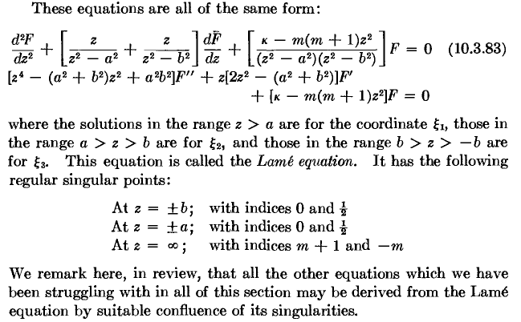

The question is this: given the above list of regular singular points and their exponents, you would expect to find solutions of these 10 forms:

(z +b)1/2 f(z) f(z)
(z - b)1/2 f(z) f(z)
(z + a)1/2 f(z) f(z)
(z - a)1/2 f(z) f(z)
(1/z)m+1 f(1/z) (1/z)-mf(1/z) // not sure of this ∞ line

where f(z) is some analytic function about the appropriate z value. The first question then is: why is it that the Lame equation has solutions of this form: (MF)

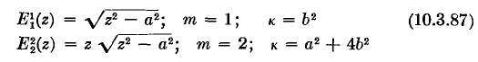
which is really of the form

(z + a)1/2 (z - a)1/2 f(z)

because this form is not on my list above. And here is another Lame solution

which is of this form

(z + a)1/2 (z - a)1/2 (z + b)1/2 (z - b)1/2f(z)

My question is sort of this: where do these solution forms "come from", given that we have solutions of the form shown in my list above.

2. Statement of the Legendre Question:

First, here is a MF quote from page 545 vol I

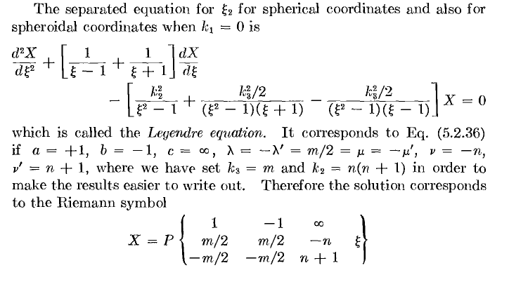
which gives us the indices for the three regular singular points. Again, you would expect solutions of this form

(z -1)m/2 f(z) (z -1)-m/2 f(z)
(z +1)m/2 f(z) (z +1)-m/2 f(z)
(1/z)-n f(1/z) (1/z)n+1 f(1/z) not sure of this ∞ line

I can come back later and worry about the point at infinity, that is a separate question, one at a time please. So there is the list for Legendre. But here is what solutions look like
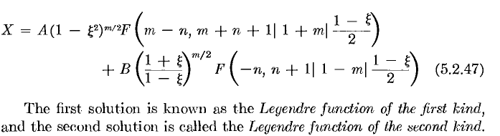

so you see forms that are not on the list above. So this then is the Legendre statement of my question.

WARNING: In the above quote, I think MF have made two errors. First of all, it is the second function that is the P function, not the first. Secondly, the first form does not appear anywhere in the Bateman tables.

However, for integer m, Bateman does say on page 148 that we can write

Pνm = (z2-1)m/2 ∂mPν

and for ν = integer n, ∂mPν is just a polynomial, so here is a case where we do in fact get the factor
(z2-1)m/2, which was my main concern.

3. Investigation of the Question

Plan A. One observation of both Lame and Legendre is that the ODE is symmetric under z → -z. Suppose we start with a Lame solution of the form g(z) = (z + a)1/2 f(z) . Then another solution must be given by h(z) = g(-z) = (-z + a)1/2 f(-z), but we don't know about the symmetry of f. Can we somehow add these solutions in this way?

(z + a)1/2 f(z) + (-z + a)1/2 f(-z) + q(z) = (z + a)1/2 (-z + a)1/2 m(z)

In other words, can we construct a solution of the desired form just by adding the official solutions? That is my Plan A. If the above were to be true we would need

(z + a)1/2 [ f(z) + (-z + a)1/2 (z + a)-1/2f(-z) + (z + a)-1/2q(z) ] = (z + a)1/2 (-z + a)1/2 m(z)

which then requires

f(z) + (-z + a)1/2 (z + a)-1/2f(-z) + (z + a)-1/2q(z) = (-z + a)1/2 m(z)

How could you balance the branch points here? I don't see how this method helps me.

Plan A1. Suppose it just happened that there was a solution g(z) = (z + a)1/2 f(z) where f(z) was symmetric in z. Then we would have h(z) = g(-z) = (-z + a)1/2 f(-z) = (-z + a)1/2 f(z) also being a solution, and then we could add these like so to get a new ODE solution q(z),

q(z) = Ag(z) + Bh(z) = A (z + a)1/2 f(z) + B (-z + a)1/2 f(z) = [A (z + a)1/2 + B (-z + a)1/2 ] f(z)

= (z + a)1/2 f(z) [A + B (-z + a)1/2 (z + a)-1/2]

But still I am not getting a product form containing (z + a)1/2 (-z + a)1/2. BUT, I do get q(z) which has explicit branch points at two locations. But on the other hand, f(z) does not exist at both branch points as a series, unless of course it truncates, an ingredient I have not yet put into the stew. I will add it later.

Plan B. Start with a solution and then wind around the other branch point. Start with this Lame form for near z = -a,

(z + a)1/2 f(z)

which has a branch point at z = -a. What happens if we wind around z = +a ? But the above form does not converge there. You cannot just say f(z) analytic everywhere! So dead end here as best I can see, (which is not too clearly). Anyway, I think this just makes a phase for a power branch point.

So this little question is resisting my simple efforts to unravel it. I am sure if I insert the complicated forms into the ODE, they will of course work. I accept that the complicated forms are in fact solutions. The question is how these solutions relate to the basic solutions with those exponents.

I think winding around branch points just produces connection formulas, see below.

Plan C: Using the little analytic continuation formulas, we know we can write things like this:

(z +1)m/2 f1(z) = A (z -1)m/2 f2(z) + B (z -1)-m/2 f3(z)

What is the word for such an equation? Bateman's table calls them "expansions". WW call them "relations". These are not the "Gauss contiguous relations" which have to do with stepping one constant by ± 1, I know about those guys. I did a web scan, and see some people referring to these things as "connection formulas", so that is the term I will use! At least I will know what I mean by such a phrase.
So, consider the above connection formula. I think there always exists a region of the z plane where all three series solutions f1,2,3 converge at the same time. These are all then fully analytic functions with no branch points. Then the RHS "reveals" that our LHS, (z +1)m/2 f1(z) , when continued to the region of z = +1, has branch points there as shown, just the two exponents at z = +1. All three of these terms are ODE solutions.
But I still have not constructed an ODE solution which has a factor (z2-1)m/2, that is my issue. If I multiply the connection formula through by some factor like (z +1)-m/2, then who says we still have a solution of the ODE? Well. let's just do it and not claim the result solves the ODE:

f1(z) = A (z +1)-m/2 (z -1)m/2 f2(z) + B (z +1)-m/2 (z -1)-m/2 f3(z)

= A [(z -1)/ (z +1)]m/2 f2(z) + B (z +1)-m (z -1)-m/2 f3(z)

I have no conclusion to reach here. The "continued" f1 function is not analytic at z = +1, but I already know that.

Plan D. Look at the Legendre P function situation

Pνμ(z) = 1/Γ(1-μ) (1+z) μ/2(1-z)-μ/2 F[ -ν, ν+1; 1- μ; (z-1)/2 ]

This converges in a disk of radius 2 around z = +1 since that disk is free of other branch points. The two solutions at this regular singular point are

(z -1)μ/2 f(z) and (z -1)-μ/2 f(z)

so the P function has the second form shown in my pair. You could say then that (1+z)μ/2 is in fact analytic in the entire convergence disk, so the above P form really is of the form (z -1)-μ/2 f(z) . So at least we have something consistent. Suppose the F function truncates due to ν and proper μ. Then we have

Pνμ(z) = A (1+z) μ/2(1-z)-μ/2 p(z-1)

where p is a (finite) polynomial in z-1. Does this match one of our forms? The thing is defined for all z! So what exactly do we mean by the "form" (z -1)-μ/2 f(z) ? Aha!

Plan E.

(a) When we say for Legendre that solutions at z = +1 have forms (z -1)μ/2 f(z-1) and (z-1)-μ/2 f(z-1), we mean (imply) that the function f is analytic in a disk centered at z = 1 whose radius is limited only by the occasion of the disk hitting another branch point. It is therefore OK for f(z-1) to have some branch points outside this disk or at the boundary of the disk! Within the disk, f(z-1) is 100% analytic. Our two solutions are still of the prescribed "form" despite possible branch points in f(z-1) beyond our disk. [ I write f(z-1) only to suggest a power series in (z-1). ]

(b) Therefore, when we write for example that

Pνμ(z) = 1/Γ(1-μ) (1+z) μ/2(1-z)-μ/2 F[ -ν, ν+1; 1- μ; (z-1)/2 ]

we think of this as valid for a disk centered at z = 1 and having radius 2, and this thing is of the form

Pνμ(z) = A(1-z)-μ/2 f(z-1)

where f(z-1) is 100% analytic inside our disk. That is to say, the extra factor (1+z) μ/2 in no way invalidates our claim that P has this "form".

(c) In general, the F series shown above will diverge somewhere on the disk boundary, perhaps right at the branch point it hits. However, suppose ν = integer, so the series truncates. Then according to the above, we have

Pnμ(z) = A(1+z) μ/2 (1-z)-μ/2 p(z-1)

where p is a finite polynomial converging for all z. Were the (1+z) μ/2 not present, we would then have a contradiction in that our solution would not have the right form near z = -1 !!! It would have been OK if the factor were (1+z)- μ/2 because that is also of the allowed form, then we have (1-z2)-μ/2 as the overall factor.

(d) Therefore, in cases where any F function truncates in any of the many forms of a solution to the Legendre ODE, that solutions MUST have this kind of overall form:

Pnμ(z) = A(1+z) ε1 μ/2 (1-z) e2 μ/2 h(z)

where h(z) is some finite polynomial in powers of z, or (1-z), or (1+z) or whatever. And ε1and ε2 are each either a + or a -.

(e) Here then are several "allowable" forms for a Legendre solution, in terms of their meeting the "exponent requirements" at z = ±1

S1(z) = A (1-z2)±μ/2 h(z) both have same exponent

S2(z) = A [ (1+z)/(1-z)]±μ/2 h(z) they have opposite exponents

We see that Pnμ(z) is of the S2 type. Some of Bateman's P function connection formulas show each of these two forms. Same for the Q's. That is, each term in a connection formula will always have one of these two forms, since we know the F functions might truncate.

(f) When μ = m = integer, we know that

Pνm(z) = (z2-1)m/2 ∂mPν(z)

In the special case ν = n = integer, we know that ∂mPn(z) is a polynomial, and then we have another example of our claim that we must have one of the two forms above, this being the S1 form. [ We ignore the phase difference implied by 1-z versus z-1 in the factors. ]

Restatement for the Lame equation.

Let's first look at these solutions quoted above

Note that all Lame solutions arise from "truncation" of the power series involved. We can say the following about these two solutions:

(1) They both apply for the entire z plane, converge everywhere.

(2) The exponents at z = b and z = -b must both be 0 (not 1/2, which is the other choice). That is why you don't see any (z-b)1/2 type factors in this solution.

(3) The exponents at z = a and z = -a are both 1/2, hence (z-a)1/2 (z+a)1/2

(4) Here then is a complete list of possible solution forms where p is something converging for all z. This is just based on the fact that all exponents can be 0 or 1/2.

p(z)

(z±a)1/2p(z)

(z2-a2)1/2 p(z)

(z±b)1/2p(z)

(z2-b2)1/2 p(z)

(z±a)1/2 (z±b)1/2 p(z) // with independent signs

(z±a)1/2 (z2-b2)1/2 p(z)

(z±b)1/2 (z2-a2)1/2 p(z)

(z2-b2)1/2 (z2-a2)1/2 p(z)

I don't know if solutions actually exist for all these forms, but any of these forms is at least "allowed" on exponent grounds. Our second solution quoted above has the last form

All the solutions shown by Byerly have the full (z2-a2)1/2 type factors, he shows none that are of the form (z-a)1/2p(z), for example. It is true that a only appears quadratically in the ODE, but I don't think this rules out this form, any more than in Legendre which as 1 and -1 so to speak. In other words, in a Lame solution you could have exponent 1/2 at +a and exponent 0 at -a, why not?
WW's last Lame chapter really does not help me much on this question. Byerly I think is saying that you just don't get solutions of the (z-a)1/2p(z) form. My discussion above does not force there to be a solution of each form listed, some forms might NOT have solutions, and I think that is the case with Lame.
Here is the first page of a 1950 paper I am not allowed to see on the web. This guy sets b = 1, so a>1. He also shows the parameter a not squared, so this thing seems only to have 4 singular points.

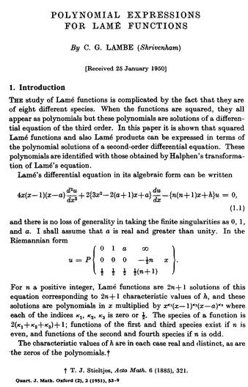

This thing seems a little different from the Lame I am used to, but I like his claim about the "forms" of the solutions in the last paragraph, which agrees exactly with my claims above. Notice also the claim about "8 species" which I think means the 23 choices of those exponents, just as I have listed them.
Our friends Wang and Gau have a few things to say,

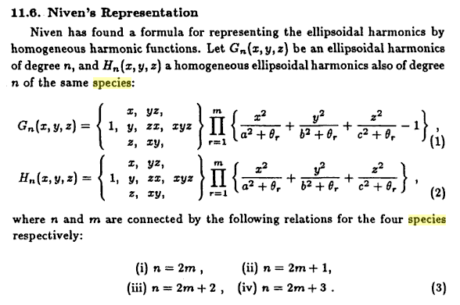
Of course this is all in Cartesian coordinates, whereas my Lame equation is not in such a coordinate.

Conclusion: I don't know if there are some Lame solutions of the extra "species" I have invented, and I cannot find any web data on this question that talks about things in Byerly terms.

Hobson, E. W., "The Theory of Spherical and Ellipsoidal Harmonics",

This above I have never been able to find, but QA406 .H7 1931 at Marriott and checked in, 500p. Would be fun to take a look next time I am there.

I think that is enough on this problem, I have found a reasonable answer to my posed question.

Plan F: Notes added 10.13.10

Here is the M&F Lamé equation from M&F (as in my long doc)

(a) Suppose we find a solution g(z;a,b). We may conclude that the following functions are also solutions, though we don't know how they are related to g(z;a,b) :

g(z;-a,b) g(z;a,-b) g(z;-a,-b)
g(z;b,a) g(z;-b,a) g(z;b,-a) g(z;-b,-a)

g(-z;a,b) g(-z;-a,b) g(-z;a,-b) g(-z;-a,-b)
g(-z;b,a) g(-z;-b,a) g(-z;b,-a) g(-z;-b,-a)

However, if h(z;a,b) is a second independent solution that goes with g(z;a,b), then we can certainly expand any of the above 15 solutions as a linear combination of g and h. [ These claims are true, but have no bearing on our question! ]

(b) Here is the cut structure of the Lamé equation,

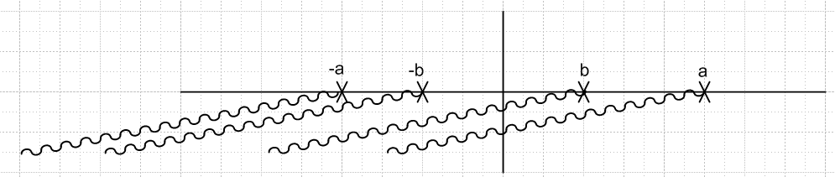

This and our facts here come from "finding solutions to the Lamé equation.doc". If we study Frobenius solutions around z = 0 (an ordinary point), we find they are either even or odd (in z) due to the nature of the coefficient recursion relation. [ True, but even and odd in z has little bearing on our question ]

(c) This is the answer to the question:

At z = +b we have these two Frobenius solution forms, where f and g are analytic at z = b:

f1(z) = $\sqrt{z-b}$f(z) f2(z) = g(z)

Without loss of generality, we can certainly redefine the analytic function f(z) by writing

f(z) = $\sqrt{z+b}$h(z) h(z) = f(z)/ $\sqrt{z+b}$

Note that $\sqrt{z+b}$ is analytic at z = b, and since f(z) is analytic at z = b, so is h(z). So now h(z) and g(z) are our arbitrary functions analytic at z = b (as far as our general forms go). Of course only certain specific h and g functions (analytic at z = b) will actually solve the Lamé equation.

So our Frobenius forms at z = b are now

f1(z) = $\sqrt{z-b}$$\sqrt{z+b}$ h(z) = $\sqrt{z2-b2}$ h(z) f2(z) = g(z)

So we have arrived at this pair of Frobenius forms at z = +b

f1(z) = $\sqrt{z2-b2}$ A(z) f2(z) = B(z) // where A(z) and B(z) are analytic at z = +b

By a similar argument we could write a set of Frobenius forms for z = -b

f3(z) = $\sqrt{z2-b2}$ C(z) f3(z) = D(z) // where C(z) and D(z) are analytic at z = -b

If we restrict our interest to functions C and D which are analytic for all z, such as polynomials, then we could claim that the pair

f1(z) = $\sqrt{z2-b2}$ p(z) f2(z) = q(z)

is a viable Frobenius pair form at both z = b and z = - b. The functions f1,2(z) have no singularities at
z = ±a, so our functions belong to the r=0 indicial class for these two points. So we might write

f1(z) = $\sqrt{z2-b2}$ p(z) r+b= 1/2 r-b = 1/2 r+a = 0 r-a= 0
f2(z) = q(z) r+b= 0 r-b = 0 r+a = 0 r-a= 0

where we are assuming that p(z) and q(z) are polynomials in z (and are general functions of a and b)

We could repeat this discussion at z = ±a and arrive at the obvious conclusions.

Now let's go back to our z = +b situation where we had

f1(z) = $\sqrt{z2-b2}$ A(z) f2(z) = B(z) // where A(z) and B(z) are analytic at z = +b

We could now write A(z) = $\sqrt{z2-a2}$E(z), noting that $\sqrt{z2-a2}$ and E(z) are analytic at z = b. Then our first function form becomes

f1(z) = $\sqrt{z2-b2}$$\sqrt{z2-a2}$ E(z) // where E(z) is analytic at z = b.

And again if E(z) is some globally analytic function like a polynomial p(z), then

f1(z) = $\sqrt{z2-b2}$$\sqrt{z2-a2}$ p(z) r+b= 1/2 r-b = 1/2 r+a = 1/2 r-a= 1/2

is a viable Frobenius form at all four singular points.

Our conclusion is that all four of the following functional forms are viable at all four finite singular points:

K(z) = p(z) r+b= 0 r-b = 0 r+a = 0 r-a= 0
L(z) = $\sqrt{z2-a2}$ p(z) r+b= 0 r-b = 0 r+a = 1/2 r-a= 1/2
M(z) = $\sqrt{z2-b2}$ p(z) r+b= 1/2 r-b = 1/2 r+a = 0 r-a= 0
N(z) = $\sqrt{z2-a2}$ $\sqrt{z2-b2}$p(z) r+b= 1/2 r-b = 1/2 r+a = 1/2 r-a= 1/2

where p(z) is some generic polynomial in z, and more generally is globally analytic in z. These then are the famous four Lamé species. You could write them all on one line:

f(z) = (z2- a2)ra (z2- a2)rb p(z) species number = 1 + 2*(2rb) + (2ra)

For each species, only certain quantized values of κ and m result in truncated series for p(z), causing it to be a polynomial. Byerly groups the solutions in a slightly strange way, namely, by the large z behavior of the solutions which will be some zn and the group name is then En(z).

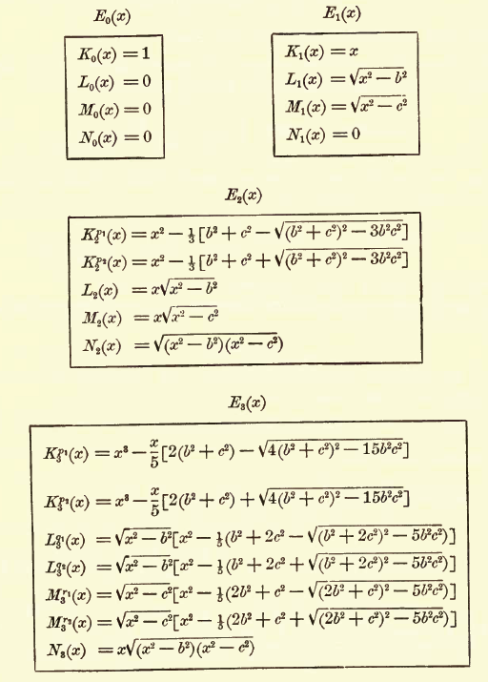

Comments: The solution forms listed above each have a definite Frobenius exponent at all four finite singular points! Obviously you could form other solutions by taking linear combinations, and those solutions then would NOT have definite exponent values at one or more of these points.
As a simpler example, we know from "ODEs with a k^2 type parameter.doc" that the ODE f"(z) = k2f(z) has exponents r = 0 and r = 1 at z = 0 (which happens to be an ordinary point). If we consider the two independent solutions to be ch(kz) and sh(kz), we find that ch(z) corresponds to r = 0 and sh(z) to r = 1, so these are solutions of definite exponent. If we make linear combinations like ekz and e-kz, these solutions do NOT have definite exponents.
Getting back to Lamé, we know for sure that there will be solutions with r+b = 1/2 and r+b = 0. But we have not "proven" in any manner that it is possible to find a solution which simultaneously has r+b = 1/2 and also has r-b = 1/2. We know we can write the form M(z) = $\sqrt{z2-b2}$ p(z) as we did above, but we don't know that a p(z) exists which makes this an actual solution. It turns out that such p(z) exist.
We might wonder if there exist solutions which simultaneously have r+b = 1/2 and r-b = 0 like R(z) = $\sqrt{z-b}$ p(z) where p(z) is a polynomial. I have never seen such a solution listed, nor do I see how you would construct such a solution from the listed ones. I suspect there are no such solutions. It seems that something about the Lamé equation forces solutions of this form to have the same exponent at ±b, but I don't know what that "something" is.
Of course the N solutions simultaneously have definite values for all four r exponents. It seems that solutions exist in all exponent cases as long as the ±b are the same and also the ±a are the same. Perhaps the reason for this shall become clear to me at some later time. Repeating the above

K(z) = p(z) r+b= 0 r-b = 0 r+a = 0 r-a= 0
L(z) = $\sqrt{z2-a2}$ p(z) r+b= 0 r-b = 0 r+a = 1/2 r-a= 1/2
M(z) = $\sqrt{z2-b2}$ p(z) r+b= 1/2 r-b = 1/2 r+a = 0 r-a= 0
N(z) = $\sqrt{z2-a2}$ $\sqrt{z2-b2}$p(z) r+b= 1/2 r-b = 1/2 r+a = 1/2 r-a= 1/2

You cannot make the claim that a solution can only be a function of a2 since only a2 appears in the equation. Our counterexample is f" = k2f where ekz is a solution, albeit not one of definite index.

