History of curvilinear coordinates PhL 11.17.10

This book has some comments on Lamé and Heine and Mathieu and Weber all of whom did elliptic things. They were amazed at what you could do with "curvilinear coordinates".

http://books.google.com/books?id=aO-v3gvY-I8C&printsec=frontcover#v=onepage&q&f=false

Mathematical thought from ancient to modern times, Volume 2

By Morris Kline // some excerpts on history of curvilinears.

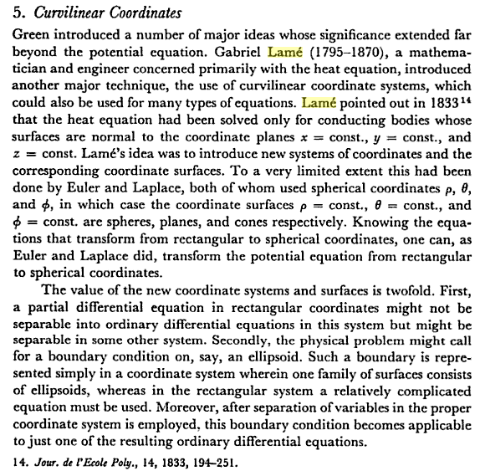

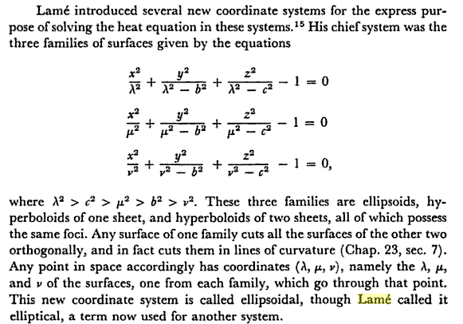

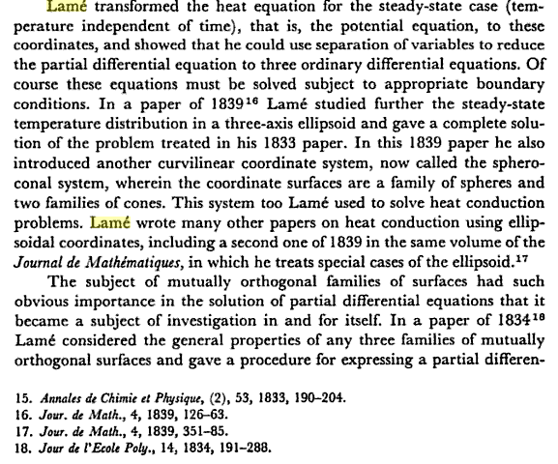
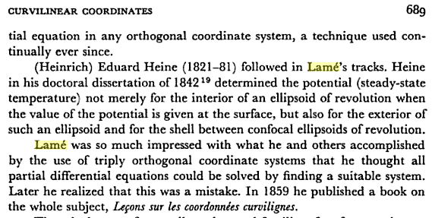
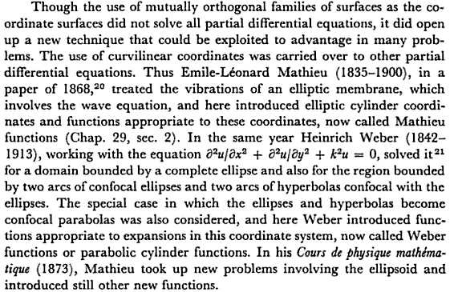
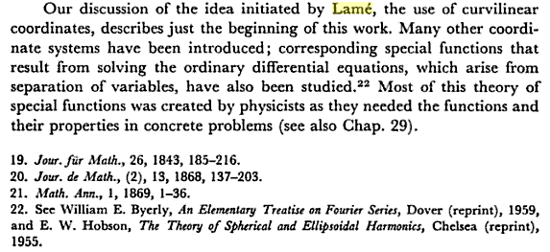

From Byerly:

