Moon and Spencer: Field Theory Handbook PhL 11.17.10

I checked out this 1931 book from Marriott. It is a small book of about 240 pages, very well worn. It lives in the "ARC" automated storage area with good temperature and humidity control.

Overview 2
About the book. 6
About the authors Parry Moon and Domina Spencer 6
Section 1: The Eleven Quadric Coordinate Systems p 1-48 47 pages 10
List of 11 classical systems 11
Section 2: Complex plane systems p 49-76 27 pages 11
List of 21 2D conformal maps see p 51 12
2D separability 12
Section 3: Cylindrical Systems p 77-95 18 pages 13
Section 4: Rotational Systems p 96-135 39 pages 15
Section 5: The Vector Helmholtz Equation p 136-143 7 pages 17
List of systems for which vector ∇² is stated here and p 136 17
Section 6: Differential Equations p 144-162 18 pages 18
Section 7: Functions p 163-216 53 pages 18
Section 7.02 Series Solutions Basics 19
Matrix Rollup Theorem. 19
Section 7.03 Series Solutions details in the three Cases 21
Section 7.04 Example: Bessel Wave ODE for general roots 21
Section 7.05 Example: Bessel Wave ODE for roots the same 21
Section 7.06 Example: Bessel Wave ODE for roots differing by an integer 21
Section 7.07 Orthogonality 22
Section 7.08 Weber Functions 22
Section 7.09 Bessel Functions 22
Section 7.10 Baer Functions 22
Section 7.11 Mathieu Functions 22
Section 7.12 Legendre Functions 22
Section 7.13 Lamé Functions 23
Section 7.14 Wangerin Functions 23
Section 7.14 Heine Functions 23
Bibliography p 217-225 8 pages 23
Symbols Used Appendix p 226-228 3 pages 23
Authors Index p 229-230 2 pages 23
Subject Index p 231-236 5 pages 23
Appendix A. Potential between two cones at constant potential. 24
Appendix B. Potential between halves of the hyperboloid in prolate spheroidal 26
Appendix C: Details on the surfaces for paraboloidal coordinates 26
Appendix D. Potential between two spheres at constant potential (fails, but result found) 28
Appendix E. Potential between two spheres at constant potential, Version 2 attempt (fails) 31

__________________________________________________________________________________

Overview

This book is frequently referenced, especially by Wolfram, but is out of print and is very hard to get hold of. I was lucky to borrow the 1931 edition from Marriott and copied it. No one seems to have the reputed 1988 second edition (the year Moon died), for loan or purchase. Photocopies exist for $116.

They deal only with 3D orthogonal coordinate systems, no non-Euclidean stuff. I suspect however that their results might be adapted to related non-Euclidian orthogonal systems.

Section 1: The 11 Classical Systems

Here we first have a review of curvilinear coordinates and then of Stackel separation theory with its S matrix. Then on page 7 we have a list of what I call the Eleven Classical systems (including Cartesian). Here is a key fact:

• In all 11 of these systems, both the Laplace and Helmholtz equations are simple-separable!

These are the only known orthogonal systems which have this property! (I am pretty sure of that)

Then in Table 1.01 we have a subsection on each of the 11 systems (they have 2nd degree or lower surfaces). For each system we get a nice picture, the separation matrix, and the separated equations and their solutions. This is done separately for Laplace and Helmholtz equations. The usual differential operators are written out. The vector Laplacians (they call instead of ∇2) appear later in Section 5.
Here is a list of these 11 classical systems, showing the functions which solve the Laplace separation equations: ( 4 cylindrical, 4 rotational, 3 neither)

Cartesian 9 x,y,z trig,expo
Circular Cylinder 12 r,ψ,z Jp(qr) Bessel
Elliptic Cylinder 17 η,ψ,z xem(ψ or iη,-q) etc Mathieu
Parabolic Cylinder 31 μ,ν,z We(op,qν or iqμ) Wangerin

Spherical 24 r,θ,ψ Ppq(cosθ) Legendre
Prolate 28 η,θ,ψ Ppq(coshη) Legendre
Oblate 31 η,θ,ψ Ppq(isinhη) Legendre
Parabolic 34 μ,ν,ψ Jp(x,iqμ) Bessel

Conical 37 r,θ,λ Jp+1/2(κr), Eqp(λ) Bessel,Lamé
Ellipsoidal 40 η,θ,λ Epq(κ,η or θ or λ) Lamé
Paraboloidal 44 μ,ν,λ Bpq(κ,μ or ν or λ) Baer

For the Helmholtz equations, some new function types appear as separation equation solutions, to wit

• for spherical, in the κ2 case instead of rp we get Jp+1/2(κr) for the radial, "spherical Bessel"
• for prolate, in the κ2 case we get Ppq(κa,cosθ) which is a "Legendre wave function".
• for parabolic, in the κ2 case we get Jp(κ,kν) which is a "Bessel wave function".
• for ellipsoidal, in the κ2 case we get Epq(κ,η) which is a "Lamé wave function".
• for paraboloidal, in the κ2 case we get Bpq(κ,μ) which is a "Baer wave function".

Information on the "wave" functions is not easy to come by on the web.

Section 2: 2D systems obtained doing conformal maps on 2D Cartesian

You can create new 3D orthogonal systems from 2D conformal maps of the 2D Cartesian coordinates. The conformal maps preserve angles and local scale, which means they are still orthogonal and they will have g11= g22 (metric tensor diagonals).
One can then either extrude the map to get a cylinder-like 3D system (g33=1), or rotate the map about either of its 2D symmetry axes. For example, toroidal and bi-spherical 3D systems are rotations of the same 2D bipolar system about the two symmetry axes, and the elliptic cylinder 3D system is an extrusion of the 2D elliptic system. The authors refer to these two system types as cylindrical (extruded) and rotational.
They discuss 21 conformal maps of interest and provide full page pictures for each map showing the level curves.
Another method of creating a new coordinate system is inversion of an existing one through the origin, and some of those appear later on.
Another method is to look for systems involving higher order surfaces. The cyclide systems are examples of 4th order. But these in fact occur amount the rotational group already mentioned.
For any 2D conformal mapped system, the Laplace equation looks just as it does in Cartesian coordinates. This is because Q1 = Q2. Thus, both 2D Laplace and 2D Helmholtz are 2D separable, and the solutions are just the usual linear, trig and expo functions.

Section 3: Cylindrical Systems

This section discusses 21 cylindrical 3D systems obtained from the conformal maps, which includes the 3 non-Cartesian classical ones. I show this list below. Here is a key fact:

• None of the 18 non-classical cylindrical systems allows Laplace or Helmholtz 3D separation!

Thus, we have no information here on things like "separation equations" and "their functions".

Table 3.01 on page 79 gives information on the 21 cylindrical systems. They are all 2D separable just from the conformal map separability noted above. The table gives designation, name, x,y,z equations, metric tensor, and separability situation.

Section 4: Rotational Systems

They first discusses simple separation versus what they call R-separation. A familiar example of R-separation occurs in toroidals where the separated form is A(φ)B(μ)C(η)/R(φ,μ,η) where R = 1/$\sqrt{chμ - cosη}$. Simple separation of course means R = 1. These notions of separability are summarized in Table 4.01.
If we were to rotate each of the 21 conformal maps of Section 3 about each of its 2 symmetry axes, we would obtain 42 rotational 3D systems. Apart from the classical systems which arise when this is done, none of these systems is separable in any way for Helmholtz. None is simple-separable for Laplace, but 10 of the 42 are R-separable for Laplace. The authors add to this set of 10 rotational systems one more system called the 6-sphere system which is the inversion of the Cartesian system and is not rotational. We then have a Group of 11 about which they provide data. Here is the Group of 11 (not to be confused with the 11 Classical systems)

tangent sphere 104 μ,ν,ψ J0(qμ) p56
cardioid 107 μ,ν,ψ Jp(qμ) 58
bispherical 110 η,θ,ψ Pp(cosθ) 64
toroidal 112 η,θ,ψ Pp-1/2(coshη) 64,other axis
inverse prolate 115 η,θ,ψ Ppq(cosθ), Pp(coshη) 70
inverse oblate 119 η,θ,ψ Ppq(cosθ), Pp(isinhη) 70
6-sphere 122 u,v,w elementary
bi-cyclide 124 μ,ν,ψ Upq(k,z) // Heine 71 = sn J1Rx
flat-ring cyclide 126 μ,ν,ψ Spq(k,z) // Wangerin ~1875 71 J1Ry
disk-cyclide 129 μ,ν,ψ Spq(k,z) // Wangerin 72 = cn J2R
cap-cyclide 132 J3R μ,ν,ψ Spq(k,z) // Wangerin 73 = sn-1 J3R

where we show the page of general data, the coordinate names, functions which solve the R-separated equations, names for new functions, and the page of the related conformal map (except for 6 sphere). Apart from the last four cyclidic systems which have Heine and Wangerin functions as solutions to the separated equations, the other 7 systems have solution functions which are our old friends Bessel and Legendre. No "wave" type functions appear here.
The above list appears on page 97. The authors then remove the 6-sphere from the above list but add in the four classical rotational systems

Spherical 24 r,θ,ψ Ppq(cosθ) Legendre
Prolate 28 η,θ,ψ Ppq(coshη) Legendre
Oblate 31 η,θ,ψ Ppq(isinhη) Legendre
Parabolic 34 μ,ν,ψ Jp(x,iqμ) Bessel

and then they add in the hyperbolic rotated system (which is not R separable so not very interesting) and this gives them a Group of 15 rotational systems. Table 4.02 then gives basic data on these 15 systems such as the x,y,z equations and metric tensor and separability
Then comes Table 4.03 which provides detailed information on each of the Group of 11 systems listed above (10 rotational + the 6-sphere, none classical).
Table 4.04 gives a linkage between the last of the Group of 11 systems (the cyclidic ones) and the list of canonical ODE's which appear in Section 7 below.

Section 5: Vector Laplacian

They display the vector Laplacian for systems that allow equations involving this operator to be separated. There are only 8 systems here. Recall F ≡ ∇ (∇•F) – ∇ x (∇ x F) .

Section 6: ODE's arising from coordinate separation

We have here the ODE's which occur for the separated variables in various systems. It seems that they can all be related to a certain standard form Bocher ODE which has one to four regular singular points (including at infinity; Bocher has no essential singularities). This book section is organized not by coordinate system, but by the type of ODE. A list of "canonical" ODE's is given each with its little Bocher "specification" notation like {1222} for the Heine equation. More tables here show different forms for the canonical ODE equations and their solutions.

Section 7: Functions which are solutions to those ODE's

This section concerns the functions which solve the ODE's of the canonical list, which are of course those that appear as the separated ODE's for various coordinate systems. Here is a list of those functions in their "wave" form ( authors use script capital letters for function names).

Wc(p,qz) Weber
Jp(x,q,z), Yp(x,q,z) Bessel
Bpq(z,μ), Cpq(z,μ) Baer
cem(qz), fem(qz), sem(qz), gem(qz) Mathieu
Ppq(κa,z), Qpq(κa,z) Legendre
Epq(κa,z), Fpq(κa,z) Lamé
Spq(k,z), Tpq(k,z) Wangerin
Upq(k,z), Vpq(k,z) Heine

Before delving into the individual functions, M&S provide a bang-up soup-to-nuts review of the Frobenius theory for doing a series solution around a regular singular point. They have an interesting method of rolling up the recursors (ie, the recursion relations) which I did not know about to get series coefficients expressed in a fairly closed form which they then utilize to handle the complex cases where the indicial equation exponents are equal or differ by an integer. This is I think the best I have seen anywhere. However, if I were computing coefficients with Maple, I would just manually roll up the recursors with a for loop. I went off and wrote another little doc about the Matrix Rollup Theorem quoted below.
They then do an amazingly complete example applying their notation to the Bessel Wave equation and its solutions.
They show how to transform the Bocher ODE differential operator into a form that is manifestly self-adjoint (think symmetric or Hermitian, so nice). This transform does not change the function form or the variable, it just replaces the P and Q functions with u,v and w where w is the weight function. Once the ODE operator is self-adjoint, the usual Stakgold-described Hilbert Space theory applies, and you know that Lu = λu will have eigenfunctions which form a complete set and allow for an expansion/projection theorem. In other words, any Bocher ODE with homogeneous boundary conditions becomes a standard Sturm-Liouville problem. Thus, any separated coordinate ODE has an associated SL problem.
In the rest of this section the authors review the functions listed above. The "wave" versions of the functions do not appear in standard references like Bateman, A&S and GR, or even in W&W.

The book wraps up with a Bibliography, list of symbols, author index and subject index.

History: Apart from the 3 commonly used systems, curvilinear coordinates theory started relatively recently with Lamé who did heat flow problems and realized that orthogonal "curvilinear" systems would simplify things (1833). I think he "invented" the metric tensor. He did the ellipsoidal coordinate system whose separated functions now bear his name. Heine did follow-on work in 1842. The circular membrane I think was first done by Euler in 1764, but the radial functions have Bessel's name. In 1868 Mathieu wanted to know about elliptical membranes, so we now have elliptical cylinder coordinates and Mathieu functions. Soon after, Weber did the Helmholtz in parabolic-cylinder coordinates and we have Weber functions. Wangerin later figured out the cyclidic coordinate systems, hence Wangerin functions. And on it went. The functions are related to physical problems, otherwise they would just be nameless series solutions to nameless ODE's just floating out in space.

________________________________________________________________________________

About the book.

You keep seeing Springer-Verlag and a 1988 2nd Ed, but Springer-Verlag don't show it.

0387184309 ISBN 978-0387184302 9780387184302

Here is something amusing

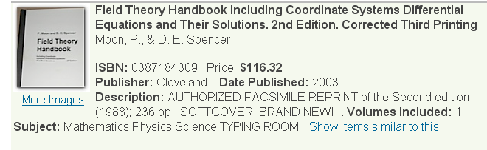

So this must be a photocopy thing. The company is Zubal Books (Cleveland, Ohio) which gets permission from people to photocopy books, fair enough. I suspect Domina has her hand in this price situation. There are no copies of that 2nd edition anywhere on the web for sale!

About the authors Parry Moon and Domina Spencer

Biography
Parry Hiram Moon was born in Beaver Dam, Wisconsin to Ossian C. & Eleanor F. (Parry) Moon. He received a BSEE from University of Wisconsin in 1922 and an MSEE from MIT in 1924. Unfulfilled with his work in transformer design at Westinghouse, Moon obtained a position as research assistant at MIT under Vannevar Bush. He was hospitalized for six months after sustaining injuries from experimental work in the laboratory. He later continued his teaching and research as an Associate Professor in MIT's Electrical Engineering Department. He married Harriet Tiffany, with whom he had a son. In 1961, after the death of his first wife, he married his co-author, collaborator and former student, Domina Eberle Spencer, a Professor of Mathematics. They have one son. Moon retired from full-time teaching in the 1960s, but continued his research until his death in 1988.
Scientific Contributions
Moon’s early career focused in optics applications for engineers. Collaborating with Domina Eberle Spencer, he began researching electromagnetism and Amperian forces. The quantity of papers that followed culminated in Foundations of Electrodynamics,^{[2]} unique for its physical insights, and two field theory books, which became standard references for many years. Much later, Moon and Spencer unified the approach to collections of data (vectors, tensors, etc.), with a concept they coined as “holors”.^{[1]} Through their work, they became disillusioned with Einsteinian relativity and sought neo-classical explanations for various phenomena
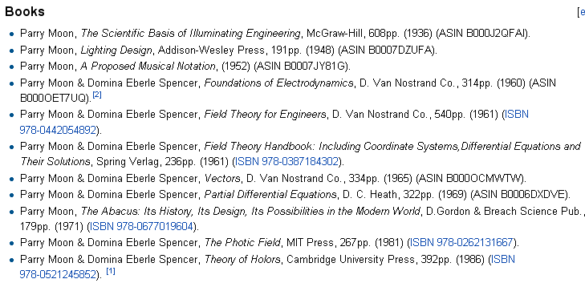
So they were a married couple when they wrote this amazing book. Notice the book titles, somewhat off the beaten path I would say. Lighting, music, abacus, holors.

The title of the book is a bit strange. The real title should be

"A collection of data about 3D orthogonal coordinate systems and their associated ODE's and functions."

or maybe

"The Coordinate System Handbook"

It is true that people use coordinates by working with functions of coordinates. And yes, a function of coordinates is a mathematical "field", and a theory involving such functions would be a "field theory". So somehow they decided to call this thing a Field Theory Handbook. The title is of course misleading to physics people and perhaps other for whom the term "field theory" has a narrower meaning.

The book really is good and I copied the whole thing. For each system, they assemble the same data in a very organized fashion. They consider both the Helmholtz and its special case the Laplace equation in all these systems. For each they give the x,y,z equations, describe the level surfaces as equations and pictures, and then sort of run my Maple program to compute things like the metric tensor and the usual "operators" in these coordinates. Then they do separation and come up with the "harmonic functions" for each case. They include in their operator list the vector Laplacian indicated not by ∇2 but by a star as shown on page 3, sort of a star of David character.

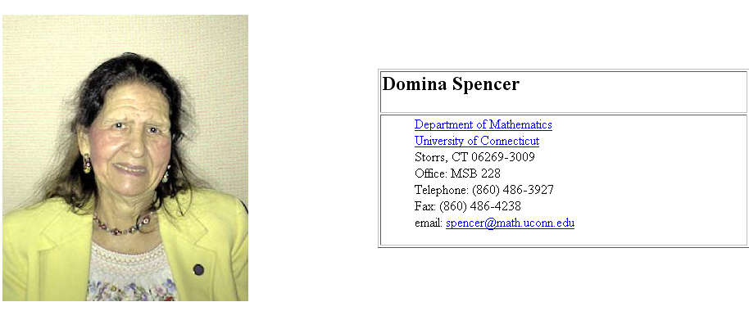

She was 88 years old in 2008. He was 88 in 1988.

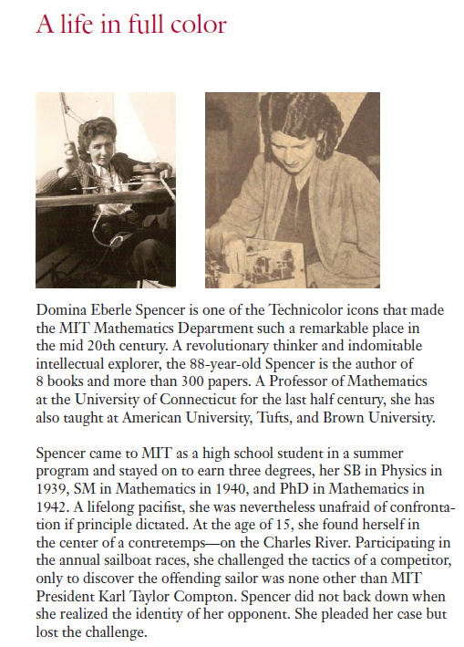

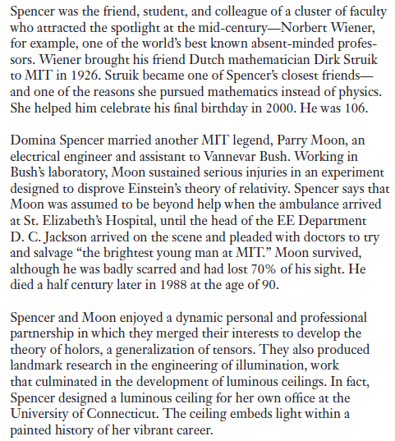

Section 1: The Eleven Quadric Coordinate Systems p 1-48 47 pages

I still have not learned the Stackel matrix theory of separation, it is sitting there in MF for when I decide to learn it. The authors point out that many coordinate systems can be classified as rotated or extruded ("cylindrical"), the latter being cylindrical-like with some non-polar 2D cross sectional coordinates. For these two kinds of systems, the Stackel matrix contains zeros as shown page 7.

There are 11 "classical" (my name, and this count includes Cartesian) systems formed from quadric (and lower) surfaces, see p 7. Four are cylindrical, four rotational, and three are neither. (ellipsoidal, conical, paraboloidal). I am familiar with 7 of these systems. Azimuth will always be called ψ, while φ serves as a generic function name. I think for all 11 you can separate both Helmholtz and Laplace.

In all 11 of these systems, both the Laplace and Helmholtz equations are simple-separable!

So after this short introduction, they dive right into the systems. They don't provide a fine index, so maybe I will (notice that toroidal is not on this list! It will appear later as a rotational system)
[ Note: MM list these 11 systems, then add 2D bipolar and toroidal to their list, giving then 13.]

List of 11 classical systems

Cartesian 9 x,y,z trig,expo
Circular Cylinder 12 r,ψ,z Jp(qr) Bessel
Elliptic Cylinder 17 η,ψ,z xem(ψ or iη,-q) etc Mathieu
Parabolic Cylinder 31 μ,ν,z We(op,qν or iqμ) Wangerin

Spherical 24 r,θ,ψ Ppq(cosθ) Legendre
Prolate 28 η,θ,ψ Ppq(coshη) Legendre
Oblate 31 η,θ,ψ Ppq(isinhη) Legendre
Parabolic 34 μ,ν,ψ Jp(x,iqμ) Bessel

Conical 37 r,θ,λ Jp+1/2(κr), Eqp(λ) Bessel,Lamé
Ellipsoidal 40 η,θ,λ Epq(κ,η or θ or λ) Lamé
Paraboloidal 44 μ,ν,λ Bpq(κ,μ or ν or λ) Baer

To make this list I just went through the MS data. For the functions, sometimes I picked Laplace and sometimes Helmholtz, I was not very careful, but see bullets below. Just want to see which special functions go with which coordinate systems. Note that MM provide none of this function data.

• for spherical, in the κ2 case instead of rp we get Jp+1/2(κr) for the radial, "spherical Bessel"
• for prolate, in the κ2 case we get Ppq(κa,cosθ) which is a "Legendre wave function".
• for parabolic, in the κ2 case we get Jp(κ,kν) which is a "Bessel wave function".
• for ellipsoidal, in the κ2 case we get Epq(κ,η) which is a "Lamé wave function".
• for paraboloidal, in the κ2 case we get Bpq(κ,μ) which is a "Baer wave function".

We don't have to leave the classical system arena to find "wave" functions! So the point here is that when you go from Laplace to Helmholtz, you go from a Joe equation with Joe functions, to a Joe Wave equation with Joe Wave functions as the solutions.

Section 2: Complex plane systems p 49-76 27 pages

They point out three kinds of orthogonal coordinate systems different from the classical 11.

• do a conformal map in 2D from Cartesian, which keeps orthog and keeps g11= g22 (scale maintained around each point), add z dimension so g33=1, and there you are. There are an infinite number of such systems possible. So extrude a conformal map.

Note: Polar coordinates are not a conformal map of Cartesian. For example, r = $\sqrt{x2+y2}$ is u(x,y) in the mapping where u = r. We know from TK that ∇2 rα = α(α+1)rα-2 so ∇2 r = 2 r-1 ≠ 0, so u(x,y) is not harmonic, so u(x,y) cannot be the real part of an analytic mapping w = f(z). Correspondingly, we find from Maple cylinder that grr = 1 and gθθ = r2 and grr ≠ gθθ .

• Or, rotate your 2D map about a planar symmetry axis to make a rotational system, and there will be an infinite number of these as well. Toroidal is an example in this class. So rotate a conformal map.

• invert an existing system to get another system. Have to ponder this a bit.

Inversion: My inversion notes point out that we have the R and R' spaces and

φ'(r ; q'i, r'i) = (a/r) φ(r' ; qi, ri) where q'i = qi(a/ri) and ri' = (a2/ri2) ri,

Obviously surfaces of constant potential in R space do NOT map into same in R' space (unless φ = 0 on that surface). Nevertheless, in R' space there will BE surfaces of constant potential.
For example, for a point charge we know that in R space a set of constant surfaces are spheres around that point charge. We know that in R' space a different set of spheres will be constant potential surfaces there.
Suppose you go ahead and find your constant potential surfaces in R' space, setting φ'(r ; q'i, r'i)= K.
In this inversion theory, we are relating two Cartesian coordinate systems (x,y,z) and (x',y',z'). φ(r) solves Laplace in R and φ'(r) = (a/r) φ(r') solves Laplace in R'. If we transform in R space to some (λ,μ,ν) orthogonal system, the big question is this: what happens in R' space?
No go for now.

• ascend to 4th degree surfaces, and you have the cyclide systems of Klein and Bocher. [ What happened top 3rd degree surfaces, and higher surfaces? ]

List of 21 2D conformal maps see p 51

This chapter is about the first of these methods, conformal maps. They first come up with a list of 21 2D conformal maps which are listed on page 51. Then they provide very nice pictures of the level curves for each of these maps. These maps are classified as to the nature of the functions w = f(z) involved : powers, expos, logs, hyperbolic trig, and elliptic. The first power case is called P1. They have a table which gives the real and imaginary parts for each, meaning the x,y equations. After several pages giving data on these 21 2D systems, they have their wonderful pictures. Think of each as a cross section of extrusion which would apply to some physical system having that cross sectional shape. Most have two symmetry axes at right angles to each other, but some only have one, such as the one looking like the end of a pipe if you rotated about that one axis.

2D separability

If you take the tensor.doc formula and eliminate the third dimension, you get -- since Q1 = Q2 --

∇2f = (1/Q12)∂12f + (1/Q12)∂22f

Therefore, the Laplace equation says ∂12f + ∂22f = 0 which is the same as the Cartesian equation, so we at once know all the solutions to such equations -- same as the Cartesian solutions, trigs and expos.

If we try Helmholtz with f = A(1)B(2) we get

(1/Q12)∂12f + (1/Q12)∂22f + κ2f = 0

∂12A(1)B(2) + ∂22 A(1)B(2) + κ2Q12 A(1)B(2)= 0

B(2)∂12 A(1) + A(1)∂22B(2) + κ2 Q12A(1)B(2)= 0

B(2)∂12A(1)/A(1) + ∂22B(2)/B(2) + κ2 Q12 = 0

Notice that in Cartesian where Q12 = 1, this is separable. If you look through the table starting page 52, with one small exception, Q11(1,2) is a non-factorizable expression of 1 and 2, so you cannot separate in the simple sense. Let's try R separation, but I will put R as a numerator factor and call it S

f = A(1)B(2)S(1,2)

B(2)∂12[A(1)S(1,2)] + A(1)∂22[B(2)S(1,2)] + κ2 Q12(1,2)A(1)B(2)S(1,2)= 0

B(2){ ∂12A(1) +∂12 S(1,2) + 2∂1A(1) ∂1S(1,2)} + A(1){ ∂22B(2) +∂22 S(1,2) + 2∂2B(2) ∂1S(1,2)} +

κ2 Q12(1,2)A(1)B(2)S(1,2)= 0

{ ∂12A(1)/A(1) +∂12S(1,2)/A(1) + 2∂1A(1) /A(1) ∂1S(1,2) }
+ { ∂22B(2)/B(2) +∂22 S(1,2)/B(2) + 2∂2B(2) /B(2)∂2S(1,2) } + κ2 Q12(1,2) S(1,2)= 0

To get separation, we need to pick S(1,2) so that the sum of the tangled terms separates. Those terms are

[1/A(1)]∂12S(1,2) + [2∂1A(1) /A(1)]∂1S(1,2)
+ [1/B(2)]∂22S(1,2) + [ 2∂2B(2) /B(2)] ∂2S(1,2) + κ2 Q12(1,2) S(1,2)= α(1) + β(2)

This is a second order (p=2) ODE in n=2 variables where we are allowed to select α and β as any functions want in order to make it work. If κ = 0, we can see that S(1,2) = 1 gives 0 + 0 which works, so Laplace is simply separable in 2D for all conformal map systems. They claim that Helmholtz is not, but that is not obvious to me staring at the above. Note that α and β can be functions of A and B here. So some work would be required here to prove there is no solution that works, I will let that ride.

Conclusions:
• any 2D conformal system is separable for Laplace.
• no 2D conformal system (except Cartesian) is separable for Helmholtz.

Section 3: Cylindrical Systems p 77-95 18 pages

Now they are going to take all those 21 systems and add a suffix C to make a 3D cylindrical system. For example, the first power conformal map P1 is now P1C

Here they are ( see page 77 for more details like the xxC ID numbers)

fig and its page
tangent-cylinder μ,ν,z 2.01 56
parabolic cylinder 2.02 57 member of classical 11
hyperbolic-cylinder μ,ν,z 2.04 59
rose-cylinder μ,ν,z 2.05 60
circular-cylinder 61 member of classical 11
cassinian-oval η,ψ,z 2.07 62
inverse cass-oval η,ψ,z 2.08 63
bi-cylinder η,ψ,z 2.09 64
maxwell-cylinder η,ψ,z 2.10 65
log-cylinder μ,ν,z 2.11 66
ln tan cylinder η,ψ,z 2.12 67
ln cosh cylinder η,ψ,z 2.13 68
elliptic cylinder 2.14 69 member of classical 11
inverse elliptic cyl η,ψ,z 2.15 70
sn-cylinder μ.ν,z 2.16 71
cn-cylinder μ.ν,z 2.17 72
inverse sn-cylinder μ.ν,z 2.18 73
ln sn-cylinder μ.ν,z 2.19 74
ln cn-cylinder μ.ν,z 2.20 75
zeta cylinder μ.ν,z 2.21 76

There are two methods of separability: simple, and R-separable. This is explained later at the start of the rotational section. He talks about 1D solutions where you just try out f(u,v,w) = f(v), say. Some systems don't allow this to work for Laplace and/or Helmholtz.

R-separability does not work for these cylinder systems, so if they separate, it has to be simple. But as we look through Table 3.01 of cylindrical systems, we see that only the 4 classical cylinder systems (includes Cartesian) allow even Laplace separation. They all allow 2D Laplace separability since that is a property of the 2D mappings as I showed earlier. For the 2D separation you just get the Cartesian Laplace equation in the 1,2 coordinates with the usual trig and expo solutions.

• None of the 18 non-classical cylindrical systems allows full Laplace or Helmholtz 3D separation!

The upshot is that there is nothing interesting happening in the world of non-classical cylindrical systems in terms of coordinate separation, so no new ODE's are encountered. I think this means these systems are only useful for physical problems with extrusion geometry. Basically these are really just 2D problems, as we saw in Stak.

After this comes Table 3.02, we have a collection of "important equations" for each of these systems: xyz equations, metric tensor, and the operators.

Section 4: Rotational Systems p 96-135 39 pages

This time in general you don't get simple separation of the H or L ODE, but you might get R-separation of the L ODE. As shown, R separation means you separate as usual but you have an extra denominator factor called R which is a function of all three coordinates. Recall our two toroidal atomic forms

$\sqrt{chμ - cosη}$ [ sin(mφ), cos(mφ)] [Pmn-1/2(chμ), Qmn-1/2(chμ)] [ sin(nη), cos(nηu)] m,n integer
$\sqrt{chμ - cosη}$ [ sin(mφ), cos(mφ)] [Pmiτ-1/2(chμ), Qmiτ-1/2(chμ)] [ sh(τη), ch(τη)] m integer, τ in (0,∞)

so here you do in fact have A(φ)B(μ)C(η) / R where R = 1/$\sqrt{chμ - cosη}$. So I am already familiar with one example of R-separation.
Now, of those 21 conformal systems listed back on page 77, only 10 appear to allow R separability. Those 10 are these, where I show on the right the page of the conformal map, and on the left the page where this system is described:

tangent sphere 104 μ,ν,ψ J0(qμ) p56
// could get potential of two touching spheres. as e-qν ?
cardioid 107 μ,ν,ψ Jp(qμ) 58
bispherical 110 η,θ,ψ Pp(cosθ) 64
// potential of two separated spheres as P + Q thing?
toroidal 112 η,θ,ψ Pp-1/2(coshη) 64,other axis
inverse prolate 115 η,θ,ψ Ppq(cosθ), Pp(coshη) 70
inverse oblate 119 η,θ,ψ Ppq(cosθ), Pp(isinhη) 70
bi-cyclide 124 μ,ν,ψ Upq(k,z) // Heine 71 = sn
flat-ring cyclide 126 μ,ν,ψ Spq(k,z) // Wangerin ~1875 71,other
disk-cyclide 129 μ,ν,ψ Spq(k,z) // Wangerin 72 = cn
cap-cyclide 132 J3R μ,ν,ψ Spq(k,z) // Wangerin 73 = sn-1

To this list, MS add one more systems to get a total then of 11:

6-sphere 122 u,v,w elementary

It is this set of 11 "new" systems that appear in Table 4.02 and Table 4.03 described below

The 6-sphere system shown on page 122 seems clearly NOT rotational (it is the inverse of the Cartesian system) but they have just tacked it onto the Group of Eleven for want of another place to put it, and they don't comment on this fact, but they do have little dashes in their page 97 Table 4.02 which has the above 11 systems.

To this list they then add the four classical rotational systems

Spherical 24 r,θ,ψ Ppq(cosθ) Legendre
Prolate 28 η,θ,ψ Ppq(coshη) Legendre
Oblate 31 η,θ,ψ Ppq(isinhη) Legendre
Parabolic 34 μ,ν,ψ Jp(x,iqμ) Bessel

which gives us a total of 15 systems, one of which is non-rotational. But now MS remove the 6-sphere system and add the hyperbolic rotational system (which does not separate any which way) to get a new group of 15 systems all of which are rotational, and these are the ones which appear in Table 4.02 starting page 99. This table gives the following information for each of these 15 systems:

• a symbol and a name,
• the page number showing the conformal map that got rotated (I added these in pencil since they were missing) and a comment on which axis got rotated.
• the x,y,z equations
• the metric tensor
• separability information.

What about separability? If we scan the table 4.02 of rotational systems, they use • only as "yes" for 1D solutions, whereas uses R or S for the 2 and 3D situations to say "yes". In all cases "x" means non-separable. We see first that our four classical rotational systems are simple separable for both Laplace and Helmholtz (as we know already). The non-classical systems in the table all have the same nature: they are R separable for Laplace and non-separable for Helmholtz. There were rotational systems that were NOT R separable for Laplace, and those are not shown in the table! There is one exception: as noted above, they included the hyperbolic rotational system, but it is not R separable.

The idea is that nobody will be interested in using a non-separable coordinate system to solve a problem. But they included the rotational hyperbolic anyway.

[ Note that rnEnp(μ)Enp(ν) is a separated atomic form for conicals, despite the 2D SL problem aspect.]

We next get Table 4.03 which gives details for the 11 new systems (Group of Eleven) shown above. I will repeat that list here

page
tangent sphere 104 μ,ν,ψ J0(qμ) p56
// could get potential of two touching spheres. as e-qν ?
cardioid 107 μ,ν,ψ Jp(qμ) 58
bispherical 110 η,θ,ψ Pp(cosθ) 64
// potential of two separated spheres as P + Q thing?
toroidal 112 η,θ,ψ Pp-1/2(coshη) 64,other axis
inverse prolate 115 η,θ,ψ Ppq(cosθ), Pp(coshη) 70
inverse oblate 119 η,θ,ψ Ppq(cosθ), Pp(isinhη) 70
6-sphere 122 u,v,w elementary
bi-cyclide 124 μ,ν,ψ Upq(k,z) // Heine 71 = sn J1Rx
flat-ring cyclide 126 μ,ν,ψ Spq(k,z) // Wangerin ~1875 71 J1Ry
disk-cyclide 129 μ,ν,ψ Spq(k,z) // Wangerin 72 = cn J2R
cap-cyclide 132 J3R μ,ν,ψ Spq(k,z) // Wangerin 73 = sn-1 J3R

As we just noted, all of these 11 are Laplace R separable. This includes the 6-sphere whose separability has not yet been commented on yet, but is in Table 4.03.

Table 4.04 concerns the last four "cyclidic" systems shown at the end of the above list, and replicates some data already given. For each of these four systems, the ODE has a certain form with ai and Ai objects appearing, and those are listed off here. They then provide a link between these four system's ODE's, and the "canonical" list of ODE's which appear later in the book in the ODE section. These ODE's have solutions which are Wangerin and Heine functions.

Notice that for all the other systems in our Group of Eleven, the ODE's and their solutions are either Bessel or Legendre (or elementary), as shown above. Since none of these systems separates for Helmholtz, all the above functions apply to the R separated equations for Laplace. So the "wave" function type solutions only appear in the world of the 11 classical systems for the Helmholtz equation.

Section 5: The Vector Helmholtz Equation p 136-143 7 pages

This means this: ( applies for example to electric and magnetic fields)

where they write ∇2 as . Then for a general rotational system and a general cylindrical system they show the general form of the three [∇2F]i which is NOT the same as ∇2(Fi). The definition of the vector thing is this

∇2 F ≡ ∇ (∇•F) – ∇ x (∇ x F) = a vector - another vector = a vector

whereas ∇2(Fi) = ∇•(∇Fi) . I comment on the vector Laplacian in my tensors doc and write the general formula there (derived by me, as is everything in that doc).
The expressions are so messy, that MS make use of certain symbols ϒ and Γ as intermediaries just to be able to write things out.

So OK, the general rotational and cylindrical results are on page 136-137, and then starting on page 138 they write out this ∇2 thing for various systems. Those systems are

List of systems for which vector ∇2 is stated here and p 136

Cartesian trivial
Cylinder
Elliptic Cylinder
Parabolic cylinder
Spherical
Prolate
Oblate
Parabolic

In each case, only certain special forms of the vector F allow for separation. For example, F = Fr(r,z) .
So this is a partial separation situation.

I don't think I have ever tried to use the vector ∇2 operator to do anything. This is why we have potential theory.

Section 6: Differential Equations p 144-162 18 pages

The Bocher ODE is a certain generic ODE form with a sum of n-1 poles at z = ai (residue mi) as the P(z) function and a specific rational polynomial as the Q(z) function. The Q denominator is a factored polynomial having poles of order mi at those same ai The numerator poly in Q has degree l. You "specify" one of these Bocher equations as {mi}, such as {3111}, where mn is the order of the pole at z=∞. What they are saying is that the equation basically has n regular singular points, including ∞.
The claim is made that all "separation equations" can be gotten into this Bocher form by some kind of simple transformation like z = cos(u). The most number of singularities we will have is four, the least is 1. On page 148 they classify the interesting Bocher equations by number of singularities, n = 1,2,3,4 and give a few examples of such equations. I know Legendre will be in the n=3 box and Lamé in the n=4 box.
The next table page 148 writes down a list of "canonical equations" meaning those that show up places and perhaps have people's names like Legendre. A "wave equation" just means they take the non-wave equation and add a k2 term to make it a Helmholtz equation. I underlined in red the names of particular forms of each canonical equation. Here they are just writing the ODE, nothing else. The last one in the table is a {1222} Heine equation. Sometimes a form will have a degenerate subform which they specify in some manner using the same {..} notation. Including those, there are about 22 ODE's in this canonical list.
Next, they take each of these 22 forms and see if it applies to any of our coordinate system separation equations. This table starts on page 152. Among other things, this table shows transformed versions of each ODE, something useful to have. In this table, they are now showing the solution functions which are all given fancy script names like Ppq(cosζ) and Qpq(cosζ) for the Legendres. New names to me are Baer, Wangerin, Heine, Mathieu I knew. This table just shows variations of the 22 forms and some associated names. There is actually no mention of "coordinate systems". I think they are just building a database where you can look up some ODE and refer to it by a code like {1222}.

Section 7: Functions p 163-216 53 pages

Comment that in 1961, many of the functions here have not been studied much. Then we have a table showing the function names and symbols. MS use script capital letters for all, but I will show them with regular caps. In most cases, there is a Joe ODE and a Joe Wave ODE where the wave ODE has an extra constant term. If Joe = Laplace, then Joe Wave = Helmholtz, for example. The Joe Wave ODE solutions require an extra argument on the function, as shown in this list.

Wc(p,qz) Weber
Jp(x,q,z), Yp(x,q,z) Bessel
Bpq(z), Cpq(z) Baer
cem(qz), fem(qz), sem(qz), gem(qz) Mathieu
Ppq(κa,z), Qpq(κa,z) Legendre
Epq(κa,z), Fpq(κa,z) Lamé
Spq(k,z), Tpq(k,z) Wangerin
Upq(k,z), Vpq(k,z) Heine

Section 7.02 Series Solutions Basics

In Section 7.02 p 165 MS treat the general ODE with P and Q functions and talk about regular singularities and that you can expand the P and Q functions about a regular singular point z0 as shown in terms of A and B coefficients. You then try out a power series with index β and coefficients C, and you get the usual set of recursors shown p 165 bottom. You get your indicial equation which determines the two β values (might be equal). They then state that you can compute the coefficients Ci just by rolling up the recursors for each β value. But then point out you can also do this in a certain matrix notation which was unfamiliar to me. I went off at this point and wrote " the matrix rollup theorem.doc" which is this:

Matrix Rollup Theorem.

Start with a list of recursors of this form (infinitely many of these)

a00x0 + a01x1 = 0
a10x0 + a11x1 + a12x2 = 0
a20x0 + a21x1 + a22x2 + a23x3 = 0
a30x0 + a31x1 + a32x2 + a33x3 + a34x4 = 0
.......

Construct the following matrices:

A2 = $\left(\begin{matrix}a00 & a01 \\ a10 & a11\end{matrix}\right)$

A3 = $\left(\begin{matrix}a00 & a01 & 0 \\ a10 & a11 & a12 \\ a20 & a21 & a22\end{matrix}\right)$

A4 = $\left(\begin{matrix}a00 & a01 & 0 & 0 \\ a10 & a11 & a12 & 0 \\ a20 & a21 & a22 & a23 \\ a30 & a31 & a33 & a34\end{matrix}\right)$ etc

The solutions of the recursor equation list are the xn. Here is the Matrix Rollup Theorem:

xn = (-1)n x0 detAn / (a01 a12 a23 ..... an-1,n) = (-1)n x0 detAn / Πi=0n-1(ai,i+1)

Δi ≡ detAi

So this explains all the determinants flying around on page 166 and later. Consider their recursor equations

a12 = f0(β+2) = C2 coefficient in my 2nd equation (their 3rd equation)
a11 = f1(β+1) = C1 coefficient in my 2nd equation (their 3rd equation)
a10 = f2(β+0) = C0 coefficient in my 2nd equation (their 3rd equation)

=> a1j = f1-j+1(β+j)

=> aij = fi-j+1(β+j) a00= f1(β) a01 = f0(β+1)
a10 = f2(β) a11 = f1(β+1) agrees p 166A
So in the MS application of this theorem, we have

aij = fi-j+1(β+j) where fi(β) = βAi + Bi i = 1,2,3...
f0(β) = β2 + (A0-1)β + B0

where recall that the Ai and Bi are expansion coefficients for P and Q. Everything in the recursor equations is known, so it is just a matter of rolling them up or using the rollup theorem. Notice that

Πi=0n-1(ai,i+1) = Πi=0n-1 fi-(i+1)+1(β+i+1) = Πi=0n-1 f0(β+i+1)

= f0(β+1) f0(β+2) f0(β+3) .... f0(β+n)

So we can now translate my theorem

xn =(-1)n x0 detAn / Πi=0n-1(ai,i+1)

to their world

Cn =(-1)n C0 detAn / f0(β+1) f0(β+2) f0(β+3) .... f0(β+n)
or
Cj =(-1)j C0 detAj / f0(β+1) f0(β+2) f0(β+3) .... f0(β+j) agrees with p 166 B

They then show that the denominators can be rewritten in a Γ Γ/Γ Γ fashion. But then when you set β = one of the roots, this simplifies to a Γ/Γ form, and you get result 7.10

Cj(b1,2) =(-1)j C0 detAj(b1,2) Γ(1±k)/[ j! Γ(j+1±k) ] k = b1- b2

where + and - go with b1 and b2. I admit, this is a pretty compact form for the coefficients and applies when k is not an integer.

When the two β's differ by an integer, MS have to do a whole page of goofing around on p 167. I am unable to locate the conclusion of this page, they are just setting things up for later I guess.

Section 7.03 Series Solutions details in the three Cases

Case I gives the Cj solution just quoted above and then the series as in 7.18. This is a completely closed form statement of the two Frobenius series in the general case, pretty good I think.

Case II: If the two roots are the same, we keep the first solution and replace the second by 7.22. Everything is clear here, but we have a new ugly object which is the derivative of detAj with respect to β. This is of course something Maple could do, it is all just polynomials. We also have a finite sum of inverse integers. As expected, we get Z1ln(z-z0) + infinite series, as shown in Watson. But here we can actually see what all the pieces are.

Case III. Roots differ by non-zero integer. This time the second solution Z2 is page 170 7.27. Now the term Z1ln(z-z0) is multiplied by a constant that is not 1, and then we have to add a finite series and then an infinite series. That ∂β∇i thing is still there, nothing new has appeared, so again a completely closed form.

So a tour de force, I have never seen this done before. M&S have given specific closed forms for the Frobenius solutions about a regular singular point in all three cases, in full detail. This might be in WW, hard copy pp 191-194 where you see various gi objects. But M&S are more specific. The determinant idea is the trick that makes it go I think.

Section 7.04 Example: Bessel Wave ODE for general roots

A very good example. The ODE shown is the Bessel Wave equation with that extra κ2 term in 7.28. They follow their plan and use a trick to simplify the determinants a bit. Only the even Cj survive with result given p 172A, where Δ' are the adjusted determinants on the previous page. They write out the first two coefficients and part of the third C6. Then 7.31 is the Z1 solution and it is in fact Jp(κ,q,z) which is the Bessel Wave Function where p = -β. Note that p and q and κ appear in the ODE. The other solution is simply J-p(κ,q,z). The singular point here was z0 = 0, so these are first kind solutions.

Section 7.05 Example: Bessel Wave ODE for roots the same

Here Z2 = Z1lnz + infinite series as in 7.35, but they are forced to introduce some Mij objects which appear when you compute ∂βΔi' . Fine. They then suddenly start talking about the second-kind Y functions and show how you would write the Z1 and Z2 solutions in this case for them. But they only do this for the p=0 case as in Y0. A reference so Nielsen is given.

Section 7.06 Example: Bessel Wave ODE for roots differing by an integer

The Z2 is shown in p 175 7.41 and has nothing much new except details of the form. The Mij appear again and it is in general a huge mess for Z2. Then in 7.42 they write Yn in terms of Jn and a huge mess.

I guess I give M&S credit for digging into this one horrible example in full gory detail. The Bessel Wave functions are beyond the ken of A&S and Bateman and GR. Even the web has pretty much nothing on such functions.

Section 7.07 Orthogonality

Here they start with the Bocher equation with its special form P and Q functions, and they throw in a pair of homo boundary conditions. They are then able to cast the ODE into a self-adjoint Stakgold form where Stak's functions p,q,s here are u,v,w. MS don't say "self adjoint" or anything like that, but they claim this is the classic Sturm-Liouville problem. They shows that the solutions must be orthogonal with weight w, and they show the associated expansion/projection theorem. Notice that the variable z and the function Z(z) has not been transformed in any way going from Bocher to self-adjoint.

Then starting on page 178 we get a nice listing of the u,v,w functions for all our "canonical equations" which are involved in Joe and Joe Wave equations. For some reason, the Wangerin and Heine parts of this table are left blank with no comment whatsoever.

Section 7.08 Weber Functions

The Weber ODE is stated and data is then given about the solutions called Weber functions. The solutions are given as their infinite series, where p and q are constants appearing in the ODE. If p is an integer, the solutions become basically Hermites. Asymptotic limits, orthogonality, and other data are given

Section 7.09 Bessel Functions

The Bessel Wave ODE is stated and the Bessel Wave function solutions are given as series. We just saw all this derived in our example above. They then reduce this to the usual Bessel functions of both real and imaginary argument and they plot a few Bessel functions in a 3D manner. Lots of data for Bessel stuff.

Section 7.10 Baer Functions

We get the Baer wave equation with poles at b and c, constants p and q. The two solutions are called Bpq and Cpq(κ,z). Not much data is given here.

Section 7.11 Mathieu Functions

In the Baer we set b=0 and c=1 and fiddle a bit and this gives the Mathieu equation which has parameters λ and q. It is a simple equation

Z" + (λ - 2q cos(2z))Z = 0

The two first kind solutions are called cep(q,z) and sep(q,z), analogous to cos and sin. The two second solutions are then fep(q,z) and gep(q,z) obtained by the usual "trick" formula on page 200.

Section 7.12 Legendre Functions

This is of course a long section, and they do the Legendre Wave equation with κa,p,q as constants.

Section 7.13 Lamé Functions

We get a Lamé wave equation with κ, b,c, p. q as constants. p(p+1) is our old friend n(n+1), and q must be related to the p in the Hobson world. Solutions are Epq(κ,ζ) where z2 = ζ . So these things are the Lamé wave functions. If you set κ = 0, you can obtain infinite series that truncate by selecting q correctly and they note these are the polynomial Lamé functions you "read about in books on the subject" . Something new here is that they make a clean statement of orthogonality for the E wave functions which of course must be true for the regular E functions. They also throw in the expansion theorem. So the implication here is that we do in fact have a single-variable Sturm-Liouville problem for the E functions, something I have been confused about. The 2D issue comes up with you do conicals. So I am left with a bit of a confusion here, but let's move on.

Section 7.14 Wangerin Functions

Section 7.14 Heine Functions

Bibliography p 217-225 8 pages

Symbols Used Appendix p 226-228 3 pages

Authors Index p 229-230 2 pages

Subject Index p 231-236 5 pages

Question: In M&S we have on page 152 their table 6.03 which shows the solutions of various ODE's having certain Bocher signatures like {01} and it is claimed that the "separation equations" have this form. How do we know which separation equations apply to which Bocher equations?

Question: What useful surfaces appear in these coordinate systems, what capacitor problems would you solve with them?

Cartesian: infinite parallel plates
Cyl: 2D wedge capacitor made from azimuth planes; concentric infinite cylinders.
Ellip-Cyl: concentric extruded ellipses; not so practical capacitance between extruded hyperbolas
Par.Cyl: between one para cyl and ∞ I suppose
Spherical: between two cones or two spheres. See App A on potential between two cones.
Prolate: between two spheroids, or two bloid halves. See App B on the latter.
Oblate: between to one-sheet bloids, between two spheroids
Parabolic: between two paraboloids concentric
Conical: nothing new here. Well, between two elliptic cones.
Ellipsoidal: between two ellipsoids, or two bloid like sheets halves
Paraboloidal: between two elliptic paraboloids. See App C below for pictures.

Tangent-sphere: between to tangent spheres, probably either one inside the other or not. Also, between two concentric toroids without holes.
Cardioid: between two cardioids
Bispherical: between two spheres! See App D, it is not very simple unfortunately.
Toroidal: between two toroids or between two spheres with bottoms cut off. ( spherical cap problems)
Inverse Prolate: between certain cyclides
Inverse Oblate: between different cyclides
6-sphere: tangent spheres, so maybe nothing new than the tangent-sphere system. I doubt this system really has any use.

Appendix A. Potential between two cones at constant potential.

We look here for solutions of the form V(r,θ1,φ) =V1 and V(r,θ2,φ) =V2 . Would like to find a solution that is just V(θ). We go to MS page 27 top, V independent of r and φ, the form is V(θ) = A + B ln cot(θ/2). Is this really true, it seems too simple? Smythe has his answer on page 146

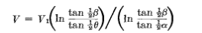

which looks pretty good. I would write from M&S

A+B ln(cotθ1/2) = V1
A+B ln(cotθ2/2) = V2 => B ln[(cotθ1/2)/(cotθ2/2)] = (V1-V2)

=> B = (V1-V2)/ ln[(cotθ1/2)/(cotθ2/2)]

so A = V1- B ln(cotθ1/2)

=> V(θ) = A + B ln cot(θ/2) = [V1- B ln(cotθ1/2)] + B ln cot(θ/2)

= V1 + B ln[(cotθ/2)/ (cotθ1/2)]

= V1 + {(V1-V2)/ ln[(cotθ1/2)/(cotθ2/2)]} ln[(cotθ/2)/(cotθ1/2)]

= V1 + {(V1-V2)/ ln[(tanθ1/2)/(tanθ2/2)]} ln[(tanθ/2)/(tanθ1/2)]

= V1 + {(V1-V2) ln[(tanθ/2)/(tanθ1/2)]/ ln[(tanθ1/2)/(tanθ2/2)]

and if V1 = 0, we get Smythe's answer if we flip the first log over. So here is a probably I never did before, but which has a pretty simple answer. The potential between two cones at constant potential V1 and V2 is this:

V(θ) = V1 + {(V1-V2) ln[(tanθ/2)/(tanθ1/2)]/ ln[(tanθ1/2)/(tanθ2/2)]

What about capacitance? Since this is not a localized surface, we cannot use the usual method of going far away and setting that equal to V = Q/r. So here you would have to compute the charge density and integrate it to get Q:

σ(r) = 2π∂V/∂n = 2π(1/Qθ)∂V/∂θ = 2π(1/r)∂V/∂θ

= (V1-V2) 1/ (ln[(tanθ1/2)/(tanθ2/2)] ) (2π/r) ∂θ { ln[(tanθ/2)/(tanθ1/2)]}

But

∂θ { ln[(tanθ/2)/(tanθ1/2)]} = [(tanθ/2)/(tanθ1/2)]-1 (tanθ1/2)-1 sec2(θ/2) 1/2

We are of course supposed to evaluate this one a cone, so set θ = θ1 to get

= (tanθ1/2)-1 sec2(θ1/2) 1/2 = (1/2)cos-2(θ1/2)cos/sin =

= (1/2)cos-1(θ1/2)/sin = 1/[ 2 sin cos] = 1/sin(θ1)

So the charge density on the V1 cone is

σ(r) = (V1-V2) 1/ (ln[(tanθ1/2)/(tanθ2/2)] ) (2π/r) /sinθ1

As expected, this is largest near r = 0 where the cones are closest together. Basically σ(r) = k ΔV/r.

The total charge on the cone is then (omit first factors for a moment)

Q = $^{\int_{0}^{∞}{}}$dAring 2π(1/rsinθ1) = $^{\int_{0}^{∞}{}}$2πrsinθ1dr 2π(1/rsinθ1) = (2π)2$^{\int_{0}^{∞}{}}$dr

and no great surprise, it diverges. But we could put in a cutoff and say Q = (2π)2R so

Q = (V1-V2) 1/ (ln[(tanθ1/2)/(tanθ2/2)] ) * (2π)2R

Then the capacitance is Q = CV so

C = (2π)2R/ ln[(tanθ1/2)/(tanθ2/2)]

So we can compute the charge density on the cones, but each integrates to ∞ so capacitance is really ∞. In practice, most of the "action" is near the tips of the cones, so doing the cutoff might be not affect much of anything, and then the formula above might in fact be reasonable. There is error since the potential off the end of the finite cone would be different. Papers talk about the capacitance per unit length. But there is no condition really for R> ? which would justify this approximation, so it is probably not justified! It is then just a theoretical problem. There is no distance scale in this problem! For comparison, think of the situation between two planes as opposed to between two parallel disks! The solution to the plane problem has little to do with the disk problem solution!

Appendix B. Potential between halves of the hyperboloid in prolate spheroidal

Coordinates are η as spheroid label, θ as bloid label, ψ azimuth. We seek solution V(θ) only, similar to appendix A. M&S top page 30 gives "indep of η and ψ" solution as our exact same result!

V(θ) = A + B ln cot(θ/2)

Of course θ is now the bloid label, not the polar angle. It is the asymptotic polar angle for large r or η. We just copy our previous answer

V(θ) = V1 + {(V1-V2) ln[(tanθ/2)/(tanθ1/2)]/ ln[(tanθ1/2)/(tanθ2/2)]

Now, let the upper half bloid be θ1 , then the lower half bloid has θ2 = π - θ1 since (0,π) range for θ. Then we have

tanθ2/2 = tan[(π - θ1)/2] = tan(π/2-θ1/2) = cot(θ1/2)

so we then have

V(θ) = V1 + {(V1-V2) ln[(tanθ/2)/(tanθ1/2)]/ ln[(tan2θ1/2)]

Then maybe we set V2 = -V1 to have a capacitor, and then

V(θ) = V1 + 2V1 ln[(tanθ/2)/(tanθ1/2)]/ ln[(tan2θ1/2)]

= V1 {1 + 2 ln[(tanθ/2)/(tanθ1/2)]/ ln[(tan2θ1/2)}

= V1 {1 + ln[(tanθ/2)/(tanθ1/2)]/ ln[(tanθ1/2)}

= V1 {1 – ln[(tanθ1/2)/(tanθ/2)]/ ln[(tanθ1/2)}

If θ1 = π/2 on the dividing plane of the two bloid halves, we get {} = {1 - 1) = 0, as expected.

If we go to large r, we are going to get the same σ(r) situation and the same Q divergence I think.

So I now know the potential between two charged metal hyperboloid halves.

Appendix C: Details on the surfaces for paraboloidal coordinates

Note: the web does not provide a picture of this system. May sites refer to the parabolic coordinates as "paraboloidal", confusing the issue. Wolfram has it right but no picture. Today 11.23.10 I made paraboloid.mws to get the surfaces, here it is for

c = 2 b = 3 μ = 4 (red) ν = 2.2 (blue) λ = 2.5 (yellow)

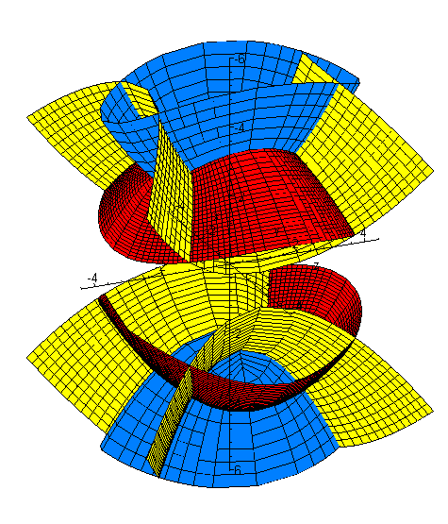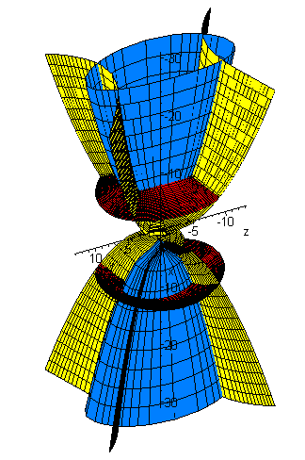
The red and blue are elliptic paraboloids in shape, each yellow is a parabolic hyperboloid that is one sheet. The two yellow guys are not connected. To make each plot, I hold one variable fixed and run the other two over their full ranges. But the range of μ is b < μ < ∞, so for μ I run only b to 10*b in the picture on the right, to 2*b on the left. So the blue and yellow. \
You can see that the M&S system as presented cannot produce z < 0 points, so we really have to double it as I have done. For z > 0, there are graphically four points of intersection of the three surfaces, where we pick ±x and ±y.
The MS equation for the parabolic hyperboloid will be restricted (see page 44) because we must have z > (λ-c) . The reason is that z = μ + ν + λ - b - c = (μ-b) + (λ-c) + ν and all three terms must be positive.
So for a given λ, if we scan μ and ν over full range, the smallest z can be is λ-c. So for the upper yellow phbloid, we only get a finite portion of the lower part of the saddle. Here is detail on this saddle region, where I restrict to μ going b to 1.1b :

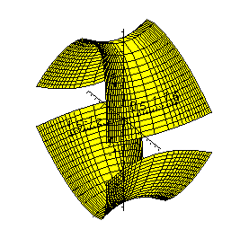

Appendix D. Potential between two spheres at constant potential (fails, but result found)

The conclusion of this appendix is that yes, bispherical coordinates allow a solution to this problem and no other coordinate system does. But, that solution is fairly complicated and cannot be obtained by the usual Smythian Form method.

Can bisphericals really do this? MS p 110. η labels the sphere pair. Separate Laplace with R factor as shown page 111. But we want a solution F(η) only, and that does not work in R separation! We do expect solution indep of ψ so can use page 112. I guess α2 is a separation constant. We have α3 = n2 = q2 from the ψ equation. The Θ equation is Legendre and you get α2 = n(n+1), n = p. For azisym have n=q=0 so bottom of page 111 applies. Well, just go to page 112 again. Atoms are Pn(cosθ)e±(n+1/2)η. Here is then the name of the game:

V(θ,η) = $\sqrt{ch(η)-cos(θ)}$ Σn=1∞ Pn(cosθ)[ Ane+(n+1/2)η + Bne–(n+1/2)η]

But how do you make V(η1) = V1 ? Let's try it

V1/ $\sqrt{ch(η)-cos(θ)}$= Σn Pn(cosθ)[ Ane+(n+1/2)η + Bne-(n+1/2)η]

Mult both sides by $^{\int_{-1}^{1}{}}$dz Pn'(cosθ) and use

$^{\int_{-1}^{1}{}}$dz Pnm(z)Pkm(z) = δn,k (n+1/2)-1 [(n+m)! / (n-m)! ] n,k = m, m+1, m+2 ...... ∞

= δn,k Knm Knm = (n+1/2)-1 (n+m)! / (n-m)!

The RHS is then Kn' [ An'e+(n'+1/2)η + Bn'e-(n'+1/2)η] . The LHS is

LHS = V1 $^{\int_{-1}^{1}{}}$dz Pn'(z)/ $\sqrt{ch(η)-z}$

GR7 p 791

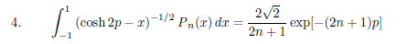 p> 0

so set η = 2p and our result is 2$\sqrt{2}$/(2n'+1)e-(2n'+1)η/2 = 2$\sqrt{2}$/(2n'+1) e-(n'+1/2)η . But to make it true for both signs of p or η, the result is really = 2$\sqrt{2}$/(2n'+1) e-(n'+1/2)|η|

Therefore

V12$\sqrt{2}$/(2n'+1) e-(n'+1/2)|η| = Kn' [ An'e+(n'+1/2)η + Bn'e-(n'+1/2)η]

V12$\sqrt{2}$/(2n+1) e-(n+1/2) |η| = Kn [ Ane+(n+1/2)η + Bne-(n+1/2)η]

V1/(n+1/2) e-(n+1/2)|η| = (n+1/2)-1 [ Ane+(n+1/2)η + Bne-(n+1/2)η]

V1e-(n+1/2)|η| = [ Ane+(n+1/2)η + Bne-(n+1/2)η]

For the upper sphere, η > 0 and we have An = 0 and Bn = 1.
For the upper sphere, η < 0 and we have An = 1 and Bn = 0.

Now go back to our atomic expansion

V(θ,η) = $\sqrt{ch(η)-cos(θ)}$ Σn=1∞ Pn(cosθ)[ Ane+(n+1/2)η + Bne-(n+1/2)η]

Our boundary condition on the upper sphere is this

V(θ,η1) = $\sqrt{ch(η1)-cos(θ)}$ Σn=1∞ Pn(cosθ)[ Ane+(n+1/2)η1 + Bne-(n+1/2)η1] = V1

From this we learned that An = 0 and Bn = V1. This boundary condition alone tell us that we must have

V(θ,η) = V1 $\sqrt{ch(η)-cos(θ)}$ Σn=1∞ Pn(cosθ)[ e-(n+1/2)η]

But the RHS = V1 for any combination of θ and η>0 you want, so this potential is constant in the entire upper half space. I think we have put V1 on both spheres and this is the result.
I have ignored the Qn(cosθ) stuff because the point θ = π is part of the sphere on which we need V finite (the top point of the upper sphere). Let's start over including the Q

V(θ,η) = $\sqrt{ch(η)-cos(θ)}$ Σn=1∞ [Pn(cosθ)+ Cn Qn(cosθ) ] [ Ane+(n+1/2)η + Bne-(n+1/2)η]

Now apply the upper sphere BC:

V(θ,η1) = $\sqrt{ch(η1)-cos(θ)}$ Σn=1∞ [Pn(cosθ)+ Cn Qn(cosθ) ] [ Ane+(n+1/2)η1 + Bne–(n+1/2)η1] = V1

But now I don't know how to isolate the Cn coefficient because we don't have orthogonality involving the Q function. So the Smythian Form Method leaves me at a loss. Amazingly I found and saved a paper on exactly this subject. The authors claim this is the general atomic form

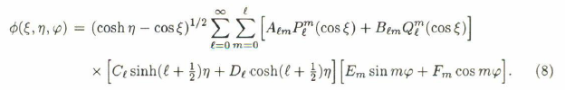

which for azisym cases reduces to my form using sh and ch. The authors claim it is the R factor that causes the trouble, but I would say it was the presence of Q. In any event, they go off and solve the problem using Green's functions. One sphere is at V1 and the other at V2 = 0 and their solution is this:

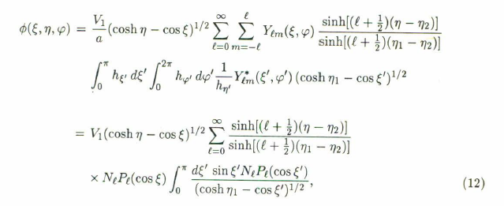
You can see that at η = η2 you get V = 0, and they show that at η = η1 you do bet V1. So it is in closed form as an infinite sum where each term is an integral. The integral they evaluate in their Appendix

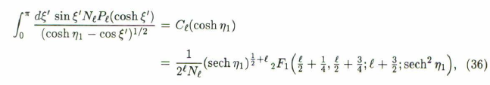
and they observe that

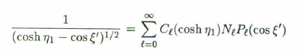
They never say what Nl is specifically, but I guess (l+1/2)-1.
So to summarize, these guys come up (in 1996) with a closed form expression for the potential of two spheres in various relative positions. If they happen to be identical and η2= -η1 then things don't simplify much as far as I can see.
My conclusion is that the Q term must be there and its singularity is somehow softened by the series. The authors don't go back and figure out the coefficients, but they do say

You could figure out the coefficients if you wanted.
So, did bispherical coordinates really do anything useful here? Yes I think so. It provided spherical surfaces for your BC's. I don't think any other coordinate system can do that.
Their references are :

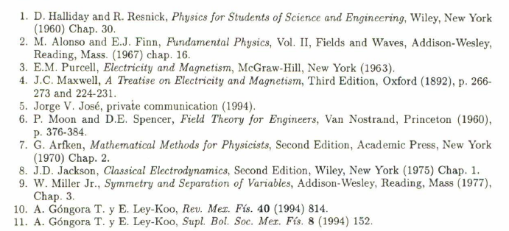

So they quote a different M&S book that probably has much of the same info as the 1931 book. BYU has copy, Marriott does not.

Appendix E. Potential between two spheres at constant potential, Version 2 attempt (fails)

Maybe we can solve this problem using alternate atoms. Recall the two sets of spherical atoms

Spherical r in (0,∞) z in (-1,1) φ in (0,2π)

expo osc osc
(1) [ rn, r-n-1] [ Pnm(z), Qnm(z)] [ sin(mφ),cos(mφ)] z = cosθ

osc expo osc
(2) (1/$\sqrt{r}$)[ riτ, r-iτ] [ Piτ-1/2m(z), Qiτ-1/2m(z)] [ sin(mφ),cos(mφ)] n = iτ-1/2
osc expo osc
~ (1/$\sqrt{r}$)[sin(τ lnr), cos(τ lnr)] [ Piτ-1/2m(z), Qiτ-1/2m(z)] [ sin(mφ),cos(mφ)]

We get from the first to the second by replacing n by iτ-1/2, for reasons explained in "Sturm-Liouville atoms...". Just so, there are two sets of bispherical atoms, namely [ note that e+(n+1/2)η = eiτη ]

Bispherical μ in (0,∞) z in (-1,1) φ in (0,2π)

expo osc osc
(1) $\sqrt{ch(η)-cos(θ)}$ [e+(n+1/2)η, e–(n+1/2)η] [ Pnm(z), Qnm(z)] [ sin(mφ),cos(mφ)] z = cosθ

osc expo osc
(2) $\sqrt{ch(η)-cos(θ)}$ (1/$\sqrt{r}$)[ eiτη, e–iτη] [ Piτ-1/2m(z), Qiτ-1/2m(z)] [ sin(mφ),cos(mφ)] n = iτ-1/2
osc expo osc
~ $\sqrt{ch(η)-cos(θ)}$ (1/$\sqrt{r}$)[sin(τη), cos(τη)] [ Piτ-1/2m(z), Qiτ-1/2m(z)] [ sin(mφ),cos(mφ)]

In the two spheres case, it is not obvious from the picture where our expo requirement lies, so we can at least try out this second form and see where it leads. To this end, we write for the m = 0 case only,

V(θ,η) = $\sqrt{ch(η)-cos(θ)}$ $^{\int_{-∞}^{∞}{}}$dτ [Piτ-1/2(z) + Cτ Qiτ-1/2m(z) ] [ Aτsin(τη) + Bτ cos(τη)]

where we now have three sets of coefficients A,B,C. Our boundary conditions are then

V1 = $\sqrt{ch(η1)-cos(θ)}$ $^{\int_{-∞}^{∞}{}}$dτ [Piτ-1/2(z) + Cτ Qiτ-1/2m(z) ] [ Aτsin(τη1) + Bτ cos(τη1)]

V2 = $\sqrt{ch(η2)-cos(θ)}$ $^{\int_{-∞}^{∞}{}}$dτ [Piτ-1/2(z) + Cτ Qiτ-1/2m(z) ] [ Aτsin(τη2) + Bτ cos(τη2)]

At this point, we can inquire about the behavior of the P and Q functions at z = ± 1. From "conicals.." I have
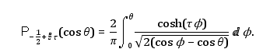

Now at θ = 0 (z=1) is seems pretty clear that Piτ-1/2(z=1) = 0 so we are finite. Vilenkin's book is on Google and says, by the way.

I think the P function is finite at z = ± 1, but I don't know about the Q. Suppose it is infinite at z = -1, then we would eliminate it and have

V(θ,η) = $\sqrt{ch(η)-cos(θ)}$ $^{\int_{-∞}^{∞}{}}$dτ [Piτ-1/2(z)] [ A(τ)sin(τη) + B(τ) cos(τη)]

We can fold the integral (by hand) to write this as

V(θ,η) = $\sqrt{ch(η)-cos(θ)}$ $^{\int_{0}^{∞}{}}$dτ [Piτ-1/2(z)] { [A(τ)-A(-τ)]sin(τη) + [B(τ)+B(-τ)] cos(τη)}

Then we could define the functions C(τ) = [A(τ)-A(-τ)] and D(τ) = [B(τ)+B(-τ)] to get

[V(θ,η)/ $\sqrt{ch(η)-cos(θ)}$] = $^{\int_{0}^{∞}{}}$dτ [Piτ-1/2(z)] [C(τ) sin(τη) + D(τ) cos(τη) ] (*)

A boundary condition is now

[V1/ $\sqrt{ch(η1)-cos(θ)}$] = $^{\int_{0}^{∞}{}}$dτ [Piτ-1/2(z)] [C(τ) sin(τη1) + D(τ) cos(τη1) ] (*)

But what do we do next? We need orthogonality for the P functions, but they are expo functions so nothing doing. Game over, it does not work.

