Spherical Unit Vectors PhL 8.29.08

1. Work done August 29, 2008 1
2. Work done August 4, 2012 3
Appendix A: Derivation of R(ξ) for Spherical Coordinates // has been updated. 3
3. Brute force computation of basis vector derivatives ( Sept 7, 2012) 6
4. How did Lai and tensor doc deal with these derivatives? 11
5. Now lets do time derivatives of the basis vectors (added 12.14.16) 14

1. Work done August 29, 2008

Comment: In this first section, the term "old sheet" refers to the yellowed hand-written page #5 in my TK (Tool Kit) binder.

Our usual active rotation matrices are:

Rx(θ) = 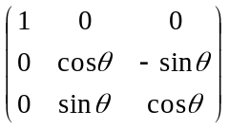 Ry(θ) = 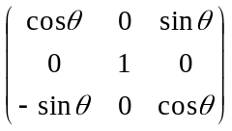 Rz(θ) = 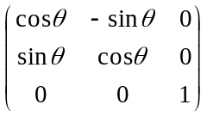

The spherical coordinates unit vectors

In spherical coordinates, we have three unit vectors called , and . Here is their relation to the normal unit vectors , and . We start with :

= Rz(φ) Ry(θ) = 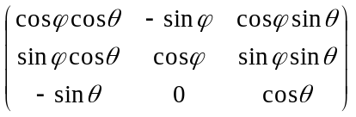$\left(\begin{matrix}0 \\ 0 \\ 1\end{matrix}\right)$ = $\left(\begin{matrix}cosφ sinθ \\ sinφ sinθ \\ cosθ\end{matrix}\right)$

= cosφ sinθ + sinφ sinθ + cosθ // agrees with old sheet
= • + • + • // another way to write it

where we have picked off the last column of the matrix for our coefficients, and we have also expressed these coefficients in terms of the usual "direction cosines". The other unit vectors are
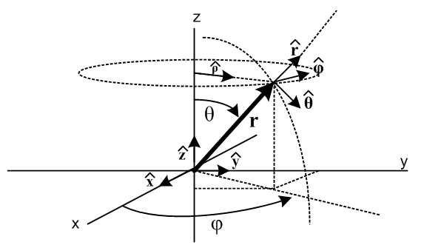

= Rz(φ) Ry(θ) = $\left(\begin{matrix}1 \\ 0 \\ 0\end{matrix}\right)$ =$\left(\begin{matrix}cosφ cosθ \\ sinφ cosθ \\ -sinθ\end{matrix}\right)$

= cosφ cosθ + sinφ cosθ - sinθ // agrees with old sheet

= Rz(φ) Ry(θ) = $\left(\begin{matrix}0 \\ 1 \\ 0\end{matrix}\right)$ =$\left(\begin{matrix}-sinφ \\ cosφ \\ 0\end{matrix}\right)$

= -sinφ + cosφ // agrees with old sheet

It is true that = Rz(φ) Ry(θ) = Rz(φ) so Ry(θ) could be omitted, but our point is the next sentence.
Notice that these unit vectors , and are the just columns of the matrix shown above, that is,

( ) = = Rz(φ) Ry(θ)

In order to paste into a Word matrix, we first list off the 9 direction cosines

• • • • • • • • •

And then we can position these into their correct positions in the above matrix

( ) = ••••••••• = = Rz(φ) Ry(θ)

For example, we associated the middle column with , and we associate the three rows with x,y,z.

The following results are developed in sections below, but I put them here to make them findable:

d/dr = 0 d/dθ = d/dφ = sinθ
d/dr = 0 d/dθ = - d/dφ = cosθ
d/dr = 0 d/dθ = 0 d/dφ = -sinθ -cosθ (A.15)

2. Work done August 4, 2012

The following section is a verbatim appendix of Frames doc. I think it is somewhat better than the above since it gets the basis vectors into the "right order". It refers to certain equations inside frames doc which I will now list here so this thing can be stand alone.

i = R(ξ) ei => ei = R(ξ)ijj or i = [R(ξ)]-1ij ej
'i = R'(ξ') e'i => e'i = R'(ξ ')ij'j or 'i = [R'(ξ ')]-1ij e'j (14.3)

R(ξ) = $\left(\begin{matrix}cosφsinθ & cosφcosθ & -sinφ \\ sinφsinθ & sinφcosθ & cosφ \\ cosθ & -sinθ & 0\end{matrix}\right)$ [R(ξ)]-1 = $\left(\begin{matrix}cosφsinθ & sinφsinθ & cosθ \\ cosφcosθ & sinφcosθ & -sinθ \\ -sinφ & cosφ & 0\end{matrix}\right)$ (14.4)

= = $\left(\begin{matrix}cosφsinθ & sinφsinθ & cosθ \\ cosφcosθ & sinφcosθ & -sinθ \\ -sinφ & cosφ & 0\end{matrix}\right)$ = [R(ξ) ]-1 = [R(ξ) ]-1$\left(\begin{matrix}e1 \\ e2 \\ e3\end{matrix}\right)$ (14.5)

= cosφ sinθ + sinφ sinθ + cosθ
= cosφ cosθ + sinφ cosθ – sinθ
= –sinφ + cosφ (14.6)

Appendix A: Derivation of R(ξ) for Spherical Coordinates // has been updated.

Here we derive equations (14.4) through (14.6). First, just for reference, here are the three active rotation matrices used below :

Rx(θ) = $\left(\begin{matrix}1 & 0 & 0 \\ 0 & cosθ & -sinθ \\ 0 & sinθ & cosθ\end{matrix}\right)$ Ry(θ) = $\left(\begin{matrix}cosθ & 0 & sinθ \\ 0 & 1 & 0 \\ -sinθ & 0 & cosθ\end{matrix}\right)$ Rz(θ) = $\left(\begin{matrix}cosθ & -sinθ & 0 \\ sinθ & cosθ & 0 \\ 0 & 0 & 1\end{matrix}\right)$ (A.1)

These are called "active" since they rotate a vector forward (counterclockwise) relative to fixed axes by amount θ according to the right hand rule when the thumb is aligned with the axis in question.

From the usual picture of spherical coordinates,

Fig A.1

one can see by staring hard enough that

= Rz(φ) Ry(θ) = R R ≡ Rz(φ) Ry(θ)
= Rz(φ) Ry(θ) = R
= Rz(φ) Ry(θ) = R (A.2)

which we rewrite as

1 = R e3
2 = R e1
3 = R e2 . (A.3)

We can repair the ordering of the basis vectors en on the right using R2 = (,,) as follows

e3 = R2 e1 $\left(\begin{matrix}0 \\ 0 \\ 1\end{matrix}\right)$ = $\left(\begin{matrix}0 & 1 & 0 \\ 0 & 0 & 1 \\ 1 & 0 & 0\end{matrix}\right)$$\left(\begin{matrix}1 \\ 0 \\ 0\end{matrix}\right)$ R2 = $\left(\begin{matrix}0 & 1 & 0 \\ 0 & 0 & 1 \\ 1 & 0 & 0\end{matrix}\right)$
e1 = R2 e2 $\left(\begin{matrix}1 \\ 0 \\ 0\end{matrix}\right)$ = $\left(\begin{matrix}0 & 1 & 0 \\ 0 & 0 & 1 \\ 1 & 0 & 0\end{matrix}\right)$$\left(\begin{matrix}0 \\ 1 \\ 0\end{matrix}\right)$
e2 = R2 e3 $\left(\begin{matrix}0 \\ 1 \\ 0\end{matrix}\right)$ = $\left(\begin{matrix}0 & 1 & 0 \\ 0 & 0 & 1 \\ 1 & 0 & 0\end{matrix}\right)$$\left(\begin{matrix}0 \\ 0 \\ 1\end{matrix}\right)$ (A.4)

Maple tells us that R2-1 = R2T and det(R2) = 1, confirming that R2 is a rotation. So we then have

1 = R R2 e1
2 = R R2 e2
3 = R R2 e3 (A.5)
or
i = R(ξ) ei. (A.6)

We have therefore found the sought-after matrix R(ξ) appearing in the top left of (14.3).

R(ξ) = R R2 . (A.7)

Specific evaluation gives

R = Rz(φ) Ry(θ) = $\left(\begin{matrix}cosφ & -sinφ & 0 \\ sinφ & cosφ & 0 \\ 0 & 0 & 1\end{matrix}\right)$$\left(\begin{matrix}cosθ & 0 & sinθ \\ 0 & 1 & 0 \\ -sinθ & 0 & cosθ\end{matrix}\right)$ = $\left(\begin{matrix}cosφcosθ & -sinφ & cosφsinθ \\ sinφsinθ & cosφ & sinφsinθ \\ -sinθ & 0 & cosθ\end{matrix}\right)$ (A8)

and then
R(ξ) = R R2 = $\left(\begin{matrix}cosφcosθ & -sinφ & cosφsinθ \\ sinφsinθ & cosφ & sinφsinθ \\ -sinθ & 0 & cosθ\end{matrix}\right)$$\left(\begin{matrix}0 & 1 & 0 \\ 0 & 0 & 1 \\ 1 & 0 & 0\end{matrix}\right)$ = $\left(\begin{matrix}cosφsinθ & cosφcosθ & -sinφ \\ sinφsinθ & sinφcosθ & cosφ \\ cosθ & -sinθ & 0\end{matrix}\right)$ (A.9)

from which we find

[R(ξ)]-1 = [R(ξ)]T = $\left(\begin{matrix}cosφsinθ & sinφsinθ & cosθ \\ cosφcosθ & sinφcosθ & -sinθ \\ -sinφ & cosφ & 0\end{matrix}\right)$. (A.10)

From the top right equation of (14.3) we can write

i = [R(ξ) ]-1ij ej = [R(ξ) ]-1i1 e1 + [R(ξ) ]-1i2 e2 + [R(ξ) ]-1i3 e3 (A.11)

which can be written in this matrix notation where the column vectors contain vectors as elements,

= $\left(\begin{matrix}cosφsinθ & sinφsinθ & cosθ \\ cosφcosθ & sinφcosθ & -sinθ \\ -sinφ & cosφ & 0\end{matrix}\right)$$\left(\begin{matrix}e1 \\ e2 \\ e3\end{matrix}\right)$ (A.12a)
or
= $\left(\begin{matrix}cosφsinθ & sinφsinθ & cosθ \\ cosφcosθ & sinφcosθ & -sinθ \\ -sinφ & cosφ & 0\end{matrix}\right)$ (A.12b)
or
= cosφ sinθ + sinφ sinθ + cosθ
= cosφ cosθ + sinφ cosθ - sinθ
= -sinφ + cosφ (A.12c)

which are the well known expressions for the spherical unit vectors in terms of the Cartesian ones. One more useful result is obtained by dotting (A.11) into basis vector ek

i• ek = [R(ξ) ]-1ij ej• ek = [R(ξ) ]-1ij δj,k = [R(ξ) ]-1ik

and therefore we get this matrix of "direction cosines",

••••••••• = $\left(\begin{matrix}cosφsinθ & sinφsinθ & cosθ \\ cosφcosθ & sinφcosθ & -sinθ \\ -sinφ & cosφ & 0\end{matrix}\right)$ = [R(ξ) ]-1 (A.13)

This collection of dot products is also apparent from (A.12c) upon visual inspection.

3. Brute force computation of basis vector derivatives ( Sept 7, 2012)

This work is a continuation of the previous section. First,

= $\left(\begin{matrix}cosφsinθ & sinφsinθ & cosθ \\ cosφcosθ & sinφcosθ & -sinθ \\ -sinφ & cosφ & 0\end{matrix}\right)$ = [R(ξ)]-1 (A.12b)

Then the inverse will be

= [R(ξ)] = $\left(\begin{matrix}cosφsinθ & cosφcosθ & -sinφ \\ sinφsinθ & sinφcosθ & cosφ \\ cosθ & -sinθ & 0\end{matrix}\right)$

from which we learn that

= cosφsinθ + cosφcosθ - sinφ
= sinφsinθ + sinφ cosθ + cosφ
= cosθ - sinθ

which is the inverse of the set provided above in the appendix. I might add this to the appendix at some point.
I then "hand computed" the following derivative using the above equations.

d/dθ = cosφ cosθ + sinφ cosθ – sinθ

= cosφ cosθ [cosφsinθ + cosφcosθ - sinφ ]
+ sinφ cosθ [sinφsinθ + sinφ cosθ + cosφ ]
– sinθ [cosθ - sinθ ]

= (cosφ cosθ cosφsinθ + sinφ cosθ sinφsinθ - sinθ cosθ
+ (cosφ cosθ cosφcosθ + sinφ cosθ sinφ cosθ + sinθ sinθ )
+ (- cosφ cosθ sinφ + sinφ cosθ cosφ)

= (cos2φ cosθ sinθ + sin2φ cosθ sinθ - sinθ cosθ)
+ (cos2φ cos2θ + sin2φ cos2θ + sin2θ )
+ ( 0 )

= cosθ sinθ (cos2φ + sin2φ - 1)
+ (cos2θ + sin2θ )

= (0)
+ (1 )

=

I then realized that there certainly must be a better way to do these derivatives. There are 9 of them, and I think I can do them from the geometry of the above figure maybe with a few support pictures. I could do them all by brute force as I did the one above, or I could do them formally by computing the affine connection as per tensor doc. But I think "little pictures" is the most direct method.

Three simple cases: From above

= cosφ sinθ + sinφ sinθ + cosθ
= cosφ cosθ + sinφ cosθ - sinθ
= -sinφ + cosφ (A.12c)

we see that none of the unit vectors is a function of variable r. So we have three of our 9 right away

____________________________________________________________________________
Assemble results here:

1 d/dr = 0 11
2 d/dr = 0 12
3 d/dr = 0 13

4. d/dθ = 0
5. d/dθ =
6. d/dφ = cosθ

7 d/dφ = sinθ
8 d/dθ = -
9 d/dφ = -sinθ -cosθ
___________________________________________________________________________

1 d/dr = 0
2 d/dr = 0
3 d/dr = 0

A fourth one is also obvious from above.

4. d/dθ = 0

That leaves only 5 to compute by hand, and I have done one above which is this:

5. d/dθ =

This result is fairly obvious from the picture. That leaves four more and I will just do them here by brute force:
d/dφ = d/dφ [cosφ cosθ + sinφ cosθ - sinθ ]

= -sinφ cosθ + cosφ cosθ

= -sinφ cosθ [cosφsinθ + cosφcosθ - sinφ ]
+ cosφ cosθ [sinφsinθ + sinφ cosθ + cosφ ]

= (-sinφ cosθ cosφsinθ + cosφ cosθ sinφsinθ)
+ (-sinφ cosθ cosφcosθ + cosφ cosθ sinφ cosθ)
+ (sinφ cosθsinφ + cosφ cosθ cosφ)

= (0)
+ (-sinφ cos2θ cosφ + cosφ cos2θ sinφ)
+ (sin2φ cosθ + cos2φ cosθ )

= (0)
+ (0)
+ (cosθ )

= cosθ

This one is just not obvious to me staring at the picture but is correct in the obvious limits. So we have just shown that

6. d/dφ = cosθ

Next:

d/dφ = d/dφ [cosφ sinθ + sinφ sinθ + cosθ ]

= -sinφsinθ + cosφsinθ + 0

= -sinφsinθ [cosφsinθ + cosφcosθ - sinφ ]
+ cosφsinθ[sinφsinθ + sinφ cosθ + cosφ ]

= (-sinφsinθ cosφsinθ + cosφsinθsinφsinθ)
+ (-sinφsinθ cosφcosθ + cosφsinθ sinφ cosθ)
+ (sinφsinθ sinφ + cosφsinθ cosφ)

= (-sinφsin2θ cosφ + cosφsin2θsinφ)
+ (0)
+ (sin2φsinθ + cos2φsinθ)

= (0)
+ (0)
+ (sinθ)

so therefore

d/dφ = sinθ

This one is pretty obvious looking at the picture.

Next:

d/dθ = d/dθ [cosφ cosθ + sinφ cosθ - sinθ ]

= -cosφsinθ - sinφsinθ -cosθ

= -cosφsinθ[cosφsinθ + cosφcosθ - sinφ ]
- sinφsinθ[sinφsinθ + sinφ cosθ + cosφ ]
-cosθ[cosθ - sinθ ]

= (-cosφsinθcosφsinθ - sinφsinθsinφsinθ -cosθcosθ )
+ (-cosφsinθ cosφcosθ - sinφsinθ sinφ cosθ +cosθ sinθ)
+ (cosφsinθ sinφ - sinφsinθ cosφ)

= (-cos2φsin2θ - sin2φsin2θ -cos2θ )
+ (-cos2φsinθcosθ - sin2φsinθ cosθ +cosθ sinθ)
+ (0φ)

= (-sin2θ -cos2θ )
+ (-sinθcosθ +cosθ sinθ)
+ (0φ)

= (-1 )
+ (0)
+ (0φ)

= -

so we have shown that

d/dθ = -

and this seems right looking at the picture. One more to go

d/dφ = d/dφ[-sinφ + cosφ ]

= -cosφ - sinφ

= - cosφ [cosφsinθ + cosφcosθ - sinφ]
- sinφ [sinφsinθ + sinφ cosθ + cosφ ]

= (- cosφ cosφsinθ- sinφ sinφsinθ)
+ (- cosφ cosφcosθ - sinφ sinφ cosθ)
+ (cosφ sinφ - sinφ cosφ)

= (- cos2φsinθ- sin2φsinθ)
+ (- cos2φcosθ - sin2φ cosθ)
+ (0)

= (-sinθ)
+ (-cosθ)
+ (0)

= -sinθ -cosθ

so we have shown that

d/dφ = -sinθ -cosθ

This result is also not very obvious from the picture.

4. How did Lai and tensor doc deal with these derivatives?

I discuss this in "Lai's grad-v method..doc" but have no clean conclusion. I find there that

dn = Σj { [ d(h'n-1) δj,n + h'n-1 Σi Rji dSin ] h'j} j

which is at least some kind of result. In tensor doc p 98 I do it this way

den = (∂'jen)dx'j = Γ 'ijn ei dx'j // from definition of Γ in Appendix F (a), but Picture A

which says

(∂'jen) = Γ 'ijn ei

But of course we then have this issue

en = h'nn // tensor doc p 100

so we get

∂'jn = ∂'j[h'n-1en]) = h'n-1(∂'j en) + (∂'j[h'n-1]) en

and then we can install the result above to get

∂'jn = h'n-1 Γ 'ijn ei + (∂'j[h'n-1]) en

Finally, we recover the hats

∂'jn = h'n-1 Γ 'ijn h'ii + (∂'j[h'n-1]) h'nn

Maybe simplify the combination

(∂'j[h'n-1]) h'n = - h'n-2(∂'j h'n) h'n = – h'n-1(∂'j h'n)

Then we have

∂'jn = h'n-1 Γ 'ijn h'i i – h'n-1(∂'j h'n)n

= (1/h'n) [h'i Γ 'ijni – (∂'j h'n) n]

= (1/h'n) [h'i Γ 'ijn i – (∂'j h'n)δn,i i]

= (1/h'n) [h'i Γ 'ijn – (∂'jh'n)δn,i] i

This is the general formula and I think is the simplest I can find. compare to

(∂'jen) = Γ 'ijn ei

so all that extra garbage comes from the unit vector business.
I did do Maple work with the affine connection in tensor doc App I (f). The file "sph_vec_lap.mws" has some very useful code. What I would like to make it compute is this (from above)

[∂'jn]i = (1/h'n) [h'i Γ 'ijn – (∂'jh'n)δn,i]

Let's try to add this to the end. Maybe define

de(j,n,i) = [∂'jn]i = (1/h'n) [h'i Γ 'ijn – (∂'jh'n)δn,i]

= (1/hp[n])* ( hp[i] * G(i,j,n) - Diff(hp[n],xp[j])*kd(n,i));

First, here is my claimed summary from the updated frames doc appendix

d/dr = 0 d/dθ = d/dφ = sinθ
d/dr = 0 d/dθ = - d/dφ = cosθ
d/dr = 0 d/dθ = 0 d/dφ = -sinθ -cosθ (A.15)

11 21 31
12 22 32
13 23 33

And now Maple confirms:

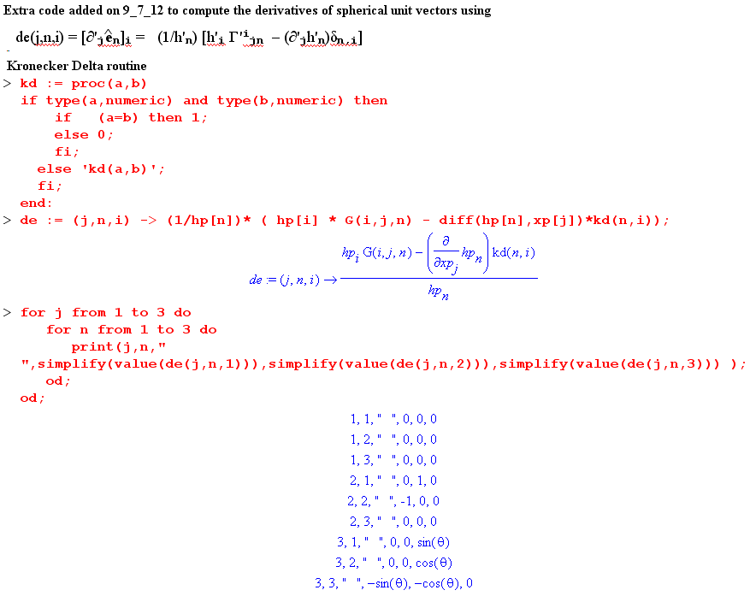

Here is a simpler Maple verification of these facts:

d/dr = 0 d/dθ = d/dφ = sinθ
d/dr = 0 d/dθ = - d/dφ = cosθ
d/dr = 0 d/dθ = 0 d/dφ = -sinθ -cosθ (A.15)

I use notation R = , T = and P = :

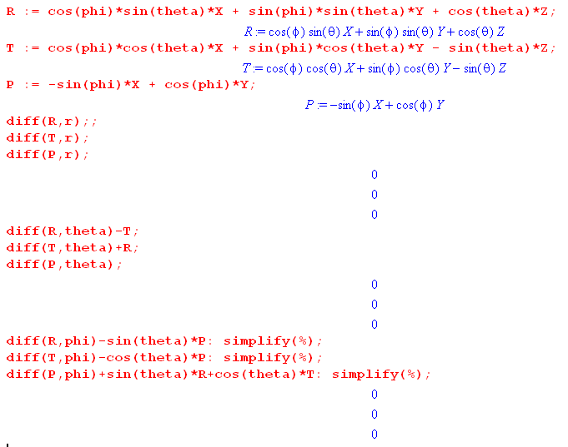

5. Now lets do time derivatives of the basis vectors (added 12.14.16)

Use this table:

d/dr = 0 d/dθ = d/dφ = sinθ
d/dr = 0 d/dθ = - d/dφ = cosθ
d/dr = 0 d/dθ = 0 d/dφ = -sinθ -cosθ (A.15)

which write as

∂r = 0 ∂θ = ∂φ = sinθ
∂r = 0 ∂θ = - ∂φ = cosθ
∂r = 0 ∂θ = 0 ∂φ = -sinθ -cosθ (A.15)

Then write

∂t = ∂r + ∂θ + ∂φ
∂t = ∂r + ∂θ + ∂φ
∂t = ∂r + ∂θ + ∂φ

Reorder
∂t = ∂r + ∂θ + ∂φ
∂t = ∂r + ∂θ + ∂φ
∂t = ∂r + ∂θ+ ∂φ

Then install from table

∂t = 0 + + sinθ
∂t = 0 – + cosθ
∂t =0 + 0 – (sinθ +cosθ )

The conclusions are :

∂t = + sinθ
∂t = – + cosθ
∂t = – sinθ – cosθ

I found a physics-notation source that I can use to verify the above

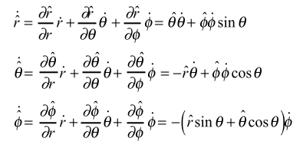

We do agree. Source is this from Singapore,

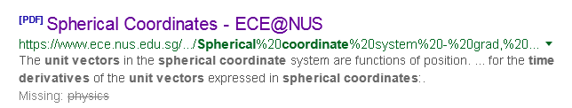

but the author is none other than Crodt!!! Hurray!

6. Particle motion in sphericals (added 12.14.16)

r = r

v = + r ∂t = + r ( + sinθ ) = + r + r sinθ

a = + ∂t + ∂t( r ) + r ∂t + ∂t( r sinθ) + r sinθ ∂t

= + ( + sinθ ) + ∂t( r ) + r ( – + cosθ )
+ ∂t( r sinθ) + r sinθ ( – sinθ – cosθ )

= [ - r2 – r 2 sin2θ ]

+ [ + ∂t( r ) - r sinθ cosθ ]

+ [ sinθ + r cosθ + ∂t( r sinθ) ]

---------------

= [ - r2 – r 2 sin2θ ]

+ [ + + r - r sinθ cosθ ]

+ [ sinθ + r cosθ + sinθ + rsinθ + r cosθ ]

-------------

= [ - r2 – r 2 sin2θ ]

+ [ 2 + r - r 2 sinθ cosθ ]

+ [ 2 sinθ +2 r cosθ + rsinθ ]

Where can I verify this mess? The same Crodt doc writes

W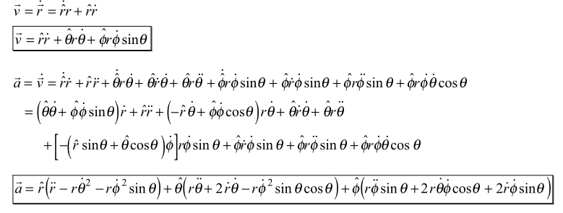

We agree except in his first term he should have sin2θ . Here is another source and I fully agree:

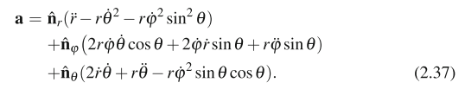

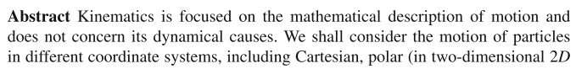

He agrees with he exactly, source a bit hazy.

Conclusions on spherical coordinate particle motion:

r = r

v = + r ∂t = + r + r sinθ

so
v = vr + vθ + vφ
where
vr =
vθ = r
vφ = r sinθ

a = [ - r2 – r 2 sin2θ ]
+ [ 2 + r - r 2 sinθ cosθ ]
+ [ 2 sinθ +2 r cosθ + rsinθ ]

so
a = ar + aθ + aφ
where
ar = - r2 – r 2 sin2θ
aθ = 2 + r - r 2 sinθ cosθ
aφ = 2 sinθ + 2 r cosθ + rsinθ

Now suppose motion is constrained to lie on a sphere or radius r. Then

v = vθ + vφ
where
vθ = r
vφ = r sinθ

a = ar + aθ + aφ
where
ar = - r2 – r 2 sin2θ
aθ = r - r 2 sinθ cosθ
aφ = +2 r cosθ + rsinθ

