Oblate Spheroidal Coordinates and the Metal Disk Problem PhL 11.7.09

Reviewed with some edits added on 11.28.09 and later 12.1.09. This doc is long, 35 pages.

Let's apply everything we learned about "curvilinear coordinates" to this orthogonal case. But alas, we have a Babel effect -- there are at least 5 different ways people define these coordinates!!

Overview (10.5.10, 5 pages) 1
1. Examining Various Choices for Oblate Spheroidal Coordinates 5
M&M Coordinates 5
Smythe coordinates. 6
Wiki Coordinates 8
Morse and Feshbach coordinates 9
2. Choose MF coordinates for Oblate: picture and comments 10
3. Metric Tensor and Laplacian etc 11
4. Inverse equations 17
Obscure comments about 4D interpretation. 20
5. The Kelvin p function in Cartesians and Spheroidals 21
6. Separation of Variables 23
Oblate spheroidal harmonics and comparison to spherical and ellipsoidal. 26
7. Potential of a charged metal disk 26
Electric Field and charge density on an oblate spheroid: 31
Tying this in with the Kelvin p function 32
Verifying Jackson's disk surface charge density result. 33

_________________________________________________________________

Overview (10.5.10, 5 pages)

In Section 1 I take a look at conventions of various authors for oblate spheroidal coordinates. In all cases you can always write out the equation of the spheroids and hyperboloids of constant parameter. The equations all involve some symbol for the elliptic focal distance. Most use a, but Smythe uses c1. This distance provides the dimensions of length for x,y,z when these are written in terms of the oblate coordinates.
In M&M the coordinates are called (u,v,φ) with u being the spheroid label. In wiki these appear as (μ, ν, φ) but ν = (π/2-v). I then show the colored surface picture and note that if you only keep the "upper" half hyperboloid labeled by v such that v is in (0,π), then (u,v,φ) is 1-to-1 with (x,y,z). I note the fact that v is similar to θ in sphericals and in fact agrees as you move far away.
Smythe is very different, so I have a table comparing things. Smythe uses (ξ,ζ,φ) where ζ is the spheroid label, and ξ = cos(v) and ζ = sh(u). Smythe perversely uses the x axis as his symmetry axis, everyone else uses z.
Wiki shows three different coordinate naming conventions. In one, they use ν = (π/2 - v) which swaps the sin and cos for this polar-like angle, which makes things quite ugly. Wiki puts the spheroid label first and uses ξ = sinν = cosv. They mention Moon and Spencer which Marriott has 530.15 M818f right now, I should go get it and take a look at this book; and they mention Smythe.
M&F use (ξ,η,φ)MF = (ζ,ξ,φ)Smy so M&F and Smythe use ξ for different things, ugh! I note that at least the variables look different in M&F. Here is my comparison table. In the first two data rows, the items are all equal as you go sideways. The last row shows the symmetry axis. The objects on the hypr row are all analogous to the z = cosθ of spherical coordinates.

surf M&M Wiki main Smythe MF Wiki στ
ellip shu shμ ζ ξ $\sqrt{σ2-1}$ σ = chu
hypr cosv sinν ξ η $\sqrt{1-τ2}$ τ = sinv
sym z z x z z

In Section 2 I adopt the M&F notation which is (ξ,η,φ) with ξ as the spheroid label. I note that as you move far away, these become spherical coordinates (r,θ,φ) = (aξ,η,φ) so spheroids become spheres and the bloids become cones. I note that a limit of the spheroids is a disc, and of the bloids is an iris (though I was using the words circular plate and plate with circular hole at this time).

In Section 3 I begin stating "the facts" using the M&F convention. First we have (think η = cosv ~ cosθ)

x = a $\sqrt{ξ2+1}$$\sqrt{1-η2}$cosφ
y = a $\sqrt{ξ2+1}$$\sqrt{1-η2}$sinφ
z = a ξ η

I then imagine (ξ,η,φ) = (q1, q2, q3) = (x'1, x'2, x'3) = qi = x'i as my tie-in to general curvilinear coordinates and I compute the transformation matrix Tab ≡ $\begin{matrix}∂xb \\ ∂x'a\end{matrix}$. For example, T33 = $\begin{matrix}∂z \\ ∂φ\end{matrix}$= 0. I show this matrix from Maple but it is not very enlightening. I then use it to compute gkp = Tki Tpi = $\begin{matrix}∂xi \\ ∂qk\end{matrix}$$\begin{matrix}∂xi \\ ∂qp\end{matrix}$ and this produces the expected diagonal metric tensor whose diagonal elements are these

Qξ2 = a2 (ξ2+ η2) / (ξ2+ 1)
Qη2 = a2 (ξ2+ η2) / (1-η2)
Qφ2 = a2(ξ2+ 1) (1-η2)

Finally, I use my general curvilinear formula for the Laplacian to get (which verifies against M&F)

∇2(f) = 1/ [a2 (ξ2+η2)] { ∂ξ [(ξ2+1) ∂ξf] + ∂η [(1-η2) ∂ηf] + [ 1/(1-η2) - 1/(ξ2+1) ] ∂φ2f }

I then write out the three surface area elements such as dSξ = QηQφ dη dφ and the volume element which comes out being dV = Q1Q2Q3 dq1 dq2 dq3 = a3 (ξ2+ η2)/(1-η2) dξ dη dφ. I am just exercising my general curvilinear machinery.

In Section 4 with much detail I invert the x,y,z equations of Section 3 above to get,

ξ2 = (1/2a2) { (r2-a2) + $\sqrt{|r2-a2|2 + 4z2}$ }
– η2 = (1/2a2) { (r2-a2) – $\sqrt{|r2-a2|2 + 4z2}$ }
φ = tan-1(y/x) where r2 = x2+ y2+ z2

and I take note of some subtleties in "pulling things out" from the square root. I conclude with a way to interpret the constant-variable surfaces in a 4D space, but don't think this is very useful.

In Section 5 I prove a geometric fact quoted by Kelvin concerning ellipses. Here is the picture

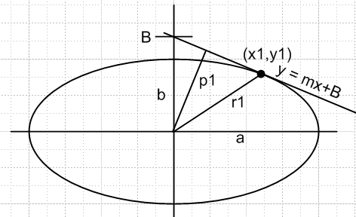

where the line y = mx+B is tangent to the ellipse at the point (x1, y1) and p1 is the distance from the origin to this line. The "fact" is that p1 = 1/$\sqrt{x12/a4 + y12/b4}$. I note that is the same as , the normal at the surface at the tangent point, and I write out the various "direction cosines" such as •. Although I don't prove it, I note the claim that, if the above represented an arbitrary ellipsoid instead of an ellipse, the results are basically the same but we get p1 = 1/$\sqrt{x12/a4 + y12/b4 + z12/c4}$ and of course we are then talking about the tangent plane at ellipsoid surface point r1, and we could again compute things like •. I use subscript 1 just because that freed up variables like x to use in y = mx+B, you could of course just remove this subscript.
For an oblate spheroid, we will then have p1 = 1/$\sqrt{ρ12/a4 + z12/c4}$. Note that for the spheroid, we really only need the 2D ellipse case which I have in fact proven, though the 3D result gives the same. For an oblate spheroid with label ξ we have:

The two equal semi-major axes are A = a $\sqrt{ξ2+1}$. // in the x and y direction
The smaller semi-minor axis is B = aξ // in the z direction

where we have now renamed a,b of the ellipse to be A,B, since a has another meaning (ie, the focal distance of the ellipse -- probably this is why Smythe calls it c). We can then express distance p in terms of a point on our spheroid (ξ,η,φ) and we find that

p = a ξ $\sqrt{(ξ2+1)}$ / $\sqrt{ξ2+ η2}$ = (1/a) AB /$\sqrt{ξ2+ η2}$

At this point, these are just quaint geometric facts of little interest. Below, however, we will use this last fact to show that the charge density on a spheroid varies with this distance p!

In Section 6 I laboriously work through the Laplace equation separation of variables in oblate spheroidal coordinates, following M&F. As usual, there are two separation constants that relate to numbers n and m. We end up with the associated Legendre ODE for η, and the same thing but in iξ for ξ. The main point is that we then end up with this general atomic form

[ Anm Pnm(η) + Bnm Qnm(η) ] [ Cnm Pnm(iξ) + Dnm Qnm(iξ) ] [ Em sin(mφ) + Fm cos(mφ)]

If a problem of interest includes the region near η = -1 and m = integer azimuthally, we know we are forced to n = integer as well with the usual n, m relation. This idea carries over from spherical coordinates. The above would be called oblate spheroidal harmonics.

In Section 7 I address the problem of the charged spheroid. The problem is trivially solved using the above Smythian form, the large ξ behavior, the η = -1 behavior, and the fact that n = m = 0. We get:

V(ξ,η,φ) = V(ξ ) = V0 Q0(iξ) / Q0(iξ1) = V0 cot-1(ξ) / cot-1(ξ1)

since Q0(iξ) = -i cot-1(ξ). If we want things in Cartesians, we can use our result from above that

ξ2 = (1/2a2) { (r2-a2) + $\sqrt{|r2-a2|2 + 4z2}$ }.

We can set ξ1 = 0 to obtain the potential of a disc. Since cot-1(0) = π/2, we get

Vdisc(ξ ) = V0(2/π) cot-1(ξ) ξ2 = (1/2a2) { (r2-a2) + $\sqrt{|r2-a2|2 + 4z2}$ }

I note that M&F solve this problem and quote their result which is of course the same.

If we go to large ξ = r/a and cot-1(ξ) = 1/ξ, we find that Vdisk = V0(2/π)(a/r) = q/r, so we find that the capacitance of a disk is C = q/V0 = (2/π)a. Alternate ways of writing the inverse trig function are these

cot-1(ξ) = tan-1(1/ξ) = cos-1(ξ/$\sqrt{1+ξ2}$) = sin-1(1/$\sqrt{1+ξ2}$)

and it is the sin-1 form that appears in Jackson 3.178. To verify Jackson's result with the above, we have to show that

2a $\sqrt{1+ξ2}$ = [ $\sqrt{(ρ-a)2 + z2}$ + $\sqrt{(ρ+a)2 + z2}$ ]

and I show this using a certain "ellipse string theorem" I had stashed away somewhere which says

(1/2) ( $\sqrt{(x-a)2+ y2}$ + $\sqrt{(x+a)2+ y2}$ )2 = (x2 + y2 + a2) + $\sqrt{(x2 - y2- a2)2 + 4x2y2}$

where the sum of the two radicals is the "string distance" one uses to make an ellipse with two nails at the foci. the Jackson disk potential is this, [note that (q/a) = V0(2/π) using our capacitance result above ]

V(x,y,z) = (q/a) cot-1(ξ) = (q/a) sin-1 [2a / ($\sqrt{(ρ-a)2+ z2}$ + $\sqrt{(ρ+a)2+ z2}$) ]

I then note in passing that the electric field lines are the hyperboloids in this problem, since those are normal to the spheroids of constant potential. I compute the electric field of a charged spheroid to be

E = (2/π) V0 / [a $\sqrt{ξ2+ η2}$] => σ ~ 1/$\sqrt{ξ2+ η2}$

For given ξ, as we move toward the equatorial plane, η → 0 and E increases. If we now recall our spheroidal geometry fact from Section 5 above that p = (1/a) AB /$\sqrt{ξ2+ η2}$, we find that

E = (2/π) V0 (p/AB) // AB = a2 ξ $\sqrt{(ξ2+1)}$

where p was that distance from center and A,B are semi-majors of the vertical slice spheroid ellipse. Since σ ~ E, we have thus shown the σ ~ E ~ p, which is the famous Kelvin observation that the charge density on a spheroid is proportional to distance p. Kelvin in fact worked this in the reverse direction, and moreover was talking about general ellipsoids where the σ ~ p result is also valid, but here we see how it works in the spheroidal case, a priori.
For a disk we have ξ = 0 and then σ ~ 1/η . In this case x2 + y2 = a2(1-η2) = ρ2 so η2 = 1 - (ρ/a)2 and we obtain the classic result σ ~ Edisk = (2 V0/πa) / $\sqrt{1 - (ρ/a)2}$ as discussed in Jackson. I show lots of details in the raw text.
__________________________________________________________________________________

1. Examining Various Choices for Oblate Spheroidal Coordinates

M&M Coordinates

From M&M p 182 we have
x = a chu sinv cosφ dxa = Tab dx'b Tab ≡ $\begin{matrix}∂x'a \\ ∂xb\end{matrix}$
y = a chu sinv sinφ
z = a shu cosv Tab ≡ $\begin{matrix}∂xb \\ ∂x'a\end{matrix}$ = something we could compute!
The normal ordering of the oblate coordinates I think is (u,v,φ). I will think of these as

(u,v,φ) = (q1, q2, q3) = (x'1, x'2, x'3) = qi = x'i

(x,y,z) = xi = Cartesians
so yes, from the above equations we can compute all elements of Tab ≡ $\begin{matrix}∂xb \\ ∂x'a\end{matrix}$ and from that we can figure out everything else. The M&M ellipsoids are these, where ±a are the foci:

z2/(a2sh2u) + (x2+ y2)/(a2ch2u) = 1 // each value of u in (0,∞) labels one

And the hyperboloids are these

- z2/(a2cos2v) + (x2+ y2)/(a2sin2v) = 1 // each value of v in (0,π) labels a half hyper

The wiki site refers to (u,v,φ) as (μ, ν, φ), all Greek letters at least. And wiki shows this specific ordering for the three coordinates, so the "ellipsoid labeler" comes first.

Comment: If we regard a ν-surface as the entire one-sheet hyperboloid, then we only need ν in (0,π/2). In this case, for ν = .001 this hyperboloid is a narrow cone enclosing the z axis, and ν = π/2 is the case where the hyperboloid is flat on the central plane. I think, however, that people like to think of ν as labeling only the upper half of this one-sheet hyperboloid. Then in the range (π/2,π) you get such a half in the lower half of the picture. I think this is the approach taken by whomever drew this picture:

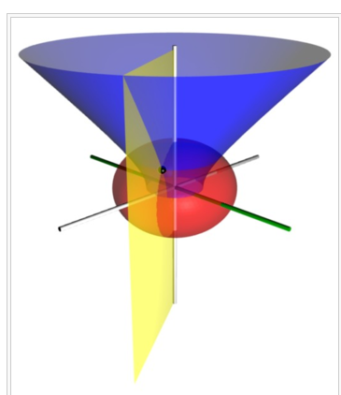

This half-hyperboloid has a benefit and a cost. The benefit is that when you specify (μ,ν,φ) where you respect the ranges μ in (0,∞) as full red ellipsoid, and ν in (0,π/2) as half blue hyperboloid, and φ in (-π,π) as the yellow plane, THEN the coordinates (μ,ν,φ) specify a unique point (x,y,z), not two points. The cost is that if you look at the blue circle where the half-hyperboloids hit the central plane, there is a sharp discontinuity in coordinate ν as you pass through the plane. So, if you take a point on the central plane, you have to decide which of two values of ν it goes with. For example, ν = +π/4 or ν = 3π/4. In the first case, you have sinν = cosν = + .707, in the second case you have sinν = same, but cosν = - .707. This means you are at negative z. But we were talking "on the plane" where u = 0, so z = 0 there anyway, so this sign change should not be a problem. The upper and lower value of cosν are opposite in sign, as in the example here. This caused me confusion in a Smythe problem where I was working right in the hole with this discontinuity going.

Smythe coordinates.

Before going another step, Smythe talks about this stuff starting p 158. Here is a hint of what he is doing:

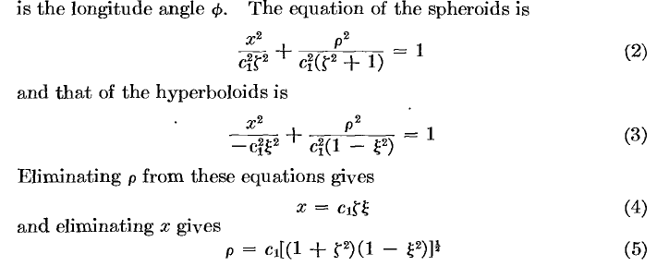

Here is a comparison

M&M Smythe
z = sym axis x = sym axis
r2 = x2+ y2 ρ2 = z2+ y2
a c1
ζ (zayta) shu 1 + ζ2 = ch2u
ξ (zeye) cosv 1 - ξ2 = sin2v
u = (0,∞) ζ = (0,∞)
v = (0,π) ξ = (1,-1)
x = c1ζξ z = a shu cosv
ρ2 = c12(1+ζ2)(1-ξ2) r2 = a2 ch2u sin2v

I think Smythe uses the M&M sin notation, but not sure yet.

Smythe seems to think of the ordering of the coordinates in this way (ξ,ζ,φ), where the ellipse labeler is the second coordinate, not the first. My evidence is this:

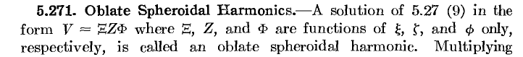

Another piece of evidence is this problem on p 172,

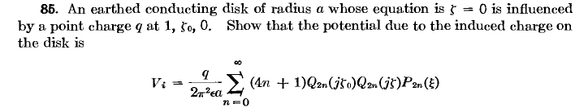
I can now try to understand where he is putting this point charge. With our usual pictures, the symmetry axis is "up", we have oblate spheroids, and ζ = 0 refers to the totally crushed spheroid which is just a line between the foci which gets rotated into a disk about the vertical axis. An ellipse labeled by ζ0 lies outside this disk, it encloses the disk but does not touch it anywhere. He puts the charge on this spheroid, but he puts it at ξ = 1 which is on the hyperboloid which is reduced to a line. So this charge is NOT on the disk axis (ξ =0), it is outside the disk in the plane of the disk! A picture is worth at least 100 words.

Wiki Coordinates

They talk about three different choices of oblate variables!

First, they have these two differences from M&M for their similar coordinates:

(1) They define μ = u,

(2) They define ν = (π/2 - v). This results in a swapping of sin and cos everywhere they appear relative to M&M. Is this the modern day standard?

Second, Wiki differs from Smythe in these ways:

(1) They order the coordinates putting the ellipse label first like this: (ζ ,ξ, φ)

(2) They say that ξ = sinν = cosv which is consistent with everything above.

(3) They refer to Smythe, WR (1968). Static and Dynamic Electricity (3rd ed. ed.). New York: McGraw-Hill. So I have only the second edition (1950) and the 3rd is not available.

They also mention what likes a masterwork on this subject, " Moon and Spencer" 1988.

Moon PH, Spencer DE (1988). "Oblate spheroidal coordinates (η, θ, ψ)". Field Theory Handbook, Including Coordinate Systems, Differential Equations, and Their Solutions (corrected 2nd ed., 3rd print ed. ed.). New York: Springer Verlag. pp. 31–34 (Table 1.07). ISBN 0-387-02732-7. Moon and Spencer use the colatitude convention θ = 90° - ν, and re-name φ as ψ [ ie, same as v in M&M ]

Third, wiki mentions yet another set of parameters like this:

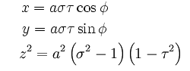

The connection to MM is pretty clear

σ = chu = chμ = $\sqrt{1-ζ2}$ so that
τ = sinv = cosν = ξ

Wiki gives the Qi (which it calls hi) for all these systems.

Morse and Feshbach coordinates

Clued in on them by a wiki reference. On page 1292 of Vol2 we have this: ( p 311 of djvu)

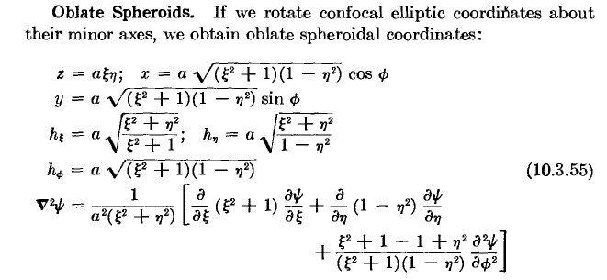

My connection to MM and Smythe would be this:

ξ = shu so that $\sqrt{ξ2 + 1}$ = chu which appears in x
But notice that Smythe uses ζ for this variable!!!!

η = cosv which Smyth calls ξ

The advantage of MF is that the symbols at least look different ! I can just imagine a blackboard filled with ζ and ξ scrawls which all look the same!

M&M Wiki main Smythe MF Wikui στ

ellip shu shμ ζ ξ $\sqrt{σ2-1}$ σ = chu

hypr cosv sinν ξ η $\sqrt{1-τ2}$ τ = sinv

sym z z x z z

I see that MF have quite a bit to say about the oblates and have a notation I can actually use on paper, so maybe they are a candidate for me to work with instead of the others.

Note added 1.15.10. Strangely, MF use a different notation for oblates on p 662 of their Vol 1.

(ξ,η) = (ξ1, ξ2) = (radial, angular)

This is probably a limit of ellipsoidals where ξ2 = ξ3.

Comment: Let's write the ellipse and hyperbola equations in these various systems, for the record. I start with the M&M ones copied from above:

z2/(a2sh2u) + (x2+ y2)/(a2ch2u) = 1 M&M ellipses f = a
- z2/(a2cos2v) + (x2+ y2)/(a2sin2v) = 1 M&M hyperbolas f = a

z2/(a2ξ2) + (x2+ y2)/(a2(1+ξ2) = 1 MF ellipses f = a
- z2/(a2η2) + (x2+ y2)/(a2(1-η2) = 1 MF hyperbolas f = a

$\frac{z2}{a2 ξ2}$ + $\frac{x2+ y2}{a2(1+ξ2)}$ = 1 MF ellipsoid C = aξ A= B = a$\sqrt{1+ξ2}$
focus = a C < A=B
– $\frac{z2}{a2 η2}$ + $\frac{x2+ y2}{a2(1-η2)}$ = 1 MF hyperboloid

The number "a" is always the focal distance. Smythe writes it as c'.

2. Choose MF coordinates for Oblate: picture and comments

x = a $\sqrt{ξ2+1}$$\sqrt{1-η2}$cosφ = a $\sqrt{ξ2+1}$sinν cosφ
y = a $\sqrt{ξ2+1}$$\sqrt{1-η2}$sinφ = a $\sqrt{ξ2+1}$sinν sinφ
z = a ξ η = a ξ cosν

0 ≤ ξ ≤ ∞ // label of red spheroid below
-1 ≤ η ≤ 1 // η = cosν where ν is the blue cone angle shown below

Some comments: [ note that a is the focal distance, not the long semi of the ellipsoid! ]

(1) Think of η = cosν of MM. This is a variable like the z = cosθ of spherical coordinates I am used to. And aξ is like the r of spherical coordinates. If you go to large ξ, those spheroids become spheres with aξ = r. Also, the angle v becomes θ so η = cosθ and these things become spherical coordinates all scaled by a. In fact v is the polar angle of the distant cone limit of a hyperboloid. This limit that v = θ is an advantage of using the MM cosv and not the sinν of wiki, since we can think of v as a polar angle in this sense. I now realize that the wiki picture is quite good:

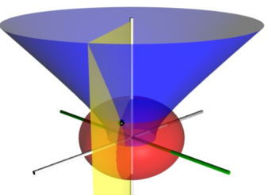

The blue just shows the upper half one-sheet hyperboloid surface which is a hyperbola of revolution around the z axis which is up. You see that far away, it is a cone whose polar angle v (of η = cosv) approaches θ in this limit. The spheroid is shown in red, and of course an azimuthal slice in yellow.

(2) Track what happens as we vary η = cosν. With v ≈ 0 and η = cosν near 1, we have thin pencil cone pointing up, and this becomes the positive z axis. As we increase the angle, η decreases and the cone widens. When we reach v = π/2, (η = 0) the blue surface is completely flat on the xy plane and has a hole in it of radius a (perfect coordinates for round hole in plate problems). As we continue to increase v and head it toward π, the blue surface is around the - z axis and in the η = -1 becomes that axis. Notice that any point in 3-space has exactly one solution for what I would call (ξ,η,φ). This is the logical ordering because it is (r,cosθ,φ) in the large ξ limit! [ ν is the polar angle θ of the limit cone, and η = cosν ]

(3) The red spheroids become spheres at large ξ, and crush down to a disk of radius a at ξ = 0. In that extreme limit, our coordinates are

x = a $\sqrt{1-η2}$cosφ = ρ cosφ
y = a $\sqrt{1-η2}$sinφ = ρ sinφ ρ = a$\sqrt{1-η2}$
z = 0 = 0

In this limit, the red spheroid is a disk, and the blue hyperboloids intersect it as usual. We can then interpret the quantity a$\sqrt{1-η2}$ as ρ, a radial coordinate on the disk. This is a limit I plan to exploit.

3. Metric Tensor and Laplacian etc

Here is how I will line things up to match my curvilinear notes:

x = a $\sqrt{ξ2+1}$$\sqrt{1-η2}$cosφ = a $\sqrt{ξ2+1}$sinν cosφ
y = a $\sqrt{ξ2+1}$$\sqrt{1-η2}$sinφ = a $\sqrt{ξ2+1}$sinν sinφ
z = a ξ η = a ξ cosν

dxa = Tab dx'b Tab ≡ $\begin{matrix}∂x'a \\ ∂xb\end{matrix}$
Tab ≡ $\begin{matrix}∂xb \\ ∂x'a\end{matrix}$ = something we could compute!

ordering of the oblate coordinates will be (ξ,η,φ). I will think of these as

(ξ,η,φ) = (q1, q2, q3) = (x'1, x'2, x'3) = qi = x'i

(x,y,z) = xi = Cartesians

Tab ≡ $\begin{matrix}∂xb \\ ∂x'a\end{matrix}$
so yes, from the above equations we can compute all elements of Tab ≡ $\begin{matrix}∂xb \\ ∂x'a\end{matrix}$ and from that we can figure out everything else. I now inform Maple of my variables:

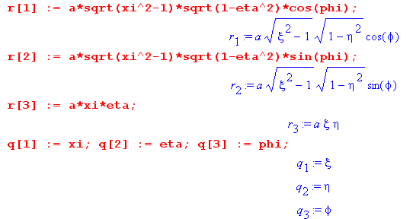

and have it compute the matrix Tab ≡ $\begin{matrix}∂xb \\ ∂x'a\end{matrix}$ ,

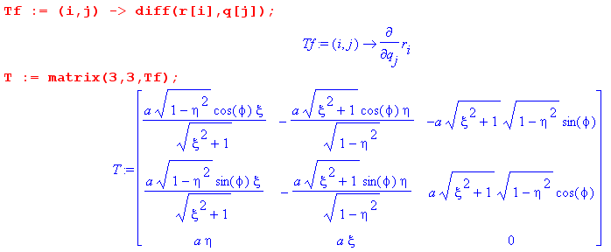

We know that (T-1)ad = Tda if we needed the other matrix in these coordinates, but I don't think I need that for anything. The metric tensor is given by

gkp = Tki Tpi = $\begin{matrix}∂xi \\ ∂qk\end{matrix}$$\begin{matrix}∂xi \\ ∂qp\end{matrix}$ or in matrix notation : g = TTT

so here is what Maple says:

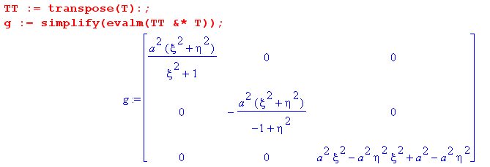

which confirms that we our oblate system is orthogonal. The three diagonal elements of this matrix are the MM notation Qi2 so we could say

Qξ2 = a2 (ξ2+ η2) / (ξ2+ 1)

Qη2 = a2 (ξ2+ η2) / (1-η2)

Qφ2 = a2(ξ2+ 1) (1-η2) // factoring what appears above

We can compare these results to M&F p 1292 (311 II)

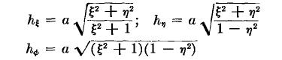

so we are cooking with gas here.
Next, we want to get right to the Laplacian: Our general formula for orthogonal systems is this:

∇2(f) = $\frac{1}{Q1Q2Q3}${ ∂1{(Q2Q3)/Q1 *(∂1f)} + cyclic } analysis

It takes a bit of battling with Maple to have it compute out these terms. We have to square things because it is too stupid to cancel things in radicals, I guess it is always worrying about branches of functions. So, our first result is this:

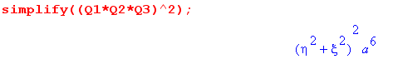
which tells us that

Q1Q1Q3 = a3 (ξ2+η2)

First term: Maple says:

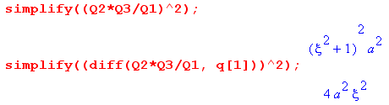
so
(Q2Q3)/Q1 = a (ξ2+1)

∂1{(Q2Q3)/Q1 = 2aξ // looking at the unsquared term shows plus!

Second term:

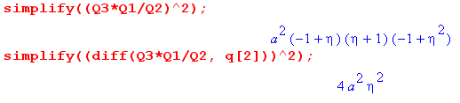
so

(Q3Q1)/Q2 = a (1-η2)

∂2{(Q3Q1)/Q2 = - 2aη // looking at the unsquared term shows minus!

Third term:

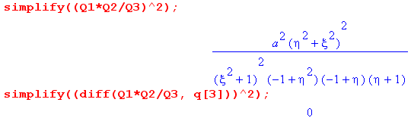
so

(Q1Q2)/Q3 = a (η2+ ξ2)/ ((ξ2+1) (1-η2) )

∂3{(Q1Q2)/Q3 =0

So let's try to assemble our oblate Laplacian (as people did in the 1800's)

∇2(f) = $\frac{1}{Q1Q2Q3}${ ∂1{(Q2Q3)/Q1 *(∂1f)} + cyclic }

= ( 1/ a3 (ξ2+η2) ) { T1 + T2 + T3 }

T1 = 2aξ ∂ξf + a (ξ2+1) ∂ξ2f
T2 = -2aη ∂ηf + a (1-η2) ∂η2f
T3 = 0 + a (η2+ ξ2)/ ((ξ2+1) (1-η2) ) ∂φ2f

Looks pretty messy:

∇2(f) = 1/ a2 (ξ2+η2) )

{ 2ξ ∂ξf + (ξ2+1) ∂ξ2f - 2η ∂ηf + (1-η2) ∂η2f + (η2+ ξ2)/ ((ξ2+1) (1-η2) ) ∂φ2f }

but this does agree with M&F p 311

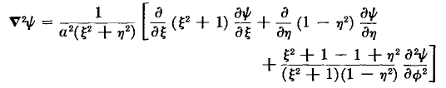

where he has written the first terms in a way I could have done, and written the last term in a truly strange but correct way. It allows us then to say

last term inside = [ 1/(1-η2) - 1/(ξ2+1) ] ∂φ2ψ

So I will write it his way

∇2(f) = 1/ a2 (ξ2+η2) )

{ ∂ξ [(ξ2+1) ∂ξf] + ∂η [(1-η2) ∂ηf] + [ 1/(1-η2) - 1/(ξ2+1) ] ∂φ2f }

So this is a great victory, we now have our all-important Laplace operator in oblate spheroidal coordinates, and I have derived it completely from scratch, using my previous curvilinear work.

While we are here, let's do the volume and surface area elements, using our curvilinear notes.

The differential surface area in general is this

dS1 = $\sqrt{g22g33- g232}$ dq2 dq3

so in orthogonal is this

dS1 = $\sqrt{g22g33}$ dq2 dq3 = Q2Q3 dq2 dq3 and cyclic

Qξ2 = a2 (ξ2+ η2) / (ξ2+ 1) 1

Qη2 = a2 (ξ2+ η2) / (1-η2) 2

Qφ2 = a2(ξ2+ 1) (1-η2) 3

So we can write them out:

dSξ = QηQφ dη dφ = [ a2 $\sqrt{ξ2+ η2}$$\sqrt{ξ2+ 1}$ ] dη dφ

dSη = QφQξ dφ dξ = [ a2$\sqrt{ξ2+ η2}$$\sqrt{1-η2}$] dφ dξ

dSφ = QξQη dξ dη = [ a2 (ξ2+ η2) / [ $\sqrt{ξ2+ 1}$$\sqrt{1-η2}$ ] dξ dη

The first one of these is the surface area patch on a spheroid.

The volume element is this:

dV = $\sqrt{det(g)}$ dq1 dq2 dq3 // in general

dV = Q1Q2Q3 dq1 dq2 dq3 // orthog

= a3 (ξ2+ η2)/(1-η2) dξ dη dφ

4. Inverse equations

Step 1: someone hands me the this equation:

$\frac{z2}{a2 u}$ + $\frac{x2+ y2}{a2(1+u)}$ = 1

Step 2: I say "Oh, if u>0 this is an ellipsoid, and if-1<u<0 it is a hyperboloid and if u < -1 it's nothing."
(I use the word ellipsoid to mean the oblate spheroid here) . We anticipate where we are going by writing

$\frac{z2}{a2 ξ2}$ + $\frac{r2- z2}{a2(1+ξ2)}$ = 1 – $\frac{z2}{a2 η2}$ + $\frac{r2- z2}{a2(1-η2)}$ = 1 (*)
red ellipsoid u = ξ 2 blue hyperboloid u = - η2
ξ2 > 0 0 < η2 < 1

Tradition uses n = - η2 instead of u = +η2 which we accept, getting a nice positive range for η2.

Step 3: To get the inverse equations, we shall approach this problem as we did the ellipsoidals (which I have now done). We start by considering this equation with a "generic" coordinate u.

$\frac{z2}{a2 u}$ + $\frac{x2+ y2}{a2(1+u)}$ = 1

Since the x2 and y2 denominators are the same, when we "multiply this out", we get a quadratic instead of the cubic we got in the ellipsoidal case. That quadratic is this

f(u) ≡ u2 – (r2/a2-1) u - z2/a2= 0 dim = L2 // checked 1.21.10

The solutions are these:

u± = (1/2) { [(r/a)2-1] ± $\sqrt{[(r/a)2-1]2 + 4(z/a)2}$}

where then f(u) = ( u - u+) ( u - u-) and so u+u- = - z2/a2 < 0. We can see by staring that u+ > 0 and u- < 0, which agrees with the fact that the product of the solutions is negative. So we want to identify:

ξ2 = u+ -η2 = u-

Here is a little plot of f(u) showing the two solutions to f(u) = 0 which are of course u- and u+:

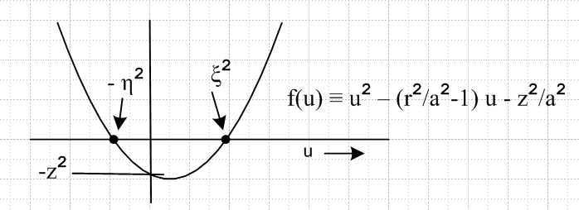

If is obvious that ξ2 > 0, but not obvious that -η2 > -1, but it turns out this is true too.

We shall now assume that z ≥ 0 so of course we can only have r ≥ z. We now pick a = 1 and remain completely general by just varying z, and we plot these u± solutions. I plot for various z in Maple, and the general nature of the plot is always the same: the u+ solution is always positive (as appropriate for being the ξ2 coordinate), and the u- solution ( = -η2) is always negative in the range (-1,0). Here are two plots

u± = (1/2) { [(r/a)2-1] ± $\sqrt{[(r/a)2-1]2 + 4(z/a)2}$} u+ = red plot u- = green plot

restart;
c := (r/a)^2 - 1:
up := (1/2)*( c + sqrt(c^2 + 4*(z/a)^2) ):
um := (1/2)*( c - sqrt(c^2 + 4*(z/a)^2) ):
a := 1: z := .2:
plot([up,um],r=z..2, color=[red,blue]);

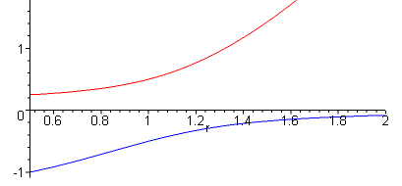 This one has z = 0.5

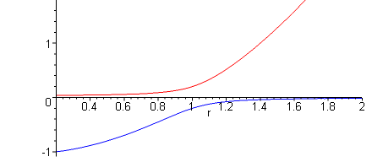 This one has z = 0.2

Notice the interesting flattening of the red curve as z → 0, which will play a role later when we ponder things like the charged metal disk.

It seems quite clear that we want to make this connection:

ξ2 = (1/2) { [(r/a)2-1] + $\sqrt{[(r/a)2-1]2 + 4(z/a)2}$}
- η2 = (1/2) { [(r/a)2-1] - $\sqrt{[(r/a)2-1]2 + 4(z/a)2}$}

We can multiply through by a2/a2 to get another form for these expressions:

ξ2 = (1/2a2) { (r2-a2) + $\sqrt{(r2-a2)2 + 4z2}$ }
- η2= (1/2a2) { (r2-a2) – $\sqrt{(r2-a2)2 + 4z2}$ }

which seems less cluttered with support symbols. Now in a radical like that shown above, there is always a temptation to "pull out" a factor (r2-a2) and write things as follows:

ξ2 = (1/2a2) { (r2-a2) +(r2-a2) $\sqrt{1 + 4z2/(r2-a2)2}$ } WRONG
- η2= (1/2a2) { (r2-a2) –(r2-a2) $\sqrt{1 + 4z2/(r2-a2)2}$ } WRONG

This would be OK if we always had r > a, but that is not the case. Notice that, by the same argument, we could alternatively "pull out" a factor (a2- r2)! The correct way to "pull out" the factor is this:

ξ2 = (1/2a2) { (r2-a2) + |r2-a2| $\sqrt{1 + 4z2/(r2-a2)2}$ }
- η2= (1/2a2) { (r2-a2) – |r2-a2| $\sqrt{1 + 4z2/(r2-a2)2}$ }

or write it this way before anything pulled out

ξ2 = (1/2a2) { (r2-a2) + $\sqrt{|r2-a2|2 + 4z2}$ }
- η2= (1/2a2) { (r2-a2) – $\sqrt{|r2-a2|2 + 4z2}$ }

and once again for good measure:

ξ2 = (1/2a2) |r2-a2|{ sign(r2-a2) + $\sqrt{1 + 4z2/(r2-a2)2}$ }
- η2= (1/2a2) |r2-a2|{ sign(r2-a2) - $\sqrt{1 + 4z2/(r2-a2)2}$ }

Any of these forms will do. In terms of the last form, we see that if we are on the "inside" r < a, then that sign is negative and as z→0 we get {-1 + 1}, so ξ → 0 everywhere "inside". That is what the red plot is showing above. In this same limit, the second equation has {-1-1} so the two terms are additive, but we never get -η2 < -1.

So, to summarize, we started with these spheroidal oblate coordinates

x = a $\sqrt{ξ2+1}$$\sqrt{1-η2}$cosφ
y = a $\sqrt{ξ2+1}$$\sqrt{1-η2}$sinφ
z = a ξ η

and we obtain the inverse coordinates as follows:

ξ2 = (1/2a2) { (r2-a2) + $\sqrt{(r2-a2)2 + 4z2}$ }
- η2 = (1/2a2) { (r2-a2) – $\sqrt{(r2-a2)2 + 4z2}$ }
φ = tan-1(y/x)

where I picked one of several ways to write the first two lines. Recall that in the more general case of ellipsoidal coordinates, the inverse coordinates were so messy we could barely write them down!

Obscure comments about 4D interpretation.

Consider : f(u,r,z) = u2 – (r2/a2-1) u - z2/a2

Imagine plotting the function f = f(u,r,z) as a real hypersurface embedded in a 4D space whose axes are u,r,z,f . For every value of u,r,z we get some unique height f and that is what we plot. Now we consider the intersection of this hypersurface with the f = 0 plane in our 4D space. The intersection is a 3D surface of some sort. For each pair (r,z), we find there are two values of u (of opposite sign) which put (u,r,z) on this intersection 3D surface. Let's call these values u1(r,z) and u2(r,z). If we pick the u1 value then f(u1,r,z) = 0 describes the 1 surface, and f(u2,r,z) = 0 describes the 2 surface. The union of these two surfaces is our complete surface which is our "intersection 3D surface". Every point on this union surface satisfies f(u,r,z) = 0. We happen to know that one of these surfaces is an ellipsoid, and the other is a hyperboloid, and they in fact intersect in 3D space, as in our red/blue wiki picture. We have

f(u1,r,z) = 0 = equation of red ellipsoid surface
f(u2,r,z) = 0 = equation of blue hyperboloid surface

Now suppose we define ξ2 ≡ u1(r,z) > 0 and - η2 ≡ u2(r,z) < 0. Then instead of having a 1-surface and a 2-surface, we have a ξ-surface and an η-surface. We then have

f(ξ2,r,z) = 0 = equation of red ellipsoid surface
f(- η2,r,z) = 0 = equation of blue hyperboloid surface

For any given (r,z), we get a unique ξ2 and a unique η2 so we can think of (ξ2, η2) as replacement coordinates (r,z). We can rewrite the equations of our two surfaces shown on the two lines above as

$\frac{z2}{a2 ξ2}$ + $\frac{r2- z2}{a2(1+ξ2)}$ = 1 – $\frac{z2}{a2 η2}$ + $\frac{r2- z2}{a2(1-η2)}$ = 1 (*)
red ellipsoid blue hyperboloid

For a given Cartesian space point (r,z), there is exactly one value of ξ2 that puts us on the red ellipsoid, and one value of η2 that puts us on the hyperboloid. This, at any point in Cartesian space, we find ourselves on an ellipsoid labeled by ξ2 and on a hyperboloid labeled by η2.
Now consider a particular ξ2 and a particular η2 so we have a particular red surface and a particular blue surface. Any point (z,r) which lies on the union of these surfaces satisfies f(u,r,z) = 0 and therefore satisfies our original generic equation. So look at the two equations in (*) above for fixed ξ and η. Certain (r,z) points lie on the left surface (red) and certain other points (r,z) lie on the right surface (blue). All these (r,z) points lie on our "intersection 3D surface" f(u,r,z) = 0. Thus, all these (r,z) points are solutions to our original equation,

$\frac{z2}{a2 u}$ + $\frac{x2+ y2}{a2(1+u)}$ = 1

5. The Kelvin p function in Cartesians and Spheroidals

Note that p is a physical distance: the perp distance from center to tangent plane.

I only ask this because it seems significant to Kelvin in his paper (see elsewhere).

Since x2/a2+ y2/b2 = 1 we know that dy/dx = - (b/a)2(x/y) = m at point (x,y). Line is then

y = mx + B m = [- (b/a)2(x1/y1)] B = y1 - m x1

If we write out B and use the ellipse equation again, we find that B = b2/y1.

The vector from the tangent point to the intercept point on top is this

v = (0,B) - (x1,y1) = (-x1, B-y1) = (-x1, -mx1) = -x1(1,m)

and we know p•v = 0 so we have

px 1 + py m = 0 => py = -px/m

But we also know that py = mpx + B so set equal to get

-px/m = mpx + B => px = -Bm/(m2+1) => py = B/(m2+1)

Now we know distance p which we set out to find:

p2 = px2+ py2 = B2/(m2+1) = (y1 - m x1)2/ (m2+1) m = [- (b/a)2(x1/y1)]

If you plug in m and do the algebra and, on the numerator, use the fact that x12/a2 + y12/b2 = 1, you get this result that is the Kelvin result:

p = 1/$\sqrt{x12/a4 + y12/b4}$

Note that is the same as , the normal at the surface at the tangent point. If we wanted to know the "direction cosine" for to the y axis, cosβ = • = • , we could compute from the picture

cosβ = p/B = (y1/b2) / $\sqrt{x2/a4 + y2/b4}$

So we have a little theorem here:

Theorem 1: Given an ellipse (a,b), and given a point (x,y) on this ellipse, the perpendicular distance from the center of the ellipse to the plane tangent at (x,y) is given by

p = 1/$\sqrt{x2/a4 + y2/b4}$

Kelvin claims that you can generalize this to an arbitrary ellipsoid (a,b,c) and the result is

p = 1/$\sqrt{x2/a4 + y2/b4 + z2/c4}$

which seems pretty reasonable to me. Would have to redo the above proof using planes instead of lines. Then you would find that'

cosβ = p/B = (y1/b2) / $\sqrt{x2/a4 + y2/b4 + z2/c4}$

and similar results for the other two direction cosines of which I just add here

cosα = p/A = (x1/a2) / $\sqrt{x2/a4 + y2/b4 + z2/c4}$
cosβ = p/B = (y1/b2) / $\sqrt{x2/a4 + y2/b4 + z2/c4}$
cosγ = p/C = (z1/c2) / $\sqrt{x2/a4 + y2/b4 + z2/c4}$

I am mentioning all this direction cosine stuff because it shows up later where I "parse" Kelvin Section 12. Now back to the 2D case:

For our oblate spheroid, we would claim that a = b so, setting ρ2 = x2+ y2,

p = 1/$\sqrt{ρ2/a4 + z2/c4}$

Now recall our results from above:

The two equal semi-major axes are A = a $\sqrt{ξ2+1}$. // in the x and y direction
The smaller semi-minor axis is B = aξ // in the z direction

so we have

p = { [ρ/(a2(ξ2+1)]2 + [z/(a2ξ2)]2 }-1/2

We can now replace:

ρ2 = a2(ξ2+1)(1-η2)

z2 = a2 ξ2 η2

p-2 = [ρ/(a2(ξ2+1)]2 + [z/(a2ξ2)]2

= ρ2/[a4(ξ2+1)2] + z2/[a4ξ4]

= a2(ξ2+1)(1-η2)/[a4(ξ2+1)2] + a2 ξ2 η2/[a4ξ4]

= a-2(1-η2)/[(ξ2+1)] + a-2 η2/[ξ2]

= a-2 [(1-η2)/ (ξ2+1) + η2/ξ2]

= a-2 [(1-η2) ξ2 + η2(ξ2+1)] / [ ξ2(ξ2+1)]

= a-2 [ξ2+ η2] / [ ξ2(ξ2+1)]

so we end up with

p = a ξ $\sqrt{(ξ2+1)}$ / $\sqrt{ξ2+ η2}$ =>

p = (1/a) AB /$\sqrt{ξ2+ η2}$

I will comment on this result below in talking about

6. Separation of Variables

This is of course the next step. Try

f = a(ξ) b(η)c(φ)

The above becomes

∇2(f) = 1/ a2 (ξ2+η2) )

{b(η)c(φ)∂ξ [(ξ2+1) ∂ξ a(ξ)] + a(ξ) c(φ)∂η [(1-η2) ∂η b(η)] + a(ξ) b(η) [ 1/(1-η2) - 1/(ξ2+1) ] ∂φ2 c(φ) }

We are doing ∇2f = 0 Laplace equation, so divide through by the three functions so that 0 =

{∂ξ [(ξ2+1) ∂ξ a(ξ)]/ a(ξ) + ∂η [(1-η2) ∂η b(η)]/ b(η) + [ 1/(1-η2) - 1/(ξ2+1) ]( ∂φ2 c(φ) )/c(φ)}

Now set ( ∂φ2 c(φ) )/c(φ) = λ for the moment and we then have

{∂ξ [(ξ2+1) ∂ξ a(ξ)]/ a(ξ) + ∂η [(1-η2) ∂η b(η)]/ b(η) + [ 1/(1-η2) - 1/(ξ2+1) ]λ} = 0

{∂ξ [(ξ2+1) ∂ξ a(ξ)]/ a(ξ) - λ/(ξ2+1)} + {∂η [(1-η2) ∂η b(η)]/ b(η) + λ /(1-η2)} = 0

Shades of hydrogen atom in parabolic coordinates here. Now make up a second separation constant:

∂ξ [(ξ2+1) ∂ξ a(ξ)]/ a(ξ) - λ/(ξ2+1) = β

∂η [(1-η2) ∂η b(η)]/ b(η) + λ /(1-η2) = - β

Now consider right away ( ∂φ2 c(φ) )/c(φ) = λ . We know that c = e±imφ so λ = -m2 all by "the usual azimuthal argument", namely, single valued and continuous etc etc. So we then have

∂ξ [(ξ2+1) ∂ξ a(ξ)]/ a(ξ) + m2/(ξ2+1) = β

∂η [(1-η2) ∂η b(η)]/ b(η) - m2 /(1-η2) = - β

Let's take the η equation and write it out

(1-η2) ∂η2 b(η) - 2η ∂η b(η) - m2 /(1-η2) b(η) = -β b(η)

(1-η2) ∂η2 b(η) - 2η ∂η b(η) - m2 /(1-η2) b(η) + β b(η) = 0

If we set η = x, and β = n(n+1), we get exactly the Associated Legendre differential equation shown Schaum p 149 top. The solutions of this equation are Pnm(η) and Qnm(η). We know m = integer, and in theory n is any complex value. But I will show soon that n must have the usual values associated with m, otherwise these solutions both blow up and are not useable. In other words, the separation constant β gets quantized as shown so that we have usable solution functions. This same thing happens in the spherical coordinates, but I never figured it out right. Soon.
Now we know the Qnm(η) functions blow up at η = 0, but this is all points on the plane outside the disk, so that is unacceptable and we have to reject that function, so only Pnm(η), just as with the spherical harmonics. And think η = cosv of the original MM choice of variables and ν → θ, etc. So we are pretty happy about this.

The first equation is then this:

∂ξ [(ξ2+1) ∂ξ a(ξ)]/ a(ξ) + m2/(ξ2+1) = β

∂ξ [(ξ2+1) ∂ξ a(ξ)] + m2 a(ξ) /(ξ2+1) = β a(ξ)

(ξ2+1) ∂2ξ a(ξ) + 2ξ ∂ξa(ξ) + m2 a(ξ) /(ξ2+1) = β a(ξ)

To make this look like associated Legendre, we have to do this

iξ = x ξ = -ix ∂ξ = -idx ∂ξ= i∂x ∂ξ2 = - ∂x2

-(-x2+1) ∂2x a(ξ) + 2(-ix) i∂x a(ξ) + m2 a(ξ) /(-x2+1) = β a(ξ)

-(1 - x2) ∂2x a(ξ) + 2x∂x a(ξ) + m2 a(ξ) /(1 - x2) = β a(ξ)

(1 - x2) ∂2x a(ξ) - 2x∂x a(ξ) - m2 a(ξ) /(1 - x2) = - β a(ξ)

(1 - x2) ∂2x a(ξ) - 2x∂x a(ξ) - m2 a(ξ) /(1 - x2) + β a(ξ) = 0

(1 - x2) ∂2x a(ξ) - 2x∂x a(ξ) - m2 a(ξ) /(1 - x2) + n(n+1) a(ξ) = 0

where of course we can think of a(ξ(x)) = A(x), some other function. This equation is now exactly associated Legendre Schaum p 149, so we conclude that

A(x) = Pnm(x) and Qnm(x)

A(iξ) = Pnm(iξ) and Qnm(iξ) = a(ξ)

So our solutions are Pnm(iξ) and Qnm(iξ) which is totally new to me, though I have seen it floating around in the oblate world. I suppose somehow at ξ = 0 which is the disk itself these are both OK. That is another thing I have to look at.
So here is what MF has to say about this:

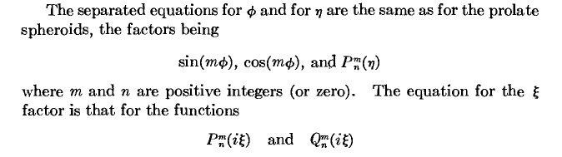

Oblate spheroidal harmonics and comparison to spherical and ellipsoidal.

Easier way: First in the above I got an ODE in variable η which had solutions Pnm(η) and Qnm(η). I know that if we set ξ2 = -η2 this will give us the ODE in variable ξ because this same substitution will create the ξ terms in the Laplacian from the η terms and it is from the Laplacian that the ODE's come. Therefore, the solutions of the ξ ODE will be Pnm(iξ) and Qnm(iξ). Thus, here is our general solution term for Laplace's equation in oblate coordinates

[ Anm Pnm(η) + Bnm Qnm(η) ] [ Cnm Pnm(iξ) + Dnm Qnm(iξ) ] eimφ

Conjecture: Second-kind functions are those the decay at large argument, and are appropriate for solving the external problem outside a metal spheroid. The first-kind functions would be used for the interior problem which we are not interested in for closed metal objects.

I think it turns out that the first-kind oblate spheroidal harmonics will be these (linkages on right)

Pnm(η) Qnm(iξ) eimφ oblate spheroidal harmonics (n,m) (n,m) (m)

which we can compare to

Rn(r) Pnm(cosθ) eimφ spherical harmonics (n) (n,m) (m)

Emp(ξ1) Emp(ξ2) Emp(ξ2) ellipsoidal harmonics (m,p) (m,p) (m,p)

7. Potential of a charged metal disk

Preliminary problem: What is the potential of a charged metal oblate spheroid ξ = ξ1. We know there is no azimuthal, so that forces m = 0. In a Smythian form for the potential we will have as factor

[ Anm Pnm(η) + Bnm Qnm(η) ] = [ An0 Pn(η) + Bn0 Qn(η) ] = An0 Pn(η)

where we throw out the Qn term since it blows up at η = -1 on our spheroid. But the potential on the particular spheroid ξ = ξ1 is a constant and cannot vary with η, so we conclude that n = 0. Meanwhile, the other fact is this:

[ Cnm Pnm(iξ) + Dnm Qnm(iξ) ] = [ Cn0 Pn(iξ) + Dn0 Qn(iξ) ] = Dn0 Qn(iξ)

where we through out the Pn since it diverges for large ξ, ie, far from the spheroid. Putting the pieces together with n=0, we end up with V ~ Q0(iξ) and this is normalized to

V = V0 Q0(iξ) / Q0(iξ1)

so you get the constant V = V0 on the metal spheroid. This is an external problem by the way, inside V = V0. If we set ξ1 = 0, we are then asking about the potential of a charged metal disk and the answer is

V = V0 Q0(iξ)/Q0(0)

As the spheroid is crushed down (we reduce ξ to 0), a vertical cross section ellipse maintains its foci at ±a, and becomes thin and the foci then become the boundary points for this crushed ellipse. In other words, the radius of our disk is a.

Recall our inversion equations (updated 1.21.10) above for r2 < a2 were (thinking disk)

ξ2 = (1/2a2) |r2-a2|{ -1 + $\sqrt{1 + 4z2/(r2-a2)2}$ } a = focus
- η2= (1/2a2) |r2-a2|{ -1 - $\sqrt{1 + 4z2/(r2-a2)2}$ } r2 = x2+ y2 +z2

On the disk we have z = 0, so these become η2 = |r2-a2|/a2 =

ξ2= 0
η2 = |r2-a2|/a2 = (a2-ρ2)/(a2) = (1 - (ρ/a)2) η = $\sqrt{1-(ρ/a)2}$ a = focus

Now consider ellipsoids enclosing our disk. We then have r2 > a2 and

ξ2 = (1/2a2) |r2-a2|{ +1 + $\sqrt{1 + 4z2/(r2-a2)2}$ } a = focus
- η2= (1/2a2) |r2-a2|{ +1 - $\sqrt{1 + 4z2/(r2-a2)2}$ } r2 = x2+ y2 +z2

Notice that ξ is then a function of disk radius a, and that then is how the potential V will depend on a. In fact, here is our disk potential solution: (updated)

V(x,y,z) = V0 Q0(iξ)/Q0(0) ξ2 = (1/2a2) |r2-a2|{ sign(r2-a2) + $\sqrt{1 + 4z2/(r2-a2)2}$ }

Suddenly I know the potential of a disk! This is the problem that Jackson had to jump through many hoops to get using "general forms" in cylindrical coordinates on page 90-92 and then he had to solve an integral equation. Jackson's result is 3.178 and I will come back to compare that to this result.
____________________________________________________________________________

Note added 1.15.10. I never "came back" so let's do it right here.

Verification of green Jackson 3.178 on page 92 potential of charged disk ( with 1/a added)

Smythe p 145 states that

Q0(iξ) = -i cot-1(ξ)

Schaum p 19 top reminds us that cot-1(ξ) = π/2, so we know that Q0(0+) = -iπ/2. Therefore

Q0(iξ)/Q0(0) = (2/π) cot-1(ξ)

We could therefore just install our ξ expression above to get a Cartesian formula for V(x,z,y) :

V(x,y,z) = V0 (2/π) cot-1(ξ) where ξ2 = (1/2a2) { (r2 - a2) + $\sqrt{|r2-a2|2 + 4a2z2}$}

This is the general result for the potential of a charged disk. We learn below that the capacitance of a disk is C =(2/π)a and we know q = CV0 = (2/π)a V0 so we can, it we like, replace V0 (2/π) with q/a to get

V(x,y,z) = (q/a) cot-1(ξ) where ξ2 = (1/2a2) { (r2 - a2) + $\sqrt{|r2-a2|2 + 4a2z2}$} // ok

Noting the sin-1 form in Jackson's 3.178, let's do our "little triangle conversion" which shows that there are many ways to write the same angle,

cot-1(ξ) = tan-1(1/ξ) = cos-1(ξ/$\sqrt{1+ξ2}$) = sin-1(1/$\sqrt{1+ξ2}$)

My result will agree with Jackson's "Weber form" 3.178 if the following can be shown to be true:

2a $\sqrt{1+ξ2}$ = [ $\sqrt{(ρ-a)2 + z2}$ + $\sqrt{(ρ+a)2 + z2}$ ] (*)

ξ2 = (1/2a2) { (r2 - a2) + $\sqrt{|r2-a2|2 + 4a2z2}$} r2 = z2 + ρ2

I am reminded of my "ellipse" problem and am thinking maybe the RHS above is the "string distance". In my doc "ellipses.doc" I derive the following:

"Ellipse Theorem 3: ( the "ellipse string theorem")

(1/2) ( $\sqrt{(x-a)2+ y2}$ + $\sqrt{(x+a)2+ y2}$ )2 = (x2 + y2 + a2) + $\sqrt{(x2 - y2- a2)2 + 4x2y2}$ "

Attempting to apply this here, let's try

x = ρ a = a y = z =>

(1/2) ( $\sqrt{(ρ-a)2+ z2}$ + $\sqrt{(ρ+a)2+ z2}$ )2 = (ρ2 + z2 + a2) + $\sqrt{(ρ2 - z2- a2)2 + 4ρ2z2}$

Now on the RHS replace ρ2 = r2-z2 in three places

RHS = (ρ2 + z2 + a2) + $\sqrt{(ρ2 - z2- a2)2 + 4ρ2z2}$

= (r2 + a2 ) + $\sqrt{(r2 - 2z2- a2)2 + 4(r2- z2)z2}$

The inside of the radical is shown by algebra to be (r2- a2) + 4z2a2 so we have

RHS = (r2 + a2 ) + $\sqrt{(r2- a2) + 4z2a2}$

Meanwhile, we can write

ξ2 = (1/2a2) { (r2 - a2) + $\sqrt{|r2-a2|2 + 4a2z2}$} r2 = z2 + ρ2

=> 1 + ξ2 = (1/2a2) { (r2 + a2 ) + $\sqrt{|r2-a2|2 + 4a2z2}$}

so I have now shown that

(1/2) ( $\sqrt{(ρ-a)2+ z2}$ + $\sqrt{(ρ+a)2+ z2}$ )2 = (r2 + a2 ) + $\sqrt{|r2-a2|2 + 4a2z2}$ = 2a2 (1 + ξ2)

or

[ $\sqrt{(ρ-a)2+ z2}$ + $\sqrt{(ρ+a)2+ z2}$] = 2a$\sqrt{1+ξ2}$

which is exactly what we wanted to show, see (*) above. So we have now confirmed Jackson 3.178 as the potential of a charged disk, except we have to divide his result by a due to a rare typo on his part.
Recall that the disk is associated with a family of confocal oblate spheroids whose cross sections are ellipses. The LHS is the "string distance" for such an ellipse, so we see that if the spheroid is labeled by ξ, the string distance happens to be 2a$\sqrt{1+ξ2}$.
[ Recall | z + $\sqrt{z2-1}$| = K and |z-1| + |z+1| = K + K-1 from "ellipses.doc" where we have a = 1. ]

So here then is the final Weber Form:

V(x,y,z) = (q/a) cot-1(ξ) = (q/a) sin-1 [2a / ($\sqrt{(ρ-a)2+ z2}$ + $\sqrt{(ρ+a)2+ z2}$) ]

which is a pretty compact simple form for this fairly difficult potential of metal disk problem.
Note 1.21.10, see Ahlfors section on power branch points. We need to interpret the above as:

V(x,y,z) = (q/a) cot-1(ξ) = (q/a) sin-1 [2a / ( | $\sqrt{(ρ-a)2+ z2}$ | + $\sqrt{(ρ+a)2+ z2}$) ]

Then the meaning is completely clear for z ≠ 0 as well as for z → 0, for either sign ρ-a .

____________________________________________________________________________

Here is MF on this problem:

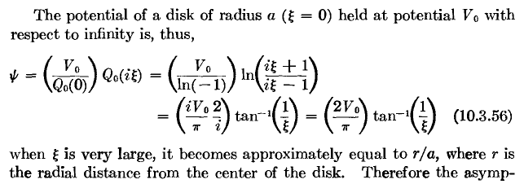

I now have a lot to verify, but think about this disk potential: if you look at any of those red spheroids as you move out from the disk. the potential is a constant on the entire surface of the spheroid. So this is how the result that spheres have constant potential outside a metal sphere of charge. This is an answer that would be in The Book : it could not be any other way.

ψ(ξ) = V0(2/π) tan-1(1/ξ)

But what is ξ ? Recall our MF ellipse equations from above

z2/(a2ξ2) + (x2+ y2)/(a2(1+ξ2) = 1 MF ellipses f = a

The variable ξ is a label that marks an ellipse which has focus = ±a, A = a$\sqrt{ξ2+1}$ B = aξ where A and B are the semi major and minor axes of the ellipse marked by ξ.

This obviously has some bearing on the plate with a hole problem, superposition or something, come back to that soon as well. Plate at V0 without hole means V0 everywhere I suppose. Then subtract the potential of the disk, get

ψplate–with-hole = V0 [ 1 - Q0(iξ)/Q0(0)] ???

but this can't be right because it then says ψ = 0 everywhere in the hole which I don't believe. This relates to Babinet's Principle, put it on the list.

Note added 10.5.10. I was thinking of superposition with the above comment, thinking that you could superpose a uniformly charged disk (sticky charge) and a uniformly charged iris (sticky charge) do get a uniformly charged infinite plane. But our "charged disk" is not uniformly charged, and when I later solved the "charged iris" problem, it too is not uniformly charged. This, the superposition makes no sense at all and my conjecture was wrong. Babinet relates to diffraction of disk and plate where the sum in that problem is 0 so one is minus the other.

Comment: The main idea not to be missed about the potential of the charged metal plate is this: the oblate spheroids are the equipotential surfaces, so the hyperboloids must be the electric field lines. Thus, we know in detail what all these things look like from our usual oblate graph,

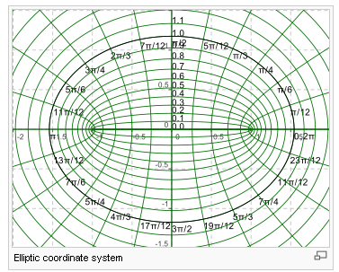

We now have a fine interpretation of the lines in this picture.

Electric Field and charge density on an oblate spheroid:

If you pick a math spheroid containing the charged metal disk, what is the electric field on its surface? Here is one way to answer. Consider two spheroids separated by dξ. They have a potential difference given by

dV = V0 (dQ0(iξ)/dξ) /Q0(0) dξ

The perpendicular distance at some point between the two spheroids is this:

(ds)2 = gξξ(dξ)2 since we keep dη = 0 to stay on a hyperb, so we are perp

gξξ = a2 (ξ2+ η2) / (ξ2+ 1)

so the electric field at some point η on our spheroid must be

E = - dV/ds = - [V0 (dQ0(iξ)/dξ) /Q0(0) ] / [ dξ a $\sqrt{ξ2+ η2}$/ $\sqrt{ξ2+ 1}$ ]

= - V0 $\sqrt{ξ2+ 1}$ (dQ0(iξ)/dξ) /Q0(0) / [a $\sqrt{ξ2+ η2}$]

Now for the moment, let's steal M&F's claim that

f(ξ) ≡ Q0(iξ)/ Q0(0) = (2/π) tan-1(1/ξ)

Then we compute

(dQ0(iξ)/dξ) /Q0(0) = f '(ξ) = (2/π) ∂ξ tan-1(1/ξ)

= (2/π) [1+(1/ξ)2 ]-1 ∂ξ(1/ξ) = (2/π) [1+(1/ξ)2 ]-1 (-1/ξ2)

= - (2/π) / $\sqrt{ξ2+1}$

so our electric field on a spheroid is given by

E = - V0 $\sqrt{ξ2+ 1}$ * [- (2/π) / $\sqrt{ξ2+1}$] / [a $\sqrt{ξ2+ η2}$]

= (2/π) V0 / [a $\sqrt{ξ2+ η2}$]

For given ξ, as we move toward the equatorial plane, η → 0 and E increases. This can be seen in the picture since two nearby ellipses are closer together there than elsewhere.

Tying this in with the Kelvin p function

Recall our result above concerning the special distance p for a spheroid

p = (1/a) AB /$\sqrt{ξ2+ η2}$ where A and B are the semi-major axes

We can then write our solution above as

E = (2/π) V0 / [a $\sqrt{ξ2+ η2}$] = (2/π) V0 (p/AB) // AB = a2 ξ $\sqrt{(ξ2+1)}$

This then justifies Kelvin's rather obscure remark that the "electric density" (he could mean electric field or surface charge, either works) on a spheroid is proportional to the perp distance p from the tangent plane to the center. Recall from above that a differential surface area piece is this

dSξ = QηQφ dη dφ = [ a2 $\sqrt{ξ2+ η2}$$\sqrt{ξ2+ 1}$ ] dη dφ

Suppose we know that, on spheroid ξ we have σ = k / $\sqrt{ξ2+ η2}$. If we integrate this over the spheroid, we are going to get

∫ dSξ σ = 2π a2$\sqrt{ξ2+ 1}$ $^{\int_{-1}^{1}{}}$dη [ $\sqrt{ξ2+ η2}$] [k / $\sqrt{ξ2+ η2}$ ]

= 2π k a2$\sqrt{ξ2+ 1}$ $^{\int_{-1}^{1}{}}$dη = 4π k a2$\sqrt{ξ2+ 1}$ = Q

Thus we can write our charge density as

σ = k / $\sqrt{ξ2+ η2}$ ={Q/[4πa2 $\sqrt{ξ2+ 1}$]} / $\sqrt{ξ2+ η2}$ = (Q/4πa2) 1/ [ $\sqrt{ξ2+ 1}$$\sqrt{ξ2+ η2}$]

As ξ gets large, we get (Q/4πr2) where r = aξ which is correct (for E far away).
As ξ = 0, we get (Q/4πa2)/η and η is computed below so we have

σ = (Q/4πa2)/ $\sqrt{1 - (ρ/a)2}$ // for disk

Verifying Jackson's disk surface charge density result.

The electric field right on the disk is this (ξ=0)

Edisk = (2/π) V0 / aη

As expected, as η→0 we move to the edge of the disk and the field diverges. On the disk we have

x = a $\sqrt{1-η2}$cosφ x2 + y2 = a2(1-η2) = ρ2
y = a $\sqrt{1-η2}$sinφ => η2 = 1 - (ρ/a)2
z = 0

so on the disk we can say

Edisk = (2 V0/πa) / $\sqrt{1 - (ρ/a)2}$ OK

and therefore the surface charge density on the disk has this same form, which finally confirms Jackson's equation 3.179. So finally I have the answer to a problem I have been long wondering about.
________________________________________________________________________________

Note added 1.16.10. Instead of just dropping the ball, let's continue to see if we can get exactly the Jackson result. I have marked the above claim as "OK", assuming I did all the steps above it correctly. We know that Q = CV0 where C = 2a/π (as shown in the next paragraph). So replace V0 = Qπ/(2a) and we then have

Edisk = (Q/a2) / $\sqrt{1 - (ρ/a)2}$

But we know that, for a pillbox sticking out of metal in cgs units, σ = (1/4π)Edisk so we get

σ = (Q/4πa2) / $\sqrt{1 - (ρ/a)2}$

This then is the charge on either surface (agrees with Kelvin p 179), so we can conclude that Jackson's result page 93 (3.179) is the total charge on the disk summed over the two sides since it has a 2 in the denominator instead of a 4. Jackson does not clarify this detail.
_________________________________________________________________________________

Capacitance. If we use σ = (1/4π)En as in Jackson p 29 then we have

σ = (Q/4πa2)/ $\sqrt{1 - (ρ/a)2}$
En = (2 V0/πa) / $\sqrt{1 - (ρ/a)2}$

(Q/4πa2)/ $\sqrt{1 - (ρ/a)2}$ = (1/4π) (2 V0/πa) / $\sqrt{1 - (ρ/a)2}$

(Q/a)= (2 V0/π)

Q = (2a/π)V0 = CV0 => C = 2a/π // round disk
(C = a for sphere, so about 2/3 sphere)
This agrees with M&F:

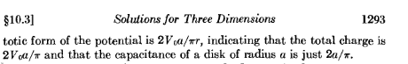

The capacitance of a spheroid of metal will be this times a constant, see below.

Related Problem: Suppose we have a charged metal spheroid with parameter ξ1. It is at some constant potential V0. What is the surface charge density on this thing?

By the same argument we used for the disk, the solution to this problem is this:

V = V0 Q0(iξ)/Q0(iξ1) = [Q0(0)/ Q0(iξ1)] { V0 Q0(iξ)/Q0(0) }

= [Q0(0)/ Q0(iξ1)] times { the solution to the disk problem }

so the solution to the charged metal spheroid problem is just a multiple of the solution to the disk problem. Therefore, we know the E field everywhere outside the spheroid will be this:

E(ξ,η) = [Q0(0)/ Q0(iξ1)] (2/π) V0 / [a $\sqrt{ξ2+ η2}$]

Then on the spheroid we have

E(ξ1,η) = [Q0(0)/ Q0(iξ1)] (2/π) V0 / [a $\sqrt{ξ12+ η2}$]

so this shows how the electric field and the charge density vary on the metal spheroid! I think Kelvin had some nicer ways to write this which I will ponder next. Just as a reminder, we can write
[Q0(iξ)/ Q0(0)] V0 like this:

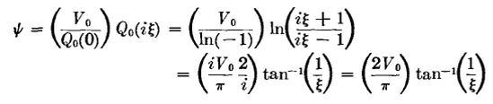

so therefore our M&F solution for the charged spheroid of parameter ξ1 is this (from a few lines above)

V = V0 Q0(iξ)/Q0(iξ1) = [Q0(0)/ Q0(iξ1)] { V0 Q0(iξ)/Q0(0) }

= (π/2)[ tan-1(1/ξ1)]-1 * V0(2/π) tan-1(1/ξ) = V0 [ tan-1(1/ξ) / tan-1(1/ξ1) ]

and again, the disk we get ξ1= 0 and tan-1(1/ξ1) = π/2 and we recover our disk answer. Recall from above that A = a $\sqrt{ξ2+1}$ B = aξ (and C = a ) for the two semi axes. Draw a little triangle to see that

tan-1(1/ξ) = sin-1(a/A) so answer is V0 [ sin-1(a/A) / sin-1(a/A1) ]

where a = focal distance and A = semi major axis used to label ellipse.

Question: Kelvin I think is claiming to know how charge distributes itself on a charged metal ellipsoid and the answer is something like this:

σ = constant * 1/ $\sqrt{x2/a4 + y2/b4 + z2/c4}$

Yes, in fact here is his claim

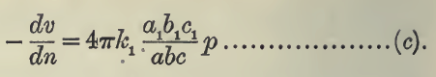

with

p = 1/$\sqrt{x2/a4 + y2/b4 + z2/c4}$

where the radical is a certain distance p he likes to talk about. How does he reach that conclusion?
See PDF-page 27 in the PDF, I think he is explaining it there in some context. I was able to confirm this is correct for a spheroid, but I had to do a lot of work with separating coordinates and finding the potential and only then did I get this answer. Separating full ellipsoidal coordinates is a real mess with Lame functions and all that, I cannot believe that is necessary.
Since Kelvin and M&F disagree on the spheroidal potential, I am suspicious of the simple result Kelvin has above for the surface charge distribution. But it certainly looks nice and has all the right limits.
[ This disagreement has since been resolved. ]

