Sturm Liouville Laplace atoms in various coord systems PhL 7.15.10

This is a pretty solid document and gathers data rarely seen like this in one place!

Comment on the need for two oscillatory dimensions. 1
0. Functions on the complex plane: the effect of changing k to ik etc. 2
1. Cartesian Atoms 3
2. Cylindrical Atoms 4
3. Spherical Atoms 5
4. Toroidal Atoms 7
5. Oblate Spheroidal Atoms 7
6. Prolate Spheroidal Atoms 8

Note: I speak below of a coordinate or dimension being "radial" or "exponential" (expo) synonymously to mean the atomic factor for that coordinate is non-oscillatory. The "radial" description arises from the classic atomic form in spherical coordinates where r is the "radial" coordinate, being the radius. The expo term comes from the sin(kx) type atom that really does become exponential if you go to imaginary k.

Let's start with this "comment" from the end of "Atoms and Problems for Cartesian Coordinates.doc"

Comment on the need for two oscillatory dimensions.

When you choose two parts of the atomic form to be oscillatory, then essentially you expand your potential in two complete sets of functions in those two variables, a sort of double generalized Fourier expansion. You know that your expansion will be well-posed, so to speak, meaning it will be an expansion that means something as the two sums go off to infinity. In each expansion term, if you select as your "radial/expo factor" the appropriate "third atom", then not only do you have a well-posed double-convergent power series, but each term in that series satisfies the Laplace equation! Perhaps you can think of that third atomic factor as the solution of the residual 1D Green's problem in "the radial direction".
In any event, if you try to set yourself up with only one oscillatory function, the pillbox method will fail because it needs two oscillatory coordinates perp to a radial direction in order to work. But I think there is a more fundamental problem in this kind of setup. You have only a single expansion in one of the three variables, and that leaves you with some Green's function problem in 2 dimensions that you don't know how to solve, because neither of those dimensions is oscillatory (and may in fact have no solution). If you go ahead and try to write a double expansion in function sets only one of which is a complete set, probably it is not a well-posed expansion and just not meaningful in the sense of infinite sums. Remember how the coefficients keep moving if you don't have a complete basis set! That basic idea comes back again and again.
In the above successful Cylindricals solution (see doc) of the Green's function for parallel plates, we are oscillatory in φ and in z, and radial only in the ρ direction. We know that, in general, other problems will be radial in z, and oscillatory in ρ. But no one ever talks about being radial in two of these three!

My goal for this doc is to write down and perhaps comment on the various ways of selecting that one radial dimension in all the coordinate systems I know about so far. In all cases, I will use real functions as the two solutions in each dimension, though Jackson would use eikx functions. For me, since the potential is always real, I like to show that explicitly.

0. Functions on the complex plane: the effect of changing k to ik etc.

The function f(z) = sin(kz) is a prototype example to look at here. If we run along parallel to the real axis, the function is oscillatory:

f(k(x+ia)) = sin(k(x+ia)) = sin(kx)cos(ika) + cos(kx) sin(ika).

but if we run vertically parallel to the imaginary axis, the function is expo:

f(k(b+iy)) = sin(k(b+iy)) = sin(kb)cos(iky) + cos(kb) sin(iky) = sin(kb)cosh(ky) + i cos(kb) sinh(ky)

This directional behavior is simply a result of the ODE which in this case says f '' + k2f = 0 If we do x → ix, it is the same as if we do k → ik : the relative sign between the curvature and the function changes, and this is what makes a function be oscillatory or expo.

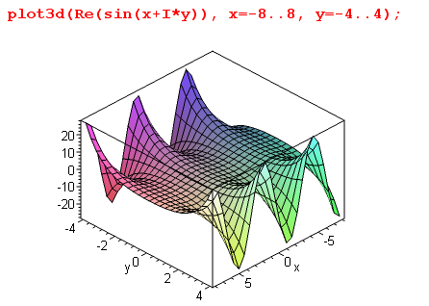

For other second order differential equations, there is a similar effect. The Legendre ODE is this:

(1-x2)f "(x) - 2xf '(x) + { n(n+1) - m2/(1-x2) } f(x) = 0 Pnm(z) Qnm(z)

This is a prototype of a "more complicated ODE". Here we can see taking x → ix is likely to cause the same effect we saw with the sine, but the effect is likely to depend on the range of x due to coefficient functions and since there is now "another term" in the ODE besides function and curvature. For example, for these two terms with m=0, things change sign if you move in or out of the range (-1,1). So things are harder to understand, but we get the same general idea. Here is a sample plot:

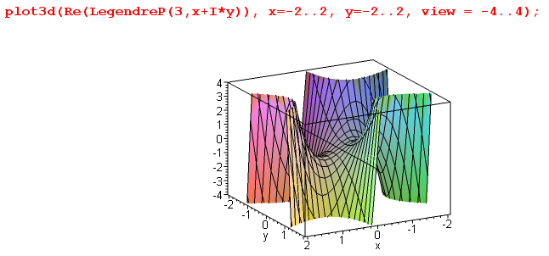

which shows sin(x) behavior in (-1,1), but expo in most other senses.
To summarize, in the solution of a more general ODE like the Legendre one, changing a parameter or the argument from real to imaginary is likely to convert oscillatory to expo behavior in the argument, and vice versa. This is in analogy to taking k→ik or x→ix in the sine case discussed above.
Aside: I recall reading somewhere that the only functions that are periodic (oscillatory) in both x and y directions are the Jacobi functions like sn(x).
When one does separation of coordinates in different coordinate systems, one often ends up with some form of the Legendre equation with certain expressions for n and m, such as n = -1/2+ N in toroidals. You have to do the details in each system to see how things come out.

1. Cartesian Atoms

x in (-∞,∞) y in (-∞,∞) z in (-∞,∞)

This is reviewed in the above referenced doc "Atoms and Problems for Cartesian Coordinates.doc".

osc osc expo
(1) [sin(kxx), cos(kxx)], [sin(kyy), cos(kyy)], [exp(κzz), exp(-κzz) ] kz = imaginary = iκz
κz = $\sqrt{kx2 + ky2}$
Apart from permuting the x,y,z labels, this is the only set of atoms you can have!

For "interior" Green's function problems, the parameters kx and ky get quantized, such as kx = nx(π/ax), and then you have your two discrete quantum numbers and the Smythian form would have a double sum. But for infinite ranges, as encountered in "exterior problems", one or both the k objects might become continuous, but you would still refer to kx and ky as your separation constants. In this case, the Smythian form would have either two k integrals, or one k integral and one k sum. Examples in the doc just mentioned.
As noted in the opening comment, for a Green's function problem we place a pillbox perp to the radial/expo direction at some location in the radial coordinate q1, obtaining δ's in the other two dimensions for transverse location of the point charge:

∂q1Vi - ∂q1Vo = 4πq (h1/h2h3) δ(q2-q2') δ(q3-q3')

Once we assume a Smythian form for the potential on the inside and outside of this radial position, we can compute the LHS as an expansion, then we can install completeness expansions of the δ's (or use orthogonality) if we are oscillatory in the q2 and q3 coordinates, and this lets us determine the coefficients in the expansions which matched on the i/o boundary.
So, in each of our cases we shall be interested in the relevant "transforms" for the two oscillatory SL problems. In the Cartesian case, these are standard Fourier Series or Fourier Integral transforms, possibly specialized to sine or cosine only, see transforms.doc for full details.

2. Cylindrical Atoms

ρ in (0,∞) z in (-∞,∞) φ in (0,2π)

This is the first of a set of systems all of which will have an azimuthal coordinate φ, and I will always take this to be one of the oscillatory dimensions, just because most simple problems use φ this way. It could be made a radial coordinate, but I think that is less common (a "slotted cylinder" eg).

Cylindricals is really the prototype system (for me at least) which shows the two forms. So we have:

expo osc osc
(1) [ e+kz, e–kz ] [ Jm(kρ), Nm(kρ)] [ sin(mφ),cos(mφ)]

osc expo osc
(2) [ sin(κz), cos(κz) ] [ Im(κρ), Km(κρ)] [ sin(mφ),cos(mφ)]

So here J,N are oscillatory and I,K are radial/expo in nature. If you start with (1) and set k = iκ, you get (2). This is a general idea, that if you take one of your separation constants (k of m,k in this case) and make it be imaginary, you still solve the 3D Laplace equation, but you swap radial/oscillatory between two of your dimensions. This works most transparently in Cartesians. For other systems, you have to write out the separated ODE's (in MF style), and then you see the effect of changing a separation constant from real to imaginary in the sense k = iκ. With k, the solution of the ODE's are some elementary or special functions with various parameter/variable labels, and wherever k appears you will have to replace it with k = iκ (perhaps k = iκ + constant). Often this is done with an accompanying shuffle of the two ODE solutions and perhaps the addition of some constant multipliers to make things be real. In the present case, we have this from blue Jackson
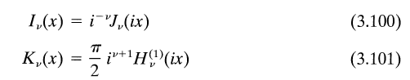
Because "radial/expo" Bessel functions are so common, they are given the special names I and K. This is not done for the other coordinate systems we shall see below, where you might have Qnm(iξ) or Pip+c(z).
The m quantum number leads to the usual sum in a Smythian form. Often problems are symmetric in φ and we have Σm=0∞ cos(mφ)... appearing in the form.
As with Cartesians, if you are doing an "interior problem" such as end-Dirichlet inside a metal cylinder (green Jackson p 76), you will have quantization of k, this time from the zeros of the Jm(kρ) functions at ρ = a, the cylinder radius, so the form will have Σk where the k are these zeros. For the related exterior Dirichlet problem, we usually get a difference form where two terms cancel at the cylinder, as we shall see in the next paragraph.
For an infinite cylinder, I found (on the web) the interior and exterior Green's functions as follows. First for an inside point charge,
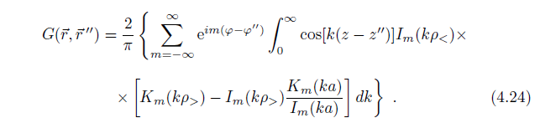

and here for an outside point charge
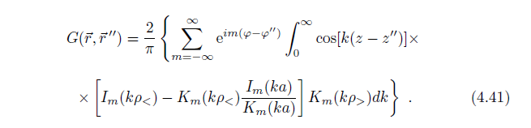
These results are from a paper I just saved "cylinders...pdf" and were done using the usual Green' reduction to 1D method. Neither of these solutions uses the zeros of the Jm functions. Rather, we see a Smythian form where the difference exactly vanishes on the cylinder. The results seem to be related by a simple swap of I with K. Notice that both these solutions use the atomic form (2) above. And notice that these forms don't show expo decay in z, but somehow we must get that decay despite the cos functions, when the terms are added due to the increasing term interference as z-z" grows.
Often (maybe always) you can solve a problem using either atomic form, such as the 1/R expansions I wrote down in a nearby doc. The first I derived and verified in MF, the second is from blue Jackson p 126

1/R = Σm=0∞εm cos[m(φ-φ')] ∫dk exp(-k|z-z'|) Jm(kρ) Jm(kρ')

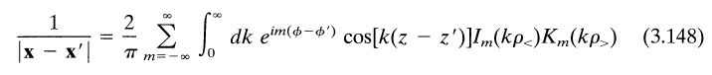

We can now ask about transforms. In either case (1) or (2), we will always use a standard Fourier Series transform for the φ dimension, possibly specialized to sine or cosine. In case (1), the oscillatory ρ function is the Jm(kρ) and for the discrete k spectrum, we use the "Bessel Series Transform", while for a continuous k spectrum, we use the continuous Bessel transform which is known as the Hankel transform. Again, both these are presented in transforms.doc. In case (2), we are oscillatory in z with the usual sine cosine transforms, either series or integral, just as in the Cartesian case.

3. Spherical Atoms

r in (0,∞) z in (-1,1) φ in (0,2π)

expo osc osc
(1) [ rn, r-n-1] [ Pnm(z), Qnm(z)] [ sin(mφ),cos(mφ)] z = cosθ

osc expo osc
(2) (1/$\sqrt{r}$)[ riτ, r-iτ] [ Piτ-1/2m(z), Qiτ-1/2m(z)] [ sin(mφ),cos(mφ)] n = iτ-1/2
osc expo osc
~ (1/$\sqrt{r}$)[sin(τ lnr), cos(τ lnr)] [ Piτ-1/2m(z), Qiτ-1/2m(z)] [ sin(mφ),cos(mφ)]

The first form is the one everyone is familiar with, and the two oscillatory coordinates are θ and φ, and together they make the spherical harmonics choosing P, and we have the usual transform associated with these harmonics. By the way, the double-complete set of the two oscillatory coordinates are always called "harmonics". The dimension r here is the "prototype" radial/expo dimension, and here the atomic factor is seen to be a power rather than an expo, the point is that it is non-oscillatory. To be more specific, the complete set of functions for φ are the usual sine cosine ones with the usual m spectrum, while for θ we have the Pnm(cosθ) as the complete set (for each m) in the θ dimension. I think this would be called the Legendre Series transform. Together these two would define the Spherical Harmonic Transform.

The second form(2) shown above is much less familiar and requires some comment. First of all, in this form, r and φ are the oscillatory dimensions and θ is the radial/expo dimension! Note that there is no z Mehler-Fock transform for this situation because z is in the wrong range, and is non-oscillatory (There will be later when we do toroidals when z will be in the right range). Second of all, setting n = -1/2+iτ has produced an extra factor of 1/$\sqrt{r}$ out front ( see Canon. page 241 for verification). Third of all, some might regard the P and Q functions shown as some sort of continued "toroidal functions" (see below), but there is nothing at all "toroidal" about our spherical atomic form adjusted for cone problems. The connection with cones, and hence the name "conical functions" for these P's and Q's, is explained in my "canonical structures Ch 6 notes.doc" in the electrostatics folder. These provide a method of finding the Green's function for a cone that is different from the Smythe "special spectrum of n" method. They are also called Mehler Functions. The Canon. doc makes the claim that one is forced to ν = -1/2+iτ for problems with conical boundaries, otherwise energy integrals diverge. But here we give a little arm-waving explanation of why we end up with this choice for n.
The index ν on Pνm(z) is "not quite right" when ν is a complex variable. Historically, it appears this way, but I think a better label would have been perhaps pVm(z) = Pνm(z) = PV-1/2m(z), where V = ν+1/2. Then instead of the symmetry being Pν = P-ν-1, it would be pVm(z) = p-Vm(z) so p would have the simple property of being symmetric in complex variable V. We would have ν(ν+1) = V2-(1/2)2. Obviously this does not fit at all with the spherical harmonic angular momentum story with integer values, but as I say, it makes more sense for non-integer values. For example, if there were no quantization of ν, we would have pVm(z) where V ranges (0,∞) ( the other half of the real axis would be redundant; in fact, the entire left half V plane Re(V) < 0 would be redundant!). Then in line with our earlier p → ip, we would take V →iV and then V ranges (0,i∞) which is up the imaginary axis in the V plane for pVm(z). It just seems more logical to run up the boundary of our half plane region rather than up some other vertical path in the middle of the active region. So when we set V = iτ, we end up with the famous ν = -1/2 + iτ . Concordant with this discussion, notice that the rν and r-ν-1 radial factors become rV-1/2 and r-V-1/2 and when we take out the 1/$\sqrt{r}$ , we have just r+V and r-V which reminds us of things in the 2D world, and of course this is then just r+iτ and r-iτ .
My own little comment here: In Smythe, we found the cone Green's function as a sum over the zeros of the functions Pn(cosθ0), and we constructed functions Pn(cosθ) which formed a complete oscillatory set in the range (0,θ0). This gave a set of non-integer points {n} that we sum over in Σn. In the Canon. method, θ is instead a radial/expo dimension as seen in form (2) above. I conjecture the following: you could rewrite this sum as a contour integral picking up residues at these zeros, then you could deform that contour to the vertical line ν = -1/2 + iτ, as is done in the Mellin-Barnes Transform. This would then be another "explanation" of why we have ν = -1/2 + iτ. If we go up vertically at some other point, we will miss some of the zeros and this miss some of the terms in the Smythe solution sum.
In form (2), the transform associated with the oscillatory r dimension is called the Mellin Transform. This is discussed in Stak Vol I page 309, and is applied to a radial problem (a 2D wedge) in exercise 6.43 in Vol II page 169. This transform is a sort of rotated version of the Laplace transform.
Perhaps you could say this: in order to get the Mellin transform as your oscillatory system in r, you are forced to take ν = -1/2 + iτ.
Well Appendix B below finally resolves this whole issue. I can summarize right here. If you are looking for a S-L oscillatory situation in coordinate r, the R(r) radial equation must be self-adjoint. But this is only true if n(n+1) is real. But this is true only in two cases: one case is that n is real, but then we can see that the solutions rn and r-n-1 are not oscillatory, so we reject that case. The other case is n = -1/2+ip, and in that case we get (1/$\sqrt{r}$) r±ip and these solutions ARE oscillatory and are therefore the correct solutions for the S-L problem in r, on interval (0,∞) more or less. Note the special n = -1/2+ip nature: you get n(n+1) = (-1/2+ip) (+1/2+ip) = -1/4 - p2 = real. For n = a+ip for some other value of a, you find that n(n+1) is complex, so the ODE is not self-adjoint, and SL falls apart.

4. Toroidal Atoms

μ in (0,∞) η in (0,2π) φ in (0,2π)

expo osc osc
(1) $\sqrt{chμ - cosη}$ [Pn-1/2m(chμ), Qn-1/2m(chμ) ] [ sin(nη),cos(nη)] [ sin(mφ),cos(mφ)]

osc expo osc
(2) $\sqrt{chμ - cosη}$ [Piτ-1/2m(chμ), Qiτ-1/2m(chμ) ] [exp(τη), exp(-τη) ] [ sin(mφ),cos(mφ)]

where n = iτ in the second case. Unlike most previous cases, a Laplace solution in toroidals must always have the overall factor shown on the left. In case (1), the Pn-1/2m(chμ) functions are expo on μ in (0,∞), while in case (2) Piτ-1/2m(chμ) are oscillatory and η is the expo dimension.
The expo functions Pn-1/2m(chμ) are known as "toroidal" or "ring" functions. In form (1), these functions are the radial/expo ones, while the other two are obviously oscillatory. In form (2), it is the P and Q functions which are now oscillatory because their argument is > 1. These oscillatory functions
Piτ-1/2m(chμ) are known as "conical" or "cone" functions, but continued out of the range (-1,1) where they were used to solve "cone problems". Now that we have the proper range, we can "activate" our Mehler-Fock Transform,

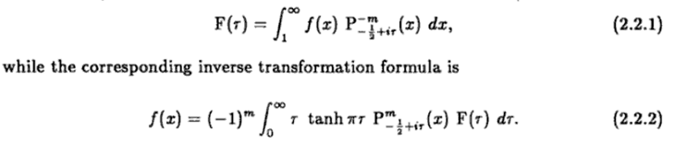
There is apparently only one table of such transforms in the world, and I have ordered a copy from the SLC library loan system. [ It arrived, and I now have a copy.]

5. Oblate Spheroidal Atoms

0 ≤ ξ ≤ ∞ // label of red spheroid below
-1 ≤ η ≤ 1 // η = cosν where ν is the blue cone angle shown below

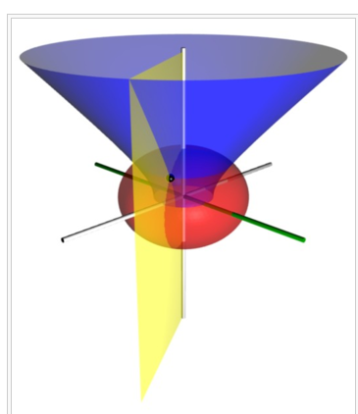

osc expo osc
(1) [ Pnm(η), Qnm(η) ] [Pnm(iξ), Qnm(iξ) ] [ sin(mφ),cos(mφ)]

expo osc osc
(2) [ Piτ-1/2m(η), Q iτ-1/2m(η) ] [P iτ-1/2m(iξ), Q iτ-1/2m(iξ) ] [ sin(mφ),cos(mφ)]

In form (1), the Pnm(η) are oscillatory and the Pnm(iξ) are expo. In the second form, the η functions with range (-1,1) are those same radial/expo functions we saw in our spherical form (2). The ξ functions must now be oscillatory, and these have not appeared anywhere else. The reason for setting n = iτ-1/2 is no doubt the same as the reason we did this in our spherical case, see notes above. Probably you just continue the Mehler-Fock Transform and it works for the form (2) osc functions shown above, but I have never worked in this area.

6. Prolate Spheroidal Atoms

I have never studied this system, but hope I can find the atoms somewhere. MF vol II says these are the atoms:
ξ in (1,∞) η in (-1,1)

osc expo osc
(1) [ Pnm(η), Qnm(η) ] [Pnm(ξ), Qnm(ξ) ] [ sin(mφ),cos(mφ)]

expo osc expo
(2) [ P iτ-1/2m(η), Q iτ-1/2m(η) ] [P iτ-1/2m(ξ), Q iτ-1/2m(ξ) ] [ sin(mφ),cos(mφ)]

I have a paper which claims that Kτm(μ) = Pm-1/2+iτ(μ) "arise in the solution of the Laplace equation in prolates". And this claim is in both coordinates! But this is exactly my form (2) above, so this little mystery is resolved.
Something interesting is that both the oblate Pnm(iξ) functions for ξ in (0,∞), and the prolate Pnm(ξ) functions for ξ > 1 are of the radial/expo type.
For form (2) we have our usual Mehler-Fock transform available.

Appendix A: Compare Two Smythian Forms for Sphericals

When doing "cone problems", such as the Green's function for a cone of angle z0 = cosα, Smythe dealt with the S-L problem in z on the interval (z0,1) instead of the usual (-1,1) and he came up with a simple spectrum for the labels n, namely, the positive zeros of Pn(zo), which we might call n = ni with i = 1,2,3.. as an enumeration index. Smythe showed this orthogonality condition directly from the ODE:

$^{\int_{z0}^{1}{}}$dz sinθ Pnm(z) Pn'm(z) = Knm(α) δn,n'

Knm(α) = - sin2α /(2n +1) * ∂zPnm(z0) ∂nPnm(z0)

Probably the corresponding completeness would be this:

Σn=ni Pnm(z') Pnm(z)/ Knm(α) = δ(z'-z) (**)

where the sum is over the positive set ni. We shall use only the orthogonality below.
Meanwhile, back at the ranch, we have the "conical function" situation described above, where we seem to have this S-L implication

$^{\int_{z0}^{1}{}}$dz P-1/2+ipm (z) P-1/2+ip'm (z) = km(p) δ(p-p') // orthogonality

$^{\int_{0}^{∞}{}}$dp P-1/2+ipm(z) P-1/2+ipm(z') km(p) = δ(z'-z) // completeness (*)

where p is now the spectral label, and n = -1/2+ip in some sense. This really makes no sense at all because when z and z' are in (-1,1) or more restricted as here (z0,1), the P functions are not oscillatory so you cannot possibly have a notion of orthog and completeness. But let's ignore that for a while and just play along and see what happens.
I am wondering if the discrete and continuous spectrum expansions/projections or orthog/completenesses can be connected by doing a contour integration as suggested in the spherical atom section above. Suppose, to this end, we were to start off with (*) above and write it this way

$^{\int_{-1/2}^{-1/2+i∞}{}}$dn Pnm(z) Pnm(z') hm(n) = δ(z'-z)

Next, let's assume without proof right now that the integrand has the right symmetry so we can write

LHS = (1/2) $^{\int_{-1/2-i∞}^{-1/2+i∞}{}}$dn Pnm(z) Pnm(z') hm(n)

Next, let's assume that the unknown function hm(n) has this form:

hm(n) = fm(n)/Pnm(z0)

so that h then has poles in the n plane located at the zeros of Pn(z0) in n. We know more or less that these are simple linear zeros so we should be able to say

Pnm(z0) ≈ Pnim(z0) + (n-ni) ∂n Pnim(z0) + .... ≈ (n-ni) ∂nPnim(z0)

OK, next let's assume -- again without proof -- that we can close our Mellin-Barnes type contour to the right so that we pick up all these poles. That is to say, we shall pick up all poles of Pn(z0) with Re(n) > -1/2. The contour sense is wrong, so we pick up a minus sign and we then have these residues:

LHS (*) = - (1/2) (1/2πi) Σi Pnim(z) Pnim(z') fm(ni) / ∂nPnim(z0)

= (i/4π) Σn=ni Pnm(z) Pnm(z') fm(n) / ∂nPnm(z0)

= Σn=ni Pnm(z) Pnm(z') {(i/4π)fm(n) / ∂nPnm(z0) }

Next, again without any rigor whatsoever, let's try to identify this with LHS (**) above which said

Σn=ni Pnm(z') Pnm(z)/ Knm(α) = δ(z'-z) (**)

So make this work, we would then have to have

{(i/4π)fm(n) / ∂nPnm(z0) } = 1/ Knm(α)

where Knm(α) = - sin2α /(2n +1) * ∂zPnm(z0) ∂nPnm(z0) as shown above.

Write the first line as

(i/4π) fm(n) Knm(α) = ∂nPnm(z0)
or
(i/4π) fm(n) [- sin2α /(2n +1) * ∂zPnm(z0) ∂nPnm(z0)] = ∂nPnm(z0)

We are now at least slightly encouraged seeing that ∂nPnm(z0) factor on both sides, so then

(i/4π) fm(n) [- sin2α /(2n +1) ∂zPnm(z0) ] = 1

(i/4π) fm(n) [- (1-z0)2 /(2n +1) ∂zPnm(z0) ] = 1

fm(n) = (4πi) (2n+1) [(1-z02) ∂zPnm(z0)]-1

Then we would have

hm(n) = fm(n)/Pnm(z0) = (4πi) (2n+1) [(1-z0)2∂zPnm(z0) Pnm(z0)]-1

= km(p) where n = -1/2+ip => 2n+1 = -1+1 + 2ip = 2ip

=> km(p) = (4πi)(2ip) [(1-z02)∂zP-1/2+ipm(z0) P-1/2+ipm(z0)]-1

= – 8πp [(1-z02)∂zP-1/2+ipm(z0) P-1/2+ipm(z0)]-1

So here is our sort of nonsense result of this fiddling:

$^{\int_{z0}^{1}{}}$dz P-1/2+ipm (z) P-1/2+ip'm (z) = km(p) δ(p-p') // orthogonality

$^{\int_{0}^{∞}{}}$dp P-1/2+ipm(z) P-1/2+ipm(z') km(p) = δ(z'-z) // completeness (*)

km(p) = – 8πp [(1-z02)∂zP-1/2+ipm(z0) P-1/2+ipm(z0)]-1

Now, having done this, we consider this idea: maybe when z and z' are > 1, this all makes sense? We might then think of z0 > 1 and change the integration limits on the first equation to get

$^{\int_{z0}^{∞}{}}$dz P-1/2+ipm (z) P-1/2+ip'm (z) = km(p) δ(p-p') // orthogonality

$^{\int_{0}^{∞}{}}$dp P-1/2+ipm(z) P-1/2+ipm(z') km(p) = δ(z'-z) // completeness (*)

km(p) = – 8πp [(1-z02)∂zP-1/2+ipm(z0) P-1/2+ipm(z0)]-1

If we further specialize to the case z0 = 1, the bracket has singular factors and we would have to take some kind of limit. Let's just leave it at that until I someday see orthog and completeness stated for the toroidal SL coordinates where this situation arises. Maybe eventually I can make some sense of this sort of "continuation" I have done here. That is to say, I have somehow started with the oscillatory SL world on interval (z0,1) in the z spherical coordinate, and I have continued it to the oscillatory SL world on interval (z0,∞) in the z toroidal coordinate.

Appendix B. Consider the separated Laplace equation for the second spherical atomic case.

From M&F p II.1264 we have these separated equations as our starting position

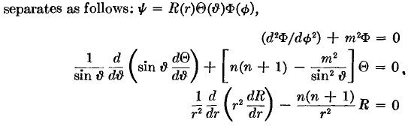

The question then is this: what do we do with this R equation to get something that is oscillatory? We know right off the bat that the two solutions are rn and r-n-1. If n is real, these solutions are not oscillatory. So suppose we let n = a + ib so then we have ra+ib and r-a-ib-1 as our two solutions. We could then write these two solutions as ra rib and r-a-1 r-ib . These would both be oscillatory solutions for any choice of a.
Well, we need more information I think. We have an SL problem in variable r, and our interval is presumably r in (0,∞). Is the R equation self-adjoint so we have proper complete eigenfunctions etc? Stak's general self-adjoint form is L = -D(pD) + q as on page 268, where p must be positive in the entire interval (implying p must be real). The other Stak requirement is that q must be real! If we could cancel 1/r2 our equation above is

-∂r(r2∂rR)+ n(n+1)R = 0 => p = r2 q = n(n+1)

So this thing would be self-adjoint for any value of n I think. We do need n(n+1) to be real, however. Consider:

n(n+1) = α = some real number

n2 + n - α = 0

n = -1/2 ± $\sqrt{1/4+α}$ // solution to quadratic equation

If α > -1/4, then n is a real number. With a suitable real α > -1/4, we can arrange to have n be any real number we want. The other possibility is α < -1/4, and in this case we get n = -1/2 ±i $\sqrt{-1/4-α}$. So THIS is the case n = -1/2 ± ip that I have been seeking.
So the requirement that the function q = n(n+1) be real (in our SL ODE), forces us into two possibilities. One is that n is real, and the other is that n = -1/2±ip where p is real. We can then look at the solutions in each of these two cases:

Case 1: n is real: rn, r-n-1 both non-oscillatory

Case 2: n = -1/2+ip r-1/2+ip, r-1/2-ip both oscillatory
( -n-1 = -1/2-ip ) (1/$\sqrt{r}$) r±ip

The official Mellin Transform involves a different ODE which is in fact the radial Laplace equation in 2D space as Stak shows page 308, so perhaps we should just call our solutions here "Mellin like" because we do have the extra 1/$\sqrt{r}$ factor.

