How does the determinant of a tensor transform? PhL 4.10.15

Part 1.

Just look at the N = 2 case. We have

det(M) = εabM1aM2b

det(M') ≡ ε'abM'1aM'2b

= εab (R1a' Rab' Ma'b')(R2a" Rbb" Ma"b") ε'ab = εab Weinberg

= (εab Rab'Rbb") (R1a'R2a"Ma'b'Ma"b")

Define K as follows,

εabRab'Rbb" = K εb'b"

because the thing is AS and my theorem says it has that form. Then

εabRa1Rb2 = K ε12 = K

K = εabRa1Rb2 = det(Rij) = det(Sji) = det(S) = J

So we end up with

det(M') = J εb'b" (R1a'R2a"Ma'b'Ma"b")

= J R1a'R2a" (εb'b"Ma'b'Ma"b")

Now study this last object. It is AS on a' and a", so write

(εb'b"Ma'b'Ma"b") = Q εa'a"

Then set a'=1 and a" = 2,

(εb'b"M1b'M2b") = Q ε12= Q g ε12 = Qg // Weinberg; (D.5.10)

so that

det(M) = Q g => Q = g-1 det(M)

We then have

det(M') = J R1a'R2a" (εb'b"Ma'b'Ma"b")

= J R1a'R2a"Q εa'a"

= J g-1 det(M) R1a'R2a" εa'a"

= J g-1 det(M) det(Rij)

= J g-1 det(M) det(Sji)

= J g-1 det(M) J

= J2 g-1 det(M)

Now try

g'α det(M') = J2 g'α g-1 det(M)

= J2 g'α g-1-α gαdet(M)

= J2 g'α(1/g)1+α gαdet(M)

Would like to see 1+α = α which means 1 = 0, so cannot find α to make this work!

So I have not clean answer, and this is a question I have never resolved!
If g = 1, then we have

det(M') = J2 det(M)

and then det(M) is a scalar density of weight - 2. But I don't have a result for the general case!

Part 2.

Comments on Part 1. I think my starting point det(M) = εabM1aM2b is not really covariant, so is a poor starting point. An idea from Part 3 below is that you could write

det(M) = (1/2!) εabεa'b' Ma'a Mb'b

I have not proven this yet, but it I think I will, and I will add it somewhere to tensor doc.

Given this covariant definition of det(M), I can just read off that

det(M') = J2 det(M) scalar density of weight - 2

Then I am completely done and I can just ignore the efforts of Part 1 above.

Part 3.

Search the web. I find in an obscure PDF the following ("Project Report pdf" I saved it)



But he also gives this comment

I am now scanning through this well-written article. Here is how basis vectors transform

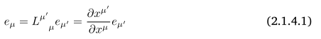

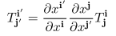

`

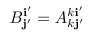

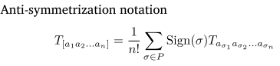 something new to me
but looks like my general App D notation.

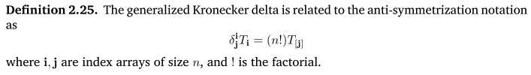

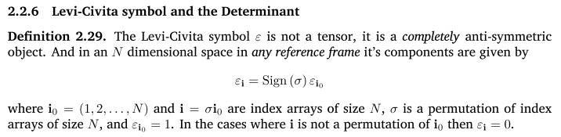

So in his notation, εi means my εabc...x with i being "an index array". σ is a permutation operator I would say, like my P. And the sign is like my (-1)p.

Next comes his definition:

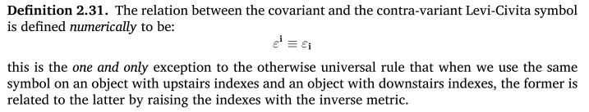

In my notation I have

εabc... = det(gij) εabc... = g εabc... // relating all down to all up
ε'abc... = det(g'ij) ε'abc... = g' ε'abc... // = g' εabc... (D.5.10)

which would say in his notation εi = g εi. He then makes a different underlying definition compared to Weinberg. I now continue in his PDF

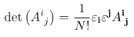

I think this would translate into

det(Aij) = (1/N!) εabc.. εa'b'c'... Aaa'Abb'......

compared to my thing

det(Aij) = εa'b'c'... A1a'A2b'......

and I can imagine these would agree. His notation is more covariant.

Assume this is true:

det(Aij) = (1/N!) εabc.. εa'b'c'... Aaa'Abb'......
Then if A were a normal tensor, I would claim that det(Aij) had weight = -2, since each of my ε tensors has weight -1 at least in my world. This agrees with my Part 1 result at least for g = 1, maybe I made a mistake?

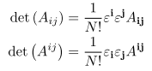

He then claims these strange results

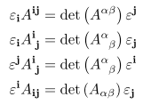 strange

He then does tensor densities like this

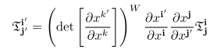

For me, J =

the Jacobian ≡ J(x') ≡ det(S(x')) = det(∂xi/∂x'k) = 1/det(R(x(x')) = 1/ det(∂x'i/∂xk) . (5.12.6)

so I would translate this something like

Ti'j' = J-W Ri'i Sjj' Tij = J-W Ri'i Rj'j Tij

and this last form agrees with my M'ab = Raa' Rbb' Ma'b' notation. So far I am still with the author.

Now comes his claim quoted above.

Let's now study his following proof. But it is based on his strange claims above.

Alternate Path to Evaluate the transformation property of det(M).

What would happen in my Appendix D if I made his basic assumption that εi = εi ?
That is to say

εabc.. = εabc...

My sections D.1 D.2 D.3 are unchanged since ε has not come up yet.

In D.4 I make this assumption

det(Rij) = R1a' R2b' ... εa'b'c'..

and I guess I now have to think about that. Here ε is the permutation tensor in Weinberg. I think I can write this as

det(Rij) = (1/N!) RAa' RBb' ... εa'b'c'.. εAB...

and then it is seen to be a scalar. That fact is concealed in the first form, but I think the first form is accurate. But, then the question is this: what is the meaning of εAB... ? For Gootvilig εi= εi, but for Weinberg we have instead εAB.. = g εAB... . So maybe I would have to have some g or g' factor out front.

Let's start again.

det(Rij) = R1a' R2b' ... εa'b'c'.. ε... = Weinberg permutation tensor

This is a "mechanical " definition of det (R) because it is what you get actually doing the det!

I think I could show that

det(Rij) = (1/N!) RAa' RBb' ... εa'b'c'.. εAB...

where now there are two permutation tensors. Let's try to prove this right here.

det(Rij) = (1/N!) RAa' RBb' ... εa'b'c'.. εAB...

= (1/N!) εAB...{ εa'b'c'.. RAa' RBb' ... }

= (1/N!) εAB...{ RA1 RB2 ... + all signed permutations of 2nd index }

= (1/N!) εAB... ΣP p P2 (RA1 RB2 ...)

Now define

QAB..X ≡ ΣP p P2(RA1 RB2 ...RXN) (D.10.1)

Argue that this is AS as in App D text, and therefore

QAB..X = K εABC..

Then we have

Q123.. = K ε123.. = K

so then

K = Q123.. = ΣP p P2(R11 R22 ...RNN)

But this is the mech def of the determinant! Thus

K = det(Rij)

and we then have

QAB..X = K εABC.. = det(Rij)εABC..

Going back we then find the thing we started with

det(Rij) = (1/N!) RAa' RBb' ... εa'b'c'.. εAB...

= (1/N!) εAB... QAB..X

= (1/N!) εAB... det(Rij)εABC..

= det(Rij) (1/N!) [ εAB... εAB...]

= det(Rij) (1/N!) [ εAB... ]2

But ΣAB [ εAB... ]2 gets a contribution of +1 each time AB... is a permutation of 12...N. There are N! such permutations, so ΣAB [ εAB... ]2 = N! This then gives

det(Rij) = det(Rij) (1/N!) N! = det(Rij)

and I have finally verified what I thought was true. So we know this is true:

det(Rij) = (1/N!) RAa' RBb' ... εa'b'c'.. εAB...

Now what comes next regarding covariance?? I would use my Weinberg result

εabc... = det(gij) εabc... = g εabc... // relating all down to all up
ε'abc... = det(g'ij) ε'abc... = g' ε'abc... // = g' εabc... (D.5.10)

so that then

εAB... = (1/g) εAB...

and then I would write

det(Rij) = (1/N!) (1/g) εa'b'c'.. εABC.. RAa' RBb' ...

Now suppose R is M, a true tensor, so all the above leads to

det(Mij) = (1/N!) (1/g) εa'b'c'.. εABC.. MAa' MBb' ...

That factor of g really is sitting there if you define det(Mij) in its mechanical sense! So write

g det(Mij) = (1/N!) εa'b'c'.. εABC.. MAa' MBb' ...

I then argue from my usual rules:

g det(Mij) transforms as a scalar density of weight - 2 // if M is a tensor

Now I also know that g' = J2g so g is a scalar density of weight - 2. This would seem then do imply that the object det(Mij) is a true scalar. This is the first time I have ever arrived at this conclusion!

What about other tilts?

Mij = giaMaj => det(Mij) = det(gij)det(Mij) = g det(Mij)
W = -2 W = -2 W=0

Mij = gjkMik => det(Mij) = det(gij)det(Mij) = (1/g) det(Mij)
W = 0 W = +2 W=-2

Mij = gikMkj => det(Mij) = det(gij)det(Mij) = (1/g) det(Mij)
W = 2 W = +2 W=0

So here is a Big Summary of all this det of tensor stuff

det(Mij) W = 0

det(Mij) = g det(Mij) W = -2

det(Mij) = (1/g) det(Mij) W = 0

det(Mij) = (1/g) det(Mij) W = 2

Now rewrite again

det(Mij) = g det(Mij)

det(Mij) = (1/g) det(Mij) = (1/g) g det(Mij) = det(Mij)

det(Mij) = (1/g) det(Mij) = (1/g) det(Mij)

Summarize yet again

det(Mij) = det(Mij) W = 0

det(Mij) = g det(Mij) W = -2

det(Mij) = (1/g) det(Mij) W = +2

Now here is a little check:

g ≡ det(gij) from Ch 5 so weight (g) = -2 agrees

1/g = det(gij) so weight = +2

Everything is finally consistent.

This is an allowed matrix mult form, so I claim that

det(Mij) = det(giaMaj) = det(gij) det(Mij) = g det(Mij).

Then the weight of det(Mij) is -2 + 0 = -2. So far then

det(Mij) = scalar density with weight W = 0

det(Mij) = scalar density with weight W = -2

Next, consider

Mij = giaMaj => det(Mij) = det(gij) det(Mij) = (1/g) det(Mij)

W = 0 W=2 W=-2
The fourth form:

Mij = gjkMik = Mik gkj => det(Mij) = det(Mij) det(gij) = det(Mij)(1/g)
W = 0 W=-2 W= 2

So here I can fill out my chart

First:

det(Mij) = g det(Mij)

det(Mij)

What happens if we make the Gootvilig convention that εabc = εabc ?

In Section D.4 I get down to this general result

ε'abc.. = Kεabc... = J-(W+1) εabc... (D.4.7)

but then I don't know what to do with ε'abc.. !!!

Here are results I end up with the Weinberg convention:

ε'abc.. = εabc... // assumption

εabc... = g εabc...

ε'abc... = g' ε'abc...

εabc.. = gaa'gbb'..... εabc..
ε'abc.. = g'aa'g'bb'..... ε'abc.. // assumption that ε is like any other tensor object

Now how would I "get to" the Loot convention?

εLabc... ≡ εabc...

εLabc... ≡ (1/g)εabc.. = (1/g) g εabc... = εabc...

Then I would have that εLabc... transforms with weight -1, but εLabc... would have weight 2 - 1 = +1
and that must be his method.

Question 1: What about G = det(g) ? Here g is a true rank-2 tensor. So by my claim above, G should be a normal scalar, but in fact it is a scalar density of weight - 2. What have I done wrong? Maybe this is the way out : G = det(gij) and not det(gij).

7. Jacobian and related

Here are translations of a few equations from Section 5.12:

(5.12.2) det(S) = 1/det(R) → det(Sij) = 1/ det(Rij) (7.5.18)

(5.12.6) J = det(S) → J = det(Sij) (7.5.19)

(5.12.12) g = det() → g = det(gij)
g' = det(') → g' = det(g'ij) (7.5.20)

(5.12.14) 1/g = det(g) → 1/g = det(gij)
1/g' = det(g') → 1/g' = det(g'ij) (7.5.21)

(5.12.14) g' = J2 g → g' = J2 g
|J| = $\sqrt{g'/g}$ → |J| = $\sqrt{g'/g}$ (7.5.22)

