Repair of Section 5_16 PhL 4.1.15

I finally have some ideas on how to explain the use of metric tensor g' in the Lai CM application.

The first idea is to use the 2D polar coordinates transformation as a flow example, and to that end I nweed a new picture, or at least a new picture arrangement. Right now in (3.5.5) I have this,

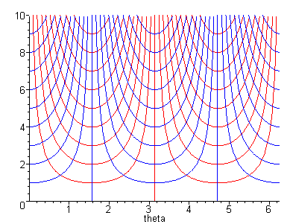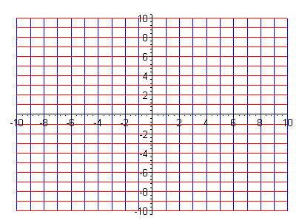
x'-space (θ,r) x-space (x,y)
(3.5.5)
I want to use this as an example of this more general concept,

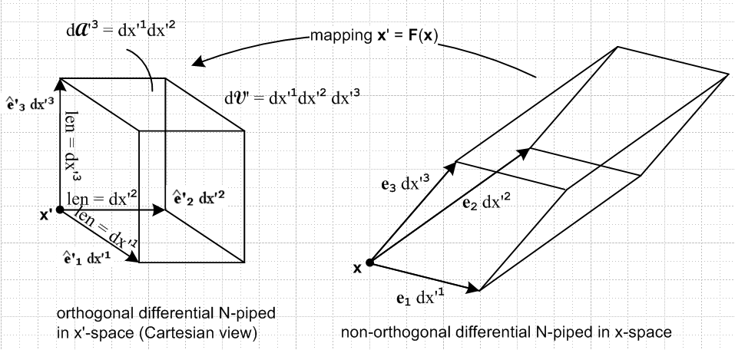

The first confusion is this: why do I have aligned squares (cubes) in x-space in the first drawing pair, but the aligned squares are in x'-space in the second? In the 3D drawing, I want the 3-piped to exist in Cartesian space because I always say that the ei exist in that space.

x = rcos(θ)
y = rsin(θ)

X = ycos(x)
Y = ysin(x)

x = Ycos(X)
y = Ysin(X)

x = tan-1(Y/X)
y = $\sqrt{X2+Y2}$

θ = tan-1(y/x)
r = $\sqrt{x2+y2}$

X = tan-1(y/x)
Y = $\sqrt{x2+y2}$

= $\left(\begin{matrix}1 & 0 \\ 0 & 1\end{matrix}\right)$

' = $\left(\begin{matrix}r2 & 0 \\ 0 & 1\end{matrix}\right)$

' = $\left(\begin{matrix}Y2 & 0 \\ 0 & 1\end{matrix}\right)$

= $\left(\begin{matrix}1 & 0 \\ 0 & 1\end{matrix}\right)$

= $\left(\begin{matrix}y2 & 0 \\ 0 & 1\end{matrix}\right)$

' = ST S

= ST S

= $\left(\begin{matrix}1 & 0 \\ 0 & 1\end{matrix}\right)$

' = $\left(\begin{matrix}1 & 0 \\ 0 & 1\end{matrix}\right)$

x' = ycos(x)
y' = ysin(x)

x = tan-1(y'/x')
y = $\sqrt{x'2+y'2}$

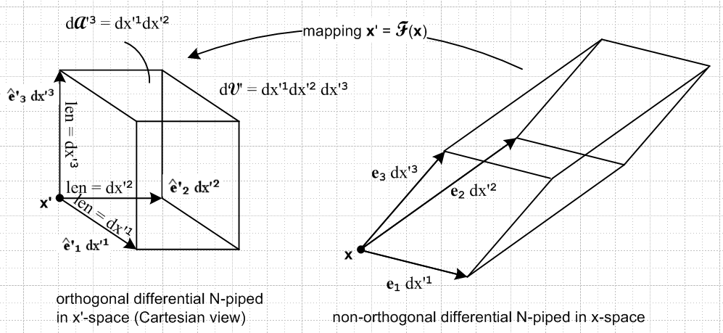

' = STS ≠ 1
' = 1

rdθ dr

