Section 5.16 Third Rewrite PhL 4.1.15

I will start here with the original tensor doc text and edit as needed.

5.16 Continuum Mechanics and its Metric Tensors

One can describe (Lai) the forward "flow" of a continuous blob of matter by x = x(X,t) where X = x(X,t0). A "particle" of matter (imagine a tiny cube) that starts at location X at time t0 ends up at x at time t. Two points in the flow separated by dX at t0 end up separated by some dx at t. The relation between these separation vectors is given by dx = F dX where F is called the deformation gradient. F describes how a particle starting say with a cubic shape at t0 gets deformed into some parallelepiped (3-piped) shape at t as shown in Fig (5.16.7) below. If we examine dx = F dX we find that | dx | ≠ | dX | since the vector dX typically gets rotated and stretched as dX → dx during the flow. [ This flow is further described in Appendix K. ] ok to here
The finite-duration flow x = x(X,t) from time t0 to time t can be thought of as a (generally non-linear) transformation of the form x = F(X,t), where we can regard t as an added parameter. Recall from Chapter 2 that a general transformation was annotated as x' = F(x) or x = F-1(x') and the linearized transformation was dx' = R dx or dx = S dx', as in (2.1.6). To be compatible with Lai notation which uses symbol F for the deformation gradient, and to make things clearer, we shall replace our Chapter 2 transformation name F by the name F-1, and we shall identify x'-space with X-space. We then have this enhanced version of Picture A,
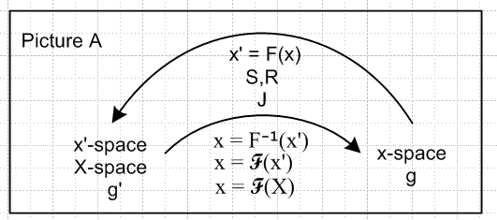 (5.16.1)

In this flow we assume Cartesian coordinates in both x-space and X-space, so the metric tensors which determine physical distance in these spaces are both 1. Before continuing, it is helpful to have an example of a fluid flow situation.

Example: A 2D Fluid Flow based on the Polar Coordinates Transformation

We first quote Fig (3.4.3) with a few enhancements ( transformation F is called F ) :

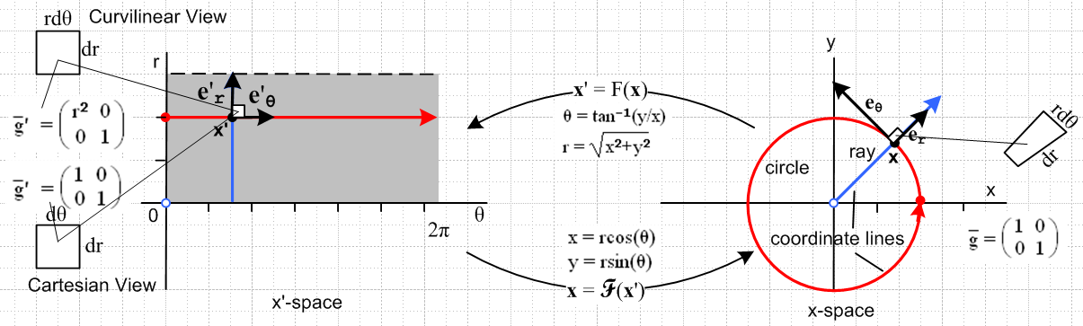
(3.4.3) (5.16.2)

The tiny white square on the left maps into a tiny white 2-piped shown on the right under this transformation. The edges of this 2-piped in x-space (on the right) are dr and rdθ, there is no confusion about that, and the area is dA = rdrdθ. The question at hand is how one should interpret the edges of the tiny white square on the left, and what is the x'-space metric tensor ' on the left? It is shown in Section C.5 that there are two distinct interpretations and each has its own use. We call the two interpretations the Cartesian View and the Curvilinear View.
The view we are familiar with is the Curvilinear View where ' = $\left(\begin{matrix}r2 & 0 \\ 0 & 1\end{matrix}\right)$. In this view, the top edge of the white square on the left has length ds' = rdθ and this matches the corresponding edge of the 2-piped on the right, which is ds = rdθ. This is the view in which hypothesis (5.2.6) is valid (that ds' = ds), so all our tensor machinery is applicable, such as the fact (5.7.9) that ' = STS. One might call this the covariant view, since distance ds is a scalar under the transformation. Here is a bit more detail.
For the upper edge of the white square on the left, we can set dx' = dθ e'θ= (dθ r) 'θ. This maps into the northeast edge of the 2-piped on the right which is then dx = (rdθ) θ. One then verifies that

(ds')2 = dx' • dx' = g'θθ dθ dθ = r2 dθ dθ = (rdθ)2 // Curvilinear View

(ds)2 = dx • dx = (rdθ) θ • (rdθ) θ = (rdθ)2 (5.16.3)

In the Cartesian View, we instead use ' = $\left(\begin{matrix}1 & 0 \\ 0 & 1\end{matrix}\right)$ on the left. In this case, the edges of the white square are dr and dθ, just as if these were regular Cartesian coordinates. As explained in Appendix C, one advantage of the Cartesian View is that, for a general coordinate system, it is the only view that can be drawn on a piece of paper (2D) allowing the reader to have some comprehension of what is going on (and this is even more true in 3D). A disadvantage of the Cartesian View is that ds ≠ ds' so it is "non-covariant". In the Cartesian View we find, for our same top edge vector,

(ds')2 = dx' • dx' = 1 dθ dθ = (dθ)2 // Cartesian View

(ds)2 = dx • dx = (rdθ) θ • (rdθ) θ = (rdθ)2 (5.16.4)

and so ds ≠ ds' which says | dx | ≠ |dx'|.

To arrive at our Example model for a fluid flow, we redraw Fig (5.16.2) renaming x' = (θ,r) to be X = (X,Y), and make corresponding changes elsewhere in the figure:

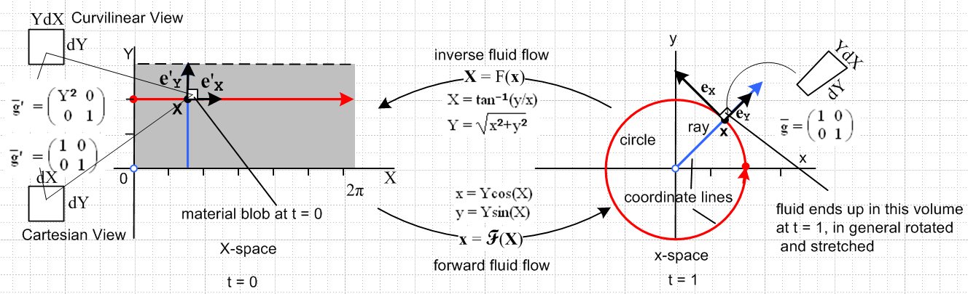
(5.16.5)

The tiny white square on the left is a blob of (2D) fluid at time t = 0 and after flowing a while it ends up in the location of the white 2-piped on the right at time t = 1. This is just a simple 2D flow example making use of a transformation we are already familiar with (see Comment below). For a general 3D forward flow transformation x = F(X,t) one finds that the differential white cubic blob at t = 0 ends up in a 3-piped at t = t which is both rotated and stretched relative to the starting cube. Due to this stretch, one finds in general that |dx| ≠ |dX| where these are vector lengths relative to the Cartesian View metric tensor, which is in fact the metric tensor that determines physical distance in both X-space and x-space. Thus, the ' = $\left(\begin{matrix}1 & 0 \\ 0 & 1\end{matrix}\right)$ metric tensor for X space has this well-defined meaning -- it relates to actual physical distance in X-space. However, it is the curvilinear view metric tensor ' = $\left(\begin{matrix}r2 & 0 \\ 0 & 1\end{matrix}\right)$ = STS whose matrix elements determine such things as how much edges stretch in the flow and how much areas and volumes change during the flow, which we shall examine below.

Comment: The Example presented above really makes no flow sense since there is no time parameter in the flow transformation! The purpose of the Example is merely to illustrate the idea of two metric tensors in X-space, and to do so with a transformation that is familiar from our "curvilinear coordinates" study, and to tie in the notions of the two Views from Appendix C. The Example could be made more reasonable using a transformation like this,

general t t = 0 t = 1
x = F(X,t): x = (1-t)X + t Y cos(X) x = X x = Ycos(X)
y = (1-t)Y + t Y sin(X) y = Y y = Ysin(X) (5.16.6)

In this case, at t = 0 we have the correct x = F(X,t=0) = X and at the end of the flow (t = 1) we have the transformation equations shown in Fig (5.16.5).

Having worked through this contrived example, we can now draw a figure showing the general mapping of a differential blob during a flow from time t = 0 to time t = t. This figure is taken from Chapter 8 where the X-space left side is called x'-space as in (15.6.1) and the initial "blob" is shown drawn in the Cartesian View: (this picture happens to use the Chapter 7 Standard Notation for coordinates, contravariant = upper index)

Flow X-space (= x'-space) t = 0 Flow x-space t = t
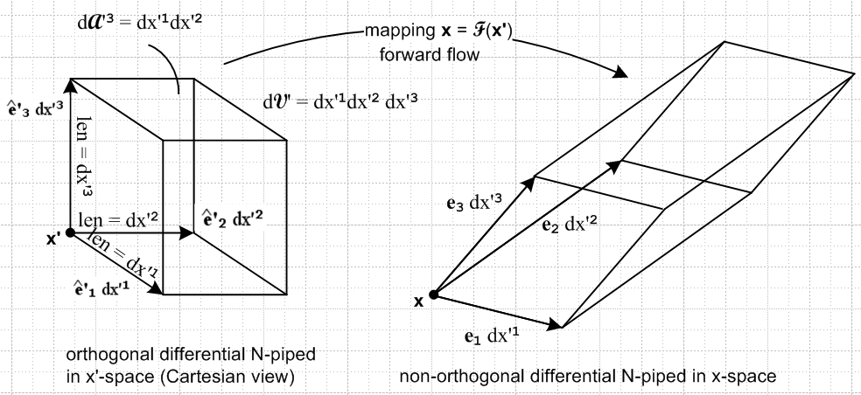
(8.2.2) (5.16.7)

We might be interested in knowing how much the dx'3 edge is stretched going from time t=0 to time t=t, and by how much the volume changes, and so on. All these geometric questions are posed and answered in Chapter 8, and we shall use some of those results below.

Here then is a translation table of sorts comparing the continuum mechanics notation of Lai to the tensor notation used earlier in our document (and in the above Example).

continuum mechanics our document ( Forward Flow X → x )
X, x ↔ x', x
x = x(X,t) = F(X,t) ↔ x = F(x',t) = F-1(x',t) // Lai p 70 (3.1.4)
dx = F dX ↔ dx = S dx' // as in (2.1.6) // Lai p 86 (3.7.6) or p105 (3.18.3)
F ↔ S
F-1 ↔ R // R = S-1
x = Cartesian ↔ = 1
X = Cartesian ↔ ' = 1 // Cartesian View
C = FTF ↔ ' = STS // Curvilinear View, as in (5.7.9) // Lai p 114 (3.23.2)
C-1 = F-1(F-1)T ↔ g' = RRT // since g' = '-1 and S-1 = R , as in (5.7.9) (5.16.8)

Thus, the deformation gradient F is just the S matrix associated with transformation F = F-1. The Curvilinear View metric tensor ' = STS appears in Lai as C = FTF which is known as the right Cauchy-Green deformation tensor (manifestly symmetric, so a viable metric tensor). [The left Cauchy-Green deformation tensor is B = FFT ].

Given the above flow situation, it is then possible to add two more transformations F1 and F2 which take X-space and x-space to independent sets of curvilinear coordinates X' and x': ( a new x' here)

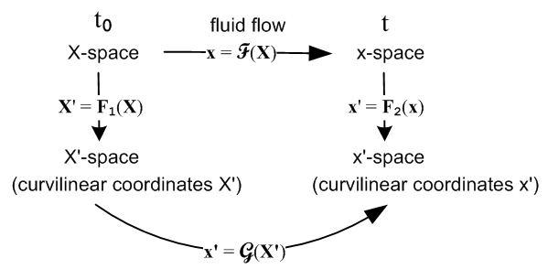 (5.16.9)

and we then have an interesting triple application of the notions of Chapter 2 to a real-world situation. This drawing is the implicit subject of Section 3.29 (p131-138) of Lai. The flow transformation of interest here is

x' = F2(x) = F2(F(X)) = F2(F(F1-1(X'))) ≡ G(X') . (5.16.10)
ok to here
In (reverse) dyadic notation the deformation gradient is written F = (∇x) where ∇ means ∇(X)so that

dx = F dX = (∇x) dX Fij = (∇x)ij = ∂j(X)xi = ∂xi/∂Xj . (5.16.11)

The (∇x) notation is explained in (E.4.4), and in Appendix G the object (∇v) for an arbitrary vector field v(x) is expressed in general curvilinear coordinates.

Consider again Fig (5.16.7) displayed above:

Flow X-space (= x'-space) t = 0 Flow x-space t = t
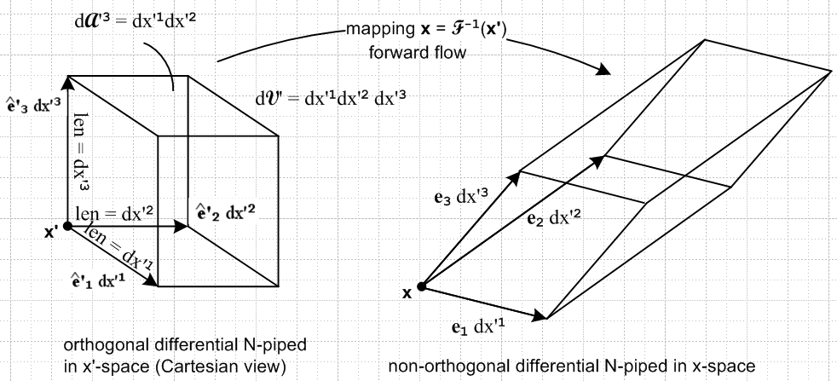
(8.2.2) (5.16.7)

We can identify the mapping shown in this picture with our Flow situation of table (5.16.8). Chapter 8 discusses in much detail how length, volume and area transform under a general transformation. The length, area and volume magnitudes on the left are called dL'n = dx'(n), dA'n and dV', while the corresponding quantities on the right are called dx(n), (n) and dV, where the first two items are vectors. Cribbing the results of Chapter 8 (8.4.g.2) and converting them from standard notation to developmental notation, we have

| dx(n)|/ dL'n = h'n = ['nn]1/2 = the scale factor for edge dx(n)

| (n)|/ dA'n = (1/h'n) |J| = (1/h'n) g'1/2 = [g'nn g']1/2 = [cof('nn)]1/2

|dV| / dV' = |J| = g'1/2 // where g' ≡ det('ij) = J2 , ' = STS (8.4.g.2) (5.16.12)

We can then translate these three lines into our Flow context:

| dx(n)| / | dX(n)| = h'n = ['nn]1/2 = [(FTF)nn]1/2 = [Cnn]1/2 // Lai p 114 (3.23.6-8)

dAn| / |dA0n| = [g'nng']1/2 = [cof('nn)]1/2 = [cof(FTF)nn)]1/2 = [cof Cnn)]1/2 // Lai p 129 (3.27.11)*

|dV| / |dV0| = |J| = g'1/2= [det('ij)]1/2 = [det(FTF)]1/2 = |det(F)| // Lai p 130 (3.28.3) (5.16.13)

where
edge area volume
X-space : dX(n) dA0n dV0 time t0
x-space : dx(n) dAn dV time t (5.16.14)

Thus, for example, the volume change of a "flowing" particle of continuous matter is given by the Jacobian |J| = |detF| associated with the deformation gradient tensor F. We put quotes on "flowing" only because this might be a particle of solid steel that is momentarily moving and deforming a very small amount during an oscillation or in response to an applied stress.

In the middle line of (5.16.13) we state that | dAn| / | dA0n| = [cof(FTF)nn)]1/2 and quote Lai p 129 (3.27.11) for verification. However, what Lai (3.27.11) actually says (slightly translated to our notation) is this:

dA(n)/dA(n)0 = det(F) | (F-1)T un | un = unit base vector, (un)i = δn,i (5.16.15)

which seems a far cry from our result [cof(FTF)nn)]1/2. But consider, using F-1 = R from table (5.16.8),

| (F-1)T un |2 = | RT un |2 = [RTun]i[RTun]i = Rni Rni = (RRT)nn = g'nn (5.16.16)
so
det(F) | (F-1)T un | = g'1/2 g'nn1/2 = [cof('nn)]1/2 = [cof(FTF)nn)]1/2 . (5.16.17)

Here we have used Theorem 1 (8.4.f.1) converted to developmental notation,

g' g'nn = [cof('nn)] . // more generally, (detA) A-1 = cof(A) if A = AT (5.16.18)

It might be noted that the Lai book does in fact use our "developmental notation" in that all indices are written "down" (when indices are shown), but no overbars mark covariant objects. Here are a few examples:

Lai notation Developmental notation Standard Notation
dA0 = dX(1)x dX(2) (3.27.1) 0 = dX(1)x dX(2) (dA0)i= εijk [dX(1)]j [dX(1)]k
[divT]i = ∂jTij (4.7.3) [divT]i = jTij [divT]i = ∂jTij (5.16.19)

Of course when Cartesian coordinates are assumed, the up and down position makes no difference.

Lai writes tensors in bold face such as F for the deformation gradient noted above, or T for the stress tensor. Perhaps this is done to emphasize the notion of a tensor as an operator as in our Appendix E (g). Lai writes a specific matrix as [T], but a matrix element is Tij. Notation is an ongoing burden and each area of physics seems to have its own accepted conventions.

