Rewrite!

5.16 Continuum Mechanics and its Metric Tensors

One can describe (see Lai) the forward "flow" of a continuous blob of matter by x = x(X,t) where X = x(X,t0). A "particle" of matter (imagine a tiny cube) that starts at location X at time t0 ends up at x at time t. Two points in the flow separated by dX at t0 end up separated by some dx at t. The relation between them is given by dx = F dX where F is called the deformation gradient. F describes how a particle starting say with a cubic shape at t0 gets deformed into some parallelepiped (3-piped) shape at t as shown in Fig (5.6.15) below. If we examine dx = F dX we find that | dx | ≠ | dX | since the vector dX typically gets rotated and stretched as dX → dx during the flow. [ This flow is further described in Appendix K. ]
The finite-time flow x = x(X,t) from time t0 to time t can be thought of as a (generally non-linear) transformation of the form x = F(X) as in our Chapter 1. Recall from Chapter 1 that a general transformation was x' = F(x) and the linearized transformation was dx' = R dx. To be compatible with Lai notation which uses symbol F for the deformation gradient, we have renamed the Chapter 1 transformation F to be F, and we shall see below that Chapter 1's R is in fact the deformation gradient F.
In this flow we assume Cartesian coordinates in both x-space and X-space, so the metric tensors which determine physical distance in these spaces are both 1.
In order to put this flow into the notation of our document, let X → x and x → x' so that

continuum mechanics our document ( Forward Flow X → x [ x → x'] )
x, X ↔ x', x
x = x(X,t) = F(X) ↔ x' = F(x) // Lai p70 (3.1.4)
dx = F dX ↔ dx' = R dx // as in (2.1.6) // Lai p86 (3.7.6), p105 (3.18.3)
F ↔ R
F-1 ↔ S
X = Cartesian ↔ g = 1
x = Cartesian ↔ g' = 1
B = FFT ↔ B = RRT // as in (5.13.2) // Lai p121 (3.25.2)
B-1 = (F-1)T (F-1) ↔ B-1 = STS (5.16.1)

Thus, the deformation gradient F is just the R matrix of the forward transformation x = x(X,t) = F(X). Matrix B = FFT is known as the left Cauchy-Green deformation tensor (manifestly symmetric).
Alternately, we can consider the above flow going backwards in time and then x = x is the starting position and x' = X is the ending position. For this inverse flow, we let F have the same meaning as in the forward flow, dx = F dX, and thus end up with this translation table where we now x → x and X → x' :

continuum mechanics our document ( Inverse Flow x → X [x → x'] )
X, x ↔ x', x
X = X(x,t) = F(x) ↔ x' = F(x) // this F is the inverse of the forward flow F
dX = F-1 dx ↔ dx' = R dx // as in (2.1.6), same F as in forward flow
F-1 ↔ R
F ↔ S // S = R-1 and Sik = (∂xi/∂x'k) ↔ Fik = (∂xi/∂Xk)
X = Cartesian ↔ g = 1
x = Cartesian ↔ g' = 1
C = FTF ↔ C = STS // as in (5.13.2) // Lai p114 (3.23.2)
C-1 = F-1(F-1)T ↔ C-1 = RRT (5.16.2)

Matrix C = FTF is known as is the right Cauchy-Green deformation tensor (again manifestly symmetric).
Given the above flow situation, it is then possible to add two more transformations F1 and F2 which take X-space and x-space to independent sets of curvilinear coordinates X' and x':

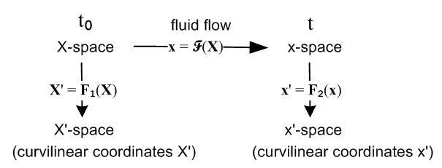 (5.16.3)

and we then have an interesting triple application of the notions of Chapter 1 to a real-world situation. This drawing is the implicit subject of Chapter 3.29 (p131) of Lai.
In (reverse) dyadic notation the deformation gradient is written F = (∇x) where ∇ means ∇(X)so that

dx = F dX = (∇x) dX Fij = (∇x)ij = ∂j(X)xi = ∂xi/∂Xj . (5.16.4)

The (∇x) notation is explained in Appendix E, and in Appendix G the object (∇v) for an arbitrary vector field v(x) is expressed in general curvilinear coordinates. ok to here

Consider now this picture taken from Chapter 8 below,

Flow X-space Flow x-space (5.16.5)
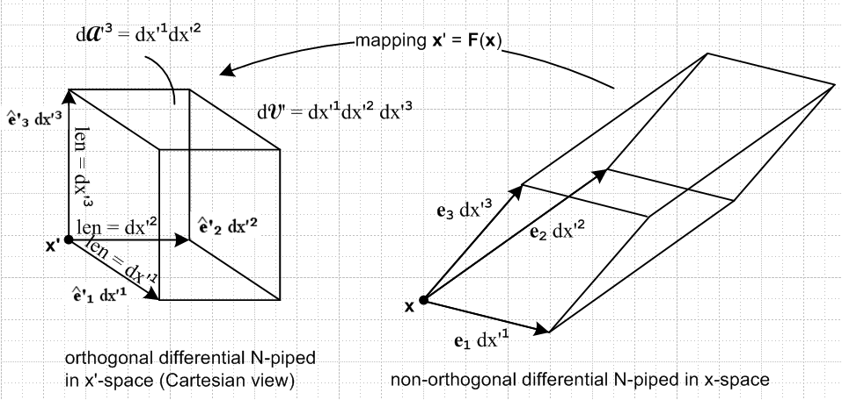

We can identify the mapping shown in this picture with our Inverse Flow situation (table above). Chapter 8 discusses in much detail how length, volume and area transform under a general transformation. The length, area and volume magnitudes on the left are called dL'n = dx'(n), dA'n and dV', while the corresponding quantities on the right are called dx(n), (n) and dV, where the first two items are vectors. Cribbing the results of Chapter 8 (c) 7 and converting them from standard notation to developmental notation, we have

| dx(n)|/ dL'n = h'n = ['nn]1/2 = the scale factor for edge dx(n) which g is this?

| (n)|/ dA'n = (1/h'n) |J| = (1/h'n) g'1/2 = [g'nn g']1/2 = [cof('nn)]1/2

|dV| / dV' = |J| = g'1/2 // where g' ≡ det('ij) = J2 , ' = STS (5.16.6)

We can then translate these three lines into our Inverse Flow context:

| dx(n)| / | dX(n)| = h'n = ['nn]1/2 = [(FTF)nn]1/2 = [Cnn]1/2 // Lai p114 (3.23.6-8)

| dAn| / |dA0n| = [g'nng']1/2 = [cof('nn)]1/2 = [cof(FTF)nn)]1/2 = [cof Cnn)]1/2 // Lai p129 (3.27.11)

|dV| / |dV0| = |J| = g'1/2= [det('ij)]1/2 = [det(FTF)]1/2 = |det(F)| // Lai p130 (3.28.3) (5.16.7)

where
edge area volume
X-space : dX(n) dA0n dV0 time t0
x-space : dx(n) dAn dV time t (5.16.8)

Thus, for example, the volume change of a "flowing" particle of continuous matter is given by the Jacobian |J| = |detF| associated with the deformation gradient tensor F. We put quotes on "flowing" only because this might be a particle of solid steel that is momentarily moving and deforming a very small amount during an oscillation or in response to an applied stress.

In the middle line above we state that | dAn| / | dA0n| = [cof(FTF)nn)]1/2 and quote Lai p 129 (3.27.11) for verification. However, what Lai (3.27.11) actually says (slightly translated to our notation) is this:

dA(n)/dA(n)0 = det(F) | (F-1)T un | un = unit base vector, (un)i = δn,i (5.16.9)

which seems a far cry from our result [cof(FTF)nn)]1/2. But consider, using the Inverse Flow table,

| (F-1)T un |2 = | RT un |2 = [RTun]i[RTun]i = Rni Rni = (RRT)nn = g'nn (5.16.10)
so
det(F) | (F-1)T un | = g'1/2 g'nn1/2 = [cof('nn)]1/2 = [cof(FTF)nn)]1/2 (5.16.11)

where we use the Chapter 8 (c) 6 theorem converted to developmental notation, stating that

g' g'nn = [cof('nn)] . // more generally, (detA) A-1 = cof(A) if A = AT (5.16.12)

It might be noted that the Lai book does in fact use our "developmental notation" in that all indices are written "down" (when indices are shown), but no overbars mark covariant objects. Here are a few examples:

Lai notation Developmental notation Standard Notation
dA0 = dX(1)x dX(2) (3.27.1) 0 = dX(1)x dX(2) (dA0)i= εijk [dX(1)]j [dX(1)]k
[divT]i = ∂jTij (4.7.3) [divT]i = jTij [divT]i = ∂jTij (5.16.13)

Of course when Cartesian coordinates are assumed, the up and down position makes no difference.

Lai writes tensors in bold face such as F for the deformation gradient noted above, or T for the stress tensor. Perhaps this is done to emphasize the notion of a tensor as an operator as in our Appendix E (g). Lai writes a specific matrix as [T], but a matrix element is Tij. Notation is an ongoing burden and each area of physics seems to have its own accepted conventions.

