Ch 3 for non-square R PhL 3.26.16

I have some problems in Chapter 3 in reviewing the generalization of tensor doc to the case where x-space has dimension N while x'-space has dimension M > N. This is a situation of a tall non-square R matrix. I will copy some of Chapter 2 and all of Chapter 3 below and do comments and edits in red.

*****************************************************************************

2.1 Linear Local Transformations

We now shift to the Picture A context, where x-space is not necessarily Cartesian,

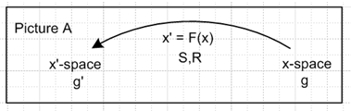 (2.1.1)

Consider again the possibly non-linear transformation x' = F(x) mapping F: RN→ RM with M > N. Imagine a very small neighborhood around the point x in x-space, a "ball" around x. Where the mapping is continuous in both directions, one expects a tiny x-space ball around x to map into a tiny x'-space ball around x' and vice versa. Here is a picture of this situation,

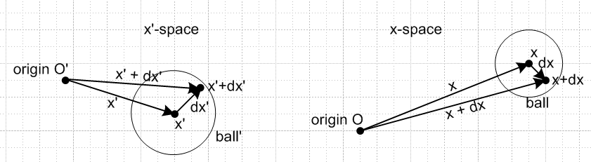(2.1.2)

where everything in one picture is the mapping of the corresponding thing in the other picture. The vector dx' on the left must lie on manifold M in x'-space.
In particular, we show a small vector in x-space called dx which maps into a small vector in x'-space called dx'. [ok] Since F was assumed invertible [ no longer assumed], it must be invertible locally in these two balls [no longer true] . That is, given a dx above, one can determine dx', and vice versa [ vice versa cannot for arbitrary dx' ] . (Anticipating a few lines below, this means that the matrices S and R will be invertible so neither can have zero determinant.) [ no longer true ]
How are these two differential vectors related? For a linear approximation,

x'i + dx'i = Fi(x + dx ) ≈ Fi(x) + Σk( ∂Fi(x)/∂xk) dxk [ok]

⇒ dx'i = Σk( ∂Fi(x)/∂xk) dxk . [ok] (2.1.3)
The last line shows an equals sign in the limit that dxk is a vanishing differential. Since Fi(x) = x'i ,

dx'i = Σk(∂x'i/∂xk) dxk = Σk Rik dxk where Rik ≡ (∂x'i/∂xk) . [ok] (2.1.4)

Doing the same operation in the other direction gives

dxi = Σk( ∂xi/∂x'k) dx'k = Σk Sik dx'k where Sik ≡ (∂xi/∂x'k) . (2.1.5)

Discussion: What is the meaning of ∂xi/∂x'k ? I am still not happy on this. How does x move if you move various directions in x'-space. In my half-sphere example, you can in fact move in any direction you want in x'-space (even in direction which takes you off M) and this does generate a movement in x-space. You would write dx = S dx' for such a movement. But if you then compute dx' = Rdx from the resulting dx, you do not get the same dx'. You get a dx' which lies on the sphere. So R(Sdx') = RS dx' ≠ dx' and so RS ≠ 1, consistent with all my notes on this topic. So OK, ∂xi/∂x'k has meaning, you can compute it for any direction dx'k you want in x-space, but be careful!

One can regard Rik and Sik as elements of MxN and NxM matrices R and S. In vector notation then,

dx' = R(x) dx Rik(x) ≡ (∂x'i/∂xk) R = S-1 // dx'i = Rij dxj
dx = S(x') dx' Sik(x') ≡ (∂xi/∂x'k) S = R-1 // dxi = Sij dx'j . (2.1.6)

It is obvious that matrices R and S are inverses of each other [no longer true], just staring at the above two vector equations. One can verify this fact from the definitions of R and S using the chain rule

(RS)ij = Σk RikSkj = Σk (∂x'i/∂xk) (∂xk/∂x'j) = Σk $\frac{∂x'i}{∂xk}$ $\frac{∂xk}{∂x'j}$ = $\frac{∂x'i}{∂x'j}$ = δi,j . (2.1.7)

Discussion: I am claiming here that Σk $\frac{∂x'i}{∂xk}$ $\frac{∂xk}{∂x'j}$ = $\frac{∂x'i}{∂x'j}$and I am calling it "the chain rule". I now think that is a completely wrong thing to do. The result is correct, but it is not the chain rule that makes it correct. I have added an errata for tensor doc to deal with this somehow.

We could get rid of one of these matrices right now, perhaps keeping R and replacing S = R-1 [ no longer true] , but keeping both simplifies expressions encountered later, so for now both are kept.
The letter R does not imply that matrix R is a rotation matrix, although it could be. According to the polar decomposition theorem (Lai p 110), any matrix R (detR ≠ 0) can be uniquely written in the form
R = RU = VR where R is a rotation matrix (the same one in RU and VR) and U and V are symmetric positive definite matrices (called right and left stretch tensors) related by U = RTVR. Matrix S could of course be written in a similar manner.
Matrices R(x) and S(x') are in general functions of a point in space x' = F(x). As one moves around in space, all the elements of matrices R and S are likely to change. So R and S represent point-dependent linear transformations which are valid for the differentials shown.
One might wonder at this point how the vector dx is related to its components dxi and the same question for dx'i and dx'i. As will be shown later in (6.6.9) and (6.6.15),

dx = Σndxn un where the un are x-space axis-aligned basis vectors of the form u1 = (1,0,0,..0)
dx' = Σndx'n e'n where the e'n are x'-space axis-aligned basis vectors of the form e'n = (1,0,0,..0)
(2.1.8)

If x-space and x'-space were Cartesian, one could write un = and e'n = ', but in general the un and e'n vectors do not have (covariant) unit length, as shown later in (6.5.3) and (6.4.1).
The reader familiar with covariant "up and down" indices will notice that all indices are peacefully sitting "down" in the presentation so far (subscripts, no superscripts). As we carry out our various developmental tasks, that is where all indices shall remain until Chapter 7, whereupon they will start frantically bobbing up and down, seemingly at will. [ Since rules are made to be violated, we have violated this one in some examples below where non-standard notation would be hard to swallow. ]
Are there any "useful objects" that can be constructed from differentials dx and which might then transform according by R or S? The answer is yes, but first we discuss scalars.

*************** rest of Chapter 2 is not copied here *******************

3. Tangent Base Vectors en and Inverse Tangent Base Vectors u'n

3.1 Differential Displacements

This entire Section is in the context of Picture A,

(3.1.1)

In Fig (2.1.2) above showing dx and dx', one has much freedom to "try out" different differential vectors. For any dx one picks at point x, one gets some dx' according to dx' = R(x) dx. Consider this slightly enhanced version of that figure (red curves added)

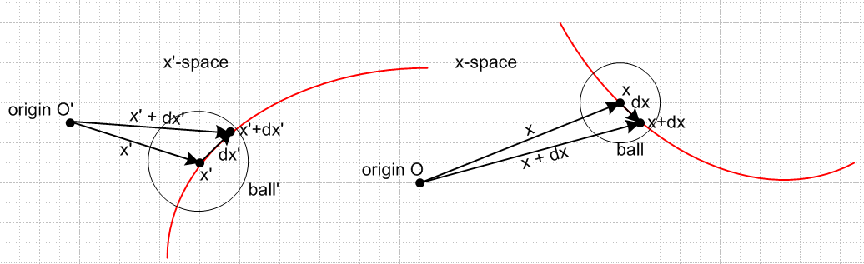
(3.1.2)

Comment: dx' on the left lies on manifold M in x'-space

The point x in x-space (right side) can be regarded as lying on some arbitrary 1-dimensional curve in RN shown on the right in red. Select dx to be the tangent to this curve at point x. That curve will then map into some (probably very different) curve in x'-space which passes through the point x'. [ this curve lies on M] The tangent to this curve at the point x' must be dx' = R(x) dx. A similar statement can be made starting instead with an arbitrary curve in x'-space [but which lies on M] . The tangent dx' there then maps into dx = S(x') dx' in x-space.
The curves in x-space are in N-dimensional space and are in general non-planar and the tangents are of course N dimensional tangents, so this 2D picture is mildly misleading. The curves in x'-space are in M-dimensional space and are in general non-planar and the tangents are of course M dimensional tangents.

We now specialize such that the red curve on the left is a straight line parallel to an x'-space axis, which means the curve on the right is a coordinate line, [ but this is likely not possible since x' has to lie on M! ]

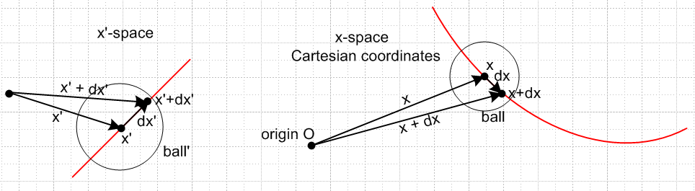
(3.1.3)

Admittedly the drawing does not strongly suggest that the red line segment on the left is parallel to an axis in x'-space, but since those axes are not drawn, one cannot complain too strenuously.

3.2 Definition of the en ; the en are the columns of S

First, define a set of N basis vectors in x'-space which point along the positive axes of x'-space,

e'n , n = 1,2...N (e'n)i = δn,i e'1 = (1,0,0...) etc . (3.2.1)

Assume that the dx' arrow above points in this e'n direction so that

dx' = e'n dx'n // no implied sum on n (3.2.2)

where dx'n is a positive differential variation of coordinate x'n along the e'n axis in x'-space. The corresponding dx in x-space will be,

dx = S dx' = S [e'n dx'n] = [ Se'n] dx'n ≡ en dx'n (3.2.3)

dx = S dx' = S [e'n dx'n] = [ Se'n] dx'n ≡ en dx'n (3.2.3)

Problem here. In writing dx = S dx', dx' must lie on manifold M. But in writing dx' = e'n dx'n , dx' must lie along an axis of x'-space and that is likely NOT to lie on manifold M. So these cannot be the same dx'! The stuff shown in red is then wrong. You can have one or the other of the above black part. In the second line, since you do have a matrix S, you can if you want apply that to e'n dx'n and you can if you want then define en ≡ Se'n as shown. But you cannot have the equation dx = [ Se'n] dx'n ≡ en dx'n .

where this last equality serves as the definition of en ,

en ≡ Se'n . (3.2.4)

Vector en = en(x) points along dx in x-space and is tangent to the x'n- coordinate line there at point x.
[ This is no longer true because we no longer have dx = en dx'n ]

Discussion: We cannot even map the x'n coordinate lines into x-space because the x'n coordinate lines generally do not lie on the manifold M. So the whole idea of having "coordinate lines" in x-space is no longer valid. There are no coordinate lines in x-space!! Thus, we are not surprised to find that the en as defined above are not tangent to such lines. That whole meaning for en goes away. If you define en ≡ Se'n as above, the M en vectors at least exist, but they are no longer "tangent" base vectors.
ok to here
This vector en is generally not a unit vector, hence no hat ^ . Writing out the ith component of (3.2.4),

(en)i = Σj Sij (e'n)j = Σj Sij δn,j = Sin [ok] (3.2.5)

so that, with (2.1.5),

(en)i = Sin = ∂xi/∂x'n [ok] or en = ∂x/∂x'n = ∂'nx . (3.2.6)

Discussion: Sin exists, but it only equals ∂xi/∂x'n for dx'n along M (which is how it was computed). You cannot regard dx'n as arbitrary in x'-space, so writing en = ∂x/∂x'n is meaningful only for dx'n on M. That is, you can only compute the derivative ∂x/∂x'n in the plane of M (so to speak)

This fact that (en)i = Sin says that the vectors en are the columns of the matrix S:

S = [e1, e2, e3 .... eN ] matrix = N columns (3.2.7)

We shall call these en vectors the tangent base vectors. The vectors exist in x-space and point along the various coordinate lines that pass through a point x.
If the points on the x'n-coordinate line were labeled with the values of x'n from which they came, one would find that en points in the direction in which those labels increase.
As one moves from x to some nearby point, the tangent base vectors all change slightly because in general S = S(x'(x)) and the en = en(x) are the columns of S. Any set of basis vectors which depends on x in this way is called a local basis. In contrast, the corresponding x'-basis e'n shown above with (e'n)i = δn,i is a global basis in x'-space since it is the same at any point x' in x'-space.
Since det(S) ≠ 0 due to our assumption that F is invertible, the tangent base vectors are linearly independent and provide a basis for EN.
One can of course normalize each of the en to be a unit vector n according to n = en/ |en|.
Here is a traditional N=3 picture showing the tangent base vectors pointing along three generic coordinate lines in x-space all of which pass through the point x:
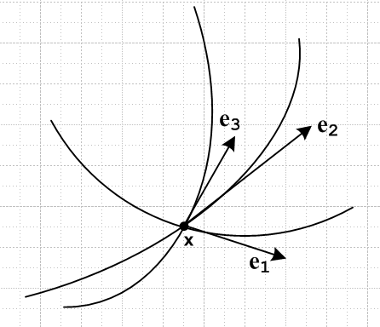 (3.2.8)

Comment on notation. Some authors refer to our en as gn or Rn or other. Later it will be shown that en•em = 'nm where 'nm is the covariant metric tensor for x'-space, so admittedly this provides a reasonable argument for using gn so that gn•gm = 'nm. But then the primes don't match which is confusing: the gn are vectors in x-space, while ' is a metric tensor in x'-space. We shall be using yet another g in the form g = det(nm) and a corresponding g'. Due to this proliferation of g objects, we stick with en, the notation used by Margenau and Murphy (p 193). A g-oriented reader can replace e → g as needed anywhere in this document. As for unit vector versions of the en, we use the notation n ≡ en/|en|. Morse and Feshbach use an for this purpose (Vol I p 22). A g-person might use n .
A related issue is what symbols to use for the "usual" basis vectors in Cartesian x-space. As noted above in (2.1.8), we are using un with (un)i = δn,i as "axis-aligned basis vectors" in x-space. If = 1 for x-space, then these are the usual Cartesian unit vectors (see (6.5.3) below that un • um = nm). Many authors use the notation en for these vectors which then conflicts with our use of en as the tangent base vectors. Morse and Feshbach use the symbols i, j, k for our Cartesian u1, u2, u3. Other authors use , , so then un = .
Often the notation en is used by authors to represent some generic arbitrary set of basis vectors. For this purpose, we shall use the notation bn.

3.3 en as a contravariant vector

The situation described above is this,

dx' = e'n dx'n x'-space (3.2.2) // no implied sum on n
dx = en dx'n x-space (3.2.3) // no implied sum on n (3.3.1)

and the full transformation F maps dx into dx'. Since dx is a contravariant vector, the linear transformation R also maps dx into dx'. Thus

dx' = R(x) dx (2.1.6)
so
[e'n dx'n] = R(x) [en dx'n] (3.3.1)
so
e'n = R(x) en . (3.3.2)

We can regard the last line as a statement that the vector en transforms as a contravariant vector under F. Written out in components one gets

(e'n)i = ΣjRij (en)j ⇒ δn,i= ΣjRijSjn (3.3.3)

recovering the fact that RS = 1. This is an example of a vector being "contravariant by definition", as discussed in (2.9.5).

The two expansions (3.3.2) and (3.2.4) are easy to verify by showing that the components of both sides are the same:

e'n ≡ Ren = Σi Rin ei since (e'n)j = Σi Rin (ei)j = Σi Rin Sji = (SR)jn = δj,n = (e'n)j

en ≡ Se'n = Σi Sin e'i since (en)j = Σi Sin (e'i)j = Σi Sin δi,j = Sjn = (en)j (3.3.4)

3.4 A semantic question: unit vectors

Above it was noted that e'1 = (1,0,0....). Should this be called "a unit vector" ? It will be seen in (6.2.7) that in fact |e'1| = ≠ 1 where ' is the covariant metric tensor in x'-space, and |e'1| is the covariant length of e'1. So e'n is a unit vector in the sense that it has a single 1 in its column vector definition, but it is not a unit vector in the sense that it does not (in general) have unit magnitude (it would if x'-space were Cartesian with g'=1).We take the magnitude = 1 requirement as the proper definition of a unit vector. For this reason, we refer to the e'n in x'-space as just "axis-aligned basis vectors" and they have no "hats". One wonders how such a vector should be depicted in a drawing, see Example 1 (b) below and also Section C.5

Example 1: Polar coordinates, tangent base vectors

(a) The first step is to compute the matrix Sik(x') ≡ (∂xi/∂x'k) from the inverse equations:

x = (x1, x2 ) = (x,y)
x' = (x1', x2') = (θ,r) // note that r chosen as the second variable x2'

x = F-1(x') ↔ x = rcos(θ) x1 = x2' cos(x1')
y = rsin(θ) x2 = x2' sin(x1') (1.4)
So
S11 = (∂x/∂θ) = -rsinθ
S12 = (∂x/∂r) = cosθ Sik ≡ ( ∂xi/∂x'k)
S21 = (∂y/∂θ) = rcosθ
S22 = (∂y/∂r) = sinθ
(3.4.1)
S = $\left(\begin{matrix}-rsinθ & cosθ \\ rcosθ & sinθ\end{matrix}\right)$ // det(S) = -r R = S-1 = $\left(\begin{matrix}-sinθ/r & cosθ/r \\ cos(θ) & sinθ\end{matrix}\right)$ .

[ Note: The above S and R are stated for the ordering 1,2 = θ,r . For the more usual ordering 1,2 = r,θ the colums of S should be swapped, and the rows of R should be swapped. In the usual ordering, det(S) = +r.]

The tangent base vectors en can be read off as the columns of S according to (3.2.7),

e1 = r(-sinθ,cosθ) = eθ = r θ // = r
e2 = (cosθ,sinθ) = er = r . // = (3.4.2)

Notice that eθ in this case is not a unit vector. Below is a properly scaled drawing showing the location of the two x'-space basis vectors on the left, and the two tangent base vectors on the right. As just shown, the length of er is 1, while the length of eθ is 2.

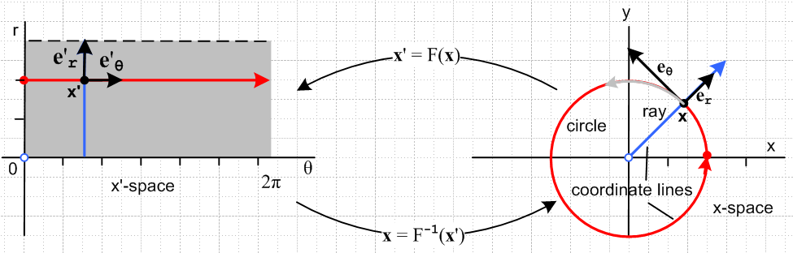
(3.4.3)
The tangent base vectors are fairly familiar animals, since er = and eθ = r in usual parlance. If one moves radially outward from point x, the er base vector stays the same, but eθ grows longer. If one moves azimuthally from x to some larger angle θ+Δθ, both vectors stay the same length but they rotate together staying perpendicular.

(b) This is a good place to point out that vectors drawn in a non-Cartesian space can have magnitudes which do not equal the length of the drawn arrows. The "graphical arrow length" of a vector v is (vx2 + vy2)1/2, but that is not the right expression for |v| in a non-Cartesian space. For example, as will be shown below in (5.10.5), |eθ'| = |eθ| , so the magnitude of the vector e'θ shown on the left above is in fact |eθ'| = r = 2 and not 1, but the graphical length of the arrow is 1 since e'θ = (1,0). See Section C.5 for further discussion of this topic with a specific 2D non-orthogonal coordinate system.

(c) In this example, two basis vectors e'n in x'-space on the left map into the two en vectors on the right according to en ≡ Se'n. If one were to apply the full mapping x = F-1(x') to each point along the arrows
e'n, for some general non-linear F one would find that these arrows map into warped arrows on the right whose bases are tangent to those of the en. Those warped arrows lie on the coordinate lines. For this particular mapping, e'θ maps under F-1 into the warped gray arrow, while e'r maps into er.

Example 2: Spherical Coordinates, tangent base vectors

x = (x1, x2, x3 ) = (x,y,z)
x' = (x1', x2',x3') = (r,θ,φ)

x = F-1(x') ↔ x = rsinθcosφ
y = rsinθsinφ
z = rcosθ (1.6)

S11= (∂x/∂r) = sinθcosφ Sik ≡ (∂xi/∂x'k)
S12 = (∂x/∂θ) = rcosθcosφ
S13 = (∂x/∂φ) = -rsinθsinφ
S21= (∂y/∂r) = sinθsinφ
S22 = (∂y/∂θ) = rcosθsinφ
S23 = (∂y/∂φ) = rsinθcosφ
S31= (∂z/∂r) = cosθ
S32 = (∂z/∂θ) = -rsinθ
S33 = (∂z/∂φ) = 0 (3.4.4)

S = $\left(\begin{matrix}sinθcosφ & rcosθcosφ & -rsinθsinφ \\ sinθsinφ & rcosθsinφ & rsinθcosφ \\ cosθ & -rsinθ & 0\end{matrix}\right)$ R = $\left(\begin{matrix}sinθcosφ & sinθsinφ & cosθ \\ cosθcosφ/r & cosθsinφ/r & -sinθ/r \\ -sinφ/(rsinθ) & cosφ/(rsinθ) & 0\end{matrix}\right)$

where Maple computes R as S-1 and finds as well that: det(S) = r2 sinθ .

Again, from (3.2.7) the tangent base vectors are the columns of S, so
er = (sinθcosφ, sinθsinφ,cosθ) |er| = 1 ≡ h'r
eθ = r(cosθcosφ,cosθsinφ,-sinθ) |eθ| = r ≡ h'θ
eφ = rsinθ(-sinφ,cosφ,0) |eφ| = rsinθ ≡ h'φ (3.4.5)

and unit vector versions are then

r = (sinθcosφ, sinθsinφ,cosθ) = er =
θ = (cosθcosφ,cosθsinφ,-sinθ) = eθ = r
φ = (-sinφ,cosφ,0) = eφ = rsinθ (3.4.6)

The unit vectors can be displayed in this standard picture,

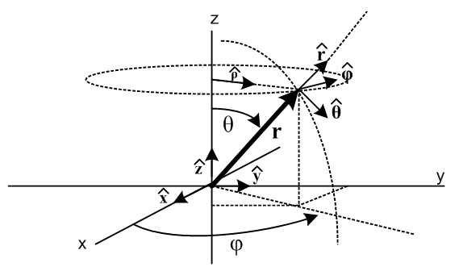 (3.4.7)

Notice that (, , ) = (1, 2, 3) form a right-handed coordinate system at the point x = r.

3.5 The inverse tangent base vectors u'n and inverse coordinate lines

A complete swap x' ↔ x for a mapping x' = F(x) of course produces the "inverse mapping". This has the effect of causing R ↔ S in the above discussion. The tangent base vectors for the inverse mapping would then be the columns of matrix R instead of S. We shall denote these inverse tangent base vectors which exist in x'-space by the symbol u'n. Then:

(en)i = Sin = ∂xi/∂x'n // the tangent base vectors as above (3.2.6)
S = [e1, e2, e3 .... eN ] // are the columns of S (3.2.7)

(u'n)i = Rin = ∂x'i/∂xn // inverse tangent base vectors
R = [u'1, u'2, u'3 .... u'N ] // are the columns of R (3.5.1)

By varying only xn in x-space holding all the other xi = constant, one generates the xn-coordinate lines in x'-space, just the reverse of the earlier discussion of this subject. Then inverse tangent base vectors u'n will then be tangent to these inverse coordinate lines. An example is given just below and another appears in Appendix C.

The vector en was shown to transform as a contravariant vector into an axis-aligned basis vector e'n in x'-space
(3.3.2) (3.3.3) (3.2.6) (3.2.1)
e'n = R en (e'n)i = ΣjRij (en)j (en)i = Sin (e'n)i = δn,i (3.5.2)

The same thing happens here, only in reverse :

un = S u'n (un)i = ΣjSij (u'n)j (u'n)i = Rin (un)i = δn,i (3.5.3)

where now the un are axis-aligned basis vectors in x-space. A prime on an object indicates which space it inhabits.

The inverse tangent base vectors u'n are not the same as the reciprocal base vectors En introduced in Chapter 6 below.

Example 1: Polar coordinates: inverse tangent base vectors and inverse coordinate lines

It was shown earlier for polar coordinates that

R = S-1 = $\left(\begin{matrix}-sinθ/r & cosθ/r \\ cos(θ) & sinθ\end{matrix}\right)$ (3.4.1)

so the inverse tangent base vectors (expressed here as row vectors as usual to save space) are given by the columns of R as per (3.5.1),

u'x = ( -sinθ/r,cosθ) // note near θ = 0 that u'x indicates a large negative slope
u'y = (cosθ/r,sinθ) . // note near θ = 0 that u'y indicates a small positive slope (3.5.4)

One expects u'x to be tangent to an inverse coordinate line in x'-space which maps to a line in x-space along which only x is varying, which is a horizontal line at fixed y (red below). Looking at the small θ region of the left graph in Fig (3.5.5) below, one sees slopes as just described above.

For the polar coordinates mapping discussed near Fig (3.4.3), horizontal (red) and vertical (blue) lines in x'-space mapped into circles (red) and rays (blue) in x-space, and the tangent base vectors in x-space were tangent to the coordinate lines there. If one instead takes horizontal (red) and vertical (blue) lines in x-space and maps them back into coordinate lines in x'-space, the picture is a bit more complicated. Since y = rsinθ, the plot of an x-coordinate line (x is varying, y fixed at yi) in x'-space has the form r = yi/sinθ, where yi denotes some selected y value (a red horizontal line), so plotting r = yi/sinθ in x'-space for various values of yi displays a set of inverse x-coordinate lines (red). Similarly r = xi/cosθ gives some y-coordinate lines (blue). Here is a Maple plot:
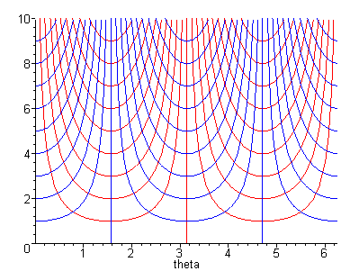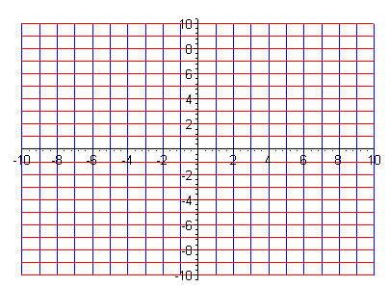
x'-space (θ,r) x-space (x,y)
(3.5.5)
Another example is given in Appendix C.

