What happens to tensor doc if R is not square PhL 3.26.16

I may have started into this topic in another doc, but I will just restart here.

In tensor doc I address curvilinear coordinates and special relativity and we always have x-space and x'-space having the same dimension. But what happens if this is not the case? Suppose

dim x-space = n dim x'-space = m n < m of interest

All I can do is go through the entire document to see what happens!

Preliminary:

Imagine that x-space is R2 and x'-space is R3. Our Manifold M in R3 is defined by x' = F(x). This equation cannot be inverted to get x = F-1(x') except for points x' which lie on manifold M. As I show in a simple example in non-square matrix/ "simple examples" and "confusion about chain rule", you can still compute both Rij ≡ (∂x'i/∂xj) and Sik ≡ (∂xi/∂x'k) which I call R and S. You compute S from the equations for x = F-1(x') where x' lies on the manifold. You find that

SR = 1 RS ≠ 1

I learned that my "chain rule identity" is not valid in the case RS ≠ 1.

Chapter 1

Consider this mapping where the space on the right is LARGER than the one on the left in dimension,

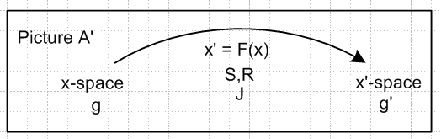

x'1 = F1(x1, x2, x3... xn) x = φ(t)
x'2 = F2(x1, x2, x3... xn) n = small m = large
...
x'm = FN(x1, x2, x3... xn) . m equations (1.2)

F : Rn (x-space) → Rm(x'-space) embedding idea if m > n.

Could then have 1-to-1 between RN and the manifold M within RM. "Too many equations" means that lots of points in x'-space have no corresponding point in x-space! Here think of x'-space on the right.

x-space x'-space
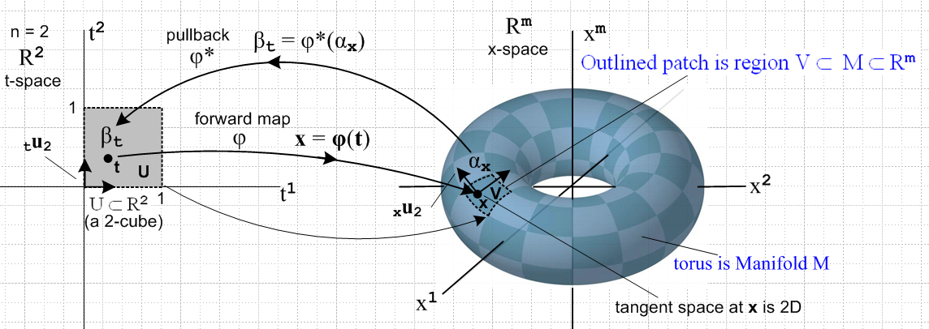

Points not on the toroid have no reverse image point in the left space.

In x-space on the left I have n axis-aligned basis vectors ui . I know that u'i= Rui span the tangent space on the right that I care about, so in tensor doc notation the interesting tangent base vectors are u'i and not ei.

If we pick a point x on the left, then I know that the n vectors u'i span the tangent space on the right at the point x' on the right. Call these u'i through u'n. These span the manifold at x', so these are the basis vectors that I care about. There are m-n other basis vectors on the right in which I have no interest.

Comment: We have x' = F(x) for all x in x-space, while we have x = F-1(x') only for x' on M. So in this sense the inverse mapping does exist, but it has a restricted domain in x'-space.

Chapter 2

2.1 Linear Local Transformations

where we just think of x'-space being replaced by manifold M inside x'-space. Then this is OK

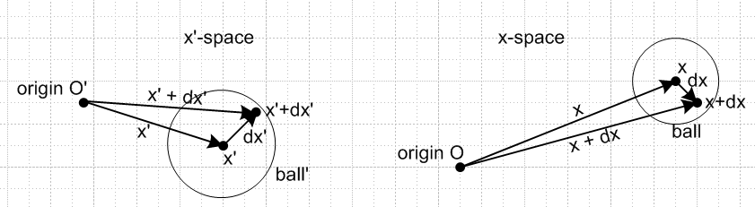

where on the left you are restricted to the manifold M. Reading through, I think this is OK

dx' = R(x) dx Rik(x) ≡ (∂x'i/∂xk) // dx'i = Rij dxj

where dx' lies on the manifold M while dx is arbitrary in x-space.

The following line is also valid, where dx' again lies on the manifold,

dx = S(x') dx' Sik(x') ≡ (∂xi/∂x'k) // dxi = Sij dx'j . (2.1.6)

because we are not allowed to select an arbitrary dx' in R3 space. Earlier I thought that S does not exist, but now I know that it does exist and showed this in an example.

But we have SR = 1 and RS ≠ 1.

2.2 Scalars

2.3 Contravariant vectors

Now what happens to the notion of vectors? Each space of course has its naive vectors with apropos number of components. We can still compare

dx' = R(x) dx

V' = R(x) V

so even though V' has m components and V has n components, I can still write V' = R(x) V as being "the rule for transformation of a vector under F ". We can still have vector fields

V'(x') = R(x) V(x)

I think that is enough for Chapter 2. At least V' = R(x) V still exists. Contravariant vectors exist.

2.4 Covariant vectors

They also exist because S exists. ' = ST

2.5 Bar notation

I think you can have bars in x-space since g and (defined in Ch 5) both exist. So = V from Ch 5 will be OK. You can say V' = R V and you can say ' = ST , so all the bar stuff is the same.

2.6 Origin of the names contravariant and covariant

2.7 Origin of the names contravariant and covariant

2.8 Linear transformations

2.9 Vectors that are contravariant by definition

2.10 Vector Fields

2.11 Names and symbols

2.12 Definition of the words "scalar", "vector" and "tensor"

The only thing lost from Chapter two was its claim that RS = 1. I don't write that equation, but I do make the claim in (2.1.6) that R = S-1 and S = R-1 and then I show RS = 1 which is the item invalidated.

Chapter 3 on tangent base vectors

3.1 Differential Displacements

Picture OK but we have to have x' and x'+dx' both lying on manifold M.

3.2 Definition of the en ; the en are the columns of S

Can define

e'n , n = 1,2...m (e'n)i = δn,i e'1 = (1,0,0...) etc . (3.2.1)

Can also define en because there is a matrix S.

en = ∂x/∂x'n = ∂'nx can be computed.

en ≡ Se'n can be computed.

Comments: From ei = ∂x/∂x'i there must be m tangent base vectors since x' has m coordinates. I always say they exist in x-space. But now we have m tangent base vectors ei existing in n-dimensional x-space, so they must not be linearly independent in that space. Presume that some subset of n of these might be an independent basis.

3.3 en as a contravariant vector

I quote this equation

(e'n)i = ΣjRij (en)j ⇒ δn,i= ΣjRijSjn (3.3.3)

This seems to say that 1 = RS, but I know for non-square R that 1 ≠ RS. So we have a problem.

3.4 A semantic question: unit vectors

3.5 The inverse tangent base vectors u'n and inverse coordinate lines

(u'n)i = Rin = ∂x'i/∂xn // inverse tangent base vectors
R = [u'1, u'2, u'3 .... u'N ] // are the columns of R (3.5.1)

The u'n vectors CAN be computed. There are only two of them in R3 = x-space.

u'n = R un

You get them by mapping the two axis-aligned basis vectors un in x-space over to x'-space.

So at least the un and u'n basis vectors still exist in the two spaces.
The e'n exist in x'-space, but the en do not exist, so we have 3 out of 4 still existing.

4. Notions of length, distance and scalar product in Cartesian Space

Not really relevant.

Chapter 5. The metric tensor

5.1 The Picture D Context

The whole plan of this section I think is going to fail. Wherever there is an S, one has to cross that line out.

5.2 Definition of the metric tensor

Summary of metric tensors in the two spaces:

x-space: Here g and both exist, perhaps is given and g is its inverse. And a•b = ijaibj exists in x-space

x'-space: I want to define g' here in terms of the transformation linking the spaces. Now g' = RgRT means that g' can be computed "from the xform" in x'-space. Call it g' = RRT. This has no inverse, so ' computed as the inverse does not exist. And ' = STG S does not exist because S does not exist, consistent with the previous fact. Then a'•b' = 'ija'ib'j does not exist.

Question: Why can't you just "declare" a metric tensor for x'-space? Perhaps Cartesian. I guess you could do this, but then there is no connection with the theory of tensor doc.

5.3 Inverse of the metric tensor

We can take g' = RGRT exists or G = 1 so g' = RRT. I showed yesterday that since R is a tall matrix, det(g) = det(RRT) = 0, very timely. Thus cannot invert g' to get ' , which confirms that ' does not exist!

5.4 A metric tensor is symmetric

At least this applies to g which exists and g = RGRT which has the right form for this proof.

5.5 det(g) and gnn of a Cartesian-generated metric tensor are non-negative

Don't really are about this right now. Valid I guess for g = RRT.

5.6 Definition of two kinds of rank-2 tensors

5.7 Proof that the metric tensor and its inverse are both rank-2 tensors

Again, only contravariant exists. Same conclusion for rank-2 tensor, only pure contravariant exists. This line is still OK

g' = R g RT g'ab = Raa'Rbb'ga'b' // g is a contravariant rank-2 tensor

Most other lines no longer valid.

5.8 Metric tensor converts vector types

Can do = V , but cannot do ' = ' V' since there is no ' So V' = RV is OK, but you cannot ever get an object called '. Consistent with earlier claims that covariant objects don't exist!

5.9 Vectors in Cartesian space

Note that g'ij contravariant exists, which is g'ij in SN, so can only raise an index. But we can't even have a lower index in SN because that would be a covariant object index! So raise/lower all gone in x'-space. Still OK in x-space.

5.10 The covariant dot product A • B and norm |A|

Can define A • B ≡ Aaa because exists.
Cannot define A' • B' ≡ A'a'a because ' does not exist.

5.11 Metric tensor and tangent base vectors: scale factors and orthogonal coordinates

Here we learn that 'mn = em • en , but the en do not exist and so ' no existe is consistent. The whole ball game is out the window!

5.12 The Jacobian J

det(S) no exist because no S.
det(R) no exist because R is not square
Could maybe rescue these equation: g = det(g) g' = det(g') J2 = g'/g

Almost everything goes away except maybe the above lines.

5.13 Some relations between g, R and S in Pictures B and C (Cartesian x-space).

Anything with an S goes away, and that is almost everything.

5.14 Special Relativity and its Metric Tensor: vectors and spinors

5.15 General Relativity and its Metric Tensor

5.16 Continuum Mechanics and its Metric Tensors

So my metric tensor chapter is decimated.

6. Reciprocal Base Vectors En and Inverse Reciprocal Base Vectors U'n

6.1 Definition of the En

Opening definition fails, En ≡ g'ni ei, because ei don't exist. However, we could in theory use this definition (En)i ≡ gicRnc.

(En)i = g'ncSic = gicRnc . // sum on second indices (6.1.5)

This defines three En vectors in x-space.

So in fact we DO have a way to compute the En. The following is OK,

En • um = Rnm . (6.1.7)

6.2 The en and En Dot Products and Reciprocity (Duality)

These equations survive:

En • Em = g'nm ⇒ |En| = $\sqrt{g'nn}$ . (En)i = gicRnc (6.2.4)

Question: Why can't you start with the three En and compute three viable en using duality

En • em = δn,m

I think since x-space = R2 has dimension 2, only two of the En would be linearly independent and this screws up the duality process.

6.3 Covariant partners for en and En

Also don't exist as initially defined, but could say

n = En ⇒ (n)i = ij(En)j = ijgjcRnc = δi,cRnc = Rni // (6.1.5) (6.3.2)

so I guess you can then define both En and n vectors.

R = = [1, 2, 3 .... N ]T (6.3.4)

Also OK

En' = REn ⇒ (En')i = Rij (En)j = RijgjcRnc = [RgRT]in = g'in // (5.7.6) (6.3.6)

6.4 Summary of the basic facts about en and En

I will make blue all the things that don't work! Things in black work OK (are computable).

(n)i = ij (en)j (n)i = ij (En)j [ n = en n = En] (5.8.4)

(e'n)i = Rij(en)j (E'n)i = Rij(En)j [ e'n = R en E'n = R En ]
('n)i = Sji(n)j ('n)i = Sji(n)j [ 'n = ST n 'n = ST n ] (2.5.1)

(en)i = Sin (En)i = gijRnj = g'njSij (en')i = δi,n (En')i = g'ni
(n)i = ijSjn = Rji'jn (n)i = Rni (n')i = 'ni (n')i = δn,i
(6.3.3) (6.3.9)
en • em = 'nm ⇒ |en| = = h'n (scale factor) En = g'ni ei
En • em = δn,m en = 'ni Ei
En • Em = g'nm ⇒ |En| = $\sqrt{g'nn}$ . (6.2.4)

e'n • e'm = 'nm ⇒ |e'n| = = h'n (scale factor) E'n = g'ni e'i
E'n • e'm = δn,m e'n = 'ni E'i
E'n • E'm = g'nm ⇒ |E'n| = $\sqrt{g'nn}$ . (6.2.7)

(n)i(en)j = δi,j [ Σn n enT = 1 ] (6.2.16) and (6.2.24) (6.4.1)

6.5 Repeat the above for the inverse transformation: definition of the U'n

Let's take a look at the u table

('n)i = 'ij (u'n)j ('n)i = 'ij (U'n)j [ 'n = ' u'n 'n = ' U'n]

(un)i = Sij(u'n)j (Un)i = Sij(Un')j [ un = S u'n Un = S Un' ]
(n)i = Rji('n)j (n)i = Rji('n)j [ n = RT 'n n = RT 'n ]

(u'n)j = Rjn (U'n)i = g'ijSnj = gnjRij (un)i = δi,n (Un)i = gni
('n)i = 'ijRjn = Sjijn ('n)i = Sni (n)i = gni (n)i = δn,i

u'n • u'm = nm ⇒ |u'n| = = hn (scale factor) U'n = gni u'i
U'n • u'm = δn,m u'n = ni U'i
U'n • U'm = gnm ⇒ |U'n| = $\sqrt{gnn}$

un • um = nm ⇒ |un| = = hn (scale factor) Un = gni ui
Un • un = δn,m un = ni Ui
Un • Um = gnm ⇒ |Un| = $\sqrt{gnn}$

('n)a(u'n)b = δa,b or Σn 'n u'nT = 1 (6.5.3)

6.6 Expanding vectors on different sets of basis vectors

Consider

V = V1 u1 + V2 u2 +... = ΣnVn un where Un • V = Vn Un = gni ui
V = 1 U1 + 2 U2 +... = Σnn Un where un • V = n
V = V'1 e1 + V'2 e2 +... = Σn V'n en where En • V = V'n En = g'ni ei
V = '1 E1 + '2 E2 +... = Σn 'n En where en • V = 'n (6.6.9)

I think the first two lines are OK in x-space. In the third line, the en don't exist. In the fourth line, the 'n don't exist. The Un are dual to the un in x-space

V' = V'1 e'1 + V'2 e'2 +... = ΣnV'n e'n where E'n • V' = V'n E'n = g'ni e'i
V' = '1 E'1 + '2 E'2 +... = Σn'n E'n where e'n • V' = 'n
V' = V1 u'1 + V2 u'2 +... = Σn Vn u'n where U'n • V' = Vn U'n = gni u'i
V' = 1 U'1 + 2 U'2 +... = Σn n U'n where u'n • V' = n (6.6.15)

Now u'a= Rua are tangent base vectors within x'-space and are well-defined. A bit hazy here.

OK, enough review of Tensor Doc for non-square R.

Question: We have a non-square R. Can't you "make up" an inverse operator S using techniques for non-spare matrices? That is, make up S so that RS = 1.
I show in my non-square matrices folder "test problem" that if R is tall and of max rank, you can find (at least one) left inverse so SlR = 1 but there is no right inverse. A candidate Sl is the following

Sl = (RTR)-1RT

and in general RTR does have an inverse because this is NOT the one with det = 0. To verify that Sl works, write

SlR = [(RTR)-1RT]R = (RTR)-1(RTR) = 1.

You could try a right inverse by analogy:

Sr = RT(RRT)-1

Then you would get

RSr = R[RT(RRT)-1] = (RRT)(RRT)-1 = 1

but this fails because we know that (RRT)-1 does not exist since det(RRT) = 0.
So yes, you could come up with a viable left inverse for R and call it Sl with Sl R = 1. But I really doubt this adds much to the current situation. This S would have no connection to the transformation world of tensor doc.

since

