Tensor Analysis and Curvilinear Coordinates: Appendices
Phil Lucht
Rimrock Digital Technology, Salt Lake City, Utah 84103
last update: Oct 21, 2012

These Appendices belong with the document "Tensor Analysis and Curvilinear Coordinates".
References and a summary of the Appendices appear there.
Maple code is available upon request. Comments and errata are welcome.
The material in this document is copyrighted by the author.

The graphics look ratty in Windows Adobe PDF viewers when not scaled up, but look just fine in this excellent freeware viewer: http://www.tracker-software.com/pdf-xchange-products-comparison-chart .
The table of contents has live links, and use of a wide Bookmarks pane is recommended.

Appendix A: Reciprocal Base Vectors the Hard Way 4
(a) Definition of E_{n} 4
(b) Simpler notation 5
(c) Generalized Cross Product of N-1 vectors of dimension N 5
(d) Missing Man Formation 7
(e) Apply this Notation to E 7
(f) Compute E_{m} • e_{n} 8
(g) Compute E_{n} • E_{m} 9
(h) Summary of relationship between the tangent and reciprocal base vectors 9
(i) Another Cross Product Notation and another expression for E 10
Appendix B: The Geometry of Parallelepipeds in N dimensions 11
(a) Preliminary: Equation of a plane in N dimensions 11
(b) N-pipeds and their Faces in Various Dimensions 12
The 1-piped 12
The 2-piped 12
The 3-piped 14
The N-piped 15
(c) The question of inward versus outward facing normal vectors. 16
(d) The Face Area and Volume of N-pipeds in Various Dimensions 17
The 2-piped 17
The 3-piped 18
The 4-piped 20
The N-piped 22
(e) Summary of Main Results of this Appendix 24
Appendix C: Elliptical Polar Coordinates ( N=2, non-orthogonal) 26
(a) Elliptical polar coordinates 26
(b) Forward coordinate lines 27
(c) Inverse coordinate lines 27
(d) Drawing a contravariant vector V in x-space: the meaning of V'_{n} . 28
(e) Drawing a contravariant vector V' in x'-space: two "Views" 29
(f) Drawing the specific contravariant vector dx in x-space and x'-space 32
(g) Study of how dx transforms in the mapping between x-space and x'-space 32
(h) Derivation of the Jacobian Integration Rule 34
Appendix D: Tensor Densities and the ε tensor 37
(a) Definition of a tensor density 37
(b) A few facts about tensor densities 38
(c) Theorem about Totally Antisymmetric Tensors: there is really only one: ε^{abc...} 40
(d) The contravariant ε tensor 41
(e) Some facts about the ε tensor 42
(f) The covariant ε tensor : repeat section (d) as if its weight were not known 44
(g) Generalized cross products 45
(h) The tensorial nature of curl B 45
(i) Tensor E as a weight 0 version of ε : three conventions 46
(j) Representation of ε, εε and contracted εε as determinants 49
(k) Covariant forms of the previous section results 55
Appendix E: Tensor Expansions: direct product, polyadic and operator notation 57
(a) Direct Product Notation 57
(b) Tensor Expansions and Bases 58
(c) Polyadic Notation 60
(d) Dyadic Products 61
(e) Transpose notation for dyadics 62
(f) Large and small dots used with dyadics 63
(g) Operators and Matrices for Rank-2 tensors 64
(h) Expansions of tensors on unit tangent base vectors 68
(i) Tensor expansions in a mixed basis 76
(j) What is a tensor? 78
Appendix F: The Affine Connection Γ^{c}_{ab} and Covariant Derivatives 80
(a) Definition and Interpretation of Γ : Γ^{c}_{ab} = e^{c} • (∂_{a}e_{b}) = R^{c}_{i}(∂_{a}R_{b}^{i}) 80
(b) Identities of the form (∂_{a}R^{d}_{n}) = – R^{e}_{n} R^{d}_{m} (∂_{a}R_{e}^{m}) 81
(c) Identities of the form (∂_{c}g^{ab}) = – [g^{an} Γ ^{b}_{cn} + g^{bn} Γª_{cn}] 82
(d) Identity: Γ^{d}_{ab} = (1/2) g^{dc} [ ∂_{a}g_{bc} + ∂_{b}g_{ca} – ∂_{c}g_{ab}] 83
(e) Picture D1 Context 85
(f) Relations between Γ and Γ ' 86
(g) Statement and Proof of the Covariant Derivative Theorem 87
(h) Rule for raising any index on a covariant derivative of a covariant tensor density. 92
(i) Examples of covariant derivative expressions 93
(j) The Leibniz rule for the covariant derivative of the product of two tensor densities 96
Appendix G: Expansion of (∇v) in curvilinear coordinates (v = vector) 100
(a) Continuum Mechanics motivation 100
(b) Expansion of ∇v on e^{i}⊗e^{j} by Method 1: Use fact that v_{b;a} is a tensor. 100
(c) Expansion of ∇v on e^{i}⊗e^{j} by Method 2: Use brute force. 102
(d) Expansion on e_{i}⊗e_{j} and _{i}⊗_{j} 104
(e) Orthogonal coordinate systems 105
(f) Maple evaluation of (∇v) in several coordinate systems 105
Appendix H: Expansion of div(T) in curvilinear coordinates (T = rank-2 tensor) 109
(a) Continuum Mechanics motivation 109
(b) Expansion of divT on e_{n} by Method 1: Use fact that T^{ab}_{;α} is a tensor. 109
(c) Expansion of divT on e_{n} by Method 2: Use brute force 110
(d) Adjustment for T expanded on (_{i}⊗_{j}) and divT expanded on _{a} 112
(e) Maple: divT in cylindrical and spherical coordinates 113
Appendix I : The Vector Laplacian in Spherical and Cylindrical Coordinates 115
(a) The first method : a review 115
(b) The first method in spherical coordinates: Maple speaks 117
(c) The first method in spherical coordinates: putting results in traditional form 120
(d) The second method : Part I 122
(e) The second method : Part II 123
(f) The second method in spherical coordinates: Maple speaks again 124
(g) Results for Cylindrical Coordinates from both methods 127
Appendix J: Expansion of (∇T) in curvilinear coordinates (T = rank-2 tensor) 132
(a) Total time derivative as prototype equation 132
(b) Computation of components (∇T)'_{ijk} 133
(c) Tensor expansions of ∇T on the u_{n} and e_{n} base vectors 134
(d) Tensor expansions of ∇T on the _{n} base vectors 134
(e) Total time derivative equation written in unit-base-vector curvilinear components 136
(f) Shorthand notations and a continuum mechanics application 137
(g) Maple computation of the (∇T)'_{ijk} components in spherical coordinates 139
(h) Maple computation of the (∇T)'_{ijk} components in cylindrical coordinates 143
Appendix K: Deformation Tensors in Continuum Mechanics 145
(a) A Preliminary Deformation Flow Picture 145
(b) A More Complicated Deformation Flow Picture 150
(c) Form of a solid constitutive equation involving the deformation tensor 155
(d) Some fluid constitutive equations 156
(e) Corotational and other objective time derivatives of the Cauchy stress tensor 157

Appendix A: Reciprocal Base Vectors the Hard Way

Note: This Appendix is written in the development notation, not the Standard Notation, though a few equations are translated to the latter form. The rules for translation to Standard Notation are

En → en Rij → Rij Sij → Sij 'nm → g'nm g'nm → g'nm .

Introduction

In Section 6 of the main text the reciprocal base vectors are defined as En ≡ g'ni ei , and the results given in that section,

(en)k = Skn en • em = 'nm |en| = = h'n S = [e1, e2, e3 .... eN ]
(En)i ≡ gia Rna En • Em = g'nm |En| = $\sqrt{g'nn}$ R = [1, 2, 3 .... N ]T
= g'na Sia en • Em = δn,m En ≡ g'ni ei en = 'ni Ei ,

are all applicable in the Picture A context with arbitrary metric tensors g' and g,

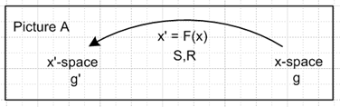

This Appendix begins with a different definition of something called Ek. Although the definition is meaningful in the general Picture A context, the object so defined only agrees with the Ek of Section 6 if x-space is Cartesian (g = 1). The reason can be traced to the fact that the dot product rule en • Em = δn,m is only valid for the Appendix A definition of Em when g = 1 because only then is a cross product orthogonal to all its component vectors. One application of the reciprocal base vectors is in the study of curvilinear coordinates where one always takes g = 1, and g' is then the curvilinear coordinates metric tensor of interest. Therefore, the reader should think of this Appendix in the context of Picture B

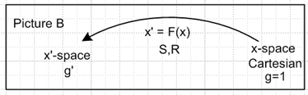

(a) Definition of En

The reciprocal base vectors are defined in the following very strange looking and clumsy manner,

(Ek)α ≡ det(R) (-1)k-1 εαi$_{1}$i$_{2}$i$_{3}$...i$_{k}$...i$_{N}$ (e1)i$_{1}$ (e2)i$_{2}$ ...... (ek)i$_{k}$.......... (eN)i$_{N}$

where N is the number of dimensions of the Cartesian x-space RN in which the vectors en and En exist. Notice that the ε subscript ik is "crossed out" and the same for factor (ek)i$_{k}$ . Crossed out means they are simply missing, they are omitted. Thus, in the above expression there are N-1 implied summation indices (α is fixed) and there are N-1 factors of the form (en)i$_{n}$ .
The object ε has N subscripts and is the "totally antisymmetric tensor" in N dimensions: ε123...N ≡ +1, and each time any two indices on ε are swapped, ε negates. For example, ε1234 = 1 but ε1432= -1. If two indices are the same, then ε = 0.

(b) Simpler notation

To avoid dealing with subscripts on subscripts, one can rewrite the above definition in a less precise but simpler notation

(Ek)α ≡ det(R) (-1)k-1εαabc...x (e1)a(e2)b ...... (eN)x // κ(k) and (ek)κ are missing

In this notation, subscript x stands for the Nth letter of the alphabet (imagine N ≤ 26). If κ is the kth letter of the alphabet, then κ is missing from the indices on ε, and the factor (ek)κ is missing from the product of factors. For example, if k = 2, then summation index κ = b is missing from the ε.
Now take the ε subscript α and slide it right to the "hole" where κ is missing, picking up a minus sign for each step of this slide. Moving k-1 positions results in (-1)k-1. Thus the above becomes,

(Ek)α ≡ det(R) εabc..α..x (e1)a(e2)b ...... (eN)x // (ek)κ is missing, α in κ position (the kth)

Example: For N = 3 the above becomes,

(E1)α ≡ det(R) εαbc(e2)b(e3)c => E1 = det(R) e2 x e3 a is missing
(E2)α ≡ det(R) εaαc(e1)a(e3)c => E2 = det(R) e3 x e1 b is missing
(E3)α ≡ det(R) εabα(e1)a(e2)b => E3 = det(R) e1 x e2 c is missing

and the results are cyclic. Here is a detail from the middle line

εaαc(e1)a(e3)c = – εαac(e1)a(e3)c = + εαca(e1)a(e3)c = εαca(e3)c (e1)a = [ e3 x e1]α

(c) Generalized Cross Product of N-1 vectors of dimension N

One can define a generalized "cross product" of N-1 vectors, each of dimension N, in this fashion:

Qa ≡ εabc...x BbCcDd.....Xx

where x and X represent the Nth letter of the alphabet. The ε object is again the totally antisymmetric tensor with N indices. In vector notation one writes this symbolically as

Q = B x C x D x ... x X / N-1 factors, N-2 crosses

This vector notation is defined by the previous line.
The vector Q is orthogonal to all the vectors from which it is constructed! For example (here is the point where Q • C ≡ gabQaCb needs to be QaCa, so g = 1 is required in x-space)

Q • C = CaQa = Ca εabc...x BbCcDd.....Xx = BbDd...Xx { εabc...x CaCc }

But {..} is the contraction of something symmetric under a↔c (CaCc) with something antisymmetric under a↔c (εαabc...x) and therefore {..} = 0. In general

SacAac = Sca Aca // relabel both dummy summation indices
= Sac (-Aac) // S is Symmetric, A is antisymmetric
= - Sac Aac // = the negative of the starting expression
= 0

Similarly, Q•A = 0, Q•B = 0 and so on.
Swapping the position of any two vectors in the generalized cross product causes Q to change sign. For example, swapping B and C,

Qa ≡ εabc...x CbBcDd.....Xx = εacb...x CcBbDd.....Xx // b ↔ c
= - εabc...x BbCcDd.....Xx = -Qa // swap indices on ε

Thus, the notions of orthogonality and interchange are consistent with the regular Q = B x C cross product for N=3.
When N=2, one must be a little careful with this notation. The component equation is

Qa ≡ εab Bb => Q1 = B2 and Q2 = -B1

One might be tempted to express the vector equation as Q = B since there are no "no crosses". This vector equation is wrong, while the component equation is correct. One can rescue the vector notation by a simple trick. When N=2 the vector B can be represented of course as B = B1 + B2 . Imagine this 2D space to be embedded in the usual 3D space with a third axis . Then consider this 3D cross product:

Q = B x => Qa ≡ εabc Bb()c = εabc Bbδ3,c = εab3 Bb = εabBb

Thus, this trick reproduces the correct component equation, and it makes more obvious the fact that Q is orthogonal to B.
Summary: The generalized cross product Q of N-1 vectors each of dimension N can be expressed in both component and vector notation:

Qa ≡ εabc...x BbCcDd.....Xx
Q = B x C x D x ... x X / N-1 factors, N-2 crosses

Q is orthogonal to all the vectors from which it is composed. Swapping any two vectors negates Q. When N=2, one can rescue the otherwise failing vector notation by thinking of it as saying Q = B x .

Comment: Notice that Q = B x C x D is defined for 4-vectors only. This is a completely different animal from the object Q = B x (C x D) which is defined for 3-vectors only. This latter object contains two ε factors, while the former only one.

(d) Missing Man Formation

We now make a small variation in the notation. Start with the above equation,

Qa ≡ εabc...x BbCcDd.....Xx ,

then change a to α, back up all the Latin letters by one (but leave the last as "unknown" x), and assume that some subscript κ and factor Kκ are "missing". The result is,

Qα ≡ εαac...x AaBbCc.....Xx // κ and Kκ are missing

There are still N-1 factors, and one can still write this in vector notation

Q = A x B x C x ... x X // K is missing

and of course it is still true that Q•C = 0, etc. For N=2 the vector notation is rescued as in (c) above.

(e) Apply this Notation to E

Compare the above Qα to the section (a) definition of (Ek)α ,

(Ek)α ≡ det(R) (-1)k-1{ εαabc...x (e1)a(e2)b ...... (eN)x } // κ(k) and (ek)κ are missing; N≥ 2

Therefore, the definition of Eκ for N > 2 can be written in this vector notation,

Ek ≡ det(R) (-1)k-1 e1 x e2 x ......x eN // ek missing; N > 2

The reciprocal base vector Ek is thus orthogonal to all the tangent base vectors from which it is constructed (remember ek is missing)! For example, for N=3 the three E vectors are given by

E1 = det(R) (-1)1-1 e2 x e3 = det(R) e2 x e3
E2 = det(R) (-1)2-1 e1 x e3 = det(R) e3 x e1
E3 = det(R) (-1)3-1 e1 x e2 = det(R) e1 x e2

which agrees with the results quoted above. For N =2 ( E's label corresponds to the missing e's label ),

E1 = det(R) (-1)1-1 e2 x = det(R) e2 x or (E1)k = det(R) εka(e2)a
E2 = det(R) (-1)2-1 e1 x = - det(R) e1 x or (E2)k = -det(R) εka(e1)a

One can combine these two lines into one as follows ( eg, k = 1, then 3-1 = 2, etc)

Ek = det(R) (-1)k-1 e3-k x = det(R) e3-k x or (E1)k = det(R) (-1)k-1εka(e3-k)a

The vector "trick" notation shows that E1•e2 = 0 and E2•e1 = 0,

E1•e2 = det(R) e2 x • e2 = 0
E2•e1 = -det(R) e1 x • e1 = 0

and also

E1•e1 = det(R) εka(e2)a (e1)k = det(R)det[e1, e2] = det(R)det(S) = 1
E2•e2 = -det(R) εka(e1)a (e2)k = -det(R)det[e2, e1] = det(R)det(S) = 1

It is shown next that these N=2 results are special cases of a general fact: Em • en = δm,n .

Section 5 (j) showed that em • en = 'mn . The other two dot products are now considered.

(f) Compute Em • en

One can now compute, for general N,

Ek • ek = (Ek)α(ek)α = { det(R) (-1)k-1εαabc...x (e1)a(e2)b ...... (eN)x } (ek)α
k is missing

Slide α to the right in the ε subscript field and put it into the hole of the missing subscript κ, picking up
(-1)k-1. At the same time, move the (eκ)α to the left and position it in its proper place in the product of factors,

Ek • ek = (Ek)α(ek)α = { det(R) εabc..α..x (e1)a(e2)b ... (eκ)α ... (eN)x }

= det(R) det [e1, e2, e3 .... eN ] = det(R) det(S) = 1 // since RS = 1

We already know that Ek is orthogonal to all the en which form the generalized cross product, therefore

Em • en = δm,n

which is the "duality relation" discussed more generally in Section 6 (b).

(g) Compute En • Em

Since the vectors { en } are linearly independent and thus form a basis in RN, Em can be expanded onto the en ,

Em = Σn An(m) en

δm,k = Em • ek = Σn An(m) en • ek = Σn An(m) 'nk

Multiplying both sides by g'ki and summing on k gives

LHS = Σk g'ki δm,k = g'mi
RHS = Σn An(m) (Σk 'nk g'ki) = Σn An(m) ('g')ni = Σn An(m)δn,i = Ai(m)

Therefore Ai(m) = g'mi so,

Em = Σn An(m) en = Σn g'mn en

which is to say Ek is this linear combination of the ei (this is the definition used in Section 6 (a))

Ek = Σi g'ki ei = g'ki ei // implied sum on i // Std Notation: ek = Σi g'ki ei

which may be compared with the previous result

Ek ≡ det(R) (-1)k-1 e1 x e2 x ......x eN // ek missing;

It seems rather impressive that these two dissimilar ways of writing E are equal. Finally,

En • Em = En • (g'mi ei) = g'mi (En • ei) = g'mi δn,i = g'mn = g'nm // recall g' symmetric

(h) Summary of relationship between the tangent and reciprocal base vectors

en • em = 'nm En • Em = g'nm en • Em = δn,m
En = Σi g'ni ei en = Σi 'ni Ei ' = g'-1

Although these results have just been derived in the Picture B context, they are also valid in the more general Picture A context, as shown in Section 6 in which the equation En = Σi g'ni ei is used as the definition of En . As a reminder, the cross product expression for En is only valid in Picture B.

In Standard Notation, the summary above can be restated as

en • em = g'nm en • em = g'nm en • em = δnm
en = Σi g'ni ei en = Σi g'ni ei g'ab = (g'ab) -1

(i) Another Cross Product Notation and another expression for E

Go back to the general cross product of N-1 vectors each of dimension N,

Q = B x C x D x ... x X // N-1 factors, N-2 crosses

Replace B,C,D ... by vectors A(n),

Q = A(1) x A(2) x A(3) x ... x A(N-1) // N-1 factors, N-2 crosses

It is convenient to write this as

Q = Πxi=1N-1 A(i) = Πxi A(i)

where in the second form it is understood that i takes on all values i = 1 to N-1. The superscript x means that this is not a regular product, it is our generalized cross product. This Πx symbol also implies correct handling of the special case N=2 such that

Q = Πxi=11 A(i) = A(1) x // ≠ A(1)

as discussed in section (c) above.
This same Πx notation can be applied to the "missing man formation" of (d) above. Suppose

Q = A(1) x A(2) x A(3) x ... x A(N) // A(n) is missing

One can write this as

Q = Πxi=1..N,i≠n A(i) ≡ Πxi≠n A(i)

And of course this idea can be applied to the expression for Ek

Ek = det(R) (-1)k-1 e1 x e2 x ......x eN // ek missing;

Ek = det(R) (-1)k-1 Πxi≠k ei

Once again, for N=2 the Πx symbol implies that ( ek = "missing", e3-k = the one not missing)

Πxi≠k ei = Πxi=1..2,i≠k ei = e3-k x

Ek = det(R) (-1)k-1 e3-k x

which is the "trick" notation of section (c) above for the N=2 case.

Appendix B: The Geometry of Parallelepipeds in N dimensions

Introduction

This Appendix presents a simple method for constructing an N dimensional parallelepiped, which name we shorten to "N-piped". It is found that an N-piped has 2N vertices and N pairs of faces for a total of 2N faces, and the locus of points that make up each of these faces is stated. Each face of an N-piped is in fact an (N-1)-piped which has 2N-1 vertices and is planar in N dimensions (meaning it lies on an N-1 dimensional flat surface). The two faces which make up each face pair lie on parallel planes in RN.
For example, for N=3 each face is a 2-piped having 23-1 = 4 vertices, and there are N=3 face pairs for a total of 6 faces, and each pair of faces is planar in 3 dimensions.
For N=4 there are 4 pairs of faces for a total of 8 faces. Each face is a 3-piped having 24-1 = 8 vertices. For example, one would say that each face of a 4-cube is a 3-cube. It is not intuitively obvious that two faces each of which is a regular cube can in fact lie on surfaces which are planar and parallel in 4 dimensions, but we show how this works below.
It is then shown that, if the N-piped is spanned by the N tangent base vectors en of Section 3, the normal vectors for the pairs of parallel faces are just the reciprocal base vectors En of Section 6.
Section (d) focuses on the area and volume of N-pipeds in various dimensions, and simple expressions for the volume and vector areas of the faces of an N-piped are obtained.
Rather than just state the results in N dimensions, we attempt an inductive approach to provide motivation for the N dimensional results. In this approach, cases N = 2,3.. are treated with nearly identical boilerplate templates to build up the inductive case.
All major results of this Appendix are concisely stated in Summary section (e). Since this is a very long section (~15 p), a reader not interested in details would do well to simply read that summary and skip the rest of this Appendix.

(a) Preliminary: Equation of a plane in N dimensions

Consider an arbitrary plane drawn in N space which does not pass through the origin. There is some point on that plane which lies closer to the origin than all other points on the plane. Let p be a vector from the origin to that closest point, and let r represent a point lying on the plane,

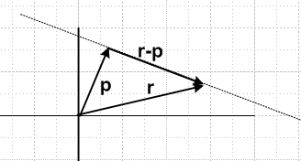

Since p is normal to the plane, and since r-p is a vector lying in the plane, it follows that

p•(r-p) = 0 => r•p = p2 => r• = p

Therefore, one way to write the equation of a plane in N dimensions is

r• = p r = (x1, x2, .....xN)

where is the unit vector normal to the plane which points "away from the origin", and where p > 0 is the distance of closest approach of the plane to the origin. In the limit p→0, the plane passes through the origin and the equation is then r• = 0 where is either normal to the plane.

(b) N-pipeds and their Faces in Various Dimensions

The 1-piped

Start with N = 1 where the piped is some arbitrary line segment e1 in direction 1 having length e1, with one end affixed to the origin of the real axis.

N=1 rvolume1 = α1 e1 0 ≤ α1 ≤ 1

This piped has two vertices located at v1 = 0 and v2 = e1. These two vertices are also the "faces" of this 1-piped, so there are two faces (one pair of faces). These faces are 0 dimensional and therefore don't point in any direction (they are the endpoints of the segment). The 1-piped is a piece of a plane in 1 dimension (a line). One can think of the vertex at the origin as the "generator 0-piped" and the other vertex as the partner face of the generator, in the sense of the generator idea described below.

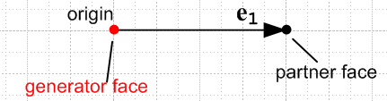

The volume of this 1-piped is e1.

The 2-piped

Now add another dimension, going to N=2. Introduce a unit vector e2 in some arbitrary direction in R2 other than e1 so that e1 and e2 are linearly independent. Take the 1-piped described above (line segment) and translate it by e2 to create a new copy of the line segment. The original 1-piped we call the generator piped, and the copy is the partner of the generator piped which, it will be shown, lies on a plane (a 1-plane = line) which is parallel to the plane of the generator piped, but its plane does not pass through the origin. In N=2 dimensions, the generator 1-piped and its partner are now "faces" of a 2-dimensional object, a parallelogram = a 2-piped. Draw line segments from all the vertices of the generator piped to matching vertices of its partner piped (add 2 line segments) to make 2 additional "side" faces. One of these faces necessarily touches the origin, and the other face does not. Faces always occur in parallel pairs one of which touches the origin, and one of which does not, the latter we will call the "partner" face. For our 2-piped, each face is a 1-piped. There are now four faces, each is a line segment.

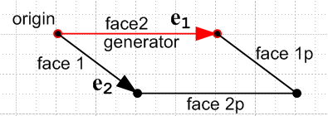

The loci of the 2-piped's volume and of its four 1-piped faces are given by

rvolume2 = α1e1 + α2 e2 0 ≤ α1,α2 ≤ 1

rface2 = α1e1 0 ≤ α1 ≤ 1 // the generator face
rface2p = α1e1 + e2 0 ≤ α1 ≤ 1 // partner of the generator face
rface1 = α2e2 0 ≤ α2 ≤ 1 // side face touching the origin
rface1p = α2e2 + e1 0 ≤ α2 ≤ 1 // partner of the above side face

The origin-touching faces are numbered using the index of the en vector that does not appear in the locus for the face. This seems strange but for N > 2 it will be clear why this is done.

It is possible to construct vectors E1 and E2 as linear combinations of e1 and e2 such that the following is true (see Section 6 (b))

Ei• ej = δi,j // Ek = Σi=12 g'ki ei , see Section 6 (a)

If one interprets the en vectors as tangent base vectors for some transformation F, then the two vectors En are the corresponding reciprocal base vectors which are discussed in Section 6 and Appendix A.

Consider now these dot products:

E2 • rface2 = E2 • α1e1 = 0 => 2 • rface2 = 0
E2 • rface2p = E2 • [ α1e1+ e2] = 1 => 2 • rface2p = 1/E2

The first line says (section (a) above) that face 2 lies on a plane which passes through the origin and which has normal vector 2. The second line says that face 2p has the same normal and its plane is therefore parallel to face 1 but misses the origin by distance 1/|E1|. Similarly,

E1 • rface1 = E1 • α2e2 = 0 => 1 • rface1 = 0
E1 • rface1p = E1 • [ α2e2+ e1] = 1 => 1 • rface1p = 1/E1

These two faces are also parallel, both having normal 1. The first touches the origin while the partner's plane misses the origin by distance 1/|E1| .

The conclusions that En is normal to face n and that the pair of faces n and np are parallel do not depend on the specific upper endpoints of the ranges of α1 and α2 which happen to be given as 1 above. This seems pretty obvious since rescaling the edges of a parallelogram does not affect its normal vector.

The 3-piped

Now add another dimension, going to N=3. Introduce a unit vector 3 in some arbitrary direction in R3 so that (1,2,3) are linearly independent. Take the 2-piped described above (parallelogram) and translate it by distance e3 in the 3 direction to create a new copy of the 2-piped. The original 2-piped we call the generator piped, and the copy is the partner of the generator piped which, as will now be shown, lies on a plane which is parallel to that of the generator piped, but which does not pass through the origin. In N=3 dimensions, the generator 2-piped and its partner are now "faces" of a 3-dimensional object, a parallelepiped = a 3-piped. Draw line segments from all 22 vertices of the generator piped to the corresponding vertices of its partner piped (add 4 line segments), to get 4 additional side faces. Two of these faces necessarily touch the origin, and the other two do not. For the 3-piped, each face is a 2-piped. There are now 2*3 = 6 faces, each is a 2-piped.

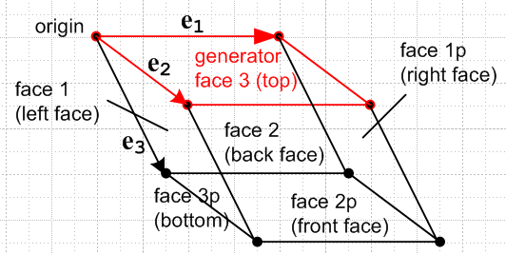

The loci of the 3-piped's volume and of its six 2-piped faces are given by

rvolume3 = α1e1 + α2 e2 + α3 e3 0 ≤ α1,α2,α3 ≤ 1

rface3 = α1e1 + α2 e2 0 ≤ α1,α2 ≤ 1 // the generator face
rface3p = α1e1 + α2 e2 + e3 0 ≤ α1,α2 ≤ 1 // partner face to the above
rface2 = α1e1 + α3 e3 0 ≤ α1,α3 ≤ 1 // the generator face
rface2p = α1e1 + α3 e3 + e2 0 ≤ α1,α3 ≤ 1 // partner face to the above
rface1 = α2e2 + α3 e3 0 ≤ α2,α3 ≤ 1 // the generator face
rface1p = α2e2 + α3 e3 + e1 0 ≤ α2,α3 ≤ 1 // partner face to the above

Notice that the partner face locus is created from the non-partner face by adding "the other" base vector. For example, face 3 is "spanned" by base vectors e1 and e2 so e3 is added to get the partner. A partner is just a copy of the non-partner which is translated by a constant vector. The above results can be summarized in this concise manner:

rvolume3 = Σnαnen 0 ≤ αn ≤ 1

rface(i) = Σn≠iαnen 0 ≤ αn ≤ 1 i = 1,2,3
rface(ip) = Σn≠iαne + ei 0 ≤ αn ≤ 1 i = 1,2,3

It is possible to construct vectors E1, E2, E3 as linear combinations of e1, e2, e3 such that the following is true (see Section 6 (b))

Ei• ej = δij // Ek = Σi g'ki ei , see see Section 6 (a)

If one interprets the en vectors as tangent base vectors, then the three vectors En are the corresponding reciprocal base vectors which are discussed in Section 6 and Appendix A. Consider now these dot products:

E1• rface1 = E1• [ α2e2 + α3 e3] = 0 => 1• rface1 = 0
E1• rface1p = E1• [α2e2 + α3 e3 + e1] = 1 => 1• rface1p = 1/E1

The first line says that face 1 lies on a plane which passes through the origin and which has normal vector 1. The second line says that face 1p has the same normal and its plane is therefore parallel to face 1 but misses the origin by distance 1/|E1|
A similar pair of equations obtains for each of the other face pairs.

The N-piped

Now add another dimension, going from N-1 to N. Introduce a unit vector N in some arbitrary direction in RN so that ( 1... N ) are linearly independent. Take the (N-1)-piped described above and translate it by distance eN in the N direction to create a new copy of the (N-1)-piped. The original (N-1)-piped we call the generator piped, and the copy is the partner of the generator piped which, it will be shown, lies on a plane which is parallel to that of the generator piped, but which does not pass through the origin. The generator (N-1)-piped and its partner are now "faces" of a N-dimensional object, an N-piped. Adding this partner piped doubles the total vertex count. Draw line segments from all 2N-1 vertices of the generator piped to the corresponding vertices of its partner piped to get 2N-2 additional side faces for a total now of 2N faces. There are N pairs of "faces" because there are N ways to omit a single ei from the list of vectors which span a face, so including the partner faces an N-piped has 2N faces in total. Half of these faces necessarily touch the origin, and the other half do not. Each face is an (N-1)-piped.
It is convenient to refer to the partner face of a pair as "the far face" and the other one, which touches the origin, as "the near face".

The loci of the N-piped's volume and of its 2N (N-1)-piped faces are given by:

rvolumeN = Σnαnen 0 ≤ αn ≤ 1
rface(i) = Σn≠iαnen 0 ≤ αn ≤ 1 i = 1,2...N
rface(ip) = Σn≠iαnen + ei 0 ≤ αn ≤ 1 i = 1,2...N

Notice that the partner face locus is created from the non-partner face by adding "the other" base vector. For example, face i is "spanned" by base vectors en n ≠ i, so it is ei that one adds to get the partner. A partner is just a copy of the non-partner which is translated by a constant vector.

It is possible to construct vectors E1...EN as linear combinations of e1.. eN such that the following is true (see Section 6 (b))

Ei• ej = δij // Ek = Σi g'ki ei

If one interprets the en vectors as tangent base vectors, then the N vectors En are the corresponding reciprocal base vectors which are discussed in Section 6 and Appendix A. Consider now these dot products:

Ei• rface(i) = Ei• [Σn≠iαnen] = 0 => i• rface(i) = 0
Ei• rface(ip) = Ei• [Σn≠iαne + ei] = 1 => i• rface(ip) = 1/Ei

The first line says that face i lies on a plane which passes through the origin and which has normal vector i. The second line says that face ip has the same normal and its plane is therefore parallel to face i but misses the origin by distance 1/|Ei|

(c) The question of inward versus outward facing normal vectors.

It has been shown above that, for an N-piped, the pair of faces i and ip has normal vector Ei. For one of these faces, Ei will be an outward directed normal, while for the other it will be an inward directed normal. One might like to know which is which. Here is one way to find out.
First, construct these three vectors

(piped)center = Σn(1/2)en // vector from origin to piped center

(face i)center = Σn≠i(1/2)en // vector from origin to center of face i

(face ip)center = Σn≠i(1/2) en + ei // vector from origin to center of face ip

Construct vectors from piped center to face centers ( results here are fairly obvious)

(face i)center - (piped)center = [Σn≠i(1/2)en] - Σn(1/2)en = - (1/2)ei
(face ip)center - (piped)center = [Σn≠i(1/2)en+ ei ] - Σn(1/2)en = + (1/2)ei

Then compute

Ei • {(face i)center - (piped)center } = Ei • [- (1/2)ei ] = -(1/2) < 0
Ei • {(face ip)center - (piped)center } = Ei • [+ (1/2)ei ] = +(1/2) > 0

One may conclude that Ei is an outward pointing normal for face ip (far face). Therefore, - Ei is an outward pointing normal for face i, which recall is the face which touches the origin (near face).

(d) The Face Area and Volume of N-pipeds in Various Dimensions

We embark now on another long march to inductively arrive at results for the general N case. Tracing the first few cases N = 2,3,4 and then extrapolating to N = N probably gives more insight than a formal induction proof which is not attempted here. Each case below is treated with the same boilerplate template which first treats Face Area and then Volume.

The 2-piped

Face Area. The area of a 2-piped face (a line segment) is just the length of the edge which is the face,

A1 = |e2|
A2 = |e1|

where here we maintain the plan of labeling an area by the index of the spanning vector which is omitted in making the area. The vector areas can be written, based on the work above,

A1 = |e2| 1 // Ek = Σi g'ki ei , see Appendix A (g)
A2 = |e1| 2

and these vectors are out-facing for faces 1p and 2p. We claim that both these results can be expressed in a single formula

An = |det(S)| En .

One can see that the direction is correct for n = 1,2, so it is just a question of verifying the magnitude. One must show that

|det(S)| |E1| = |e2| and |det(S)| |E2| = |e1|
or
|Ek| = |det(R)| |e3-k| k=1,2 // RS = 1

Using the N=2 trick notation from Appendix A (c),

Ek = det(R) (-1)k-1 e3-k x
so that
| Ek | = | det(R)| | e3-k x | = |det(R)| | e3-k| k = 1,2

since e3-k and are perpendicular. QED.
We stress the formula An = |det(S)| En because it will turn out that this is valid for all N ≥ 2 .
One can restate An = |det(S)| En using the cross product notation presented in Appendix A (i):

An = |det(S)| En = |det(S)| det(R) (-1)n-1 Πxi≠n ei

= σ (-1)n-1 Πxi≠n ei σ ≡ sign(det(S)) = sign(det(R))

Volume. The volume of a 2-piped is the base times the height of a parallelogram, familiarly given as by the cross product of the edges,

volume(2) = | e1 x e2 | = | εab (e1)a(e2)b | = | det [ e1, e2 ] | = | det(S) |

where S is the linearized transformation matrix for N=2, see Section 2. Of course strictly in N=2 the notation e1 x e2 has no meaning, so one has to imagine a dimension to give it meaning. The second form does have a meaning for N=2, and that meaning is |(e1)1 (e2)2 – (e1)2 (e2)1|.

The 3-piped

Face Area: The faces of a 3-piped are 2-pipeds. For N=2, the 2-piped volume was

volume(2) = | εab (e1)a(e2)b | ,

where e1 and e2 were 2D vectors. For the 2-piped which is "face 3" of the 3-piped -- a "near" face which touches the origin of the 3D skewed en coordinate system -- vectors e1 and e2 are 3D vectors. The first 2 components of each of these 3D vectors are the same as the components of the 2D ei vectors, while the 3rd components are both 0. This is so because face 3 lies in a plane defined by this 3rd component being 0. The volume(2) formula expressed in terms of these new 3D vectors is therefore |εab3 (e1)a(e2)b|, where ε is now a 3D ε tensor. The conclusion is that

A3 = |εab3 (e1)a(e2)b|

and this then is the scalar area of both face 3 and its partner face 3p, the far face. Similar arguments would then support these other area expressions

A1 = |ε1ab (e2)a(e3)b|
A2 = |εa2b (e3)a(e1)b|

Since indices on ε can be swapped for free due to the absolute value, the non-summed index can be put first in all three cases and one may then conclude that

A1 = |e2 x e3| face 1 and face 1p
A2 = |e3 x e1| face 2 and face 2p
A3 = |e1 x e2| face 3 and face 3p

In Appendix A (e) it was shown that E1 = det(R) e2 x e3 so that e2 x e3 lines up with E1. Regardless of the sign of det(R), we define the vector areas to point in the +n directions. Thus,

A1 ≡ |e2 x e3| 1 face 1p out-facing
A2 ≡ |e3 x e1| 2 face 2p out-facing
A3 ≡ |e1 x e2| 3 face 3p out-facing

These equations can be combined into the following single formula

An = |e1 x ... x e3| n // en missing

where the ei are reordered for free due to the absolute value signs. But Appendix A says

En = det(R) (-1)n-1 e1 x ... x e3 // en missing
so
|En| = | det(R) | | e1 x ... x e3 | // en missing

Thus,
An = n |En| / |det(R)| = |det(S)| En
= |det(S)| det(R) (-1)n-1e1 x ... x e3 // en missing
= σ (-1)n-1e1 x ... x e3 // en missing
where σ ≡ sign[det(S)] = sign[det(R)]

To summarize, for N=3 one has

An = |det(S)| En = σ (-1)n-1e1 x ... x e3 // en missing
= σ (-1)n-1 Πxi≠n ei

where the last line uses the shorthand notation of Appendix A (i). These expressions have the same form as those of the 2-piped.

Volume. The volume of a 3-piped (with each of the above An in turn treated as the base) is base times height, so

volume(3) = | A1 • e1 | = | A2 • e2 | = | A3 • e3 |
or
volume(3) = | e2 x e3 • e1 | = | e3 x e1 • e2 | = | e1 x e2 • e3 |
Here is a drawing showing the last case (σ = +1), where "base" is A3 = | e1 x e2 | and "height" is e3 cosθ ,

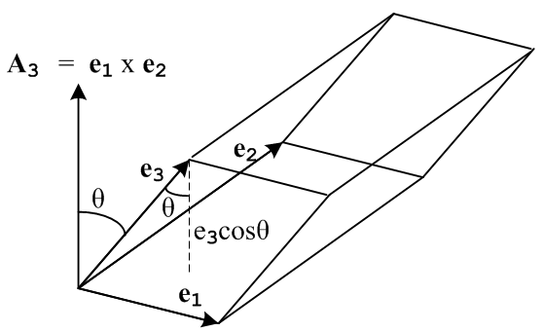

Using ε notation one can write

e3 • e1 x e2 = (e3)i εijk(e1)j(e2)k = εijk (e1)j(e2)k (e3)i = εjki (e1)j(e2)k(e3)i

= det [ e1, e2, e3] = det(S)
so that

volume(3) = | e3 • e1 x e2 | = | εabc (e1)a(e2)b(e3)c | = | det [ e1, e2, e3] | = | det(S) |

These expressions have the same form as those of the 2-piped.

The 4-piped

Face Area: The faces of a 4-piped are 3-pipeds. For N=3, the 3-piped volume was

volume(3) = | εabc (e1)a(e2)b(e3)c |

where e1,e2,e3 were 3D vectors. For the 3-piped which is "face 4" of the 4-piped -- a "near" face which touches the origin of the 4D skewed en coordinate system -- vectors e1,e2,e3 are 4D vectors. The first 3 components of each of these 4D vectors are the same as the components of the 3D ei vectors, while the 4th components are all 0. This is so because face 4 lies in a plane defined by this 4th component being 0. The volume(3) formula expressed in terms of these new 4D vectors is therefore | εabc4 (e1)a(e2)b(e3)c |, where ε is now a 4D ε tensor. The conclusion is that

A4 = | εabc4 (e1)a(e2)b(e3)c |

and this then is the scalar area of both face 4 and its partner face 4p, the far face. Similar arguments would then support these other area expressions

A1 = | ε1abc (e2)a(e3)b(e4)c |
A2 = | εa2bc (e3)a(e4)b(e1)c |
A3 = | εab3c (e4)a(e1)b(e2)c |

Since indices on ε can be swapped for free due to the absolute value, the non-summed index can be put first in all three cases and one may then conclude that

A1 = |e2 x e3 x e4| face 1 and face 1p
A2 = |e3 x e4 x e1| face 2 and face 2p
A3 = |e4 x e1 x e2| face 3 and face 3p
A4 = |e1 x e2 x e3| face 4 and face 4p

where, as discussed in Appendix A (c),

Q = A x B x C is defined by Qk = εkabc AaBbCc .

In Appendix A (e) it was shown that E1 = det(R) e2 x e3 x e4 so that e2 x e3 x e4 lines up with E1. Regardless of the sign of det(R), we define the vector areas to point in the +n directions. Thus

An = |e1 x ... x e3| n // en missing n = 1,2,3,4

where the ei are reordered for free due to the absolute value signs. But Appendix A says

En = det(R) (-1)n-1 e1 x ... x e4 // en missing
so
|En| = | det(R) | | e1 x ... x e4 | // en missing

Thus,
An = |En| n / |det(R)| = |det(S)| En
= |det(S)| det(R) (-1)n-1e1 x ... x e4 // en missing
= σ (-1)n-1e1 x ... x e4 // en missing σ ≡ sign[det(S)] = sign[det(R)]

To summarize, for N=4 one has

An = |det(S)| En = σ (-1)n-1e1 x ... x e4 // en missing
= σ (-1)n-1 Πxi≠n ei σ ≡ sign[det(S)] = sign[det(R)]

These expressions have the same form as those of the 2-piped and the 3-piped.

Volume. The volume of a 4-piped (with each of the above An in turn treated as the base) is base times height, so

volume(4) = | A1 • e1 | = | A2 • e2 | = | A3 • e3 | = | A4 • e4 |
or
volume(4) = | e2 x e3 x e4 • e1 | = | e3 x e4 x e1 • e2 | = | e4 x e4 x e1 • e3 | = | e1 x e4 x e2 • e4 |

Using ε notation one can write the first case as

e2 x e3 x e4 • e1 = (e1)a εabcd(e2)b(e3)c(e4)d = εabcd(e1)a(e2)b(e3)c(e4)d

= det [ e1, e2, e3, e4] = det(S)
so that

volume(4) = | det(S) | = | det [ e1, e2, e3, e4] | = | εabcd(e1)a(e2)b(e3)c(e4)d |

These expressions have the same form as those of the 2-piped and the 3-piped.

The N-piped

Face Area: The faces of a N-piped are (N-1)-pipeds. If there had been an (N-1)-piped section prior to this one, the volume formula there would have been

volume(N-1) = | εabc...x (e1)a(e2)b... (eN-1)x |

where e1,e2,...eN-1 were (N-1)D vectors. For the N-piped which is "face N" of the N-piped -- a "near" face which touches the origin of the ND skewed en coordinate system -- vectors e1,e2,...eN-1 are ND vectors. The first N-1 components of each of these ND vectors are the same as the components of the (N-1)D ei vectors, while the Nth components are all 0. This is so because face N lies in a plane defined by this Nth component being 0. The volume(N-1) formula expressed in terms of these new ND vectors is therefore | εabc...xN (e1)a(e2)b... (eN-1)x |, where ε is now an ND ε tensor. The conclusion is that

AN = | εabc...xN (e1)a(e2)b... (eN-1)x |

and this then is the scalar area of both face N and its partner face Np, the far face. Similar arguments would then support similar expressions for the other faces, for example,

A1 = | ε1abc...x (e2)a(e3)b... (eN-1)w (eN)x |
A2 = | εa2bc...x (e3)a(e4)b... (eN)w (e1)x |

Since indices on ε can be swapped for free due to the absolute value, the non-summed index can be put first in all three cases and one may then conclude that

A1 = |e2 x e3 x e4 x e5... x eN| face 1 and face 1p
A2 = |e3 x e4 x e5 x e6... x e1| face 2 and face 2p
A3 = |e4 x e5 x e6 x e7... x e2| face 3 and face 3p
...
AN = |e5 x e6 x e7 x e8.. x e3| face N and face Np

where, as discussed in Appendix A (c),

Q = A x B x C.... X is defined by Qk = εkabc...x AaBbCc .....Xx

In Appendix A (e) it was shown that E1 = det(R) e2 x e3 ... eN so that e2 x e3 ... eN lines up with E1. Regardless of the sign of det(R), we define the vector areas to point in the +n directions. Thus

An = |e1 x ... x eN| n // en missing n = 1,2,3...N

where the ei are reordered for free due to the absolute value signs. But Appendix A says

En = det(R) (-1)n-1 e1 x ... x eN // en missing
so
|En| = | det(R) | | e1 x ... x eN | // en missing

Thus,

An = |En| n / |det(R)| = |det(S)| En
= |det(S)| det(R) (-1)n-1e1 x ... x eN // en missing
= σ (-1)n-1e1 x ... x eN // en missing σ ≡ sign[det(S)] = sign[det(R)]

To summarize, for N=N one has

An = |det(S)| En = σ (-1)n-1e1 x ... x eN // en missing
= σ (-1)n-1 Πxi≠n ei σ ≡ sign[det(S)] = sign[det(R)]

These expressions have the same form as those of the 2-piped, the 3-piped and the 4-piped.

Volume. The volume of a N-piped (with each of the above An in turn treated as the base) is base times height, so

volume(N) = | A1 • e1 | = | A2 • e2 | = ... = | AN • eN |
or
volume(N) = | e2 x e3 x e4....eN • e1 | = ...

Using ε notation one can write the first case as

e2 x e3 x e4...eN • e1 = (e1)a εabc...x(e2)b(e3)c.....(eN)x = εabc...x(e1)a(e2)b(e3)c....(eN)x

= det [ e1, e2, e3, ....eN] = det(S)

where x is the Nth letter of the alphabet, so that

volume(N) = | det(S) | = | det [ e1, e2, e3, ....eN] | = | εabc...x(e1)a(e2)b(e3)c....(eN)x |

These expressions have the same form as those of the 2-piped, the 3-piped and the 4-piped. This result is also consistent with the volume(N-1) expression stated above.

(e) Summary of Main Results of this Appendix

1. One way to write the equation of a plane in N dimensions is

r• = p r = (x1, x2, .....xn)

where is the unit vector normal to the plane which points "away from the origin", and where p > 0 is the distance of closest approach of the plane to the origin. In the limit p→0, the plane passes through the origin and the equation is then r• = 0 where is either normal to the plane.

2. An N-piped has 2N vertices as demonstrated by the inductive construction method presented above.

3. The locus of points making up the (closed) interior of an N-piped spanned by e1...eN is given by

rvolumeN = Σn=1Nαnen 0 ≤ αn ≤ 1

The tails of all the vectors e1...eN meet at the origin of RN space.

4. There are N pairs of faces on an N-piped, and each face is an (N-1)-piped having 2N-1 vertices. The total face count is 2N. Each face is spanned by a subset of N-1 of the base vectors en, so each face is "missing" one of the en and the face is labeled using the index of this missing base vector. The loci of points making up the faces of an N-piped are given by

rface(i) = Σn≠iαnen 0 ≤ αn ≤ 1 i = 1,2...N
rface(ip) = Σn≠iαnen + ei 0 ≤ αn ≤ 1 i = 1,2...N

where "face i" has a corner touching the origin of the N-piped (near face), while its parallel partner face "ip" does not touch the origin (far face).

5. If the N-piped spanning vectors en are the tangent base vectors associated with some transformation F, then Ei• ej = δi,j where Ei are the reciprocal base vectors. In this case, the equations of the faces of the N-piped can be written in the form shown in item 1 above,

i• r(face i) = 0 i• r(face ip) = 1/Ei i = 1,2...N

so that both faces of a pair i are planar (in N dimensional space) and they have the same normal vector i so the faces of a pair lie on parallel planes.

6. The vector Ei is an outward-facing normal for face ip, while -Ei is an outward-facing normal vector for face i (which touches the origin).

7. The out-facing vector area of face ip of an N-piped can be expressed as

Ai = |det(S)| Ei

Ai = σ (-1)i-1 Πxj≠i ej σ ≡ sign[det(S)] = sign[det(R)]

Ai = σ (-1)i-1 e1 x e2 ... x eN // ei missing

where ei is the vector missing from the face's spanning set. The outfacing area for face i is - Ai. The last two lines are shorthands for the following, as discussed in Appendix A (i),

(Ai )α = σ (-1)i-1 εαabc..x (e1)a (e2)b ... (eN)x // where (ei)ί and ί are missing

For N=2 the last two expressions for Ai are interpreted as shown in Appendix A (c)

Ai = σ (-1)i-1 e3-i x i = 1,2

8. The volume of an N-piped spanned by e1...eN is given by

volume(N) = | det(S) | = | det [ e1, e2, e3, ....eN] | = | εabc...x(e1)a(e2)b(e3)c....(eN)x |

where one can regard the tangent base vectors as the columns of the linearized transformation matrix S.

Appendix C: Elliptical Polar Coordinates ( N=2, non-orthogonal)

This Appendix is written in the developmental notation of Sections 1-6.

(a) Elliptical polar coordinates

The 2D "elliptic" coordinate system has coordinate lines which are orthogonal ellipses and hyperbolas. When rotated about its two symmetry axes, this system generates 3D prolate or oblate spheroidal coordinates. This is not the 2D coordinate system described in this Appendix. For "elliptical polar" coordinates, the coordinate lines are taken instead as the ellipses from elliptic coordinates, and the rays from polar coordinates. This non-orthogonal system is perhaps not very useful, but provides a good "sandbox" in which to study general aspects of coordinate systems.
The transformation x' = F(x) is given by
x'-space x-space (Cartesian)
ρ2 = x2/a2 + y2/b2 x2+ y2 = r2 still x'1 = θ x1= x
tanθ = y/x x'2 = ρ x2 = y

Writing the first equation above as

1 = x2/(ρa)2 + y2/(ρb)2

it should be clear that ρ serves to label an ellipse of semi-major axis ρa, and semi-minor axis ρb, while θ labels the ray at angle θ, as in polar coordinates. The inverse transform x = F-1(x') is given by

x = aρcosθ x/a = ρcosθ => x2/a2 + y2/b2 = ρ2
y = bρsinθ y/b = ρsinθ => tanθ = y/x

The matrix S is given by

S11 = (∂x/∂θ) = -aρsinθ
S12 = (∂x/∂ρ) = acosθ Sik ≡ ( ∂xi/∂x'k)
S21 = (∂y/∂θ) = bρcosθ
S22 = (∂y/∂ρ) = bsinθ

S = $\left(\begin{matrix}-aρsinθ & acosθ \\ bρcosθ & bsinθ\end{matrix}\right)$ => det(S) = -abρ and R = S-1 = $\left(\begin{matrix}-sinθ/(aρ) & cosθ/(bρ) \\ cosθ/a & sinθ/b\end{matrix}\right)$

The tangent base vectors en can be read off as the columns of S

e1 = ρ(-asinθ,bcosθ) = eθ |eθ| = ρ $\sqrt{a2sin2θ + b2cos2θ}$≡ hθ eθ = |eθ| θ
e2 = (acosθ,bsinθ) = eρ |eρ| = $\sqrt{a2cos2θ + b2sin2θ}$ ≡ hρ eρ = |eρ| ρ

The covariant metric tensor is,

' = STS = $\left(\begin{matrix}ρ2\{a2sin2(θ) + b2cos2(θ)\} & [b2-a2]ρ sin(θ)cos(θ) \\ [b2-a2]ρ sin(θ)cos(θ) & a2cos2(θ) + b2sin2(θ)\end{matrix}\right)$ = ••••

which is clearly non-diagonal (but symmetric) as expected. When a = b = 1 it reduces to the polar coordinates system metric tensor where then ρ = r. The coordinate system is non-orthogonal because e1•e2 ≠ 0, or equivalently, because ' is non-diagonal.

(b) Forward coordinate lines

Here is a Maple plot of some x-space forward coordinate lines (parameters a = 2 and b = 1)
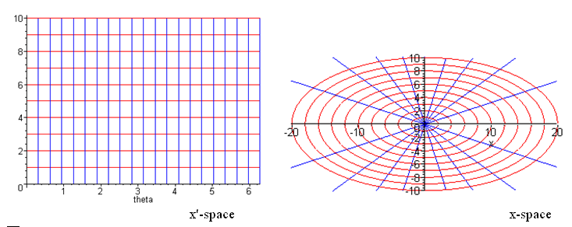

where ρ is the x'-space vertical axis. The coordinate lines in x-space are plotted using these equations,

y = b $\sqrt{ρi2-(x/a)2}$ // ellipses ρi= 1,2...10 10 ellipses
y = x tanθi // rays θi = 2π (i/20) , i = 1,2...20 20 rays

which are obtained from the forward transformation equations

ρ2 = x2/a2 + y2/b2
tanθ = y/x .

(c) Inverse coordinate lines

Here is a Maple plot of some x'-space inverse coordinate lines (parameters a = 2 and b = 1)
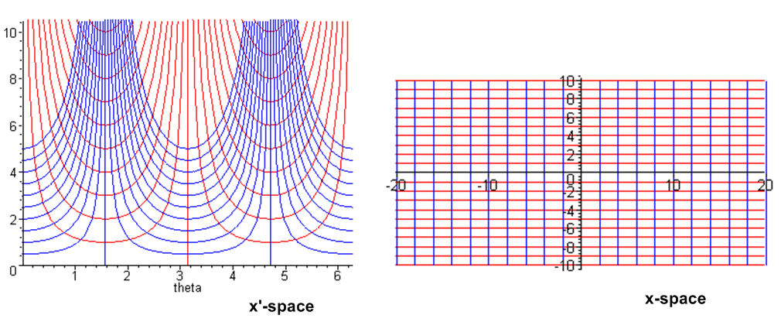
The coordinate lines in x'-space are plotted using these equations

ρ = xi/(acosθ) xi = -10 to +10 21 blue curves( one is a boxy U )
ρ = yi/(bsinθ) yi = -10 to +10 21 red curves ( one is a boxy U)

which are obtained from the inverse transformation equations

x = aρ cosθ
y = bρ sinθ

The secθ and cscθ curve families appear to "change shape", but that is just what happens when functions are scaled up vertically but not horizontally. If one plots one sine hump at different vertical scalings, the humps have different shapes.

(d) Drawing a contravariant vector V in x-space: the meaning of V'n .

A contravariant vector field V(x) can be expanded in these two ways (Section 6 (f))

V = V1(x) + V2(x) = Vx(x) + Vy(x) // un = for Cartesian

V = V'1(x') e1 + V'2(x') e2 = V'θ(x') eθ + V'ρ(x') eρ V'(x') = R(x) V(x)

where the V'n are the components of V transformed into x'-space where V becomes V'. The prime is not necessary on V'ρ but we maintain it as a reminder that it is an x'-space component. R(x) is the matrix of Section 2 and en are the tangent base vectors of Section 3. The fields V'n(x') are "the components of vector field V' in x'-space", since V' = RV , or V'i = RijVj. Moreover, these V'n(x') are "expressed in terms of curvilinear coordinates" x'. If one is asked to "express a vector V in curvilinear coordinates", one is usually being asked to write V as the second expansion above. The vectors en and V exist in x-space, and in the second expansion it just happens that the coefficients V'n(x') are the components of V', the transformed vector in x'-space, when it is expanded on the axis-aligned vectors e'n in x'-space.

Here is a graphical representation of this vector V in x-space:

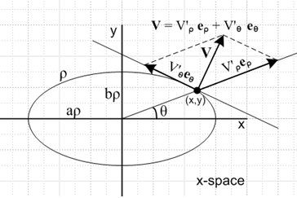

As advertised, the tangent base vectors are not at right angles. The V parallelogram accurately illustrates the equation V = V'θ eθ + V'ρ eρ. Since x-space is Cartesian, there is no distinction between Cartesian length (graphical length) and covariant length for vectors in x-space. Graphically, one could find the values for V'θ and V'ρ as follows: (1) for the point (x,y), compute the vectors eθ and eρ and compute their lengths |eθ| = h'θ and |eρ| = h'ρ ; (2) draw the parallelogram shown aligned with these vectors for some given V and find the edge lengths. The edges of the parallelogram are V'θ h'θ and V'ρ h'ρ so then the values of V'θ and V'ρ can be found.
The alternative method is to compute R and use V'i = RijVj.

(e) Drawing a contravariant vector V' in x'-space: two "Views"

As with previous examples, the above picture is drawn to the right of an x'-space picture as follows:

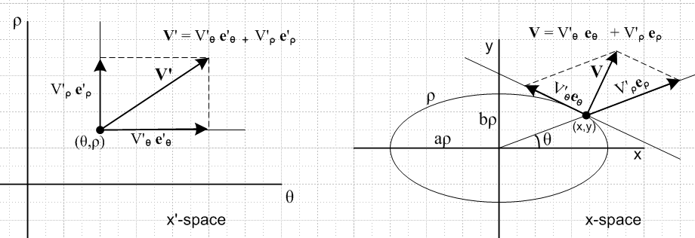

In Section 3 the axis-aligned basis vectors e'n were introduced as

e'n , n = 1,2...N // (e'n)i = δn,i e'1 = (1,0,0...) etc

and en was shown to be a contravariant vector,

e'n = R(x) en.

Applying matrix R(x) to the equation V = V'θ eθ + V'ρ eρ one gets the expansion noted above,

V' = V'θ e'θ + V'ρ e'ρ

which appears first in the list of expansions of V' in Section 6 (f). There is no ambiguity concerning this last equation. Ambiguity can arise, however, when one tries to represent this equation graphically in x'-space.
There are two very different "views" one can take of a drawing in x'-space. In the first view, we take x'-space to be "flat" (Cartesian) so that g' = 1. In the second view, we take x'-space to be "curved" with g' ≠ 1. These views are really two different x'-spaces since the metric tensors are different.

In the Cartesian View of x'-space the length (norm) of a vector is given by |A|2 = δijAiAj = ΣAi2, so one has, since (e'n)i = δn,i,

' = 1 |e'n| = 1 e'n = 'n = ' = the usual axis-aligned unit vectors in x'-space

V' = V'θ + V'ρ = '1 = '2

The left-side graph shown above is, in this view, a "normal Cartesian graph" and the vectors add up properly, for example Pythagoras tells us that

|V'|2 = V'θ2 + V'ρ2
and
• = 1
• = 1
• = 0

This Cartesian View, which is x'-space with ' = 1, is appropriate in applications in which it is not required or desired that norms and dot products be tensorial scalars, as discussed at the end of Section 5 (a). For example, when ' is set to 1, one has |V'| ≠ |V| in the above picture.
Another use of this view involves integration as will be seen below.

In the Curvilinear View of x'-space, one assumes that ' takes a value which enforces the scalarity of norms and dot products between x-space and x'-space, which is to say, one takes ' = ST S where is the x-space metric tensor for x-space. Normally =1 (Cartesian x-space), so '= STS. In this Curvilinear View, then, the length |A'| of a contravariant vector A' is determined by |A'|2 = 'ijA'iA'j where

' = STS ≠ 1 |e'n| = |en| = h'n ≡ n = 1,2 for θ,ρ

V' = V'θ e'θ + V'ρ e'ρ = V'θ h'θ 'θ + V'ρ h'ρ 'ρ 'n ≡ e'n |en| = e'n h'n

|V'|2 = |V|2 = Vx2 + Vy2 ≠ (V'θ h'θ)2 + (V'ρ h'ρ)2 // unless x'i are orthogonal coordinates

This last inequality says that in the Curvilinear View the Pythagorean Theorem is invalid. In fact

|V'|2 = 'ijV'iV'j = 'θθ V'θ2 + 'ρρ V'ρ2 + 2 'θρV'θ V'ρ

= (V'θ h'θ)2 + (V'ρ h'ρ)2 + 2 'θρV'θ V'ρ

In writing |e'n| = |en| and |V'|2 = |V|2 above, we use the rule shown in Section 5 (i) which says |A'|2 = |A|2 for any contravariant vector A (|A|2 is a scalar ). Moreover,

'θ • 'θ = e'θ • e'θ / (h'θ2) = eθ • eθ / (h'θ2) = 'θθ / (h'θ2) = 1
'ρ • 'ρ = e'ρ • e'ρ / (h'ρ2) = eρ • eρ / (h'ρ2) = 'ρρ / (h'ρ2) = 1
'θ • 'ρ = e'θ • e'ρ / (h'θh'ρ) = eθ • eρ / (h'θh'ρ) = 'θρ / (h'θh'ρ) ≠ 0 <= !!

so that the 'n are unit vectors having unit covariant length, but 'θ • 'ρ ≠ 0 despite the fact that these vectors are drawn at right angles in the x'-space graph above, en = h'n 'n. One might imagine trying to slant the lines of the x'-space graph to cause all intersection points to have angles which match the metric tensor, which is to say, at each intersection point one would need an angle ψ where 'θ • 'ρ = cosψ. But in general 'n • 'm = 'nm / (h'nh'm) has a different value at every point, so such a graph would be quite complex.
The upshot is that for a non-orthogonal system, the axes in x'-space are still drawn at right angles and the purpose of the graph is mainly to "locate" all the points x' which correspond to points x in x-space according to x' = F(x). The graph does successfully represent the idea that V' = V'ρ e'ρ + V'θ e'θ, but one must give up on Euclidean geometry for this vector sum triangle. It might be imagined that the x'-space graph is the projection onto the plane of paper of some vectors drawn on a curved surface emerging from the plane of paper, and that is then why Pythagoras is wrong.
In the case of an orthogonal coordinate system (diagonal '), the 90 degree angles between the axes in x'-space are accurate representations of the fact that 'n• 'm = 0 when n ≠m. And since scalars are preserved, one has in the Curvilinear View,

|V'|2 = Σn (h'nV'n)2 = Σn V'n2 = |V|2 = Σn Vn2 // orthogonal only
where
V'n ≡ h'nV'n and V' =Σn V'n 'n
and V =Σn V'n n

One can then still apply regular Euclidean geometry to the vector addition N-piped in x'-space in the sense that |V'|2 = Σn (h'nV'n)2.

(f) Drawing the specific contravariant vector dx in x-space and x'-space

Since dx is the primordial contravariant vector, everything stated in the last two sections applies with V → dx and V'θ → dx'θ = dθ, V'ρ → dx'ρ = dρ, where we finally drop the primes on dθ and dρ. The expansions of dx and dx' are,

dx = dθ eθ + dρ eρ // in x-space
dx' = dθ e'θ + dρ e'ρ // in x'-space

For V = dx the picture above becomes

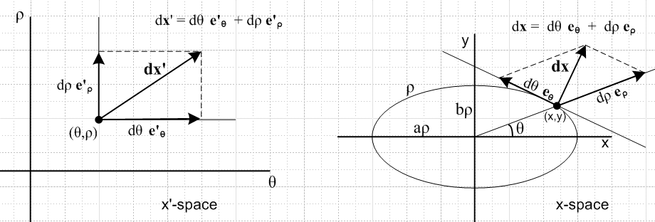

It must be understood that now the vector arrows like dx are highly magnified and in reality are very small compared to, say, the curvature of the ellipse. From above,

e'θ • e'θ = 'θθ 'θ • 'θ = 1
e'ρ • e'ρ = 'ρρ 'ρ • 'ρ = 1
e'ρ • e'θ = 'ρθ 'θ • 'ρ = 'θρ / (h'θh'ρ)

and once again the "right angle" in the x'-space picture is deceptive.

(g) Study of how dx transforms in the mapping between x-space and x'-space

Consider this drawing which shows a representative set of vectors dx in x-space (the bars), along with the forward mappings (dx' = F(dx) or dx' = Rdx ) of the corresponding vectors dx' in x'-space. The vectors on the right all point up, those on the left point generally to the northeast.

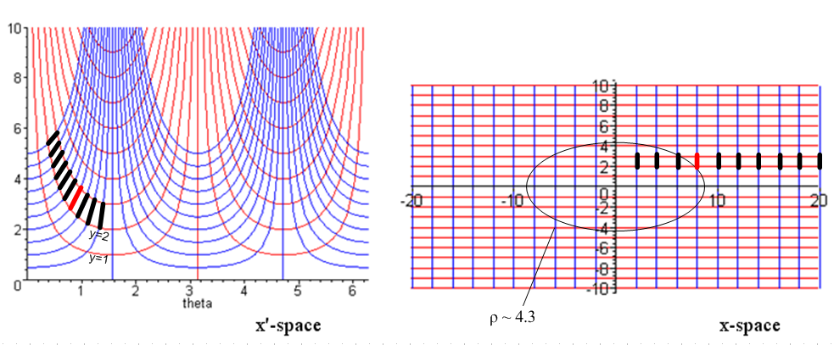
x'-space x-space

Now select the red dx bar on the right and operationally apply the previous picture. First determine the tangent base vectors eθ and eρ at the location of the red bar. Then setting dx = dθ eθ + dρ eρ, consider the value of the two numbers dθ and dρ for this red bar. Graphically, knowing which way eθ and eρ point at the bottom of the red dx, one expects dθ > 0 and dρ > 0. The red dx' bar on the left has these Cartesian values dθ and dρ, and has a Cartesian-view length of |dx|2 = (dθ)2+(dρ)2. One can see from the picture that these Cartesian lengths vary for the 10 bars shown, though the lengths are all the same in x-space. The Curvilinear-view lengths of the x'-space bars are all the same, and are equal to the Cartesian length of those bars in x-space since dx'•dx' = dx•dx.
Consider now some bar mapping in the other direction:

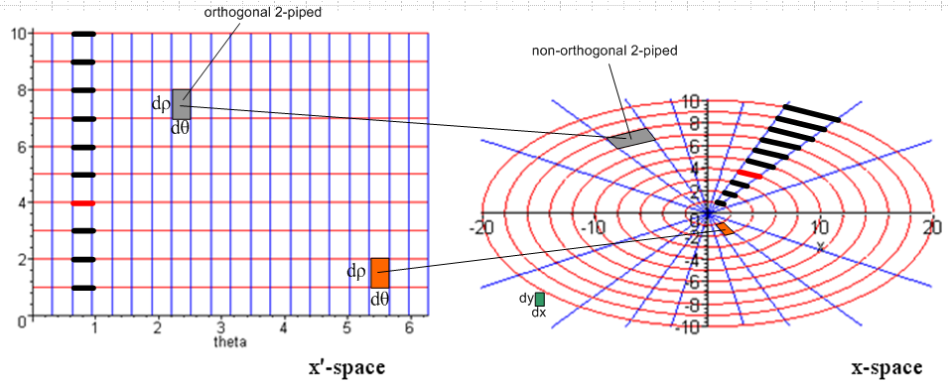

Now the dx bars on the right all have different lengths. Those on the left have the same Cartesian length, which is what the drawing shows, but each one's Curvilinear-view length matches that of its corresponding bar on the right. The ratio of the length of a bar on the right to the Cartesian length of the corresponding bar on the left is the scale factor hθ which recall is a function of location in space:

bar on right = dx(1) = e1 dx'1 = 1 h'1 dx'1 = eθ dθ = θ hθ dθ graph length = hθ dθ
bar on left (Cartesian view) = dx'(1) = e'1 dx'1 = '1 dx'1 = θ dθ graph length = dθ

=> right bar length / left bar length = hθ = ρ $\sqrt{a2sin2θ + b2cos2θ}$ (increases with ρ)

If a=b, then hθ = ρ and the bar length on the right is then ρdθ as is obvious in polar coordinates.

(h) Derivation of the Jacobian Integration Rule

Consider now an integral ∫dθdρ f(θ,ρ). The tiny rectangles of area dθdρ, like the specific gray and orange ones highlighted on the left above, are regarded for the purposes of integration as being in the Cartesian view of x'-space. One then writes [ dA' is called dV' in Section 8 ]

dA' ≡ dρdθ = the area of a differential patch in Cartesian-view x'-space

This is the graphical area one sees in the picture. There is no need to define or consider any Curvilinear-view area in x'-space because the Cartesian-view area is being used.
In the limiting process which defines the integration, each dθdρ patch on the left has the same area dρdθ. The interior of each patch on the left maps into some parallelogram patch on the right. One is not surprised to see that the patch areas on the right are different, though they map into patches on the left of the same Cartesian-view area. As shown in Section 8 (e), the ratio of the two patch areas is the absolute value of the Jacobian |J(x')|,

(area of skewed patch on the right at location x) = |J(x')| dA' = |J(x')| dρdθ

This is not what we mean by "the Jacobian Integration Rule" in the section title. That is coming below and it is going to involve the quantity dxdy.
The mapping shown above between patches is an N=2 example of the general N-dimensional discussion in Section 8 (a) which describes an orthogonal differential N-piped in (Cartesian-view) x'-space mapping into a non-orthogonal differential N-piped in x-space.
Now back to the integration issue. There are two ways an integration can be done in Cartesian x-space:

integral of f(x) = lim Σi dA1(xi) f(xi) dA1(xi) = patches shown on the right above

integral of f(x) = lim Σi dA2(xi) f(xi) dA2(xi) = dxdy

In the first integral, every patch dA1(xi) on the right has a different shape and a different area as the integral is computed in the usual limiting-sum manner. The gray and orange patches on the right are two of these many patches. Despite their non-uniform shape and area, this rag-tag band of patches certainly "covers" the area being integrated over, and does so perfectly in the calculus limit. The area of one of these rag-tag patches is |J(x')|dA' = |J(x')|dθdρ and the areas are different because the Jacobian is a function of x = x(x').

In the second integral, every patch dA2(xi) has the same area dxdy, so really dA2(xi) does not depend on xi in this form of the integration. One such dxdy patch is shown in green above. The coverage of the dA2 patches is of course also "perfect coverage" in the calculus limit.

Since both integrals cover the same area perfectly, they both give the same result in the limiting process that defines the integral. This point is sometimes misunderstood. One is not just "replacing" a parallelogram patch such as the orange one on the right with some dxdy patch that approximates it in area, like the green patch. The statement is about an integration. Thus one has

lim Σi dA1(xi) f(xi) = lim Σi dA2(xi) f(xi)

or
∫[|J(x')| dθdρ] f(x(x')) = ∫[dxdy] f(x)

where on the left f(x) = f(x(x')) where x = F-1(x') ≡ x(x'). In the sense of distribution theory (Stakgold Chapters 1 and 5), one can then make this symbolic statement

|J(θ,ρ)| dρdθ = dxdy

where the meaning of this symbolic equality is the integral statement above,

∫D dxdy f(x) = ∫D' dθdρ |J(x')| f(x(x')) ,

valid for any integrable f(x) and any integration region D (region D' corresponds to D in x'-space.) Either of these last two equations constitute the "Jacobian Integration Rule" of the section title.

The integral on the left is well defined in 2D calculus, so the expression on the right shows how to "evaluate the integral on the left in curvilinear coordinates".

At this point one may introduce a new but obvious symbol

dA ≡ dxdy

so the above equality of integrals can be written

∫dA f(x) = ∫ dA' |J(x')| f(x(x')) |J(x')| dA' = dA

In N dimensions, dA and dA' are differential "volumes", and the general Jacobian Integration rule takes the form,

∫dV f(x) = ∫ dV' |J(x')| f(x(x')) |J(x')| dV' = dV

dV' ≡ dx'1dx'2....dx'N = the volume of an orthogonal differential N-piped
in the Cartesian-view x'-space

dV = dx1dx2....dxN = the volume of an orthogonal differential N-piped in x-space.

Notice that these are not the two N-pipeds which "map into each other" as noted above. The N-piped dV has nothing to do that that mapping which involved a non-orthogonal N-piped in x-space.

To finish off our sample N=2 case, recall from earlier that for our polar elliptical coordinate system

|J'(x')| = | det(S)| = abρ

and therefore

∫dxdy f(x,y) = ∫ dθdρ |J(x')| f(aρ cosθ, bρ sinθ) = ab ∫dθdρ ρ f(aρ cosθ, bρ sinθ)

In the limit of regular polar coordinates, one then has a = b = 1 and ρ = r so

∫dxdy f(x,y) = ∫rdrdθ f(rcosθ, rsinθ)

which is the familiar result.

Appendix D: Tensor Densities and the ε tensor

Picture A is used in this Appendix along with Standard Notation.

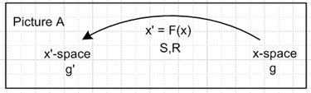

(a) Definition of a tensor density

First, recall from the Section 5 (k) discussion of the Jacobian J,

J ≡ det(Sij) = σ $\sqrt{sg'}$/$\sqrt{sg}$ = σ(sg'/sg)1/2 = σ(g'/g)1/2 => (g'/g)1/2 = σJ = |J| > 0

s = sign[det(gij)] = sign(g) = sign(g') g = det(gij) sg = |g| > 0 Sij ≡ (∂xi/∂x'j)
σ = sign[det(Sij)] = sign(J) g' = det(g'ij) sg' = |g'| > 0

For proper Lorentz transformations of special relativity, det(S) = 1 so σ = +1. For curvilinear coordinates, one normally selects an ordering of the xi so that σ = +1, such as r,θ,φ in spherical coordinates. Nevertheless, we allow for the possibility of J < 0.

Second, recall our generic sample tensor transformation from Section 7 (j),

T ' abcde = Raa' Rbb' Rcc' Sd'd Se'e Ta'b'c'd'e'

which can be rewritten in a more standard way using the theorem of Section 7 (q) that Sμν = Rνμ,

T ' abcde = Raa' Rbb' Rcc' Rdd' Ree' Ta'b'c'd'e'

T is a mixed rank-5 tensor, meaning it transforms as shown above with respect to the underlying transformation F. T is a regular standard-issue tensorial tensor.

Now suppose instead that the object T were to transform like this, with J being the Jacobian noted above,

T ' abcde = J-W Raa' Rbb' Rcc' Rdd' Ree' Ta'b'c'd'e'

where the extra factor J-W has been introduced. If T transforms this way, it is called a tensor density of weight W. Thus, an ordinary tensor is a tensor density of weight 0.
The convention for the sign of W used here is that of Weinberg p 99 Eq. (4.4.4), which equation has the following factor on the right side of a sample tensor density transform equation,

|∂x'/∂x|W ≡ [det(∂x'/∂x)]+W = [ det(∂x'i/∂xk) ]+W = J-W

Some authors use -W as the "weight" instead of +W, but we shall stick with Weinberg's convention.
An immediate example of a tensor density is provided by (g'/g)1/2 = |J| rewritten as

g' = J2 g =J-(-2) g => weight(g) = -2 g' is a scalar density of weight - 2 .

This is the scalar density mentioned in Section 5 (k) of weight -2. Notice that from g one can construct other scalar densities of other weights, for example

g'-1 = J-(2) g-1 => weight(g-1) = +2 g'-1 is a scalar density of weight +2

(b) A few facts about tensor densities

1. It is pretty obvious that a sum of two index-similar tensor densities of weight W has weight W.

2. Contracting indices within a tensor density does not alter its weight W. If indices a and d are contracted in the example above, one gets

T ' abcae = J-W Raa' Rbb' Rcc' Rad' Ree' Ta'b'c'd'e'

= J-W (Raa'Rad') Rbb' Rcc' Ree' Ta'b'c'd'e'

= J-W δa'd' Rbb' Rcc' Ree' Ta'b'c'd'e'

= J-W Rbb' Rcc' Ree' Ta'b'c'a'e'

The factor J-W just sits there, impervious to contraction activities.

3. Going the other direction, when a larger tensor density is formed from two smaller ones, called a direct product or outer product, the weights get added.

Example 1:

A'a = J-W1 Raa'Aa'

B'cd = J-W2 Rcc'Rdd' Bc'd'

=> (A'a B'cd) = J-(W1+W2) Raa' Rcc'Rdd' (Aa' Bc'd')

Example 2: Suppose in the outer product the first factor is the scalar density g-W1/2 of weight W1 :

g'-W1/2 = J-W1 g-W1/2 // since g' = J2g from Section 5 (k), no R factors since scalar

B'cd = J-W2 Rcc'Rdd' Bc'd' // same as in previous example

=> g'-W1/2B'cd = J-(W1+W2) Raa' Rcc'Rdd' (g-W1/2 Bc'd')

If one selects W1 = –W2, the added factor neutralizes the weight of the tensor density to which it is prefixed, generating thereby a regular tensor (weight 0). So if tensor density B has weight W,

(g'W/2 B'cd) = Raa' Rcc'Rdd' (gW/2 Bc'd')

and then (gW/2 Bij) transforms under F as a regular tensor. (One should always keep in mind the fact that there is an underlying transformation x' = F(x) upon which the House of Tensor is built ).

4. Although sometimes authors take a differing stance for certain tensors, we shall assume that indices are raised and lowered on a tensor density in exactly the same way they are raised and lowered on an ordinary tensor of the same index structure. This means the gab raises an index and gab lowers an index.

5. Raising or lowering an index does not change the weight of a tensor density. Again, using our generic example above,

T 'abcde = J-W Raa' Rbb' Rcc' Rdd' Ree' Ta'b'c'd'e'

T 'abcde = g'ex T 'abcdx // raise last index in x'-space

Ta'b'c'd'e' = ge'e" Ta'b'c'd'e" // lower last index in x-space

Therefore

T 'abcde = g'ex [ J-W Raa' Rbb' Rcc' Rdd' Rxe' Ta'b'c'd'e']

= g'ex [ J-W Raa' Rbb' Rcc' Rdd' Rxe' (ge'e" Ta'b'c'd'e")]

= JW Raa' Rbb' Rcc' Rdd' (g'ex Rxe' ge'e") Ta'b'c'd'e"

= J-W Raa' Rbb' Rcc' Rdd' (Ree") Ta'b'c'd'e" // Section 7 (o) facts about R

and again J-W passively watches all the action fly by. The weight of our generic tensor density with its last index raised is still W.

6. The covariant dot product of vector densities A and B of weights W and w is a scalar density of weight W + w and therefore A'•B' = J-(W+w) A•B .

Proof: First form the rank-2 tensor density AiBj which by item 3 has weight W+w. Lower the second index and the mixed rank-2 tensor AiBj by item 5 still has weight W+w. Then contract to get A•B = AiBi and by item 2, the weight is still W+w.

Corollary: The magnitude of a vector density A of weight W is a scalar density of weight W, and therefore |A|' = J-W |A| .

Proof: |A|2 = A • A which has weight 2W meaning |A'|2 = J-2W |A|2. Therefore |A'| = J-W |A| .

7. As J→1, tensor densities become true tensors. One could imagine some limiting/morphing process on an underlying transformation F such that the linearized transformation matrix R approaches a rotation matrix at all points in space (RRT= 1 and detR = 1) and then J = detS → 1. In this case J-W → 1-W = 1 and therefore any tensor density, regardless of its weight W, becomes an ordinary tensor. Perhaps we should restrict this comment to underlying transformations F having detS > 0 since passing through detS = 0 is problematical.
An example: the cross product considered in section (g) below of N-1 contravariant vectors becomes in this limit an ordinary covariant vector. If g=1 in x-space, then g' = RRT = 1 in x'-space and then that resulting vector can be considered either contravariant or covariant since both spaces are then Cartesian. This is the case with A = B x C under rotations in 3D space. On can think of the εabc as moving in this limit from a tensor density of weight -1 to an ordinary tensor.

(c) Theorem about Totally Antisymmetric Tensors: there is really only one: εabc...

Theorem: Apart from a scalar factor, there exists only one totally antisymmetric (TA) tensor.

Proof: Suppose there were two TA tensors called εabc... and rabc.... If two or more of the indices are equal, both tensors are 0, so for such index sets, one can say rabc.. = f εabc.. where f is any finite function whatsoever. Consider now the case where all the indices are distinct and therefore exhaust the set 123...N, and consider abc... to be a permutation of 123...N obtained by doing S pairwise swaps,

abc... = P(123...) p = (-1)S .

If one were to associate a sign change with each swap, the total sign change would be p, the parity. Since ε and r are both TA tensors, each tensor can be "unwound" back to a standard index order by doing these S swaps, and the swaps will cause a total sign of p relative to that standard order, so

rabc.. = p r123... // for example, r2134.. = (-1)1 r1234..
εabc.. = p e123...

Define scalar function f ≡ r123... / e123... , whatever it might be. Then

rabc.. = p(f e123...)
εabc.. = p e123...

and dividing these two equations one finds,

rabc.. = f εabc..

which has now been shown valid for all index sets abc.. . Therefore, any "other" totally antisymmetric tensor is just a scalar function times the ε tensor.

(d) The contravariant ε tensor

Knowing nothing to start, assume that the famous εabc.. totally antisymmetric tensor transforms under F as a tensor density of some weight W which we hope to determine. Then

ε'abc.. = J-W Raa' Rbb' ... εa'b'c'.. (*)

Assume that εabc.. is the usual permutation tensor normalized to ε123...N = +1. This is the convention used by Weinberg p 99. This means each index swap changes the sign, and if two or more indices are the same, ε = 0. This is an important starting assumption, and from it most everything follows.
Given this assumption, the RHS of (*) is totally antisymmetric (TA). The argument is given once here and then used later several times. Consider an a↔b swap. Then

ε'bac.. = J-W Rba' Rab' ... εa'b'c'.. = J-W Rbb' Raa' ... εb'a'c'..

= J-W Raa' Rbb' ... (–εa'b'c'..) = – ε'abc..

The same result is true for any swap, thus RHS (*) = TA. Since according to section (b) there is only one TA tensor available, apart from a scalar function factor, it follows that

ε'abc.. = Kεabc...

where K is some scalar function, perhaps just a constant. Equation (*) above then reads

K εabc... = J-W Raa' Rbb' ... εa'b'c'.. (**)

Setting in the standard order, one finds that

K ε123... = J-W R1a' R2b' ... εa'b'c'..
or
K = J-W det(Rij) = J-W (J)-1 = J-(W+1)

so now

ε'abc.. = Kεabc... = J-(W+1) εabc...

A second assumption is now made: that εabc.. (contravariant!) has the same value structure in any frame of reference, which is to say it is the same in x'-space as it is in x-space,

ε'abc.. = εabc...

This assumption is consistent with taking W = -1 in the previous equation.
Again, this follows the convention of Weinberg p 99. Some authors instead arrange for the above equation to be true for the covariant ε tensors, and use then ε123...N = ε'123...N = +1, but we shall follow Weinberg.
To summarize, assuming that εabc... is the usual permutation tensor normalized in the usual way, and assuming that ε'abc.. = εabc... so this tensor is the same in all frames or spaces, THEN one concludes that εabc... must transform as a rank-N tensor density of weight W = -1. That is to say,

ε'abc.. = J Raa' Rbb' ... εa'b'c'.. // this is (*) above with W = -1

This then is our second example of a tensor density. Viewed in this light, the tensor εabc.. is known as the Levi-Civita tensor.

Tullio Levi-Civita (1873-1941). Italian, University of Padua 1892, with Ricci published the theory of tensor algebra in 1900 (see Refs.), which work assisted Einstein circa 1915 in formulating the theory of general relativity. The ε tensor bears his name. Sometimes the affine connection is called the Levi-Civita connection.

(e) Some facts about the ε tensor

1. Consider ( based on section (b) 4 above),

εabc... = gaa' gbb'..... εa'b'c'...

This is again in the convention of Weinberg p 99 (4.4.10).

Added sign s convention. Some authors make a special exception for the ε tensor and introduce an extra sign s into the above equation ( recall that s = -1 for special relativity)

εabc... = s gaa' gbb'..... εa'b'c'... s = sign[det(gij)]

Inserting such a sign renders any ε mixed tensor like εabc.. ambiguous when s = - 1, but is acceptable if one promises never to make use of a mixed ε tensor. We shall refer to these two methods as "the Weinberg convention" and the "added sign s convention", the former being assumed unless otherwise stated.

Install the reference sequence to obtain

ε123.. = g1a' g2b'..... εa'b'c'... = det(gij) = g // Section 5 (k)

Similarly, ε'123.. = det(g'ij). To summarize,

ε123.. = det(gij) = g // ε all-down index reference values
ε'123.. = det(g'ij) = g'

In the "added sign s convention", these last two equations would have sg = |g| and sg' = |g'| on the right which means then these two ε values would be always positive.

2. Take the same starting point as above

εabc... = gaa' gbb'..... εa'b'c'...

The RHS is a totally antisymmetric in indices abc... (see above) and can therefore be written

RHS = C εabc...

since we showed earlier that there is only one TA tensor apart from scalar C. Therefore

εabc... = C εabc... (*)

Insert the reference sequence

ε123... = C ε123... = C

But in 1 it was just showed that ε123... = det(gij) . Therefore

C = det(gij)

and then (*) says for the "Weinberg convention",

εabc... = det(gij) εabc... = g εabc... // relating all down to all up
ε'abc... = det(g'ij) ε'abc... = g' ε'abc... // = g' εabc...

where the second line follows by the same argument. These equations relate all indices down to all up in the same space. Notice that both εabc... and ε'abc... are totally antisymmetric.

In the "added sign s convention" the above equations are instead

εabc... = |det(gij)| εabc... = |g| εabc... // relating all down to all up
ε'abc... = |det(g'ij)| ε'abc... = |g'| ε'abc... // = |g'| εabc...

3. Divide the last two Weinberg convention equations to find that

ε'abc... = [det(g'ij)/ det(gij)] εabc... = (g'/g) εabc...

From Section 5 (k) one has (g'/g) = J2 so the conclusions regarding ε are these:

ε'abc... = J2 εabc... = (g'/g) εabc.. ε'abc... = εabc... = permutation tensor // general
εabc... = permutation tensor if g=1

These conclusions are valid for the "added sign s convention" as well since det(g) and det(g') always have the same sign as shown in Section 5 (k).

Two comments:

• Although we set ε'abc... = εabc... by fiat, we cannot similarly set ε'abc... = εabc...by fiat. This latter result comes out being ε'abc... = J2 εabc... as just shown.

• The fact that ε'abc... = J2 εabc... does not say that εabc is a tensor density of weight -2 because there are no R factors showing. (See the section (a) definition of a tensor density transformation. )

(f) The covariant ε tensor : repeat section (d) as if its weight were not known

According to section (b) 5, lowering indices does not change the weight of a tensor density. Section (d) showed that εabc.. is a tensor density of weight -1, so we know right away that εabc.. is also a tensor density of weight -1. Nevertheless, it is interesting to see what happens when the same method used in section (d) for εabc... is applied to εabc... .
We start by assuming εabc.. is a tensor density of some unknown weight W,

ε'abc.. = J-W [ Raa' Rbb'.... εa'b'c'..] (*)

Section (e) 2 noted that εa'b'c'... is a totally antisymmetric tensor, and therefore as in section (d) one concludes that the RHS of (*) is also totally antisymmetric and can be written as RHS(*) = K εabc.. , so (*) then says

K εabc.. = J-W [ Raa' Rbb'.... εa'b'c'..] (**)

Use section (e) 2 to set εa'b'c'.. = det(gij) εa'b'c'.. inside the bracket,

K εabc.. = J-W [ Raa' Rbb'.... det(gij) εa'b'c'..] ,

and then install the reference sequence on both sides

K ε123.. = J-W [ R1a' R2b'.... det(gij) εa'b'c'..]

But section (e) 1 says ε123.. = det(gij), so cancel det(gij) on both sides to get

K = J-W [ R1a' R2b'.... εa'b'c'..] = J-W det(Rij) = J-W det(Sji) = J-W J = J-(W-1)

So here the result is K = J-(W-1) whereas in section (d) the result was K = J-(W+1) . In the current case, since (*) and (**) have the same RHS, setting the LHS's equal says

ε'abc.. = K εabc.. = J-(W-1) εabc..

But section (e) 3 said that ε'abc.. = J2 εabc.. and therefore one gets W = -1.

Thr conclusion is that εabc... transforms with weight -1, the same as εabc..., so (*) becomes

ε'abc.. = J [ Raa' Rbb'.... εa'b'c'..]

(g) Generalized cross products

In Appendix A (c) the following cross product of N-1 vectors is considered (converted now to standard notation)

Qa ≡ εabc...x BbCcDd.....Xx or Q = B x C x D .... x X

If the vectors B,C,D..X are all contravariant vectors, then applying the rule of section (b) 3, one concludes that, since ε is a tensor density of weight -1 and since all the RHS vectors have weight 0, the object Qa is a covariant vector density of weight = -1, and thus has this transformation rule

Q'a = J RabQb

Similarly, one may consider

Qa ≡ εabc...x BbCcDd.....Xx .

If vectors B,C,D...X are covariant vectors, then Qa is a vector density of weight -1 and

Q'a = J RabQb

(h) The tensorial nature of curl B

It has just been shown that C = A x B is a vector density of weight -1, this being a special case of the generalized cross product discussion above. As noted in section (a) 7, if R happens to be a (global) rotation, then C is in fact a tensorial vector. One might conjecture that C = ∇ x B is also a vector density of weight -1, and that conjecture is correct as is now shown. Consider

Cn = εnab ∂aBb

where B is assumed to be an tensorial vector. It is helpful to write this equation in the following manner

Cn = εnab [ ∂aBb – ∂bBa ]/2

where the second term is the same as the first term, since

– εnab ∂bBa = εnba ∂bBa = εnab ∂aBb .

Recall now from Section 7 (v) that the covariant derivative of a vector is given by

Bb;a = ∂aBb – Γcab Bc

where the affine connection Γcab is symmetric under a↔b. Therefore

Bb;a – Ba;b = [∂aBb – Γcab Bc] - [∂bBa – Γcba Bc] = ∂aBb – ∂bBa

Therefore Cn can be expressed as

Cn = εnab [Bb;a – Ba;b ]/2

so by the same ε anti-symmetry noted above the final result is

Cn = εnab Bb;a .

The major feature of Bb;a -- as discussed in Section 7 (v) -- is that it is a rank-2 tensor if B is a tensorial vector. The weight addition rule of section (b) 3 can then be applied to εnab Bb;a. Since εnab has weight -1 and Bb;a has weight 0, the conclusion is that Cn is a vector density of weight -1.

Thus, C = curl B is a vector density of weight -1. If the underlying transformation F is a rotation, C becomes an ordinary vector as per section (a) 7.

(i) Tensor E as a weight 0 version of ε : three conventions

1. Equations in the "Weinberg Convention"

In this section it is assumed that gij and gij raise and lower indices of the ε tensor just as they do for any other tensor (Weinberg convention). In sections (d) and (e) it was established that

εabc... = g εabc... ε123.. = +1 ε123... = g
ε'abc... = g'ε'abc... ε'123.. = +1 ε'123... = g'

ε'abc... = J2 εabc... = (g'/g) εabc... ε is a rank-N tensor of weight W = -1

Again, just in passing, notice that ε'abc...= J2 εabc...does not say ε has weight -2 because the R factors are not present on the right side.
Consider now the following new objects defined by (sg = |g|, s= sign(g) = sign(g') as in Section 5 (k))

Eabc... ≡ |g|-1/2 εabc... => E123... = |g| -1/2 g = |g| -1/2 s |g| = s |g|1/2
E'abc... ≡ |g'|-1/2 ε'abc.. . => E'123... = |g'| -1/2 g' = |g'| -1/2 s |g'| = s |g'|1/2

It was shown in Section 5 (k) that g' = J2g so that g transforms as a scalar density of weight -2. Since the sign of g and g' are the same, if follows that (sg) = |g| is also a scalar density of weight -2, and then the
quantity |g|-1/2 transforms as a scalar density of weight +1, since |g'|-1/2 = J-1 |g|-1/2. Looking at the equation Eabc... ≡ |g|-1/2 εabc... above, and using the weight summation rule of section (b) 3, one concludes at that Eabc... transforms as a tensor of weight (+1) + (-1) = 0, and so Eabc... is an ordinary tensor. This is the motivation of the above definitions. It was shown at the end of Section 7 (u) that a tensor density equation with matching weights is "covariant", so one is not surprised to see the second line above being the same as the first line but everything is primed (s = s').

Raising indices on both sides gives

Eabc... ≡ |g|-1/2 εabc... => E123... = |g|-1/2
E'abc... ≡ |g'|-1/2 ε'abc... => E'123... = |g'|-1/2

To compare Eabc... and Eabc... ,

Eabc... = |g|-1/2 εabc... = |g|-1/2 g εabc... = s |g|-1/2 |g| εabc... = s |g|1/2 εabc...
Eabc... = |g|-1/2 εabc...

so that,

Eabc... = s|g| Eabc... = g Eabc...

Summarizing,

E123... = |g|-1/2 E123... = s|g|+1/2 Eabc... = g Eabc... = s|g| Eabc...
E'123... = |g'|-1/2 E'123... = s|g'|+1/2

Eabc... EABC... = |g|-1 εabc... εABC...
E'abc... E'ABC... = |g'|-1 ε'abc... ε'ABC...

Since |g|-1 is a scalar density of weight +2 and each ε has weight -1 and each E has weight 0, one is happy to see the weights balance of the two sides of this pair of covariant equations.

2. Equations in the "added sign s convention"

The previous section shows how things work out using the "Weinberg convention" noted at the start of section (e). Here is the previous section redone in the "added sign s convention":

In section (e) it was established that ( g = det(gij))

εabc... = sgεabc... ε123.. = +1 ε123... = sg = |g| // g → sg
ε'abc... = sg'ε'abc... ε'123.. = +1 ε'123... = sg' = |g'| // g' → sg'

ε'abc... = |J|2 εabc... = (g'/g) εabc... ε is rank-N tensor of weight W = -1 // same

Consider the following new objects defined by ( sg = |g|, s= sign(g) = sign(g') as in Section 5 (k) )

Eabc... ≡ |g| -1/2 εabc... => E123... = |g| -1/2 |g| = |g|1/2
E'abc... ≡ |g'| -1/2 ε'abc... => E'123... = |g'|-1/2 |g'| = |g'|1/2

But the same argument given above, Eabc... is an ordinary covariant tensor (ie, weight = 0). However, the indices cannot be raised by gij. In this convention then one must make independent definitions of the contravariant components as follows,

Eabc... ≡ |g|-1/2 εabc... => E123... = |g|-1/2
E'abc... ≡ |g'|-1/2 ε'abc... => E'123... = |g'|-1/2

To compare Eabc... and Eabc... ,

Eabc... = |g|-1/2 εabc... = |g|-1/2 |g| εabc... = |g|-1/2 |g| εabc...
Eabc... = |g|-1/2 εabc...

so that
Eabc... = |g| Eabc...
Summarizing,

E123... = |g|-1/2 E123... = |g|+1/2 Eabc... = |g| Eabc...
E'123... = |g'|-1/2 E'123... = |g'|+1/2 E'abc... = |g'| E'abc...

Eabc... EABC... = |g|-1 εabc... εABC...
E'abc... E'ABC... = |g'|-1 ε'abc... ε'ABC...

In this "added sign s" convention, all these summarized results involve only |g| and there are no factors of s floating around. The cost of this benefit is a lack of true covariance (when s=-1), as demonstrated in section (k) below.

3. Equations in the "Ricci-Levi-Civita convention"

Ricci and Levi-Civita use the "added s convention" but add a factor σ = sign(det(S)) into their definition of E ( see their paper p 135 or Hermann pp 31-21) so that

Eabc... ≡ σ|g| -1/2 εabc... => E123... = σ|g| -1/2 |g| = σ|g|1/2
E'abc... ≡ σ|g'| -1/2 ε'abc... => E'123... = σ|g'|-1/2 |g'| = σ|g'|1/2

Eabc... ≡ σ|g|-1/2 εabc.. => E123... = σ|g|-1/2
E'abc... ≡ σ|g'|-1/2 ε'abc... => E'123... = σ|g'|-1/2

Summarizing,

E123... = σ|g|-1/2 E123... = σ|g|+1/2 Eabc... = |g| Eabc...
E'123... = σ|g'|-1/2 E'123... = σ|g'|+1/2 E'abc... = |g'| E'abc...

Eabc... EABC... = |g|-1 εabc... εABC...
E'abc... E'ABC... = |g'|-1 ε'abc... ε'ABC...

Notice that in all three conventions, last equation pair is the same.

Since Ricci and Levi-Civita did not raise and lower individual indices in their 1900 paper, they were not concerned about their convention being non-covariant in that sense.

(j) Representation of ε, εε and contracted εε as determinants

1. Theorem about a certain permutation sum

Consider the following object Q defined as a signed permutation sum of the product of N matrix elements of a matrix Mij,

Qabc..x ≡ ΣP p P2(Ma1Mb2 Mc3.....MxN)

In this equation, P2 represents a permutation of the set of 2nd indices of the N matrix elements, and the sum is over all N! such permutations.
There are many ways to arrive at a given permutation of 123...N by doing pairwise swaps, but for all these ways, the number of swaps S will be either even or odd. The parity p of a permutation is defined then as (-1)S and this p appears in the above sum.
If one were to swap 2↔3 on the right above, each permutation would have S→ S+1 since an extra swap is needed to undo 2↔3. Thus, all parities p → -p and in fact the whole object negates. But the swap 2↔3 is the same as b↔c since Mb3 Mc2 = Mc2 Mb3. Applying this argument to any pair of indices, one concludes that Qabc..x is totally antisymmetric and therefore can be written as K εabc...x :

ΣP p P2(Ma1Mb2 Mc3.....MxN) = K εabc...x

Setting abc..x to 123..N, one gets.

ΣP p P2(M11M22 M33.....MNN) = K

The left side of this last equation can be written as

ΣP p P2(M11M22 M33.....MNN) = Σabc..x εabc...x M1aM2b M3c.....MNx

because p = εabc...x correctly assesses the parity of any given permutation. But this object is simply det(M) so the conclusion is that K = det(M) and then

ΣP p P2(Ma1Mb2 Mc3.....MxN) = det(M) εabc...x

Consider now the following matrix where abc..x is some permutation of 123...x,

where M(abc..) = Ma1 Ma2 Ma3 ... MaN
Mb1 Mb2 Mb3 ... MbN
Mc1 Mc2 Mc3 ... McN
...
Mx1 Mx2 Mx3 ... MxN

By rearranging the rows into their normal numerical order, one obtains matrix M, but incurs a sign from the various row swaps which sign is just εabc..x. Therefore

det(M(abc..) ) = εabc...x det(M)

and therefore

ΣP p P2(Ma1Mb2 Mc3.....MxN) = det(M(abc..) ) = det(M) εabc...x

The permutation sum is thus just the determinant of matrix M(abc..). The first term in the permutation sum, the term with an identity permutation, corresponds to the product of the diagonals of that matrix.

2. Application of the theorem to M = δ: a representation of ε

Apply the above theorem to matrix M = 1 ≡ δ, the identity matrix, having Mij = δi,j. Clearly det(δ) = 1 and one then has

ΣP p P2(δa,1δb,2 δc,3.....δx,N) = det[δ(abc..) ] = εabc...x

Thus is obtained the famous representation of εabc..x as a certain determinant of Kronecker deltas,

εabc...x = det[δ(abc..) ]

where δ(abc..) = δa,1 δa,2 δa,3 ... δa,N = Ra
δb,1 δb,2 δb,3 ... δb,N = Rb
δc,1 δc,2 δc,3 ... δc,N = Rc
...
δx,1 δx,2 δx,3 ... δx,N = Rx

where, for future use, each row vector has been given a name like Ra where (Ra)i = δa,i .

The conclusion then is that

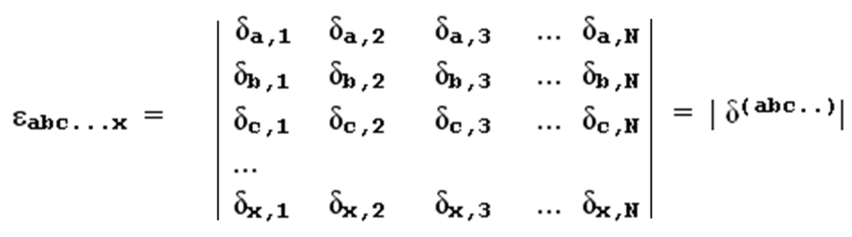
which is the same as

εabc...x = ΣP p P2(δa,1δb,2 δc,3.....δx,N) .

3. Outer product of two ε tensors.

Consider now

εabc...x = det $\left(\begin{matrix}Ra \\ Rb \\ ... \\ Rx\end{matrix}\right)$ and εa'b'c'...x' = det $\left(\begin{matrix}Ra' \\ Rb' \\ ... \\ Rx'\end{matrix}\right)$

Then
εabc...x εa'b'c'...x' = det $\left(\begin{matrix}Ra \\ Rb \\ ... \\ Rx\end{matrix}\right)$ det $\left(\begin{matrix}Ra' \\ Rb' \\ ... \\ Rx'\end{matrix}\right)$ = det $\left(\begin{matrix}Ra \\ Rb \\ ... \\ Rx\end{matrix}\right)$ det ( Ra' Rb' ... Rx')

= det { $\left(\begin{matrix}Ra \\ Rb \\ ... \\ Rx\end{matrix}\right)$( Ra' Rb' ... Rx') }

which is the determinant of this matrix

Ra• Ra' Ra• Rb' Ra• Rc' ... Ra• Rx'
Rb• Ra' Rb• Rb' Rb• Rc' ... Rb• Rx'
Rc• Ra' Rc• Rb' Rc• Rc' ... Rc• Rx'
...
Rx• Ra' Rx• Rb' Rx• Rc' ... Rx• Rx'

A typical element of this matrix is given by

Rc• Rb' = (Rc)i(Rb')i = δc,i δb',i = δc,b'

so that matrix can be written as

δa,a' δa,b' δa,c' .... δa,x'
δb,a' δb,b' δb,c' .... δb,x'
δc,a' δc,b' δc,c' .... δc,x' ≡ δ(abc..x; a'b'c'..x')
....
δx,a' δx,b' δx,c' .... δx,x'

where we have made up a name for this matrix as shown.

The conclusion then is that

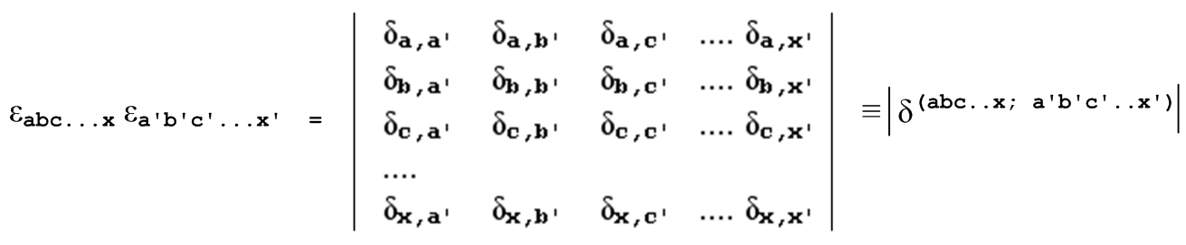
which is the same as

εabc...x εa'b'c'...x' = ΣP p P2(δa,a'δb,b'δc,c'.....δx,x')

As usual, the argument of P2 is the product of the diagonal elements of the matrix.

4. Contracting the first index of the outer product of two ε tensors.

Consider what happens if one sums on the first index of the εε product:

Σa εabc...x εab'c'...x'

For fixed given values of bc..x and b'c'...x' , there is only one way this sum can be non-zero. In that one way, bc..x and b'c'...x' must each be permutations of the set {12..N exclude A} where A is the "hit value" of a in the sum on a. Then

Σa εabc...x εab'c'...x' = εAbc...x εAb'c'...x'

= ΣP p P2(δA,Aδb,b'δc,c'.....δx,x') = ΣP p P2(δb,b'δc,c'.....δx,x') (*)

where in this last expression the sum can be regarded as being over permutations where b'c'...x' is a permutation of b,c..x. Each of these lists of integers is in turn a permutation of {12..N exclude A}. Now, parity p = (-1)S where S is a number of swaps it takes to connect b'c'...x' with b,c..x, since a = a' = A. One might wonder if the overall sign of the RHS of the last equation is correct. A check of the first term in this sum which is just δb,b'δc,c'.....δx,x' shows that this overall sign is indeed correct. This first term must be positive because the product of two ε's is either +1 or 0. As an example,

Σa εabc εab'c' = ΣP p P2(δb,b'δc,c') = δb,b'δc,c' – δb,c'δc,b'

The permutation sum shown on the right side of (*) is the determinant of δ(abc..x; a'b'c'..x') but with the first row and column crossed out. It can then be thought of as either the minor or cofactor of the element aa of this big δ matrix. Therefore,

Σa εabc...x εab'c'...x' = [cof δ(abc..x; a'b'c'..x')]aa

where the notation cofM refers to a matrix of cofactors with elements [cofM]ij. Don't confuse the a on the right side with the local dummy summation index a on the left side.

The conclusion then is that (implied summation on a on the LHS)

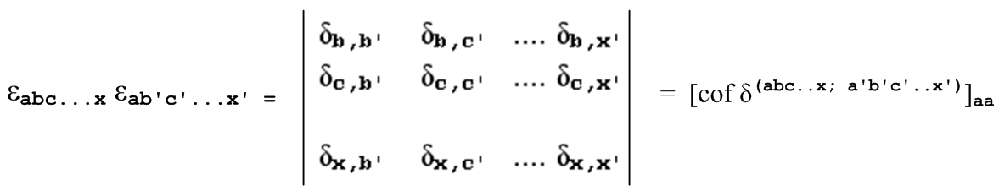

5. Contracting two or more indices of the outer product of two ε tensors.

Consider what happens if one sums on the first two indices of the εε product:

Σa,b εabcd...x εabc'd'...x'

For fixed given values of c,d..x and c'd'...x' , in order for this double sum to be non-zero, the index sets cd..x and c'd'...x' must each be permutations of the set {12..N exclude A,B} where A,B are a pair of hit values for the a and b sums. If a=A and b=B is hit value, then so is a=B and a=A, so there are 2! contributing terms in the sum, and each term is +1. Therefore

Σa,b εabcd...x εabc'd'...x' = 2! εABc...x εABc'...x'

= 2! ΣP p P2(δA,AδB,B'δc,c'δd,d'.....δx,x') = 2!ΣP p P2(δc,c' δd,d'.....δx,x') (*)

where in this last expression the sum is over permutations where c'd'...x' is a permutation of c,d....x. Each of these lists of integers is in turn a permutation of {12..N exclude A,B}. Now parity p = (-1)S where S is a number of swaps it takes to connect c'd'...x' with c,d....x. Since the product of two ε's is either +1 or 0, the overall sign of the right side shown must be correct. As an example,

Σa,b εabc εabc' = 2!ΣP p P2(δc,c') = 2 δc,c'

If c = c' = 2, then this says

Σa,b εab2 εab2 = ε132 ε132 + ε312 ε312 = 1 + 1 = 2

The permutation sum shown on the right side of (*) is the determinant of δ(abc..x; a'b'c'..x') but with the first 2 rows and columns crossed out. Therefore,

Σa,b εabcd...x εabc'd'...x' = 2! { [cof δ(abc..x; a'b'c'..x')]aa}bb

The conclusion then is that (implied summation on a,b on the LHS)

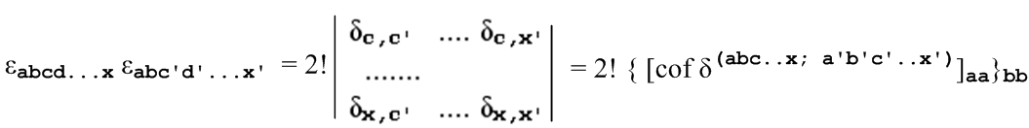

This pattern continues as more indices are contracted. If three indices a,b,c are contracted, there will then be 3! hit values which are A,B,C and its permutations, and one just repeats the above discussion. The result will then be

Σa,b,c εabcd...x εabcd'...x' = 3! {{ [cof δ(abc..x; a'b'c'..x')]aa}bb}cc

The conclusion then is that (implied summation on a,b,c on the LHS)

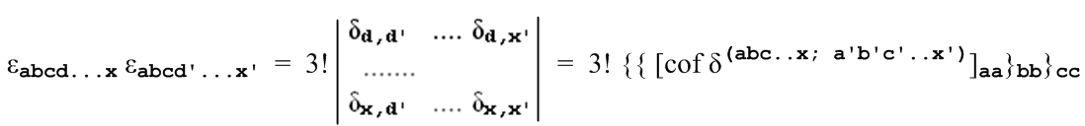

Eventually one arrives at a point where all but one of the indices are summed, so that

εabcd...x εabcd...x' = (N-1)! |δx,x'| = (N-1)! δx,x'

an example being

εabc2 εabc2 = 3! δ22 = 3! = ε1342 ε1342 + ε1432 ε1432 + 4 more terms = 1+1+4 = 6

The final point is that at which all indices are summed, with result

εabcd...x εabcd...x = N!

and example of which is

εabcεabc = ε1232 + ε2132 + 4 more terms = 1 + 1 + 4 = 6

6. Summary of Results
• • • •

εabcd...x εabcd...x' = (N-1)! δx,x'

εabcd...x εabcd...x = N!

(k) Covariant forms of the previous section results

The results above were all developed in Cartesian x-space where up and down indices on the ε's did not matter. The rules for converting any result above to covariant form are as follows:

Weinberg convention:

• write the left side as either |g|-1 ε***** ε***** or as E***** E***** .The objects with indices as shown by asterisks are true tensors (weight 0).

• write the right side replacing every δa,b by δab → gab as shown in Section 7 (m). Then the right side will also be a true tensor.

Example: The εε product for N=2 with no indices summed was written above as (g = 1)

εabεa'b' = $\left|\begin{matrix}δaa' & δab' \\ δba' & δbb'\end{matrix}\right|$ = δa,a' δb,b' – δa,b' δb,a'

The covariant form is as follows, where now g is some arbitrary metric tensor for x-space,

EabEa'b' = |g|-1 εabεa'b' = $\left|\begin{matrix}gaa' & gab' \\ gba' & gbb'\end{matrix}\right|$ = gaa' gbb' – gab' gba'

The equation in x'-space would then be

E'abE'a'b' = |g'|-1 ε'abε'a'b' = $\left|\begin{matrix}g'ab & g'ab' \\ g'a'b & g'a'b'\end{matrix}\right|$ = g'ab g'ab' – g'a'b g'a'b'

because true tensor equations are "covariant"(Section 7 (u)). One can raise and lower individual indices to get for example these valid tensor equations which are 3 members of the family of 4! = 24 tensor equations obtained by raising and lowering indices:

EabEa'b' = |g|-1 εabεa'b' = $\left|\begin{matrix}gaa' & gab' \\ gba' & gbb'\end{matrix}\right|$ = gaa' gbb' – gab' gba'

EabEa'b' = |g|-1 εabεa'b' = $\left|\begin{matrix}gaa' & gab' \\ gba' & gbb'\end{matrix}\right|$ = gaa' gbb' – gab' gba'

EabEa'b' = |g|-1 εabεa'b' = $\left|\begin{matrix}gaa' & gab' \\ gba' & gbb'\end{matrix}\right|$ = gaa' gbb' – gab' gba'

and of course in x'-space the equations are the same but everything is primed.

Added-sign-s and Ricci-Levi-Civita conventions:

Do the above two bullet items, then add an overall sign s to the right side, because
εabc.. = s g εabc... in these conventions instead of εabc.. = g εabc... so that
εabc..(Weinberg) = sεabc..(added-sign).

Example: The first equation above becomes ( εa'b'→ s εa'b')

EabEa'b' = |g|-1 εabεa'b' = s $\left|\begin{matrix}gaa' & gab' \\ gba' & gbb'\end{matrix}\right|$ = s ( gaa' gbb' – gab' gba')

The second equation is undefined (when s=-1), and the third equation is

EabEa'b' = |g|-1 εabεa'b' = $\left|\begin{matrix}gaa' & gab' \\ gba' & gbb'\end{matrix}\right|$ = gaa' gbb' – gab' gba'

The first and third equations are true tensor equations, except individual indices cannot be raised and lowered. If one were doing some significant work involving covariance and s=-1, it would certainly seem advisable to use the Weinberg convention since it is completely "covariant" for either sign of s.

Appendix E: Tensor Expansions: direct product, polyadic and operator notation

This entire section uses the general Picture A context where x-space need not be Cartesian,

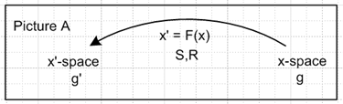

The Standard Notation is used throughout.

(a) Direct Product Notation

The key tool required for the expression of tensor expansions is the notion of a direct product of n tensorial vectors defined in this simple way,

(A⊗B⊗C ...)abc... ≡ AaBbCc.....
(A⊗B⊗C ...)abc... ≡ AaBbCc..... etc

The tensor A⊗B⊗C ... is nothing more than the outer product of vectors A,B,C as discussed in Section 7 (a) for contravariant vectors, but later extended to any mixture of vector types. As noted in Section 7 (j), one can define a direct product of two rank-2 tensors in this way,

(M⊗N)ab,AB ≡ MaANbB // rank = n = 2; number of tensors = I = 2
(M⊗N)ab,AB ≡ MaANbB etc

and then the same idea can be applied to form a direct product of tensors of any rank, for example

(M⊗N)ab,AB,αβ = MaAαNbBβ etc // rank = n = 3; number of tensors = I = 2

On the left side the number of groups of indices equals the tensor rank n, and the number of indices within each group matches the number I of tensors being direct-product-multiplied.
In what follows, only the direct product of vectors shall be considered. One can define the dot product of two direct-product-space vectors in this obvious manner,

(A⊗B⊗C ...) • (A'⊗B'⊗C' ...) ≡ (A⊗B⊗C ...)abc... (A'⊗B'⊗C' ...)abc

= AaBbCc..... A'aB'bC'c..... = A•A' B•B' C•C' ...

where of course the indices abc can be tilted in any way desired according to Section 7 (k).

(b) Tensor Expansions and Bases

Let bi be an arbitrary complete set of basis vectors in x-space. As shown in Section 6 (b) there exists a unique set of dual ("reciprocal") basis vectors bi (also in x-space) such that bi• bj = δij. Consider then the following expansion of a rank-3 tensor A

A = Σijk αijk (bi⊗bj⊗bk) where (bi⊗bj⊗bk ...)abc = (bi)a (bj)b (bk)c .

The coefficients αijk can be obtained by dotting both sides with (bi'⊗bj'⊗bk') and using

(bi'⊗bj'⊗bk') • (bi⊗bj⊗bk) = bi'• bi bj'• bj bk'• bk = δi'iδj'jδk'k .

The result is then (unpriming indices)

αijk = A • (bi⊗bj⊗bk) = Aabc (bi⊗bj⊗bk)abc = Aabc (bi)a (bj)b (bk)c . (*)

where Aabc are the contravariant components of tensor A in x-space, and (bi)a are the covariant components of vector bi in x-space.
In this manner, a tensor A of any rank can be expanded on an arbitrary complete set of basis vectors, and the coefficients of that expansion can be obtained by the inversion shown above for rank 3.
Two special bases are of interest.
The ui are the axis-aligned basis vectors in x-space as discussed in see Section 7 (s). For these basis vectors, one has (ui)a = δia and (ui)a = δia . If one considers this expansion,

A = Σijk αijk (ui⊗uj⊗uk)

where (ui⊗uj⊗uk ...)abc = (ui)a (uj)b (uk)c = δia δjb δkc

then the coefficients are found to be

αijk = A • (ui⊗uj⊗uk) = Aabc δia δjb δkc = Aijk

so the coefficients are exactly the x-space contravariant components of the tensor A. Thus

A = Σijk Aijk (ui⊗uj⊗uk)

On the other hand, if ei are the tangent base vectors in x-space (see Sections 3), the dual vectors are the ei and from Section 7 (s) one has (ei)a = Sai = Ria and (ei)a = Sai = Ria . If one considers the expansion

A = Σijk αijk (ei⊗ej⊗ek)

where (ei⊗ej⊗ek ...)abc = (ei)a (ej)b (ek)c = Ria Rjb Rkc

then the coefficients are found to be

αijk = A • (ei⊗ej⊗ek) = Aabc (ei)a(ej)b(ek)c = Aabc Ria Rjb Rkc

= Ria Rjb Rkc Aabc = A'ijk

and thus the coefficients in this case are exactly the x'-space contravariant components of tensor A, as shown in Section 7 (j). Thus,

A = Σijk A'ijk (ei⊗ej⊗ek) .

Expansions like the above are the generalizations to tensors of any rank of these vector expansions stated in Section 7 (s),

A = Σiαi bi αi = bi • A // arbitrary basis

A = ΣiAi ui // axis aligned unit vectors

A = ΣiA'i ei // tangent base vectors

where we continue to write rank-1 tensors (vectors) in bold font: A.

To summarize, here is the general rank-n tensor expansion for an arbitrary basis, and then for the two specific bases just discussed:

A = Σijk... αijk... (bi⊗bj⊗bk...) αijk... = Aabc... (bi)a (bj)b (bk)c...

A = Σijk... Aijk... (ui⊗uj⊗uk...) Aijk... = contravariant components of A in x-space

A = Σijk... A'ijk... (ei⊗ej⊗ek...) A'ijk... = contravariant components of A in x'-space

Orthonormal basis. If the basis vectors bi happen to be orthonormal as defined by bi• bj = δij then bi = bi because the dual basis is unique. As indicated in (*) above, this implies that coefficient αijk is unchanged if any or all indices are lowered, as if these αijk were components of a tensor in some Cartesian space. That Cartesian space is in fact the x'-space that would arise if transformation F were custom-selected such that the bi were the tangent base vectors ei for that F, for then g'ij = ei • ej = δi,j so that x'-space would in fact be Cartesian. But for a pre-determined F, the αijk are just some coefficients and are not components of a tensor relative to F, and it just happens that αijk = αijk etc.
An example of orthonormal basis vectors arises if bi = i ≡ ei/h'i and x'-space has a diagonal metric tensor g'ab = h'a2δa,b. One then has i • j = δi,j since

i • j = ei • ej / (h'i h'j) = g'ij/ (h'i h'j) = h'i2δij/ (h'i h'j) = δi,j .

Then since the dual basis is unique, one has i = i and then

αijk(any up/down) = Aabc (i)a (j)b (k)c = A'ijk (h'ih'jh'k)

where the last expression comes from the third expansion shown above. Expansions on the unit versions of the tangent base vectors i are discussed more in section (h) below.

Tensor density. If A is a tensor density of weight W, the general rule is to make this replacement:

A'ijk... → J WA'ijk...

so the third general expansion above would be written

A = J W Σijk... A'ijk... (ei⊗ej⊗ek...) A'ijk... = contravariant components of A in x'-space

As justification for this rule, start with a regular tensor transformation for A,

A'ijk... = Rii' Rjj' Rkk'..... Ai'j'k'...

The rule gives

J W A'ijk... = Rii' Rjj' Rkk'..... Ai'j'k'...
or
A'ijk... = J-W Rii' Rjj' Rkk'..... Ai'j'k'...

which is the correct form for the transformation of a tensor density of weight W (Appendix D).

Expansion of tensor-like objects. If Aijk is some "tensor like" object having three indices (such as ∂iTjk) one can still do the three expansions shown above but the results would have to be restated this way:

A = Σijk... αijk... (bi⊗bj⊗bk...) αijk... = Aabc... (bi)a (bj)b (bk)c...

A = Σijk... Aijk... (ui⊗uj⊗uk...) Aijk... = components of A in x-space

A = Σijk... Aijk... (ei⊗ej⊗ek...) Aijk... = Ria Rjb Rkc Aabc

Since A is not a tensor, in this case Aijk... are not the contravariant components of tensor A in x'-space relative to the transformation x' = F(x).

(c) Polyadic Notation

Some fields of study historically use "polyadic notation" as follows,

(ABC...) ≡ A⊗B⊗C ...

It is sometimes a bit disturbing to modern readers to see bolded vectors stacked directly against each other, but the direct product makes the meaning clear. For arbitrary basis vectors, one would then have, for example,

(bibjbk...) ≡ bi⊗bj⊗bk ...

Sometimes this basis vector notation is compressed even more, to wit,

i j k ... ≡ (bibjbk...) ≡ bi⊗bj⊗bk ...

although this notation seems to be mostly used when the bi are the unit vectors ui.
In all these notations, one must be aware that the symbols do not "commute". For example

i j = (bibj) = bi⊗bj => (i j )nm = (bibj)nm = (bi⊗bj)nm = (bi)n (bj)m
(j i )nm = (bjbi)nm = (bj⊗bi)nm = (bj)n (bi)m ≠ (i j )nm

and therefore one cannot write i j = j i.
The general expansion stated above now appears as

A = Σijk... αijk... (bi⊗bj⊗bk...)
= Σijk... αijk... (bibjbk...)
= Σijk... αijk... (i j k ...)

where

αijk... = A • (bi⊗bj⊗bk...)
= A • (bibjbk...)
= A • (id jd kd ... )
= Aabc... (bi)a (bj)b (bk)c...

where we have just made up a notation id to stand for the dual vector bi.
One can find further discussion of polyadic notation for example in Backus.

(d) Dyadic Products

When two vectors A and B are combined in polyadic notation, the result is called a dyadic product (AB) [ also known as a dyad or just a dyadic ]

(AB)ij ≡ AiBj // = (A⊗B)ij

In this notation, the expansion given above for a rank-2 tensor becomes

A = Σij αij (bibj) αij = Aab(bi)a (bj)b = Aab (bibj)ab .

Notice that the dyadic product (AB) is a rank-2 tensor if we assume that the underlying Ai and Bi are the x-space contravariant components of tensorial vectors A and B (which we normally assume). As a reminder, x-space need not be Cartesian. In section (g) below it will be shown that the matrix (AB)ij can be associated with an operator (AB) in the un basis so (AB)ij = <ui |(AB)| uj >, but this interpretation is not necessary for what follows.

(e) Transpose notation for dyadics

Superscript T as usual indicates the transpose of a vector or matrix.

For a vector V, certainly Vi = (VT)i, meaning the object in the ith row of V is the same as the object in the ith column of VT . Therefore one can express the dyadic product in this more down-to-earth manner,

(ab)ij ≡ aibj = ai (bT)j = (abT)ij
or
ab = abT

Here one knows that ab is a "dyadic" because there is no other meaning for two bolded column vectors abutting each other with no intervening operator, so no special notation like [ab] is needed to indicate that ab is a dyadic. The object abT on the other hand has a well-defined meaning in matrix algebra,

abT = $\left(\begin{matrix}a1 \\ a2\end{matrix}\right)$ (b1 b2) = $\left(\begin{matrix}a1b1 & a1b2 \\ a2b1 & a2b2\end{matrix}\right)$ = a matrix

and one sees that in fact

(ab)ij = (abT)ij = aibTj = aibj .

Meanwhile, the object aTb is just a number,

aTb = a • b = (a1 a2) $\left(\begin{matrix}b1 \\ b2\end{matrix}\right)$ = a1b1 + a2b2 = a scalar (if a and b are vectors) .

This transpose notation can then be applied to the dyadic expansion of a 2x2 matrix A,

A = Σij αij bibj = Σij αij bibjT = α11 b1 b1T + α12 b1 b2T ...

In the special case that the bi are the unit vectors ui , and assuming N = 2 dimensions, one has

A = Σnm Anm unum = Σnm Anm unumT = A11 u1 u1T + A12 u1 u2T + A21 u2 u1T + A22 u2 u2T
= a matrix with A12 in the upper right corner

where un is a column unit vector and unT is the corresponding row unit vector (see comments in Section 3 (c) about "unit" vectors). For example,

u1u2T= $\left(\begin{matrix}1 \\ 0\end{matrix}\right)$ ( 0 1) = $\left(\begin{matrix}0 & 1 \\ 0 & 0\end{matrix}\right)$ .

Obviously this matrix visualization is valid for any dimension N, not just N=2. For rank n > 2, however, this transpose-of-vector concept does not conveniently generalize. For n=3 the object uaubuc would be a cube of zeros with a single 1 located at coordinates a,b,c, and so on for n > 3. One cannot write this as uaubucT for example. The direct product or polyadic notation seems clearest for rank n > 2.

(f) Large and small dots used with dyadics

Sometimes a small-size dot • is used to indicate the action of a dyadic (matrix) on a vector. If A is a dyadic (same symbol for matrix), and if c and d are vectors, then one defines:

A • c ≡ Ac = a column vector => (A • c)i = (Ac)i = Aijcj => A • c = ΣijAijcj ui
c • A ≡ cTA = a row vector => (c • A)i = (cTA)i = cjAji => c • A = ΣijcjAji ui
d • A • c = dTAc = a number = diAijcj .

It then follows that, for the particular dyadic A = ab ,

(ab) • c ≡ (ab) c = (abT)c = a(bTc) = a (b • c) = (b • c) a = a column vector
c • (ab) ≡ cT (ab) = cT(abT) = (cTa) bT = (c • a) bT = a row vector
d • (ab) • c = dT (ab) c = dTabT c = (dTa)( bT c) = (d • a)(b • c) = a number .

Here is more detail on the first line of the above group showing a skeletal matrix structure,

(ab) c = (a bT)c = abTc = a(bTc) = a(b•c)
{ $\left(\begin{matrix}x & x \\ x & x\end{matrix}\right)$} $\left(\begin{matrix}c1 \\ c2\end{matrix}\right)$ = {$\left(\begin{matrix}a1 \\ a2\end{matrix}\right)$(b1 b2)} $\left(\begin{matrix}c1 \\ c2\end{matrix}\right)$ = $\left(\begin{matrix}a1 \\ a2\end{matrix}\right)$ (b1 b2) $\left(\begin{matrix}c1 \\ c2\end{matrix}\right)$ = $\left(\begin{matrix}a1 \\ a2\end{matrix}\right)${ (b1 b2) $\left(\begin{matrix}c1 \\ c2\end{matrix}\right)$} = $\left(\begin{matrix}a1 \\ a2\end{matrix}\right)$ b•c

The same small dot is used to indicate the product of two dyadics, which is to say, matrix multiplication

A•B ≡ AB

Regarding this small size dot • : (1) from a matrix algebra point of view, it is completely superfluous except in the case c • A ≡ cTA ; (2) it is completely different from the dot • used in bTc = b•c . It is this larger dot • which was the subject of Section 5 (i); (3) The next section provides an explanation of the small dot as part of an operator interpretation for dyadics.

(g) Operators and Matrices for Rank-2 tensors

Operator concept. As discussed in Section 5 (i), x-space and x'-space of Picture A are both N-dimensional real Hilbert Spaces with scalar product indicated by the large dot •, and one can regard V as a vector in either space. Expressed as a "vector" in x-space one can write, as done above with generic basis bi ,

V = Σi [V(b)]i bi // [V(b)]i are the coefficients of this expansion .

Moreover, one can regard a rank-2 tensor A as an "operator" in this Hilbert space,

A = Σij [A(b)]ij bibjT

Application of (bT)n on the left and bm on the right, and then a double use of (bT)nbi = bn • bi = δni gives

[A(b)]nm = (bT)n A bm

Here, one regards A as an operator in the x Hilbert space, whereas [A(b)]nm is a "matrix" which is associated with the operator A in the particular bn basis. The idea of A as operator has an abstract meaning distinct from the matrix Aij. In the above equation the symbol A is this abstract operator and (bT)n A bm has a meaning distinct from our interpretation of it in terms of the matrix combination of three objects. In the matrix interpretation, one writes (bT)n A bm = [(bT)n]i Aij [bm]j = [bT]i Aij [bm]j and only then does A become a "matrix". This matrix happens to be the contravariant Aij matrix because we happened to select the un basis to write the components like [bm]j = uj • bm.

Bra-ket Notation. For the author of this document, the bra-ket notation commonly used in quantum mechanics (Paul Dirac 1939) provides a clean way to look at a rank-2 tensor A as an operator. It is true that in quantum mechanics one usually deals with infinite dimensional Hilbert spaces and complex numbers, but the formalism applies just as well to real Hilbert spaces with finite dimensions. In bra-ket notation one writes bi → |bi>, biT→ <bi| , so that the above equations become

|V> = Σi [V(b)]i |bi> <bj|bi> = δji orthogonality of the basis
[V(b)]i = <bi|V> 1 = Σi | bi><bi| completeness of the basis
<U | V> = U • V = scalar product
A = Σij [A(b)]ij | bi> <bj|
[A(b)]ij = <bi | A | bj > .

In this notation, the N |bi> are a set of basis vectors which span an N-dimensional real Hilbert Space, while <bi| span the so-called adjoint (or transpose in our case) Hilbert Space. One then refers to [A(b)]ij as the "matrix element of the operator A in the bi basis ". In general, |bi> and |bi> are different vectors. In this notation, based on what was presented earlier, one can write,

Anm = <un | A | um > = the x-space components of tensor A (basis un) raise/lower with g

A'nm = <en | A | em > = the x'-space components of tensor A (basis en) raise/lower with g'

[A(b)]nm = <bn | A | bm > = the matrix of A in the bn basis raise/lower with w

In the first of these three lines, one can raise and lower indices with gab and gab on both sides of the equation. On the second line this can be done with g'ab and g'ab. It was shown in Section 6 (b) that bn = wnmbk and conversely bn = wnmbk where wnm is the metric tensor g' one would get for some underlying transformation Fb which causes bn to be its tangent base vectors. Thus, on the third line above we can raise and lower indices on each side with wab and wab where wnm = bn • bm .
Notice in the last three equations that the operator A between the vertical bars is the exact same operator in each case. The matrices are different not because the operator has changed, but because the basis vectors are different.
[A(b)]nm are the components of a rank-2 tensor in only two cases -- those shown in the first pair of equations above. In the first case Anm are components of a tensor in x-space, and in the second case the A'nm are components of a tensor in x'-space.
In a consistent notation one might write Anm = [A(u)]nm and A'nm = [A(e)]nm .

Bases are related by a transformation. Consider again,

[A(b)]nm = <bn | A | bm > = (bn)T A bm = [bn]i Aij [bm]j = <bn|ui><ui|A|uj><uj|bm> .

We lower index m on both sides (using wab as noted above) and reverse the j tilt to get

[A(b)]nm = <bn | A | bm > = (bn)T A bm = [bn]i Aij [bm]j = <bn|ui><ui|A|uj><uj|bm> .

One could then define the following tensor-like object,

Bni ≡ [bn]i .

The first index on B is raised and lowered by w, while the second is raised and lowered by g, so this object is a bit like R and S in its non-tensor nature. Lowering n and raising i then gives

Bni = [bn]i = (BT)in ,

where we use the notion of the transpose of a tilted matrix described in Section 7 (i) item 8. One then has

[A(b)]nm = Bni Aij(BT)jm .

Since all the matrices are tilted the same way and summed indices are contractions, this is one of the "legal" Standard Notation matrix forms and we then write,

A(b) = BABT or more precisely [A(b) = BABT ]SN,dt

where SN,dt means Standard Notation, down-tilt, as described in Section 7 (i) item 7. The matrix equation A(b) = BABT shows that the [A(b)]nm are related to the Aij by a "congruence transformation" with a matrix Bni = [bn]i whose rows are the basis vectors bm . When bm = um , matrix B is the identity matrix, and when bm = em one has Bni = [en]i = Rni, so that B = R in this case. It was shown in Section 7 (i) that in standard notation R is real orthogonal, so in fact one has for the bm = em basis,

A(e) = BABT = R A RT = R A R-1 = R A S .

Specifically in this case,

[A(e)]nm = RniAijSjm = RniRmjAij = A'nm .

More on bra-ket notation and its relation to the small dyadic dot.

Consider the following facts,

<d | A | c > = dT A c = dT [A c ] = <d |Ac >

<d | A | c > = dT A c = [ dT A] c = [AT d]T c = <ATd | c>

where

|(Ac) > = a new Hilbert space vector which results when A is applied to |c>, A|c>

<(ATd) | = a new transpose Hilbert space vector which results when A is applied to <d|, <d|A .

So one has this general idea that

<d | A | c > = <d |Ac > = <ATd | c>

A | c > = |(Ac)> <d | A = <(ATd) | .

In this last line, the isolated A's are the same operator A sitting in the Hilbert space. This operator can "act" either to the right or to the left as shown. The object |(Ac)> ≡ |e> is some different vector in the Hilbert space (different from |c>), call it |e>, and the grouping (Ac) labels this vector. Similarly, <(ATd) | is some vector <f| in the transpose Hilbert space. The distinction between A as an abstract operator in the Hilbert space, and the A in (Ac) and (ATd) = (dTA)T as vectors in the Hilbert space is a subtle one. It is just this distinction that is implied by the small dot in the dyadic notation discussed in the previous section, and here is the correspondence between the dyadic notation and the bra-ket notation:

A • c = Ac d • A = (ATd)T = dTA d • A • c = dTAc A • B c
A | c > = |Ac> <d | A = <(ATd)| <d | A | c > = <d | Ac > AB| c >

In the rightmost column operator B is applied first to |c> to get vector |(Bc)>, and then operator A is applied to |(Bc)> to give yet another vector | (Abc)>. In bra-ket notation the product of two abstract operators is given just as AB, but in dyadic notation it is written A • B.

Dyadics as operators. According to the above discussion, one can regard a dyadic (AB), being a rank-2 tensor, as an operator and not as a matrix. The matrix Tnm = (AB)nm = AnBm is specific to the un basis in x-space (again, one might have g ≠1)

Tnm = (AB)nm = <un |(AB)| um > = (un)T A BT um

= [(un)T]a Aa (BT)b [um]b = δna Aa Bb δmb = AnBm .

In the generic bn basis one has

[(AB)(b)]nm = <bn |(AB)| bm > .

It is to emphasize this operator view of a dyadic that Morse and Feshbach use fancy letters like U to represent dyadics. Then the small-dot notation U • B emphasizes the idea of an operator acting on a vector, equivalent to U| B> . Here then are a few quotes from Morse and Feshbach (an = un) to illustrate some of the notation described above. These authors are working in Cartesian space (g=1) where up and down indices don't matter. ( The first item here is A • c = ΣijAijcj ui from the start of section (f). )

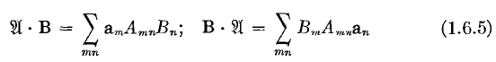

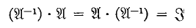

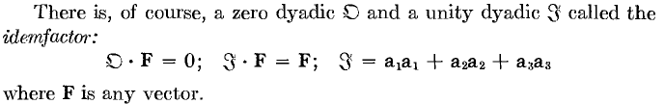

Notice the impressive name "idemfactor" for the identity operator 1 = Σi | ai><ai| = Σi aiaiT = Σiaiai.

(h) Expansions of tensors on unit tangent base vectors

We start with the general Picture A (and later specialize to orthogonal coordinates),

In section (b) above it was established that one can expand a tensor A on the tangent base vectors en as

A = Σijk... A' ijk... (ei⊗ej⊗ek...) A' ijk... = contravariant components of A in x'-space

A' ijk... = Rii'Rjj'Rkk'...... A i'j'k'... .

Since en = h'n n, this same expansion for tensor A can be written

A = Σijk... h'ih'jh'k......A' ijk... (i⊗j⊗k...)

= Σijk... [A()]ijk... (i⊗j⊗k...)

where the unit-vector expansion coefficients are given by

[A()]ijk... = h'ih'jh'k......A' ijk...

= h'ih'jh'k...... Rii'Rjj'Rkk'...... A i'j'k'...

= (h'i Rii')( h'j Rjj')( h'k Rkk') ..... A i'j'k'...

Coefficient notation. In a curvilinear coordinates application of these expansions, the expansion coefficients are usually written in the following manner,

[A()]ijk... = Ax'$_{i}$x'$_{j}$x'$_{k}$ ......

where the x'n are the names of the coordinates. For example, for a rank-4 tensor in spherical coordinates with coordinates x'1 = r, x'2 = θ and x'3 = φ one might write

[A()]2213 = Aθθrφ .

Since [A()]ijk... is not a tensor (with respect to F), there is no particular reason to put the indices "up" and for that reason they are usually written down, as in Aθθrφ .

Matrices M and N. It is convenient now to define

Mab ≡ h'a Rab

so that then

[A()]ijk... = Mii'Mjj'Mkk'...... A i'j'k'... .

Defining Nab to be the inverse of Mab, one has

Nab ≡ h'b-1Sab = h'b-1Rba
so
A ijk... = Nii'Njj'Nkk'...... [A()]i'j'k'... .

To verify that this N is the correct inverse or M,

MakNkc = (h'a Rak)( h'c-1Rck) = (h'a/ h'c) Rak Rck = (h'a/ h'c)δac = δac

making use of the orthogonality rule of Section 7 (r), Rak Rck = δac . M and N can be written in terms of the tangent base vectors as follows:

Mni ≡ h'n Rni = h'n(en)i

Nin = h'n-1Rni = h'n-1(en)i = (n)i

which says that Nin = { 1 , 2, .... } -- the columns of Nin are the unit tangent base vectors.

Rank-1 tensors. For a vector, the above coefficient relation is written

[A()]i = Mij Aj or A() = M A and A = N A()

where A has these two familiar expansions,

A = Anun = [A()]n n [A()]n = Ax'$_{n}$ for example [A()]1 = Ar .

Rank-2 tensors. Here the coefficient relation is

[A()]ij = Mii'Mjj'A i'j' = Mii' A i'j' Mjj'

which can be written

[A()]nm = Mni A ij Mmj = Mni A ij (MT)jm Mni = h'n(en)i .

Defining bn = h'nen , then [bn]i = h'n(en)i = Mni = Bni of section (g) . Meanwhile, from Section 6 (b) we know that wnk = bn • bk = h'nh'k(en • ek) , and then wnk = (w-1)nk . In any event, whatever wnk is, it is the object which can lower the n or m indices on both sides of the above equation. Lowering just the m index and then reversing the j tilt gives

[A()]nm = Mni A ij Mmj = Mni A ij (MT)jm = Mni A ij (MT)jm

and we replicate the section (g) result with B = M :

A() = M A MT // [A() = M A MT ]SN,dt .
Matrix H and x"-space. In the discussion above one has x-space with basis vectors un and x'-space with basis vectors en (the tangent base vectors). It is useful then to define x"-space as the space whose basis vectors are the n unit vectors, which are generally not orthogonal. The relation Mab ≡ h'a Rab given above can be written in down-tilt form as

M = HR where Hij ≡ diag(h'1, h'2.....).

It then follow that

N = M-1 = R-1H-1 = SH-1

Finally, note that

x = xiui = x'iei = x'i(h'ii) = x"ii => x"i = h'i x'i or x" = H x'

which shows that the transformation from x'-space to x"-space is linear with matrix H. We can now show all three spaces in the same picture as follows:

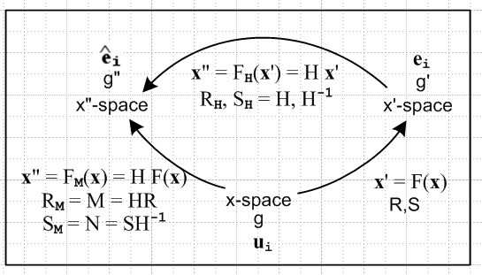

This picture shows that the transformation directly from x-space to x"-space is

FM(x) = H F(x) .

Here F(x) is a (generally) non-linear transformation assumed to connect x'-space to x-space. This is then concatenated with linear transformation H to get non-linear transformation FM(x).
We can now write A() as A" and restate equations above as

A = Σijk... A" ijk... (i⊗j⊗k...) // rank-n tensor expanded on i⊗j⊗k...

A" ijk... = Mii'Mjj'Mkk'...... A i'j'k'... // rank-n tensor transformation

A ijk... = Nii'Njj'Nkk'...... A" i'j'k'... // inverse of the above

A" i = Mij Aj // rank-1 tensor

A" ij = Mii'Mjj'A i'j' // rank-2 tensor

A" = M A MT // rank-2 tensor, matrix notation

The word "tensor" suddenly has a new meaning in the above equations. The equations indicate objects being tensors with respect to this non-linear transformation FM(x) whose linearized-at-a-point matrix is RM = M = HR, where R is the linearized-at-a-point matrix version of F(x), and H is the diagonal matrix of scale factors h'i which are associated with g'ij in x'-space. The Aijk... are contravariant components of tensor A in x-space, while A"ijk... are the corresponding contravariant components of A in x"-space, all with respect to FM(x) and its matrix RM = M where, for example, dx" = M dx.
At this point the spaces are completely general, and none of R, RH = H, RM = M is a rotation matrix. In the next section, we shall specialize the above picture so that x-space is Cartesian with g = 1, and x'-space is the space of a set of orthogonal curvilinear coordinates x'. In this scenario, F(x) is non-linear and so then is FM(x) = H F(x) . Since the i now form a frame of orthonormal vectors, and since ui also form such a frame, one will not be surprised to find that M is now a rotation which relates these two frame sets.

Orthogonal curvilinear coordinates application

We now switch to picture B (g=1) and assume that the x'i are orthogonal coordinates,

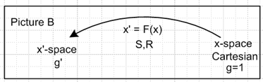

and our three-frame picture above then becomes

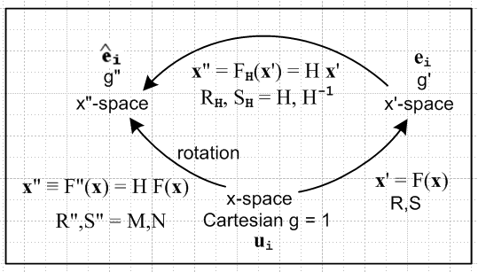

In this situation, x-space is Cartesian with gab = gab = δab and g'ab = h'a2δab and g'ab = h'a-2δab. Since the metric tensors are diagonal, one could write H = $\sqrt{g'ab}$, but we continue to use H.
In what follows, the plan is simply to exercise both the developmental and standard notations with regard to the M and N matrices. To this end, we first collect the following facts from Section 7 (o),

Rab = Rab' gb'b = Rab
Rab = g'aa'Ra'b' gb'b = g'aa'Ra'b = h'a2 Rab = h'a2 Rab
Rab= g'aa'Ra'b = h'a2 Rab
or
Rab = Rab Rab = Rab = h'a2 Rab Rab = h'a-2 Rab .

Also from Section 7 (11),

g'ab = Raa'Rbb'ga'b' = Raa'Rba' = RacRbc
g'ab = Sa'a Sb'b ga'b' = Raa' Rbb'ga'b' = Raa' Rba' = RacRbc
or
g'ab = RacRbc and g'ab = RacRbc .

In this scenario, regardless of what R and S are, M is a "rotation" (verified below), where we include in this term possible axis reflections. What we really mean is that in developmental notation M is a real-orthogonal matrix, MMT = 1. Since N=M-1, N is then also a rotation.
To prove that M is a rotation in developmental notation, the standard notation equation Mab ≡ h'a Rab can be reverse-translated to Mab = h'aRab . Then (now g' = RRT from Section 5 (l) )

(MMT)ac = MabMcb = h'aRab h'cRcb = h'ah'c RabRTbc = h'ah'c(RRT)ac

= h'ah'cg'ac = h'ah'c [ h'a–2 δa,c] = δa,c => MMT = 1 .

Proving the same thing directly in standard notation requires showing that Mab Mcb = δa,c ( see the end of Section 7 (i) )

Mab Mcb = h'a Rab h'c Rcb = h'a h'c Rab Rcb = h'a h'c Rab (h'c-2 Rcb) = (h'a/h'c) (Rab Rcb)

= (h'a/h'c)δac = δac = δa,c

where use was again made of the orthogonality rule of Section 7 (r), Rab Rcb = δac.

Relation beween M and N. Looking at

Mab Mcb = δa,c

and knowing that

Mab (M-1)bc = δac = δa,c

one concludes that (M-1)bc = Mcb . But (M-1)bc = Nbc so

Nbc = Mcb // reminder: this does not say that N = MT in standard notation

which can be verified from the above expressions for N and M.

Interpretation of N and M. Since en = S un ( Section 3 (a) with e'n = un) and since en = h'nn , it follows that

n = h'n-1 S un
or
(n)a = h'n-1 Sab (un)b = h'n-1 Sab δnb = h'n-1 San = Nan = Nabδbn = Nab(un)b
or
n = N un and (n)a = Nan . // => un = M n

Since the un are the Cartesian unit vectors, it seems intuitively obvious that the transformation that moves this frame of orthonormal unit vectors {un} into the orthonormal frame {n} must be a "rotation".
Above it was shown that Nan = Mna , therefore

Mna = Nan = (n)a

The rotation matrix Nan = (n)a has the orthogonal basis vectors n as its columns, while the rotation matrix Mna = (n)a has the orthogonal basis vectors n as its rows. From this point of view, it seems pretty reasonable that MN = 1.

It might be noted that, in our situation with Cartesian x-space and orthogonal coordinates, n = n :

n = en/|en| |en|2 = en• en = g'nn = h'n-2
so
n = en h'n = h'n g'nn en = h'nh'n-2 en = h'n-1 en = n .

The relation un = M n can be written un = M(x) n(x) to emphasize that the rotation M(x) = RM(x) is really a different rotation at every point x, since the n(x) vary with x. This is very different from a global rotation which is the same at all points. For a global rotation R, F = R = linear and ∂iuj is a tensor. For RM being a rotation which varies from point to point, FM is non-linear just as F defining the curvilinear coordinates is non-linear, and ∂iuj fails to be a tensor under either F or FM.

One implication of the above picture relates to tensor equations being covariant, as discussed in Section 7 (u). If one has a tensor field equation in x-space,

Qadc(x) = Hab(x)Tbc(x) Bd(x) ,

in which all the objects transform as tensors with respect to the underlying x" = FM(x) (and its linear approximation M(x) as in dx" = M(x) dx), then the equation is covariant and takes the same form in x"-space,

Q"adc(x") = H"ab(x")T"bc(x") B"d(x") .

An x-space observer has axes un (Frame S) while an x"-space observer has axes n(x) (Frame S"), and these two sets of observation axes are related by un = M(x) n(x) where M(x) is a rotation. If the first equation describes something at location x in the realm of Newtonian mechanics, we expect the equation to have the same form in both Frame S and Frame S" which are related by this local rotation M(x). In other words, rotations are an invariance of Newtonian mechanics, and this means equations are covariant with respect to rotations. The above example, which might apply to fluid dynamics, has this covariance at each point x in the fluid, and it happens that the rotation is a different rotation at different points x, but it is always a rotation.

Example: Polar Coordinates. In polar coordinates now with ordering r,θ = 1,2 one has

S11 = (∂x/∂r) = cosθ x = rcosθ
S12 = (∂x/∂θ) = -rsinθ y = rsinθ
S21 = (∂y/∂r) = sinθ
S22 = (∂y/∂θ) = rcosθ

Sij = $\left(\begin{matrix}cosθ & -rsinθ \\ sinθ & rcosθ\end{matrix}\right)$ Rij = $\left(\begin{matrix}cosθ & sinθ \\ -sinθ/r & cosθ/r\end{matrix}\right)$ R = S-1

[g' = RRT]DN = $\left(\begin{matrix}cosθ & sinθ \\ -sinθ/r & cosθ/r\end{matrix}\right)$$\left(\begin{matrix}cosθ & -sinθ/r \\ sinθ & cosθ/r\end{matrix}\right)$ = $\left(\begin{matrix}1 & 0 \\ 0 & 1/r2\end{matrix}\right)$ → g'ab = $\left(\begin{matrix}h'r-2 & 0 \\ 0 & h'θ-2\end{matrix}\right)$
so hr = 1 and hθ = r .
The N and M matrices may be computed as follows:

Mab ≡ h'a Rab = $\left(\begin{matrix}1 & 0 \\ 0 & r\end{matrix}\right)$$\left(\begin{matrix}cosθ & sinθ \\ -sinθ/r & cosθ/r\end{matrix}\right)$ = $\left(\begin{matrix}cosθ & sinθ \\ -sinθ & cosθ\end{matrix}\right)$ = Rz(-θ)

Nab ≡ Sab h'b-1 = $\left(\begin{matrix}cosθ & -rsinθ \\ sinθ & rcosθ\end{matrix}\right)$$\left(\begin{matrix}1 & 0 \\ 0 & 1/r\end{matrix}\right)$ = $\left(\begin{matrix}cosθ & -sinθ \\ sinθ & cosθ\end{matrix}\right)$ = Rz(θ)

Therefore, the relation between a rank-2 tensor's n-expanded form components and the Cartesian form components is given by the expression stated above for rank-2 tensors,

A() = M A MT
or
$\left(\begin{matrix}Arr & Arθ \\ Aθr & Aθθ\end{matrix}\right)$ = $\left(\begin{matrix}cosθ & sinθ \\ -sinθ & cosθ\end{matrix}\right)$ $\left(\begin{matrix}A11 & A12 \\ A21 & A22\end{matrix}\right)$$\left(\begin{matrix}cosθ & -sinθ \\ sinθ & cosθ\end{matrix}\right)$ . // Lai p 316 Problem 5.71

Airy functions. In isotropic elastic stress analysis for states of plane stress and plane strain, the Cartesian stress tensor Tij has a simple form in which the upper left four components can be represented as derivatives of a potential-like function called an Airy function φ, so that T11 = ∂22φ, T22 = ∂12φ, and
T12 = T21 = – ∂1∂2φ. In this case, the above equation becomes

$\left(\begin{matrix}Trr & Trθ \\ Tθr & Tθθ\end{matrix}\right)$ = $\left(\begin{matrix}cosθ & sinθ \\ -sinθ & cosθ\end{matrix}\right)$ $\left(\begin{matrix}∂22φ & – ∂1∂2φ \\ – ∂1∂2φ & ∂12φ\end{matrix}\right)$$\left(\begin{matrix}cosθ & -sinθ \\ sinθ & cosθ\end{matrix}\right)$ (*)
where
∂1 = cosθ ∂r - (sinθ/r)∂θ ∂1 = ∂/∂x1
∂2 = sinθ ∂r + (cosθ/r)∂θ ∂2 = ∂/∂x2
Using Maple's dchange function, one can have Maple compute $\left(\begin{matrix}Trr & Trθ \\ Tθr & Tθθ\end{matrix}\right)$ from (*) to be
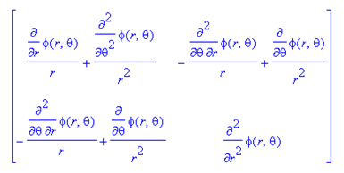 // Lai p 264 (5.27.3)

This then is a real-world example of using a rank-2 tensor in curvilinear coordinates expanded on the unit tangent base vectors. The mentioned plane of strain or stress has Cartesian coordinates x1,x2 which are converted to polar coordinates r,θ. The third Cartesian coordinate x3 is more or less ignored.
The relation between the stress tensor Tij and the infinitesimal strain tensor Eij for an isotropic material is stated in Cartesian coordinate x-space as ( a form of Hooke's Law generalizing F = -kx),

Tij = λ tr(E)δij + 2μEij or the same thing Tij = λ tr(E)δij + 2μEij

where λ and μ are Lamé's constants. With respect to transformation FM, this is a "true tensor equation" (tr(E) = Ekk is scalar under rotations), so according to Section 7 (u) it is "covariant" and in x"-space may be written

T"ij = λ tr(E")δij + 2μE"ij
or
[T()]ij = λ [T()]kk δij + 2μ[E()]ij .

For example, using the notation convention described above,

Trr = λ [ Trr+ Tθθ] + 2μ Err
Trθ = 2μ Erθ .

Notice that δ"ij = δij under transformation FM , since δ"ij = MiaMjbδab = MiaMja = δij, whereas under transformation F one has δ'ij = RiaRjbδab = RiaRja = g'ij.
By way of contrast, the Cartesian-coordinates equation Eij = (∂iuj + ∂jui)/2, which relates strain tensor Eij to the vector displacement u of a continuum particle, is not a "true tensor equation", so Erθ ≠ (∂ruθ + ∂θur)/2. In fact, this relation is E = [(∇u)T + (∇u)] / 2 and (∇u) for polar coordinates is computed in Appendix G and one ends up with Erθ = (∂ruθ + (1/r) ∂θur - uθ/r) / 2 .

(i) Tensor expansions in a mixed basis

Recall the rank-n tensor expansion from section (b) above,

A = Σijk... αijk... (bi⊗bj⊗bk...) αijk = A • (bi⊗bj⊗bk)

where αijk... are the coefficients of the expansion of A on the direct product basis shown. A might be a tensor, or it might be a tensor-like object. To make explicit the fact that the coefficients depend on the choice of basis, one might write (one b for each index, number of b's is the rank of the tensor) ,

αijk... = [ A(b,b,b...)]ijk... .

The fact that the indices ijk... are "up" indicates that the b label stands for the bi basis and not bi. So here is an example showing the expansion of a rank-3 tensor,

A = Σijk [ A(b,b,b)]ijk (bi⊗bj⊗bk) [ A(b,b,b)]ijk = A • (bi⊗bj⊗bk) .

Earlier we used the simpler notation [A(b)]ijk for the above coefficient, but now we want to show all the basis elements because now we want to consider a "mixed basis expansion" such as

A = Σijk [ A(b,e,u)]ijk (bi⊗ej⊗uk) [ A(b,e,u)]ijk = A • (bi⊗ej⊗uk) .

This is a completely viable expansion since the b, e and u basis vectors are each a complete set within their part of the direct-product space. To verify the validity of this expansion, consider :

[ A(b,e,u)]ijk = {A} • (bi⊗ej⊗uk)

= { Σi'j'k' [ A(b,e,u)]i'j'k' (bi'⊗ej'⊗uk')}• (bi⊗ej⊗uk)

= { Σi'j'k' [ A(b,e,u)]i'j'k' (bi'• bi) (ej'• ej) (uk'• uk)

= { Σi'j'k' [ A(b,e,u)]i'j'k' δi'iδj'jδk'k

= [ A(b,e,u)]ijk .

Alternatively, one could relate this coefficient to the coefficients expanded on ui⊗uj⊗uk,

[ A(b,e,u)]ijk = A • (bi⊗ej⊗uk) = Aabc (bi)a (ei)a (ui)a

as was shown near the start of section (b).
In the case of a rank-2 tensor, one has the option of using the other notations discussed above,

A = Σij [ A(b,u)]ij (bi⊗uj) = Σij [ A(b,u)]ij (biuj)
direct product dyadic
= Σij [ A(b,u)]ij (biujT) = Σij [ A(b,u)]ij |bi><uj|
matrix bra-ket
where

[ A(b,u)]ij = A • (bi⊗uj) = Aab (bi)a (uj)b = (bi)T A (ujj) = < bi| A | uj > .

One can of course use unit versions of the en basis vectors, n, and then one might write for example

A = Σijk [ A(,,u)]ijk (i⊗j⊗uk)

where the hats are replicated into the superscript tensor label.

Example of a mixed-basis expansion of a tensor

The identity tensor can be expanded this way, since ui • uj = (ui)Tuj = δij = <ui| uj> ,

1 = Σj uj ⊗ uj = Σj uj(uj)T = Σj ujuj = Σj | uj>< uj| .
direct product matrix dyadic bra-ket

The ui are related to the ei according to

uj = Rij ei .

Proof: (uj)a = Rij (ei)a => δja = Rij Ria which is an orthogonality rule of Section 7 (r).

It follows that

1 = Σij Rij ei ⊗ uj = Σij Rij ei(uj)T = Σij Rij eiuj = Σij Rij | ei><uj|
direct product matrix dyadic bra-ket
where

Rij = (ei)T 1 uj = ei • uj = eiuj = <ei | uj> // as in Section 7 (s)
matrix dot dyadic bra-ket

This then is a mixed-basis expansion of the identity tensor. Another form would be

1 = Σij Rij ei ⊗ uj = Σij [1(e,u)]ij ei ⊗ uj

following the notation discussed above, leading to this rather obscure way of writing Rij ,

Rij = [1(e,u)]ij .

(j) What is a tensor?

We are now in a better position to examine some possible answers to this question.

(1) A tensor is an operator like A which lives inside a direct product Hilbert Space.
We can associate with this tensor A a large variety of up-indexed objects such as [A(b,e,u)]ijk in the example above. If one has at hand K different bases of interest, then for a tensor of rank n there would be Kn possible up-indexed objects. In the case of rank 2, these K2 different indexed objects are matrices. Given the un and en bases used throughout this document, there are two special up-indexed objects of rank 3: [A(u,u,u)]ijk and [A(e,e,e)]ijk which we abbreviate as [A(u)]ijk and [A(e)]ijk or as [A]ijk and [A']ijk . The indexed object [A]ijk is a set of N3 contravariant components of a rank-3 tensor in x-space, and [A']ijk is a set of N3 contravariant components of the same rank-3 tensor in x'-space, where these two spaces are linked by a transformation x' = F(x) which has a linearized form dx' = R dx at a point x. The two sets of contravariant components are related by

[A']ijk = Rii'Rjj'Rkk' [A]i'j'k' .

These sets of components "transform as a rank-3 tensor with respect to the underlying transformation x' = F(x). As outlined in Section 7, the all-up indexed tensor of rank n is just one of a family of 2n tensors where the indices take all possibly up and down positions, and each such tensor has a corresponding transformation rule, such as

[A']ijk = Rii'Rjj'Rkk' [A]i'j'k' for A = Σijk [ A']ijk (ei⊗ej⊗ek) .

For this definition of "tensor" as an abstract operator A, there are many possible set pairs of components (indexed objects where the values of all indices are set in all possible ways) which do NOT transform as a rank-3 tensor with respect to F as just described. The component sets that do transform as tensors are those for which the components are coefficients of an expansion of A on a direct product basis where the individual basis vectors are selected from ei or ei, or are selected from ui or ui. If some other generic basis vector bi appears, then the component set does not transform as a tensor under F.

Definition (1) is basically the definition of "tensor" used in this document.

(2) Another definition of tensor might be: a tensor is any of the indexed objects mentioned in (1) above. The set of components like [A(b,e,u)]ijk is called a "tensor" because it is a possible coefficient set that can be obtained by expanding the "tensor operator" A on suitable basis vectors. Just as a matrix is sometimes written without its indices, so this tensor object might be represented just as A(b,e,u). The components of this particular indexed object do not transform as either end of the transformation rule stated above, so this tensor is a tensor, but does not transform as a tensor.

(3) A third possible definition: a tensor is any indexed object each of whose indices ranges from 1 to N where N is the dimension of one's space of interest. By this definition, any NxN matrix Aij would be a tensor of rank 2. It would be very unlikely that a random matrix like this would be part of the transformation rule [A']ij = Rii'Rjj' [A]i'j' so this matrix Aij is then a tensor, but it probably doesn't transform as a tensor.

In fields of physics involving relativity, the first definition is normally used, and an indexed object is called a tensor only if it transforms the way a tensor should transform with respect to a transformation of interest. For example, the affine connection Γcab is never called a tensor. In most other areas of physics definition (3) seems more common, where any matrix is a rank-2 tensor, also known as a second-order tensor. The whole subject of second order tensors is then identified with linear algebra where the operators are matrices. It may turn out that a particular matrix is in fact a tensor by definition (1) with respect to rotations. This is the case for basic matrices involved in equations which must be covariant. In continuum mechanics, which generally uses definition (3), there are many tensors which do not transform as tensors under rotations or other transformations. In that field, when a tensor in fact transforms as a tensor, it is called an objective tensor (sometimes an indifferent tensor). Equations which are covariant in the sense of Section 7 (u) are called "frame indifferent". See Appendix K for examples.

Appendix F: The Affine Connection Γcab and Covariant Derivatives

(a) Definition and Interpretation of Γ : Γcab = ec • (∂aeb) = Rci(∂aRbi)

Context can be confusing in a discussion of the affine connection Γ, so we start with a modified Picture C in which the quasi-Cartesian space on the right is called ξ-space instead of x(0)-space as in Picture C. The notation ξi for the coordinates of ξ-space seems traditional in general relativity writing, an application in which the Γ object appears frequently.

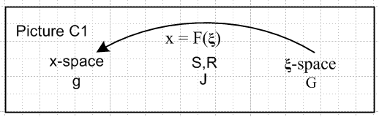

Recall from Section 1 that the metric tensor G is a diagonal matrix whose elements are independently +1 or -1. And recall from Section 5 (b) that in x-space, gab = RaiRbjGij. If G = 1, then the xi coordinates of x-space are the "curvilinear coordinates" and the ξi are the "Cartesian coordinates".
In Picture C1 the tangent base vectors en exist in ξ-space and the components of en are given by (en)i = Rni, as in Example 1 of Section 3 (polar coordinates). Since matrix R is the linearization of transformation F at ξ and since x = F(ξ), one can regard R as a function either of ξ or x. We choose x as the variable and write [en(x)]i = Rni(x). For example, Example 2 of Section 3 (spherical coordinates) showed that eφ(x) = rsinθ (r,θ,φ).
In any event, en(x) varies with x, and one wonders just how en varies with x. For a small variation dx in the x-space coordinates, one has,

d(en)i = ∂j(en)i dxj ∂j ≡ ∂/∂xi
or
(den)i = (∂jen)i dxj .

Since en and (∂jen) are both vectors in ξ-space, and since the ek are known to form a complete basis in ξ-space, it must be possible to expand (∂jen) on the ek with some appropriate coefficients, call them Γkjn :

(∂jen) = Γkjn ek .

Dotting this equation into ek gives

Γkjn = ek • (∂jen) = Rki(∂jRni)

where we recall from Section 7 (s) that (ek)i = Rki and (en)i = Rni. These coefficients Γkjn(x) comprise a tensor-like field called the affine connection, so we shall regard the above line as the definition of Γkjn in the context of Picture C1 above. With more standard index names, the above becomes

Γcab = ec • (∂aeb) = Rci(∂aRbi) .

From Section 7 (q) we know that, for Picture C1,

Rci = (∂xc/∂ξi)
Rbi = (∂ξi/∂xb)
(∂aRbi) = (∂2ξi/∂xa∂xb) = (∂bRai)

Therefore one can write

Γcab = Rci(∂aRbi) = (∂xc/∂ξi) (∂2ξi/∂xa∂xb) = $\frac{∂xc}{∂ξi}$$\frac{∂2xi}{∂ξa∂ξb}$ ,

which form appears in Weinberg p 100 (4.5.1). Notice again that (∂bRcn) = (∂cRbn) and that Γcbc is symmetric on the lower two indices. In the next section an alternate form for Γ is derived, so both forms will be stated here:

Γcab = Rci(∂aRbi) // ∂a = ∂/∂xa
Γcab = – Rbi (∂aRci)

(b) Identities of the form (∂aRdn) = – Ren Rdm (∂aRem)

The identities are :

Rdm (∂aRem) = – Rem (∂aRdm) 1

(∂aRdn) = – Ren Rdm (∂aRem) 2 ∂a ≡ ∂/∂xa

(∂aRdn) = – Ren Rdm (∂aRem) 3

The second two lines are just restatements of the first line, but all are derived below.

Corollary: The first identity above allows an alternate form for the affine connection in terms of R:

Γcab = Rci(∂aRbi) // as in section (a) above
Γcab = – Rbi (∂aRci) // alternate form

Our context is:

.

Proof: These identities are a simple consequence of the fact that RS = 1 which in standard notation is written δcb = RcαRbα (one of the orthogonality rules). So,

0 = ∂a(δde) = ∂a(RdmRem) = Rdm (∂aRem) + Rem (∂aRdm) QED 1 (*)

Apply Σe Ren to both sides of (*) to get ( or, just use the Inversion Rule of Section 7 (r) )

0 = Ren Rdm (∂aRem) + (Ren Rem) (∂aRdm) = Ren Rdm (∂aRem) + δnm (∂aRdm)
= Ren Rdm (∂aRem) + (∂aRdn)

=> (∂aRdn) = – Ren Rdm (∂aRem) QED 2

Alternatively, apply Σd Rdn to both sides of (*) to get

0 = (Rdn Rdm) (∂aRem) + Rdn Rem (∂aRdm) = δnm (∂aRem) + Rdn Rem (∂aRdm)
= (∂aRen) + Rdn Rem (∂aRdm)

=> (∂aRen) = – Rdn Rem (∂aRdm) now swap d and e:
=> (∂aRdn) = – Ren Rdm (∂aRem) QED 3

(c) Identities of the form (∂cgab) = – [gan Γ bcn + gbn Γacn]

The derivatives of the metric tensor are given by ( ∂c = ∂/∂xc)

(∂cgab) = – [gan Γ bcn + gbn Γacn] 1

(∂cgab) = + [gan Γncb + gbn Γnca] 2

Proof of 1: (∂cgab) = – [gan Γ bcn + gbn Γacn]

The LHS is given by

LHS = (∂cgab) = ∂c(RaiRbi)Gii = Rai(∂cRbi)Gii + Rbi(∂cRai)Gii

For the RHS, the Γ objects can be replaced by their alternate definitions from section (a)

Γcab = – Rbi (∂aRci) // from section (a)
Γbcn = – Rni (∂cRbi) // b→n then c→b then a→c
Γacn = – Rni (∂cRai)

The RHS of the claimed identity may then be written

RHS = – gan Γ bcn – gbn Γacn

= {RakRnkGkk }{Rni (∂cRbi)} + {RbkRnkGkk }{Rni(∂cRai)}

= Rak(Rnk Rni) (∂cRbi) Gkk + Rbk(Rnk Rni) (∂cRai) Gkk

= Rakδki (∂cRbi) Gkk + Rbkδki (∂cRai) Gkk

= Rai (∂cRbi) Gii + Rbi (∂cRai) Gii = LHS QED

Proof of 2: (∂cgab) = + [gan Γncb + gbn Γnca]

The LHS is given by

LHS = (∂cgab) = ∂c(RaiRbi)Gii = Rai (∂cRbi)Gii + Rbi (∂cRai)Gii

For the RHS, the Γ objects can be replaced by their primary definitions from section (a)

Γcab = Rci(∂aRbi)
Γncb = Rni(∂cRbi) // c→n then a→c then i→k
Γnca = Rni(∂cRai)

The RHS of the claimed identity may then be written

RHS = gan Γncb + gbn Γnca

= {RakRnkGkk}{Rni(∂cRbi)} +{RbkRnkGkk}{Rni(∂cRai)}

= Rak (Rnk Rni)(∂cRbi)Gkk + Rbk(Rnk Rni)(∂cRai)Gkk

= Rak δki(∂cRbi)Gkk + Rbk∂ki(∂cRai)Gkk

= Rai (∂cRbi)Gii + Rbi (∂cRai)Gii = LHS QED

(d) Identity: Γdab = (1/2) gdc [ ∂agbc + ∂bgca – ∂cgab]

The identity states that Γdab may be expressed entirely in terms of the metric tensor,

Γdab = (1/2) gdc [ ∂agbc + ∂bgca – ∂cgab] .

Recall in our definition above, Γdab = Rdk(∂aRbk), that Γ was given in terms of R matrices.
The following corollary ( derived at the end of this section ) concerns contraction of the upper Γ index with a lower one:

Γaan = (1/2) gad ∂ngad = (1/2)(1/g)∂ng = (1/$\sqrt{g}$) ∂n($\sqrt{g}$) .

Proof: Γdab = (1/2) gdc [ ∂agbc + ∂bgca – ∂cgab]

We know that

gab = RaeRbe Gee // sum on e
gdc = RdiRci Gii // sum on i

The first line below is computed from the first line in the pair above, then the next two lines below are obtained by doing forward cyclic permutations of the first line :

∂cgab = [Rbe (∂cRae) + Rae(∂cRbe) ]Gee
∂agbc = [Rce (∂aRbe) + Rbe(∂aRce) ]Gee
∂bgca = [Rae (∂bRce) + Rce(∂bRae) ]Gee .

The last four lines can be inserted into the Right Hand Side of our desired identity to obtain

(RHS)dab = (1/2) gdc [ ∂agbc + ∂bgca – ∂cgab]

= (1/2) (RdiRci Gii) Gee *
[Rce (∂aRbe) + Rbe(∂aRce) + Rae (∂bRce) + Rce(∂bRae) – Rbe (∂cRae) – Rae(∂cRbe) ]
1 2 3 4 5 6

Due to the symmetry noted above in section (a), (∂iRje) = (∂jRie), terms 2 and 5 cancel as do terms 3 and 6, while terms 1 and 4 are equal. Therefore,

(RHS)dab = (1/2) RdiRci Gii Gee * 2 Rce (∂aRbe)

= Rdi (Rce Rci) Gii Gee (∂aRbe) = Rdi δei Gii Gee (∂aRbe)

= Rde Gee Gee (∂aRbe) = Rde(∂aRbe) = Γdab QED

Proof of Corollary: The abovementioned corollary is this (g ≡ det(gab) )

Γaan = (1/2) gad( ∂agnd + ∂ngad – ∂dgan ) = (1/2) gad ∂ngad = (1/2) (1/g)∂ng = (1/$\sqrt{g}$) ∂n($\sqrt{g}$)

The first and third terms of the second expression cancel due to symmetry

gad∂agnd – gad∂dgan = gad∂agnd – gda∂agdn = gad∂agnd – gad∂agnd = 0

and the fact that (1/g) ∂ng = gab(∂ngab) is proved as follows:

(1) gab = (g-1)ab = cof(gab)T/det(gab) = cof(gab)/g => cof(gab) = g gab

(2) g = det(gab) = Σab gabcof(gab) => ∂g/∂gab = cof(gab) = g gab

(3) ∂ng = ∂g/∂xn = (∂g/∂gab)( ∂gab/∂xn) = g gab (∂ngab) => (1/g) ∂ng = gab(∂ngab) .

The final form shown is just calculus :

g-1/2 ∂n(g1/2) = g-1/2 (1/2) g-1/2 ∂n(g) = (1/2) (1/g) (∂ng) .

(e) Picture D1 Context

Our main context of interest is Picture A,

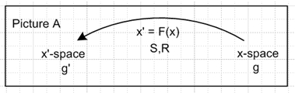 .

For the proof given in the next section below, it is useful to think of Picture A as the top part of this Picture D1,

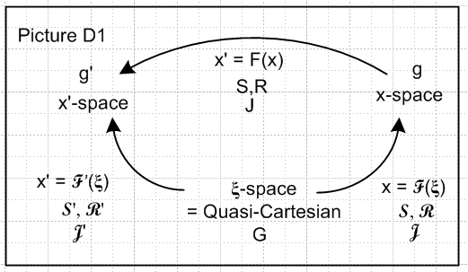

The relationship between the R's and S's are these

R = R' R-1 = R' S => R' = RR
S = R R'-1 = R S'

The tangent and reciprocal base vectors in ξ-space associated with transformations F and F ' are these:

(en)i = Rni (en)i = Rni x-space
(e'n)i = R'ni (e'n)i = R'ni x'-space

Now there are two affine connections,

Γcab ≡ (∂xc/∂ξn) (∂2ξn/∂xa∂xb) = Rcn ∂a (∂ξn/∂xb) = Rcn(∂aRbn) ∂a = ∂/∂xa
= [ec]i • (∂a[eb]i) = ec • (∂aeb)

Γ 'cab ≡ (∂x'c/∂ξn) (∂2ξn/∂x'a∂x'b) = R'cn ∂'a (∂ξn/∂x'b) = R'cn(∂'aR'bn) ∂'a = ∂/∂x'a
= [e'c]i • (∂'a[e'b]i) = e'c • (∂'ae'b)

(f) Relations between Γ and Γ '
The claimed relations are the following in the context of Picture A shown above,

Γ 'cab = Rcd Raα Rbβ Γdαβ + Rcα (∂'aRbα) // Weinberg p 100 (4.5.2)

Γ 'cab = Rcd Raα Rbβ Γdαβ – Rbβ(∂'aRcβ)

Γ 'cab = Rcd Raα Rbβ Γdαβ – Raα Rbβ (∂αRcβ) // Weinberg p 102 (4.5.8)

If the second term were not present, the relation would state that Γdαβ transforms as a mixed rank-3 tensor in the usual manner (Section 7 (j)). Since the second term is present, Γdαβ is not a tensor.

Proof of the first relation : We now make use of Picture D1 shown above. Start with the Γ ' definition given above,

Γ 'cab ≡ R'cn(∂'aR'bn) = (RR)cn ∂'a(RR)bn = RcdRdn ∂'a(RbβRβn) // R' = RR

= RcdRdnRbβ(∂'aRβn) + Rcd(RdnRβn)( ∂'aRbβ)

= RcdRdnRbβ([Raα∂α]Rβn) + Rcd(δdβ)( ∂'aRbβ) // ∂'a = Raα∂α in first term only

= RcdRaαRbβRdn(∂αRβn) + Rcβ (∂'aRbβ)

= RcdRaαRbβ Γdαβ + Rcα (∂'aRbα) // Γdαβ ≡ Rdn(∂αRβn) QED

Magically, all the R's have gone away.
The second term in the above relation can be written a different manner as follows. Consider,

0 = ∂'a(δcb) = ∂'a(RcαRbα) = Rcα (∂'aRbα) + Rbα (∂'aRcα)

=> Rcα (∂'aRbα) = – Rbα(∂'aRcα) = – Rbβ(∂'aRcβ)

= – Rbβ Raα(∂αRcβ)

and this gives the other two relations stated above.

(g) Statement and Proof of the Covariant Derivative Theorem

Many examples of this theorem will be given later. In this proof it is assumed that the tensor density of interest is purely covariant (all indices "down"). In the next section it will then be shown how to adjust the theorem if one or more of the tensor density indices is "up".

Covariant Derivative Theorem: The covariant derivative (Babc..x;α as defined below) of a covariant tensor density of rank n and weight W (Babc..x ) transforms as a covariant tensor density of rank n+1 and weight W.

The implication is that all the indices including α of Babc..x;α can be treated as ordinary tensor indices with respect to raising, lowering, contraction, and so on. The first term in Babc..x;α is the regular derivative ∂α Babc..x, often written as Babc..x,α (comma, not semicolon), and this first term is not a tensor. Only when all the "correction terms" are included does the object become a tensor.

The covariant derivative in x-space and then in x'-space is defined as follows: (Weinberg p 104 4.6.12)

Babc..x;α ≡ ∂α Babc..x – ΓnaαBnbc..x – ΓnbαBanc..x – .... – ΓnxαBabc..n // x-space
del a-term b-term x-term
+ (W/2g) (∂αg) Babc..x

B'abc..x;α ≡ ∂'α B'abc..x – Γ 'naαB'nbc..x – Γ 'nbαB'anc..x – .... – Γ 'nxαB'abc..n // x'-space
del a-term b-term x-term
+ (W/2g') (∂'αg') B'abc..x

The two definitions are the same except everything is primed in x'-space (except constant weight W). This is as one would expect if the x-space equation were a "true tensor equation" as discussed in Section 7 (u) and were therefore "covariant". Although the Γ objects are not tensors themselves, the combination of terms shown in the definition of Babc..x;α is a rank n+1 tensor (as will be demonstrated).

As was shown in section (d), (1/2)(1/g)∂αg = Γκκα so the W terms could be written as W Γκκα Babc..x and W Γ 'κκα B'abc..x, and this form is commonly seen in the literature on this subject.

A proof of the theorem must then show that Babc..x;α as defined above in fact transforms as a tensor density of rank n+1 and weight W, which is to say, one must show that

B'abc..x;α = J-W Raa'Rbb'..... Rxx' Rαα' Ba'b'c'..x';α'
or
B'ABC..X;α
= J-WRαα'{RAa'RBb'..... RXx'} *
Ba'b'c'..x';α'

or, in gory detail,

∂'αB'ABC..X – Γ 'nAαB'nBC..X – Γ 'nBαB'AnC..X – ........... – Γ 'nXαB'ABC..n // LHS
del' a'-term b'-term x'-term
+ (W/2g') (∂'αg') B'ABC..X

= J-W Rαα'{RAa'RBb'..... RXx'} * // RHS
{∂α'Ba'bc'..x' – Γna'α'Bnb'c'..x' – Γnb'α'Ba'nc'..x' – .. – Γnx'α'Ba'b'c'..n
del a-term b-term x-term
+ (W/2g) (∂α'g) Ba'b'c'..x' }
Proof:

1. Expand the LHS del' term and show del'-del matches the RHS del term.

∂'αB'ABC..X = (Rαβ∂β)( J-W RAaRBb..... RXx Babc..x) del'

= Rαβ(∂β J-W) RAaRBb..... RXx Babc..x del'-J

= Rαβ J-W (∂βRAa)RBb..... RXx Babc..x del'-a

+ Rαβ J-W RAa(∂βRBb)..... RXx Babc..x del'-b
...
+ Rαβ J-W RAaRBb. ... (∂βRXx) Babc..x del'-x

+ Rαβ J-W RAaRBb.............RXx (∂β Babc..x) del'-del

We first claim that this del'-del term of the LHS matches the del term on the RHS:

del'-del LHS = Rαβ J-W {RAaRBb...........RXx} (∂β Babc..x)

del RHS = J-W Rαα'{RAa'RBb'..... RXx'} {∂α' Ba'bc'..x'}

Unpriming all the Latin indices and setting α' = β shows that these two terms indeed match.

2. Show that the a-related terms balance. The a'-term on the LHS is this

– Γ 'nAαB'nBC..X

The connection between Γ ' and Γ given in section (f) says

Γ 'cab = Rcd Raκ Rbσ Γdκσ – Raκ Rbσ (∂κRcσ)
or
Γ 'nAα = Rnd RAκ Rασ Γdκσ – RAκ Rασ (∂κRnσ) .

Inserting the above for Γ 'nAα and the transformation rule for B', the LHS a'-term becomes

– { Rnd RAκ Rασ Γdκσ – RAκ Rασ (∂κRnσ)} { J-W Rnn'RBbRCc....Rxx Bn'bc..x }

and to this we must add the contribution called del'-a above.
Meanwhile, the RHS a-term is this

J-W Rαα'{RAa'RBb'..... RXx'}{– Γna'α'Bnb'c'..x'} // remove Latin primes, then n→n'

= – { J-W Rαα'{RAaRBb..... RXx}{Γn'aα'Bn'bc..x}

so we have to show that

– { Rnd RAκ Rασ Γdκσ – RAκ Rασ (∂κRnσ)} { J-W Rnn'RBbRCc....Rxx Bn'bc..x }
+ Rαβ J-W (∂βRAn')RBb..... RXx Bn'bc..x // a→n' , this is the del'-a term

= – { J-W Rαα'{RAaRBb..... RXx}{Γn'aα'Bn'bc..x} ?

where now the del'-a term has been added in to the LHS, and in so doing index a→ n'. We can see that the factors J-W RBbRCc....Rxx Bn'bc..x are the same on both sides so they can be removed to give a simpler relation which we must show is valid:

– { Rnd RAκ Rασ Γdκσ – RAκ Rασ (∂κRnσ)} { Rnn' }
+ Rαβ (∂βRAn')
= – { Rαα'{RAa }{Γn'aα'}

In the first term one sees Rnd Rnn' = δdn' which pins d to n' in that term only, so the above becomes

– RAκ Rασ Γn'κσ + Rnn'RAκ Rασ (∂κRnσ) + Rαβ (∂βRAn') = – RασRAκ Γn'κσ .

The first term on the left cancels the term on the right, and do β→σ in the third term to get

RAκ Rασ {Rnn'(∂κRnσ)} + Rασ (∂σRAn') = 0 .

Then cancel the common Rασ factor and use the symmetry (∂κRnσ) = (∂σRnκ) to get

(∂σRAn') = – Rnn'RAκ (∂σRnκ)

Now in this order do σ→a, A→d, n→e, n'→n, κ→m to get

(∂aRdn) = –Ren Rdm (∂aRem) .

But this is seen to be the third identity of section (b)! By reversing the above sequence of steps, one shows that the three a-related terms in the above LHS = RHS equation balance:

a'-term + del'-a = a-term.
or
– { Rnd RAκ Rασ Γdκσ – RAκ Rασ (∂κRnσ)} { Rnn'RBbRCc....Rxx Bn'bc..x }
+ Rαβ (∂βRAn')RBb..... RXx Bn'bc..x

= – { Rαα'{RAaRBb..... RXx}{Γn'aα'Bn'bc..x}

In reversing the sequence, one of course adds back in the deleted common factors as well as the various implied index sums. It seems clearer to state the proof this way rather than start with the last equality with no justification and artificially thread backwards to the desired equation. This method is used as well in the next section.

3. Show that the b-related terms balance. In the previous equation, which was shown true, do A,a↔B,b (indices) and Bn'bc..x → Ban'c..x to get the following known-valid equation :

– { Rnd RBκ Rασ Γdκσ – RBκ Rασ (∂κRnσ)} { Rnn'RAaRCc....Rxx Ban'c..x }
+ Rαβ (∂βRBn')RAa..... RXx Ban'c..x

= – { Rαα'{RBbRAa..... RXx}{Γn'bα' Ban'c..x } .

The first line is in fact the b'-term (– Γ 'nBαB'AnC..X), the second line is del'-b, and the RHS is the b-term. This shows that the three b-related terms match LHS = RHS.

4. Similarly, the c,d.....x terms match. Just repeat item 3 above for each extra index.

5. It remains to show that the three terms so far neglected match as well. These terms are

LHS: Rαβ(∂β J-W) RAaRBb..... RXx Babc..x // the del'-J term
+ (W/2g') (∂'αg') B'ABC..X // the LHS W term

RHS: J-W Rαα'{RAa'RBb'..... RXx'}(W/2g) (∂α'g) Ba'b'c'..x' // the RHS W term

That is, one must show that

Rαβ(∂β J-W) RAaRBb..... RXx Babc..x + (W/2g') (∂'αg') B'ABC..X

= J-W Rαα'{RAa'RBb'..... RXx'}(W/2g) (∂α'g) Ba'b'c'..x' .

Expanding B'ABC..X in the second term gives

Rαβ(∂β J-W) RAaRBb..... RXx Babc..x + (W/2g') (∂'αg') J-W{RAa'RBb'..... RXx'} * Ba'b'c'..x'

= J-W Rαα'{RAa'RBb'..... RXx'}(W/2g) (∂α'g) Ba'b'c'..x' .

Now unprime the primed Latin indices and set β = α' in the first term to get

Rαα'(∂α' J-W) RAaRBb..... RXx Babc..x + (W/2g') (∂'αg') J-W{RAaRBb..... RXx} * Babc..x

= J-W Rαα'{RAaRBb..... RXx}(W/2g) (∂α'g) Babc..x .

Next, remove all common factors (and associated implied sums) to get

Rαα' (∂α' J-W) + (W/2g') (∂'αg') J-W = J-W Rαα' (W/2g) (∂α'g) .

Since ∂'α = Rαα'∂α' this becomes

(∂'α J-W) + (W/2g') (∂'αg') J-W = J-W (W/2g) (∂'αg) .

Move the second term to the RHS and do the derivative to get

(-W) J-W-1(∂'α J) = J-W (W/2)[ (∂'αg)/g – (∂'αg')/g' ]

so it remains then to show that

J-1(∂'α J) = (1/2)[ (∂'αg')/g' - (∂'αg)/g ]

From Section 5 (k) one has J2 = g'/g and J = (g'/g)1/2 so we need to show that

∂'α (g'/g)1/2 = (1/2) (g'/g)1/2[ (∂'αg')/g' - (∂'αg)/g ]
or
(1/2) (g'/g)-1/2 ∂'α (g'/g) = (1/2) (g'/g)1/2[ (∂'αg')/g' - (∂'αg)/g ]
or
∂'α (g'/g) = (g'/g) [ (∂'αg')/g' - (∂'αg)/g ] = [ g(∂'α g') – g' (∂'α g)]/g2. (*)

But (finally) evaluation of the LHS of (*) gives

[ g(∂'α g') – g' (∂'α g)]/g2

which shows that equation (*) is valid. Once again, by reversing the above sequence of steps, one shows that the remaining three terms are in balance.
QED

(h) Rule for raising any index on a covariant derivative of a covariant tensor density.

The Rule is stated at the end of this section before the examples.

Consider the general form given in section (g) for a covariant derivative

Babc..x;α ≡ ∂α Babc..x – ΓnaαBnbc..x – ΓnbαBanc..x – .... – ΓnxαBabc..n // x-space
del a-term b-term x-term
+ (W/2g) (∂αg) Babc..x

Notice that there are n indices on Babc..x and there are n corresponding terms on the RHS in addition to the del and W terms. Each index of Babc..x thus has its own "correction term". What happens if one of the indices (say b) on Babc..x is raised? To find out, apply gβb to both sides. The effect of doing this is trivial for all terms except the del term and the b-term, since b is a regular tensor index on all such terms, so we get

Baβc..x;α ≡ gβb ∂α Babc..x – ΓnaαBnβc..x – gβb ΓnbαBanc..x – .... – ΓnxαBaβc..n del a-term b-term x-term
+ (W/2g) (∂αg) Baβc..x
The del term can be written

gβb (∂α Babc..x) = ∂α (gβb Babc..x) – (∂α gβb) Babc..x
= ∂α Baβc..x – (∂α gβb) Babc..x .

The second term here can be combined with the b-term to give

del-extra + b-term = – (∂α gβb) Babc..x – gβb ΓnbαBanc..x

= – (∂α gβn) Banc..x – gβb ΓnbαBanc..x // b→n in first term only

= [– (∂α gβn) – gβb Γnbα] Banc..x .

The first identity of section (c) reads

(∂cgab) = – [gai Γ bci + gbi Γaci]
or
[– (∂cgab) – gai Γ bci] = gbi Γaci // now do c→α, b→n, a→β
or
[– (∂αgβn) – gβi Γ nαi] = gni Γβαi
or
[– (∂αgβn) – gβb Γ nαb] = gni Γβαi .

Therefore,

del-extra + b-term = gni Γβαi Banc..x = Γβαi Baic..x = Γβαn Banc..x

so it has been shown that

Baβc..x;α ≡ ∂α Baβc..x – ΓnaαBnβc..x + Γβαn Banc..x – ... – ΓnxαBaβc..n + W Γκκα Babc..x new b term
Here then is a comparison

Babc..x;α ≡ ∂α Babc..x – ΓnaαBnbc..x – ΓnbαBanc..x – .... – ΓnxαBabc..n + W Γκκα Babc..x
Babc..x;α ≡ ∂α Babc..x – ΓnaαBnbc..x + Γbαn Banc..x – .... – ΓnxαBabc..n + W Γκκα Babc..x del a-term b-term x-term W-term

Rule for raising some non-last index q:

(1) In all terms, raise the corresponding B index.
(2) in the q correction term, make the replacement – Γnqα → + Γqnα ( = Γqαn )

Corollary: In order to construct the covariant derivative of any rank-n tensor density B------ (indices in any positions), write out the above form and use a covariant correction term for each covariant index (such as –ΓnaαBnbc..x for the a index above) and use a contravariant correction term for each contravariant index (such as +Γbαn Banc..x for the b index above).

Rule for raising the last index α: Raising the ;α index must be done "manually" so the first term will have gαα'∂α = ∂α' and all remaining terms will have explicit gαα' factors.

(i) Examples of covariant derivative expressions

It will be assumed that all B objects in the examples are true tensors unless otherwise specified.

Example J = 0 (covariant derivative of a scalar B) // J is the rank of the B tensor

B;α = ∂α B covariant vector // = B,α
B;α = ∂α B contravariant vector // = B,α

The above examples also apply if B is a scalar density of any weight W. Since ∂αB is then a vector density of weight W (the addition rule), one will have (∂'αB') = J-WRαα'(∂α'B) and no "correction terms" are required.

Example J=1: (covariant derivative of a vector B)

Ba;α = ∂α Ba – ΓnaαBn covariant rank-2 tensor // 2nd term is symmetric on a↔α

Ba;α = ∂α Ba + Γaαn Bn mixed rank-2 tensor

To obtain the other two possibilities, it is necessary to apply the metric tensor gαβ and gαβ∂β = ∂α ,

Ba;α = ∂α Ba – gαβΓnaβBn mixed rank-2 tensor

Ba;α = ∂α Ba + gαβΓaβn Bn contravariant rank-2 tensor

Example J=2: (covariant derivative of a rank-2 tensor)

Bab;α ≡ ∂α Bab – ΓnaαBnb – ΓnbαBan covariant rank-3 tensor

Bab;α ≡ ∂α Bab + Γaαn Bnb – ΓnbαBan etc.

Bab;α ≡ ∂α Bab – ΓnaαBnb + Γbαn Ban

Bab;α ≡ ∂α Bab + Γaαn Bnb + Γbαn Ban .

Again, application of gαβ would give expressions for the other four possibilities with ;α being "up". These "other possibilities" are always present, but we shall no longer mention them in the following examples.

Example J=3: (covariant derivative of a rank-3 tensor

Babc;α ≡ ∂α Babc – ΓnaαBnbc – ΓnbαBanc – ΓncαBabn

Babc;α ≡ ∂α Babc + Γaαn Bnbc – ΓnbαBanc – ΓncαBabn
...

Babc;α ≡ ∂α Babc + ΓanαBnbc + ΓbnαBanc + ΓcnαBabn

Special J=2 application to the metric tensor:

gab;α ≡ ∂α gab – Γnaαgnb – Γnbαgan = 0 by section (c) identity 2

gab;α ≡ ∂α gab + Γaαn gnb – Γnbαgan = 0 + Γaαb – Γabα = 0

gab;α ≡ ∂α gab – Γnaαgnb + Γbαn gan = 0 – Γbaα + Γbαa = 0

gab;α ≡ ∂α gab + Γaαn gnb + Γbαn gan = 0 by section (c) identity 1

The middle lines use the fact that gij = δij. Since gab;α is a tensor, knowing that any one of the above vanishes implies that all four lines vanish! The net result is

gab;α = gab;α = gab;α = gab;α = 0 . // Weinberg p 105 (4.6.16,17,18)

The covariant derivative of any form of the metric tensor vanishes. As Weinberg points one, one knows that in a quasi-Cartesian x-space gab;α = 0 since gab = Gaaδa,b and Γ = 0. Then in any x'-space g'ab;α = 0 as well since g'ab;α = Raa' Rbb' Rαα' ga'b';α' .

Example J=2: (double covariant derivatives)

Consider again the J=1 examples from above

Ba;α = ∂α Ba – ΓnaαBn
Ba;α = ∂α Ba + Γaαn Bn .

This applies to any vector Ba. As the J=0 example shows, B;a and B;a are bona-fide vectors (covariant and contravariant components of the same vector ) and therefore

B;a;α = ∂α B;a – ΓnaαB;n
B;a;α = ∂α B;a + Γaαn B;n

where we have simply inserted a semicolon in each term.

Consider again the J=2 examples from above,

Bab;α = ∂α Bab – ΓnaαBnb – ΓnbαBan
Bab;α = ∂α Bab + Γaαn Bnb – ΓnbαBan

This applies to any rank-2 tensors Bab or Bab. According to sections (i) and (h) above, Ba;b and Ba;b are bona-fide rank-2 tensors, and therefore

Ba;b;α = ∂α Ba;b – ΓnaαBn;b – ΓnbαBa;n
Ba;b;α = ∂α Ba;b + Γaαn Bn;b – ΓnbαBa;n

In a similar manner one can derive expressions for triple covariant derivatives and beyond. For example

Ba;b;c;α = ∂α Ba;b;c – ΓnaαBn;b;c – ΓnbαBa;n;c – ΓncαBa;b;n .

The next examples are for tensor densities: (The trivial J=0 cases were already considered above.)

Example J = 1 (vector density of weight W) // recall Γκκα = (1/2g)∂αg

Ba;α = ∂α Ba – ΓnaαBn + W Γκκα Ba covariant rank-2 tensor density
Ba;α = ∂α Ba + Γaαn Bn + W Γκκα Ba

Example J = 2 (rank-2 tensor density of weight W)

Bab;α = ∂α Bab – ΓnaαBnb – ΓnbαBan + W Γκκα Bab covariant rank-3 tensor density
Bab;α = ∂α Bab + Γaαn Bnb – ΓnbαBan + W Γκκα Bab
Bab;α = ∂α Bab – ΓnaαBnb + Γbαn Ban + W Γκκα Bab
Bab;α = ∂α Bab + Γaαn Bnb + Γbαn Ban + W Γκκα Bab .

As noted in Appendix D (b) item 3 Example 2, adding a factor gW/2 to a tensor density of weight W neutralizes the weight, and the result is a regular tensor. Here then are a few examples in which this is done. Since the product is a tensor, there are no W correction terms.

Example J = 0 (covariant derivative of a scalar density B of weight W)

(gW/2B);α = ∂α(gW/2B) covariant vector
(gW/2B);α = ∂α(gW/2B) contravariant vector

Example J=1: (covariant derivative of a vector density B of weight W)

(gW/2Ba);α = ∂α (gW/2Ba) – gW/2 Γnaα Bn covariant rank-2 tensor
(gW/2Ba);α = ∂α (gW/2Ba) + gW/2 Γaαn Bn mixed rank-2 tensor

Example J=2: (covariant derivative of a tensor density B of weight W)

(gW/2Bab);α = ∂α (gW/2Bab) – Γnaα(gW/2Bnb) – Γnbα(gW/2Ban) covariant rank-3 tensor
(gW/2Bab);α = ∂α (gW/2Bab) + Γaαn (gW/2Bnb) – Γnbα(gW/2Ban) etc.
(gW/2Bab);α = ∂α (gW/2Bab) – Γnaα(gW/2Bnb) + Γbαn (gW/2Ban)
(gW/2Bab);α = ∂α (gW/2Bab) + Γaαn (gW/2Bnb) + Γbαn (gW/2Ban)

(j) The Leibniz rule for the covariant derivative of the product of two tensor densities

If A and B are arbitrary tensor densities each with an arbitrary set of up and down indices and arbitrary weight, then the claim of the product rule is this:

(A----B----);α ≡ A----;α B---- + A---- B----;α // Weinberg p 105 (4.6.14) (*)

Recall from the Covariant Derivative Theorem of section (g) above that A---- and A----;α have the same weight, call it WA. Similarly, B---- and B----;α have the same weight WB. According to the outer product rule of Appendix D (b) item 3, both terms on the RHS above have weight WA+WB and therefore this sum is the weight of the LHS (A----B----);α as well.

Proof: Start with

A----;α = A----,α + (A index correction terms) + WA Γκκα A----

B----;α = B----,α + (B index correction terms) + WB Γκκα B----

The "index correction terms" are those Γ terms discussed in the previous sections. One can then write out the two terms on the RHS of (*) above as:

A----;α B---- = A----,α B---- + (A index correction terms) B---- + [WA Γκκα A---- ] B----

A---- B----;α = A---- B----,α + A---- (B index correction terms) + A---- [WB Γκκα B---- ]

Meanwhile, the LHS of (*) can be written as

(A----B----);α = (A----B----),α + ( all index correction terms) + (WA+ WB) Γκκα (A----B----)

Momentarily ignoring the index correction terms, it is clear that the other terms match between LHS and RHS. The W terms match by visual inspection, while the regular derivative terms match due to the "regular" Leibniz rule for the derivative of a product

(A----B----),α = A----,α B---- + A---- B----,α

which is to say

∂α(A----B----) = (∂αA----)B---- + A---- (∂α B----) .

Consider now the LHS terms called (all index correction terms) above. This set of terms can be partitioned into two groups,

(all index correction terms) = (terms involving A indices) + (terms involving B indices) .

Let us pause to look at a simple example where ICT means we just show the index correction terms,

(AabBcd);α|ICT = – Γnaα(AnbBcd) – Γnbα(AanBcd) + Γcαn (AabBnd) + Γdαn (AabBcn) .

The correction terms can be reordered in this way

= { – Γnaα(Anb) – Γnbα(Aan) } Bcd + Aab { ΓcαnBnd + ΓdαnBcn }

= { index correction terms for Aab } Bcd + Aab { index correction terms for Bcd }

Just so, in the general case one has

(A----B----);α|ICT = ( all index correction terms)

= { index correction terms for A---- } B---- + A---- { index correction terms for B---- }

and this then shows that the index correction terms on the two sides of (*) do in fact match. QED

Once the above product rule is verified, it is then easy to generalize just as for regular derivatives:

(A----B----C----);α ≡ A----;α B---- C---- + A---- B----;α C---- + A---- B---- C----;α

Examples with two vectors:

(AaBb);α = Aa;αBb + AaBb;α
(AaBb);α = Aa;αBb + AaBb;α
(AaBb);α = Aa;αBb + AaBb;α
(AaBb);α = Aa;αBb + AaBb;α

Example with a scalar function A and a vector B:

(ABb);α = A;αBb + ABb;α = A,αBb + ABb;α // for a scalar A, A;α = A,α

Example with a scalar constant A and a vector B:

(ABb);α =A(Bb;α) // since A;α = A,α = 0

so a scalar constant can always be extracted from (ABb);n to give A(Bb;n). A tensor constant like εabc cannot be extracted in this manner since εabc;α ≠0. In fact

εabc;α = Γanαεnbc + Γbnαεanc + Γcnαεabn
ε123;α = Γ1nαεn23 + Γ2nαε1n3 + Γ3nαε123 = Γ11α + Γ22α + Γ33α .

A more general example:

(AabcBde);α ≡ Aabc;α Bde + Aabc Bde;α

An example with the metric tensor:

(gabB----b----);α = gab;α B----b---- + gab B----b----;α .

But gab;α = 0 as shown at the end of section (h). Therefore,

(B----a----);α = gab B----b----;α

which says that raising an index "commutes" with covariant differentiation -- one can raise an index ignoring the fact that :α is sitting there. But we already know this must be true because we know that the object B----b----;α is a true tensor, and gab can raise any index on a true tensor.

Appendix G: Expansion of (∇v) in curvilinear coordinates (v = vector)

This appendix assumes the usual curvilinear coordinates context, Picture B

(a) Continuum Mechanics motivation

Although the polyadic notation is regarded as archaic by some writers (eg, Wolfram), it is well embedded into the literature of continuum mechanics, a field awash in tensors.
In the literature one sometimes sees, in Cartesian coordinates,

(∇A)ij ≡ ∂jAi ≡ Ai,j

where the indices are the reverse of the normal dyadic definition of Appendix E,

(BA)ij ≡ BiAj .

For example, in continuum mechanics one encounters the so-called convective or material derivative of an arbitrary vector field A(x,t) in the Eulerian or spatial "view" of the motion of a blob of continuous matter ( eg, Lai (3.4.3) and (3.4.8) ),

DAi/Dt = ∂tAi + ∇Ai • v = ∂tAi + (∂jAi) vj = ∂tAi + (∇A)ij vj = ∂tAi + [(∇A) v]i

=> DA/Dt = ∂tA + (∇A) v // = ∂tA + (v•∇)A = (∂t + v•∇) A = D/Dt (A).

DAi/Dt is a historical notation for the total derivative dAi(x,t)/dt. Here v(x,t) is the velocity field of the moving matter blob. An example is acceleration a, where A = v,

a = Dv/Dt = ∂tv + (∇v) v // = ∂tv + (v•∇)v = (∂t + v•∇) v = D/Dt (v).

The object (∇v), called the velocity gradient, is of great interest in fluid mechanics. Correspondingly, the object (∇u) is of great interest in the theory of elastic solids, where u is the displacement field.
The matrix ∇A is not a differential operator since the derivative does not act on the vector standing to the right of ∇A, but one is still often interested in expressing ∇A in curvilinear coordinates. This is done in the following sections, where we replace the generic vector A by generic vector v and this v has nothing to do with the velocity v mentioned above.

(b) Expansion of ∇v on ei⊗ej by Method 1: Use fact that vb;a is a tensor.

The covariant derivative vb;a is discussed in Appendix F (g,h,i). We shall define a true tensor object (∇v) as vb;a so that

(∇v)ba ≡ vb;a = [vb,a – Γ cab vc] // vb,a ≡ ∂avb
(∇v)'ba ≡ v'b;a = [v'b,a – Γ 'cab v'c] // v'b,a ≡ ∂'av'b

In Cartesian space Γ = 0 so one has

(∇v)ba = vb,a = ∂avb

so (∇v)ba aligns with our object of interest in Cartesian space.
As shown in Appendix E (b) one can expand the rank-2 tensor vb;a in either of these ways,

∇v = Σij vi;j ui⊗uj vi;j = [vi,j – Γcij vc] = vi,j = ∂jvi
∇v = Σij v'i;j ei⊗ej v'i;j = [v'i,j – Γ ' cij v'c]

where the ui are the Cartesian basis vectors in x-space, while ei are the reciprocal base vectors. According to Appendix F (e), the affine connection Γ ' in x'-space is given by Γ 'cab = R'cn(∂'aR'bn).
When x-space is Cartesian, R = 1 and then R' = R, so

Γ 'cab = Rci(∂'aRbi)
Γ 'cij = Rck(∂'jRik) .

Inserting this into our expansions above gives

∇v = Σij v'i;j ei⊗ej v'i;j = [(∂'jv'i) – Rck(∂'jRik) v'c]
or
∇v = Σij [(∇v)(e)]ij ei⊗ej [(∇v)(e)]ij = [(∂'jv'i) – Rck(∂'jRik) v'c]

Note that the expression shown contains only x'-space coordinates and objects. The (e) superscript tells us that this matrix element of operator (∇v) is taken in the en basis, see Appendix E (g):

[(∇v)(e)]ij = <ei|∇v| ej> = (ei)T (∇v) ej = ei • (∇v) ej = ei • (∇v) • ej
bra-ket matrix dot of vectors dyadic

An alternate form is obtained using the identities of Appendix F (b) (adjusted from Picture C1 to Picture D1 shown in that Appendix ),

(∂'aRdn) = – Ren Rdm (∂'aRem)
(∂'jRik) = – Rek Rim (∂'jRem)

Then

Rck(∂'jRik) = – Rck Rek Rim (∂'jRem) = – δce Rim (∂'jRem) = –Rim(∂'jRcm)

so that

∇v = Σij [(∇v)(e)]ij ei⊗ej [(∇v)(e)]ij = v'i;j = [(∂'jv'i) + Rim(∂'jRcm) v'c] .

We shall use this second form for [(∇v)(e)]ij below.

Comment 1: A variation of the above development would be to start this way

∇v = Σij vi;j ui⊗uj vi;j = [vi,j + Γijc vc] = vi,j = ∂jvi
∇v = Σij v'i;j ei⊗ej v'i;j = [v'i,j + Γ ' ijc v'c]

which quickly leads to a result similar to the above, where

∇v = Σij [(∇v)(e)]ij ei⊗ej [(∇v)(e)]ij = v'i;j = [(∂'jv'i) – Rcm (∂'jRim) v'c] .

Comment 2: The idea that [(∇v)(e)]ij = [∂'jv'i + Γ ' ijc v'c] can be reached by this alternate path:

dvi = (∂jvi)dxj (chain rule) => dv = (∇v)dx

Expand: dx = dx'i ei and v = v'n en => dv = dv'n en + v'n den ,
but
den = (∂'jen)dx'j = Γ 'ijn ei dx'j // from definition of Γ in Appendix F (a), but Picture A
so
dv = dv'n en + v'n Γ 'ijn dx'j ei = dv'i ei + v'n Γ 'ijn dx'j ei = (dv'i + v'a Γ 'ija dx'j )ei .
But
dv'i = (∂v'i/∂x'j)dx'j = (∂'jv'i) dx'j
so
dv = (∂'jv'i) dx'j + v'a Γ 'ija dx'j )ei = [∂'jv'i + v'a Γ 'ija ] dx'j ei .
Then
dv = (∇v)dx => [∂'jv'i + v'a Γ 'ija ] dx'j ei = (∇v) dx'j ej
or
[∂'jv'i + v'a Γ 'ija ] ei = (∇v) ej

=> ei• (∇v) ej = ei• [∂'jv'i + v'a Γ 'ija ] ei = (∂'jv'i + v'a Γ 'ija )

=> [(∇v)(e)]ij = ei• (∇v) ej = [∂'jv'i + Γ 'ijc v'c ]

(c) Expansion of ∇v on ei⊗ej by Method 2: Use brute force.

Method 1 is perhaps elegant in that it makes use of tensor transformations and the affine connection Γ. But a simple brute force method is really just as simple and does not require knowledge of Γ and covariant differentiation. Instead of using the ei⊗ej notation for basis vectors, here we use the alternate notation ei(ej)T which works for rank-2 tensor expansions. Recall that ei(ej)T is an NxN matrix as discussed in Appendix E (e).

In this brute force method, start with the Cartesian space expansion of Appendix E,

(∇v) = Σcd(∇v)dc uducT = Σcd(∂cvd) uducT // note that ud = ud in Cartesian space

To express things in x'-coordinates, first write

∂cvd = (Ric∂'i)( Rjdv'j) = Ric [(∂'iRjd) v'j + Rjd (∂'iv'j)]

The next step is to express the matrix uducT as a linear combination of ee efT. In Section 3 (b) it was shown that the tangent base vectors transform in this way

e'n = Σi Rin ei where (e'n)i = δni (*)

For present purposes, we write this as

ud = Σe Red ee where (ud)e = δde

Therefore

ud = Σe Red ee

Then we can change this column vector to a row vector,

ucT = Σf Rfc efT

and so

uducT = Σef Red Rfc ee efT = Red Rfc ee efT

Inserting these two results gives

(∇v) = Σcd(∇v)dc uducT = Σcd(∂cvd) uducT

= { Ric [(∂'iRjd) v'j + Rjd (∂'iv'j)] } { Red Rfc ee efT }

= { Ric [(∂'iRjd) v'j + Rjd (∂'iv'j)] } { Red Rfc ee efT }

= { (Rfc Ric)[Red (∂'iRjd) v'j + (Red Rjd)(∂'iv'j)] } ee efT

= δfi [Red (∂'iRjd) v'j + δej (∂'iv'j)] ee efT

= [Red (∂'fRjd) v'j + (∂'fv'e)] ee efT

= Σef [(∇v)(e)]ef ee efT

where

[(∇v)(e)]ef = (∂'fv'e) + Red (∂'fRjd) v'j
or
[(∇v)(e)]ij = (∂'jv'i) + Rim (∂'jRjm) v'j

and this agrees with the second form obtained by Method 1.

(d) Expansion on ei⊗ej and i⊗j

Reversing the covariant tilts in the above expansion one gets

∇v = Σij v'i;j ei⊗ej

where v'i;j = g'iag'jb v'a;b = g'iag'jb [(∂'bv'a) + Ram(∂'bRcm) v'c]

Then since ei = h'ii one gets yet another expansion (more generally see Appendix E (h) ),

∇v = Σij (v'i;j h'i h'j) i⊗j = Σij [(∇v)()]ij i⊗j

where

[(∇v)()]ij = h'i h'j v'i;j = h'i h'j g'iag'jb [(∂'bv'a) + Ram(∂'bRcm) v'c] .

Here is a summary of results so far

∇v = Σij [(∇v)(e)]ij ei⊗ej [(∇v)(e)]ij = [(∂'jv'i) + Rim(∂'jRcm) v'c]

∇v = Σij [(∇v)(e)]ij ei⊗ej [(∇v)(e)]ij = [(∂'jv'i) – Rcm (∂'jRim) v'c] .

∇v = Σij [(∇v)(e)]ij ei⊗ej [(∇v)(e)]ij = g'iag'jb [(∂'bv'a) + Ram(∂'bRcm) v'c]

∇v = Σij [(∇v)()]ij i⊗j [(∇v)()]ij = h'i h'j g'iag'jb [(∂'bv'a) + Ram(∂'bRcm) v'c]

One could replace v'a = g'adv'd in any of the above results. For example, the last object becomes

[(∇v)()]ij = h'i h'j g'iag'jb [(∂'b[g'adv'd]) + Ram(∂'bRcm) (g'cdv'd)] .

Another choice is to use the v'n components of v obtained when expanding v on the n ,

v = Σn v'n en = Σn v'n (h'nn) = Σn (h'n v'n) n = Σn v'n n => v'n ≡ h'n v'n

so one then replaces v'n = h'n-1v'n. The same object above then becomes

[(∇v)()]ij = h'i h'j g'iag'jb [(∂'b[g'ad h'd-1v'd]) + Ram(∂'bRcm) (g'cd h'd-1v'd)]

As discussed in Section 14 Example 1, the components v'n are convenient since they all have the same dimensions. Moreover, when a specific curvilinear system is selected, one can dispense with the unpleasant font used in v'n and just write v'n = vx'(n). For example, in spherical coordinates r,θ,φ :

v'1 = vr v'2 = vθ v'3 = vφ v = Σn v'n n = vr + vθ + vφ .

(e) Orthogonal coordinate systems

In this case g'ab = h'a2δa,b and g'ab = h'a-2δa,b and things simplify. The above four expansions become (there is no change in the first two expansions)

∇v = Σij [(∇v)(e)]ij ei⊗ej [(∇v)(e)]ij = [(∂'jv'i) + Rim(∂'jRcm) v'c]

∇v = Σij [(∇v)(e)]ij ei⊗ej [(∇v)(e)]ij = [(∂'jv'i) – Rcm (∂'jRim) v'c] .

∇v = Σij [(∇v)(e)]ij ei⊗ej [(∇v)(e)]ij = h'i-2 h'j-2 [(∂'jv'i) + Rim(∂'jRcm) v'c]

∇v = Σij [(∇v)()]ij i⊗j [(∇v)()]ij = h'i-1 h'j-1 [(∂'jv'i) + Rim(∂'jRcm) v'c]

and the last object noted above becomes (m→d and c→b)

Pij ≡ [(∇v)()]ij = h'i-1 h'j-1 [(∂'j[h'iv'i]) + Rim(∂'jRcm) (h'cv'c)]

= h'i-1 h'j-1 [(∂'j[h'iv'i]) + Rid(∂'jRbd) (h'bv'b)] // m→d,c→b

= h'i-1 h'j-1 [ (∂'jh'i) v'i + h'i(∂'jv'i) + h'i2Rid(∂'jRbd) (h'bv'b)]
T2 T3 T1

where Rid = g'iaRab gbd = h'i2Rid is used to put all R's into their down-tilt form.

(f) Maple evaluation of (∇v) in several coordinate systems

This object Pij shown above can be computed in Maple by a simple program which is easily modified for other orthogonal curvilinear systems. The first task is to obtain the R matrix from the inverse transformation equations,

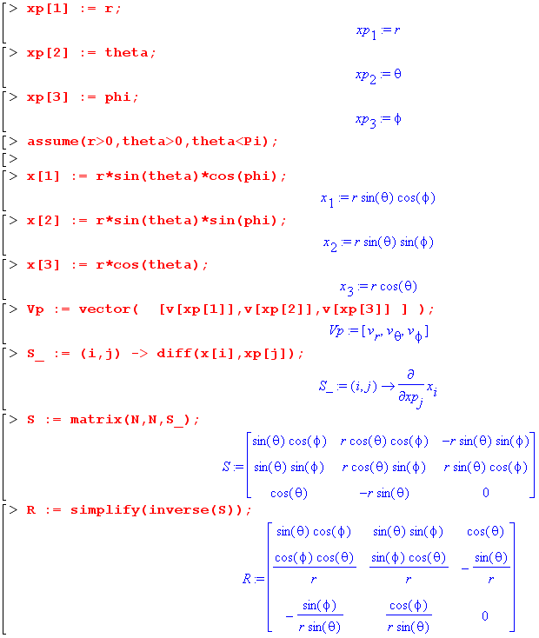

Then one needs the scale factors hn' from the metric tensor = STS ( dev notation Section 5 (l) )

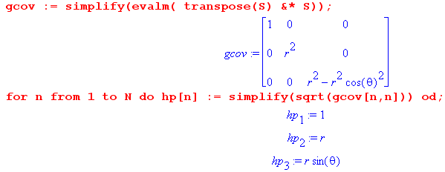

The terms T1,T2 and T3 shown above are then entered,

Pij ≡ [(∇v)()]ij = h'i-1 h'j-1 [ (∂'jh'i) v'i + h'i(∂'jv'i) + h'i2Rid(∂'jRbd) (h'bv'b)]
T2 T3 T1
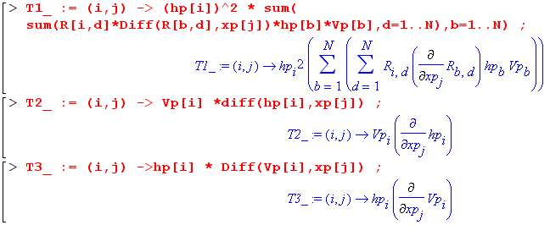

The terms are then added and simplified and out pops the result,

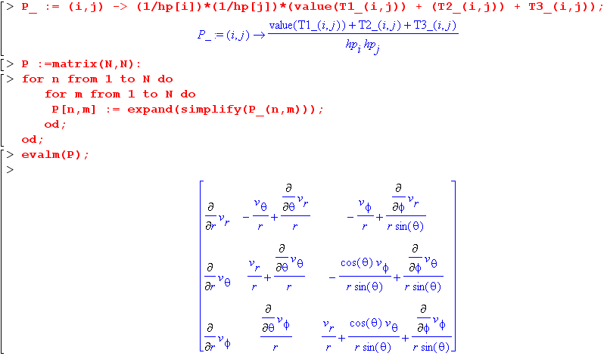

Below are some sample results (including the above):

(∇v) = Σij Pij i jT Pij = [(∇v)()]ij

• Pij in polar coordinates (where 1,2 = r,θ) :
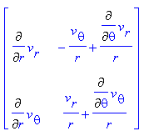 // agrees with Lai (2.23.23)

• Pij in cylindrical coordinates (where 1,2,3 = r,θ,z) :
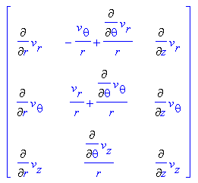 // agrees with Lai (2.34.5)

The polar coordinates results are seen to be upper left 2x2 piece of the cylindrical results.

• Pij in spherical coordinates (where 1,2,3 = r,θ,φ) :
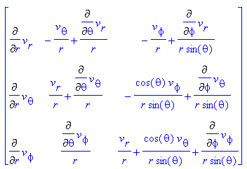 // agrees with Lai (2.35.25)

By entering the usual inverse transformation equations x' = F-1(x), and with suitable small alterations, the above Maple code can compute ∇v in any orthogonal curvilinear coordinate system in any number of dimensions N.

Appendix H: Expansion of div(T) in curvilinear coordinates (T = rank-2 tensor)

The object of attention in this Appendix, divT, is expressed this way in Cartesian coordinates,

(divT)i = ∂jTij ,

where Tij is a rank-2 tensor. One can regard the above equation as describing the normal divergence of the "vector" which forms the ith row of the matrix Tij. In general (that is to say, under general transformations F), the rows of Tij are not tensorial vectors, and that is why (divT)i is not a tensorial scalar. Nor, in fact, are the (divT)i as defined above the components of a tensorial vector! As shown in section (b) below, divT will be redefined as a true tensorial vector which equals ∂jTij in Cartesian coordinates.

(a) Continuum Mechanics motivation

The vector divT arises for example when Newton's 2nd Law F = ma is applied to a particle of continuous matter, in which case this law is known as Cauchy's Equation of Motion,

divT + ρB = ρa // Lai p 169 (4.7.4)

In this equation T is known as the Cauchy stress tensor, ρ is the mass density of the particle, B is any action-at-a-distance force (body force) per unit mass (such as gravity), and of course a is the acceleration of the particle.

Comment. Under rotations and translations the quantity (divT)i = ∂jTij is a tensorial vector, ρ is a tensorial scalar, and a and B are tensorial vectors. As one would expect, divT + ρB = ρa is covariant in the sense of Section 7 (u) under these kinds of transformations.

As in the case of ∇v, one is interested in expressing divT in general curvilinear coordinates.

(b) Expansion of divT on en by Method 1: Use fact that Tab;α is a tensor.

As shown in the examples of Appendix F (i), the following object transforms as a rank-3 tensor,

Tab;α ≡ ∂αTab + Γaαn Tnb + Γbαn Tan = ∂α Tab // x-space where g=1, Γ = 0
T 'ab;α ≡ ∂'αT 'ab + Γ 'aαn T 'nb + Γ 'bαn T 'an // x'-space

Contracting b with α yields the following tensorial vector equations,

(divT)a = Tab;b = ∂bTab // x-space where Γ = 0
(divT)'a = T 'ab;b ≡ ∂'bT 'ab + Γ 'abn T 'nb + Γ 'bbn T 'an // x'-space

Note that the Cartesian space statement (divT)a = ∂bTab is obtained, as noted in the opening comments above. According to Section 7 (s) or Appendix E (b), the vector divT can be expanded as

divT = Σa(divT)'a ea (divT)'a = [(divT)(e)]a // divT in the en basis

From Appendix F (a), adjusted from Picture C to Picture A context (primes on ∂),

Γ 'cab = – Rbi (∂'aRci)
Γ 'abn = – Rni (∂'bRai) // b→n then a→b then c→a
Γ 'bbn = – Rni (∂'bRbi)

=> (divT)'a = ∂'bT 'ab + Γ 'abn T 'nb + Γ 'bbn T 'an

= ∂'bT 'ab – Rni (∂'bRai) T 'nb – Rni (∂'bRbi)T 'an

The conclusion is that

divT = Σa[(divT)(e)]a ea

[(divT)(e)]a = ∂'b T 'ab – Rni(∂'bRai) T 'nb – Rni (∂'bRbi)T 'an // sum on n and b

The vector divT = Σa(∂bTab)ua has thus been expressed in terms of x'-space coordinates and objects, and as usual the en are the tangent base vectors in x-space.

(c) Expansion of divT on en by Method 2: Use brute force

Start with the known expansion of divT in Cartesian x-space

divT = Σi [divT]i ui = Σi (∂jTij) ui

Compute

(∂jTij) = (Raj∂'a)( Rb'i Rc'j T 'b'c')

= Raj Rb'i Rc'j (∂'a T 'b'c') + Raj Rb'i (∂'a Rc'j) T 'b'c' + Raj Rc'j (∂'a Rb'i) T 'b'c'

= (Raj Rc'j) Rb'i (∂'a T 'b'c') + Raj Rb'i (∂'a Rc'j) T 'b'c' + (Raj Rc'j) (∂'a Rb'i) T 'b'c'

= δac' Rb'i (∂'a T 'b'c') + Raj Rb'i (∂'a Rc'j) T 'b'c' + δac' (∂'a Rb'i) T 'b'c'

= Rb'i (∂'a T 'b'a) + Raj Rb'i (∂'a Rc'j) T 'b'c' + (∂'a Rb'i) T 'b'a

Then use the same ui expansion as in Appendix G (c),

ui = Σe Rni en

Combining one gets,

divT = Σi (∂jTij) ui

= { (Rni Rb'i) (∂'a T 'b'a) + Raj (Rni Rb'i) (∂'a Rc'j) T 'b'c' + Rni (∂'a Rb'i) T 'b'a} en

= { δnb' (∂'a T 'b'a) + Raj δnb' (∂'a Rc'j) T 'b'c' + Rni (∂'a Rb'i) T 'b'a} en

= { (∂'a T 'na) + Raj (∂'a Rc'j) T 'nc' + Rni (∂'a Rb'i) T 'b'a} en

= Σn[(divT)(e)]n en

where

[(divT)(e)]n = (∂'a T 'na) + Raj (∂'a Rc'j) T 'nc' + Rni (∂'a Rb'i) T 'b'a

From Appendix F (b) item 3 one has (Picture C1 → Picture A so primes on ∂'s),

(∂'aRdn) = – Ren Rdm (∂'aRem)
(∂'aRc'j) = – Rej Rc'm (∂'aRem) // d→c', n→j
(∂'aRb'i) = – Rei Rb'm (∂'aRem)

so then

[(divT)(e)]n = (∂'a T 'na) + Raj (∂'a Rc'j) T 'nc' + Rni (∂'a Rb'i) T 'b'a

= (∂'a T 'na) – Raj Rej Rc'm (∂'aRem) T 'nc' – Rni Rei Rb'm (∂'aRem) T 'b'a

= (∂'a T 'na) – δaeRc'm (∂'aRem) T 'nc' – δne Rb'm (∂'aRem) T 'b'a

= (∂'a T 'na) – Rc'm (∂'aRam) T 'nc' – Rb'm (∂'aRnm) T 'b'a

Reverse the order of the last two terms

[(divT)(e)]n = (∂'a T 'na) – Rb'm (∂'aRnm) T 'b'a – Rc'm (∂'aRam) T 'nc' .

Replace summation indices m→i, a→b,

= (∂'b T 'nb) – Rb'i (∂'bRni) T 'b'b – Rc'i (∂'bRbi) T 'nc' .

Finally, change n→a and then c'→ n and b'→n,

[(divT)(e)]a = (∂'b T 'ab) – Rni (∂'bRai) T 'nb – Rni (∂'bRbi) T 'an . // sum on n and b

This is seen to match the result of Method 1 of the previous section. The brute force method is in fact not too bad and requires no explicit use of the affine connection Γ.

Technical Note: In the above expression one can write for example Rni(∂'bRai) = g'nmRmi(∂'bRai). Then using the fact that RmiRai = g'ma one finds Rmi(∂'bRai) + Rai(∂'bRmi) = (∂'bg'ma) which then allows the replacement Rni(∂'bRai) = g'nm (∂'b g'ma) – g'nm Rai(∂'bRmi). This kind of transformation leads to an alternate form for divT shown above, still with all down-tilt R matrices, but the index structure is different. This other form appears when one does the "brute force" method starting with (∂jTij) instead of with (∂jTij). Of course in Cartesian space these two objects must be the same.

(d) Adjustment for T expanded on (i⊗j) and divT expanded on a

In the above, it has been assumed that Tij is a rank-2 tensor so that, in the notation of Appendix E,

T = ΣijTij(ui⊗uj) = ΣijT 'ij(ei⊗ej)

If one is interested in an expansion of T on the unit vectors i where ei = h'i i this becomes

T = Σij[T 'ijh'ih'j] (i⊗j) = Σij[T()]ij (i⊗j)

One then has

[T()]ij = h'ih'jT 'ij => T 'ij = h'i-1 h'j-1 [T(e^)]ij

If one is interested in this form of the T matrix elements, then one is likely also interested in this expansion for divT,

divT = Σa[(divT)(e)]a ea = Σn { [(divT)(e)]a h'a } a ≡ [(divT)()]a a

where then

[(divT)()]a = h'a[(divT)(e)]a

= h'a [(∂'b T 'ab) – Rni (∂'bRai) T 'nb – Rni (∂'bRbi) T 'an]

= h'a * { ∂'b (h'a-1 h'b-1 [T()]ab) – Rni (∂'bRai) h'n-1 h'b-1 [T()]nb
– Rni (∂'bRbi) h'a-1 h'n-1 [T()]an }

= h'a * { ∂'b (h'a-1 h'b-1) [T()]ab – Rni (∂'bRai) h'n-1 h'b-1 [T()]nb
+ h'a-1 h'b-1 (∂'b [T()]ab) – Rni (∂'bRbi) h'a-1 h'n-1 [T()]an }
Now

∂'b (h'a-1 h'b-1) = ∂'b(h'a h'b)-1 = – (h'a h'b)-2 ∂'b(h'a h'b) = – h'a-2 h'b-2 ∂'b(h'a h'b)

so the above sequence for [(divT)()]a continues,

= h'a * { – h'a-2 h'b-2 ∂'b(h'a h'b) [T()]ab – Rni (∂'bRai) h'n-1 h'b-1 [T()]nb
+ h'a-1 h'b-1 (∂'b [T()]ab) – Rni (∂'bRbi) h'a-1 h'n-1 [T()]an }

= { – h'a-1 h'b-2 ∂'b(h'a h'b) [T()]ab – h'a h'n-1 h'b-1 g'nm Rmi (∂'bRai) [T()]nb
+ h'b-1 (∂'b [T()]ab) – h'n-1 g'nm Rmi (∂'bRbi) [T()]an }

where recall that Rni = Rni since x-space is Cartesian. In the last form only the down-tilt R matrix appears which simplifies calculation with Maple. This and all other results above are valid for general curvilinear coordinates, orthogonal as well as non-orthogonal.

At this point, we will specialize to orthogonal systems so the last form above becomes
T1 T3
[(divT)()]a = { – h'a-1 h'b-2 ∂'b(h'a h'b) [T()]ab – h'a h'b-1 h'n Rni (∂'bRai) [T()]nb
+ h'b-1 (∂'b [T()]ab) – h'n Rni (∂'bRbi) [T()]an }
T2 T4
Even for an orthogonal curvilinear coordinate system, the form of this tensor divergence is amazingly complicated. Here it is expressed in terms of the down-tilt R matrix and the scale factors and as usual repeated indices are summed.

(e) Maple: divT in cylindrical and spherical coordinates

The above object [(divT)()]a can be evaluated by Maple code very similar to that shown in Appendix G for (∇v). The main difference is the set of entry lines for the terms,

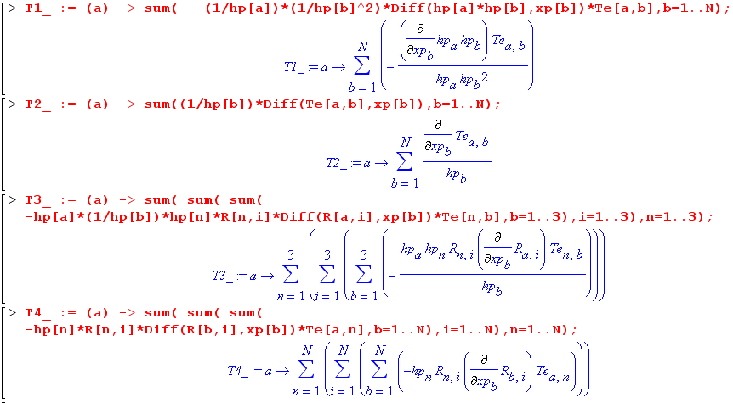

Here are some results for [(divT)()]a = "divTa" :

• cylindrical coordinates (where 1,2,3 = r,θ,z) :
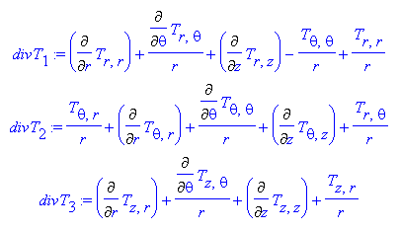 // agrees with Lai p 60 (2.34.8,9,10)

• For polar coordinates P1 and P2 are given by the first two lines above with the last terms set to 0. These polar results then agree with Lai p58 (2.33.32,33).

• spherical coordinates (where 1,2,3 = r,θ,φ) :
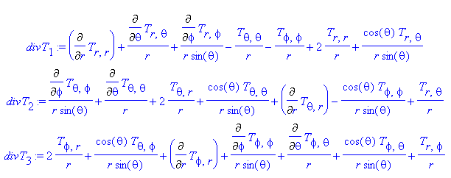

The expressions above agree with Lai p 65 (2.35.33,34,35).

Appendix I : The Vector Laplacian in Spherical and Cylindrical Coordinates

This appendix assumes the usual curvilinear coordinates context, Picture B,

.

In this section the vector Laplacian is computed in two different ways, each associated with a particular "tensorization" of its Cartesian form. The second method, though less pleasant than the first, gives insight into why the vector Laplacian always includes the scalar Laplacian of the field components. It is in this inclusive form that results are usually stated in the literature.
In passing, it should be noted that the vector Laplacian is not just an idle mathematical curiosity. It shows up for example in the wave equations for electric and magnetic fields in a vacuum,

(∇2 + k2)E(x) = 0 (∇2 + k2)B(x) = 0 k = ω/c E,B(x,t) = E,B(x)e-iωt

In continuum mechanics, it appears for example in the Navier/Cauchy equation which describes the small vector displacement u field in an isotropic elastic solid,

ρo∂t2u = ρ0B + (λ+μ)∇e + μ ∇2u e = div u = dilatation // Lai p 216 (5.6.9)

Here ρ0 is the unperturbed mass density, B the body force, and λ and μ are the two Lamé constants which describe an isotropic elastic medium. The vector Laplacian makes another appearance in the better-known Navier-Stokes equation which describes the vector velocity field v in an incompressible Newtonian fluid,

ρ [ ∂tv + (∇v)v] = ρB - ∇p + μ∇2v // Lai p 361 (6.7.6)

where ρ is the mass density and p is pressure.

(a) The first method : a review

In Section 13 (c) it was shown that, in Cartesian coordinates,

∇2(Bn) = [ grad(div B) – curl (curl B) ]n ∇2 = ∂j∂j
or
∇•∇ (Bn) = [∇(∇• B) – ∇ x (∇ x B) ]n

When all components are considered in a single equation, one could write

∇2(B) = grad(div B) – curl (curl B)
or
∇•∇ (B) = ∇(∇• B) – ∇ x (∇ x B)

and this is frequently done (see examples cited above). Since ∇2(B) ≠ ∂j∂j B in curvilinear coordinates, it seems notionally safer in our current context to use a different symbol for the vector Laplacian operator, and following Moon and Spencer we use so the second last equation above then says:

B = grad(div B) – curl (curl B) .

Since [B]n agrees with ∇2(Bn) in Cartesian coordinates, and since we know how to write div, grad and curl in curvilinear coordinates (Sections 9,10,12 or Section 15), the right hand side of the above equation provides our "first method" of writing B in curvilinear coordinates. In Section 15 (g) it was shown that the proper "tensorization" of the above equation is given by

(B)n = (Bj;j);n – g-1/2εnab(g-1/2εbdeBe;d);a B = (B)n un

and therefore, in x'-space (x' are the curvilinear coordinates of interest) ,

(B)'n = (B'j;j);n – g'-1/2ε'nab(g'-1/2ε'bdeB'e;d);a B = (B)'n en

where (B'j;j) = div B. The object B is a normal vector (weight 0), assuming B is a normal vector. Doing various simplifying steps, we then arrived at the following expression which lends itself to calculation:

(B)'n = ∂'n{(1/$\sqrt{g'}$) ∂'i($\sqrt{g'}$B'i)} B = (B)'n en
– (1/$\sqrt{g'}$) ε'ncd ε'eab ∂'c { (1/$\sqrt{g'}$) g'de(∂'a[g'bfB'f]) }

where ε'ncd is the usual permutation tensor (ε'ncd = εncd). In this notation, B'i is an official x'-space contravariant vector component.
We are often interested in working with vectors which are expanded on unit vector versions of the tangent base vectors. In such a unit vector expansion of a vector, italic font has been used for the components. As shown in various places, one has

B'n = B'n/h'n en = h'n n B = B'nen = B'nn h'n = scale factor

and this then gives

(B)'n = ∂'n{(1/$\sqrt{g'}$) ∂'i($\sqrt{g'}$B'i/h'i)} B = (B)'n en
– (1/$\sqrt{g'}$) ε'ncd ε'eab ∂'c { (1/$\sqrt{g'}$) g'de(∂'a[g'bfB'f/h'f]) }

or, as we will use it with unit vectors,

(B)'n = h'n ∂'n{(1/$\sqrt{g'}$) ∂'i($\sqrt{g'}$B'i/h'i)} B = (B)'n n
– h'n (1/$\sqrt{g'}$) ε'ncd ε'eab ∂'c { (1/$\sqrt{g'}$) g'de(∂'a[g'bfB'f/h'f]) } .

Specializing to orthogonal coordinates yields the form we shall use for computation in Maple,

(B)'n = (1/h'n) ∂'n{(1/$\sqrt{g'}$) ∂'i($\sqrt{g'}$B'i/h'i)} B = (B)'n n
– (h'n/$\sqrt{g'}$) ε'ncd ε'dab ∂'c { (1/$\sqrt{g'}$) h'd2(∂'a[h'bB'b]) } .

The second term could be written as two terms by reducing the product ε'ncd ε'dab into δδ - δδ in the usual manner, but Maple is happy to just "do it" as stated. And for non-orthogonal coordinates, the reduction of ε'ncd ε'eab is much uglier (Appendix D (j) item 3) and then one would want to use the εε product as is.

(b) The first method in spherical coordinates: Maple speaks

In this section, the following notation is used:

B'1 = Br B'2 = Bθ B'3 = Bφ
B = B'nn = Brr + Bθθ + Bφφ = Br + Bθ + Bφ .

Maple begins in the same manner as shown earlier in Appendix G (f), the idea being that this code could be used for any coordinate system,

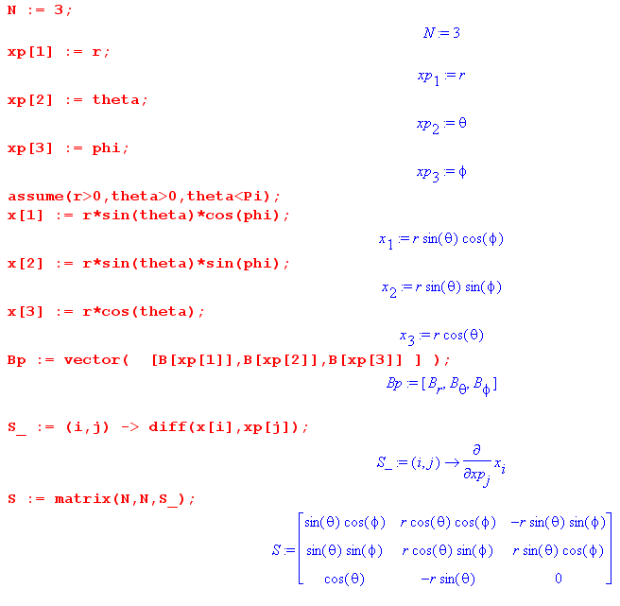
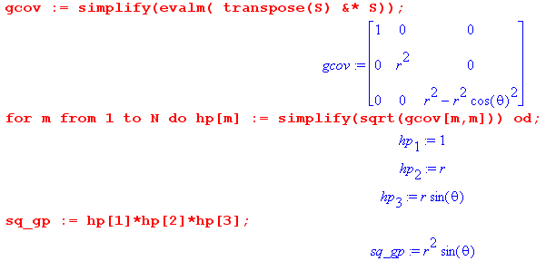

The last object is $\sqrt{g'}$, where hp[n] = h'n . The next chunk of code computes the scalar Laplacian of an unspecified function f, and this expression will be used below in parsing the vector Laplacian results :

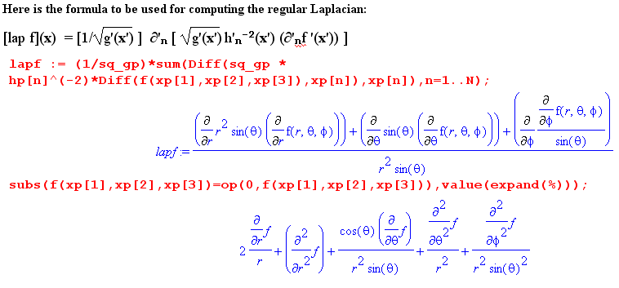
The subs command used here (and more intensely below) removes the arguments of the function f for purely cosmetic reasons (see A Maple User's Guide nearby for details, operands section). The arguments are added in the first place to prevent Maple from thinking the unspecified function f is a constant.
Next comes a low-budget implementation of the permutation tensor eps(a,b,c) = εabc,

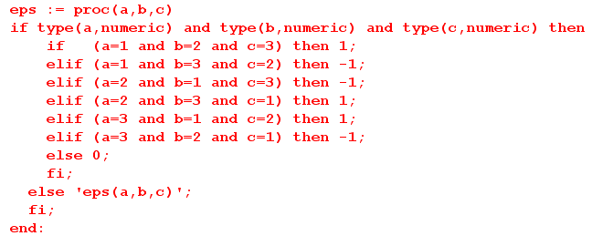

The two terms of the above (B)'n expression shown at the end of section (a) are then duly entered,

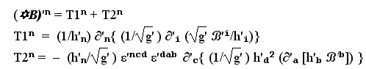
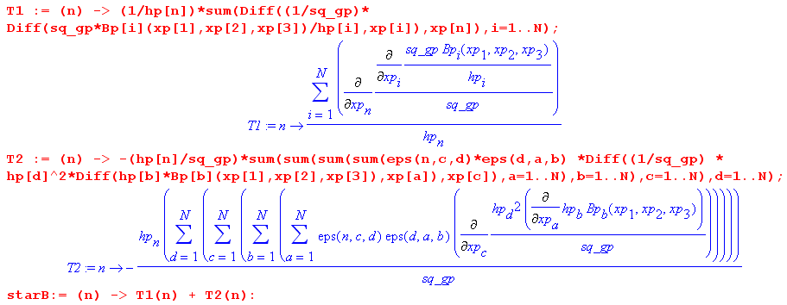

In the following code, we use ( in line with the notation shown at the start of this section)

q1_ = (B)'1 = (B)r
q2_ = (B)'2 = (B)θ
q3_ = (B)'3 = (B)φ

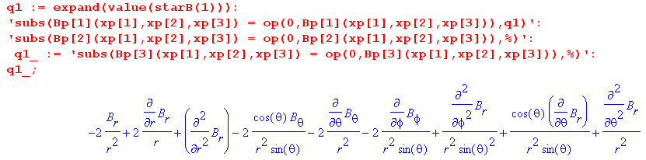
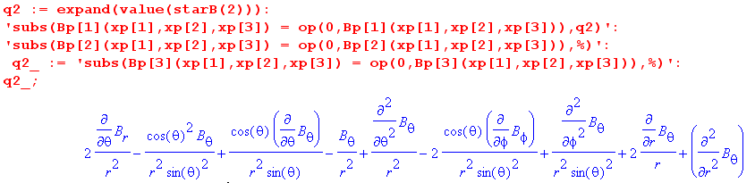
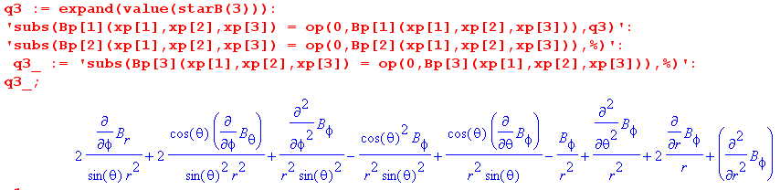

See comment above about the Maple subs commands (purely cosmetic).

(c) The first method in spherical coordinates: putting results in traditional form

It turns out that in each component of the vector Laplacian stated above, 5 of the 9 terms can be represented as if they were the scalar Laplacian acting on the component in question. Here is how it works:

∇2f = (1/r2)∂r(r2∂rf) + (1/r2sinθ)∂θ(sinθ∂θf) + (1/r2sin2θ)∂φ2f =
1 + 2 3+4 5
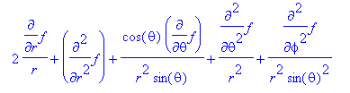
1 2 3 4 5
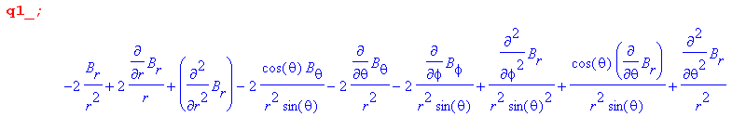
1 2 5 3 4
Therefore

(B)r = ∇2(Br) - (2/r2)Br - (2/r2)cot(θ)Bθ - (2/r2)∂θBθ -(2/r2sinθ) ∂φBφ

= ∇2(Br) – (2/r2) [ Br + cotθ Bθ + ∂θBθ + cscθ ∂φBφ ]

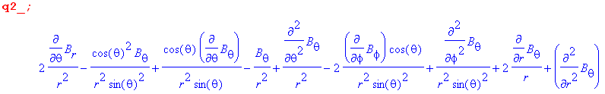
3 4 5 1 2
Therefore

(B)θ = ∇2(Bθ) - (1/r2) [ - 2 ∂θBr + cot2θ Bθ + Bθ + 2 cotθcscθ∂φBφ ]

= ∇2(Bθ) - (1/r2) [csc2θ Bθ - 2 ∂θBr + 2 cotθcscθ∂φBφ ]
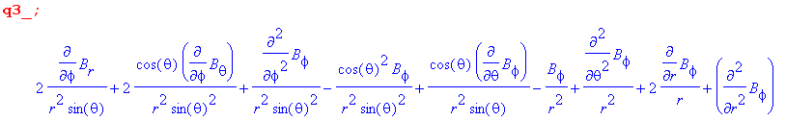
5 3 4 1 2

(B)φ = ∇2(Bφ) - (1/r2) [csc2θBφ - 2cscθ∂φBr - 2cotθcscθ∂φBθ ]

In this manner, we end up with the components of the vector Laplacian expressed in the traditional manner,

(B)r = ∇2(Br) – (2/r2) [ Br + cotθ Bθ + ∂θBθ + cscθ ∂φBφ ]
(B)θ = ∇2(Bθ) – (1/r2) [csc2θ Bθ – 2 ∂θBr + 2cotθcscθ∂φBφ ]
(B)φ = ∇2(Bφ) – (1/r2) [csc2θ Bφ – 2cscθ∂φBr – 2cotθcscθ∂φBθ ]

where ∇2f = (1/r2)∂r(r2∂rf) + (1/r2sinθ)∂θ(sinθ∂θf) + (1/r2sin2θ)∂φ2f

= (2/r)∂rf + ∂r2f + (cotθ/r2)∂θf + (1/r2) ∂θ2f + (1/r2sin2θ)∂φ2f

Once again, written out in gory detail, these three expressions are (in the same order r,θ,φ) :
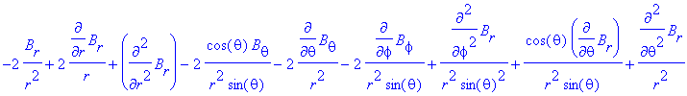
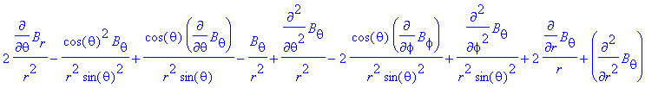
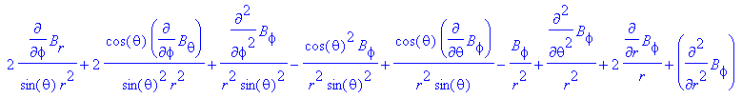

and each expression contains nine terms.

The curious reader might wonder why, in each case, five of the nine terms of the vector Laplacian components can be represented by the scalar Laplacian acting on the component. This question is answered in the following section.

(d) The second method : Part I

In the first method, described in section (a) above, we used this tensorization of the vector Laplacian,

(B)n = (B'j;j);n – g'-1/2ε'nab(g'-1/2g'bcε'cdeB'e;d);a .

At the end of Section 15 (b) it was noted that there is an alternative tensorization , namely

(B)n = B'n;j;j .

These two tensors must be the same since the tensorization of a Cartesian form equation is unique, but it is not so easy to show. Be that as it may, our "second method" is to use this B'n;j;j tensorization to compute once again the components of the vector Laplacian.

Appendix F (i) has among its examples the following covariant derivative of a rank 2 tensor,

Bab;α ≡ ∂α Bab + Γaαn Bnb + Γbαn Ban

and since Ba;b is a rank-2 tensor one can write (indices are substituted in the second line)

Ba;b;α ≡ ∂α Ba;b + Γaαk Bk;b + Γbαk Ba;k
Bn;j;j ≡ ∂j Bn;j + Γnjk Bk;j + Γjjk Bn;k // Γ'jjk = (1/$\sqrt{g}$) ∂k($\sqrt{g}$) as in App F (d) .

Another example in that Appendix shows that (the lower three lines are index substitutions of the first)

Ba;α = ∂α Ba + gαbΓabs Bs
Bn;j = ∂j Bn + gjbΓnbs Bs
Bk;j = ∂j Bk + gjbΓkbs Bs
Bn;k = ∂k Bn + gkbΓnbs Bs

Therefore,

Bn;j;j = ∂j[∂j Bn + gjbΓnbs Bs] + Γnjk[∂j Bk + gjbΓkbs Bs] + Γjjk[∂k Bn + gkbΓnbs Bs]

Combining the second last term with the first gives

Bn;j;j = [∂j ∂j Bn + Γjjk(∂kBn )]
+ ∂j(gjbΓnbs Bs) + Γnjk[∂j Bk + gjbΓkbs Bs] + Γjjk[gkbΓnbs Bs]

Since no terms have been dropped, we are still "covariant" and in x'-space everything gets primed,

B'n;j;j = [∂'j ∂'j B'n + Γ 'jjk(∂'kB'n )]
+ ∂'j(g'jbΓ 'nbs B's) + Γ 'njk[∂'j B'k + g'jbΓ 'kbs B's] + Γ 'jjk[g'kbΓ 'nbs B's]

The first two terms can be written this way,

[∂'j ∂'j B'n + Γ 'jjk(∂'kB'n )] = [∂'j ∂'j B'n + (1/$\sqrt{g'}$) ∂'k($\sqrt{g'}$) (∂'kB'n )] = lap (B'n)

in the sense that we earlier wrote ( Section 15 (e) ) ,

∂'j∂'jf ' + (1/$\sqrt{g'}$) ∂'k($\sqrt{g'}$) ∂'kf = (1/$\sqrt{g'}$) ∂'k [$\sqrt{g'}$ (∂'kf ) = lap (f)

Therefore

Bn;j;j = lap (B'n) + ∂'j(g'jbΓ 'nbs B's) + Γ 'njk[∂'j B'k + g'jbΓ 'kbs B's] + Γ 'jjk[g'kbΓ 'nbs B's]

= lap (B'n) + Extra Terms

So we begin to see why the scalar Laplacian of a B component appears in (B)n.

(e) The second method : Part II

Unfortunately, we don't want to see lap (B'n), we want to see lap(B'n) ! Consider then,

lap (B'n) = lap (B'n/hn) = [∂'j ∂'j (B''n/hn) + (1/$\sqrt{g'}$) ∂'k($\sqrt{g'}$) (∂'k (B''n/hn) )]

and one computes the pieces as follows:

∂'j ∂'j (B'n/hn) = ∂'j ∂'j (B'nh-1n) = ∂'j [(∂'jB'n) h-1n + B'n(∂'j h-1n) ]
= (∂'j∂'jB'n)h-1n + (∂'jB'n) (∂'j h-1n) + (∂'j B'n)(∂'j h-1n) + B'n (∂'j ∂'j h-1n)
= (∂'j∂'jB'n) h-1n + 2(∂'jB'n) (∂'j h-1n) + B'n (∂'j ∂'j h-1n)

∂'k (B'n/hn) = [(∂'kB'n) h-1n + B'n(∂'k h-1n) ]

so that

lap (B'n) = (∂'j∂'jB'n) h-1n + 2(∂'jB'n) (∂'j h-1n) + B'n (∂'j ∂'j h-1n)
+ (1/$\sqrt{g'}$) ∂'k($\sqrt{g'}$)[(∂'kB'n) h-1n + B'n(∂'k h-1n) ]

= h-1n {(∂'j∂'jB'n) + (1/$\sqrt{g'}$) ∂'k($\sqrt{g'}$)(∂'kB'n) }
+ 2(∂'jB'n) (∂'j h-1n) + B'n (∂'j ∂'j h-1n) + (1/$\sqrt{g'}$) ∂'k($\sqrt{g'}$)B'n(∂'k h-1n)

= h-1n lap (B'n)
+ 2(∂'jB'n) (∂'j h-1n) + B'n (∂'j ∂'j h-1n) + (1/$\sqrt{g'}$) ∂'k($\sqrt{g'}$)B'n(∂'k h-1n)

= h-1n lap (B'n) + Other Terms

The conclusion so far is that

(B)n = Bn;j;j = lap(B'n) + Extra Terms

= h-1n lap(B'n) + Other Terms + Extra Terms

As before, our interest is with the expansion B = (B)'n n where then

(B)'n = lap(B'n) + h'n [Other Terms + Extra Terms]

This result applies to any x'-space curvilinear coordinate system, orthogonal or otherwise. Thus we have demonstrated why it is that lap(B'n) always appears as part of the vector Laplacian component (B)'n.

The Terms shown are these, just quoting from above,

Extra Terms = ∂'j(g'jbΓ 'nbs B's) + Γ 'njk[∂'j B'k + g'jbΓ 'kbs B's] + Γ 'jjk[g'kbΓ 'nbs B's]

Other Terms = 2(∂'jB'n) (∂'j h-1n) + B'n (∂'j ∂'j h-1n) + (1/$\sqrt{g'}$) ∂'k($\sqrt{g'}$)B'n(∂'k h-1n)

Rather than attempt algebraic simplification of the above terms, we will just throw them into Maple as is. Replacing B's = B's/h's and "lowering" the differential operators appropriately, one gets

Extra Terms =
∂'j(g'jb Γ 'nbs B's/h's) + Γ 'njkg'js∂'s(B'k/h'k) + Γ 'njkg'jb Γ 'kbs B's/h's + Γ 'jjkg'kb Γ 'nbs B's/h's
ET1 ET2 ET3 ET4
Other Terms =
2(g'js ∂'sB'n) (∂'jh'n-1) + B'n (∂'j ∂'jh'n-1) + (1/$\sqrt{g'}$) ∂'k($\sqrt{g'}$)B'n(∂'kh'n-1)
OT1 OT2 OT3

(f) The second method in spherical coordinates: Maple speaks again

In method 1, there was no need in the Maple calculation for the affine connection object ,

Γ 'dab = (1/2) g'dc [ ∂'ag'bc + ∂'bg'ca – ∂'cg'ab]

which in orthogonal coordinates simplifies to

Γ 'dab = (1/2) h'd-2 [δdb ∂'a(h'b2) + δda∂'b(h'a2) – δab ∂'d(h'a2)] .

This last form shows that Γ 'dab = 0 unless two indices match, in which case it might not vanish. For coordinate systems like spherical and cylindrical coordinates, Γ 'dab is very sparse, and this explains why we are not going to be simply swamped by all those Extra Terms shown above.
For spherical coordinates, only 9 of the 27 elements of the object Γdab are non-zero :

Γ '122 = -r Γ '212 = Γ '221 = 1/r // notation: Γ '122 = Γrθθ
Γ '133 = -r sin2θ Γ '313 = Γ '331 = 1/r
Γ '233 = -cosθsinθ Γ '323 = Γ '332 = cotθ // 1,2,3 = r,θ,φ = radius, polar, azimuthal

Γ r = $\left[\begin{matrix}0 & 0 & 0 \\ 0 & -r & 0 \\ 0 & 0 & -rsin2θ\end{matrix}\right]$ Γθ = $\left[\begin{matrix}0 & 1/r & 0 \\ 1/r & 0 & 0 \\ 0 & 0 & -sinθcosθ\end{matrix}\right]$ Γφ = $\left[\begin{matrix}0 & 0 & 1/r \\ 0 & 0 & cotθ \\ 1/r & cotθ & 0\end{matrix}\right]$

To maintain generality, however, we let Maple compute Γdab = G(d,a,b) from the first equation above, so

Γdab = (1/2) gdc [ ∂agbc + ∂bgca – ∂cgab]

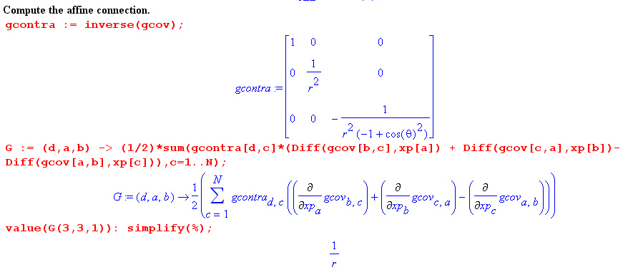
The Extra Terms are then entered, as shown above :

(continued on next page)
Extra Terms =
∂'j(g'jb Γ 'nbs B's/h's) + Γ 'njkg'js∂'s(B'k/h'k) + Γ 'njkg'jb Γ 'kbs B's/h's + Γ 'jjkg'kb Γ 'nbs B's/h's
ET1 ET2 ET3 ET4
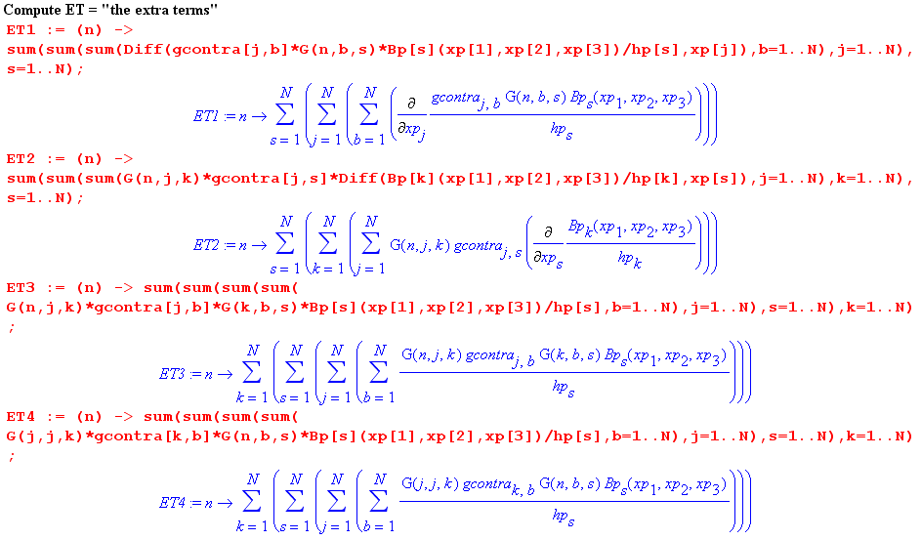

And then the Other Terms are entered as well,

Other Terms =
2(g'js ∂'sB'n) (∂'jh'n-1) + B'n (∂'j ∂'jh'n-1) + (1/$\sqrt{g'}$) ∂'k($\sqrt{g'}$)B'n(∂'kh'n-1)
OT1 OT2 OT3
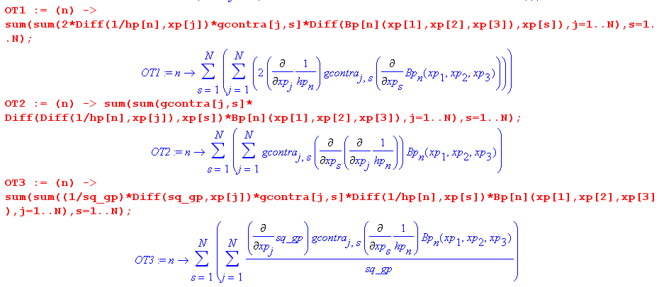

The final results are then generated :

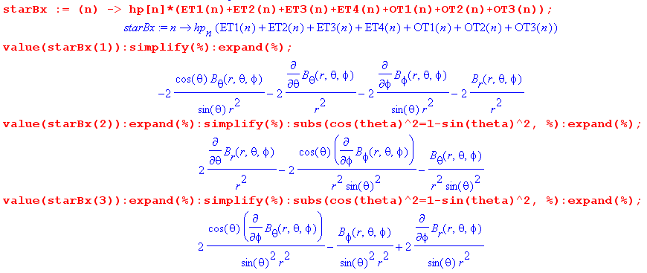

These are seen to match the unnumbered terms in the q1_,q2_,q3_ expressions of section (c) above, those terms which get added to the scalar Laplacian contribution. Quoting from method 1 above,

(B)r = ∇2(Br) – (2/r2) [ Br + cotθ Bθ + ∂θBθ + cscθ ∂φBφ ]
(B)θ = ∇2(Bθ) – (1/r2) [csc2θ Bθ – 2 ∂θBr + 2cotθcscθ∂φBφ ]
(B)φ = ∇2(Bφ) – (1/r2) [csc2θ Bφ – 2cscθ∂φBr – 2cotθcscθ∂φBθ ]

(g) Results for Cylindrical Coordinates from both methods

The Maple program was easily modified for this system. Here are the results:

B'1 = Br B'2 = Bφ B'3 = Bz
B = B'nn = Brr + Bφφ + Bφz = Br + Bθ + Bφ .

The scalar Laplacian of an unspecified function f :

∇2f = (1/r)∂r(rf) + (1/r2)∂φ2f + ∂z2f =
1 + 2 3 4
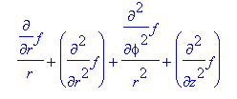
1 2 3 4

The components of the vector Laplacian are found by the "first method" to be

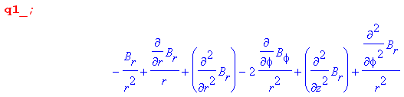
1 2 4 3
Therefore,

(B)r = ∇2(Br) - Br/r2 - 2∂φBφ/r2 .

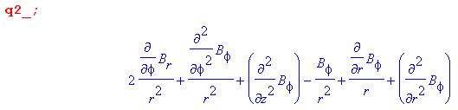
3 4 1 2
Therefore,

(B)φ = ∇2(Bφ) - Bφ/r2 + 2∂φBr/r2 .

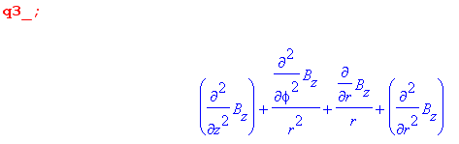
4 3 1 2

Therefore,

(B)z = ∇2(Bz)

as befits a component which is Cartesian. In this manner, we end up with the components of the vector Laplacian expressed in the traditional manner,

(B)r = ∇2(Br) – (1/r2)[Br – 2∂φBφ]
(B)φ = ∇2(Bφ) – (1/r2)[Bφ + 2∂φBr]
(B)z = ∇2(Bz)

where ∇2f = (1/r)∂r(rf) + (1/r2)∂φ2f + ∂z2f

= ∂2rf +(1/r)∂rf + (1/r2)∂φ2f + ∂z2f

Once again, written out in gory detail, these three expressions are (in the same order r,φ,z) :

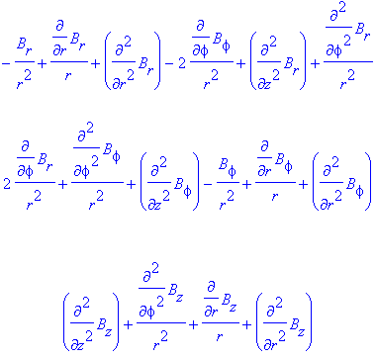

The "second method" produces these results for the terms which are added to the scalar Laplacian,

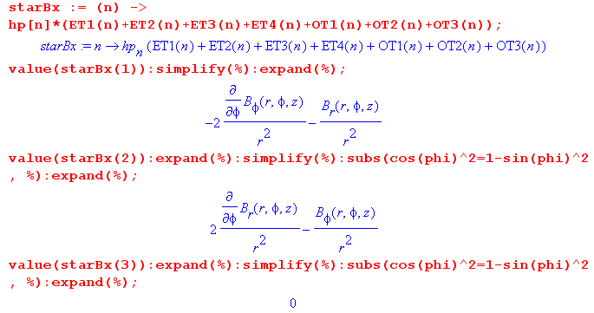

and these are seen to agree with the unnumbered terms in q1_, q2_ and q3_ shown above.

In cylindrical coordinates the Γ object is even sparser than in spherical coordinates. One has

Γ 'dab = (1/2) h'd-2 [δdb ∂'a(h'b2) + δda∂'b(h'a2) – δab ∂'d(h'a2)] .

Γ '122 = -r // notation: Γ '122 = Γrφφ
Γ '212 = 1/r
Γ '221 = 1/r // 1,2,3 = r,φ,z

Γr = $\left[\begin{matrix}0 & 0 & 0 \\ 0 & -r & 0 \\ 0 & 0 & 0\end{matrix}\right]$ Γφ = $\left[\begin{matrix}0 & 1/r & 0 \\ 1/r & 0 & 0 \\ 0 & 0 & 0\end{matrix}\right]$ Γz = $\left[\begin{matrix}0 & 0 & 0 \\ 0 & 0 & 0 \\ 0 & 0 & 0\end{matrix}\right]$

so only 3 of 27 components are non-vanishing. Recall from Appendix F (a) that Γ just describes how the tangent base vectors move as x' moves, (∂ 'jen(x')) = Γ ' kjn(x') ek(x'), and cylindrical coordinates is just polar coordinates with z tacked on so the tangent base vectors don't move much, e3 = not at all.

dTij(x,t)/dt = ∂Tij/∂t + (∂Tij/∂xk) (∂xk/dt) = ∂Tij/∂t + (∂Tij/∂xk) vk
or
dtTij = ∂tTij + (∂kTij) vk . // dt ≡ d/dt, ∂t ≡ ∂/∂t, ∂k ≡ ∂/∂xk

We take this as a useful prototype equation to work with for two reasons. First, it contains our object of interest, which is the gradient of a rank-2 tensor. Second, this equation plays a role in the continuum mechanics of non-Newtonian fluids as discussed below in section (f).
One can define, in Cartesian coordinates, a (∇T) object :

(∇T)ijk ≡ ∂kTij

so that

dtTij = ∂tTij + (∇T)ijk vk .

Comment: Our convention has been to bold vectors and not to bold other tensors. In line with this idea, we shall write ∇T where the grad is bolded and the T is not bolded.

In order to express the above equation in curvilinear coordinates, it must be "tensorized" in the sense of Section 15 (b) so that the equation is covariant. Thus, (∇T)ijk must be regarded as components of a (mixed) rank-3 tensor which, in Cartesian coordinates, are equal to ∂kTij. Since vk are the components of a tensorial vector, (∇T)ijk vk transforms as a rank-2 tensor, and then all terms in the above equation are rank-2 tensors and the equation is then covariant and therefore appears this way in x'-space,

dtT'ij = ∂tT'ij + (∇T)'ijk v'k .

In our usual formalism, x'-space is the space of some generic curvilinear coordinates x'n (not necessarily orthogonal) and then the above equation tells us the form taken by the time derivative equation in curvilinear coordinates, and it remains only to compute the objects (∇T')ijk.

For convenience, we can lower the tensorial ij indices on the above tensor equations to get

dtTij = ∂tTij + (∇T)ijk vk (∇T)ijk ≡ ∂kTij // Cartesian coordinates

dtT'ij = ∂tT'ij + (∇T)'ijk v'k // curvilinear coordinates

and then we can deal with the pure covariant tensor components (∇T)'ijk .

Appendix J: Expansion of (∇T) in curvilinear coordinates (T = rank-2 tensor)

This appendix assumes the usual curvilinear coordinates context, Picture B

(a) Total time derivative as prototype equation

The total time derivative of a contravariant rank-2 tensor field Tij(x,t) can be written as

dTij(x,t)/dt = ∂Tij/∂t + (∂Tij/∂xk) (∂xk/dt) = ∂Tij/∂t + (∂Tij/∂xk) vk
or
dtTij = ∂tTij + (∂kTij) vk . // dt ≡ d/dt, ∂t ≡ ∂/∂t, ∂k ≡ ∂/∂xk

We take this as a useful prototype equation to work with for two reasons. First, it contains our object of interest, which is the gradient of a rank-2 tensor. Second, this equation plays a role in the continuum mechanics of non-Newtonian fluids as discussed below in section (f).
One can define, in Cartesian coordinates, a (∇T) object :

(∇T)ijk ≡ ∂kTij

so that

dtTij = ∂tTij + (∇T)ijk vk .

Comment: Our convention has been to bold vectors and not to bold other tensors. In line with this idea, we shall write ∇T where the grad is bolded and the T is not bolded.

In order to express the above equation in curvilinear coordinates, it must be "tensorized" in the sense of Section 15 (b) so that the equation is covariant. Thus, (∇T)ijk must be regarded as components of a (mixed) rank-3 tensor which, in Cartesian coordinates, are equal to ∂kTij. Since vk are the components of a tensorial vector, (∇T)ijk vk transforms as a rank-2 tensor, and then all terms in the above equation are rank-2 tensors and the equation is then covariant and therefore appears this way in x'-space,

dtT'ij = ∂tT'ij + (∇T)'ijk v'k .

In our usual formalism, x'-space is the space of some generic curvilinear coordinates x'n (not necessarily orthogonal) and then the above equation tells us the form taken by the time derivative equation in curvilinear coordinates, and it remains only to compute the objects (∇T')ijk.

For convenience, we can lower the tensorial ij indices on the above tensor equations to get

dtTij = ∂tTij + (∇T)ijk vk (∇T)ijk ≡ ∂kTij // Cartesian coordinates

dtT'ij = ∂tT'ij + (∇T)'ijk v'k // curvilinear coordinates

and then we can deal with the pure covariant tensor components (∇T)'ijk .

(b) Computation of components (∇T)'ijk

The covariant derivative is discussed in Appendix F (g,h,i). We shall define a true tensor object (∇T)abc as Tab;α so that ( see App F, J=2 example with Bab;α, take B→T and α→c )

(∇T)abc = Tab;c ≡ Tab,c – ΓnacTnb – ΓnbcTan = Tab,c = ∂cTab // x-space
(∇T)'abc = T'ab;c ≡ T'ab,c – Γ'nacT'nb – Γ'nbcT'an . // x'-space

Recall that Tab,c is a shorthand for ∂cTab and that Γcab is the affine connection which tells how the basis vectors change as one moves around in space. In Cartesian x-space (first line above) the basis vectors are the fixed un which don't change, so Γcab ≡ 0. In curvilinear x'-space, Γ'cab ≠ 0. Since Tab;c transforms as a true rank-3 tensor, its defining equation is "covariant" (Section7 (u)) so that in x'-space the equation has exactly the same form but everything is primed.
The above two lines characterize the process of "tensorization": we find a true "tensorial tensor" Tab;c which agrees with (∇T)abc = ∂cTab in Cartesian space. The tensorized version of Tab,c is unique, and it is Tab;c . Since this tensor is given by T'ab;c in x'-space, we use the second line above to compute the components of the tensor (∇T) object in x'-space, which is to say, in curvilinear coordinates.
It is a simple matter to have Maple compute Γ'cab for any curvilinear coordinate system, and then the second line above reports out the components (∇T)'abc :

(∇T)'abc = ∂'cT'ab – Γ'nacT'nb – Γ'nbcT'an (*)

Γ 'dab = (1/2) g'dc [ ∂'ag'bc + ∂'bg'ca – ∂'cg'ab] // Appendix F (d), g' = metric tensor

and then we know how to write the time derivative equation in any curvilinear coordinates

dtT'ij = ∂tT'ij + (∇T)'ijk v'k
or
dtT'ij = ∂tT'ij + (∇T)'ijk v'k (∇T)'ijk = g'ii'g'jj'(∇T)'i'j'k

In Appendix I (b) we show Maple code to compute the covariant metric tensor g'ij from the curvilinear coordinates defining equations (such as x = rsinθcosφ for sphericals). Then Appendix I (f) shows the extra code for computing g'ij and Γ 'dab . The reader can then add a few extra lines to have Maple compute the desired (∇T)'abc using the equation (*) above. Later in this appendix we shall use Maple to compute certain related quantities which we can then verify against a known source.

(c) Tensor expansions of ∇T on the un and en base vectors

It is useful at this point to write out the tensor expansions for the rank-3 tensor (∇T) to show exactly where the components (∇T)'abc appear. As shown in Appendix E (b) one can expand the rank-3 tensor Tab;c in various ways. The first line below shows expansions on x-space basis vectors, while the second line shows expansion on the reciprocal and tangent base vectors (which also exist in x-space) :

∇T = Σijk Tij;k ui⊗uj⊗uk = Σijk [(∇T)(u)]ijk ui⊗uj⊗uk = Σijk [(∇T)(u)]ijk ui⊗uj⊗uk
∇T = Σijk T'ij;k ei⊗ej⊗ek = Σijk [(∇T)(e)]ijk ei⊗ej⊗ek = Σijk [(∇T)(e)]ijk ei⊗ej⊗ek

As usual, up and down index positions are the same for the first line in Cartesian space, but are significant on the second line. The superscripts on the (∇T)(u) and (∇T)(e) components indicate which basis vectors are being expanded upon. One normally just writes (∇T)(u) = (∇T), and (∇T)(e) = (∇T)' where the prime indicates the curvilinear x'-space. So, we now have three different notations for the expansion components:

Tij;k = [(∇T)(u)]ijk = (∇T)ijk

T'ij;k = [(∇T)(e)]ijk = (∇T)'ijk .

Just to fill things out, here are the corresponding expansions for rank-2 tensor T,

T = Σij Tij ui⊗uj = Σij [T(u)]ij ui⊗uj = Σij [T(u)]ij ui⊗uj
T = Σij T'ij ei⊗ej = Σij [T(e)]ij ei⊗ej = Σij [T(e)]ij ei⊗ej

Tij = [T(u)]ij
T'ij = [T(e)]ij

and then for a rank-1 tensor v,

v = Σi vi ui = Σi [v(u)]i ui = Σi [v(u)]i ui
v = Σi v'i ei = Σi [v(e)]i ei = Σi [v(e)]i ei

vi = [v(u)]i
v'i = [v(e)]i

(d) Tensor expansions of ∇T on the n base vectors

In practical applications, it is sometimes useful to deal with components of tensors which are expanded on the unit versions of the tangent base vectors, n ≡ en/ |en| = en/h'n . On the one hand, this introduces major complications (see below) since such components are non-covariant (neither contravariant nor covariant nor mixed). On the other hand, since the unit vectors are all dimensionless, all tensor components have the same dimensions, which is very useful in any practical engineering work. We shall refer to such tensor components as "unit-base-vector components".

This subject is addressed in Appendix E (h). We start with the expansion given above,

∇T = Σijk [(∇T)(e)]ijk ei⊗ej⊗ek

and process it in this manner ,

= Σijk [(∇T)(e)]ijk (h'ii) ⊗ (h'jj) ⊗ (h'kk)

= Σijk { h'i h'j h'k [(∇T)(e)]ijk } i⊗j⊗k

= Σijk [(∇T)()]ijk i⊗j⊗k where [(∇T)()]ijk = h'i h'j h'k [(∇T)(e)]ijk .

Since the n don't transform as vectors, and since the [(∇T)()]ijk are not tensorial components, we let the indices on [(∇T)()]ijk arbitrarily be "down". Putting them up gives a false impression of a covariant matching index tilt.
Now for convenience later, we make one more definition

(∇T)'ijk ≡ [(∇T)()]ijk = h'i h'j h'k [(∇T)(e)]ijk = h'i h'j h'k (∇T)'ijk

where we follow our convention that the components of unit-base-vector tensors are written in script. (The symbol T is a script T , not a "tau" τ. )
Similarly, we can write the unit-base-vector expansion for a rank-2 tensor T

T = Σij [T()]ij i⊗j where [T()]ij = h'i h'j [T(e)]ij

with the definition

T'ij ≡ [T()]ij = h'i h'j [T(e)]ij = h'i h'j T'ij .

Finally, for a vector v,

v = Σi [v()]i i where [v()]i = h'i [v(e)]i

with the definition

v'i ≡ [v()]i = h'i [v(e)]i = h'i v'i .

In terms of the scripted unit-base-vector components, our three expansions are:

∇T = Σijk (∇T)'ijk i⊗j⊗k (∇T)'ijk = h'i h'j h'k (∇T)'ijk

T = Σij T'ij i⊗j T'ij = h'i h'j T'ij

v = Σi v'i i v'i = h'i v'i .

The scripted tensor components have indices which are integers, i = 1,2...N. Once we actually select a particular curvilinear coordinate system, one can replace the indices with curvilinear coordinate names and then, since those names indicate that one is talking about x'-space components, and since we just assume we are dealing with unit-base-vector components, both the script and the prime can be dropped. For example, in spherical coordinates with 1,2,3 = r,θ,φ one can write

(∇T)'123 = (∇T)rθφ
T'12 = Trθ T'11 = Trr
v'3 = vφ v'1 = vr

Notice that the scripted forms are always necessary when summations like Σijk are involved, unless one is willing to write out all the terms in the sum, which is a bit clumsy. The continuum mechanics book of Lai, which we shall refer to below, avoids summations in curvilinear coordinates and thus has no need for our scripted components.

(e) Total time derivative equation written in unit-base-vector curvilinear components

Recall from section (a) our prototype time derivative equation of interest in x'-space

dtT'ij = ∂tT'ij + (∇T)'ijk v'k .

How does one write this equation in terms of unit-base-vector tensor components? From section (d) we had (no implied sums here)

T'ij = h'i h'j T'ij v'k = h'k v'k

so the above dt equation can be processed as follows:

dtT'ij = ∂tT'ij + (∇T)'ijk v'k

h'i h'j dtT'ij = h'i h'j ∂tT'ij + h'i h'j (∇T)'ijk h'k-1 h'k v'k

dt(h'ih'j T'ij) = ∂t(h'ih'j T'ij) + h'i h'j h'k-1 (∇T)'ijk (h'k v'k) // h'n = h'n(x'), no t

dt T'ij = ∂t T ij + [ h'i h'j h'k-1 (∇T)'ijk ] v'k

dt T'ij = ∂t T'ij + Q'ijk v'k Q'ijk ≡ h'i h'j h'k-1 (∇T)'ijk (*)

Comment: Note that dth'n(x) = ∂th'n(x) = 0 and not dth'n(x) = ∂th'n(x) + (∇h'n) v. The reason is that the field h'n(x) is not an Eulerian fluid property (see application below), it is a property of space at point x.

Recall that no assumption has been made that the curvilinear coordinates are orthogonal. Section (b) showed how the (∇T)'ijk can be computed for any curvilinear coordinate system, and thus one can compute the Q'ijk shown above. Our question is now answered: (*) shows how one writes the total time derivative equation in arbitrary curvilinear coordinates.

If we now assume the coordinates are orthogonal, then

(∇T)'ijk = gkk'(∇T)'ijk' = hk2δk,k' (∇T)'ijk' = hk2(∇T)'ijk

and then

Q'ijk ≡ h'i h'j h'k-1 (∇T)'ijk = h'i h'j h'k-1 hk2(∇T)'ijk = h'i h'j h'k(∇T)'ijk = (∇T)ijk

and so for orthogonal coordinates (*) may be written

dt T'ij = ∂t T'ij + (∇T)'ijk v'k (∇T)'ijk ≡ h'i h'j h'k (∇T)'ijk . // orthogonal

We shall assume from now on that the curvilinear coordinates are orthogonal.
As a reminder, here is what the above equation says if i = j = 1, using the notation scheme just described above :

dt T'11 = ∂t T'11 + (∇T)'11k v'k

dt Trr = ∂t Trr + (∇T)rrr vr + (∇T)rrθ vθ + (∇T)rrφ vφ

(f) Shorthand notations and a continuum mechanics application

Consider our original Cartesian time derivative equation,

dtTij = ∂tTij + (∇T)ijk vk .

One could regard (∇T)ijk as the components of a vector (∇T)ij labeled by fixed values i and j, so that

[(∇T)ij]k = (∇T)ijk .

Then one can say

dtTij = ∂tTij + (∇T)ij• v .

The next step is to suppress the ij labels, since the equation above is true for any i and j,

dtT = ∂tT + (∇T) • v .

This is only a shorthand notation, no precision justification is required. We can do the same thing to the equation written in curvilinear coordinates

dt T'ij = ∂t T'ij + (∇T)'ijk v'k

[(∇T)'ij]k = (∇T)'ijk

dt T'ij = ∂t T'ij + (∇T)'ij • v'k

dt T' = ∂t T' + (∇T)' • v'

and then we have

dtT = ∂tT + (∇T) • v
dt T' = ∂t T' + (∇T)' • v'

which gives the nice impression that the equation is written in a coordinate-independent manner. In the book of Lai, the • is omitted and the shorthand notations are written

dtT = ∂tT + (∇T) v
dt T' = ∂t T' + (∇T)' v' (*)

where one imagines that (∇T) and (∇T)' are 3-index operators which act on a 1-index object to generate a 2-index object. Again, it is just a shorthand. The real meaning of these equations is

dtTij = ∂tTij + (∇T)ijk vk or dtTij = ∂tTij + (∇T)ijk vk
dt T'ij = ∂t T'ij + (∇T)'ijk v'k

An application of our total time derivative equation appears in the first line of Lai p 470 ,

DA1/Dt = ∂A1/∂t + (∇A1) v

where D/Dt is the way a total time derivative is expressed in continuum mechanics (D/Dt = d/dt). It is the convective or material derivative for Eulerian-picture functions ( like A1(x,t) ), meaning that the second term registers a time change in a fluid property at the fixed point x due to "new fluid" with velocity v passing through that point. In the notation described above, this would be written

dtA'1 = ∂tA'1 + (∇A1)' v'

which is just an example of equation (*) above. The detailed meaning is

dt (A'1)ij = ∂t (A'1)ij + (∇A1)'ijk v'k

and for i = j = 1 this says (spherical coordinates) ,

dt[(A1)rr] = ∂t[(A1)rr] + (∇A1)rrr vr + (∇A1)rrθ vθ + (∇A1)rrφ vφ .

The tensor A1 is the first "Rivlin-Ericksen tensor" associated with the flow of non-Newtonian fluids (rheology). The Ai tensors, briefly mentioned in Appendix K (d), are derivatives of a certain deformation tensor called Ct, and computation of the Ai is done in the following iterative manner,

Ai+1 = DtAi + Ai(∇v) + (∇v)TAi // Lai p 468 (8.11.3)

where (∇v) is the gradient-of-vector object treated in Appendix G, v being the fluid velocity field. In particular, A2 = DtA1 + A1(∇v) + (∇v)TA1 which involves our object of interest DtA1 = dtA1. So, in order to compute A2 in curvilinear coordinates, one needs dt(A'1)ij which involves the (∇A1)'ijk. In order to use the above equation in practice, one has to know for example that (∇A1)rrθ = [ ∂θ(A1)rr - (A1)θr - (A1)rθ]/r, a fact that is certainly not immediately obvious (see table in next section).

So, our next task is to compute the (∇T)'ijk which appears in our generic equation above,

dt T' = ∂t T' + (∇T)' v'
dt T'ij = ∂t T'ij + (∇T)'ijk v'k

(g) Maple computation of the (∇T)'ijk components in spherical coordinates

From section (e) we have, for arbitrary curvilinear coordinates,

(∇T)'ijk ≡ h'i h'j h'k (∇T)'ijk

and from section (b) ,

(∇T)'abc = ∂'cT'ab – Γ'nacT'nb – Γ'nbcT'an

Γ 'dab = (1/2) g'dc [ ∂'ag'bc + ∂'bg'ca – ∂'cg'ab] . g' = metric tensor for x'-space

But we are now assuming only orthogonal coordinates, so

g'ab = δa,bha2 g'ab = δa,bha-2

=> (∇T)'ijk = g'ii'g'jj'g'kk'(∇T)'i'j'k' = (h'i h'j h'k)-2 (∇T)'ijk

and then

(∇T)'ijk = (h'i h'j h'k)-1 (∇T)'ijk .

We want the result expressed in terms of the T'ij and not the T'ij, so recall

T'ij = (h'i h'j) T'ij = (h'i h'j) g'ii' g'jj'T'i'j' = (h'i h'j)-1 T'ij

=> T'ij = (h'i h'jT'ij)

Then

(∇T)'abc = ∂'cT'ab – Γ'nacT'nb – Γ'nbcT'an

(∇T)'ijk = ∂'kT'ij – Γ'nikT'nj – Γ'njkT'in

(∇T)'ijk = ∂'k(h'i h'jT'ij) – Γ'nik(h'n h'jT'nj) – Γ'njk(h'i h'nT'in)

= h'i h'j(∂'kT'ij) + ∂'k(h'i h'j) T'ij – Γ'nik(h'n h'jT'nj) – Γ'njk(h'i h'nT'in)

where we break the ∂'k term in two pieces for Maple technical reasons.

So the Maple program will compute

(∇T)'ijk = (h'i h'j h'k)-1 (∇T)'ijk

where (∇T)'ijk = h'i h'j(∂'kT'ij) + ∂'k(h'i h'j) T'ij – Γ'nik(h'n h'jT'nj) – Γ'njk(h'i h'nT'in)
T1 T2 T3 T4

The Maple code is similar to that reported in Appendix I (b) and (f). The code computes the affine connection from the metric tensor,

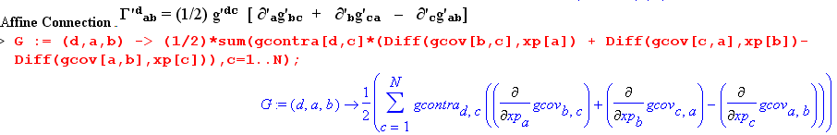

Then the terms shown above are entered (T'ij = Te[i,j], h'i = hp[i], Γ 'dab = G(d,a,b), etc.)

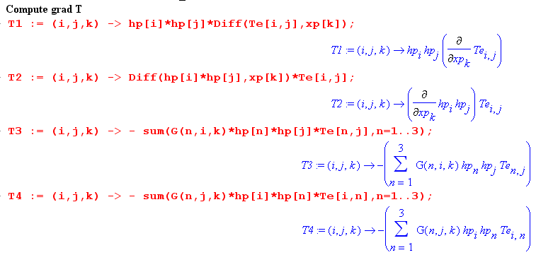
The terms are then added, multiplied by (h'i h'j h'k)-1, and then displayed,

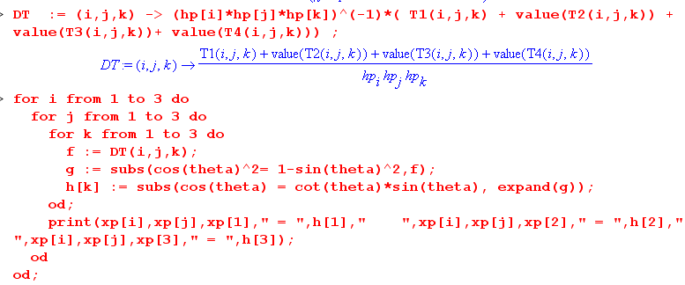

and here are the resulting values for (∇T)'ijk (for example, (∇T)'112 = (∇T)rrθ )
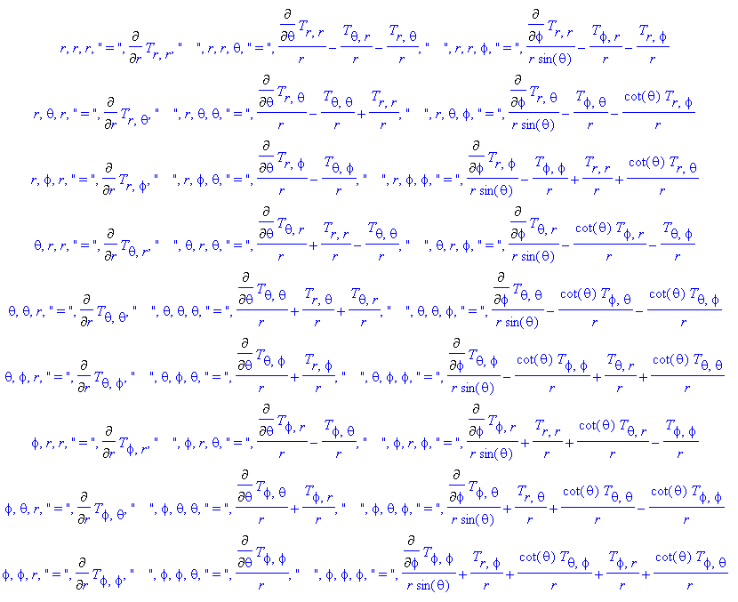

The strange " symbols in the above table should be ignored, just a Maple artifact.
These results agree with the spherical coordinates table given in Lai p 505.
The divT results of Appendix H can be verified from the above table using

(divT)'i = ∂'jT'ij = (∇T)'ijj

For example,

(divT)r = (∇T)rrr + (∇T)rθθ + (∇T)rφφ

= ∂rTrr + (1/r)[∂θTrθ - Tθθ + Trr] + (1/r)[ cscθ ∂φTrφ - Tφφ + Trr + cotθ Trθ]

= ∂rTrr + (1/r)∂θTrθ - Tθθ/r + (2/r)Trr + (1/rsinθ) ∂φTrφ - Tφφ/r + cotθ Trθ /r

and we quote from Appendix H

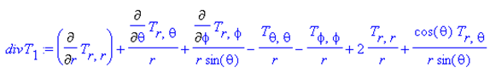.

The Lai method of computing (∇T)'ijk is different from ours. Lai uses an "affine connection" which is geared to the unit tangent base vectors, which in our notation would be written

∂'ji = Γ'(Lai)ijkk , // Lai p 502 (8A.12)

whereas "the true" affine connection measures the change of the full tangent base vectors,

(∂'jen) = Γ'kjn ek . // Appendix F (a)

It is not hard to show that the connection between these two affine connections is,

Γ'(Lai)ijk = h'i-1 [h'kΓ'kji– ∂'j(h'i) δi,k] = h'k-1[– h'i Γ'ijk + δi,k(∂'jh'i) ]

where the second form can be obtained from the first using this identity from Appendix F (c)

(∂cgab) = – [gan Γ bcn + gbn Γacn] .

The object Γ 'dab in spherical coordinates has 9 of its 27 components non-zero, as shown at the start of Appendix I (f), but Γ 'dab = Γ 'dba means there are only 6 distinct non-vanishing components. Correspondingly, the Γ'(Lai)ijk object has 6 of its 27 components non-zero (Lai p 503 (8A.14)).

Lai uses Mijk = (∇T)'ijk and in Lai notation the expansion is ∇T = Σijk Mijk ijj (p 501) which provides an example of the polyadic notation described in our Appendix E (c) (ijj= i⊗j⊗k).

(h) Maple computation of the (∇T)'ijk components in cylindrical coordinates

Making four small edits to the spherical coordinates Maple program converts it to a cylindrical coordinates program. Here are the resulting values for (∇T)'ijk (for example, (∇T)'123 = (∇T)rθz )

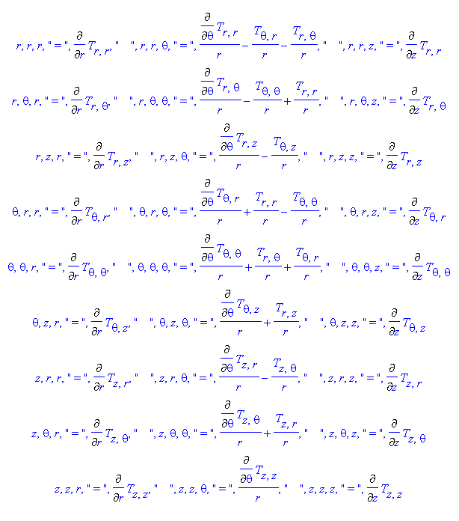
and these expressions agree with those in the table on page 504 of Lai. The same comment made about divT at the end of the previous section applies here as well. The object Γ 'dab has 3 of 27 components non zero as shown at the end of Appendix I (g), only 2 of which are distinct. Correspondingly Γ'(Lai)ijk has only 2 of 27 non zero as shown in Lai p 502 (8A.13).
It should be emphasized that this same simple Maple code can be used to compute the (∇T)'ijk for any system of orthogonal curvilinear coordinates in any number of dimensions N. And the code implied at the end of section (b) and in the middle of section (e) with Q'ijk computes (∇T)'abc and (∇T)'ijk for non-orthogonal as well as orthogonal coordinates.

Appendix K: Deformation Tensors in Continuum Mechanics

Tensor-like objects appear everywhere in continuum mechanics. As was noted in Section 2 (k), and later in Appendix E (i), continuum mechanics texts generally refer to all objects having indices as being "tensors", whether or not these objects actually transform as tensors with respect to some underlying transformation. The most commonly appearing tensors have two indices and are just 3x3 matrices associated with 3D space. In this category, there are several kinds of stress tensors, and many kinds of strain and deformation tensors which describe how a tiny volume of continuous matter (perhaps a tiny cube near some point x) changes shape in response to some applied stress. For a fluid, a fixed stress pattern can cause a continuous ongoing change of shape which is measured then by a "rate of deformation tensor" often called D.
An equation relating stress to strain/deformation is called a constitutive equation and describes the "response" of some physical system to "stimulus". The constitutive equation for a spring is F = -kΔx, for example, which is distinct from the equation of motion for a mass on a spring which is F = ma. For the spring, the stimulus is the force F ("stress"), and the response is the spring stretch Δx ("strain").

In this section we shall study the tensor aspects of several kinds of deformation tensors appearing in continuum mechanics. In the book of Lai et. al. this material is spread over several chapters, but here it will all be put in one place with Lai references provided. Section (c) below considers the form of a candidate constitutive equation for a continuous solid whose form is determined by the requirement that the equation be "covariant" as discussed in Section 7 (u). Similarly, sections (d) and (e) consider covariant constitutive equations for fluids

(a) A Preliminary Deformation Flow Picture

Recall the general nature of the Pictures appearing through this document, such as

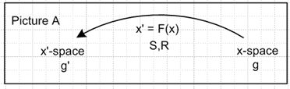

The arrow represents an underlying generally non-linear transformation between x-space and x'-space given by x' = F(x), while R(x) (S = R-1) is the linearized-at-point-x version of the transformation which defines the notion of a vector as in dx' = R dx (see Section 2). Since F will have another meaning below, we shall change the transformation name so that x' = F(x).

Now consider the picture below in which appear two sequential transformations Fto and Ft. There are three spaces called X-space on the bottom, x-space in the middle, and x'-space on the top. The spaces are associated with frames of reference S0 , S and S'. Each frame has some set of basis vectors to be discussed below. The linearized R matrix objects associated with the two transformations are shown to the right and are given the names Rt0 = F on the bottom and Rt= Ft on the top. The transformation x' = Ft(x,τ) is a spatial coordinate transformation only, the time coordinate τ is a parameter. In the picture below, time increases in the upward direction, so τ > t > t0.

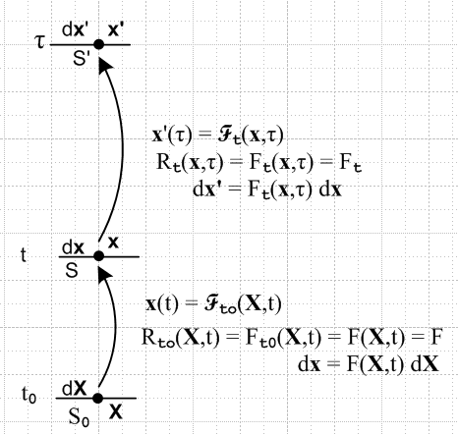 Fig 1

Consider for the moment just the bottom transformation. The transformation Fto ≡ F describes the deformation of a particle of continuous matter which starts at position X and time t0 and ends up at position x at time t. If we look at a large cube of continuous matter, we might find that it deforms in a very complicated manner as determined by the non-linear transformation F applied to all the particles within this large cube. The cube gets stirred up and is probably no longer recognizable. But if instead we consider a differentially small starting cube at X and t0, we shall find that at time t that cube is at location x but has been transformed into a tiny rotated parallelepiped whose axes are no longer orthogonal. It is assumed that the flow is reasonable and smooth, we are not considering some kind of "explosion" here. We use the words flow and fluid, but the deformation concept applies to elastic solids as well as fluids since these deform in some way when they are stressed (think jello or even steel).
Rather than think of the flow in terms of the edges of this tiny cube, one can instead consider two very closely spaced points in the fluid close to X which are separated by spacing dX at time t0, which we think of as "a little dumbbell". At time t, if one carefully tracks the "pathlines" of the ends of the dumbbell, one finds that the dumbbell tumbles and stretches and ends up as dx at time t and location x,

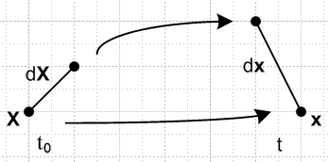 Fig 2

This differential dumbbell can be regarded as a mathematical "probe" embedded in the continuous medium. The relationship between dx and dX is given by

dx = F(X,t) dX dxi = FijdXj // Lai p 105 (3.18.13)

where the matrix Fij is called "the deformation gradient". It is also known as "the deformation gradient tensor" even though it is not a "tensorial tensor" with respect to any identifiable transformation. In Section 5 (o) the above equation was identified with dx' = R(x)dx with R(x) here being F(x,t). The picture above is then the second figure shown in Section 2 (left-right switched). Thus, the deformation gradient F is the linearized version (at point x) of some fancy non-linear (and unknown) "flow transformation" F. Since one can write

dxi = (∂xi/∂Xj)dXj ,

one finds that

Fij = (∂xi/∂Xj) ≡ ∂jXi or F = (∇x) // Lai p 105 (3.18.4)

where the gradient ∇ is with respect to X, so it is really ∇ = ∇(X). Thus the name "deformation gradient".
[ Notice that (∇x) is a matrix. In Appendix G the form of (∇v) for arbitrary vector v is found in arbitrary curvilinear coordinates. The index order reversal Fij = ∂jXi is mentioned there as well. ]
The deformation gradient F(X,t) depends implicitly on the time t0. At t = t0+ε (with a very small ε) no flow has yet taken place, so dxi = dXi and then F(X,t0) = 1. Time t0 is called the reference time and one could display it by writing F(X,t) = Ft0(X,t), but normally this t0 label is suppressed.

Now consider the upper flow in Fig 1 above. It is entirely analogous to the lower flow, but names are changed. We get from the lower flow to the upper flow by making these replacements :

t0 → t dX → dx Fto(X,t) → Ft(x,τ) S0 → S Fto(X,t0) = 1 → Ft(x,t) = 1
t → τ dx → dx' Fto(X,t) → Ft(x,τ) S → S' Fto(X,t0) = 1 → Ft(x,t) = 1

The equations corresponding to those shown above are

dx' = Ft(x,τ) dx dx'i = (Ft)ijdxj // Lai p 457 (8.7.2)

Since one can write

dx'i = (∂x'i/∂xj)dxj ,

one finds that

(Ft)ij = (∂x'i/∂xj) or Ft = (∇x') // Lai p 457 (8.7.3)

where the gradient ∇ is with respect to x, so it is really ∇ = ∇(x).

In the lower flow, t0 is the reference time, and t is the "current time". In the upper flow, the current time t is the reference time, and τ is some time τ > t. The upper flow is relative to current time t as reference, and for that reason the word "relative" is pre-pended to the names of all related tensors. Thus, Ft is called the "relative deformation gradient ", whereas F is just the "deformation gradient ".

Why are relative tensors useful?

The main motivation for use of the relative tensors concerns differentiation with respect to time in the vicinity of the current time t. One can write

dtFt(x,t) ≡ [∂τFt(x,τ)]τ=t // x fixed (for example, x = x1)
where
∂τFt(x,τ) ≈ [ Ft(x,τ+dτ) - Ft(x,τ) ] / dτ .

Here dt = Dt = d/dt = D/Dt = the total time derivative, and ∂t = ∂/∂t = the partial time derivative. Since x is fixed, dx = 0 so dt = ∂t. We want to know the rate of deformation at some fixed current time t, and it is the τ argument of the function Ft(x,τ) that lets this derivative be computed.
One could in theory carry out this same differentiation using the "non-relative" tensors by doing d/dt0 with t0 near t:

dtFt(X,t) ≡ [∂t0Ft0(X,t)]t0=t // X fixed
where
∂t0Ft0(X,t) ≈ [ Ft0(X,t) - Ft0-dt0(X,t) ] / dt0 ,

but this goes against the grain of the idea that X is a material coordinate at initial time t0 which is earlier than t. And in the above, we end up with a statement about Lagrangian functions f(X,t) rather than Eulerian functions f(x,t), though one might argue that as t0→ t, one has X → x. The relative tensor approach makes the differentiation process clearer, and will be used below for that purpose.

The frames of reference and the cameraman

Each of the three frames of reference S0, S and S' in Fig 1 has its own set of orthonormal basis vectors which we are completely free to set in any manner. As a construct it is helpful to imagine that, as the flow proceeds, it is observed by a cameraman who flies around on a camera platform which translates and rotates in some arbitrary manner. Since our main concern will be with the dumbbells like dX, dx and dx', the translational part of the camera platform motion is irrelevant since dX is invariant under translations. We allow the cameraman's arbitrary orientation at times t0, t and τ to determine the axes of the three frames S0, S and S'. The cameraman is an "observer".
The values of the deformation gradient matrix elements Fij depend on the choice of basis vectors in frames S0 and S, so they in fact are dependent on how the cameraman flies his platform. Consider,

dx = dx11(S) + dx2 2(S) + dx3 3(S)

dX = dX11(S0) + dX2 2(S0) + dX3 3(S0)

Once the axes are chosen, the value of the Fij are determined, for example,

F12 ≈ (dx1)/(dX2) .

If we were to rotate the basis vectors in frame S, for example, dx1 would change, dX2 would stay the same, and F12 would change.

Tensor expansions of the deformation gradients

These two expansions won't be used below, they are just inserted here "for interest". The expansions use the basis vectors just defined above which are n(S0) for frame S0 and n(S) for frame S.

• Consider this candidate expansion for the deformation gradient F,

F = Σij Fij i(S) ⊗ j(S0) = Σij Fij [i(S)] [j(S0)]T

where Fij = [F(S,S0)]ij = [i(S)]T F [j(S0)] = (∂xi/∂Xj) ,

where we write the expansion in both direct product and matrix form as in Appendix E. This is a "mixed basis expansion" as discussed in Appendix E (i). Consider the application of this expansion to dX :

{ Σij Fij [i(S)] [j(S0)]T } dX

= Σij Fij [i(S)] [j(S0)]T { ΣkdXkk(S0)}

= Σij Fij ΣkdXk [i(S)] [j(S0)]T [ k(S0)]

= Σij Fij ΣkdXk [i(S)] δj,k

= [ Σij Fij dXj] i(S)

= [ dxi ] i(S) // using the fact that F dX = dx

= dx .

Since {expansion}dX = dx and since (∇(X)x) dX = dx by the chain rule, it seems reasonable to conclude that {expansion} = (∇(X)x) = F.

• If we agree to use the i(S) for both dx and dx', so that dx = dxii(S) and dx' = dx'ii(S), then the following is a viable expansion for the relative deformation gradient Ft:

Ft = Σij (Ft)ij i(S) ⊗ j(S) = Σij (Ft)ij [i(S)] [j(S)]T

where (Ft)ij = [Ft(S,S)]ij = [i(S)]T Ft [j(S)] = (∂x'i/∂xj)

The verification is similar to the above,

{ Σij (Ft)ij [i(S)] [j(S)]T } dx

= Σij (Ft)ij [i(S)] [j(S)]T { Σkdxkk(S)}

= Σij (Ft)ij Σkdxk [i(S)] [j(S)]T [ k(S)]

= Σij (Ft)ij Σkdxk [i(S)] δj,k

= [ Σij (Ft)ij dxj] i(S)

= [ dx'i ] i(S) // using the fact that Ft dx = dx'

= dx' .

Since {expansion}dx = dx' and since (∇(x)x') dx = dx' by the chain rule, it seems reasonable to conclude that {expansion} = (∇(x)x') = Ft.

(b) A More Complicated Deformation Flow Picture

Consider now this flow picture,

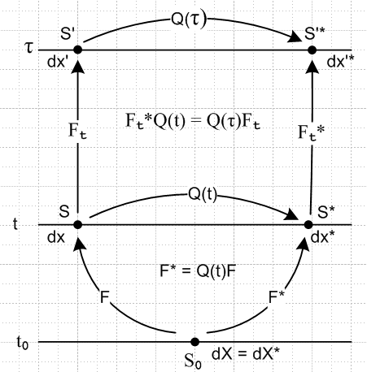 Fig 3

There is much to be said about this drawing.
The left side is the same as in Fig 1 shown above.
The picture is simplified in that it shows only the linearized R-type transformations like F and not the full transformations like F, and these R-type matrices are now labeled right on the transformation arrows. We only care about these F matrices because we only care about the dumbbells like dx. For example, on the lower left we have dx = F dX .
The two sides of the picture represent observations of the same flow by two independent flying cameraman observers, call them C and C*. On each side the basis vectors of the various frames are set by the motions of these cameramen. The two cameramen have agreed to start off at time t0 with their camera platforms in exact alignment, so there is no need for a frame S0*.
The two frames of reference S and S* are related by some Galilean transformation (rotation plus translation) which brings the two independent camera platforms into alignment at time t :

x* = Q(t) (x-x0) + c(t) => dx* = Q(t) dx

Here x0 is a randomly selected center for the rotation Q(t), and c(t) the corresponding translation. As above, we only care about the Q(t) part of this transformation, so in terms of dx objects, the frames S and S* are in effect related by the rotation Q(t).
The arrows in the picture correctly describe the transformations of the dx type objects in moving between frames. In the lower part, for example, we have

dx* = Q(t) dx dx = F dX dx* = F* dX

Comparing the left and right equations one has Q(t) dx = F* dX and then the center equation can be used on the left side to get Q(t) F dX = F*dX . Since this has to be true for any dX, we have Q(t) F = F* as shown in the drawing. This result is trivially obtained just by looking at the alternate arrow paths from frame S0 to frame S*. So:

F* = Q(t) F or F*(x*,t*) = Q(t) F(x,t) t* = t

At time τ we have a similar situation, but there are four arrows instead of three. Comparing the arrow paths from frame S to frame S'* one finds

Ft*Q(t) = Q(τ)Ft =>

Ft* = Q(τ)FtQ(t)T or Ft*(x*,τ*) = Q(τ) Ft(x,τ)Q(t)T t* = t

The two Q's are rotations (reflections included) and are therefore orthogonal so Q-1 = QT.

Does F transform as a tensor with respect to rotation Q(t) ?

We can think of F(x,t) as a property of the continuous material at location x and current time t. F describes the "state of deformation". If F transformed as a tensor with respect to Q(t), one would need this to be true,

F* = Q(t) F Q(t)T // not true!

which is the matrix form for the transformation of a rank-2 tensor as shown, for example, in Section 5 (f). But we have just seen that F* = Q(t) F so the required Q(t)T on the right is missing. We conclude therefore that in fact F, although it is called a tensor, does not transform as a tensor under Q(t). One then says that F is a non-objective tensor with respect to Q(t). Equation F* = Q(t) F in fact says that the columns of matrix F transform as vectors under Q(t), which is very different frame saying F transforms as a rank-2 tensor under Q(t).
If one is trying to construct a phenomenological equation modeling a continuous material at point x and time t, one must make sure that equation is "covariant" (frame-indifferent) with respect to rotation Q(t). The observers (cameramen) in frame S and frame S* must see equations which have exactly the same form, which means the elements in the equations must be objective with respect to Q(t). See Section 7 (u) for a general discussion of "covariance". Since F is non-objective, it is not directly useful in the construction of covariant model equations.

Do any of the usual "derived tensors" transform as tensors with respect to Q(t) ?

By "the usual derived tensors" we mean B, C, U, V and associated R all defined as follows:

B = FFT = the left Cauchy-Green deformation tensor = the Piola deformation tensor

C = FTF = the right Cauchy-Green deformation tensor = the Finger deformation tensor

F = RU = VR R = rotation U,V = symmetric positive definite

Tensors B and C are defined simply as shown, and both are therefore symmetric tensors. The last line is a statement of the polar decomposition theorem which says that any (real) non-singular matrix (det ≠ 0) can be uniquely written in these two ways (we apply this theorem to the deformation tensor F)

F = RU = VR => U = RTVR and V = RURT // Lai p 114 (3.21.1,2,4)

where R is a rotation matrix and V and U are symmetric positive definite matrices (meaning the eigenvalues are all positive) known as the left and right stretch tensors. Note that R is the same matrix in both the RU and VR forms. The idea is that the R matrix takes into account the rotational part of the deformation F, while U or V take into account the stretch component of the deformation. If the deformation is a pure rotation, U = V = 1, whereas if the deformation is a pure stretch then R = 1. A general deformation is a rotation/stretch/shear affair and one will find that none of R, U, V are unity.
One can combine the three equations above to find that

B = FFT = (VR)(VR)T = VRRTVT = VVT = VV = V2 // Lai p 125 (3.25.1)

C = FTF = (RU)T(RU) = UTRTRU = UTU = U2 // Lai p 115 (3.22.1,2)

So our task is to discover whether any of these derived tensors transform as a tensor relative to Q(t). If they do transform as tensors (if they are objective), then they are candidates for use in constructing model equations for the continuous material.
We start with B and C:

B* = F*F*T = (QF)(QF)T = QF FTQT = QBQT => B* = Q(t)BQ(t)T .

C* = F*TF* = (QF)T(QF) = FTQTQF = FTF = C => C* = C

Thus, the left Cauchy-Green deformation tensor B actually does transform as a rank-2 tensor with respect to Q(t), so it is a tensorial tensor, it is "objective". In contrast, since C* = C, the right Cauchy-Green deformation tensor does not transform as a rank-2 tensor. In fact each element of matrix C transforms as a tensorial scalar with respect to Q(t).
What about V and U as defined above, the left and right stretch tensors?

F = RU = VR F* = R*U* = V*R*

Consider,

F* = QF = Q(RU) = (QR) (U) = R*U*

Since U is positive definite symmetric, and since QR is a rotation, and since the polar decomposition is unique, it must be that

R* = QR and U* = U .

Next write

F* = QF = Q(VR) = (QVQT)(QR) = V* R*

Since the eigenvalues of symmetric V are determined by det(V-λI) = 0, and since this is the same as the equation det(QVQT-λI) = 0, QVQT has the same eigenvalues as V and so (QVQT) is symmetric and positive definite. Due to this fact and the fact that QR is a rotation, and the fact that the polar decomposition is unique, it must be that

V* = QVQT and QR = R* .

So here is a summary for our tensors of interest. Only two of the five deformation tensors actually transform as tensors. The references are to Lai page 336-337 :

F* = Q(t)F // Lai (5.56.21)
B* = Q(t)BQ(t)T // rank-2 tensor with respect to Q(t) so objective // Lai (5.56.31)
C* = C // Lai (5.56.28)
U* = U
V* = Q(t)VQ(t)T // rank-2 tensor with respect to Q(t) so objective
R* = Q(t)R

Comment: Recall that F = F(x,t) has a hidden parameter t0 so in fact F = Ft0(x,t) . Similarly, all derived tensors have this same hidden parameter. Thus, for example, one could write the transformation of B as

Bt0*(x*,t*) = Q(t) Bt0(x,t)Q(t)T t* = t x* = Q(t) (x-x0) + c(t) dx* = Q(t) dx .

The parameter t0 is treated as a fixed constant here and plays no role in the question of whether or not B transforms as a rank-2 tensor. The important time argument of B is the current time t, and the main idea is that B*(t) = Q(t) B(t)Q(t)T so that B(t) is objective with respect to the rotation Q(t). The transformation is valid for any value of t0. In the limit that t0 → t, the equation says 1 = Q(t) 1 Q(t)T which of course is true since rotation Q(t) is orthogonal.

Do any of the usual relative derived tensors transform as tensors with respect to Q(t) ?

Again we think of a relative tensor Wt as being a property of the continuous material at current time t, a measure of the state of deformation. Such a tensor is objective only if Wt* = Q(t)WtQ(t)T. With regard to the above Comment, in this new situation it is the t of Wt which is the time variable of interest (the current time), and time τ is regarded as a fixed parameter, as was t0 in the Comment. It just happens that the notational positions of the current time t and the parameter time τ are swapped in this case relative to the last, so now we have

Wt*(x*,τ*) = Q(t)Wt(x,τ) Q(t)T τ* = τ x* = Q(t) (x-x0) + c(t) dx* = Q(t) dx .

A tensor Wt which transforms as a rank-2 tensor (is objective) with respect to rotation Q(t) must satisfy the rule above, where the arguments of both Q rotations are t. As in the Comment above, this transformation is valid for any value of parameter τ, and as τ→t, the equation says 1 = Q(t) 1 Q(t)T.

Our study of the transformation properties of the relative tensors proceeds in a manner similar to that used for the regular tensors above. We start with Bt ≡ FtFtT :

Bt* = Ft*Ft*T = [Q(τ) Ft QT(t)] [Q(τ) Ft QT(t)]T = Q(τ) Ft QT(t) Q(t) FtT Q(τ)T

= Q(τ) Ft FtT Q(τ)T = Q(τ) Bt Q(τ)T // not a rank-2 tensor since t ≠ τ

Next comes Ct ≡ FtTFt :

Ct* = Ft*TFt* = [Q(τ) Ft QT(t)]T [Q(τ) Ft QT(t)] = Q(t) FtT Q(τ)T Q(τ) Ft QT(t)

= Q(t) FtT Ft QT(t) = Q(t) CtQT(t) // yes a rank-2 tensor with respect to Q(t)

What about the left and right relative stretch tensors Vt and Ut?

Ft= RtUt = VtRt Ft* = Rt*Ut* = Vt*Rt*

Consider,

Ft* = Q(τ) Ft QT(t) = Q(τ) RtUtQT(t) = [Q(τ) RtQT(t)] [Q(t)UtQT(t)] = Rt*Ut* .

Since [Q(τ) RtQT(t)] is a rotation and since [Q(t)UtQT(t)] is a symmetric positive definite matrix by the argument given in the previous section, and since the polar decomposition is unique, it must be that

Rt* = Q(τ) RtQT(t) and Ut* = Q(t)UtQT(t) // Ut is a rank-2 tensor

Finally, write

Ft* = Q(τ) FtQT(t) = Q(τ)VtRtQT(t) = [Q(τ)VtQT(τ)] [Q(τ) RtQT(t)] = Vt* Rt*

By the same argument used several times above, we conclude that

Rt* = Q(τ)RtQT(t) and Vt* = Q(τ)VtQT(τ) // Vt is not a rank-2 tensor, τ ≠ t

The rule for transforming Rt is the same as found a few lines above.
Here then are the conclusions, with references to Lai page 472:

Ft* = Q(τ)FtQT(t) // Lai (8.13.6)
Bt* = Q(τ)BtQ(τ)T // Lai (8.13.12)
Ct* = Q(t)CtQT(t) // rank-2 tensor with respect to Q(t) so objective // Lai (8.13.10)
Ut* = Q(t)UtQT(t) // rank-2 tensor with respect to Q(t) so objective // Lai (8.13.9)
Vt* = Q(τ)VtQT(τ) // Lai (8.13.12)
Rt* = Q(τ)RtQT(t) // Lai (8.13.8)

Notice that among the "normal" tensors, B and V are objective, whereas among the "relative tensors" it is Ct and Ut that are objective. All the other tensors are "non-objective".

(c) Form of a solid constitutive equation involving the deformation tensor

For a solid continuous material in frame S one can consider a stress/deformation relationship of the form
T = f(B), where T is the Cauchy stress tensor, B is the left Cauchy-Green deformation tensor mentioned in section (b) above, and f is "some function".
In frame S*, there will be some covariant version of the equation T* = f*(B*). If the medium is isotropic (rotationally invariant in its properties), then f* = f and one will have T* = f(B*) in Frame S*. Two observers of the same system in frames related by a rotation cannot observe different functions f ≠ f* if the material is isotropic. Notice that there are two separate issues here: (1) equation must be covariant under rotations to be viable; (2) isotropic implies f = f*.
If f is a polynomial, or a function which can be approximated by one (f is smooth), then T = f(B) with polynomial coefficients which are rotational scalars (with respect to Q) is a viable equation form for the following reason: since B is a rank-2 tensor, so is any power of B,

B*2 = [QBQT][QBQT] = Q B2QT etc.

and if the polynomial coefficients are scalars, then f(B) is a rank-2 tensor.
Just as a particle force F transforms as a rank-1 tensor under rotations, the Cauchy stress tensor T transforms as a rank-2 tensor under rotations, and then both sides of T = f(B) transform in the same way -- as rank-2 tensors. Any candidate equation between T and a deformation tensor which did not have both sides transforming the same way would be invalid from the get-go (except perhaps as an approximation).
The scalar coefficients must be functions of the Bij and there are three such scalars known as the principal scalar invariants of B (Lai p 40), one of which is det(B), so the scalar coefficients can be any functions of these three scalar invariants. Furthermore, one can use the fact that B = FFT is symmetric along with the Cayley-Hamilton theorem (symmetric matrix B satisfies its own secular equation, whose coefficients by the way are those scalar invariants) to show that any powers of B in polynomial f(B) larger than degree 2 can be expressed as a linear combination of I, B and B2. One ends up then with T = aI + bB + cB2 where a,b,c are functions of the three scalar invariants of tensor B.
Since both sides of T = f(B) transform in the same way (rank-2 tensors), the equation T = f(B) is "covariant" as discussed in Section 7 (u), meaning it has the same form in frame S* as it has in S.
The equation T = f(B) is a relation between stress and strain in the form of deformation, and as such is called a constitutive equation for the continuous material. One wants such equations to be covariant between frames of reference related by any Galilean transformation (rotation + translation), even if one or both of these frames are non-inertial. This is an extension of Hooke's Law for a spring, F = -k Δx , which is covariant under rotations and translations.
In contrast, equations of motion are only covariant if both frame S and S* are inertial frames.
Notice that this entire discussion falls apart completely if one tries T = f(F) or T = f(C) as a candidate constitutive relation, since then the two sides of the equation don't transform the same way.
This subject is discussed in Lai pp 334-342 and p 40 for the scalar invariants. The requirement of covariance for an isotropic material and the fact that B is symmetric and transforms as a tensor puts a severe restriction on the form of the constitutive equation and we end up with T = aI + bB + cB2. Since one can replace B3 = αB2 + βB + γI, if B is invertible (detB ≠ 0) one has B2 = αB + βI + γB-1 and this allows the alternate form T = a'I + b'B + c'B-1 . This last equation is used to model large deformations of an isotropic elastic material. An example is the Mooney-Rivlin theory for rubber.

(d) Some fluid constitutive equations

It was noted in section (b) that the relative deformation tensors are appropriate when one is interested in time derivatives of the tensors. It was also noted that the relative deformation tensor Ct is objective. One can expand Ct(x,τ) in a Taylor series about current time t in this manner (∂τ ≡ ∂/∂τ) ,

Ct(x,τ) = Σn=0∞ [ ∂τnCt(x,τ)]τ=t (τ-t)n/n! = Σn=0∞An(x,t) (τ-t)n/n! // Lai p 463 (8.10.1)

An(x,t) ≡ [ ∂τnCt(x,τ)]τ=t ,

where the coefficient derivatives are given the names An(x,t) called Rivlin-Ericksen tensors. Each of these coefficient tensors is in fact objective, just as is Ct, since (as usual, t = t*, τ = τ* )

Q(t) [ ∂τnCt(x,τ)]τ=t QT(t) = { ∂τn [Q(t) Ct(x,τ) QT(t)]}τ=t = { ∂τ*n Ct*(x*,τ*)}τ*=t

=> Q(t) An(x,t) QT(t) = A*n(x*,t)

These An(x,t) tensors appear in various models of "non-Newtonian" fluid behavior, the general study of which is called rheology, based on the Greek word for a current flow (a rheostat controls electric current),

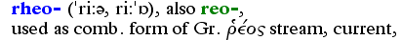 // OED2

Here are a few covariant constitutive equations and the names assigned to them (Lai p 481). Note that for any normal fluid, there is always a -pI tensor term in the expression for stress T, where p is the fluid pressure and I is the identity matrix. The diagonal elements of matrix -pI are the equal normal stresses of the surroundings of a tiny cube of fluid pulling out on the cube faces, hence the -p (p > 0) since we know the fluid actually pushes in on the cube.

T = -pI + functional of Ct(τ), τ ≤ t // "simple" fluid, since ∇nFt not involved (Ct=FtT Ft)

T = -pI +$^{\int_{-∞}^{t}{}}$ dτ f1(τ) Ct(τ) // single-integral simple fluid. f1(τ) = a memory weight function

T = -pI + f(A1, A2....AN) // Rivlin-Ericksen incompressible fluid of complexity N
T = -pI + f(A1,A2) // viscometric flow fluid (there are conditions on A1 and A2)
T = -pI + μ1A1 + μ2A12 + μ3A2 // second order fluid (paint, blood, polymers)

T = -pI + μA1 // incompressible Newtonian fluid (fluids like water)

It turns out that A1 = 2D where D = [(∇v) + (∇v)T] /2 ≡ (∇v)sym , so A1 is twice the rate of deformation tensor D. The other An can then be found from this recursion relation,

An+1 = dtAn + An(∇v) + (∇v)TAn // Lai p 468 (8.11.2)

Here v is the fluid velocity vector and dt = d/dt = D/Dt. Again, (∇v) is the subject of Appendix G.

(e) Corotational and other objective time derivatives of the Cauchy stress tensor

The Cauchy stress tensor T transforms as a tensor under Q(t); it is objective. One can write therefore,

T*(x*,t*) = Q(t) T(x,t) Q(t)T t* = t x* = Q(t) (x-x0) + c(t) dx* = Q(t) dx

Clarification of the above equation

One can think of the above equation T* = QTQT as involving operators in Hilbert Space, as outlined in Appendix E (g). In the upper part of Fig 3 above we show four different frames of reference called S, S*, S' and S'* each of which has its own set of basis vectors we might call un, u*n, u'n and u*'n. It happens that the picture refers to S and S* at time t, and S' and S'* at time τ, but any basis vectors can be "used" at any time one wants. For example, here are four expansions of the operator T(x,t)

T(x,t) = Σab Tab(x,t) ua ⊗ ub = Σab T*ab(x*,t) u*a ⊗ u*b

= Σab T'ab(x',t) u'a ⊗ u'b = Σab T'*ab(x'*,t) u'*a ⊗ u'*b

in which we see four different kinds of components Tab, T*ab, T'ab, T'*ab . The spatial arguments of each component are written as appropriate for that frame of reference and of course all "correspond" to each other (for example, x' = Ft(x,τ)). Recall from Section 2 (i) the notion of the transformation of a contravariant vector field in developmental notation

V'(x') = R V(x) contravariant Rik(x) ≡ (∂x'i/∂xk) R = S-1

where the argument is appropriate to the space of interest.
The time argument t in the above four expansions of T can be set to any arbitrary value. The stress tensor at a point x is in general a function of time t. One could for example set t = τ in all the expansions.
Having said this, we now decide that only the frame S basis vectors un shall be used in our expansions and components. Then for example ( these un were called n(S) earlier)

T(x,t) = Σab Tab(x,t) ua ⊗ ub
T*(x*,t) = Σab T*ab(x*,t) ua ⊗ ub

Q(t) = Σab Qab(t) ua ⊗ ub .

Our operator statement of objectivity then becomes the following when expressed in components,

T*(x*,t*)ij = Q(t)ia T(x,t)ab Q(t)Tbj t* = t

Thus, there should be no confusion about the following two equations which we express back in operator notation with the position arguments suppressed (but shown on the right)

T*(t) = Q(t) T(t) Q(t)T // T*(x*, t) = Q(t) T(x,t) Q(t)T

T*(τ) = Q(τ) T(τ) Q(τ)T // T*(x*, τ) = Q(τ) T(x,τ) Q(τ)T

Problem: The tensor dT/dt fails to transform as a rank-2 tensor, even though T does so transform.

If one tries to construct covariant constitutive equations involving dT/dt, a problem arises because dT/dt is non-objective,

T*(t) = Q(t) T(t) Q(t)T

(dT*/dt) = Q (dT/dt) QT + [ (dQ/dt) T QT + Q T (dQ/dt)T ] ,

so there are two extra unwanted terms. Just as B = FFT is constructed to provide an objective derived tensor from non-objective F, one can construct a derived version of (dT/dt) which is objective. In the next three sections, three different derived versions are described.

The corotational/Jaumann derivatives

The first step is to define an adjusted stress tensor Jt(τ) at time τ according to (see Lai p 483, (8.19.3); Lai does not have a t subscript on J).

Jt(τ) ≡ RtT(τ) T(τ) Rt(τ) // Jt(x,τ) ≡ RtT(x,τ) T(x,τ) Rt(x,τ)

where Rt(τ) is the rotation which appears above in section (b), where we had (showing τ arguments),

Rt*(τ) = Q(τ) Rt(τ)QT(t) .

The tensor Rt(τ) is non-objective due to appearance of Q(τ) instead of Q(t) on the left (see comments on Wt above). Recall that this rotation Rt(τ) is unique and is determined from the deformation tensor by the polar decomposition Ft(τ) = Rt(τ)Ut(τ) = Vt(τ) Rt(τ). Thus, in some sense Jt(τ) knows about the stress tensor T(τ), and it knows something about the deformation tensor through Rt(τ). [ The meaning of the term "corotational" is explained far below. ]

The claim now is that the time derivative of this corotating stress tensor Jt is objective, meaning that tensor dtJt transforms as a rank-2 tensor under the rotation Q(t). Here is a proof :

We first assemble the following facts,

T*(τ) = Q(τ) T(τ) Q(τ)T // transformation of stress tensor T at time τ (see prev section)
Rt*(τ) = Q(τ) Rt(τ)QT(t) // how Rt(τ) transforms, where Ft(τ) = Rt(τ)Ut(τ)
Jt(τ) ≡ RtT(τ) T(τ) Rt(τ) // definition of Jt(τ) in frame S
Jt*(τ) ≡ Rt*T(τ) T*(τ) R*t(τ) // corresponding Jt* in frame S*

and then we combine these ingredients to obtain a transformation rule for Jt :

Jt*(τ) ≡ Rt*T(τ) T*(τ) R*t(τ) = [Q(τ) Rt(τ)QT(t)]T [Q(τ) T(τ) Q(τ)T] [Q(τ) Rt(τ)QT(t)]

= [Q(t) RtT(τ)QT(τ)] [Q(τ) T(τ) Q(τ)T] [Q(τ) Rt(τ)QT(t)]

= Q(t) RtT(τ) [QT(τ)Q(τ)] T(τ) [Q(τ)TQ(τ)] Rt(τ)QT(t)

= Q(t) [ RtT(τ)T(τ) Rt(τ)] QT(t)

= Q(t) Jt(τ) QT(t) . (*)

Since this equation Jt*(τ) = Q(t) Jt(τ) QT(t) fulfills the condition described earlier for Wt to be objective, we conclude that the corotating stress transforms as a rank-2 tensor, where τ is treated as a parameter.

Consider now the limit of (*) as τ → t. One finds,

Jt(τ) ≡ RtT(τ) T(τ) Rt(τ)
Jt(t) ≡ RtT(t) T(t) Rt(t) = 1 T(t) 1 = T(t)
and
J*t(τ) ≡ R*tT(τ) T*(τ) R*t(τ)
J*t(t) ≡ R*tT(t) T*(t) R*t(t) = 1 T*(t) 1 = T*(t) .

In this limit, the corotation Rt-1(τ) has come to a halt, and (*) becomes a statement that T is objective.

More interestingly, we can apply ∂τn = ∂n/∂τn to both sides of (*) to get

dτn Jt*(τ) = Q(t)[ dτn Jt(τ) ] QT(t) .

Taking the limit τ→t then gives

[dtn Jt*](t) = Q(t) [dtn Jt](t) QT(t)

which says that dtnJt are all objective tensors. And in particular, for n = 1,

(dtJt)* = Q(t) (dtJt) QT(t) ,

and this concludes our proof that dJt/dt is objective, whereas dT/dt is not objective.

The above objective tensor time derivatives are sometimes written using the following strange notation

n ≡ [dnJt(t)/dtn], n = 1,2,3... ≡ 1 Jt(τ) ≡ RtT(τ) T(τ) Rt(τ)

and these are called corotational or Jaumann derivatives (Lai p 484) [Jaumann-Zaremba]. It can be shown that
= dtT + TW-WT where W = [(∇v) – (∇v)T]/2 = "the spin tensor" // Lai p 484 (8.19.10)

The Oldroyd Lower convected derivatives

An alternative solution to the same problem uses a different adjusted stress tensor,

JL(τ) ≡ FtT(τ) T(τ) Ft(τ) // Lai p 484 (8.19.12)

We suppress the t subscript on JL just to avoid having to write (JL)t(τ). In the table at the end of section (b) one sees that Ft transforms the same way Rt does, so one can repeat the above analysis to conclude that the derivatives [dnJL(t)/dtn] are all objective tensors (just replace Rt→ Ft everywhere), so

n ≡ [dnJL(t)/dtn] , n = 1,2,3... ≡ 1, JL(τ) ≡ FtT(τ) T(τ) Ft(τ) // = ∪n

and these are the "Oldroyd lower convected derivatives" (Lai p 485, called ∪n) . is sometimes called the Cotter-Rivlin stress rate. It can be shown that

= ∪ = dtT + T(∇v) + (∇v)TT . // Lai p 484 (8.19.21)

The Oldroyd Upper convected derivatives

Finally, consider again the non-objective way that Ft transforms (table end of section (b))

Ft*(τ) = Q(τ)Ft(τ)QT(t)

=> (Ft-1)*(τ) = Q(t) (Ft-1(τ)) QT(τ) // inverted

=> (Ft-1)T*(τ) = Q(τ) (Ft-1)T(τ) QT(t) // then transposed

This object Ft-1,T therefore transforms the same way Rt and Ft transform, so we obtain a third set of objective time derivatives called the Oldroyd upper convected derivatives (Lai p 486 uses n)

∇n ≡ [dnJU(t)/dtn] , n = 1,2,3... ∇ ≡ ∇1, JU(τ) ≡ Ft-1(τ) T(τ) Ft-1,T(τ) // = n

The meaning of the term "convected" is explained below. It can be shown that

∇ = = dtT – (∇v)T – T(∇v)T // Lai p 486 (8.19.26)

Covariant constitutive equations

Constitutive equations involving an objective time derivative of the stress tensor are called "rate type constitutive equations". Here are some models for incompressible fluids :

T = -pI + S where S + λ = 2μD // a convected Maxwell fluid

T = -pI + S where S + λ(∂S/∂t) = 2μD // linear Maxwell fluid, see below (non-covariant)

T = -pI + S where S = 2μD // Newtonian fluid

T = -pI + S where S + λ1 = 2μ(D + λ2) // a corotational Jeffrey fluid

T = -pI + S where S + λ1∇ = 2μ(D + λ2∇) // Oldroyd fluid A

Fluids with stress time derivatives in their constitutive equations exhibit both elastic and viscous behavior at the same time. Pull on a chunk of such a fluid and the pull is initially resisted by an elastic force, but after a while the internal stress field damps out (molasses, honey) and that elastic force goes away, as if the fluid were microscopically constructed of little springs and dragging dashpots. When a constitutive equation includes a time derivative of stress, the "response" (in this case D = [(∇v) + (∇v)T]/2 ) to the "stimulus" (T or S) includes factors of the form e-t/c where the c are decay time constants which are functions of the fluid parameters λi. In this case, the fluid has memory of its past over a time period less than these time constants, as with the honey example. For flow that is very slow relative to these time constants, the time derivative term may be neglected. In the moderately slow flow case, it can be shown that the distinction between the corotational time derivative and (dS/dt) can be neglected and then the convected Maxwell fluid shown above becomes the traditional linear Maxwell fluid which is modeled on those springs and dashpots with S + λ (∂S/∂t) = 2μD. (The time derivatives here are meant to act only on the second argument of S(x,τ) so may be regarded as partial derivatives. ) If λ = 0, the linear Maxwell fluid becomes an (incompressible) Newtonian fluid like water which has no memory.

Comment: The linear Maxwell fluid equation S + λ (∂S/∂t) = 2μD can be solved for S using the standard Green's Function method and the solution is S(t) = 2 $^{\int_{-∞}^{t}{}}$ dt' [ (μ/λ)e-(t-t')/λ] D(t') where the bracketed quantity (the Green's Function or kernel) is called the stress relaxation function φ(t-t'). One can see in this solution the notion of memory (history) with time constant λ: the stress of the present is a function of the rate of deformation D going on in the entire past history. This solution fits into the "simple fluid" form shown earlier, where recall that D = (1/2)A1 and A1 = [ ∂τCt(x,τ)]τ=t.

Our main point is to demonstrate the construction of constitutive equations which are covariant with respect to rotations, and which therefore can contain only tensors which in fact transform as tensors under rotations. In continuum mechanics, such tensors are said to be objective tensors.

Interpretation of the adjusted stress tensors discussed above.

In Section 2 we discuss the notion of the transformation of a contravariant vector V' = RV in developmental notation. In x'-space, the vector components are V'i = RijVi where Vi are the components in x-space. If R is a rotation matrix, then the unit basis vectors in the two spaces can be taken as Cartesian, call them u'n in x'-space and un in x-space. We have these two expansions of V:

V = Σn Vn un = Σn V'n u'n where Vn = V • un V'n = V • u'n

In the "active view" of things, we can think of V' = RV as creating a new vector V' in x-space from the old vector V created by rotating the vector V by R. In the "passive view", we think of the V'i as the components of the original vector V projected onto the backwards-rotated basis vectors u'n = R-1 un. To verify this relation between the basis vectors, we can write

V'n = V • u'n = V • R-1un = RV • RR-1un = RV • un = V'• un = V'n .

So one can think either of V being rotated forward in x-space into V' where V' has x-space components V'n , or one can think of the V'n as the components of V one measures in frame that is backwards rotated by R-1 , that is, u'n = R-1 un.
Consider then a rank-2 tensor that transforms as in Section 5 (f) according to M' = R M RT. The passive interpretation is that the components M'ij are those one observes in a frame of reference whose basis vectors are rotated by R-1 relative to the basis vectors of the unprimed frame, just as in the vector case of the last paragraph. If we now set R = R-1, then M' = R-1 M (R-1)T tells us that the components M'ij of tensor M are those measured in a frame whose basis vectors are rotated forward by R relative to the unprimed frame. If it happens that R = R(t), we would say that M'ij are the components of M which are observed in a frame of reference which is rotating by R(t) relative to the frame of the unprimed components Mij. The basis vectors of the primed frame are then u'n = R un .

With this long-winded introduction, we now consider the corotational stress tenser Jt(τ) from above,

Jt(τ) ≡ RtT(τ) T(τ) Rt(τ)

Since Rt(τ) is a rotation, RtT(τ) = Rt-1(τ), so we have, suppressing τ,

Jt = Rt-1T Rt .

Therefore, we can regard (Jt)ij as T'ij, the components of stress T measured in a frame which is rotating by Rt relative to the frame in which the Tij are measured. Since this primed frame rotates by Rt relative to the unprimed frame, it is called a corotating frame, and Jt is then called the corotational stress, and its time derivative is called the corotational stress rate.

We next consider the upper Oldroyd stress given above a

JU ≡ Ft-1 T (Ft-1)T

In analogy with the above discussion, we can regard (JU)ij as T'ij, the components of stress T measured in a frame which is deforming by Ft relative to the unprimed frame. That is to say, the basis vectors of the primed frame are given by u'n = Ft un. In this case, since Ft is not a rotation, if the un start as unit vectors, then the u'n are not unit vectors. One can think of each basis vector un as being aligned with its own dumbbell dx(n) and then we have dx'(n)= Ft dx(n). What this says is that the basis vectors are embedded in the fluid which deforms as it flows according to Ft. The basis vectors "convect" with the fluid, so this upper Oldroyd stress is called the upper convective stress tensor.

For the lower Oldroyd stress we have

JL ≡ FtT T Ft

and this cannot be written in the form JL = R-1 M (R-1)T so this does not fit into our interpretive
template. But in the next section we show that JL is the covariant partner to the contravariant tensor JU so they are both the same animal and we are happy to have the interpretation above for JU.

The Oldroyd convected stresses in developmental and standard notation

In the previous section two adjusted stress tensors were introduced,

JU ≡ Ft-1 T Ft-1T // upper
JL ≡ FtT T Ft // lower

In developmental notation, a covariant tensor gets an overbar while a contravariant one does not. If we assume that frame S is Cartesian, then T = as per Section 5 (h) for vectors. We can interpret the above two equations in this manner

J ≡ Ft-1 T Ft-1T // upper
≡ FtT Ft // lower

which we compare with the first equations in Section 5 (f) where we change generic matrix name M to T,

T' = R T RT // contravariant rank-2 tensor transforms this way
' = ST S // covariant rank-2 tensor transforms this way .

Setting R = Ft-1 and S = R-1 = Ft gives

T' = Ft-1 T Ft-1T // contravariant rank-2 tensor
' = FtT Ft // covariant rank-2 tensor

Therefore we identify

JU = J = T' = contravariant stress tensor T viewed from a frame convecting at Ft-1
JL = = ' = covariant stress tensor T viewed from a frame convecting at Ft-1

In standard notation the two equations

J ≡ Ft-1 T Ft-1T // upper
≡ FtT Ft // lower

become

Jij = (Ft-1)ia (Ft-1)jb Tab (JU)ij = Jij = contravariant
Jij = (Ft-1)ia (Ft-1)jb Tab (JL)ij = Jij = covariant

and this explains the meaning of the words "upper" and "lower" in respect to the Oldroyd objects. See footnote on Lai page 485.

