old Section 8 saved 2_29_12 PhL 2.29.12

On this date I replaced all of Section 8 with a "new improved" version, and for the record I just save the old version here. The old version is 14 pages, the new one is 18 pages.
___________________________________________________________________________

8. Transformation of Differential Area, Volume and Length

This Section and all remaining Sections use the Standard Notation introduced in Section 7.
The term N-piped is short for N dimensional parallelepiped.
The context is Picture B:

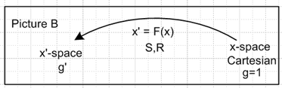

Since this Section is lengthy, a brief overview is in order:

Overview

The transformation of differential length, area, and volume is framed in terms of the mapping of a differential orthogonal N-piped in x'-space to a likely rotated and possibly skewed differential N-piped in x-space. The N-piped in x'-space has axis-aligned edges of length dx'n, while the N-piped in x-space has edges endx'n where en are the tangent base vectors introduced in Section 3. We want to know what happens to the volume, edges and face areas as one N-piped is mapped into the other by an inverse curvilinear coordinates transformation x = F-1(x').
After defining the two N-pipeds of interest in section (a), the focus is on the x-space N-piped. In section (b) results are quoted from Appendix B which describe the geometry of finite parallelepipeds in N dimensions. In Section (c) these results are adapted to the differential x-space N-piped and expressions are obtained for the three x-space objects dx(n), dAn and dV (edge, face area, volume).
Section (d) addresses the tensor density weights of the area vector dAn and the volume scalar dV. These weights are found to be -1 causing these two objects to transform in a non-tensorial manner.
Section (e) finds expressions for the corresponding x'-space objects dx'(n), dA'n and dV'.
Section (f) evaluates the covariant magnitudes of the x-space edge and area vectors, and then provides Examples of area magnitude transformations.
Section (g) evaluates the corresponding x'-space edge and area vector magnitudes, and then Section (h) summarizes all the results in two simple tables followed by a set of interpretative comments.
Section (i) derives the Jacobian Integration Rule as a distribution, and finally Section (j) gives a list of different interpretations of the Jacobian.

(a) The differential N-piped mapping

Section 3 (a) above considered the following situation (dx'n > 0) :

dx'(n) = e'n dx'n x'-space n-axis-aligned differential vector, (e'n)i = δni

dx(n) = en dx'n x-space mapping of the above vector under F-1 or R-1

dx'(n) = R(x) dx(n) relation of the two differential vectors (contravariant rule)

A superscript (n) on the differentials makes clear there is no implied sum on n. The vectors dx(n) span a differential N-piped in x-space, while the dx'(n) span a corresponding differential N-piped in x'-space, and the two N-pipeds are related by the mapping x' = F(x). In Appendix C (e) we discuss the somewhat confusing issue of the "two views" of x'-space, one Cartesian (g'=1) and one Curvilinear (g'=g'). The N-piped in x'-space just mentioned is considered in this Cartesian view of x'-space in which the basis vectors e'n [ e'1 = (1,0,0..), etc. ] are orthonormal Cartesian vectors. Here is a depiction of the mapping for N=3:

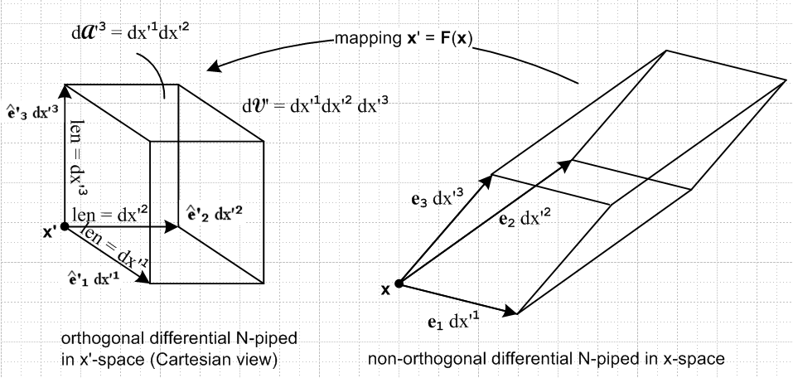

The true Curvilinear-view x'-space N-piped has axes e'n and not 'n and g' ≠1 . The false Cartesian view N-piped merely allows visualization of these curvilinear coordinate variations, all dx'k > 0,

dL'n ≡ dx'n
dA'n ≡ Πi≠ndx'i
dV' ≡ Πidx'i = dAn dLn

For example, for N=3 one would have

dL'1 ≡ dx'1
dA'3 = dx'1dx'2 dA'1 = dx'2dx'3 dA'2 = dx'3dx'1
dV' = dx'1dx'2dx'3

The Cartesian-view x'-space N-piped is always orthogonal since its spanning vectors 'n are orthogonal. In contrast, the x-space N-piped is typically rotated and possibly skewed as well (if the coordinates x'i describe a non-orthogonal coordinate system). The transformation F and its linearized version R map the skewed x-space N-piped into the orthogonal x'-space N-piped. As one moves around in x-space so that point x changes, the picture on the left above keeps its shape, just translating itself to the new point x', but the picture on the right changes shape and volume because the vectors en(x) are functions of x.

(b) Properties of the finite N-piped spanned by the en in x-space

The finite N-piped spanned by the tangent base vectors en in x-space has the following properties (as shown in Appendix B) :

• The N spanning edges are the vectors en which have lengths |en| = h'n (scale factors ).

• There are 2N vertices.

• There are N pairs of faces. The two faces of each pair are parallel in N dimensions. One face of each pair touches the point where the tails of all the en vectors meet (the near face) while the other does not touch this meeting point (the far face).

• Each face of an N-piped is an (N-1)-piped having 2N-1 vertices. The faces are planar surfaces of dimension N-1 embedded in an N dimensional space.

• A face's vector area An is spanned by all the ei except en and is labeled by this missing en vector.

• The far face has out-facing vector area An , and the near face has out-facing area vector - An. These vector areas are normal to the faces.

• The vector area An is given by several equivalent expressions:

An = |det(Sab)| en

An = σ (-1)n-1 Πxi≠n ei

An = σ (-1)n-1 e1 x e2 ... x eN // en missing σ ≡ sign[det(Sab)] = sign[det(Rab)]

(An)i = σ (-1)n-1 εiabc..x (e1)a(e2)b.... (eN)x // en missing

• The volume of the N-piped is given by (see Section 5 (k) concerning J)

V = | det [ e1, e2, e3 ... eN] | = | det(Sab) | = g'1/2 = |J|

(c) Objects in x-space

If the edges of the finite N-piped described above are scaled by positive differentials dx'n > 0, the result is a differential N-piped in x-space which has the properties listed above with the following adjustments:

dx(n) = en dx'n // an edge vector, as in section (a) above

dAn = |det(Sab)| en Πi≠ndx'i = g'1/2 en Πi≠ndx'i // label on dAn is placed up to match that on en

dAn = σ (-1)n-1 Πxi≠n (eidx'i) = σ (-1)n-1 Πxi≠nei Πi≠ndx'i

dAn = σ (-1)n-1 e1 x e2 ... x eN Πi≠ndx'i // en missing σ ≡ sign[det(Sab)] = sign[det(Rab)]

dV = | det [ e1, e2, e3 ... eN] | Πidx'i = | det(Sab) | Πidx'i = g'1/2 Πidx'i

Notice, for example, that scaling the edges of an N-piped by a set of N numbers does not alter the direction of the faces' area normal vectors. A suitable normal for face pair n can always be taken as en. Using the curvilinear coordinate variation definitions from section (a), these results may be restated as

dx(n) = en dL'n dL'n ≡ dx'n
dAn = σ (-1)n-1 Πxi≠nei dA'n = g'1/2en dA'n dA'n ≡ Πi≠ndx'i
dV = g'1/2 dV' dV' ≡ Πidx'i

These three items are the x-space objects of interest.

(d) Tensor density weights of objects

Appendix D discusses the notion of tensor densities and their weights and lists various properties of and theorems about tensor densities. Weights are additive when smaller tensors are assembled to form larger ones, and ordinary tensors, such as tensorial vectors, have weight 0. In Appendix D (f) it is noted that the covariant Levi-Civita tensor written as εabc... has weight -1. Since

(An)i = σ (-1)n-1 εiabc..x (e1)a(e2)b.... (eN)x // en missing

and since the en are ordinary tensorial vectors, it follows that the vector An is in fact a vector density of weight -1. A vector density V of weight W transforms from x-space to x'-space in this manner

V' = |J|-W R V

and therefore

A'n = |J|-(-1) R An = |J| R An = g'1/2RAn

and this applies also to dAn .

The object dx(n) transforms as an ordinary tensorial vector (weight 0).

The object dV may be written as

dV = | dAn • dx(n) |

which can be verified as follows:

dV = | dAn • dx(n) | = | (dAn)i (dx(n))i |

= | σ (-1)n-1 εiabc..x (e1)a(e2)b.... (eN)x Πi≠ndx'i dx'n (en)i | // en missing in x prod

= | (-1)n-1 εiabc..x (e1)a(e2)b.... (en)i.... (eN)x | Πidx'i

= | εiabc..i..x (e1)a(e2)b.... (en)i.... (eN)x | Πidx'i

= | det(Sab) | Πidx'i // Section 3 (a)

which agrees with the form given above.
Appendix D (b) 6 shows that the covariant dot product of vector densities A and B of weights W and w is a scalar density of weight W + w and therefore A'•B' = |J|W+w A•B. Since dV = | dAn • dx(n) |, one concludes that dV is a scalar density of weight -1+0 = -1 and therefore

dV' = J dV = g'1/2 dV

To summarize the weight situation for our length, area and volume objects,

dx(n) weight = 0 ordinary vector
dAn weight = -1 vector density
dV weight = -1 scalar density

(e) Objects in x'-space

Assuming all three objects are tensors of weights shown, one finds that

dx'(n) = R dx(n)
dA'n = J R dAn = g'1/2 R dAn
dV' = J dV = g'1/2 dV

The first object may be written

dx'(n) = R [en dx'n] = [Ren] dL'n = e'n dL'n

so that

(dx'(n))i = (e'n)i dL'n = δni dL'n

The differential vectors dx'(n) are thus axis-aligned in x'-space.

For the third object, using the expression dV = (g')1/2 dV from section (c),

dV' = g'1/2 dV = g' dV'

The remaining second object dA'n object may be calculated as follows:

(dA'n)i = g'1/2 Rik (dAn)k = // g'1/2 = |J| = |J|-(-1), weight = -1

= g'1/2 Rik σ (-1)n-1 { εkabc...x (e1)a(e2)b ...... (eN)x } dA'n // n missing

= g'1/2 Rik σ (-1)n-1 { εkabc...x Sa1 Sb2 ...... SxN } dA'n // n missing

= g'1/2 Ski σ (-1)n-1 { εkabc...x Sa1 Sb2 ...... SxN } dA'n // n missing

= g'1/2 σ { (-1)n-1εkabc...x Sa1 Sb2 .. .. Ski..... SxN } dA'n

= g'1/2 σ {εabc..k..x Sa1 Sb2 .. .. Ski..... SxN } dA'n

If i ≠k, then two S second indices must be the same and result is 0. If i =k, then {} = det(Sab) = σg'1/2. Therefore

(dA'n)i = δni g' dA'n

So the area vectors dA'n are also axis-aligned in x'-space.

To summarize, the x'-space objects can be written in this manner

(dx'(n))i = δni dL'n length edge is axis-aligned
(dA'n)i = δni g' dA'n area area vector is axis-aligned
dV' = g' dV' volume

(f) Evaluation of x-space edge and area magnitudes

Edge

Consider from section (c),

dx(n) = en dL'n .

The magnitude squared is given by (vertical bars always indicate covariant length, Section 5 (i))

| dx(n)|2 = dx(n)• dx(n) = (dL'n)2 en • en = g'nn (dL'n)2 = h'n2(dL'n)2

so that

dx(n) ≡ | dx(n)| = hn' dL'n

Area

Turning now to the area, section (c) showed that

dAn = g'1/2en dA'n ,

so the magnitude squared is given by

|dAn|2 = dAn• dAn = (g'1/2 dA'n)2 en • en = (dA'n)2 g' g'nn = (dA'n)2 g' (1/h'n)2 .

Therefore one way to write the magnitude is this

dAn ≡ |dAn| = (1/h'n) g'1/2 dA'n

Another way to write this same dAn arises from the following fact:

g' g'nn = cof(g'nn)

which we now prove:

(g'up)ab ≡ g'ab (g'dn)ab ≡ g'ab

g'up = (g'dn)-1 = cof(g'dnT)/det(g'dn) = cof(g'dn)/det(g'dn)

=> (g'up)nn = cof[(g'dn)nn]/det(g'dn)
or
g'nn = cof[g'nn] / g' QED

Therefore, one can write

|dAn|2 = (dA'n)2 g' g'nn = (dA'n)2 cof(g'nn)

and then one ends up with two forms for the area magnitude dAn ≡ |dAn| and one form for | dx(n)|

dAn = (1/h'n) g'1/2 dA'n
dAn = $\sqrt{cof(g'nn)}$ dA'n
dx(n) = h'n dL'n

When dAn is written in its alternative form

dAn = σ (-1)n-1 Πxi≠n (eidx'i) = σ (-1)n-1 Πxi≠nei dA'n

one finds that

dAn = | Πxi≠nei| dA'n

Therefore it must be true that

| Πxi≠nei| = $\sqrt{cof(g'nn)}$

A proof of this fact is not too difficult:

| Πxi≠n (ei)|2 = Πxi≠n (ei) • Πxj≠n (ej) = [ Πxi≠n (ei)]k [ Πxj≠n (ej)]k

= [ εkabc...x (e1)a(e2)b ...... (eN)x] [ εka'b'c'...x (e1)a'(e2)b' ...... (eN)x'] // en missing in both

= εkabc...x εka'b'c'...x {(e1)a(e2)b ...... (eN)x } (e1)a'(e2)b' ...... (eN)x' // en missing

= e1•e1 e2•e2 .... eN•eN + all signed permutations of 2nd labels // en missing

= g'11g'12..... g'NN + all signed permutations of 2nd indices // en missing

But this is last object is the determinant of the g'ij matrix with g'nn crossed out, which is to say, it is the minor of g'nn. Since g'nn is a diagonal element, the minor and cofactor are the same. Thus, this last object is in fact just cof(g'nn). QED.

The fact that | Πxi≠nei| = $\sqrt{cof(g'nn)}$can be shown for N=3 using normal vector algebra. Setting n = 1, for example, one needs to show that

| Πxi≠1 ei |2 = | e2 x e3 |2 = cof(g'11)

To this end, use the vector identity

(A x B) • (A x B) = A2B2 – (A•B)2

to show that

| e2 x e3 |2 = (e2 x e3) • (e2 x e3 ) = |e2|2 |e3|2 - (e2•e3)2 = g'22 g'33 - (g'23)2 = cof(g'11).

and the cases n = 2 and 3 are similar.

Examples of area magnitude transformation for N = 2,3,4

In the previous section it was shown that dAn = $\sqrt{cof(g'nn)}$ dA'n. Since this is a somewhat strange result, some examples are in order. Recall that the dAn are the areas of the faces of the differential N-piped in x-space, while the dA'n are the curvilinear coordinate variations

For N=2 the area magnitude transformation results are (for a general non-orthogonal x'-space system)

dA1 = $\sqrt{g'22}$ dA'1 = h'2 dA'1 dA'1 = dx'1 = dL'1
dA2 = $\sqrt{g'11}$ dA'2 = h'1 dA'2 dA'2 = dx'2 = dL'2

These equations are simple because the area of a parallelogram "face" is the length of an edge and so these equations just coincide with the length transformation results stated above . Remember that a face is labeled by the index of the vector which does not span the face, so h2' appears in the face 1 equation.

For N=3 the area magnitude transformation results are

dA1 = $\sqrt{g'22 g'33 - (g'23)2}$ dA'1 dA'1 = dx'2dx'3
dA2 = $\sqrt{g'33 g'11 - (g'31)2}$ dA'2 dA'2 = dx'3dx'1
dA3 = $\sqrt{g'11 g'22 - (g'12)2}$ dA'3 dA'3 = dx'1dx'2

For an orthogonal N=3 system the metric tensor g'ab is diagonal, and then the above simplifies to

dA1 = $\sqrt{g'22 g'33}$ dA'1 = h'2 h'3 dA'1 dA'1 = dx'2dx'3
dA2 = $\sqrt{g'33 g'11}$ dA'2 = h'3 h'1 dA'2 dA'2 = dx'3dx'1
dA3 = $\sqrt{g'11 g'22}$ dA'3 = h'1 h'2 dA'3 dA'3 = dx'1dx'2

For an N=4 orthogonal system,

dA1 = $\sqrt{cof(g'11)}$ dA'1 = h'2 h'3 h'4 dA'1 dA'1 = dx'2dx'3dx'4
dA2 = $\sqrt{cof(g'22)}$ dA'2 = h'1 h'3 h'4 dA'2 dA'2 = dx'3dx'4dx'1
dA3 = $\sqrt{cof(g'33)}$ dA'3 = h'1 h'2 h'4 dA'3 dA'3 = dx'4dx'1dx'2
dA4 = $\sqrt{cof(g'44)}$ dA'4 = h'1 h'2 h'3 dA'4 dA'4 = dx'1dx'2dx'3

Example 2: Spherical Coordinates: area patches

Consider again dAn = $\sqrt{cof(g'nn)}$ dA'n. Since spherical coordinates are orthogonal, the orthogonal N=3 example above may be used. Example 2 of Section 5 showed that [ 1,2,3 = r,θ,φ ]

h'1 = h'r = 1 dA'1 = dx'2dx'3 = dθdφ
h'2 = h'θ = r dA'2 = dx'3dx'1 = drdφ
h'3 = h'φ = rsinθ dA'3 = dx'1dx'2 = drdθ

Therefore

dA1 = dA11 => dAr = dAr r = dAr with dAr = h'2 h'3 dA'1 = r2sinθ dθdφ
dA2 = dA22 => dAθ = dAθ θ = dAθ with dAθ = h'3 h'1 dA'2 = rsinθ drdφ
dA3 = dA33 => dAφ = dAφ φ = dAφ with dAφ = h'1 h'2 dA'3 = rdrdθ

so that

dAr = r2sinθ dθdφ ρdφ rdθ ρ = rsinθ
dAθ = rsinθ drdφ ρdφ dr
dAφ = rdrdθ rdθ dr

where all three vectors are seen to have the correct dimensions L2. As an exercise in staring, the reader is invited to verify these results from the picture below using the hints shown above on the right,
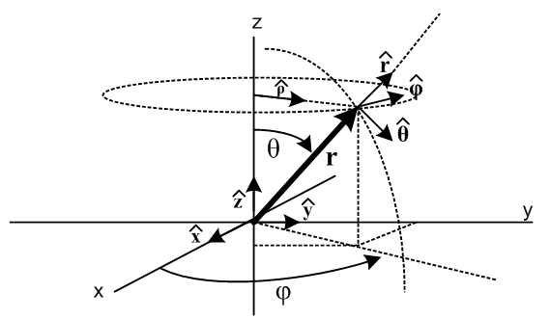

(g) Evaluation of x'-space edge, area and volume magnitudes

In the previous section, the x-space edge and area magnitudes were given as

dx(n) = h'n dL'n
dAn = (1/h'n) g'1/2 dA'n = $\sqrt{cof(g'nn)}$ dA'n

Appendix D (b) 6 shows that |A|' = |J|-W |A| for a vector density of weight W. This rule can then be used to trivially compute the edge and area magnitudes in x'-space ( W = -1 => |J|-W = |J| = g'1/2) :

dx'(n) = dx(n) since weight = 0
dA'(n) = g'1/2dA(n) since weight = -1
dV' = g'1/2 dV since weight = -1

and therefore

dx'(n) = hn' dL'n
dA'(n) = (1/h'n) g' dA'n = g'1/2$\sqrt{cof(g'nn)}$ dA'n
dV' = g' dV'

(h) Summary of length, area and volume transformation results

x-space expression x-space magnitude
length dx(n) = en dL'n dx(n)= hn' dL'n
area dAn = g'1/2en dA'n dAn = $\sqrt{cof(g'nn)}$ dA'n = (1/h'n) g'1/2 dA'n
volume dV = (g')1/2 dV' dV = (g')1/2 dV'

x'-space expression x'-space magnitude
length (dx'(n))i = δni dL'n dx'(n) = hn' dL'n
area (dA'n)i = δni g' dA'n dA'(n) = g'1/2$\sqrt{cof(g'nn)}$ dA'n = (1/h'n) g' dA'n
volume dV' = g' dV' dV' = g' dV'

where dL'n ≡ dx'n |J| = σJ = g'1/2 // Section 5 (k)
dA'n ≡ Πi≠ndx'i
dV' ≡ Πidx'i = dA'n dL'n // no implied sum

Comments:

1. In the N-piped transformation described above, the edge dx'(n) = e'ndx'n which is axis-aligned in x'-space is mapped (rotated and stretched) into the x-space edge dx(n) = endx'n which is of course aligned with the tangent base vector en in x-space. The length of the edge dx(n) in x-space is given by hn' dx'n. In the visualization mapping drawing above, one would say that the Cartesian-view edge length dx'n on the left got scaled by factor hn' by the transformation x' = F(x), and this is why h'n is called a "scale factor".

2. The transformation rule dV = (g')1/2 dV' relates the visualized orthogonal volume dV' = Πidx'i on the left of the mapping drawing to the volume dV of the rotated and possibly skewed N-piped on the right. The equation dV = (g')1/2dV' is therefore not the famous Jacobian Integration Rule since that rule involves an orthogonal differential volume in x-space. (The Rule is given in the next section).

3.The x'-space axis-aligned differential area vector (dA'n)i = δni g' dA'n gets rotated and scaled on its way to x-space and ends up there as dAn = g'1/2en dA'n where it points in the direction of the reciprocal base vector en. The en and en are illustrated in this picture for N=3 :

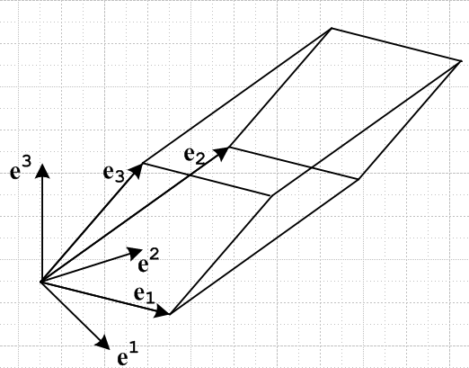

In this picture the en form a right-handed coordinate system as described in Section 6 (i). As shown there, this means that σ = sign(detS) = sign(detR) = +1. Appendix A shows that, with En→ en ,

en = det(R) (-1)n-1 e1 x e2 x ......x eN // en missing

and for N=2

e1 = det(R) e2 x e3
e2 = det(R) e3 x e1
e3 = det(R) e1 x e2

so the en vectors really are perpendicular to the vectors which span their areas, as the figure attempts to show. The en imagined on the three "near" face centers all point "inward" toward the N-piped center, in agreement with the claim above concerning the directions of the dAn vectors. The general perpendicularity rule of course is that en • em = 0 for all m ≠n, see Appendix A (f).

(i) Transformation of Differential Volume applied to Integration

As discussed in Appendix C (h), the integral ∫D dV h(x) is the same regardless of the way the dV elements are chosen, as long as those elements exactly fill the integration region D.
In the discussion above, dV (call it dVa) refers to a differential volume element in x-space which is typically not aligned with the axes and for a general transformation F is not in general orthogonal. Moreover, the shape of the differential volume N-piped varies over the region of integration. Nevertheless, this "rag-tag band" of differential volumes, as noted in Appendix C for the 2D case, fills the integration region perfectly.
Alternatively one could consider dV (call it dVb) to be the usual dx1dx2.....dxN differential volume elements, and of course this set of differential volume elements also fills the integration space perfectly.
Thinking of these two different differential volumes as dVa and dVb , one can see from the definition of the integral as the limit of a sum,

lim Σi dVa(xi) f(xi) = lim Σi dVb(xi) f(xi)
that
∫D dVa h(x) = ∫D dVb h(x)

There would be little meaning to the statement dVa = dVb, since no one is claiming there is some particular skewed N-piped of volume dVa which matches some axis-aligned N-piped of volume dVb . Nevertheless, one could write dVa = dVb as a distributional symbolic equality where the meaning of that symbolic equality is precisely the equivalence of the two integrals above for any domain D and for any reasonable function h(x). [ Formally one might have to require h(x) to be a "test function" φ(x). Certainly one would require that both integrals converge. ]

What has been shown in the previous section, regarding the Jacobian, is that

dVa = |J(x')| dV' = |J(x')| ( Πi=1N dx'i) |J(x')| = $\sqrt{g'(x)}$ // g = +1

Combining this with the distributional symbolic equation dVa = dVb gives

dVa = dVb

|J(x')| ( Πi=1N dx'i) = ( Πi=1N dxi)
or
|J(x')| dV' = dVb

Now overriding our previous notation, we can make these new commonly used definitions

dV ≡ ( Πi=1N dxi)
dV' ≡ ( Πi=1N dx'i)

and express the distributional result as

|J(x')| dV' = dV

We refer to this distributional equality in Appendix C as the Jacobian Integration Rule. The symbolic equation is a shorthand for this equation

∫D dV h(x) = ∫D' dV' |J(x')| h(x)

where h(x) = h(x(x')), and where region D' is the same region as D expressed in terms of the x' coordinates . Writing out the volume elements this says

∫D ( Πi=1N dxi) h(x) = ∫D' ( Πi=1N dx'i) |J(x')| h(x(x'))

and finally using Section 5 (k),

∫D ( Πi=1N dxi) h(x) = ∫D' ( Πi=1N dx'i) [ $\sqrt{det(g'ab)}$] h(x(x'))

For example, when applied to polar and spherical coordinates, one gets

∫D dxdy h(x) = ∫D' drdθ [r] h(x(r,θ)) $\sqrt{det(g'ab)}$ = r

∫D dxdydz h(x) = ∫D' drdθdφ [ r2sinθ ] h(x(r,θ,φ)) $\sqrt{det(g'ab)}$ = r2 sinθ

In the first case h(x) = h(x,y) and h(x(r,θ)) = h(rcosθ,rsinθ).
In the second case h(x) = h(x,y,z) and h(x(r,θ,φ)) = h(rsinθcosφ,rsinθsinφ,rcosθ).

(j) Interpretations of the Jacobian

Using Section 5 (k) facts (in standard notation) and the above sections, one can produce various expressions and interpretations for the Jacobian J and its absolute value |J| :

J(x') ≡ det(Sij(x')) = det(∂xi/∂x'k) = 1/det(Rij(x(x')) = 1/ det(∂x'i/∂xk) // Section 5 (k)

|J(x')| = $\sqrt{det(g'ab(x'))}$ = $\sqrt{g'(x')}$ // Section 5 (k)

|J(x')| = the volume of the N-piped in x-space spanned by the en(x), where x = F-1(x')

|J(x')| = dVN-piped/dV' = ratio of differential x-space N-piped volume / ( Πi=1N dx'i)

|J(x')| = dV/dV' = ( Πi=1N dxi)/ ( Πi=1N dx'i) // distributional Jacobian Integration Rule

As discussed in Section 6 (i), if the curvilinear coordinates are ordered so that the en form a right handed coordinate system, then det(S)>0, σ = sign(det(S)) = +1, and |J| = J.

