Grad of Tensor Doc v2 PhL 10.13.12

I have decided to swap names App J ↔ App K, decision made 10.19.12. I will have to make some edits after doing this because I have referred to these appendices! Installed this 8:47 PM 10.19.12.

Appendix J: Expansion of (∇T) in curvilinear coordinates (T = rank-2 tensor) 1
(a) Total time derivative as prototype equation 1
(b) Computation of components (∇T)'_{ijk} 2
(c) Tensor expansions of ∇T on the u_{n} and e_{n} base vectors 3
(d) Tensor expansions of ∇T on the _{n} base vectors 4
(e) Total time derivative equation written in unit-base-vector curvilinear components 5
(f) Shorthand notations and a continuum mechanics application 7
(g) Maple computation of the (∇T)'_{ijk} components in spherical coordinates 8
(h) Maple computation of the (∇T)'_{ijk} components in cylindrical coordinates 12

Appendix J: Expansion of (∇T) in curvilinear coordinates (T = rank-2 tensor)

This appendix assumes the usual curvilinear coordinates context, Picture B

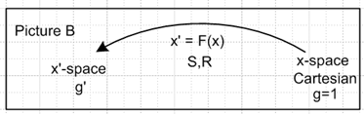

(a) Total time derivative as prototype equation

The total time derivative of a contravariant rank-2 tensor field Tij(x,t) can be written as

dTij(x,t)/dt = ∂Tij/∂t + (∂Tij/∂xk) (∂xk/dt) = ∂Tij/∂t + (∂Tij/∂xk) vk
or
dtTij = ∂tTij + (∂kTij) vk . // dt ≡ d/dt, ∂t ≡ ∂/∂t, ∂k ≡ ∂/∂xk

We take this as a useful prototype equation to work with for two reasons. First, it contains our object of interest, which is the gradient of a rank-2 tensor. Second, this equation plays a role in the continuum mechanics of non-Newtonian fluids as discussed below in section (f).
One can define, in Cartesian coordinates, a (∇T) object :

(∇T)ijk ≡ ∂kTij

so that

dtTij = ∂tTij + (∇T)ijk vk .

Comment: Our convention has been to bold vectors and not to bold other tensors. In line with this idea, we shall write ∇T where the grad is bolded and the T is not bolded.

In order to express the above equation in curvilinear coordinates, it must be "tensorized" in the sense of Section 15 (b) so that the equation is covariant. Thus, (∇T)ijk must be regarded as components of a (mixed) rank-3 tensor which, in Cartesian coordinates, are equal to ∂kTij. Since vk are the components of a tensorial vector, (∇T)ijk vk transforms as a rank-2 tensor, and then all terms in the above equation are rank-2 tensors and the equation is then covariant and therefore appears this way in x'-space,

dtT'ij = ∂tT'ij + (∇T)'ijk v'k .

In our usual formalism, x'-space is the space of some generic curvilinear coordinates x'n (not necessarily orthogonal) and then the above equation tells us the form taken by the time derivative equation in curvilinear coordinates, and it remains only to compute the objects (∇T')ijk.

For convenience, we can lower the tensorial ij indices on the above tensor equations to get

dtTij = ∂tTij + (∇T)ijk vk (∇T)ijk ≡ ∂kTij // Cartesian coordinates

dtT'ij = ∂tT'ij + (∇T)'ijk v'k // curvilinear coordinates

and then we can deal with the pure covariant tensor components (∇T)'ijk .

(b) Computation of components (∇T)'ijk

The covariant derivative is discussed in Appendix F (g,h,i). We shall define a true tensor object (∇T)abc as Tab;α so that ( see App F, J=2 example with Bab;α, take B→T and α→c )

(∇T)abc = Tab;c ≡ Tab,c – ΓnacTnb – ΓnbcTan = Tab,c = ∂cTab // x-space
(∇T)'abc = T'ab;c ≡ T'ab,c – Γ'nacT'nb – Γ'nbcT'an . // x'-space

Recall that Tab,c is a shorthand for ∂cTab and that Γcab is the affine connection which tells how the basis vectors change as one moves around in space. In Cartesian x-space (first line above) the basis vectors are the fixed un which don't change, so Γcab ≡ 0. In curvilinear x'-space, Γ'cab ≠ 0. Since Tab;c transforms as a true rank-3 tensor, its defining equation is "covariant" (Section7 (u)) so that in x'-space the equation has exactly the same form but everything is primed.
The above two lines characterize the process of "tensorization": we find a true "tensorial tensor" Tab;c which agrees with (∇T)abc = ∂cTab in Cartesian space. The tensorized version of Tab,c is unique, and it is Tab;c . Since this tensor is given by T'ab;c in x'-space, we use the second line above to compute the components of the tensor (∇T) object in x'-space, which is to say, in curvilinear coordinates.
It is a simple matter to have Maple compute Γ'cab for any curvilinear coordinate system, and then the second line above reports out the components (∇T)'abc :

(∇T)'abc = ∂'cT'ab – Γ'nacT'nb – Γ'nbcT'an (*)

Γ 'dab = (1/2) g'dc [ ∂'ag'bc + ∂'bg'ca – ∂'cg'ab] // Appendix F (d), g' = metric tensor

and then we know how to write the time derivative equation in any curvilinear coordinates

dtT'ij = ∂tT'ij + (∇T)'ijk v'k
or
dtT'ij = ∂tT'ij + (∇T)'ijk v'k (∇T)'ijk = g'ii'g'jj'(∇T)'i'j'k

In Appendix I (b) we show Maple code to compute the covariant metric tensor g'ij from the curvilinear coordinates defining equations (such as x = rsinθcosφ for sphericals). Then Appendix I (f) shows the extra code for computing g'ij and Γ 'dab . The reader can then add a few extra lines to have Maple compute the desired (∇T)'abc using the equation (*) above. Later in this appendix we shall use Maple to compute certain related quantities which we can then verify against a known source.

(c) Tensor expansions of ∇T on the un and en base vectors

It is useful at this point to write out the tensor expansions for the rank-3 tensor (∇T) to show exactly where the components (∇T)'abc appear. As shown in Appendix E (b) one can expand the rank-3 tensor Tab;c in various ways. The first line below shows expansions on x-space basis vectors, while the second line shows expansion on the reciprocal and tangent base vectors (which also exist in x-space) :

∇T = Σijk Tij;k ui⊗uj⊗uk = Σijk [(∇T)(u)]ijk ui⊗uj⊗uk = Σijk [(∇T)(u)]ijk ui⊗uj⊗uk
∇T = Σijk T'ij;k ei⊗ej⊗ek = Σijk [(∇T)(e)]ijk ei⊗ej⊗ek = Σijk [(∇T)(e)]ijk ei⊗ej⊗ek

As usual, up and down index positions are the same for the first line in Cartesian space, but are significant on the second line. The superscripts on the (∇T)(u) and (∇T)(e) components indicate which basis vectors are being expanded upon. One normally just writes (∇T)(u) = (∇T), and (∇T)(e) = (∇T)' where the prime indicates the curvilinear x'-space. So, we now have three different notations for the expansion components:

Tij;k = [(∇T)(u)]ijk = (∇T)ijk

T'ij;k = [(∇T)(e)]ijk = (∇T)'ijk .

Just to fill things out, here are the corresponding expansions for rank-2 tensor T,

T = Σij Tij ui⊗uj = Σij [T(u)]ij ui⊗uj = Σij [T(u)]ij ui⊗uj
T = Σij T'ij ei⊗ej = Σij [T(e)]ij ei⊗ej = Σij [T(e)]ij ei⊗ej

Tij = [T(u)]ij
T'ij = [T(e)]ij

and then for a rank-1 tensor v,

v = Σi vi ui = Σi [v(u)]i ui = Σi [v(u)]i ui
v = Σi v'i ei = Σi [v(e)]i ei = Σi [v(e)]i ei

vi = [v(u)]i
v'i = [v(e)]i

(d) Tensor expansions of ∇T on the n base vectors

In practical applications, it is sometimes useful to deal with components of tensors which are expanded on the unit versions of the tangent base vectors, n ≡ en/ |en| = en/h'n . On the one hand, this introduces major complications (see below) since such components are non-covariant (neither contravariant nor covariant nor mixed). On the other hand, since the unit vectors are all dimensionless, all tensor components have the same dimensions, which is very useful in any practical engineering work. We shall refer to such tensor components as "unit-base-vector components".

This subject is addressed in Appendix E (h). We start with the expansion given above,

∇T = Σijk [(∇T)(e)]ijk ei⊗ej⊗ek

and process it in this manner ,

= Σijk [(∇T)(e)]ijk (h'ii) ⊗ (h'jj) ⊗ (h'kk)

= Σijk { h'i h'j h'k [(∇T)(e)]ijk } i⊗j⊗k

= Σijk [(∇T)()]ijk i⊗j⊗k where [(∇T)()]ijk = h'i h'j h'k [(∇T)(e)]ijk .

Since the n don't transform as vectors, and since the [(∇T)()]ijk are not tensorial components, we let the indices on [(∇T)()]ijk arbitrarily be "down". Putting them up gives a false impression of a covariant matching index tilt.
Now for convenience later, we make one more definition

(∇T)'ijk ≡ [(∇T)()]ijk = h'i h'j h'k [(∇T)(e)]ijk = h'i h'j h'k (∇T)'ijk

where we follow our convention that the components of unit-base-vector tensors are written in script. (The symbol T is a script T , not a "tau" τ. )
Similarly, we can write the unit-base-vector expansion for a rank-2 tensor T

T = Σij [T()]ij i⊗j where [T()]ij = h'i h'j [T(e)]ij

with the definition

T'ij ≡ [T()]ij = h'i h'j [T(e)]ij = h'i h'j T'ij .

Finally, for a vector v,

v = Σi [v()]i i where [v()]i = h'i [v(e)]i

with the definition

v'i ≡ [v()]i = h'i [v(e)]i = h'i v'i .

In terms of the scripted unit-base-vector components, our three expansions are:

∇T = Σijk (∇T)'ijk i⊗j⊗k (∇T)'ijk = h'i h'j h'k (∇T)'ijk

T = Σij T'ij i⊗j T'ij = h'i h'j T'ij

v = Σi v'i i v'i = h'i v'i .

The scripted tensor components have indices which are integers, i = 1,2...N. Once we actually select a particular curvilinear coordinate system, one can replace the indices with curvilinear coordinate names and then, since those names indicate that one is talking about x'-space components, and since we just assume we are dealing with unit-base-vector components, both the script and the prime can be dropped. For example, in spherical coordinates with 1,2,3 = r,θ,φ one can write

(∇T)'123 = (∇T)rθφ

T'12 = Trθ T'11 = Trr

v'3 = vφ v'1 = vr

Notice that the scripted forms are always necessary when summations like Σijk are involved, unless one is willing to write out all the terms in the sum, which is a bit clumsy. The continuum mechanics book of Lai, which we shall refer to below, avoids summations in curvilinear coordinates and thus has no need for our scripted components.

(e) Total time derivative equation written in unit-base-vector curvilinear components

Recall from section (a) our prototype time derivative equation of interest in x'-space

dtT'ij = ∂tT'ij + (∇T)'ijk v'k .

How does one write this equation in terms of unit-base-vector tensor components? From section (d) we had (no implied sums here)

T'ij = h'i h'j T'ij v'k = h'k v'k

so the above dt equation can be processed as follows:

dtT'ij = ∂tT'ij + (∇T)'ijk v'k

h'i h'j dtT'ij = h'i h'j ∂tT'ij + h'i h'j (∇T)'ijk h'k-1 h'k v'k

dt(h'ih'j T'ij) = ∂t(h'ih'j T'ij) + h'i h'j h'k-1 (∇T)'ijk (h'k v'k) // h'n = h'n(x'), no t

dt T'ij = ∂t T ij + [ h'i h'j h'k-1 (∇T)'ijk ] v'k

dt T'ij = ∂t T'ij + Q'ijk v'k Q'ijk ≡ h'i h'j h'k-1 (∇T)'ijk (*)

Comment: Note that dth'n(x) = ∂th'n(x) = 0 and not dth'n(x) = ∂th'n(x) + (∇h'n) v. The reason is that the field h'n(x) is not an Eulerian fluid property (see application below), it is a property of space at point x.

Recall that no assumption has been made that the curvilinear coordinates are orthogonal. Section (b) showed how the (∇T)'ijk can be computed for any curvilinear coordinate system, and thus one can compute the Q'ijk shown above. Our question is now answered: (*) shows how one writes the total time derivative equation in arbitrary curvilinear coordinates.

If we now assume the coordinates are orthogonal, then

(∇T)'ijk = gkk'(∇T)'ijk' = hk2δk,k' (∇T)'ijk' = hk2(∇T)'ijk

and then

Q'ijk ≡ h'i h'j h'k-1 (∇T)'ijk = h'i h'j h'k-1 hk2(∇T)'ijk = h'i h'j h'k(∇T)'ijk = (∇T)ijk

and so for orthogonal coordinates (*) may be written

dt T'ij = ∂t T'ij + (∇T)'ijk v'k (∇T)'ijk ≡ h'i h'j h'k (∇T)'ijk // orthogonal

We shall assume from now on that the curvilinear coordinates are orthogonal.
As a reminder, here is what the above equation says if i = j = 1, using the notation scheme just described above :

dt T'11 = ∂t T'11 + (∇T)'11k v'k

dt Trr = ∂t Trr + (∇T)rrr vr + (∇T)rrθ vθ + (∇T)rrφ vφ

(f) Shorthand notations and a continuum mechanics application

Consider our original Cartesian time derivative equation,

dtTij = ∂tTij + (∇T)ijk vk

One could regard (∇T)ijk as the components of a vector (∇T)ij labeled by fixed values i and j, so that

[(∇T)ij]k = (∇T)ijk .

Then one can say

dtTij = ∂tTij + (∇T)ij• v .

The next step is to suppress the ij labels, since the equation above is true for any i and j,

dtT = ∂tT + (∇T) • v

This is only a shorthand notation, no precision justification is required. We can do the same thing to the equation written in curvilinear coordinates

dt T'ij = ∂t T'ij + (∇T)'ijk v'k

[(∇T)'ij]k = (∇T)'ijk

dt T'ij = ∂t T'ij + (∇T)'ij • v'k

dt T' = ∂t T' + (∇T)' • v'

and then we have

dtT = ∂tT + (∇T) • v
dt T' = ∂t T' + (∇T)' • v'

which gives the nice impression that the equation is written in a coordinate-independent manner. In the book of Lai, the • is omitted and the shorthand notations are written

dtT = ∂tT + (∇T) v
dt T' = ∂t T' + (∇T)' v' (*)

where one imagines that (∇T) and (∇T)' are 3-index operators which act on a 1-index object to generate a 2-index object. Again, it is just a shorthand. The real meaning of these equations is

dtTij = ∂tTij + (∇T)ijk vk or dtTij = ∂tTij + (∇T)ijk vk
dt T'ij = ∂t T'ij + (∇T)'ijk v'k

An application of our total time derivative equation appears in the first line of Lai p 470 ,

DA1/Dt = ∂A1/∂t + (∇A1) v

where D/Dt is the way a total time derivative is expressed in continuum mechanics (D/Dt = d/dt). It is the convective or material derivative for Eulerian-picture functions ( like A1(x,t) ), meaning that the second term registers a time change in a fluid property at the fixed point x due to "new fluid" with velocity v passing through that point. In the notation described above, this would be written

dtA'1 = ∂tA'1 + (∇A1)' v'

which is just an example of equation (*) above. The detailed meaning is

dt (A'1)ij = ∂t (A'1)ij + (∇A1)'ijk v'k

and for i = j = 1 this says (spherical coordinates) ,

dt[(A1)rr] = ∂t[(A1)rr] + (∇A1)rrr vr + (∇A1)rrθ vθ + (∇A1)rrφ vφ .

The tensor A1 is the first "Rivlin-Ericksen tensor" associated with the flow of non-Newtonian fluids (rheology). The Ai tensors, briefly mentioned in Appendix J (d), are derivatives of a certain deformation tensor called Ct, and computation of the Ai is done in the following iterative manner,

Ai+1 = DtAi + Ai(∇v) + (∇v)TAi // Lai p 468 (8.11.3)

where (∇v) is the gradient-of-vector object treated in Appendix G, v being the fluid velocity field. In particular, A2 = DtA1 + A1(∇v) + (∇v)TA1 which involves our object of interest DtA1 = dtA1. So, in order to compute A2 in curvilinear coordinates, one needs dt(A'1)ij which involves the (∇A1)'ijk. In order to use the above equation in practice, one has to know for example that (∇A1)rrθ = [ ∂θ(A1)rr - (A1)θr - (A1)rθ]/r, a fact that is certainly not immediately obvious (see table in next section).

So, our next task is to compute the (∇T)'ijk which appears in our generic equation above,

dt T' = ∂t T' + (∇T)' v'
dt T'ij = ∂t T'ij + (∇T)'ijk v'k

(g) Maple computation of the (∇T)'ijk components in spherical coordinates

From section (e) we have, for arbitrary curvilinear coordinates,

(∇T)'ijk ≡ h'i h'j h'k (∇T)'ijk

and from section (b) ,

(∇T)'abc = ∂'cT'ab – Γ'nacT'nb – Γ'nbcT'an

Γ 'dab = (1/2) g'dc [ ∂'ag'bc + ∂'bg'ca – ∂'cg'ab] . g' = metric tensor for x'-space

But we are now assuming only orthogonal coordinates, so

g'ab = δa,bha2 g'ab = δa,bha-2

=> (∇T)'ijk = g'ii'g'jj'g'kk'(∇T)'i'j'k' = (h'i h'j h'k)-2 (∇T)'ijk

and then

(∇T)'ijk = (h'i h'j h'k)-1 (∇T)'ijk .

We want the result expressed in terms of the T'ij and not the T'ij, so recall

T'ij = (h'i h'j) T'ij = (h'i h'j) g'ii' g'jj'T'i'j' = (h'i h'j)-1 T'ij

=> T'ij = (h'i h'jT'ij)

Then

(∇T)'abc = ∂'cT'ab – Γ'nacT'nb – Γ'nbcT'an

(∇T)'ijk = ∂'kT'ij – Γ'nikT'nj – Γ'njkT'in

(∇T)'ijk = ∂'k(h'i h'jT'ij) – Γ'nik(h'n h'jT'nj) – Γ'njk(h'i h'nT'in)

= h'i h'j(∂'kT'ij) + ∂'k(h'i h'j) T'ij – Γ'nik(h'n h'jT'nj) – Γ'njk(h'i h'nT'in)

where we break the ∂'k term in two pieces for Maple technical reasons.

So the Maple program will compute

(∇T)'ijk = (h'i h'j h'k)-1 (∇T)'ijk

where (∇T)'ijk = h'i h'j(∂'kT'ij) + ∂'k(h'i h'j) T'ij – Γ'nik(h'n h'jT'nj) – Γ'njk(h'i h'nT'in)
T1 T2 T3 T4

The Maple code is similar to that reported in Appendix I (b) and (f). The code computes the affine connection from the metric tensor,

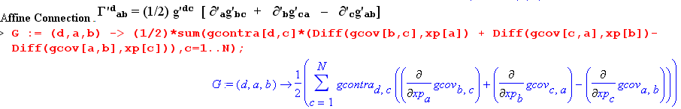

Then the terms shown above are entered (T'ij = Te[i,j], h'i = hp[i], Γ 'dab = G(d,a,b), etc.)

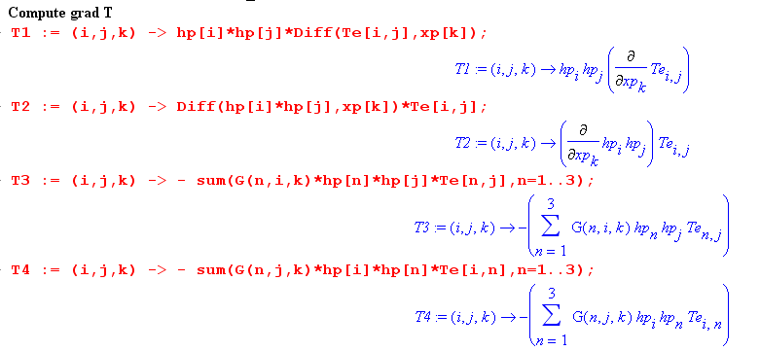
The terms are then added, multiplied by (h'i h'j h'k)-1, and then displayed,

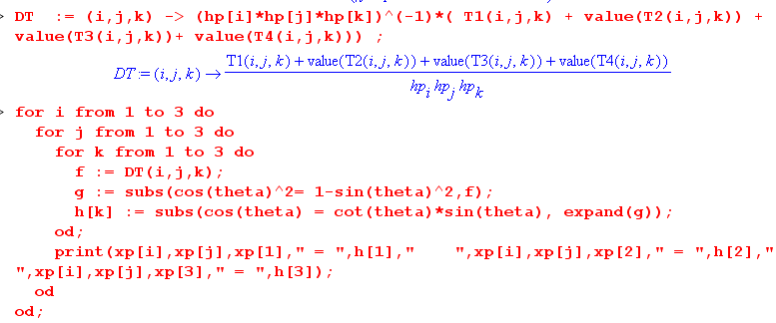

and here are the resulting values for (∇T)'ijk (for example, (∇T)'112 = (∇T)rrθ )
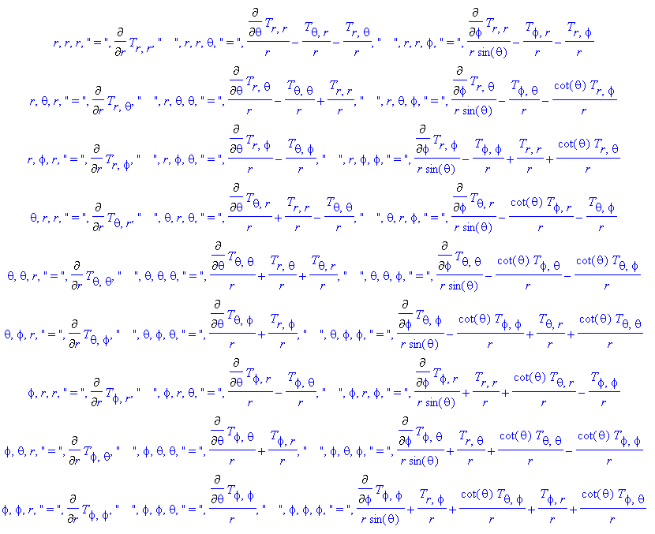
The strange " symbols in the above table should be ignored, just a Maple artifact.
These results agree with the spherical coordinates table given in Lai p 505.
The divT results of Appendix H can be verified from the above table using

(divT)'i = ∂'jT'ij = (∇T)'ijj

For example,

(divT)r = (∇T)rrr + (∇T)rθθ + (∇T)rφφ

= ∂rTrr + (1/r)[∂θTrθ - Tθθ + Trr] + (1/r)[ cscθ ∂φTrφ - Tφφ + Trr + cotθ Trθ]

= ∂rTrr + (1/r)∂θTrθ - Tθθ/r + (2/r)Trr + (1/rsinθ) ∂φTrφ - Tφφ/r + cotθ Trθ /r

and we quote from Appendix H

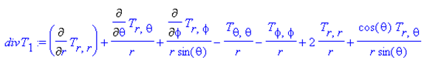.

The Lai method of computing (∇T)'ijk is different from ours. Lai uses an "affine connection" which is geared to the unit tangent base vectors, which in our notation would be written

∂'ji = Γ'(Lai)ijkk , // Lai p 502 (8A.12)

whereas "the true" affine connection measures the change of the full tangent base vectors,

(∂'jen) = Γ'kjn ek . // Appendix F (a)

It is not hard to show that the connection between these two affine connections is,

Γ'(Lai)ijk = h'i-1 [h'kΓ'kji– ∂'j(h'i) δi,k] = h'k-1[– h'i Γ'ijk + δi,k(∂'jh'i) ]

where the second form can be obtained from the first using this identity from Appendix F (c)

(∂cgab) = – [gan Γ bcn + gbn Γacn] .

The object Γ 'dab in spherical coordinates has 9 of its 27 components non-zero, as shown at the start of Appendix I (f), but Γ 'dab = Γ 'dba means there are only 6 distinct non-vanishing components. Correspondingly, the Γ'(Lai)ijk object has 6 of its 27 components non-zero (Lai p 503 (8A.14)).

Lai uses Mijk = (∇T)'ijk and in Lai notation the expansion is ∇T = Σijk Mijk ijj (p 501) which provides an example of the polyadic notation described in our Appendix E (c) (ijj= i⊗j⊗k).

(h) Maple computation of the (∇T)'ijk components in cylindrical coordinates

Making four small edits to the spherical coordinates Maple program converts it to a cylindrical coordinates program. Here are the resulting values for (∇T)'ijk (for example, (∇T)'123 = (∇T)rθz )

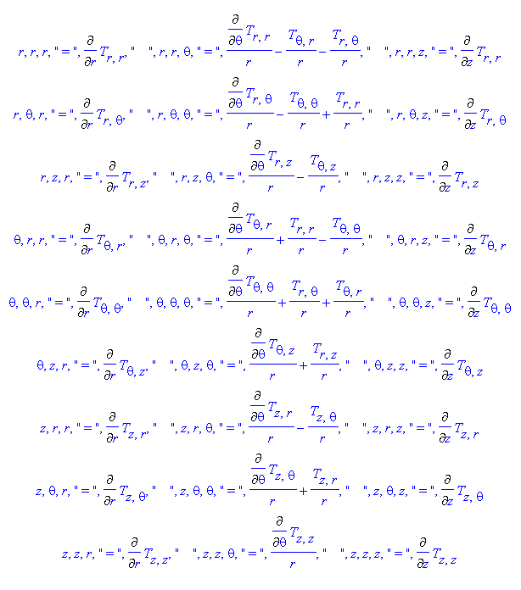
and these expressions agree with those in the table on page 504 of Lai. The same comment made about divT at the end of the previous section applies here as well. The object Γ 'dab has 3 of 27 components non zero as shown at the end of Appendix I (g), only 2 of which are distinct. Correspondingly Γ'(Lai)ijk has only 2 of 27 non zero as shown in Lai p 502 (8A.13).
It should be emphasized that this same simple Maple code can be used to compute the (∇T)'ijk for any system of orthogonal curvilinear coordinates in any number of dimensions N. And the code implied at the end of section (b) and in the middle of section (e) with Q'ijk computes (∇T)'abc and (∇T)'ijk for non-orthogonal as well as orthogonal coordinates.

