Appendix D research concerning E conventions

******************************************* scratch work ************************

The upshot of adding σ is that then

Eabc...x R1aR2b.....RNx = σ|g|-1/2 εabc.. R1aR2b.....RNx

= σ |g|-1/2 det(Rij) = σ |g|-1/2 det(∂x'i/∂xk) = σ |g|-1/2 Jinv(x)

so this says then

Eabc...x R1aR2b.....RNx = σ Jinv(x) / $\sqrt{g}$

Since the Rij are not tensors, the LHS is not a scalar and neither is the RHS. So I don't see any real value in this equation.

Let's now compare this to RLC and to the translation:

RLC: They define Δ ≡ Jinv/ |g|1/2 so my equation above reads

σΔ(x') = Eabc...x R1aR2b.....RNx

and this agrees with their result except they don't show the σ = ±.

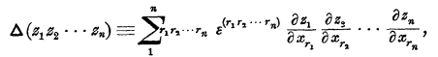

Hermann: uses Δ = J straight, so his result should read

σ |g|-1/2 Δ = Eabc...x R1aR2b.....RNx

but he has the power wrong on |g|, this I think is a typo. Apart from that power, this agrees exactly.

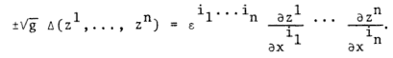

So this builds my confidence a bit that I have the E object defined OK. Interesting that they both got something wrong in this equation, and not the same thing.

Robert Hermann

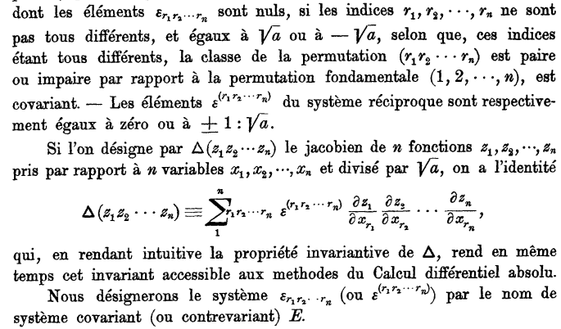

Here is Hermann's translation (he may be wrong!)

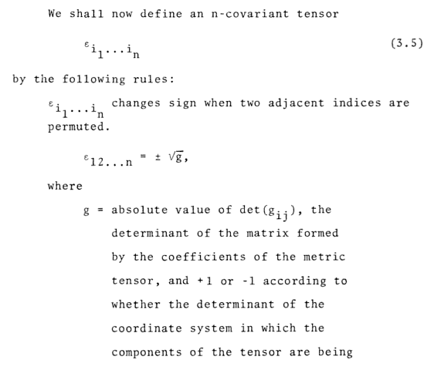
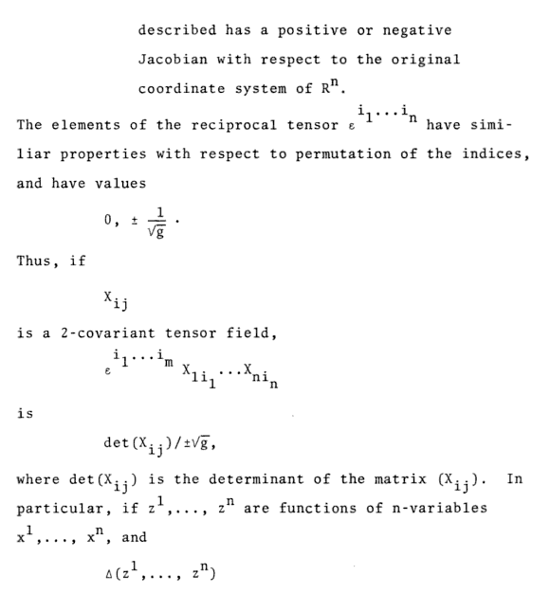
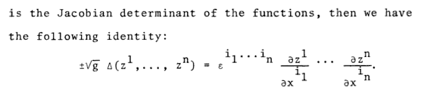
Here is verification of the RL meaning of colon

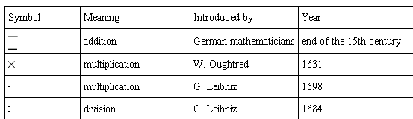

*****************

εabc... = g εabc...

g

Here is that strange comment again

http://www.scribd.com/doc/55201640/14/The-Levi-Civita-Tensor-and-Hodge-Dualisation

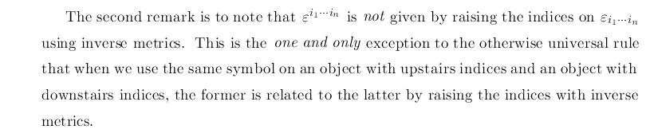

Why is this exception made? OK, see self notes above.

