Plotting coordinate lines in Maple PhL 10.29.11

There are two Maple files which go with this doc:

Sections 1 and 2: polar grids.mws
Sections 3 and 3: epolar grids.mws

1. Polar Coordinates, squares in x-y space 1
(a) Plot some vertical and horizontal lines in x,y space: 1
(b) Plot the inverse coordinate lines corresponding to the above grid 3
(c) The Combined Picture: 5
2. Polar Coordinates, squares in θ-r space 5
(a) Plot some vertical and horizontal lines in θ,r space: 6
(b) Plot the forward coordinate lines corresponding to the above grid 8
(c) The Combined Picture: 10
3. Elliptical Polar Coordinates, squares in x-y space 10
(a) Plot some vertical and horizontal lines in x,y space: 11
(b) Plot the inverse coordinate lines corresponding to the above grid 13
(c) The Combined Picture: 14
4. Elliptical Polar Coordinates, squares in θ,r space 15
(a) Plot some vertical and horizontal lines in θ,r space: 15
(b) Plot the forward coordinate lines corresponding to the above grid 17
(c) The Combined Picture 19

1. Polar Coordinates, squares in x-y space

Here we make squares in x-y space then plot the inverse coordinate lines.

Let's start with the math for polar coordinates:

x = r cosθ
y = r sinθ

r = xi/cosθ These make the inverse coordinate lines
r =yi/sinθ

r2 = x2 + y2
tanθ = y/x

y = $\sqrt{ri2-x2}$ These make the forward coordinate lines.
y = x tanθi

(a) Plot some vertical and horizontal lines in x,y space:

Horizontal lines: yi = -N..N gives about 2N horizontal lines

N := 10:
hor := plot([seq(yi,yi=-N..N)],color = red):display(hor);
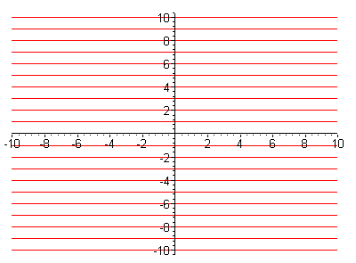

Vertical lines. xi = -N..N gives about 2N vertical lines

ver_pre := plot([seq(yi,yi=-N..N)],color=blue):display(ver_pre);

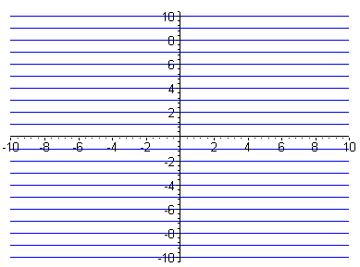

This set of lines is identical to the above, but are made blue. Now we reflect them in the diagonal to get vertical lines:

ver := reflect(ver_pre, [[0,0],[1,1]]):display(ver);

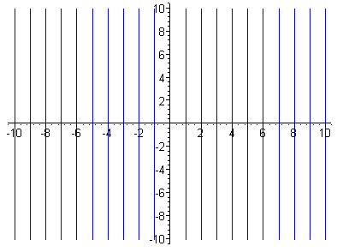

Both:

display(ver,hor);

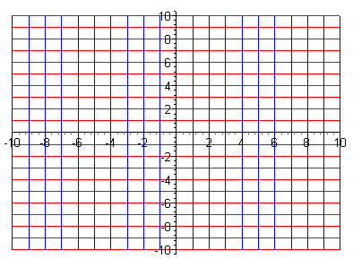

This is a grid of 400 squares for x-y space.

(b) Plot the inverse coordinate lines corresponding to the above grid

As noted above, the equations of interest here are

r = xi/cosθ These make the inverse coordinate lines
r = yi/sinθ

xgrid := plot([seq(xi/(1*cos(theta)),xi=-10..10)],theta = .001..2*Pi-.001, color=blue, view = [0..2*Pi,0..10]): display(xgrid);

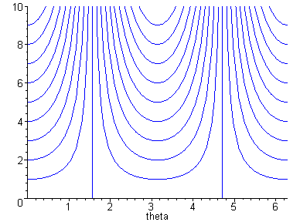

ygrid := plot([seq(yi/(1*sin(theta)),yi=-10..10)],theta = .001..2*Pi-.001, color=red, view = [0..2*Pi,0..10]): display(ygrid);

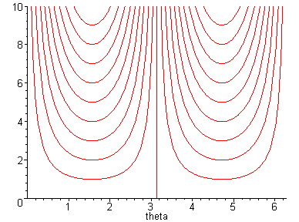
display(xgrid,ygrid);

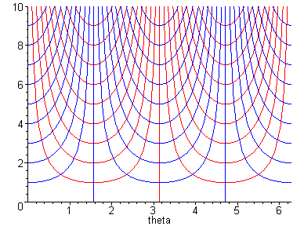

This thing has about 400 patches and matches the x-y grid in that regard. I like the count here because the above drawing then is "good". Fewer boxes or more would make it less good. So we are done with this job.

(c) The Combined Picture:

x'-space x-space

2. Polar Coordinates, squares in θ-r space

Here we make squares in θ-r space then plot the forward coordinate lines.

Let's start with the math for polar coordinates:

x = r cosθ
y = r sinθ

r = xi/cosθ These make the inverse coordinate lines
r =yi/sinθ

r2 = x2 + y2
tanθ = y/x

y = $\sqrt{ri2-x2}$ These make the forward coordinate lines.
y = x tanθi

(a) Plot some vertical and horizontal lines in θ,r space:

Horizontal lines: ri = 0..Nh gives about N horizontal lines

Nh := 10: // this will create Nh circles eventually
unassign('x');
hor :=plot([seq(ri,ri=0..Nh)],theta=0..2*Pi, color=red): display(hor);

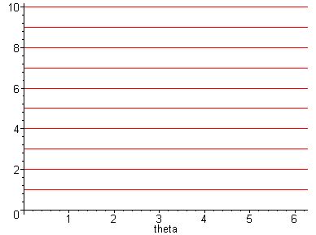

Vertical lines. xi = 2π (i/N), i=0..Nv gives about Nv vertical lines

Nv := 20:
ver_pre :=plot([seq(2*Pi*i/Nv,i=0..Nv)],theta=0..Nv/2,color=blue, view = [0..Nv/2,0..2*Pi]): display(ver_pre);

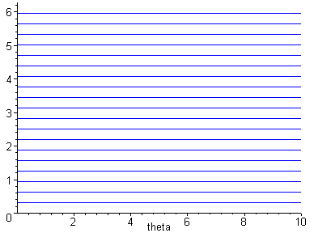

ver := reflect(ver_pre, [[0,0],[1,1]]):display(ver);

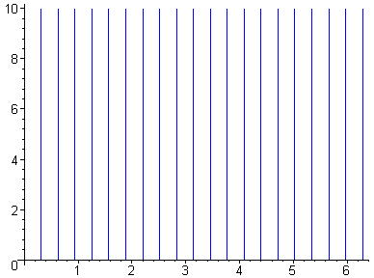

And finally we display both at the same time:

display(ver,hor);

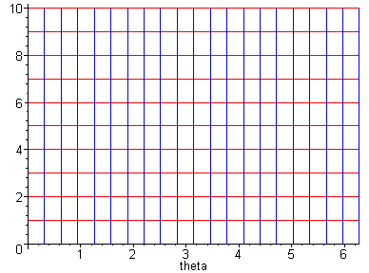

This is a grid of 200 squares for x-y space.

(b) Plot the forward coordinate lines corresponding to the above grid

As noted above, the equations of interest here are

y = $\sqrt{ri2-x2}$ These make the forward coordinate lines.
y = x tanθi

Circles:

We first make the upper half circles this way:

Nc := 10:unassign('x');
> upper := plot([seq(Re(sqrt(ri^2-x^2)),ri=0..Nc)], x = -Nc..Nc, scaling=constrained, color=red): display(upper);

The Re is needed because in the x scan, $\sqrt{ri2-x2}$goes imaginary when we are out of range and this causes an error. Perhaps this causes red on the horizontal axis where Re=0 but I don't see it, fine.
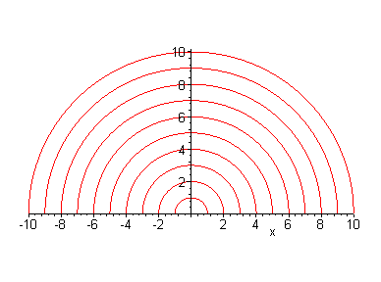
lower := plot([seq(-Re(sqrt(ri^2-x^2)),ri=0..Nc)], x = -Nc..Nc, scaling=constrained, color=red): display(lower);
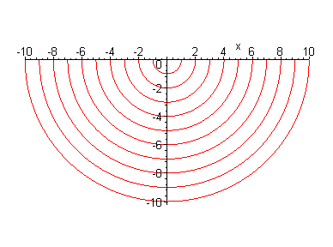
display(upper,lower);

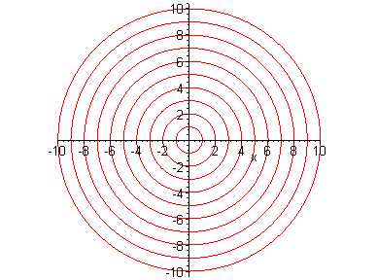

So here then are our Nc circles, finally.

Rays:

Next, we need to make the rays θi = 2π(i/N)

Nr is the number of rays, while N is as it was earlier, (N,N) is upper right corner of x-y grid

Nr := 20: N := 10:
rays :=plot([seq(x*tan(2*Pi*(i+.0001)/Nr),i=1..Nr)], x = -N..N,scaling=constrained, color=blue, view = [-N..N,-N..N]): display(rays);

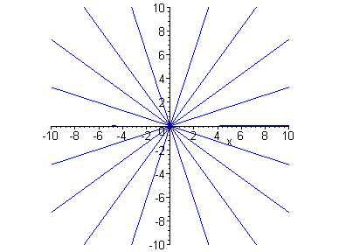

Both:

display(upper,lower,rays);

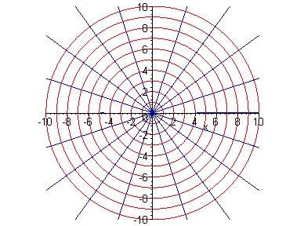

This grid also has 200 patches, so matches the mesh earlier.

(c) The Combined Picture:

x'-space x-space

3. Elliptical Polar Coordinates, squares in x-y space

Here we make squares in x-y space then plot the inverse coordinate lines in θ-r space.

Let's start with the math for elliptical polar coordinates:

x = aρcosθ x/a = ρcosθ => x2/a2 + y2/b2 = ρ2
y = bρ sinθ y/b = ρsinθ => tanθ = y/x

ρ = xi/(acosθ) These make the inverse coordinate lines
ρ = yi/(asinθ)

ρ2= 2/a2 + y2/b2
tanθ = y/x

y = b $\sqrt{ρi2-(x/a)2}$ These make the forward coordinate lines.
y = x tanθi

(a) Plot some vertical and horizontal lines in x,y space:

Horizontal lines: yi = -a*Nh/2..a*Nh/2 gives about 2N horizontal lines

Nh := 20: a :=2: b := 1:
hor := plot([seq(yi,yi=-Nh/2..Nh/2)],x = -Nh..Nh, color = red , scaling = constrained):display(hor);
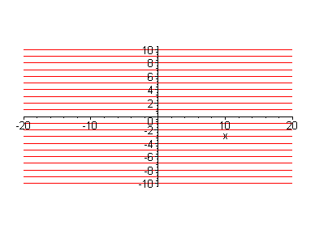

Vertical lines. xi = -Nv/2..Nv/2 gives about 2N vertical lines

Nv:= 20;
ver_pre := plot([seq(a*yi,yi=-Nv/2..Nv/2)],x = -Nv/2..Nv/2, color=blue ,scaling = constrained):display(ver_pre);

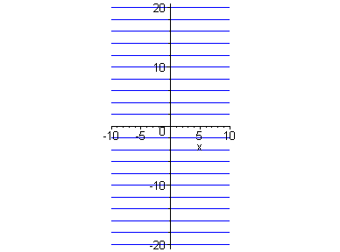

Now we reflect them in the diagonal to get vertical lines:

ver := reflect(ver_pre, [[0,0],[1,1]]):display(ver);

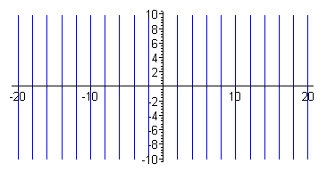

Both:

display(ver,hor);

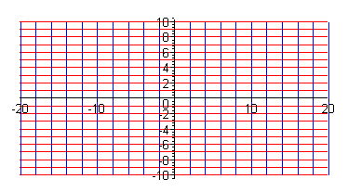

This is a grid of 400 squares for x-y space.

(b) Plot the inverse coordinate lines corresponding to the above grid

As noted above, the equations of interest here are

r = xi/(acosθ) These make the inverse coordinate lines
r = yi/(bsinθ)

a :=2: b:= 1:

x := plot([seq(xi/(1*(a*cos(theta))),xi=-10..10)],theta = .001..2*Pi-.001, color=blue, view = [0..2*Pi,0..10]): display(x);

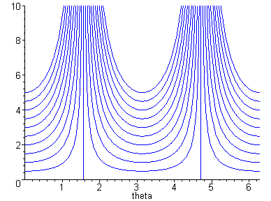

y := plot([seq(yi/(1*(b*sin(theta))),yi=-10..10)],theta = .001..2*Pi-.001, color=red, view = [0..2*Pi,0..10]): display(y);

display(x,y);

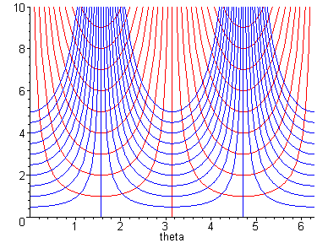

This thing has about 400 patches and matches the x-y grid in that regard. I like the count here because the above drawing then is "good". Fewer boxes or more would make it less good. So we are done with this job.

(c) The Combined Picture:

x'-space x-space

4. Elliptical Polar Coordinates, squares in θ,r space

Here we make squares in θ-r space then plot the forward coordinate lines.

Let's start with the math for elliptical polar coordinates:

x = aρcosθ x/a = ρcosθ => x2/a2 + y2/b2 = ρ2
y = bρ sinθ y/b = ρsinθ => tanθ = y/x

ρ = xi/(acosθ) These make the inverse coordinate lines
ρ = yi/(asinθ)

ρ2 = x2/a2 + y2/b2
tanθ = y/x

y = b $\sqrt{ρi2-(x/a)2}$ These make the forward coordinate lines.
y = x tanθi

(a) Plot some vertical and horizontal lines in θ,r space:

Horizontal lines: ri = 0..Nh gives about N horizontal lines

Nh := 10: // this will create Nh circles eventually
unassign('x');
hor :=plot([seq(ri,ri=0..Nh)],theta=0..2*Pi, color=red): display(hor);

Vertical lines. xi = 2π (i/N), i=0..Nv gives about Nv vertical lines

Nv := 20:
ver_pre :=plot([seq(2*Pi*i/Nv,i=0..Nv)],x=0..Nv/2,color=blue, view = [0..Nv/2,0..2*Pi]): display(ver_pre);

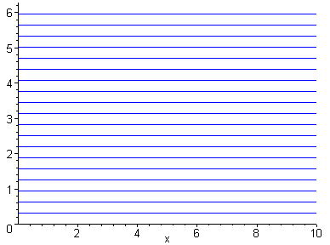

ver := reflect(ver_pre, [[0,0],[1,1]]):display(ver);

And finally we display both at the same time:

display(ver,hor);

This is a grid of 200 squares for x-y space.

(b) Plot the forward coordinate lines corresponding to the above grid

As noted above, the equations of interest here are

y = b $\sqrt{ρi2-(x/a)2}$ These make the forward coordinate lines.
y = x tanθi

Ellipses:

We first make the upper half ellipses this way:

Nc := 10:unassign('x');
> upper := plot([seq(b*Re(sqrt(ri^2-(x/a)^2)),ri=0..Nc)], x = -a*Nc..a*Nc, scaling=constrained, color=red): display(upper);

The Re is needed because in the x scan, $\sqrt{ρi2-(x/a)2}$goes imaginary when we are out of range and this causes an error. Perhaps this causes red on the horizontal axis where Re=0 but I don't see it, fine.
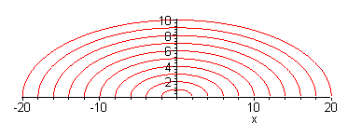

lower := plot([seq(-b*Re(sqrt(ri^2-(x/a)^2)),ri=0..Nc)], x = -Nc..Nc, scaling=constrained, color=red): display(lower);
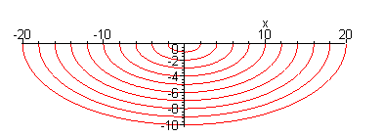
display(upper,lower);

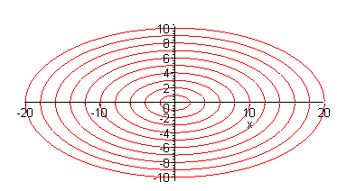

So here then are our Nc circles, finally.

Rays:

Next, we need to make the rays θi = 2π(i/N)

Nr is the number of rays, while N is as it was earlier, (N,N) is upper right corner of x-y grid

Nr := 20: N := 10:
rays :=plot([seq(x*tan(2*Pi*(i+.0001)/Nr),i=1..Nr)], x = -a*N..a*N,scaling=constrained, color=blue, view = [-a*N..a*N,-N..N]): display(rays);

Both:

display(upper,lower,rays);

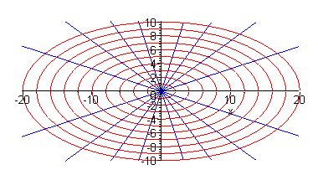

This grid also has 200 patches, so matches the mesh earlier.

(c) The Combined Picture

x'-space x-space

