Clearing up confusion about dA' and dV' PhL 2.22.12

Several issues in this doc: ( today is 2.28.12)
A. are the dA and dV type equations "primeable"? Ie, are they covariant? [ Now all settled.]
B. What is the meaning of dA' ? [ it has no drawable meaning really ]
C. More of the same.
D. Seeking the Lai connection. [ this was cleared up only later ]

1. First, some general comments about the N-pipeds. The finite x-space N-piped is a real world object it is true, having areas and volume and edges. But, the interior of this object does not map back to any useful object in x'-space. Certainly the interior does not map back into the interior of any orthogonal N-piped in x-space, and certainly not into the entire "office building" in x'-space. Only the entire x-space maps into that full interior!
Therefore, it makes no sense to talk about a non-existent mapping between a finite N-piped in x-space and a finite orthogonal N-piped in x'-space. This was just a bad notion that I slipped into.
The mapping only applies to the differential N-pipeds !!!

2. Now consider these excellent differential N-piped x-space equations:

(dAn)i = σ (-1)n-1 εiabc..x (e1)a(e2)b.... (eN)x // en missing

dAn = |det(Sab)| en Πi≠ndx'i = g'1/2 en Πi≠ndx'i = | det [ e1, e2, e3 ... eN] | en Πi≠ndx'i

dAn = σ (-1)n-1 Πxi≠nei Πi≠ndx'i

dV = | det [ e1, e2, e3 ... eN] | Πidx'i = | det(Sab) | Πidx'i = g'1/2 Πidx'i

Question A: Does it make any sense to prime both sides of any of these equations?
[ the answer as shown in the new Section 8 is that you can prime ALL of the above equations! ]

(a) One place where we "prime" both sides of an equation is when we have an equation that is covariant so that by priming things, we find the version of the equation valid in a primed frame.

(b) If we have something that is known to be a true tensor, such as a vector V, then we know that if we take an x-space component like Vi and prime it, we obtain V'i which we know is a valid x'-space component of that tensor, and we know that V' = RV

(c) If we have something that is known to be a tensor density, such as a vector density V, then we know that if we take an x-space component like Vi and prime it, we obtain V'i which we know is a valid x'-space component of that tensor, and we know that V' = |J|-W RV where W is the weight.

Now I think (dAn)i as given by the first line above is a tensor density of weight -1, so I expect that

dA'n = |J| R (dAn) | det(Sab) | = g'1/2 = |J| = r2sinθ

A Big Question now arises:

Question B: How do we interpret the object (dA'n) given by the above equation?

Let's go right to spherical coordinates and construct an example to look at. Consider

dAθ = |J|eθ drdφ = r2sinθ eθ drdφ

This is the real physical Cartesian space area of a certain patch we know all about. This patch is one of the faces of our x-space N-piped. The magnitude of this patch is given by

| dAθ| = r2sinθ | eθ| drdφ = r2sinθ h'θ-1| drdφ = rsinθdrdφ // agrees with tensor doc

Consider this alternate calculation which gives the same result:

(dAθ) • (dAθ) = |J|e2 drdφ • |J|e2 drdφ = |J|2 g'22 (drdφ)2 = |J|2 h'2-2(drdφ)2

=> | dAθ| = |J| h'2-1drdφ = r2sinθ (1/r)drdφ = rsinθdrdφ

We know that this face maps back into a certain face of our Cartesian view orthogonal N-piped in x'-space. It is a face there with dimensions dr and dφ and this forms one of the faces of our little sugar cube whose origin corner lies at r,θ,φ in x'-space. Now for this dAθ let us construct the object dA'θ as shown above and see what it looks like:

dA'n = |J| R (dAn) [correct] dA2 = |J| e2 Πi≠ndx'i

(dA'2)i = |J| Rij (dA2)j = |J| Rij [|J| (e2)j drdφ

(dA'2)i = |J|2 Rij (e2)j drdφ = |J|2 RijR2j drdφ = |J|2δ2i drdφ

(dA'θ) = (0, |J|2 drdφ , 0 ) = (0, r4sin2θ drdφ , 0 )

I have no useful interpretation of this thing, other than it seems to be in the right direction.

What is the covariant magnitude of this thing? According to the rules for tensor densities, we add the weights and get |J|-(W+w) = |J|2

(dA'θ) • (dA'θ) = |J|2 (dAθ) • (dAθ) => | dA'θ | = |J|1| dAθ |

| dAθ| = |J| h'2-1drdφ // from above [ correct, agrees with Sec 8]

=> | dA'θ | = |J|1| dAθ | = |J|1|J| h'2-1drdφ = |J|2 h'2-1 drdφ

Let's try computing this same thing a different way:

(dA'2)i = |J|2δ2i drdφ from above

(dA'θ) • (dA'θ) = g'ii|J|2δ2i drdφ|J|2δ2j drdφ = |J|4 g'22 (drdφ)2 = |J|4 h'2-2 (drdφ)2

=> | dA'θ | = |J|2h'2-1 drdφ

which agrees with the previous method. So we have then

| dA'θ | = (r2sinθ)2 (1/r) drdφ = r3sin2θ drdφ

Interpretations anyone?? Dimensions L4. I draw a complete blank on this thing. It is all based on the tensor density idea for dAn. It just seems like something you define through the tensor density concept and then it has no useful meaning whatsoever.

Question C: Consider the two θ type areas that map into each other

area in x'-space is drdφ in the direction in x'-space

area in x-space is rsinθdrdφ in the direction in x-space

What is the ratio of these areas?

ratio = rsinθ

Now THIS is something I can understand.

Question D: How does this connect with Lai's flow discussion?

[ this was written before I realized that we can have g' = 1 in x'-space for Lai.]

Imagine that we have some x' = F(x) such that all the xi and all the x'i have dimension L. So we rule out the spherical coordinate transformation as a possible F.

We know of course that

dx' = R dx

(a) Patch in x-space. Suppose x-space is Cartesian. We can consider the N-piped face patch of area in x-space,

dA1 = |J| en dx'2dx'3 n = 1,2,3 refer to x'1, x'2,x'3.

= e2 x e3 dx'2dx'3

= |J| h'n-1 dx'2dx'3 n

Thus, our x-space patch area magnitude against this unit vector is

|dA1| = |J| h'n-1 dx'2dx'3

This patch in x-space is spanned by these two vectors

dx(2) ≡ dx'2e2
dx(3) ≡ dx'3e3

The lengths of the vectors are

| dx(2)| = dx'2 h'2
| dx(3)| = dx'3 h'3

(b) Back-mapped patch in x'-space.

If we map back these two face edge vectors we get

dx'(2) = R dx(2) = R e2 dx'2
dx'(3) = R dx(3) = R e3 dx'3

[dx'(2)]i = [R e2]i dx'2 = Rij(e2)j dx'2 = RijR2j dx'2 = δi2 dx'2

=> dx'(2) = (0, dx'2, 0) in contravariant components = (e'2) dx'2
dx'(2) = (0, 0, dx'3) in contravariant components = (e'3) dx'3

What are the covariant lengths of these edges?

dx'(2) • dx'(2) = g'ij [dx'(2)]i[dx'(2)]j = g'22 dx'2 dx'2 = h'22 dx'2 dx'2

=> | dx'(2)| = h'2 dx'2

As expected, this is the same as | dx(2)| since this is a true vector.

(c) Conclusion: I KNOW that both the early and late Lai spaces are Cartesian, because I do the experiment right in my own office and at both times space is 3D Cartesian. I am forced to my earlier 3-space model picture:

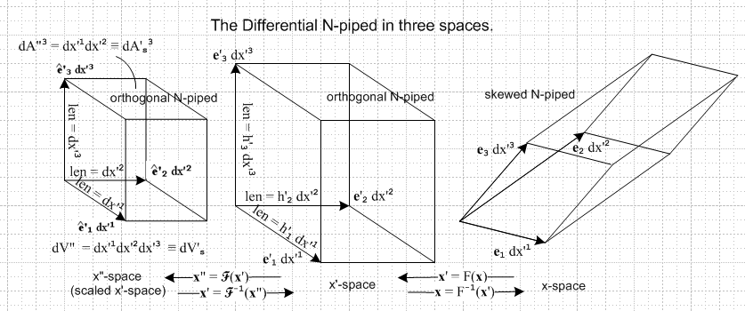

which I luckily found in a Visio file in "the previous tensor paper" folder. In Lai's application, g' for x'-space is NOT diagonal since it is g' = FTF or some such. It is symmetric but not diagonal.
My characterization of the middle picture as "orthogonal N-piped" is inaccurate because, from above

dx'(2) • dx'(3) = g'ij [dx'(2)]i[dx'(3)]j = g'23 dx'2 dx'3 ≠ 0

so these two edges are not "perpendicular" as I have drawn them. On the other hand, we do have that

(e'n)i = δn,i (e'1)i = (1,0,0) (e'2)i = (0,1,0) (e'3)i = (0,0,1)

so this makes the drawing a little justified. We just have to give up on Cartesian geometry involving such things as "angles".
What we want to do to "get" the left space is this: take contravariant vectors in the middle space and make them be the contravariant vectors of the left space, but replace g' = RRT by g' = 1. The term "scaled x'-space" is not good because we are NOT just scaling the axes in the Lai application!
So Lai's flow model is from the sugar cube on the far left to the 3-piped on the far right. Both spaces are Cartesian. The ratio of lengths is the scale factor. The ratio of areas is just what we want.

area left space = dx'2dx'3

area right space = |J| h'n-1 dx'2dx'3 n

area magnitude ratio = |J| h'n-1 = |detS| h'n-1 = g'1/2 h'n-1

In standard notation we have (I did this in Section 8 td)

(area magnitude ratio)2 = g' h'n–2 = g' g'nn = cof(g'nn)

and we then get the famous result

(area magnitude ratio) = $\sqrt{cof(g'nn)}$

In Lai page 129 this ratio appears this way

(area magnitude ratio) = (detS) | RTn| 3.27.11

Now Lai's n is my Cartesian un, so he is really claiming that

(area magnitude ratio) = (detS) | RTun|

So consider then

[RTun]i = (RT)ij (un)j = (RT)ij δn,j = (RT)in = Rni

Then

[RTun]i[RTun]i = Rni Rni = (RRT)nn = g'nn

His result is then this

(area magnitude ratio) = (detS) $\sqrt{g'nn}$ = $\sqrt{g' g'nn}$

(area magnitude ratio)2 = g' g'nn // dev notation

= g' g'nn // std notation

and this agrees with my result .

Conclusion: Lai and I are in full agreement concerning the ratio of areas, where one area is in Cartesian X early space, and where the other area is the cross product of the corresponding vectors in Cartesian-view x late space.

_________________________________________________________________________________

Appendix A.

Is it impossible to even draw the middle picture? [ yes! ] Remember this is all differentials, nothing finite. that takes me right to Appendix C from which I quote:

For V = dx the picture above becomes

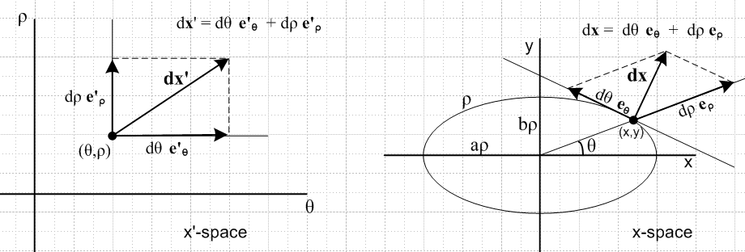

It must be understood that now the vector arrows like dx are highly magnified and in reality are very small compared to, say, the curvature of the ellipse. From above,

e'θ • e'θ = 'θθ 'θ • 'θ = 1
e'ρ • e'ρ = 'ρρ 'ρ • 'ρ = 1
e'ρ • e'θ = 'ρθ 'θ • 'ρ = 'θρ / (h'θh'ρ)

and once again the "right angle" in the x'-space picture is deceptive.

_________________________________________________________________________________

