Hi Dan, 6 March 2011

While fumbling around with Mehler transforms, I think I spotted an obscure errata in your Differential Equations book, 3rd Edition 1997. I don't see it in your website errata list last updated Nov 22, 2000.

In Section 78 page 351 you have

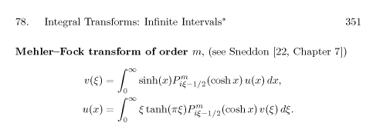

I think this is only correct for m = 0, but I don't have Sneddon's book to check. However, right now I am staring at page 2 of F. Oberhettinger and T. P. Higgins, Tables of Lebedev, Mehler and Generalized Mehler Transforms, which is reference [21] on your page 355, and here is what I see:

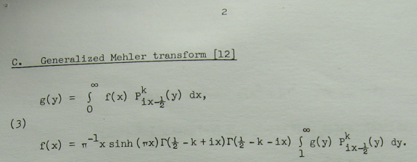

In something I wrote a while ago, I presented the transform in this manner:
_______________________________________________________________________________

The generalized Mehler-Fock (Mehler-Fok) transform (Oberhettinger and Higgins* page 2) is this,

g(y) = $^{\int_{0}^{∞}{}}$dτ Pm-1/2+iτ(y) f(τ) // expansion
f(τ) = (τ/π) sh(πτ) Γ(1/2-m+iτ) Γ(1/2-m-iτ)$^{\int_{1}^{∞}{}}$dy Pm-1/2+iτ(y) g(y) // projection

and for m = 0, using Γ(1/2+iτ)Γ(1/2-iτ) = π/cosh(πτ), one obtains the regular Mehler-Fock transform,

g(y) = $^{\int_{0}^{∞}{}}$dτ P-1/2+iτ(y) f(τ) // expansion
f(τ) = τ th(πτ)$^{\int_{1}^{∞}{}}$dy P-1/2+iτ(y) g(y) // projection

which can also be written as

G(ξ) = $^{\int_{0}^{∞}{}}$dτ P-1/2+iτ(chξ) f(τ) // expansion
f(τ) = τ th(πτ) $^{\int_{0}^{∞}{}}$dξ shξ P-1/2+iτ(chξ) G(ξ) // projection

* F. Oberhettinger and T. P. Higgins, Tables of Lebedev, Mehler and Generalized Mehler Transforms, (Boeing Scientific Research Laboratories, Mathematical No. 246, 1961). A 48 page monograph with about 16 transforms per page. The first author is a member of A. Erdelyi et. al mentioned above. We obtained this book by interlibrary loan from the Coe library at the University of Wyoming.
_______________________________________________________________________________

As another piece of evidence, here is a clip from your page 355 Nasim reference [19] :

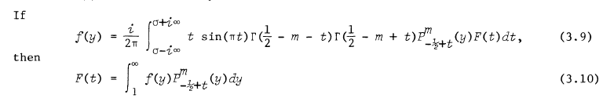

You can set σ = 0 and t = ix to get something equivalent to Oberhettinger and Higgins.

Best regards,

Phil Lucht
Salt Lake City

