Toroidal coordinates PhL 38 pages 4.30.10

Motivation: (1) The Green's function of a thin circular ring of wire of circular cross section is, I think, well treated in toroidals. (2) The toroidal Qm-1/2 function has shown up mysteriously in my attempts to find the iris Green's function. (3) These two might be related if you think of an iris as an integral of thin circular wires. (4) I want to add toroidals to my experience list, have never used them before. (5) toroidals might also be appropriate for a charged bowl [ I finally did this in Jan 2011.]

Overview (added 9.13.10, 5 pages) (needs updating) 1
Summary of notations and geometry for 3D toroidal coordinates azimuth = φ : 5
Bipolar 2D and Toroidal 3D Coordinate Systems ξ = - π/8 6
(a) derivation of the M&F bipolar results shown above 8
(b) The horizontal set of circles for constant ξ 9
(c) The vertical set of circles for constant θ 11
(c1) Redoing the θ parameterization with y→ -y 12
(c2) Introducing the u parameterization 13
(d) The vertical set of circles for constant u 14
(f) Apollonius comments and geometrical interpretation of the parameters ξ and u 17
(f0) More Graphical Interpretation of Coordinate u: the contact angle 20
(f1) the metric tensor. 21
(g) Summary on bipolar coordinates in u parameterization 23
Note added 1.22.11: Large r limit. 24
(g1) Summary on bipolar coordinates (different notation) 24
(g2) Complex notation. (added 9.11.10) 24
(h) extension to and summary of toroidal coordinates. 28
(i) Margenau and Murphy 31
(j) Morse and Feshbach: atomic forms + potential of a charged torus + 1/R expansion 32
(k) Other sources on toroidals 37
(l) Sturm-Liouville aspects of toroidal coordinates: Mehler-Fock Transform 41
(m) Summary of toroidal atomic forms: 43
(n) Converting from toroidal to Cartesian coordinates. 43
Material Added 11/27/15. 44

___________________________________________________________________________________

Overview (added 9.13.10, 5 pages) (needs updating)

In the Summary section below, I first list off the various notations different authors use for the two interesting toroidal coordinates (ie, the bipolar ones). Oddly, M&F use three different notations and I eventually decided to settle on their third choice which is donut label = μ and bowl label = η. I then make a set of "geometric" statements related to these coordinates. I note that the quantum number n (associated with η) will be quantized to integers for any problem whose spatial region includes a circulating path around a focal point, which path lies in an azimuthal plane (or any distortion of such a path). This makes you go around a horizontal circle so the requirement of single-valuedness kicks in.

I now review each lettered subsection of the remaining doc. In the opening unlettered intro text, I show the M&F 2D bipolar coordinate system which is unfortunately labeled with the bowl label θ = η+π. People might use this 2D system apart from 3D toroidal coordinates, and the 3D system is simply what you get when you add azimuth.

In Section a I accept the M&F expressions for x and y as the definition of the 2D bipolar coordinates, and from these expressions I derive their other expressions, and in the next sections the geometry:

In Section b I show that the loci of constant μ=ξ are in fact a horizontal set of circles which become donuts (toroids) in the 3D scheme. I show the constant-μ loci are circles by showing that, when written in terms of x and y, these loci have the form of circles. From this form, I of course then know the location of the circle centers, and I know the circle radii. Centers are at xc = a coth(μ), radii are R = a/|shμ|. As the colored picture shows, the circles start tight around the foci (large μ), but then get larger such that the circle centers move far outside the foci (small μ). The limiting circle μ = 0 is the vertical axis. There are in fact two sets of circles, the set on the right has μ > 0, that on the left has μ < 0. But when we later add azimuth, we keep only the set on the right for obvious reasons, so we end up with μ in (0,∞). Below I show that either circle set is a set of Apollonius.

In Sections c and d I show that the loci of constant η = u = θ-π are in fact a vertical set of circles which become spheres in the 3D scheme. I show the constant-η loci are circles by showing that, when written in terms of x and y, these loci have the form of circles. From this form, I of course then know the location of the circle centers, and I know the circle radii. Centers are at yc = a cot(η), radii are R = a/|sinη|. Note that if we simply replace the hyperbolic functions with trig ones, our previous centers and radii become the current ones! All these circles pass through the two foci. A huge circle mostly in the upper plane has η ≈ π/100. As we increase η moving toward π/2, we move to a circle symmetrically located upper/lower. As we then further increase to η = π, we end up with a large circle mostly in the lower half plane. This really exhausts all the circles, but there is a little "Catch 22" here that will be discussed in Section e. It will turn out that although the loci here are "circles", only part of each circle is "legal"! The legal circles are truncated by the horizontal picture axis, and then in 3D when you rotate these truncated circles you get bowls. In Section c I worked with the original M&F θ coordinate, while in Section d I redo things in the more commonly used η = u = θ-π coordinate.

In Section e I address this issue of truncation of the circles in the vertical set. When we developed the equations of the circles in Section c, we squared x and y, and in doing so we introduced spurious sections of loci! If we go back to the defining equation y = a sinη/(chμ - cosη) it is instantly clear that when η lies in the range (0,π), we have y > 0. So although we just described the circles above as η varied from 0 to π, we now see that only the portion each circle in the upper half plane is on the true locus of the defining equations! If we want to access points in the lower half plane, we must let η also range (π,2π) [ this is the tradition, it could have been (-π,0) ]. Thus, the full range for η is in fact (0,2π). At this point, I made some Maple plots and added labels in Visio so you can get a good feel for the truncated circles. There are two limits that are of great interest to me (though I have not really used them as of 9.12.10). When η = π, the truncated upper circle is just the line segment joining the foci, and in 3D this becomes a disk. You can regard η = π±ε as a disk in the upper/lower half plane. The other limits of interest are η = 0 which is an iris in the upper half plane, and η = 2π which is an iris in the lower half plane. In passing, note that the disk and iris also appear as limiting surfaces of constant parameter in oblate spheroidal coordinates, but in that case it is not "the same parameter": the disk is a spheroid, the iris is a hyperboloid. I think toroidal coordinates is the only system which delivers a "bowl" as a surface of constant parameter. It is of course the only system (I think) that similarly delivers a "donut".

In Section f I discuss the geometric interpretation of the coordinates μ and η. For the horizontal circles, which are those of constant μ, it is easy to show that the circle set is an Apollonius set, which means the ratio of the distance from a point r on such a circle to the two foci is a constant "α" , and we exhaust the set by letting α take all positive real values. I show that:

d2/d1 ≡ | r - a | / | r + a | = α = e-μ => μ = ln (d1/d2)

so each value of μ defines one of these circles. So our "geometric interpretation" of donut label μ is that μ is the log of the ratio of the distances shown. Here is a tricky picture that I copy from below:

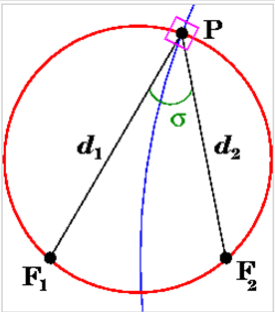

This picture shows an entire vertical circle in red, but only a tiny section of one of our Apollonius horizontal circles in blue. This blue circle has the label μ, and we have μ = ln (d1/d2).
The angle σ in this picture is in fact our coordinate η. This fact is of course not obvious, but I show that it is in fact true. Once we find it is true, we realize that the "circle chord angle theorem" causes this angle σ to be the same for all points P on the upper part of the red circle, which is of course our truncated circle locus. This then is why angle η = σ serves as a label for this red circle. [ For P in the lower half plane, we have to interpret η = σ + π I think. ]
I then took this opportunity to learn a set of "circle theorems" from wiki.

In Section f0 I re-interpret the trig parameter η = σ = u as the outside upper bowl lip angle whose complement is the sessile drop contact angle.

In Section f1 I have Maple compute the metric tensor for our bipolar 2D coordinates. If is of course diagonal and we find that hμ = hη = a/(chμ-cosη) ≡ hμη. Notice that this chμ-cosη factor appears also in the denominator of the defining x and y equations x = a shμ/(chμ - cosη) and y = a sinη/(chμ - cosη), so we could simply say that x = hμη shμ and y = hμη sinη.

In Section g I summarize all results for 2D bipolar coordinates, doing so in coordinates ξ and u (μ and η). At this point, the up direction is still y. I show a picture and discuss the large-r limit.

In Section g1, anticipating my introduction of the 3D coordinates, I restate the section g results making certain changes that make the results compatible with the upcoming toroidals: I replace up y with up z. I replace x with ρ. I replace ξ,u with μ,η.

In Section g2 I discuss complex notation. I first derive, in the "comment", the fact that ρ+iz = a coth[(μ-iη)/2] for toroidal coordinates. I first saw this in the Wilson 2005 PDF, and later in Lebedev as z + iρ = ia coth[ (μ+iη)/2], and was at first a bit mystified. But then I realized this is just the complex mapping w = (z-a)/(z+a) mentioned in Ahlfors which produces the Steiner circles which are the bipolar coordinate circle sets, and this formula ρ+iz = a coth[(μ-iη)/2] falls out easily. If z = x+iy, I show that

x + iy = a coth[(μ-iη)/2] μ-iη = ln[(x + iy +a)/( x + iy -a)]

I then start with ρ+iz = a coth[(μ-iη)/2] and verify (brute force!) that this gives the usual bipolar coordinate definitions ρ = a shμ/(chu - cosη) and z = a sinη /(chu - cosη).

In Section h I officially add azimuth φ to Section g2 to get our final toroidal coordinates whose equations I summarize. Maple computes the diagonal metric tensor and finds that

hμ = hη = a/[ chμ - cosη] ≡ hμη hφ = a shμ/[ chμ - cosη] = shμ hμη

Our toroidal defining equations are then

x = a cosφ shμ/(chμ - cosη) = cosφ hφ ρ = a shμ/(chμ - cosη) = hφ
y = a sinφ shμ/(chμ - cosη) = sinφ hφ
z = a sinu/(chμ - cosη) = sinη hμη

In Section i I look at the offerings of M&M (1943) on the toroidal subject. They make use of the complex mapping w = (z-a)/(z+a) mentioned above. They use ξ MM = η and η MM = μ and ψ MM = φ which is of course immensely confusing because this is just the exact reverse of MFp1310 for the first two, see table above.

In Section j I first quote the Laplace operator ∇2 in toroidals from M&F (along with other equations which agree with things I have already done above). I then follow M&F to show that the Laplace equation simplifies greatly if you redefine your potential ψ = (chμ - cosη)F, where we encounter a M&F typo. Then I follow through the separation of variables F(μ,η,φ) = f(μ)g(η)h(φ) and in this way I find that m and n are quantized to integers (modulo comments above) and we end up with atomic forms of this type

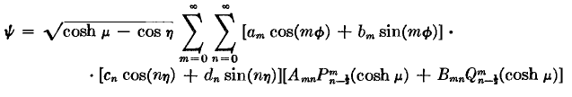
and thus it is that our associated Legendre functions appear yet again in orthogonal coordinates! In this context, P and Q are called "ring functions" or "toroidal functions".
I then follow through an obvious sample problem: compute the potential outside a charged metal toroid whose label is μ0 and whose potential is V0. We start with this Smythian form

ψ = $\sqrt{chμ - cosη}$ Σn An Pn-1/2(chμ) cos(nη)

I could have done this myself, but instead I just follow M&F and out comes this final result

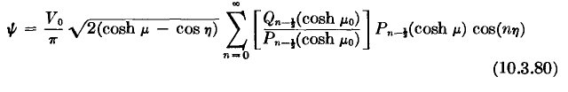 // should have εn

M&F at this point give the general 1/R expansion which I later derived in my 1/R toroidal doc, but which I will quote here anyway:

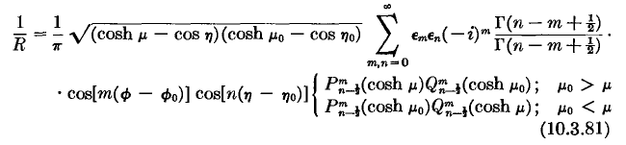 // should be (-1)n

I show that M&F have two errata in their section on this general subject, noted above (total of 3 then).

In Section k I search for other sources of toroidal information. Smythe, Jackson, W&W and Jeans all have nada. It was at this point that I found the Lebedev book which has some stuff on toroidals. And I located the recent papers of Fabrikant which I still have not examined. Also this is where I first discovered the ancient Chester Snow paper which was on-line only, and it had the hybrid 1/R expansion.

In Section l I comment on the alternative toroidal atomic form involving Piτ-1/2(chμ) which for this type of argument should be called Mehler functions ( they are conical functions when |z| < 1). In this atomic form, μ is an oscillatory coordinate and thus has a transform which is the Mehler-Fock Transform, and I make further comments on this subject.

In Section m I summarize the two toroidal atomic forms:

$\sqrt{chμ - cosη}$ [ sin(mφ), cos(mφ)] [Pmn-1/2(chμ), Qmn-1/2(chμ)] [ sin(nη), cos(nηu)] m,n integer
$\sqrt{chμ - cosη}$ [ sin(mφ), cos(mφ)] [Pmiτ-1/2(chμ), Qmiτ-1/2(chμ)] [ sh(τη), ch(τη)] m integer, τ in (0,∞)

In Section n I write down some toroidal quantities in Cartesian coordinates.
___________________________________________________________________________________

Summary of notations and geometry for 3D toroidal coordinates azimuth = φ :

MFp1210 M&F wiki M&M MFp1301 Leb
toroid label ξ ξ τ η μ α (0,∞)
bowl label: θ = u+π u σ ξ η β (0,2π)

Large nearly spherical bowl up top , u = 0.1π ("far") Large nearly spherical bowl below, u =1.9π.
Shallow thin bowl up top u = 0.9π Shallow thin bowl below , u =1.1π
bowl center: zc = +a cot(u) bowl radius: R = a/|sin(u)|
For a given upper or lower bowl u, bowl rim is at ξ=∞, on-bowl pole at ξ = 0.

Thin wire toroid: ξ = +100 Fat toroid: ξ = 0.1 ("far")
toroid radius: ρc = a coth(ξ) toroid cross section radius: R = a/|shξ|
For a given toroid ξ, the upper half is described by u = (0,π) ranging, lower half u = (π,2π)

For a full toroid shape, this fact causes integer quantization of quantum number n (related to u).
Upper/lower symmetry means only cos(nu) appear in expansion.

The question of quantization of n (associated with η).

First, think spherical coordinates. There, if we have a conductor geometry "defined" for all 2π of azimuth, the azimuthal atom like cos(mφ) results in m being quantized to an integer. An example would be a metal bowl or barrel. Such a geometry could include a sheet of metal at some prescribed potential in a φ = constant plane, because we know the potential is continuous through a sheet of metal. The idea is that if all 2π is in your "defined space", then m is an integer so the potential will be single valued when you rotate around by 2π.
But suppose we have a spatial region that is defined for only part of this 2π azimuth. The classic case is the orange slice let's say with some general prescribed potential on the two slice faces to give us a Dirichlet problem (I have never done such a general problem). In this case, assuming the two faces have different prescribed potentials, the potential would not be periodic in φ with period 2π nor with period α where α is the Δφ of the slice. Since the potential is not periodic in the φ coordinate, we will not find that m is quantized. The spectrum of m would be all continuous real values. Now it happens that in the special case where the two faces have the same potential, the potential will in fact be periodic in a math sense (not a physical sense since we only care about the inside of the slice) with period α, so we will find that m is quantized to the usual non-integral values. And the famous special case of this is when the two faces are grounded.
Now think toroidal coordinates. The same comments would apply to the toroidal azimuthal coordinate φ, but we are interested in coordinate η and its quantum number n. My claim is this: if your problem's defined "region of space" includes any path which circulates at least one focal point, then you will have n = integer because the potential must be periodic in η with period 2π (ie, must be single valued in η). This would be the case for example if you seek the potential of a charged torus, or of a charged bowl (ie, an open top bowl). An analogy to the spherical orange slice would be a "bowl lune" -- the region between two bowls where each bowl has some prescribed potential. In general, the potential will then not be periodic in η, so n will not be quantized. Notice that this includes the case of a closed bowl. If both bowl boundaries are grounded, then we will be the "accidental" quantization of n as with the orange slice.

Bipolar 2D and Toroidal 3D Coordinate Systems ξ = - π/8

Noted added 12.31.13. In the picture below, the up direction is y. In toroidal coordinates this will be z.

First, we need to think of "bipolar coordinates" which I will call θ and ξ which are an alternative to the coordinates x and y, we are just talking the x-y plane here. One discussion is MFII p1210. We get this interesting picture with some labels. [ the focal points are at x = ± a, I forgot to say that earlier ]
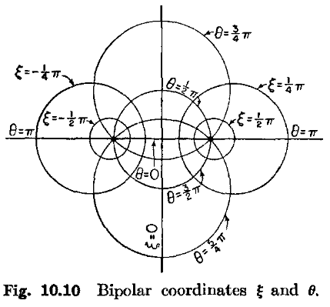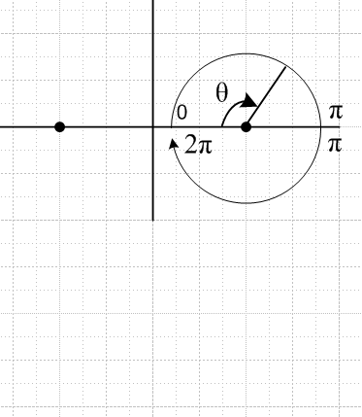

It is important to understand the range of the angle θ, and this is clarified in the right-side picture above. There is a discontinuity on the line between the two foci. The x axis goes off to the right, and the y axis is up, both as usual.
The basic information is this:

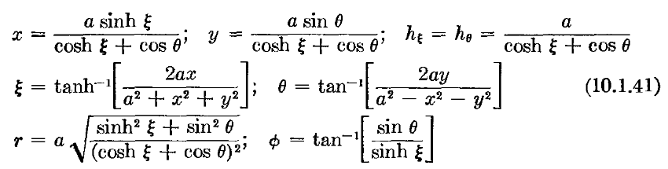

Note that x/y = shξ/sinθ so sinθ = (y/x)shξ.

Question 12.31.13: What is the meaning of φ in the above equation set? I guess (r,φ) are polar angles for the picture.

A Note on finding θ. We will show below without ambiguity that this fact is true

tanθ = 2ay/(a2-x2-y2)

and we can formally say then that θ = tan-1[2ay/(a2-x2-y2)], as shown above. However, we have no idea what θ really is because we don't know which branch of tan-1 we are on. So here is how you find the right θ if you are given a, x and y:

1. Compute ξ from the unambiguous formula shown above involving tanh-1.
2. Compute cosθ from the " x = " formula above.
3. Compute sinθ from the "y = " formula above.
4. Then compute θ manually from these values, or use θ = arctan2P(cosθ,sinθ)

This function arctan2P is discussed in the trig folder "arctan.doc".

(a) derivation of the M&F bipolar results shown above

We take the above expressions for x and y to be the definition of the bipolar coordinates. I will now derive all the other equations shown above.
The r expression is obvious, r2 = x2 + y2. Similarly, the equation for tanφ is obvious, just y/x.

Let's first write cos2θ in terms of ξ and x

(chξ + cosθ) = (a/x) shξ => cosθ = (a/x) shξ - chξ

=> cos2θ = (a/x)2sh2ξ + ch2ξ - 2(a/x) shξ chξ

Meanwhile, we see that

y/x = sinθ/shξ => sinθ = (y/x)shξ

=> sin2θ = (y/x)2sh2ξ

We then write cos2θ + sin2θ = 1 to get

(a/x)2sh2ξ + ch2ξ - 2(a/x) shξ chξ + (y/x)2sh2ξ = 1

We want to solve this for ξ
. Multiply through by x2

a2sh2ξ + x2ch2ξ - 2ax shξ chξ + y2sh2ξ = x2

a2sh2ξ + x2sh2ξ - 2ax shξ chξ + y2sh2ξ =0

a2shξ + x2shξ - 2ax chξ + y2shξ =0

(a2+x2+y2)shξ = 2ax chξ =0

thξ = 2ax / (a2+x2+y2) // agrees with clip above

Meanwhile, we know that

tanφ = y/x = sinθ/shξ

Next, we want to repeat all of the above sort of swapping the roles of ξ and θ. So:

(chξ + cosθ) = (a/y) sinθ => chξ = (a/y) sinθ - cosθ

=> ch2ξ = (a/y)2 sin2θ + cos2θ - 2(a/y) sinθcosθ

Meanwhile, we see that

y/x = sinθ/shξ => shξ = (x/y)sinθ

=> sh2ξ = (x/y)2 sin2θ

We then write ch2ξ - sh2ξ = 1 to get

(a/y)2 sin2θ + cos2θ - 2(a/y) sinθcosθ - (x/y)2 sin2θ = 1

Multiply through by y2

a2 sin2θ + y2cos2θ - 2ay sinθ cosθ - x2 sin2θ = y2

a2 sin2θ - y2sin2θ - 2ay sinθ cosθ - x2 sin2θ = 0

a2 sinθ - y2sinθ - 2ay cosθ - x2 sinθ = 0

(a2 - x2-y2)sinθ = 2ay cosθ

tanθ = 2ay/(a2 - x2-y2) // agrees with screen clip above

So we have derived all equations above except for the scale factors which I will hold off on for a while.

(b) The horizontal set of circles for constant ξ

I now want to find the curves which I know are circles. If we have ξ = constant, then we have

(a2+x2+y2) = 2a cothξ x

(x2 - 2acothξ x + K) + y2 = -a2 + K K will complete the square

K = (acothξ)2

(x - acothξ)2 + y2 = a2(coth2ξ - 1) = a2/sh2ξ

So what we get is a horizontal stack of circles centered on the x axis (y=0)

(x - acothξ)2 + y2 = a2/sh2ξ xc = a coth(ξ) R = a/|shξ|

Setting y=0 gives us the locations at which these circles intersect the x axis.

x = a cothξ ± a/shξ = a(chξ ± 1)/shξ

Since chξ ≥ 1 always, you see that these intercepts have the same sign as ξ. So for ξ > 0, all circles are completely on the right side.

In the limit ξ = 0+ the center moves far to the right and the radius gets larger and the circle approaches the y axis from the right. In the final limit, x = 0 and we get

(acothξ)2 = a2/sh2ξ => a2ch2ξ = a2 a2sh2ξ = 0 shξ = 0

In the limit ξ → ∞ we get cothξ → 1 so circle becomes

(x - a)2 + y2 = a2/sh2ξ

which is a set of circles shrinking around the bipolar point x = a. So I have now explained the circles shown on the right side of the above picture. If we take ξ → -ξ we get

(x + acothξ)2 + y2 = a2/sh2ξ

(- x - acothξ)2 + y2 = a2/sh2ξ

so all the circles are just reflected in the y axis, as shown. Here is a wiki picture where τ = ξ and we are just looking at the circles for ξ > 0. These circles do not get into the left half plane. Notice that τ = ξ is normally the "expo" or "radial" coordinate. To remember that, we are moving radially away from the torus or focal point.

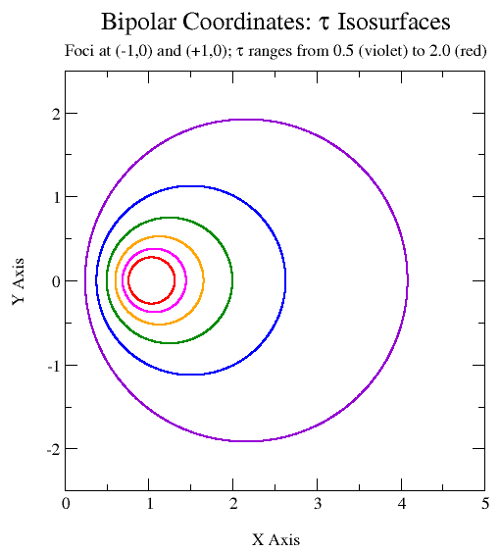
Note: If in our parameterization we were to replace θ by u = θ + π, we would have cos(θ) → - cos(u), but that has no effect at all on the horizontal set of circles each defined by constant ξ.

Comment: when we rotate the above picture around the vertical axis, each circle becomes a toroid. Then we will have each toroid being a surface of constant ξ, where ξ is the "hyperbolic" variable. So think later of toroids having labels ξ, and the toroid cross section circle has xc = a coth(ξ) and R = a/|shξ|

(c) The vertical set of circles for constant θ

Now we want to have θ = constant and see what happens.

(a2 - x2-y2) = 2ay cotθ

(x2+y2- a2) = - 2ay cotθ

x2 + y2+ 2ay cotθ + K = a2 + K K to complete the square

x2 + (y+ acotθ)2 = a2 + a2cot2θ = a2/sin2θ

So again we have a set of circles

x2 + (y+ acotθ)2 = a2/sin2θ yc = -a cot(θ) R = a/|sinθ|

If x = ± a, we get

(y+ acotθ)2 = a2/sin2θ - a2 = a2 cot2θ => y + a cotθ = ± a cotθ

=> y = 0 and y = -2a cotθ

The first solution says that all these circles pass through the two focal points at x = ± a and y = 0. If θ is a small positive angle, then the second solution gives some negative y values, which seems to disagree with the above picture! M&F claim circle centers are at y = +acotθ but I get them at y = -acotθ. So yes, M&F have a little bug here in their presentation which I will ignore since I am about to change to u.

A reasonable complete parameter range for θ is θ in (0,π). In this range, cot(θ) takes all possible values (Schaum p 14). When θ is in (0,π/2), cot(θ) is positive, circle center is negative, and we get the lower set of circles. When θ is in (π/2,π), cot(θ) is negative, circle center is positive, and we get the upper set of circles. M&F have two errors in their text. First, they state that y = +2a cotθ which is off by a sign, and second the vertical circles are labeled incorrectly, labels should be vertically flipped. Probably this has to do with an edit they did from a different parameterization, see below.

(c1) Redoing the θ parameterization with y→ -y

I won't draw the circle set, but suppose we take the one above and we reflect it through the x axis, which is to say we take y→-y. We could draw it, but it would take lots of time so I won't. But here is what happens to the little angular definition picture:

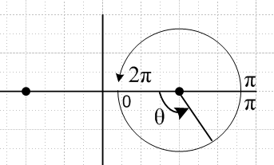

Notice that the discussion on section (b) is unaltered by this y→-y change since y only appears squared. And in section (c) we just replace y→-y to get adjusted results.
Here then are our modified M&F equations

x = ashξ/(chξ+cosθ) hξ = hθ = a/(chξ+cosθ) -y/x = sinθ/shξ
-y = asinθ/(chξ+cosθ)

ξ = tanh-1[2ax/(a2+ x2+ y2)]
θ = tan-1[ -2ay/(a2-x2-y2)]

r2 = a2 (sh2ξ + sin2θ) / (chξ+cosθ)2 tanφ ≡ y/x = -sinθ/shξ

x2 + (y - acotθ)2 = a2/sin2θ yc = a cot(θ) R = a/|sinθ|

As before, in order to find θ we compute ξ, then cosθ, then sinθ then θ = arctan2P(cosθ,sinθ) since the formal tan-1 shown above is ambiguous.

(c2) Introducing the u parameterization

We now choose to label our vertical circles using this parameterization (right drawing)

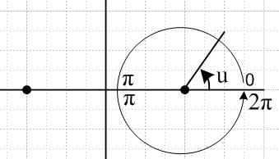

The relationship between u here and θ of the previous section is this:

u = (θ+π) mod (2π)
or
u = θ+π for θ in (0,π)
u = θ-π for θ in (π,2π)
or
u = θ + π sign(π-θ)

For any θ in (0,2π) we know the following to be true:

sinθ = - sinu
cosθ = - cosu
tanθ = + tanu

since it does not matter whether we shift π on one direction or the other. Therefore, we get these formulas from above

x = ashξ/(chξ–cosu) hξ = hu = a/(chξ–cosu) y/x = sinu/shξ
y = asinu/( chξ–cosu)

ξ = tanh-1[2ax/(a2+ x2+ y2)]
tanu = [ -2ay/(a2-x2-y2)]

r2 = a2 (sh2ξ + sin2u) / (chξ-cosu)2 tanφ ≡ y/x = sinu/shξ

x2 + (y- acotu)2 = a2/sin2u yc = a cot(u) R = a/|sinu|
(x - acothξ)2 + y2 = a2/sh2ξ xc = acothξ R = a/|shξ|

As usual, in order to find u we have to do our algorithm described above, but here I will be more detailed:

1. Compute ξ = tanh-1[2ax/(a2+ x2+ y2)]
2. Compute cosu = chξ - (a/x)shξ
3. Compute sinu = (y/x)shξ.
4. Compute u = arctan2P(cosu,sinu)

(d) The vertical set of circles for constant u

I bet M&F had this parameterization once and then did edits to add the complex variable connection, but did not change other text and the picture. Once again, we can take u to be in (0,π) since this will create all possible circles top and bottom. When u is in (0,π/2), cot(u) is positive, circle center is positive, and we get the upper set of circles. When u is in (π/2,π), cot(u) is negative, circle center is negative, and we get the lower set of circles. This is what M&F drew and wrote about, and here is the wiki drawing for (0,π/2) where σ = u. Notice that the red circle at u = π/2 is special, just touching the two foci on the sides.

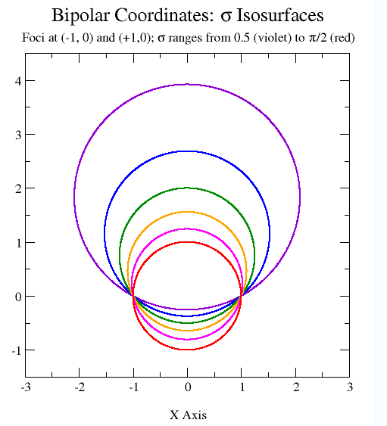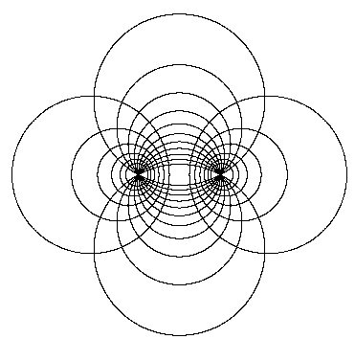

As u → 0+, the purple circle gets very large and becomes the entire x axis approached from above. And as u → π-, you would have a lower large circle approaching the x axis from below.

Comment: when we rotate the above picture around the vertical axis, each circle becomes a sphere. Then we will have each sphere being a surface of constant u, where u is the "trigonometric" variable. So think later of spheres having labels u, and the sphere cross section circle has zc = +a cot(u) and R = a/|sin(u)|. As we shall see below, the locus of "valid" points for some constant value of u lie on a spherical bowl! When u is in the range (0,π), that bowl lies above the z = 0 plane, as shown in Figure A below. Moreover, as u → π, we get the limit of the spherical bowl which is a disk of radius a ! And for u → 0, we get the limit of the spherical bowl which is an iris! So this toroidal system sounds like it may be very useful for the problems I have recently been thinking about! The nice feature is that by considering u = u0 , we are talking about a spherical bowl in 3D space. In spherical coordinates, we need two coordinates to discuss this, we have to say r = r0 and bowl is for θ < θ0 say. In toroidal coordinates, we need one coordinate to describe the bowl, u = u0. I really like how the limits work for disk and iris.

(e) Defining equations versus the circles geometry: proper range of parameters u and ξ

First of all, if we want to cover both left and right half planes with horizontal circles, we need -∞ < ξ < ∞. And if we want to have all vertical circles, we need 0 < u < π . If you look at the picture on the right above, you see that a given (ξ,u) determines one vertical and one horizontal circle. However, such a pair of circles has two intersection points and this determines two (x,y) values. However, our defining equations describe only the upper right intersection point in this case.

x = a shξ/(chξ - cosu) x > 0 sign(x) = sign(ξ)
y = a sinu/(chξ - cosu) y > 0 sign(y) = sign (sin(u))

So the mapping is really 1 to 1, despite the geometry situation.
Now let's study these two defining equations a little more. As u → 0 we have

x = a shξ/(chξ - 1) = a {± $\sqrt{ch2ξ - 1}$/(chξ - 1) } = ± a [ (chξ+1)/(chξ-1) ]1/2

The quantity (chξ+1)/(chξ-1) > 1 for all ξ (since +1 > -1), so when u = 0, as we vary ξ we get all of the x axis outside the two foci. It is true that the large vertical circle becomes all the x axis, but only the part outside the foci is generated by our defining equations!

Similarly, when u → π, cos(u) = -1 and we have

x = a shξ/(chξ + 1) = a {± $\sqrt{ch2ξ - 1}$/(chξ + 1) } = ± a [ (chξ-1)/(chξ+1) ]1/2

and in this case the quantity is always < 1 and we generate just the portion of the x axis between the foci. M&F shows this, but in terms of θ = 0+π.
I suspect this may have a big significance. First, suppose we are interested in a 2D wire segment which runs from -a to a. That wire is represented by u = π and the full range of ξ. And when we go to the full 3D toroidals, u = π will represent just the disk, and u = 0 will represent just the iris. This could be the connection I am looking for.
Now there is another similar issue. If we restrict u to (0,π), it is true that our two sets of circles saturate the entire x-y plane. However, the values produced by the defining equations for (x,y) will then all have sin(u) > 0 and we will then only get y > 0 values since y = a sinu/(chξ - cosu). In other words, only half the points of our two circle set saturation really count, and for (0,π) only those in the upper half plane are hit! This then is why we really need the full range u in (0,2π). I need some good way to draw this.

OK, consider this Maple plot

with(plots):
u := n*Pi/8:
implicitplot( {seq((x)^2 + (y-cot(u))^2 = (sin(u))^(-2),n=1..7)}, x=-2..2, y = -2..2, scaling=CONSTRAINED, view=[-2..2, 0..2]);

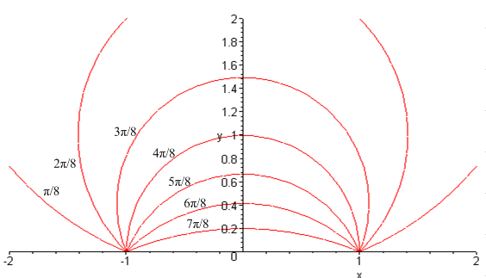 Figure A

For u in the range (0,π), this plot shows the possible points you can hit, all have y > 0. As u→0, you get the x axis outside the foci, and as u→ π, you get the x axis only inside the foci. Notice the π/2 circle in the middle of this family of circles.
If we examine the range (π,2π) in the same manner, we get this situation and we get the y < 0 points

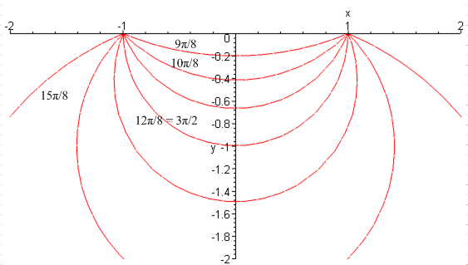 Figure B

So once again: if you set u = 0+ε, you get the x axis outside the foci, but just above. For u = 2π-ε, you get the same thing, but just below. And for u = π, you get the line segment between the foci. The Maple program here is with u := n*Pi/8 + Pi: and we "view" only the lower part.
There is no such "restriction" on the horizontal circles set. Once you pick one or the other of the two situations above, any horizontal set circle intersects at only one point. u=π

Note added 7.9.10. Consider again Figure A, and suppose we set u = 3π/8, and we let ξ then vary in its full range -∞ < ξ < ∞. We get the truncated circle shown in Fig A. In 3D toroidal coordinates, the fixed value u = 3π/8 must therefore describe a spherical bowl! I would imagine, therefore, that if you want to solve the problem of a charged spherical bowl, toroidal coordinates are the way to go! So fixed parameters in toroidal coordinates give you toroids and spherical bowls.

(f) Apollonius comments and geometrical interpretation of the parameters ξ and u

My geometry/a geometry problem points out that the horizontal circles set can be expressed in this way

| r - a| / | r + a| = α, some constant

My doc says that you can relate α to the location of the circle center. It says:

cx = - (-ax+α2bx)/ (1-α2)

which in our case means this

cx = - (-a-α2a)/ (1-α2) = a (1+α2)/(1-α2)

but for our horizontal circles we have this center

cx = a coth(ξ)

so we have

coth(ξ) = (1+α2)/(1-α2)

which has the solution

α 2 = (cothξ-1)/ (cothξ+1) = e-4ξ => α = e-ξ => ln α = -ξ

=> ln [| r - a| / | r + a| ] = -ξ or ξ = ln [| r + a| / | r - a| ] = ln (d1/d2)

This ratio will be 1 when ξ = 0, which is the case that a horizontal circle is the y axis. As ξ → +∞, α → 0 and the | r - a| → 0 as our circles shrink around x = +a. Here is how wiki presents this fact: (ξ = τ)

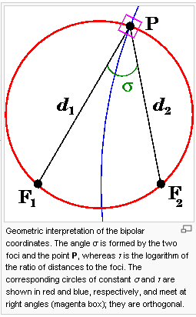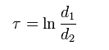

In this picture, the blue circle is the Apollonius horizontal set circle (donut with label τ). The red circle is just the vertical set circle that happens to pass through our selected point P. So if we were to move point P up or down along the blue donut circle, ln(d1/d2) would remain constant and equal to the donut label τ.

Showing the interpretation of angle u=σ is harder. Let's for the moment call the angle shown in the above picture as σ by the name u'. We have

d22 = (x-a)2+y2 d12 + d22 = 2(x2 + y2 + a2 )
d12 = (x+a)2+y2

(2a)2 = d12 + d22 - 2d1d2 cos(u')

cos(u') = (d12 + d22 - 4a2)/(2 d1d2) = [2(x2 + y2 + a2 ) - 4a2] /(2 d1d2)

= [x2 + y2 + a2 - 2a2] / (d1d2) = [x2 + y2 - a2 ] / (d1d2)

Meanwhile we have

(d1d2)2 = [(x-a)2+y2] [(x+a)2+y2] = [x2 + y2 + a2 -2ax] [x2 + y2 + a2+2ax]

= [(x2 + y2 + a2)/2ax -1] [(x2 + y2 + a2)/2ax +1] (2ax)2

= [ cothξ - 1] [ cothξ + 1] (2ax)2 = (coth2ξ-1) (2ax)2 = (2ax)2/(shξ)2

= (2a)2 a2sh2ξ/(chξ - cosu)2/(shξ)2 = (2a2)2 / (chξ - cosu)2

=> d1d2 = 22/(chξ - cosu) => 1/(d1d2) = (chξ - cosu)/(2a2)

So going back we then have (see Summary for 2nd =)

cos(u') = [x2 + y2 - a2 ] / (d1d2) = [x2 + y2 - a2 ] (chξ - cosu)/(2a2)

= 2ay cot(u) (chξ - cosu)/(2a2) = y cot(u) (chξ - cosu) /a

= { a sinu/(chξ - cosu) } cot(u) (chξ - cosu)/a = sinu cot(u) = cosu

Thus we have shown that the angle appearing in the above picture (which I called u' and picture calls σ) is in fact the same as the parameter u. Below is a theorem I never knew before, which then verifies the idea that as P moves along the red circle above, angle σ stays the same (σ is the bowl label). In the figure below, you can think of σ as angle a.

Circle Theorems Batch 1: Consider this picture where the horizontal line represents any chord

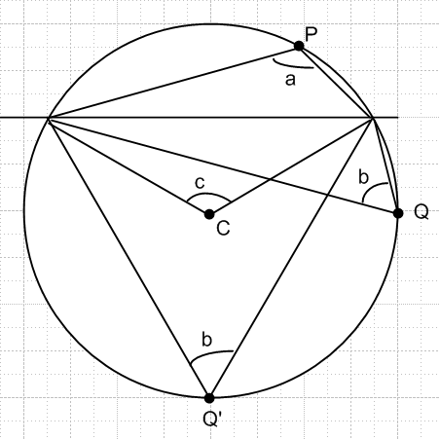

The theorem says that as P moves along the circle above the chord, the angle a stays constant. Similarly, as Q moves on the lower portion, the angle b stays constant. Moreover, a+b = π. This appears on the wiki circle page in this way:

It also turns out that angle b shown above is half the central angle c:

As a special case, if the chord is a diameter, then angle c = π and angle b = π/2 ( = angle a), and even this special case is not very obvious (this is the case that Crodt knew).

I don't think the above "facts" have any particular name. I might just say they are part of a set of "chord theorems" for a circle.

(f0) More Graphical Interpretation of Coordinate u: the contact angle

One implication of the chord theorem above is illustrated in the first figure below. Although this figure shows one sphere and two chords, one should think of it as representing two spheres and one chord -- it was just easier to draw it this way. In each case, think of the chord as the x axis and the part above this axis being an "upper bowl". The upper chord case is usually the picture used to describe a "sessile droplet" of liquid on a flat surface. It is a shallow bowl case. The lower chord case shows a droplet (if it could exist that way) which is more than a hemisphere. Now the implication of our chord theorem above is simply this: in both cases we are showing the angle u (the toroidal coordinate u) exactly as in the above two pictures. In the first picture above this angle is called σ, and in the second it is called a or b. If we move the dotted point down to the right toward the chord intersection, we find that the toroidal coordinate u is in fact the same as the "outside upper bowl lip angle". The figure shows this is the case for a shallow bowl and for a bowl that is more than a hemisphere, and we are thinking of u ranging (0,π) since we are only talking here about "upper bowls". For sessile droplets, the complementary angle θ is "the contact angle".

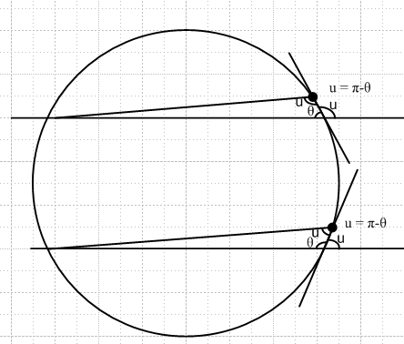

We can now draw the corresponding picture for two lower bowls:

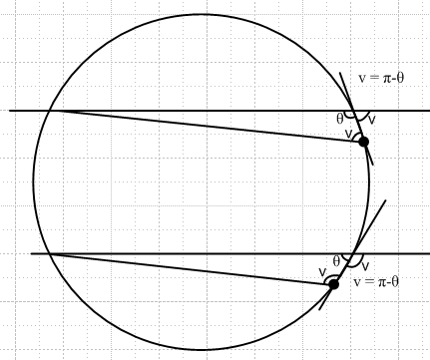

The lower chord now represents a shallow lower bowl. We have used v instead of u for a particular reason. As we saw in the red Maple plots above, for lower bowls the range of the u coordinate is (π,2π). The connection to our angle v is simply u = 2π - v. For example, in Figure B we show a lower shallow bowl with u = 9π/8. The outside bowl lip angle is v = 7π/8 for this bowl, and the contact angle θ= 1π/8. So we see that u = 2π - v = 2π - 7π/8 = 9π/8 and verifies our little formula. So if we now want to relate u to the contact angle we have this:

u = 2π - v = 2π - (π-θ) = π + θ

So if we have an upper bowl and a lower bowl of exactly the same shape with contact angle θ, we know then that (contact angle θ is the same for both bowls and lies in the range (0,π) )

u = π-θ for the upper bowl
u = π+θ for the lower bowl

(f1) the metric tensor.

From doc "tensors and curvilinear coordinates" we have:

g'ab = Tac Tbc or g'dn = Tup(Tup)T

Tab = $\begin{matrix}∂xb \\ ∂x'a\end{matrix}$

The coordinates x are the Cartesians x,y, and the x' = q are the "curvilinear" coordinates like ξ,y. Here is some standard code to compute the metric tensor g' for our current case. Recall that

x = a shξ/(chξ - cosu)
y = a sinu/(chξ - cosu)

We start by building the T matrix in Maple. Notice the a and b in the TT line and compare to the above where we have Tab = $\begin{matrix}∂xb \\ ∂x'a\end{matrix}$. The (a,b) are in the usual Mab order where a = row, b = col index.

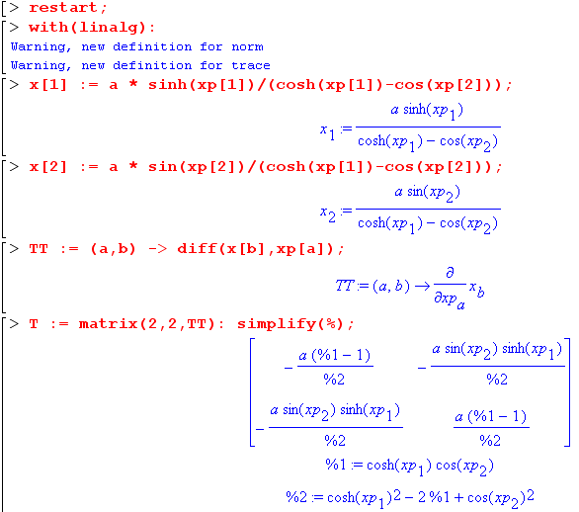

Then we make Maple compute the g' matrix

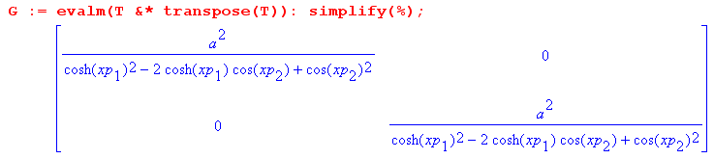

This shows that (1) the metric tensor is diagonal, so we have an orthogonal coordinate system, which means our circles meet at right angles, something we did not prove above, but here it is in effect proved. (2) both diagonal elements are the same. Thus we have shown that (since gii = hi2)

hξ = hu = a/[ ch(ξ) - cos(u)]

which agrees with wiki

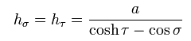

and with the M&F screen clip above where we cosθ = - cosu. It is interesting and a bit unusual I think that both scale factors are the same. This probably has some significance.

(g) Summary on bipolar coordinates in u parameterization

First, here is the picture that goes with the equations below (focal points are at x = ± a)

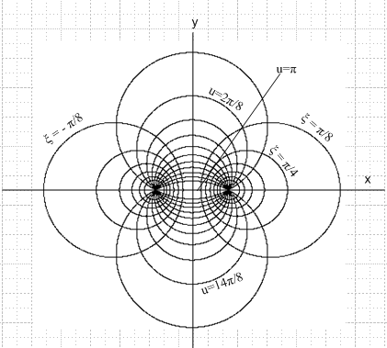

So to summarize our situation with bipolar coordinates, we have (just copy down from earlier)

x = ashξ/(chξ–cosu) hξ = hu = a/(chξ–cosu) y/x = sinu/shξ
y = asinu/( chξ–cosu)

ξ = tanh-1[2ax/(a2+ x2+ y2)]
tanu = [ -2ay/(a2-x2-y2)] // use algorithm to find u

r2 = a2 (sh2ξ + sin2u) / (chξ-cosu)2 tanφ ≡ y/x = sinu/shξ

x2 + (y- acotu)2 = a2/sin2u yc = a cot(u) R = a/|sinu|
(x - acothξ)2 + y2 = a2/sh2ξ xc = acothξ R = a/|shξ|

ranges: ξ in (-∞, ∞) u in (0,2π)

Note added 1.22.11: Large r limit. We know that "large r" corresponds to BOTH u and ξ being small (see doc on bowl). Therefore in this limit we have from a bove

r2 = a2 (sh2ξ + sin2u)/(chξ - cosu)2 ≈ a2 (ξ2+u2) / [ (1/2)(ξ2+u2)]2 = (2a)2/ (ξ2+u2)

where we have used

(chξ - cosu) ≈ (1/2)(ξ2+u2) => $\sqrt{ξ2+u2}$ ≈ $\sqrt{2}$$\sqrt{chξ - cosu}$

r ≈ 2a/$\sqrt{ξ2+u2}$ r ≈ $\sqrt{2}$a / $\sqrt{chξ - cosu}$ => $\sqrt{chξ - cosu}$ ≈ $\sqrt{2}$a/r in the large r limit

Note that this large r limit stuff is the same for toroidal as for bipolar, so I don't repeat it below.

(g1) Summary on bipolar coordinates (different notation)

I want to restate all results of section (g) with y → z, with ξ → μ, with u → η, and with x → ρ, so we will then be in M&F notation, ready for the next section. Since the angle called φ above is not the cylindrical azimuthal angle φ, I give it the new name Φ to avoid possible confusion.

I just copy and edit:

x = ashμ/(chμ–cosη) hμ = hη = a/(chμ–cosη) y/x = sinη/shμ
y = asinu/( chμ–cosu)

μ = tanh-1[2ax/(a2+ x2+ y2)]
tanη = [ -2ay/(a2-x2-y2)] // use algorithm to find η

r2 = a2 (sh2μ + sin2η) / (chμ-cosη)2 tanφ ≡ y/x = sinη/shξ

x2 + (y- acotη)2 = a2/sin2η yc = a cot(η) R = a/|sinη|
(x - acothμ)2 + y2 = a2/sh2μ xc = acothμ R = a/|shμ|

ranges: μ in (-∞, ∞) η in (0,2π)

(g2) Complex notation. (added 9.11.10)

I learned from the "wilson toroid green's" pdf paper that you can relate cylindrical ρ,z to toroidal μ,η in the following manner:

ρ + iz = a coth[ (μ-iη)/2] (*)

I verify this below with brute force algebra, but later I added the comment which gives a more elegant derivation. Wilson gives no reference for (*). Page 234 of Lebedev's book makes the claim that z + ir = ic coth[ (α+iβ)/2]. If we mult by -i, this becomes r-iz = c coth[ (α+iβ)/2], then do CC and this becomes r_iz = c coth[ (α-iβ)/2] which then agrees with the Wilson result. Lebedev also makes no comment on this "concise" formula, but at least I have now seen it in two sources.

Comment: In Ahlfors page 84, we considered the complex mapping w = k (z-a)/(z-b) and we learned that rays and concentric circles in w space map into the Steiner circles which are precisely our bipolar coordinates if we set b = -a and k = 1 and we make the correct associations of parameter. So consider
w = (z-a)/(z+a) as our complex mapping. We know that if we take |w| = |(z-a)|/|(z+a)| = α [ using notation above] then those concentric circles in w space are mapping into the horizontal Apollonius circles, and we already know from Section f above that α = e-μ. This means we must be able to write
w = (z-a)/(z+a) = e-μ eiψ where ψ is some phase. If we redraw our little picture above with some added angles, where we show one of the "vertical circles" of our bipolar coordinates:

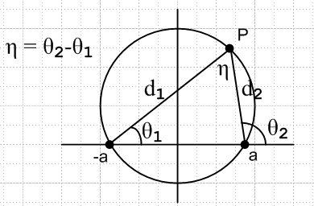

We this see at once that ψ = θ2-θ1 = η, so we have then shown that (beware toroidal z overload)

(z-a)/(z+a) = eiη-μ = w z = x+iy // = ρ + iz in toroidals
// Note that z = a(1+w)/(1-w)
From this we may conclude that

μ-iη = ln[(z+a)/(z-a)] = 2 coth-1(z/a) // Schaum p 29 8.58

Therefore we find that

z = a coth[(μ-iη)/2] = x + iy (compare to * above)

and thus we have a quick derivation of Wilson's result. This then leads, as shown in our Verification below, to the usual defining equations for x and y in bipolar coordinates. To summarize both directions:

x + iy = a coth[(μ-iη)/2] μ-iη = ln[(x + iy +a)/( x + iy -a)]

So, we find that rays and concentric circles in w space, of the complex mapping w = (z-a)/(z+a) [ which is to say z = a(1+w)/(1-w)], map into the vertical and horizontal sets of circles of our bipolar coordinates in z space, where z = x+iy. The vertical circles are labeled by η, and the horizontal circles by μ. Given point z = x + iy, we may compute the correct values for μ and η according to μ-iη = ln[(x+iy+a)/(x+iy-a)]. Here is another way to write this

η = arg(z-a) - arg(z+a) μ = ln|z+a| - ln|z-a| where z = x+iy
|

Verification of (*): How would I verify this? Got to p 27 Schaum and write

coth[ (μ-iη)/2] = coth(a-b) = [ coth(a)coth(b) - 1 ] / (coth(b) - coth(a) )

= -[ coth(μ/2)coth(iη/2) - 1 ] / (coth(μ/2) - coth(iη/2) )

= -[ coth(μ/2)(-i)cot(η/2) - 1 ] / (coth(μ/2) - (-i)cot(η/2) ) // Schaum p 31, conf 2008

= -[ -i coth(μ/2)cot(η/2) - 1 ] / (coth(μ/2) +i cot(η/2) )

At this point we can rationalize in the usual way to get

= -(coth(μ/2) -i cot(η/2) ) [ -i coth(μ/2)cot(η/2) - 1 ] / (coth2(μ/2) + cot2(η/2) ) = N/D

The numerator here is then

-N = (coth(μ/2) -icot(η/2) ) [ -i coth(μ/2)cot(η/2) - 1 ]

= { - cot2(η/2) coth(μ/2) - coth(μ/2) } + i { - coth2(μ/2)cot(η/2) + cot(η/2) }

= coth(μ/2){ - cot2(η/2) - 1 } + i cot(η/2) { - coth2(μ/2) + 1 }

= coth(μ/2){ - csc2(η/2) } + i cot(η/2) { - csch2(μ/2) }

So at this point we have shown that

coth[ (μ-iη)/2] = [coth(μ/2)csc2(η/2) + i cot(η/2)csch2(μ/2) ] / [(coth2(μ/2) + cot2(η/2) )]

and everything is still in half-angles. But our known ρ and z formulas are in full angles. The claim at this point is this:

ρ = a coth(μ/2)csc2(η/2) / [(coth2(μ/2) + cot2(η/2) )]

z = a cot(η/2)csch2(μ/2) ] / [(coth2(μ/2) + cot2(η/2) )]

But at once we have a problem with the sign and the ρ claim, since we know μ > 0 and ρ > 0. I have checked it all line by line, so something is amiss. Let's ignore this problem for now and go on to process things further.

coth(μ/2) = shμ/(chμ-1) Schaum p 27
csch2(μ/2) = 2/(chμ-1)

cot(η/2) = sinη/(1-cosη) Schaum p 16
csc2(η/2) = 2/(1-cosη)

D = coth2(μ/2) + cot2(η/2) = sh2μ/(chμ-1)2 + sin2η/(1-cosη)2

So our results then are

ρ = a shμ/(chμ-1) * 2/(1-cosη) * 1 / [sh2μ/(chμ-1)2 + sin2η/(1-cosη)2]
z = a sinη/(1-cosη) * 2/(chμ-1) * / [sh2μ/(chμ-1)2 + sin2η/(1-cosη)2]

Multiply each of these lines by (1-cosη) (chμ-1) to get

ρ = a shμ * 2 * 1 / [(1-cosη)sh2μ/(chμ-1) + (chμ-1)sin2η/(1-cosη)] = 2 a shμ / E
z = a sinη * 2 * / [(1-cosη)sh2μ/(chμ-1) + (chμ-1)sin2η/(1-cosη)] = 2 a sinη / E

where the two denominators are the same. Let's call them E. Then we have

E = [(1-cosη)sh2μ/(chμ-1) + (chμ-1)sin2η/(1-cosη)]
= [(1-cosη)2sh2μ + (chμ-1)2 sin2η]/ [(chμ-1) (1-cosη)] = F/G

Continuing on this long journey, we can then write

F = (1-cosη)2sh2μ + (chμ-1)2 sin2η
= (1 + cos2η - 2cosη) sh2μ + (ch2μ + 1 - 2chμ) sin2η
= (1 + cos2η - 2cosη) (ch2μ - 1) + (ch2μ + 1 - 2chμ) (1 - cos2η)

= (ch2μ) { (1 + cos2η - 2cosη) + (1 - cos2η) } + chμ { 2 (cos2η - 1) }
- (1 + cos2η - 2cosη) + (1 - cos2η)

= (ch2μ) { (1 - 2cosη) + (1) } + chμ { 2 (cos2η - 1) } - (cos2η - 2cosη) + (- cos2η)
= (ch2μ) { (2 - 2cosη)} + chμ { 2 (cos2η - 1) } - (2cos2η - 2cosη)
= (ch2μ) 2 { (1 - cosη)} + chμ 2 { (cos2η - 1) } - 2 cosη (cosη - 1)
= 2 { (ch2μ) (1 - cosη) + chμ (cos2η - 1) - cosη (cosη - 1) }
= 2 { (ch2μ) (1 - cosη) + chμ (cosη - 1) (cosη + 1) - cosη (cosη - 1) }
= 2 (1 - cosη){ ch2μ – chμ (cosη + 1) + cosη }
= 2 (1 - cosη){ ch2μ – chμ cosη – chμ + cosη }
= 2 (1 - cosη){ chμ (chu - cosη) – (chμ - cosη) }
= 2 (1 - cosη) (chu - cosη){ chμ – 1) }
= 2 (1 - cosη) (chu - cosη)( chμ – 1)

It is quite amazing that this factors in this way! We then know that

E = F/G = 2 (1 - cosη) (chu - cosη)( chμ – 1) / [(chμ-1) (1-cosη)] = 2 (chu - cosη)

Our results are then

ρ = 2 a shμ/E = a shμ/(chu - cosη)

z = 2 a sinη / E = a sinη /(chu - cosη)

These then are the correct answers. Here is a Maple confirmation of my factorization of F.

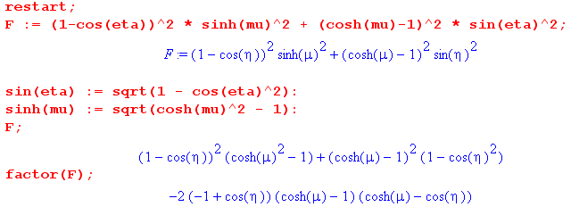

(h) extension to and summary of toroidal coordinates.

The plan is to think of (x,y) above as (x,z) instead, so our bipolar coordinates are on the x,z plane. Then we will rotate that plane around the z axis by angle φ to get our toroidal coordinates. If we now restrict ξ to (0,+∞), we are restricting our 2D bipolar coordinates to the right half x-z plane. But then if we do azimuthal rotation about the z axis by φ, then that half plane sweeps out all space, so we haven't lost anything. Our starting position here is then

x = a shξ/(chξ - cosu) a = focal distance = radius of the limiting torus
z = a sinu/(chξ - cosu)

So we should then end up with: [ that is to say, x = xold cosφ and y = xold sinφ]

x = a cosφ shξ/(chξ - cosu) ρ = a shξ/(chξ - cosu) ρ2 = x2+ y2
y = a sinφ shξ/(chξ - cosu)
z = a sinu/(chξ - cosu)

This agrees with wiki. The above also agrees with M&M page 191. Here is our new picture:

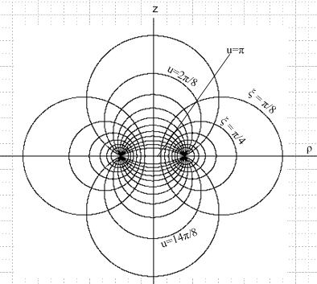

and here are the bipolar results from above, converted to the toroidal coordinates

ρ = ashξ/(chξ–cosu) ρ>0 hξ = hu = a/(chξ–cosu) z/ρ = sinu/shξ
z = asinu/( chξ–cosu) ρ2 = x2+ y2

ξ = tanh-1[2aρ/(a2+ ρ2+ z2)]
tanu = [ -2az/(a2-ρ2-z2)] // use algorithm to find u

r2 = a2 (sh2ξ + sin2u) / (chξ-cosu)2 tanφ ≡ z/ρ = sinu/shξ

ρ2 + (z- acotu)2 = a2/sin2u zc = a cot(u) R = a/|sinu|
(ρ - acothξ)2 + z2 = a2/sh2ξ ρc = acothξ R = a/|shξ|

ranges: ξ in (0, ∞) u in (0,2π)

Let's compute the toroidal metric tensor. We do this as above but now we have (x1', x2', x3') = (ξ,u,φ). First we enter the transformation equations

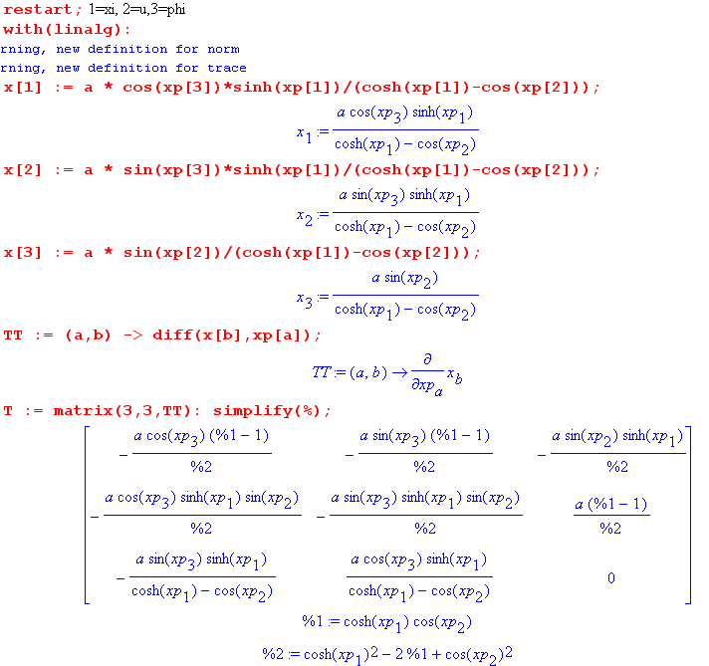

and then we compute G, where ordering is (ξ,u,φ).

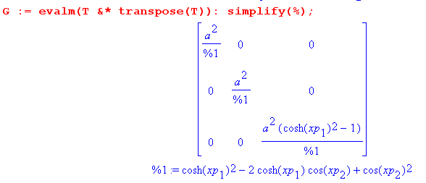
This shows that the hξ and hu are the same as they were in the bipolar case, and now we have hφ = shξ hξ getting that extra shξ factor. So in our current notation we have

x = a cosφ shξ/(chξ - cosu) ρ = a shξ/(chξ - cosu)
y = a sinφ shξ/(chξ - cosu)
z = a sinu/(chξ - cosu)

hξ = hu = a/[ ch(ξ) - cos(u)] hφ = a shξ/[ ch(ξ) - cos(u)]

Notice that we write ρ = $\sqrt{x2+y2}$ and this is the ρ of cylindrical coordinates. So we can relate our toroidal coordinates to cylindrical coordinates in this manner

ρ = a shξ/(chξ - cosu)
z = a sinu/(chξ - cosu)
φ = φ

I keep thinking this is going to relate to my iris/disk problems.

Now we shall look at what various authors have to say on the subject of bipolar and toroidal coordinates.

(i) Margenau and Murphy

They first treat 2D bipolars on page 187. A long development with preliminary facts well-known to current day readers. Then ρ = x+iy and we end up with the usual stuff where:

ηMM = ξ from above
ξMM = u from above

Picture on page 189. They show the complex mapping that results in bipolars, there has to be one, but I am not concerned about that right now. Finally on page 190 we see the two scale factors as above. Same coordinate ranges as I note above. Well, here is the complex transform, but in M&F notation, just for the record

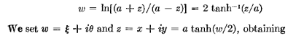

[MM use -iχ = w and χ = ξ + iη in MM variables. See also Ahlfors p 84 B in his "analytic functions as mappings" chapter, which adds a complex constant k out front of the log. Ahlfors calls the two circle sets "Steiner Circles" and never mentions that this is known as "bipolar coordinates" when k = 1 . Page 85 shows how the x-y plane rays map into the vertical circle set, while x-y plane concentric circles map into the Apo horizontal circle set. ]

Then on page 190 MM start toroidals and they have my equations top p 191 including scale factors, but of course they use completely different symbols, to wit

η MM = ξ from above
ξ MM = u from above
ψ MM = φ from above

At least MM used the same two bipolar variable names when they went to toroidals.

(j) Morse and Feshbach: atomic forms + potential of a charged torus + 1/R expansion

Page 1301 of Vol II has

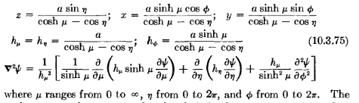

So M&F have not even used their own same bipolar symbols. They now have

μ M&F = ξ from above
η M&F = u from above
φ M&F = φ from above // at least this one agrees!

and the ranges agree. M&F go on to process the Laplace equation. First

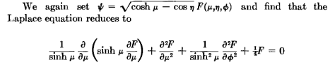

(I have not checked this step, but accept it for now). So now we have a PDE for function F which will cause ψ to solve the Laplace PDE. BUT there is a big typo! The second term should be ∂η2F ! [ I would add this to the M&F errata page if there were one ]. Now it comes time to separate this thing so write

F(μ,η,φ) = f(μ)g(η)h(φ)

and the above becomes

g(η)h(φ) (1/shμ)∂μ(shμ ∂μ) f(μ) + f(μ) h(φ)∂η2 g(η) + (1/shμ)2 f(μ)g(η) ∂φ2 h(φ) + f(μ)g(η)h(φ)/4= 0

and as usual divide by the triple product and get

[(1/shμ)∂μ(shμ ∂μ) f(μ)]/f(μ) + [ ∂η2 g(η)]/g(η) + (1/shμ)2 [∂φ2 h(φ)]/h(φ) + 1/4 = 0

For the middle term, we can separate out the η action and have g(η) = sin(nη) so [ ∂η2 g(η)]/g(η) = -n2 so

[(1/shμ)∂μ(shμ ∂μ) f(μ)]/f(μ) -n2 + (1/shμ)2 [∂φ2 h(φ)]/h(φ) + 1/4 = 0

Multiply this by (shμ)2 to get

[shμ ∂μ(shμ ∂μ) f(μ)]/f(μ) + (1/4-n2)(shμ)2 + [∂φ2 h(φ)]/h(φ) = 0

Now separate the φ part saying h(φ) = sin(mφ) so [ ∂φ2 h(φ)]/h(φ) = -m2 so

[shμ ∂μ(shμ ∂μ) f(μ)]/f(μ) + (1/4-n2) (shμ)2 - m2= 0

Multiply by f(μ) to get

[shμ ∂μ(shμ ∂μ) f(μ)] - [(n2-1/4)(shμ)2 + m2] f(μ) = 0

Divide by shμ2

[(1/shμ) ∂μ(shμ ∂μ) f(μ)] - [(n2-1/4)+ m2/(shμ)2] f(μ) = 0

which agrees with M&F result

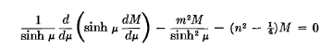

where their M is my f. Now to make contact with Legendre, set z = chμ and shμ = $\sqrt{z2-1}$and

dz = shμ dμ ∂μ = shμ ∂z = $\sqrt{z2-1}$∂z

so we have

(1/$\sqrt{z2-1}$) * $\sqrt{z2-1}$∂z ($\sqrt{z2-1}$*$\sqrt{z2-1}$∂z) K(z) - m2/(z2-1) K(z) - (n2-1/4) K(z) = 0

(1/$\sqrt{z2-1}$) * $\sqrt{z2-1}$∂z ($\sqrt{z2-1}$*$\sqrt{z2-1}$∂z) K(z) - m2/(z2-1) K(z) - (n2-1/4) K(z) = 0

∂z ((z2-1)∂z) K(z) - m2/(z2-1) K(z) - (n2-1/4) K(z) = 0

(z2-1) ∂2zK(z) + 2z ∂zK(z) - m2/(z2-1) * K(z) - (n2-1/4) K(z) = 0

[ (z2-1) ∂2z + 2z ∂z - m2/(z2-1) - (n2-1/4) ] K(z) = 0

Let N = n-1/2 then N(N+1) = (n-1/2)(n+1/2) = (n2-1/4) so we have

[ (z2-1) ∂2z + 2z ∂z - m2/(z2-1) - N(N+1) ] K(z) = 0

[ (1-z2) ∂2z - 2z ∂z + m2/(z2-1) + N(N+1) ] K(z) = 0

[ (1-z2) ∂2z - 2z ∂z - m2/ (1-z2) + N(N+1) ] K(z) = 0

And this has the form shown Schaum p 149 and we then know that

K(z) = Pn-1/2m(z) type functions

and then we have our complete solution atoms of this form:

ψ = $\sqrt{chμ - cosη}$ sin(nη) sin(mφ) Pn-1/2m(chμ)

where I just show a representative atom. M&F then write a full atomic expansion as

and it seems pretty clear that in this form, φ and η are oscillatory and μ is the "expo" or "radial" coordinate. NOTE: m quantized to integers if full azimuth, n quantized to integers if full toroid surface.

Comment added: The range of the η variable is (0,2π) similar to azimuth. We know that any problem which has the full range of azimuth must have m quantized to an integer. Similarly, a problem with full range of η (which would mean includes all bowls top and bottom of the z = 0 plane) must have n = integer. Thus, the "ring functions" Pn-1/2(chμ) are usually thought of with n = integers, so you are then talking about the P's with half integral order.

M&F Sample Problem. In M&F notation, parameter μ labels one of the horizontal circles and thus defines an entire closed torus. The problem is this: what is the potential of a charged metal torus?
First issue: as you move radially away from the torus, you are moving to horizontal circles of smaller μ, which was called τ in our picture above

So as we move radially away, μ → 0 so we have to de-select the function Qn-1/2m(chμ) because we know that this thing is singular at chμ = 1 and blows up, whereas Pn-1/2m(chμ) is in general finite at chμ = 1. Recall from leg prop doc

the P(+1) finite cases: Pνm(1) = 0 in these cases [ with exception P00(1) =1] , else Pνm(1)= ∞
ν = anything:
Re(m) < 0 and m ≠ integer
m = integer Pνm(1) = δ0m

and we have m = integer, so this function is δ0m for any ν!
Second issue: we know the solution is m = 0 only, so there is no φ dependence. Therefore we can write an atomic form this way [ we know that z ~ sin(η) , we know the result is even in z, so it must also be even in η, hence only the cos(nη) appears here. ]

ψ = $\sqrt{chμ - cosη}$ Σn An Pn-1/2(chμ) cos(nη)

Now assume the metal torus has μ = μ0. Then M&F claim they know the An coefficient as shown here: [ Note that there should be a factor εn on the RHS in 10.3.80! ] M&M 1953 page 1304

// should have εn

We know this has the right atomic form, we know it has the right distance behavior, and if we evaluate it on the metal torus we get

ψ(μ0, η, φ) = (V0/π) $\sqrt{2}$ $\sqrt{chμ - cosη}$ Σn=0∞ εn Qn-1/2(chμ0) cos(nη) (*)

BUT, M&F have just proven all this stuff

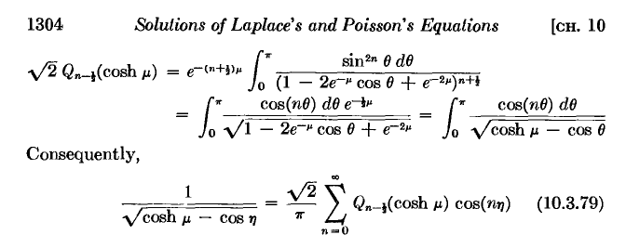(** should have εn)

where the first is an integral representation of Q (which we don't need right here) and the last thing is a series representation for 1/$\sqrt{chμ - cosη}$. Such things are very hard to find. GR have some series in their Special functions section, such as

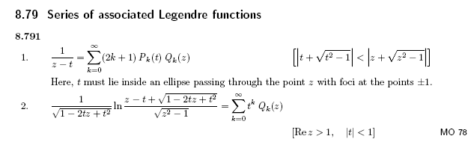
but the toroidal one shown above in M&F is nowhere to be found. This would be a good sum to think about, I think it has some simple interpretation, and we know of a similar sum for Pn, and I think each coordinate system has a sum like this. And in fact I ran into this I think in my disk stuff.

Note added 9.13.10. I derive the above result (**) in my 1/R toroidal doc and my derivation shows that there should be a factor εn on the right side, so this is another M&F errata! The formula can be interpreted as a special case of the general 1/R expansion written in a hybrid manner, see that doc. This also follows from my "ragged doc" Fourier analysis.

So here is the punch line: if we use the sum (**) in our potential (*) at the toroid surface, we find

ψ(μ0, η, φ) = V0

which then verifies the claimed solution above. Very good, I like it!
M&F's final useful result in their toroidal section is an expansion for 1/R ( errata!)

It seems reasonable, but I have not derived it. [ I have now, and the (-i)n should be (-1)n. ] The last factor is of course Pn-1/2(chμ<) Qn-1/2(chμ>) so that far away you get μ → 0 which means μ < μ0 so μ = μ< and we get the converging P function. Conversely, we can imagine our metal torus is just a math surface on which we have V0, and as we move to smaller math tori inside, we will be going to large μ and we need Q to get convergence.
I am dubious about the (-i)m factor because everything should be real here including P and Q. I was unable to find verification of the above in a quick web search. Take note of the following claim:

The Helmholtz differential equation is not separable in toroidal coordinates, but Laplace's equation is.

On page 666 M&F have their "page" on toroidals, but it is more in the ellipsoidal parameters form with ξ1,2,3 so not relevant to the above, you could make the connection such as ξ1 = chμ and so one.

Note Added 5.21.10. Since writing the above stuff, I learned more about the integral shown above! In my now very ragged "cos(nx) over sqrt(a-bcosx).doc", I show that

1/$\sqrt{a - b cos(x)}$ = (1/π) $\sqrt{2/b}$ Σn=0∞ εn Qn-1/2(a/b) cos(nx) // expansion

$^{\int_{0}^{π}{}}$dx cos(nx)/ $\sqrt{a - b cos(x)}$ = $\sqrt{2/b}$ Qn-1/2(a/b) // projection

If I set b = 1 and a = chμ and x = η, this becomes

1/$\sqrt{chμ - cosη}$ = (1/π) $\sqrt{2}$ Σn=0∞ εn Qn-1/2(chμ) cos(nη) // expansion

$^{\int_{0}^{π}{}}$dη cos(nη)/ $\sqrt{chμ - cosη}$ = $\sqrt{2}$ Qn-1/2(chμ) // projection

Notice that M&F have an error! They are missing the εn factor in the expansion! I know it is there for many reasons, one of which is equation (5) of my Selvaggi paper. M&F only do one application which only involves m = 0, and εm = 1 for m=0 so this error does not affect their application!
So I am now very happy with the entire screen clip above.

(k) Other sources on toroidals

Smythe's only references to "toroidal" are in problems, references and the index! So nada!

Green and red Jackson don't even mention toroidals.

None of my other downloaded math methods books even has toroidal anything (Lebedev does, below).

Neither big W&W book has anything.

The huge Jeans PDF has no appearance of the word "toroidal".

At this site

http://books.google.com/books?id=po-6Yxz851MC&pg=PP13&lpg=PP13&dq=%22toroidal+coordinates%22+%22point+charge%22&source=bl&ots=w5f6kZUt0i&sig=ehg57WeZISx_o_symqUmd36RVPg&hl=en&ei=CqHcS86TKYiyswP2zPDQBg&sa=X&oi=book_result&ct=result&resnum=10&ved=0CDcQ6AEwCQ#v=onepage&q=%22toroidal%20coordinates%22%20%22point%20charge%22&f=false

I found some interesting stuff . This is a Dover book by Lebedev and Silverman called "Special Functions and their Applications" . A download seems to be here

http://rs334.rapidshare.com/files/130746999/special_functions_and_their_applications__lebedev_-_prentice_hall.djvu

I think I have it. Yup. This book has a solution of the spherical bowl problem using toroidals! It also does the axial Green's for a disk. It shows how to do general Dirichlet problems in toroidals. Just another good reference.

I think Fabricant is on to something, here is one of his references

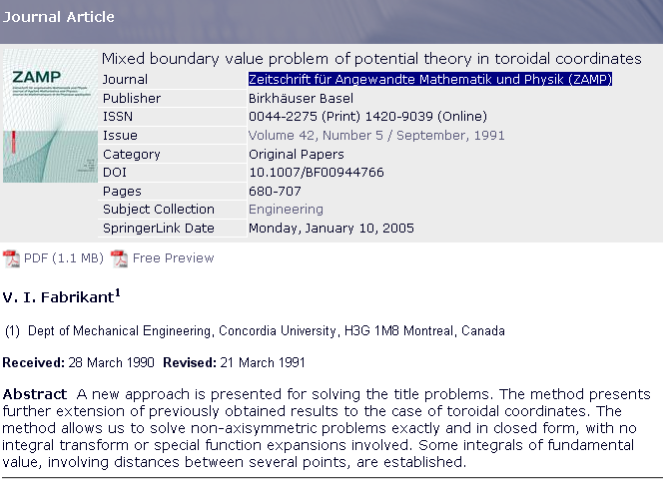

Marriott has this journal in the ARC

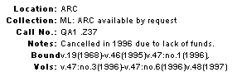

but Fabrikant has previous papers,



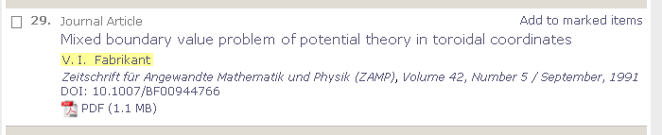



I just found this paper for download here

http://dml.cz/dmlcz/104200

Meanwhile,

http://en.wikipedia.org/wiki/Green%27s_function_for_the_three-variable_Laplace_equation

has the following: ( good old Chester Snow! )

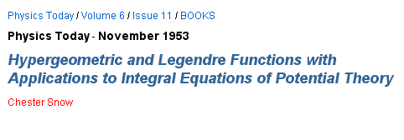
But this is not online at Marriott since < 1975 and I looked hard on the web. But I found something
here http://babel.hathitrust.org/cgi/pt?id=mdp.39015023896346 So I can at least browse the paper.
He has this

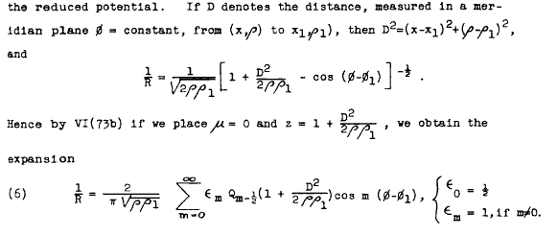
He is in cylindrical coordinates where my z is his x. I have seen this kind of thing elsewhere. This book has PL-like hand written Greek letters in the equations, and is pre-Bateman! Enough!

(l) Sturm-Liouville aspects of toroidal coordinates: Mehler-Fock Transform

The azimuthal φ coordinate will quantize m to integers in the usual way. I will take this to be an oscillatory coordinate. Let's use the M&F coordinate names η and μ. It all depends on what problems are being attacked, but we might select η to be the second oscillatory coordinate, with quantum number n = integer (problems with a full toroid shape around the cross section), leaving μ as the "radial" coordinate. In this case, I suppose functions like Pn-1/2(chμ) are analogous to rn and r-n-1 of spherical coordinates, and we don't obtain any "new information" about the ring functions P and Q.
I could imagine, however, problems (perhaps the charged bowl problem) where we might want the η solutions to be e±pη (V→0 far away). In this case, η would be the non-oscillatory coordinate, and we would then have an interesting SL problem in the μ coordinate, and we have then a new quantum number I have just called p (replacing n), and this SL problem would determine that legal values of p. The way this works of course is that we have n = ip, and then the μ functions are going to be of the form Pip-1/2(chμ). As shown Bateman p 174, these are the so-called "conical functions" which I have never used before (or even thought about for 1 second). In this world, we are going to have some sort of "expansion theorem", orthogonality, and all that good stuff. I don't see this in M&F anywhere, Smythe says a little referring to "cone functions". They are also called Mehler functions (the big circle is perhaps starting to close now). I think the expansion theorem has the name Mehler-Fock transformation, here are some notes from a new site I just found suggesting p has continuous range (0,∞) as its spectrum:

http://dlmf.nist.gov/14.20 // but this site crashes me later

Instead I quote from page 35 of the book shown below in red,

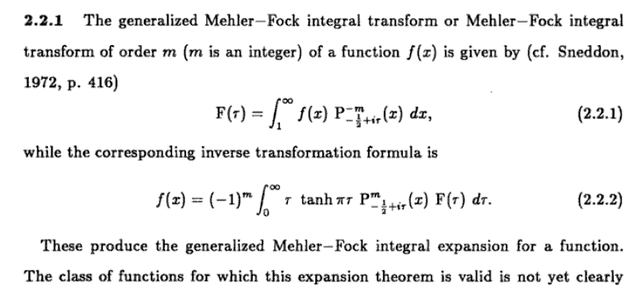

The above also appears in Bateman Legendres page 175 with f(x) slightly redefined. [ A variation of the above also appears in my newly acquired Boeing Report 246.]

At least you can read the transform above. This must be the SL problem in the μ direction. This is probably the same Sneddon reference that red Jackson has. [ wrong, this ref is from Sned's transforms book, not his dual integral equations book.]

Here, the variable I called p above is called τ. The second line is an expansion of some function g(x) over the continuous spectrum of τ. The first line is the projection f(τ). We could combine these to get a statement of completeness and orthogonality.
I just found an entire 1997 BOOK just on this subject (Google books), in which they solve the hyperboloid Dirichlet problem using the cone functions

http://books.google.com/books?id=8omV52FJRV8C&printsec=frontcover&dq=mehler+fock&source=bl&ots=3xOOWF5k37&sig=JMIkTSSjTIb5wxav6yVM2OAEM3w&hl=en&ei=I4r8S_GZBoLcNeaLwd4H&sa=X&oi=book_result&ct=result&resnum=5&ved=0CCYQ6AEwBA#v=onepage&q&f=false



There is a whole modern world of information including papers on this subject, which I don't plan to digress further into. My Vilenkin book has it, but I don't have that section copied. It is here

http://books.google.com/books?id=08hPoGgSQFIC&pg=PA530&lpg=PA530&dq=mehler+fock&source=bl&ots=ufAwf4AnBt&sig=_mz3i4i-eOjXnCJNYvG9H-aD6a8&hl=en&ei=HkT3S8WwO4yKNt_L4IMI&sa=X&oi=book_result&ct=result&resnum=3&ved=0CBkQ6AEwAjgK#v=onepage&q=mehler%20fock&f=false

But I did find a compacted version of this book that looks very good, only 100 pages or so. They only have the full book in Russian of course.

(m) Summary of toroidal atomic forms:

Given full continuous azimuth and full continuous toroid cross section: (up/down sym = > cos(nu) only)

$\sqrt{chξ - cosu}$ [ sin(mφ), cos(mφ)] [Pmn-1/2(chξ), Qmn-1/2(chξ)] [ sin(nu), cos(nu)] m,n integer

Given full continuous azimuth and "far decay": (eg, exterior of a charged bowl?)

$\sqrt{chξ - cosu}$ [ sin(mφ), cos(mφ)] [Pmip-1/2(chξ), Qmip-1/2(chξ)] [ sh(pu), ch(pu)] m integer, p in (0,∞)

We can probably get 1/R in either form. Notice the linkage of the separation constants.

(n) Converting from toroidal to Cartesian coordinates.

If we wanted to some toroidal expression in Cartesian coordinates, we would use these equations taken from above

thξ = 2aρ/(a2+ρ2+z2) // inversions
tan(u) = - 2az/(a2- ρ2-z2) cot(u) = (ρ2+z2-a2)/(2az)
a = Rsinu0

We know that (see Maple program in this folder)

chξ = 1/$\sqrt{1-th2ξ}$

1 - th2ξ = [ z2 + (a-ρ)2] [ z2 + (a+ρ)2] / (a2+ρ2+ z2)2

chξ = (a2+ρ2+ z2)/ $\sqrt{[ z2 + (a-ρ)2] [ z2 + (a+ρ)2]}$
shξ = 2aρ / $\sqrt{[ z2 + (a-ρ)2] [ z2 + (a+ρ)2]}$ ≥ 0

Then in the u department we have

cosu = 1/$\sqrt{1+tan2u}$

1 + tan2u = [ z2 + (a-ρ)2] [ z2 + (a+ρ)2] / (a2-ρ2- z2)2

cos u = (a2-ρ2- z2)/ $\sqrt{[ z2 + (a-ρ)2] [ z2 + (a+ρ)2]}$
sin u = 2az / $\sqrt{[ z2 + (a-ρ)2] [ z2 + (a+ρ)2]}$

Then we get this combination

chξ - cosu = (a/ρ)shξ = 2a2 / $\sqrt{[ z2 + (a-ρ)2] [ z2 + (a+ρ)2]}$

Material Added 11/27/15.

Things were left quite unfinished when I was doing toroidals here, much has happened since.

Today I created toroidal3.mws to mimic my bipolar doc calculation. I find that gij is diagonal

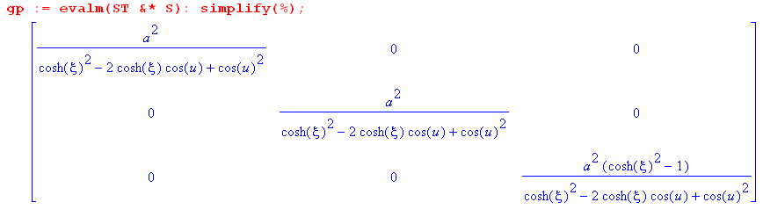

The diagonal elements are the squares of these scale factors,

hξ = hu = $\frac{a}{(chξ-cosu)}$ hφ = $\frac{ashξ}{(chξ-cosu)}$.

This agrees with M&S on their page 101. And it agrees with section (h) above, but I cannot find the mws code that was used there. It might be over in the bowl area, but now we have it here as well

Next, from tensor doc I have

J2 = det(')/ det() = g'/g ⇒ g' = J2 g . (5.12.14)

so for toroidals we just have

J2 = det(') = hξ2hu2hφ2 = hu4hφ2

J = hξhuhφ = hu2hφ2 = [$\frac{a}{(chξ-cosu)}$]2 $\frac{ashξ}{(chξ-cosu)}$ = $\frac{a3shξ}{(chξ-cosu)3}$

This would mean that

dxdydz = $\frac{a3shξ}{(chξ-cosu)3}$dξdudφ just as dxdy = r drdφ for polars

