Gathering Data on Conical Functions PhL 7.12.10

Such data is not easy to come by. HT I has 1 page or so. AS has 1/4 of a page. WW nothing. GR7 page 980 has same as HT I. Nothing simple in ET II table, nothing specific to conical form. MathWorld has very little, but reminds us conicals similar to toroidals with real v instead of ip. Wiki has nothing really on "conical functions" but a few references, one of which is NIST below.
Note: This doc is about both conical and Mehler functions, see comment at the end for the distinction which is the range of the argument z.

Contents:
What NIST Has to Say about "Conical Functions" 1
What PBM Have to Say 2
Exercise #1: Compute the Mehler transform $^{\int_{1}^{∞}{}}$dx P_{ν}(x) /$\sqrt{x-cosu0'}$ 5
The Boeing Table of Mehler Transforms 6
Exercise #2 (I pooped out here): Using integral representations for the P function 8
Comments on three functions: conical, Mehler, ring/toroidal 10

What NIST Has to Say about "Conical Functions"
_____________________________________________________________________________________

http://dlmf.nist.gov/14.20

which is a US gov thing on functions. It notes that "Mehler functions" is another name for these things. It has some plots of the functions. In 1991 some guy Dunster introduced some special versions of the Q functions perhaps similar to my q functions, who knows. The basic integral rep seems quite common

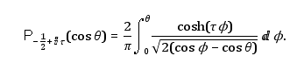 // conical

Then we have the "generalized" MF transform (but no table of such transforms), which means μ is there on the P function. [ see toroidal coords.doc for a different form of this transform] : [ notice the strange notation used for i ]

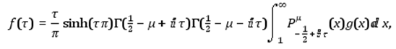// Mehler projection=transform
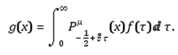 // Mehler expansion = inverse transform

Semantics comment: When we talk about the Laplace Transform, we could say that the word "transform" applies to both directions, but usually we think of the actual "transform" as being the projection direction which we write as fs = $^{\int_{0}^{∞}{}}$dt e-st f(t). We are "projecting" onto the group representation label s. The other direction (the Mellin-Barnes integral) is then called the inverse Laplace transform. Similarly, for a Legendre transform, we think of the "transform" being the projection gnm = $^{\int_{-1}^{1}{}}$dz Pmn(z) g(z), where we are projecting onto SO(3) representation labels Dn0,m etc. So for the Mehler-Fock thing, we need to regard μ and n = -1/2+iτ as the group rep labels, and we should call the first item above the "transform" or the "projection". That is: fτμ = .... ∫ dx Pμ-1/2+iτ(x) f(x). However, I suspect that the literature sometimes thinks of the second line above as the "transform".

Exactly one table entry is given, here it is: [ first is the Mehler projection of g(x) = (t+x)-1 ]
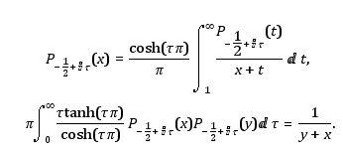 // Mehler

So the second line is expanding the function f(x) = (x+y)-1 where y is a constant. Naturally it is symmetric as shown, and we have a nice integral of a P function against a pole. They go on to give lots of asymptotic forms, and then there are a few references. Hobson 1931 gives the zeros, and Prudnikov 1990 vol 3 has 10 pages of integrals, so I will track that down soon. // I found and downloaded the PBM series of integral books, stored near GR7. [ Eventually I also got hold of Hobson 1931. He has a whole chapter on the zeros of P and Q's, in both z and n, but has no actual values stated. ]

[ the label on P is -1/2 + i τ; for some reason the "i" appears strangely here as a π-like script thing: ]
_________________________________________________________________________________

What PBM Have to Say

PBM: I now have most of these volumes, and I have found the conical (and Mehler) integrals! In my Russian vol 3 they are on pages 181-190, so maybe I will get some payoff on all that downloading work! They have a bunch of integrals of "p" of the -1/2+ip, which is the Mehler expansion, and correctly these integrals run from 0 to ∞. Here they are: [ from PBM ]

NOTE: Most of these integrals are with respect to the imaginary part of the order. The argument is always assumed to be a constant c which is sometimes in the "conical" range and sometimes in the "Mehler" range. However, the first integral is in a class by itself because the order is not of the form ix-1/2 but rather is of the form x-1/2. The P here is not really a "ring function" because x is not an integer, and also because the argument is < 1.

toroidal function: (but n = -x is real in this integral)

conical and Mehler expansion integrals, ignore the first one since it appears just above:
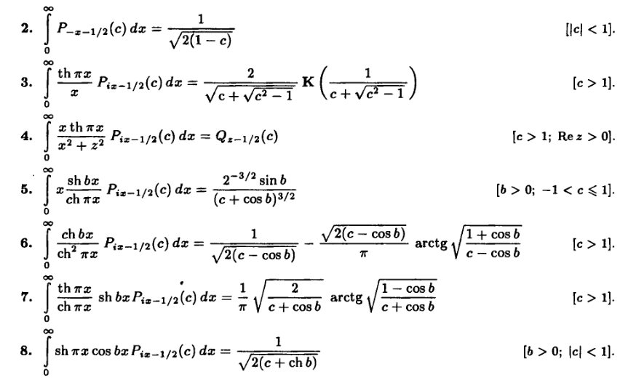
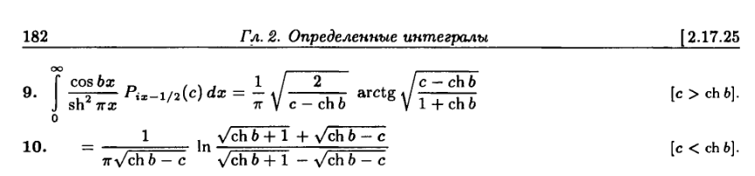
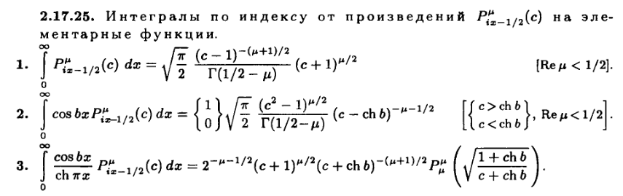

There are many more, but they involve combinations of conical P's with Bessel or Gamma functions or multiple P's. It is a pretty impressive section! Page 200 has similar stuff for Q functions (only 2 integrals!) I know of no other place to find these integrals!
I think the following is a special case of the second last integral above:

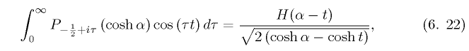

where H is the Heaviside function. It also appears in GR7 page 788

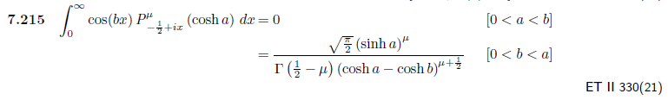
and I see it in my copied ET II integrals list!

Comment: The above integral is just the inverse Mehler transform of cos(ax). It appears in the Boeing tables only on page 28 in the "generalized" section and you then set k = 0 to get the above. The same integral appears in Bateman's ET II volume in the Legendre section, page 330 (21) in my Xerox pages. Notice that this is an example of a "discontinuous integral" in the Sneddon sense (and this probably arises as I show in my notes as the expo real or imaginary part vanishing etc), but it is not in the J J "class" of discontinuous integrals. Still, I expect it to appear in solutions of toroidal dual integral equation problems!

Exercise #1: Compute the Mehler projection $^{\int_{1}^{∞}{}}$dx Pν(x) /$\sqrt{x-cosu0'}$

I am not sure why I was interested in this integral, I'm sure it will reappear soon. It is a Mehler projection or transform of the function 1/$\sqrt{x-cosu0'}$, but the label is written ν instead of the usual -1/2 +iτ .

On page 163 of PBM vol 3 we see

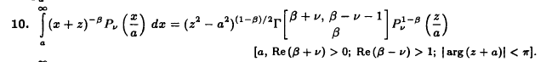

So if I set a = 1 and β = 1/2 I get

$^{\int_{1}^{∞}{}}$dx Pν(x) /$\sqrt{x+z}$ = (z2-1)1/4 Γ(1/2+ν)Γ(-ν-1/2) Pν1/2(z)/Γ(1/2)

Now try setting ν = ip-1/2 and we get 1/2+ν= ip so

= (z2-1)1/4 Pip-1/21/2(z) π/[p sh(πp)]* 1 /Γ(1/2)

I have never even seen a Pνμ where μ = 1/2 before! Bateman would say

Pν1/2(z) = (z+1)1/4(z-1)-1/4/ Γ(1/2) * F(-ν, 1+ν; 1/2; (1-z)/2)

By a tortuous Maple "conicals1.mws", if I assume z = cosu0 and u0 in (0,π), I find that

F(-ν, 1+ν; 1/2; (1-z)/2) = cosh(u0p)/cos(u0/2) assuming ν = ip-1/2 and z = cos(u0)

so I seem to have this result

$^{\int_{1}^{∞}{}}$dx Pν(x) /$\sqrt{x+cosu0}$ = (z2-1)1/4 π/[p sh(πp)] * Pip-1/21/2(z)* 1 /Γ(1/2)

= (z2-1)1/4 π/[p sh(πp)] * (z+1)1/4(z-1)-1/4/ Γ(1/2) * cosh(u0p)/cos(u0/2)* 1 /Γ(1/2)

= π/[p sh(πp)] * (z+1)1/2 / Γ(1/2)2 * cosh(u0p)/cos(u0/2)

= π/[p sh(πp)] * $\sqrt{2}$cos(u0/2) / π * cosh(u0p)/cos(u0/2)

= $\sqrt{2}$ cosh(u0p)/[p sh(πp)] u0 in (0,π)

Now define

u0' = uo + π cosu0' = -cosu0

our result then becomes

$^{\int_{1}^{∞}{}}$dx Pν(x) /$\sqrt{x-cosu0'}$

= $\sqrt{2}$ cosh(p(u0'-π))/[p sh(πp)] where ν = ip-1/2

and this agrees exactly with the result I got in "charged bowl in toroidals.doc". But result is a little slippery in terms of this sign change!
NOTE: In the Maple program, if I assume u0 lies in (-π,0), then u0' lies in (0,π) where I want it. It is true for u0 that sign(cos(u0/2)) = +1 as I told Maple. So I think the above is totally justified!

2.20.11. Here is another version of doing this integral. Start with

I ≡ $^{\int_{1}^{∞}{}}$dx Piτ-1/2(x) / $\sqrt{x - cosu0}$

Write out our Q expansion

1/$\sqrt{a - b cos(x)}$ = (1/π) $\sqrt{2/b}$ Σn=0∞ εn Qn-1/2(a/b) cos(nx) // expansion (10.3a)
$^{\int_{0}^{π}{}}$dx cos(nx)/ $\sqrt{a - b cos(x)}$ = $\sqrt{2/b}$ Qn-1/2(a/b) // projection (10.3b)

Now write the expansion with x→u0 and b = 1 and a = x

1/$\sqrt{x - cosu0}$ = (1/π) $\sqrt{2}$ Σn=0∞ εn Qn-1/2(x) cos(nu0) // expansion (10.3a)

Then insert this expansion to get

I = ($\sqrt{2}$/π) Σn=0∞ εn cos(nu0) $^{\int_{1}^{∞}{}}$dx Piτ-1/2(x) Qn-1/2(x)

Now we have this GR7 integral page 770
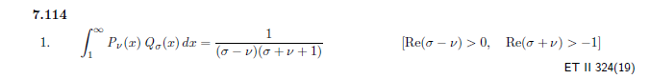

in which we set ν = -1/2+iτ and σ = n-1/2 so that

σ-ν = n-1/2 - (-1/2+iτ) = n-iτ Re part > 0 except maybe for n = 0

σ + ν + 1 = = n-1/2 + -1/2+iτ + 1 = n+iτ same idea, see limits above, I think we are OK

Therefore

(σ-ν)( σ + ν + 1) = (n-iτ)( n+iτ) = n2+τ2

So we then have

I = ($\sqrt{2}$/π) Σn=0∞ εn cos(nu0) / (n2+τ2)

Now is this a sum which appears in GR7 ? Yes. GR page 47 has this

Which we can write as

1/(2α2) + Σk=1∞ cos(kx)/(k2+α2) = (π/2α) cosh[α(π-x)]/sinh(απ)
or

1/(α2) + Σk=1∞ 2cos(kx)/(k2+α2) = (π/α) cosh[α(π-x)]/sinh(απ)

or
Σk=0∞ εk cos(kx)/(k2+α2) = (π/α) cosh[α(π-x)]/sinh(απ)

and set k = n and x = u0 and α = τ to get

Σn=0∞ εn cos(nx)/(n2+τ2) = (π/τ) cosh[τ(π- u0)]/sinh(τπ)

So we have then shown that

$^{\int_{1}^{∞}{}}$dx Piτ-1/2(x) / $\sqrt{x - cosu0}$ = ($\sqrt{2}$/π) (π/τ) cosh[τ(π- u0)]/sinh(τπ)

= $\sqrt{2}$ cosh[τ(π- u0)]/ [ τ sinh(τπ)]

which is our same result! So that is way to do it with only GR7 stuff.

_________________________________________________________________________________

So OK, I have still not really found data specific to conical functions! I conclude that this is an extremely esoteric corner of "special functions" and you are not going to find any kind of table of integrals.

The Boeing Table of Mehler Transforms

What about a search on Mehler transform, hoping to find a table somewhere? I found a reference which makes this claim:

1. The integral transform. One result of recent studies of boundary-value problems of the wave and diffusion equations involving wedge- or conically-shaped boundaries has been the interest shown in integrals in which the variable of integration appears as the order of Bessel or Legendre functions. An integral of this type occurs as the inversion formula for the generalized Mehler transform which is defined by
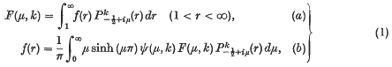
where ψ(μ, k) = Γ(½ − k + iμ)Γ(½ − k − iμ) and is the associated Legendre function of the first kind. Oberhettinger and Higgins (4) have given a table of transform pairs corresponding to the above transform.
People continue to mention Sneddon, maybe another library trip?
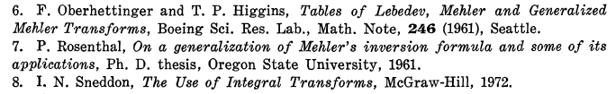


http://www.worldcat.org/title/tables-of-lebedev-mehler-and-generalized-mehler-transforms/oclc/9522890

Claims this thing can be found here:

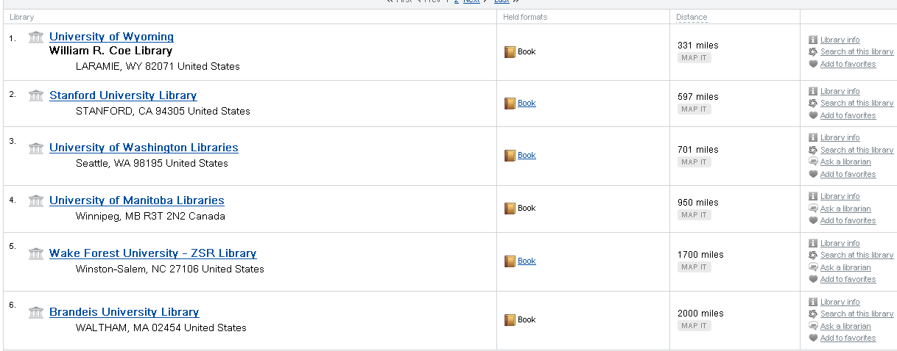

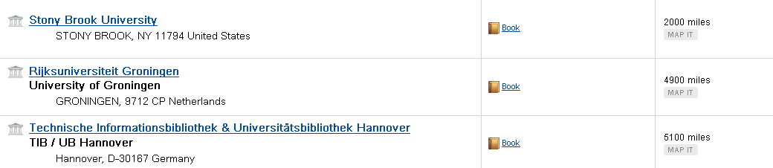

Wyoming has it just sitting there



I found a jstor article at least on the general subject, but too bad, it has nothing useful, ref Higgins of course. Called Tom, her kids are no longer enrolled, but a library exchange might be possible. At Tom's suggestion, I walked down to the library and learned sure, they do interlibrary loans, no problem! So I filled out a form and attached printed stuff above, the lady said 4-6 weeks. They get it from wherever they can get it, she said, but not overseas. So I guess I will let that ride, I should hear in an email at some point, I will probably be on the Cod at that time. This is my first ever loan deal. She said they do 5-20 a week just from the Sweet branch, maybe 100 city wide each week. She will "do it herself" she said. Should have gotten a name. [ it is all done, I have a copy of the above doc! ]

Exercise #2 (I pooped out here): Using integral representations for the P function

Again, I don't recall why I was interested in this, but probably will bump into it soon. I seem to have just pooped out in this exercise. What we have here is a Mehler inverse transform. Neither of the two terms appear in the Boeing doc or PBM. Not in Bateman. In my "toroidal thing", I wanted to "check" this result:

V(ξ,u0,φ) = V0$\sqrt{2}$ [ $\sqrt{chξ - cosu0}$ $^{\int_{0}^{∞}{}}$ dp Pip-1/2(chξ) ch[p(u0-π)]/(ch(πp))

Suppose we use the classic integral rep (AS p 337 or above)

Pip-1/2(cosθ) = (1/$\sqrt{2}$π) $^{\int_{0}^{θ}{}}$dφ cosh(pφ) / $\sqrt{cosφ-cosθ}$

This "exposes" the p dependence in a relatively simple way, basically just an exponential. But how do we use this thing for cosθ > 1? Let's try this

cosθ = cosh(iθ)
cosφ = cosh(iφ)

Pip-1/2(cosh(iθ)) = (1/$\sqrt{2}$π) $^{\int_{0}^{θ}{}}$dφ cosh(pφ) / $\sqrt{cosh(iφ)- cosh(iθ)}$

Now set iφ = x and iθ = y and idφ = dx, and we have

Pip-1/2(cosh(y)) = (1/$\sqrt{2}$π) $^{\int_{0}^{y}{}}$(-idx) cosh(-ipx) / $\sqrt{cosh(x)- cosh(y)}$
= (1/$\sqrt{2}$π) (-i) $^{\int_{0}^{y}{}}$dx cos(px) / $\sqrt{cosh(x)- cosh(y)}$

Now I just take a stab at the sign (fix it later) and this becomes

Pip-1/2(cosh(y)) = (1/$\sqrt{2}$π) $^{\int_{0}^{y}{}}$dx cos(px) / $\sqrt{cosh(y)- cosh(x)}$

where now everything in the integrand is real. Can I get this verified somewhere? All GR7 has is this:

which is just more veggies into the soup.
All of this seems very wobbly, I can't see more time getting hung out without any way to check things. Here is the Jackson Sneddon reference:

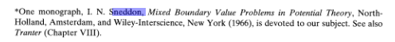

But I think it is his 1972 "Use of Integral Transforms" that people talk about. Marriott has one copy, but it is checked out till July 26 of this month, maybe check later. Does PBM talk about this stuff? Does PBM have a section that just talks "about" special functions?

Question : why are Pip-1/2m(chμ) known as conical functions?

The notion of a cone does not seem to fit well with toroidal coordinates. The answer to this question is given in my "canonical" pdf, but I have to study it. The cone geometry definitely appears in this discussion. // I now understand this, see the Atoms doc for a quick explanation. See also below!

Comments on three functions: conical, Mehler, ring/toroidal

(1) In my view, a "conical function" is one of the form Pnm(z) [ or Q] where n = -1/2+ip and where z lies in (-1,1). Such functions appear in the spherical coordinates "atomic form" when you insist that the radial equation have S-L oscillatory solutions, which causes the z equation to be radial/expo. As I show in the atoms doc, you are forced to the above general value for n in this case [ by n(n+1) must be real and radial solutions must be oscillatory], and of course z is in the range shown since this is spherical coordinates. The connection with "cones" is this: a cone is a surface of constant z=cosθ in spherical coordinates. If we want to do something like a Dirichlet problem with a prescribed potential on a cone, we must have oscillatory in both the φ and r directions! This leaves the θ direction as an expo/radial coordinate direction. Usually we think of r as expo, but in a Dirichlet cone problem, you must have r be oscillatory.

(2) A special case of Dirichlet would be V = 0 on the cone, and we need V = 0 also in a cone Green's function problem. We can write out Smythian form in terms of these conical atoms

~ (1/$\sqrt{r}$)[sin(p lnr), cos(p lnr)] [ Pip-1/2m(z), Qip-1/2m(z)] [ sin(mφ),cos(mφ)]

and then require that V(r,θ=α,φ) = some Dirichlet f(r,φ) which could be f(r,φ) = 1 or f(r,φ) = 0. In the Green's case, we could write f(r,φ) = -1/R in an appropriate expansion and find the potential just of the charge induced on the cone. It just happens that there is a whole alternate expansion where n takes on the values ni which are the zeros of Pn(cosα), and this expansion will also yield solutions to the V=0 problem. In a sense, this is a very singular approach since we force V = 0 by the spectrum of n, and not by arranging our two oscillatory coordinates r and φ to obtain V = 0. That is to say, we select the spectrum ni such that we get V = 0 on the cone with (θ,φ) as the oscillatory coordinates. Obviously this singular approach only works for the V = 0 case and not for any other Dirichlet case. In retrospect, it seems odd that Smythe did not take his readers into the land of conicals and do some problems there. Once again, the conical functions as defined here are non-oscillatory.

(3) In my view, a "Mehler function" is one of the form Pnm(z) [ or Q] where n = -1/2+ip and where z lies in (1,∞). This is then different from a "conical function" because of the range implied for the argument. It turns out that Mehler functions ARE oscillatory, and therefore we have a SL problem for them, we have a complete set of eigenfunctions, and therefore we have an expansion/projection theorem which means we have a "transform". This transform is the generalized (ie, m ≠ 0) Mehler-Foch transform. The Mehler functions appear in the μ variable of toroidal coordinates, where μ labels toroids and ranges 0,∞ where the case μ = ∞ gives the limit where the toroid is a circular wire, and μ = 0 the limit where the toroid fills all of space, being a fat donut with no hole left. Again, in the toroidal system the functions Pnm(coshμ) are oscillatory and form a complete set.

(4) I have never written out orthogonality and completeness for the Mehler functions. There is no such orthogonality and completeness for conical functions since they are not oscillatory!

(5) In my view, a "ring or toroidal function" is one of the form Pνm(z) [ or Q] where ν = -1/2+n where n is an integer, and where z lies in (1,∞). When you do toroidal atoms, if you want oscillatory in η and φ (both just simple trig functions), then you are expo/radial in μ so you get these Pn-1/2(coshμ) functions. Bateman allows that n might be complex and you still call it a ring function. Thus, the distinction between ring and Mehler is blurred by this fact. For a toroidal function, n = integer only if the full range of η is realized in the solution. Looking at my toroidal doc, maybe you can say this is the case if you can approach the z = 0 plane "iris" from both positive and negative z directions and you need to get the same solution in both cases. This would be the case, for example, if you were computing the potential surrounding a toroid at constant potential, or surrounding a bowl at constant potential.

(6) Here is an important expansion (derived in integrals / cos(nx)...doc ) which involves ring functions:

1/$\sqrt{a - b cos(x)}$ = (1/π) $\sqrt{2/b}$ Σn=0∞ εn Qn-1/2(a/b) cos(nx) // expansion

This is nothing more than a cosine Fourier series with this projection integral

$^{\int_{0}^{π}{}}$dx cos(nx)/ $\sqrt{a - b cos(x)}$ = $\sqrt{2/b}$ Qn-1/2(a/b)

also derived in that same doc. This can be regarded as a very useful "integral representation" of a ring Q function that you don't see in the usual sources. The above then leads to the following interesting 1/R expansion in cylindrical coordinates : ( see same doc)

1/R = 1/ $\sqrt{a - b cos(x)}$ = (1/π) $\sqrt{2/b}$ Σn=0∞ εn Qn-1/2(a/b) cos(nx)

= (1/π$\sqrt{ρρ'}$) Σn=0∞ εn cos[n(φ-φ')] Qn-1/2[(ρ2 + ρ'2 + (z-z')2)/(2ρρ')]

The odd fact is that we have a ring Q function, which we normally associate with toroidal coordinates, appearing in a situation of cylindrical coordinates. But of course we also earlier had another toroidal function with -1/2+ip appearing in spherical coordinates, so the animals sometimes jump their fences.

